+ Ash Wednesday
March 2, 2022

St. Andrew Lutheran Church
304 Morewood Ave.
Pittsburgh, PA 15213
St_andrewELCA@verizon.net
www.standrewpittsburgh.org

+ Ash Wednesday
Order for Worship

On Ash Wednesday we begin our forty-day journey toward Easter with a day of fasting and repentance. Marking our foreheads with dust, we acknowledge that we die and return to the earth. At the same time, the dust traces the life-giving cross indelibly marked on our foreheads at baptism. While we journey through Lent to return to God, we have already been reconciled to God through Christ. We humbly pray for God to make our hearts clean while we rejoice that “now is the day of salvation.” Returning to our baptismal call, we more intentionally bear the fruits of mercy and justice in the world.

A few notes on precautions and protocols, which apply to everyone regardless of vaccination status, as St. Andrew returns to worship in the sanctuary:

- Face masks that fully cover both your mouth and nose are required at all times for everyone over the age of two (2) – the only exception being the brief moment of moving mask aside to partake in Holy Communion.
- Outside food and drink are thus not permissible during worship.
- Physical distancing of at least six (6) feet will be observed at all times for people not from your household.
- We invite the congregation to join in the singing of the hymns (with masks on) during worship!
- Hand sanitizer is available at the front of the sanctuary to use before Holy Communion, after you proceed past the baptismal font, as the alcohol has been affecting the finish on the font’s bowl.

Worship Services are live streamed to multiple online platforms.
By attending worship, you agree that your image and voice may be broadcast.

Gathering

Worship begins in silence.
Please rise as you are able.

Greeting

P: The Lord be with you.
C: And also with you.

Prayer of the Day

P: Let us pray.
Holy God, mighty and immortal,
you are beyond our knowing, yet we see your glory in the face of Jesus Christ.
Transform us into the likeness of your Son,
who renewed our humanity that we may share in his divinity,
Jesus Christ our Lord, who lives and reigns with you and the Holy Spirit,
one God, now and forever.
C: Amen.

Please be seated

Word

First Reading – Joel 2: 1-2, 12-17

¹Blow the trumpet in Zion;
sound the alarm on my holy mountain!
Let all the inhabitants of the land tremble,
for the day of the Lord is coming, it is near—
²a day of darkness and gloom,
a day of clouds and thick darkness!
Like blackness spread upon the mountains
a great and powerful army comes;
their like has never been from of old,
nor will be again after them
in ages to come.
¹²Yet even now, says the Lord,
return to me with all your heart,
with fasting, with weeping, and with mourning;
¹³rend your hearts and not your clothing.
Return to the Lord, your God,
who is gracious and merciful,
slow to anger, and abounding in steadfast love,
and relents from punishing.
¹⁴Who knows whether the Lord will not turn and relent,
and leave a blessing behind,
a grain offering and a drink offering
for the Lord, your God?
¹⁵Blow the trumpet in Zion;
sanctify a fast;
call a solemn assembly;
¹⁶gather the people.
Sanctify the congregation;
assemble the aged;
gather the children,
even infants at the breast.
Let the bridegroom leave his room,
and the bride her canopy.
¹⁷Between the vestibule and the altar
let the priests, the ministers of the Lord, weep.
Let them say, “Spare your people, O Lord,
and do not make your heritage a mockery,
a byword among the nations.
Why should it be said among the peoples,
‘Where is their God?’ ”

L: Word of God, word of life.
C: Thanks be to God.

Psalm 51: 1-17

The psalm will be spoken, led by the cantor, with the congregation invited to join the lector
in responding with the alternate verses.

¹Have mercy on me, O God, according to your | steadfast love;
in your great compassion blot out | my offenses.
²Wash me through and through | from my wickedness,
and cleanse me | from my sin.
³For I know | my offenses,
and my sin is ev- | er before me.
⁴Against you only have I sinned and done what is evil | in your sight;
so you are justified when you speak and right | in your judgment.
⁵Indeed, I was born | steeped in wickedness,
a sinner from my | mother’s womb.
⁶Indeed, you delight in truth | deep within me,
and would have me know wisdom | deep within.
⁷Remove my sins with hyssop, and I | shall be clean;
wash me, and I shall be pur- | er than snow.
⁸Let me hear | joy and gladness;
that the body you have broken | may rejoice.
⁹Hide your face | from my sins,
and blot out | all my wickedness.
¹⁰Create in me a clean | heart, O God,
and renew a right spir- | it within me.
¹¹Cast me not away | from your presence,
and take not your Holy Spir- | it from me.
¹²Restore to me the joy of | your salvation
and sustain me with your boun- | tiful Spirit.
¹³Let me teach your ways | to offenders,
and sinners shall be re- | stored to you.
¹⁴Rescue me from bloodshed, O God of | my salvation,
and my tongue shall sing | of your righteousness.
¹⁵O Lord, o- | pen my lips,
and my mouth shall pro- | claim your praise.
¹⁶For you take no delight in sacrifice, or | I would give it.
You are not pleased | with burnt offering.
¹⁷The sacrifice of God is a | troubled spirit;
a troubled and broken heart, O God, you will | not despise.

Second Reading – 2 Corinthians 5: 20b – 6: 10

^{20b}We entreat you on behalf of Christ, be reconciled to God. ²¹For our sake God made him to be sin who knew no sin, so that in him we might become the righteousness of God.
^{6:1}As we work together with Christ, we urge you also not to accept the grace of God in vain. ²For God says,
“At an acceptable time I have listened to you,
and on a day of salvation I have helped you.”
See, now is the acceptable time; see, now is the day of salvation! ³We are putting no obstacle in anyone’s way, so that no fault may be found with our ministry, ⁴but as servants of God we have commended ourselves in every way: through great endurance, in afflictions, hardships, calamities, ⁵beatings, imprisonments, riots, labors, sleepless nights, hunger; ⁶by purity, knowledge, patience, kindness, holiness of spirit, genuine love, ⁷truthful speech, and the power of God; with the weapons of righteousness for the right hand and for the left; ⁸in honor and dishonor, in ill repute and good repute. We are treated as impostors, and yet are true; ⁹as unknown, and yet are well known; as dying, and see—we are alive; as punished, and yet not killed; ¹⁰as sorrowful, yet always rejoicing; as poor, yet making many rich; as having nothing, and yet possessing everything.

L: Word of God, word of life.
C: Thanks be to God.

Please rise as you are able.

Gospel Acclamation

C: Return to the Lord, your God, who is gracious and merciful,
slow to anger, and abounding in steadfast love.

Gospel – Matthew 6: 1-6, 16-21

P: The holy Gospel according to St. Matthew.
C: Glory to you, O Lord.

[Jesus said to the disciples:] ¹“Beware of practicing your piety before others in order to be seen by them; for then you have no reward from your Father in heaven.
²“So whenever you give alms, do not sound a trumpet before you, as the hypocrites do in the synagogues and in the streets, so that they may be praised by others. Truly I tell you, they have received their reward. ³But when you give alms, do not let your left hand know what your right hand is doing, ⁴so that your alms may be done in secret; and your Father who sees in secret will reward you.
⁵“And whenever you pray, do not be like the hypocrites; for they love to stand and pray in the synagogues and at the street corners, so that they may be seen by others. Truly I tell you, they have received their reward. ⁶But whenever you pray, go into your room and shut the door and pray to your Father who is in secret; and your Father who sees in secret will reward you.
¹⁶“And whenever you fast, do not look dismal, like the hypocrites, for they disfigure their faces so as to show others that they are fasting. Truly I tell you, they have received their reward. ¹⁷But when you fast, put oil on your head and wash your face, ¹⁸so that your fasting may be seen not by others but by your Father who is in secret; and your Father who sees in secret will reward you.
¹⁹“Do not store up for yourselves treasures on earth, where moth and rust consume and where thieves break in and steal; ²⁰but store up for yourselves treasures in heaven, where neither moth nor rust consumes and where thieves do not break in and steal. ²¹For where your treasure is, there your heart will be also.”

P: The Gospel of the Lord.
C: Praise to you, O Christ.

Please be seated.

Sermon

Please rise as you are able.

Hymn of the Day Restore in Us, O God ELW 328
v. 1-3

1 Restore in us, O God,
the splendor of your love;
renew your image in our hearts,
and all our sins remove.

2 O Spirit, wake in us
the wonder of your pow'r;
from fruitless fear unfurl our lives
like springtime bud and flow'r.

3 Bring us, O Christ, to share
the fullness of your joy;
baptize us in the risen life
that death cannot destroy.

Text: Carl P. Daw, Jr., b. 1944. Music: BAYLOR, Hal H. Hopson, b. 1933. Text © 1989 Hope Publishing Company, Carol Stream, IL 60188. Music © 1985 Hope Publishing Company. All rights reserved. Reprinted with permission under OneLicense.net # A-722139.

Invitation to Lent

P: Friends in Christ, today with the whole church we enter the time of remembering Jesus’ passover from death to life, and our life in Christ is renewed.

We begin this holy season by acknowledging our need for repentance and for God’s mercy.
We are created to experience joy in communion with God, to love one another, and to live in harmony with creation. But our sinful rebellion separates us from God, our neighbors, and creation, so that we do not enjoy the life our creator intended.

As disciples of Jesus, we are called to a discipline that contends against evil and resists whatever leads us away from love of God and neighbor. I invite you, therefore, to the discipline of Lent—self-examination and repentance, prayer and fasting, sacrificial giving and works of love—strengthened by the gifts of word and sacrament. Let us continue our journey through these forty days to the great Three Days of Jesus’ death and resurrection.

Confession of Sin

P: Let us confess our sin in the presence of God and of one another.

The assembly kneels or sits. Silence is kept for reflection and self-examination.

P: Most holy and merciful God,
C: we confess to you and to one another,
and before the whole company of heaven,
that we have sinned by our fault,
by our own fault,
by our own most grievous fault,
in thought, word, and deed,
by what we have done and by what we have left undone.

P: We have not loved you with our whole heart, and mind, and strength.
We have not loved our neighbors as ourselves.
We have not forgiven others as we have been forgiven.
C: Have mercy on us, O God.

P: We have resisted your call to serve as Christ served us.
We have not been true to the mind of Christ.
We have grieved your Holy Spirit.
C: Have mercy on us, O God.

P: Our past unfaithfulness, the pride, envy, hypocrisy, and apathy that have infected our lives,
we confess to you.
C: Have mercy on us, O God.

P: Our self-indulgent appetites and ways, and our exploitation of other people,
we confess to you.
C: Have mercy on us, O God.

P: Our negligence in prayer and worship, and our failure to share the faith that is in us,
we confess to you.
C: Have mercy on us, O God.

P: Our neglect of human need and suffering, and our indifference to injustice and cruelty,
we confess to you.
C: Have mercy on us, O God.

P: Our false judgments, our uncharitable thoughts toward our neighbors,
and our prejudice and contempt toward those who differ from us, we confess to you.
C: Have mercy on us, O God.

P: Our waste and pollution of your creation, and our lack of concern for those who come after us, we confess to you.
C: Have mercy on us, O God.

P: Restore us, O God, and let your anger depart from us.
C: Hear us, O God, for your mercy is great.
Imposition of Ashes

P: Almighty God, you have created us out of the dust of the earth.
May these ashes be a sign of our mortality and penitence, reminding us
that only by the cross of our Lord Jesus Christ are we given eternal life;
through the same Jesus Christ, our Savior and Lord.
C: Amen.

People of the congregation may come forward to receive the ashes. Cushions are available at the altar rail if anyone would like to kneel for prayer and reflection after receiving the ashes.

The minister marks the forehead of each person with a cross of ashes, saying:
P: Remember that you are dust, and to dust you shall return.

During this time, penitential hymns are sung.

Hymns during Imposition of Ashes
Savior, When in Dust to You ELW 601
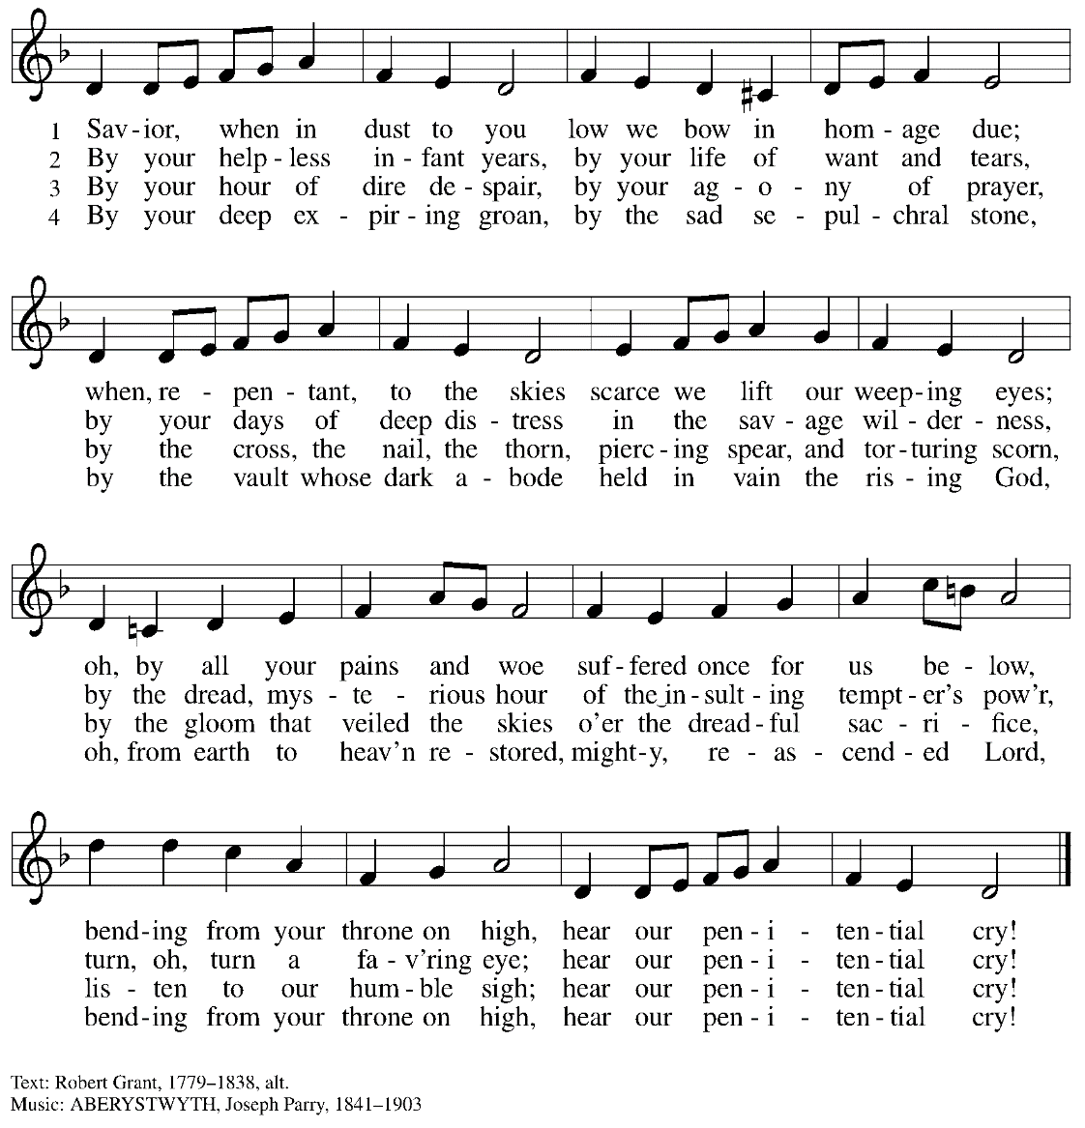
Hymns during Imposition of Ashes
Remember That You Are Dust ACS 919

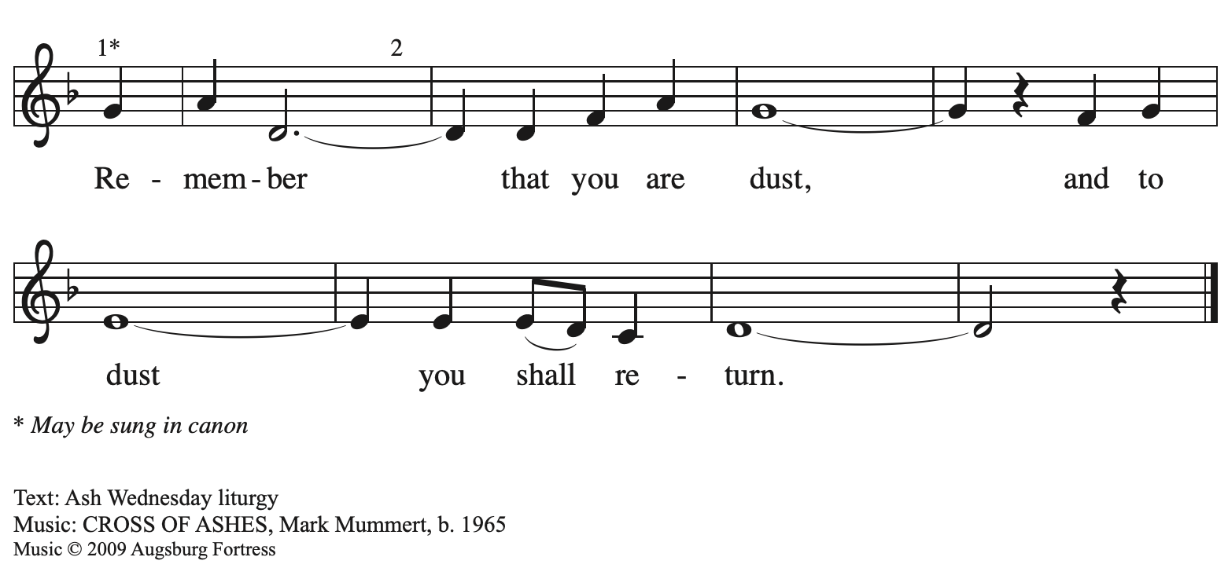
All rights reserved. Reprinted with permission under OneLicense.net # A-722139.

After those who desire ashes have received them, all may be seated. The minister continues:
P: Accomplish in us, O God, the work of your salvation,
C: that we may show forth your glory in the world.

P: By the cross and passion of your Son, our Savior,
C: bring us with all your saints to the joy of his resurrection.

The presiding minister addresses the assembly.
P: Almighty God have mercy on us, forgive us all our sins through our Lord Jesus Christ, strengthen us in all goodness, and by the power of the Holy Spirit keep us in eternal life.
C: Amen.

Prayers of the People

P: Turning our hearts to God who is gracious and merciful,
we pray for the church, the world, and all who are in need.

After each petition
P: Merciful God,
C: receive our prayer.

P: Accept the prayers we bring before you, O God, on behalf of a world in need,
through Jesus Christ, our Savior.
C: Amen.

Please be seated.

We offer ourselves, our gifts, and our faithful service to God.
An usher will pass around an offering plate for anyone who would like to offer gifts before God.

Meal

Please rise as you are able.

Offertory Prayer

P: Let us pray. God our provider,
C: you have not fed us with bread alone, but with words of grace and life.
Bless us and these your gifts, which we receive from your bounty,
through Jesus Christ our Lord. Amen.

Dialogue

P: The Lord be with you.
C: And also with you.

P: Lift up your hearts.
C: We lift them to the Lord.

P: Let us give thanks to the Lord our God.
C: It is right to give our thanks and praise.

Preface

P: It is indeed right, our duty and our joy…
… and join their unending hymn.

Sanctus

C: Holy, holy, holy Lord,
God of power and might:
Heaven and earth are full of your glory.
Hosanna in the highest.
Blessed is the one who comes in the name of the Lord.
Hosanna in the highest.

Eucharistic Prayer

P: Blessed are you, O God of the universe …
Do this for the remembrance of me.

With this bread and cup, we remember our Lord’s Passover from death to life
as we proclaim the mystery of faith.
C: Christ has died. Christ is risen. Christ will come again.

P: O God of resurrection and new life …
… grace our table with your presence.
C: Come, Holy Spirit.

P: Reveal yourself to us in the breaking of the bread …
… with justice, peace, and love.
C: Come, Holy Spirit.

P: With your holy ones of all times and places …
… blessed and Holy Trinity, now and forever.
C: Amen.

Lord’s Prayer

P: Gathered as one by the Holy Spirit, let us pray as Jesus taught us.
C: Our Father in heaven,
hallowed be your name,
your kingdom come,
your will be done,
on earth as in heaven.
Give us today our daily bread.
Forgive us our sins
as we forgive those
who sin against us.
Save us from the time of trial
and deliver us from evil.
For the kingdom, the power,
and the glory are yours,
now and forever. Amen.

Fraction and Invitation

Agnus Dei / Lamb of God

C: Lamb of God, you take away the sin of the world; have mercy on us.
Lamb of God, you take away the sin of the world; have mercy on us.
Lamb of God, you take away the sin of the world; grant us peace.

Please be seated.

Holy Communion
- Hand sanitizer is available if you would like to use it prior to receiving Communion.
- We will not be kneeling at the altar rail due to the need for physical distancing.
- Worshipers from the pulpit side will proceed forward first, followed by the center section, and then the lectern side.
- The Communion wafers (regular and gluten-free) have been thoughtfully prepared using the gifts of the congregation by a member of St. Andrew’s altar care team, with a drop of wine or grape juice on each. The presiding minister will distribute one to each communicant.
- When you reach the presiding minister, please indicate if you would like grape juice or a gluten-free wafer.
- A blessing will be provided for anyone who does not yet receive the sacrament.
- Everyone is asked to wait until you return to your place to consume the elements, and then promptly replace your mask.

Hymns during Holy Communion
Just As I Am, without One Plea ELW 592
v. 1-3

1 Just as I am, without one plea,
but that thy blood was shed for me,
and that thou bidd'st me come to thee,
O Lamb of God, I come, I come.

2 Just as I am, though tossed about
with many a conflict, many a doubt,
fightings and fears within, without,
O Lamb of God, I come, I come.

3 Just as I am, thou wilt receive,
wilt welcome, pardon, cleanse, relieve;
because thy promise I believe,
O Lamb of God, I come, I come.

Text: Charlotte Elliott, 1789-1871. Music: William B. Bradbury, 1816-1868.

Hymns during Holy Communion
Around You, O Lord Jesus ELW 468

1 Around you, O Lord Jesus,
your own you gather still
to share the feast you give us
with grace our lives to fill.
You say to us so lovingly,
“Take, eat! This is my body!
Take, drink! This is my blood!”

2 We hear your invitation,
and heed, O Lord, your call;
your word of consolation
is spoken here to all.
It draws us to your loving heart;
it brings to us your blessing,
which never will depart.

3 We are your own forever;
until our final breath
we will be true and never
in joy, in grief, in death
depart from you, for you are still
among your people dwelling,
as you have said you will.

Text: Frans Mikael Franzén, 1772-1847; tr. composite. Music: H. Thomissön, Der danske Psalmebog, 1569. Text © 1978 Lutheran Book of Worship, admin. Augsburg Fortress. All rights reserved. Reprinted with permission under OneLicense.net # A-722139.

When all have returned to their places, please rise as you are able.

Blessing

P: The body and blood of our Lord Jesus Christ strengthen you and keep you in his grace.
C: Amen.

Prayer

P: Let us pray.
Merciful God, accompany our journey through these forty days.
Renew us in the gift of Baptism, that we may provide for those who are poor,
pray for those in need, fast from self-indulgence, and above all
that we may find our treasure in the life of your Son, Jesus Christ, our Savior and Lord,
who lives and reigns with you and the Holy Spirit, one God, now and forever.
C: Amen.

Sending

Benediction

P: Almighty God, Father, ☩ Son, and Holy Spirit,
bless you, now and forever.
C: Amen.

Dismissal

P: Go forth into the world to serve God with gladness;
be of good courage;
hold fast to that which is good;
render to no one evil for evil;
strengthen the fainthearted; support the weak;
help the afflicted; honor all people;
love and serve God, rejoicing in the power of the Holy Spirit.
C: Thanks be to God.

Abbreviations

P: Pastor/Presiding Minister
L: Lector
C: Congregation

ELW: Evangelical Lutheran Worship hymnal
ACS: All Creation Sings hymnal

Those serving in worship today

Piano Jeff Denlinger
Organ Jimmi Kocher-Hillmer
Cantor Kristen Asplin
Lector Sue Gaugler
Director of Faith Formation Christopher Atwood
Presiding Minister Pastor Ross Carmichael

Liturgy and Hymnody Acknowledgements

From SundaysandSeasons.com. Copyright © 2022 Augsburg Fortress. All rights reserved. Reprinted under OneLicense.net # A-722139.
Used by permission of Augsburg Fortress.

