+ First Sunday in Lent
March 6, 2022

St. Andrew Lutheran Church
304 Morewood Ave.
Pittsburgh, PA 15213
St_andrewELCA@verizon.net
www.standrewpittsburgh.org

+ First Sunday in Lent
Order for Worship

The forty days called Lent are like no other.
The season is our opportune time to return to the God who rescues,
to receive the gifts of God’s grace, to believe with the heart and confess
the wonder of God’s love in Jesus, and to resist temptation at every turn.
This is no small pilgrimage on which we have just embarked.
It is a struggle Jesus knew. It is a struggle Jesus shares.
The nearness of the Lord, in bread and wine, water and word, will uphold and sustain us.

A few notes on precautions and protocols, which apply to everyone regardless of vaccination status, as St. Andrew returns to worship in the sanctuary:

- Face masks that fully cover both your mouth and nose are required at all times for everyone over the age of two (2) – the only exception being the brief moment of moving mask aside to partake in Holy Communion.
- Outside food and drink are thus not permissible during worship.
- Physical distancing of at least six (6) feet will be observed at all times for people not from your household.
- We invite the congregation to join in the singing of the hymns (with masks on) during worship!
- Hand sanitizer is available at the front of the sanctuary to use before Holy Communion, after you proceed past the baptismal font, as the alcohol has been affecting the finish on the font’s bowl.

Worship Services are live streamed to multiple online platforms.
By attending worship, you agree that your image and voice may be broadcast.

Welcome

Gathering

Centering Music Return to God ACS 921

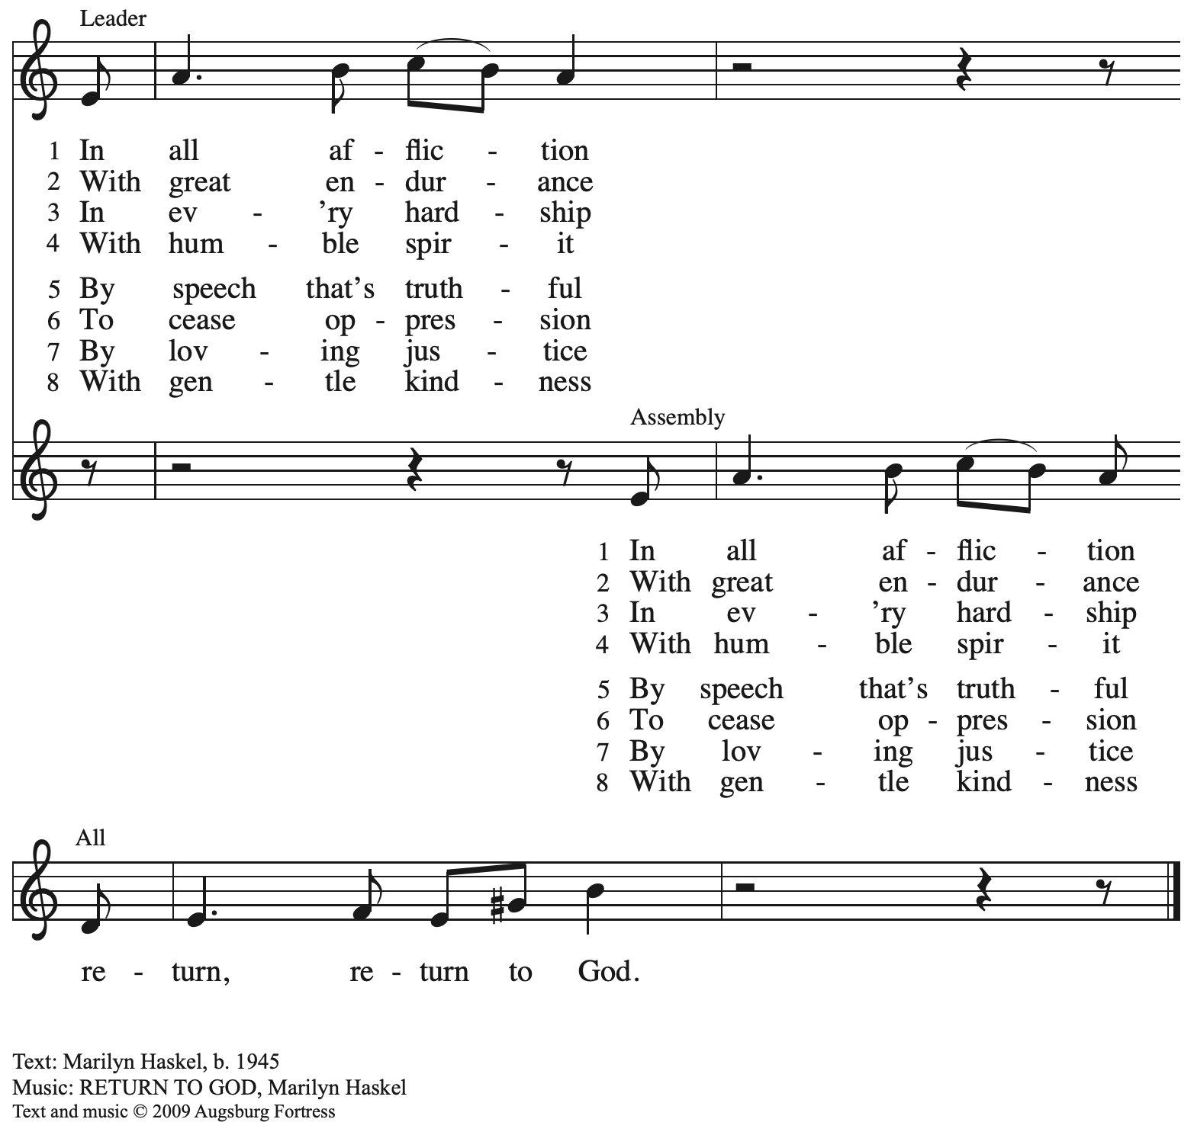
All rights reserved. Reprinted with permission under OneLicence.net # A-722139.

Please rise as you are able.

Confession of Sin

P: In the name of our ☩ Triune God,
who makes a way in the wilderness,
accompanies us, and guides us in our pilgrimage.
C: Amen.

Silence is kept for reflection.

P: Holy One,
C: we confess that we have wandered far from you:
we have not trusted your promises,
we have ignored your prophets in our own day,
we have squandered our inheritance of grace,
we have failed to recognize you in our midst.
Have mercy on us.
Forgive us and turn us again to you.
Teach us to follow in your ways,
assure us again of your love,
and help us to love our neighbor.
Amen.

P: Beloved in Christ,
the Word draws near to you,
and all who call out to God shall be saved.
In Jesus, God comes to you again and again
and gathers you under wings of love.
In ☩ Jesus’ name, your sins are forgiven.
God journeys with you and teaches you how to live in love.

Gathering Hymn Bless Now, O God, the Journey Following Page

Gathering Hymn Bless Now, O God, the Journey ELW 326

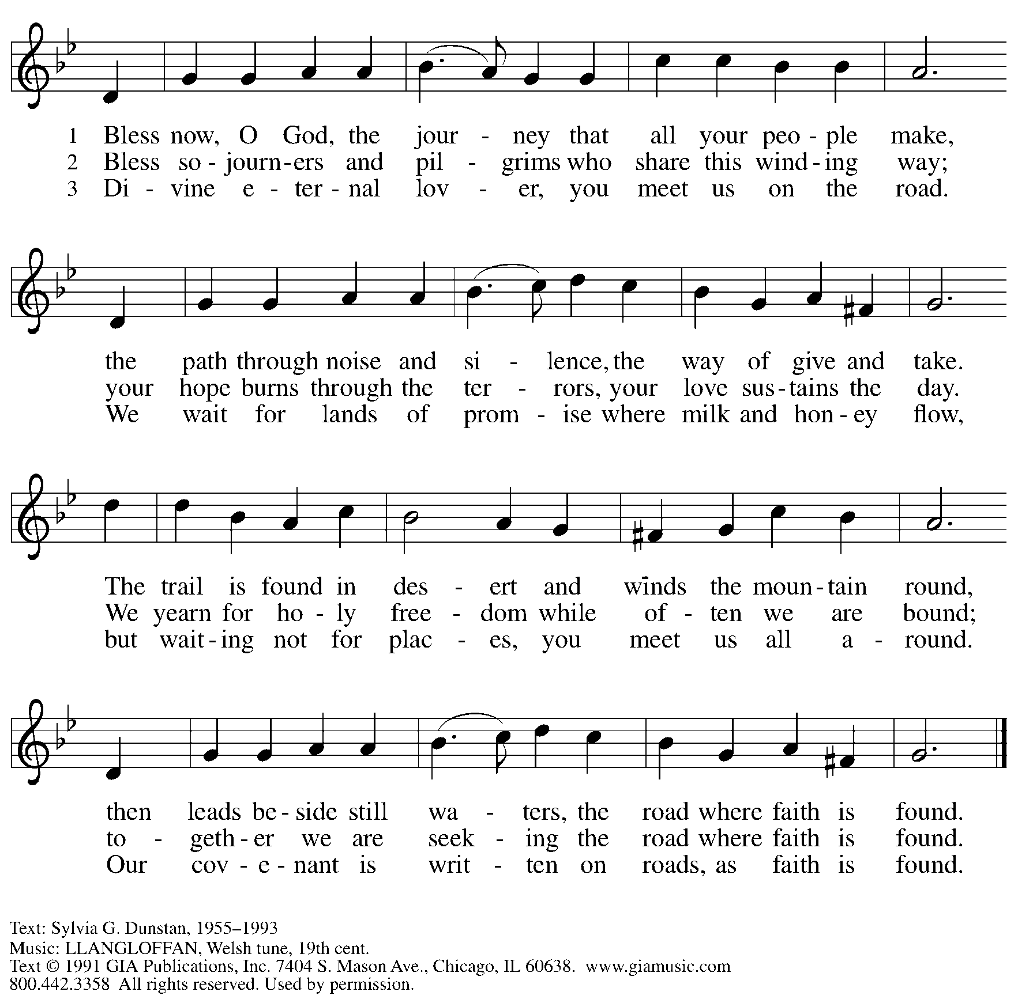
Reprinted under OneLicense.net # A-722139.

Greeting

P: The grace of our Lord Jesus Christ, the love of God,
and the communion of the Holy Spirit be with you all.
C: And also with you.

Prayer of the Day

P: Let us pray.
O Lord God, you led your people through the wilderness and brought them to the promised land. Guide us now, so that, following your Son, we may walk safely through the wilderness of this world toward the life you alone can give, through Jesus Christ, our Savior and Lord,
who lives and reigns with you and the Holy Spirit, one God, now and forever.
C: Amen.

Please be seated

Word

First Reading – Deuteronomy 26: 1-11

¹When you have come into the land that the Lord your God is giving you as an inheritance to possess, and you possess it, and settle in it, ²you shall take some of the first of all the fruit of the ground, which you harvest from the land that the Lord your God is giving you, and you shall put it in a basket and go to the place that the Lord your God will choose as a dwelling for God’s
name. ³You shall go to the priest who is in office at that time, and say to him, “Today I declare to the Lord your God that I have come into the land that the Lord swore to our ancestors to give us.” ⁴When the priest takes the basket from your hand and sets it down before the altar of the Lord your God, ⁵you shall make this response before the Lord your God: “A wandering Aramean was my ancestor; he went down into Egypt and lived there as an alien, few in number, and there he became a great nation, mighty and populous. ⁶When the Egyptians treated us harshly and afflicted us, by imposing hard labor on us, ⁷we cried to the Lord, the God of our ancestors; the Lord heard our voice and saw our affliction, our toil, and our oppression. ⁸The
Lord brought us out of Egypt with a mighty hand and an outstretched arm, with a terrifying display of power, and with signs and wonders; ⁹and the Lord brought us into this place and gave us this land, a land flowing with milk and honey. ¹⁰So now I bring the first of the fruit of the ground that you, O Lord, have given me.” You shall set it down before the Lord your God and bow down before the Lord your God. ¹¹Then you, together with the Levites and the aliens who reside among you, shall celebrate with all the bounty that the Lord your God has given to you and to your house.

L: Word of God, word of life.
C: Thanks be to God.

Psalm 91: 1-2, 9-16

The psalm will be spoken, led by the cantor, with the congregation invited to join the lector
in responding with the alternate verses.

¹You who dwell in the shelter of the Most High,
who abide in the shadow of the Almighty—
²you will say to the Lord, “My refuge and my stronghold,
my God in whom I put my trust.”
⁹Because you have made the Lord your refuge,
and the Most High your habitation,
¹⁰no evil will befall you,
nor shall affliction come near your dwelling.
¹¹For God will give the angels charge over you,
to guard you in all your ways.
¹²Upon their hands they will bear you up,
lest you strike your foot against a stone.
¹³You will tread upon the lion cub and viper;
you will trample down the lion and the serpent.
¹⁴I will deliver those who cling to me;
I will uphold them, because they know my name.
¹⁵They will call me, and I will answer them;
I will be with them in trouble; I will rescue and honor them.
¹⁶With long life will I satisfy them,
and show them my salvation.

Second Reading – Romans 10: 8b-13

^{8b}“The word is near you,
on your lips and in your heart”
(that is, the word of faith that we proclaim); ⁹because if you confess with your lips that Jesus is Lord and believe in your heart that God raised him from the dead, you will be saved. ¹⁰For one believes with the heart and so is justified, and one confesses with the mouth and so is saved. ¹¹The scripture says, “No one who believes in [Christ] will be put to shame.” ¹²For there is no distinction between Jew and Greek; the same Lord is Lord of all and is generous to all who call on him. ¹³For, “Everyone who calls on the name of the Lord shall be saved.”

L: Word of God, word of life.
C: Thanks be to God.

Please rise as you are able.

Gospel Acclamation

C: One does not live by bread alone, but by every word that comes from the mouth of God.

Gospel – Luke 4: 1-13

P: The holy Gospel according to St. Luke.
C: Glory to you, O Lord.

¹Jesus, full of the Holy Spirit, returned from the Jordan and was led by the Spirit in the wilderness, ²where for forty days he was tempted by the devil. He ate nothing at all during those days, and when they were over, he was famished. ³The devil said to him, “If you are the Son of God, command this stone to become a loaf of bread.” ⁴Jesus answered him, “It is written, ‘One does not live by bread alone.’ ”
⁵Then the devil led him up and showed him in an instant all the kingdoms of the world. ⁶And the devil said to him, “To you I will give their glory and all this authority; for it has been given over to me, and I give it to anyone I please. ⁷If you, then, will worship me, it will all be yours.” ⁸Jesus answered him, “It is written,
‘Worship the Lord your God,
and serve only God.’ ”
⁹Then the devil took him to Jerusalem, and placed him on the pinnacle of the temple, saying to him, “If you are the Son of God, throw yourself down from here, ¹⁰for it is written,
‘God will command God’s angels concerning you,
to protect you,’
¹¹and
‘On their hands they will bear you up,
so that you will not dash your foot against a stone.’ ”
¹²Jesus answered him, “It is said, ‘Do not put the Lord your God to the test.’ ” ¹³When the devil had finished every test, he departed from him until an opportune time.

P: The Gospel of the Lord.
C: Praise to you, O Christ.

Please be seated.

Sermon

Please rise as you are able.

Hymn of the Day O Lord, throughout These Forty Days ELW 319
v. 1-2

1 O Lord, throughout these forty days
you prayed and kept the fast;
inspire repentance for our sin,
and free us from our past.

2 You strove with satan, and you won;
your faithfulness endured;
lend us your nerve, your skill, and trust
in God's eternal word.

Text: based on Claudia F. Hernaman, 1838-1898; para. Gilbert E. Doan Jr., b. 1930. Music: CONSOLATION, A. Davisson, Kentucky Harmony, 1816; arr. Theodore A. Beck, 1929-2003. Text © 1978 Lutheran Book of Worship, admin. Augsburg Fortress. Arr. © 1969 Concordia Publishing House. All rights reserved. Reprinted under OneLicense.net # A-722139.

Apostles’ Creed

C: I believe in God, the Father almighty,
creator of heaven and earth.

I believe in Jesus Christ, God’s only Son, our Lord,
who was conceived by the Holy Spirit,
born of the virgin Mary,
suffered under Pontius Pilate,
was crucified, died, and was buried;
he descended to the dead.*
On the third day he rose again;
he ascended into heaven,
he is seated at the right hand of the Father,
and he will come to judge the living and the dead.

I believe in the Holy Spirit,
the holy catholic church,
the communion of saints,
the forgiveness of sins,
the resurrection of the body,
and the life everlasting. Amen.

*Or, “he descended into hell,” another translation of this text in widespread use.

Prayers of the People

P: Turning our hearts to God who is gracious and merciful,
we pray for the church, the world, and all who are in need.

After each petition
P: Merciful God,
C: receive our prayer.

P: Accept the prayers we bring before you, O God, on behalf of a world in need,
through Jesus Christ, our Savior.
C: Amen.

Please be seated.

We offer ourselves, our gifts, and our faithful service to God.
An usher will pass around and offering plate for anyone who would like to offer gifts before God.

Meal

Please rise as you are able.

Offertory Prayer

P: Let us pray. God our provider,
C: you have not fed us with bread alone, but with words of grace and life.
Bless us and these, your gifts, which we receive from your bounty,
through Christ our Lord. Amen.

Dialogue

P: The Lord be with you.
C: And also with you.

P: Lift up your hearts.
C: We lift them to the Lord.

P: Let us give thanks to the Lord our God.
C: It is right to give our thanks and praise.

Preface

P: It is indeed right, our duty and our joy…
… and join their unending hymn.

Sanctus

C: Holy, holy, holy Lord,
God of power and might:
Heaven and earth are full of your glory.
Hosanna in the highest.
Blessed is the one who comes in the name of the Lord.
Hosanna in the highest.

Eucharistic Prayer

P: Blessed are you, O God of the universe …
Do this for the remembrance of me.

With this bread and cup, we remember our Lord’s Passover from death to life
as we proclaim the mystery of faith.
C: Christ has died. Christ is risen. Christ will come again.

P: O God of resurrection and new life …
… grace our table with your presence.
C: Come, Holy Spirit.

P: Reveal yourself to us in the breaking of the bread …
… with justice, peace, and love.
C: Come, Holy Spirit.

P: With your holy ones of all times and places …
… blessed and Holy Trinity, now and forever.
C: Amen.

Lord’s Prayer

P: Gathered as one by the Holy Spirit, let us pray as Jesus taught us.
C: Our Father in heaven,
hallowed be your name,
your kingdom come,
your will be done,
on earth as in heaven.
Give us today our daily bread.
Forgive us our sins
as we forgive those
who sin against us.
Save us from the time of trial
and deliver us from evil.
For the kingdom, the power,
and the glory are yours,
now and forever. Amen.

Fraction and Invitation

Agnus Dei / Lamb of God

C: Lamb of God, you take away the sin of the world; have mercy on us.
Lamb of God, you take away the sin of the world; have mercy on us.
Lamb of God, you take away the sin of the world; grant us peace.

Please be seated.

Holy Communion
- Hand sanitizer is available if you would like to use it prior to receiving Communion.
- We will not be kneeling at the altar rail due to the need for physical distancing.
- Worshipers from the pulpit side will proceed forward first, followed by the center section, and then the lectern side.
- The Communion wafers (regular and gluten-free) have been thoughtfully prepared using the gifts of the congregation by a member of St. Andrew’s altar care team, with a drop of wine or grape juice on each. The presiding minister will distribute one to each communicant.
- When you reach the presiding minister, please indicate if you would like grape juice or a gluten-free wafer.
- A blessing will be provided for anyone who does not yet receive the sacrament.
- Everyone is asked to wait until you return to your place to consume the elements, and then promptly replace your mask.

Hymns during Holy Communion
As the Winter Days Grow Longer ACS 924

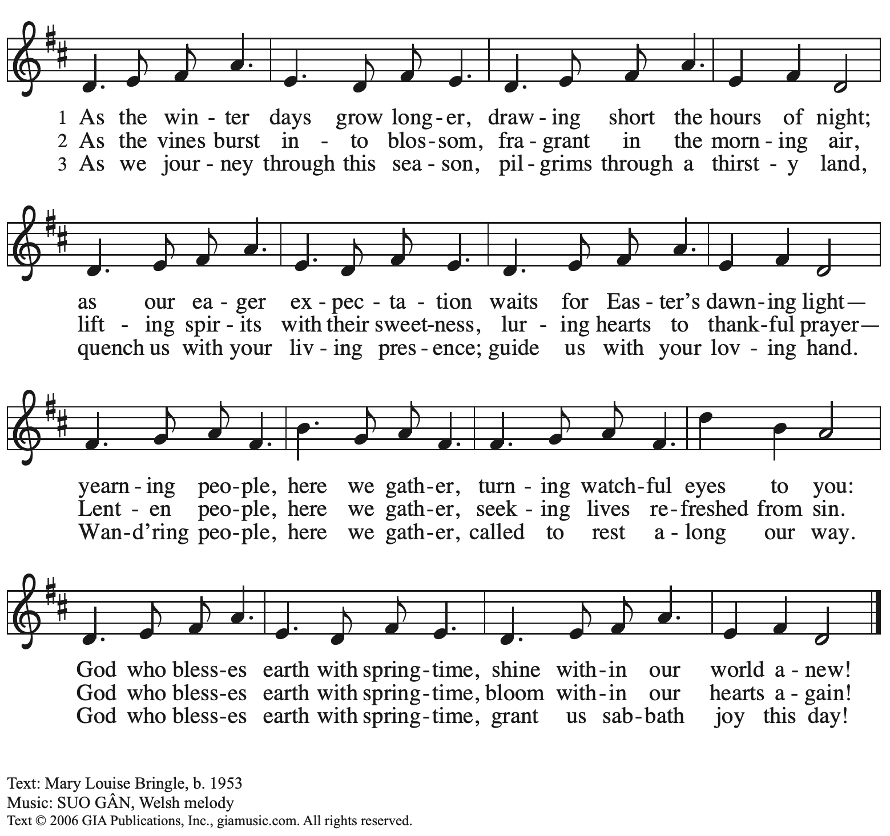
Reprinted with permission under OneLicense.net # A-722139.
Hymns during Holy Communion
Lord, Take My Hand and Lead Me ELW 767

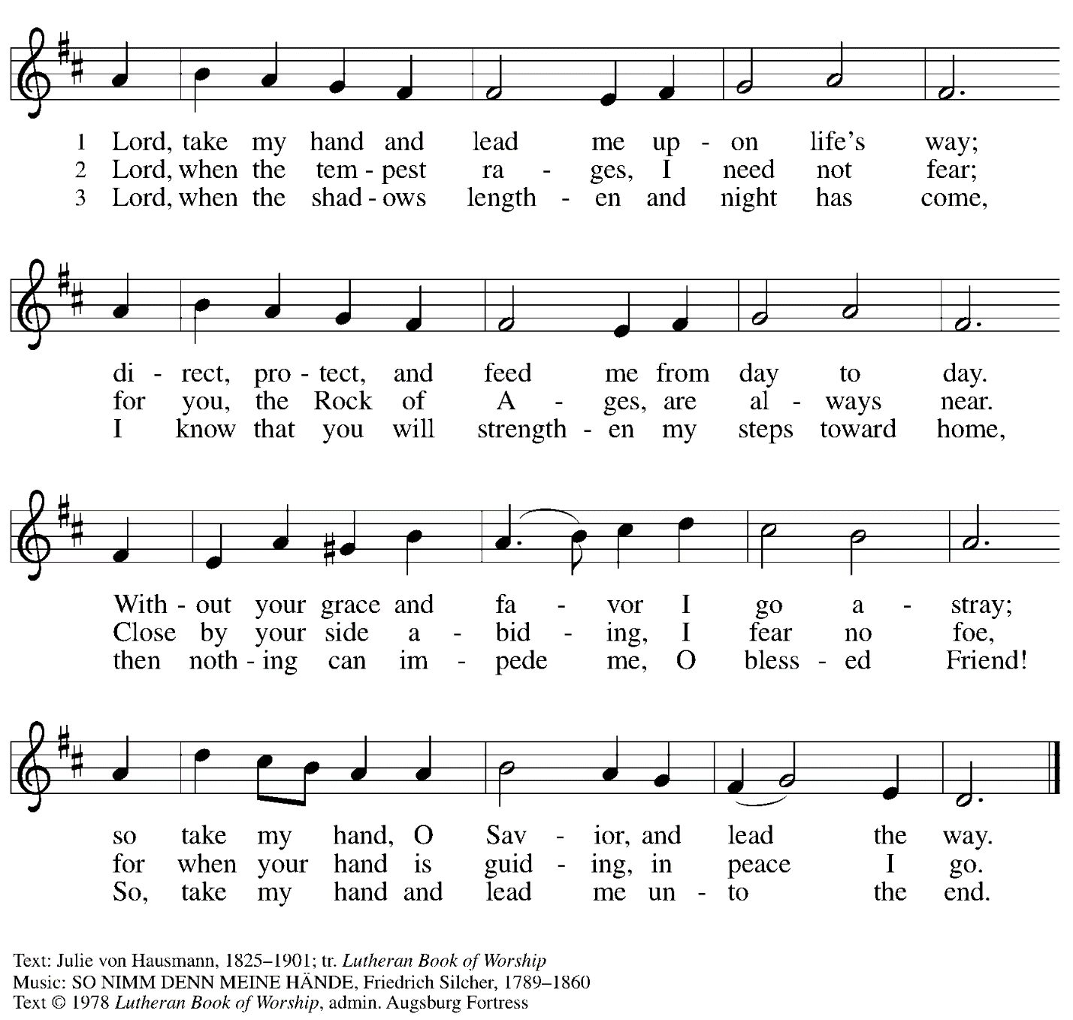
All rights reserved. Reprinted under OneLicense.net # A-722139.

When all have returned to their places, please rise as you are able.

Blessing

P: The body and blood of our Lord Jesus Christ strengthen you and keep you in his grace.
C: Amen.

Prayer

P: Let us pray.
Compassionate God,
you have fed us with the bread of heaven.
Sustain us in our Lenten pilgrimage: may our fasting be hunger for justice;
our alms, a making of peace; and our prayer, the song of grateful hearts,
through Jesus Christ, our Savior and Lord.
C: Amen.

Sending

Benediction

P: You are children of God,
anointed with the oil of gladness
and strengthened for the journey.
Almighty God,
motherly, majestic, and mighty,
☩ bless you this day and always.
C: Amen.

Dismissal

P: Go in peace. Jesus is with you on the way.
C: Thanks be to God.

Abbreviations

P: Pastor/Presiding Minister
L: Lector
C: Congregation

ELW: Evangelical Lutheran Worship hymnal
ACS: All Creation Sings hymnal

Those serving in worship today

Piano Lily Cai
Cantor Richard Krug
Lector Dixie Tymitz
Director of Faith Formation Christopher Atwood
Presiding Minister Pastor Ross Carmichael

Liturgy and Hymnody Acknowledgements

From SundaysandSeasons.com. Copyright © 2022 Augsburg Fortress. All rights reserved. Reprinted under OneLicense.net # A-722139.
Used by permission of Augsburg Fortress.

