+ Fourth Sunday in Lent
March 27, 2022
St. Andrew Lutheran Church
304 Morewood Ave.
Pittsburgh, PA 15213
St_andrewELCA@verizon.net
www.standrewpittsburgh.org

+ Fourth Sunday in Lent
Order for Worship

The psalm sets the tone this day: “Happy are they whose transgressions are forgiven,
and whose sin is put away!” Happy are those who have “become the righteousness of God”
in the merits of Christ Jesus. Happy are those for whom the forgiveness of God has “rolled away . . . the disgrace” of former times. Happy is the father at the return of his prodigal son.
Happy are we that our sins are forgiven for Jesus’ sake. Rejoice!

A few notes on precautions and protocols, which apply to everyone regardless of vaccination status, as St. Andrew returns to worship in the sanctuary:

- Face masks that fully cover both your mouth and nose are required at all times for everyone over the age of two (2) – the only exception being the brief moment of moving mask aside to partake in Holy Communion.
- Outside food and drink are thus not permissible during worship.
- Physical distancing of at least six (6) feet will be observed at all times for people not from your household.
- We invite the congregation to join in the singing of the hymns (with masks on) during worship!
- Hand sanitizer is available at the front of the sanctuary to use before Holy Communion, after you proceed past the baptismal font, as the alcohol has been affecting the finish on the font’s bowl.

Worship Services are live streamed to multiple online platforms.
By attending worship, you agree that your image and voice may be broadcast.

Welcome

Gathering

Gathering Hymn Return to God ACS 921

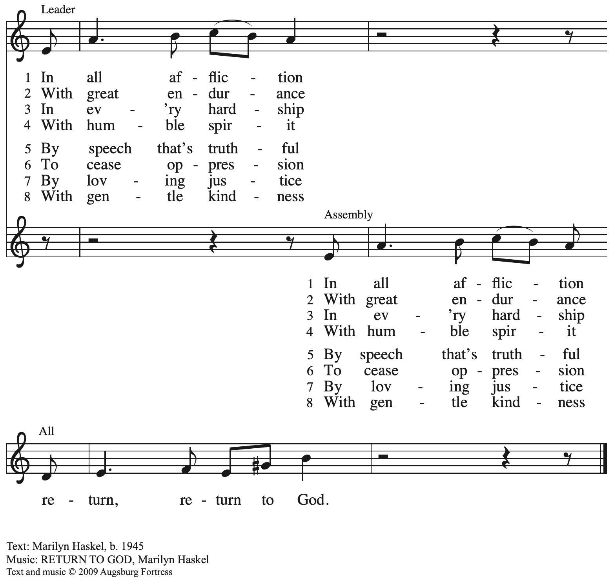
All rights reserved. Reprinted with permission under OneLicence.net # A-722139.

Please rise as you are able.

Confession of Sin

P: In the name of our ☩ Triune God,
who makes a way in the wilderness,
accompanies us, and guides us in our pilgrimage.
C: Amen.

Silence is kept for reflection.

P: Holy One,
C: we confess that we have wandered far from you:
we have not trusted your promises,
we have ignored your prophets in our own day,
we have squandered our inheritance of grace,
we have failed to recognize you in our midst.
Have mercy on us.
Forgive us and turn us again to you.
Teach us to follow in your ways,
assure us again of your love,
and help us to love our neighbor.
Amen.

P: Beloved in Christ,
the Word draws near to you,
and all who call out to God shall be saved.
In Jesus, God comes to you again and again
and gathers you under wings of love.
In ☩ Jesus’ name, your sins are forgiven.
God journeys with you and teaches you how to live in love.
C: Amen.

Gathering Hymn Softly and Tenderly Jesus Is Calling ELW 608

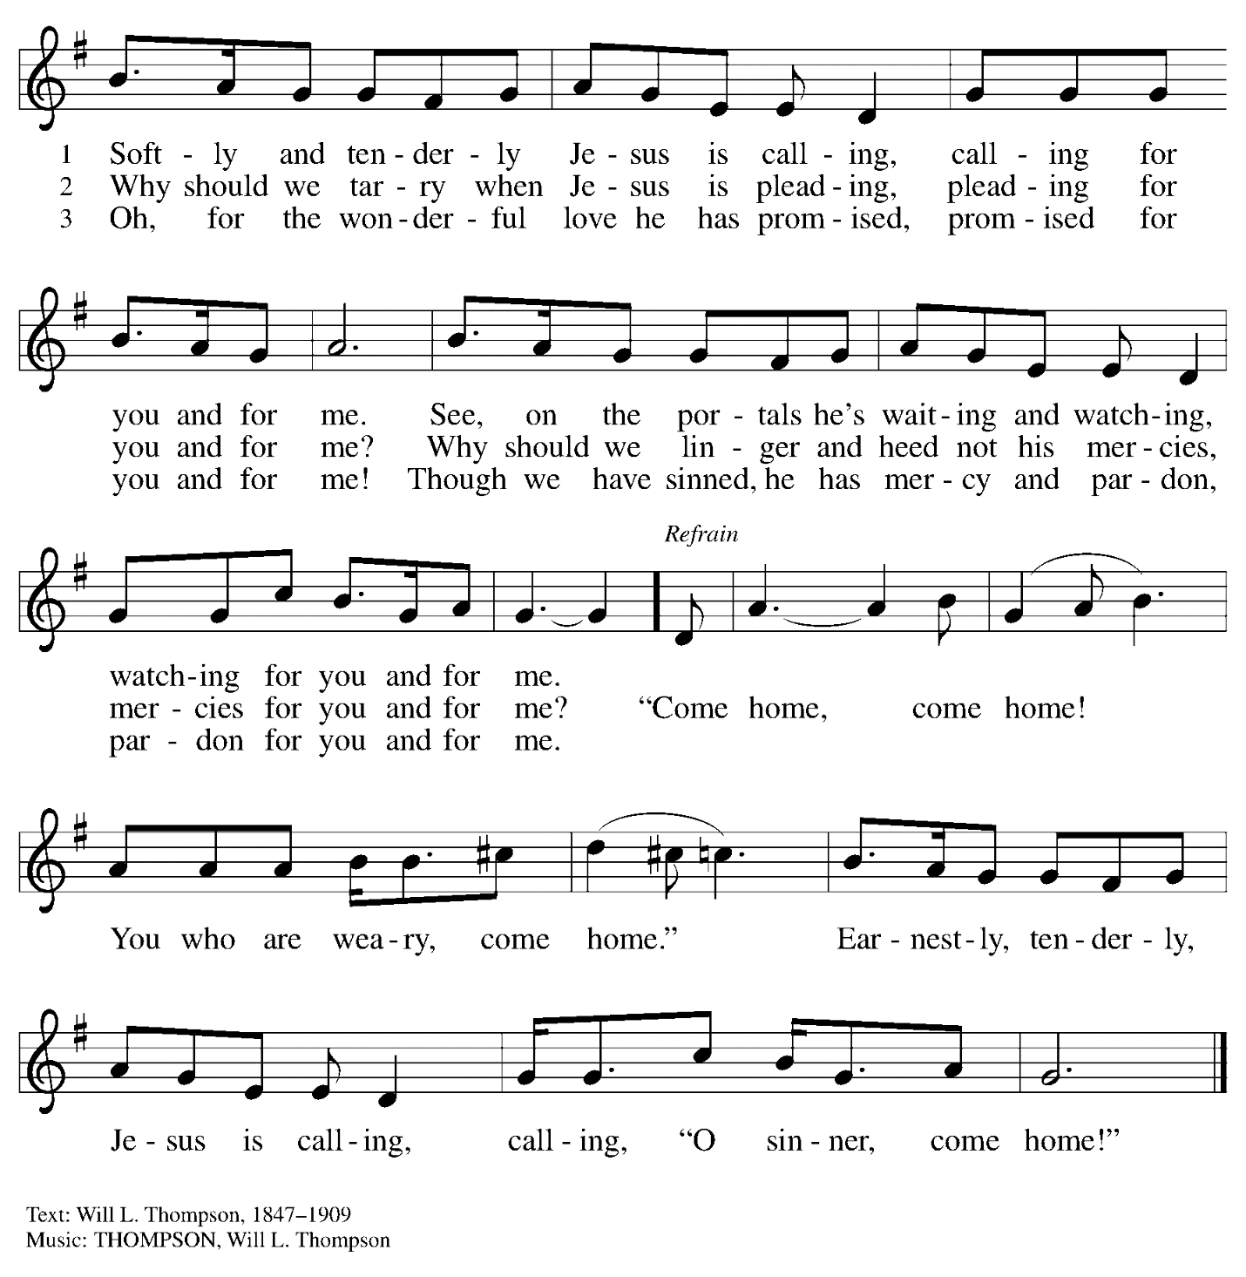

Greeting

P: The grace of our Lord Jesus Christ, the love of God,
and the communion of the Holy Spirit be with you all.
C: And also with you.

Prayer of the Day

P: Let us pray.
God of compassion, you welcome the wayward and embrace us all with your mercy.
By our Baptism, clothe us with garments of your grace, and feed us at the table of your love,
through Jesus Christ, our Savior and Lord, who lives and reigns with you and the Holy Spirit, one God, now and forever.
C: Amen.

Please be seated

Word

First Reading – Joshua 5: 9-12

⁹The Lord said to Joshua, “Today I have rolled away from you the disgrace of Egypt.” And so that place is called Gilgal to this day.

¹⁰While the Israelites were camped in Gilgal they kept the passover in the evening on the fourteenth day of the month in the plains of Jericho. ¹¹On the day after the passover, on that very day, they ate the produce of the land, unleavened cakes and parched grain. ¹²The manna ceased on the day they ate the produce of the land, and the Israelites no longer had manna; they ate the crops of the land of Canaan that year.

L: Word of God, word of life.
C: Thanks be to God.

Psalm 32

The psalm will be spoken, led by the cantor, with the congregation invited to join the lector
in responding with the alternate verses.

¹Happy are they whose transgressions are forgiven,
and whose sin is put away!
²Happy are they to whom the Lord imputes no guilt,
and in whose spirit there is no guile!
³While I held my tongue, my bones withered away,
because of my groaning all day long.
⁴For your hand was heavy upon me day and night;
my moisture was dried up as in the heat of summer.
⁵Then I acknowledged my sin to you, and did not conceal my guilt.
I said, “I will confess my transgressions to the Lord.” Then you forgave me the guilt of my sin.
⁶Therefore all the faithful will make their prayers to you in time of trouble;
when the great waters overflow, they shall not reach them.
⁷You are my hiding-place; you preserve me from trouble;
you surround me with shouts of deliverance.
⁸“I will instruct you and teach you in the way that you should go;
I will guide you with my eye.
⁹Do not be like horse or mule, which have no understanding;
who must be fitted with bit and bridle, or else they will not stay near you.”
¹⁰Great are the tribulations of the wicked;
but mercy embraces those who trust in the Lord.
¹¹Be glad, you righteous, and rejoice in the Lord;
shout for joy, all who are true of heart.

Second Reading – 2 Corinthians 5: 16-21

¹⁶From now on, therefore, we regard no one from a human point of view; even though we once knew Christ from a human point of view, we know him no longer in that way. ¹⁷So if anyone is in Christ, there is a new creation: everything old has passed away; see, everything has become new! ¹⁸All this is from God, who reconciled us to Godself through Christ, and has given us the ministry of reconciliation; ¹⁹that is, in Christ God was reconciling the world to Godself, not counting their trespasses against them, and entrusting the message of reconciliation to us. ²⁰So we are ambassadors for Christ, since God is making God’s appeal through us; we entreat you on behalf of Christ, be reconciled to God. ²¹For our sake God made him to be sin who knew no sin, so that in [Christ] we might become the righteousness of God.

L: Word of God, word of life.
C: Thanks be to God.

Please rise as you are able.

Gospel Acclamation

C: I will arise and go to my father and say, “I have sinned against heaven and before you.”

Gospel – Luke 15: 1-3, 11b-32

P: The holy Gospel according to St. Luke.
C: Glory to you, O Lord.

¹Now all the tax collectors and sinners were coming near to listen to [Jesus.] ²And the Pharisees and the scribes were grumbling and saying, “This fellow welcomes sinners and eats with them.”
³So [Jesus] told them this parable: ^{11b}“There was a man who had two sons. ¹²The younger of them said to his father, ‘Father, give me the share of the property that will belong to me.’ So he divided his property between them. ¹³A few days later the younger son gathered all he had and traveled to a distant country, and there he squandered his property in dissolute living. ¹⁴When he had spent everything, a severe famine took place throughout that country, and he began to be in need. ¹⁵So he went and hired himself out to one of the citizens of that country, who sent him to his fields to feed the pigs. ¹⁶He would gladly have filled himself with the pods that the pigs were eating; and no one gave him anything. ¹⁷But when he came to himself he said, ‘How many of my father’s hired hands have bread enough and to spare, but here I am dying of hunger! ¹⁸I will get up and go to my father, and I will say to him, “Father, I have sinned against heaven and before you; ¹⁹I am no longer worthy to be called your son; treat me like one of your hired hands.”’ ²⁰So he set off and went to his father. But while he was still far off, his father saw him and was filled with compassion; he ran and put his arms around him and kissed him. ²¹Then the son said to him, ‘Father, I have sinned against heaven and before you; I am no longer worthy to be called your son.’ ²²But the father said to his slaves, ‘Quickly, bring out a robe—the best one—and put it on him; put a ring on his finger and sandals on his feet. ²³And get the fatted calf and kill it, and let us eat and celebrate; ²⁴for this son of mine was dead and is alive again; he was lost and is found!’ And they began to celebrate.
²⁵“Now his elder son was in the field; and when he came and approached the house, he heard music and dancing. ²⁶He called one of the slaves and asked what was going on. ²⁷He replied, ‘Your brother has come, and your father has killed the fatted calf, because he has got him back safe and sound.’ ²⁸Then he became angry and refused to go in. His father came out and began to plead with him. ²⁹But he answered his father, ‘Listen! For all these years I have been working like a slave for you, and I have never disobeyed your command; yet you have never given me even a young goat so that I might celebrate with my friends. ³⁰But when this son of yours came back, who has devoured your property with prostitutes, you killed the fatted calf for him!’ ³¹Then the father said to him, ‘Son, you are always with me, and all that is mine is yours. ³²But we had to celebrate and rejoice, because this brother of yours was dead and has come to life; he was lost and has been found.’”

P: The Gospel of the Lord.
C: Praise to you, O Christ.

Please be seated.

Sermon

Please rise as you are able.

Hymn of the Day Our Father, We Have Wandered ELW 606

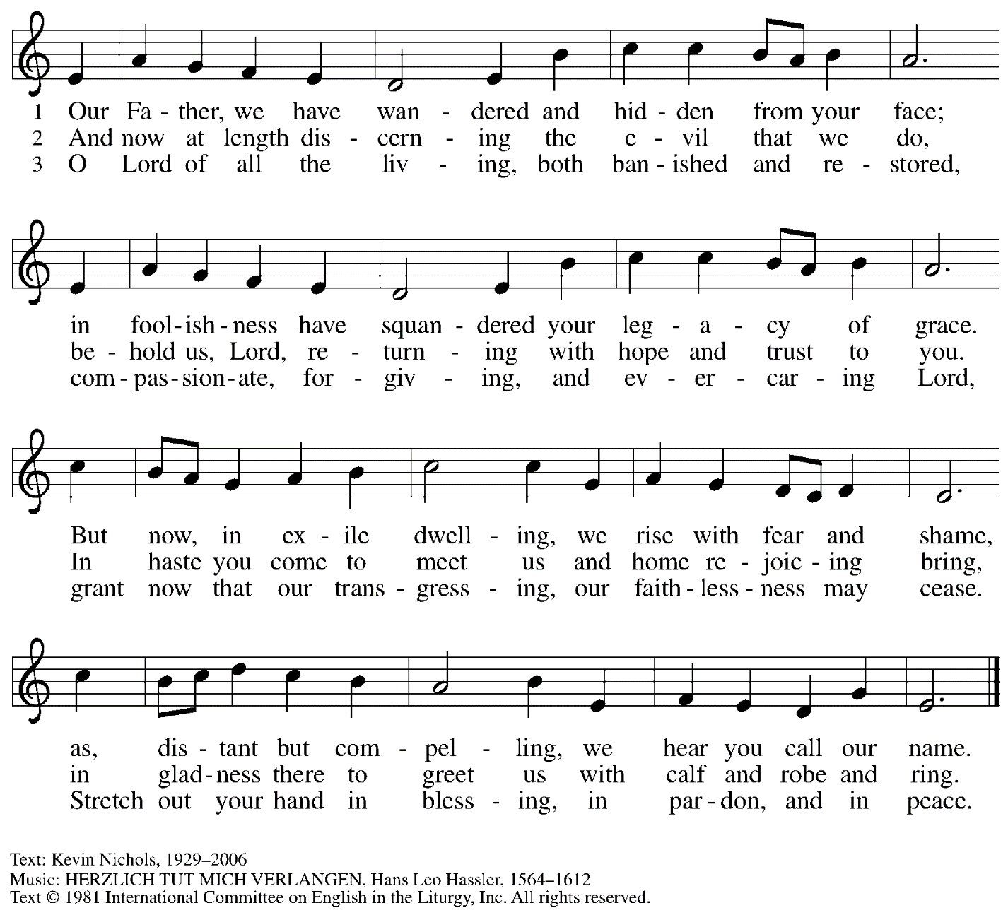
Reprinted with permission of the publisher.

Apostles’ Creed

C: I believe in God, the Father almighty,
creator of heaven and earth.

I believe in Jesus Christ, God’s only Son, our Lord,
who was conceived by the Holy Spirit,
born of the virgin Mary,
suffered under Pontius Pilate,
was crucified, died, and was buried;
he descended to the dead.*
On the third day he rose again;
he ascended into heaven,
he is seated at the right hand of the Father,
and he will come to judge the living and the dead.

I believe in the Holy Spirit,
the holy catholic church,
the communion of saints,
the forgiveness of sins,
the resurrection of the body,
and the life everlasting. Amen.

*Or, “he descended into hell,” another translation of this text in widespread use.

Prayers of the People

P: Turning our hearts to God who is gracious and merciful,
we pray for the church, the world, and all who are in need.

After each petition
P: Merciful God,
C: receive our prayer.

P: Accept the prayers we bring before you, O God, on behalf of a world in need,
through Jesus Christ, our Savior.
C: Amen.

Please be seated.

Offering

We offer ourselves, our gifts, and our faithful service to God.
An usher will pass around and offering plate for anyone who would like to offer gifts before God.

Music during the Offering
Lord, Take My Hand and Lead Me ELW 767

Meal

Please rise as you are able.

Offertory Prayer

P: Let us pray.
P: God our provider,
C: you have not fed us with bread alone, but with words of grace and life.
Bless us and these your gifts, which we receive from your bounty,
through Jesus Christ our Lord.
Amen.

Dialogue

P: The Lord be with you.
C: And also with you.

P: Lift up your hearts.
C: We lift them to the Lord.

P: Let us give thanks to the Lord our God.
C: It is right to give our thanks and praise.

Preface

P: It is indeed right, our duty and our joy…
… and join their unending hymn.

Sanctus

C: Holy, holy, holy Lord,
God of power and might:
Heaven and earth are full of your glory.
Hosanna in the highest.
Blessed is the one who comes in the name of the Lord.
Hosanna in the highest.

Eucharistic Prayer

P: Blessed are you, O God of the universe …
Do this for the remembrance of me.

With this bread and cup, we remember our Lord’s Passover from death to life
as we proclaim the mystery of faith.
C: Christ has died. Christ is risen. Christ will come again.

P: O God of resurrection and new life …
… grace our table with your presence.
C: Come, Holy Spirit.

P: Reveal yourself to us in the breaking of the bread …
… with justice, peace, and love.
C: Come, Holy Spirit.

P: With your holy ones of all times and places …
… blessed and Holy Trinity, now and forever.
C: Amen.

Lord’s Prayer

P: Gathered as one by the Holy Spirit, let us pray as Jesus taught us.
C: Our Father in heaven,
hallowed be your name,
your kingdom come,
your will be done,
on earth as in heaven.
Give us today our daily bread.
Forgive us our sins
as we forgive those
who sin against us.
Save us from the time of trial
and deliver us from evil.
For the kingdom, the power,
and the glory are yours,
now and forever. Amen.

Fraction and Invitation

Agnus Dei / Lamb of God

C: Lamb of God, you take away the sin of the world; have mercy on us.
Lamb of God, you take away the sin of the world; have mercy on us.
Lamb of God, you take away the sin of the world; grant us peace.

Please be seated.

Holy Communion
- Hand sanitizer is available if you would like to use it prior to receiving Communion.
- We will not be kneeling at the altar rail due to the need for physical distancing.
- Worshipers from the pulpit side will proceed forward first, followed by the center section, and then the lectern side.
- The Communion wafers (regular and gluten-free) have been thoughtfully prepared using the gifts of the congregation by a member of St. Andrew’s altar care team, with a drop of wine or grape juice on each. The presiding minister will distribute one to each communicant.
- When you reach the presiding minister, please indicate if you would like grape juice or a gluten-free wafer.
- A blessing will be provided for anyone who does not yet receive the sacrament.
- Everyone is asked to wait until you return to your place to consume the elements, and then promptly replace your mask.

Hymns during Holy Communion
Amazing Grace, How Sweet the Sound ELW 779

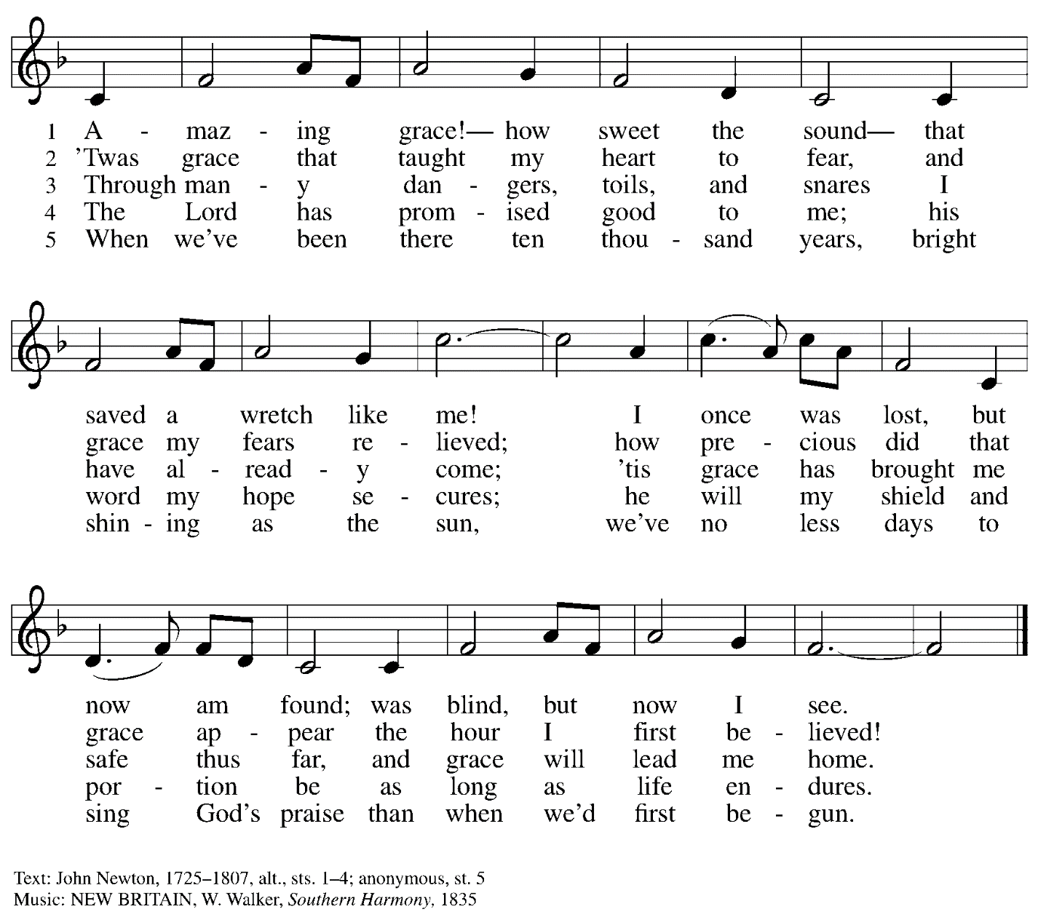

Hymns during Holy Communion
Go, My Children, with My Blessing ELW 543

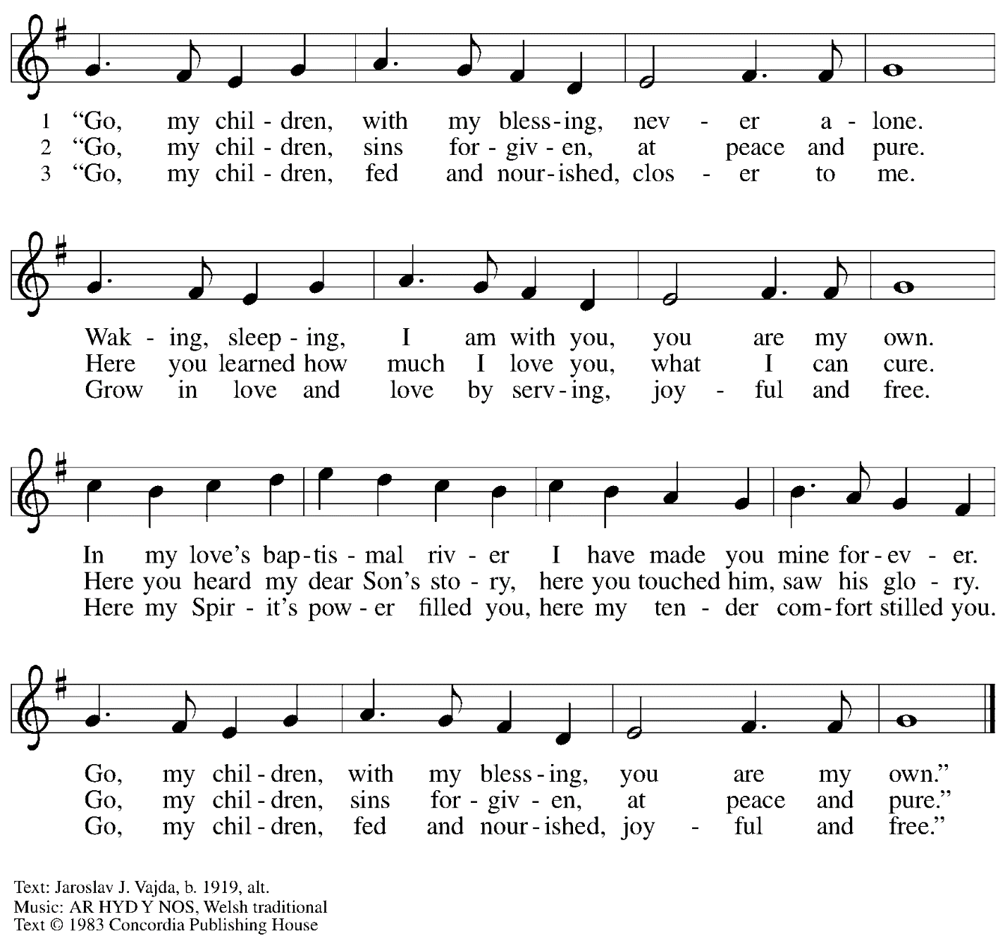
All rights reserved. Reprinted with permission under OneLicense.net # A-722139.

When all have returned to their places, please rise as you are able.

Blessing

P: The body and blood of our Lord Jesus Christ strengthen you and keep you in his grace.
C: Amen.

Prayer

P: Let us pray.
Compassionate God, you have fed us with the bread of heaven.
Sustain us in our Lenten pilgrimage: may our fasting be hunger for justice;
our alms, a making of peace; and our prayer, the song of grateful hearts,
through Jesus Christ, our Savior and Lord.
C: Amen.

Sending

Benediction

P: You are children of God,
anointed with the oil of gladness
and strengthened for the journey.
Almighty God,
motherly, majestic, and mighty,
☩ bless you this day and always.
C: Amen.

Dismissal

P: Go in peace. Jesus is with you on the way.
C: Thanks be to God!

Abbreviations

P: Pastor/Presiding Minister
L: Lector
C: Congregation

ELW: Evangelical Lutheran Worship hymnal
ACS: All Creation Sings hymnal

Those serving in worship today

Piano Lily Cai
Cantor Kristen Asplin
Lector Sue Gaugler
Director of Faith Formation Christopher Atwood
Presiding Minister Pastor Ross Carmichael

Liturgy and Hymnody Acknowledgements

From SundaysandSeasons.com. Copyright © 2022 Augsburg Fortress. All rights reserved. Reprinted under OneLicense.net # A-722139.
Used by permission of Augsburg Fortress.

"Our Father, We Have Wandered" by Msgr. Kevin Nichols from Resource Collection of Hymns and Service Music for the Liturgy © 1981, International Commission on English in the Liturgy Corporation. All rights reserved.

