+ Second Sunday in Lent
March 13, 2022

St. Andrew Lutheran Church
304 Morewood Ave.
Pittsburgh, PA 15213
St_andrewELCA@verizon.net
www.standrewpittsburgh.org

+ Second Sunday in Lent
Order for Worship

Though we sometimes doubt and often resist God’s desire and efforts to protect and save us,
our God persists. In Holy Baptism, God’s people have been called and gathered into a God-initiated relationship that will endure. Lent provides the church with a time and a tradition
in which to seek God’s face again. Lent provides another occasion to behold the God of our salvation in the face of the Blessed One who “comes in the name of the Lord.”

A few notes on precautions and protocols, which apply to everyone regardless of vaccination status, as St. Andrew returns to worship in the sanctuary:

- Face masks that fully cover both your mouth and nose are required at all times for everyone over the age of two (2) – the only exception being the brief moment of moving mask aside to partake in Holy Communion.
- Outside food and drink are thus not permissible during worship.
- Physical distancing of at least six (6) feet will be observed at all times for people not from your household.
- We invite the congregation to join in the singing of the hymns (with masks on) during worship!
- Hand sanitizer is available at the front of the sanctuary to use before Holy Communion, after you proceed past the baptismal font, as the alcohol has been affecting the finish on the font’s bowl.

Worship Services are live streamed to multiple online platforms.
By attending worship, you agree that your image and voice may be broadcast.

Welcome

Gathering

Gathering Hymn Return to God ACS 921

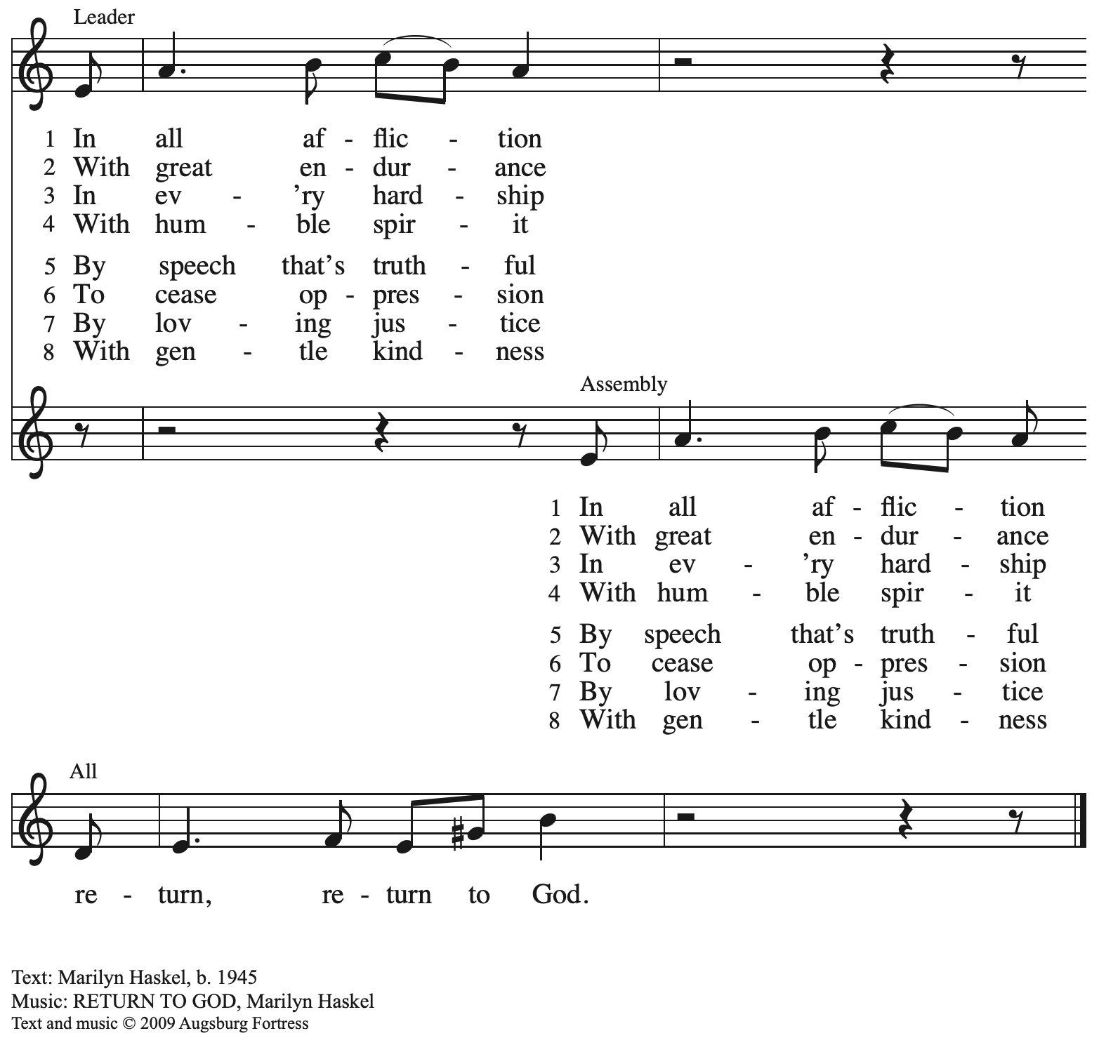
All rights reserved. Reprinted with permission under OneLicence.net # A-722139.

Please rise as you are able.

Confession of Sin

P: In the name of our ☩ Triune God,
who makes a way in the wilderness,
accompanies us, and guides us in our pilgrimage.
C: Amen.

Silence is kept for reflection.

P: Holy One,
C: we confess that we have wandered far from you:
we have not trusted your promises,
we have ignored your prophets in our own day,
we have squandered our inheritance of grace,
we have failed to recognize you in our midst.
Have mercy on us.
Forgive us and turn us again to you.
Teach us to follow in your ways,
assure us again of your love,
and help us to love our neighbor.
Amen.

P: Beloved in Christ,
the Word draws near to you,
and all who call out to God shall be saved.
In Jesus, God comes to you again and again
and gathers you under wings of love.
In ☩ Jesus’ name, your sins are forgiven.
God journeys with you and teaches you how to live in love.
C: Amen.

Gathering Hymn As the Sun with Longer Journey ELW 329
v. 1-2

1 As the sun with longer journey
melts the winter's snow and ice,
with its slowly growing radiance
warms the seed beneath the earth,
may the sun of Christ's uprising
gently bring our hearts to life.

2 Through the days of waiting, watching,
in the desert of our sin,
searching on the far horizon
for a sign of cloud or wind,
we await the healing waters
of our Savior's victory.

Text: John Patrick Earls, OSB, b. 1935. Music: NAGEL, Carl F. Schalk, b. 1929. Text © 1981 Order of Saint Benedict, admin. Liturgical Press, Collegeville, MN 56321. www.litpressorg. Music © 1995 Augsburg Fortress. All rights reserved. Reprinted with permission under OneLicense.net # A-722139.

Greeting

P: The grace of our Lord Jesus Christ, the love of God,
and the communion of the Holy Spirit be with you all.
C: And also with you.

Prayer of the Day

P: Let us pray.
God of the covenant,
in the mystery of the cross you promise everlasting life to the world.
Gather all peoples into your arms, and shelter us with your mercy,
that we may rejoice in the life we share in your Son, Jesus Christ, our Savior and Lord,
who lives and reigns with you and the Holy Spirit, one God, now and forever.
C: Amen.

Please be seated

Word

First Reading – Genesis 15: 1-12, 17-18

¹After these things the word of the Lord came to Abram in a vision, “Do not be afraid, Abram, I am your shield; your reward shall be very great.” ²But Abram said, “O Lord God, what will you give me, for I continue childless, and the heir of my house is Eliezer of Damascus?” ³And Abram said, “You have given me no offspring, and so a slave born in my house is to be my heir.” ⁴But the word of the Lord came to him, “This man shall not be your heir; no one but your very own issue shall be your heir.” ⁵God brought him outside and said, “Look toward heaven and count the stars, if you are able to count them.” Then God said to him, “So shall your descendants be.” ⁶And he believed the Lord; and the Lord reckoned it to him as righteousness.
⁷Then God said to him, “I am the Lord who brought you from Ur of the Chaldeans, to give you this land to possess.” ⁸But he said, “O Lord God, how am I to know that I shall possess it?” ⁹God said to him, “Bring me a heifer three years old, a female goat three years old, a ram three years old, a turtledove, and a young pigeon.” ¹⁰He brought God all these and cut them in two, laying each half over against the other; but he did not cut the birds in two. ¹¹And when birds of prey came down on the carcasses, Abram drove them away.
¹²As the sun was going down, a deep sleep fell upon Abram, and a deep and terrifying darkness descended upon him.
¹⁷When the sun had gone down and it was dark, a smoking fire pot and a flaming torch passed between these pieces. ¹⁸On that day the Lord made a covenant with Abram, saying, “To your descendants I give this land, from the river of Egypt to the great river, the river Euphrates.”

L: Word of God, word of life.
C: Thanks be to God.

Psalm 27

The psalm will be spoken, led by the cantor, with the congregation invited to join the lector
in responding with the alternate verses.

¹The Lord is my light and my salvation; whom then shall I fear?
The Lord is the stronghold of my life; of whom shall I be afraid?
²When evildoers close in against me to devour my flesh,
they, my foes and my enemies, will stumble and fall.
³Though an army encamp against me, my heart will not fear.
Though war rise up against me, my trust will not be shaken.
⁴One thing I ask of the Lord; one thing I seek;
that I may dwell in the house of the Lord all the days of my life; to gaze upon the beauty of the Lord and to seek God in the temple.
⁵For in the day of trouble God will give me shelter,
hide me in the hidden places of the sanctuary, and raise me high upon a rock.
⁶Even now my head is lifted up above my enemies who surround me.
Therefore I will offer sacrifice in the sanctuary, sacrifices of rejoicing; I will sing and make music to the Lord.
⁷Hear my voice, O Lord, when I call;
have mercy on me and answer me.
⁸My heart speaks your message— “Seek my face.”
Your face, O Lord, I will seek.
⁹Hide not your face from me, turn not away from your servant in anger.
Cast me not away—you have been my helper; forsake me not, O God of my salvation.
¹⁰Though my father and my mother forsake me,
the Lord will take me in.
¹¹Teach me your way, O Lord;
lead me on a level path, because of my oppressors.
¹²Subject me not to the will of my foes,
for they rise up against me, false witnesses breathing violence.
¹³This I believe—that I will see the goodness of the Lord
in the land of the living!
¹⁴Wait for the Lord and be strong.
Take heart and wait for the Lord!

Second Reading – Philippians 3: 17 – 4: 1

¹⁷Kindred, join in imitating me, and observe those who live according to the example you have in us. ¹⁸For many live as enemies of the cross of Christ; I have often told you of them, and now I tell you even with tears. ¹⁹Their end is destruction; their god is the belly; and their glory is in their shame; their minds are set on earthly things. ²⁰But our citizenship is in heaven, and it is from there that we are expecting a Savior, the Lord Jesus Christ. ²¹He will transform the body of our humiliation that it may be conformed to the body of his glory, by the power that also enables him to make all things subject to himself. ^{4:1}Therefore, my kindred, whom I love and long for, my joy and crown, stand firm in the Lord in this way, my beloved.

L: Word of God, word of life.
C: Thanks be to God.

Please rise as you are able.

Gospel Acclamation

C: The Son of Humanity must be lifted up,
that whoever believes in him may have eternal life.

Gospel – Luke 13: 31-35

P: The holy Gospel according to St. Luke.
C: Glory to you, O Lord.

³¹At that very hour some Pharisees came and said to [Jesus,] “Get away from here, for Herod wants to kill you.” ³²He said to them, “Go and tell that fox for me, ‘Listen, I am casting out demons and performing cures today and tomorrow, and on the third day I finish my work. ³³Yet today, tomorrow, and the next day I must be on my way, because it is impossible for a prophet to be killed outside of Jerusalem.’ ³⁴Jerusalem, Jerusalem, the city that kills the prophets and stones those who are sent to it! How often have I desired to gather your children together as a hen gathers her brood under her wings, and you were not willing! ³⁵See, your house is left to you. And I tell you, you will not see me until the time comes when you say, ‘Blessed is the one who comes in the name of the Lord.’”

P: The Gospel of the Lord.
C: Praise to you, O Christ.

Please be seated.

Sermon

Please rise as you are able.

Hymn of the Day Thy Holy Wings ELW 613
v. 1-2

1 Thy holy wings, O Savior,
spread gently over me,
and let me rest securely
through good and ill in thee.
Oh, be my strength and portion,
my rock and hiding place,
and let my ev'ry moment
be lived within thy grace.

2 Oh, let me nestle near thee,
within thy downy breast
where I will find sweet comfort
and peace within thy nest.
Oh, close thy wings around me
and keep me safely there,
for I am but a newborn
and need thy tender care.

Text: Carolina Sandell Berg, 1832-1903, sts. 1, 3; Gracia Grindal, b. 1943, st. 2; tr. Composite. Music: BRED DINA VIDA VINGAR, Swedish folk tuine; arr. hymnal version. Text © 1983 Gracia Grindal, Selah Publishing Co., Inc., agent. www.selahpub.com. Arr. © 2006 Augsburg Fortress. All rights reserved. Reprinted under OneLicense.net # A-722139.

Apostles’ Creed

C: I believe in God, the Father almighty,
creator of heaven and earth.

I believe in Jesus Christ, God’s only Son, our Lord,
who was conceived by the Holy Spirit,
born of the virgin Mary,
suffered under Pontius Pilate,
was crucified, died, and was buried;
he descended to the dead.*
On the third day he rose again;
he ascended into heaven,
he is seated at the right hand of the Father,
and he will come to judge the living and the dead.

I believe in the Holy Spirit,
the holy catholic church,
the communion of saints,
the forgiveness of sins,
the resurrection of the body,
and the life everlasting. Amen.

*Or, “he descended into hell,” another translation of this text in widespread use.

Prayers of the People

P: Turning our hearts to God who is gracious and merciful,
we pray for the church, the world, and all who are in need.

After each petition
P: Merciful God,
C: receive our prayer.

P: Accept the prayers we bring before you, O God, on behalf of a world in need,
through Jesus Christ, our Savior.
C: Amen.

Please be seated.

Offering

We offer ourselves, our gifts, and our faithful service to God.
An usher will pass around and offering plate for anyone who would like to offer gifts before God.

Music during the Offering
Tree of Life and Awesome Mystery ELW 334

Meal

Please rise as you are able.

Offertory Prayer

P: Let us pray. God our provider,
C: you have not fed us with bread alone, but with words of grace and life.
Bless us and these your gifts, which we receive from your bounty,
through Jesus Christ our Lord.
Amen.

Dialogue

P: The Lord be with you.
C: And also with you.

P: Lift up your hearts.
C: We lift them to the Lord.

P: Let us give thanks to the Lord our God.
C: It is right to give our thanks and praise.

Preface

P: It is indeed right, our duty and our joy…
… and join their unending hymn.

Sanctus

C: Holy, holy, holy Lord,
God of power and might:
Heaven and earth are full of your glory.
Hosanna in the highest.
Blessed is the one who comes in the name of the Lord.
Hosanna in the highest.

Eucharistic Prayer

P: Blessed are you, O God of the universe …
Do this for the remembrance of me.

With this bread and cup, we remember our Lord’s Passover from death to life
as we proclaim the mystery of faith.
C: Christ has died. Christ is risen. Christ will come again.

P: O God of resurrection and new life …
… grace our table with your presence.
C: Come, Holy Spirit.

P: Reveal yourself to us in the breaking of the bread …
… with justice, peace, and love.
C: Come, Holy Spirit.

P: With your holy ones of all times and places …
… blessed and Holy Trinity, now and forever.
C: Amen.

Lord’s Prayer

P: Gathered as one by the Holy Spirit, let us pray as Jesus taught us.
C: Our Father in heaven,
hallowed be your name,
your kingdom come,
your will be done,
on earth as in heaven.
Give us today our daily bread.
Forgive us our sins
as we forgive those
who sin against us.
Save us from the time of trial
and deliver us from evil.
For the kingdom, the power,
and the glory are yours,
now and forever. Amen.

Fraction and Invitation

Agnus Dei / Lamb of God

C: Lamb of God, you take away the sin of the world; have mercy on us.
Lamb of God, you take away the sin of the world; have mercy on us.
Lamb of God, you take away the sin of the world; grant us peace.

Please be seated.

Holy Communion
- Hand sanitizer is available if you would like to use it prior to receiving Communion.
- We will not be kneeling at the altar rail due to the need for physical distancing.
- Worshipers from the pulpit side will proceed forward first, followed by the center section, and then the lectern side.
- The Communion wafers (regular and gluten-free) have been thoughtfully prepared using the gifts of the congregation by a member of St. Andrew’s altar care team, with a drop of wine or grape juice on each. The presiding minister will distribute one to each communicant.
- When you reach the presiding minister, please indicate if you would like grape juice or a gluten-free wafer.
- A blessing will be provided for anyone who does not yet receive the sacrament.
- Everyone is asked to wait until you return to your place to consume the elements, and then promptly replace your mask.

Hymns during Holy Communion
Mothering God, You Gave Me Birth ELW 735

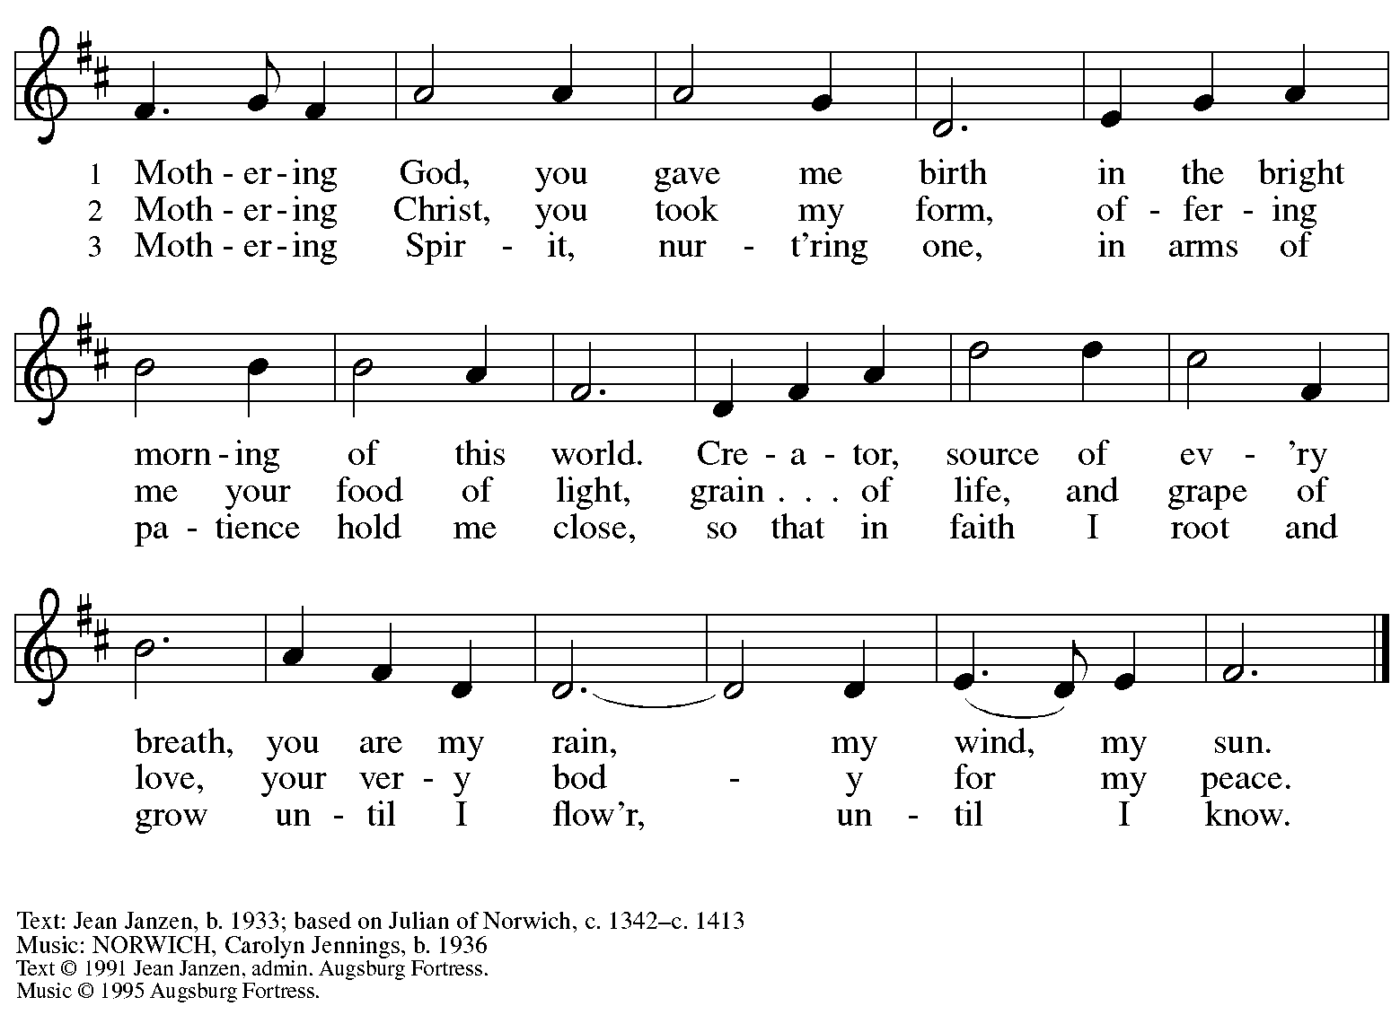
All rights reserved. Reprinted under OneLicense.net # A-722139.

Hymns during Holy Communion
By Your Hand You Feed Your People ELW 469

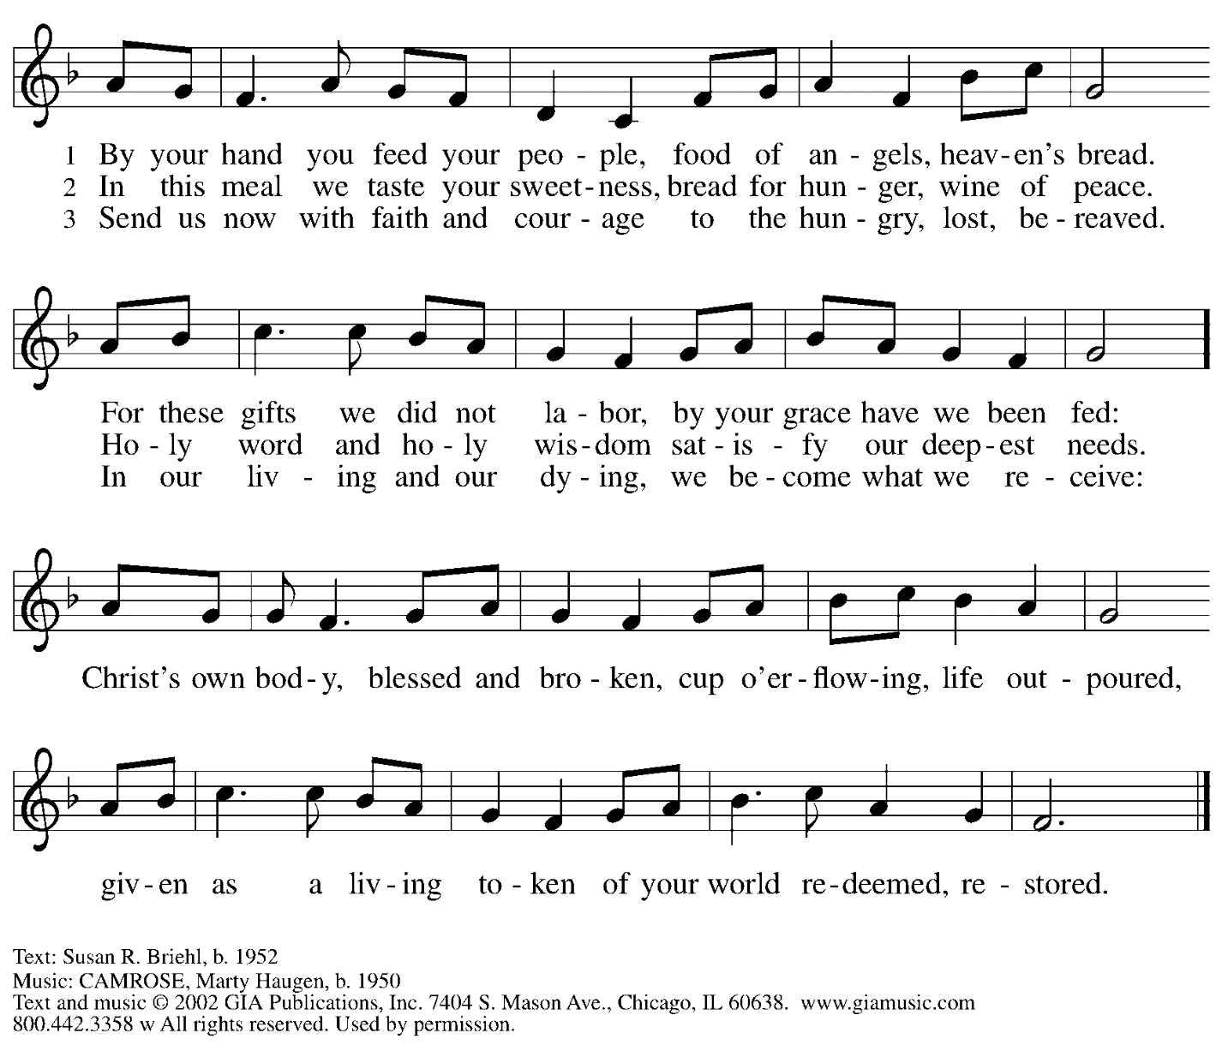
Reprinted with permission under OneLicense.net #A-722139.

When all have returned to their places, please rise as you are able.

Blessing

P: The body and blood of our Lord Jesus Christ strengthen you and keep you in his grace.
C: Amen.

Prayer

P: Let us pray.
Compassionate God, you have fed us with the bread of heaven.
Sustain us in our Lenten pilgrimage: may our fasting be hunger for justice;
our alms, a making of peace; and our prayer, the song of grateful hearts,
through Jesus Christ, our Savior and Lord.
C: Amen.

Sending

Benediction

P: You are children of God,
anointed with the oil of gladness
and strengthened for the journey.
Almighty God,
motherly, majestic, and mighty,
☩ bless you this day and always.
C: Amen.

Dismissal

P: Go in peace. Jesus is with you on the way.
C: Thanks be to God!

Abbreviations

P: Pastor/Presiding Minister
L: Lector
C: Congregation

ELW: Evangelical Lutheran Worship hymnal
ACS: All Creation Sings hymnal

Those serving in worship today

Piano Lily Cai
Cantor Ian Brown
Lector Lester Prince
Director of Faith Formation Christopher Atwood
Presiding Minister Pastor Ross Carmichael

Liturgy and Hymnody Acknowledgements

From SundaysandSeasons.com. Copyright © 2022 Augsburg Fortress. All rights reserved. Reprinted under OneLicense.net # A-722139.
Used by permission of Augsburg Fortress.

