+ Third Sunday in Lent
March 20, 2022

St. Andrew Lutheran Church
304 Morewood Ave.
Pittsburgh, PA 15213
St_andrewELCA@verizon.net
www.standrewpittsburgh.org

+ Third Sunday in Lent
Order for Worship

On the Third Sunday in Lent, warnings are accompanied by God’s invitation to attentiveness: “Incline your ear, and come to me; listen, so that you may live.” The landowner’s ultimatum about cutting down the unfruitful tree is forestalled by the gardener’s grace and willingness to till the ground one more year. That is good news for all of us. Thanks be to God!

A few notes on precautions and protocols, which apply to everyone regardless of vaccination status, as St. Andrew returns to worship in the sanctuary:

- Face masks that fully cover both your mouth and nose are required at all times for everyone over the age of two (2) – the only exception being the brief moment of moving mask aside to partake in Holy Communion.
- Outside food and drink are thus not permissible during worship.
- Physical distancing of at least six (6) feet will be observed at all times for people not from your household.
- We invite the congregation to join in the singing of the hymns (with masks on) during worship!
- Hand sanitizer is available at the front of the sanctuary to use before Holy Communion, after you proceed past the baptismal font, as the alcohol has been affecting the finish on the font’s bowl.

Worship Services are live streamed to multiple online platforms.
By attending worship, you agree that your image and voice may be broadcast.

Welcome

Gathering

Centering Music Return to God ACS 921

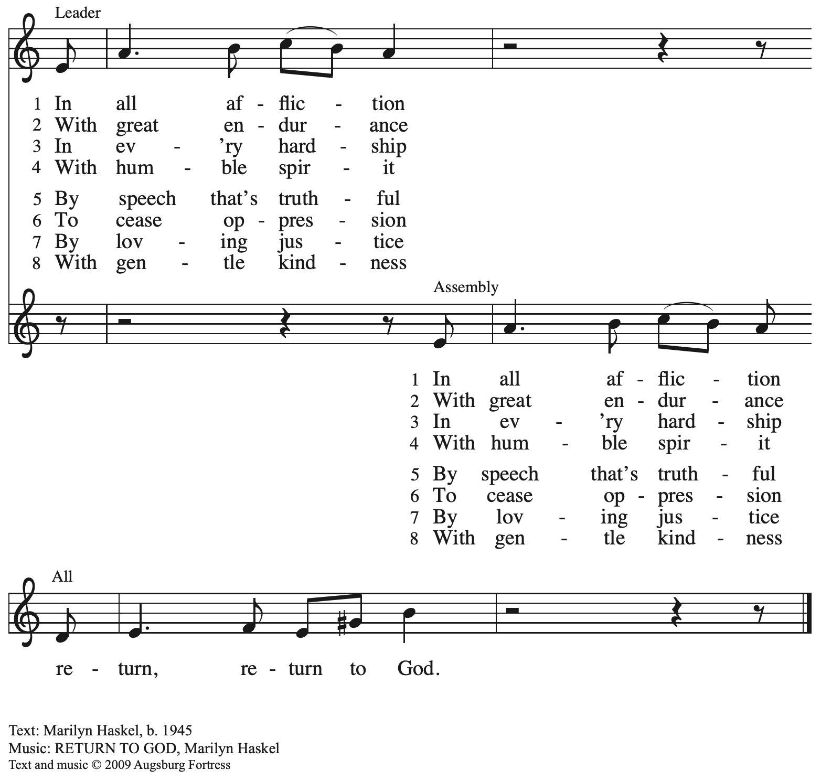
All rights reserved. Reprinted with permission under OneLicence.net # A-722139.

Please rise as you are able.

Confession of Sin

P: In the name of our ☩ Triune God,
who makes a way in the wilderness,
accompanies us, and guides us in our pilgrimage.
C: Amen.

Silence is kept for reflection.

P: Holy One,
C: we confess that we have wandered far from you:
we have not trusted your promises,
we have ignored your prophets in our own day,
we have squandered our inheritance of grace,
we have failed to recognize you in our midst.
Have mercy on us.
Forgive us and turn us again to you.
Teach us to follow in your ways,
assure us again of your love,
and help us to love our neighbor.
Amen.

P: Beloved in Christ,
the Word draws near to you,
and all who call out to God shall be saved.
In Jesus, God comes to you again and again
and gathers you under wings of love.
In ☩ Jesus’ name, your sins are forgiven.
God journeys with you and teaches you how to live in love.
C: Amen.

Gathering Hymn Come to the Water of Life ACS 955

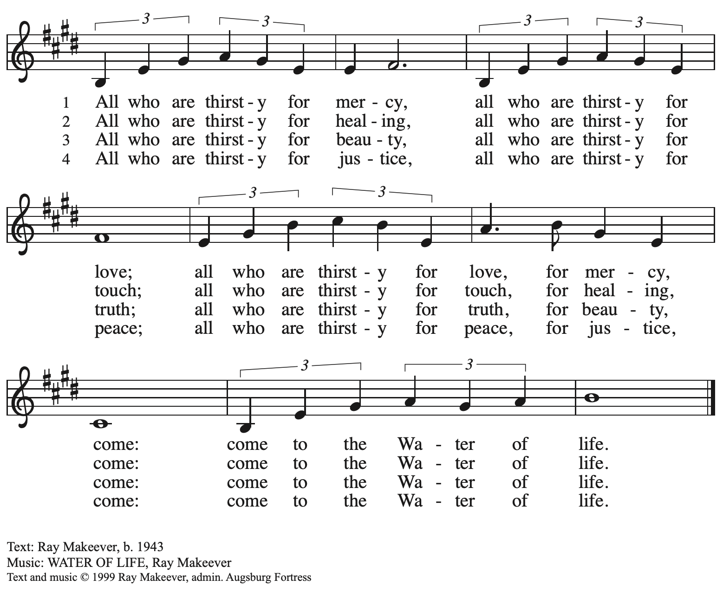
All rights reserved. Reprinted with permission under OneLicense.net # A-722139.

Greeting

P: The grace of our Lord Jesus Christ, the love of God,
and the communion of the Holy Spirit be with you all.
C: And also with you.

Prayer of the Day

P: Let us pray.
Eternal God, your reign has broken into our troubled world through the life, death, and resurrection of your Son. Help us to hear your word and obey it, and bring your saving love to fruition in our lives, through Jesus Christ, our Savior and Lord, who lives and reigns with you and the Holy Spirit, one God, now and forever.
C: Amen.

Please be seated

Word

First Reading – Isaiah 55: 1-9

¹Ho, everyone who thirsts,
come to the waters;
and you that have no money,
come, buy and eat!
Come, buy wine and milk
without money and without price.
²Why do you spend your money for that which is not bread,
and your labor for that which does not satisfy?
Listen carefully to me, and eat what is good,
and delight yourselves in rich food.
³Incline your ear, and come to me;
listen, so that you may live.
I will make with you an everlasting covenant,
my steadfast, sure love for David.
⁴See, I made him a witness to the peoples,
a leader and commander for the peoples.
⁵See, you shall call nations that you do not know,
and nations that do not know you shall run to you,
because of the Lord your God, the Holy One of Israel,
for the Lord has glorified you.

⁶Seek the Lord while the Lord may be found,
call upon the Lord while the Lord is near;
⁷let the wicked forsake their way,
and the unrighteous their thoughts;
let them return to the Lord, that the Lord may have mercy on them,
and to our God, for God will abundantly pardon.
⁸For my thoughts are not your thoughts,
nor are your ways my ways, says the Lord.
⁹For as the heavens are higher than the earth,
so are my ways higher than your ways
and my thoughts than your thoughts.

L: Word of God, word of life.
C: Thanks be to God.

Psalm 63: 1-8

The psalm will be spoken, led by the cantor, with the congregation invited to join the lector
in responding with the alternate verses.

¹O God, you are my God; eagerly I seek you;
my soul thirsts for you, my flesh faints for you, as in a dry and weary land where there is no water.
²Therefore I have gazed upon you in your holy place,
that I might behold your power and your glory.
³For your steadfast love is better than life itself;
my lips shall give you praise.
⁴So will I bless you as long as I live
and lift up my hands in your name.
⁵My spirit is content, as with the richest of foods,
and my mouth praises you with joyful lips,
⁶when I remember you upon my bed,
and meditate on you in the night watches.
⁷For you have been my helper,
and under the shadow of your wings I will rejoice.
⁸My whole being clings to you;
your right hand holds me fast.

Second Reading – 1 Corinthians 10: 1-13

¹I do not want you to be unaware, kindred, that our ancestors were all under the cloud, and all passed through the sea, ²and all were baptized into Moses in the cloud and in the sea, ³and all ate the same spiritual food, ⁴and all drank the same spiritual drink. For they drank from the spiritual rock that followed them, and the rock was Christ. ⁵Nevertheless, God was not pleased with most of them, and they were struck down in the wilderness.
⁶Now these things occurred as examples for us, so that we might not desire evil as they did.
⁷Do not become idolaters as some of them did; as it is written, “The people sat down to eat and drink, and they rose up to play.” ⁸We must not indulge in sexual immorality as some of them did,
and twenty-three thousand fell in a single day. ⁹We must not put Christ to the test, as some of them did, and were destroyed by serpents. ¹⁰And do not complain as some of them did, and were destroyed by the destroyer. ¹¹These things happened to them to serve as an example, and they were written down to instruct us, on whom the ends of the ages have come. ¹²So if you think you are standing, watch out that you do not fall. ¹³No testing has overtaken you that is not common to everyone. God is faithful, and God will not let you be tested beyond your strength, but with the testing God will also provide the way out so that you may be able to endure it.

L: Word of God, word of life.
C: Thanks be to God.

Please rise as you are able.

Gospel Acclamation

C: Jesus began to proclaim, “Repent, for the reign of heaven has come near.”

Gospel – Luke 13: 1-9

P: The holy Gospel according to St. Luke.
C: Glory to you, O Lord.

¹At that very time there were some present who told him about the Galileans whose blood Pilate had mingled with their sacrifices.²[Jesus] asked them, “Do you think that because these Galileans suffered in this way they were worse sinners than all other Galileans?³No, I tell you; but unless you repent, you will all perish as they did. ⁴Or those eighteen who were killed when the tower of Siloam fell on them—do you think that they were worse offenders than all the others living in Jerusalem? ⁵No, I tell you; but unless you repent, you will all perish just as they did.”
⁶Then he told this parable: “A man had a fig tree planted in his vineyard; and he came looking for fruit on it and found none. ⁷So he said to the gardener, ‘See here! For three years I have come looking for fruit on this fig tree, and still I find none. Cut it down! Why should it be wasting the soil?’ ⁸He replied, ‘Sir, let it alone for one more year, until I dig around it and put manure on it. ⁹If it bears fruit next year, well and good; but if not, you can cut it down.’”

P: The Gospel of the Lord.
C: Praise to you, O Christ.

Please be seated.

Sermon

Please rise as you are able.

Hymn of the Day When Pain of the World Surrounds Us ELW 704

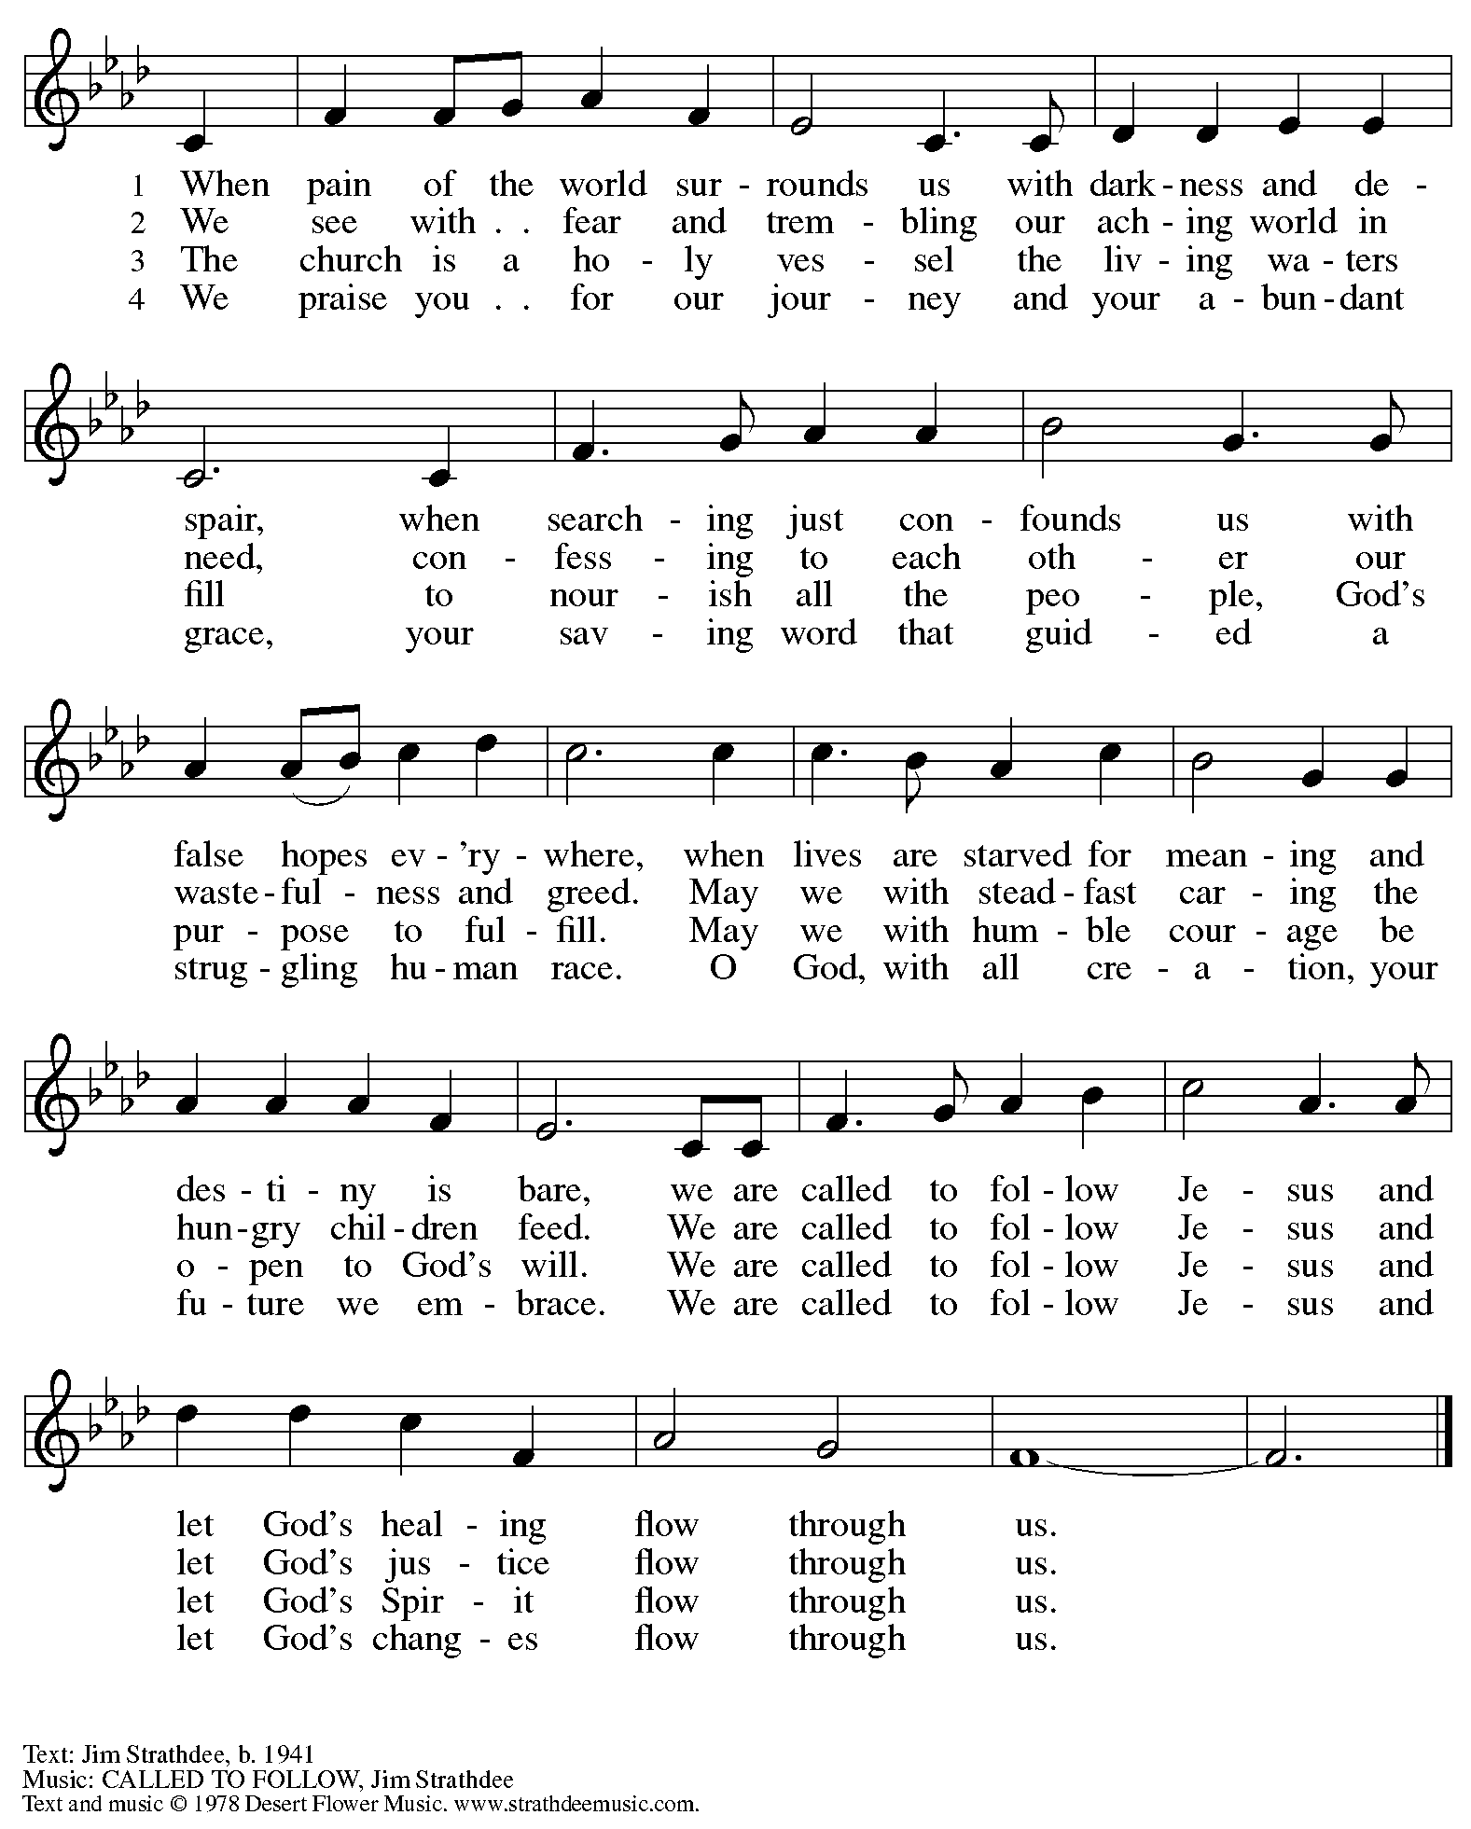
All rights reserved. Reprinted with permission under OneLicense.net # A-722139.

Apostles’ Creed

C: I believe in God, the Father almighty,
creator of heaven and earth.

I believe in Jesus Christ, God’s only Son, our Lord,
who was conceived by the Holy Spirit,
born of the virgin Mary,
suffered under Pontius Pilate,
was crucified, died, and was buried;
he descended to the dead.*
On the third day he rose again;
he ascended into heaven,
he is seated at the right hand of the Father,
and he will come to judge the living and the dead.

I believe in the Holy Spirit,
the holy catholic church,
the communion of saints,
the forgiveness of sins,
the resurrection of the body,
and the life everlasting. Amen.

*Or, “he descended into hell,” another translation of this text in widespread use.

Prayers of the People

P: Turning our hearts to God who is gracious and merciful,
we pray for the church, the world, and all who are in need.

After each petition
P: Merciful God,
C: receive our prayer.

P: Accept the prayers we bring before you, O God, on behalf of a world in need,
through Jesus Christ, our Savior.
C: Amen.

Please be seated.

Offering

We offer ourselves, our gifts, and our faithful service to God.
An usher will pass around and offering plate for anyone who would like to offer gifts before God.

Music during the Offering
As the Deer Runs to the River ELW 331

Meal

Please rise as you are able.

Offertory Prayer

P: Let us pray. God our provider,
C: you have not fed us with bread alone, but with words of grace and life.
Bless us and these your gifts, which we receive from your bounty,
through Jesus Christ our Lord.
Amen.

Dialogue

P: The Lord be with you.
C: And also with you.

P: Lift up your hearts.
C: We lift them to the Lord.

P: Let us give thanks to the Lord our God.
C: It is right to give our thanks and praise.

Preface

P: It is indeed right, our duty and our joy…
… and join their unending hymn.

Sanctus

C: Holy, holy, holy Lord,
God of power and might:
Heaven and earth are full of your glory.
Hosanna in the highest.
Blessed is the one who comes in the name of the Lord.
Hosanna in the highest.

Eucharistic Prayer

P: Blessed are you, O God of the universe …
Do this for the remembrance of me.

With this bread and cup, we remember our Lord’s Passover from death to life
as we proclaim the mystery of faith.
C: Christ has died. Christ is risen. Christ will come again.

P: O God of resurrection and new life …
… grace our table with your presence.
C: Come, Holy Spirit.

P: Reveal yourself to us in the breaking of the bread …
… with justice, peace, and love.
C: Come, Holy Spirit.

P: With your holy ones of all times and places …
… blessed and Holy Trinity, now and forever.
C: Amen.

Lord’s Prayer

P: Gathered as one by the Holy Spirit, let us pray as Jesus taught us.
C: Our Father in heaven,
hallowed be your name,
your kingdom come,
your will be done,
on earth as in heaven.
Give us today our daily bread.
Forgive us our sins
as we forgive those
who sin against us.
Save us from the time of trial
and deliver us from evil.
For the kingdom, the power,
and the glory are yours,
now and forever. Amen.

Fraction and Invitation

Agnus Dei / Lamb of God

C: Lamb of God, you take away the sin of the world; have mercy on us.
Lamb of God, you take away the sin of the world; have mercy on us.
Lamb of God, you take away the sin of the world; grant us peace.

Please be seated.

Holy Communion
- Hand sanitizer is available if you would like to use it prior to receiving Communion.
- We will not be kneeling at the altar rail due to the need for physical distancing.
- Worshipers from the pulpit side will proceed forward first, followed by the center section, and then the lectern side.
- The Communion wafers (regular and gluten-free) have been thoughtfully prepared using the gifts of the congregation by a member of St. Andrew’s altar care team, with a drop of wine or grape juice on each. The presiding minister will distribute one to each communicant.
- When you reach the presiding minister, please indicate if you would like grape juice or a gluten-free wafer.
- A blessing will be provided for anyone who does not yet receive the sacrament.
- Everyone is asked to wait until you return to your place to consume the elements, and then promptly replace your mask.

Hymns during Holy Communion
Guide Me Ever, Great Redeemer ELW 618
v. 1-2

1 Guide me ever, great Redeemer,
pilgrim through this barren land.
I am weak, but you are mighty;
hold me with your pow'rful hand.
Bread of heaven, bread of heaven,
feed me now and evermore,
feed me now and evermore.

2 Open now the crystal fountain
where the healing waters flow;
let the fire and cloudy pillar
lead me all my journey through.
Strong deliv'rer, strong deliv'rer,
shield me with your mighty arm,
shield me with your mighty arm.

Text: William Williams, 1717-1791; tr. William Williams and Peter Williams, 1722-1796, alt. Music: CWM RHONDDA, John Hughes, 1873-
1932.

Hymns during Holy Communion
All Who Hunger, Gather Gladly ELW 461

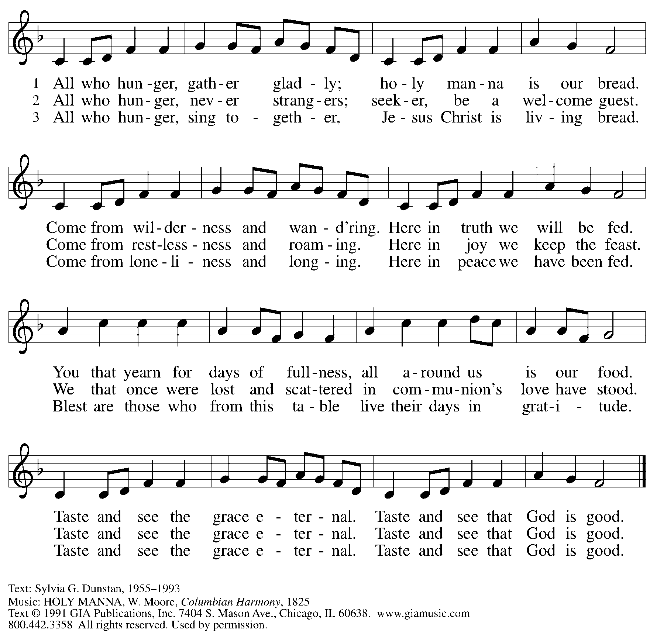
Reprinted with permission under OneLicense.net # A-722139.

When all have returned to their places, please rise as you are able.

Blessing

P: The body and blood of our Lord Jesus Christ strengthen you and keep you in his grace.
C: Amen.

Prayer

P: Let us pray.
Compassionate God, you have fed us with the bread of heaven.
Sustain us in our Lenten pilgrimage: may our fasting be hunger for justice;
our alms, a making of peace; and our prayer, the song of grateful hearts,
through Jesus Christ, our Savior and Lord.
C: Amen.

Sending

Benediction

P: You are children of God,
anointed with the oil of gladness
and strengthened for the journey.
Almighty God,
motherly, majestic, and mighty,
☩ bless you this day and always.
C: Amen.

Dismissal

P: Go in peace. Jesus is with you on the way.
C: Thanks be to God!

Abbreviations

P: Pastor/Presiding Minister
L: Lector
C: Congregation

ELW: Evangelical Lutheran Worship hymnal
ACS: All Creation Sings hymnal

Those serving in worship today

Piano Lily Cai
Cantor Timothy Kocher-Hillmer
Lector Joyce Compton
Director of Faith Formation Christopher Atwood
Presiding Minister Pastor Ross Carmichael

Liturgy and Hymnody Acknowledgements

From SundaysandSeasons.com. Copyright © 2022 Augsburg Fortress. All rights reserved. Reprinted under OneLicense.net # A-722139.
Used by permission of Augsburg Fortress.

