+ Triduum – Vigil of Easter
April 16, 2022
St. Andrew Lutheran Church
304 Morewood Ave.
Pittsburgh, PA 15213
St_andrewELCA@verizon.net
www.standrewpittsburgh.org

+ Triduum – Vigil of Easter
Order for Worship

This is the night of salvation!
At the Vigil of Easter, we gather around fire, word, water, bread, and wine, proclaiming through story and song that ours is a God who continuously brings life out of death.
On this night we experience again the heart of God’s baptismal promise and the center of our faith: we are claimed and cleansed, renewed in the death and resurrection of Christ.
We gather with all the saints of every time and place to celebrate the good news:
Christ is risen indeed! Alleluia!

A few notes on precautions and protocols, which apply to everyone regardless of vaccination status, as St. Andrew returns to worship in the sanctuary:

- Inside the building, face masks that fully cover both your mouth and nose are required at all times for everyone over the age of two (2) – the only exception being the brief moment of moving masks aside to partake in Holy Communion.
- Outside food and drink are thus not permissible during worship.
- Physical distancing of at least six (6) feet will be observed at all times for people not from your household.
- We invite the congregation to join in the singing of the hymns (with masks on) during worship!
- Hand sanitizer is available at the front of the sanctuary to use before Holy Communion, after you proceed past the baptismal font, as the alcohol has been affecting the finish on the font’s bowl.

Worship Services are live streamed to multiple online platforms.
By attending worship, you agree that your image and voice may be broadcast.

Service of Light
The new fire and lighting of the Paschal candle signify the dawning of the resurrection

Greeting

P: The grace of our Lord Jesus Christ, the love of God,
and the communion of the Holy Spirit be with you all.
C: And also with you.

The presiding minister welcomes the assembly to the vigil.
P: Beloved in Christ, on this most holy night when our Savior Jesus Christ passed from death to life, we gather with the church throughout the world in vigil and prayer. This is the Passover of Jesus Christ. Through light and the word, through water and oil, bread and wine, we proclaim Christ’s death and resurrection, share Christ’s triumph over sin and death, and await Christ’s coming again in glory.

The new fire is lighted.

The presiding minister waits until the fire is burning before praying.
P: Let us pray.
Eternal God, in Jesus Christ you have given the light of life to all the world.
Bless this new fire, and increase in us a desire to shine forth
with the brightness of Christ’s rising, until we feast at the banquet of eternal light;
through the Sun of righteousness, Jesus Christ our Lord.
C: Amen.

The presiding minister traces the inscription on the Paschal candle.
P: Christ, yesterday and today, ☩
the beginning and the ending. A Ω
To Christ belongs all time 2
and all the ages; 0
to Christ belongs glory and dominion decade
now and forever. year
C: Amen.

The presiding minister lights the Paschal candle, using a stick or taper from the fire, and sings:
P: The light of Christ, rising in glory,
dispel the darkness of our | hearts and minds.
The assisting minister lifts the candle so that all may see it.
Procession

The procession begins, led by the assisting minister bearing the Paschal candle.

As the procession begins, a cantor sings:

The procession continues, stopping at midpoint. The assisting minister lifts the Paschal candle and the cantor sings on a higher tone:
The procession continues. The assisting minister takes the Paschal candle to its stand and lifts it high, and the cantor sings on a still higher tone:

The Paschal candle is placed in its stand.

Easter Proclamation

Two cantors sing the Easter proclamation.

C: Rejoice, now, all heavenly powers! Sing, choirs of angels! …
… echoing the mighty song of all God’s people.

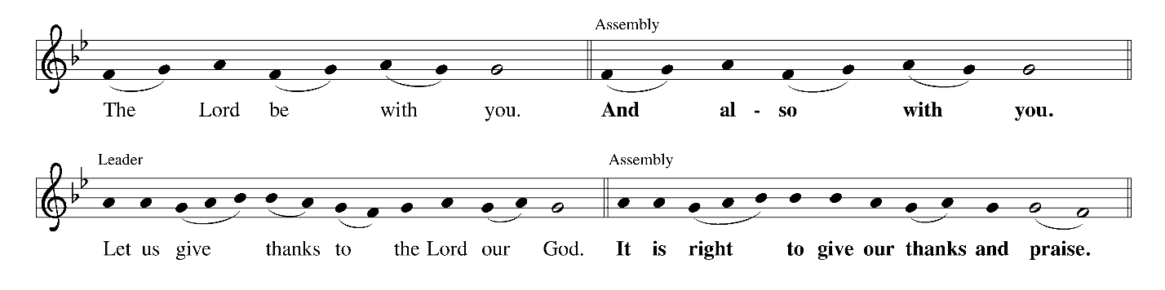

C: It is indeed right, our duty and our joy …
… the doorposts of the faithful are made holy.

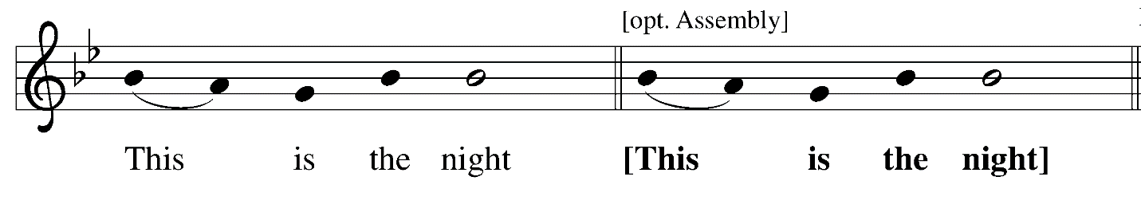

C: in which, in ancient times …
you delivered our forebears, the children of Israel,
and led them, dry-shod, through the sea.

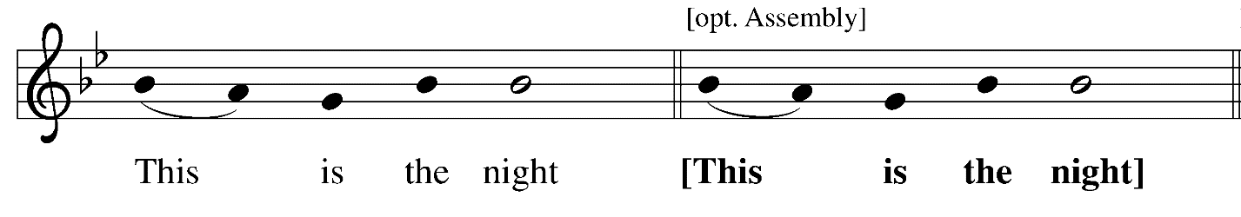

C: in which the darkness of sin has been purged away by the rising brightness.

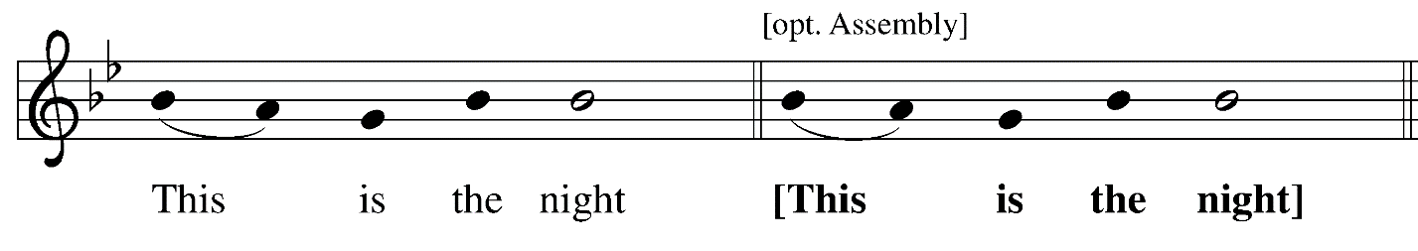

C: in which all who believe in Christ are rescued from evil and the gloom of sin,
are renewed in grace, and are restored to holiness.

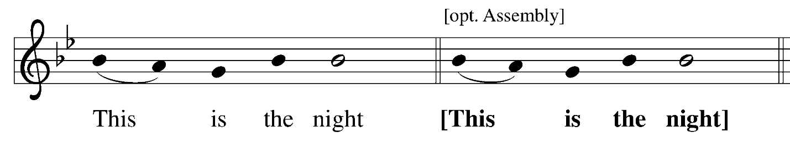

C: in which, breaking the chains of death,
Christ arises from hell in triumph …

…O night truly blessed which alone was worthy to know
the time and hour in which Christ rose again from hell!

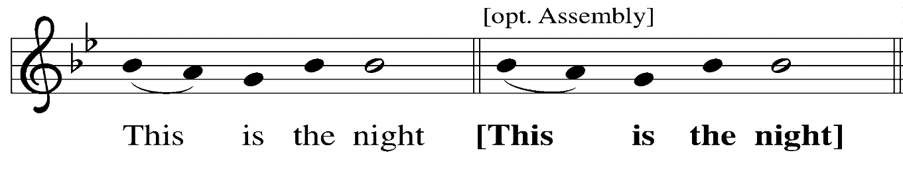

C: of which it is written: “The night is as clear as the day,” …
… have made for the substance of this candle.

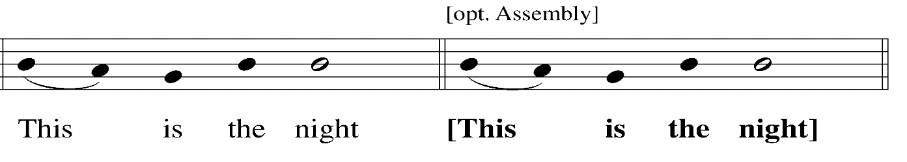

C: in which heaven and earth are joined – things human and things divine …
… one God, now and forever.

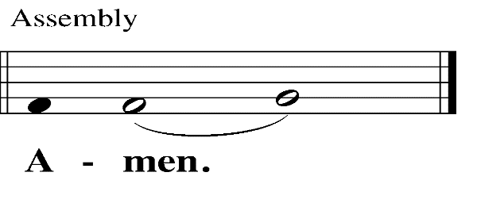

Prayer of the Day

P: Let us pray.
Eternal giver of life and light, this holy night shines with the radiance of the risen Christ.
Renew your church with the Spirit given us in baptism,
that we may worship you in sincerity and truth
and may shine as a light in the world,
through your Son, Jesus Christ our Lord,
who lives and reigns with you and the Holy Spirit,
one God, now and forever.
C: Amen.

Please be seated.
Service of Readings
The history of God’s faithfulness and salvation is told through the Hebrew Scriptures

First Reading – Genesis 1: 1 – 2: 4a

The first reading will be a children’s version of the first creation story, read by the Director of Faith Formation and represented visually with props by children of the congregation.

First Response – We Thank You Lord, for You Are Good
based on Psalm 136: 1-9, 23-26
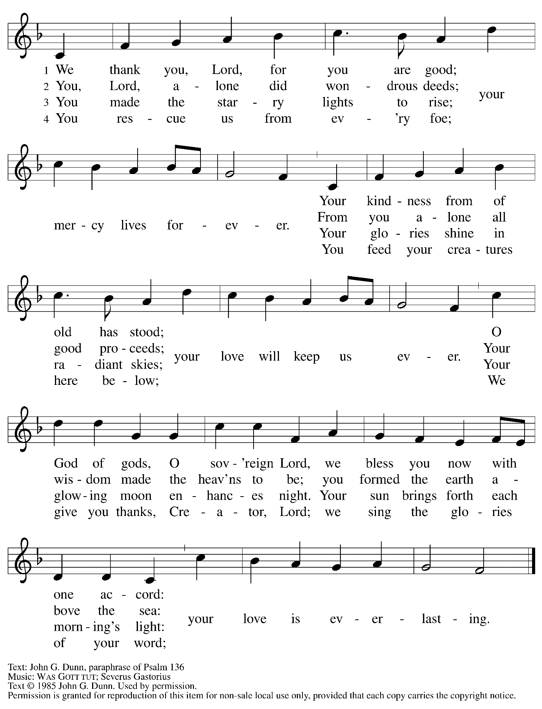
First Prayer

P: Let us pray.
Almighty God,
you wonderfully created the dignity of human nature and yet more wonderfully restored it.
In your mercy, let us share the divine life of the one who came to share our humanity,
Jesus Christ, your Son, our Lord.
C: Amen.

Second Reading – Exodus 14: 10-31; 15: 20-21

The second reading will be read by a lector from the New Revised Standard Version of the Bible.

Second Response – I Will Sing to the Lord
based on Exodus 15: 1b-13, 17-18

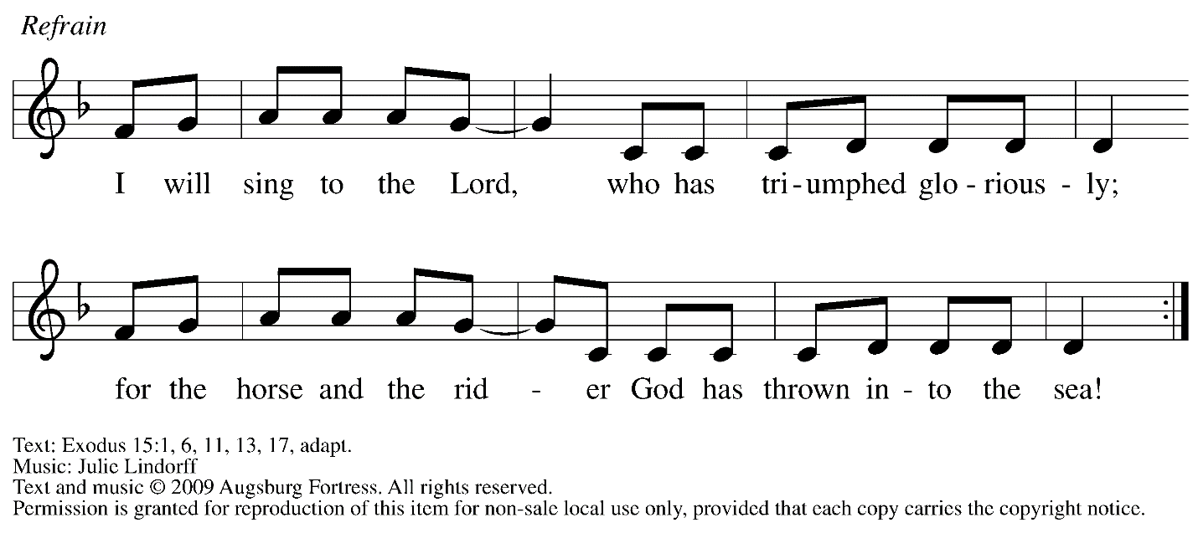

^{1b}I will sing to the Lord, who has | triumphed gloriously;
throwing horse and rider in- | to the sea.
²The Lord is my strength | and my might,
and has become | my salvation;
this is my God—this God | I will praise;
my father’s God—this God I | will exalt.
³The Lord| is a warrior;
the Lord| is his name. R
⁴The Lord hurled Pharaoh’s chariots and army in- | to the sea;
his picked officers were sunk in | the Red Sea.
⁵The floods | covered them;
they went down into the depths | like a stone.
⁶Your right hand, O Lord, glo- | rious in power—
your right hand, O Lord, shat- | tered the enemy.
⁷In the greatness of your majesty you overthrew your | adversaries;
you sent out your fury, it consumed | them like stubble. R
⁸At the blast of your nostrils the waters piled up, the floods stood up | in a heap;
the deeps congealed in the heart | of the sea.
⁹The enemy said, “I will pursue, I will overtake, I will divide the spoil, my desire shall have its
| fill of them.
I will draw my sword, my hand | shall destroy them.”
¹⁰You blew with your wind, the sea | covered them;
they sank like lead in the | mighty waters.
¹¹“Who is like you, O Lord, a- | mong the gods?
Who is like you, majestic in holiness, awesome in splendor, | doing wonders? R
¹²You stretched out | your right hand,
the earth | swallowed them.
¹³In your steadfast love you led the people whom | you redeemed;
you guided them by your strength to your ho- | ly abode.
¹⁷You brought them in and planted them on the mountain of your | own possession,
the place, O Lord, that you made | your abode,
the sanctuary, O Lord, that your hands | have established.
¹⁸The Lord will reign forev- | er and ever. R

Second Prayer

L: Let us pray.
O God, whose wonderful deeds of old shine forth even to our own day:
By the power of your mighty arm, you once delivered your chosen people from slavery
under Pharaoh, a sign for us of the salvation offered to everyone by the water of baptism.
Grant that all the peoples of earth may partake in the salvation of the Israelites
and together dance on the safe side of the sea, through Jesus Christ, our Savior and Lord.
C: Amen.

Third Reading – Isaiah 55: 1-11

The third reading will be read by a lector from the New Revised Standard Version of the Bible.

Third Response – Surely God Is My Salvation
based on Isaiah 12: 2-6

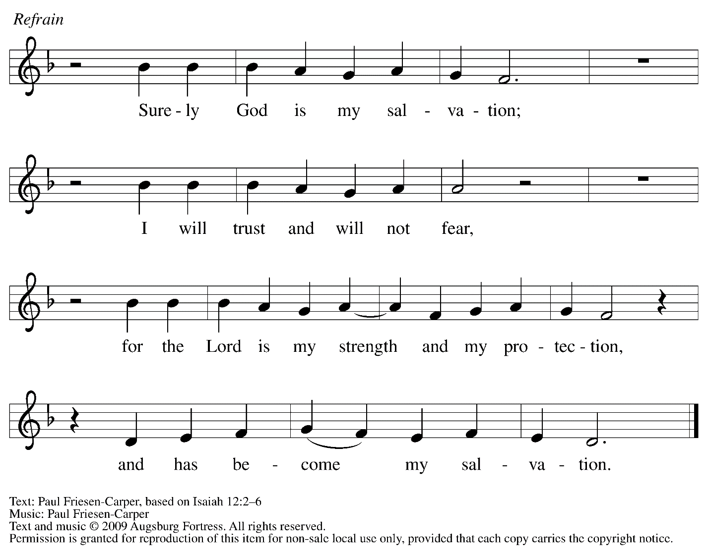

²Surely God is my salvation; I will trust, and will not | be afraid,
for the Lord God is my strength and my might, and has become | my salvation.
³With joy you | will draw water
from the wells | of salvation. R

⁴And you will say in that day: Give thanks to the Lord, call | on God’s name;
make known the deeds of the Lord among the nations; proclaim that this name | is exalted.
⁵Sing praises to the Lord, for he has done | gloriously;
let this be known in | all the earth.
⁶Shout aloud and sing for joy, O | royal Zion,
for great in your midst is the Holy | One of Israel. R

Third Prayer

L: Let us pray.
Holy God,
you created all things by the power of your Word, and you renew the whole earth by your Spirit. Give now the water of life to all who thirst for you, that, rejoicing in your covenant of mercy,
we may bring forth abundant fruit, through Jesus Christ, our Savior and Lord.
C: Amen.

Fourth Reading – Jonah 1: 1 – 2: 1

The fourth reading will be interpreted by a storyteller from the congregation.

Fourth Response – Jonah Prayed
based on Jonah 2: 1-3, 7-9

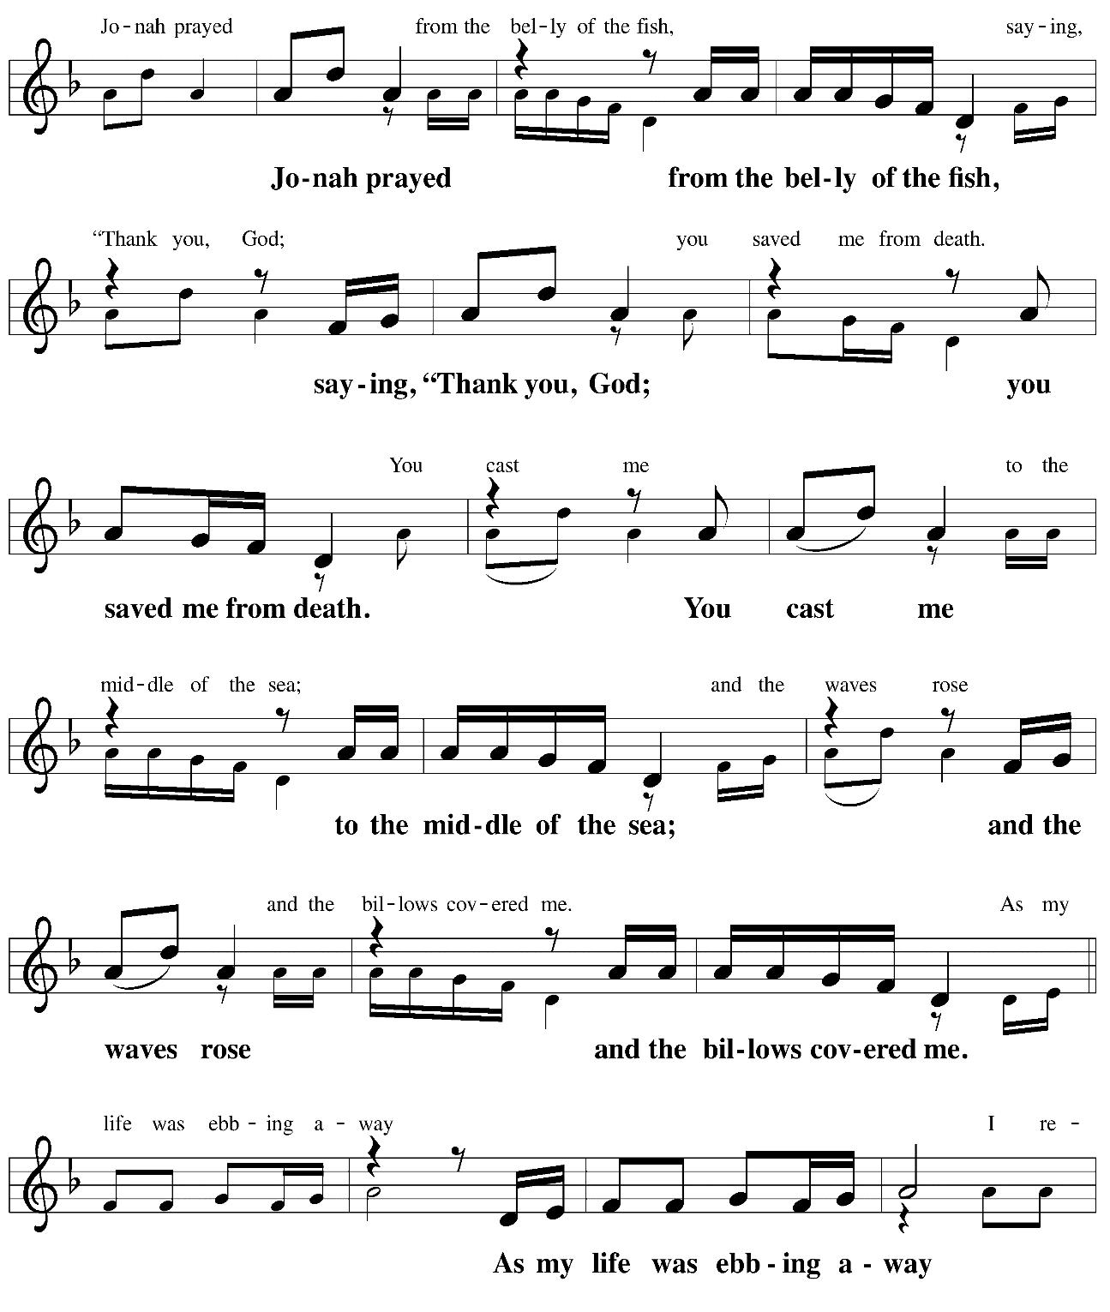

Continued
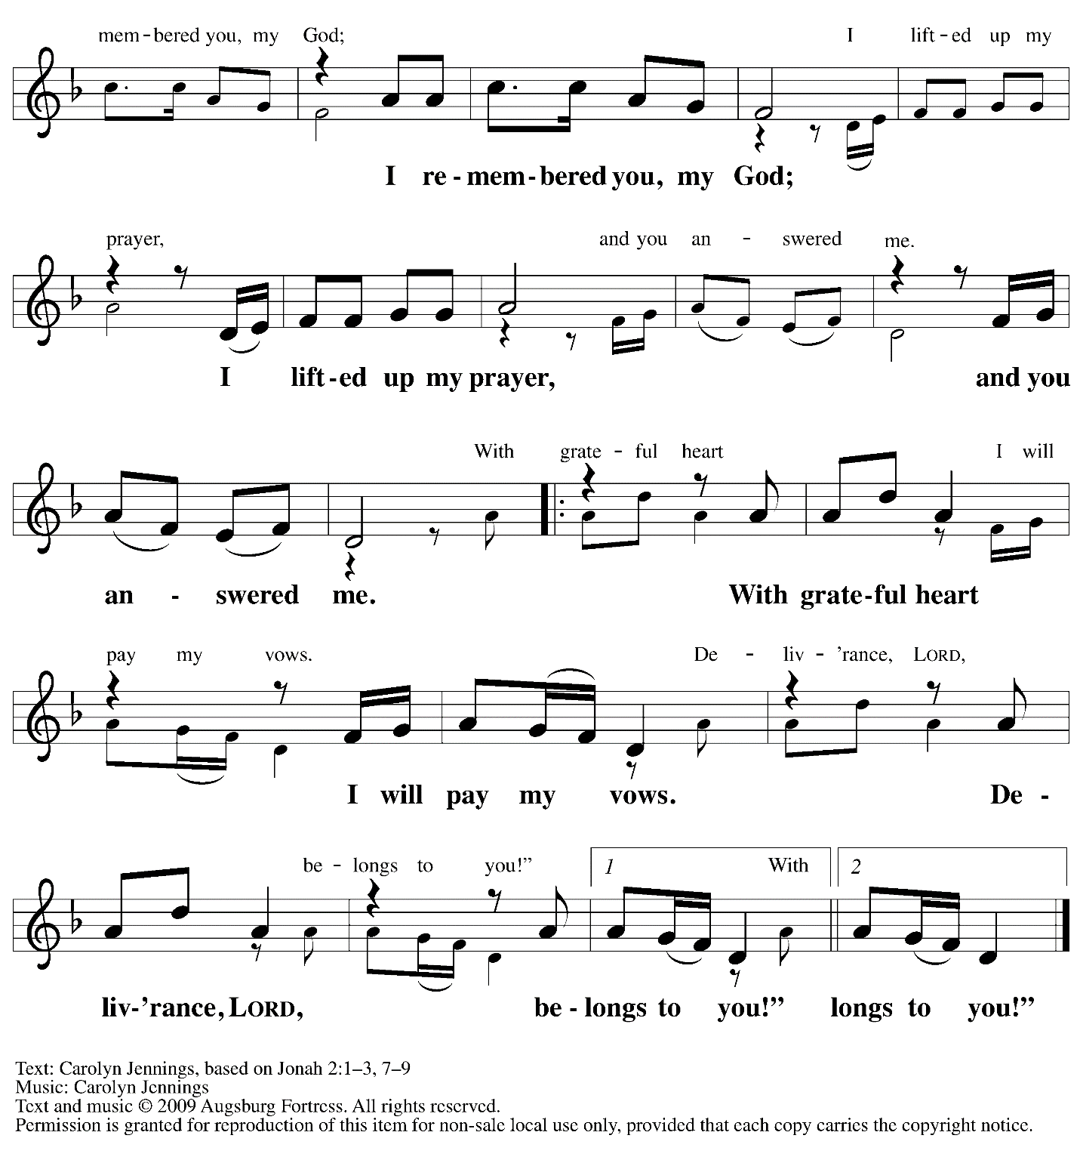

Fourth Prayer

P: Let us pray.
O God of deliverance,
you saved Jonah through the waters of death, and after three days you brought him to new life.
Speak to us by this sign, and call us to repentance, that we may heed the voice of your risen Son,
Jesus Christ, our Savior and Lord.
C: Amen.

Fifth Reading – Daniel 3: 1-29

The story of three faithful people of God and the fiery furnace has been adapted by youth of the congregation, who will also present the story.

Fifth Response – All You Works of God, Bless the Lord
based on Song of the Three 35-65

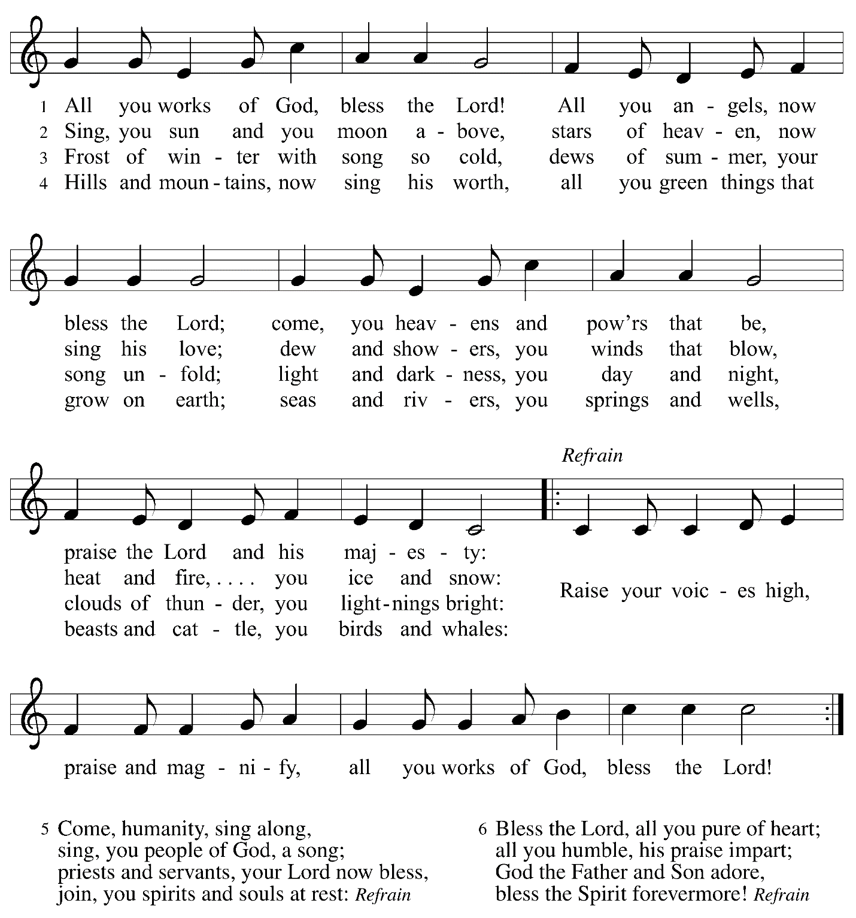

All are invited to join in singing the fifth response. As the response is sung, the assisting minister will lift the Paschal candle from its stand and lead the congregation in procession into the church sanctuary.
Service of the Word
God speaks to us in Scripture reading, preaching, and song

Reading – Romans 6: 3-11

³Do you not know that all of us who have been baptized into Christ Jesus were baptized into his death? ⁴Therefore we have been buried with him by baptism into death, so that, just as Christ was raised from the dead by the glory of the Father, so we too might walk in newness of life.
⁵For if we have been united with him in a death like his, we will certainly be united with him in a resurrection like his. ⁶We know that our old self was crucified with him so that the body of sin might be destroyed, and we might no longer be enslaved to sin. ⁷For whoever has died is freed from sin. ⁸But if we have died with Christ, we believe that we will also live with him. ⁹We know that Christ, being raised from the dead, will never die again; death no longer has dominion over him. ¹⁰The death he died, he died to sin, once for all; but the life he lives, he lives to God. ¹¹So you also must consider yourselves dead to sin and alive to God in Christ Jesus.

L: Word of God, word of life.
C: Thanks be to God.

After the New Testament reading, a time of silence is observed.
The cantor will then introduce the first line of the Hymn of Praise, and the lights will come up.
Please rise as you are able. The congregation is invited to join in singing as the music begins.
It is Easter! Christ is risen! Alleluia!

Gospel Acclamation This Is the Feast ELW p. 149-150

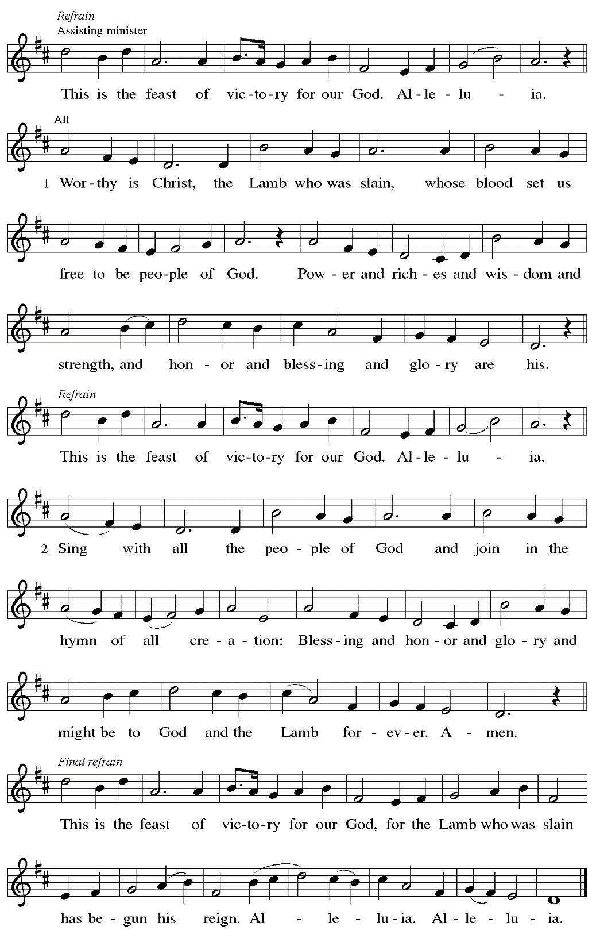

Gospel – John 20: 1-18

P: The holy Gospel according to St. John.
C: Glory to you, O Lord.

¹Early on the first day of the week, while it was still dark, Mary Magdalene came to the tomb and saw that the stone had been removed from the tomb. ²So she ran and went to Simon Peter and the other disciple, the one whom Jesus loved, and said to them, “They have taken the Lord out of the tomb, and we do not know where they have laid him.” ³Then Peter and the other disciple set out and went toward the tomb. ⁴The two were running together, but the other disciple outran Peter and reached the tomb first. ⁵He bent down to look in and saw the linen wrappings lying there, but he did not go in. ⁶Then Simon Peter came, following him, and went into the tomb. He saw the linen wrappings lying there, ⁷and the cloth that had been on Jesus’ head, not lying with the linen wrappings but rolled up in a place by itself. ⁸Then the other disciple, who reached the tomb first, also went in, and he saw and believed; ⁹for as yet they did not understand the scripture, that he must rise from the dead. ¹⁰Then the disciples returned to their homes.
¹¹But Mary stood weeping outside the tomb. As she wept, she bent over to look into the tomb; ¹²and she saw two angels in white, sitting where the body of Jesus had been lying, one at the head and the other at the feet. ¹³They said to her, “Woman, why are you weeping?” She said to them, “They have taken away my Lord, and I do not know where they have laid him.” ¹⁴When she had said this, she turned around and saw Jesus standing there, but she did not know that it was Jesus. ¹⁵Jesus said to her, “Woman, why are you weeping? Whom are you looking for?” Supposing him to be the gardener, she said to him, “Sir, if you have carried him away, tell me where you have laid him, and I will take him away.” ¹⁶Jesus said to her, “Mary!” She turned and said to him in Hebrew, “Rabbouni!” (which means Teacher). ¹⁷Jesus said to her, “Do not hold on to me, because I have not yet ascended to the Father. But go to my brothers and say to them, ‘I am ascending to my Father and your Father, to my God and your God.’ ” ¹⁸Mary Magdalene went and announced to the disciples, “I have seen the Lord”; and she told them that he had said these things to her.

P: The Gospel of the Lord.
C: Praise to you, O Christ.

Please be seated.

Sermon

Please rise as you are able.
The service continues with the Hymn of the Day,
found on the following page.

Hymn of the Day Day of Delight and Beauty Unbounded ACS 933

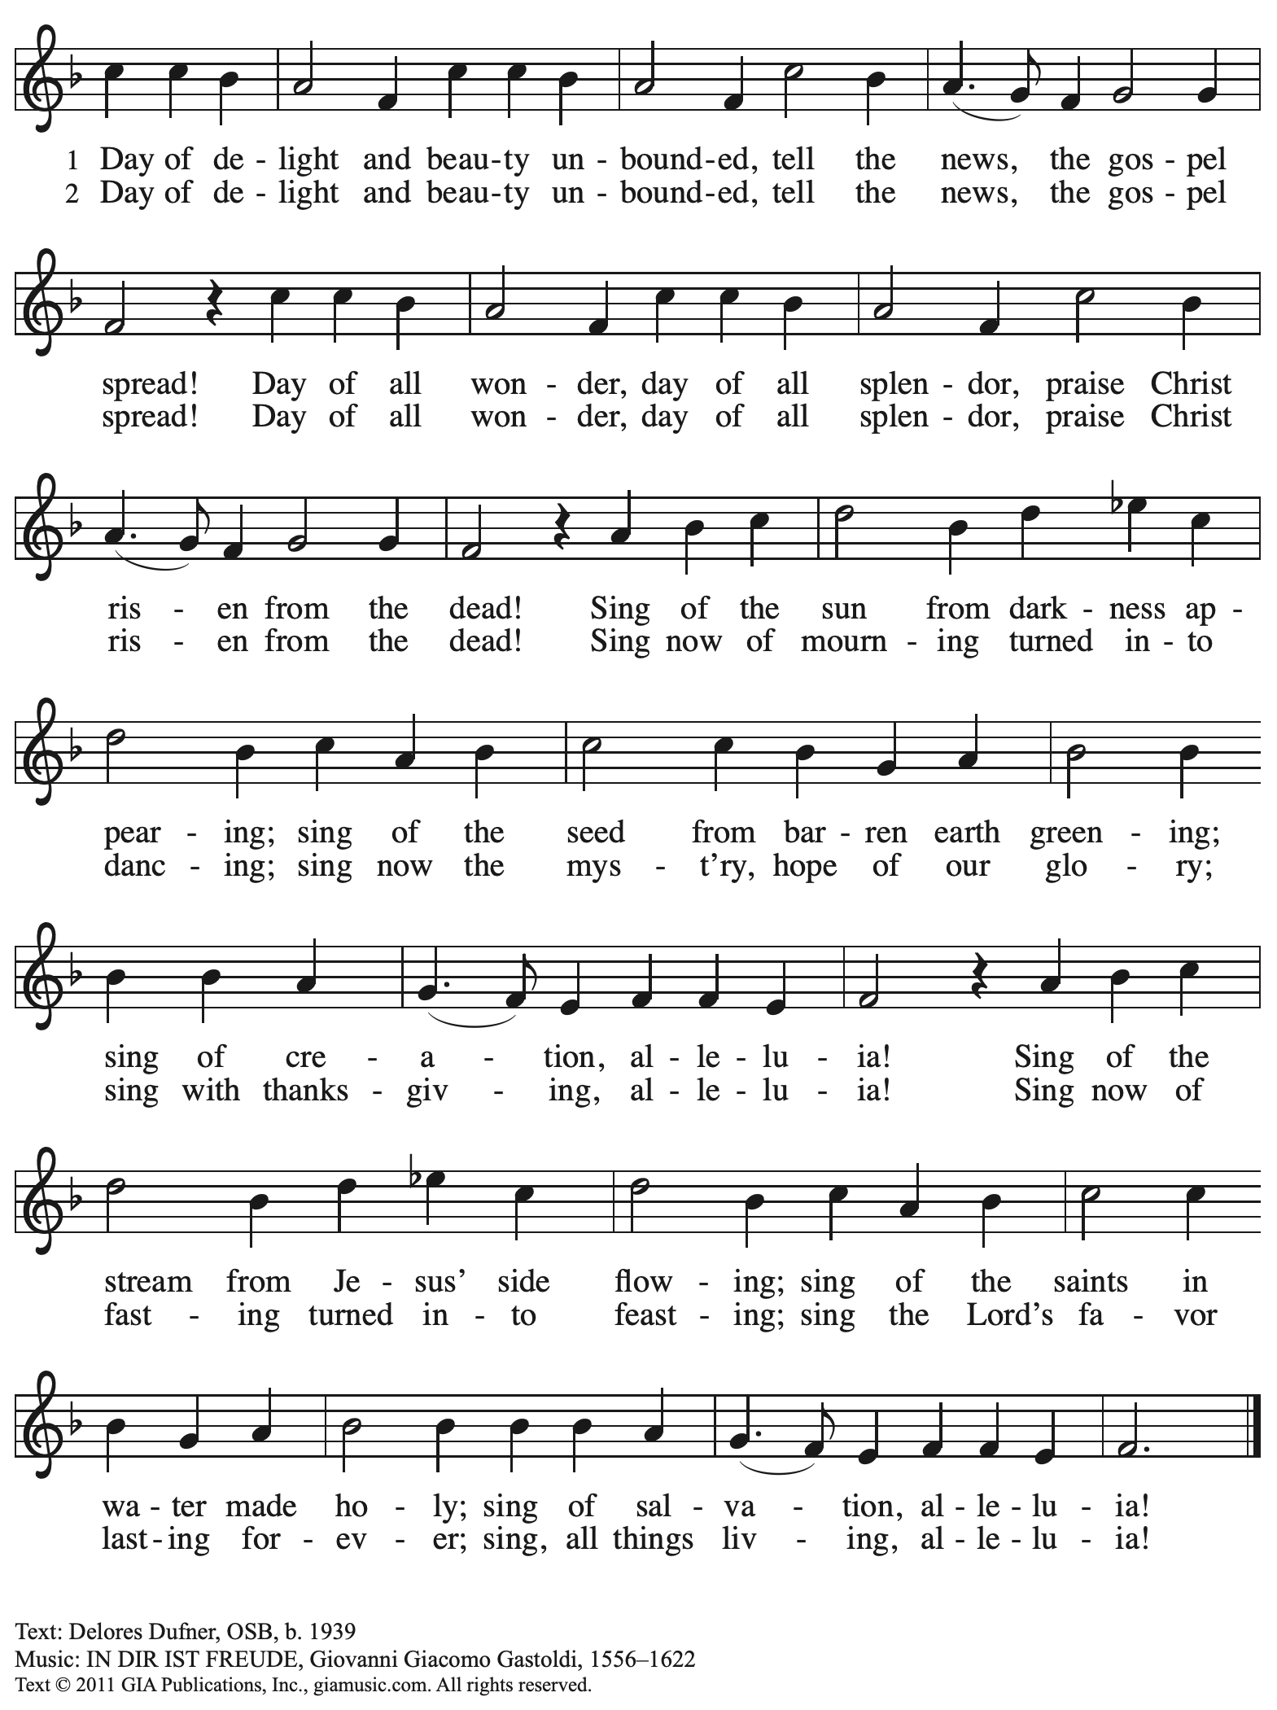
Reprinted with permission under OneLicense.net # A-722139.
Service of Baptismal Affirmation
The congregation celebrates the gifts of the covenant of Holy Baptism

Thanksgiving for the Waters of Baptism

The presiding minister moves to the baptismal font. The Paschal candle, a sign of Christ’s presence among us, is lowered into and raised from the water, as Christ was lowered into death and raised to life. The water becomes a symbol of both our death to sin and our rising to life in Christ.

The presiding minister prays over the baptismal waters.
P: Holy God, you give us grace through sacramental signs …

… May all who are buried with Christ in the death of Baptism rise also with Christ
to newness of life, through Christ our Lord.
C: Amen. Springs of water, bless the Lord!
Give God glory and praise forever!

P: Beloved in Christ, on this holiest of nights, the Church …
… and promised to serve God faithfully in the Church.

Affirmation of Baptism

Profession of Faith

The presiding minister addresses the assembly.
Please rise as able and join in the responses.

P: I ask you to profess your faith in Christ Jesus, reject sin, and confess the faith of the church.

P: Do you renounce the devil and all the forces that defy God?
Response: I renounce them.

P: Do you renounce the powers of this world that rebel against God?
Response: I renounce them.

P: Do you renounce the ways of sin that draw you from God?
Response: I renounce them.

The presiding minister addresses the assembly.
P: Do you believe in God the Father?
C: I believe in God, the Father almighty,
creator of heaven and earth.

P: Do you believe in Jesus Christ, the Son of God?
C: I believe in Jesus Christ, God’s only Son, our Lord,
who was conceived by the Holy Spirit,
born of the virgin Mary,
suffered under Pontius Pilate,
was crucified, died, and was buried;
he descended to the dead.*
On the third day he rose again;
he ascended into heaven,
he is seated at the right hand of the Father,
and he will come to judge the living and the dead.

P: Do you believe in God the Holy Spirit?
I believe in the Holy Spirit,
the holy catholic church,
the communion of saints,
the forgiveness of sins,
the resurrection of the body,
and the life everlasting.

*Or, “he descended into hell,” another translation of this text in widespread use.

Affirmation of Baptism

The presiding minister addresses the assembly.
You have made public profession of your faith. Do you intend to continue in the covenant God made with you in Holy Baptism:
to live among God’s faithful people,
to hear the word of God and share in the Lord’s supper,
to proclaim the good news of God in Christ through word and deed,
to serve all people, following the example of Jesus,
and to strive for justice and peace in all the earth?

The assembly makes affirmation: I do, and I ask God to help and guide me.

The minister addresses the assembly.
P: People of God, do you promise to support and pray for one another
in your life in Christ?
C: We do, and we ask God to help and guide us.

The presiding minister prays for God’s blessing.
P: Let us pray.
We give you thanks, O God, that through water and the Holy Spirit, you give us new birth, cleanse us from sin, and raise us to eternal life.
P: Stir up in your people the gift of your Holy Spirit: the spirit of wisdom and understanding,
the spirit of counsel and might, the spirit of knowledge and the fear of the Lord,
the spirit of joy in your presence, both now and forever.
C: Amen.

St. Andrew’s congregational refrain is sung in celebration of the gift of Baptism
and in thanksgiving for our new sibling in Christ.

C: Christ goes before, and we are called to follow,
and all who follow find the Way, the Truth, the Life.

All return to their places. Worship continues with the Prayers of the People.

Prayers of the People

P: On this holiest of nights, we pray for the church, those in need,
and the world God so greatly loves.

After each petition
P: Gracious God,
C: receive our prayer.

P: We offer these petitions and those we carry in our hearts, O God,
trusting in your abundant and ever-present mercy, through Jesus Christ our Savior.
C: Amen.

Please be seated.

Offering

We offer ourselves, our gifts, and our faithful service to God.
An usher will pass around an offering plate for anyone who would like to offer gifts before God.

Service of Holy Communion
God feeds us with the presence of Jesus Christ

Please rise as you are able.

Offertory Prayer

P: Let us pray. Blessed are you,
O God, ruler of heaven and earth. Day by day you shower us with blessings.
As you have raised us to new life in Christ, give us glad and generous hearts,
ready to praise you and to respond to those in need,
through Jesus Christ, our Savior and Lord. Amen.

Dialogue

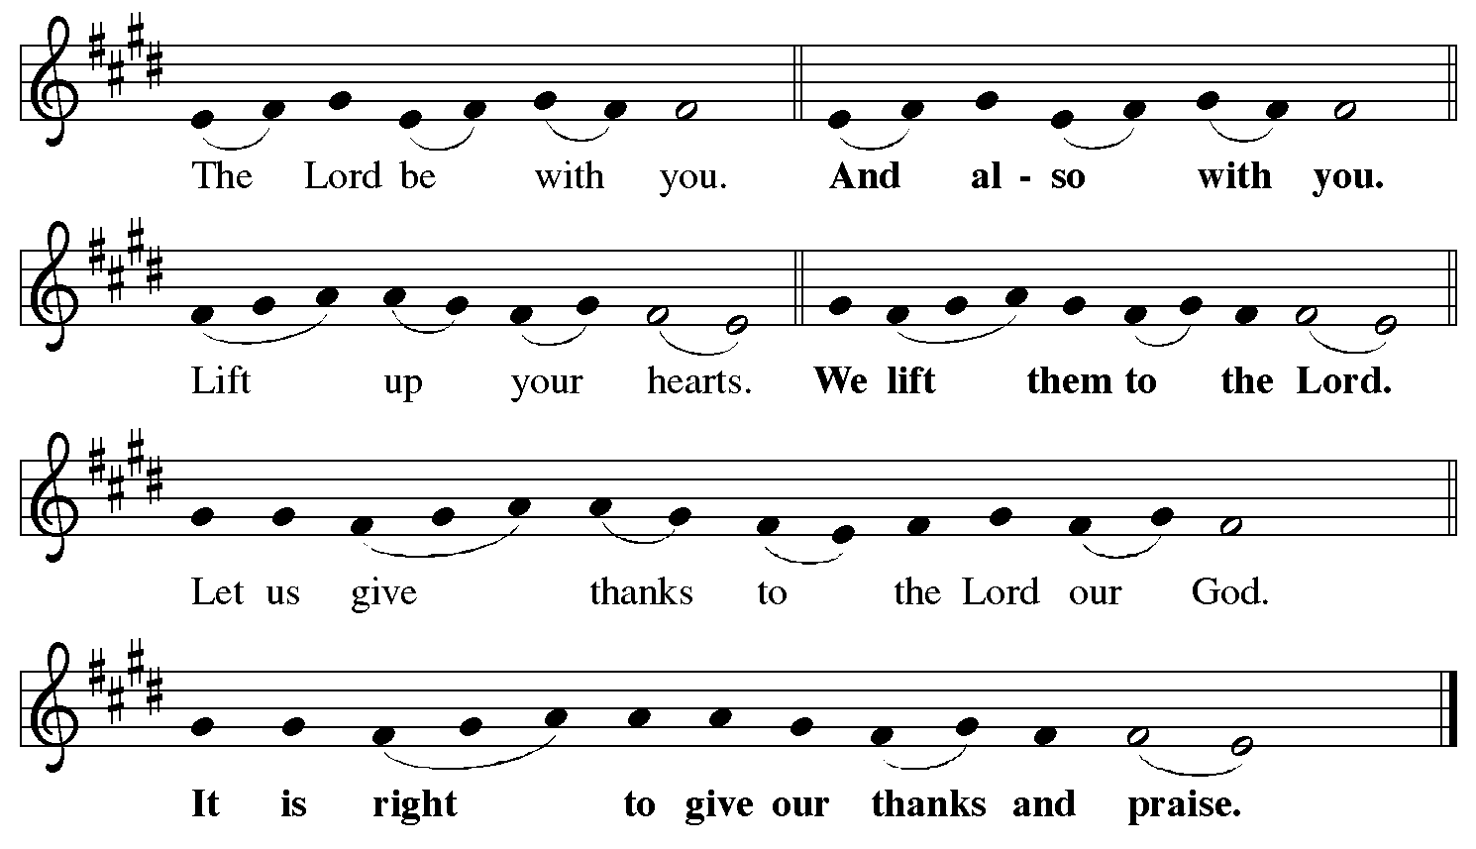

Preface (Sung by the presiding minister)

P: It is indeed right, our duty and our joy,
that we should at all times and in all places
give thanks and praise to you, almighty and merciful God,
for the glorious resurrection of our Savior Jesus Christ,
the true Paschal Lamb who gave himself to take away our sin;
who in dying has destroyed death,
and in rising has brought us to eternal life.
And so, with Mary Magdalene and Peter and all the witnesses of the resurrection,
with earth and sea and all their creatures,
and with angels and archangels, cherubim and seraphim,
we praise your name and join their unending hymn:
Sanctus

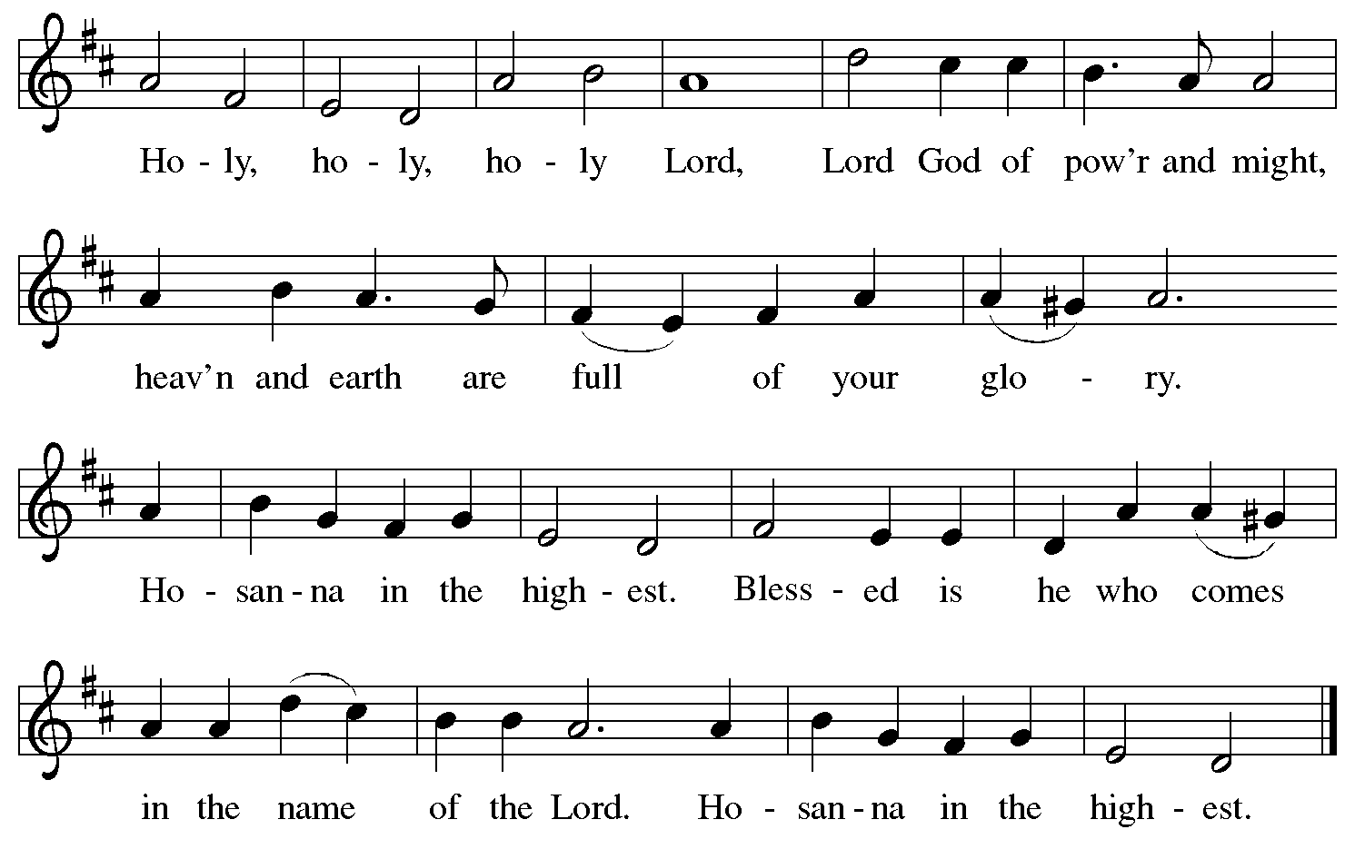

Eucharistic Prayer

P: Blessed are you, O God of the universe …
… for Christ is risen:
C: Christ is risen indeed!

P: This is the day on which you gave light to the earth …
and that light is Christ:
C: Thanks be to God.

P: This is the day on which you broke the chains of death …
… for Christ is risen:
C: Christ is risen indeed!

P: In the night in which he was betrayed …
… Do this for the remembrance of me.

Let us proclaim the mystery of faith.
C: Christ has died. Christ is risen. Christ will come again.

P: On this day send us the power of your Holy Spirit …
… for that light is Christ:
C: Thanks be to God.

P: All holy and mighty and glorious God …
… for Christ is risen:
C: Christ is risen indeed!

P: Amen and Amen!
C: Amen and Amen!

Lord’s Prayer

P: Gathered as one by the Holy Spirit, let us pray as Jesus taught us.
C: Our Father in heaven,
hallowed be your name,
your kingdom come,
your will be done,
on earth as in heaven.
Give us today our daily bread.
Forgive us our sins
as we forgive those
who sin against us.
Save us from the time of trial
and deliver us from evil.
For the kingdom, the power,
and the glory are yours,
now and forever. Amen.

Fraction and Invitation

Agnus Dei / Lamb of God

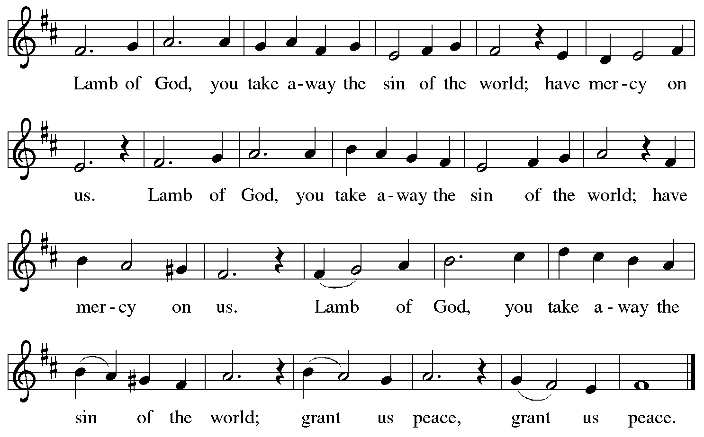

Please be seated.

Holy Communion
- Hand sanitizer is available if you would like to use it prior to receiving Communion.
- Worshipers from the pulpit side will proceed forward first, followed by the center section, and then the lectern side.
- The Communion wafers (regular and gluten-free) have been thoughtfully prepared using the gifts of the congregation by a member of St. Andrew’s altar care team, with a drop of wine or grape juice on each. The presiding minister will distribute one to each communicant.
- When you reach the presiding minister, please indicate if you would like grape juice or a gluten-free wafer.
- A blessing will be provided for anyone who does not yet receive the sacrament.
- A cushion has been placed at the altar rail for anyone who would like to kneel for prayer and reflection before returning to their pew.
- Everyone is asked to wait until you return to your place to consume the elements, and then promptly replace your mask.

Hymns during Holy Communion
At the Lamb’s High Feast We Sing ELW 362

1 At the Lamb's high feast we sing
praise to our victorious king,
who has washed us in the tide
flowing from his wounded side. Alleluia!

2 Praise we Christ, whose love divine
gives his sacred blood for wine,
gives his body for the feast—
Christ the victim, Christ the priest. Alleluia!

4 Praise we Christ, whose blood was shed,
Paschal victim, Paschal bread;
with sincerity and love
eat we manna from above. Alleluia!

6 Now no more can death appall,
now no more the grave enthrall;
you have opened paradise,
and your saints in you shall rise. Alleluia!

7 Easter triumph, Easter joy,
this alone can sin destroy!
From sin's pow'r, Lord, set us free,
newborn souls in you to be. Alleluia!

8 Father, who the crown shall give,
Jesus, by whose death we live
Spirit guide through all our days:
Three in One your name we praise. Alleluia!

Latin hymn, 17th cent.; tr. Robert Campbell, 1814-1868, alt. Music: SONNE DER GERECHTIGKEIT, Bohemian Brethren, Kirchengeseng, 1566.

Hymns during Holy Communion
Thine Is the Glory ELW 376

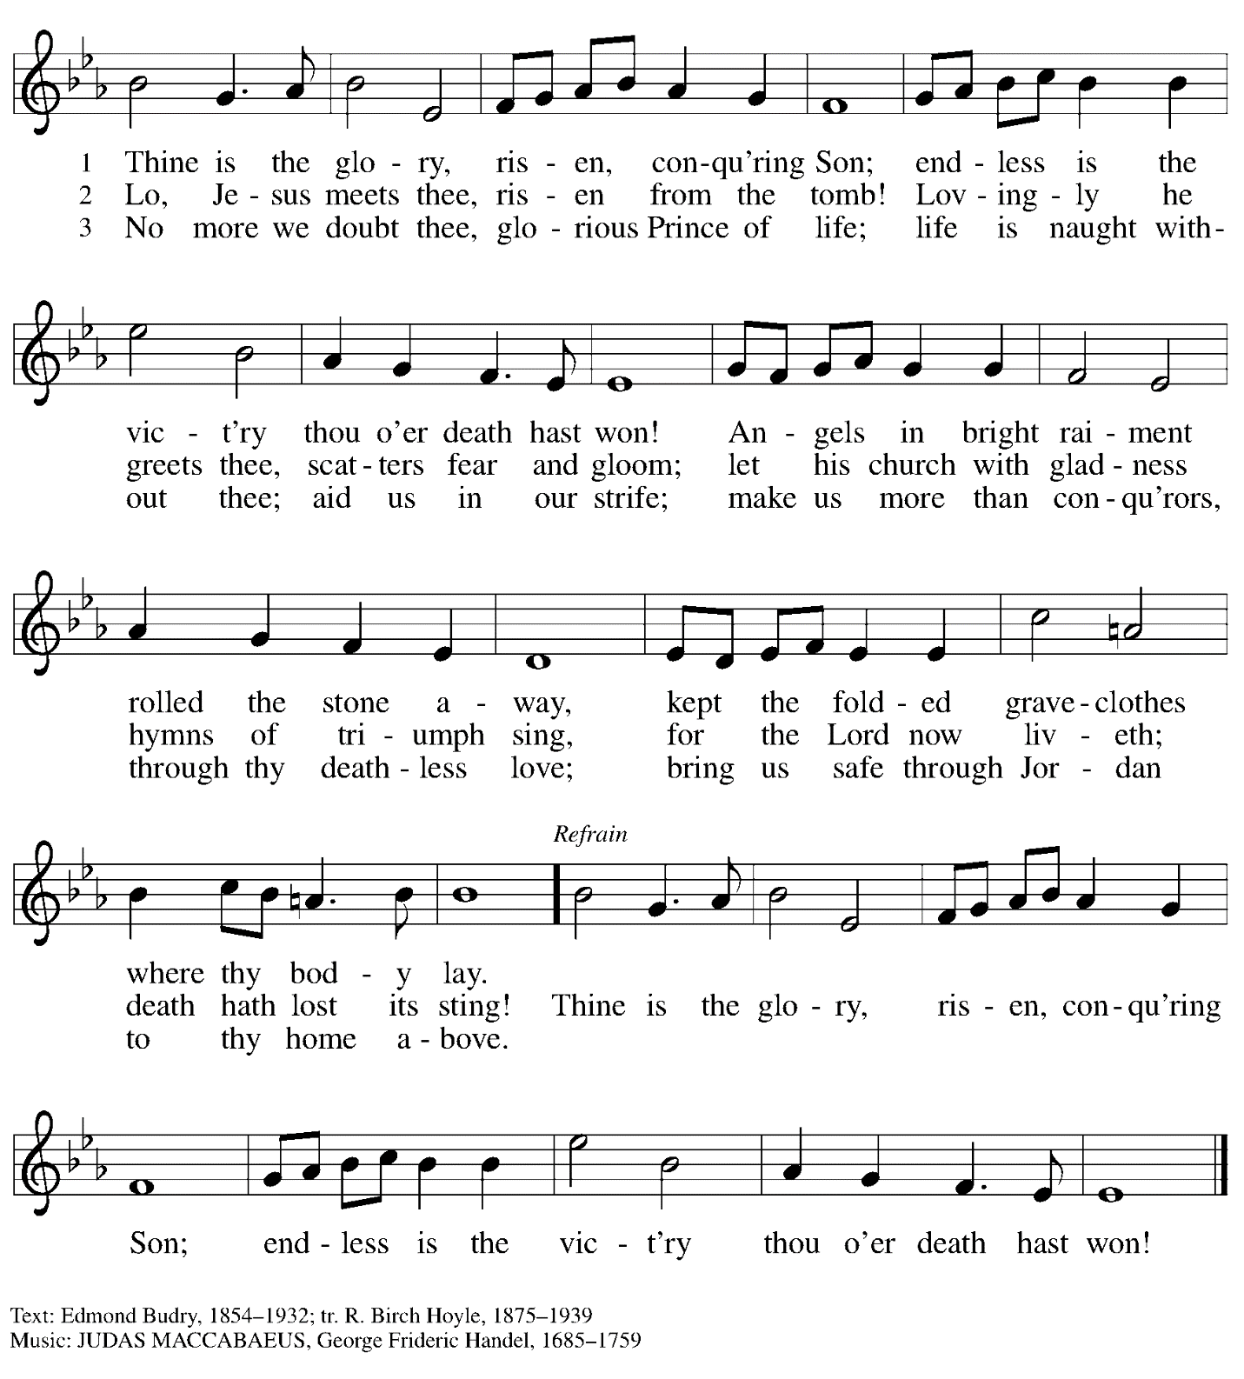

When all have returned to their places, please rise as you are able.

Blessing

P: The body and blood of our Lord Jesus Christ strengthen you and keep you in his grace.
C: Amen.

Prayer

P: Let us pray.
Life-giving God, in the mystery of Christ’s resurrection you send light to conquer darkness, water to give new life, and the bread of life to nourish your people.
Send us forth as witnesses to your Son’s resurrection,
that we may show your glory to all the world,
through Jesus Christ, our risen Lord.
C: Amen.

Service of Sending
God blesses us and sends us in mission to the world

Benediction

P: May our glorious God grant you a spirit of wisdom
to know and love the risen Christ.

Almighty God, holy One, ☩ holy Three,
bless you now and forever.
C: Amen.

Dismissal

P: Go in peace. Share the good news!
C: Thanks be to God!

The full celebration of the Easter resurrection begins tomorrow morning,
with worship at 10:00 a.m.

Abbreviations

P: Pastor/Presiding Minister
L: Lector
C: Congregation

ELW: Evangelical Lutheran Worship hymnal
ACS: All Creation Sings hymnal

Those serving in worship today

Psachal Candle Bearer Isabel Doshi
Organ Jimmi Kocher-Hillmer
Piano Laura Reynolds
Cantors Kristen Asplin
Timothy Kocher-Hillmer
Richard Krug
Lectors Alda Maria Gonzaga
Joseph Paetz
Philip Koch
St. Andrew Youth
Johanna Asplin
Isabel Doshi
Sarita Doshi
Crispin Galyardt
Rachel Faulkner
Dixie Tymitz
Director of Faith Formation Christopher Atwood
Presiding Minister Pastor Ross Carmichael

Liturgy and Hymnody Acknowledgements

From SundaysandSeasons.com. Copyright © 2022 Augsburg Fortress. All rights reserved. Reprinted under OneLicense.net # A-722139.
Used by permission of Augsburg Fortress.

Easter Proclamation from Evangelical Lutheran Worship © 2007 Augsburg Fortress. All rights reserved. Reprinted under OneLicense.net # A-722139.

Fourth Response: Jonah Prayed – Text: Carolyn Jennings, based on Jonah 2: 1-3, 7-9. Music: Carolyn Jennings. Text and music © 2009 Augsburg Fortress. All rights reserved. Permission is granted for reproduction of this item for non-sale local use, provided that each copy carries the copyright notice.

Fifth Response: All You Works of God, Bless the Lord – Text: Stephen P. Starke, paraphrase of Song of the Three 35-65. Music: LINSTEAD, Jamaican folk song, adapt. Doreen Potter. Text © 1995 Stephen P. Starke, admin. Concordia Publishing House. Used by permission. Music © 1975 Hope Publishing Company, Carol Stream, IL 60188. All rights reserved. Reprinted with permission under OneLicense.net # A-722139.

Eucharistic Prayer, For the Resurrection of our Lord: Easter Day – Adapted from Pray, Praise, and Give Thanks: A Collection of Litanies, Laments, and Thanksgivings at Font and Table by Gail Ramshaw, copyright © 2017 Augsburg Fortress. All rights reserved. Reprinted with permission.

