+ The Resurrection of our Lord
Easter Sunday
April 17, 2022
St. Andrew Lutheran Church
304 Morewood Ave.
Pittsburgh, PA 15213
St_andrewELCA@verizon.net
www.standrewpittsburgh.org

+ The Resurrection of our Lord
Easter Sunday
Order for Worship

“The last enemy to be destroyed is death,” Paul writes. Today Christ is risen, and we gather together with astonishment and joy. Christ is risen, and we have been set free from the bonds of death. Christ is risen, and we are forgiven. Christ is risen, and with the women at the tomb and Peter, we are amazed. Let us rejoice: Christ is risen indeed! Alleluia!

A few notes on precautions and protocols, which apply to everyone regardless of vaccination status, as St. Andrew returns to worship in the sanctuary:

- Face masks that fully cover both your mouth and nose are required at all times for everyone over the age of two (2) – the only exception being the brief moment of moving masks aside to partake in Holy Communion.
- Outside food and drink are thus not permissible during worship.
- Physical distancing of at least six (6) feet will be observed at all times for people not from your household.
- We invite the congregation to join in the singing of the hymns (with masks on) during worship!
- Hand sanitizer is available at the front of the sanctuary to use before Holy Communion, after you proceed past the baptismal font, as the alcohol has been affecting the finish on the font’s bowl.

Worship Services are live streamed to multiple online platforms.
By attending worship, you agree that your image and voice may be broadcast.

Pre-Service Music

Welcome

Gathering
The Holy Spirit calls us together as the people of God.

Unburying of Alleluias

Once the Alleluias have been brought out, the presiding minister and congregation proclaim:
P: Alleluia! Christ is risen!
C: Christ is risen indeed! Alleluia! Alleluia!

Please rise as you are able.
Processional Hymn Jesus Christ Is Risen Today ELW 365

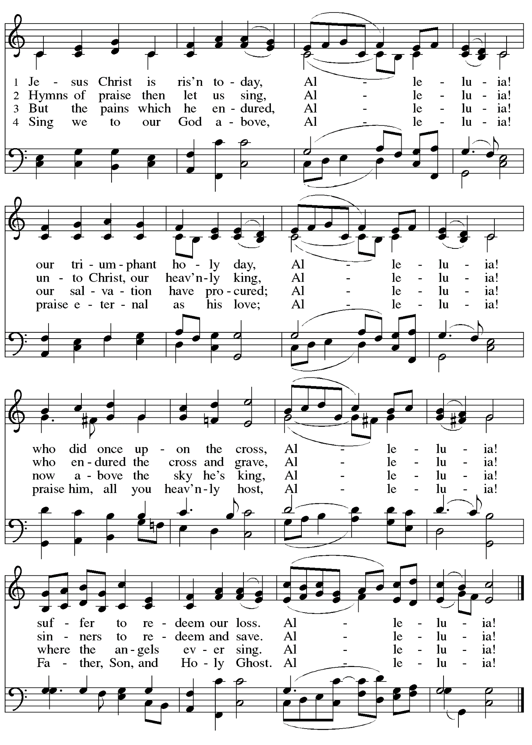
Greeting

P: The grace of our Lord Jesus Christ, the love of God,
and the communion of the Holy Spirit be with you all.
C: And also with you.

Hymn of Praise This Is the Feast ELW p. 149-150

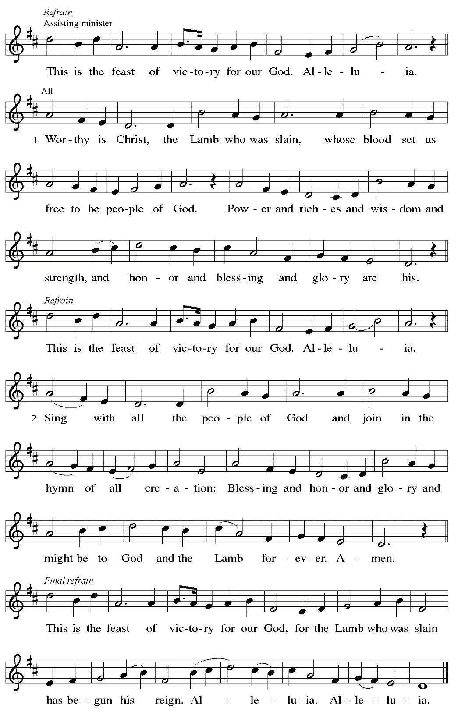

Prayer of the Day

P: The Lord be with you.
C: And also with you.

P: Let us pray.
O God, you gave your only Son to suffer death on the cross for our redemption,
and by his glorious resurrection you delivered us from the power of death.
Make us die every day to sin, that we may live with him forever in the joy of the resurrection, through your Son, Jesus Christ our Lord, who lives and reigns with you and the Holy Spirit,
one God, now and forever.
C: Amen.

Please be seated.

Word
God speaks to us in Scripture reading, preaching, and song

First Reading – Acts 10: 34-43

³⁴Peter began to speak to [the people]: “I truly understand that God shows no partiality, ³⁵but in every nation anyone who fears God and does what is right is acceptable to God. ³⁶You know the message God sent to the people of Israel, preaching peace by Jesus Christ—he is Lord of all. ³⁷That message spread throughout Judea, beginning in Galilee after the baptism that John announced: ³⁸how God anointed Jesus of Nazareth with the Holy Spirit and with power; how he went about doing good and healing all who were oppressed by the devil, for God was with him. ³⁹We are witnesses to all that he did both in Judea and in Jerusalem. They put him to death by hanging him on a tree; ⁴⁰but God raised him on the third day and allowed him to appear, ⁴¹not to all the people but to us who were chosen by God as witnesses, and who ate and drank with him after he rose from the dead. ⁴²He commanded us to preach to the people and to testify that he is the one ordained by God as judge of the living and the dead. ⁴³All the prophets testify about him that everyone who believes in him receives forgiveness of sins through his name.”

L: Word of God, word of life.
C: Thanks be to God.

Psalm 118: 1-12, 14-24

The psalm will be sung responsively, led by the cantor with the congregation responding with the bold verses and refrain.

Refrain
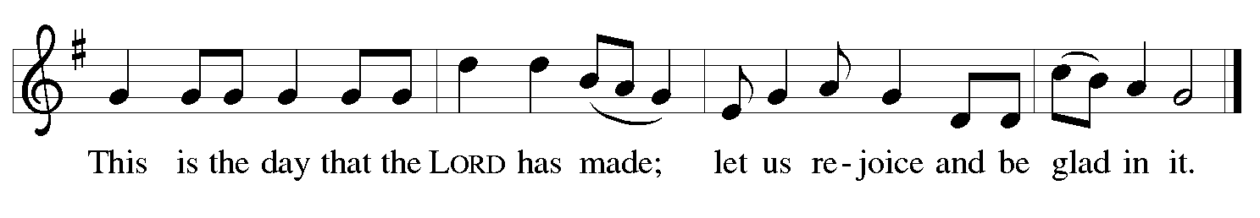

¹Give thanks to the Lord, for the | Lord is good;
God’s mercy en- | dures forever.
²Let Israel | now declare,
“God’s mercy en- | dures forever.”
¹⁴The Lord is my strength | and my song,
and has become | my salvation.
¹⁵Shouts of rejoicing and salvation echo in the tents | of the righteous:
“The right hand of the | Lord acts valiantly!
¹⁶The right hand of the Lord| is exalted!
The right hand of the | Lord acts valiantly!”
¹⁷I shall not | die, but live,
and declare the works | of the Lord. R
¹⁸The Lord indeed pun- | ished me sorely,
but did not hand me o- | ver to death.
¹⁹Open for me the | gates of righteousness;
I will enter them and give thanks | to the Lord.
²⁰“This is the gate | of the Lord;
here the righ- | teous may enter.”
²¹I give thanks to you, for you have | answered me
and you have become | my salvation. R
²²The stone that the build- | ers rejected
has become the chief | cornerstone.
²³By the Lord has | this been done;
it is marvelous | in our eyes.
²⁴This is the day that the | Lord has made;
let us rejoice and be | glad in it. R

Second Reading – 1 Corinthians 15: 19-26

¹⁹If for this life only we have hoped in Christ, we are of all people most to be pitied.
²⁰But in fact Christ has been raised from the dead, the first fruits of those who have died. ²¹For since death came through a human being, the resurrection of the dead has also come through a human being; ²²for as all die in Adam, so all will be made alive in Christ. ²³But each in their own order: Christ the first fruits, then at his coming those who belong to Christ. ²⁴Then comes the end, when he hands over the kingdom to God the Father, after he has destroyed every ruler and every authority and power. ²⁵For he must reign until he has put all his enemies under his feet. ²⁶The last enemy to be destroyed is death.

L: Word of God, word of life.
C: Thanks be to God.

Please rise as you are able.

Gospel Acclamation

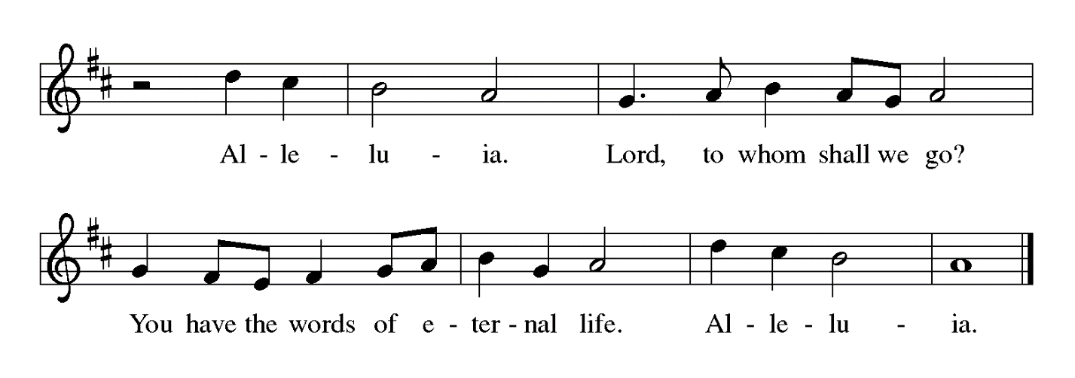

Gospel – Luke 24: 1-12

P: The holy Gospel according to St. Luke.
C: Glory to you, O Lord.

¹On the first day of the week, at early dawn, [the women] came to the tomb, taking the spices that they had prepared. ²They found the stone rolled away from the tomb, ³but when they went in, they did not find the body. ⁴While they were perplexed about this, suddenly two men in dazzling clothes stood beside them. ⁵The women were terrified and bowed their faces to the ground, but the men said to them, “Why do you look for the living among the dead? He is not here, but has risen. ⁶Remember how he told you, while he was still in Galilee, ⁷that the Son of Man must be handed over to sinners, and be crucified, and on the third day rise again.” ⁸Then they remembered his words, ⁹and returning from the tomb, they told all this to the eleven and to all the rest. ¹⁰Now it was Mary Magdalene, Joanna, Mary the mother of James, and the other women with them who told this to the apostles. ¹¹But these words seemed to them an idle tale, and they did not believe them. ¹²But Peter got up and ran to the tomb; stooping and looking in, he saw the linen cloths by themselves; then he went home, amazed at what had happened.

P: The Gospel of the Lord.
C: Praise to you, O Christ.

Please be seated.

Sermon

A time of silence for prayer and reflection follows the sermon.
When the hymn of the day begins, please rise as you are able.

Hymn of the Day Christ Is Risen! Alleluia! ELW 382

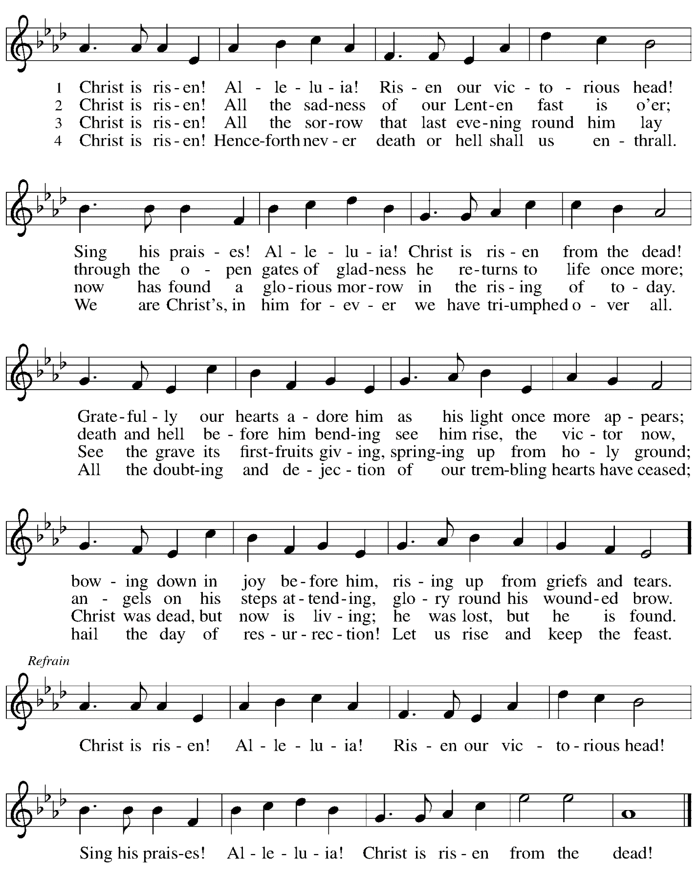
Prayers of the People

P: On this day of resurrection joy, we offer our prayers for the church, the world,
and all who are in need.

After each petition
P: Gracious God,
C: receive our prayer.

P: We offer these petitions and those we carry in our hearts, O God,
trusting in your abundant and ever-present mercy, through Jesus Christ our risen Savior.
C: Amen.

Please be seated.

Meal

Offering

We offer ourselves, our gifts, and our faithful service to God.
An usher will pass around an offering plate for anyone who would like to offer gifts before God.

Music during the Offering

Offertory Song Let the Vineyards Following Page

Offertory Song Let the Vineyards ELW 184

Please rise as you are able.

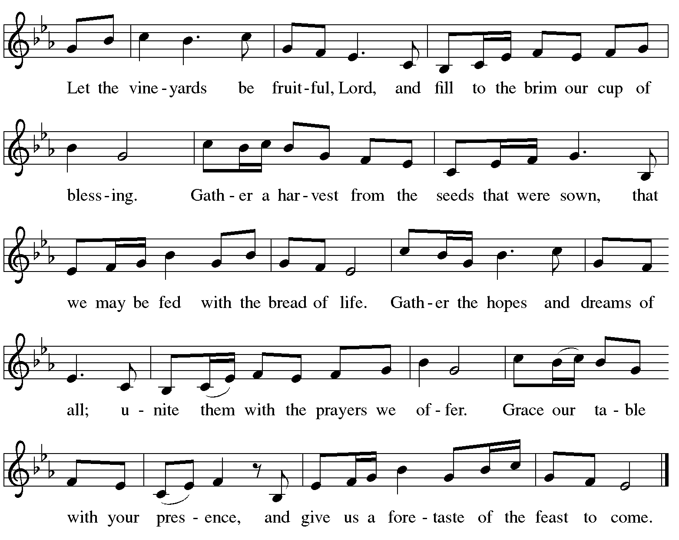

Offertory Prayer

P: Let us pray.
Blessed are you, O God,
C: ruler of heaven and earth.
Day by day you shower us with blessings.
As you have raised us to new life in Christ, give us glad and generous hearts,
ready to praise you and to respond to those in need,
through Jesus Christ, our Savior and Lord.
Amen.

Dialogue

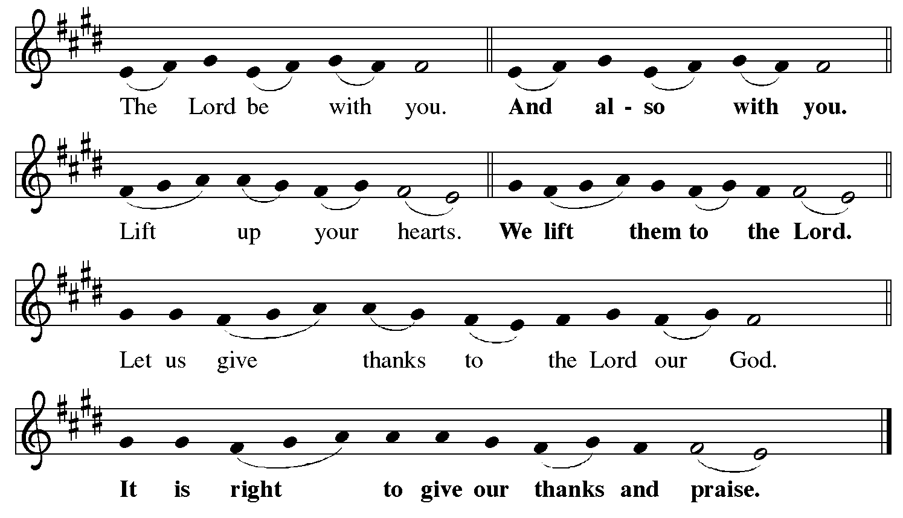

Preface (Sung by the presiding minister)

P: It is indeed right, our duty and our joy,
that we should at all times and in all places
give thanks and praise to you, almighty and merciful God,
for the glorious resurrection of our Savior Jesus Christ,
the true Paschal Lamb who gave himself to take away our sin;
who in dying has destroyed death,
and in rising has brought us to eternal life.
And so, with Mary Magdalene and Peter and all the witnesses of the resurrection,
with earth and sea and all their creatures,
and with angels and archangels, cherubim and seraphim,
we praise your name and join their unending hymn:

Sanctus

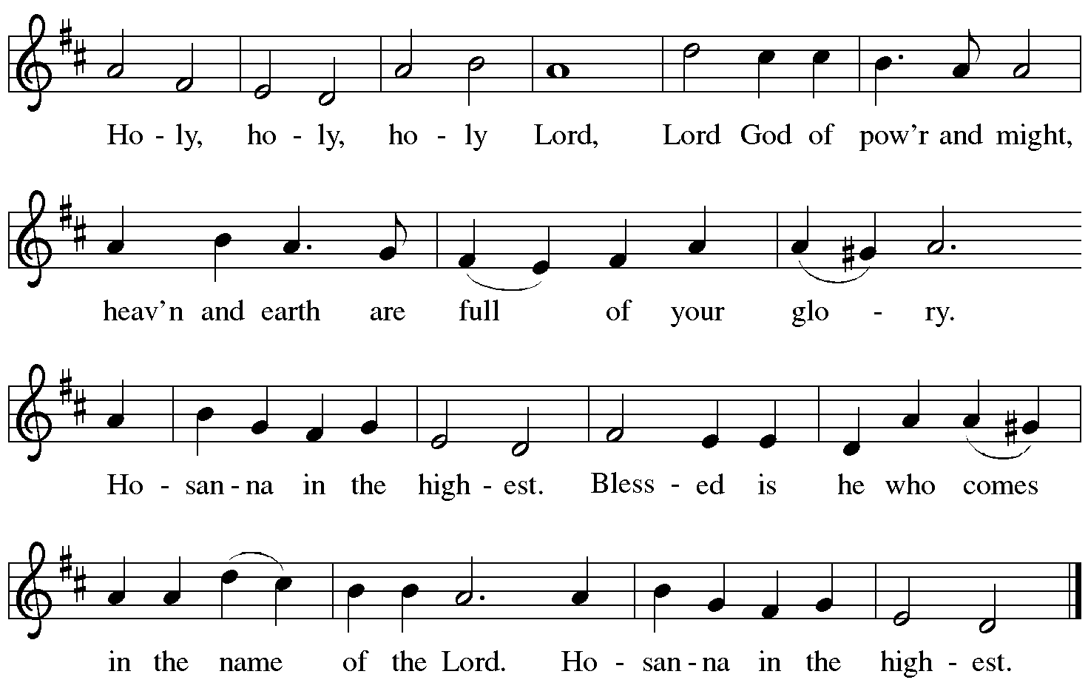

Eucharistic Prayer

P: Blessed are you, O God of the universe …
For Christ is risen:
C: Christ is risen indeed!

P: This is the day on which you gave light to the earth …
and that light is Christ:
C: Thanks be to God.

P: This is the day on which you broke the chains of death …
For Christ is risen:
C: Christ is risen indeed!

P: In the night in which he was betrayed …
… Do this for the remembrance of me.

Let us proclaim the mystery of faith.
C: Christ has died. Christ is risen. Christ will come again.

P: On this day send us the power of your Holy Spirit …
For that light is Christ:
C: Thanks be to God.

P: All holy and mighty and glorious God …
… for Christ is risen:
C: Christ is risen indeed!

P: Amen and Amen!
C: Amen and Amen!

Lord’s Prayer

P: Gathered as one by the Holy Spirit, let us pray as Jesus taught us.
C: Our Father in heaven,
hallowed be your name,
your kingdom come,
your will be done,
on earth as in heaven.
Give us today our daily bread.
Forgive us our sins
as we forgive those
who sin against us.
Save us from the time of trial
and deliver us from evil.
For the kingdom, the power,
and the glory are yours,
now and forever. Amen.

Fraction and Invitation

P: Alleluia! Christ is risen!
C: Christ is risen indeed! Alleluia! Alleluia!

P: This is the feast of victory for our God. Alleluia! Alleluia!
Come, share the feast.

Agnus Dei / Lamb of God Following Page

Agnus Dei / Lamb of God

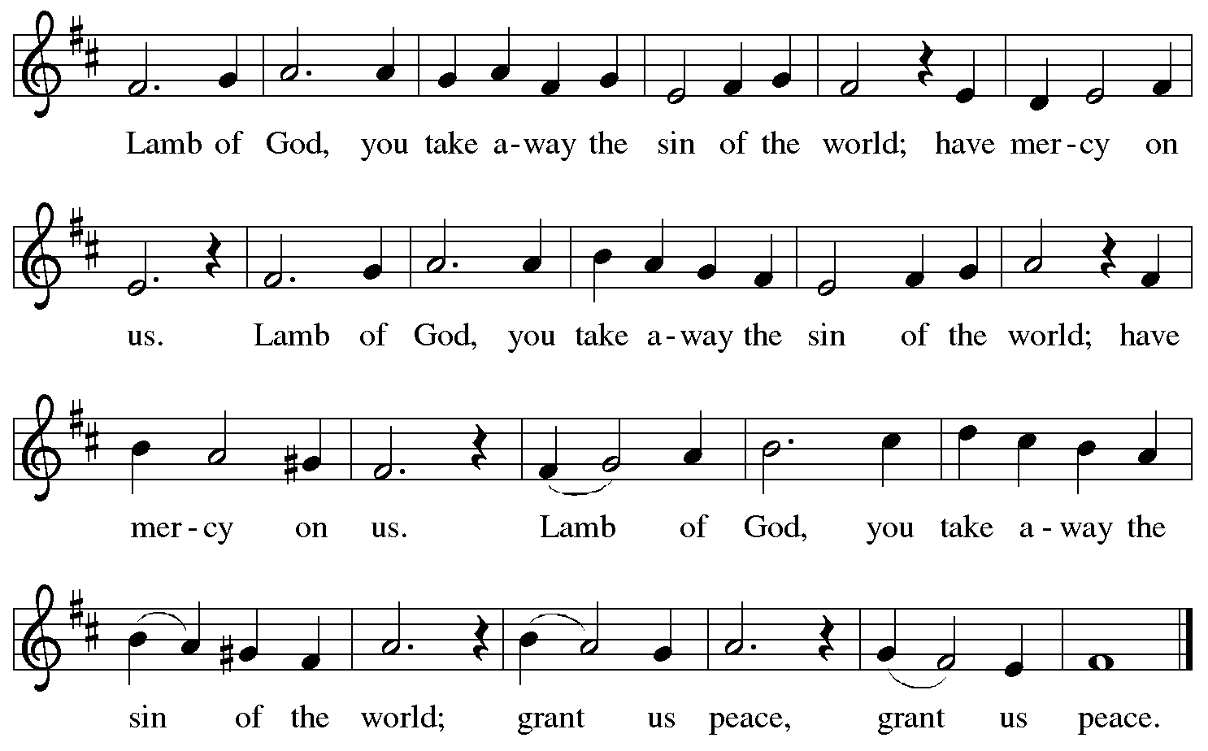

Please be seated.

Holy Communion
- Hand sanitizer is available if you would like to use it prior to receiving Communion.
- Worshipers from the pulpit side will proceed forward first, followed by the center section, and then the lectern side.
- The Communion wafers (regular and gluten-free) have been thoughtfully prepared using the gifts of the congregation by a member of St. Andrew’s altar care team, with a drop of wine or grape juice on each. The presiding minister will distribute one to each communicant.
- When you reach the presiding minister, please indicate if you would like grape juice or a gluten-free wafer.
- A blessing will be provided for anyone who does not yet receive the sacrament.
- A cushion has been placed at the altar rail for anyone who would like to kneel for prayer and reflection before returning to their pew.
- Everyone is asked to wait until you return to your place to consume the elements, and then promptly replace your mask.

Hymns during Holy Communion
Lord, Enthroned in Heavenly Splendor ELW 475

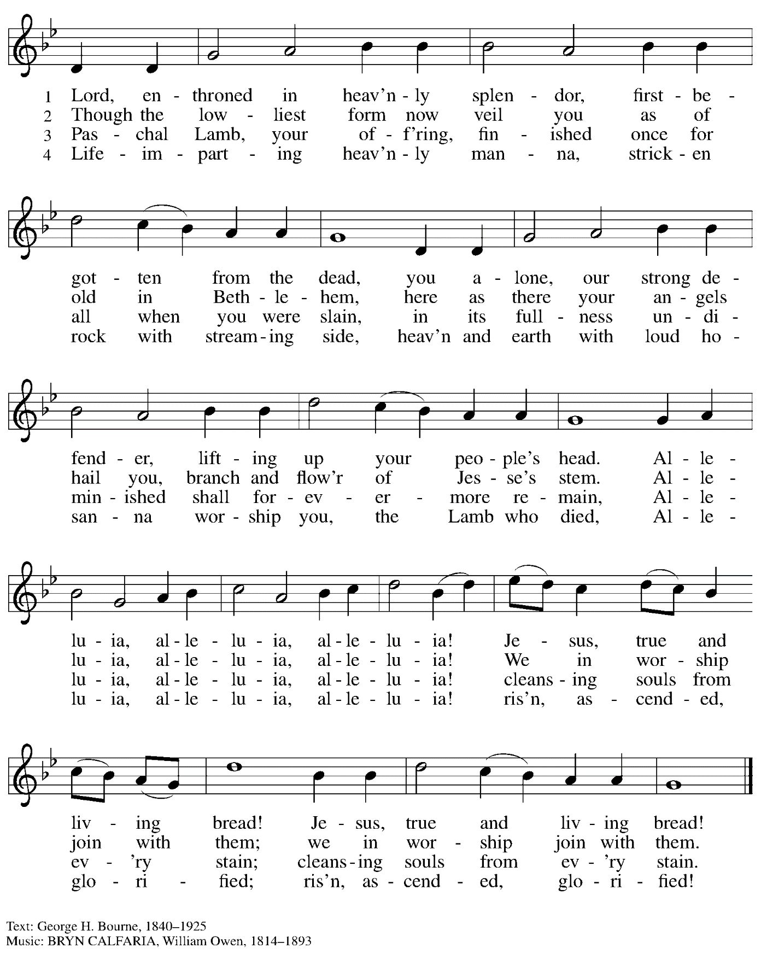

Hymns during Holy Communion
Alleluia! Jesus Is Risen! ELW 377

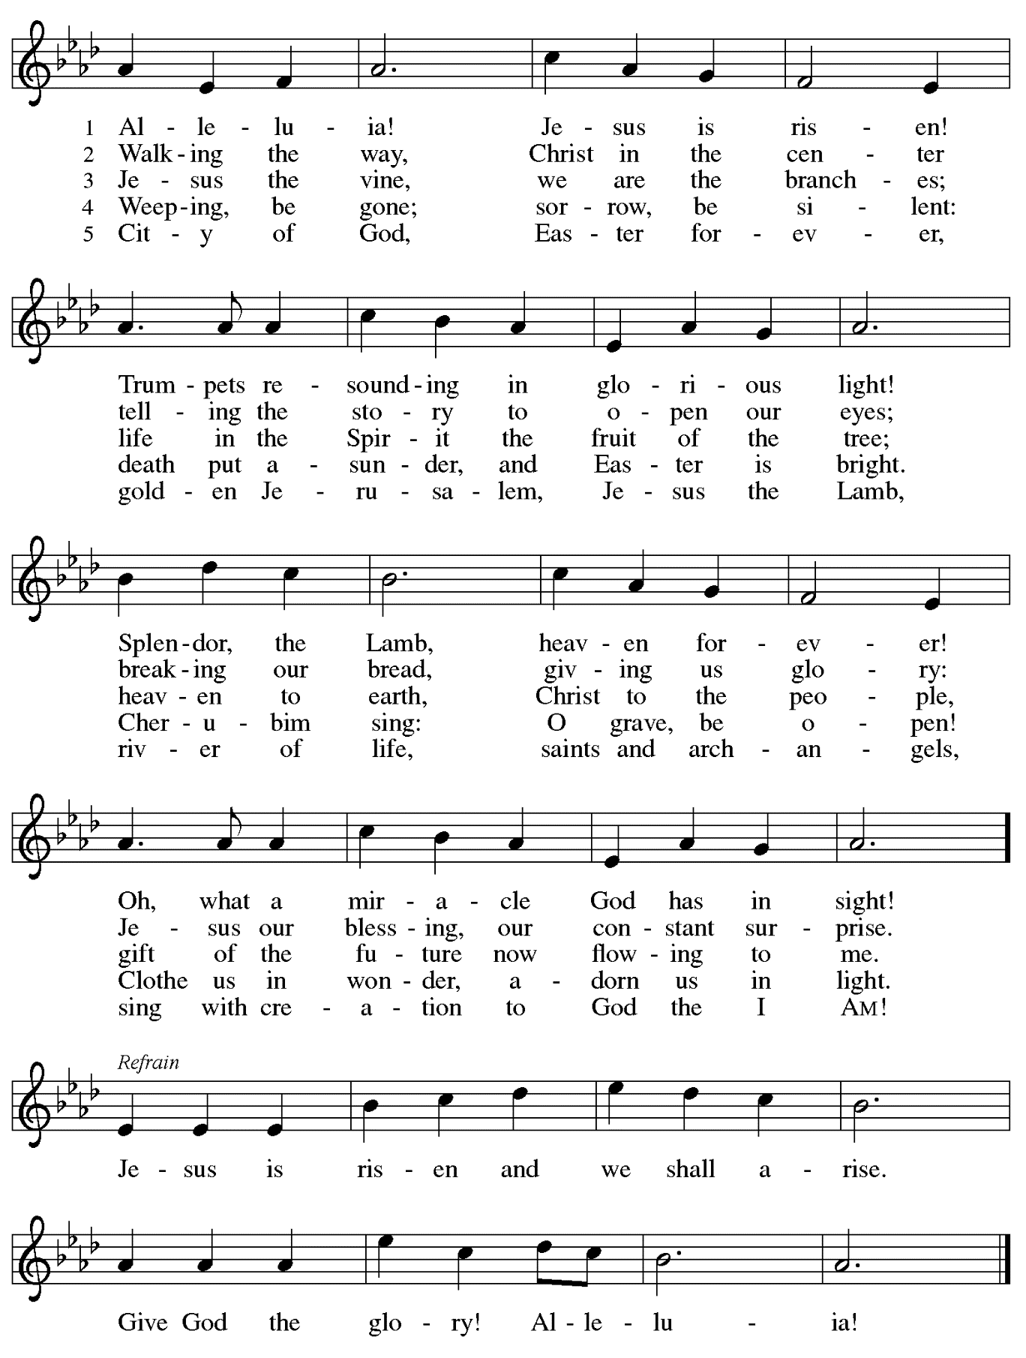
Hymns during Holy Communion
This Joyful Eastertide ELW 391

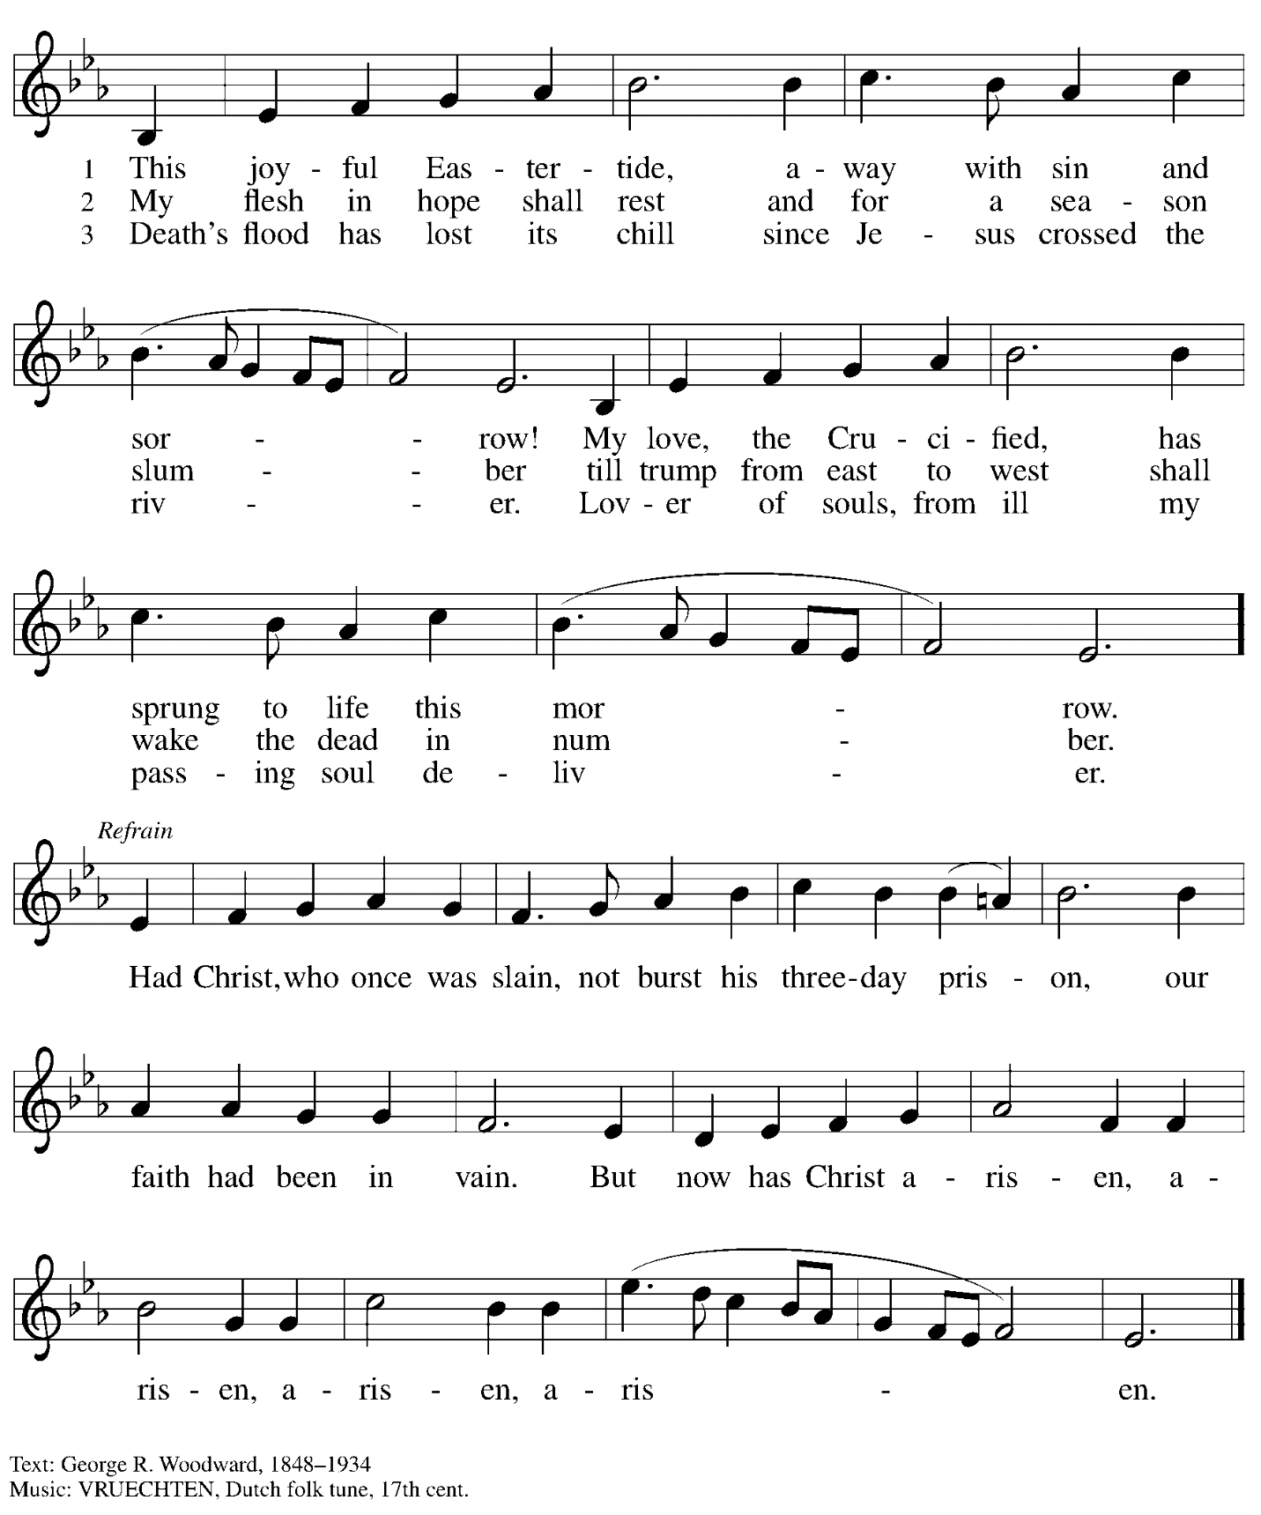

When all have returned to their places, please rise as you are able.

Blessing

P: The body and blood of our Lord Jesus Christ strengthen you and keep you in his grace.
C: Amen.

Prayer

P: Let us pray.
Life-giving God,
in the mystery of Christ’s resurrection, you send light to conquer darkness,
water to give new life, and the bread of life to nourish your people.
Send us forth as witnesses to your Son’s resurrection,
that we may show your glory to all the world,
through Jesus Christ, our risen Lord.
C: Amen.

Sending

Benediction

P: May our glorious God grant you a spirit of wisdom
to know and love the risen Christ.

Almighty God, holy One, ☩ holy Three,
bless you now and forever.
C: Amen.

Recessional Hymn Now All the Vault of Heaven Resounds Following page

Recessional Hymn Now All the Vault of Heaven Resounds ELW 367

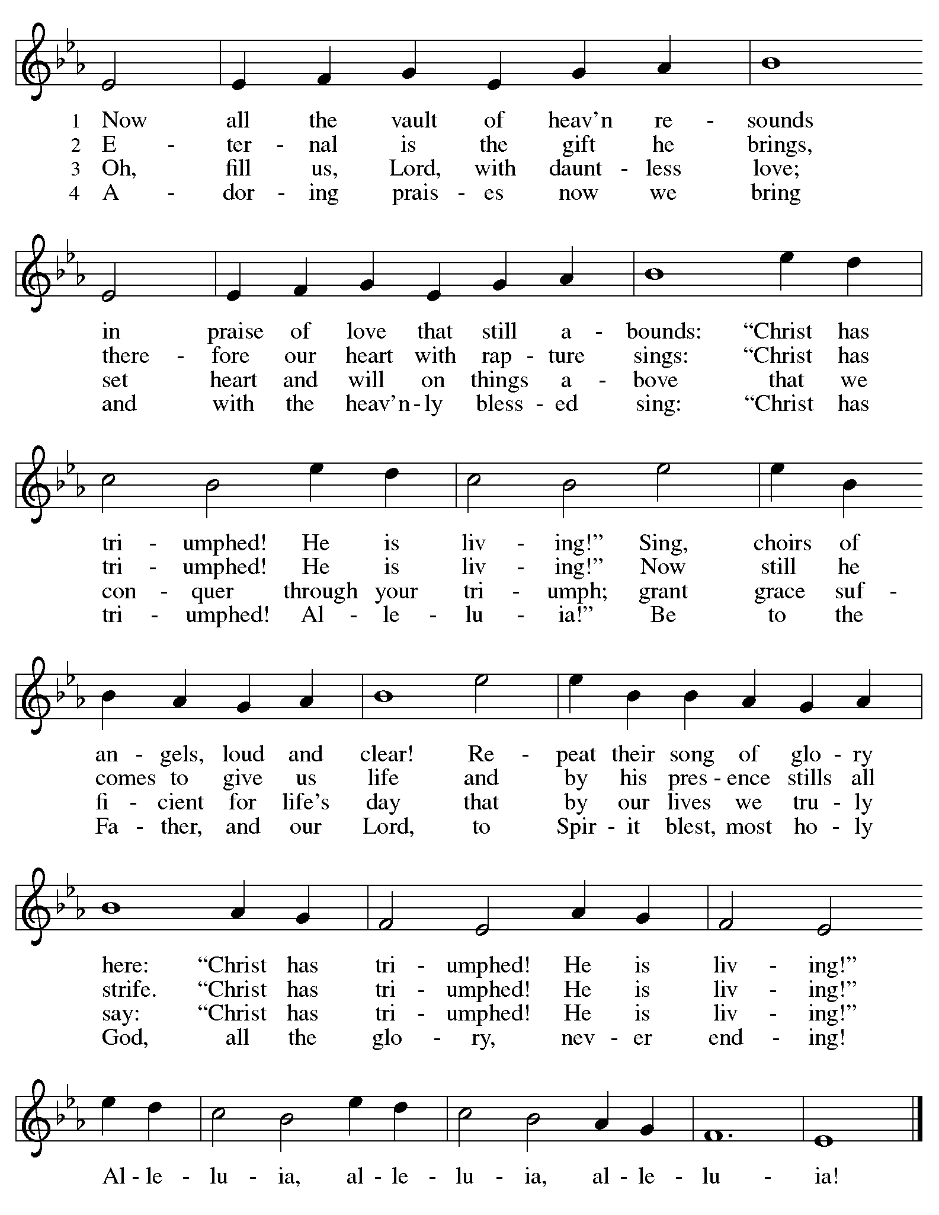
Dismissal

P: Alleluia! Christ is risen!
C: Christ is risen indeed! Alleluia! Alleluia!

P: Go in peace. Share the good news!
C: Thanks be to God!

Postlude

Abbreviations

P: Pastor/Presiding Minister
L: Lector
C: Congregation

ELW: Evangelical Lutheran Worship hymnal

Those serving in worship today

Crucifer Johanna Asplin
Organ Jimmi Kocher-Hillmer
Piano Lily Cai
Cantor Timothy Kocher-Hillmer
Lector Lester Prince
Director of Faith Formation Christopher Atwood
Presiding Minister Pastor Ross Carmichael

Liturgy and Hymnody Acknowledgements

From SundaysandSeasons.com. Copyright © 2022 Augsburg Fortress. All rights reserved. Reprinted under OneLicense.net # A-722139.
Used by permission of Augsburg Fortress.

Jesus Christ Is Risen - Text: Latin carol, 14th cent., sts. 1-3; tr. J. Walsh, Lyra Davidica, 1708, alt.; Charles Wesley, 1707-1788, st. 4. Music: EASTER HYMN, J. Walsh, Lyra Davidica, 1708.

This Is the Day – Psalm Refrain – Psalm 118: 24. Psalm refrain reproduced from Psalter for Worship Year C © 2006 Augsburg Fortress.

Christ Is Risen! Alleluia! – Text: John S. B. Monsell, 1811-1875, alt. Music: MORGANLIED, Frederick C. Maker, 1844-1927.

Eucharistic Prayer, For the Resurrection of our Lord: Easter Day – Adapted from Pray, Praise, and Give Thanks: A Collection of Litanies, Laments, and Thanksgivings at Font and Table by Gail Ramshaw, copyright © 2017 Augsburg Fortress. All rights reserved. Reprinted with permission.

Let the Vineyards – Text: John W. Arthur, 1922-1980. Music: Ronald A. Nelson, b. 1927. Text and Music © 1978 Lutheran Book of Worship, admin. Augsburg Fortress.

Alleluia! Jesus Is Risen! – Text: Herbert F. Brokering, b. 1926. Music: David N. Johnson, 1922-1987. Text © 1995 Augsburg Fortress. Music © 1969 Contemporary Worship 1, admin. Augsburg Fortress. All rights reserved. Reprinted with permission under OneLicense.net # A722139.

Now All the Vault of Heaven Resounds – Text: Paul Z. Strodach, 1876-1947, alt. Music: LASST UNS ERFREUEN, Geistliche Kirchengesänge, Köln, 1623. Text © 1958 Service Book and Hymnal, admin. Augsburg Fortress. All rights reserved. Reprinted with permission under OneLicense.net # A-722139.

