

**+ Triduum – Good Friday**

**April 15, 2022**





**St. Andrew Lutheran Church**

**304 Morewood Ave.**

**Pittsburgh, PA 15213**

[**St_andrewELCA@verizon.net**](mailto:St_andrewELCA@verizon.net)

[**www.standrewpittsburgh.org**](http://www.standrewpittsburgh.org)

**+ Triduum – Good Friday**

**Order for Worship**

*Life and death are side by side as we enter into Good Friday.*

*Jesus reveals the power and glory of God, even as he is put on trial and sentenced to death. Standing with the disciples at the foot of the cross, we pray for the whole world in the ancient bidding prayer, as Christ’s death offers life to all. We gather in solemn devotion, but always with the promise that the tree around which we assemble is indeed a tree of life. We depart silently, and we anticipate the culmination of the Three Days in the Easter Vigil*

*Tonight’s service will be a Tenebrae service, from a Latin word for darkness. As we read through the seven last words of Jesus from the various Gospels, candles will be extinguished as the church moves more deeply into the darkness of Good Friday. Worship for this evening concludes with adoration of the cross and the crucified Jesus, which brings the promise of salvation to the world.*

***A few notes on precautions and protocols, which apply to everyone regardless of vaccination status****,* ***as St. Andrew returns to worship in the sanctuary:***

* Face masks that fully cover both your mouth and nose are required at all times for everyone over the age of two (2).
* Outside food and drink are thus not permissible during worship.
* Physical distancing of at least six (6) feet will be observed at all times for people not from your household.
* We invite the congregation to join in the singing of the hymns (with masks on) during worship!

***Worship Services are live streamed to multiple online platforms.***

***By attending worship, you agree that your image and voice may be broadcast.***

*Worship begins in silence.*

*Please rise as you are able.*

**Prayer of the Day**

P: Let us pray.

Almighty God, look with loving mercy on your human family, for whom our Lord Jesus Christ was willing to be betrayed, to be given over to the hands of sinners, and to suffer death on the cross; the one who now lives and reigns with you and the Holy Spirit, one God, now and forever.

**C: Amen.**

*Please be seated.*

**First Word Luke 23: 32-34**

32Two others also, who were criminals, were led away to be put to death with him. 33When they came to the place that is called The Skull, they crucified Jesus there with the criminals, one on his right and one on his left. [[ 34Then Jesus said, "Father, forgive them; for they do not know what they are doing."]] And they cast lots to divide his clothing.

**Response Ah, Holy Jesus *ELW* 349**

**v. 1-2, 4**

**1 Ah, holy Jesus, how hast thou offended**

**that we to judge thee have in hate pretended?**

**By foes derided, by thine own rejected,**

**O most afflicted.**

**2 Who was the guilty? Who brought this upon thee?**

**Alas, my treason, Jesus, hath undone thee.**

**'Twas I, Lord Jesus, I it was denied thee;**

**I crucified thee.**

**4 For me, kind Jesus, was thine incarnation,**

**thy mortal sorrow, and thy life's oblation;**

**thy death of anguish and thy bitter passion,**

**for my salvation.**

Text: Johann Heermann, 1585-1647; tr. Robert Bridges, 1844-1930, alt. Music: HERZLIEBSTER JESU, Johann Crüger, 1598-1662.

**Second Word Luke 23: 39-43**

39One of the criminals who were hanged there kept deriding him and saying, "Are you not the Messiah? Save yourself and us!" 40But the other rebuked him, saying, "Do you not fear God, since you are under the same sentence of condemnation? 41And we indeed have been condemned justly, for we are getting what we deserve for our deeds, but this man has done nothing wrong." 42Then he said, "Jesus, remember me when you come into your kingdom." 43He replied, "Truly I tell you, today you will be with me in Paradise."

**Response Jesus, Remember Me *ELW* 616**

*Jesus, Remember Me is a hymn in the Taizé style,*

*sung multiple times to aid in focused meditation.*

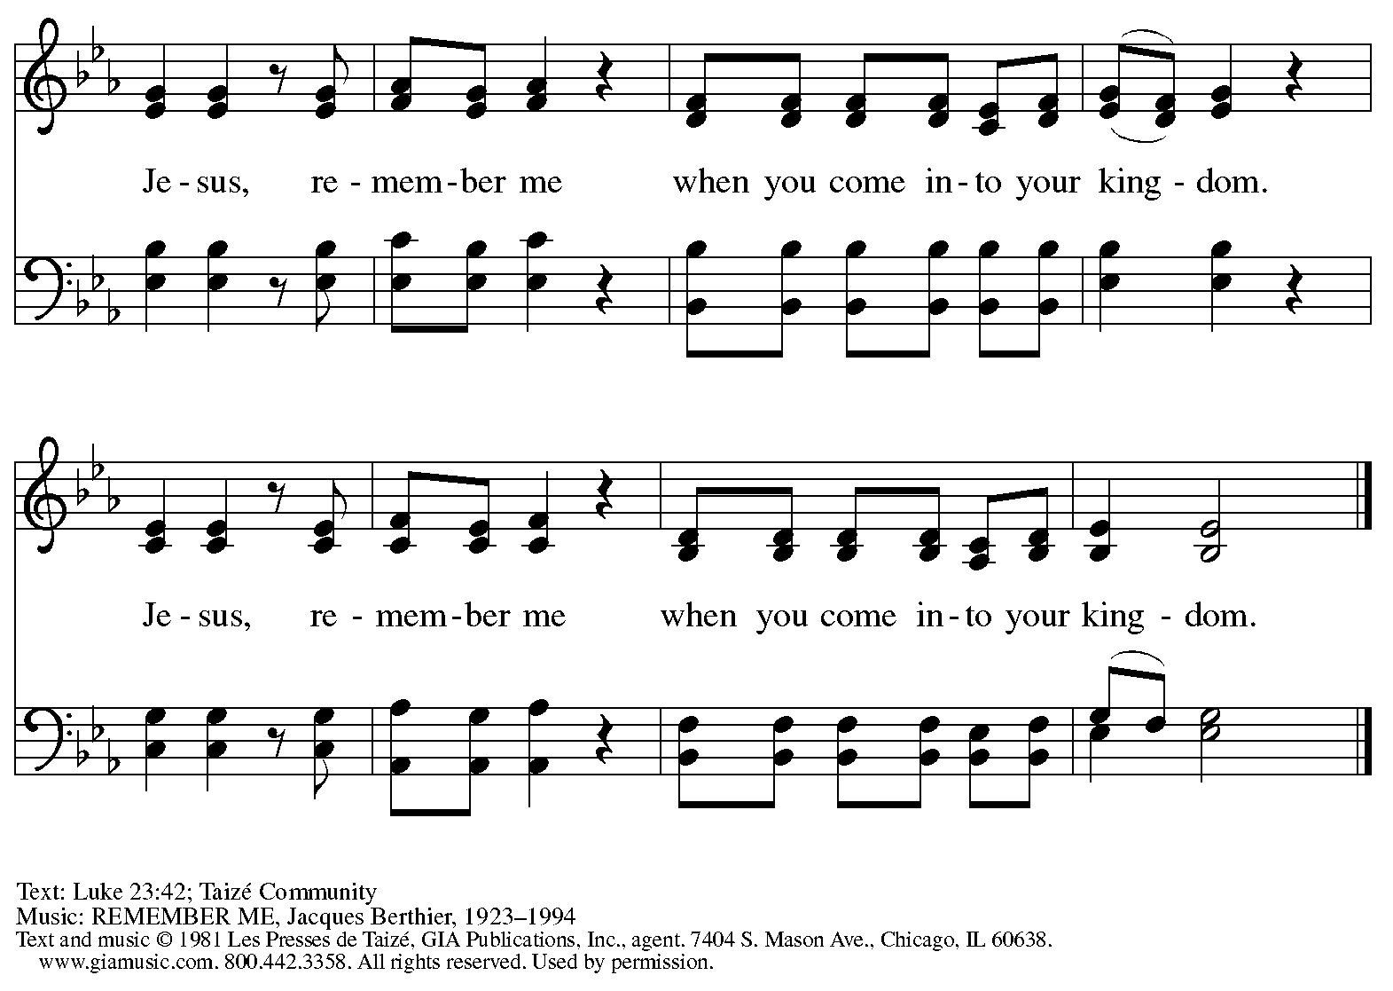

Reprinted with permission under OneLicense.net # A-722139.

**Third Word John 19: 25b-27**

Meanwhile, standing near the cross of Jesus were his mother, and his mother's sister, Mary the wife of Clopas, and Mary Magdalene. 26When Jesus saw his mother and the disciple whom he loved standing beside her, he said to his mother, "Woman, here is your son." 27Then he said to the disciple, "Here is your mother." And from that hour the disciple took her into his own home.

**Response Bidding Prayer**

*The Bidding Prayer is the traditional prayer of the Christian church on Good Friday.*

*The assisting minister leads the invitations to prayer (the bids).*

*Silence for prayer follows each bid.*

*The presiding minister leads the prayers that conclude the silence.*

*At the conclusion of each prayer,* “… through Christ our Lord,”

*the assembly responds,* **C: Amen.**

*The assembly prays for the following:*

*the church throughout the world*

*leaders in the church*

*those preparing for Baptism*

*Christians in other churches*

*the Jewish people, the first to hear the word of God*

*those who do not share our faith in Christ*

*those who do not believe in God*

*God’s creation*

*those who serve in public office*

*those in need*

*The prayers conclude:*

A: Finally, let us pray for all those things for which our Lord would have us ask.

**C: Our Father in heaven,**

**hallowed be your name,**

**your kingdom come,**

**your will be done,**

**on earth as in heaven.**

**Give us today our daily bread.**

**Forgive us our sins**

**as we forgive those**

**who sin against us.**

**Save us from the time of trial**

**and deliver us from evil.**

**For the kingdom, the power,**

**and the glory are yours,**

**now and forever. Amen.**

**Fourth Word Matthew 27: 45-49**

45From noon on, darkness came over the whole land until three in the afternoon. 46And about three o'clock Jesus cried with a loud voice, "Eli, Eli, lema sabachthani?" that is, "My God, my God, why have you forsaken me?" 47When some of the bystanders heard it, they said, "This man is calling for Elijah." 48At once one of them ran and got a sponge, filled it with sour wine, put it on a stick, and gave it to him to drink. 49But the others said, "Wait, let us see whether Elijah will come to save him."

**Response Psalm 22**

*The psalm will be led by the cantors. The congregation is invited to join in singing the refrain,*

*as indicated by the* ***R.***

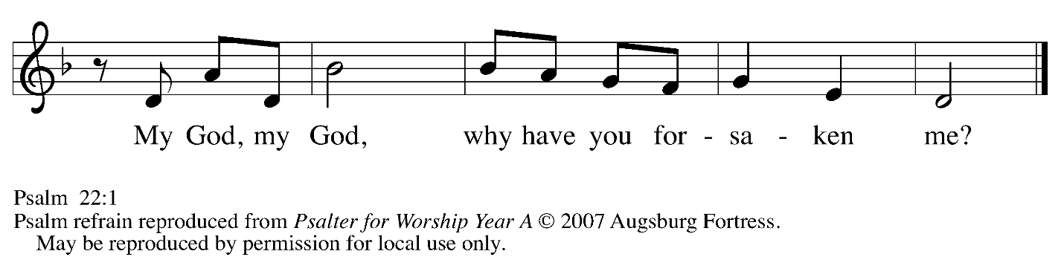

My God, my God, why have you for- | saken me?

Why so far from saving me, so far from the words | of my groaning?

2**My God, I cry out by day, but you | do not answer;**

**by night, but I | find no rest.**

3Yet you are the | Holy One,

enthroned on the prais- | es of Israel.

4**Our ancestors put their | trust in you,**

**they trusted, and you | rescued them. *R***

5They cried out to you and | were delivered;

they trusted in you and were not | put to shame.

6**But as for me, I am a worm | and not human,**

**scorned by all and despised | by the people.**

7All who see me laugh | me to scorn;

they curl their lips; they | shake their heads.

8**"Trust in the LORD; let the | LORD deliver;**

**let God rescue him if God so de- | lights in him." *R***

9Yet you are the one who drew me forth | from the womb,

and kept me safe on my | mother's breast.

10**I have been entrusted to you ever since | I was born;**

**you were my God when I was still in my | mother's womb.**

11Be not far from me, for trou- | ble is near,

and there is no | one to help.

12**Many young bulls en- | circle me;**

**strong bulls of Ba- | shan surround me. *R***

13They open wide their | jaws at me,

like a slashing and | roaring lion.



*Psalm 22 continues*

14**I am poured out like water; all my bones are | out of joint;**

**my heart within my breast is | melting wax.**

15My strength is dried up like a potsherd; my tongue sticks to the roof | of my mouth;

and you have laid me in the | dust of death.

16**Packs of dogs close me in, a band of evildoers | circles round me;**

**they pierce my hands | and my feet. *R***

17I can count | all my bones

while they stare at | me and gloat.

18**They divide my gar- | ments among them;**

**for my clothing, | they cast lots.**

19But you, O LORD, be not | far away;

O my help, hasten | to my aid.

20**Deliver me | from the sword,**

**my life from the power | of the dog.**

21Save me from the | lion's mouth!

From the horns of wild bulls you have | rescued me.

22**I will declare your name | to my people;**

**in the midst of the assembly | I will praise you. *R***

23You who fear the LORD, give praise! All you of Jacob's | line, give glory.

Stand in awe of the LORD, all you off- | spring of Israel.

24**For the LORD does not despise nor abhor the poor in their poverty;**

**neither is the LORD's face hid- | den from them;**

**but when they cry out, | the LORD hears them.**

25From you comes my praise in the | great assembly;

I will perform my vows in the sight of those who | fear the LORD.

26**The poor shall eat | and be satisfied.**

**Let those who seek the LORD give praise! May your hearts | live forever!**

27All the ends of the earth shall remember and turn | to the LORD;

all the families of nations shall bow | before God.

28**For dominion belongs | to the LORD,**

**who rules o- | ver the nations. *R***

29Indeed all who sleep in the earth shall bow | down in worship;

all who go down to the dust, though they be dead, shall kneel be- | fore the LORD.

30**Their descendants shall | serve the LORD,**

**whom they shall proclaim to genera- | tions to come.**

31They shall proclaim God's deliverance to a people | yet unborn,

saying to them, "The | LORD has acted!" ***R***

Reprinted from *Words for Worship*, copyright 2007 Augsburg Fortress.

Used by permission of Augsburg Fortress.

**Fifth Word John 19: 28-29**

28After this, when Jesus knew that all was now finished, he said (in order to fulfill the scripture), "I am thirsty." 29A jar full of sour wine was standing there. So they put a sponge full of the wine on a branch of hyssop and held it to his mouth.

**Response Isaiah 52: 13 – 53: 12**

*The response from Isaiah will be read responsively, led by the cantors, with the congregation joining in the alternate verses, indicated in bold.*

13See, my servant shall prosper;  
  he shall be exalted and lifted up,  
  and shall be very high.  
**14Just as there were many who were astonished at him  
  —so marred was his appearance, beyond human semblance,  
  and his form beyond that of mortals—**  
 15so he shall startle many nations;  
  kings shall shut their mouths because of him;  
 for that which had not been told them they shall see,  
  and that which they had not heard they shall contemplate.  
**53:1Who has believed what we have heard?  
  And to whom has the arm of the Lord been revealed?**  
 2For he grew up before him like a young plant,  
  and like a root out of dry ground;  
 he had no form or majesty that we should look at him,  
  nothing in his appearance that we should desire him.  
**3He was despised and rejected by others;  
  a man of suffering and acquainted with infirmity;  
 and as one from whom others hide their faces  
  he was despised, and we held him of no account.**  
  
 4Surely he has borne our infirmities  
  and carried our diseases;  
 yet we accounted him stricken,  
  struck down by God, and afflicted.  
**5But he was wounded for our transgressions,  
  crushed for our iniquities;  
 upon him was the punishment that made us whole,  
  and by his bruises we are healed.**

 6All we like sheep have gone astray;  
  we have all turned to our own way,  
 and the Lord has laid on him  
  the iniquity of us all.  
**7He was oppressed, and he was afflicted,  
  yet he did not open his mouth;  
 like a lamb that is led to the slaughter,  
  and like a sheep that before its shearers is silent,  
  so he did not open his mouth.**  
 8By a perversion of justice he was taken away.  
  Who could have imagined his future?  
 For he was cut off from the land of the living,  
  stricken for the transgression of my people.  
**9They made his grave with the wicked  
  and his tomb with the rich,  
 although he had done no violence,  
  and there was no deceit in his mouth.**  
  
 10Yet it was the will of the Lord to crush him with pain.  
 When you make his life an offering for sin,  
  he shall see his offspring, and shall prolong his days;  
 through him the will of the Lord shall prosper.  
**11Out of his anguish he shall see light;  
 he shall find satisfaction through his knowledge.  
  The righteous one, my servant, shall make many righteous,  
  and he shall bear their iniquities.**  
 12Therefore I will allot him a portion with the great,  
  and he shall divide the spoil with the strong;  
 because he poured out himself to death,  
  and was numbered with the transgressors;  
 yet he bore the sin of many,  
  and made intercession for the transgressors.

**Sixth Word Luke 23: 44-49**

44It was now about noon, and darkness came over the whole land until three in the afternoon,

45while the sun's light failed; and the curtain of the temple was torn in two. 46Then Jesus, crying with a loud voice, said, "Father, into your hands I commend my spirit." Having said this, he breathed his last. 47When the centurion saw what had taken place, he praised God and said, "Certainly this man was innocent." 48And when all the crowds who had gathered there for this spectacle saw what had taken place, they returned home, beating their breasts. 49But all his acquaintances, including the women who had followed him from Galilee, stood at a distance, watching these things.

**Response Beneath the Cross of Jesus *ELW* 338**

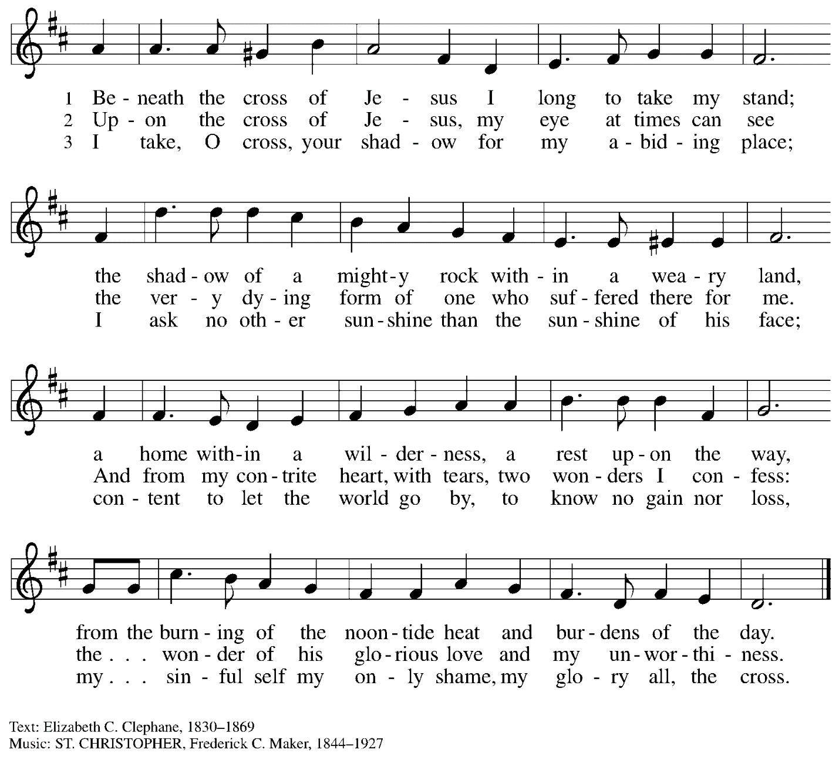

**Seventh Word John 19: 30-37**

30When Jesus had received the wine, he said, "It is finished." Then he bowed his head and gave up his spirit. 31Since it was the day of Preparation, the Jews did not want the bodies left on the cross during the sabbath, especially because that sabbath was a day of great solemnity. So they asked Pilate to have the legs of the crucified men broken and the bodies removed. 32Then the soldiers came and broke the legs of the first and of the other who had been crucified with him. 33But when they came to Jesus and saw that he was already dead, they did not break his legs. 34Instead, one of the soldiers pierced his side with a spear, and at once blood and water came out. 35(He who saw this has testified so that you also may believe. His testimony is true, and he knows that he tells the truth.) 36These things occurred so that the scripture might be fulfilled, "None of his bones shall be broken." 37And again another passage of scripture says, "They will look on the one whom they have pierced."

**Procession of the Cross**

*A large cross is carried in procession through the church and placed before the assembly.*

*The assembly faces the cross as it is brought forward.*

*The following dialogue is sung as procession begins, at its midpoint, and at the end, with the assembly responding to the leader:*

P: Behold, the life-giving cross, on which was hung the salvation of | the whole world.

**C: Oh, come, let us | worship Christ.**

*Please be seated.*

**Adoration of the Cross**

*At this time, worshipers may come to the large cross to make a sign of reverence.*

*Reverencing the cross may include such actions as pausing before the cross, bowing,*

*kneeling before it for prayer, or touching it.*

**Solemn Reproaches**

*During the adoration of the cross, the cantors will intone the Solemn Reproaches, a traditional element of Good Friday services. Each reproach will conclude with the words, “… but you have prepared a cross for your Savior.” The congregation is invited to join in singing the refrain:*

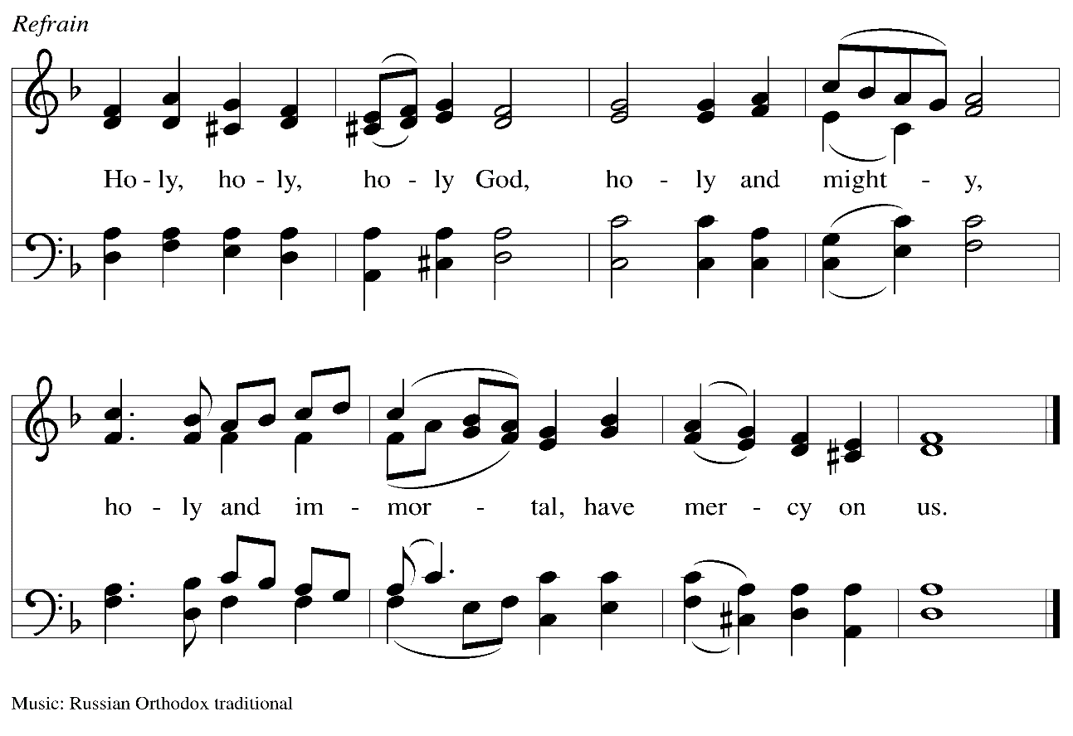

*When all have returned to their places, after a brief silence, the presiding minister continues:*

P: We adore you, O Christ, | and we bless you,

**C: for by your cross you have re- | deemed the whole world.**

*Please rise as you are able.*

**Hymn Were You There *ELW* 353**

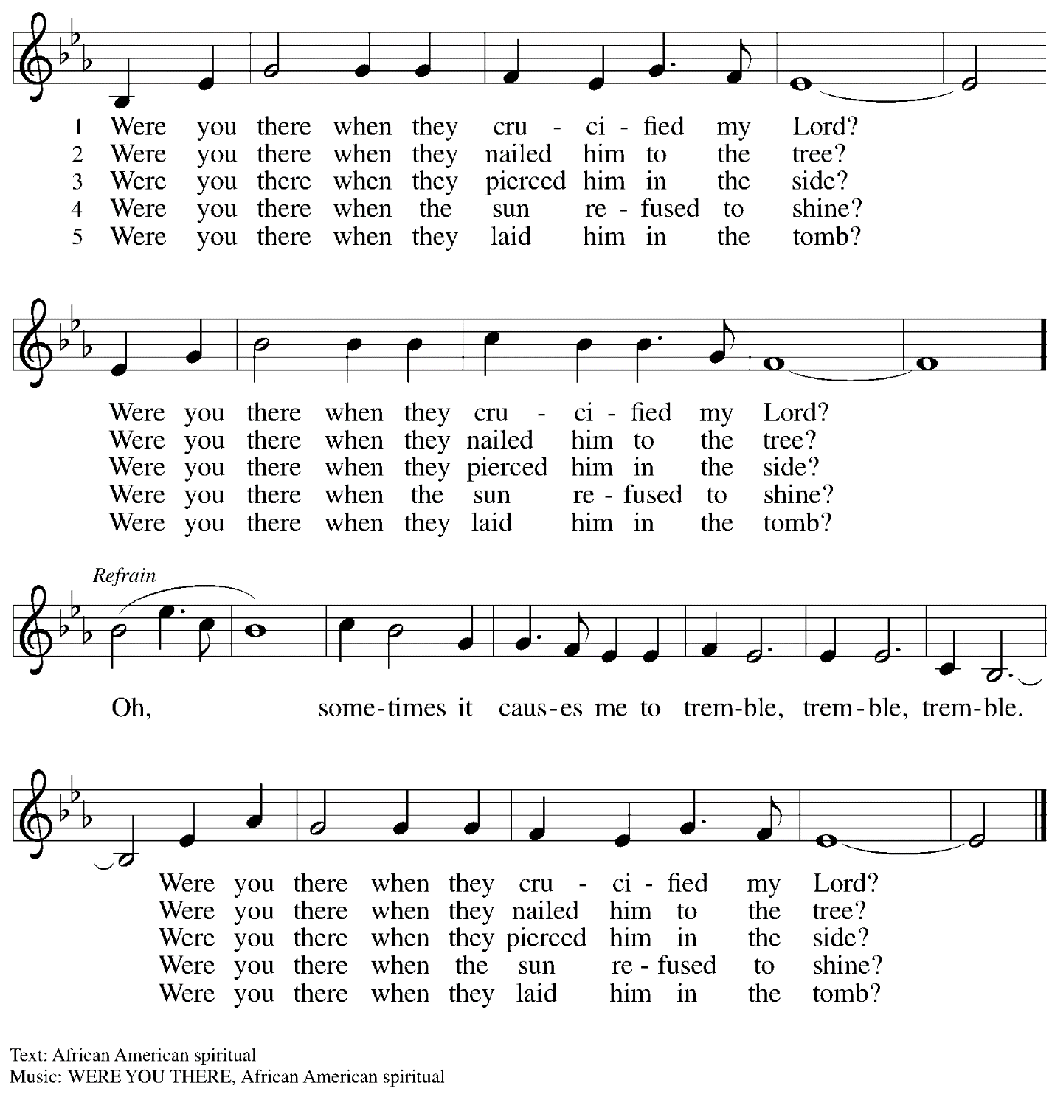

*The last candle is extinguished.*

*Silence is kept for prayer and meditation.*

*The strepitus, a loud noise, indicates the sealing of the tomb.*

*After a period of silence, a single lit candle is returned to the altar.*

*All depart in silence.*

*If they have not done so earlier, worshipers may reverence the cross before they depart.*

*The service of the Triduum continues tomorrow with the Vigil of Easter at 5:30 p.m.*

*We will gather in the parking lot behind the church.*

*Abbreviations*

P: Pastor/Presiding Minister

L: Lector

**C: Congregation**

***ELW*: *Evangelical Lutheran Worship* hymnal**

*Those serving in worship today*

Piano Lily Cai

Acolyte Johanna Asplin

Cantors Kristen Asplin

Timothy Kocher-Hillmer

Lectors The Rev. Paul and Sharon Koch

Director of Faith Formation Christopher Atwood

Presiding Minister Pastor Ross Carmichael

*Liturgy and Hymnody Acknowledgements*

From SundaysandSeasons.com. Copyright © 2022 Augsburg Fortress. All rights reserved. Reprinted under OneLicense.net # A-722139.

Used by permission of Augsburg Fortress.