Little Church; Big Faith
Holy Week Service
April 15, 2022
St. Andrew Lutheran Church
304 Morewood Ave.
Pittsburgh, PA 15213
St_andrewELCA@verizon.net
www.standrewpittsburgh.org

Little Church; Big Faith – Holy Week Service
April 15, 2022

The assembly will move to different stations throughout the service, experiencing
various elements of Jesus’ passion during Holy Week. Maundy Thursday stations will include the Last Supper, where we will share a “meal” together, and the Footwashing, where Jesus gives his disciples a new commandment to love one another as he has loved them – by serving one another. For Good Friday, we will gather at the Garden and pray as Jesus prayed, following the church’s tradition of the bidding prayer. We conclude Good Friday at the cross, with Adoration of the Crucified, honoring Jesus, whose death on the cross has saved us and given life to us and to all the world.

Invocation

P: In the name of the Father, and of the ☩ Son, and of the Holy Spirit.
C: Amen.

Prayer of the Day

P: The Lord be with you.
C: And also with you.

P: Let us pray. O God, Look with love on your family,
all of us whom you have called your children.
Help us to think of Jesus and his love in the meal we share,
when we help and serve each other,
and when we pray.
Help us remember that everything Jesus went through,
even being hurt by his friends, even being put on the cross,
was so that we could see your great love for us and all the world.
We pray in the name of Jesus, who lives with you and the Holy Spirit,
forever and ever.
C: Amen.

First Station – Maundy Thursday: Last Supper

Children are invited to gather around the table.
The story of Jesus’ last supper with his disciples is told.
The children are invited to eat the bread and drink the grape juice,
then the ministers distribute the bread and juice to the whole assembly.
When each individual has received them, we continue with the hymn.

Hymn Eat This Bread / Jesus Christ, Bread of Life ELW 472

Eat this Bread is a hymn in the Taizé style, meant for repetitive singing to help in reflection and meditation. We will sing it through several times. Please feel free to sing either version.

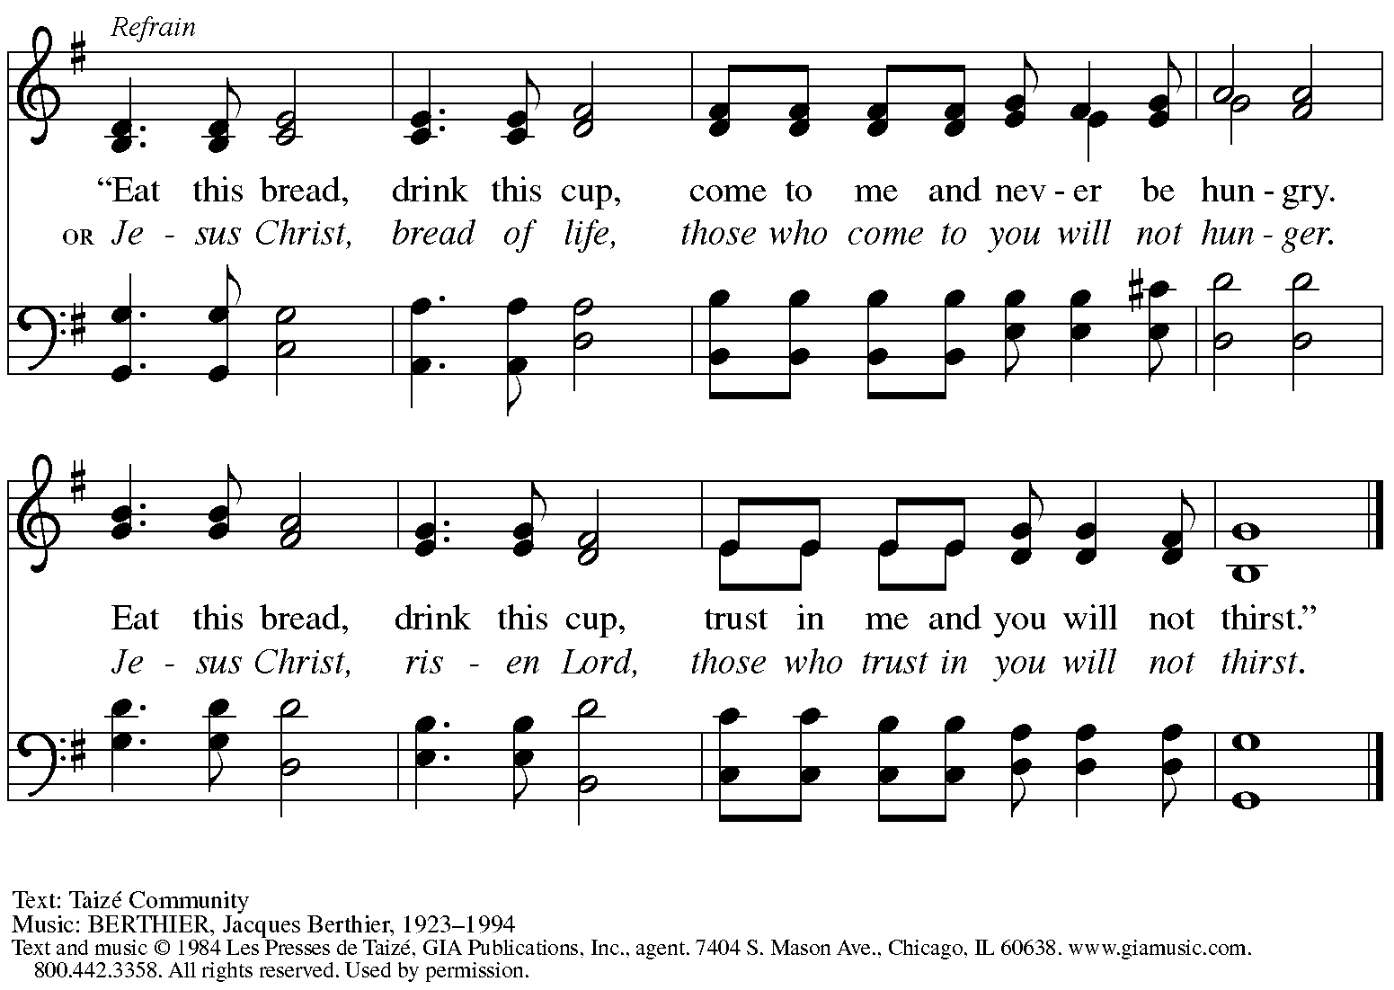
Reprinted under OneLicense.net # A-722139.

Second Station – Maundy Thursday: Footwashing

The children are invited to gather around the washbasin, pitcher, and chairs.
The story following the last supper in John’s Gospel, in which Jesus washes his disciples’ feet and gives a new commandment to love one another as he has loved them, is told.

After the story, children are invited to share in the disciples’ experience by having their feet washed. Everyone who would like to participate is asked to remove shoes and socks.
Once everyone has had a chance to participate, we continue with the hymn.

Hymn Jesus Loves Me! ELW 595

1 Jesus loves me! this I know,
for the Bible tells me so;
little ones to him belong,
they are weak, but he is strong.

Refrain
Yes, Jesus loves me,
yes, Jesus loves me,
yes, Jesus loves me,
the Bible tells me so.

Text: Anna B. Warner, 1820-1915, alt.

Third Station – Good Friday: Garden – Watch and Pray

The children are invited to gather in the garden, where Jesus prayed before his arrest.
After the story is told, the assembly joins in a children’s version of the church’s Bidding Prayer.

Bidding Prayer

After each petition
P: We ask this through Jesus.
C: Amen.

A: Last, let us pray as Jesus taught us.

V: Last, let us pray as Jesus taught us.
C: Our Father Our Father in heaven,
hallowed be your name,
your kingdom come,
your will be done,
on earth as in heaven.
Give us today our daily bread.
Forgive us our sins
as we forgive those
who sin against us.
Save us from the time of trial
and deliver us from evil.
For the kingdom, the power,
and the glory are yours,
now and forever. Amen.

Worship continues with the hymn.

Hymn Lord, Listen to Your Children Praying ELW 752

Eat this Bread is a hymn in the Taizé style, meant for repetitive singing to help in reflection and meditation. We will sing it through several times.

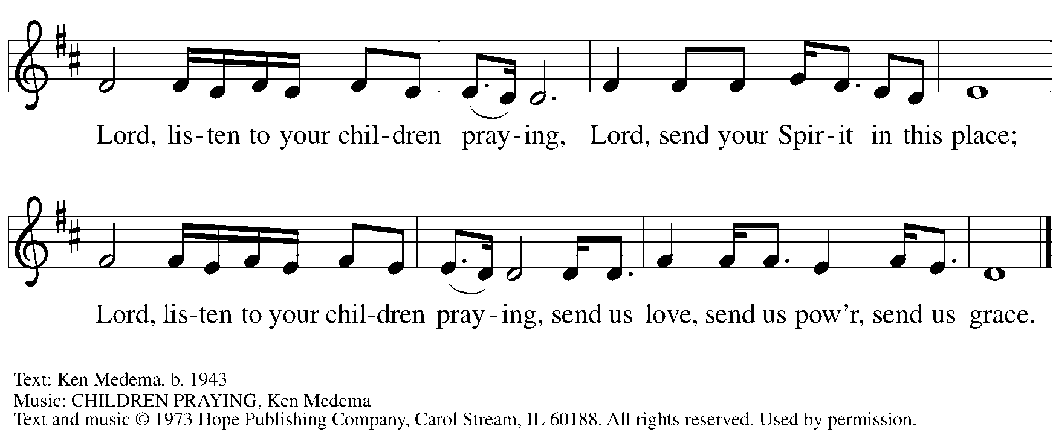
All rights reserved. Reprinted under OneLicense.net # A-722139.

Fourth Station – Good Friday: Cross

The children are invited to gather around the cross. The story of Jesus’ suffering and death on Good Friday is told.

After the story has concluded, all are invited to show their love for Jesus by touching the cross, bowing in front of it, or praying in front of it.
The hymn begins as we reverence the cross.

Hymn Jesus, Remember Me ELW 616

Eat this Bread is a hymn in the Taizé style, meant for repetitive singing to help in reflection and meditation. We will sing it through several times.

Hymn Jesus, Remember Me ELW 616

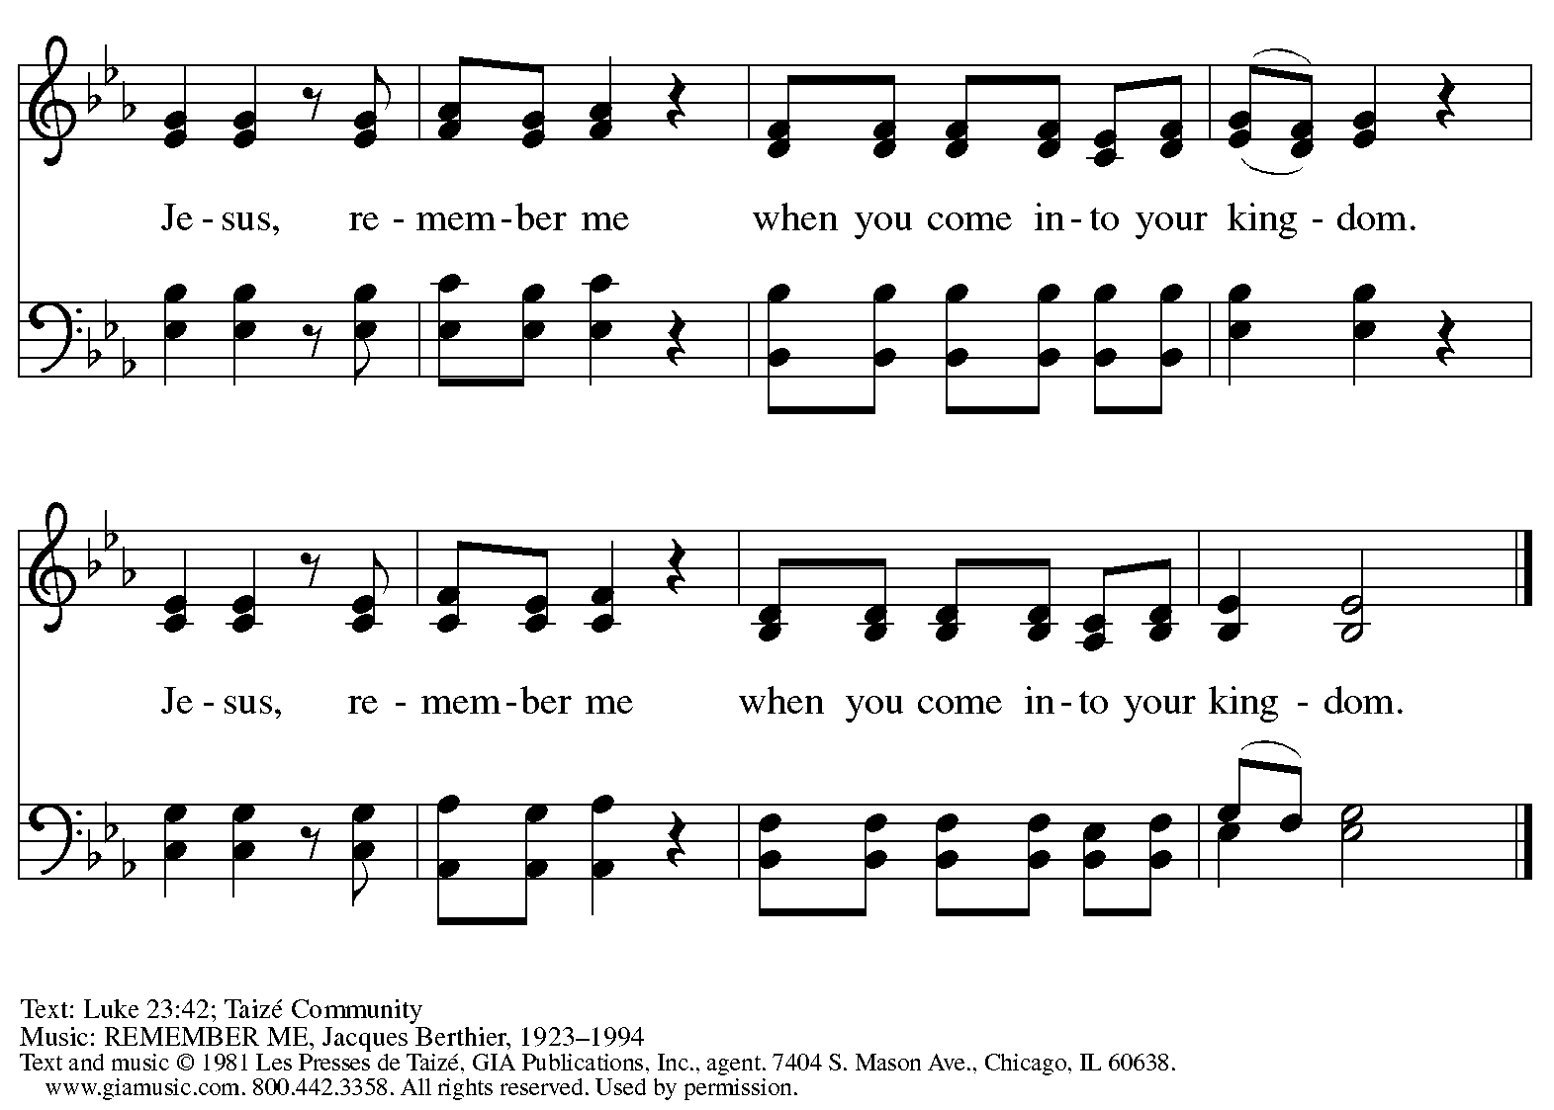
Reprinted under OneLicense.net # A-722139.

When all have made their sign of adoration, worship concludes with the dialogue.

P: We love you, O Jesus, and we bless you.
C: By your cross you have saved us and all the world.

The assembly departs.
If they have not done so earlier, worshipers may honor the cross before they depart.

