+ Triduum – Maundy Thursday
April 14, 2022
St. Andrew Lutheran Church
304 Morewood Ave.
Pittsburgh, PA 15213
St_andrewELCA@verizon.net
www.standrewpittsburgh.org

+ Triduum – Maundy Thursday
Order for Worship

This evening our Lenten observance comes to an end, and we gather with Christians around the world to celebrate the Three Days of Jesus’ death and resurrection. Tonight we remember Christ’s last meal with his disciples, but the central focus is his commandment that we live out the promise embodied in this meal. As Jesus washed his disciples’ feet, so we are called to give and receive love in humble service to one another. Formed into a new body in Christ through this holy meal, we are transformed by the mercy we have received and carry it into the world. Departing worship in solemn silence, we anticipate the coming days.

A few notes on precautions and protocols, which apply to everyone regardless of vaccination status, as St. Andrew returns to worship in the sanctuary:

- Face masks that fully cover both your mouth and nose are required at all times for everyone over the age of two (2) – the only exception being the brief moment of moving mask aside to partake in Holy Communion.
- Outside food and drink are thus not permissible during worship.
- Physical distancing of at least six (6) feet will be observed at all times for people not from your household.
- We invite the congregation to join in the singing of the hymns (with masks on) during worship!
- Hand sanitizer is available at the front of the sanctuary to use before Holy Communion, after you proceed past the baptismal font, as the alcohol has been affecting the finish on the font’s bowl.

Worship Services are live streamed to multiple online platforms.
By attending worship, you agree that your image and voice may be broadcast.

Gathering
The Holy Spirit calls us together as the people of God

Please rise as you are able.

Confession and Forgiveness

P: Friends in Christ, in this Lenten season we have heard our Lord’s call to struggle against sin, death, and the devil—all that keeps us from loving God and each other.
This is the struggle to which we were called at Baptism.

Within the community of the church, God never wearies of forgiving sin and giving the peace of reconciliation. On this night let us confess our sin against God and our neighbor, and enter the celebration of the great Three Days reconciled with God and with one another.

Silence is kept for reflection and self-examination.

P: Most merciful God,
C: we confess that we are captive to sin and cannot free ourselves.
We have sinned against you in thought, word, and deed,
by what we have done and by what we have left undone.
We have not loved you with our whole heart;
we have not loved our neighbors as ourselves.
For the sake of your Son, Jesus Christ,
have mercy on us.
Forgive us, renew us, and lead us,
so that we may delight in your will
and follow in your ways,
to the glory of your holy name. Amen.

P: God, who is rich in mercy, loved us even when we were dead in sin,
and made us alive together with Christ.
By grace you have been saved.
In the name of ☩ Jesus Christ, your sins are forgiven.
Almighty God strengthen you with power through the Holy Spirit,
that Christ may live in your hearts through faith.
C: Amen.

The presiding minister moves to the altar for the Greeting and Prayer of the Day.

Greeting

P: The grace of our Lord Jesus Christ, the love of God,
and the communion of the Holy Spirit be with you all.
C: And also with you.

Prayer of the Day

P: Let us pray.
Holy God, source of all love, on the night of his betrayal, Jesus gave us a new commandment,
to love one another as he loves us. Write this commandment in our hearts, and give us the will
to serve others as he was the servant of all, your Son, Jesus Christ, our Savior and Lord,
who lives and reigns with you and the Holy Spirit, one God, now and forever.
C: Amen.

Please be seated.

Word
God speaks to us in Scripture reading, preaching, and song

First Reading – Exodus 12: 1-4 [5-10] 11-14

¹The Lord said to Moses and Aaron in the land of Egypt: ²This month shall mark for you the beginning of months; it shall be the first month of the year for you. ³Tell the whole congregation of Israel that on the tenth of this month they are to take a lamb for each family, a lamb for each household. ⁴If a household is too small for a whole lamb, it shall join its closest neighbor in obtaining one; the lamb shall be divided in proportion to the number of people who eat of it.
[⁵Your lamb shall be without blemish, a year-old male; you may take it from the sheep or from the goats. ⁶You shall keep it until the fourteenth day of this month; then the whole assembled congregation of Israel shall slaughter it at twilight. ⁷They shall take some of the blood and put it on the two doorposts and the lintel of the houses in which they eat it. ⁸They shall eat the lamb that same night; they shall eat it roasted over the fire with unleavened bread and bitter herbs. ⁹Do not eat any of it raw or boiled in water, but roasted over the fire, with its head, legs, and inner organs. ¹⁰You shall let none of it remain until the morning; anything that remains until the morning you shall burn. ] ¹¹This is how you shall eat it: your loins girded, your sandals on your feet, and your staff in your hand; and you shall eat it hurriedly. It is the passover of the Lord. ¹²For I will pass through the land of Egypt that night, and I will strike down every firstborn in the land of Egypt, both human beings and animals; on all the gods of Egypt I will execute judgments: I am the Lord. ¹³The blood shall be a sign for you on the houses where you live: when I see the blood, I will pass over you, and no plague shall destroy you when I strike the land of Egypt.
¹⁴This day shall be a day of remembrance for you. You shall celebrate it as a festival to the Lord; throughout your generations you shall observe it as a perpetual ordinance.

L: Word of God, word of life.
C: Thanks be to God.

Psalm 116: 1-2, 12-19

The psalm will be spoken, led by the cantor, with the congregation invited to join the lector
in responding with the alternate verses.

¹I love the Lord, who has | heard my voice,
and listened to my | supplication,
²for the Lord has given | ear to me
whenev- | er I called.
¹²How shall I re- | pay the Lord
for all the good things God has | done for me?
¹³I will lift the cup | of salvation
and call on the name | of the Lord.
¹⁴I will fulfill my vows | to the Lord
in the presence of | all God’s people.
¹⁵Precious in your | sight, O Lord,
is the death | of your servants.
¹⁶O Lord, truly I | am your servant;
I am your servant, the child of your handmaid; you have freed me | from my bonds.
¹⁷I will offer you the sacrifice | of thanksgiving
and call upon the name | of the Lord.
¹⁸I will fulfill my vows | to the Lord
in the presence of | all God’s people,
¹⁹in the courts of | the Lord’s house,
in the midst of you, | O Jerusalem.

Second Reading – 1 Corinthians 11: 23-26

²³For I received from the Lord what I also handed on to you, that the Lord Jesus on the night when he was betrayed took a loaf of bread, ²⁴and when he had given thanks, he broke it and said, “This is my body that is for you. Do this in remembrance of me.” ²⁵In the same way he took the cup also, after supper, saying, “This cup is the new covenant in my blood. Do this, as often as you drink it, in remembrance of me.” ²⁶For as often as you eat this bread and drink the cup, you proclaim the Lord’s death until he comes.

L: Word of God, word of life.
C: Thanks be to God.

Please rise as you are able.

Gospel Verse (Sung by the cantor)

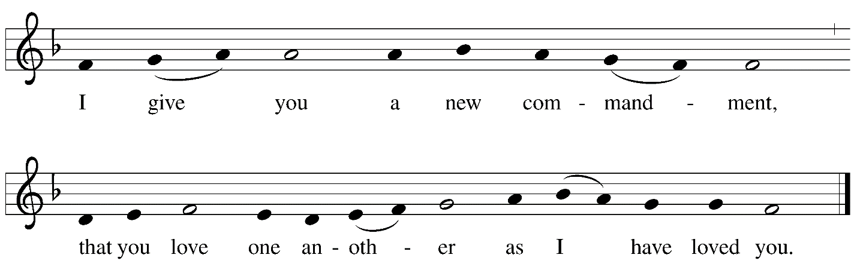
Gospel – John 13: 1-17, 31b-35

P: The holy Gospel according to St. John.
C: Glory to you, O Lord.

¹Now before the festival of the Passover, Jesus knew that his hour had come to depart from this world and go to the Father. Having loved his own who were in the world, he loved them to the end. ²The devil had already put it into the heart of Judas son of Simon Iscariot to betray him. And during supper ³Jesus, knowing that the Father had given all things into his hands, and that he had come from God and was going to God, ⁴got up from the table, took off his outer robe, and tied a towel around himself. ⁵Then he poured water into a basin and began to wash the disciples’ feet and to wipe them with the towel that was tied around him. ⁶He came to Simon Peter, who said to him, “Lord, are you going to wash my feet?” ⁷Jesus answered, “You do not know now what I am doing, but later you will understand.” ⁸Peter said to him, “You will never wash my feet.” Jesus answered, “Unless I wash you, you have no share with me.” ⁹Simon Peter said to him, “Lord, not my feet only but also my hands and my head!” ¹⁰Jesus said to him, “One who has bathed does not need to wash, except for the feet, but is entirely clean. And you are clean, though not all of you.” ¹¹For he knew who was to betray him; for this reason he said, “Not all of you are clean.”
¹²After he had washed their feet, had put on his robe, and had returned to the table, he said to them, “Do you know what I have done to you? ¹³You call me Teacher and Lord—and you are right, for that is what I am. ¹⁴So if I, your Lord and Teacher, have washed your feet, you also ought to wash one another’s feet. ¹⁵For I have set you an example, that you also should do as I have done to you. ¹⁶Very truly, I tell you, servants are not greater than their master, nor are messengers greater than the one who sent them. ¹⁷If you know these things, you are blessed if you do them.”

^{31b}Now the Son of Humanity has been glorified, and God has been glorified in him. ³²If God has been glorified in him, God will also glorify him in Godself and will glorify him at once. ³³Little children, I am with you only a little longer. You will look for me; and as I said to the Jews so now I say to you, ‘Where I am going, you cannot come.’ ³⁴I give you a new commandment, that you love one another. Just as I have loved you, you also should love one another. ³⁵By this everyone will know that you are my disciples, if you have love for one another.”

P: The Gospel of the Lord.
C: Praise to you, O Christ.

Please be seated.

Sermon

Please rise as you are able.

Hymn of the Day Great God, Your Love Has Called Us Following Page

Hymn of the Day Great God, Your Love Has Called Us ELW 358

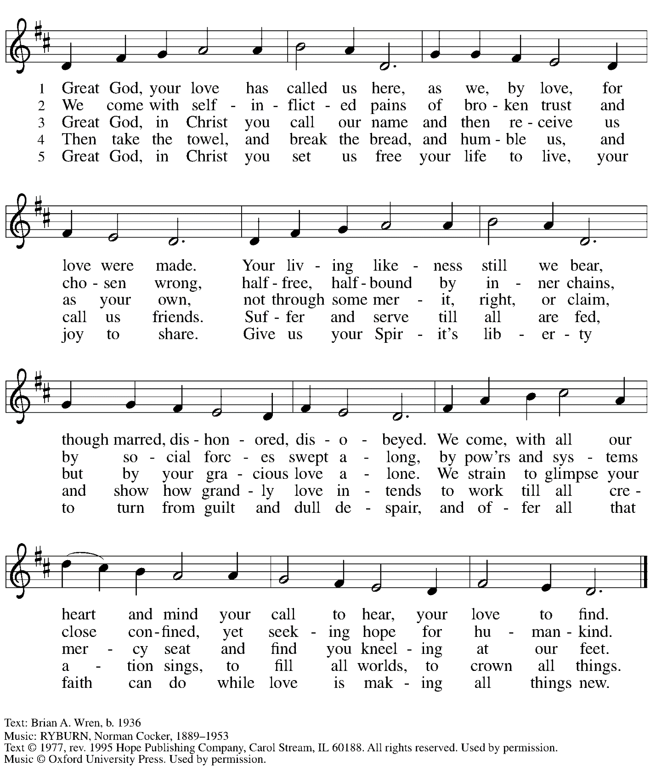
All rights reserved. Reprinted with permission under OneLicense.net # A-722139.

Footwashing

P: On this night, we have heard our Lord’s commandment to love one another as he has loved us. We who receive God’s love in Jesus Christ are called to love one another, to be servants to each other as Jesus became our servant. Our commitment to this loving service is signified in the washing of feet, following the example our Lord gave us on the night before his death.

People of the assembly are invited to come forward to the steps of the chancel and remove shoes and socks as the presiding minister washes the people’s feet.
Assembly song accompanies the footwashing.

Hymns during Footwashing
Love Consecrates the Humblest Act ELW 360

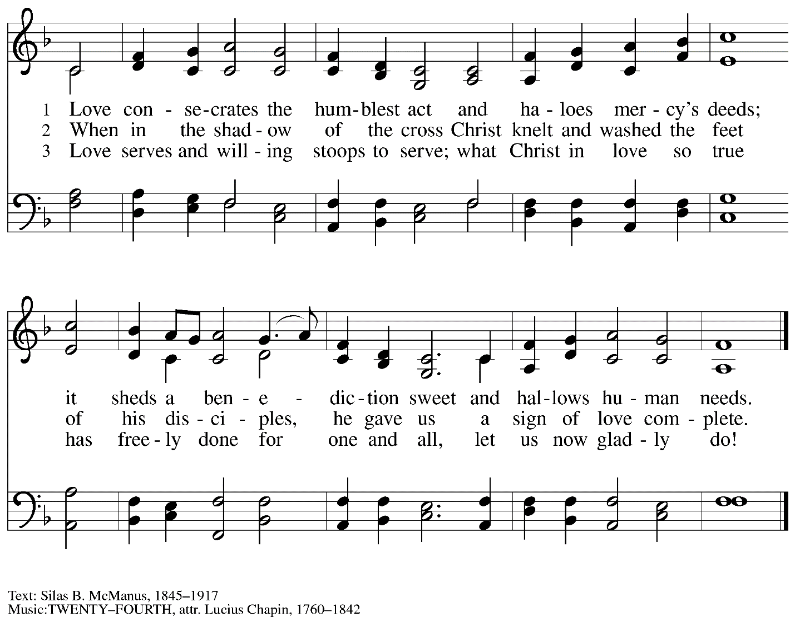

Hymns during Footwashing
Ubi caritas et amor ELW 642

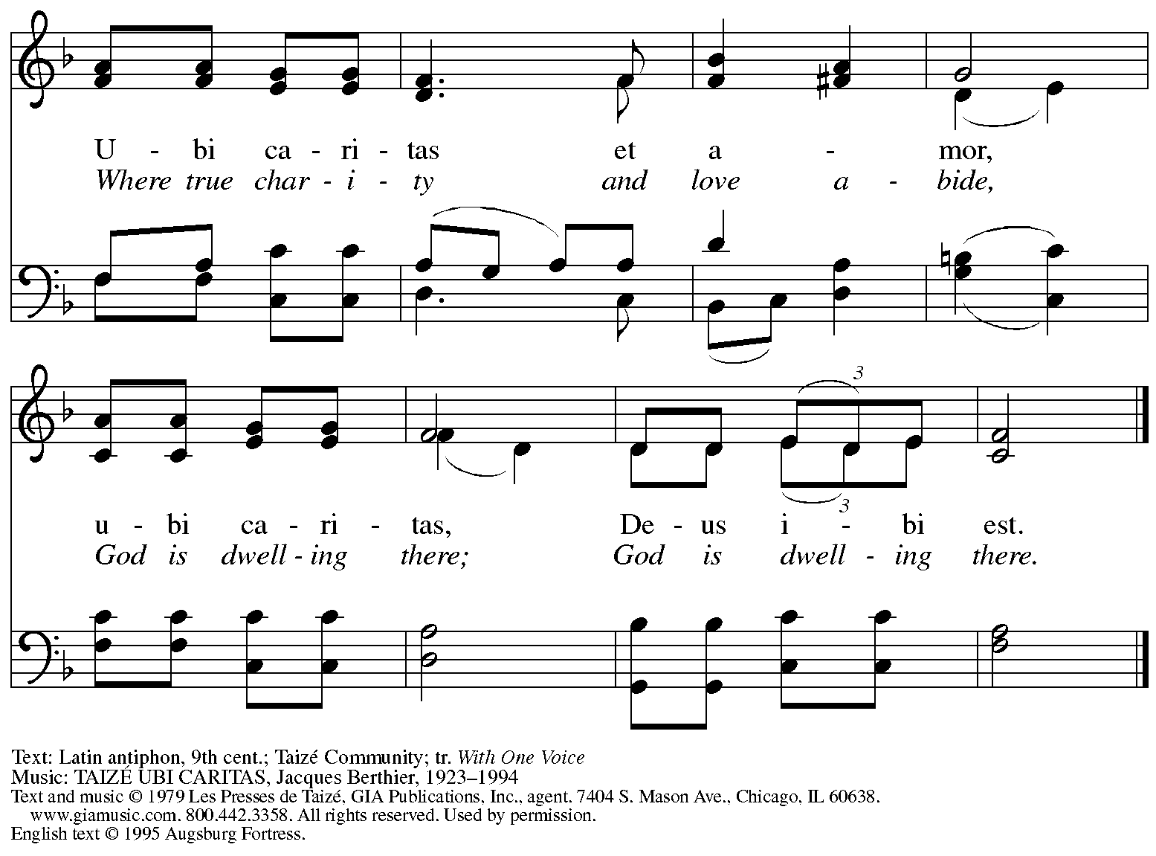
All rights reserved. Reprinted with permission under OneLicense.net # A-722139.

When all have returned to their places, worship continues with the Prayers of the People.

Prayers of the People

P: Let us pray for new life in the church, new hope for the world,
and God’s love for all who are in need.

After each petition
P: Merciful God,
C: receive our prayer.

P: We pray to you, O God, in the name of the one who endured the cross,
forgives our sin, and feeds us at his table, Jesus Christ our Lord.
C: Amen.

Please be seated.

Offering

We offer ourselves, our gifts, and our faithful service to God.
An usher will pass around an offering plate for anyone who would like to offer gifts before God.

Hymn during Offering

Meal
God feeds us with the presence of Jesus Christ

Please rise as you are able.

Offertory Prayer

P: Let us pray.
God of all creation,
C: You bring forth bread from the earth and fruit from the vine.
Nourish us with these gifts,
that we might be for the world signs of your gracious presence
in Jesus Christ, our Savior and Lord.
Amen.

Dialogue

P: The Lord be with you.
C: And also with you.

P: Lift up your hearts.
C: We lift them to the Lord.

P: Let us give thanks to the Lord our God.
C: It is right to give our thanks and praise.

Preface

P: It is indeed right, our duty and our joy …
… we praise your name and join their unending hymn:

Sanctus

C: Holy, holy, holy Lord,
God of power and might:
Heaven and earth are full of your glory.
Hosanna in the highest.
Blessed is the one who comes in the name of the Lord.
Hosanna in the highest.

Eucharistic Prayer

P: Blessed are you, O living God, sovereign of time and space …
… Blessed be God forever!
C: Blessed be God forever!

P: Blessed are you, O living God, for your glory revealed in Jesus Christ …
… Blessed be God forever!
C: Blessed be God forever!

P: On the night in which he was betrayed …
… Do this for the remembrance of me.

Blessed be God forever!
C: Blessed be God forever!

P: Blessed are you, O Living God, for your Spirit of love …
Blessed be God forever!
C: Blessed be God forever!

P: Amen and Amen.
C: Amen and Amen.

Lord’s Prayer

P: Gathered as one by the Holy Spirit, let us pray as Jesus taught us.
C: Our Father in heaven,
hallowed be your name,
your kingdom come,
your will be done,
on earth as in heaven.
Give us today our daily bread.
Forgive us our sins
as we forgive those
who sin against us.
Save us from the time of trial
and deliver us from evil.
For the kingdom, the power,
and the glory are yours,
now and forever. Amen.

Fraction and Invitation

Agnus Dei / Lamb of God

C: Lamb of God, you take away the sin of the world; have mercy on us.
Lamb of God, you take away the sin of the world; have mercy on us.
Lamb of God, you take away the sin of the world; grant us peace.

Please be seated.

Holy Communion
- Hand sanitizer is available if you would like to use it prior to receiving Communion.
- Worshipers from the pulpit side will proceed forward first, followed by the center section, and then the lectern side.
- The Communion wafers (regular and gluten-free) have been thoughtfully prepared using the gifts of the congregation by a member of St. Andrew’s altar care team, with a drop of wine or grape juice on each. The presiding minister will distribute one to each communicant.
- When you reach the presiding minister, please indicate if you would like grape juice or a gluten-free wafer.
- A blessing will be provided for anyone who does not yet receive the sacrament.
- A cushion has been placed at the altar rail for anyone who would like to kneel for prayer and reflection before returning to their pew.
- Everyone is asked to wait until you return to your place to consume the elements, and then promptly replace your mask.

Hymns during Holy Communion
In This Feast of Love ACS 962

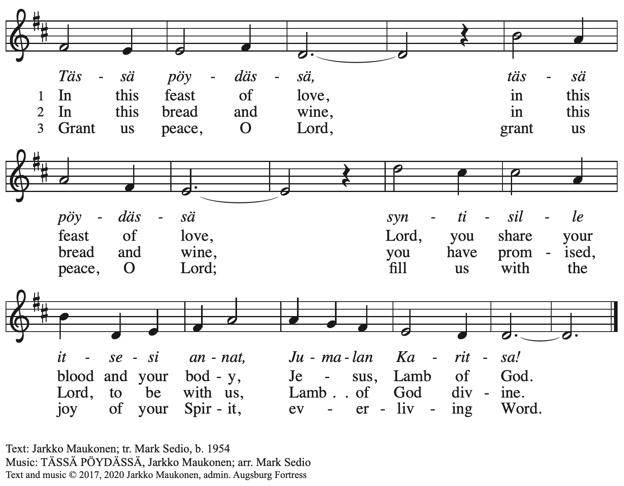
All rights reserved. Reprinted with permission under OneLicense.net # A-722139.

Hymns during Holy Communion
Three Holy Days Enfold Us Now ACS 930

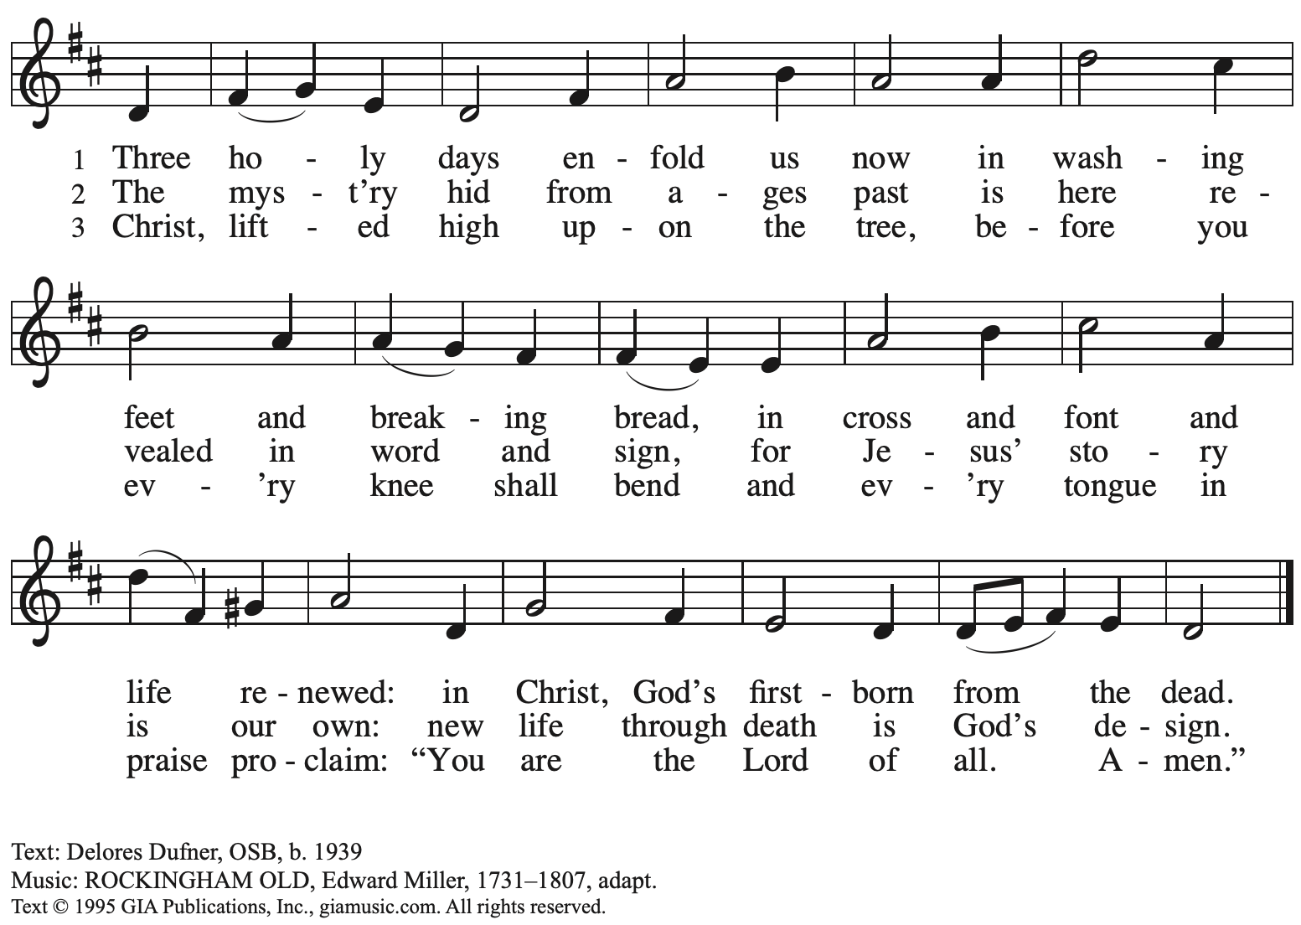
Reprinted with permission under OneLicense.net # A-722139.

When all have returned to their places, please rise as you are able.

Blessing

P: The body and blood of our Lord Jesus Christ strengthen you and keep you in his grace.
C: Amen.

Prayer

P: Let us pray.
Lord Jesus, in a wonderful sacrament you strengthen us
with the saving power of your suffering, death, and resurrection.
May this sacrament of your body and blood so work in us
that the fruits of your redemption will show forth in the way we live,
for you live and reign with the Father and the Holy Spirit, one God, now and forever.
C: Amen.

Stripping of the Altar

The service concludes with the stripping of the altar. The assembly is seated. The sacramental elements and vessels, linens, paraments, banners, and books are removed from the worship space. Psalm 22 is sung by the cantor, with the assembly invited to join in on the refrain.
Lights are dimmed as the worship space is stripped.

Psalm 22

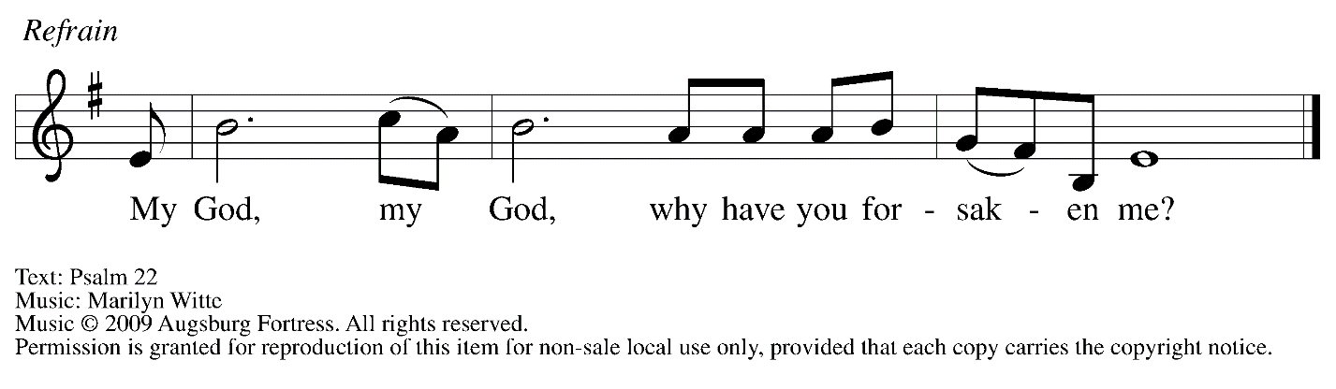

The benediction and dismissal are omitted. All depart in silence.

The service of the Triduum continues tomorrow, Good Friday, with worship at 7:00 p.m.

Abbreviations

P: Pastor/Presiding Minister
L: Lector
C: Congregation

ELW: Evangelical Lutheran Worship hymnal
ACS: All Creation Sings hymnal

Those serving in worship today

Piano Lily Cai
Cantor Joseph Paetz
Lector Joyce Compton
Director of Faith Formation Christopher Atwood
Presiding Minister Pastor Ross Carmichael

Liturgy and Hymnody Acknowledgements

From SundaysandSeasons.com. Copyright © 2022 Augsburg Fortress. All rights reserved. Reprinted under OneLicense.net # A-722139.
Used by permission of Augsburg Fortress.

Gospel Verse: I Give You A New Commandment – Text: John 13: 34. Music: Scott Weidler. Music © 2009 Augsburg Fortress. All rights reserved. Reprinted with permission.

Eucharistic Prayer – From Pray, Praise, and Give Thanks: A Collection of Litanies, Laments, and Thanksgivings at Font and Table by Gail Ramshaw, copyright © 2017 Augsburg Fortress. All rights reserved. Reprinted with permission.

