+ Palm Sunday – Sunday of the Passion
April 10, 2022
St. Andrew Lutheran Church
304 Morewood Ave.
Pittsburgh, PA 15213
St_andrewELCA@verizon.net
www.standrewpittsburgh.org

+ Palm Sunday – Sunday of the Passion
Order for Worship

Today we follow Christ from triumphal entry to the cross, each waypoint of the journey marked by Jesus’ compassion for those who would betray, mock, accuse, or do violence to him. Though persecuted and beaten, Jesus the Son of God is not disgraced; instead, he asks forgiveness for those who put him to death. We have walked the Lenten pathway these forty days, each of us invited through baptism to “let the same mind be in you that was in Christ Jesus.” We enter this holy week accompanying Jesus to the cross with both grief and thanksgiving in our hearts, trusting in God’s redeeming love.

A few notes on precautions and protocols, which apply to everyone regardless of vaccination status, as St. Andrew returns to worship in the sanctuary:

- Face masks that fully cover both your mouth and nose are required at all times for everyone over the age of two (2) – the only exception being the brief moment of moving mask aside to partake in Holy Communion.
- Outside food and drink are thus not permissible during worship.
- Physical distancing of at least six (6) feet will be observed at all times for people not from your household.
- We invite the congregation to join in the singing of the hymns (with masks on) during worship!
- Hand sanitizer is available at the front of the sanctuary to use before Holy Communion, after you proceed past the baptismal font, as the alcohol has been affecting the finish on the font’s bowl.

Worship Services are live streamed to multiple online platforms.
By attending worship, you agree that your image and voice may be broadcast.

Gathering
The Holy Spirit calls us together as the people of God.

Acclamation
The presiding minister begins (3x)
P: Blessed is the one who comes in the name of the Lord!
C: Hosanna in the highest!

Processional Gospel – Luke 19: 28-40

P: The holy Gospel according to St. Luke.
C: Glory to you, O Lord.

²⁸After he had said this, [Jesus] went on ahead, going up to Jerusalem.
²⁹When he had come near Bethphage and Bethany, at the place called the Mount of Olives, he sent two of the disciples, ³⁰saying, “Go into the village ahead of you, and as you enter it you will find tied there a colt that has never been ridden. Untie it and bring it here. ³¹If anyone asks you, ‘Why are you untying it?’ just say this, ‘The Lord needs it.’” ³²So those who were sent departed and found it as he had told them. ³³As they were untying the colt, its owners asked them, “Why are you untying the colt?” ³⁴They said, “The Lord needs it.” ³⁵Then they brought it to Jesus; and after throwing their cloaks on the colt, they set Jesus on it. ³⁶As he rode along, people kept spreading their cloaks on the road. ³⁷As he was now approaching the path down from the Mount of Olives, the whole multitude of the disciples began to praise God joyfully with a loud voice for all the deeds of power that they had seen, ³⁸saying,
“Blessed is the king
who comes in the name of the Lord!
Peace in heaven,
and glory in the highest heaven!”
³⁹Some of the Pharisees in the crowd said to him, “Teacher, order your disciples to stop.”
⁴⁰He answered, “I tell you, if these were silent, the stones would shout out.”

P: The Gospel of the Lord.
C: Praise to you, O Christ.

Blessing of Palms

People of the assembly are invited to raise their palm branches, as able, for the blessing.

P: The Lord be with you.
C: And also with you.

P: Let us pray.
We praise you, O God, for redeeming the world through our Savior Jesus Christ.
Today he entered the holy city in triumph and was proclaimed messiah and king
by those who spread garments and branches along his way.
Bless these branches and those who carry them.
Grant us grace to follow our Lord in the way of the cross,
so that, joined to his death and resurrection, we enter into life with you;
through the same Jesus Christ, who lives and reigns with you and the Holy Spirit,
one God, now and forever.
C: Amen.

P: Let us go forth in peace.
C: In the name of Christ. Amen.

The assembly follows the ministers into the church. “All glory, laud, and honor” (#344) is sung as the people process into the church.

Processional Hymn All Glory, Laud, and Honor ELW 344

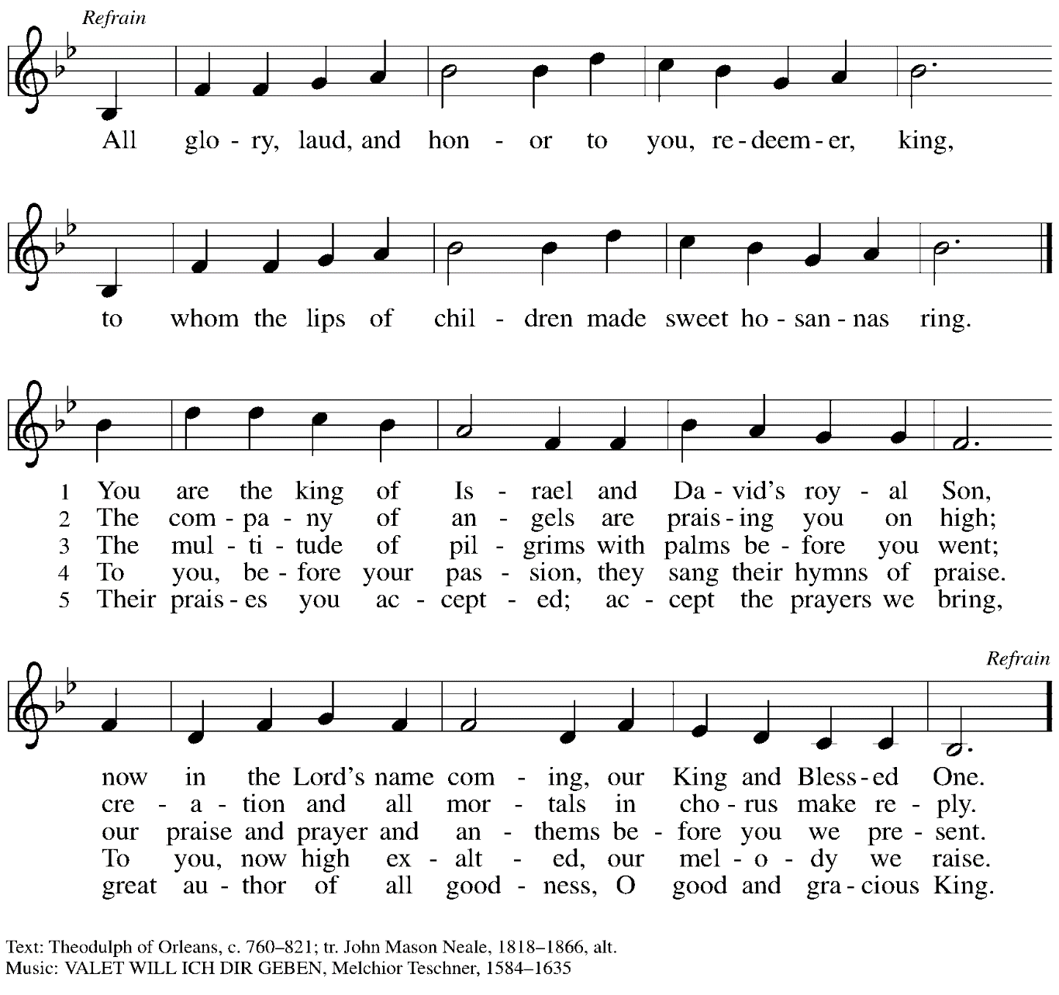

Greeting

P: The grace of our Lord Jesus Christ, the love of God,
and the communion of the Holy Spirit be with you all.
C: And also with you.

Prayer of the Day

P: Let us pray.
Everlasting God, in your endless love for the human race you sent our Lord Jesus Christ to take on our nature and to suffer death on the cross. In your mercy enable us to share in his obedience to your will and in the glorious victory of his resurrection, he who lives and reigns with you and the Holy Spirit, one God, now and forever.
C: Amen.

Please be seated.
Children are invited to proceed to the Social Hall for Little Church; Big Faith activities.

Word
God speaks to us in Scripture reading and song

First Reading – Isaiah 50: 4-9a

⁴The Lord God has given me
the tongue of a teacher,
that I may know how to sustain
the weary with a word.
Morning by morning the Lord wakens—
wakens my ear
to listen as those who are taught.
⁵The Lord God has opened my ear,
and I was not rebellious,
I did not turn backward.
⁶I gave my back to those who struck me,
and my cheeks to those who pulled out the beard;
I did not hide my face
from insult and spitting.

⁷The Lord God helps me;
therefore I have not been disgraced;
therefore I have set my face like flint,
and I know that I shall not be put to shame;
⁸the who vindicates me is near.
Who will contend with me?
Let us stand up together.
Who are my adversaries?
Let them confront me.
^{9a}It is the Lord God who helps me;
who will declare me guilty?

L: Word of God, word of life.
C: Thanks be to God.

Psalm 31: 9-16

The psalm will be spoken, led by the cantor, with the congregation invited to join the lector in responding with the alternate verses.

⁹Have mercy on me, O Lord, for I am in trouble;
my eye is consumed with sorrow, and also my throat and my belly.
¹⁰For my life is wasted with grief, and my years with sighing;
my strength fails me because of affliction, and my bones are consumed.
¹¹I am the scorn of all my enemies, a disgrace to my neighbors, a dismay to my acquaintances;
when they see me in the street | they avoid me.
¹²Like the dead I am forgotten, out of mind;
I am as useless as a broken pot.
¹³For I have heard the whispering of the crowd; fear is all around;
they put their heads together against me; they plot to take my life.
¹⁴But as for me, I have trusted in you, O Lord.
I have said, “You are my God.
¹⁵My times are in your hand;
rescue me from the hand of my enemies, and from those who persecute me.
¹⁶Let your face shine upon your servant;
save me in your steadfast love.”

Second Reading – Philippians 2: 5-11

⁵Let the same mind be in you that was in Christ Jesus,
⁶who, though he was in the form of God,
did not regard equality with God
as something to be exploited,
⁷but emptied himself,
taking the form of a slave,
being born in human likeness.
And being found in human form,
⁸he humbled himself
and became obedient to the point of death—
even death on a cross.

⁹Therefore God also highly exalted him
and gave him the name
that is above every name,
¹⁰so that at the name of Jesus
every knee should bend,
in heaven and on earth and under the earth,
¹¹and every tongue should confess
that Jesus Christ is Lord,
to the glory of God the Father.

L: Word of God, word of life.
C: Thanks be to God.

Please rise as you are able.

Gospel Acclamation

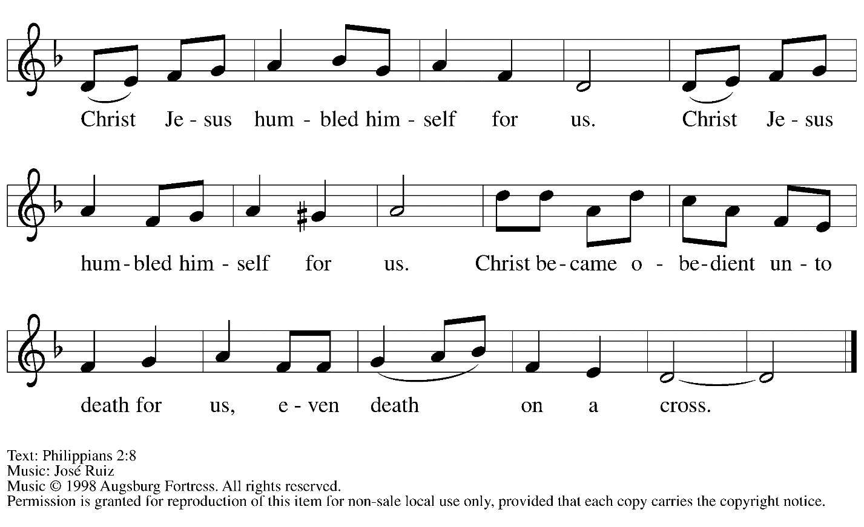

Gospel – Luke 22: 14 – 23: 56

N: The passion of our Lord Jesus Christ according to St. Luke.

Please be seated.
The narrative of Christ’s Passion from the Gospel of Luke is read by several people of the congregation. At three interludes, a verse from the hymn Go to Dark Gethsemane, ELW 347, will be sung. Please follow the prompts below to join in the singing.

N: Now the Festival of Unleavened Bread …
… J: It is enough.

Go to Dark Gethsemane v. 1 ELW 347

1 Go to dark Gethsemane,
all who feel the tempter's pow'r;
your Redeemer's conflict see.
Watch with him one bitter hour;
turn not from his griefs away;
learn from Jesus Christ to pray.

N: Jesus came out and went, as was his custom …
… P: What further testimony do we need?
We have heard it from his own lips!

Go to Dark Gethsemane v. 2 ELW 347

2 Follow to the judgment hall,
view the Lord of life arraigned;
oh, the wormwood and the gall!
Oh, the pangs his soul sustained!
Shun not suff'ring, shame, or loss;
learn from him to bear the cross.

N: Then the assembly rose …
… he handed over Jesus as they wished.

Go to Dark Gethsemane v. 3 ELW 347

3 Calv'ry's mournful mountain climb;
there, adoring at his feet,
mark that miracle of time,
God's own sacrifice complete.
"It is finished!" hear him cry;
learn from Jesus Christ to die.

When the Passion reading concludes, a period of silence is observed for prayer and reflection.

After the time of silence, please rise as you are able.
Worship continues with the Prayers of the People.

Prayers of the People

P: Drawn close to the heart of God, we offer these prayers for the church,
the world, and all who are in need.

After each petition
P: Merciful God,
C: receive our prayer.

P: Accept the prayers we bring before you, O God, on behalf of a world in need,
through Jesus Christ, our Savior.
C: Amen.

Please be seated.

Offering

We offer ourselves, our gifts, and our faithful service to God.
An usher will pass around an offering plate for anyone who would like to offer gifts before God.

Music during the Offering
In the Cross of Christ I Glory

Meal
God feeds us with the presence of Jesus Christ

Please rise as you are able.

Offertory Prayer

P: Let us pray.
God of all creation,
C: all you have made is good, and your love endures forever.
You bring forth bread from the earth and fruit from the vine.
Nourish us with these gifts, that we might be for the world signs of your gracious presence
in Jesus Christ, our Savior and Lord.
Amen.

Dialogue

P: The Lord be with you.
C: And also with you.

P: Lift up your hearts.
C: We lift them to the Lord.

P: Let us give thanks to the Lord our God.
C: It is right to give our thanks and praise.

Preface

P: It is indeed right, our duty and our joy…
… and join their unending hymn.

Sanctus

C: Holy, holy, holy Lord,
God of power and might:
Heaven and earth are full of your glory.
Hosanna in the highest.
Blessed is the one who comes in the name of the Lord.
Hosanna in the highest.

Eucharistic Prayer

P: Blessed are you, O God of the universe …
Do this for the remembrance of me.

With this bread and cup, we remember our Lord’s Passover from death to life
as we proclaim the mystery of faith.
C: Christ has died. Christ is risen. Christ will come again.

P: O God of resurrection and new life …
… grace our table with your presence.
C: Come, Holy Spirit.

P: Reveal yourself to us in the breaking of the bread …
… with justice, peace, and love.
C: Come, Holy Spirit.

P: With your holy ones of all times and places …
… blessed and Holy Trinity, now and forever.
C: Amen.

Lord’s Prayer

P: Gathered as one by the Holy Spirit, let us pray as Jesus taught us.
C: Our Father in heaven,
hallowed be your name,
your kingdom come,
your will be done,
on earth as in heaven.
Give us today our daily bread.
Forgive us our sins
as we forgive those
who sin against us.
Save us from the time of trial
and deliver us from evil.
For the kingdom, the power,
and the glory are yours,
now and forever. Amen.

Fraction and Invitation

Agnus Dei / Lamb of God

C: Lamb of God, you take away the sin of the world; have mercy on us.
Lamb of God, you take away the sin of the world; have mercy on us.
Lamb of God, you take away the sin of the world; grant us peace.

Please be seated.

Holy Communion
- Hand sanitizer is available if you would like to use it prior to receiving Communion.
- Worshipers from the pulpit side will proceed forward first, followed by the center section, and then the lectern side.
- The Communion wafers (regular and gluten-free) have been thoughtfully prepared using the gifts of the congregation by a member of St. Andrew’s altar care team, with a drop of wine or grape juice on each. The presiding minister will distribute one to each communicant.
- When you reach the presiding minister, please indicate if you would like grape juice or a gluten-free wafer.
- A blessing will be provided for anyone who does not yet receive the sacrament.
- A cushion has been placed at the altar rail for anyone who would like to kneel for prayer and reflection before returning to their pew.
- Everyone is asked to wait until you return to your place to consume the elements, and then promptly replace your mask.

Hymns during Holy Communion
Jesus, I Will Ponder Now ELW 345

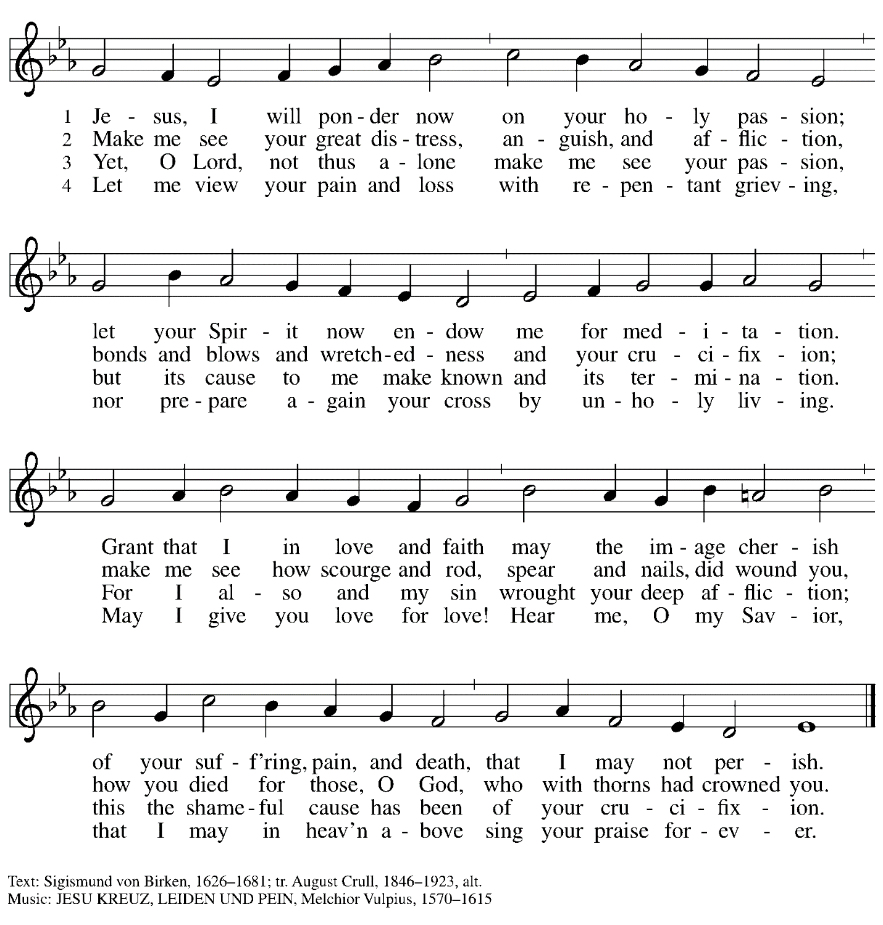

Hymns during Holy Communion
Jesus, Remember Me ELW 616

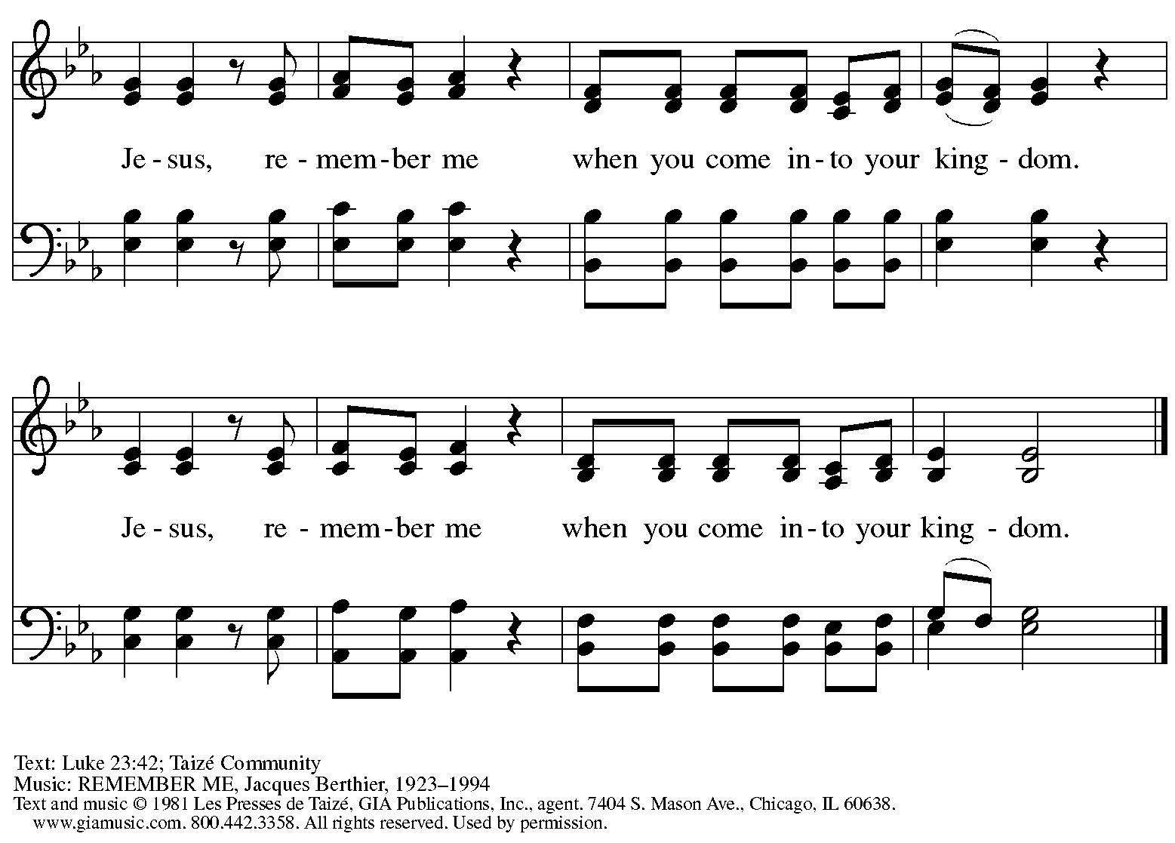
Reprinted with permission under OneLicense.net # A-722139.

When all have returned to their places, please rise as you are able.

Blessing

P: The body and blood of our Lord Jesus Christ strengthen you and keep you in his grace.
C: Amen.

Prayer

P: Let us pray.
Blessed Jesus,
in this meal of grace,
you have fed us with your body, the bread of life.
Now send us forth to bear your life-giving hope
to a world in need.
C: Amen.

Sending
God blesses us and sends us in mission to the world.

Benediction

P: The holy Three,
the holy One
increase your hope,
strengthen your faith,
deepen your love,
and ☩ grant you peace.
C: Amen.

Dismissal

P: Go in peace. Christ is with you.
C: Thanks be to God.

Abbreviations

P: Pastor/Presiding Minister
L: Lector
C: Congregation
N: Narrator
J: Jesus

ELW: Evangelical Lutheran Worship hymnal
ACS: All Creation Sings hymnal

Those serving in worship today

Crucifer Timothy Kocher-Hillmer
Piano Lily Cai
Cantor Richard Krug
Lector Dixie Tymitz
Passion Reading Lectors Emily Duque
Sue Gaugler
Jan Kurth
Pat Lutz
Maria Mangano
Director of Faith Formation Christopher Atwood
Presiding Minister Pastor Ross Carmichael

Liturgy and Hymnody Acknowledgements

From SundaysandSeasons.com. Copyright © 2022 Augsburg Fortress. All rights reserved. Reprinted under OneLicense.net # A-722139.
Used by permission of Augsburg Fortress.

Go to Dark Gethsemane – Text: James Montgomery, 1771-1854. Music: GETHSEMANE, Richard Redhead, 1820-1901.

