+ Second Sunday of Easter
April 24, 2022
St. Andrew Lutheran Church
304 Morewood Ave.
Pittsburgh, PA 15213
St_andrewELCA@verizon.net
www.standrewpittsburgh.org

+ Second Sunday of Easter
Order for Worship

In spite of all we have heard and all we have seen, it is often hard to believe.
Because it is hard to believe, we will invest ourselves in the Easter mystery for fifty days (a week of weeks). Because it is hard to believe, John the evangelist will provide sign after sign celebrating Jesus’ victory over death. Because it is hard to believe, the risen Jesus will return to us again and again in the mystery of holy communion, inviting us to touch and taste his presence, and offering us his peace.

A few notes on precautions and protocols, which apply to everyone regardless of vaccination status, as St. Andrew returns to worship in the sanctuary:

- Face masks that fully cover both your mouth and nose are required at all times for everyone over the age of two (2) – the only exception being the brief moment of moving mask aside to partake in Holy Communion.
- Outside food and drink are thus not permissible during worship.
- Physical distancing of at least six (6) feet will be observed at all times for people not from your household.
- We invite the congregation to join in the singing of the hymns (with masks on) during worship!
- Hand sanitizer is available at the front of the sanctuary to use before Holy Communion, after you proceed past the baptismal font, as the alcohol has been affecting the finish on the font’s bowl.

Worship Services are live streamed to multiple online platforms.
By attending worship, you agree that your image and voice may be broadcast.

Welcome

Prelude

Gathering
The Holy Spirit calls us together as the people of God.

Thanksgiving for Baptism

P: Alleluia! Christ is risen.
C: Christ is risen indeed. Alleluia!

P: In the waters of baptism,
we have passed over from death to life with Jesus Christ,
and we are a new creation.
For this saving mystery, and for this water, let us bless God,
who was, who is, and who is to come.

Water may be poured into the font as the presiding minister gives thanks.

P: We thank you, God, for your river of life,
flowing freely from your throne:
throughout the earth, through the city, to every living thing.
You rescued Noah and his family from the flood;
You opened wide the sea for the Israelites.
Now in these waters you flood us with mercy,
and our sin is drowned forever.
You open the gate of righteousness
and we pass safely through.
In Jesus Christ, you calm and trouble the waters.
You nourish us and enclose us in safety.
You call us forth and send us out.
In lush and barren places, you are with us.
You have become our salvation.
Now breathe upon this water
and awaken your church once more.
Claim us again as your beloved and holy people.
Quench our thirst; cleanse our hearts; wipe away every tear.
To you, our Beginning and our End,
our Shepherd and Lamb,
be honor, glory, praise, and thanksgiving,
now and forever.
C: Amen.

Gathering Hymn Christ the Lord Is Risen Today; Alleluia ELW 369
v. 1, 4

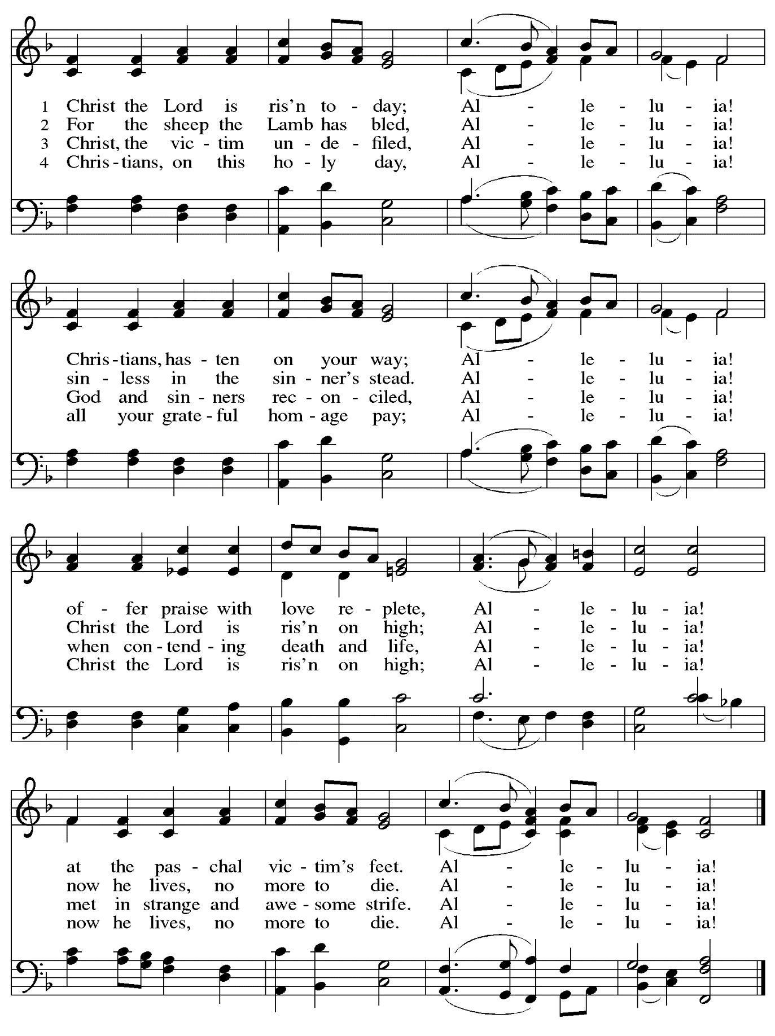
Greeting

P: The grace of our Lord Jesus Christ, the love of God,
and the communion of the Holy Spirit be with you all.
C: And also with you.

Hymn of Praise This Is the Feast ELW p. 149-150

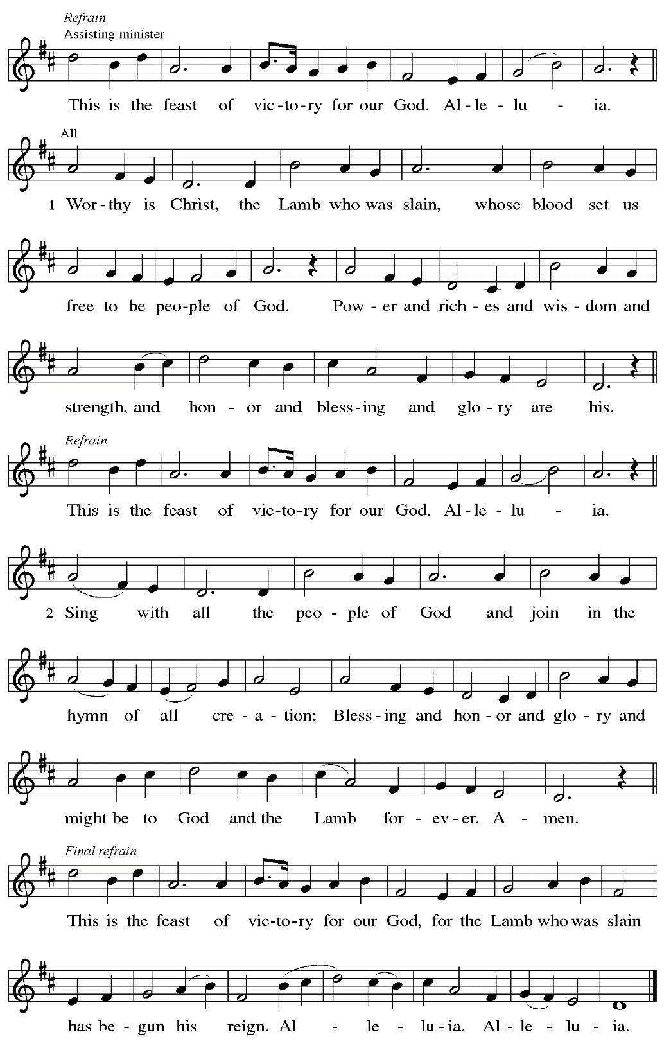

Prayer of the Day

P: The Lord be with you.
C: And also with you.

P: Let us pray.
O God of life, you reach out to us amid our fears with the wounded hands of your risen Son.
By your Spirit’s breath, revive our faith in your mercy,
and strengthen us to be the body of your Son, Jesus Christ, our Savior and Lord,
who lives and reigns with you and the Holy Spirit, one God, now and forever.
C: Amen.

Please be seated.

Word
God speaks to us in Scripture reading, preaching, and song

First Reading – Acts 5: 27-32

²⁷When they had brought [the apostles,] they had them stand before the council. The high priest questioned them, ²⁸saying, “We gave you strict orders not to teach in this name, yet here you have filled Jerusalem with your teaching and you are determined to bring this man’s blood on us.” ²⁹But Peter and the apostles answered, “We must obey God rather than any human authority. ³⁰The God of our ancestors raised up Jesus, whom you had killed by hanging him on a tree. ³¹God exalted him at God’s right hand as Leader and Savior that he might give repentance to Israel and forgiveness of sins. ³²And we are witnesses to these things, and so is the Holy Spirit whom God has given to those who obey God.”

L: Word of God, word of life.
C: Thanks be to God.

Psalm 118: 14-29

The psalm will be sung responsively, led by the cantor.

Tone

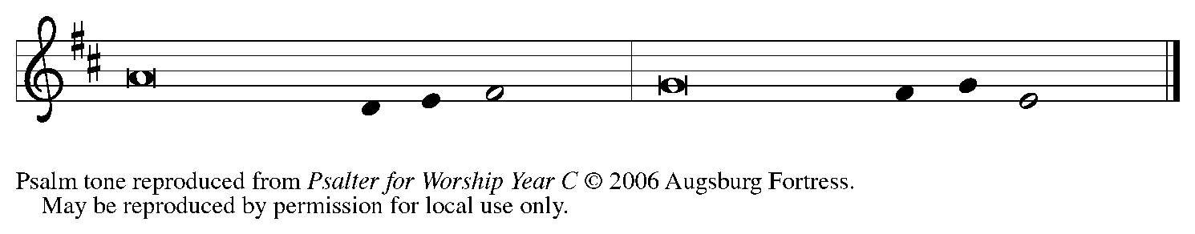

Refrain

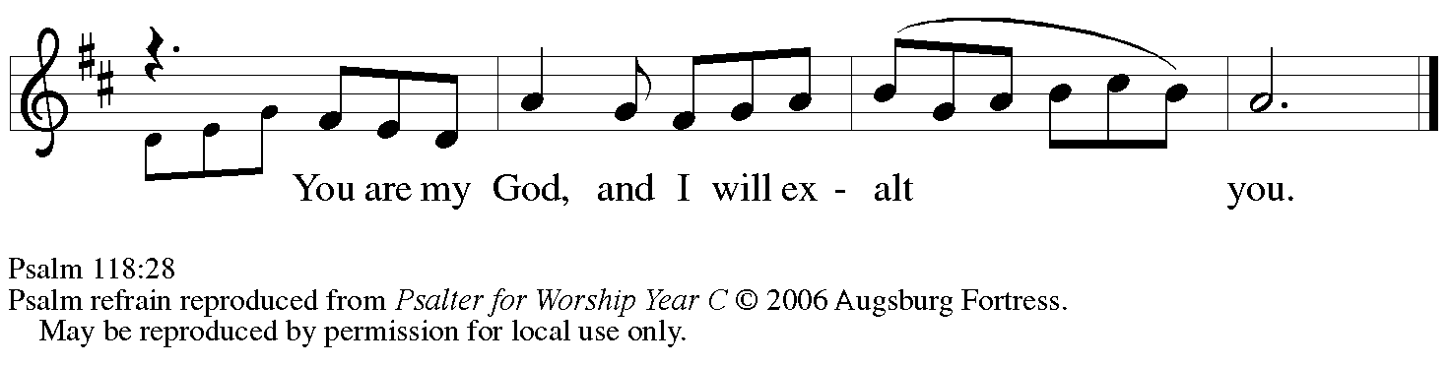

¹⁴The Lord is my strength | and my song,
and has become | my salvation.
¹⁵Shouts of rejoicing and salvation echo in the tents | of the righteous:
“The right hand of the | Lord acts valiantly!
¹⁶The right hand of the Lord| is exalted!
The right hand of the | Lord acts valiantly!”
¹⁷I shall not | die, but live,
and declare the works | of the Lord. R
¹⁸The Lord indeed pun- | ished me sorely,
but did not hand me o- | ver to death.
¹⁹Open for me the | gates of righteousness;
I will enter them and give thanks | to the Lord.
²⁰“This is the gate | of the Lord;
here the righ- | teous may enter.”
²¹I give thanks to you, for you have | answered me
and you have become | my salvation. R
²²The stone that the build- | ers rejected
has become the chief | cornerstone.
²³By the Lord has | this been done;
it is marvelous | in our eyes.
²⁴This is the day that the | Lord has made;
let us rejoice and be | glad in it.
²⁵Hosanna! | O Lord, save us!
We pray to you, Lord, pros- | per our days! R
²⁶Blessed is the one who comes in the name | of the Lord;
we bless you from the house | of the Lord.
²⁷The Lord is God and has giv- | en us light.
Form a procession with branches up to the corners | of the altar.
²⁸You are my God, and | I will thank you;
you are my God, and I | will exalt you.
²⁹Give thanks to the Lord, for the | Lord is good;
God’s mercy en- | dures forever. R

Second Reading – Revelation 1: 4-8

⁴John to the seven churches that are in Asia:
Grace to you and peace from the who is and who was and who is to come,
and from the seven spirits who are before God’s throne,
⁵and from Jesus Christ, the faithful witness, the firstborn of the dead,
and the ruler of the kings of the earth.
To him who loves us and freed us from our sins by his blood, ⁶and made us to be a kingdom, priests serving his God and Father, to him be glory and dominion forever and ever. Amen.
⁷Look! He is coming with the clouds;
every eye will see him,
even those who pierced him;
and on his account all the tribes of the earth will wail.
So it is to be. Amen.
⁸“I am the Alpha and the Omega,” says the Lord God, who is and who was and who is to come, the Almighty.

L: Word of God, word of life.
C: Thanks be to God.

Please rise as you are able.

Gospel Acclamation

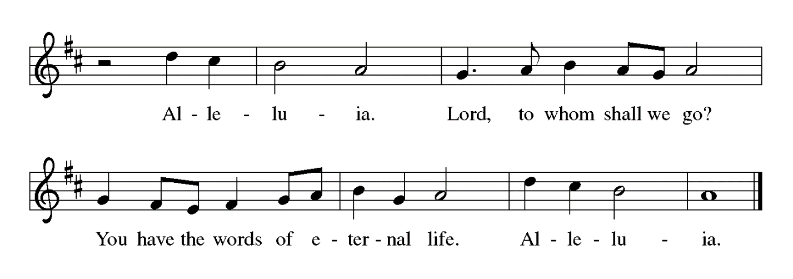

Gospel – John 20: 19-31

P: The holy Gospel according to St. John.
C: Glory to you, O Lord.

¹⁹When it was evening on that day, the first day of the week, and the doors of the house where the disciples had met were locked for fear of the Jews, Jesus came and stood among them and said, “Peace be with you.” ²⁰After he said this, he showed them his hands and his side. Then the disciples rejoiced when they saw the Lord. ²¹Jesus said to them again, “Peace be with you. As the Father has sent me, so I send you.” ²²When he had said this, he breathed on them and said to them, “Receive the Holy Spirit. ²³If you forgive the sins of any, they are forgiven them; if you retain the sins of any, they are retained.”
²⁴But Thomas (who was called the Twin), one of the twelve, was not with them when Jesus came. ²⁵So the other disciples told him, “We have seen the Lord.” But he said to them, “Unless I see the mark of the nails in his hands, and put my finger in the mark of the nails and my hand in his side, I will not believe.”
²⁶A week later his disciples were again in the house, and Thomas was with them. Although the doors were shut, Jesus came and stood among them and said, “Peace be with you.” ²⁷Then he said to Thomas, “Put your finger here and see my hands. Reach out your hand and put it in my side. Do not doubt but believe.” ²⁸Thomas answered him, “My Lord and my God!” ²⁹Jesus said to him, “Have you believed because you have seen me? Blessed are those who have not seen and yet have come to believe.”
³⁰Now Jesus did many other signs in the presence of his disciples, which are not written in this book. ³¹But these are written so that you may come to believe that Jesus is the Messiah, the Son of God, and that through believing you may have life in his name.

P: The Gospel of the Lord.
C: Praise to you, O Christ.

Please be seated.

Sermon

A time of silence for prayer and reflection follows the sermon.
When the hymn of the day begins, please rise as you are able.

Hymn of the Day We Walk by Faith ELW 635

1 We walk by faith and not by sight;
with gracious words draw near,
O Christ, who spoke as none e'er spoke:
"My peace be with you here."

2 We may not touch your hands and side,
nor follow where you trod;
but in your promise we rejoice,
and cry, "My Lord and God!"

3 Help then, O Lord, our unbelief;
and may our faith abound
to call on you when you are near
and seek where you are found:

4 For you, O resurrected Lord,
are found in means divine:
beneath the water and the word,
beneath the bread and wine.

Text: Henry Alford, 1810-1871, alt. Music: SHANTI, Marty Haugen, b. 1950. Music © 1984 GIA Publications, Inc., 7404 S. Mason Ave., Chicago, IL 60638. www.giamusic.com. 800.442.3358. All rights reserved. Reprinted with permission under OneLicense.net #A-722139.

Affirmation of Baptism

Those making affirmation gather with the presiding minister at the font.
The presiding minister addresses the assembly with these or similar words.
P: Dear friends, we give thanks for the gift of Baptism and for Wayne,
one with us in the body of Christ, who is making public affirmation of his Baptism.

Those making affirmation are presented by a sponsor or another representative of the congregation:
R: I present Wayne, who desires to make public affirmation of his Baptism.

The presiding minister continues with prayer.
P: Let us pray.
Merciful God, we thank you for this brother in Christ,
whom you have made your own by water and the Word in Baptism.
You have called him to yourself,
enlightened him with the gifts of your Spirit,
and nourished him in the community of faith.
Uphold your servant in the gifts and promises of Baptism,
and unite the hearts of all whom you have brought to new birth.
We ask this in the name of Christ.
C: Amen.

Profession of Faith

The presiding minister addresses those making public affirmation of Baptism.
The assembly may rise as able and join in the responses.

P: I ask you to profess your faith in Christ Jesus, reject sin, and confess the faith of the church.

P: Do you renounce the devil and all the forces that defy God?
Response: I renounce them.

P: Do you renounce the powers of this world that rebel against God?
Response: I renounce them.

P: Do you renounce the ways of sin that draw you from God?
Response: I renounce them.

The presiding minister addresses the assembly.
P: Do you believe in God the Father?
C: I believe in God, the Father almighty,
creator of heaven and earth.

P: Do you believe in Jesus Christ, the Son of God?
C: I believe in Jesus Christ, God’s only Son, our Lord,
who was conceived by the Holy Spirit,
born of the virgin Mary,
suffered under Pontius Pilate,
was crucified, died, and was buried;
he descended to the dead.*
On the third day he rose again;
he ascended into heaven,
he is seated at the right hand of the Father,
and he will come to judge the living and the dead.

P: Do you believe in God the Holy Spirit?
I believe in the Holy Spirit,
the holy catholic church,
the communion of saints,
the forgiveness of sins,
the resurrection of the body,
and the life everlasting.

*Or, “he descended into hell,” another translation of this text in widespread use.

Affirmation of Baptism

The presiding minister addresses the assembly.
You have made public profession of your faith. Do you intend to continue in the covenant God made with you in Holy Baptism:
to live among God’s faithful people,
to hear the word of God and share in the Lord’s supper,
to proclaim the good news of God in Christ through word and deed,
to serve all people, following the example of Jesus,
and to strive for justice and peace in all the earth?

The individual responds: I do, and I ask God to help and guide me.

The minister addresses the assembly.
P: People of God, do you promise to support this brother and pray for him in his life in Christ?
C: We do, and we ask God to help and guide us.

The presiding minister prays for God’s blessing.
P: Let us pray.
We give you thanks, O God, that through water and the Holy Spirit, you give us new birth, cleanse us from sin, and raise us to eternal life.

The blessing may be repeated for each person. The minister may lay both hands on the head of the person and say:
P: Stir up in Wayne the gift of your Holy Spirit: the spirit of wisdom and understanding,
the spirit of counsel and might, the spirit of knowledge and the fear of the Lord,
the spirit of joy in your presence, both now and forever.
C: Amen.

Those making affirmation turn and face the assembly. A representative of the congregation addresses the assembly.
R: Let us rejoice with this brother in Christ.
C: We rejoice with you in the life of Baptism.
Together we will give thanks and praise to God
and proclaim the good news to all the world.

St. Andrew’s congregational refrain is sung in celebration of the gift of Baptism
and in thanksgiving for our new sibling in Christ.

C: Christ goes before, and we are called to follow,
and all who follow find the Way, the Truth, the Life.

All return to their places. Worship continues with the Prayers of the People.

Prayers of the People

P: Set free from captivity to sin and death, we pray to the God of resurrection for the church,
the world, and all who are in need.

After each petition
P: Gracious God,
C: receive our prayer.

P: In your mercy, O God, receive our prayers and renew us by your life-giving Spirit,
through Jesus Christ, our Savior.
C: Amen.

Please be seated.

Meal

Offering

We offer ourselves, our gifts, and our faithful service to God.
An usher will pass around an offering plate for anyone who would like to offer gifts before God.

Music during the Offering

Please rise as you are able.

Offertory Song Let the Vineyards ELW 184

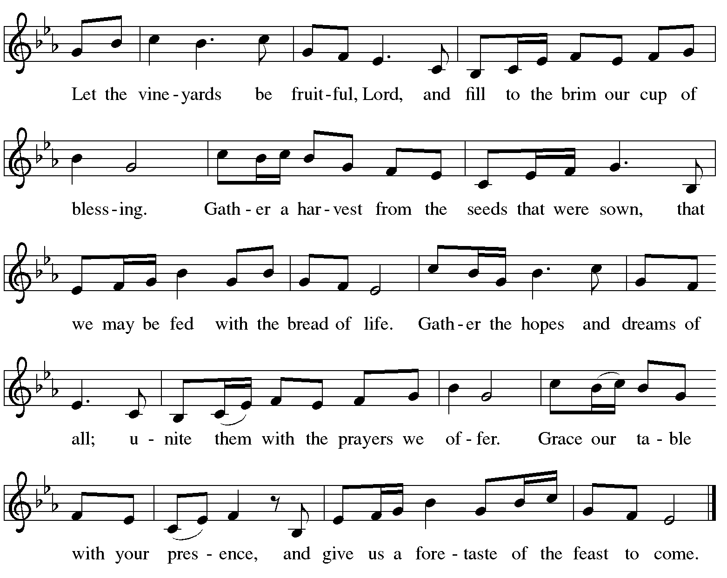

Offertory Prayer

P: Let us pray.
Blessed are you, O God,
ruler of heaven and earth.
Day by day you shower us with blessings.
As you have raised us to new life in Christ, give us glad and generous hearts,
ready to praise you and to respond to those in need,
through Jesus Christ, our Savior and Lord.
Amen.

Dialogue

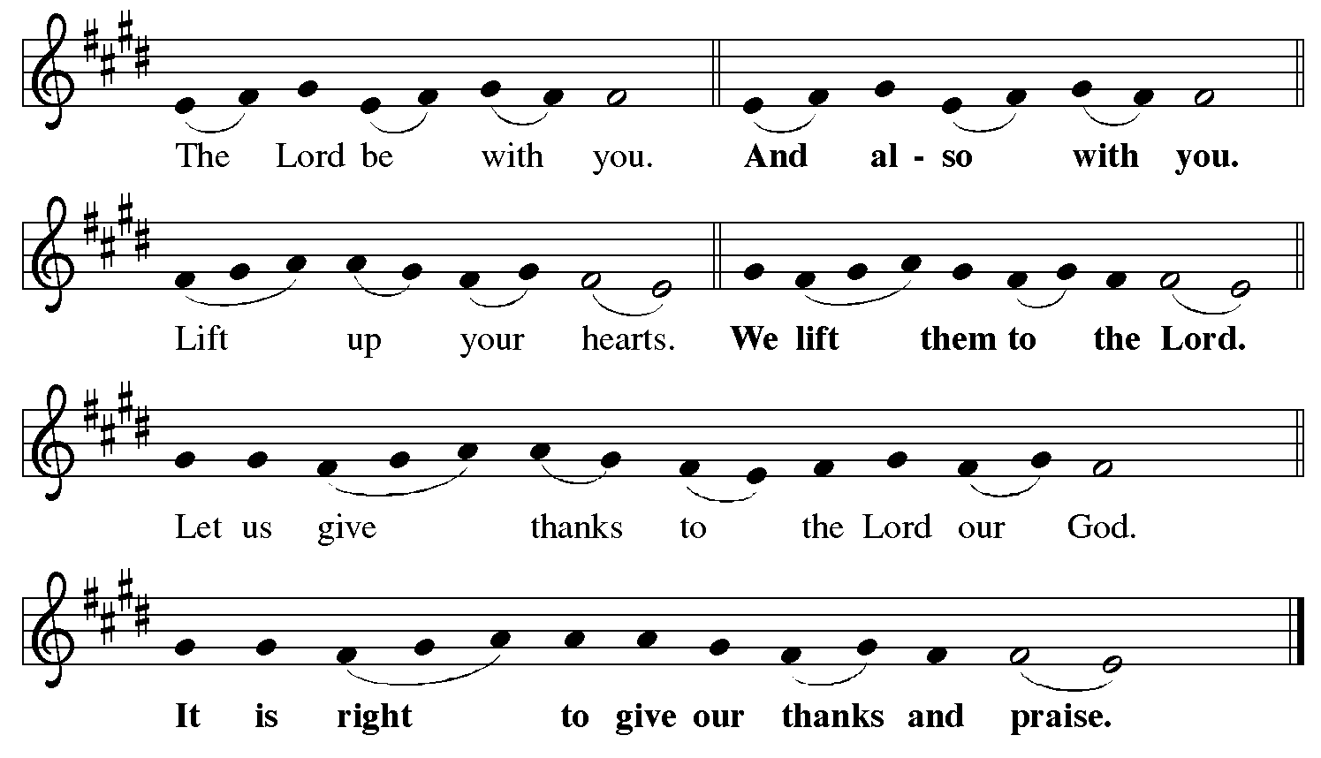

Preface (Sung by the presiding minister)

P: It is indeed right, our duty and our joy,
that we should at all times and in all places
give thanks and praise to you, almighty and merciful God,
for the glorious resurrection of our Savior Jesus Christ,
the true Paschal Lamb who gave himself to take away our sin;
who in dying has destroyed death,
and in rising has brought us to eternal life.
And so, with Mary Magdalene and Peter and all the witnesses of the resurrection,
with earth and sea and all their creatures,
and with angels and archangels, cherubim and seraphim,
we praise your name and join their unending hymn:

Sanctus

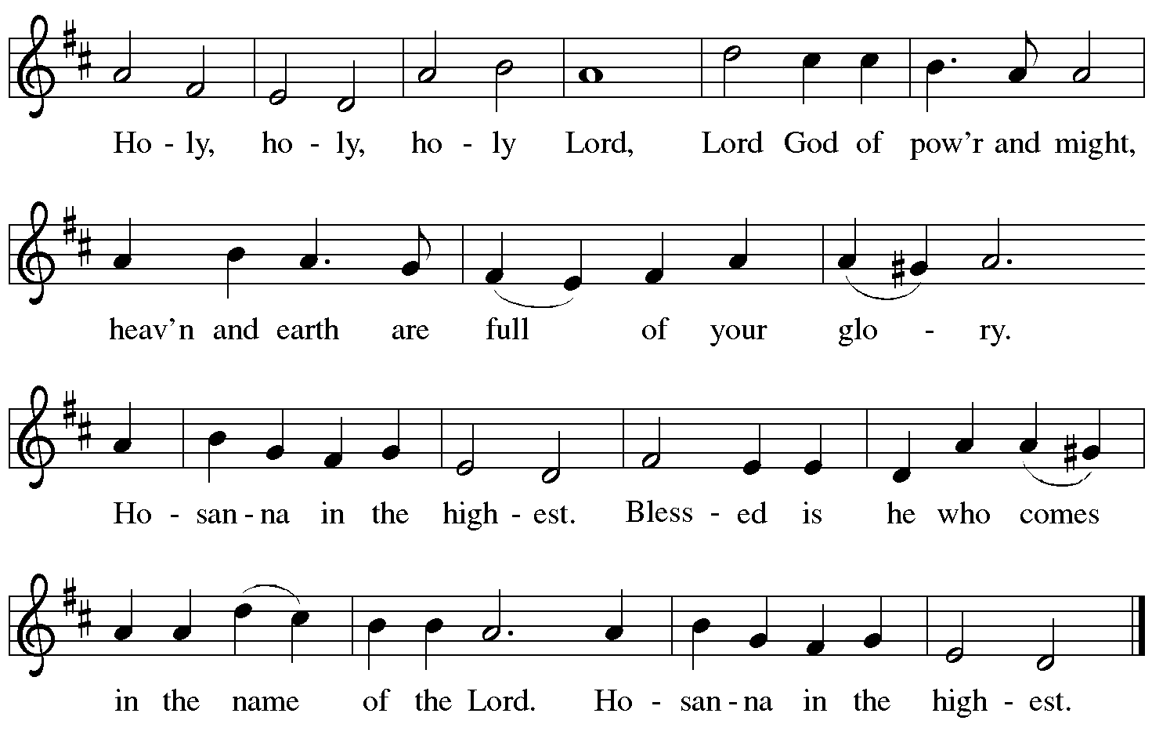

Eucharistic Prayer

P: Blessed are you, O God of the universe …
… Do this for the remembrance of me.

With this bread and cup we remember our Lord’s Passover from death to life
as we proclaim the mystery of faith.
C: Christ has died. Christ is risen. Christ will come again.

P: O God of resurrection and new life …
… Grace our table with your presence.
C: Come, Holy Spirit.

P: Reveal yourself to us in the breaking of the bread …
… burning with justice, peace, and love.
C: Come, Holy Spirit.

P: With your holy ones of all times and places …
… blessed and Holy Trinity, now and forever.
C: Amen.

Lord’s Prayer

P: Gathered as one by the Holy Spirit, let us pray as Jesus taught us.
C: Our Father in heaven,
hallowed be your name,
your kingdom come,
your will be done,
on earth as in heaven.
Give us today our daily bread.
Forgive us our sins
as we forgive those
who sin against us.
Save us from the time of trial
and deliver us from evil.
For the kingdom, the power,
and the glory are yours,
now and forever. Amen.

Fraction and Invitation

Agnus Dei / Lamb of God

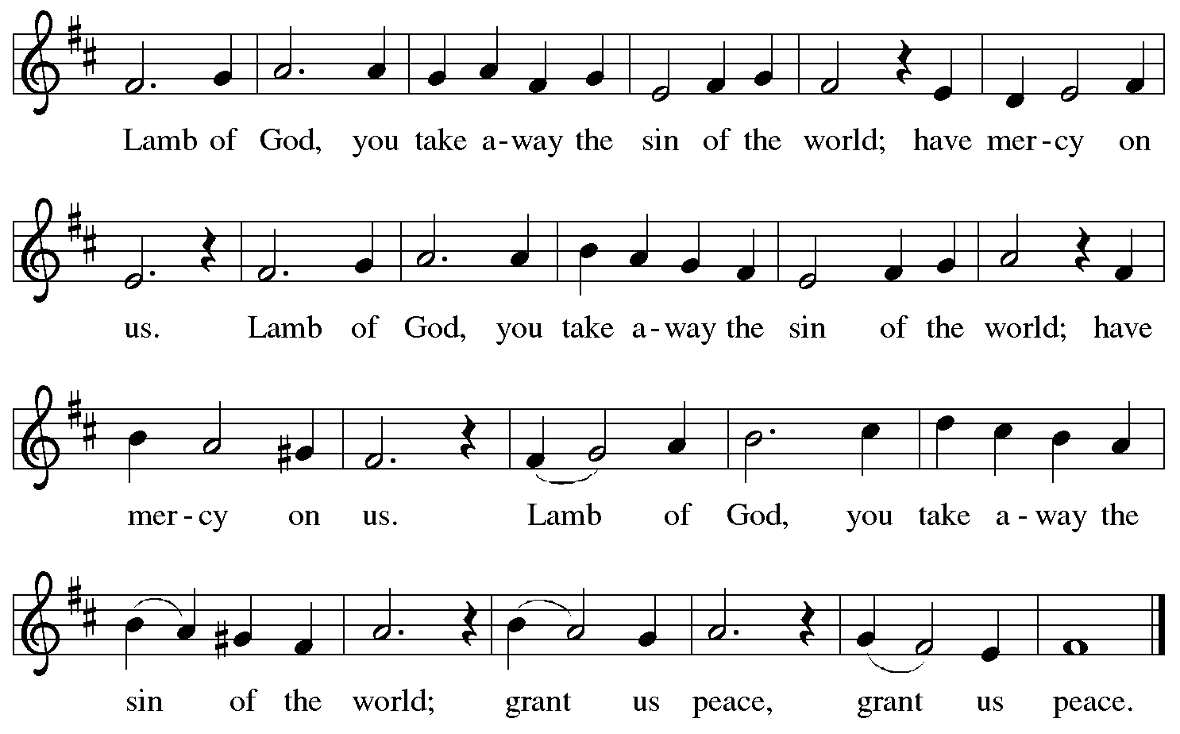

Please be seated.

Holy Communion
- Hand sanitizer is available if you would like to use it prior to receiving Communion.
- Worshipers from the pulpit side will proceed forward first, followed by the center section, and then the lectern side.
- The Communion wafers (regular and gluten-free) have been thoughtfully prepared using the gifts of the congregation by a member of St. Andrew’s altar care team, with a drop of wine or grape juice on each. The presiding minister will distribute one to each communicant.
- When you reach the presiding minister, please indicate if you would like grape juice or a gluten-free wafer.
- A blessing will be provided for anyone who does not yet receive the sacrament.
- A cushion has been placed at the altar rail for anyone who would like to kneel for prayer and reflection before returning to their pew.
- Everyone is asked to wait until you return to your place to consume the elements, and then promptly replace your mask.

Hymns during Holy Communion
By Your Hand You Feed Your People ELW 469

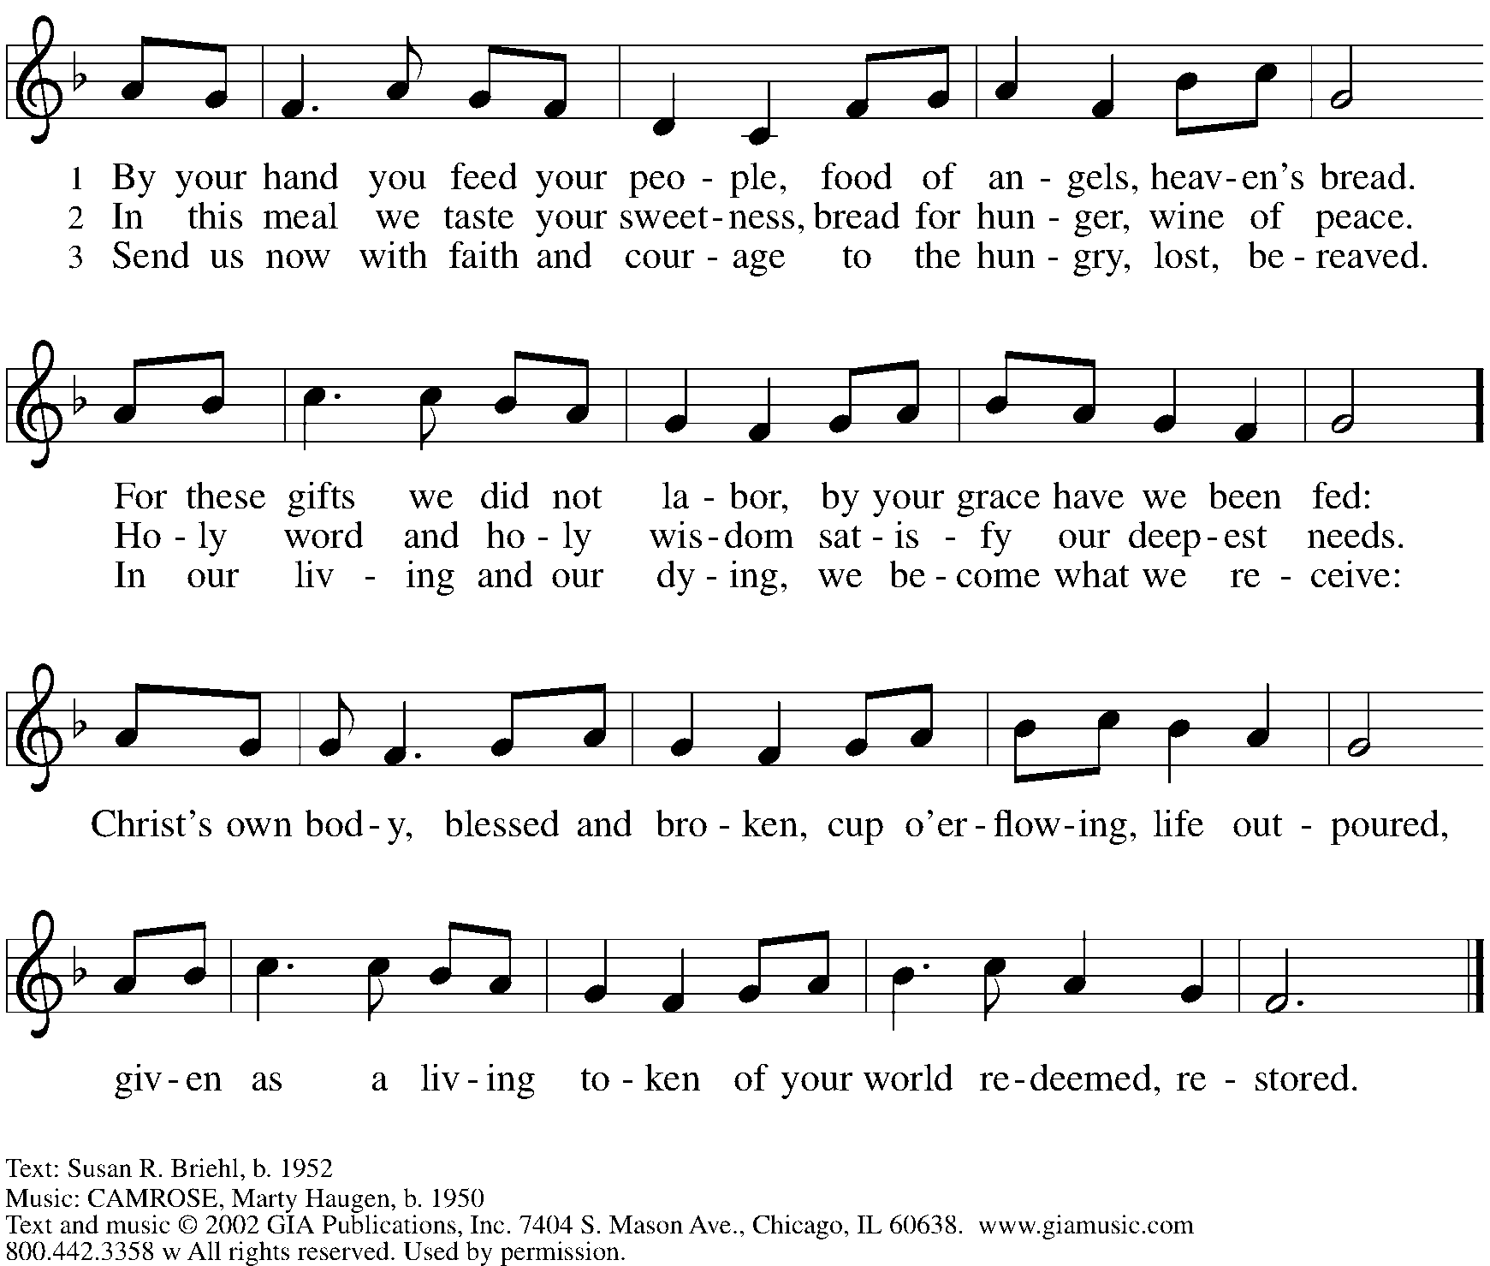
Reprinted with permission under OneLicense.net # A-722139.

Hymns during Holy Communion
With High Delight Let Us Unite ELW 368

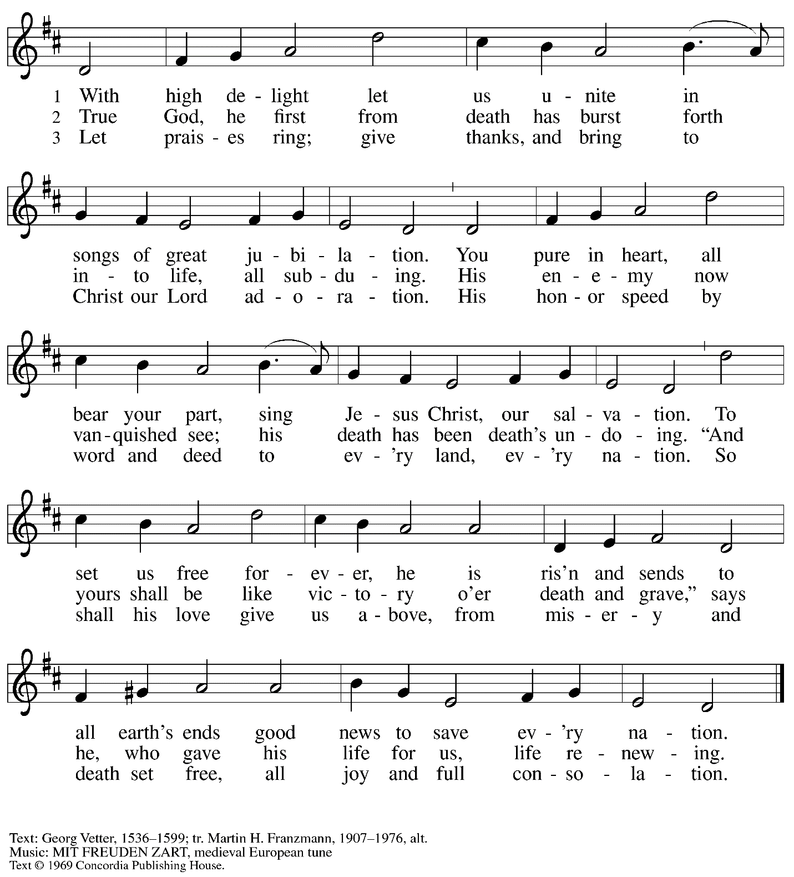
All rights reserved. Reprinted under OneLicense.net # A-722139.

When all have returned to their places, please rise as you are able.

Blessing

P: The body and blood of our Lord Jesus Christ strengthen you and keep you in his grace.
C: Amen.

Prayer

P: Let us pray.
Life-giving God,
in the mystery of Christ’s resurrection you send light to conquer darkness,
water to give new life, and the bread of life to nourish your people.
Send us forth as witnesses to your Son’s resurrection,
that we may show your glory to all the world,
through Jesus Christ, our risen Lord.
C: Amen.

Sending

Benediction

P: May our glorious God grant you a spirit of wisdom
to know and love the risen Christ.

Almighty God, holy One, ☩ holy Three,
bless you now and forever.
C: Amen.

Sending Hymn Rise, O Church, Like Christ Arisen ELW 548

1 Rise, O church, like Christ arisen,
from this meal of love and grace;
may we through such love envision
whose we are, and whose, our praise.
Alleluia, alleluia;
God, the wonder of our days.
2 Rise, transformed, and choose to follow
after Christ, though wounded, whole;
broken, shared, our lives are hallowed
to release and to console.
Alleluia, alleluia;
Christ, our present, past, and goal.

Text: Susan Palo Cherwien, b. 1953. Music: SURGE ECCLESIA, Timothy J. Strand, b. 1958. Text © 1997 Susan Palo Cherwien, admin. Augsburg Fortress. Music © 1997 Augsburg Fortress. All rights reserved. Reprinted under OneLicense.net # A-722139.

Dismissal

P: Alleluia! Christ is risen!
C: Christ is risen indeed! Alleluia! Alleluia!

P: Go in peace. Share the good news!
C: Thanks be to God!

Abbreviations

P: Pastor/Presiding Minister
L: Lector
C: Congregation

ELW: Evangelical Lutheran Worship hymnal

Those serving in worship today

Piano Jeff Denlinger
Cantor Kristen Asplin
Lector Sue Gaugler
Director of Faith Formation Christopher Atwood
Presiding Minister Pastor Ross Carmichael

Liturgy and Hymnody Acknowledgements

From SundaysandSeasons.com. Copyright © 2022 Augsburg Fortress. All rights reserved. Reprinted under OneLicense.net # A-722139.
Used by permission of Augsburg Fortress.

Christ the Lord Is Risen Today; Alleluia! – Text: attr. Wipo of Burgundy, d. c. 1050; tr. Jane E. Leeson, 1807-1882, alt. Music: LLANFAIR, Robert Williams, 1781-1821.

Let the Vineyards – Text: John W. Arthur, 1922-1980. Music: Ronald A. Nelson, b. 1927. Text and Music © 1978 Lutheran Book of Worship, admin. Augsburg Fortress.

