+ Third Sunday of Easter
May 1, 2022
St. Andrew Lutheran Church
304 Morewood Ave.
Pittsburgh, PA 15213
St_andrewELCA@verizon.net
www.standrewpittsburgh.org

+ Third Sunday of Easter
Order for Worship

Today, John’s Gospel shares a post-resurrection appearance of Jesus by the sea of Tiberias. Jesus enables his disciples to bring in a large catch of fish, and then invites them to share breakfast with him on the shore. Wading in the water (remembering Baptism) and eating with Jesus (celebrating a meal of communion) is our weekly encounter with the risen Christ. Jesus asks of us again and again: Do you love me? And Jesus invites us, again and again, to follow him, bringing Easter to life for others.

A few notes on precautions and protocols, which apply to everyone regardless of vaccination status, as St. Andrew returns to worship in the sanctuary:

- Face masks that fully cover both your mouth and nose are required at all times for everyone over the age of two (2) – the only exception being the brief moment of moving mask aside to partake in Holy Communion.
- Outside food and drink are thus not permissible during worship.
- Physical distancing of at least six (6) feet will be observed at all times for people not from your household.
- We invite the congregation to join in the singing of the hymns (with masks on) during worship!
- Hand sanitizer is available at the front of the sanctuary to use before Holy Communion, after you proceed past the baptismal font, as the alcohol has been affecting the finish on the font’s bowl.

Worship Services are live streamed to multiple online platforms.
By attending worship, you agree that your image and voice may be broadcast.

Welcome

Prelude

Gathering
The Holy Spirit calls us together as the people of God.

Thanksgiving for Baptism

P: Alleluia! Christ is risen!
C: Christ is risen indeed. Alleluia!

P: In the waters of baptism,
we have passed over from death to life with Jesus Christ,
and we are a new creation.
For this saving mystery, and for this water, let us bless God,
who was, who is, and who is to come.

Water may be poured into the font as the presiding minister gives thanks.

P: We thank you, God, for your river of life,
flowing freely from your throne:
throughout the earth, through the city, to every living thing.
You rescued Noah and his family from the flood;
You opened wide the sea for the Israelites.
Now in these waters you flood us with mercy,
and our sin is drowned forever.
You open the gate of righteousness
and we pass safely through.
In Jesus Christ, you calm and trouble the waters.
You nourish us and enclose us in safety.
You call us forth and send us out.
In lush and barren places, you are with us.
You have become our salvation.
Now breathe upon this water
and awaken your church once more.
Claim us again as your beloved and holy people.
Quench our thirst; cleanse our hearts; wipe away every tear.
To you, our Beginning and our End,
our Shepherd and Lamb,
be honor, glory, praise, and thanksgiving,
now and forever.
C: Amen.

Gathering Hymn The Day of Resurrection! ELW 361
v. 1, 4

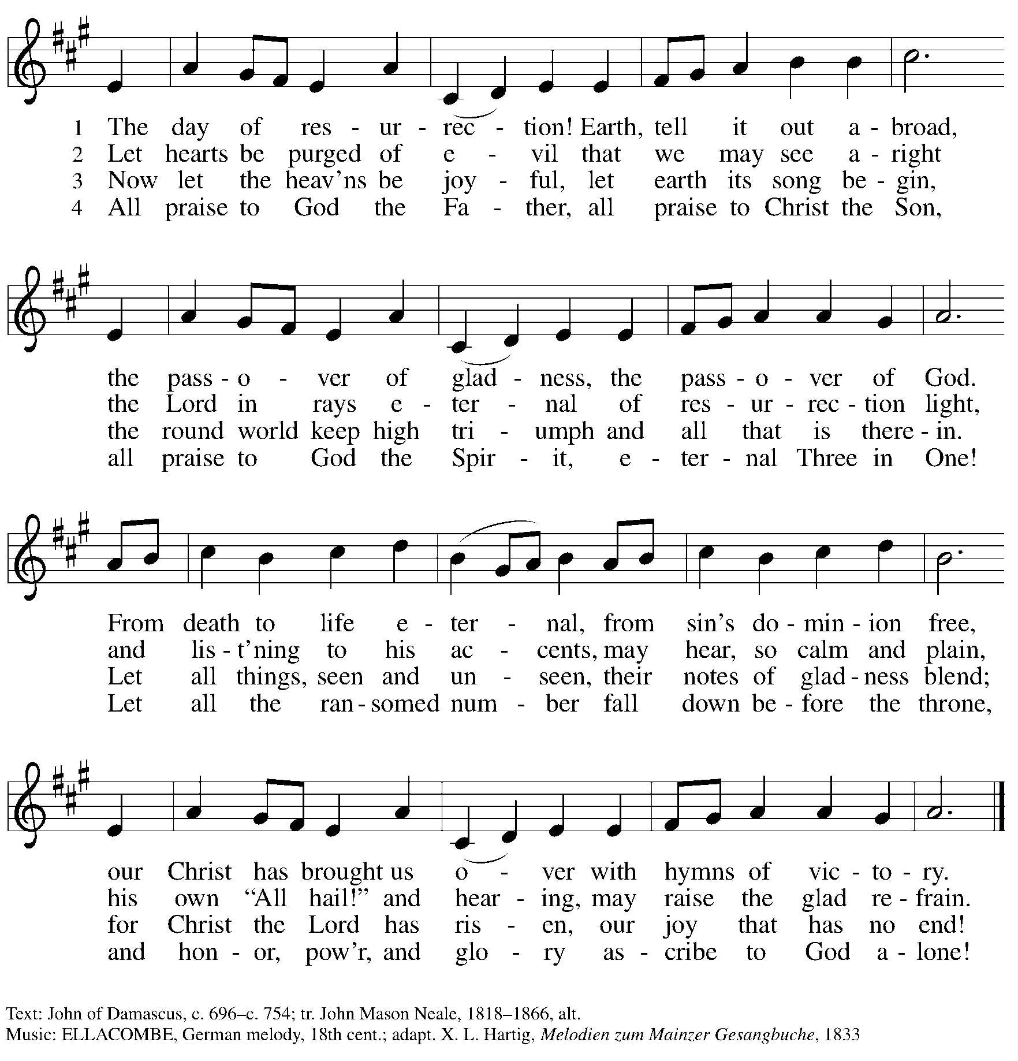

Greeting

P: The grace of our Lord Jesus Christ, the love of God,
and the communion of the Holy Spirit be with you all.
C: And also with you.

Hymn of Praise This Is the Feast ELW p. 149-150

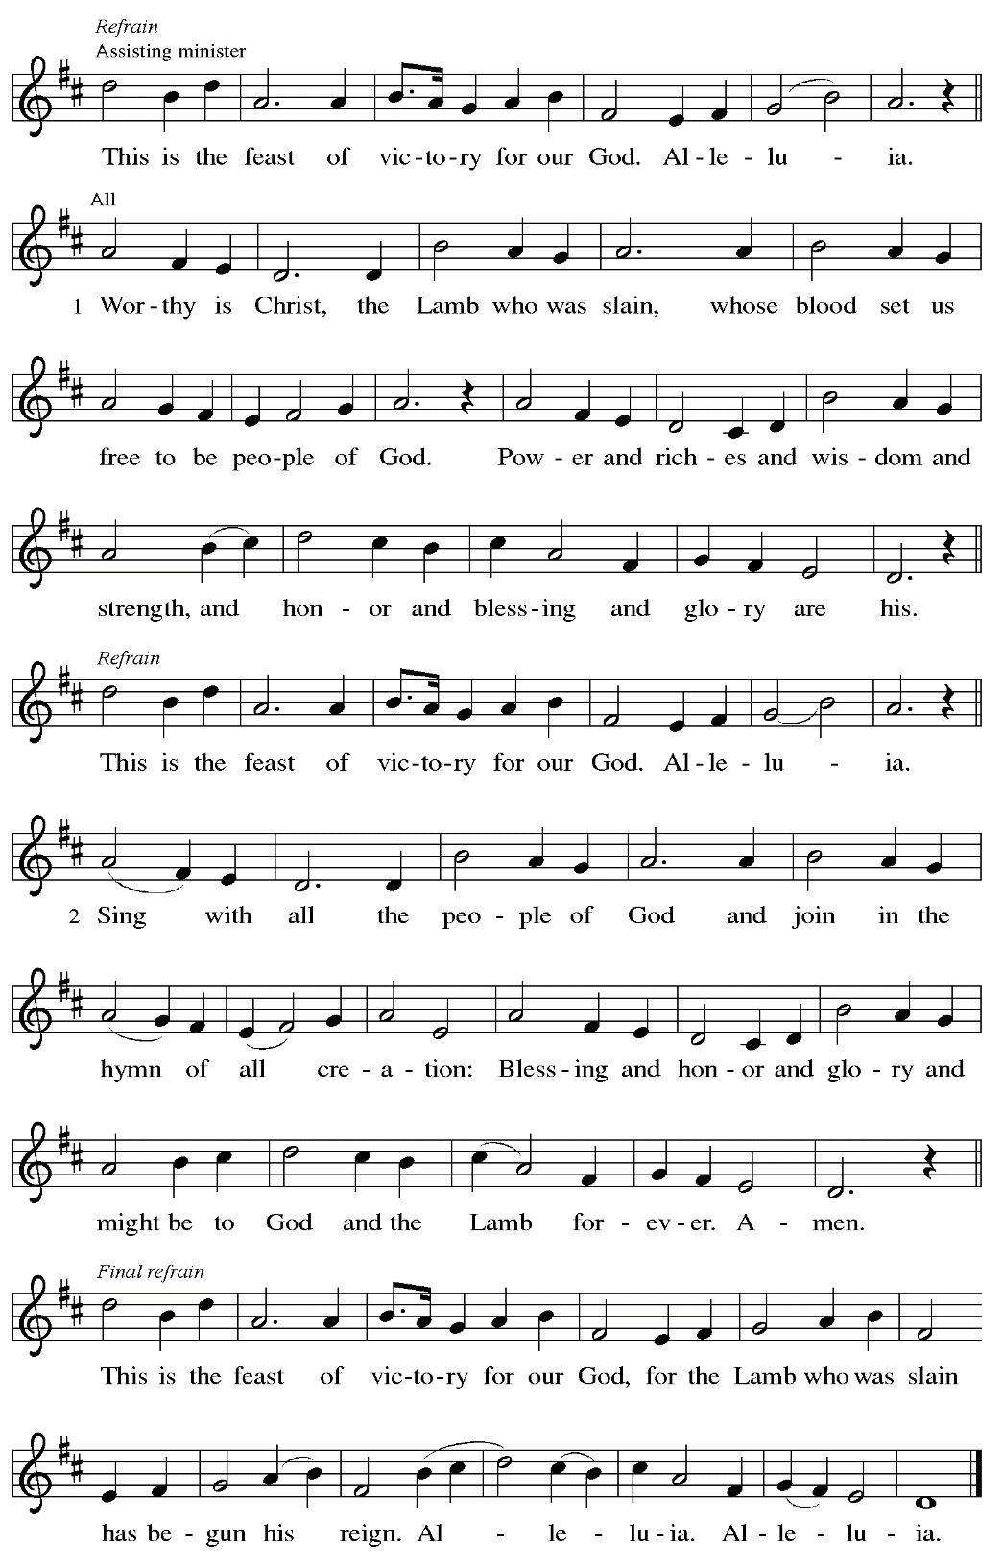

Prayer of the Day

P: The Lord be with you.
C: And also with you.

P: Let us pray.
Eternal and all-merciful God,
with all the angels and all the saints we laud your majesty and might.
By the resurrection of your Son, show yourself to us and inspire us to follow Jesus Christ,
our Savior and Lord, who lives and reigns with you and the Holy Spirit, one God,
now and forever.
C: Amen.

Please be seated.

Word
God speaks to us in Scripture reading, preaching, and song

First Reading – Acts 9: 1-6 [7-20]

¹Saul, still breathing threats and murder against the disciples of the Lord, went to the high priest ²and asked him for letters to the synagogues at Damascus, so that if he found any who belonged to the Way, men or women, he might bring them bound to Jerusalem. ³Now as he was going along and approaching Damascus, suddenly a light from heaven flashed around him. ⁴He fell to the ground and heard a voice saying to him, “Saul, Saul, why do you persecute me?” ⁵He asked, “Who are you, Lord?” The reply came, “I am Jesus, whom you are persecuting. ⁶But get up and enter the city, and you will be told what you are to do.” [⁷The men who were traveling with him stood speechless because they heard the voice but saw no one. ⁸Saul got up from the ground, and though his eyes were open, he could see nothing; so they led him by the hand and brought him into Damascus. ⁹For three days he was without sight, and neither ate nor drank.
¹⁰Now there was a disciple in Damascus named Ananias. The Lord said to him in a vision, “Ananias.” He answered, “Here I am, Lord.” ¹¹The Lord said to him, “Get up and go to the street called Straight, and at the house of Judas look for a man of Tarsus named Saul. At this moment he is praying, ¹²and he has seen in a vision a man named Ananias come in and lay his hands on him so that he might regain his sight.” ¹³But Ananias answered, “Lord, I have heard from many about this man, how much evil he has done to your saints in Jerusalem; ¹⁴and here he has authority from the chief priests to bind all who invoke your name.” ¹⁵But the Lord said to him, “Go, for he is an instrument whom I have chosen to bring my name before Gentiles and kings and before the people of Israel; ¹⁶I myself will show him how much he must suffer for the sake of my name.” ¹⁷So Ananias went and entered the house. He laid his hands on Saul and said, “Brother Saul, the Lord Jesus, who appeared to you on your way here, has sent me so that you may regain your sight and be filled with the Holy Spirit.” ¹⁸And immediately something like scales fell from his eyes, and his sight was restored. Then he got up and was baptized, ¹⁹and after taking some food, he regained his strength.
For several days he was with the disciples in Damascus, ²⁰and immediately he began to proclaim Jesus in the synagogues, saying, “He is the Son of God.”]

L: Word of God, word of life.
C: Thanks be to God.

Psalm 30

The psalm will be sung responsively, led by the cantor.

Tone

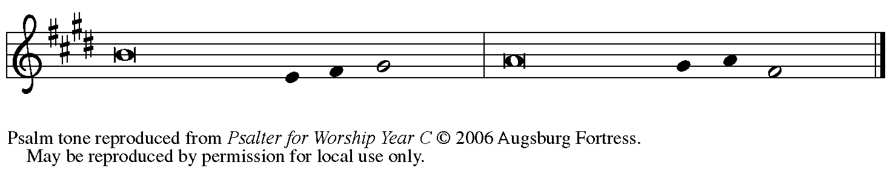

Refrain

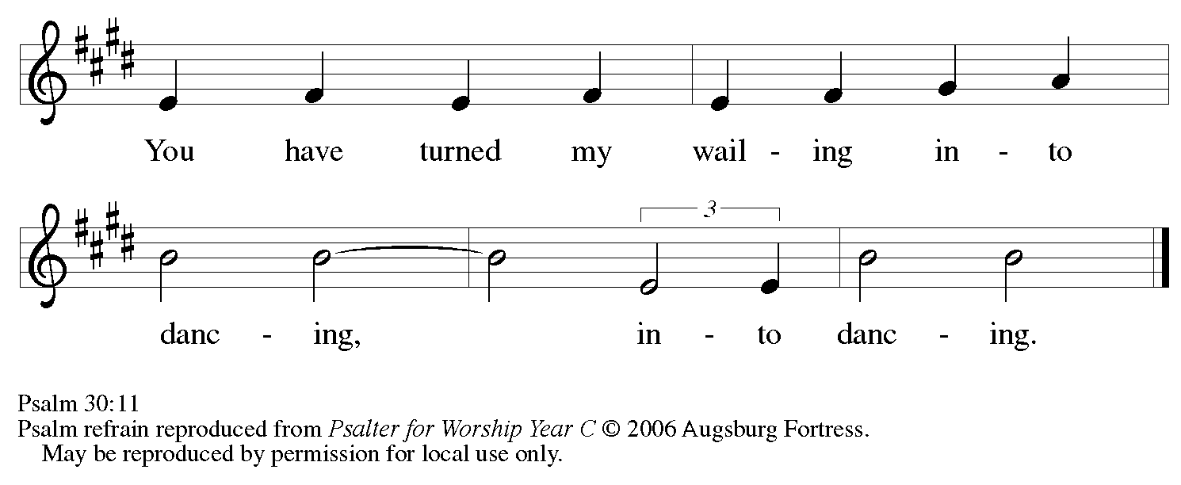

¹I will exalt you, O Lord, because you have lift- | ed me up
and have not let my enemies triumph | over me.
²O Lord my God, I cried | out to you,
and you restored | me to health.
³You brought me up, O Lord, | from the dead;
you restored my life as I was going down | to the grave.
⁴Sing praise to the Lord, | all you faithful;
give thanks in ho- | ly remembrance. R
Refrain

⁵God’s wrath is short; God’s favor | lasts a lifetime.
Weeping spends the night, but joy comes | in the morning.
⁶While I felt se- | cure, I said,
“I shall never | be disturbed.
⁷You, Lord, with your favor, made me as strong | as the mountains.”
Then you hid your face, and I was | filled with fear.
⁸I cried to | you, O Lord;
I pleaded with | my Lord, saying,
⁹“What profit is there in my blood, if I go down | to the pit?
Will the dust praise you or de- | clare your faithfulness?
¹⁰Hear, O Lord, and have mer- | cy upon me;
O Lord, | be my helper.” R
¹¹You have turned my wailing | into dancing;
you have put off my sackcloth and clothed | me with joy.
¹²Therefore my heart sings to you | without ceasing;
O Lord my God, I will give you | thanks forever. R

Second Reading – Revelation 5: 11-14

¹¹Then I looked, and I heard the voice of many angels surrounding the throne and the living creatures and the elders; they numbered myriads of myriads and thousands of thousands, ¹²singing with full voice,
“Worthy is the Lamb that was slaughtered
to receive power and wealth and wisdom and might
and honor and glory and blessing!”
¹³Then I heard every creature in heaven and on earth and under the earth and in the sea, and all that is in them, singing,
“To the one seated on the throne and to the Lamb
be blessing and honor and glory and might
forever and ever!”
¹⁴And the four living creatures said, “Amen!” And the elders fell down and worshiped.

L: Word of God, word of life.
C: Thanks be to God.

Please rise as you are able.

Gospel Acclamation

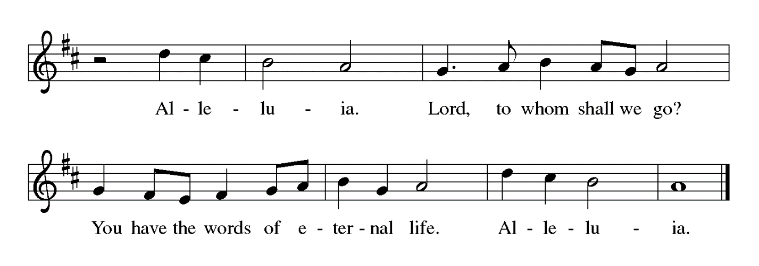

Gospel – John 21: 1-19

P: The holy Gospel according to St. John.
C: Glory to you, O Lord.

¹After [he appeared to his followers in Jerusalem,] Jesus showed himself again to the disciples by the Sea of Tiberias; and he showed himself in this way. ²Gathered there together were Simon Peter, Thomas called the Twin, Nathanael of Cana in Galilee, the sons of Zebedee, and two others of his disciples. ³Simon Peter said to them, “I am going fishing.” They said to him, “We will go with you.” They went out and got into the boat, but that night they caught nothing.
⁴Just after daybreak, Jesus stood on the beach; but the disciples did not know that it was Jesus. ⁵Jesus said to them, “Children, you have no fish, have you?” They answered him, “No.” ⁶He said to them, “Cast the net to the right side of the boat, and you will find some.” So they cast it, and now they were not able to haul it in because there were so many fish. ⁷That disciple whom Jesus loved said to Peter, “It is the Lord!” When Simon Peter heard that it was the Lord, he put on some clothes, for he was naked, and jumped into the sea. ⁸But the other disciples came in the boat, dragging the net full of fish, for they were not far from the land, only about a hundred yards off.
⁹When they had gone ashore, they saw a charcoal fire there, with fish on it, and bread. ¹⁰Jesus said to them, “Bring some of the fish that you have just caught.” ¹¹So Simon Peter went aboard and hauled the net ashore, full of large fish, a hundred fifty-three of them; and though there were so many, the net was not torn. ¹²Jesus said to them, “Come and have breakfast.” Now none of the disciples dared to ask him, “Who are you?” because they knew it was the Lord. ¹³Jesus came and took the bread and gave it to them, and did the same with the fish. ¹⁴This was now the third time that Jesus appeared to the disciples after he was raised from the dead.
¹⁵When they had finished breakfast, Jesus said to Simon Peter, “Simon son of John, do you love me more than these?” He said to him, “Yes, Lord; you know that I love you.” Jesus said to him, “Feed my lambs.” ¹⁶A second time he said to him, “Simon son of John, do you love me?” He said to him, “Yes, Lord; you know that I love you.” Jesus said to him, “Tend my sheep.” ¹⁷He said to him the third time, “Simon son of John, do you love me?” Peter felt hurt because he said to him the third time, “Do you love me?” And he said to him, “Lord, you know everything; you know that I love you.” Jesus said to him, “Feed my sheep. ¹⁸Very truly, I tell you, when you were younger, you used to fasten your own belt and to go wherever you wished. But when you grow old, you will stretch out your hands, and someone else will fasten a belt around you and take you where you do not wish to go.” ¹⁹(He said this to indicate the kind of death by which he would glorify God.) After this he said to him, “Follow me.”

P: The Gospel of the Lord.
C: Praise to you, O Christ.

Please be seated.

Sermon

A time of silence for prayer and reflection follows the sermon.
When the hymn of the day begins, please rise as you are able.

Hymn of the Day That Easter Day with Joy Was Bright Following Page

Hymn of the Day That Easter Day with Joy Was Bright ELW 384

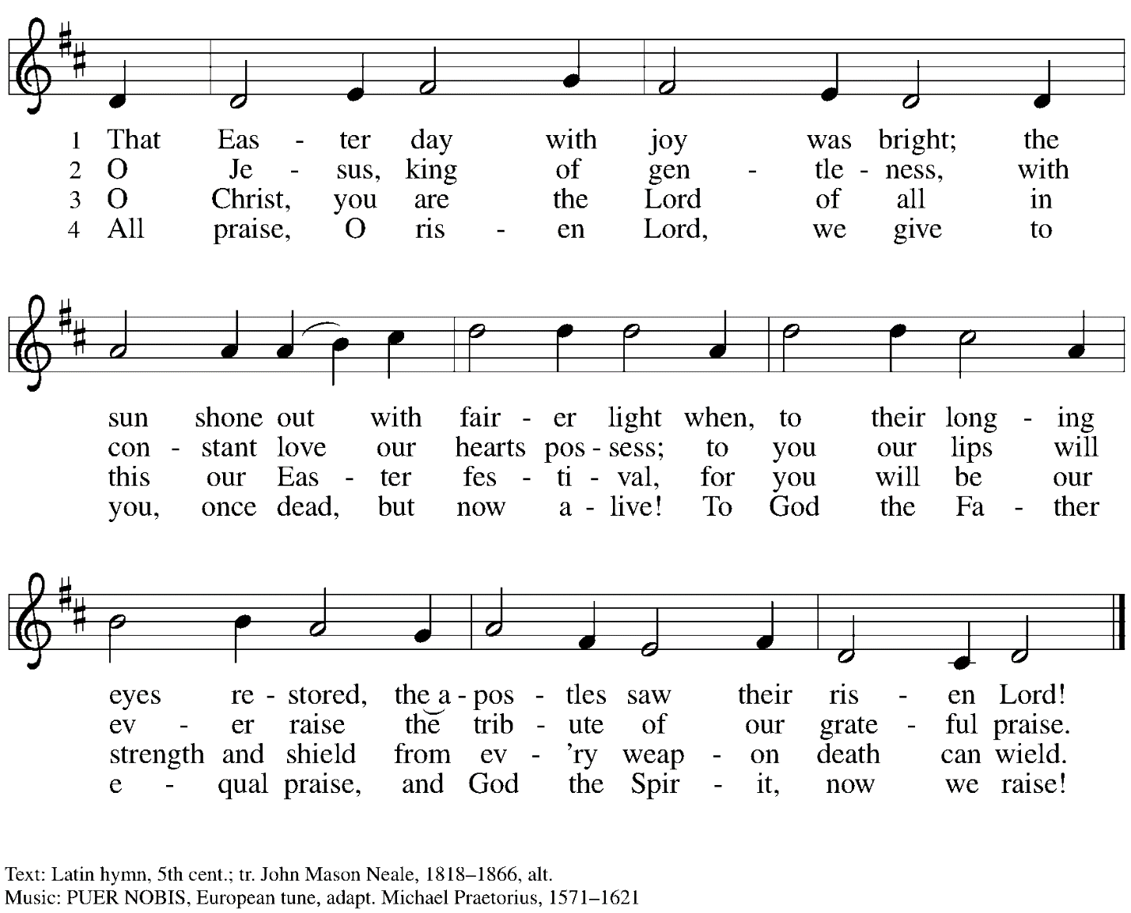

Prayers of the People

P: Set free from captivity to sin and death, we pray to the God of resurrection for the church,
the world, and all who are in need.

After each petition
P: Gracious God,
C: receive our prayer.

P: In your mercy, O God, receive our prayers and renew us by your life-giving Spirit,
through Jesus Christ, our Savior.
C: Amen.

Please be seated.

Meal

Offering

We offer ourselves, our gifts, and our faithful service to God.
An usher will pass around an offering plate for anyone who would like to offer gifts before God.

Music during the Offering

Please rise as you are able.

Offertory Song Let the Vineyards ELW 184

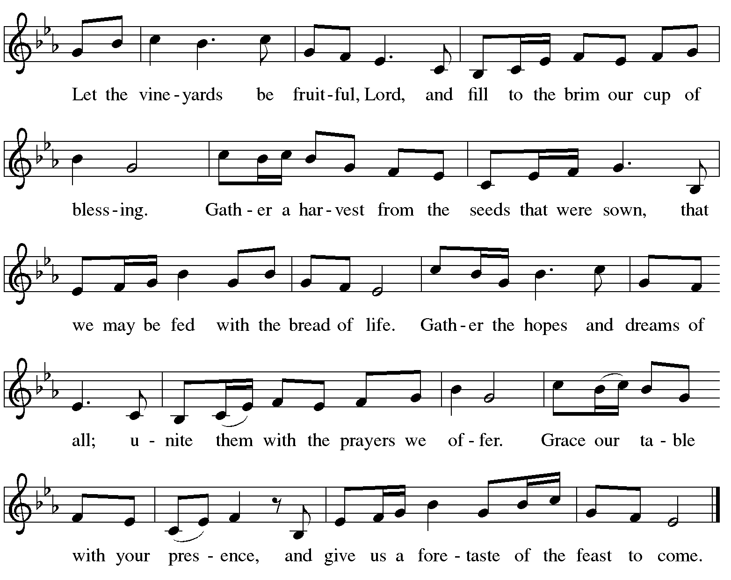

Offertory Prayer

P: Let us pray.
Blessed are you, O God,
C: ruler of heaven and earth.
Day by day you shower us with blessings.
As you have raised us to new life in Christ, give us glad and generous hearts,
ready to praise you and to respond to those in need,
through Jesus Christ, our Savior and Lord.
Amen.

Dialogue

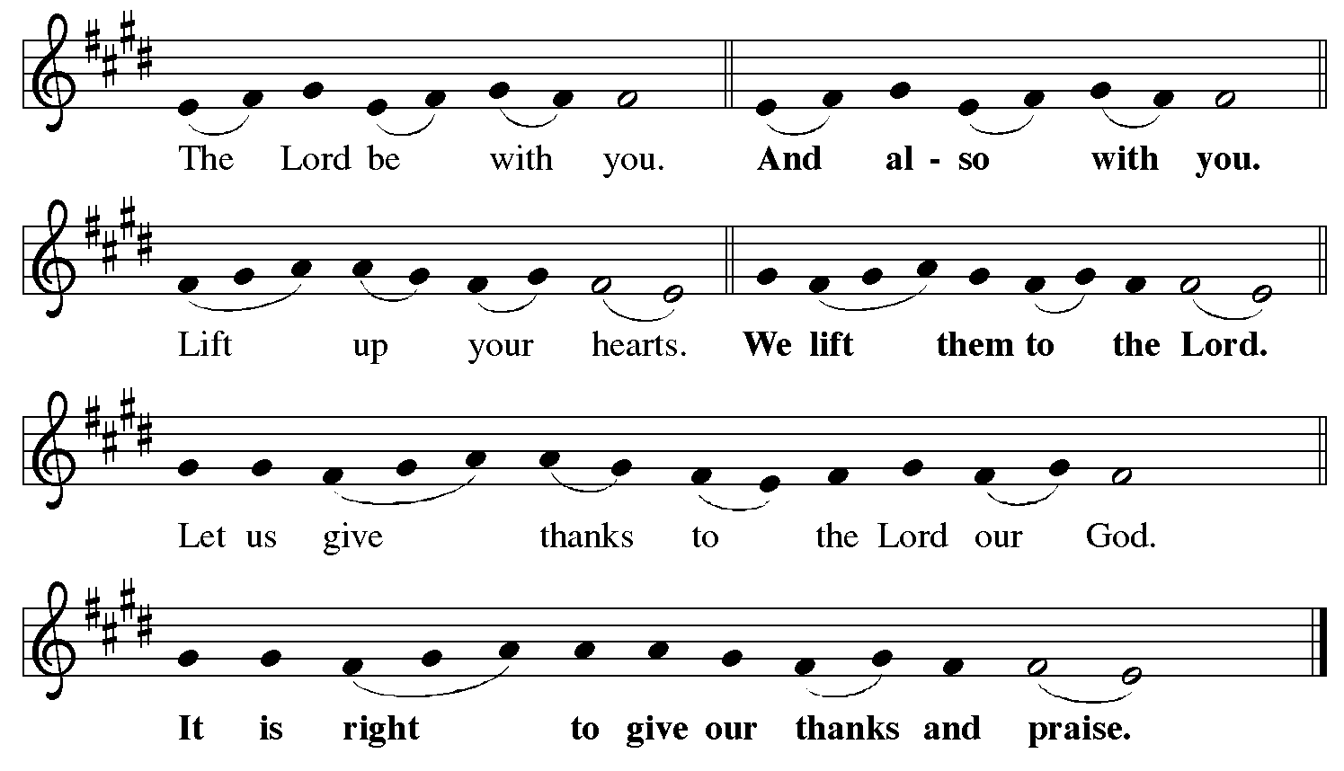

Preface (Sung by the presiding minister)

P: It is indeed right, our duty and our joy,
that we should at all times and in all places
give thanks and praise to you, almighty and merciful God,
for the glorious resurrection of our Savior Jesus Christ,
the true Paschal Lamb who gave himself to take away our sin;
who in dying has destroyed death,
and in rising has brought us to eternal life.
And so, with Mary Magdalene and Peter and all the witnesses of the resurrection,
with earth and sea and all their creatures,
and with angels and archangels, cherubim and seraphim,
we praise your name and join their unending hymn:

Sanctus

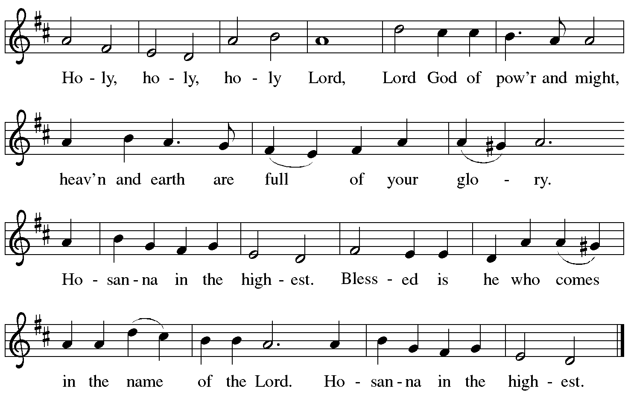

Eucharistic Prayer

P: Blessed are you, O God of the universe …
… Do this for the remembrance of me.

With this bread and cup we remember our Lord’s Passover from death to life
as we proclaim the mystery of faith.
C: Christ has died. Christ is risen. Christ will come again.

P: O God of resurrection and new life …
… Grace our table with your presence.
C: Come, Holy Spirit.

P: Reveal yourself to us in the breaking of the bread …
… burning with justice, peace, and love.
C: Come, Holy Spirit.

P: With your holy ones of all times and places …
… blessed and Holy Trinity, now and forever.
C: Amen.

Lord’s Prayer

P: Gathered as one by the Holy Spirit, let us pray as Jesus taught us.
C: Our Father in heaven,
hallowed be your name,
your kingdom come,
your will be done,
on earth as in heaven.
Give us today our daily bread.
Forgive us our sins
as we forgive those
who sin against us.
Save us from the time of trial
and deliver us from evil.
For the kingdom, the power,
and the glory are yours,
now and forever. Amen.

Fraction and Invitation

Agnus Dei / Lamb of God

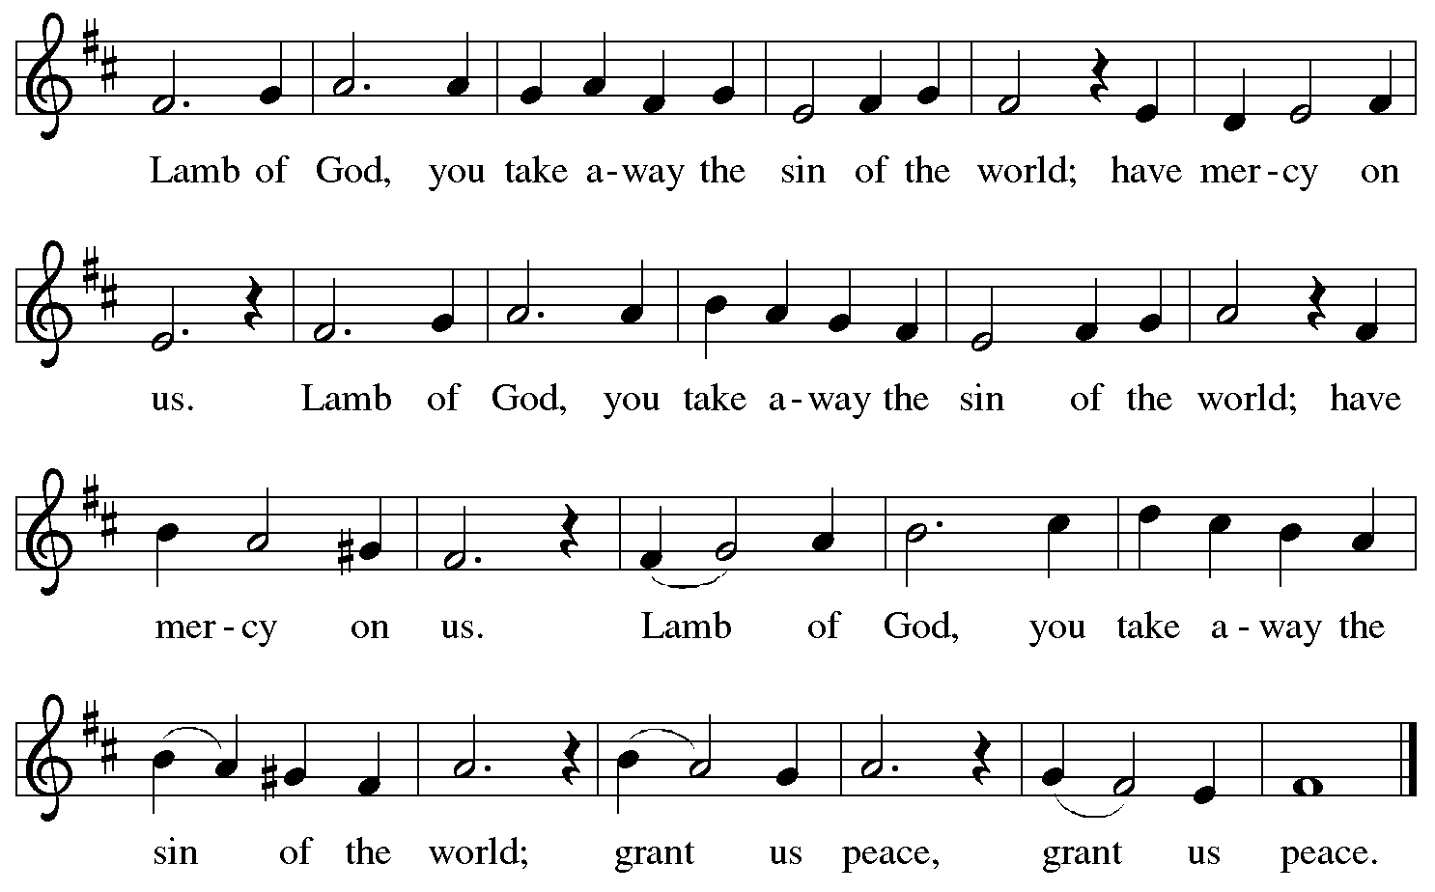

Please be seated.

Holy Communion
- Hand sanitizer is available if you would like to use it prior to receiving Communion.
- Worshipers from the pulpit side will proceed forward first, followed by the center section, and then the lectern side.
- The Communion wafers (regular and gluten-free) have been thoughtfully prepared using the gifts of the congregation by a member of St. Andrew’s altar care team, with a drop of wine or grape juice on each. The presiding minister will distribute one to each communicant.
- When you reach the presiding minister, please indicate if you would like grape juice or a gluten-free wafer.
- A blessing will be provided for anyone who does not yet receive the sacrament.
- A cushion has been placed at the altar rail for anyone who would like to kneel for prayer and reflection before returning to their pew.
- Everyone is asked to wait until you return to your place to consume the elements, and then promptly replace your mask.

Hymns during Holy Communion
Bread of Life from Heaven ELW 474

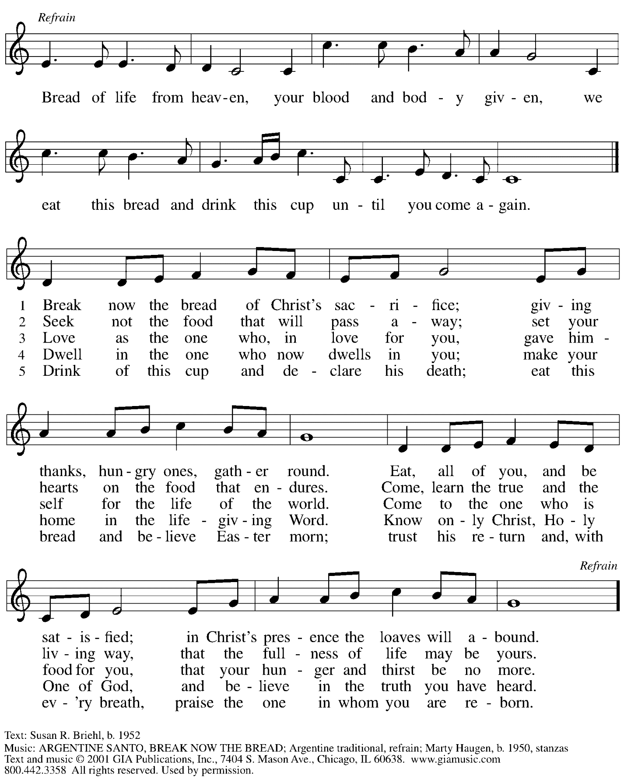
Reprinted under OneLicense.net # A-722139.
Hymns during Holy Communion
Lord, Speak to Us That We May Speak ELW 676

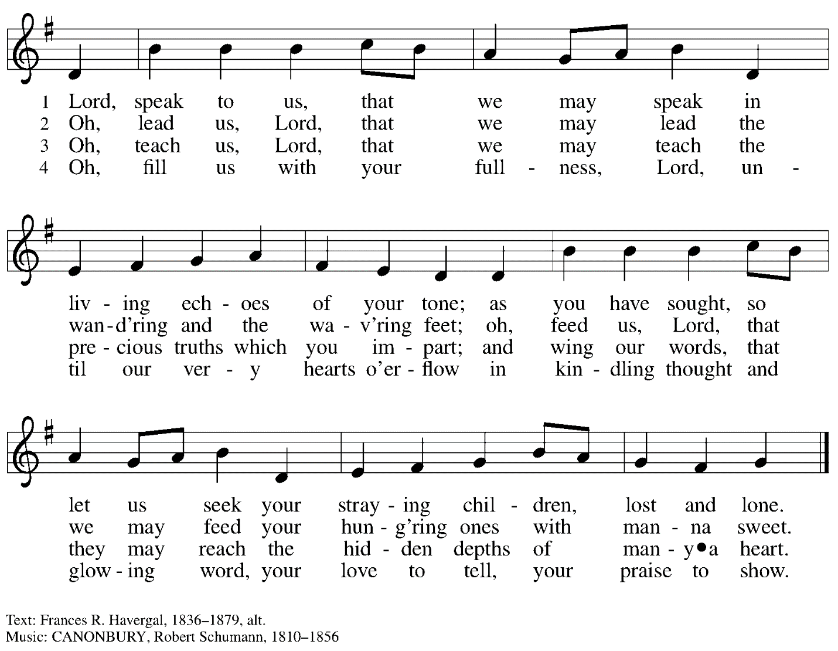

When all have returned to their places, please rise as you are able.

Blessing

P: The body and blood of our Lord Jesus Christ strengthen you and keep you in his grace.
C: Amen.

Prayer

P: Let us pray. Life-giving God,
in the mystery of Christ’s resurrection you send light to conquer darkness,
water to give new life, and the bread of life to nourish your people.
Send us forth as witnesses to your Son’s resurrection,
that we may show your glory to all the world, through Jesus Christ, our risen Lord.
C: Amen.

Sending

Benediction

P: May our glorious God grant you a spirit of wisdom
to know and love the risen Christ.

Almighty God, holy One, ☩ holy Three,
bless you now and forever.
C: Amen.

Sending Hymn The Church of Christ, in Every Age ELW 729
v. 1, 3, 5

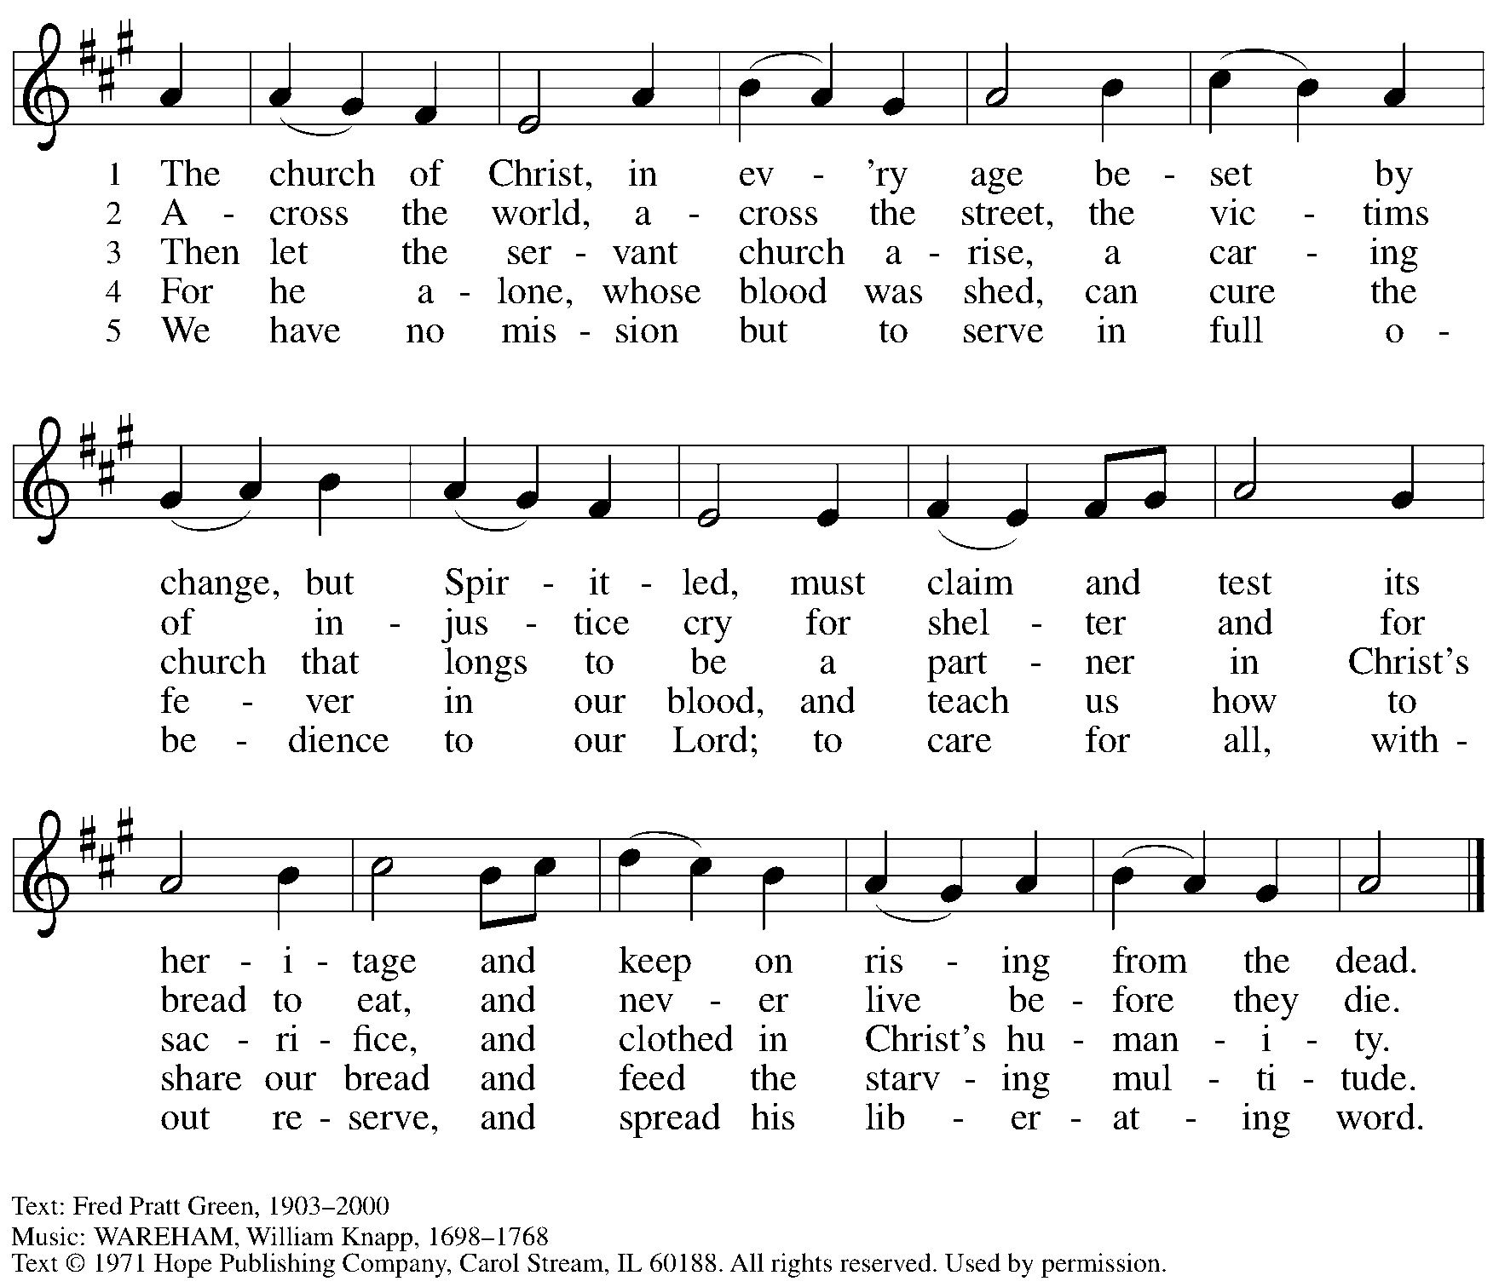
Reprinted with permission under OneLicense.net # A-722139.

Dismissal

P: Alleluia! Christ is risen!
C: Christ is risen indeed! Alleluia! Alleluia!

P: Go in peace. Share the good news!
C: Thanks be to God!

Abbreviations

P: Pastor/Presiding Minister
L: Lector
C: Congregation

ELW: Evangelical Lutheran Worship hymnal

Those serving in worship today

Piano Lili Cai
Cantor Ian Brown
Director of Faith Formation Christopher Atwood
Presiding Minister Pastor Ross Carmichael

Liturgy and Hymnody Acknowledgements

From SundaysandSeasons.com. Copyright © 2022 Augsburg Fortress. All rights reserved. Reprinted under OneLicense.net # A-722139.
Used by permission of Augsburg Fortress.

Let the Vineyards – Text: John W. Arthur, 1922-1980. Music: Ronald A. Nelson, b. 1927. Text and Music © 1978 Lutheran Book of Worship, admin. Augsburg Fortress.

