+ Seventh Sunday of Easter
May 29, 2022
St. Andrew Lutheran Church
304 Morewood Ave.
Pittsburgh, PA 15213
St_andrewELCA@verizon.net
www.standrewpittsburgh.org

+ Seventh Sunday of Easter
Order for Worship

This week’s Gospel highlights Jesus’ high priestly prayer, a prayer he offered shortly before his death. It is possible to hear in this prayer the petitions of the ascended Christ for his own throughout history—to our day—and beyond. Jesus prays for us. In Holy Baptism we become believers in God, have our robes washed in the flood of Christ’s forgiveness, and receive the gift of life forever with all the saints.

A few notes on precautions and protocols, which apply to everyone regardless of vaccination status, as St. Andrew returns to worship in the sanctuary:

- Face masks that fully cover both your mouth and nose are required for parishioners over the age of two (2) – St. Andrew’s next step in restoring worship will be having the worship leaders remove masks during their parts that are conducted at a distance from the pews.
- Physical distancing of at least six (6) feet will be observed at all times for people not from your household.
- We invite the congregation to join in the singing of the hymns (with masks on) during worship!
- Hand sanitizer is available at the front of the sanctuary to use before Holy Communion, after you proceed past the baptismal font, as the alcohol has been affecting the finish on the font’s bowl.

Worship Services are live streamed to multiple online platforms.
By attending worship, you agree that your image and voice may be broadcast.

Welcome

Prelude

Gathering
The Holy Spirit calls us together as the people of God.

Lament in a Time of Violence

P: Gracious God, the news of these days has ripped our hearts and torn our souls. We are moving through the valley of the shadow of death. In the depths of our pain and anger, we gather before you, O God, our rock and our refuge. You are our only comfort. You are our hope. Merciful God, you know the depth of our suffering. We have only begun to mourn all those whose lives have been lost.

Uphold all those who love them, we pray.

Faithful God, surround us with your everlasting arms. Hear our cries of despair, heed our calls for justice, and do not let us lose hope, in the name of Jesus, our risen and ascended Savior, we pray.
C: Amen.

Scripture Dialogue From Psalm 94

P: How long, O Lord,
how long shall the wicked triumph?
C: They bluster in their insolence;
all evildoers are full of boasting.

P: They crush your people, O Lord,
and afflict your very own.
C: They kill the widow and stranger
and pout orphans to death.

P: Yet you will not abandon your people.
nor will you forsake your very own.
C: If the Lord had not been my help,
I should soon have dwelt in the land of silence.

P: As often as I said, “My foot has slipped,”
your steadfast love upheld me.
C: The Lord has become my stronghold,
my God is my rock of refuge.

From Revelation 21

P: Then I saw a new heaven and a new earth;
for the first heaven and the first earth had passed away,
and the sea was no more.
C: And I saw the holy city, the new Jerusalem,
coming down out of heaven from God.

P: And I heard a loud voice from the throne saying,
“See, the home of God is among mortals.
C: God will dwell with them,
and they will be God’s people.

P: God will be with them
and will wipe every tear from their eyes.
C: Death will be no more;
mourning and crying and pain will be no more,
for the first things have passed away.”

P: And the one who was seated on the throne said,
“See, I am making all things new.
I am the Alpha and the Omega,
the beginning and the end.
C: To the thirsty I will give water
as a gift from the spring of the water of life.”

P: We wait for you, O Lord,
C: And in your word we hope.

P: Our help comes from you, O Lord, who made the heaven and the earth.
In the midst of grief, you are our comfort.
In the face of uncertainty, you are our rock.
In the wake of tragedy, you are our hope.
So, even as we weep and mourn, we praise you,
and we place our trust in you.
We pray in the name of the one who suffered, died, and was raised for us,
our Savior, Jesus Christ.
C: Amen.

Gathering Hymn Sometimes Our Only Song Is Weeping ACS 1050

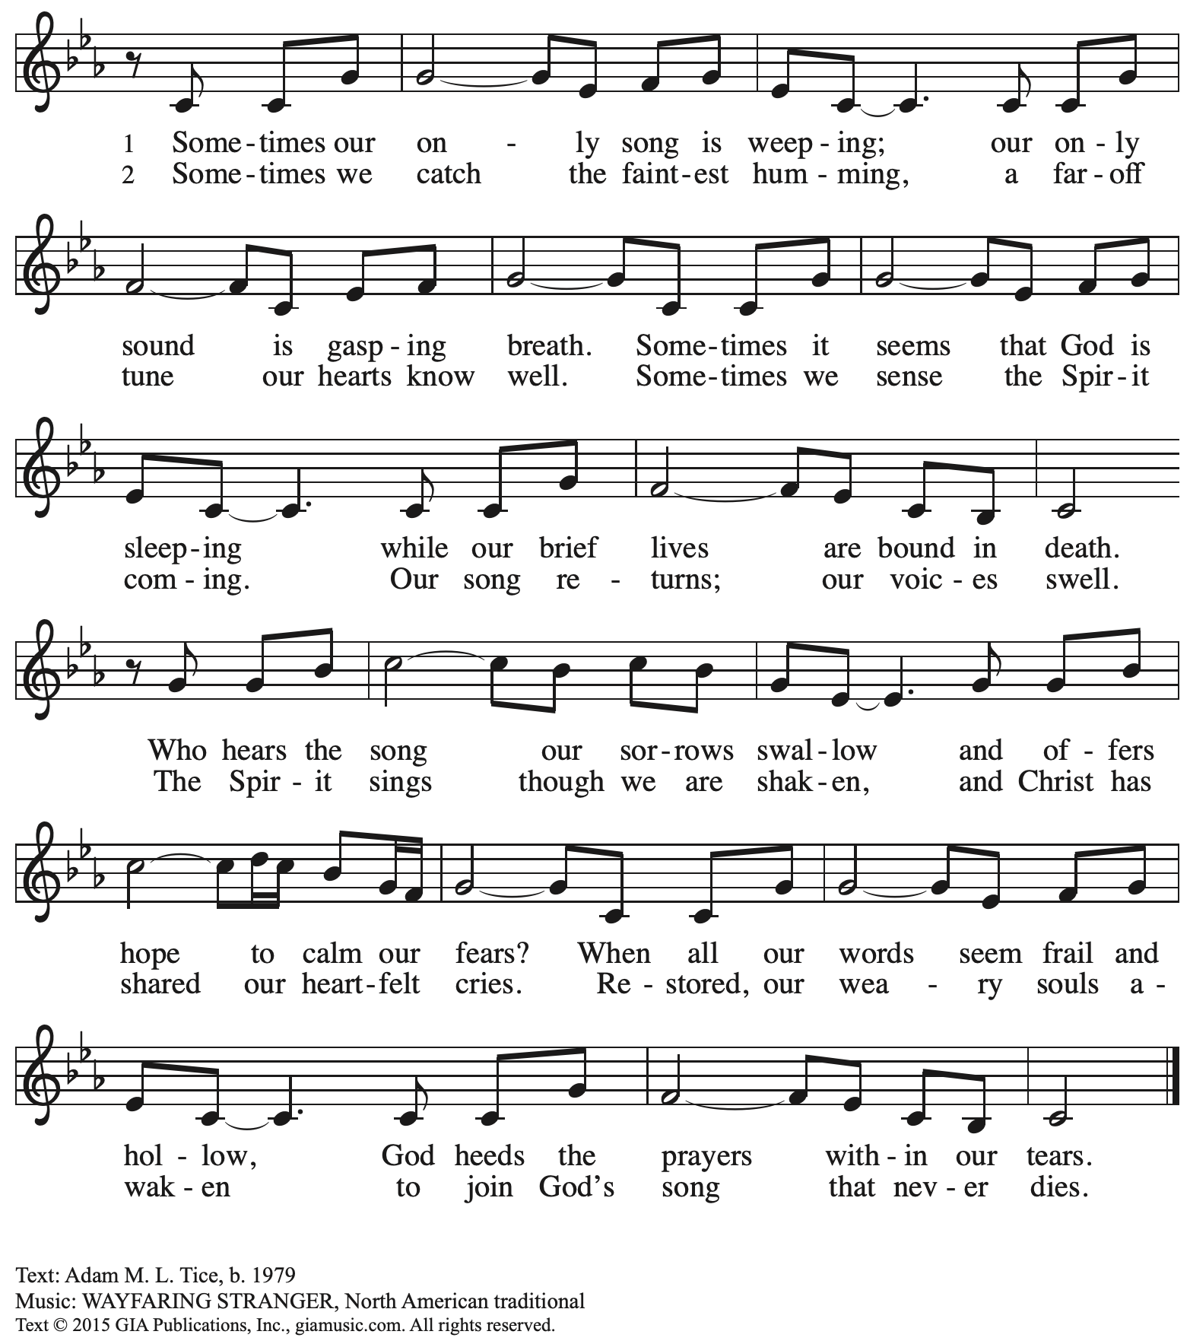
Reprinted with permission under OneLicense.net # A-722139.

Greeting

P: The grace of our Lord Jesus Christ, the love of God,
and the communion of the Holy Spirit be with you all.
C: And also with you.
Hymn of Praise This Is the Feast ELW p. 149-150

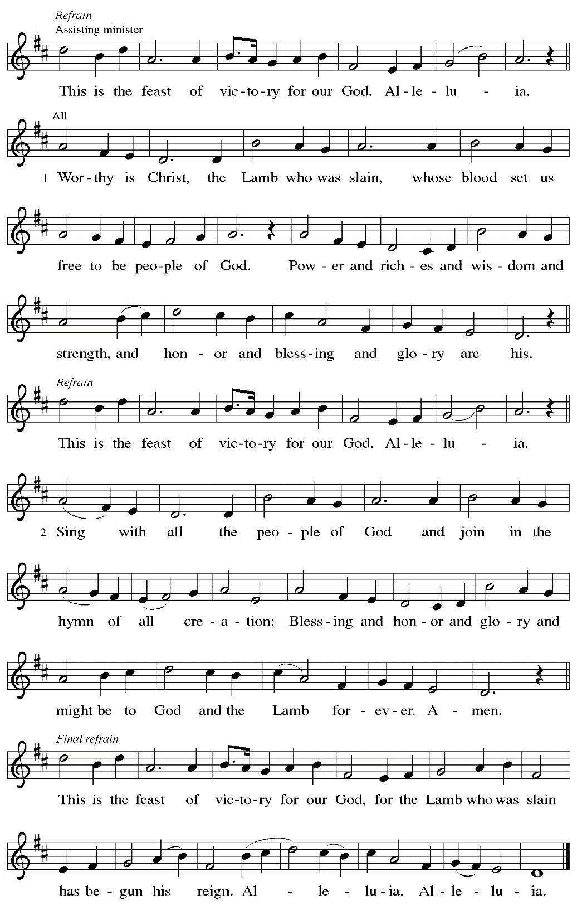

Prayer of the Day

P: The Lord be with you.
C: And also with you.

P: Let us pray.
O God, form the minds of your faithful people into your one will.
Make us love what you command and desire what you promise,
that, amid all the changes of this world,
our hearts may be fixed where true joy is found,
your Son, Jesus Christ, our Lord,
who lives and reigns with you and the Holy Spirit,
one God, now and forever.
C: Amen.

Please be seated.

Word
God speaks to us in Scripture reading, preaching, and song

First Reading – Acts 16: 16-34

¹⁶One day, as we were going to the place of prayer, we met an enslaved girl who had a spirit of divination and brought her owners a great deal of money by fortune-telling. ¹⁷While she followed Paul and us, she would cry out, “These men are slaves of the Most High God, who proclaim to you a way of salvation.” ¹⁸She kept doing this for many days. But Paul, very much annoyed, turned and said to the spirit, “I order you in the name of Jesus Christ to come out of her.” And it came out that very hour.
¹⁹But when her owners saw that their hope of making money was gone, they seized Paul and Silas and dragged them into the marketplace before the authorities. ²⁰When they had brought them before the magistrates, they said, “These men are disturbing our city; they are Jews ²¹and are advocating customs that are not lawful for us as Romans to adopt or observe.” ²²The crowd joined in attacking them, and the magistrates had them stripped of their clothing and ordered them to be beaten with rods. ²³After they had given them a severe flogging, they threw them into prison and ordered the jailer to keep them securely. ²⁴Following these instructions, he put them in the innermost cell and fastened their feet in the stocks.
²⁵About midnight Paul and Silas were praying and singing hymns to God, and the prisoners were listening to them. ²⁶Suddenly there was an earthquake, so violent that the foundations of the prison were shaken; and immediately all the doors were opened and everyone’s chains were unfastened. ²⁷When the jailer woke up and saw the prison doors wide open, he drew his sword and was about to kill himself, since he supposed that the prisoners had escaped. ²⁸But Paul shouted in a loud voice, “Do not harm yourself, for we are all here.” ²⁹The jailer called for lights, and rushing in, he fell down trembling before Paul and Silas. ³⁰Then he brought them outside and said, “Sirs, what must I do to be saved?” ³¹They answered, “Believe on the Lord Jesus, and you will be saved, you and your household.” ³²They spoke the word of the Lord to him and to all who were in his house. ³³At the same hour of the night he took them and washed their wounds; then he and his entire family were baptized without delay. ³⁴He brought them up into the house and set food before them; and he and his entire household rejoiced that he had become a believer in God.

L: Word of God, word of life.
C: Thanks be to God.

Psalm 97

The psalm will be sung responsively, led by the cantor.

Tone

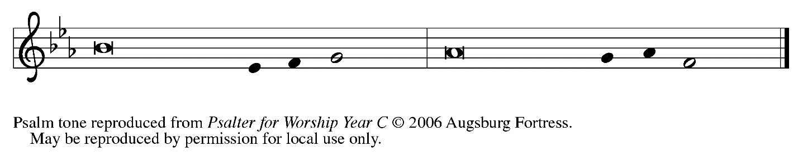

Refrain

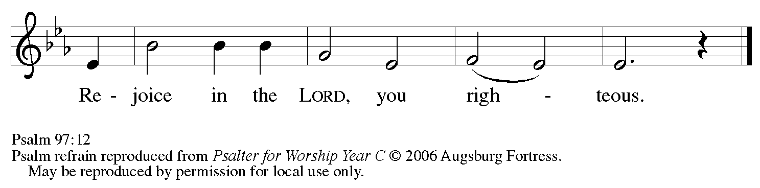

¹The Lord reigns; let the | earth rejoice;
let the multitude of the | isles be glad.
²Clouds and darkness sur- | round the Lord,
righteousness and justice are the foundations | of God’s throne.
³Fire goes be- | fore the Lord,
burning up enemies on | every side.
⁴Lightnings light | up the world;
the earth | sees and trembles.
⁵The mountains | melt like wax
before the Lord of | all the earth.
⁶The heavens declare your righteous- | ness, O Lord,
and all the peoples | see your glory. R

Refrain

⁷Confounded be all who worship carved images and delight | in false gods!
Bow down before the Lord, | all you gods.
⁸Zion hears and is glad, and the cities of Ju- | dah rejoice,
because of your judg- | ments, O Lord.
⁹For you are the Lord, most high over | all the earth;
you are exalted far a- | bove all gods.
¹⁰You who love the | Lord, hate evil!
God guards the lives of the saints and rescues them from the hand | of the wicked.
¹¹Light dawns | for the righteous,
and joy for the hon- | est of heart.
¹²Rejoice in the | Lord, you righteous,
and give thanks to God’s | holy name. R

Second Reading – Revelation 22: 12-14, 16-17, 20-21

¹²“See, I am coming soon; my reward is with me, to repay according to everyone’s work. ¹³I am the Alpha and the Omega, the first and the last, the beginning and the end.”
¹⁴Blessed are those who wash their robes, so that they will have the right to the tree of life and may enter the city by the gates.
¹⁶“It is I, Jesus, who sent my angel to you with this testimony for the churches. I am the root and the descendant of David, the bright morning star.”
¹⁷The Spirit and the bride say, “Come.”
And let everyone who hears say, “Come.”
And let everyone who is thirsty come.
Let anyone who wishes take the water of life as a gift.
²⁰The one who testifies to these things says, “Surely I am coming soon.”
Amen. Come, Lord Jesus!
²¹The grace of the Lord Jesus be with all the saints. Amen.

L: Word of God, word of life.
C: Thanks be to God.

Please rise as you are able.

Gospel Acclamation

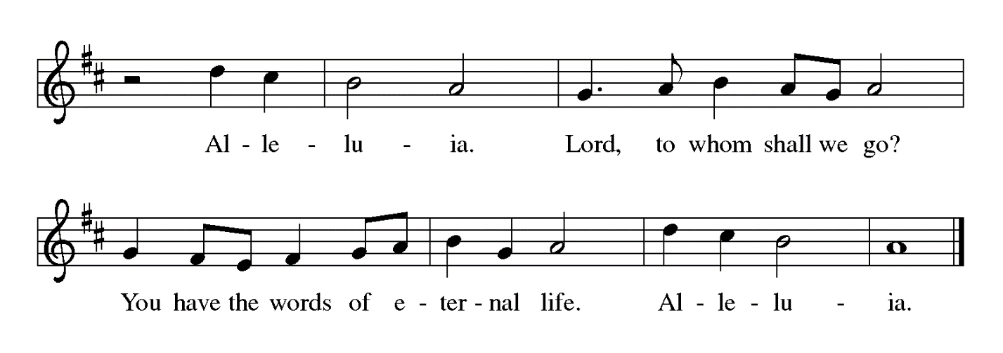

Gospel – John 17: 20-26

P: The holy Gospel according to St. John.
C: Glory to you, O Lord.

[Jesus prayed:] ²⁰“I ask not only on behalf of these, but also on behalf of those who will believe in me through their word, ²¹that they may all be one. As you, Father, are in me and I am in you, may they also be in us, so that the world may believe that you have sent me. ²²The glory that you have given me I have given them, so that they may be one, as we are one, ²³I in them and you in me, that they may become completely one, so that the world may know that you have sent me and have loved them even as you have loved me. ²⁴Father, I desire that those also, whom you have given me, may be with me where I am, to see my glory, which you have given me because you loved me before the foundation of the world.
²⁵“Righteous Father, the world does not know you, but I know you; and these know that you have sent me. ²⁶I made your name known to them, and I will make it known, so that the love with which you have loved me may be in them, and I in them.”

P: The Gospel of the Lord.
C: Praise to you, O Christ.

Please be seated.

Sermon

A time of silence for prayer and reflection follows the sermon.
When the hymn of the day begins, please rise as you are able.

Hymn of the Day To Christ Belong, in Christ Behold ACS 958

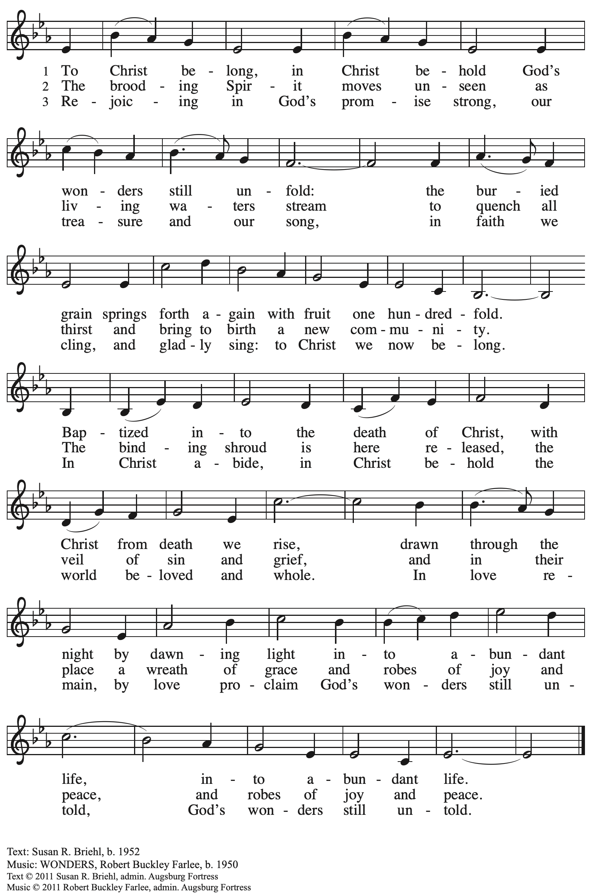
All rights reserved. Reprinted with permission under OneLicense.net # A-722139.

Prayers of the People

P: Set free from captivity to sin and death, we pray to the God of resurrection for the church,
the world, and all who are in need.

After each petition
P: Gracious God,
C: receive our prayer.

P: In your mercy, O God, receive our prayers and renew us by your life-giving Spirit,
through Jesus Christ, our Savior.
C: Amen.

Please be seated.

Meal

Offering

We offer ourselves, our gifts, and our faithful service to God.
An usher will pass around an offering plate for anyone who would like to offer gifts before God.

Music during the Offering

Please rise as you are able.

Offertory Song Let the Vineyards ELW 184

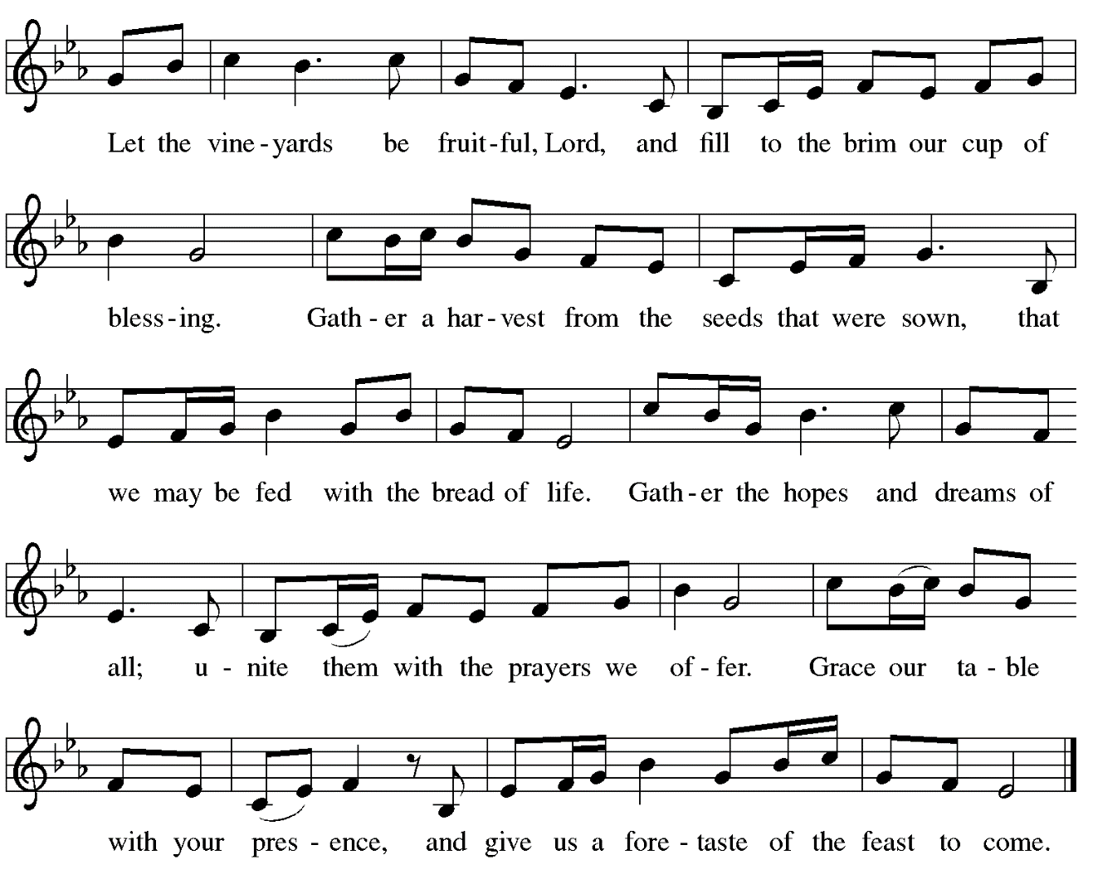

Offertory Prayer

P: Let us pray.
Blessed are you, O God,
C: ruler of heaven and earth.
Day by day you shower us with blessings.
As you have raised us to new life in Christ,
give us glad and generous hearts,
ready to praise you and to respond to those in need,
through Jesus Christ, our Savior and Lord.
Amen.

Dialogue

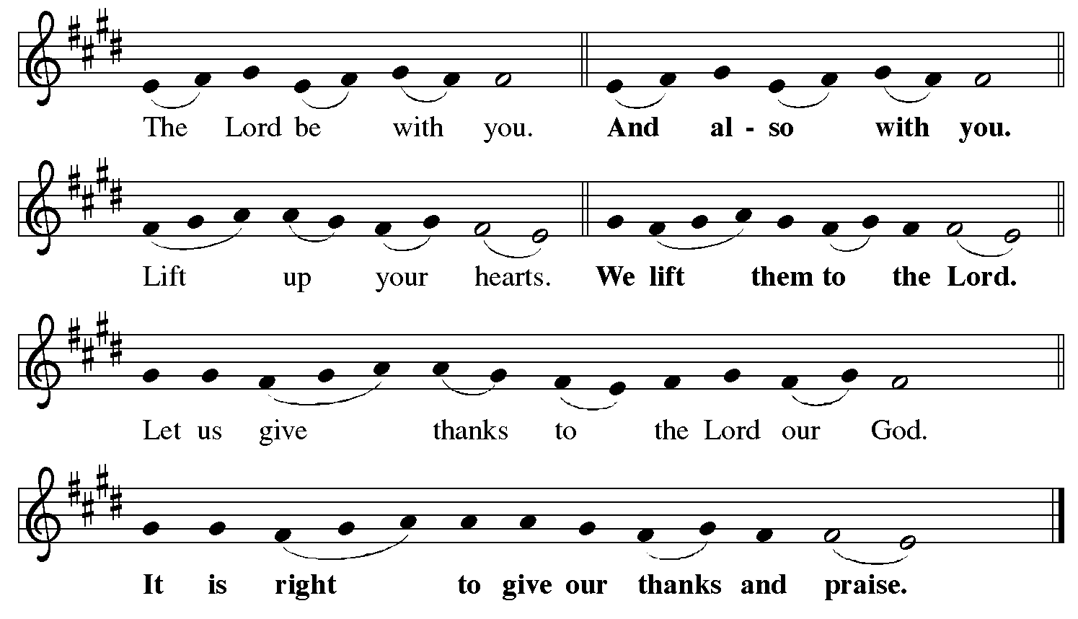

Preface (Sung by the presiding minister)

P: It is indeed right, our duty and our joy,
that we should at all times and in all places
give thanks and praise to you, almighty and merciful God,
for the glorious resurrection of our Savior Jesus Christ,
the true Paschal Lamb who gave himself to take away our sin;
who in dying has destroyed death,
and in rising has brought us to eternal life.
And so, with Mary Magdalene and Peter and all the witnesses of the resurrection,
with earth and sea and all their creatures,
and with angels and archangels, cherubim and seraphim,
we praise your name and join their unending hymn:

Sanctus

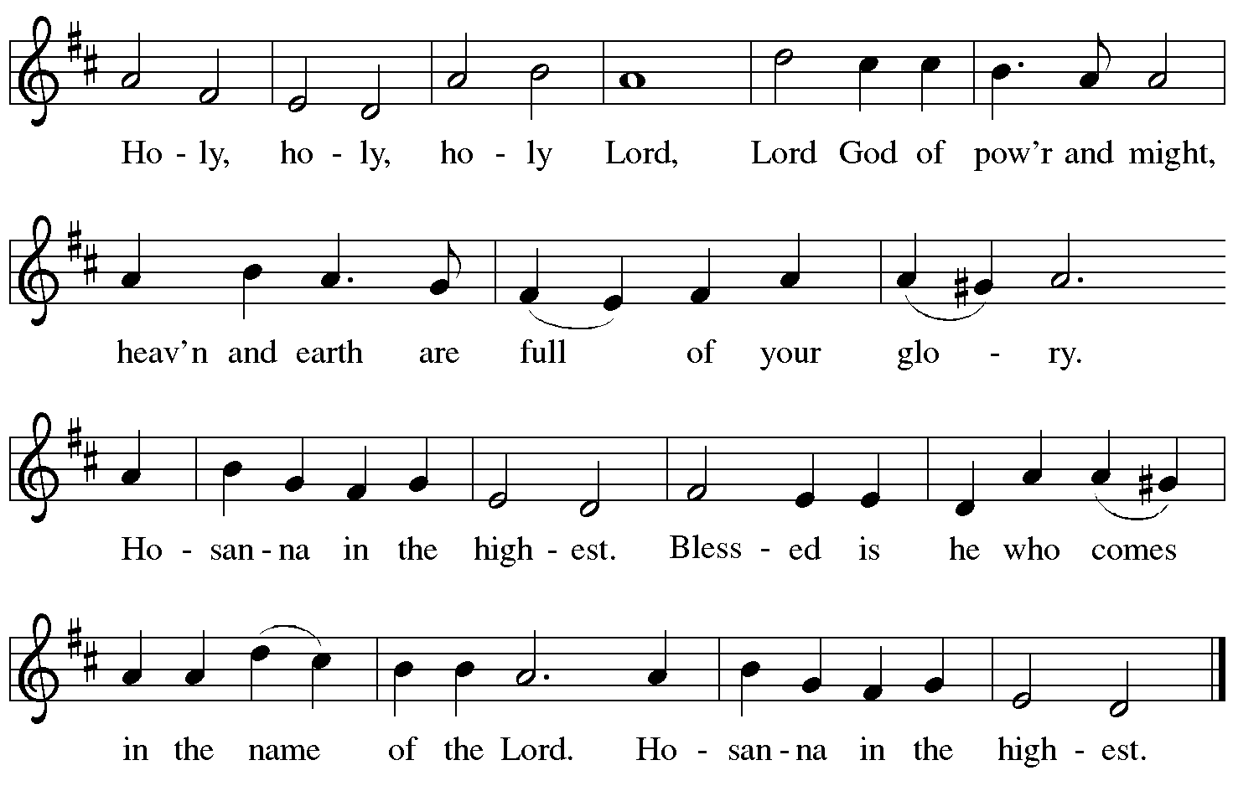

Eucharistic Prayer

P: Blessed are you, O God of the universe …
… Do this for the remembrance of me.

With this bread and cup we remember our Lord’s Passover from death to life
as we proclaim the mystery of faith.
C: Christ has died. Christ is risen. Christ will come again.

P: O God of resurrection and new life …
… Grace our table with your presence.
C: Come, Holy Spirit.

P: Reveal yourself to us in the breaking of the bread …
… burning with justice, peace, and love.
C: Come, Holy Spirit.

P: With your holy ones of all times and places …
… blessed and Holy Trinity, now and forever.
C: Amen.

Lord’s Prayer

P: Gathered as one by the Holy Spirit, let us pray as Jesus taught us.
C: Our Father in heaven,
hallowed be your name,
your kingdom come,
your will be done,
on earth as in heaven.
Give us today our daily bread.
Forgive us our sins
as we forgive those
who sin against us.
Save us from the time of trial
and deliver us from evil.
For the kingdom, the power,
and the glory are yours,
now and forever. Amen.

Fraction and Invitation

Agnus Dei / Lamb of God

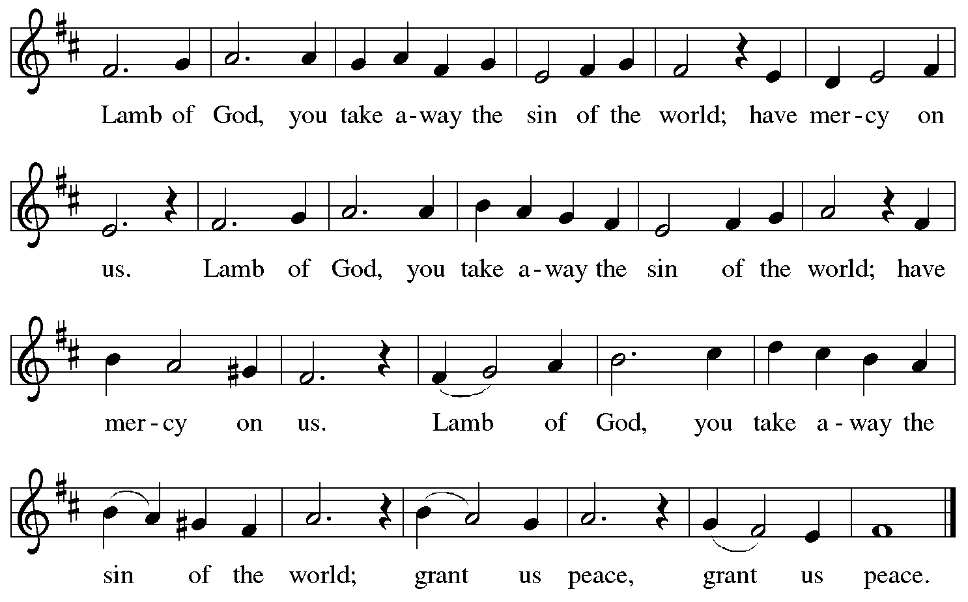

Please be seated.

Holy Communion
- Hand sanitizer is available if you would like to use it prior to receiving Communion.
- Worshipers from the pulpit side will proceed forward first, followed by the center section, and then the lectern side.
- The Communion wafers (regular and gluten-free) have been thoughtfully prepared using the gifts of the congregation by a member of St. Andrew’s altar care team, with a drop of wine or grape juice on each. The presiding minister will distribute one to each communicant.
- When you reach the presiding minister, please indicate if you would like grape juice or a gluten-free wafer.
- A blessing will be provided for anyone who does not yet receive the sacrament.
- A cushion has been placed at the altar rail for anyone who would like to kneel for prayer and reflection before returning to their pew.
- Everyone is asked to wait until you return to your place to consume the elements, and then promptly replace your mask.

Hymns during Holy Communion
I Come with Joy ELW 482

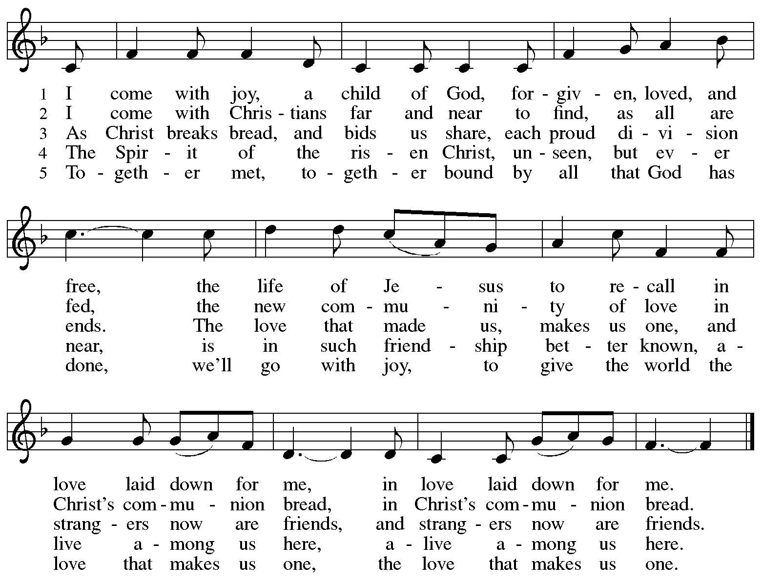
Hymns during Holy Communion
One Bread, One Body ELW 496

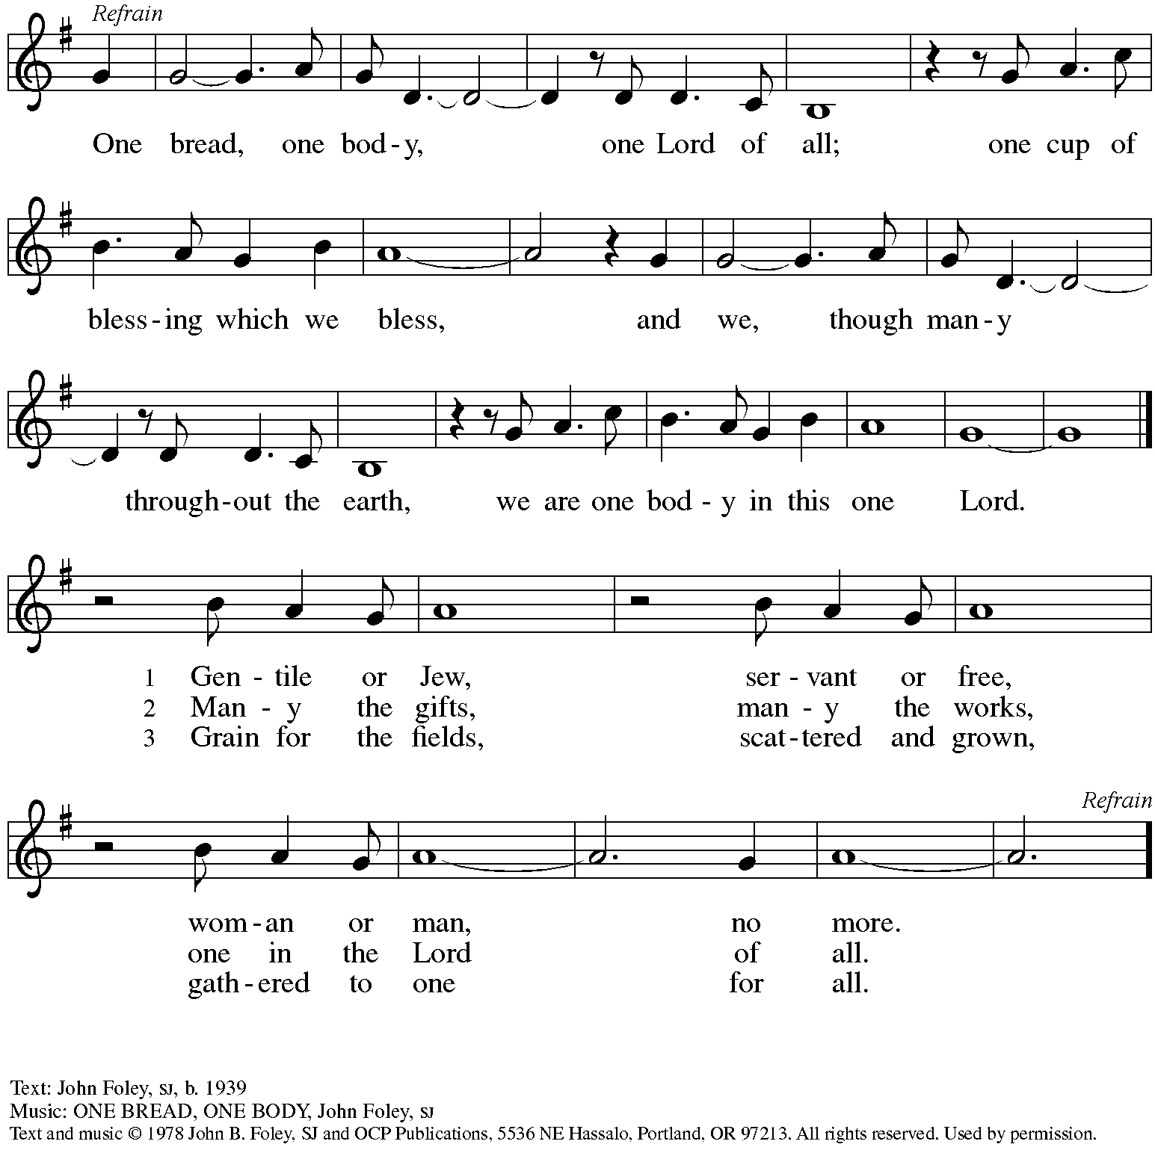
Reprinted with permission under OneLicense.net # A-722139.

When all have returned to their places, please rise as you are able.

Blessing

P: The body and blood of our Lord Jesus Christ strengthen you and keep you in his grace.
C: Amen.

Prayer

P: Let us pray. Life-giving God,
in the mystery of Christ’s resurrection you send light to conquer darkness,
water to give new life, and the bread of life to nourish your people.
Send us forth as witnesses to your Son’s resurrection,
that we may show your glory to all the world, through Jesus Christ, our risen Lord.
C: Amen.

Sending

Announcements

Journey Together Sending Prayer

Benediction

P: May our glorious God grant you a spirit of wisdom
to know and love the risen Christ.

Almighty God, holy One, ☩ holy Three,
bless you now and forever.
C: Amen.

Sending Hymn Hallelujah, Jesus Lives! ELW 380
v. 1-2, 5

1 Hallelujah! Jesus lives!
He is now the Living One;
from the gloomy halls of death
Christ, the conqueror, has gone,
bright forerunner to the skies
of his people, yet to rise.

2 Jesus lives! Why do you weep?
Why that sad and mournful sigh?

Christ who died our brother here
lives our brother still on high,
lives forever to bestow
blessings on his church below.

5 Hallelujah! Angels, sing!
Join with us in hymns of praise.
Let your chorus swell the strain
which our feebler voices raise:
Glory to our God above
and on earth God’s peace and love!

Text: Carl B. Garve, 1763-1841; tr. Jane L. Borthwick, 1813-1897, alt. Music: FRED TIL BOD, Ludvig M. Lindeman, 1812-1887.

Dismissal

P: Alleluia! Christ is risen!
C: Christ is risen indeed! Alleluia! Alleluia!

P: Go in peace. Share the good news!
C: Thanks be to God!

Abbreviations

P: Pastor/Presiding Minister
L: Lector
C: Congregation

ELW: Evangelical Lutheran Worship hymnal
ACS: All Creation Sings hymnal

Those serving in worship today

Piano Lili Cai
Cantor Richard Krug
Lector Dixie Tymitz
Director of Faith Formation Christopher Atwood
Presiding Minister Pastor Ross Carmichael

Liturgy and Hymnody Acknowledgements

From SundaysandSeasons.com. Copyright © 2022 Augsburg Fortress. All rights reserved. Reprinted under OneLicense.net # A-722139.
Used by permission of Augsburg Fortress.

Let the Vineyards – Text: John W. Arthur, 1922-1980. Music: Ronald A. Nelson, b. 1927. Text and Music © 1978 Lutheran Book of Worship, admin. Augsburg Fortress.

I Come with Joy – Text: Brian A. Wren, b. 1936. Music: DOVE OF PEACE, W. Walker, Southern Harmony, 1835. Text © 1971, ren. 1995 Hope Publishing Company, Carol Stream, IL 60188. All rights reserved. Reprinted with permission under OneLicense.net # A-722139.

