

+ Sixth Sunday of Easter
May 22, 2022


St. Andrew Lutheran Church
304 Morewood Ave.
Pittsburgh, PA 15213
St_andrewELCA@verizon.net
www.standrewpittsburgh.org

+ Sixth Sunday of Easter
Order for Worship

Visions abound in the readings for the sixth Sunday of Easter.
Paul has a vision about what to do. John has a vision of what will be.
Jesus provides visions of peace that surpasses human understanding
and power beyond human imagination.

A few notes on precautions and protocols, which apply to everyone regardless of vaccination status, as St. Andrew returns to worship in the sanctuary:

- Face masks that fully cover both your mouth and nose are required for parishioners over the age of two (2) – St. Andrew’s next step in restoring worship will be having the worship leaders remove masks during their parts that are conducted at a distance from the pews. Please note that as previously in the pandemic, these changes may need to be changed at any time.
- Physical distancing of at least six (6) feet will be observed at all times for people not from your household.
- We invite the congregation to join in the singing of the hymns (with masks on) during worship!
- Hand sanitizer is available at the front of the sanctuary to use before Holy Communion, after you proceed past the baptismal font, as the alcohol has been affecting the finish on the font’s bowl.

Worship Services are live streamed to multiple online platforms.
By attending worship, you agree that your image and voice may be broadcast.

Welcome

Prelude

Gathering
The Holy Spirit calls us together as the people of God.

Thanksgiving for Baptism

P: Alleluia! Christ is risen!
C: Christ is risen indeed! Alleluia!

P: In the waters of baptism,
we have passed over from death to life with Jesus Christ,
and we are a new creation.
For this saving mystery, and for this water, let us bless God,
who was, who is, and who is to come.

Water may be poured into the font as the presiding minister gives thanks.

P: We thank you, God, for your river of life,
flowing freely from your throne:
throughout the earth, through the city, to every living thing.
You rescued Noah and his family from the flood;
You opened wide the sea for the Israelites.
Now in these waters you flood us with mercy,
and our sin is drowned forever.
You open the gate of righteousness
and we pass safely through.
In Jesus Christ, you calm and trouble the waters.
You nourish us and enclose us in safety.
You call us forth and send us out.
In lush and barren places, you are with us.
You have become our salvation.
Now breathe upon this water
and awaken your church once more.
Claim us again as your beloved and holy people.
Quench our thirst; cleanse our hearts; wipe away every tear.
To you, our Beginning and our End,
our Shepherd and Lamb,
be honor, glory, praise, and thanksgiving,
now and forever.
C: Amen.

Gathering Hymn Christ Has Arisen, Alleluia ELW 364
v. 1-3

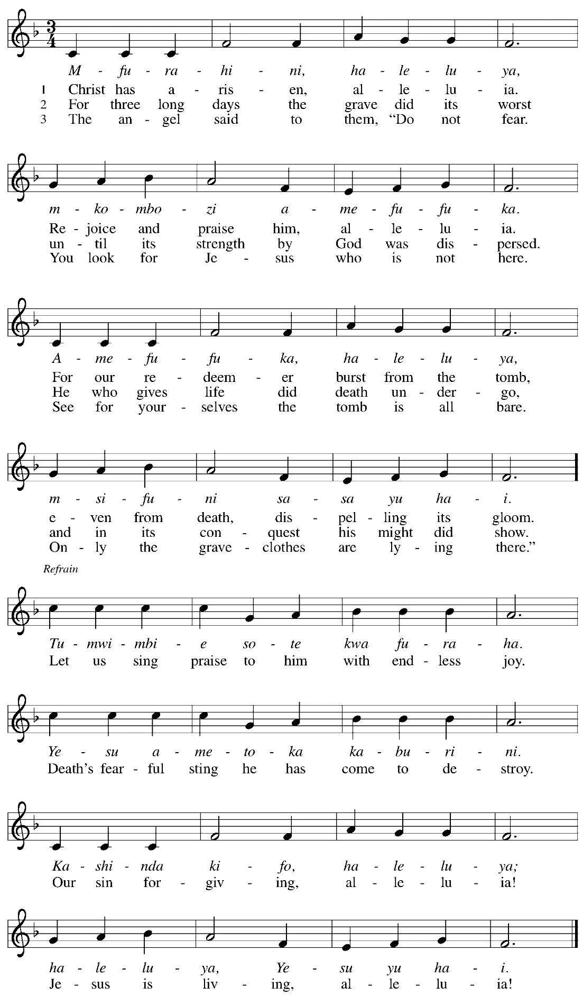
Greeting

P: The grace of our Lord Jesus Christ, the love of God,
and the communion of the Holy Spirit be with you all.
C: And also with you.

Hymn of Praise This Is the Feast ELW p. 149-150
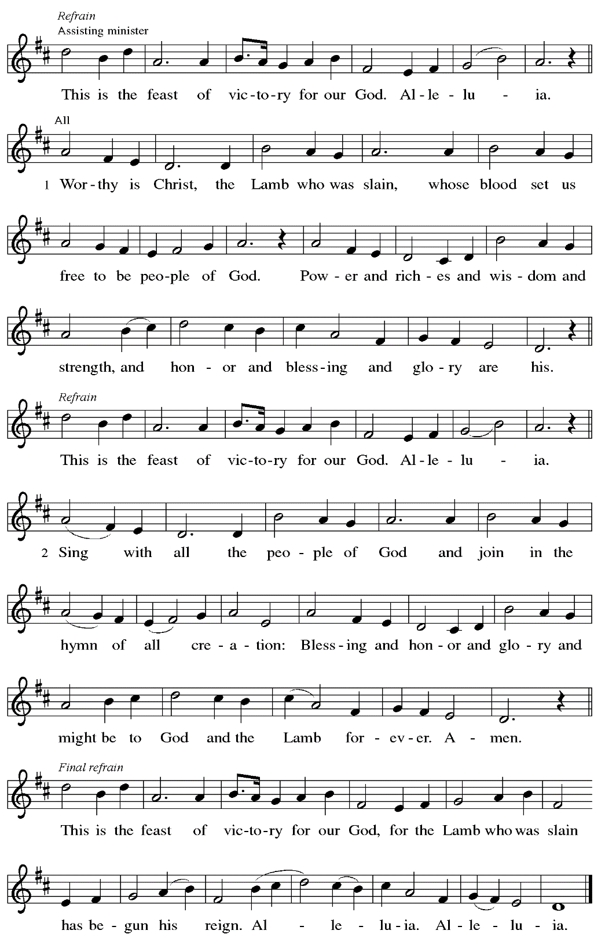
Prayer of the Day

P: The Lord be with you.
C: And also with you.

P: Let us pray.
Bountiful God, you gather your people into your realm,
and you promise us food from your tree of life.
Nourish us with your word, that, empowered by your Spirit,
we may love one another and the world you have made,
through Jesus Christ, our Savior and Lord,
who lives and reigns with you and the Holy Spirit,
one God, now and forever.
C: Amen.

Please be seated.

Word
God speaks to us in Scripture reading, preaching, and song

First Reading – Acts 16: 9-15

⁹During the night Paul had a vision: there stood a man of Macedonia pleading with him and saying, “Come over to Macedonia and help us.” ¹⁰When he had seen the vision, we immediately tried to cross over to Macedonia, being convinced that God had called us to proclaim the good news to them.

¹¹We set sail from Troas and took a straight course to Samothrace, the following day to Neapolis, ¹²and from there to Philippi, which is a leading city of the district of Macedonia and a Roman colony. We remained in this city for some days. ¹³On the sabbath day we went outside the gate by the river, where we supposed there was a place of prayer; and we sat down and spoke to the women who had gathered there. ¹⁴A certain woman named Lydia, a worshiper of God, was listening to us; she was from the city of Thyatira and a dealer in purple cloth. The Lord opened her heart to listen eagerly to what was said by Paul. ¹⁵When she and her household were baptized, she urged us, saying, “If you have judged me to be faithful to the Lord, come and stay at my home.” And she prevailed upon us.

L: Word of God, word of life.
C: Thanks be to God.

Psalm 67

The psalm will be sung responsively, led by the cantor.

Tone

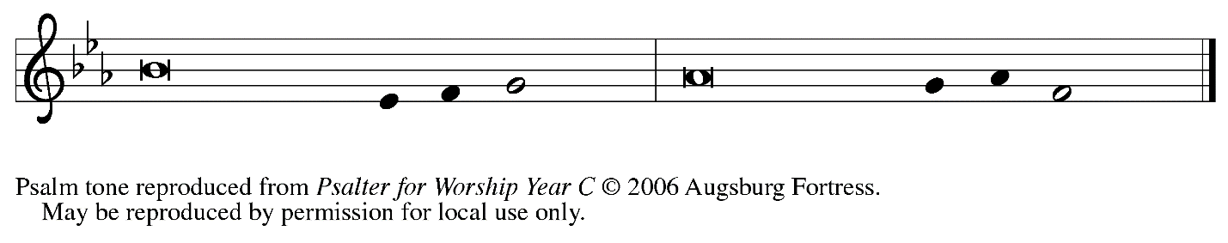

Refrain

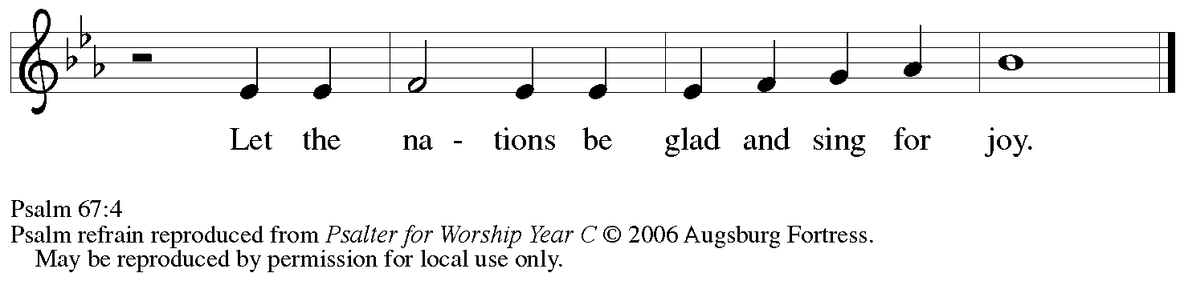

¹May God be merciful to | us and bless us;
may the light of God’s face | shine upon us.
²Let your way be known | upon earth,
your saving health a- | mong all nations.
³Let the peoples praise | you, O God;
let all the | peoples praise you.
⁴Let the nations be glad and | sing for joy,
for you judge the peoples with equity and guide all the na- | tions on earth. R
⁵Let the peoples | praise you, O God;
let all the | peoples praise you.
⁶The earth has brought | forth its increase;
God, our own | God, has blessed us.
⁷May God | give us blessing,
and may all the ends of the earth | stand in awe. R

Second Reading – Revelation 21: 10, 22 – 22: 5

¹⁰And in the spirit [one of the angels] carried me away to a great, high mountain and showed me the holy city Jerusalem coming down out of heaven from God.
²²I saw no temple in the city, for its temple is the Lord God the Almighty and the Lamb. ²³And the city has no need of sun or moon to shine on it, for the glory of God is its light, and its lamp is the Lamb. ²⁴The nations will walk by its light, and the kings of the earth will bring their glory into it. ²⁵Its gates will never be shut by day—and there will be no night there. ²⁶People will bring into it the glory and the honor of the nations. ²⁷But nothing unclean will enter it, nor anyone who practices abomination or falsehood, but only those who are written in the Lamb’s book of life.
^{22:1}Then the angel showed me the river of the water of life, bright as crystal, flowing from the throne of God and of the Lamb ²through the middle of the street of the city. On either side of the river is the tree of life with its twelve kinds of fruit, producing its fruit each month; and the leaves of the tree are for the healing of the nations. ³Nothing accursed will be found there any more. But the throne of God and of the Lamb will be in it, and his servants will worship him; ⁴they will see his face, and his name will be on their foreheads. ⁵And there will be no more night; they need no light of lamp or sun, for the Lord God will be their light, and they will reign forever and ever.

L: Word of God, word of life.
C: Thanks be to God.

Please rise as you are able.

Gospel Acclamation

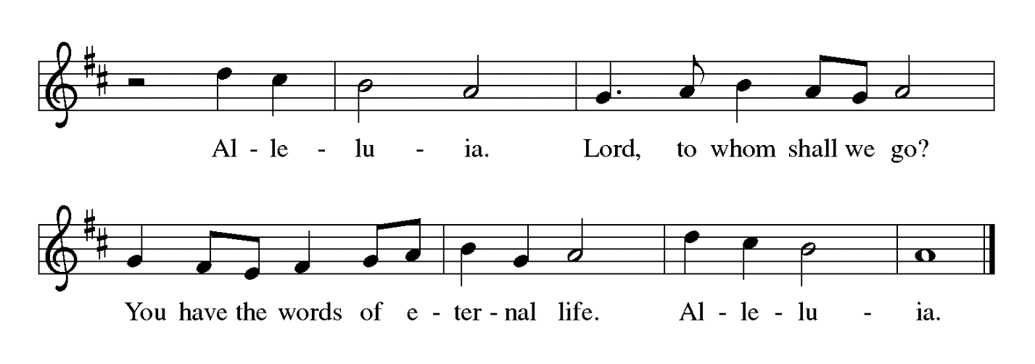

Gospel – John 14: 23-29

P: The holy Gospel according to St. John.
C: Glory to you, O Lord.

²³Jesus answered [Judas (not Iscariot),] “Those who love me will keep my word, and my Father will love them, and we will come to them and make our home with them. ²⁴Whoever does not love me does not keep my words; and the word that you hear is not mine, but is from the Father who sent me.
²⁵“I have said these things to you while I am still with you. ²⁶But the Advocate, the Holy Spirit, whom the Father will send in my name, will teach you everything, and remind you of all that I have said to you. ²⁷Peace I leave with you; my peace I give to you. I do not give to you as the world gives. Do not let your hearts be troubled, and do not let them be afraid. ²⁸You heard me say to you, ‘I am going away, and I am coming to you.’ If you loved me, you would rejoice that I am going to the Father, because the Father is greater than I. ²⁹And now I have told you this before it occurs, so that when it does occur, you may believe.”

P: The Gospel of the Lord.
C: Praise to you, O Christ.

Please be seated.

Sermon

A time of silence for prayer and reflection follows the sermon.

Sacrament of Holy Baptism

Presentation

Candidates for Baptism, sponsors/godparents, and parents gather with the ministers at the font. The assembly is seated.

The presiding minister may address the assembly in these or similar words:
P: God, who is rich in mercy and love, gives us a new birth into a living hope through the sacrament of Baptism. By water and the Word God delivers us from sin and death and raises us to new life in Jesus Christ. We are united with all the baptized in the one body of Christ, anointed with the gift of the Holy Spirit, and joined in God's mission for the life of the world.

Sponsors for each candidate, in turn, present the candidates:
I present name for Baptism.

The presiding minister addresses parents or others who bring for Baptism
children who are not able to answer for themselves:
P: Called by the Holy Spirit, trusting in the grace and love of God,
do you desire to have your child/ren baptized into Christ?
Response: I do.

P: As you bring your children to receive the gift of Baptism, you are entrusted with responsibilities:
to live with them among God's faithful people,
bring them to the word of God and the holy supper,
teach them the Lord's Prayer, the Creed, and the Ten Commandments,
place in their hands the holy scriptures,
and nurture them in faith and prayer,
so that your children may learn to trust God,
proclaim Christ through word and deed,
care for others and the world God made,
and work for justice and peace.
Do you promise to help your children grow in the Christian faith and life?
Response: I do.

The presiding minister addresses sponsors:
P: Sponsors, do you promise to nurture these persons in the Christian faith
as you are empowered by God's Spirit, and to help them live in the covenant of Baptism
and in communion with the church?
Response: I do.

The presiding minister addresses the assembly:
P: People of God, do you promise to support name/s
and pray for them in their new life in Christ?
C: We do.

Please rise as you are able.

Profession of Faith

The presiding minister addresses candidates for Baptism as well as the parents and sponsors of young children. The assembly may join in the responses.
P: I ask you to profess your faith in Christ Jesus, reject sin, and confess the faith of the church.

P: Do you renounce the devil and all the forces that defy God?
Response:
I renounce them.

P: Do you renounce the powers of this world that rebel against God?
Response:
I renounce them.

P: Do you renounce the ways of sin that draw you from God?
Response:
I renounce them.

The presiding minister addresses the candidates and the assembly.
P: Do you believe in God the Father?
C: I believe in God, the Father almighty,
creator of heaven and earth.

P: Do you believe in Jesus Christ, the Son of God?
C: I believe in Jesus Christ, God’s only Son, our Lord,
who was conceived by the Holy Spirit,
born of the virgin Mary,
suffered under Pontius Pilate,
was crucified, died, and was buried;
he descended to the dead.*
On the third day he rose again;
he ascended into heaven,
he is seated at the right hand of the Father,
and he will come to judge the living and the dead.

P: Do you believe in God the Holy Spirit?
C: I believe in the Holy Spirit,
the holy catholic church,
the communion of saints,
the forgiveness of sins,
the resurrection of the body,
and the life everlasting.

*Or, “he descended into hell,” another translation of this text in widespread use.

Thanksgiving at the Font

Water may be poured into the font before or during the thanksgiving.

At the font, the presiding minister begins the thanksgiving:
P: The Lord be with you.
C: And also with you.

P: Let us give thanks to the Lord our God.
C: It is right to give our thanks and praise.

P: We give you thanks, O God, for in the beginning your Spirit moved over the waters and by your Word you created the world, calling forth life in which you took delight. Through the waters of the flood you delivered Noah and his family, and through the sea you led your people Israel from slavery into freedom. At the river your Son was baptized by John and anointed with the Holy Spirit. By the baptism of Jesus' death and resurrection you set us free from the power of sin and death and raise us up to live in you.

Pour out your Holy Spirit, the power of your living Word, that those who are washed in the waters of baptism may be given new life. To you be given honor and praise through Jesus Christ our Lord, in the unity of the Holy Spirit, now and forever.
C: Amen.

The assembly may be seated.

Baptism

The presiding minister baptizes each candidate. Water is poured on the candidate's head,
as the presiding minister says:
P: Name , I baptize you in the name of the Father,

The candidate is immersed or water is poured on the candidate's head a second time:

and of the Son,

The candidate is immersed or water is poured on the candidate's head a third time:
and of the Holy Spirit.
C: Amen.

After each Baptism, the assembly responds:
C: Blessed be God, the source of all life,
the word of salvation, the spirit of mercy.

The presiding minister continues:
P: Let us pray.
We give you thanks, O God, that through water and the Holy Spirit
you give your children new birth, cleanse them from sin, and raise them to eternal life.

Laying both hands on the head of each of the newly baptized, the minister prays for each:
Sustain name with the gift of your Holy Spirit: the spirit of wisdom and understanding,
the spirit of counsel and might, the spirit of knowledge and the fear of the Lord,
the spirit of joy in your presence, both now and forever.
C: Amen.

The presiding minister marks the sign of the cross on the forehead of each of the baptized.
Oil prepared for this purpose may be used. As the sign of the cross is made, the minister says:
P: Name, child of God, you have been sealed by the Holy Spirit and marked with the cross of Christ forever.
C: Amen.

Welcome

A lighted candle may be given to each of the newly baptized (to a sponsor of a young child)
as a representative of the congregation says:
R: Let your light so shine before others
that they may see your good works
and glorify your Father in heaven.

The ministers and the baptismal group face the assembly.
A representative of the congregation leads the assembly in the welcome.
R: Let us welcome the newly baptized.
C: We welcome you into the body of Christ and into the mission we share:
join us in giving thanks and praise to God
and bearing God's creative and redeeming word to all the world.

The presiding minister introduces the newly baptized to the assembly.
The assembly celebrates with them, their parents, and sponsors by singing St. Andrew’s congregational refrain:
C: Christ goes before, and we are called to follow,
and all who follow find the Way, the Truth, the Life.

As the baptismal parties return to their places, the assembly joins in the baptismal hymn.

Baptismal Hymn Borning Cry Following page

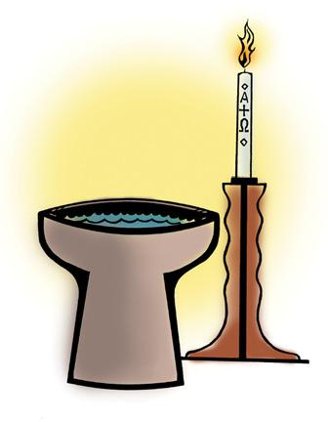

Baptismal Hymn Borning Cry ELW 732

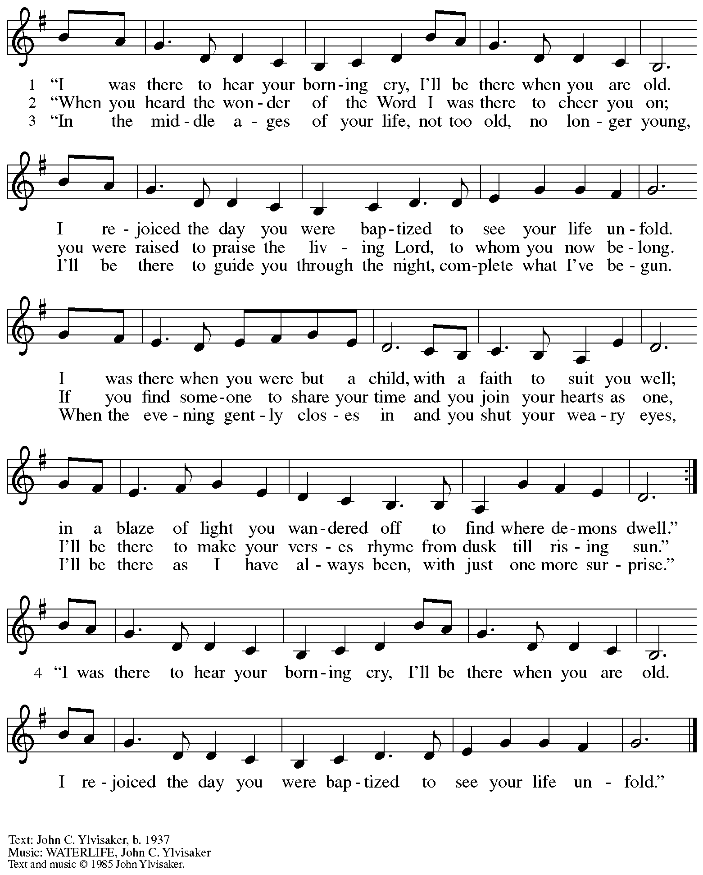
Copyright used by permission. Ylvisaker/Kruger Contract No. 13547

Prayers of the People

P: Set free from captivity to sin and death, we pray to the God of resurrection for the church,
the world, and all who are in need.

After each petition
P: Gracious God,
C: receive our prayer.

P: In your mercy, O God, receive our prayers and renew us by your life-giving Spirit,
through Jesus Christ, our Savior.
C: Amen.

Please be seated.



Meal

Offering

We offer ourselves, our gifts, and our faithful service to God.
An usher will pass around an offering plate for anyone who would like to offer gifts before God.

Music during the Offering

Please rise as you are able.

Offertory Song Let the Vineyards ELW 184

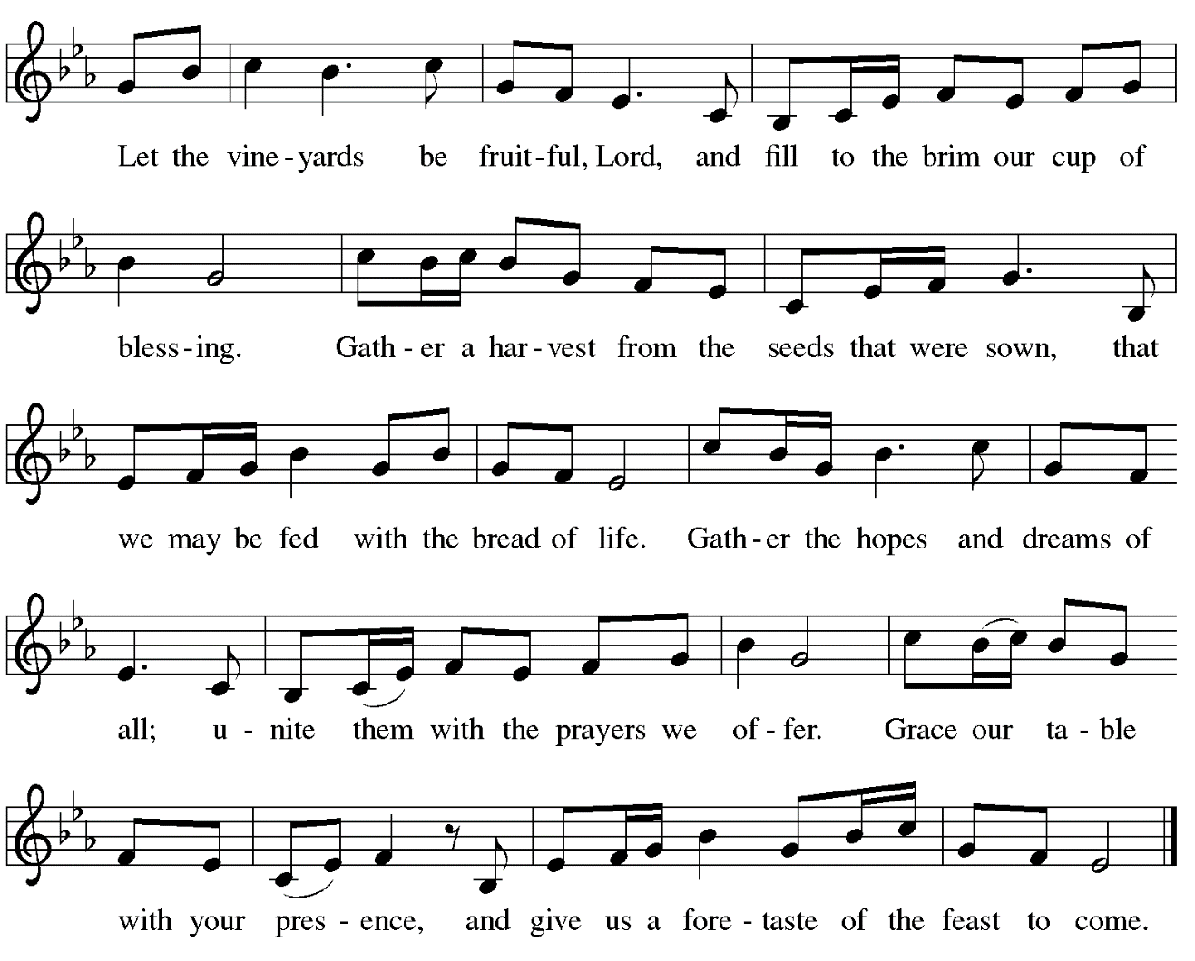

Offertory Prayer

P: Let us pray.
Blessed are you, O God,
C: ruler of heaven and earth.
Day by day you shower us with blessings.
As you have raised us to new life in Christ,
give us glad and generous hearts,
ready to praise you and to respond to those in need,
through Jesus Christ, our Savior and Lord.
Amen.

Dialogue

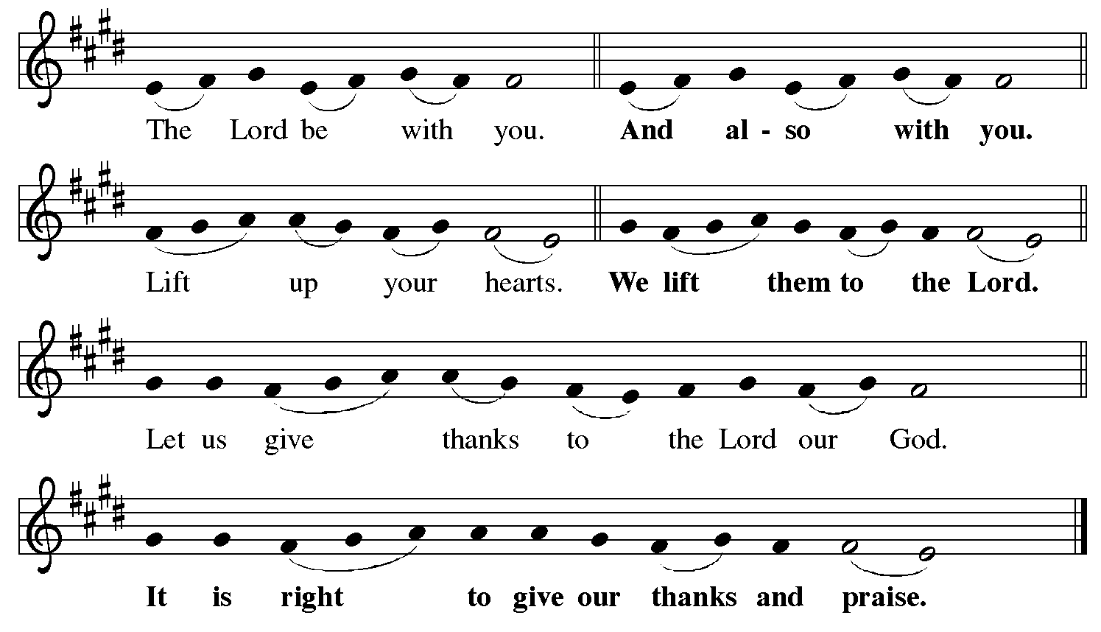

Preface (Sung by the presiding minister)

P: It is indeed right, our duty and our joy,
that we should at all times and in all places
give thanks and praise to you, almighty and merciful God,
for the glorious resurrection of our Savior Jesus Christ,
the true Paschal Lamb who gave himself to take away our sin;
who in dying has destroyed death,
and in rising has brought us to eternal life.
And so, with Mary Magdalene and Peter and all the witnesses of the resurrection,
with earth and sea and all their creatures,
and with angels and archangels, cherubim and seraphim,
we praise your name and join their unending hymn:

Sanctus

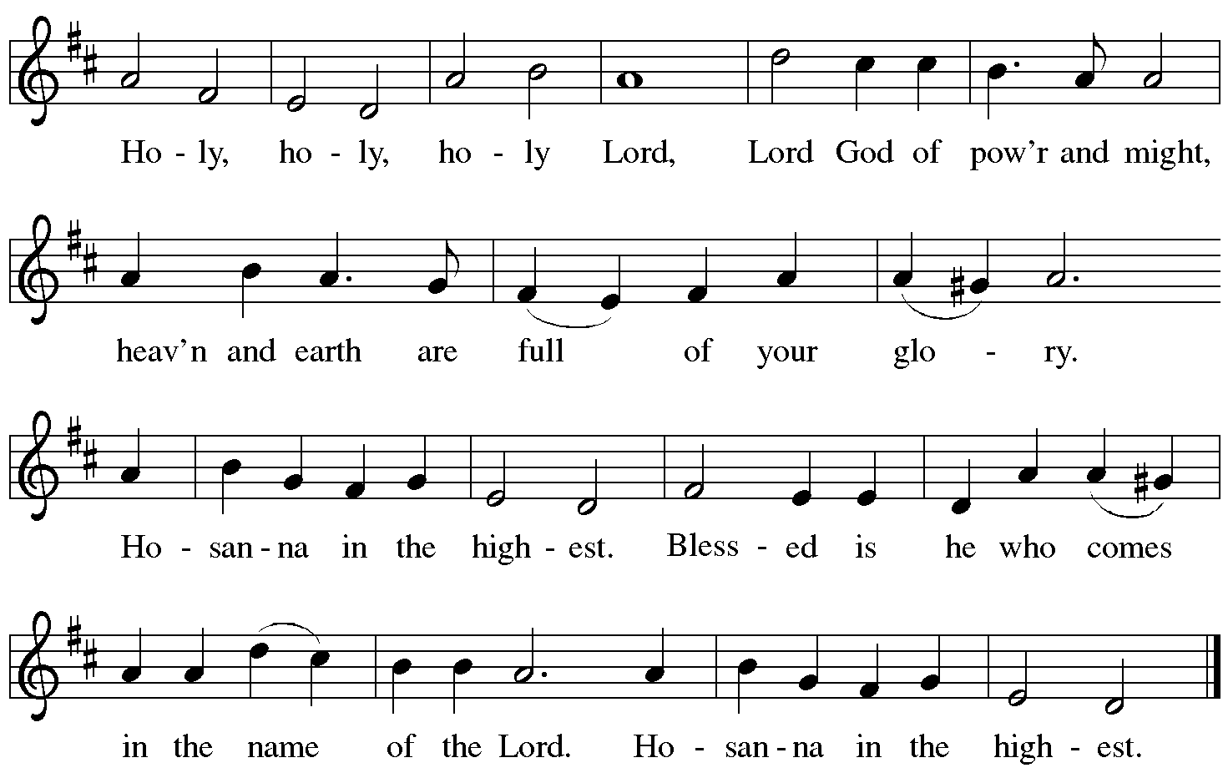

Eucharistic Prayer

P: Blessed are you, O God of the universe …
… Do this for the remembrance of me.

With this bread and cup we remember our Lord’s Passover from death to life
as we proclaim the mystery of faith.
C: Christ has died. Christ is risen. Christ will come again.

P: O God of resurrection and new life …
… Grace our table with your presence.
C: Come, Holy Spirit.

P: Reveal yourself to us in the breaking of the bread …
… burning with justice, peace, and love.
C: Come, Holy Spirit.

P: With your holy ones of all times and places …
… blessed and Holy Trinity, now and forever.
C: Amen.

Lord’s Prayer

P: Gathered as one by the Holy Spirit, let us pray as Jesus taught us.
C: Our Father in heaven,
hallowed be your name,
your kingdom come,
your will be done,
on earth as in heaven.
Give us today our daily bread.
Forgive us our sins
as we forgive those
who sin against us.
Save us from the time of trial
and deliver us from evil.
For the kingdom, the power,
and the glory are yours,
now and forever. Amen.

Fraction and Invitation

Agnus Dei / Lamb of God

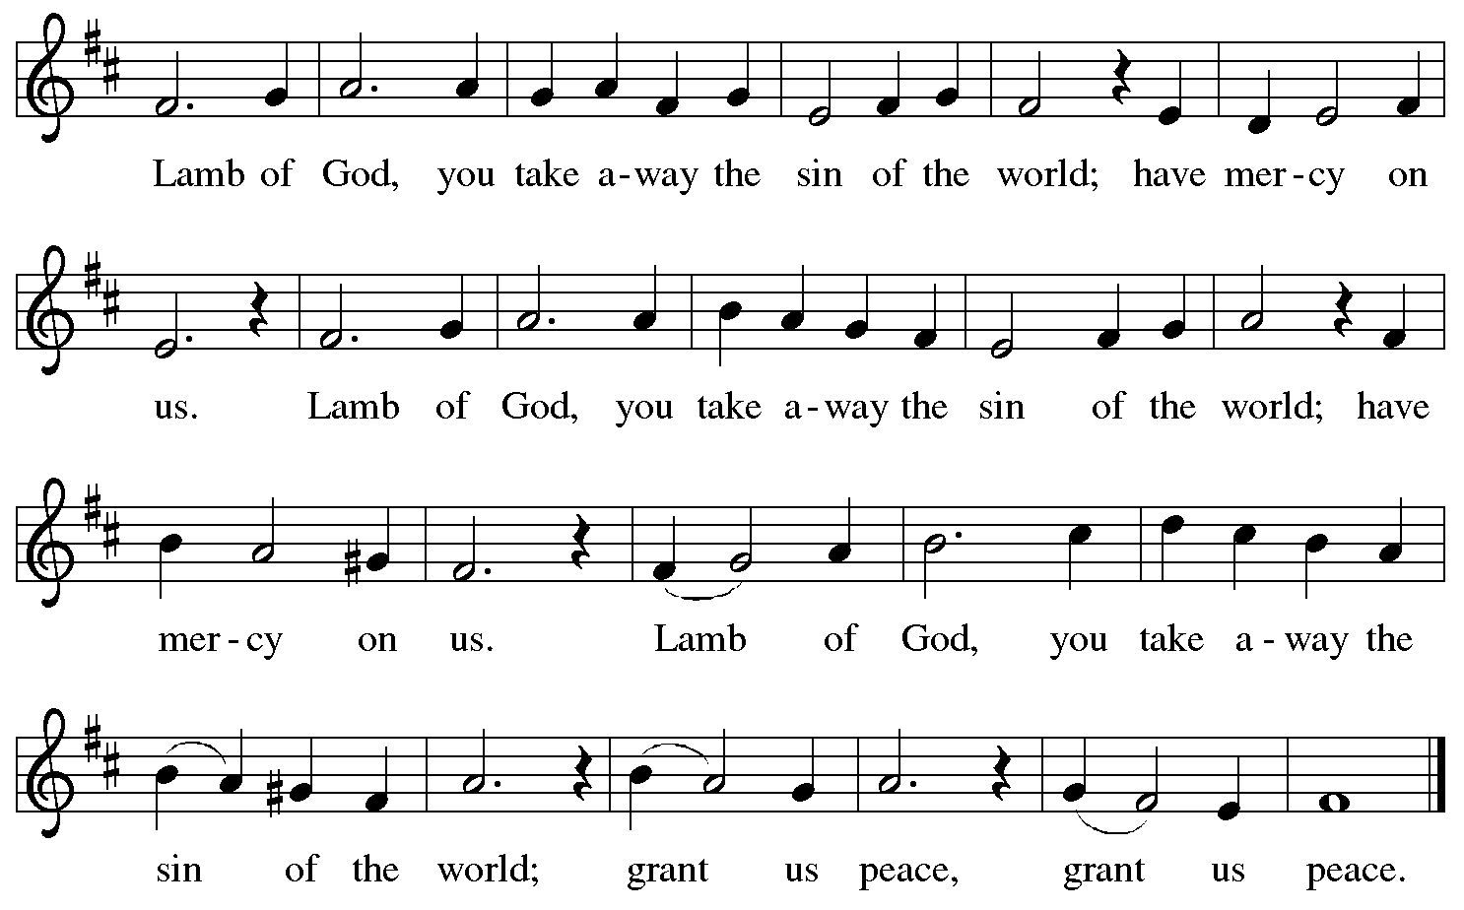

Please be seated.

Holy Communion
- Hand sanitizer is available if you would like to use it prior to receiving Communion.
- Worshipers from the pulpit side will proceed forward first, followed by the center section, and then the lectern side.
- The Communion wafers (regular and gluten-free) have been thoughtfully prepared using the gifts of the congregation by a member of St. Andrew’s altar care team, with a drop of wine or grape juice on each. The presiding minister will distribute one to each communicant.
- When you reach the presiding minister, please indicate if you would like grape juice or a gluten-free wafer.
- A blessing will be provided for anyone who does not yet receive the sacrament.
- A cushion has been placed at the altar rail for anyone who would like to kneel for prayer and reflection before returning to their pew.
- Everyone is asked to wait until you return to your place to consume the elements, and then promptly replace your mask.



Hymns during Holy Communion
What a Friend We Have in Jesus ELW 742

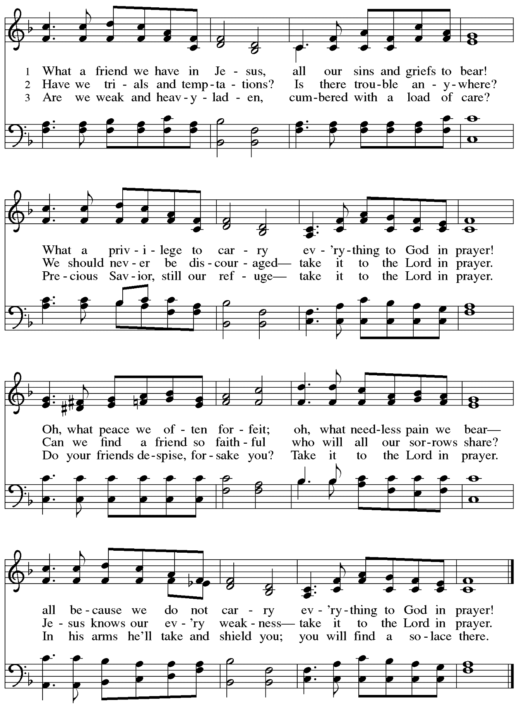
Hymns during Holy Communion
Blessed Assurance ELW 638

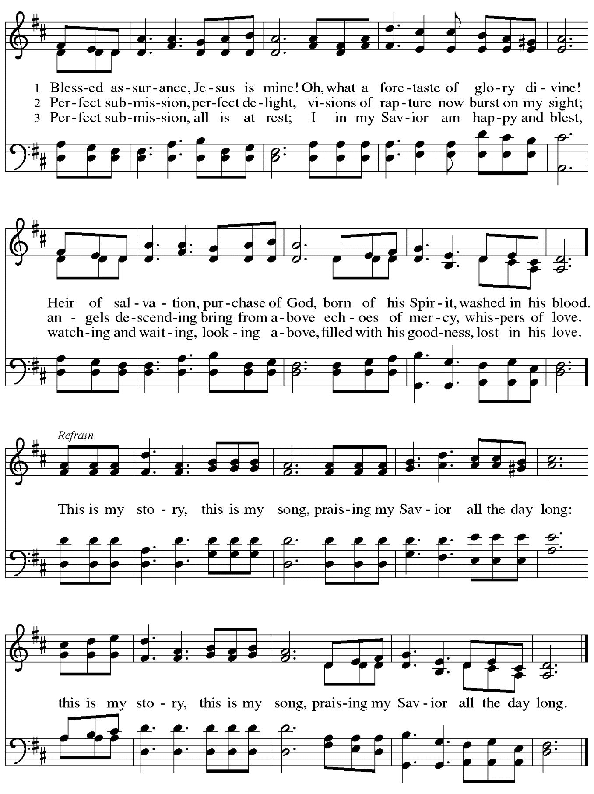
When all have returned to their places, please rise as you are able.

Blessing

P: The body and blood of our Lord Jesus Christ strengthen you and keep you in his grace.
C: Amen.

Prayer

P: Let us pray. Life-giving God,
in the mystery of Christ’s resurrection you send light to conquer darkness,
water to give new life, and the bread of life to nourish your people.
Send us forth as witnesses to your Son’s resurrection,
that we may show your glory to all the world, through Jesus Christ, our risen Lord.
C: Amen.

Please be seated.

Sending

Announcements

Please rise as you are able.

Benediction

P: May our glorious God grant you a spirit of wisdom
to know and love the risen Christ.

Almighty God, holy One, ☩ holy Three,
bless you now and forever.
C: Amen.

Sending Hymn Alleluia! Sing to Jesus ELW 392
v. 1-3

1 Alleluia! Sing to Jesus;
his the scepter, his the throne;
Alleluia! his the triumph,
his the victory alone.
Hark! The songs of peaceful Zion
thunder like a mighty flood:
"Jesus out of ev'ry nation
has redeemed us by his blood."

2 Alleluia! Not as orphans
are we left in sorrow now;
Alleluia! he is near us;
faith believes, nor questions how.
Though the cloud from sight received him
when the forty days were o'er,
shall our hearts forget his promise:
"I am with you evermore"?

3 Alleluia! Bread of heaven,
here on earth our food, our stay;
Alleluia! here the sinful
flee to you from day to day.
Intercessor, friend of sinners,
earth's redeemer, hear our plea
where the songs of all the sinless
sweep across the crystal sea.

Text: William C. Dix, 1837-1898, alt. Music: HYFRYDOL, Rowland H. Priichard, 1811-1887.

Dismissal

P: Alleluia! Christ is risen!
C: Christ is risen indeed! Alleluia! Alleluia!

P: Go in peace. Share the good news!
C: Thanks be to God!

Abbreviations

P: Pastor/Presiding Minister
L: Lector
R: Representative of the Congregation
C: Congregation

ELW: Evangelical Lutheran Worship hymnal
ACS: All Creation Sings hymnal

Those serving in worship today

Piano Lili Cai
Organ Jimmi Kocher-Hillmer
Assisting Minister Timothy Kocher-Hillmer
Cantor Kristen Asplin
Lector Lester Prince
Director of Faith Formation Christopher Atwood
Presiding Minister Pastor Ross Carmichael

Liturgy and Hymnody Acknowledgements

From SundaysandSeasons.com. Copyright © 2022 Augsburg Fortress. All rights reserved. Reprinted under OneLicense.net # A-722139.
Used by permission of Augsburg Fortress.

Christ Has Arisen, Alleluia – Text: Bernard Kyamanywa, b. 1938; tr. Howard S. Olson, b. 1922. Music: MFURAHINI, ALELUYA, Tanzanian traditional. Text © 1968 Lutheran Theological College, Makumira, Tanzania, admin. Augsburg Fortress. Tr. © 1977 Howard S. Olson, admin. Augsburg Fortress. All rights reserved. Reprinted with permission under OneLicense.net A A-722139.

Let the Vineyards – Text: John W. Arthur, 1922-1980. Music: Ronald A. Nelson, b. 1927. Text and Music © 1978 Lutheran Book of Worship, admin. Augsburg Fortress.

What a Friend We Have in Jesus – Text: Joseph Scriven, 1820-1886. Music: CONVERSE, Charles C. Converse, 1832-1918.

Blessed Assurance – Fanny J. Crosby, 1820-1915. Music: ASSURANCE, Phoebe P. Knapp, 1830-1908.

