+ Fourth Sunday of Easter
May 8, 2022
St. Andrew Lutheran Church
304 Morewood Ave.
Pittsburgh, PA 15213
St_andrewELCA@verizon.net
www.standrewpittsburgh.org

+ Fourth Sunday of Easter
Order for Worship

The gift of new life, of eternal life, is the gift of the risen Christ. It is the promise of Jesus.
It was true for Dorcas in Joppa. It was true for those “who have come out of the great ordeal”
in the Revelation vision. It is true for us and for all the baptized: Surely goodness and mercy shall follow me all the days of my life, and I will dwell in the house of the Lord forever.

A few notes on precautions and protocols, which apply to everyone regardless of vaccination status, as St. Andrew returns to worship in the sanctuary:

- Face masks that fully cover both your mouth and nose are required for parishioners over the age of two (2) – St. Andrew’s next step in restoring worship will be having the worship leaders remove masks during their parts that are conducted at a distance from the pews.
- Physical distancing of at least six (6) feet will be observed at all times for people not from your household.
- We invite the congregation to join in the singing of the hymns (with masks on) during worship!
- Hand sanitizer is available at the front of the sanctuary to use before Holy Communion, after you proceed past the baptismal font, as the alcohol has been affecting the finish on the font’s bowl.

Worship Services are live streamed to multiple online platforms.
By attending worship, you agree that your image and voice may be broadcast.

Welcome

Prelude

Gathering
The Holy Spirit calls us together as the people of God.

Thanksgiving for Baptism

P: Alleluia! Christ is risen!
C: Christ is risen indeed! Alleluia!

P: In the waters of baptism,
we have passed over from death to life with Jesus Christ,
and we are a new creation.
For this saving mystery, and for this water, let us bless God,
who was, who is, and who is to come.

Water may be poured into the font as the presiding minister gives thanks.

P: We thank you, God, for your river of life,
flowing freely from your throne:
throughout the earth, through the city, to every living thing.
You rescued Noah and his family from the flood;
You opened wide the sea for the Israelites.
Now in these waters you flood us with mercy,
and our sin is drowned forever.
You open the gate of righteousness
and we pass safely through.
In Jesus Christ, you calm and trouble the waters.
You nourish us and enclose us in safety.
You call us forth and send us out.
In lush and barren places, you are with us.
You have become our salvation.
Now breathe upon this water
and awaken your church once more.
Claim us again as your beloved and holy people.
Quench our thirst; cleanse our hearts; wipe away every tear.
To you, our Beginning and our End,
our Shepherd and Lamb,
be honor, glory, praise, and thanksgiving,
now and forever.
C: Amen.

Gathering Hymn Christ Is Alive! Let Christians Sing! ELW 389
v. 1-2, 5

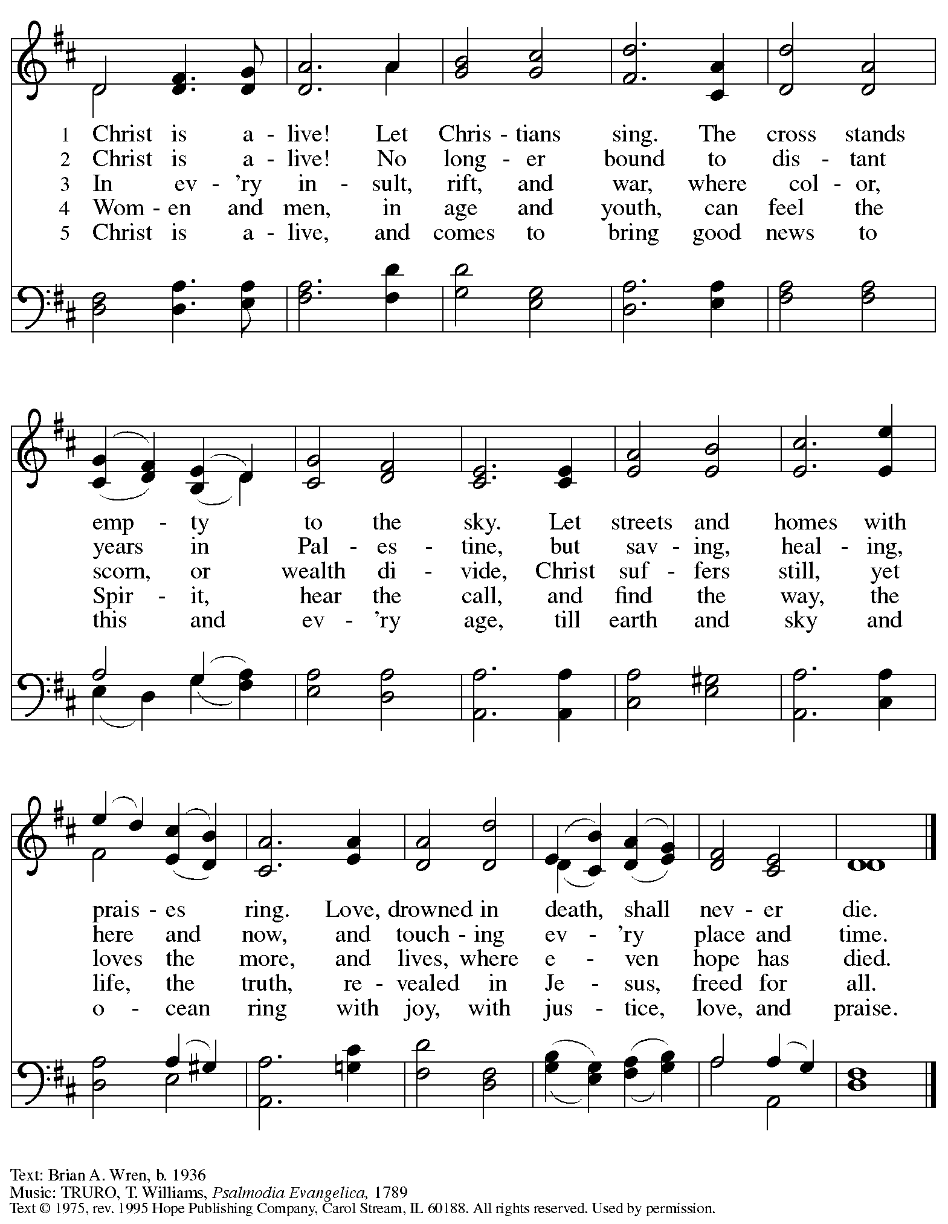
Reprinted under OneLicense.net # A-722139.
Greeting

P: The grace of our Lord Jesus Christ, the love of God,
and the communion of the Holy Spirit be with you all.
C: And also with you.

Hymn of Praise This Is the Feast ELW p. 149-150

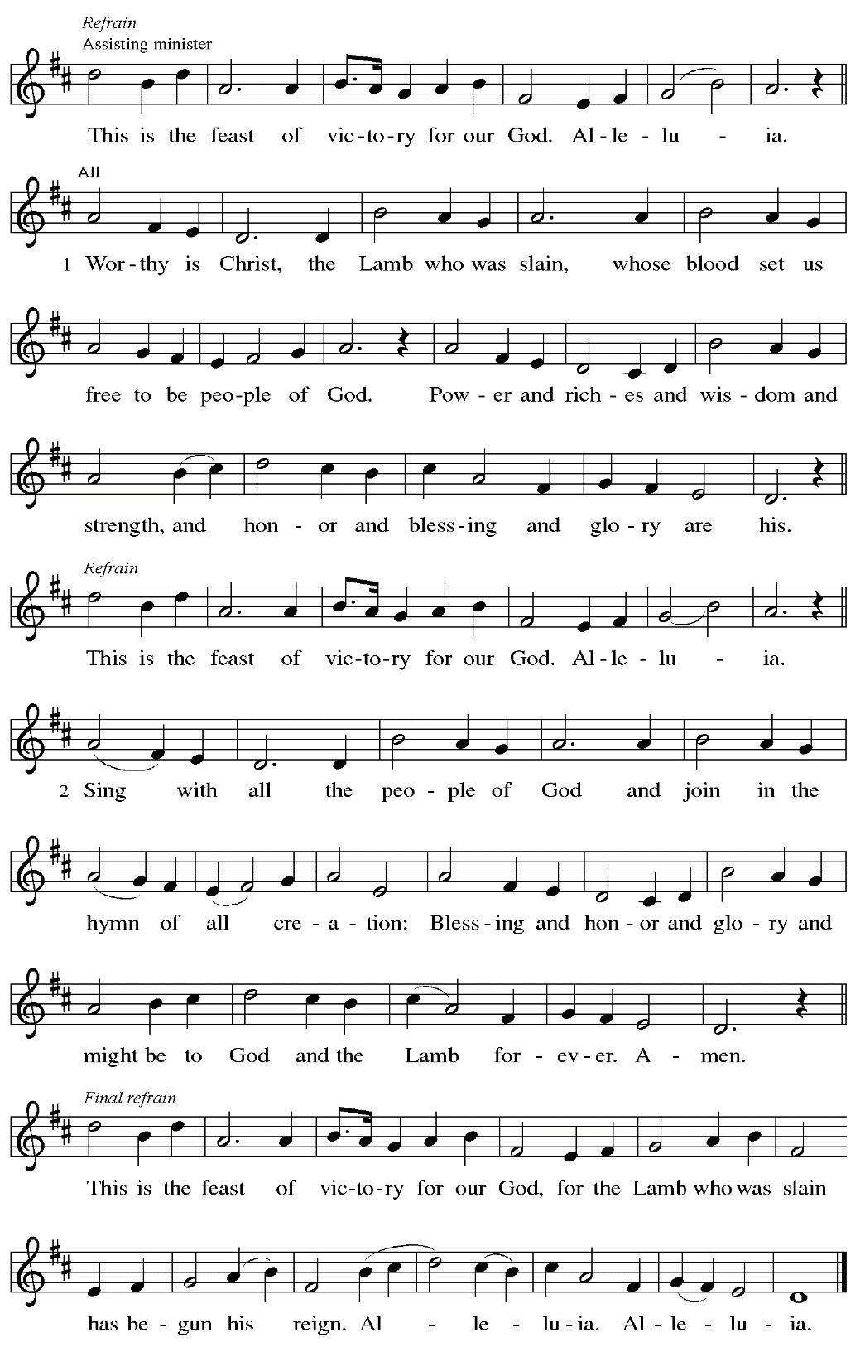
Prayer of the Day

P: The Lord be with you.
C: And also with you.

P: Let us pray.
O God of peace, you brought again from the dead our Lord Jesus Christ, the great shepherd
of the sheep. By the blood of your eternal covenant, make us complete in everything good
so that we may do your will, and work among us all that is well-pleasing in your sight,
through Jesus Christ, our Savior and Lord, who lives and reigns with you and the Holy Spirit, one God, now and forever.
C: Amen.

Please be seated.

Word
God speaks to us in Scripture reading, preaching, and song

First Reading – Acts 9: 36-43

³⁶Now in Joppa there was a disciple whose name was Tabitha, which in Greek is Dorcas. She was devoted to good works and acts of charity. ³⁷At that time she became ill and died. When they had washed her, they laid her in a room upstairs. ³⁸Since Lydda was near Joppa, the disciples, who heard that Peter was there, sent two men to him with the request, “Please come to us without delay.” ³⁹So Peter got up and went with them; and when he arrived, they took him to the room upstairs. All the widows stood beside him, weeping and showing tunics and other clothing that Dorcas had made while she was with them. ⁴⁰Peter put all of them outside, and then he knelt down and prayed. He turned to the body and said, “Tabitha, get up.” Then she opened her eyes, and seeing Peter, she sat up. ⁴¹He gave her his hand and helped her up. Then calling the saints and widows, he showed her to be alive. ⁴²This became known throughout Joppa, and many believed in the Lord. ⁴³Meanwhile he stayed in Joppa for some time with a certain Simon, a tanner.

L: Word of God, word of life.
C: Thanks be to God.

Psalm 23 Following Page

The psalm will be sung responsively, led by the cantor.

Psalm 23

Tone

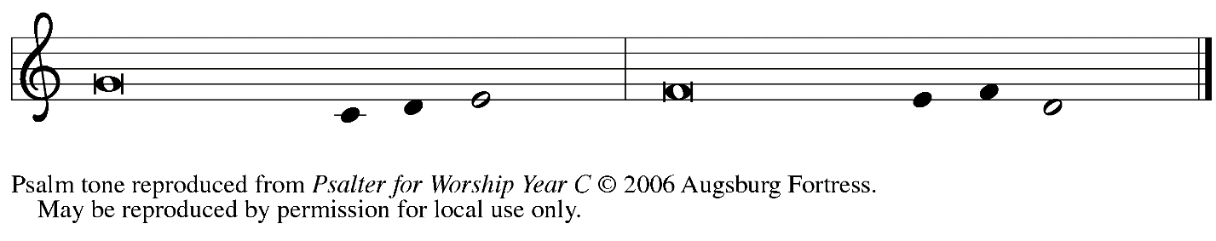

Refrain

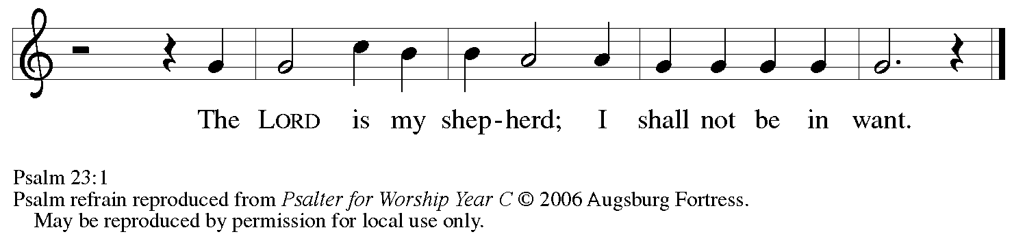

¹The Lord| is my shepherd;
I shall not | be in want.
²The Lord makes me lie down | in green pastures
and leads me be- | side still waters.
³You restore my | soul, O Lord,
and guide me along right pathways | for your name’s sake.
⁴Though I walk through the valley of the shadow of death, I shall | fear no evil;
for you are with me; your rod and your staff, they | comfort me. R
⁵You prepare a table before me in the presence | of my enemies;
you anoint my head with oil, and my cup is | running over.
⁶Surely goodness and mercy shall follow me all the days | of my life,
and I will dwell in the house of the | Lord forever. R

Second Reading – Revelation 7: 9-17

⁹After this I looked, and there was a great multitude that no one could count, from every nation, from all tribes and peoples and languages, standing before the throne and before the Lamb, robed in white, with palm branches in their hands. ¹⁰They cried out in a loud voice, saying,
“Salvation belongs to our God who is seated on the throne, and to the Lamb!”
¹¹And all the angels stood around the throne and around the elders and the four living creatures, and they fell on their faces before the throne and worshiped God, ¹²singing,
“Amen! Blessing and glory and wisdom
and thanksgiving and honor
and power and might
be to our God forever and ever! Amen.”
¹³Then one of the elders addressed me, saying, “Who are these, robed in white, and where have they come from?” ¹⁴I said to him, “Sir, you are the one that knows.” Then he said to me, “These are they who have come out of the great ordeal; they have washed their robes and made them white in the blood of the Lamb.
¹⁵For this reason they are before the throne of God,
and worship God day and night within God’s temple,
and the one who is seated on the throne will shelter them.
¹⁶They will hunger no more, and thirst no more;
the sun will not strike them,
nor any scorching heat;
¹⁷for the Lamb at the center of the throne will be their shepherd,
and [the Lamb] will guide them to springs of the water of life,
and God will wipe away every tear from their eyes.”

L: Word of God, word of life.
C: Thanks be to God.

Please rise as you are able.

Gospel Acclamation

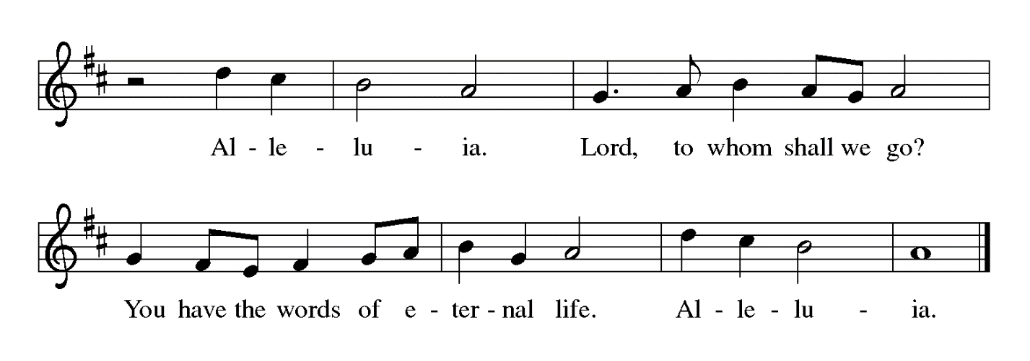

Gospel – John 10: 22-30

P: The holy Gospel according to St. John.
C: Glory to you, O Lord.

²²At that time the festival of the Dedication took place in Jerusalem. It was winter, ²³and Jesus was walking in the temple, in the portico of Solomon. ²⁴So the Jews gathered around him and said to him, “How long will you keep us in suspense? If you are the Messiah, tell us plainly.”
²⁵Jesus answered, “I have told you, and you do not believe. The works that I do in my Father’s name testify to me; ²⁶but you do not believe, because you do not belong to my sheep. ²⁷My sheep hear my voice. I know them, and they follow me. ²⁸I give them eternal life, and they will never perish. No one will snatch them out of my hand. ²⁹What my Father has given me is greater than all else, and no one can snatch it out of the Father’s hand. ³⁰The Father and I are one.”

P: The Gospel of the Lord.
C: Praise to you, O Christ.

Please be seated.

Sermon

A time of silence for prayer and reflection follows the sermon.
When the hymn of the day begins, please rise as you are able.

Hymn of the Day Savior, Like a Shepherd Lead Us ELW 789
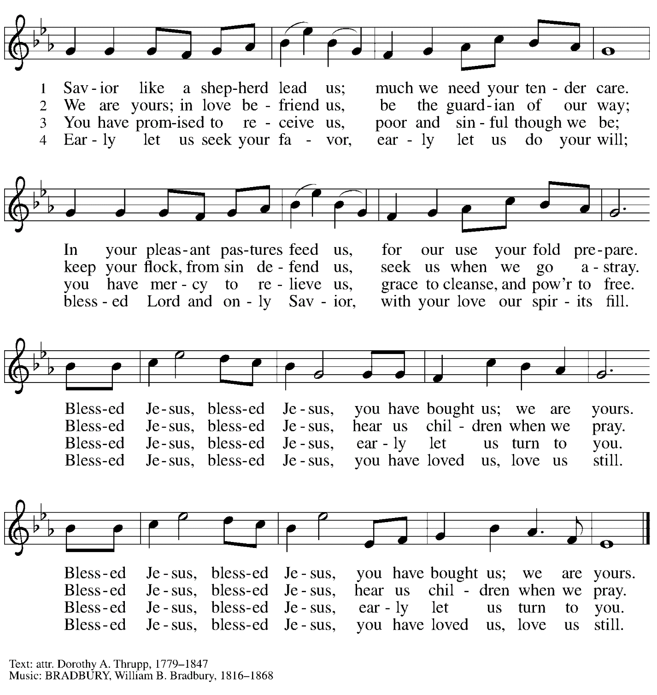

Prayers of the People

P: Set free from captivity to sin and death, we pray to the God of resurrection for the church,
the world, and all who are in need.

After each petition
P: Gracious God,
C: receive our prayer.

P: In your mercy, O God, receive our prayers and renew us by your life-giving Spirit,
through Jesus Christ, our Savior.
C: Amen.

Please be seated.

Meal

Offering

We offer ourselves, our gifts, and our faithful service to God.
An usher will pass around an offering plate for anyone who would like to offer gifts before God.

Music during the Offering

Please rise as you are able.
Offertory Song Let the Vineyards ELW 184

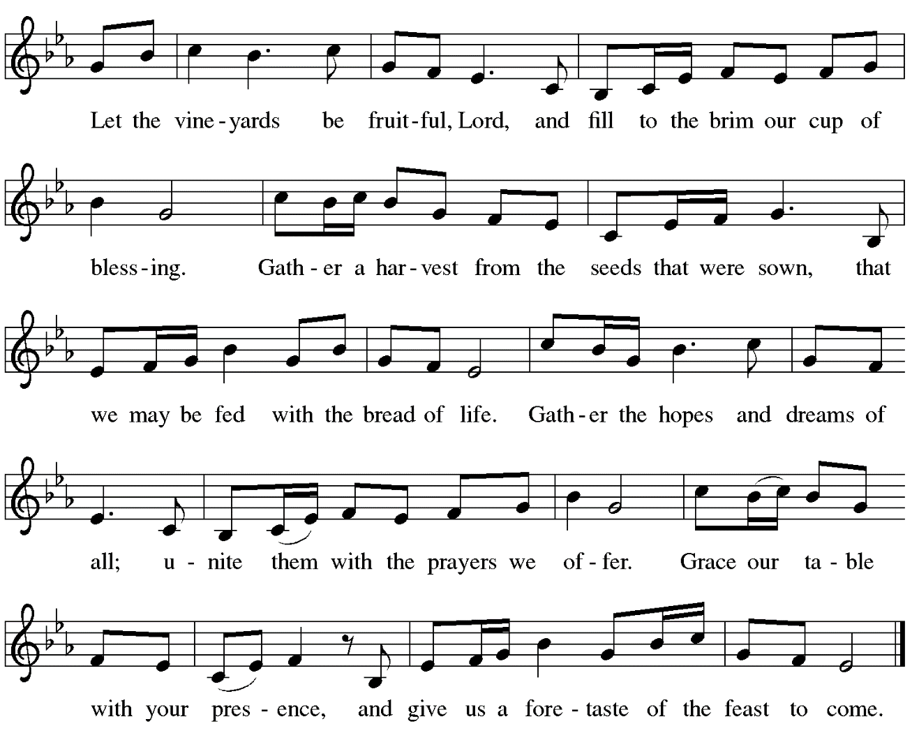

Offertory Prayer

P: Let us pray.
Blessed are you, O God,
C: ruler of heaven and earth.
Day by day you shower us with blessings.
As you have raised us to new life in Christ,
give us glad and generous hearts,
ready to praise you and to respond to those in need,
through Jesus Christ, our Savior and Lord.
Amen.

Dialogue

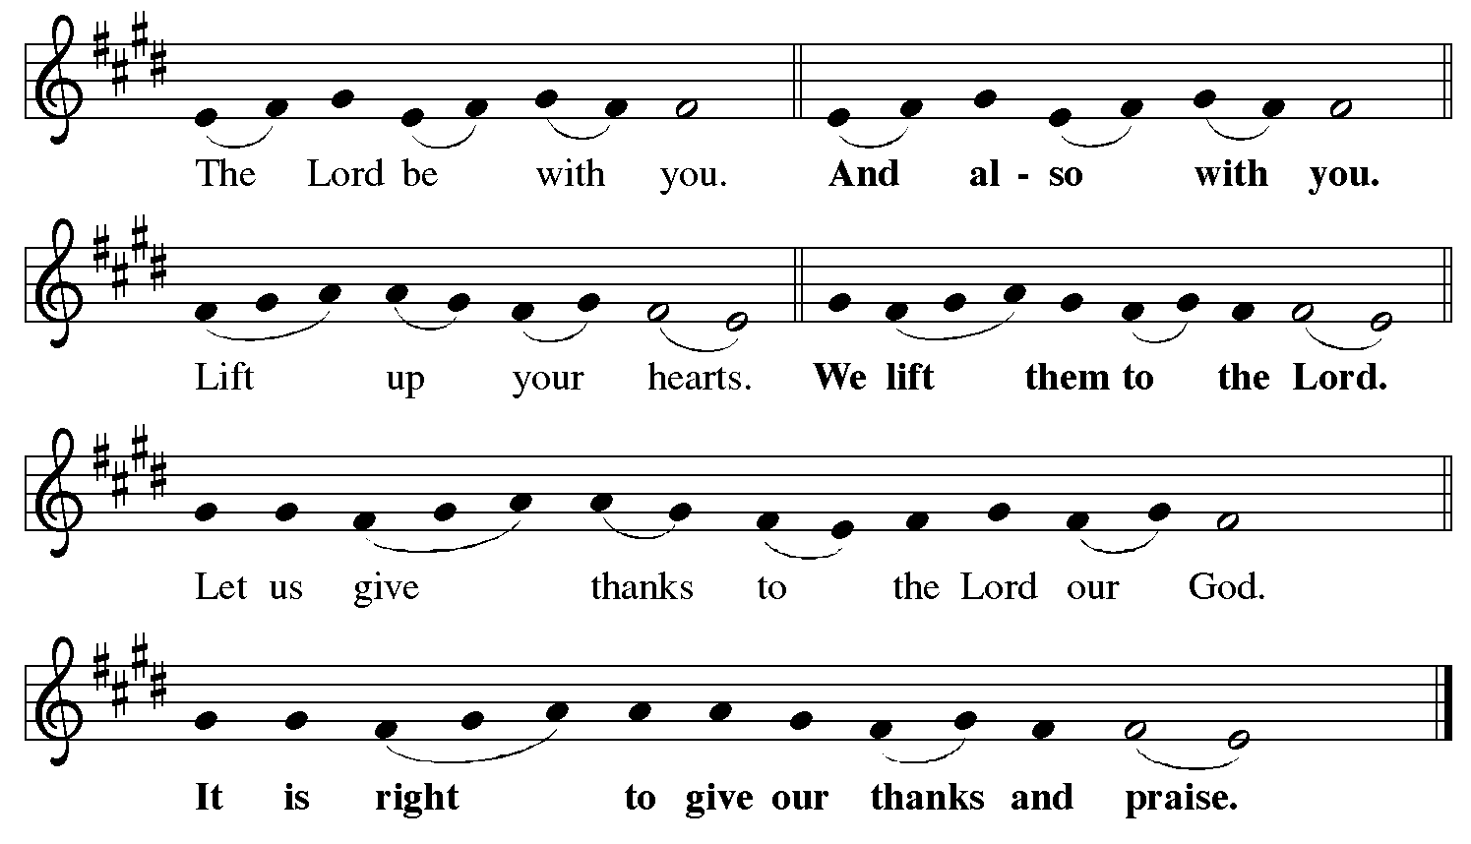

Preface (Sung by the presiding minister)

P: It is indeed right, our duty and our joy,
that we should at all times and in all places
give thanks and praise to you, almighty and merciful God,
for the glorious resurrection of our Savior Jesus Christ,
the true Paschal Lamb who gave himself to take away our sin;
who in dying has destroyed death,
and in rising has brought us to eternal life.
And so, with Mary Magdalene and Peter and all the witnesses of the resurrection,
with earth and sea and all their creatures,
and with angels and archangels, cherubim and seraphim,
we praise your name and join their unending hymn:

Sanctus

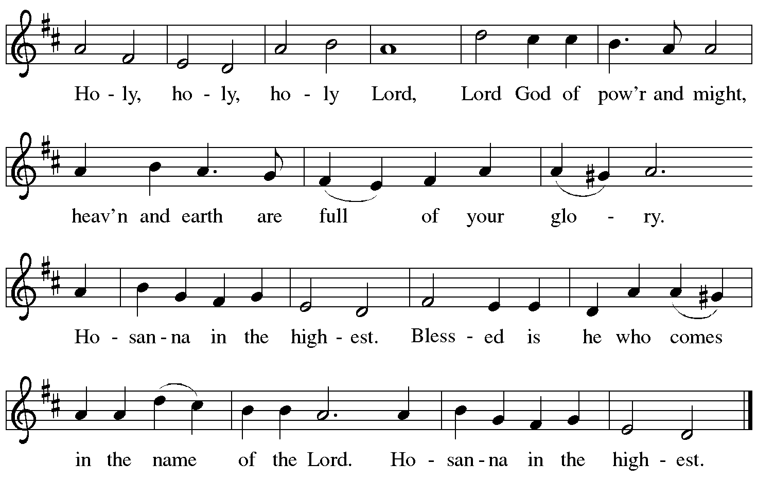

Eucharistic Prayer

P: Blessed are you, O God of the universe …
… Do this for the remembrance of me.

With this bread and cup we remember our Lord’s Passover from death to life
as we proclaim the mystery of faith.
C: Christ has died. Christ is risen. Christ will come again.

P: O God of resurrection and new life …
… Grace our table with your presence.
C: Come, Holy Spirit.

P: Reveal yourself to us in the breaking of the bread …
… burning with justice, peace, and love.
C: Come, Holy Spirit.

P: With your holy ones of all times and places …
… blessed and Holy Trinity, now and forever.
C: Amen.

Lord’s Prayer

P: Gathered as one by the Holy Spirit, let us pray as Jesus taught us.
C: Our Father in heaven,
hallowed be your name,
your kingdom come,
your will be done,
on earth as in heaven.
Give us today our daily bread.
Forgive us our sins
as we forgive those
who sin against us.
Save us from the time of trial
and deliver us from evil.
For the kingdom, the power,
and the glory are yours,
now and forever. Amen.

Fraction and Invitation

Agnus Dei / Lamb of God

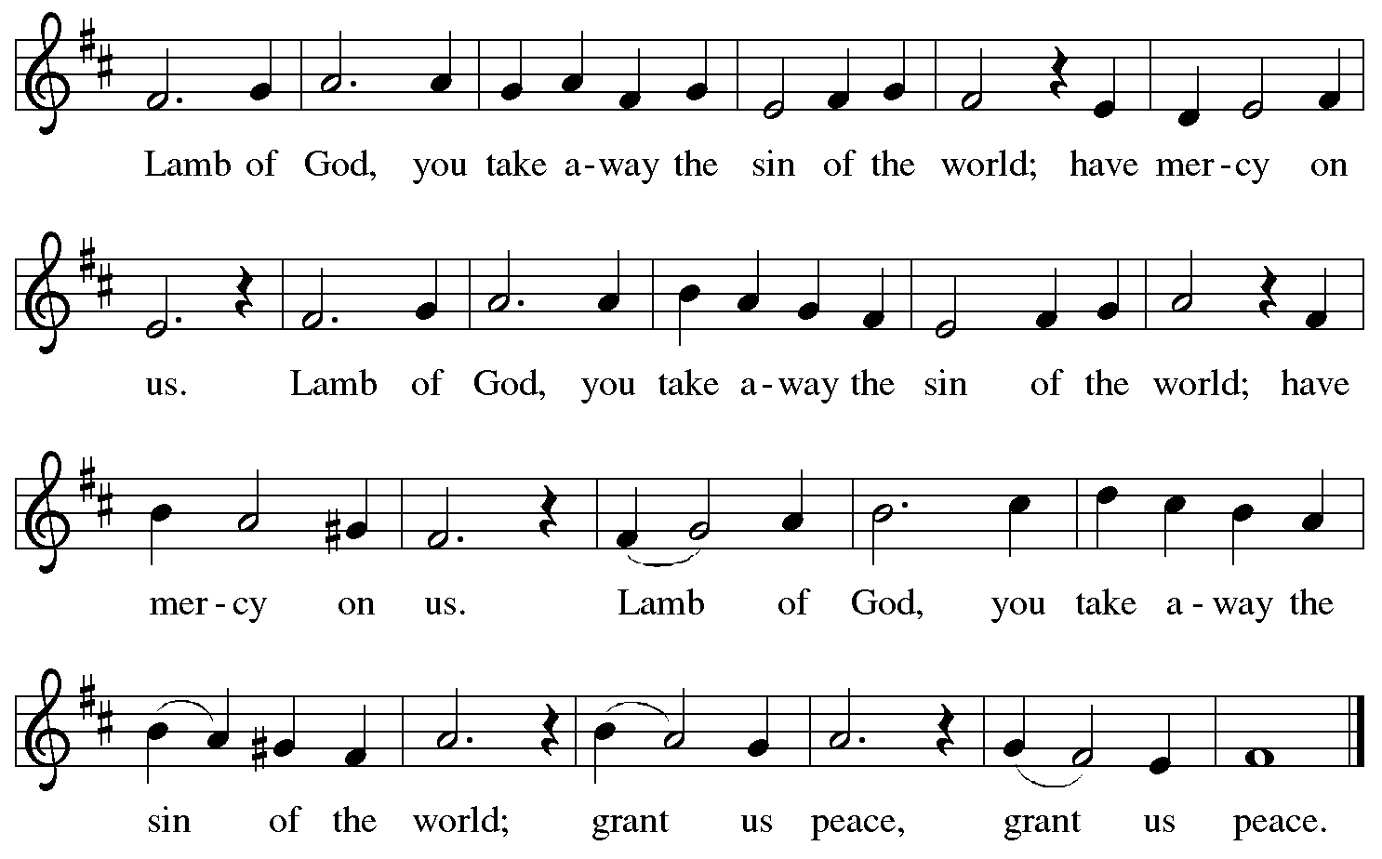

Please be seated.

Holy Communion
- Hand sanitizer is available if you would like to use it prior to receiving Communion.
- Worshipers from the pulpit side will proceed forward first, followed by the center section, and then the lectern side.
- The Communion wafers (regular and gluten-free) have been thoughtfully prepared using the gifts of the congregation by a member of St. Andrew’s altar care team, with a drop of wine or grape juice on each. The presiding minister will distribute one to each communicant.
- When you reach the presiding minister, please indicate if you would like grape juice or a gluten-free wafer.
- A blessing will be provided for anyone who does not yet receive the sacrament.
- A cushion has been placed at the altar rail for anyone who would like to kneel for prayer and reflection before returning to their pew.
- Everyone is asked to wait until you return to your place to consume the elements, and then promptly replace your mask.

Hymns during Holy Communion
You Satisfy the Hungry Heart ELW 484

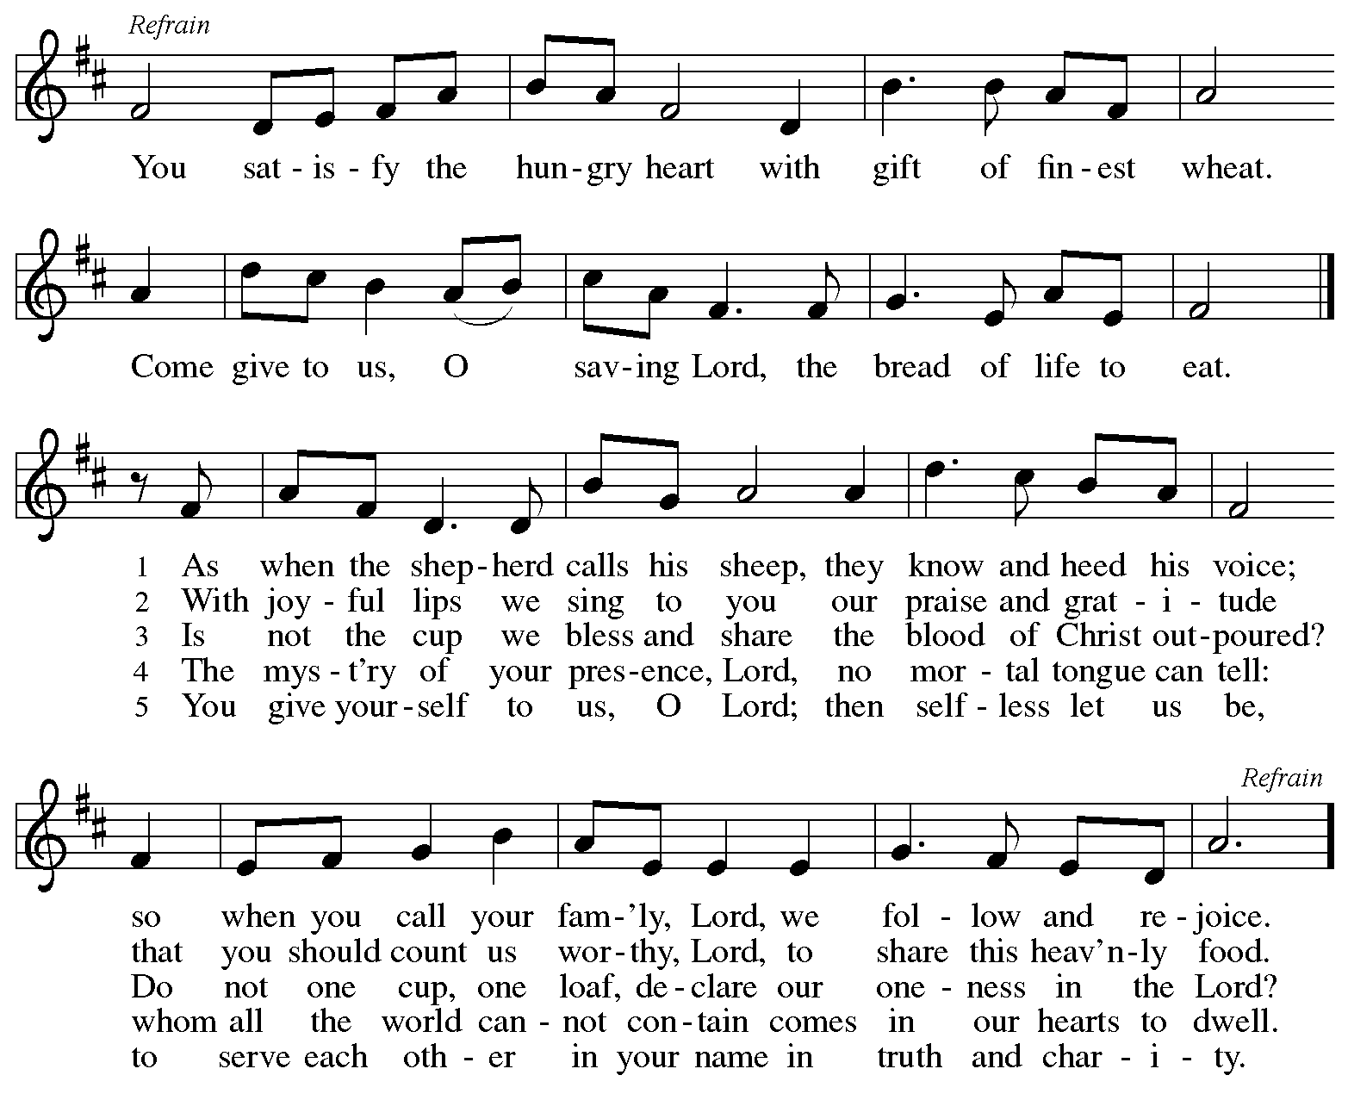
Hymns during Holy Communion
Blessing and Honor ELW 854

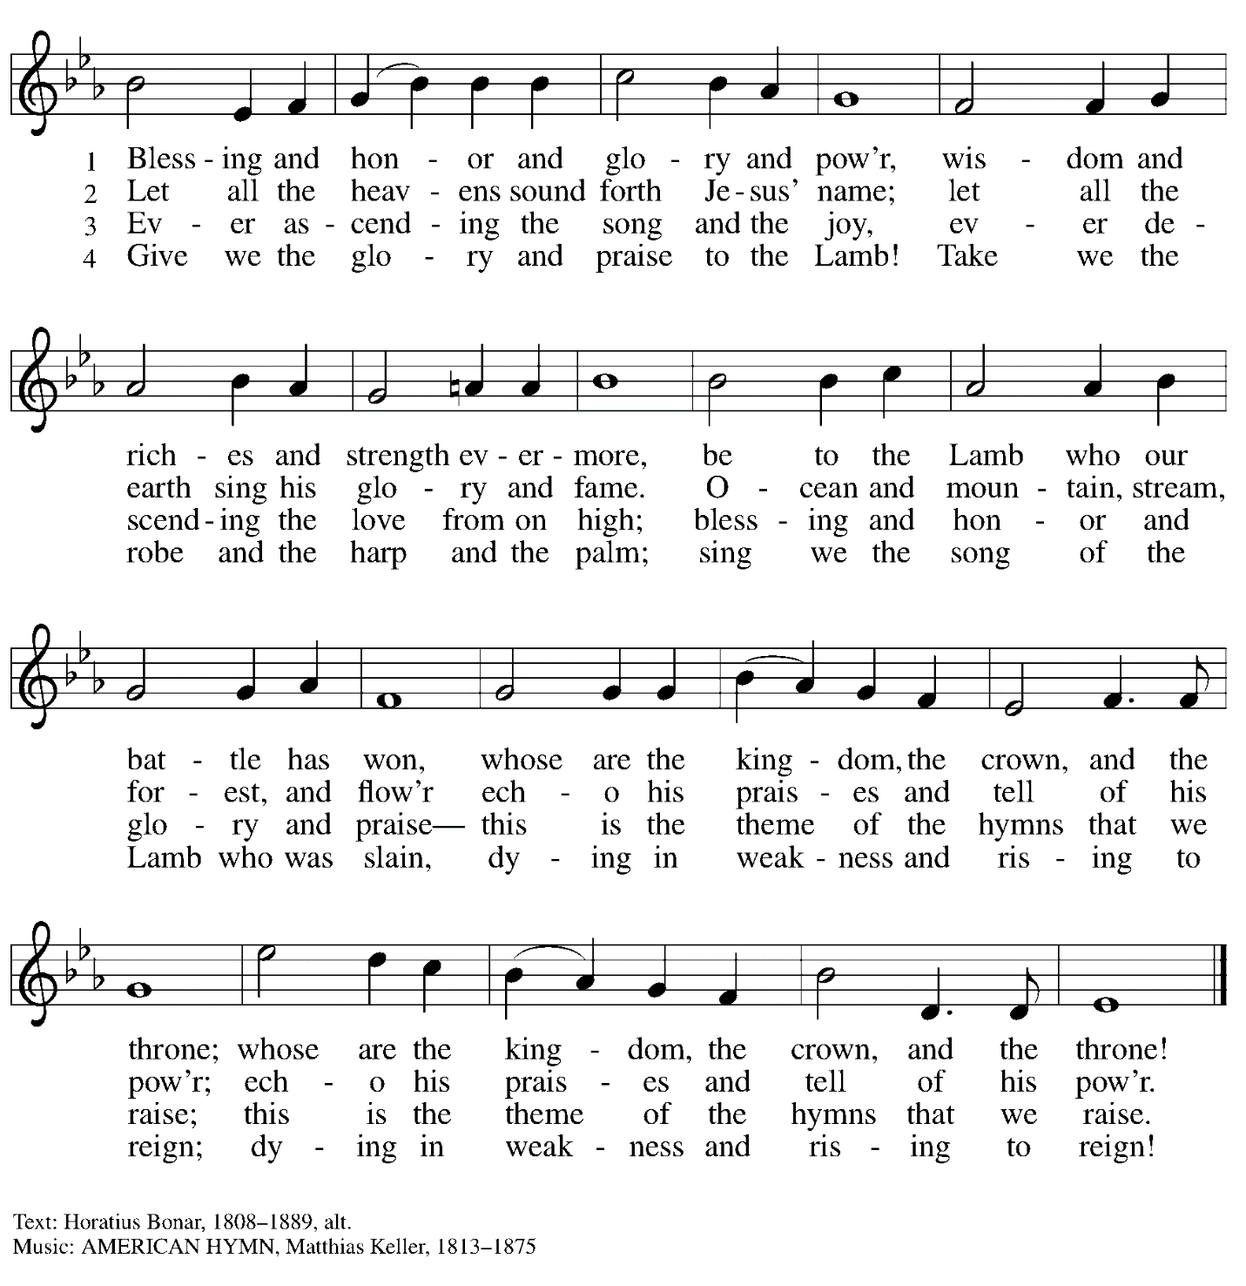

When all have returned to their places, please rise as you are able.

Blessing

P: The body and blood of our Lord Jesus Christ strengthen you and keep you in his grace.
C: Amen.

Prayer

P: Let us pray. Life-giving God,
in the mystery of Christ’s resurrection you send light to conquer darkness,
water to give new life, and the bread of life to nourish your people.
Send us forth as witnesses to your Son’s resurrection,
that we may show your glory to all the world, through Jesus Christ, our risen Lord.
C: Amen.

Sending

Benediction

P: May our glorious God grant you a spirit of wisdom
to know and love the risen Christ.

Almighty God, holy One, ☩ holy Three,
bless you now and forever.
C: Amen.

Sending Hymn Praise the Lord, Rise Up Rejoicing ELW 544

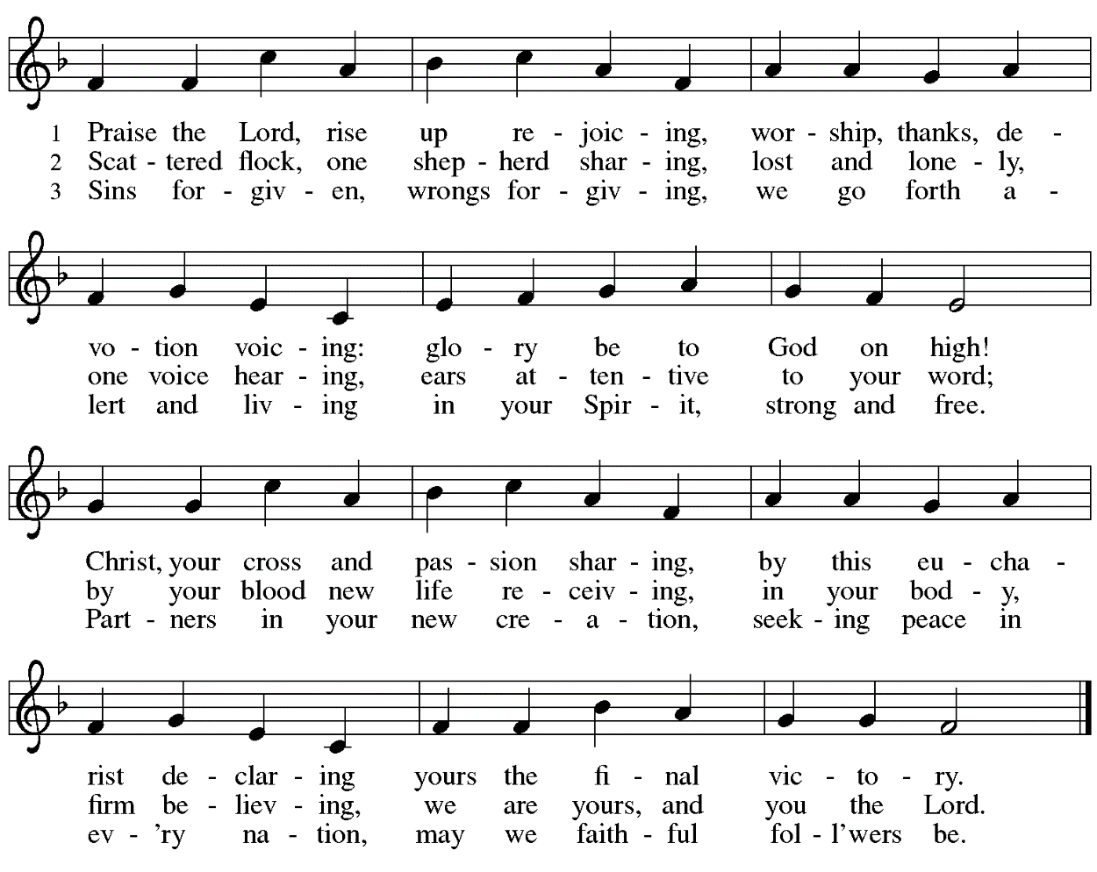
Dismissal

P: Alleluia! Christ is risen!
C: Christ is risen indeed! Alleluia! Alleluia!

P: Go in peace. Share the good news!
C: Thanks be to God!

Abbreviations

P: Pastor/Presiding Minister
L: Lector
C: Congregation

ELW: Evangelical Lutheran Worship hymnal

Those serving in worship today

Piano Lili Cai
Cantor Richard Krug
Lector Kelly Spanninger
Director of Faith Formation Christopher Atwood
Presiding Minister Pastor Ross Carmichael

Liturgy and Hymnody Acknowledgements

From SundaysandSeasons.com. Copyright © 2022 Augsburg Fortress. All rights reserved. Reprinted under OneLicense.net # A-722139.
Used by permission of Augsburg Fortress.

Let the Vineyards – Text: John W. Arthur, 1922-1980. Music: Ronald A. Nelson, b. 1927. Text and Music © 1978 Lutheran Book of Worship, admin. Augsburg Fortress.

You Satisfy the Hungry Heart – Text: Omer Westendorf, 1916-1997. Music: BICENTENNIAL, Robert E. Kreutz, 1922-1996. Text and music © Archdiocese of Philadelphia, admin. International Liturgy Publications. All rights reserved. Reprinted with permission under OneLicense.net # A-722139.

Praise the Lord, Rise Up Rejoicing – Text: Howard C.A. Gaunt, 1902-1983, alt. Music: ALLES IST AN GOTTES SEGEN, Johann Löhner, 1645-1705, adapt. Text © Oxford University Press. All rights reserved. Reprinted with permission under OneLicense.net # A-722139.

