+ Holy Trinity
June 12, 2022
St. Andrew Lutheran Church
304 Morewood Ave.
Pittsburgh, PA 15213
St_andrewELCA@verizon.net
www.standrewpittsburgh.org

+ Holy Trinity
Order for Worship

“O Lord our Lord, how majestic is your name in all the earth!”
Today we celebrate the holy Trinity. Paul writes that through Jesus we have peace with God, whose love pours into our hearts through the Holy Spirit, giving us lasting hope.
We celebrate the gracious One-in-Three, eternal Three-in-One, as we worship in community;
as we share water and word, bread and wine;
and as we bring God’s love and hope to our neighbors.

A few notes on precautions and protocols, which apply to everyone regardless of vaccination status, as St. Andrew returns to worship in the sanctuary:

- Face masks that fully cover both your mouth and nose are required for parishioners over the age of two (2).
- Physical distancing of at least six (6) feet will be observed at all times for people not from your household.
- We invite the congregation to join in the singing of the hymns (with masks on) during worship!
- Hand sanitizer is available at the front of the sanctuary to use before Holy Communion, after you proceed past the baptismal font, as the alcohol has been affecting the finish on the font’s bowl.

Worship Services are live streamed to multiple online platforms.
By attending worship, you agree that your image and voice may be broadcast.

Welcome

Prelude

Gathering
The Holy Spirit calls us together as the people of God.

Confession and Forgiveness

P: Blessed be the holy Trinity, ☩ one God,
whose steadfast love endures forever.
C: Amen.

P: Let us confess our sin in the presence of God and of one another.

Silence is kept for reflection.

P: Merciful God,
C: we confess that we have not followed your path
but have chosen our own way.
Instead of putting others before ourselves,
we long to take the best seats at the table.
When met by those in need,
we have too often passed by on the other side.
Set us again on the path of life.
Save us from ourselves
and free us to love our neighbors.
Amen.

P: Hear the good news!
God does not deal with us according to our sins
but delights in granting pardon and mercy.
In the name of ☩ Jesus Christ, your sins are forgiven.
You are free to love as God loves.
C: Amen.

Gathering Hymn Come, Join the Dance of Trinity ELW 412
v. 1-3

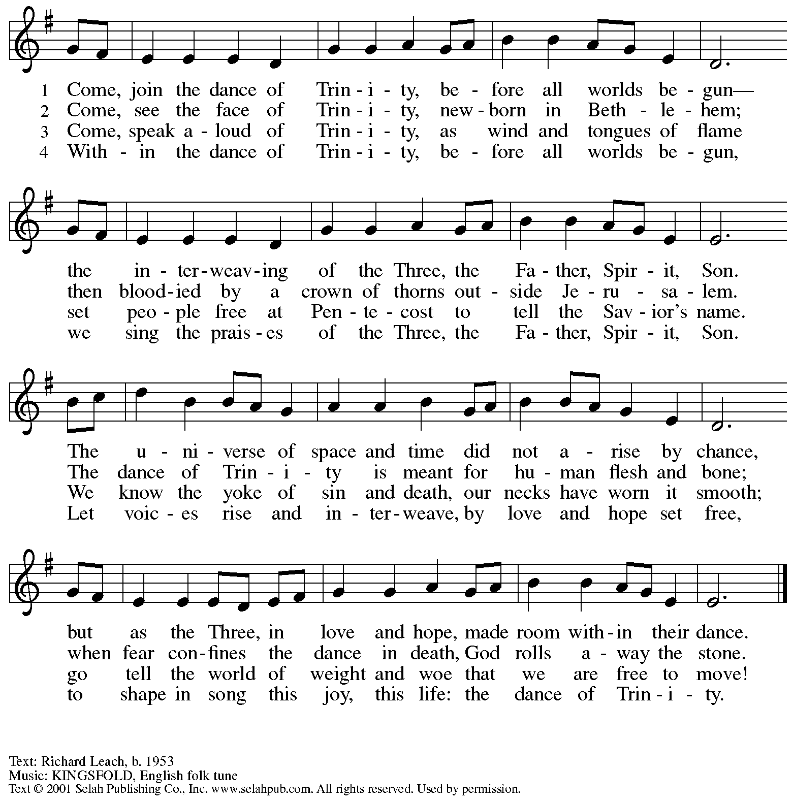
Reprinted with permission under OneLicense.net # A-722139.

Greeting

P: The grace of our Lord Jesus Christ, the love of God,
and the communion of the Holy Spirit be with you all.
C: And also with you.

Hymn of Praise ELW p. 204

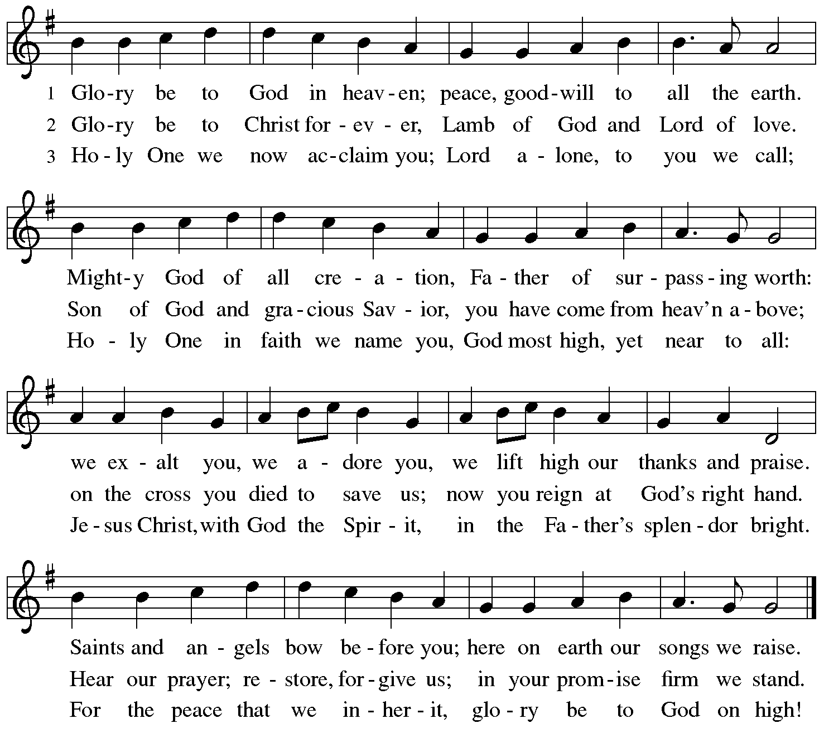

Prayer of the Day

P: The Lord be with you.
C: And also with you.

P: Let us pray.
Almighty Creator and ever-living God:
we worship your glory, eternal Three-in-One, and we praise your power, majestic One-in-Three. Keep us steadfast in this faith, defend us in all adversity, and bring us at last into your presence, where you live in endless joy and love, Father, Son, and Holy Spirit, one God, now and forever.
C: Amen.

Please be seated.

Word
God speaks to us in Scripture reading, preaching, and song

First Reading – Proverbs 8: 1-4, 22-31

¹Does not wisdom call,
and does not understanding raise her voice?
²On the heights, beside the way,
at the crossroads she takes her stand;
³beside the gates in front of the town,
at the entrance of the portals she cries out:
⁴“To you, O people, I call,
and my cry is to all that live.
²²The Lord created me at the beginning of his work,
the first of his acts of long ago.
²³Ages ago I was set up,
at the first, before the beginning of the earth.
²⁴When there were no depths I was brought forth,
when there were no springs abounding with water.
²⁵Before the mountains had been shaped,
before the hills, I was brought forth—
²⁶when he had not yet made earth and fields,
or the world’s first bits of soil.
²⁷When he established the heavens, I was there,
when he drew a circle on the face of the deep,
²⁸when he made firm the skies above,
when he established the fountains of the deep,
²⁹when he assigned to the sea its limit,
so that the waters might not transgress his command,
when he marked out the foundations of the earth,
³⁰then I was beside him, like a master worker;
and I was daily his delight,
rejoicing before him always,
³¹rejoicing in his inhabited world
and delighting in the human race.”

L: Word of God, word of life.
C: Thanks be to God.

Please rise as you are able.

Gospel Acclamation

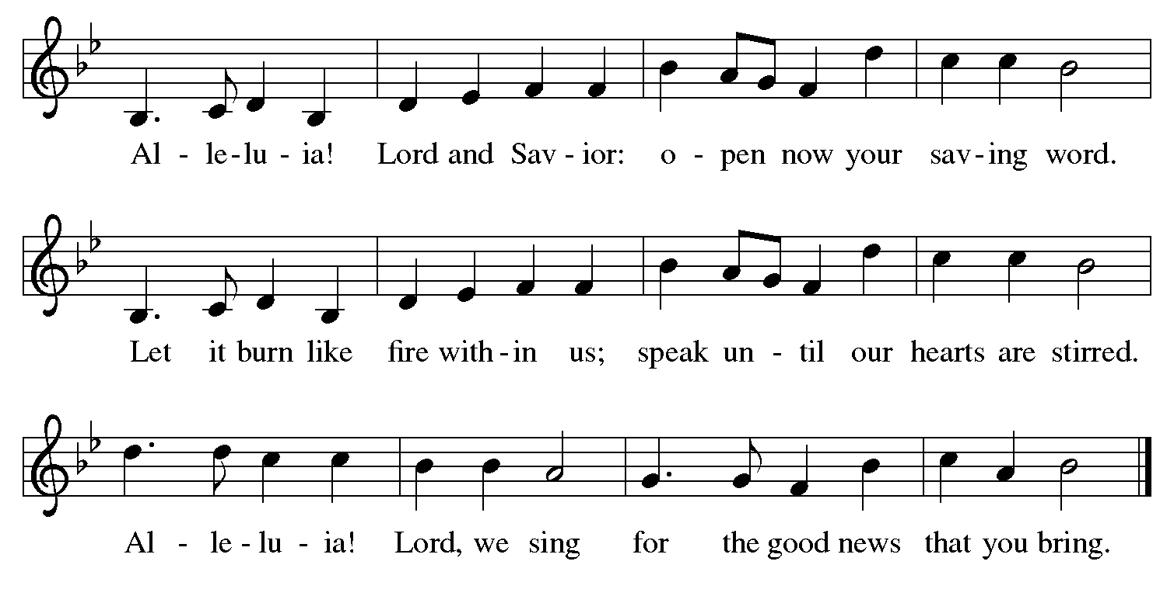

Gospel – John 16: 12-15

P: The holy Gospel according to St. John.
C: Glory to you, O Lord.

[Jesus said,] ¹²“I still have many things to say to you, but you cannot bear them now. ¹³When the Spirit of truth comes, he will guide you into all the truth; for he will not speak on his own, but will speak whatever he hears, and he will declare to you the things that are to come. ¹⁴He will glorify me, because he will take what is mine and declare it to you. ¹⁵All that the Father has is mine. For this reason I said that he will take what is mine and declare it to you.”

P: The Gospel of the Lord.
C: Praise to you, O Christ.

Please be seated.

Sermon

A time of silence for prayer and reflection follows the sermon.

When the hymn of the day begins, please rise as you are able.

Hymn of the Day God of Tempest, God of Whirlwind ELW 400

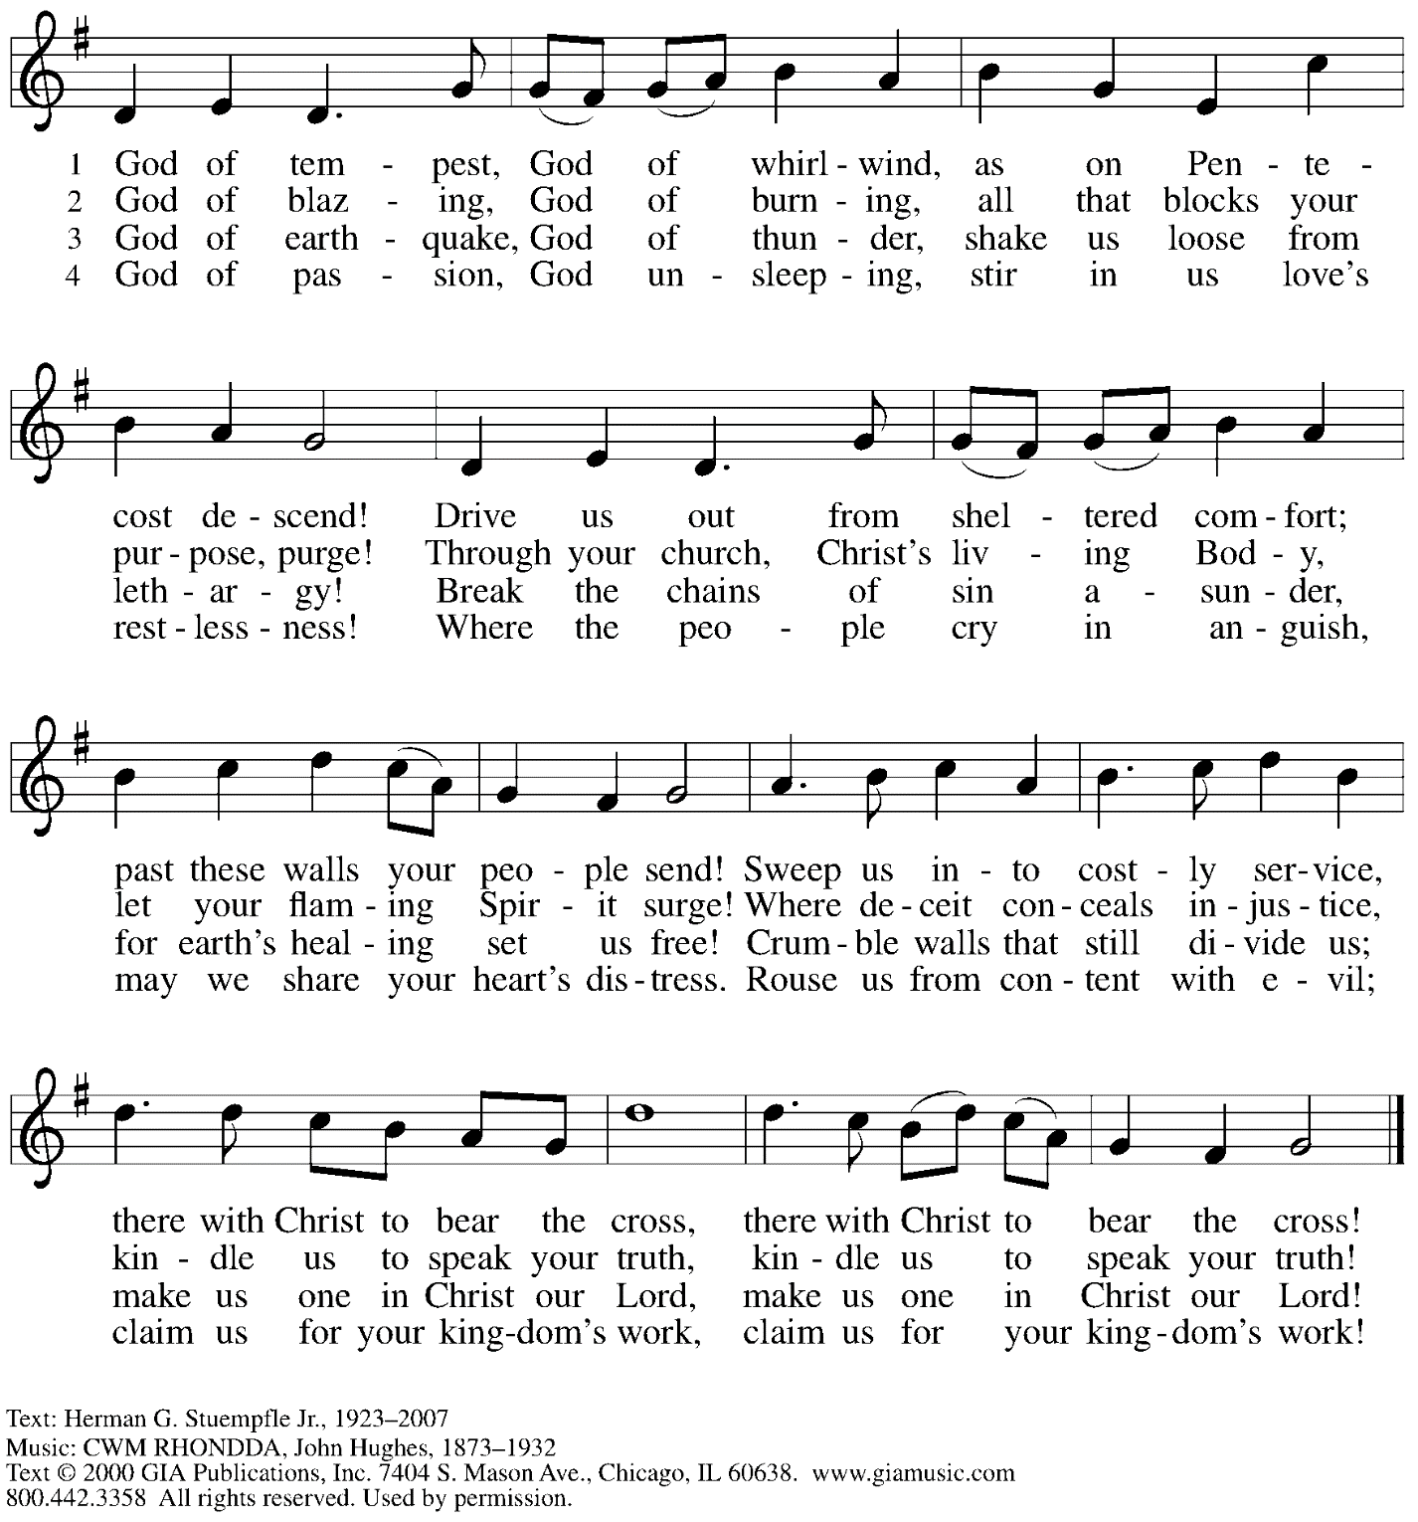
Reprinted with permission under OneLicense.net # A-722139.

Prayers of the People

P: United in Christ and guided by the Spirit,
we pray for the church, the world, and all who are in need.

After each petition
P: God of mercy,
C: receive our prayer.

P: God of every time and place, we offer these prayers and those of our hearts to you,
in Jesus’ name.
C: Amen.

Please be seated.

Meal

Offering

We offer ourselves, our gifts, and our faithful service to God.
An usher will pass around an offering plate for anyone who would like to offer gifts before God.

Music during the Offering

Please rise as you are able.

Offertory Song We Give Thee but Thine Own ELW 686
v. 1-2

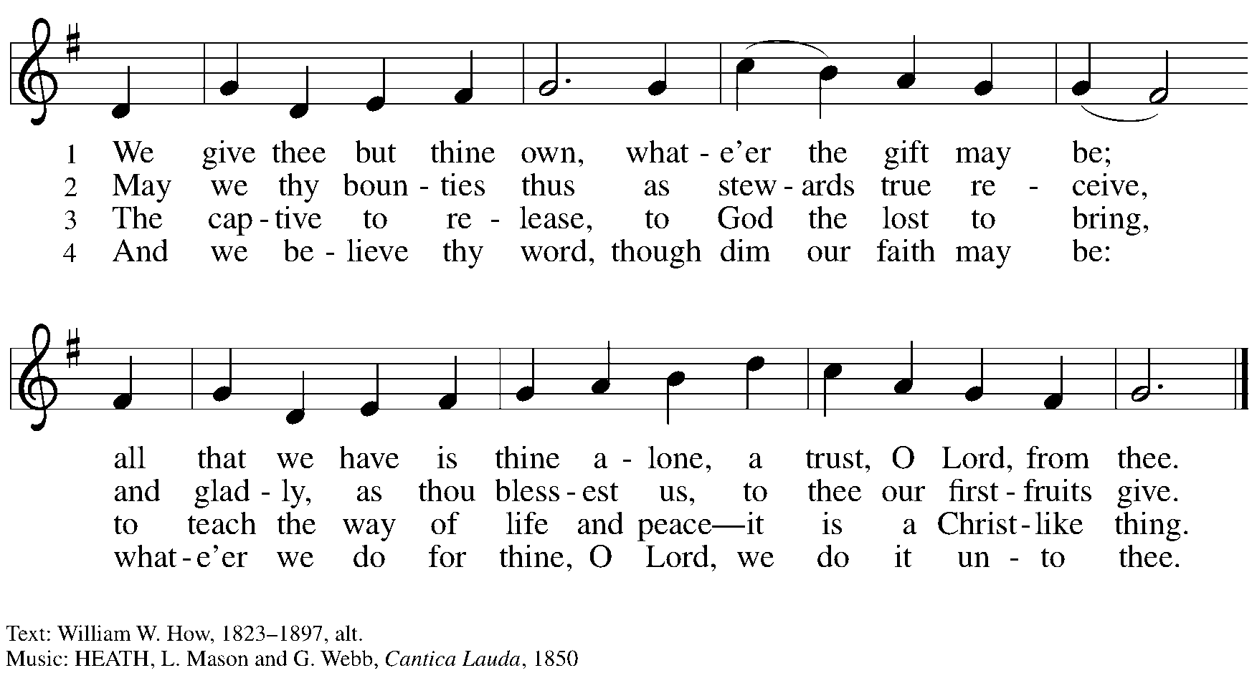

Offertory Prayer

P: Let us pray.
God of all creation,
C: all you have made is good, and your love endures forever.
You bring forth bread from the earth and fruit from the vine.
Nourish us with these gifts, that we might be for the world
signs of your gracious presence in Jesus Christ, our Savior and Lord.
Amen.

Dialogue

P: The Lord be with you.
C: And also with you.

P: Lift up your hearts.
C: We lift them to the Lord.

P: Let us give thanks to the Lord our God.
C: It is right to give our thanks and praise.

Preface

P: It is indeed right, our duty and our joy,
that we should at all times and in all places
give thanks and praise to you, almighty and merciful God.
You reveal your glory
as the glory of the Father, the Son, and the Holy Spirit:
equal in majesty, undivided in splendor, one Lord, one God,
ever to be adored in your eternal glory.
And so, with all the choirs of angels,
with the church on earth and the hosts of heaven,
we praise your name and join their unending hymn:

Sanctus

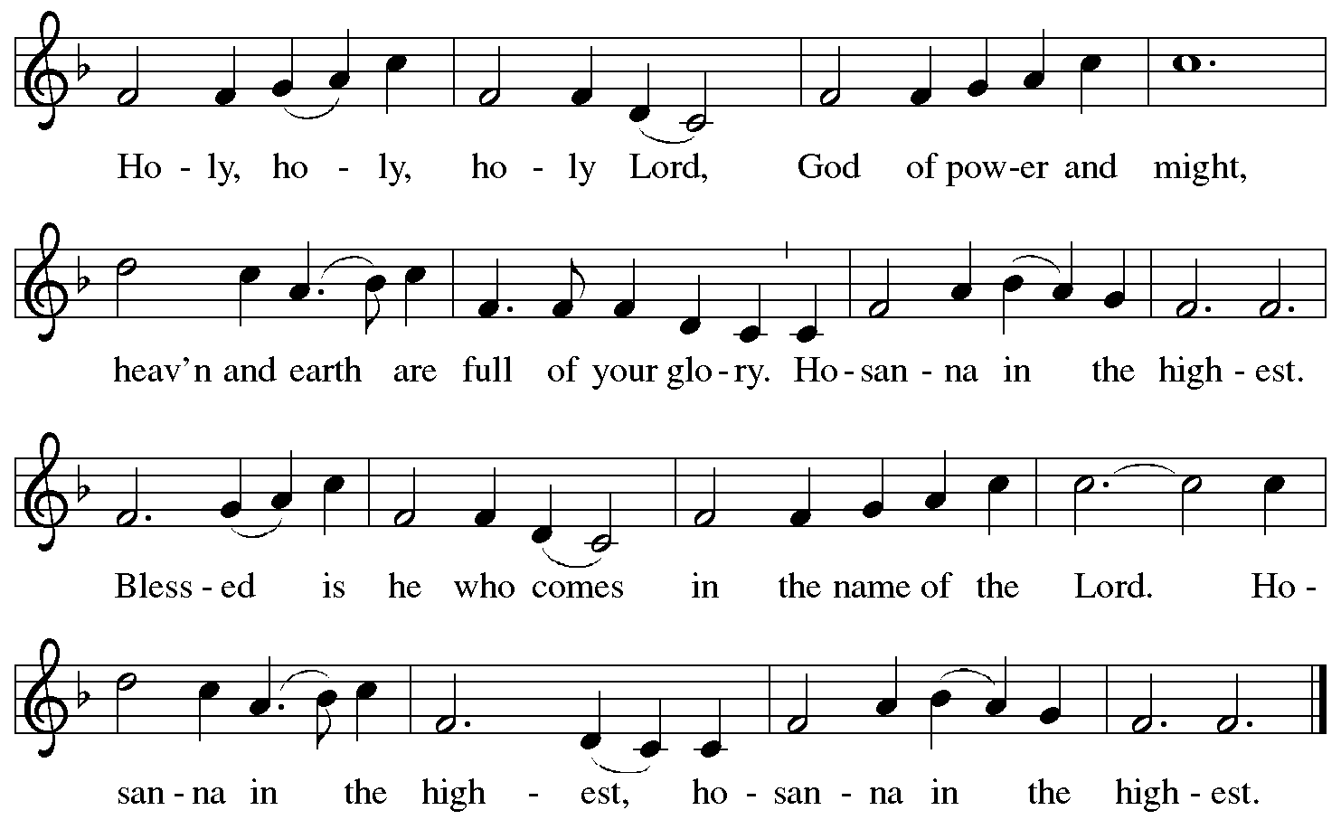

Eucharistic Prayer

P: Holy, mighty, and merciful Lord …
… be all honor and glory, now and forever.
C: Amen.

Lord’s Prayer

P: Gathered as one by the Holy Spirit, let us pray as Jesus taught us.
C: Our Father in heaven,
hallowed be your name,
your kingdom come,
your will be done,
on earth as in heaven.
Give us today our daily bread.
Forgive us our sins
as we forgive those
who sin against us.
Save us from the time of trial
and deliver us from evil.
For the kingdom, the power,
and the glory are yours,
now and forever. Amen.

Fraction and Invitation

Agnus Dei / Lamb of God

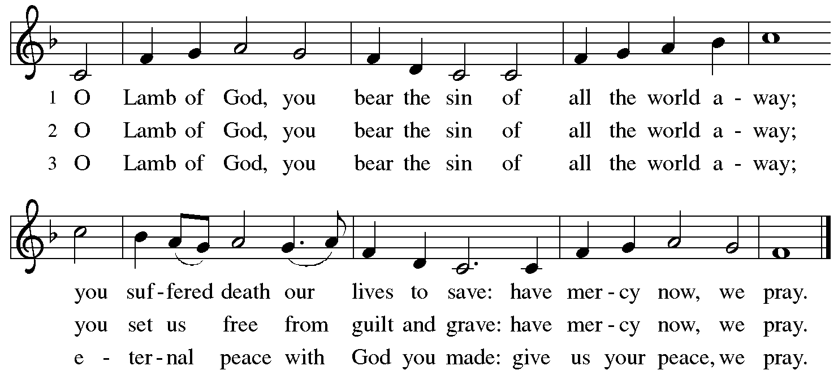

Please be seated.

Holy Communion
- Hand sanitizer is available if you would like to use it prior to receiving Communion.
- Worshipers from the pulpit side will proceed forward first, followed by the center section, and then the lectern side.
- The Communion wafers (regular and gluten-free) have been thoughtfully prepared using the gifts of the congregation by a member of St. Andrew’s altar care team, with a drop of wine or grape juice on each. The presiding minister will distribute one to each communicant.
- When you reach the presiding minister, please indicate if you would like grape juice or a gluten-free wafer.
- A blessing will be provided for anyone who does not yet receive the sacrament.
- Cushions have been placed at the altar rail for anyone who would like to kneel for prayer and reflection before returning to their pew.
- Everyone is asked to wait until you return to your place to consume the elements, and then promptly replace your mask.

Hymns during Holy Communion
Creating God, Your Fingers Trace ELW 684

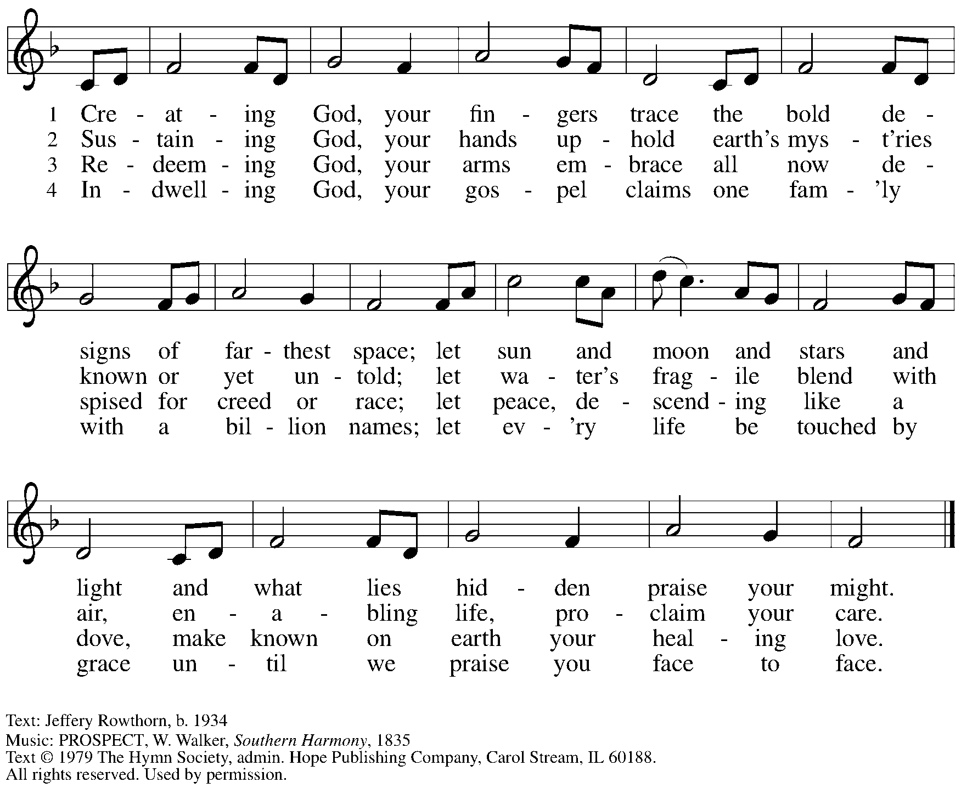
Reprinted with permission under OneLicense.net # A-722139.

Hymns during Holy Communion
Now Thank We All Our God ELW 840

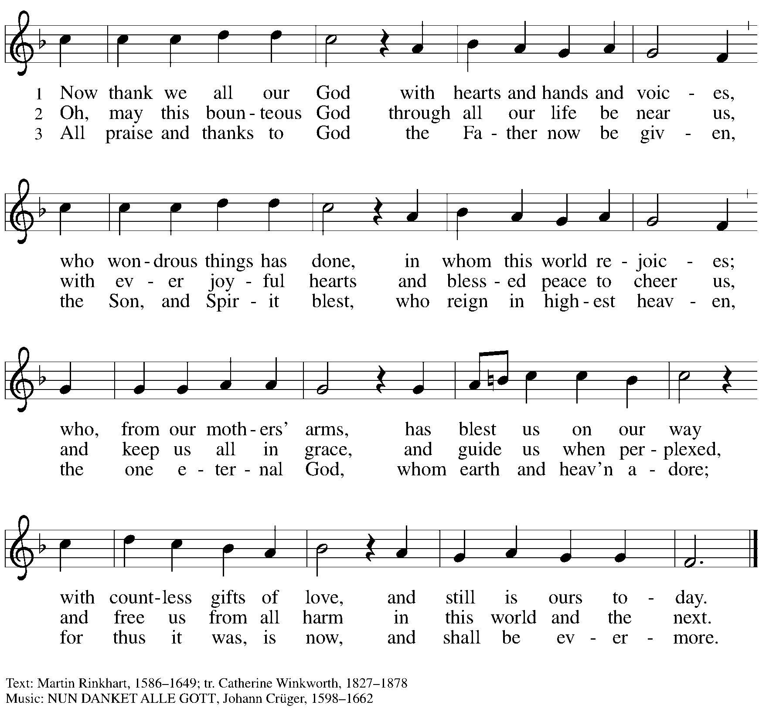

When all have returned to their places, please rise as you are able.

Blessing

P: The body and blood of our Lord Jesus Christ strengthen you and keep you in his grace.
C: Amen.

Prayer

P: Let us pray.
God of abundance, with this bread of life and cup of salvation you have united us with Christ, making us one with all your people. Now send us forth in the power of your Spirit, that we may proclaim your redeeming love to the world and continue forever in the risen life of Jesus Christ, our Lord.
C: Amen.

Sending

Announcements

Blessing of Graduates

Benediction

P: God, the Author of life,
Christ, the living Cornerstone,
and the life-giving Spirit of adoption,
☩ bless you now and forever.
C: Amen.

Sending Hymn Glory to God, Whose Goodness Shines on Me ACS 1087

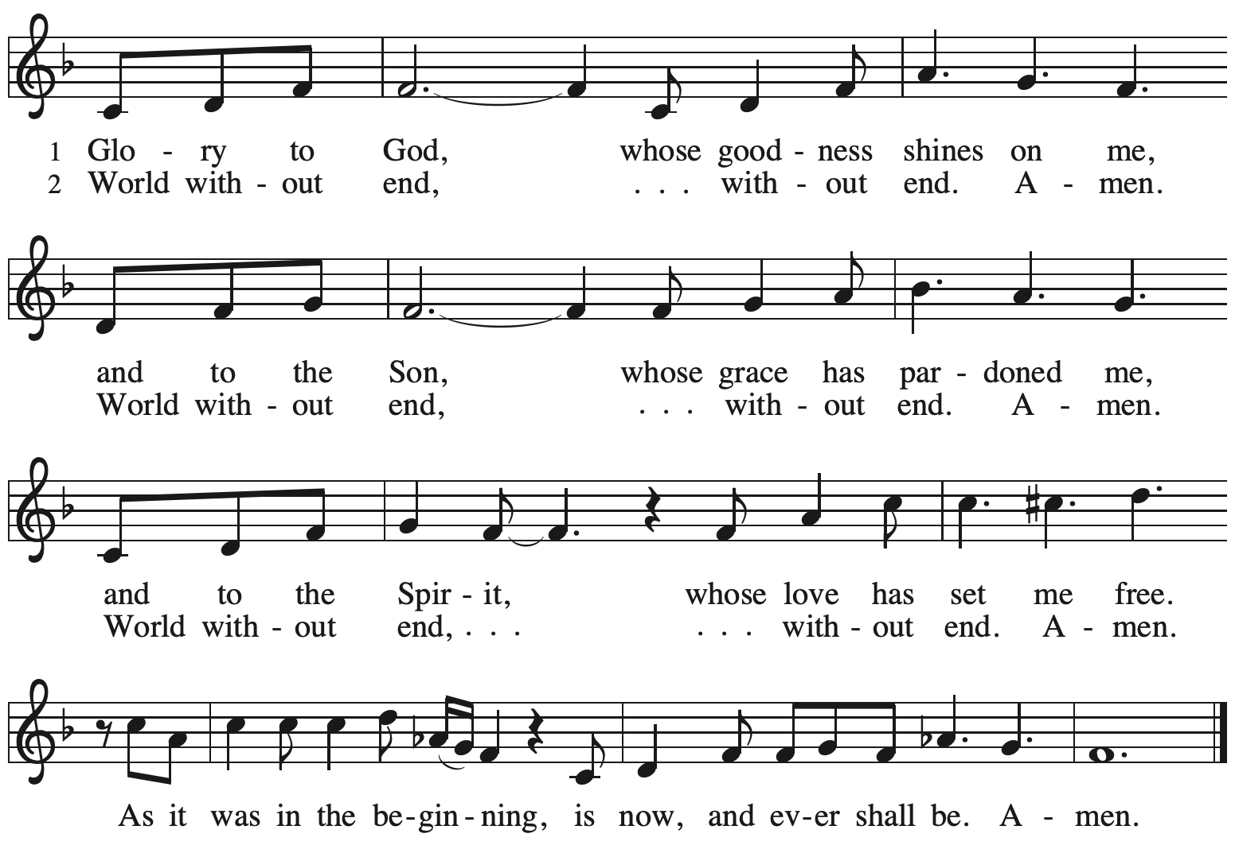
Dismissal

P: Go in peace. Serve the Lord.
C: Thanks be to God!

Abbreviations

P: Pastor/Presiding Minister
L: Lector
C: Congregation

ELW: Evangelical Lutheran Worship hymnal
ACS: All Creation Sings hymnal

Those serving in worship today

Piano Sue Gaugler
Cantor Ian Brown
Lector Kelly Spanninger
Director of Faith Formation Christopher Atwood
Presiding Minister Rev. Ross Carmichael

Liturgy and Hymnody Acknowledgements

From SundaysandSeasons.com. Copyright © 2022 Augsburg Fortress. All rights reserved. Reprinted under OneLicense.net # A-722139.
Used by permission of Augsburg Fortress.

Let the Vineyards – Text: John W. Arthur, 1922-1980. Music: Ronald A. Nelson, b. 1927. Text and Music © 1978 Lutheran Book of Worship, admin. Augsburg Fortress.

Glory to God, Whose Goodness Shines on Me – Text: Paul M. Vasile, b. 1976, based on the Gloria Patri. Muisc: GLORY TO GOD (Vasile), Paul M. Vasile. Text and music © Paul M. Vasile, admin. Augsburg Fortress. All rights reserved. Reprinted under OneLicense.net # A-722139.

