+ Day of Pentecost
June 5, 2022
St. Andrew Lutheran Church
304 Morewood Ave.
Pittsburgh, PA 15213
St_andrewELCA@verizon.net
www.standrewpittsburgh.org

+ Day of Pentecost
Order for Worship

On Pentecost, we celebrate with the whole Church that God has given us an Advocate
to accompany us. Poured out in wind and fire, water, wine, and bread, the Holy Spirit abides
in and among us. We give thanks that God speaks to each of us, no matter our origins, language, or life path. Filled with the Spirit of truth, we go out from worship to proclaim the saving power of Christ’s love and the freedom of God’s grace with all the world.

A few notes on precautions and protocols, which apply to everyone regardless of vaccination status, as St. Andrew returns to worship in the sanctuary:

- Face masks that fully cover both your mouth and nose are required for parishioners over the age of two (2) – St. Andrew’s next step in restoring worship will be having the worship leaders remove masks during their parts that are conducted at a distance from the pews.
- Physical distancing of at least six (6) feet will be observed at all times for people not from your household.
- We invite the congregation to join in the singing of the hymns (with masks on) during worship!
- Hand sanitizer is available at the front of the sanctuary to use before Holy Communion, after you proceed past the baptismal font, as the alcohol has been affecting the finish on the font’s bowl.

Worship Services are live streamed to multiple online platforms.
By attending worship, you agree that your image and voice may be broadcast.

Welcome

Prelude

Gathering
The Holy Spirit calls us together as the people of God.

Thanksgiving for Baptism

P: Alleluia! Christ is risen!
C: Christ is risen indeed! Alleluia!

P: In the waters of baptism,
we have passed over from death to life with Jesus Christ,
and we are a new creation.
For this saving mystery, and for this water, let us bless God,
who was, who is, and who is to come.

Water may be poured into the font as the presiding minister gives thanks.

P: We thank you, God, for your river of life,
flowing freely from your throne:
throughout the earth, through the city, to every living thing.
You rescued Noah and his family from the flood;
You opened wide the sea for the Israelites.
Now in these waters you flood us with mercy,
and our sin is drowned forever.
You open the gate of righteousness
and we pass safely through.
In Jesus Christ, you calm and trouble the waters.
You nourish us and enclose us in safety.
You call us forth and send us out.
In lush and barren places, you are with us.
You have become our salvation.
Now breathe upon this water
and awaken your church once more.
Claim us again as your beloved and holy people.
Quench our thirst; cleanse our hearts; wipe away every tear.
To you, our Beginning and our End,
our Shepherd and Lamb,
be honor, glory, praise, and thanksgiving,
now and forever.
C: Amen.

Gathering Hymn Gracious Spirit, Heed our Pleading ELW 401
v. 1-3

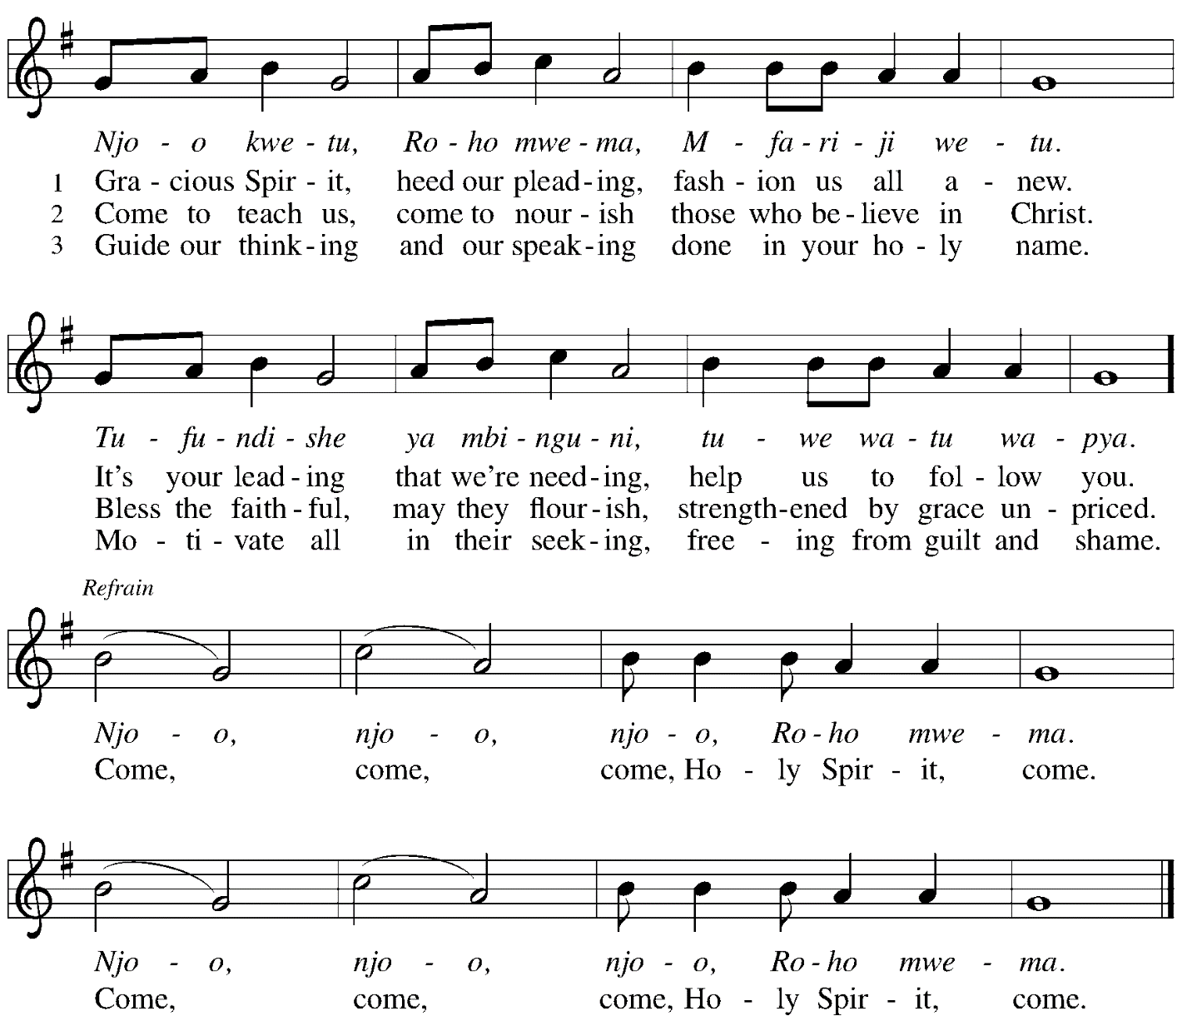

All rights reserved. Reprinted with permission under OneLicense.net # A-722139.

Greeting

P: The grace of our Lord Jesus Christ, the love of God,
and the communion of the Holy Spirit be with you all.
C: And also with you.

Hymn of Praise This Is the Feast ELW p. 149-150

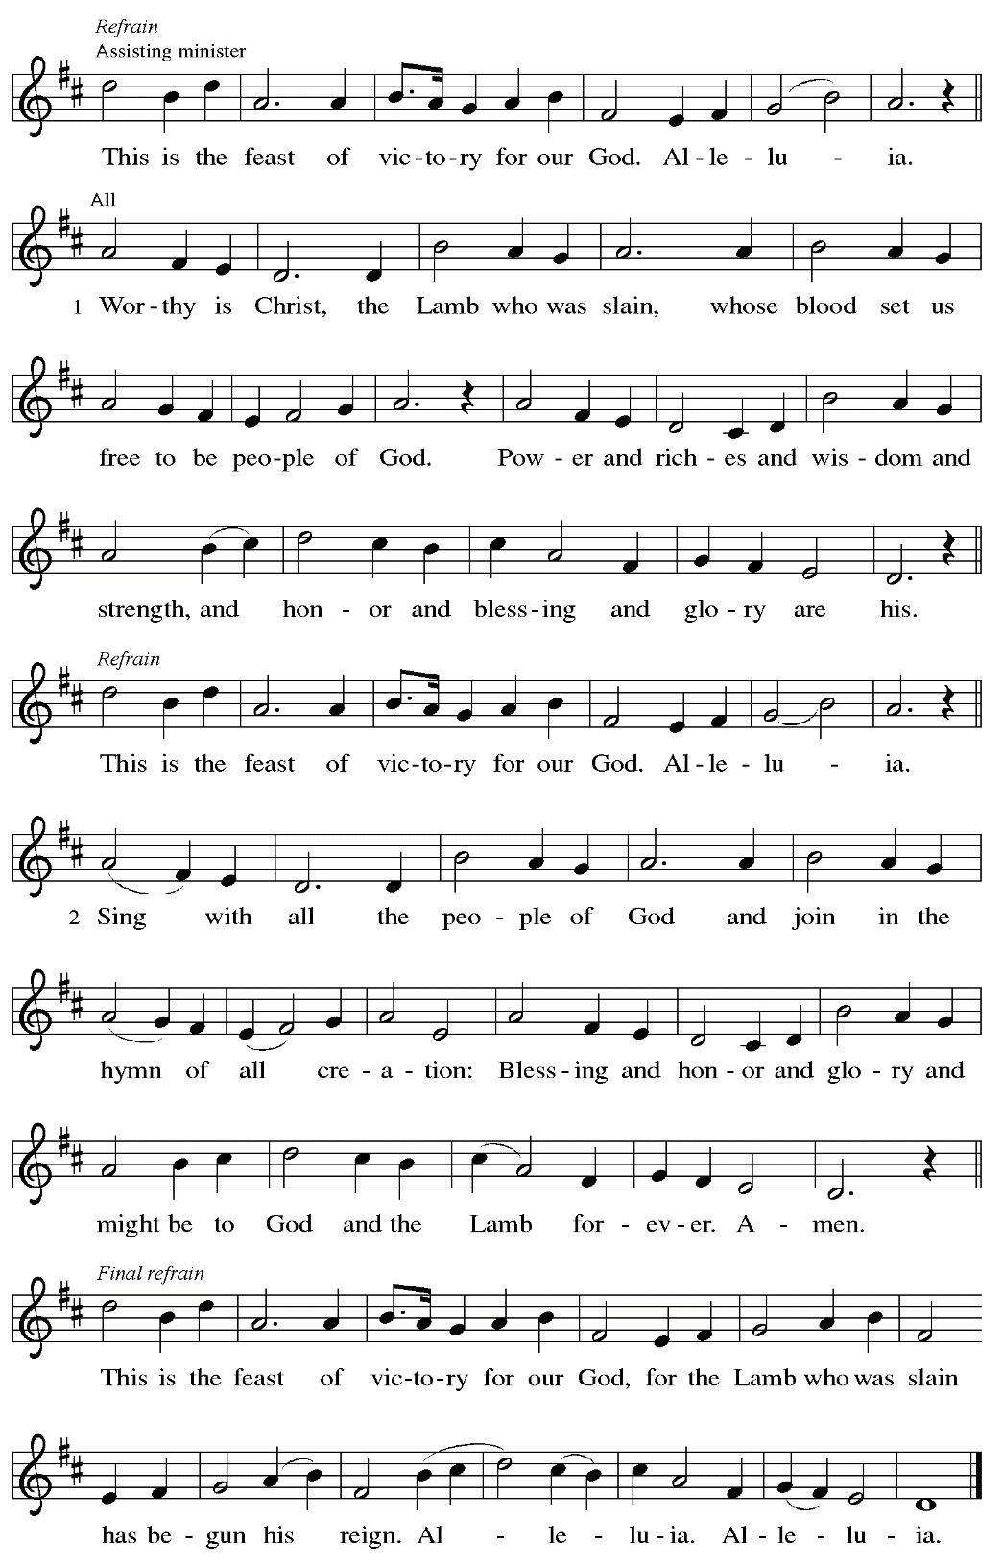

Prayer of the Day

P: The Lord be with you.
C: And also with you.

P: Let us pray.
God our creator, the resurrection of your Son offers life to all the peoples of earth.
By your Holy Spirit, kindle in us the fire of your love,
empowering our lives for service and our tongues for praise,
through Jesus Christ, our Savior and Lord,
who lives and reigns with you and the Holy Spirit,
one God, now and forever.
C: Amen.

Please be seated.

Word
God speaks to us in Scripture reading, preaching, and song

First Reading – Acts 2: 1-21

¹When the day of Pentecost had come, [the apostles] were all together in one place. ²And suddenly from heaven there came a sound like the rush of a violent wind, and it filled the entire house where they were sitting. ³Divided tongues, as of fire, appeared among them, and a tongue rested on each of them. ⁴All of them were filled with the Holy Spirit and began to speak in other languages, as the Spirit gave them ability.
⁵Now there were devout Jews from every nation under heaven living in Jerusalem. ⁶And at this sound the crowd gathered and was bewildered, because each one heard them speaking in the native language of each. ⁷Amazed and astonished, they asked, “Are not all these who are speaking Galileans? ⁸And how is it that we hear, each of us, in our own native language?
⁹Parthians, Medes, Elamites, and residents of Mesopotamia, Judea and Cappadocia, Pontus and Asia, ¹⁰Phrygia and Pamphylia, Egypt and the parts of Libya belonging to Cyrene, and visitors from Rome, both Jews and proselytes, ¹¹Cretans and Arabs—in our own languages we hear them speaking about God’s deeds of power.” ¹²All were amazed and perplexed, saying to one another, “What does this mean?” ¹³But others sneered and said, “They are filled with new wine.”
¹⁴But Peter, standing with the eleven, raised his voice and addressed them, “Men of Judea and all who live in Jerusalem, let this be known to you, and listen to what I say. ¹⁵Indeed, these are not drunk, as you suppose, for it is only nine o’clock in the morning. ¹⁶No, this is what was spoken through the prophet Joel:
¹⁷‘In the last days it will be, God declares,
that I will pour out my Spirit upon all flesh,
and your sons and your daughters shall prophesy,
and your young men shall see visions,
and your old men shall dream dreams.
¹⁸Even upon my slaves, both men and women,
in those days I will pour out my Spirit;
and they shall prophesy.
¹⁹And I will show portents in the heaven above
and signs on the earth below,
blood, and fire, and smoky mist.
²⁰The sun shall be turned to darkness
and the moon to blood,
before the coming of the Lord’s great and glorious day.
²¹Then everyone who calls on the name of the Lord shall be saved.’ ”

L: Word of God, word of life.
C: Thanks be to God.

Psalm 104: 24-34, 35b

The psalm will be sung responsively, led by the cantor.

Tone

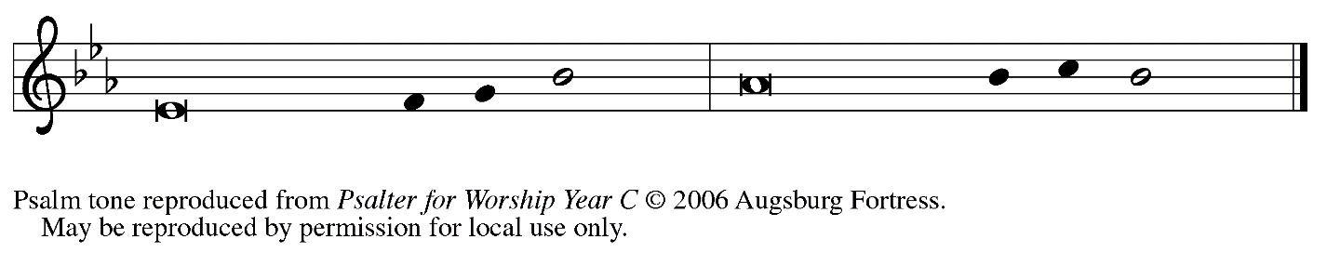

Refrain

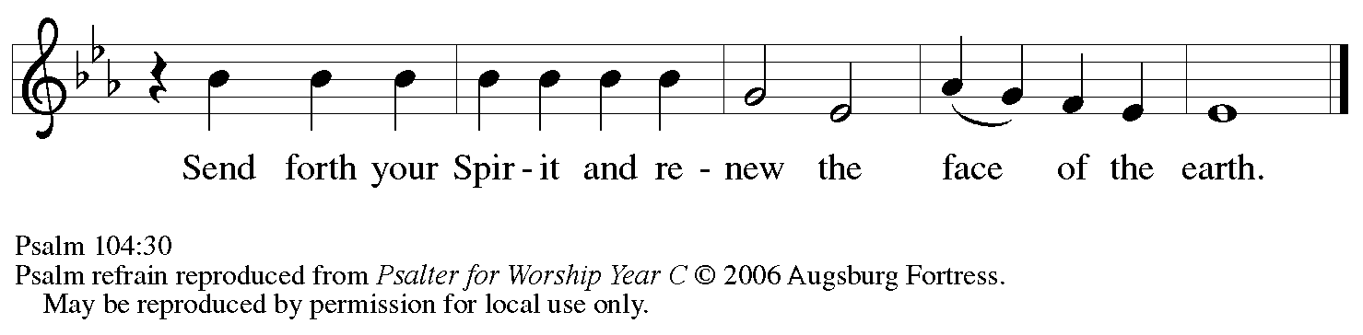

²⁴How manifold are your | works, O Lord!
In wisdom you have made them all; the earth is full | of your creatures.
²⁵Yonder is the sea, great and wide, with its swarms too man- | y to number,
living things both | small and great.
²⁶There go the ships | to and fro,
and Leviathan, which you made for the | sport of it.
²⁷All of them | look to you
to give them their food | in due season. R

Refrain

²⁸You give it to them; they | gather it;
you open your hand, and they are filled | with good things.
²⁹When you hide your face, | they are terrified;
when you take away their breath, they die and return | to their dust.
³⁰You send forth your Spirit, and they | are created;
and so you renew the face | of the earth.
³¹May the glory of the Lord en- | dure forever;
O Lord, rejoice in | all your works. R
³²You look at the earth | and it trembles;
you touch the mountains | and they smoke.
³³I will sing to the Lord as long | as I live;
I will praise my God while I | have my being.
³⁴May these words of | mine please God.
I will rejoice | in the Lord.
^{35b}Bless the Lord, | O my soul.
Hal- | lelujah! R

Second Reading – Romans 8: 14-17

¹⁴For all who are led by the Spirit of God are children of God. ¹⁵For you did not receive a spirit of slavery to fall back into fear, but you have received a spirit of adoption. When we cry, “Abba! Father!” ¹⁶it is that very Spirit bearing witness with our spirit that we are children of God, ¹⁷and if children, then heirs, heirs of God and joint heirs with Christ—if, in fact, we suffer with him so that we may also be glorified with him.

L: Word of God, word of life.
C: Thanks be to God.

Please rise as you are able.

Gospel Acclamation

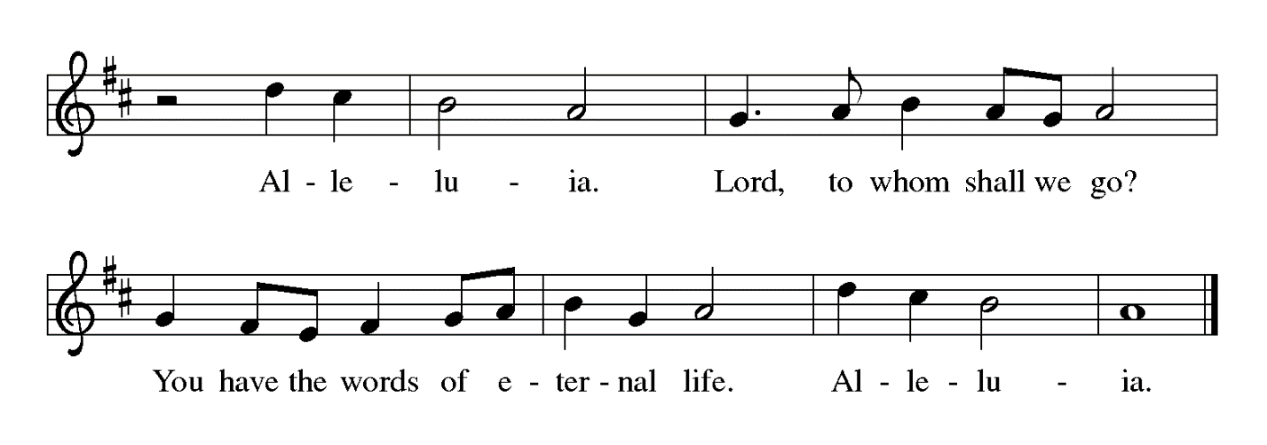

Gospel – John 14: 8-17 [25-27]

P: The holy Gospel according to St. John.
C: Glory to you, O Lord.

⁸Philip said to [Jesus,] “Lord, show us the Father, and we will be satisfied.” ⁹Jesus said to him, “Have I been with you all this time, Philip, and you still do not know me? Whoever has seen me has seen the Father. How can you say, ‘Show us the Father’? ¹⁰Do you not believe that I am in the Father and the Father is in me? The words that I say to you I do not speak on my own; but the Father who dwells in me does his works. ¹¹Believe me that I am in the Father and the Father is in me; but if you do not, then believe me because of the works themselves. ¹²Very truly, I tell you, the one who believes in me will also do the works that I do and, in fact, will do greater works than these, because I am going to the Father. ¹³I will do whatever you ask in my name, so that the Father may be glorified in the Son. ¹⁴If in my name you ask me for anything, I will do it.
¹⁵“If you love me, you will keep my commandments. ¹⁶And I will ask the Father, and he will give you another Advocate, to be with you forever. ¹⁷This is the Spirit of truth, whom the world cannot receive, because it neither sees him nor knows him. You know him, because he abides with you, and he will be in you.
[ ²⁵“I have said these things to you while I am still with you. ²⁶But the Advocate, the Holy Spirit, whom the Father will send in my name, will teach you everything, and remind you of all that I have said to you. ²⁷Peace I leave with you; my peace I give to you. I do not give to you as the world gives. Do not let your hearts be troubled, and do not let them be afraid.”]

P: The Gospel of the Lord.
C: Praise to you, O Christ.

Please be seated.

Sermon

A time of silence for prayer and reflection follows the sermon.
When the hymn of the day begins, please rise as you are able.

Hymn of the Day God of Tempest, God of Whirlwind ELW 400

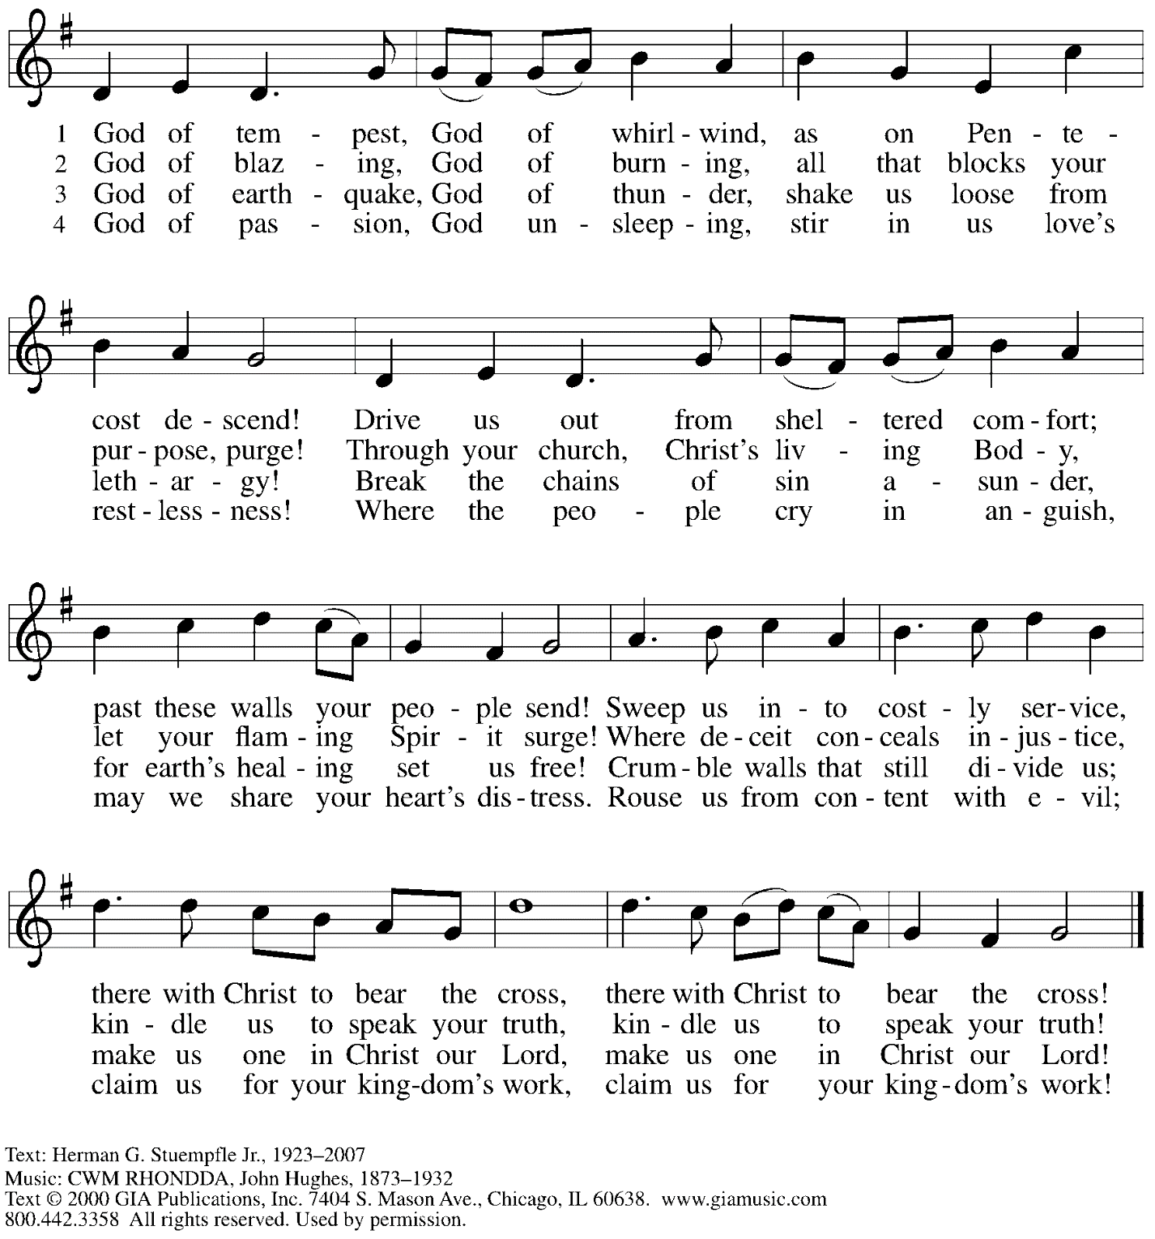
Reprinted with permission under OneLicense.net # A-722139.

Prayers of the People

P: Set free from captivity to sin and death, we pray to the God of resurrection for the church,
the world, and all who are in need.

After each petition
P: Gracious God,
C: receive our prayer.

P: In your mercy, O God, receive our prayers and renew us by your life-giving Spirit,
through Jesus Christ, our Savior.
C: Amen.

Please be seated.

Meal

Offering

We offer ourselves, our gifts, and our faithful service to God.
An usher will pass around an offering plate for anyone who would like to offer gifts before God.

Music during the Offering

Please rise as you are able.

Offertory Song Let the Vineyards ELW 184

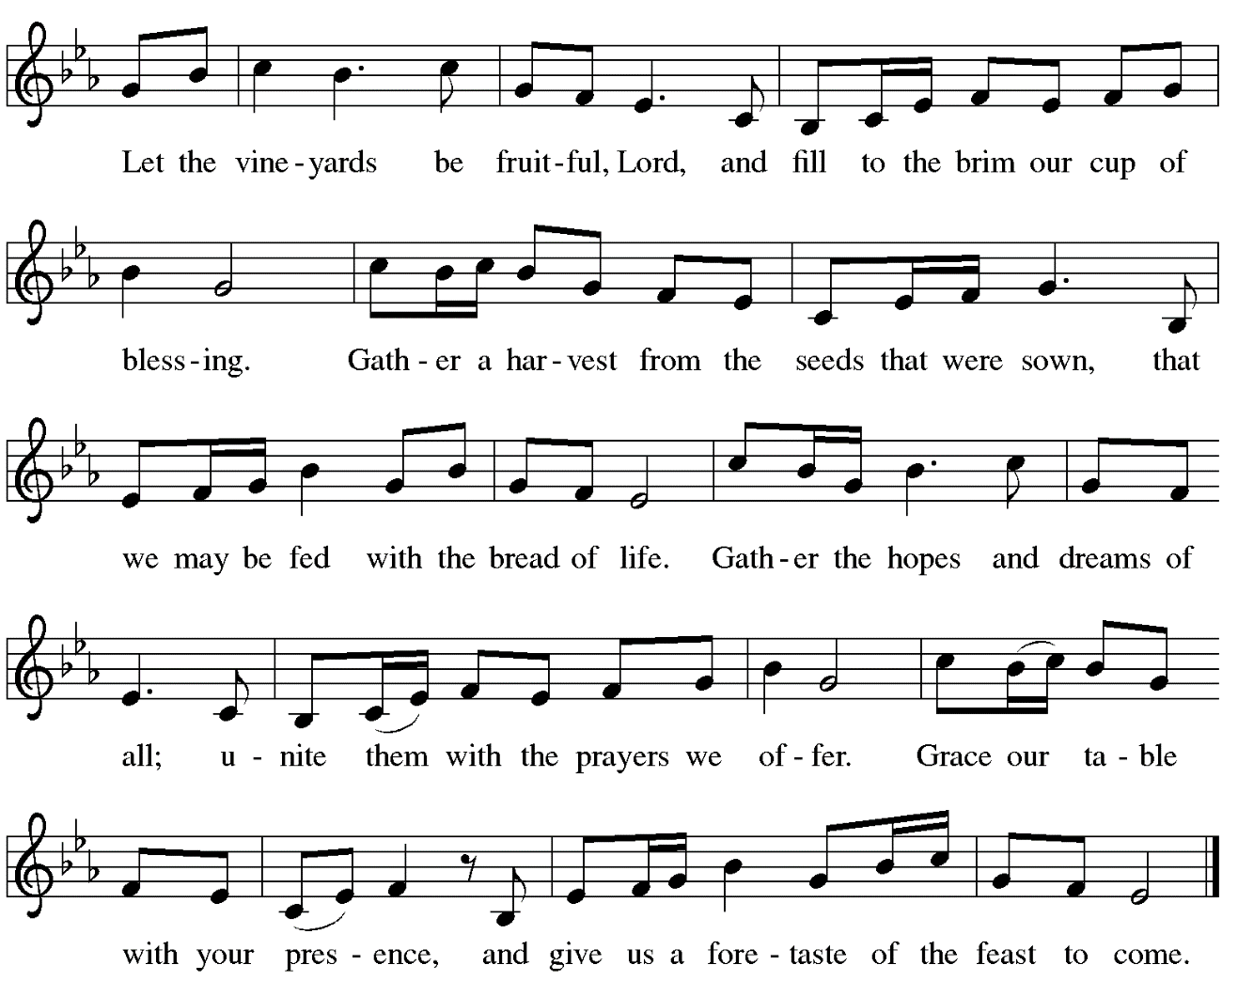

Offertory Prayer

P: Let us pray.
Blessed are you, O God,
C: ruler of heaven and earth.
Day by day you shower us with blessings.
As you have raised us to new life in Christ,
give us glad and generous hearts,
ready to praise you and to respond to those in need,
through Jesus Christ, our Savior and Lord.
Amen.

Dialogue

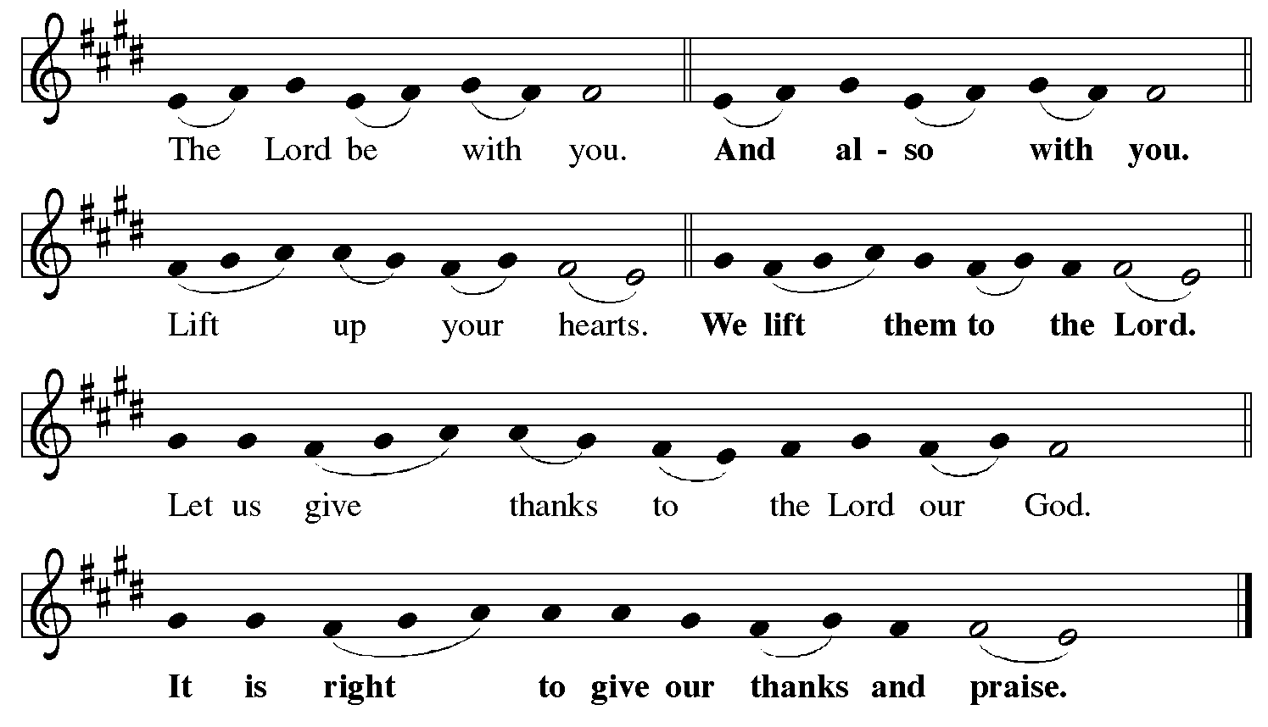

Preface (Sung by the presiding minister)

P: It is indeed right, our duty and our joy,
that we should at all times and in all places
give thanks and praise to you, almighty and merciful God,
through our Savior Jesus Christ.
Fulfilling the promise of the resurrection,
you pour out the fire of your Spirit,
uniting in one body people of every nation and tongue.
And so, with Mary Magdalene and Peter and all the witnesses of the resurrection,
with earth and sea and all their creatures,
and with angels and archangels, cherubim and seraphim,
we praise your name and join their unending hymn:

Sanctus

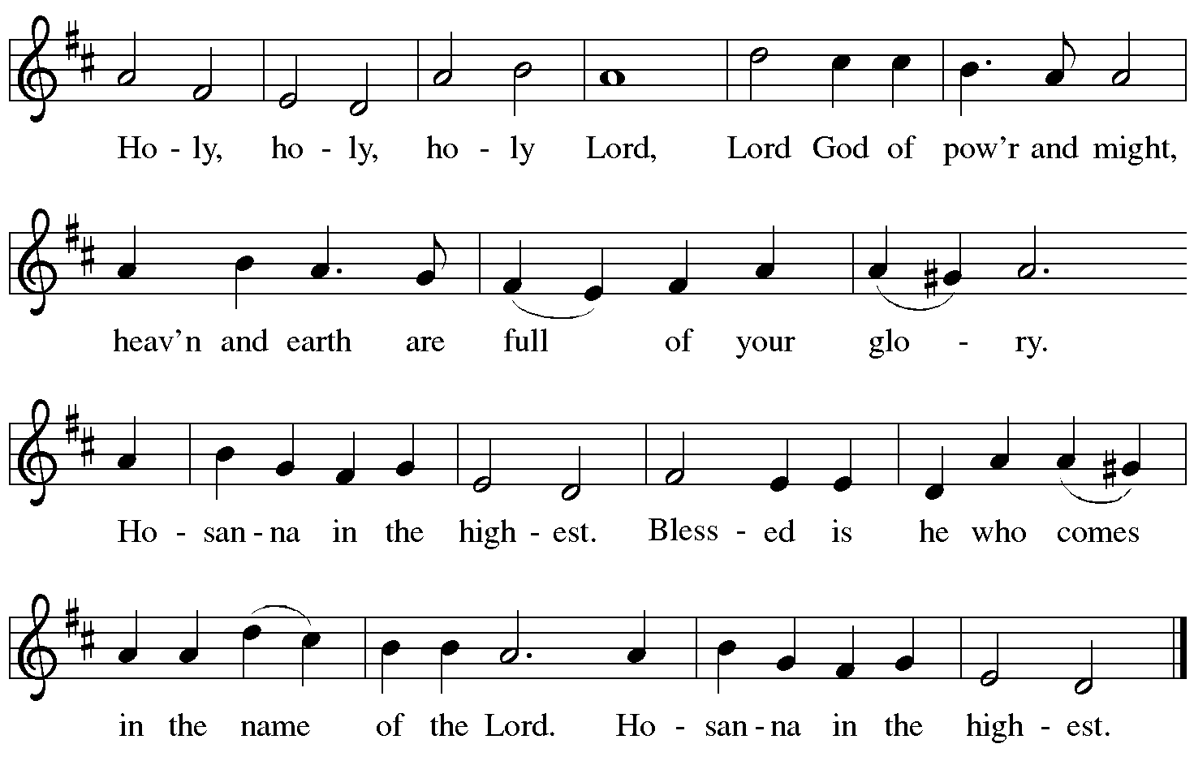

Eucharistic Prayer

P: Blessed are you, O God of the universe …
… Do this for the remembrance of me.

With this bread and cup we remember our Lord’s Passover from death to life
as we proclaim the mystery of faith.
C: Christ has died. Christ is risen. Christ will come again.

P: O God of resurrection and new life …
… Grace our table with your presence.
C: Come, Holy Spirit.

P: Reveal yourself to us in the breaking of the bread …
… burning with justice, peace, and love.
C: Come, Holy Spirit.

P: With your holy ones of all times and places …
… blessed and Holy Trinity, now and forever.
C: Amen.

Lord’s Prayer

P: Gathered as one by the Holy Spirit, let us pray as Jesus taught us.
C: Our Father in heaven,
hallowed be your name,
your kingdom come,
your will be done,
on earth as in heaven.
Give us today our daily bread.
Forgive us our sins
as we forgive those
who sin against us.
Save us from the time of trial
and deliver us from evil.
For the kingdom, the power,
and the glory are yours,
now and forever. Amen.

Fraction and Invitation

Agnus Dei / Lamb of God

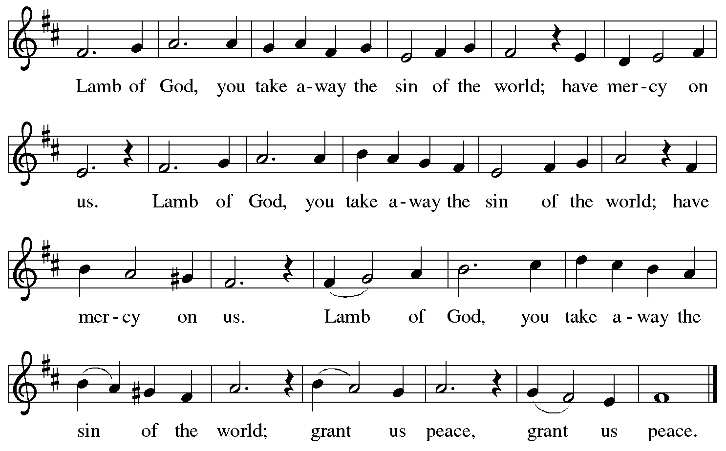

Please be seated.

Holy Communion
- Hand sanitizer is available if you would like to use it prior to receiving Communion.
- Worshipers from the pulpit side will proceed forward first, followed by the center section, and then the lectern side.
- The Communion wafers (regular and gluten-free) have been thoughtfully prepared using the gifts of the congregation by a member of St. Andrew’s altar care team, with a drop of wine or grape juice on each. The presiding minister will distribute one to each communicant.
- When you reach the presiding minister, please indicate if you would like grape juice or a gluten-free wafer.
- A blessing will be provided for anyone who does not yet receive the sacrament.
- A cushion has been placed at the altar rail for anyone who would like to kneel for prayer and reflection before returning to their pew.
- Everyone is asked to wait until you return to your place to consume the elements, and then promptly replace your mask.

Hymns during Holy Communion
Draw Us in the Spirit’s Tether ELW 470

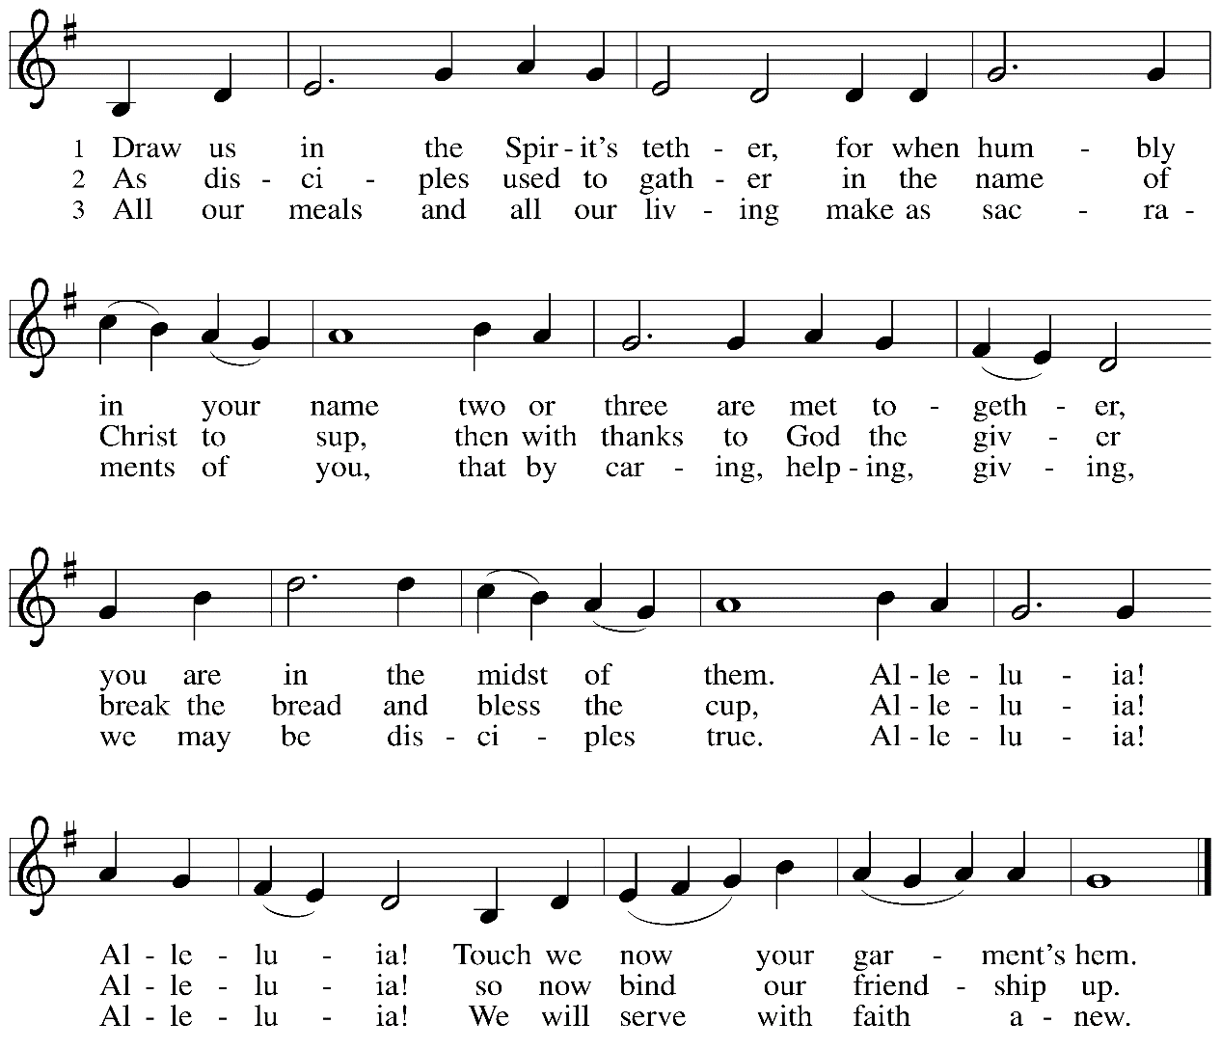
Hymns during Holy Communion
Holy Spirit, Truth Divine ELW 398

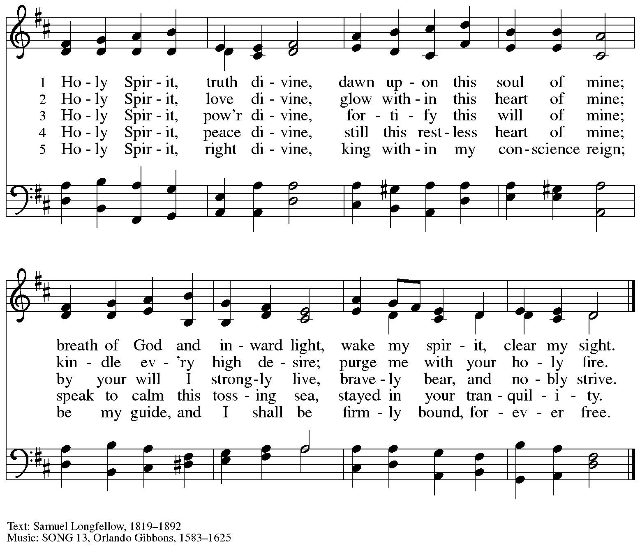

When all have returned to their places, please rise as you are able.

Blessing

P: The body and blood of our Lord Jesus Christ strengthen you and keep you in his grace.
C: Amen.

Prayer

P: Let us pray. Life-giving God,
in the mystery of Christ’s resurrection you send light to conquer darkness,
water to give new life, and the bread of life to nourish your people.
Send us forth as witnesses to your Son’s resurrection,
that we may show your glory to all the world, through Jesus Christ, our risen Lord.
C: Amen.

Sending

Announcements

Benediction

P: God, the Author of life,
Christ, the living Cornerstone,
and the life-giving Spirit of adoption,
☩ bless you now and forever.
C: Amen.

Sending Hymn O Day Full of Grace Following page

Sending Hymn O Day Full of Grace ELW 627
v. 1-4

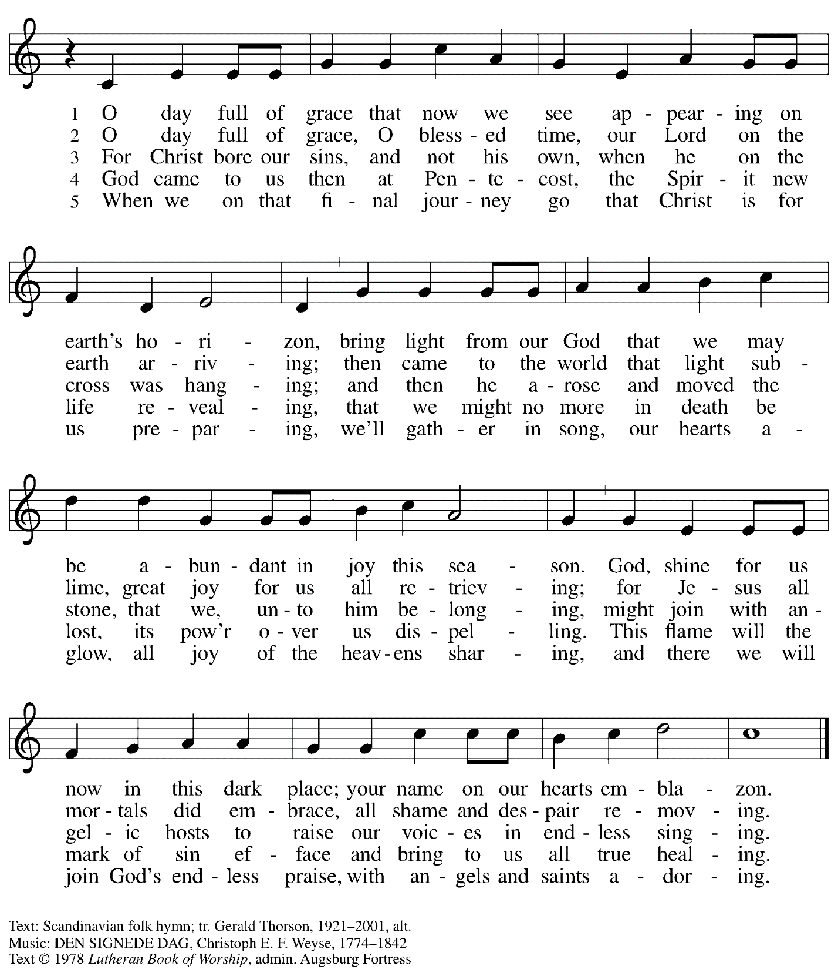
All rights reserved. Reprinted under OneLicense.net # A-722139.

Dismissal

P: Go in peace. Share the good news!
C: Thanks be to God.

Abbreviations

P: Pastor/Presiding Minister
L: Lector
C: Congregation

ELW: Evangelical Lutheran Worship hymnal
ACS: All Creation Sings hymnal

Those serving in worship today

Preaching and Presiding Minister The Rev. Peter Asplin
Organ Jimmi Kocher-Hillmer
Cantor Timothy Kocher-Hillmer
Lector Sue Gaugler
Director of Faith Formation Christopher Atwood

Liturgy and Hymnody Acknowledgements

From SundaysandSeasons.com. Copyright © 2022 Augsburg Fortress. All rights reserved. Reprinted under OneLicense.net # A-722139.
Used by permission of Augsburg Fortress.

Let the Vineyards – Text: John W. Arthur, 1922-1980. Music: Ronald A. Nelson, b. 1927. Text and Music © 1978 Lutheran Book of Worship, admin. Augsburg Fortress.

Draw Us in the Spirit’s Tether – Text: Percy Dearmer, 1867-1936, alt. Music: UNION SEMINARY, Harold Friedell, 1905-1958. Text © Oxford University Press, 1931. Used by permission. Music © 1957, 1985 H.W. Gray, admin. CPP/Belwin. All rights reserved. Reprinted under OneLicense.net #A-722139.

