+ Second Sunday after Pentecost
June 19, 2022
St. Andrew Lutheran Church
304 Morewood Ave.
Pittsburgh, PA 15213
St_andrewELCA@verizon.net
www.standrewpittsburgh.org

+ Second Sunday after Pentecost
Order for Worship

In this week’s Gospel, Jesus confronts the powers of evil that harm, oppress, and cause suffering for God’s people. Jesus casts out demons from a man, bringing him healing and restoring him to community. We continue to see the devastating effects of such powers on individuals and our communities today. This week, the church commemorates the nine martyrs of Mother Emanuel Church in Charleston, SC, whose lives were taken on June 17th, 2015. We renounce the evils of racism, white supremacy, and violence that plague our society, and we turn to God, who in Christ brings us the hope of healing and peace, and leads us in the way of life.

A few notes on safety precautions and protocols, which apply to everyone regardless of vaccination status.

- Face masks that fully cover both your mouth and nose are required for parishioners over the age of two (2) – Worship leaders will remove masks during their parts that are conducted at a distance from the pews.
- Physical distancing of at least six (6) feet will be observed at all times for people not from your household.
- We invite the congregation to join in the singing of the hymns (with masks on) during worship!
- Hand sanitizer is available at the front of the sanctuary to use before Holy Communion, after you proceed past the baptismal font, as the alcohol has been affecting the finish on the font’s bowl.

Worship Services are live streamed to multiple online platforms.
By attending worship, you agree that your image and voice may be broadcast.

Welcome to St. Andrew!
- A restroom is available on the main level of the church, through the doors to the Social Hall and to the right in the main office.
- After the Prayer of the Day, children are invited to gather in the Social Hall for Little Church; Big Faith, a Bible lesson and activity. The group returns to the worship space for the Communion portion of the service.

Welcome

Prelude

Please rise as you are able.

Gathering
The Holy Spirit calls us together as the people of God.

Confessional Litany and Lament Commemorating the Emanuel Nine

P: We remember with lament the evening of Wednesday, June 17, 2016, when the faithful people of Emanuel AME Church in Charleston, South Carolina gathered around the word of God, welcomed a stranger, and prayed together:

The Rev. Sharonda Coleman-Singleton
Cynthia Marie Graham Hurd
Susie Jackson
Ethel Lee Lance
The Rev. DePayne Middleton-Doctor
Tywanza Kibwe Diop Sanders
The Rev. Daniel Lee Simmons
The Rev. Myra Singleton Quarles Thompson
The honorable state senator and pastor of the church, the Rev. Clementa C. Pinckney.

P: As we remember, we remain grieved, once again in pain,
burning and anguished, lamenting the horror of evil unleashed.
And so we cry out,
C: Have mercy, O God, have mercy on us.

P: Sorrow and heartache have come to us.
Death and mourning have visited us.
We feel far from you, O God, and distant from one another. And so we cry out,
C: Have mercy, O God, have mercy on us.

P: Evil besets us in our land.
We acknowledge that our nation is socialized in ways that promote and normalize colonization.
We cry out against the horrors and agonies of racism. And so we cry out,
C: Have mercy, O God, have mercy on us.

P: The privileged of our nation have benefited from practices that dehumanize indigenous peoples. We have claimed as “discovery” lands that were not ours. These lands have been stolen and the nations, that were the original occupants of these lands, slain. And so we cry out,
C: Have mercy, O God, have mercy on us.

P: Tribalism has led to the denial of your presence, O God.
Present generations, those whose ancestors were kidnapped and sold into slavery,
those forced to labor not on their own behalf,
still suffer and struggle to live in freedom
while the children of colonizers live in white privilege,
denying the fullness of your presence in all people. And so we cry out,
C: Have mercy, O God, have mercy on us.

P: Assaults born of greed and murder continue propping up
white privilege that is institutionalized in our church and nation,
preventing us from recognizing the twin evils of racism and nationalism
still perpetuated among us. And so we cry out,
C: Have mercy, O God, have mercy on us.

P: Open our eyes, O God, open our hearts.
Open our ears, O God, open our minds.
Help us to behold one another as you behold us.
Help us to be more firmly rooted
in the practices of the gospel—so that, when we pray,
the way we live will make real the dream of your beloved community
within and among us. And so we cry out,
C: Have mercy, O God, have mercy on us.

P: With the help of your mercy and grace,
lead us to think, believe, and change.
May your gospel’s transforming power
by the working of the Holy Spirit
be present in us, in our churches,
in our nation and all the nations of the earth.
May it be so. And the people said, “Amen.”
C: Amen.

Gathering Hymn Sometimes Our Only Song Is Weeping Following Page

Gathering Hymn Sometimes Our Only Song Is Weeping ACS 1050

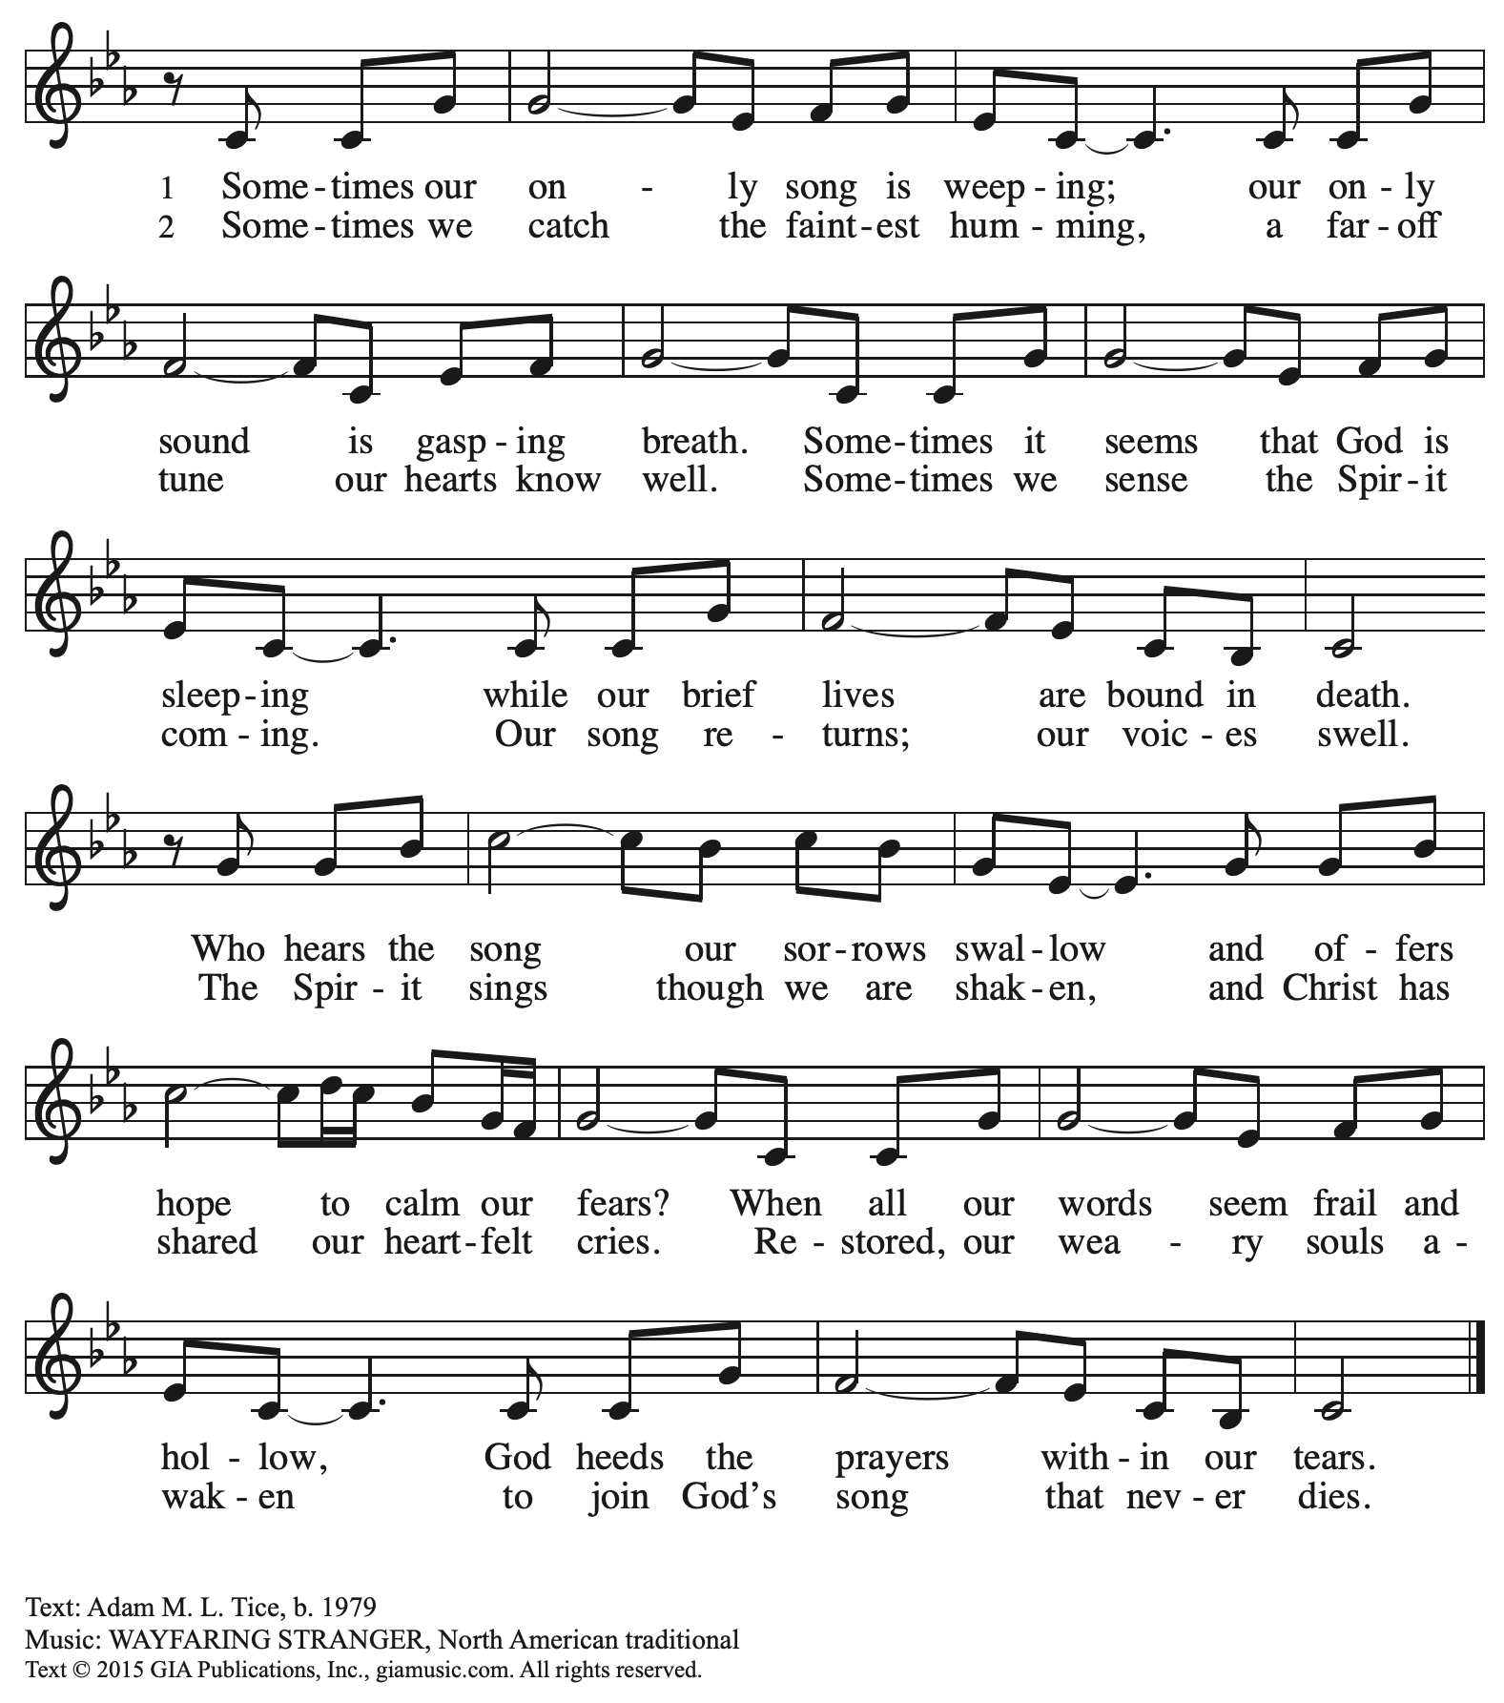
Reprinted with permission under OneLicense.net # A-722139.

Greeting

P: The grace of our Lord Jesus Christ, the love of God,
and the communion of the Holy Spirit be with you all.
C: And also with you.

Hymn of Praise ELW p. 204

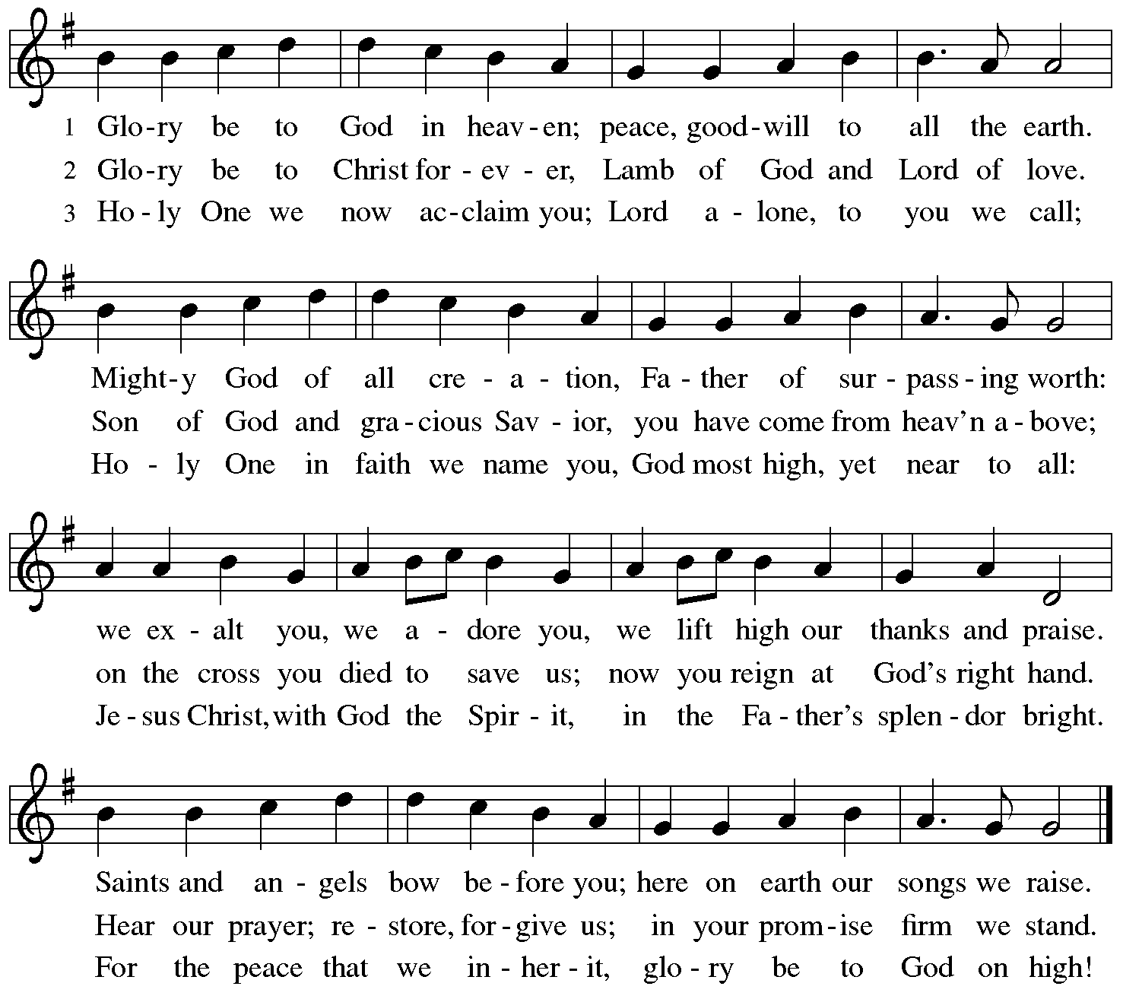

Prayer of the Day

P: The Lord be with you.
C: And also with you.

P: Let us pray. O Lord God, we bring before you the cries of our sorrowing world.
In your mercy, set us free from the chains that bind us,
and defend us from everything that is evil,
through Jesus Christ, our Savior and Lord.
C: Amen.

Please be seated. Children are invited to move to the Social Hall for Little Church; Big Faith.
Word
God speaks to us in Scripture reading, preaching, and song

First Reading – Isaiah 65: 1-9

¹I was ready to be sought out by those who did not ask,
to be found by those who did not seek me.
I said, “Here I am, here I am,”
to a nation that did not call on my name.
²I held out my hands all day long
to a rebellious people,
who walk in a way that is not good,
following their own devices;
³a people who provoke me
to my face continually,
sacrificing in gardens
and offering incense on bricks;
⁴who sit inside tombs,
and spend the night in secret places;
who eat swine’s flesh,
with broth of abominable things in their vessels;
⁵who say, “Keep to yourself,
do not come near me, for I am too holy for you.”
These are a smoke in my nostrils,
a fire that burns all day long.
⁶See, it is written before me:
I will not keep silent, but I will repay;
I will indeed repay into their laps
⁷their iniquities and their ancestors’ iniquities together, says the Lord;
because they offered incense on the mountains
and reviled me on the hills,
I will measure into their laps
full payment for their actions.
⁸Thus says the Lord:
As the wine is found in the cluster,
and they say, “Do not destroy it,
for there is a blessing in it,”
so I will do for my servants’ sake,
and not destroy them all.
⁹I will bring forth descendants from Jacob,
and from Judah inheritors of my mountains;
my chosen shall inherit it,
and my servants shall settle there.

L: Word of God, word of life.
C: Thanks be to God.

Please rise as you are able.

Gospel Acclamation ELW p. 205

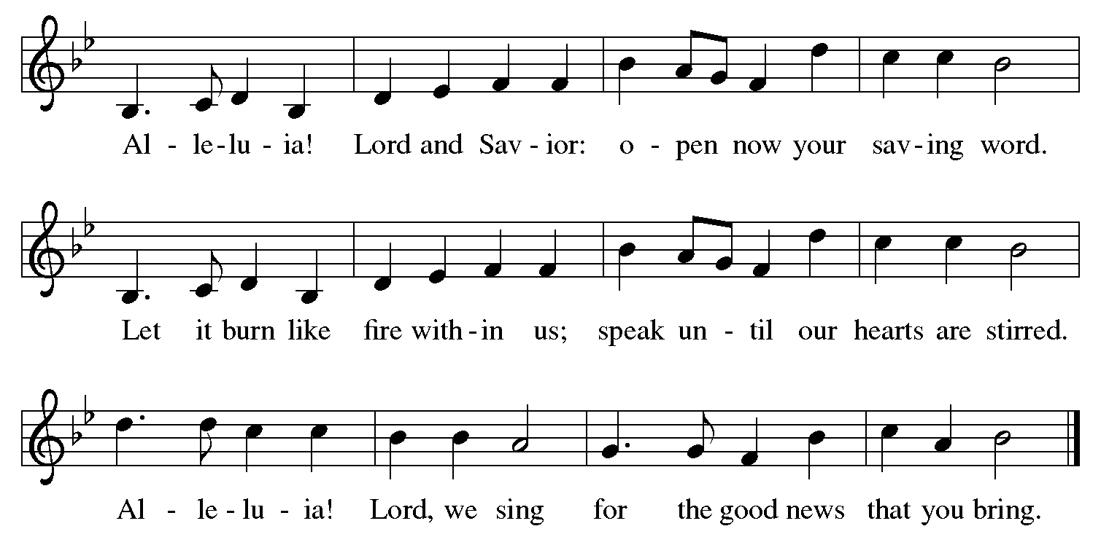

Gospel – Luke 8: 26-39

P: The holy Gospel according to St. Luke.
C: Glory to you, O Lord.

²⁶Then [Jesus and his disciples] arrived at the country of the Gerasenes, which is opposite Galilee. ²⁷As he stepped out on land, a man of the city who had demons met [Jesus]. For a long time [the man] had worn no clothes, and he did not live in a house but in the tombs. ²⁸When he saw Jesus, he fell down before him and shouted at the top of his voice, “What have you to do with me, Jesus, Son of the Most High God? I beg you, do not torment me”—²⁹for Jesus had commanded the unclean spirit to come out of the man. (For many times it had seized him; he was kept under guard and bound with chains and shackles, but he would break the bonds and be driven by the demon into the wilds.) ³⁰Jesus then asked him, “What is your name?” He said, “Legion”; for many demons had entered him. ³¹They begged him not to order them to go back into the abyss.
³²Now there on the hillside a large herd of swine was feeding; and the demons begged Jesus to let them enter these. So he gave them permission. ³³Then the demons came out of the man and entered the swine, and the herd rushed down the steep bank into the lake and was drowned.
³⁴When the swineherds saw what had happened, they ran off and told it in the city and in the country. ³⁵Then people came out to see what had happened, and when they came to Jesus, they found the man from whom the demons had gone sitting at the feet of Jesus, clothed and in his right mind. And they were afraid. ³⁶Those who had seen it told them how the one who had been possessed by demons had been healed. ³⁷Then all the people of the surrounding country of the Gerasenes asked Jesus to leave them; for they were seized with great fear. So he got into the boat and returned. ³⁸The man from whom the demons had gone begged that he might be with him; but Jesus sent him away, saying, ³⁹“Return to your home, and declare how much God has done for you.” So he went away, proclaiming throughout the city how much Jesus had done for him.

P: The Gospel of the Lord.
C: Praise to you, O Christ.

Please be seated.

Sermon

A time of silence for prayer and reflection follows the sermon.
When the hymn of the day begins, please rise as you are able.

Hymn of the Day Cast Out, O Christ ACS 1016
v. 1-2, 4

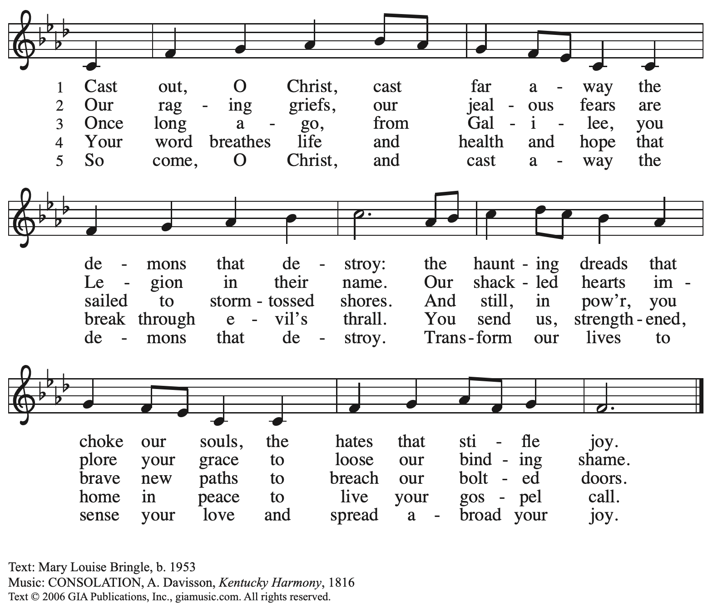
Reprinted with permission under OneLicense.net # A-722139.

Prayers of the People

P: United in Christ and guided by the Spirit,
we pray for the church, the world, and all who are in need.

After each petition
P: God of mercy,
C: receive our prayer.

P: God of every time and place, we offer these prayers and those of our hearts to you,
in Jesus’ name.
C: Amen.

Please be seated.

Meal

Offering

We offer ourselves, our gifts, and our faithful service to God.
An usher will pass around an offering plate for anyone who would like to offer gifts before God.

Music during the Offering

Please rise as you are able.

Offertory Song We Give Thee but Thine Own ELW 686
v. 1-2

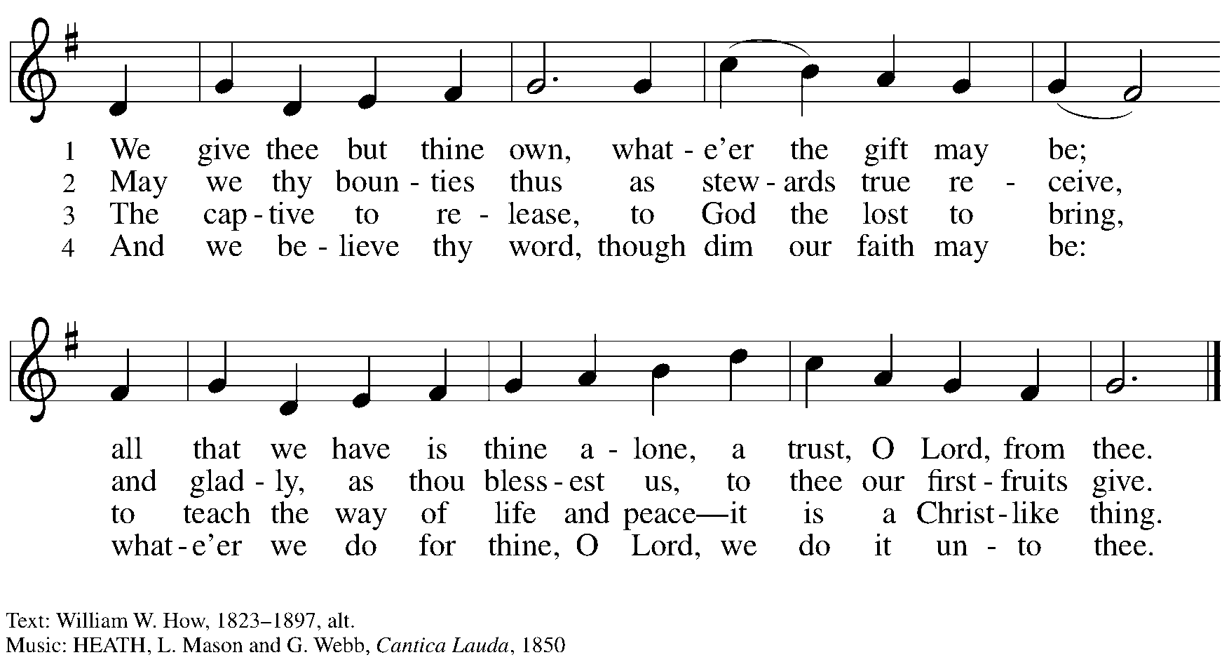

Offertory Prayer

P: Let us pray.
God of all creation,
C: all you have made is good, and your love endures forever.
You bring forth bread from the earth and fruit from the vine.
Nourish us with these gifts, that we might be for the world
signs of your gracious presence in Jesus Christ, our Savior and Lord.
Amen.

Dialogue

P: The Lord be with you.
C: And also with you.

P: Lift up your hearts.
C: We lift them to the Lord.

P: Let us give thanks to the Lord our God.
C: It is right to give our thanks and praise.

Preface

P: It is indeed right, our duty and our joy,
that we should at all times and in all places
give thanks and praise to you, almighty and merciful God,
through our Savior Jesus Christ;
who on this day overcame death and the grave,
and by his glorious resurrection opened to us the way of everlasting life.
And so, with all the choirs of angels,
with the church on earth and the hosts of heaven,
we praise your name and join their unending hymn:

Sanctus ELW p. 207

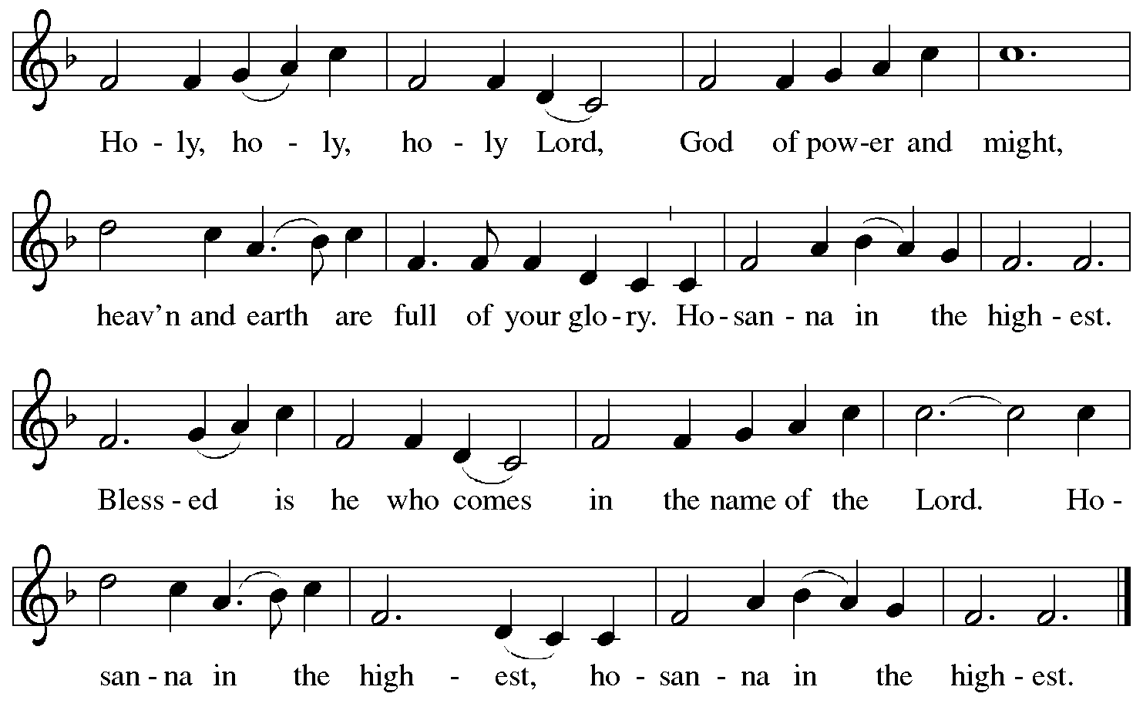

Eucharistic Prayer

P: Holy, mighty, and merciful Lord …
… be all honor and glory, now and forever.
C: Amen.

Lord’s Prayer

P: Gathered as one by the Holy Spirit, let us pray as Jesus taught us.
C: Our Father in heaven,
hallowed be your name,
your kingdom come,
your will be done,
on earth as in heaven.
Give us today our daily bread.
Forgive us our sins
as we forgive those
who sin against us.
Save us from the time of trial
and deliver us from evil.
For the kingdom, the power,
and the glory are yours,
now and forever. Amen.

Fraction and Invitation

Agnus Dei / Lamb of God ELW p. 208

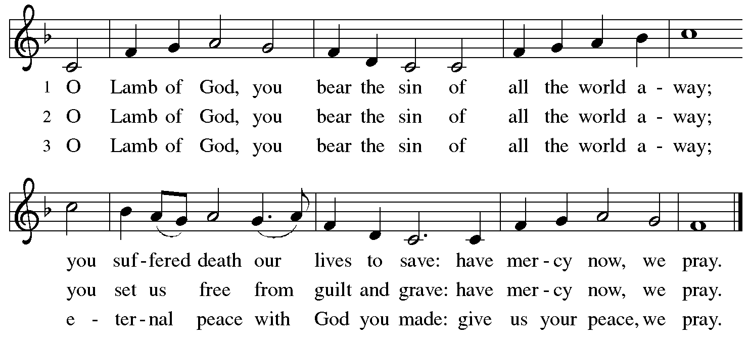

Please be seated.

Holy Communion
- Hand sanitizer is available if you would like to use it prior to receiving Communion.
- Worshipers from the pulpit side will proceed forward first, followed by the center section, and then the lectern side.
- The Communion wafers (regular and gluten-free) have been thoughtfully prepared using the gifts of the congregation by a member of St. Andrew’s altar care team, with a drop of wine or grape juice on each. The presiding minister will distribute one to each communicant.
- When you reach the presiding minister, please indicate if you would like grape juice or a gluten-free wafer.
- A blessing will be provided for anyone who does not yet receive the sacrament.
- Cushions have been placed along the altar rail for anyone who would like to kneel for prayer and reflection before returning to their pew.
- Everyone is asked to wait until you return to your place to consume the elements, and then promptly replace your mask.

Hymns during Holy Communion
We Come to You for Healing, Lord ELW 617

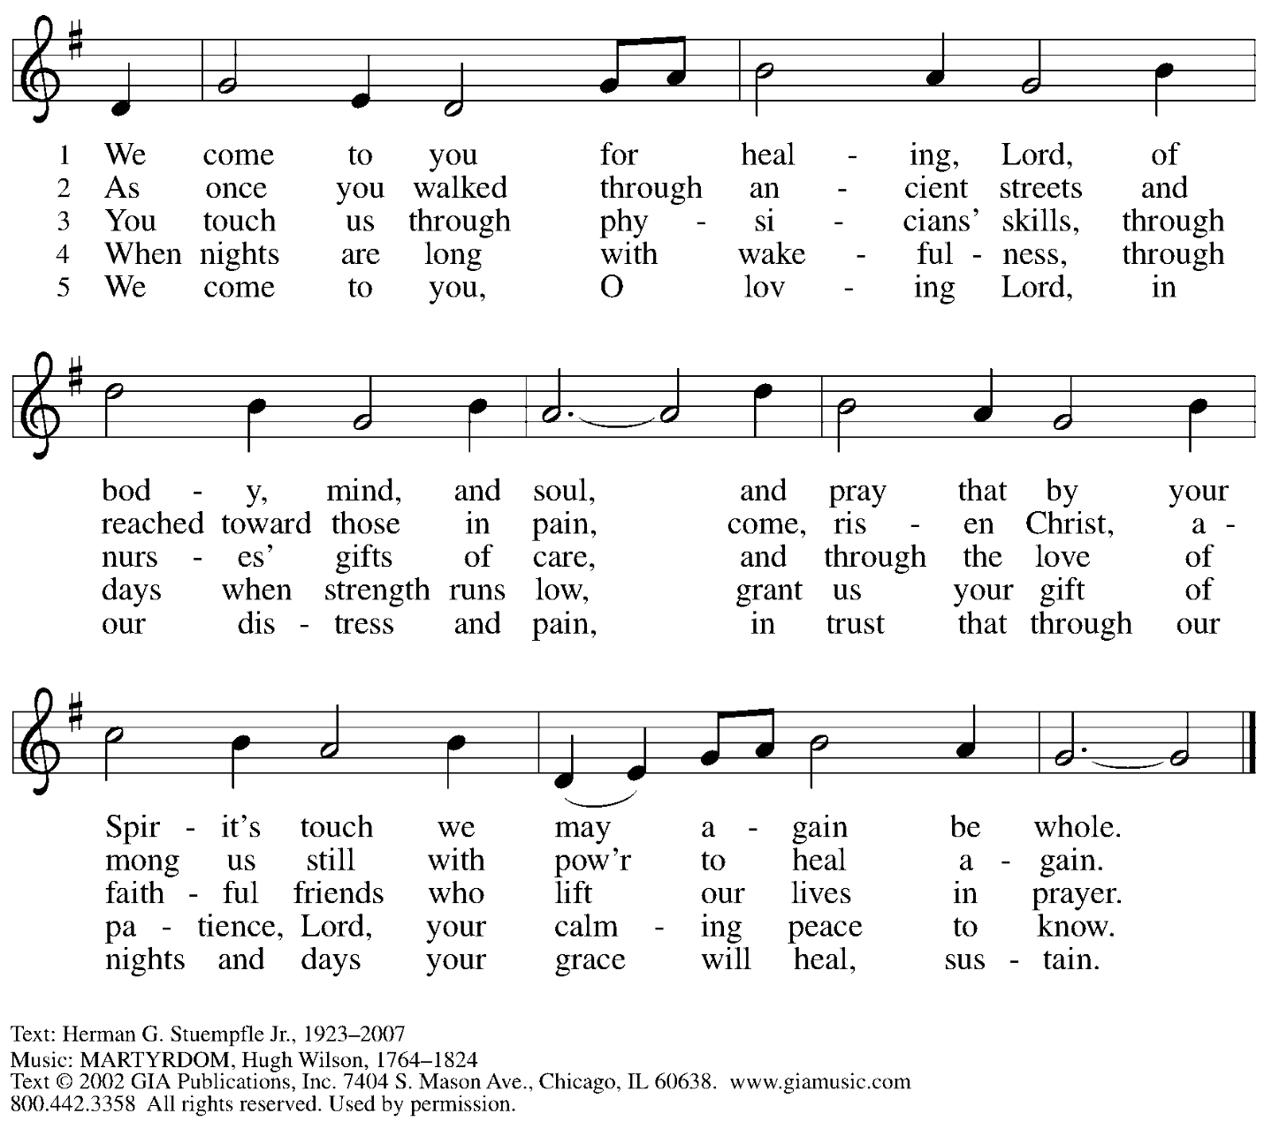
Reprinted with permission under OneLicense.net # A-722139.

Hymns during Holy Communion
I Love to Tell the Story ELW 661

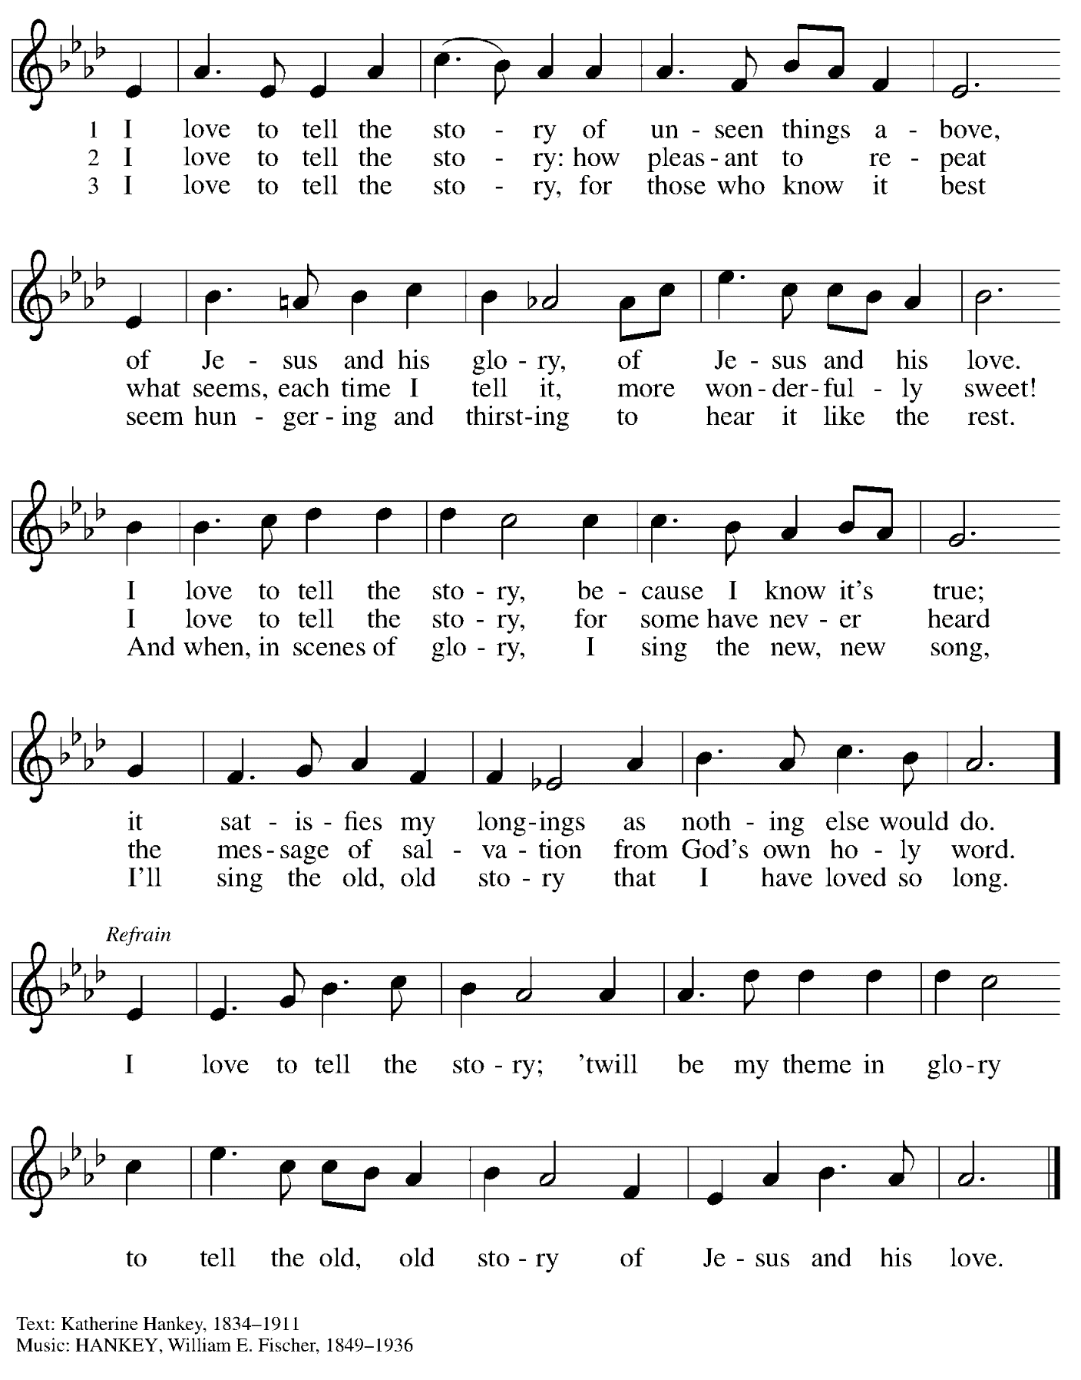

When all have returned to their places, please rise as you are able.

Blessing

P: The body and blood of our Lord Jesus Christ strengthen you and keep you in his grace.
C: Amen.

Prayer

P: Let us pray.
God of abundance, with this bread of life and cup of salvation you have united us with Christ, making us one with all your people. Now send us forth in the power of your Spirit, that we may proclaim your redeeming love to the world and continue forever in the risen life of Jesus Christ, our Lord.
C: Amen.

Please be seated.

Sending

Announcements

Please rise as you are able.

Benediction

P: God, the Author of life,
Christ, the living Cornerstone,
and the life-giving Spirit of adoption,
☩ bless you now and forever.
C: Amen.

Sending Hymn Following Page

Sending Hymn Rise, Shine, You People ELW 665
v. 1-3

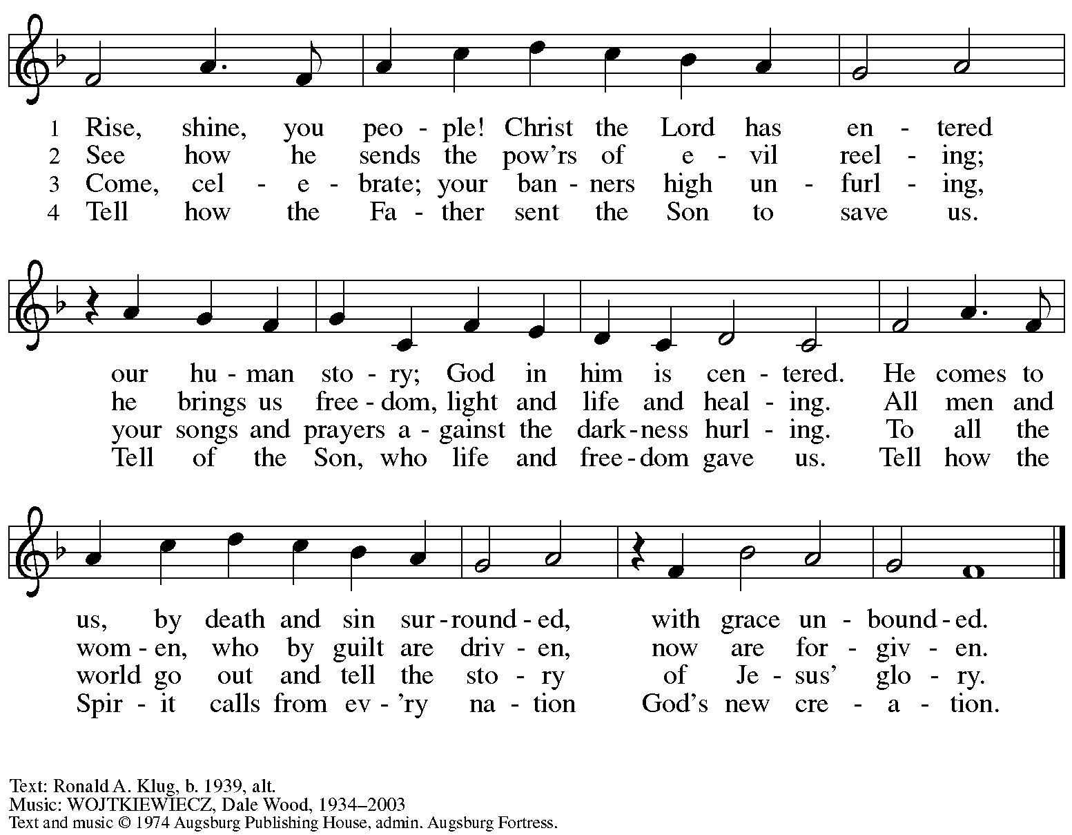
All rights reserved. Reprinted with permission under OneLicense.net # A-722139.

Dismissal

P: Go in peace. Serve the Lord.
C: Thanks be to God!

Abbreviations

P: Pastor/Presiding Minister
L: Lector
C: Congregation

ELW: Evangelical Lutheran Worship hymnal
ACS: All Creation Sings hymnal

Those serving in worship today

Piano Jeff Denlinger
Cantor Timothy Kocher-Hillmer
Lector Lester Prince
Director of Faith Formation Christopher Atwood
Presiding Minister Rev. Ross Carmichael

Liturgy and Hymnody Acknowledgements

From SundaysandSeasons.com. Copyright © 2022 Augsburg Fortress. All rights reserved. Reprinted under OneLicense.net # A-722139.
Used by permission of Augsburg Fortress.

