+ Third Sunday after Pentecost
June 26, 2022
St. Andrew Lutheran Church
304 Morewood Ave.
Pittsburgh, PA 15213
St_andrewELCA@verizon.net
www.standrewpittsburgh.org
+ Third Sunday after Pentecost
Order for Worship

We have no good apart from God. That makes Jesus’ call to follow him an invitation to freedom. This is freedom to revel in the Spirit’s fruit: love, joy, peace, and patience.
This is freedom to not be imprisoned by anything that would keep us
from the fullness of the life God has given us. This is the path of life.

A few notes on precautions and protocols, which apply to everyone regardless of vaccination status, as St. Andrew returns to worship in the sanctuary:

- Face masks that fully cover both your mouth and nose are required for parishioners over the age of two (2) – Now that local transmission rates have decreased, worship leaders will once again remove masks during their parts that are conducted at a distance from the pews.
- Physical distancing of at least six (6) feet will be observed at all times for people not from your household.
- We invite the congregation to join in the singing of the hymns (with masks on) during worship!
- Hand sanitizer is available at the front of the sanctuary to use before Holy Communion, after you proceed past the baptismal font, as the alcohol has been affecting the finish on the font’s bowl.

Worship Services are live streamed to multiple online platforms.
By attending worship, you agree that your image and voice may be broadcast.

Welcome to St. Andrew!
- A restroom is available on the main level of the church, through the doors to the Social Hall and to the right in the main office.
- After the Prayer of the Day, children are invited to gather in the Social Hall for Little Church; Big Faith, a Bible lesson and activity. The group returns to the worship space for the Communion portion of the service.

Welcome

Prelude

Gathering
The Holy Spirit calls us together as the people of God.

Confession and Forgiveness

P: Blessed be the holy Trinity, ☩ one God,
whose steadfast love endures forever.
C: Amen.

P: Let us confess our sin in the presence of God and of one another.

Silence is kept for reflection.

P: Merciful God,
C: we confess that we have not followed your path
but have chosen our own way.
Instead of putting others before ourselves,
we long to take the best seats at the table.
When met by those in need,
we have too often passed by on the other side.
Set us again on the path of life.
Save us from ourselves
and free us to love our neighbors.
Amen.

P: Hear the good news!
God does not deal with us according to our sins
but delights in granting pardon and mercy.
In the name of ☩ Jesus Christ, your sins are forgiven.
You are free to love as God loves.
C: Amen.

Gathering Hymn Gather Us In ELW 532
v. 1, 4

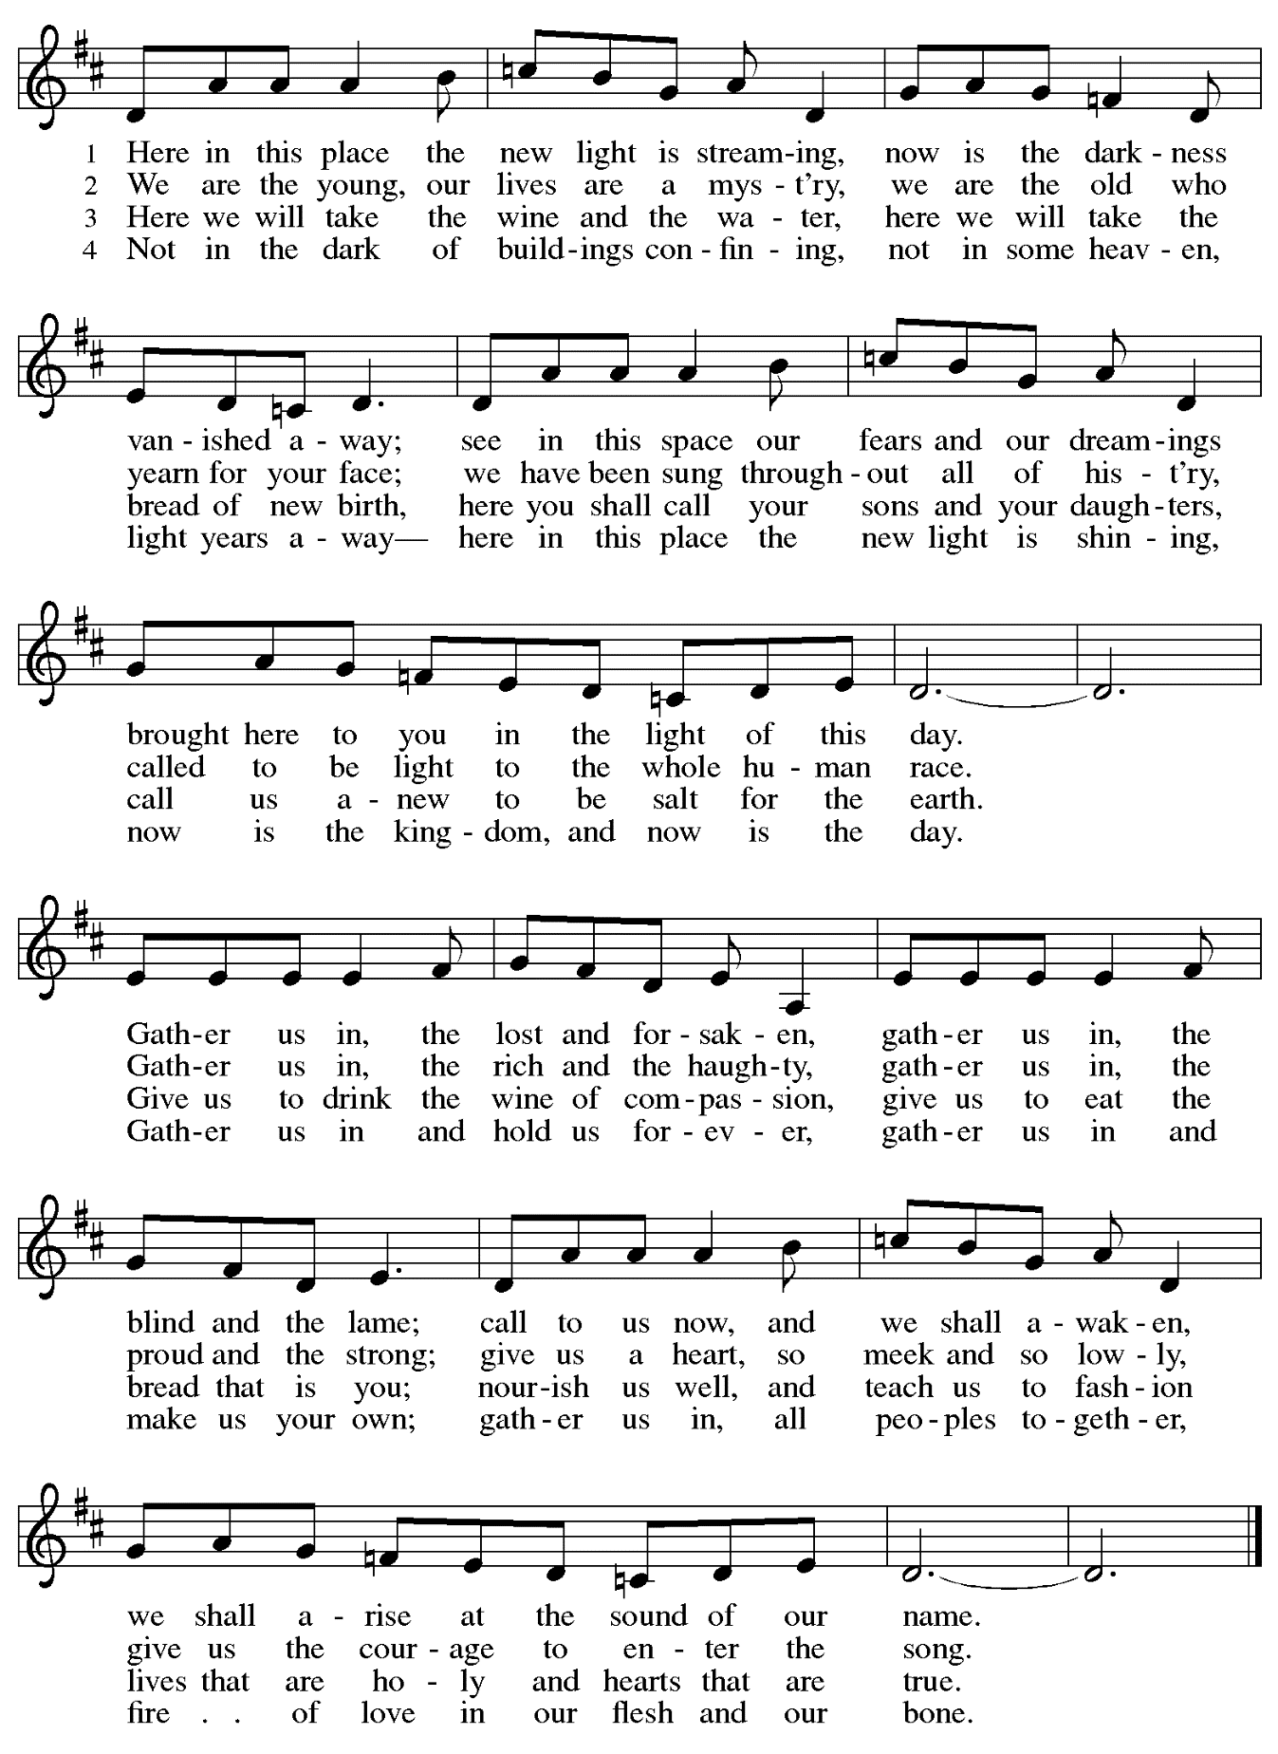

Greeting

P: The grace of our Lord Jesus Christ, the love of God,
and the communion of the Holy Spirit be with you all.
C: And also with you.

Hymn of Praise ELW p. 204

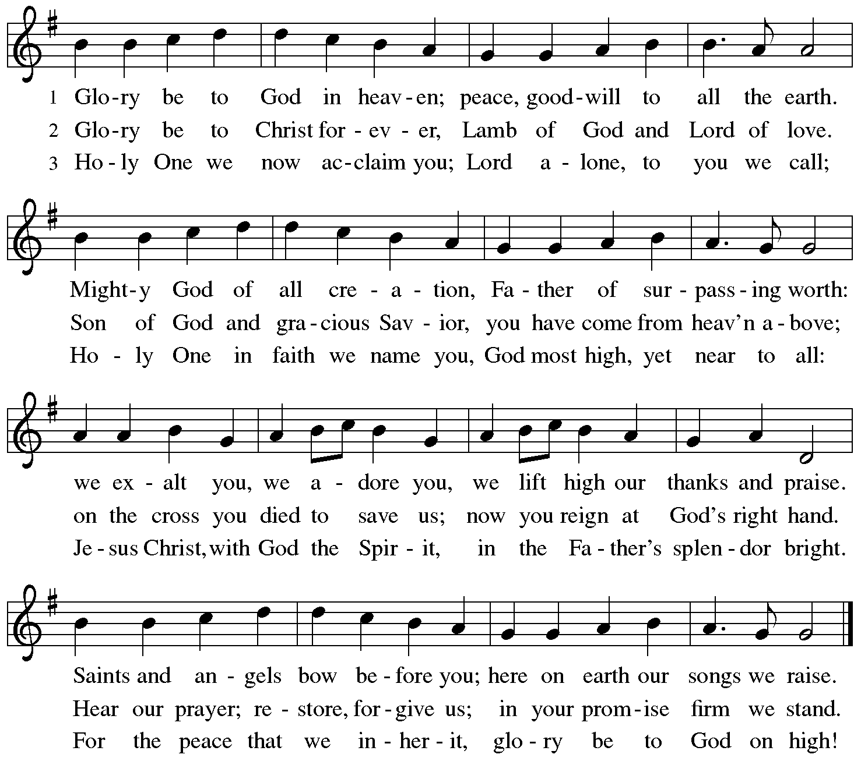

Prayer of the Day

P: The Lord be with you.
C: And also with you.

P: Let us pray.
Sovereign God, ruler of all hearts, you call us to obey you, and you favor us with true freedom. Keep us faithful to the ways of your Son, that, leaving behind all that hinders us,
we may steadfastly follow your paths, through Jesus Christ, our Savior and Lord.
C: Amen.

Please be seated. Children are invited to move to the Social Hall for Little Church; Big Faith.

Word
God speaks to us in Scripture reading, preaching, and song

First Reading – 1 Kings 19: 15-16, 19-21

¹⁵Then the Lord said to [Elijah,] “Go, return on your way to the wilderness of Damascus; when you arrive, you shall anoint Hazael as king over Aram. ¹⁶Also you shall anoint Jehu son of Nimshi as king over Israel; and you shall anoint Elisha son of Shaphat of Abel-meholah as prophet in your place.
¹⁹So he set out from there, and found Elisha son of Shaphat, who was plowing. There were twelve yoke of oxen ahead of him, and he was with the twelfth. Elijah passed by him and threw his mantle over him. ²⁰He left the oxen, ran after Elijah, and said, “Let me kiss my father and my mother, and then I will follow you.” Then Elijah said to him, “Go back again; for what have I done to you?” ²¹He returned from following him, took the yoke of oxen, and slaughtered them; using the equipment from the oxen, he boiled their flesh, and gave it to the people, and they ate. Then he set out and followed Elijah, and became his servant.
L: Word of God, word of life.
C: Thanks be to God.

Please rise as you are able.

Gospel Acclamation Following Page

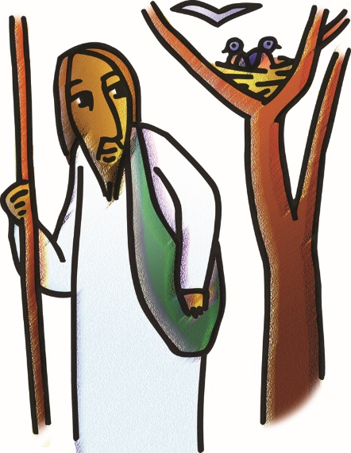
Gospel Acclamation ELW p. 205

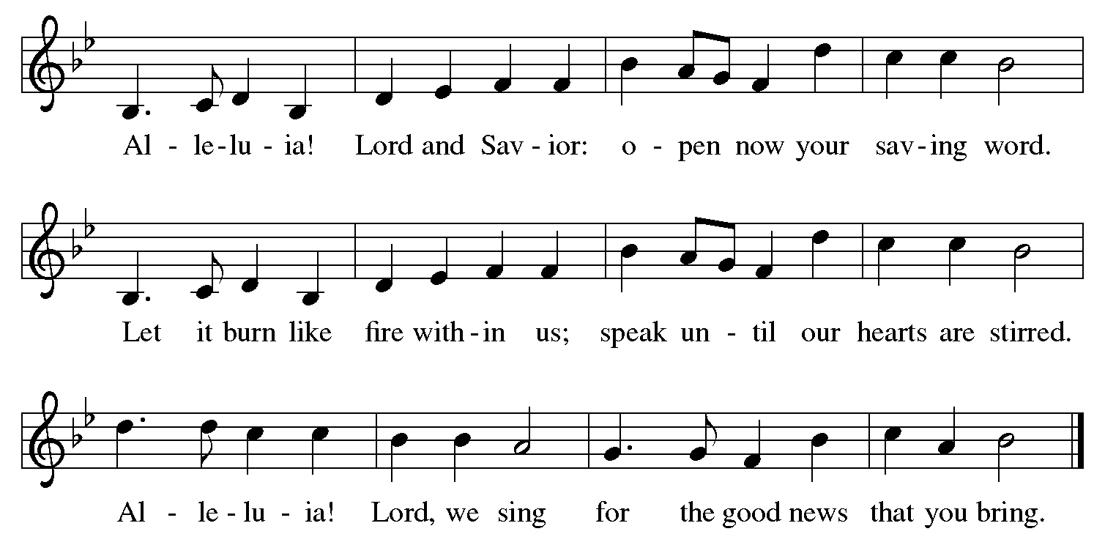

Gospel – Luke 9: 51-62

P: The holy Gospel according to St. Luke.
C: Glory to you, O Lord.

⁵¹When the days drew near for [Jesus] to be taken up, he set his face to go to Jerusalem. ⁵²And he sent messengers ahead of him. On their way they entered a village of the Samaritans to make ready for him; ⁵³but they did not receive him, because his face was set toward Jerusalem. ⁵⁴When his disciples James and John saw it, they said, “Lord, do you want us to command fire to come down from heaven and consume them?” ⁵⁵But he turned and rebuked them. ⁵⁶Then they went on to another village.
⁵⁷As they were going along the road, someone said to him, “I will follow you wherever you go.” ⁵⁸And Jesus said to him, “Foxes have holes, and birds of the air have nests; but the Son of Humanity has nowhere to lay his head.” ⁵⁹To another he said, “Follow me.” But he said, “Lord, first let me go and bury my father.” ⁶⁰But Jesus said to him, “Let the dead bury their own dead; but as for you, go and proclaim the kingdom of God.” ⁶¹Another said, “I will follow you, Lord; but let me first say farewell to those at my home.” ⁶²Jesus said to him, “No one who puts a hand to the plow and looks back is fit for the kingdom of God.”

P: The Gospel of the Lord.
C: Praise to you, O Christ.

Please be seated.

Sermon

A time of silence for prayer and reflection follows the sermon.
When the hymn of the day begins, please rise as you are able.

Hymn of the Day Will You Come and Follow Me, v. 1, 4-5 ELW 798

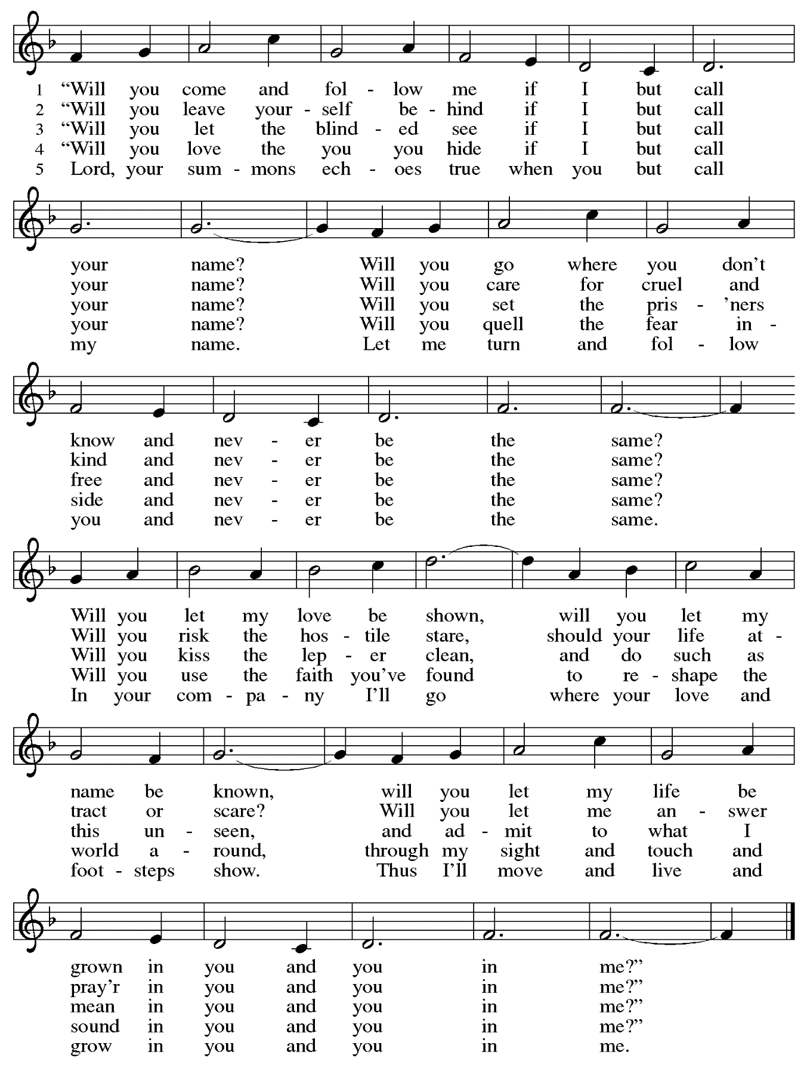
Sacrament of Holy Baptism

Presentation

Candidates for Baptism, sponsors/godparents, and parents gather with the ministers at the font. The assembly is seated.

The presiding minister may address the assembly in these or similar words:
P: God, who is rich in mercy and love, gives us a new birth into a living hope through the sacrament of Baptism. By water and the Word God delivers us from sin and death and raises us to new life in Jesus Christ. We are united with all the baptized in the one body of Christ, anointed with the gift of the Holy Spirit, and joined in God's mission for the life of the world.

Sponsors for each candidate, in turn, present the candidates:
I present name for Baptism.

The presiding minister addresses parents or others who bring for Baptism
children who are not able to answer for themselves:
P: Called by the Holy Spirit, trusting in the grace and love of God,
do you desire to have your child baptized into Christ?
Response: I do.

P: As you bring your child to receive the gift of Baptism, you are entrusted with responsibilities:
to live with her among God's faithful people,
bring her to the word of God and the holy supper,
teach her the Lord's Prayer, the Creed, and the Ten Commandments,
place in her hands the holy scriptures,
and nurture her in faith and prayer,
so that your child may learn to trust God,
proclaim Christ through word and deed,
care for others and the world God made,
and work for justice and peace.
Do you promise to help your child grow in the Christian faith and life?
Response: I do.

The presiding minister addresses sponsors:
P: Sponsors, do you promise to nurture this person in the Christian faith
as you are empowered by God's Spirit, and to help her live in the covenant of Baptism
and in communion with the church?
Response: I do.

The presiding minister addresses the assembly:
P: People of God, do you promise to support name and pray for her in her new life in Christ?
C: We do.

Please rise as you are able.

Profession of Faith

The presiding minister addresses candidates for Baptism as well as the parents and sponsors of young children. The assembly may join in the responses.
P: I ask you to profess your faith in Christ Jesus, reject sin, and confess the faith of the church.

P: Do you renounce the devil and all the forces that defy God?
Response:
I renounce them.

P: Do you renounce the powers of this world that rebel against God?
Response:
I renounce them.

P: Do you renounce the ways of sin that draw you from God?
Response:
I renounce them.

The presiding minister addresses the candidates and the assembly.
P: Do you believe in God the Father?
C: I believe in God, the Father almighty,
creator of heaven and earth.

P: Do you believe in Jesus Christ, the Son of God?
C: I believe in Jesus Christ, God’s only Son, our Lord,
who was conceived by the Holy Spirit,
born of the virgin Mary,
suffered under Pontius Pilate,
was crucified, died, and was buried;
he descended to the dead.*
On the third day he rose again;
he ascended into heaven,
he is seated at the right hand of the Father,
and he will come to judge the living and the dead.

P: Do you believe in God the Holy Spirit?
C: I believe in the Holy Spirit,
the holy catholic church,
the communion of saints,
the forgiveness of sins,
the resurrection of the body,
and the life everlasting.

*Or, “he descended into hell,” another translation of this text in widespread use.

Thanksgiving at the Font

Water may be poured into the font before or during the thanksgiving.

At the font, the presiding minister begins the thanksgiving:
P: The Lord be with you.
C: And also with you.

P: Let us give thanks to the Lord our God.
C: It is right to give our thanks and praise.

P: We give you thanks, O God, for in the beginning your Spirit moved over the waters and by your Word you created the world, calling forth life in which you took delight. Through the waters of the flood you delivered Noah and his family, and through the sea you led your people Israel from slavery into freedom. At the river your Son was baptized by John and anointed with the Holy Spirit. By the baptism of Jesus' death and resurrection you set us free from the power of sin and death and raise us up to live in you.

Pour out your Holy Spirit, the power of your living Word, that those who are washed in the waters of Baptism may be given new life. To you be given honor and praise through Jesus Christ our Lord, in the unity of the Holy Spirit, now and forever.
C: Amen.

The assembly may be seated.

Baptism

The presiding minister baptizes each candidate. Water is poured on the candidate's head,
as the presiding minister says:
P: Name , I baptize you in the name of the Father,

The candidate is immersed or water is poured on the candidate's head a second time:

and of the Son,

The candidate is immersed or water is poured on the candidate's head a third time:
and of the Holy Spirit.
C: Amen.

After each Baptism, the assembly responds:
C: Blessed be God, the source of all life, the word of salvation, the spirit of mercy.

The presiding minister continues:
P: Let us pray.
We give you thanks, O God, that through water and the Holy Spirit
you give your children new birth, cleanse them from sin, and raise them to eternal life.

Laying both hands on the head of each of the newly baptized, the minister prays for each:
Sustain name with the gift of your Holy Spirit: the spirit of wisdom and understanding,
the spirit of counsel and might, the spirit of knowledge and the fear of the Lord,
the spirit of joy in your presence, both now and forever.
C: Amen.

The presiding minister marks the sign of the cross on the forehead of each of the baptized.
Oil prepared for this purpose may be used. As the sign of the cross is made, the minister says:
P: Name, child of God, you have been sealed by the Holy Spirit and marked with the cross of Christ forever.
C: Amen.

Welcome

A lighted candle may be given to each of the newly baptized (to a sponsor of a young child)
as a representative of the congregation says:
R: Jesus said, I am the light of the world.
Whoever follows me will have the light of life.

The ministers and the baptismal group face the assembly.
A representative of the congregation leads the assembly in the welcome.
R: Let us welcome the newly baptized.
C: We welcome you into the body of Christ and into the mission we share:
join us in giving thanks and praise to God
and bearing God's creative and redeeming word to all the world.

The presiding minister introduces the newly baptized to the assembly.
The assembly celebrates with them, their parents, and sponsors by singing St. Andrew’s congregational refrain:
C: Christ goes before, and we are called to follow,
and all who follow find the Way, the Truth, the Life.

The baptismal party returns to their places.
Worship continues with the Prayers of the People.

Prayers of the People

P: United in Christ and guided by the Spirit,
we pray for the church, the world, and all who are in need.

After each petition
P: God of mercy,
C: receive our prayer.

P: God of every time and place, we offer these prayers and those of our hearts to you,
in Jesus’ name.
C: Amen.

Please be seated.

Meal

Offering

We offer ourselves, our gifts, and our faithful service to God.
An usher will pass around an offering plate for anyone who would like to offer gifts before God.

Music during the Offering

Please rise as you are able.

Offertory Song We Give Thee but Thine Own ELW 686
v. 1-2

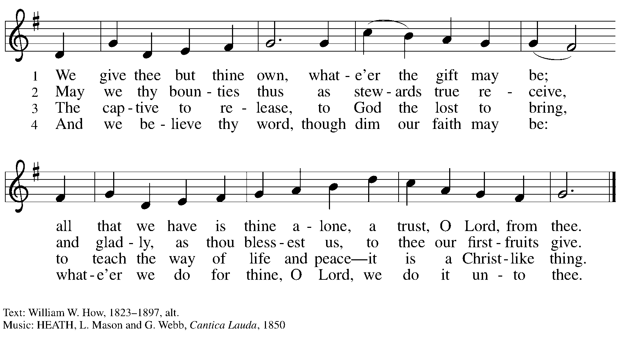

Offertory Prayer

P: Let us pray.
God of all creation,
C: all you have made is good, and your love endures forever.
You bring forth bread from the earth and fruit from the vine.
Nourish us with these gifts, that we might be for the world
signs of your gracious presence in Jesus Christ, our Savior and Lord.
Amen.

Dialogue

P: The Lord be with you.
C: And also with you.

P: Lift up your hearts.
C: We lift them to the Lord.

P: Let us give thanks to the Lord our God.
C: It is right to give our thanks and praise.
Preface

P: It is indeed right, our duty and our joy,
that we should at all times and in all places
give thanks and praise to you, almighty and merciful God.
You reveal your glory
as the glory of the Father, the Son, and the Holy Spirit:
equal in majesty, undivided in splendor, one Lord, one God,
ever to be adored in your eternal glory.
And so, with all the choirs of angels,
with the church on earth and the hosts of heaven,
we praise your name and join their unending hymn:

Sanctus ELW p. 207

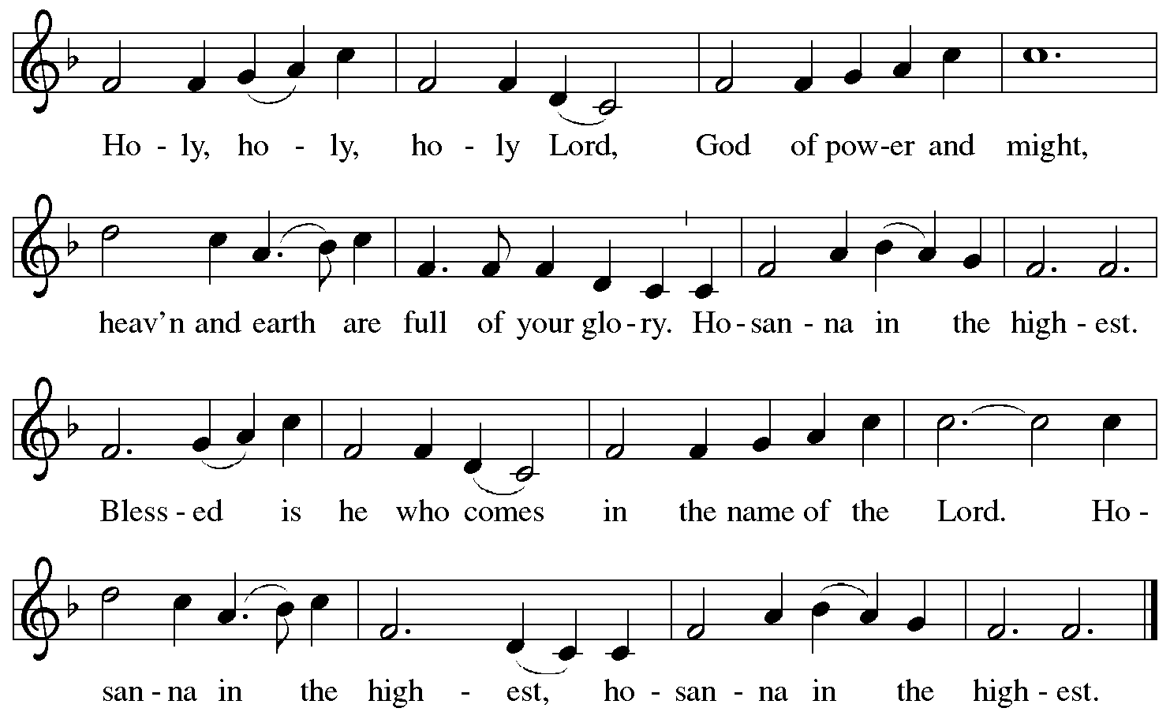

Eucharistic Prayer

P: Holy, mighty, and merciful Lord …
… be all honor and glory, now and forever.
C: Amen.

Lord’s Prayer

P: Gathered as one by the Holy Spirit, let us pray as Jesus taught us.
C: Our Father in heaven,
hallowed be your name,
your kingdom come,
your will be done,
on earth as in heaven.
Give us today our daily bread.
Forgive us our sins
as we forgive those
who sin against us.
Save us from the time of trial
and deliver us from evil.
For the kingdom, the power,
and the glory are yours,
now and forever. Amen.

Fraction and Invitation

Agnus Dei / Lamb of God ELW p. 208

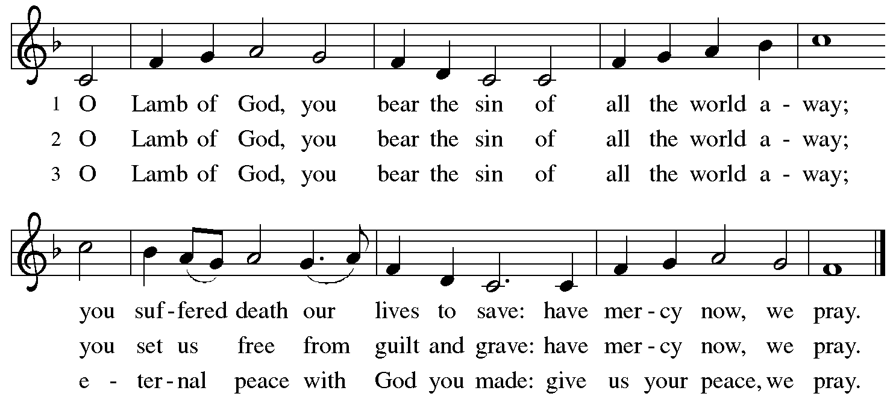

Please be seated.

Holy Communion
- Hand sanitizer is available if you would like to use it prior to receiving Communion.
- Worshipers from the pulpit side will proceed forward first, followed by the center section, and then the lectern side.
- The Communion wafers (regular and gluten-free) have been thoughtfully prepared using the gifts of the congregation by a member of St. Andrew’s altar care team, with a drop of wine or grape juice on each. The presiding minister will distribute one to each communicant.
- When you reach the presiding minister, please indicate if you would like grape juice or a gluten-free wafer.
- A blessing will be provided for anyone who does not yet receive the sacrament.
- A cushion has been placed at the altar rail for anyone who would like to kneel for prayer and reflection before returning to their pew.
- Everyone is asked to wait until you return to your place to consume the elements, and then promptly replace your mask.

Hymns during Holy Communion
Beloved, God’s Chosen ELW 648

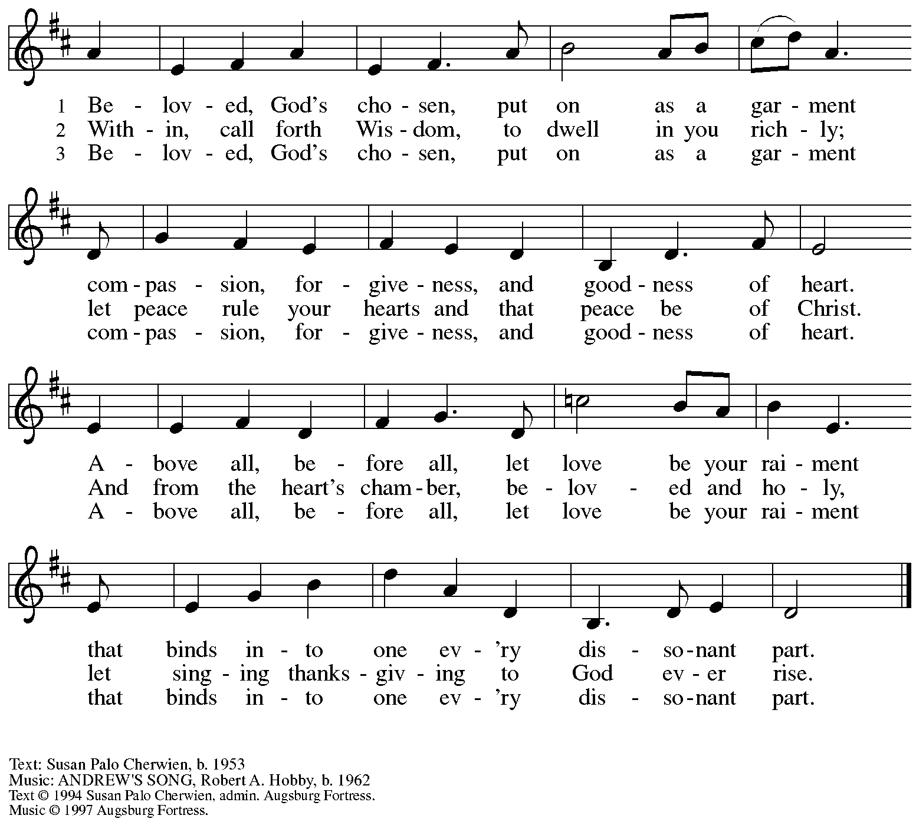
All rights reserved. Reprinted with permission under OneLicense.net # A-722139.

Hymns during Holy Communion
All Who Hunger, Gather Gladly ELW 461

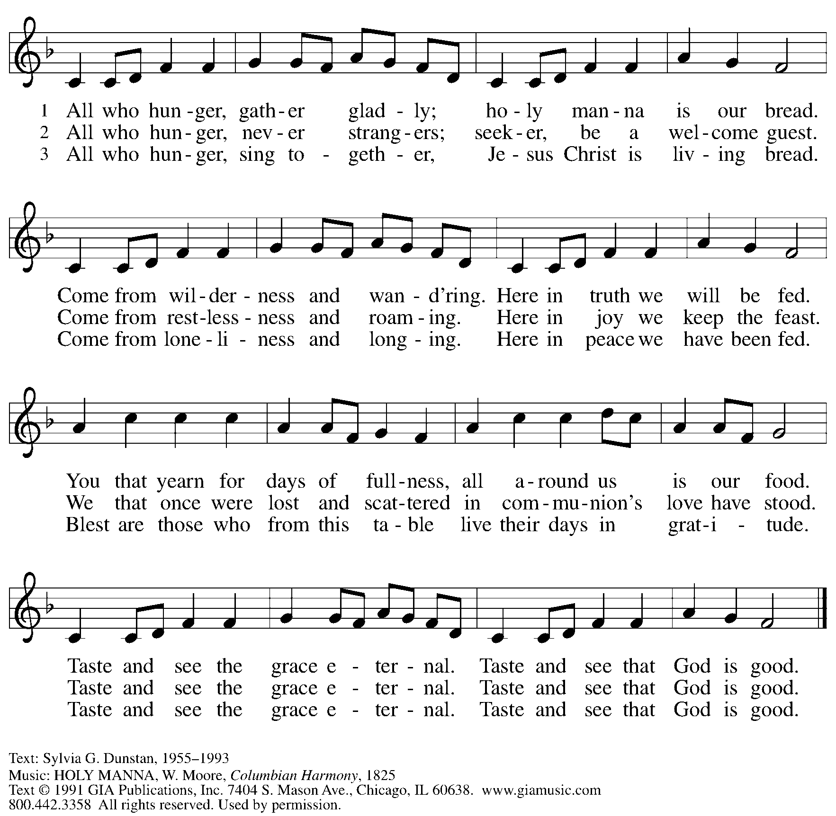
All rights reserved. Reprinted under OneLicense.net # A-722139.

When all have returned to their places, please rise as you are able.

Blessing

P: The body and blood of our Lord Jesus Christ strengthen you and keep you in his grace.
C: Amen.

Prayer

P: Let us pray.
God of abundance, with this bread of life and cup of salvation you have united us with Christ, making us one with all your people. Now send us forth in the power of your Spirit, that we may proclaim your redeeming love to the world and continue forever in the risen life of Jesus Christ, our Lord.
C: Amen.

Please be seated.

Sending

Announcements

Please rise as you are able.

Benediction

P: God, the Author of life,
Christ, the living Cornerstone,
and the life-giving Spirit of adoption,
☩ bless you now and forever.
C: Amen.

Sending Hymn Lift High the Cross ELW 660
v. 2, 4

Refrain
Lift high the cross, the love of Christ proclaim
till all the world adore his sacred name.

2 All newborn servants of the Crucified
bear on their brows the seal of him who died. Refrain

4 So shall our song of triumph ever be:
praise to the Crucified for victory! Refrain

Text: George W. Kitchin, 1827-1912; rev. Michael R. Newbolt, 1874-1956. Music: CRUCIFER, Sydney H. Nicholson, 1875-1947. Text © 1974 Hope Publishing Company, Carol Stream, IL 60188. All rights reserved. Reprinted under OneLicense.net # A-722139.

Dismissal

P: Go in peace. Serve the Lord.
C: Thanks be to God.
Abbreviations

P: Pastor/Presiding Minister
L: Lector
C: Congregation

ELW: Evangelical Lutheran Worship hymnal
ACS: All Creation Sings hymnal

Those serving in worship today

Organ Jimmi Kocher-Hillmer
Lector Dixie Tymitz
Assisting Minister and Cantor Timothy Kocher-Hillmer
Audio/Visual Minister Jason Galyardt
Director of Faith Formation Christopher Atwood
Presiding Minister Rev. Ross Carmichael

Liturgy and Hymnody Acknowledgements

From SundaysandSeasons.com. Copyright © 2022 Augsburg Fortress. All rights reserved. Reprinted under OneLicense.net # A-722139.
Used by permission of Augsburg Fortress.

Gather Us In – Text: Marty Haugen, b. 1950. Music: GATHER US IN, Marty Haugen. Text and music © 1982 GIA Publications, Inc., 7404 S. Mason Ave., Chicago, IL 60638. www.giamusic.com. 800.442.3358. All rights reserved. Reprinted with permission under OneLicense.net #A-722139.

Will You Come and Follow Me – Text: John L. Bell, b. 1949. Music: KELVINGROVE, Scottish traditional. Text © 1987 Iona Community, GIA Publications, Inc., agent. 7404 S. Mason Ave., Chicago, IL 60638. www.giamusic.com. 800.442.3358. All rights reserved. Reprinted with permission under OneLicense.net # A-722139.

Announcements – Sunday, June 26, 2022

- Worship in the Sanctuary and Online on Sunday, June 26th, + Third Sunday after Pentecost – Welcome to today’s worship at St. Andrew! As more people return to worship, we invite everyone to make your own name tag at the back of the worship space to help us all get to know one another. Allegheny County transmission rates have continued decreasing so leaders will once again be removing masks during parts conducted at a distance from the congregation. We ask that worship attendees also continue to wear masks properly and maintain physical distance. Please remember we are returning to (Outdoor, BYOB) coffee hour after worship each Sunday!
- Celebrate Pride with Renaissance City Choir’s 2022 Pride Concert, “Like a Rainbow,” Sunday, June 26th at 2:00 p.m. - The concert will be held at East Liberty Presbyterian Church, 116 N. Highland Ave., Pittsburgh 15206. Online ticket sales only - no tickets sold at the door. Please visit www.rccpittsburgh.com for tickets.
  - Also, RCC is looking for new volunteers for Renaissance City Choir's board of directors, especially persons who do not sing in the choir. We are especially interested in candidates with experience or interest in development, marketing, outreach, arts administration, and/or leadership and advocacy in the LGBTQIA+ community.
Our board members guide the vision and strategy of the choir, provide support at performances and fundraising events, and help spread the word about what this amazing group has to offer. No minimum contribution is required; we simply ask that board members keep RCC at the top of their giving list as they are financially able.
Ready for an opportunity to make an impact in our community? Please forward a brief letter of interest and resume to president@rccpittsburgh.com.
- Join us for a St Andrew Dinner Club! Sunday, June 26th after Worship
  - Where: East End Brewing Company, 147 Julius St., Pittsburgh, 15206
- “Journey Together” Continues Next Saturday, July 2nd, at 4:00 p.m. - This summer, we at St. Andrew are journeying together to learn about how we can trust God, grow in our faith, and live in community. If you are attending this weekend please bring your favorite Bible. These gatherings are for people of all ages!
- The next ReconcilingWorks meeting will be Monday, July 11th, at 6:00 p.m., Online.
- Crisis in Ukraine - Join the ELCA and its Communion Partners in Helping Provide Relief and Support - St. Andrew joins the world in ongoing concern for the people of Ukraine, and we have received inquiries as to how we can respond. If you would like to donate financially or offer support in other ways, see below for more information on how you can help!
- Little Pantry and Little Library Assistance - St. Andrew is accepting donations of food items, as well as financial gifts, for the Little Pantry on an ongoing basis. We would especially appreciate help restocking in June. If you would like to help with the Pantry and/or Library, please sign up here: https://www.signupgenius.com/go/5080544AAAC22A1F58-free. Contact Joyce Compton at joycecompton28@gmail.com if you have any questions.

