+ Fourth Sunday after Pentecost
July 3, 2022
St. Andrew Lutheran Church
304 Morewood Ave.
Pittsburgh, PA 15213
St_andrewELCA@verizon.net
www.standrewpittsburgh.org

+ Fourth Sunday after Pentecost
Order for Worship

God is the source of our nourishment. Jesus’ invitation to “take and eat . . . take and drink”
is a repeated one. In Holy Communion, in the word read and proclaimed, in the assembly of the people of God, the dominion of God has come near. Rejoice! Your name is written in heaven.

A few notes on precautions and protocols, which apply to everyone regardless of vaccination status, as St. Andrew returns to worship in the sanctuary:

- Now that the Covid-19 transmission rates have reached the “low” category in Allegheny County, masks are optional for all worship attendees.
- Adult and child-sized masks will continue to be available at the entrances.
- Hand sanitizer is available at the front of the sanctuary to use before Holy Communion, after you proceed past the baptismal font, as the alcohol has been affecting the finish on the font’s bowl.

Worship Services are live streamed to multiple online platforms.
By attending worship, you agree that your image and voice may be broadcast.

Welcome to St. Andrew!
- A restroom is available on the main level of the church, through the doors to the Social Hall and to the right in the main office.
- After the Prayer of the Day, children are invited to gather for Little Church; Big Faith, a Bible lesson and activity. The group returns to the worship space for the Communion portion of the service.

Welcome

Prelude

Gathering
The Holy Spirit calls us together as the people of God.

Confession and Forgiveness

P: Blessed be the holy Trinity, ☩ one God,
whose steadfast love endures forever.
C: Amen.

P: Let us confess our sin in the presence of God and of one another.

Silence is kept for reflection.

P: Merciful God,
C: we confess that we have not followed your path
but have chosen our own way.
Instead of putting others before ourselves,
we long to take the best seats at the table.
When met by those in need,
we have too often passed by on the other side.
Set us again on the path of life.
Save us from ourselves
and free us to love our neighbors.
Amen.

P: Hear the good news!
God does not deal with us according to our sins
but delights in granting pardon and mercy.
In the name of ☩ Jesus Christ, your sins are forgiven.
You are free to love as God loves.
C: Amen.

Gathering Hymn We All Are One in Mission ELW 576
v. 1-2

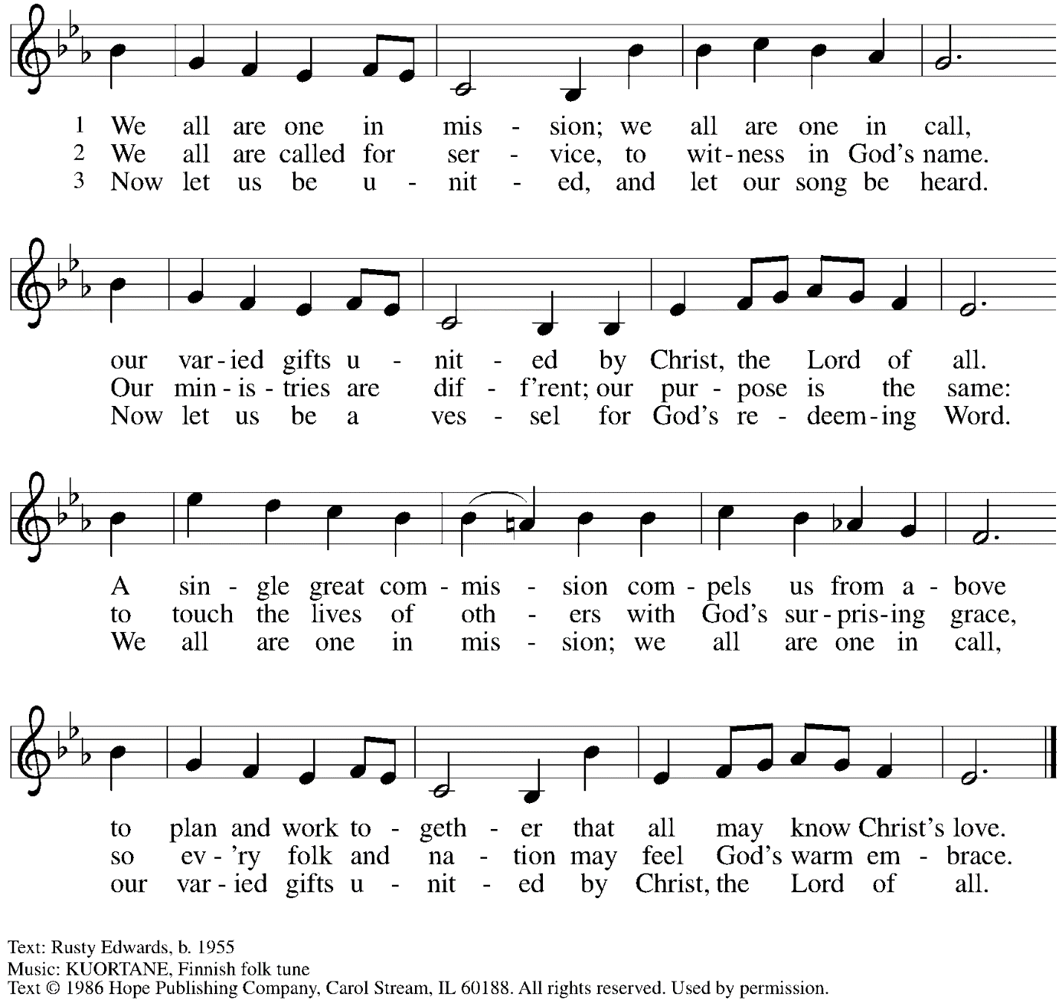
Reprinted with permission under OneLicense.net # A-722139.

Greeting

P: The grace of our Lord Jesus Christ, the love of God,
and the communion of the Holy Spirit be with you all.
C: And also with you.

Hymn of Praise ELW p. 204

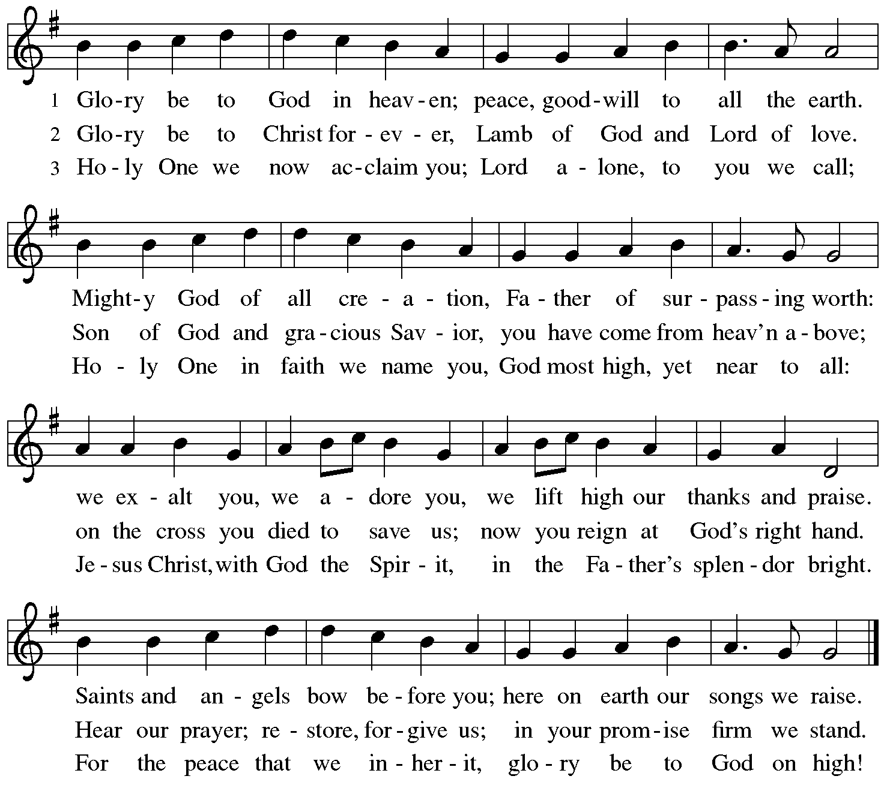

Prayer of the Day

P: The Lord be with you.
C: And also with you.

P: Let us pray.
O God, the Father of our Lord Jesus,
you are the city that shelters us, the mother who comforts us.
With your Spirit accompany us on our life’s journey,
that we may spread your peace in all the world,
through your Son, Jesus Christ, our Savior and Lord.
C: Amen.

Please be seated.
Children are invited to move to the Social Hall for Little Church; Big Faith.

Word
God speaks to us in Scripture reading, preaching, and song

First Reading – Isaiah 66: 10-14

¹⁰Rejoice with Jerusalem, and be glad for her,
all you who love her;
rejoice with her in joy,
all you who mourn over her—
¹¹that you may nurse and be satisfied
from her consoling breast;
that you may drink deeply with delight
from her glorious bosom.
¹²For thus says the Lord:
I will extend prosperity to her like a river,
and the wealth of the nations like an overflowing stream;
and you shall nurse and be carried on her arm,
and dandled on her knees.
¹³As a mother comforts her child,
so I will comfort you;
you shall be comforted in Jerusalem.
¹⁴You shall see, and your heart shall rejoice;
your bodies shall flourish like the grass;
and it shall be known that the hand of the Lord is with God’s servants,
and the Lord’s indignation is against God’s enemies.
L: Word of God, word of life.
C: Thanks be to God.

Please rise as you are able.

Gospel Acclamation ELW p. 205

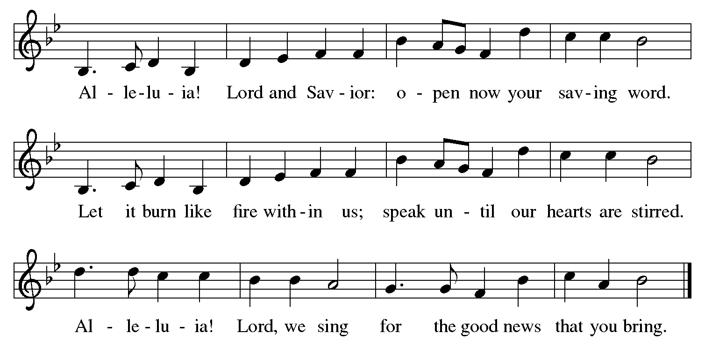

Gospel – Luke 10: 1-11, 16-20

P: The holy Gospel according to St. Luke.
C: Glory to you, O Lord.

¹After [Jesus spoke to his potential followers] the Lord appointed seventy others and sent them on ahead of him in pairs to every town and place where he himself intended to go. ²He said to them, “The harvest is plentiful, but the laborers are few; therefore ask the Lord of the harvest to send out laborers into God’s harvest. ³Go on your way. See, I am sending you out like lambs into the midst of wolves. ⁴Carry no purse, no bag, no sandals; and greet no one on the road.
⁵Whatever house you enter, first say, ‘Peace to this house!’ ⁶And if anyone is there who shares in peace, your peace will rest on that person; but if not, it will return to you. ⁷Remain in the same house, eating and drinking whatever they provide, for the laborer deserves to be paid. Do not move about from house to house. ⁸Whenever you enter a town and its people welcome you, eat what is set before you; ⁹cure the sick who are there, and say to them, ‘The kingdom of God has come near to you.’ ¹⁰But whenever you enter a town and they do not welcome you, go out into its streets and say, ¹¹‘Even the dust of your town that clings to our feet, we wipe off in protest against you. Yet know this: the kingdom of God has come near.’ ”

¹⁶“Whoever listens to you listens to me, and whoever rejects you rejects me, and whoever rejects me rejects the one who sent me.”

¹⁷The seventy returned with joy, saying, “Lord, in your name even the demons submit to us!” ¹⁸He said to them, “I watched Satan fall from heaven like a flash of lightning. ¹⁹See, I have given you authority to tread on snakes and scorpions, and over all the power of the enemy; and nothing will hurt you. ²⁰Nevertheless, do not rejoice at this, that the spirits submit to you, but rejoice that your names are written in heaven.”

P: The Gospel of the Lord.
C: Praise to you, O Christ.

Please be seated.

Sermon

A time of silence for prayer and reflection follows the sermon.
When the hymn of the day begins, please rise as you are able.

Hymn of the Day Lord, You Give the Great Commission Following Page

Hymn of the Day Lord, You Give the Great Commission ELW 579
v. 1-3

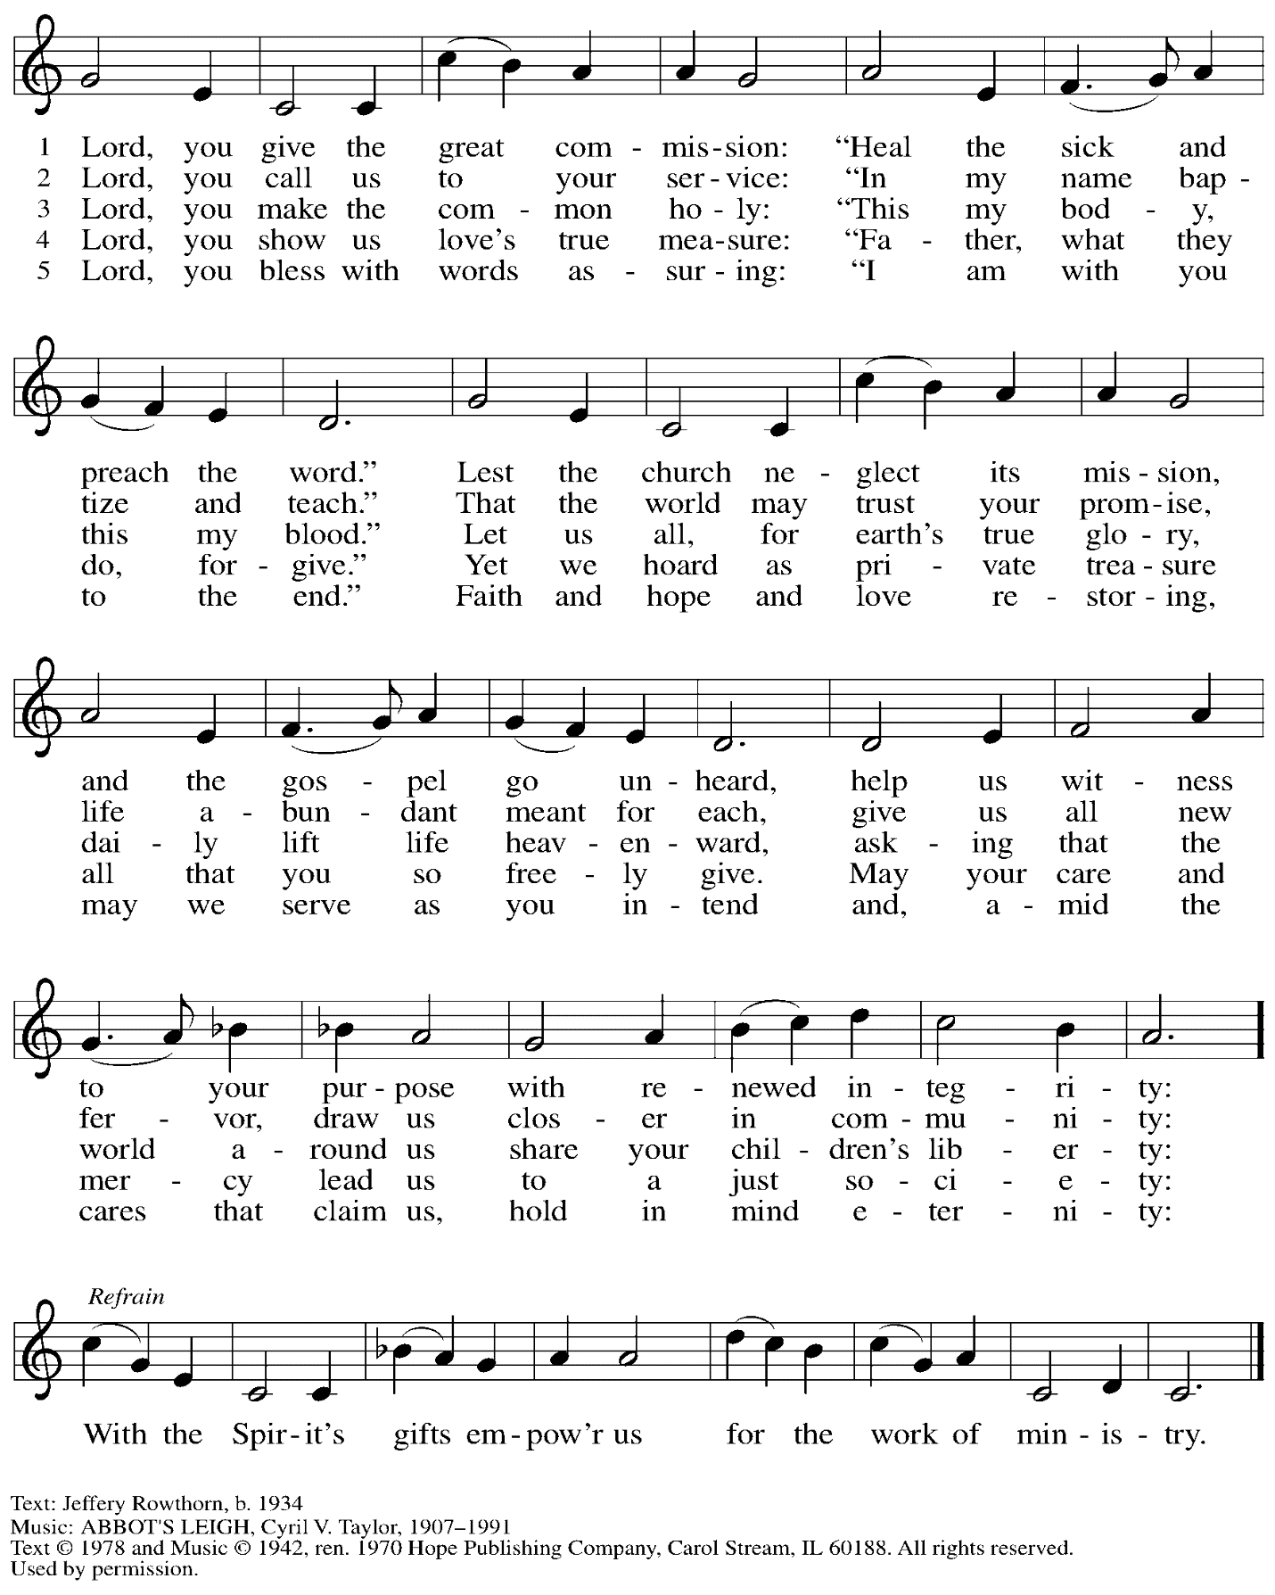
Reprinted with permission under OneLicense.net # A-722139.

Prayers of the People

P: United in Christ and guided by the Spirit,
we pray for the church, the world, and all who are in need.

After each petition
P: God of mercy,
C: receive our prayer.

P: God of every time and place, we offer these prayers and those of our hearts to you,
in Jesus’ name.
C: Amen.

Please be seated.

Meal

Offering

We offer ourselves, our gifts, and our faithful service to God.
An usher will pass around an offering plate for anyone who would like to offer gifts before God.

Music during the Offering

Please rise as you are able.

Offertory Song We Give Thee but Thine Own ELW 686
v. 1-2

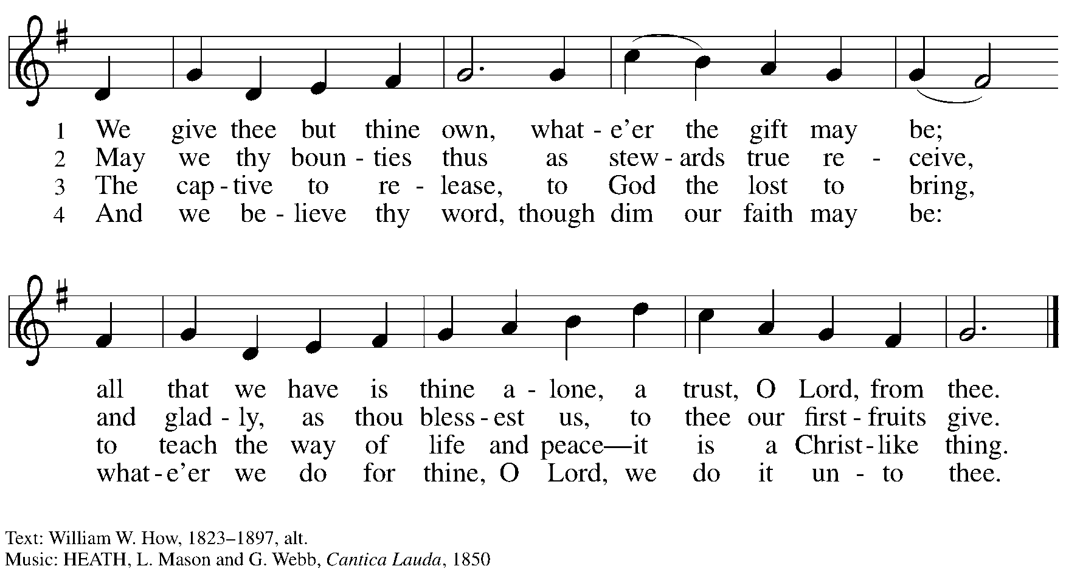

Offertory Prayer

P: Let us pray. God of all creation,
C: all you have made is good, and your love endures forever.
You bring forth bread from the earth and fruit from the vine.
Nourish us with these gifts, that we might be for the world
signs of your gracious presence in Jesus Christ, our Savior and Lord.
Amen.

Dialogue

P: The Lord be with you.
C: And also with you.

P: Lift up your hearts.
C: We lift them to the Lord.

P: Let us give thanks to the Lord our God.
C: It is right to give our thanks and praise.
Preface

P: It is indeed right, our duty and our joy,
that we should at all times and in all places
give thanks and praise to you, almighty and merciful God,
through our Savior Jesus Christ;
who on this day overcame death and the grave,
and by his glorious resurrection opened to us the way of everlasting life.
And so, with all the choirs of angels,
with the church on earth and the hosts of heaven,
we praise your name and join their unending hymn:

Sanctus ELW p. 207

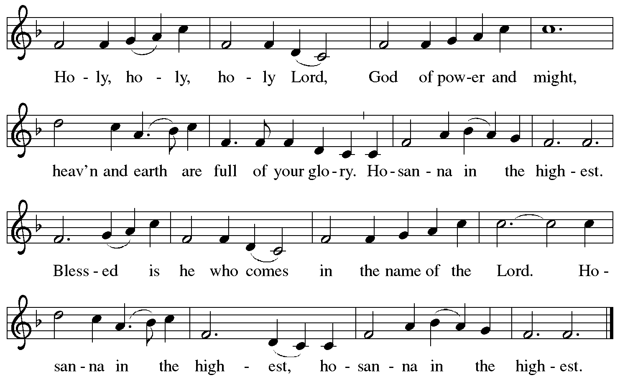

Eucharistic Prayer

P: Holy, mighty, and merciful Lord …
… be all honor and glory, now and forever.
C: Amen.

Lord’s Prayer

P: Gathered as one by the Holy Spirit, let us pray as Jesus taught us.
C: Our Father in heaven,
hallowed be your name,
your kingdom come,
your will be done,
on earth as in heaven.
Give us today our daily bread.
Forgive us our sins
as we forgive those
who sin against us.
Save us from the time of trial
and deliver us from evil.
For the kingdom, the power,
and the glory are yours,
now and forever. Amen.

Fraction and Invitation

Agnus Dei / Lamb of God ELW p. 208

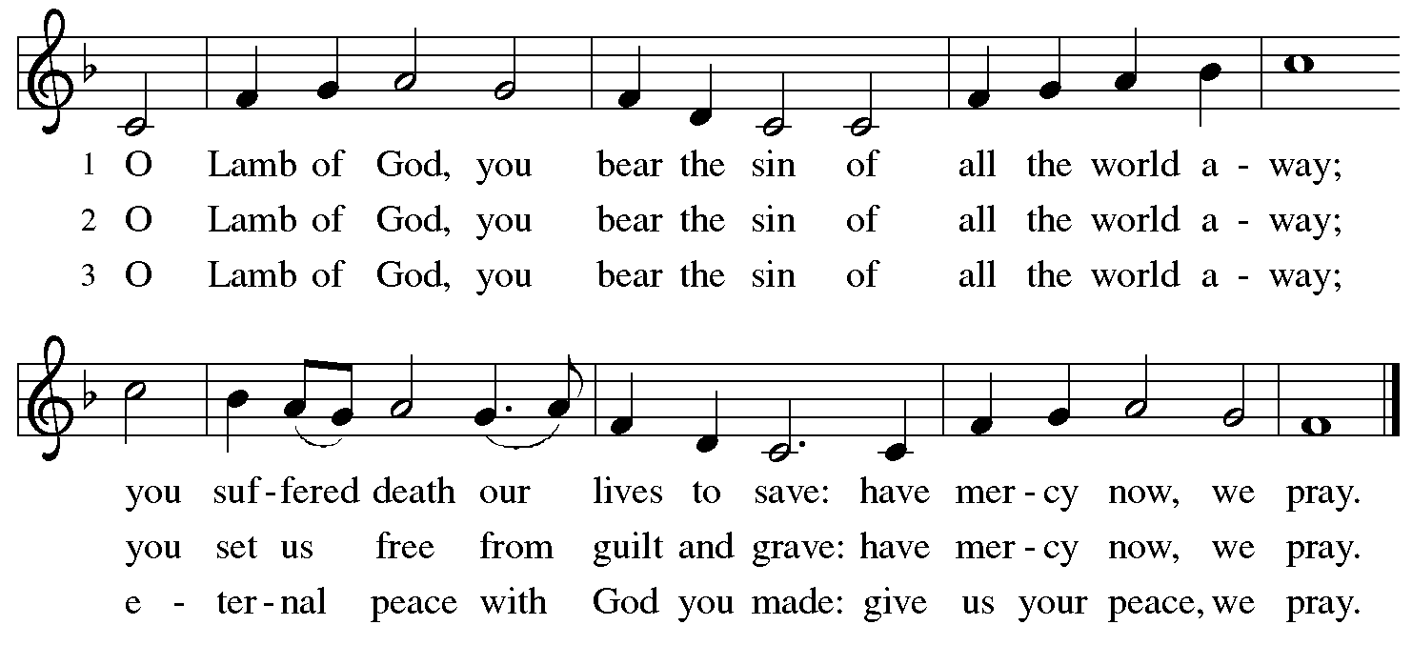

Please be seated.

Holy Communion
- Hand sanitizer is available if you would like to use it prior to receiving Communion.
- Worshipers from the pulpit side will proceed forward first, followed by the center section, and then the lectern side.
- The Communion wafers (regular and gluten-free) have been thoughtfully prepared using the gifts of the congregation by a member of St. Andrew’s altar care team, with a drop of wine or grape juice on each. The presiding minister will distribute one to each communicant.
- When you reach the presiding minister, please indicate if you would like grape juice or a gluten-free wafer.
- A blessing will be provided for anyone who does not yet receive the sacrament.
- Cushions have been placed at the altar rail for anyone who would like to kneel for prayer and reflection before returning to their pew.

Hymns during Holy Communion
Bread of Life, Our Host and Meal ELW 464

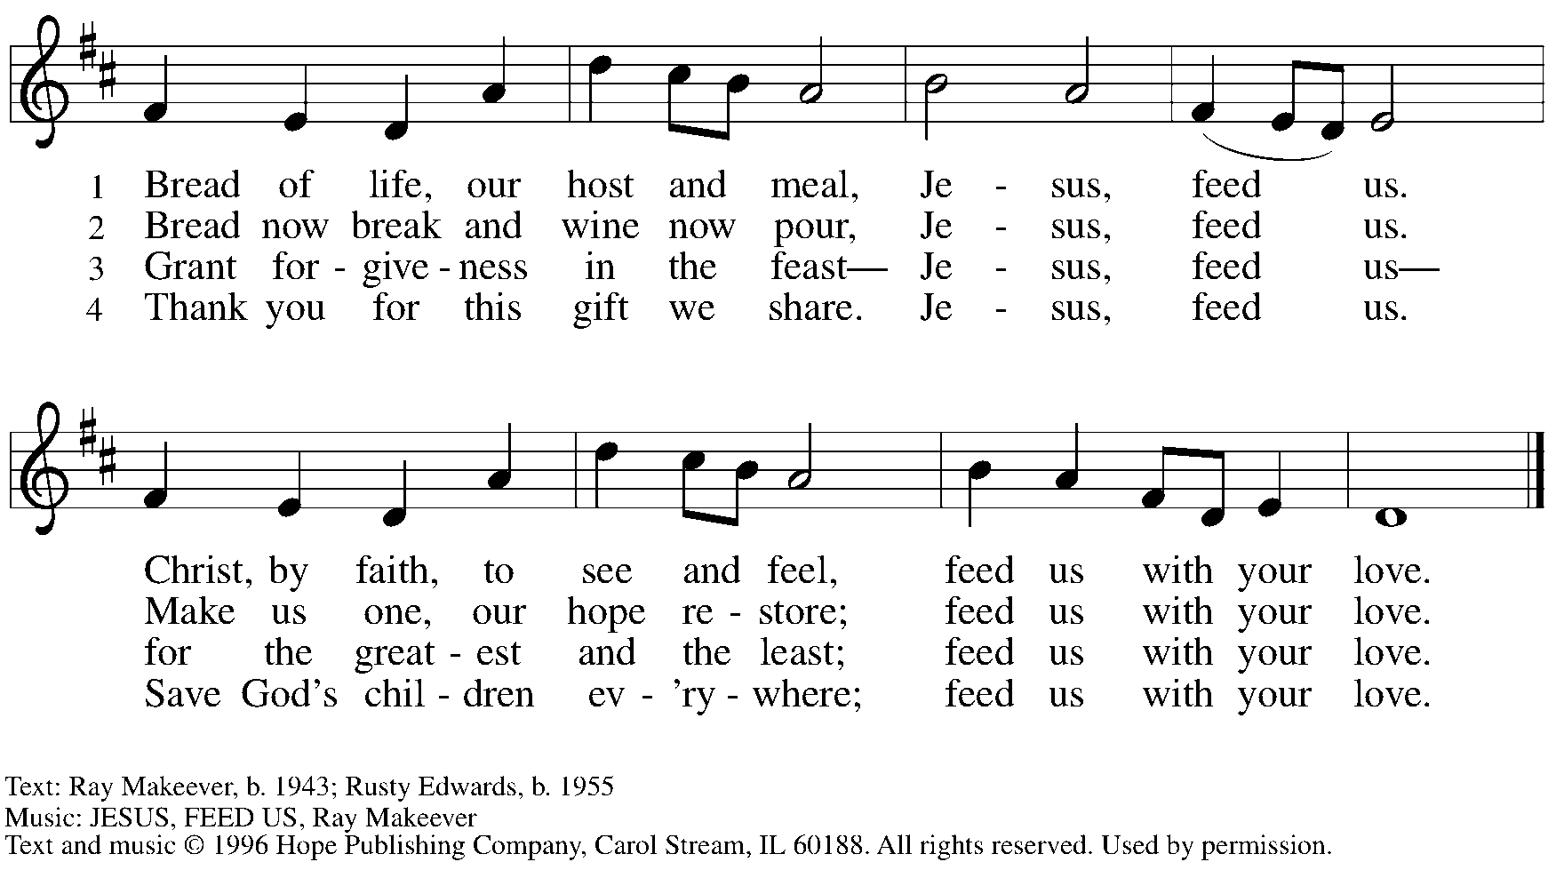
Reprinted with permission under OneLicense.net # A-722139.

Hymns during Holy Communion
Come Down, O Love Divine ELW 804

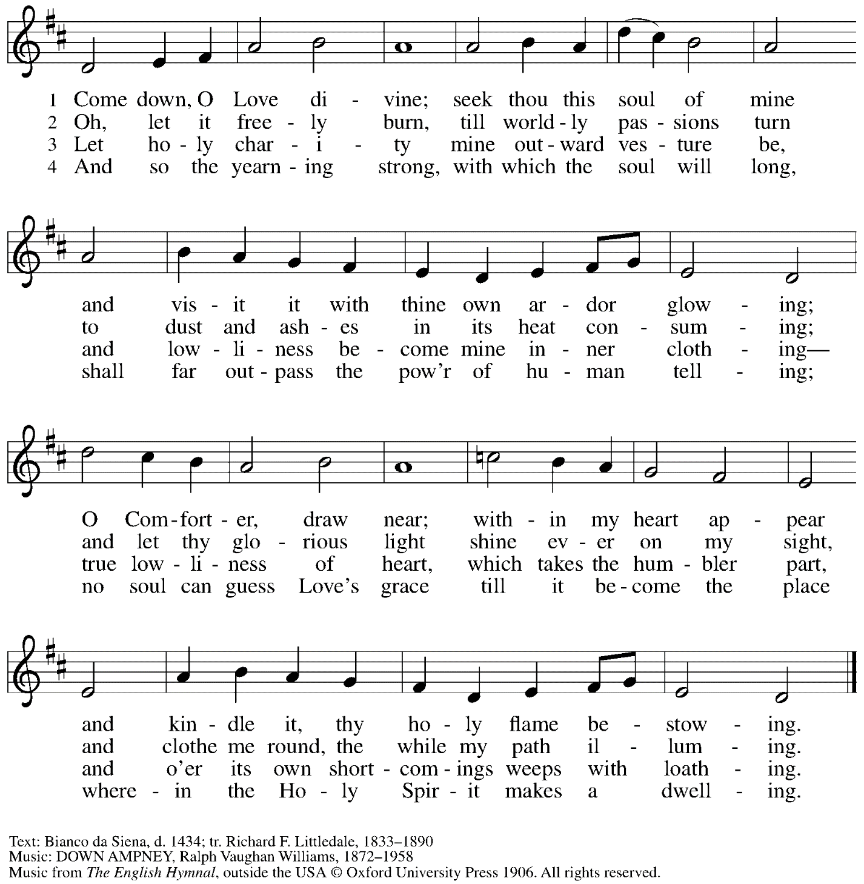
Reprinted with permission under OneLicense.net # A-722139.

When all have returned to their places, please rise as you are able.

Blessing

P: The body and blood of our Lord Jesus Christ strengthen you and keep you in his grace.
C: Amen.

Prayer

P: Let us pray. God of abundance, with this bread of life and cup of salvation you have united us with Christ, making us one with all your people. Now send us forth in the power of your Spirit, that we may proclaim your redeeming love to the world and continue forever in the risen life of Jesus Christ, our Lord.
C: Amen.

Please be seated.

Sending

Announcements

Please rise as you are able.

Benediction

P: God, the Author of life,
Christ, the living Cornerstone,
and the life-giving Spirit of adoption,
☩ bless you now and forever.
C: Amen.

Sending Hymn Go to the World! ACS 991
v. 1-2

1 Go to the world! Go into all the earth.
Go preach the cross where Christ renews life's worth,
baptizing as the sign of our rebirth.
Alleluia. Alleluia.

2 Go to the world! Go into ev'ry place.
Go live the word of God's redeeming grace.
Go seek God's presence in each time and space.
Alleluia. Alleluia.

Text: Sylvia G. Dunstan, 1955-1993. Music: SINE NOMINE, Ralph Vaughan Williams, 1872-1958. Text © 1991 GIA Publications, Inc. www.giamusic.com. Music © Oxford University Press. All rights reserved. Reprinted under OneLicense.net # A-722139.

Dismissal

P: Go in peace. Serve the Lord.
C: Thanks be to God.

Abbreviations

P: Pastor/Presiding Minister
L: Lector
C: Congregation

ELW: Evangelical Lutheran Worship hymnal
ACS: All Creation Sings hymnal

Those serving in worship today

Piano Jeff Denlinger
Cantor Ian Brown
Lector Joyce Compton
Presiding Minister Rev. Ross Carmichael

Liturgy and Hymnody Acknowledgements

From SundaysandSeasons.com. Copyright © 2022 Augsburg Fortress. All rights reserved. Reprinted under OneLicense.net # A-722139.
Used by permission of Augsburg Fortress.

