+ Fifth Sunday after Pentecost
July 10, 2022
St. Andrew Lutheran Church
304 Morewood Ave.
Pittsburgh, PA 15213
St_andrewELCA@verizon.net
www.standrewpittsburgh.org

+ Fifth Sunday after Pentecost
Order for Worship

To love the Lord your God with all your heart, soul, strength, and mind is to reflect God’s mercy in responding to one’s neighbor. That mercy found its most profound expression in the “gospel that has come to you”—namely the life, death, and resurrection of Jesus Christ.
That gospel mercy comes to us again today: at the font, at the table, and from the pulpit.
It is very near to you.

- Now that the Covid-19 transmission rates have reached the “low” category in Allegheny County, masks are optional for all worship attendees. That policy may need to change if the rates once again increase.
- Adult and child-sized masks will continue to be available at the entrances.
- Hand sanitizer is available at the front of the sanctuary to use before Holy Communion, after you proceed past the baptismal font, as the alcohol has been affecting the finish on the font’s bowl.

Worship Services are live streamed to multiple online platforms.
By attending worship, you agree that your image and voice may be broadcast.

Welcome to St. Andrew!
- A restroom is available on the main level of the church, through the doors to the Social Hall and to the right in the main office.
- After the Prayer of the Day, children are invited to gather in the Social Hall for Little Church; Big Faith, a Bible lesson and activity. The group returns to the worship space for the Communion portion of the service.

Welcome

Prelude

Gathering
The Holy Spirit calls us together as the people of God.

Confession and Forgiveness

P: Blessed be the holy Trinity, ☩ one God,
whose steadfast love endures forever.
C: Amen.

P: Let us confess our sin in the presence of God and of one another.

Silence is kept for reflection.

P: Merciful God,
C: we confess that we have not followed your path
but have chosen our own way.
Instead of putting others before ourselves,
we long to take the best seats at the table.
When met by those in need,
we have too often passed by on the other side.
Set us again on the path of life.
Save us from ourselves
and free us to love our neighbors.
Amen.

P: Hear the good news!
God does not deal with us according to our sins
but delights in granting pardon and mercy.
In the name of ☩ Jesus Christ, your sins are forgiven.
You are free to love as God loves.
C: Amen.

Gathering Hymn Lord, Whose Love in Humble Service ELW 712
v. 1, 3

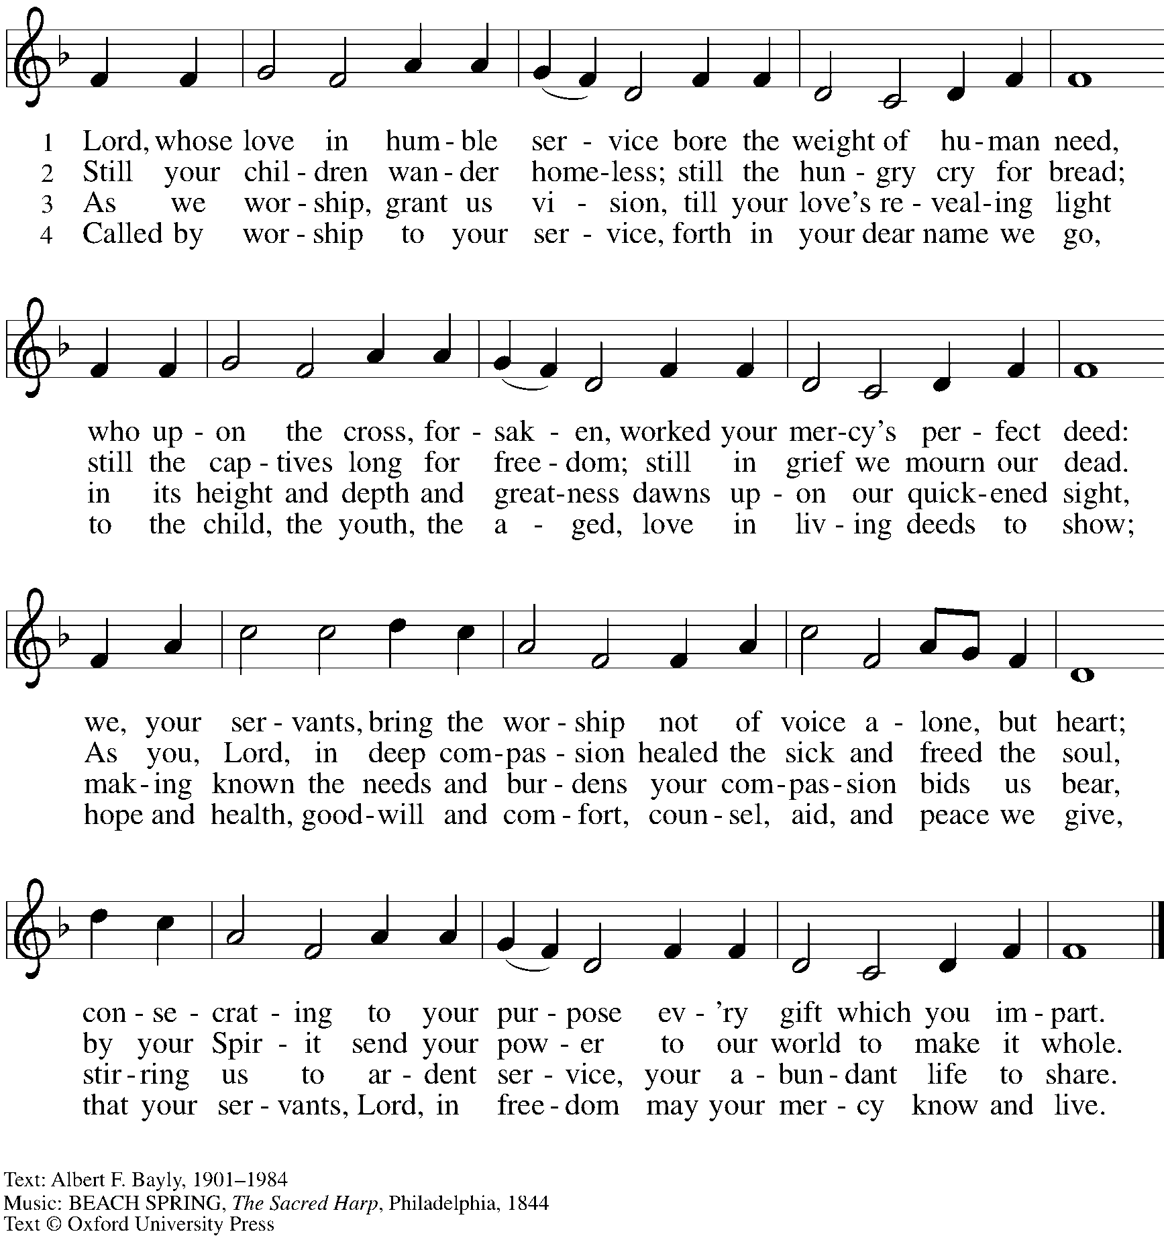
All rights reserved. Reprinted with permission under OneLicense.net # A-722139.

Greeting

P: The grace of our Lord Jesus Christ, the love of God,
and the communion of the Holy Spirit be with you all.
C: And also with you.

Prayer of the Day

P: Let us pray.
O Lord God, your mercy delights us, and the world longs for your loving care.
Hear the cries of everyone in need, and turn our hearts to love our neighbors
with the love of your Son, Jesus Christ, our Savior and Lord.
C: Amen.

Please be seated.
Children are invited to move to the Social Hall for Little Church; Big Faith.

Word
God speaks to us in Scripture reading, preaching, and song

First Reading – Deuteronomy 30: 9-14

⁹The Lord your God will make you abundantly prosperous in all your undertakings, in the fruit of your body, in the fruit of your livestock, and in the fruit of your soil. For the Lord will again take delight in prospering you, just as the Lord delighted in prospering your ancestors, ¹⁰when you obey the Lord your God by observing God’s commandments and decrees that are written in this book of the law, because you turn to the Lord your God with all your heart and with all your soul.
¹¹Surely, this commandment that I am commanding you today is not too hard for you, nor is it too far away. ¹²It is not in heaven, that you should say, “Who will go up to heaven for us, and get it for us so that we may hear it and observe it?” ¹³Neither is it beyond the sea, that you should say, “Who will cross to the other side of the sea for us, and get it for us so that we may hear it and observe it?” ¹⁴No, the word is very near to you; it is in your mouth and in your heart for you to observe.
L: Word of God, word of life.
C: Thanks be to God.

Please rise as you are able.

Gospel Acclamation

C: Alleluia. You shall love the Lord your God with all your heart,
and your neighbor as yourself. Alleluia.

Gospel – Luke 10: 25-37

P: The holy Gospel according to St. Luke.
C: Glory to you, O Lord.

²⁵Just then a lawyer stood up to test Jesus. “Teacher,” he said, “what must I do to inherit eternal life?” ²⁶He said to him, “What is written in the law? What do you read there?” ²⁷He answered, “You shall love the Lord your God with all your heart, and with all your soul, and with all your strength, and with all your mind; and your neighbor as yourself.” ²⁸And he said to him, “You have given the right answer; do this, and you will live.”
²⁹But wanting to justify himself, he asked Jesus, “And who is my neighbor?” ³⁰Jesus replied, “A man was going down from Jerusalem to Jericho, and fell into the hands of robbers, who stripped him, beat him, and went away, leaving him half dead. ³¹Now by chance a priest was going down that road; and when he saw him, he passed by on the other side. ³²So likewise a Levite, when he came to the place and saw him, passed by on the other side. ³³But a Samaritan while traveling came near him; and when he saw him, he was moved with pity. ³⁴He went to him and bandaged his wounds, having poured oil and wine on them. Then he put him on his own animal, brought him to an inn, and took care of him. ³⁵The next day he took out two denarii, gave them to the innkeeper, and said, ‘Take care of him; and when I come back, I will repay you whatever more you spend.’ ³⁶Which of these three, do you think, was a neighbor to the man who fell into the hands of the robbers?” ³⁷He said, “The one who showed him mercy.” Jesus said to him, “Go and do likewise.”

P: The Gospel of the Lord.
C: Praise to you, O Christ.

Please be seated.

Sermon

A time of silence for prayer and reflection follows the sermon.
When the hymn of the day begins, please rise as you are able.

Hymn of the Day O Christ, Your Heart, Compassionate Following Page

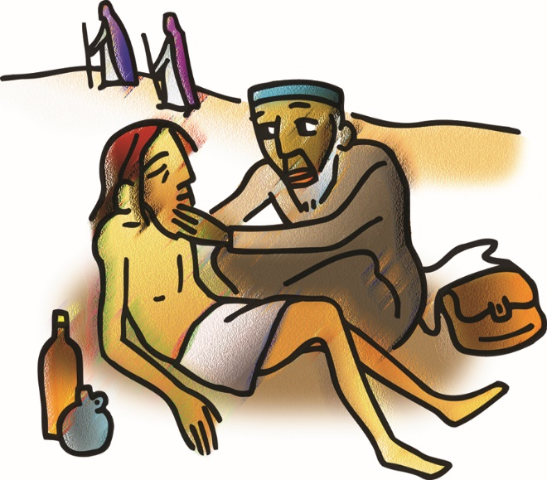

Hymn of the Day O Christ, Your Heart, Compassionate ELW 722
v. 1-2

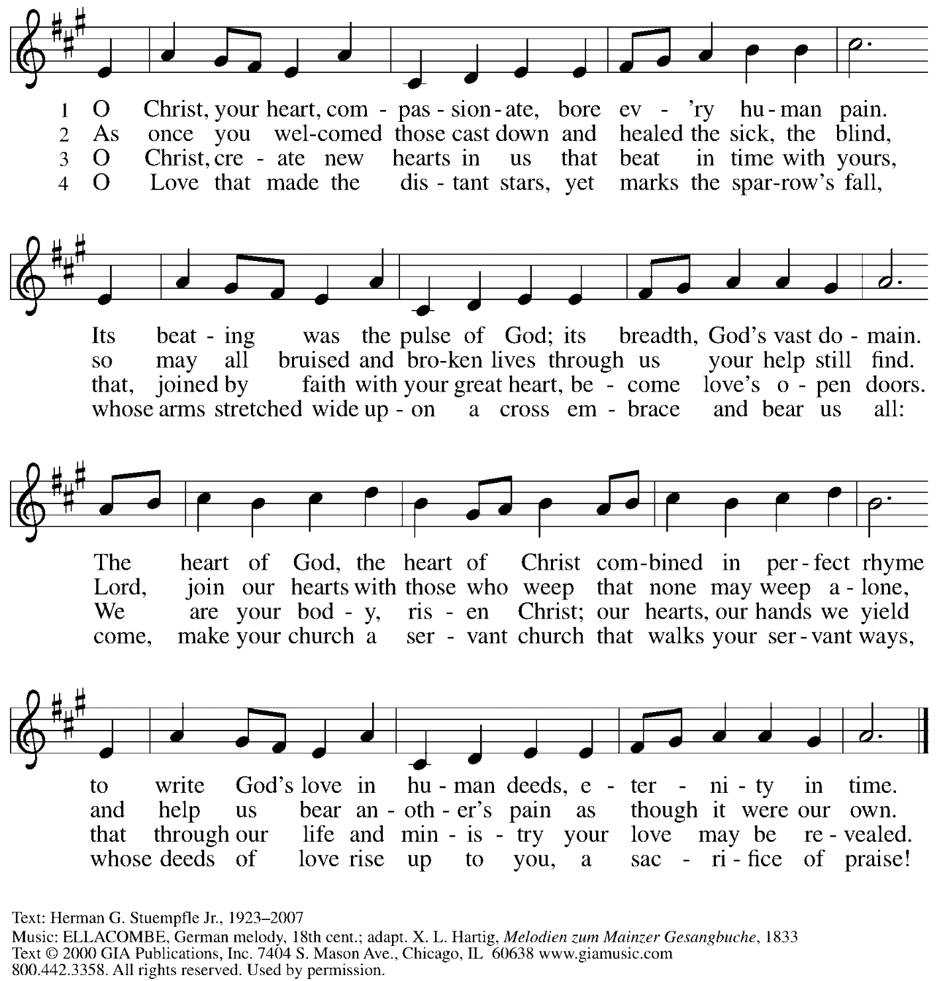
Reprinted with permission under OneLicense.net # A-722139.

Prayers of the People

P: United in Christ and guided by the Spirit,
we pray for the church, the world, and all who are in need.

After each petition
P: God of grace,
C: receive our prayer.

P: God of every time and place, we offer these prayers and those of our hearts to you,
in Jesus’ name.
C: Amen.

Please be seated.

Meal

Offering

We offer ourselves, our gifts, and our faithful service to God.
An usher will pass around an offering plate for anyone who would like to offer gifts before God.

Music during the Offering

Please rise as you are able.

Offertory Song Accept, O Lord, the Gifts We Bring ELW 691
v. 1-2

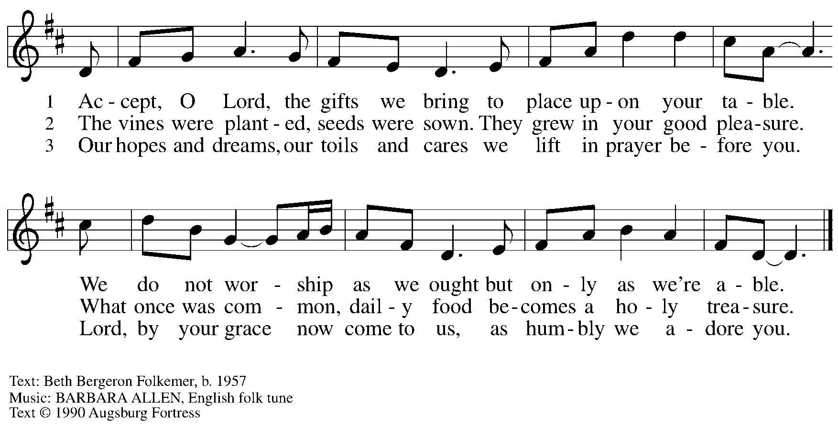
All rights reserved. Reprinted with permission under OneLicense.net # A-722139.

Offertory Prayer

P: Let us pray. Holy God, gracious and merciful,
C: you bring forth food from the earth and nourish your whole creation.
Turn our hearts toward those who hunger in any way, that all may know your care;
and prepare us now to feast on the bread of life, Jesus Christ, our Savior and Lord.
Amen.

Dialogue

P: The Lord be with you.
C: And also with you.

P: Lift up your hearts.
C: We lift them to the Lord.

P: Let us give thanks to the Lord our God.
C: It is right to give our thanks and praise.

Preface

P: It is indeed right, our duty and our joy,
that we should at all times and in all places
give thanks and praise to you, almighty and merciful God,
through our Savior Jesus Christ;
who on this day overcame death and the grave,
and by his glorious resurrection opened to us the way of everlasting life.
And so, with all the choirs of angels,
with the church on earth and the hosts of heaven,
we praise your name and join their unending hymn:

Sanctus

Holy, holy, holy Lord,
God of power and might:
Heaven and earth are full of your glory.
Hosanna in the highest.
Blessed is the one who comes in the name of the Lord.
Hosanna in the highest.

Eucharistic Prayer

P: Holy God, holy and mighty, holy and immortal …
… Do this for the remembrance of me.

Together as the body of Christ, we proclaim the Lord’s death until he comes.
C: Christ has died.
Christ has risen.
Christ will come again.

P: With this bread and cup we remember your Son …
… all our sins and sorrows will be no mor
C: Amen. Come, Lord Jesus.

P: Holy God, holy and merciful one, holy and compassionate …
… sharing your bounty with all the world.
C: Amen. Come, Holy Spirit.

P: Holy and benevolent God …
… with the Holy Spirit, in your holy church, now and forever.
C: Amen.

Lord’s Prayer

P: Gathered as one by the Holy Spirit, let us pray as Jesus taught us.
C: Our Father in heaven,
hallowed be your name,
your kingdom come,
your will be done,
on earth as in heaven.
Give us today our daily bread.
Forgive us our sins
as we forgive those
who sin against us.
Save us from the time of trial
and deliver us from evil.
For the kingdom, the power,
and the glory are yours,
now and forever. Amen.

Fraction and Invitation

Agnus Dei / Lamb of God

Lamb of God, you take away the sin of the world; have mercy on us.
Lamb of God, you take away the sin of the world; have mercy on us.
Lamb of God, you take away the sin of the world; grant us peace.

Please be seated.

Holy Communion
- Hand sanitizer is available if you would like to use it prior to receiving Communion.
- Worshipers from the pulpit side will proceed forward first, followed by the center section, and then the lectern side.
- The Communion wafers (regular and gluten-free) have been thoughtfully prepared using the gifts of the congregation by a member of St. Andrew’s altar care team, with a drop of wine or grape juice on each. The presiding minister will distribute one to each communicant.
- When you reach the presiding minister, please indicate if you would like grape juice or a gluten-free wafer.
- A blessing will be provided for anyone who does not yet receive the sacrament.
- Cushions have been placed at the altar rail for anyone who would like to kneel for prayer and reflection before returning to their pew.

Hymns during Holy Communion
By Your Hand You Feed Your People Following Page

Hymns during Holy Communion
By Your Hand You Feed Your People ELW 469

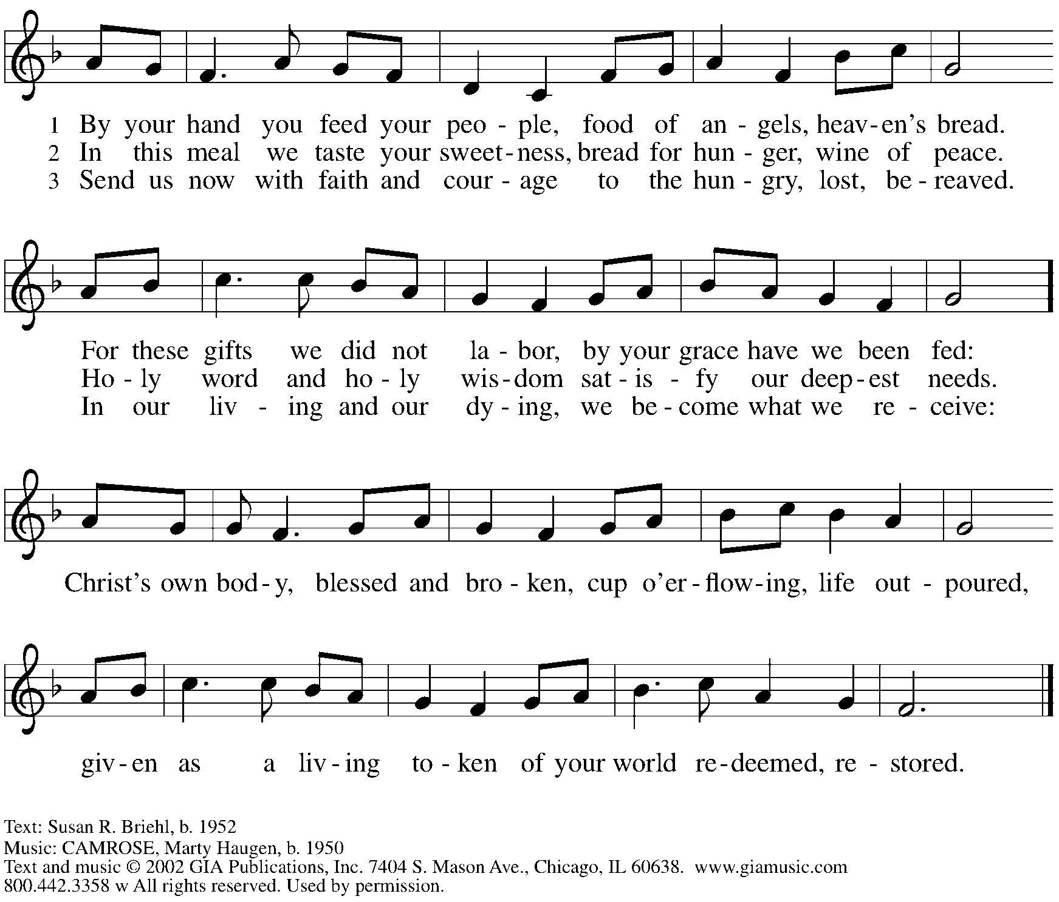
Reprinted with permission under OneLicense.net # A-722139.

Hymns during Holy Communion
Spirit of God, Descend upon My Heart ELW 800

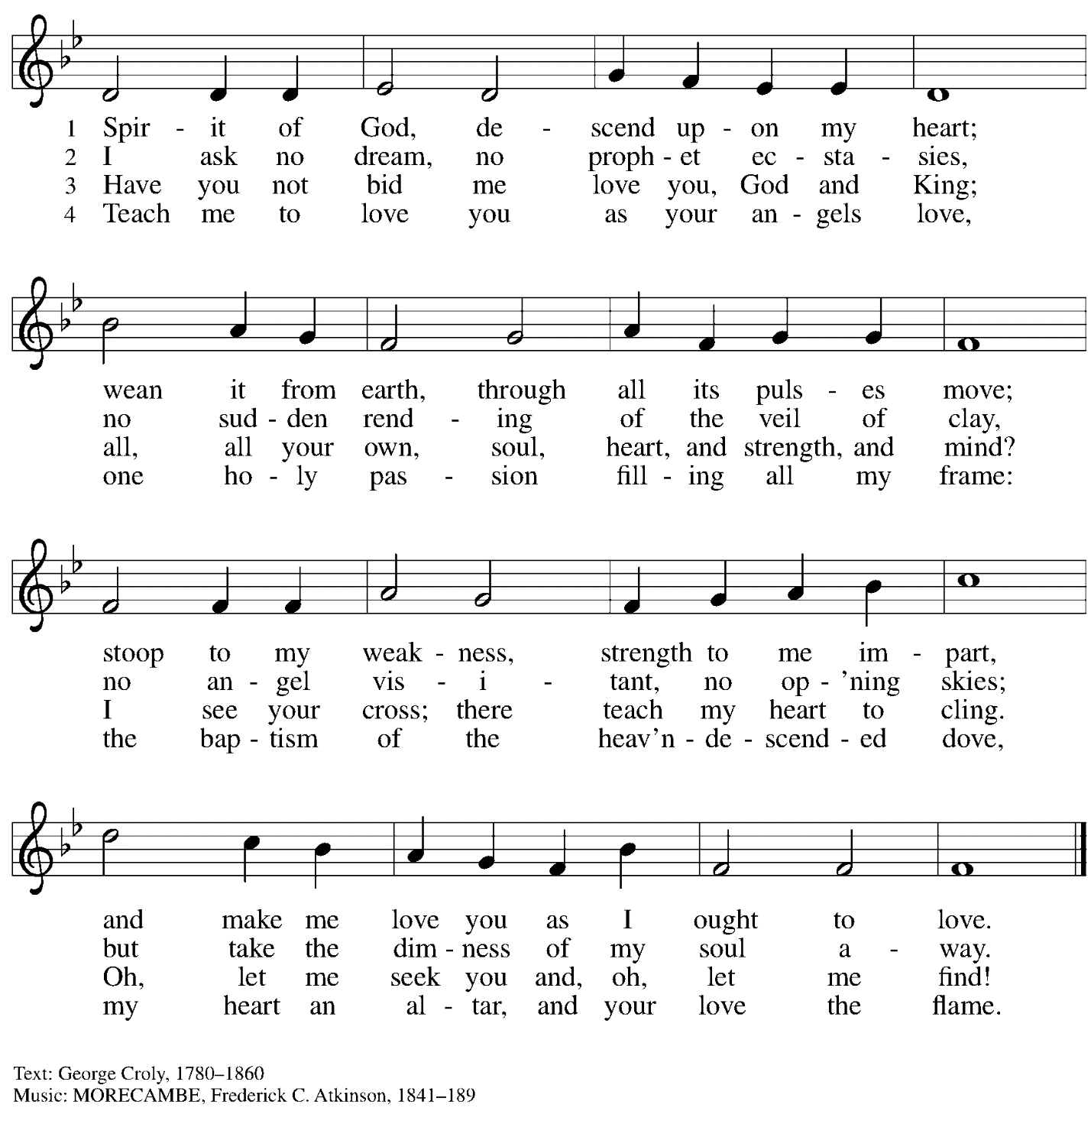

When all have returned to their places, please rise as you are able.

Blessing

P: The body and blood of our Lord Jesus Christ strengthen you and keep you in his grace.
C: Amen.

Prayer

P: Let us pray.
Life-giving God,
through this meal you have bandaged our wounds
and fed us with your mercy.
Now send us forth to live for others,
both friend and stranger,
that all may come to know your love.
This we pray in the name of Jesus.
C: Amen.

Please be seated.

Sending

Announcements

Please rise as you are able.

Benediction

P: The God ☩ of peace,
bless you, comfort you,
and show you the path of life,
this day and always.
C: Amen.

Sending Hymn The Lord Now Sends Us Forth Following Page

Sending Hymn The Lord Now Sends Us Forth ELW 538

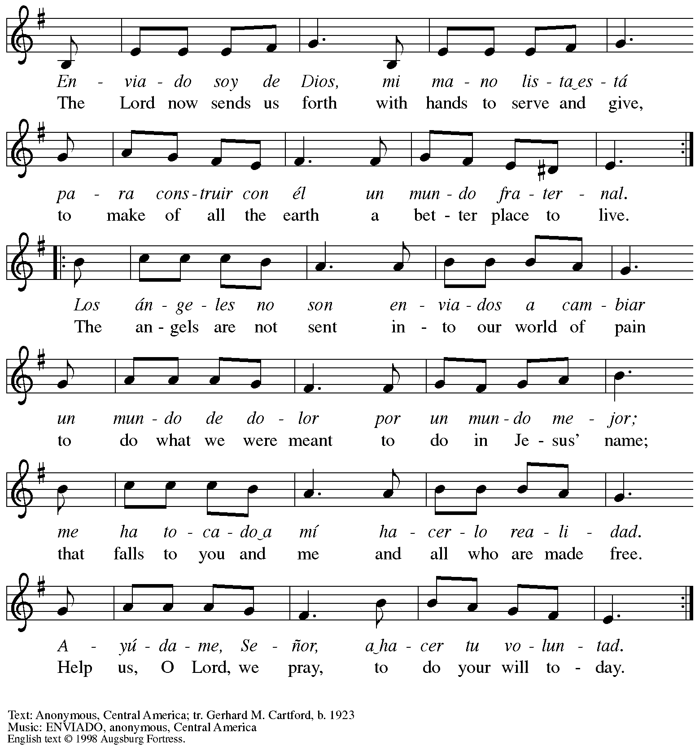
All rights reserved. Reprinted with permission under Onelicense.net # A-722139.

Dismissal

P: Go in peace. Serve the Lord.
C: Thanks be to God!

Abbreviations

P: Pastor/Presiding Minister
L: Lector
C: Congregation

ELW: Evangelical Lutheran Worship hymnal
ACS: All Creation Sings hymnal

Those serving in worship today

Piano Jeff Denlinger
Cantor Timothy Kocher-Hillmer
Lector Lester Prince
Presiding Minister Rev. Ross Carmichael

Liturgy and Hymnody Acknowledgements

From SundaysandSeasons.com. Copyright © 2022 Augsburg Fortress. All rights reserved. Reprinted under OneLicense.net # A-722139.
Used by permission of Augsburg Fortress.

