+ Sixth Sunday after Pentecost
July 17, 2022
St. Andrew Lutheran Church
304 Morewood Ave.
Pittsburgh, PA 15213
St_andrewELCA@verizon.net
www.standrewpittsburgh.org

+ Sixth Sunday after Pentecost
Order for Worship

The church at its best is an attentive, listening body. God urges the faithful, again and again,
to “listen up” – to heed the divine Word that gives life.
So it was with Abraham and Sarah and Mary and Martha;
so it is today as we gather in assembly to hear the Word of God, the word of life.

- Now that the Covid-19 transmission rates have reached the “low” category in Allegheny County, masks are optional for all worship attendees. That policy may need to change if the rates once again increase.
- Adult and child-sized masks will continue to be available at the entrances.
- Hand sanitizer is available at the front of the sanctuary to use before Holy Communion, after you proceed past the baptismal font, as the alcohol has been affecting the finish on the font’s bowl.

Worship Services are live streamed to multiple online platforms.
By attending worship, you agree that your image and voice may be broadcast.

Welcome to St. Andrew!
- A restroom is available on the main level of the church, through the doors to the Social Hall and to the right in the main office.
- After the Prayer of the Day, children are invited to gather in the Social Hall for Little Church; Big Faith, a Bible lesson and activity. The group returns to the worship space for the Communion portion of the service.

Welcome

Prelude

Gathering
The Holy Spirit calls us together as the people of God.

Confession and Forgiveness

P: Blessed be the holy Trinity, ☩ one God,
whose steadfast love endures forever.
C: Amen.

P: Let us confess our sin in the presence of God and of one another.

Silence is kept for reflection.

P: Merciful God,
C: we confess that we have not followed your path
but have chosen our own way.
Instead of putting others before ourselves,
we long to take the best seats at the table.
When met by those in need,
we have too often passed by on the other side.
Set us again on the path of life.
Save us from ourselves
and free us to love our neighbors.
Amen.

P: Hear the good news!
God does not deal with us according to our sins
but delights in granting pardon and mercy.
In the name of ☩ Jesus Christ, your sins are forgiven.
You are free to love as God loves.
C: Amen.

Gathering Hymn Open Your Ears, You Faithful People ELW 519

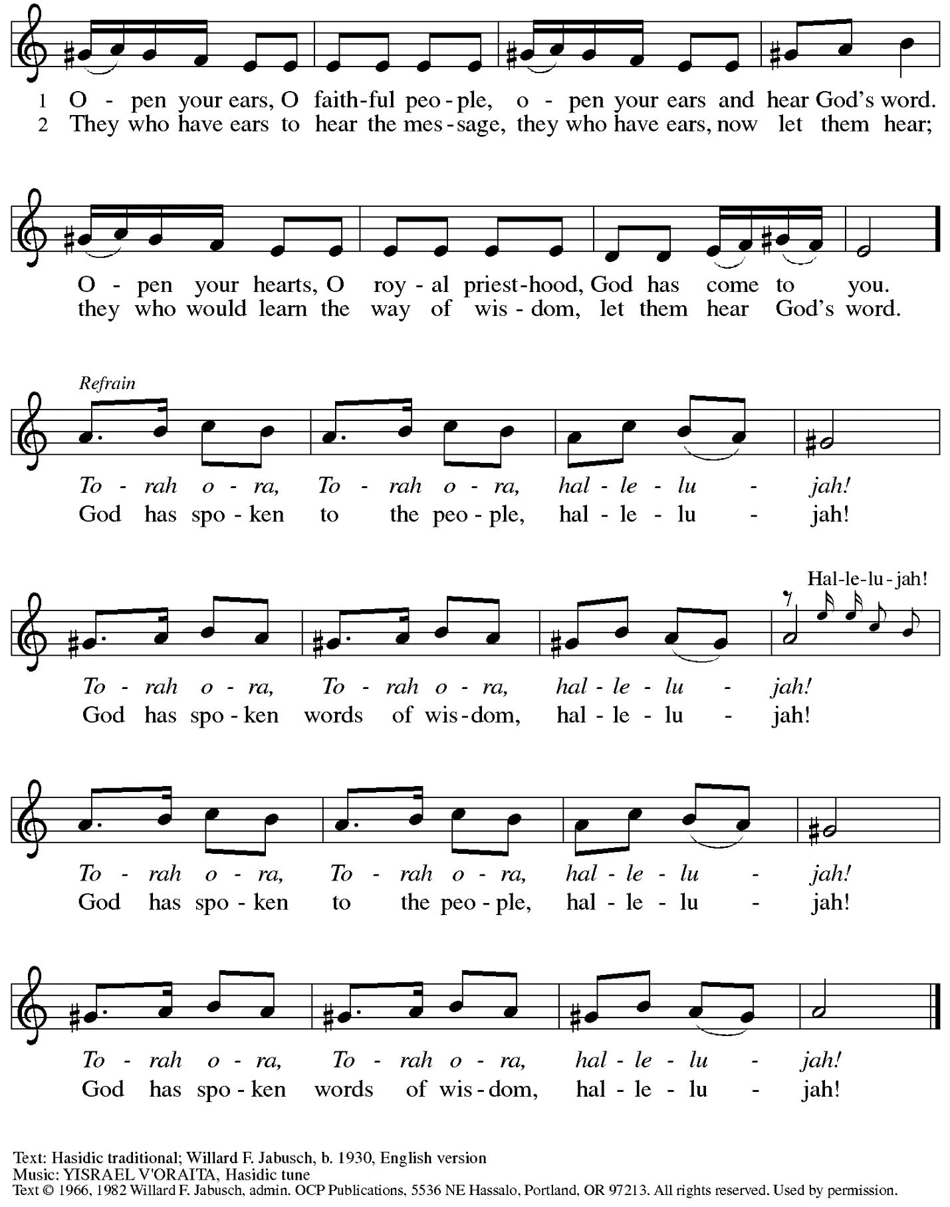
Reprinted under OnceLicense.net # A-722139.
Greeting

P: The grace of our Lord Jesus Christ, the love of God,
and the communion of the Holy Spirit be with you all.
C: And also with you.

Prayer of the Day

P: Let us pray.
Eternal God, you draw near to us in Christ, and you make yourself our guest.
Amid the cares of our lives, make us attentive to your presence,
that we may treasure your word above all else, through Jesus Christ, our Savior and Lord.
C: Amen.

Please be seated.
Children are invited to move to the Social Hall for Little Church; Big Faith.

Word
God speaks to us in Scripture reading, preaching, and song

First Reading – Genesis 18: 1-10a

¹The Lord appeared to Abraham by the oaks of Mamre, as he sat at the entrance of his tent in the heat of the day. ²He looked up and saw three men standing near him. When he saw them, he ran from the tent entrance to meet them, and bowed down to the ground. ³He said, “My lord, if I find favor with you, do not pass by your servant. ⁴Let a little water be brought, and wash your feet, and rest yourselves under the tree. ⁵Let me bring a little bread, that you may refresh yourselves, and after that you may pass on—since you have come to your servant.” So they said, “Do as you have said.” ⁶And Abraham hastened into the tent to Sarah, and said, “Make ready quickly three measures of choice flour, knead it, and make cakes.” ⁷Abraham ran to the herd, and took a calf, tender and good, and gave it to the servant, who hastened to prepare it. ⁸Then he took curds and milk and the calf that he had prepared, and set it before them; and he stood by them under the tree while they ate.
⁹They said to him, “Where is your wife Sarah?” And he said, “There, in the tent.” ^{10a}Then one said, “I will surely return to you in due season, and your wife Sarah shall have a son.”

L: Word of God, word of life.
C: Thanks be to God.

Please rise as you are able.

Gospel Acclamation

C: Alleluia. Blessed are those who hold the word fast in an honest and good heart,
and bear fruit with patient endurance. Alleluia.

Gospel – Luke 10: 38-42

P: The holy Gospel according to St. Luke.
C: Glory to you, O Lord.

³⁸Now as [Jesus and his disciples] went on their way, he entered a certain village, where a woman named Martha welcomed him into her home. ³⁹She had a sister named Mary, who sat at the Lord’s feet and listened to what he was saying. ⁴⁰But Martha was distracted by her many tasks; so she came to him and asked, “Lord, do you not care that my sister has left me to do all the work by myself? Tell her then to help me.” ⁴¹But the Lord answered her, “Martha, Martha, you are worried and distracted by many things; ⁴²there is need of only one thing. Mary has chosen the better part, which will not be taken away from her.”

P: The Gospel of the Lord.
C: Praise to you, O Christ.

Please be seated.

Sermon

A time of silence for prayer and reflection follows the sermon.
When the hymn of the day begins, please rise as you are able.

Hymn of the Day Word of God, Come Down on Earth Following Page

Hymn of the Day Word of God, Come Down on Earth ELW 510

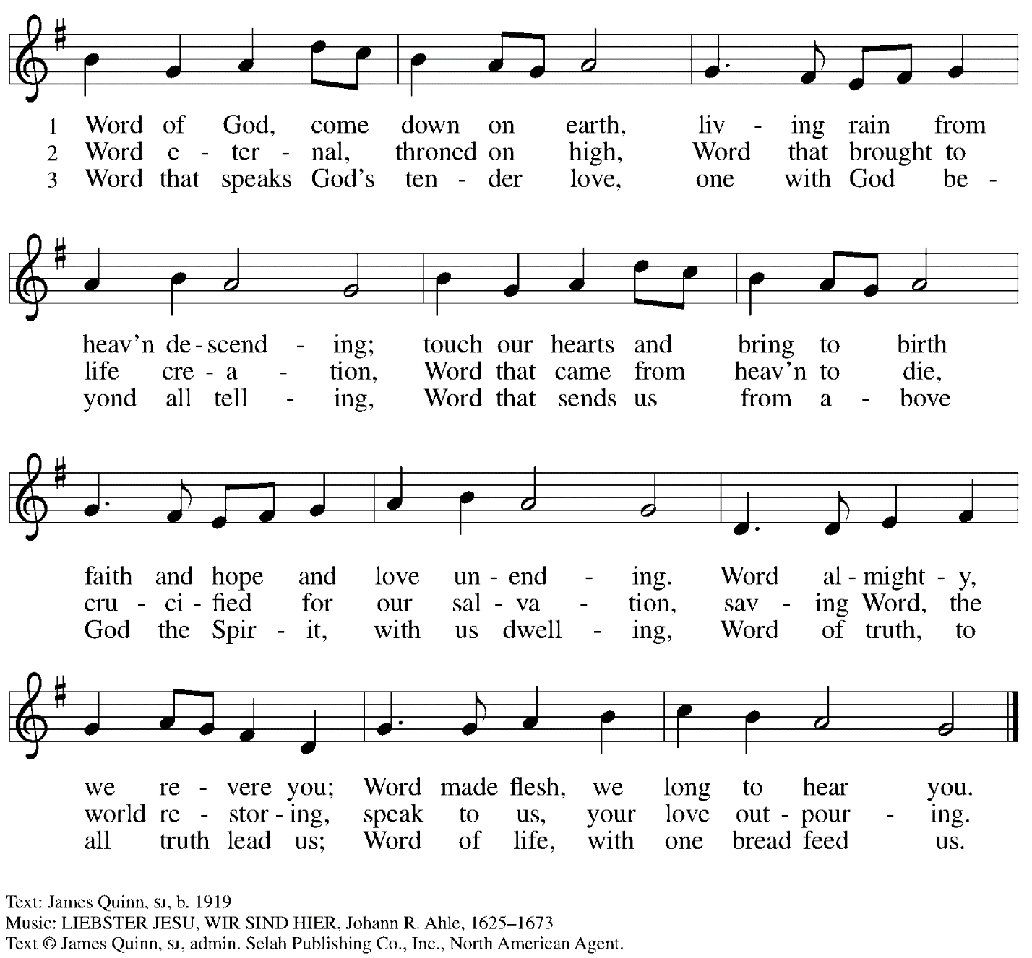
All rights reserved. Reprinted under OneLicense.net # A-722139.

Prayers of the People

P: United in Christ and guided by the Spirit,
we pray for the church, the world, and all who are in need.

After each petition
P: God of grace,
C: receive our prayer.

P: God of every time and place, we offer these prayers and those of our hearts to you,
in Jesus’ name.
C: Amen.

Please be seated.

Meal

Offering

We offer ourselves, our gifts, and our faithful service to God.
An usher will pass around an offering plate for anyone who would like to offer gifts before God.

Music during the Offering

Please rise as you are able.

Offertory Song Accept, O Lord, the Gifts We Bring ELW 691
v. 1-2

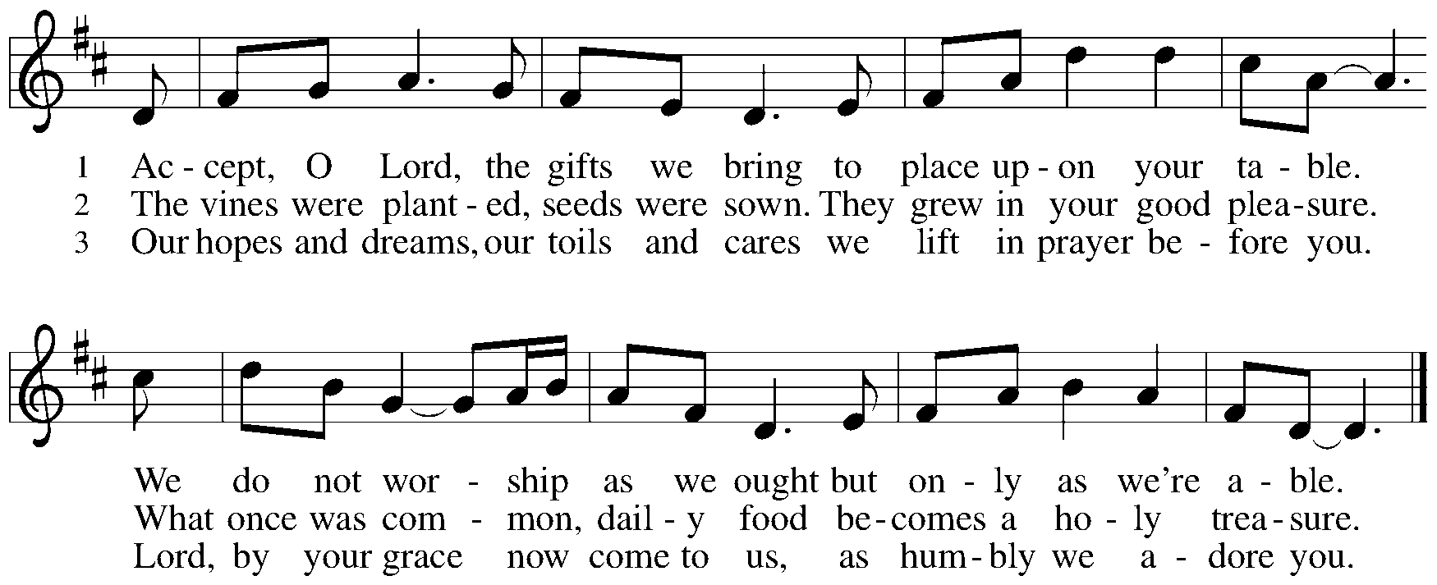

Offertory Prayer

P: Let us pray. Holy God, gracious and merciful,
C: you bring forth food from the earth and nourish your whole creation.
Turn our hearts toward those who hunger in any way, that all may know your care;
and prepare us now to feast on the bread of life, Jesus Christ, our Savior and Lord.
Amen.

Dialogue

P: The Lord be with you.
C: And also with you.

P: Lift up your hearts.
C: We lift them to the Lord.

P: Let us give thanks to the Lord our God.
C: It is right to give our thanks and praise.

Preface

P: It is indeed right, our duty and our joy,
that we should at all times and in all places
give thanks and praise to you, almighty and merciful God,
through our Savior Jesus Christ;
who on this day overcame death and the grave,
and by his glorious resurrection opened to us the way of everlasting life.
And so, with all the choirs of angels,
with the church on earth and the hosts of heaven,
we praise your name and join their unending hymn:

Sanctus

Holy, holy, holy Lord,
God of power and might:
Heaven and earth are full of your glory.
Hosanna in the highest.
Blessed is the one who comes in the name of the Lord.
Hosanna in the highest.

Eucharistic Prayer

P: Holy God, holy and mighty, holy and immortal …
… Do this for the remembrance of me.

Together as the body of Christ, we proclaim the Lord’s death until he comes.
C: Christ has died.
Christ has risen.
Christ will come again.

P: With this bread and cup we remember your Son …
… all our sins and sorrows will be no more.
C: Amen. Come, Lord Jesus.

P: Holy God, holy and merciful one, holy and compassionate …
… sharing your bounty with all the world.
C: Amen. Come, Holy Spirit.

P: Holy and benevolent God …
… with the Holy Spirit, in your holy church, now and forever.
C: Amen.

Lord’s Prayer

P: Gathered as one by the Holy Spirit, let us pray as Jesus taught us.
C: Our Father in heaven,
hallowed be your name,
your kingdom come,
your will be done,
on earth as in heaven.
Give us today our daily bread.
Forgive us our sins
as we forgive those
who sin against us.
Save us from the time of trial
and deliver us from evil.
For the kingdom, the power,
and the glory are yours,
now and forever. Amen.

Fraction and Invitation

Agnus Dei / Lamb of God

Lamb of God, you take away the sin of the world; have mercy on us.
Lamb of God, you take away the sin of the world; have mercy on us.
Lamb of God, you take away the sin of the world; grant us peace.

Please be seated.

Holy Communion
- Hand sanitizer is available if you would like to use it prior to receiving Communion.
- Worshipers from the pulpit side will proceed forward first, followed by the center section, and then the lectern side.
- The Communion wafers (regular and gluten-free) have been thoughtfully prepared using the gifts of the congregation by a member of St. Andrew’s altar care team, with a drop of wine or grape juice on each. The presiding minister will distribute one to each communicant.
- When you reach the presiding minister, please indicate if you would like grape juice or a gluten-free wafer.
- A blessing will be provided for anyone who does not yet receive the sacrament.
- Cushions have been placed at the altar rail for anyone who would like to kneel for prayer and reflection before returning to their pew.
- Everyone is asked to wait until you return to your place to consume the elements, and then promptly replace your mask.

Hymns during Holy Communion
Jesus, the Very Thought of You ELW 754

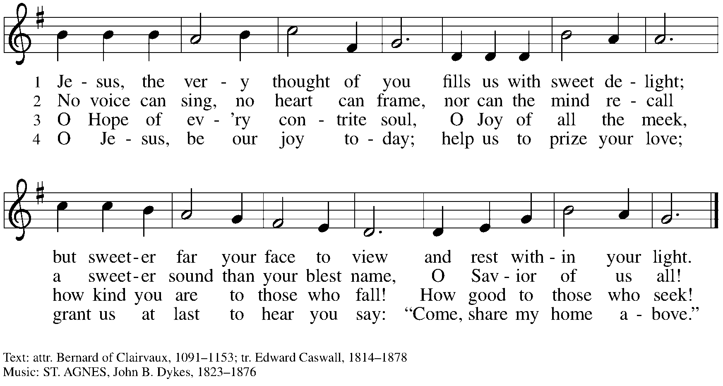

Hymns during Holy Communion
We Eat the Bread of Teaching ELW 518

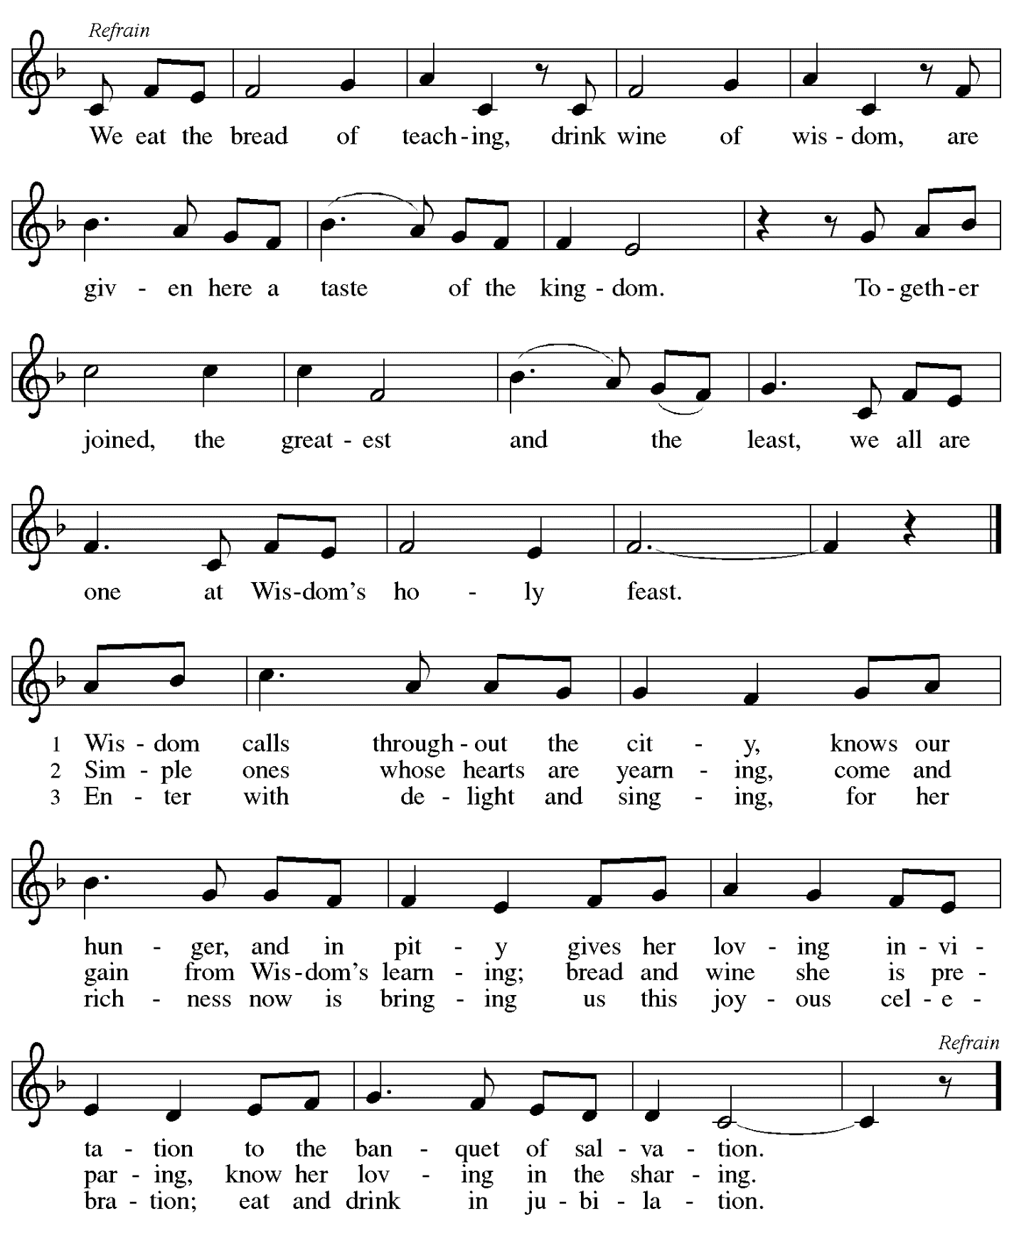

When all have returned to their places, please rise as you are able.

Blessing

P: The body and blood of our Lord Jesus Christ strengthen you and keep you in his grace.
C: Amen.

Prayer

P: Let us pray.
Life-giving God,
through this meal you have bandaged our wounds
and fed us with your mercy.
Now send us forth to live for others,
both friend and stranger,
that all may come to know your love.
This we pray in the name of Jesus.
C: Amen.

Please be seated.

Sending

Announcements

Please rise as you are able.

Benediction

P: The God ☩ of peace,
bless you, comfort you,
and show you the path of life
this day and always.
C: Amen.

Sending Hymn How Clear Is Our Vocation, Lord ELW 580

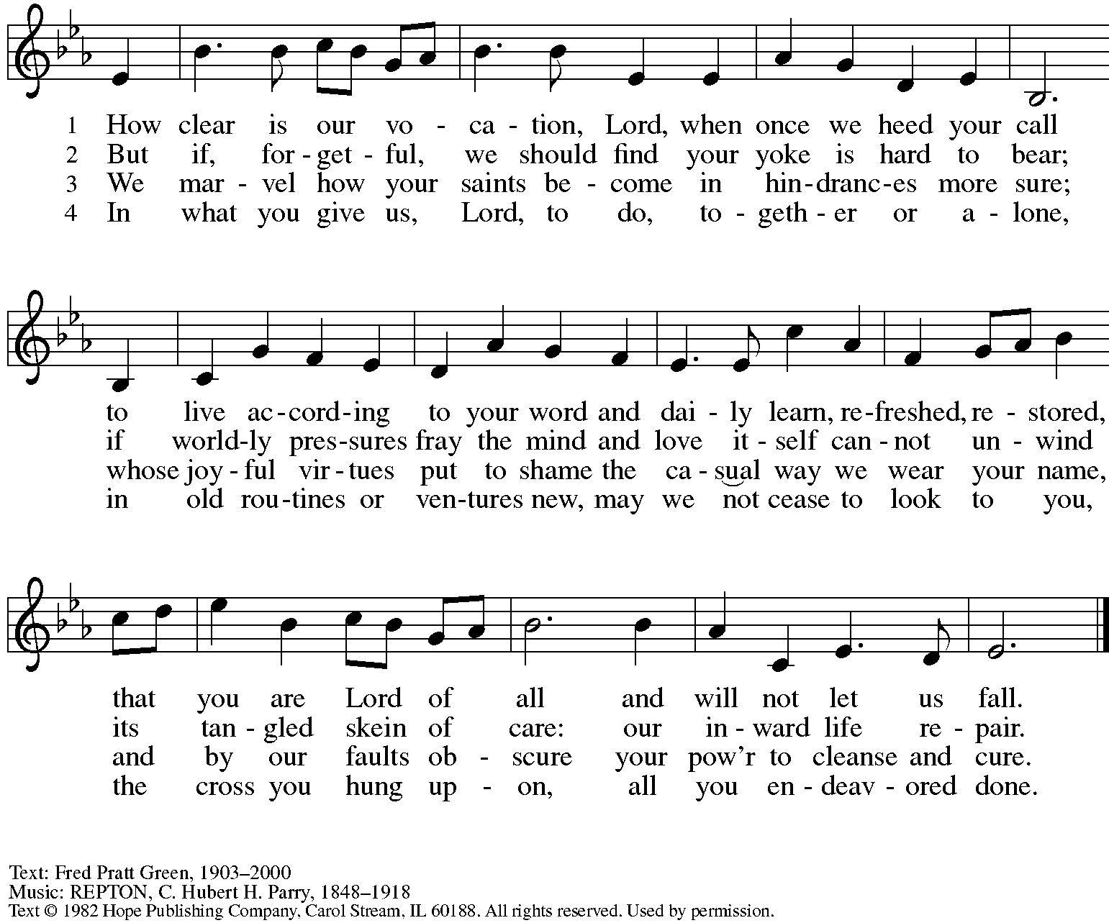
Reprinted with permission under OneLicense.net # A-722139.

Dismissal

P: Go in peace. Serve the Lord.
C: Thanks be to God!

Abbreviations

P: Pastor/Presiding Minister
L: Lector
C: Congregation

ELW: Evangelical Lutheran Worship hymnal
ACS: All Creation Sings hymnal

Those serving in worship today

Organ Jimmi Kocher-Hillmer
Cantor Kristen Asplin
Lector Kelly Spanninger
Presiding Minister Rev. Ross Carmichael

Liturgy and Hymnody Acknowledgements

From SundaysandSeasons.com. Copyright © 2022 Augsburg Fortress. All rights reserved. Reprinted under OneLicense.net # A-722139.
Used by permission of Augsburg Fortress.

Accept, O Lord, the Gifts We Bring – Text: Beth Bergeron Folkemer, b. 1957. Music: BARBARA ALLEN, English folk tune. Text © 1990 Augsburg Fortress. All rights reserved. Reprinted with permission under OneLicense.net # A-722139.

We Eat the Bread of Teaching – Text: Omer Westendorf, 1916-1997. Music: WISDOM”S FEAST, Jerry Ray Brubaker, b. 1946. Text and Music © 1998 World Library Publications, 3708 River Rd., Franklin Park, IL 60131-2158. All rights reserved. Reprinted with permission under OneLicense.net # A-722139.

