

**+ Seventh Sunday after Pentecost**

**July 24, 2022**





**St. Andrew Lutheran Church**

**304 Morewood Ave.**

**Pittsburgh, PA 15213**

[**St_andrewELCA@verizon.net**](mailto:St_andrewELCA@verizon.net)

[**www.standrewpittsburgh.org**](http://www.standrewpittsburgh.org)

**+ Seventh Sunday after Pentecost**

**Order for Worship**

*Persistence in prayer is encouraged by Jesus and wins the attention of God*

*when Abraham intercedes for the city of Sodom and its people.*

*The life of the baptized—to be rooted and built up in Christ Jesus—is to be nurtured with prayer. God hears and answers prayer and so strengthens God’s own.*

*“When I called, you answered me; you increased my strength within me.”*

* Now that the Covid-19 transmission rates have reached the “low” category in Allegheny County, masks are optional for all worship attendees. That policy may need to change if the rates once again increase.
* Adult and child-sized masks will continue to be available at the entrances.
* Hand sanitizer is available at the front of the sanctuary to use before Holy Communion, after you proceed past the baptismal font, as the alcohol has been affecting the finish on the font’s bowl.

***Worship Services are live streamed to multiple online platforms.***

***By attending worship, you agree that your image and voice may be broadcast.***

***Welcome to St. Andrew!***

* *A restroom is available on the main level of the church, through the doors to the Social Hall and to the right in the main office.*
* *After the Prayer of the Day, children are invited to gather in the Social Hall for Little Church; Big Faith, a Bible lesson and activity. The group returns to the worship space for the Communion portion of the service.*

**Welcome**

**Prelude**

**Gathering**

*The Holy Spirit calls us together as the people of God.*

**Confession and Forgiveness**

P: Blessed be the holy Trinity, ☩ one God,

whose steadfast love endures forever.

**C: Amen.**

P: Let us confess our sin in the presence of God and of one another.

*Silence is kept for reflection.*

P: Merciful God,

**C: we confess that we have not followed your path**

**but have chosen our own way.**

**Instead of putting others before ourselves,**

**we long to take the best seats at the table.**

**When met by those in need,**

**we have too often passed by on the other side.**

**Set us again on the path of life.**

**Save us from ourselves**

**and free us to love our neighbors.**

**Amen.**

P: Hear the good news!

God does not deal with us according to our sins

but delights in granting pardon and mercy.

In the name of ☩ Jesus Christ, your sins are forgiven.

You are free to love as God loves.

**C: Amen.**

**Gathering Hymn O Day of Rest and Gladness *ELW* 521**

**v. 1, 3**

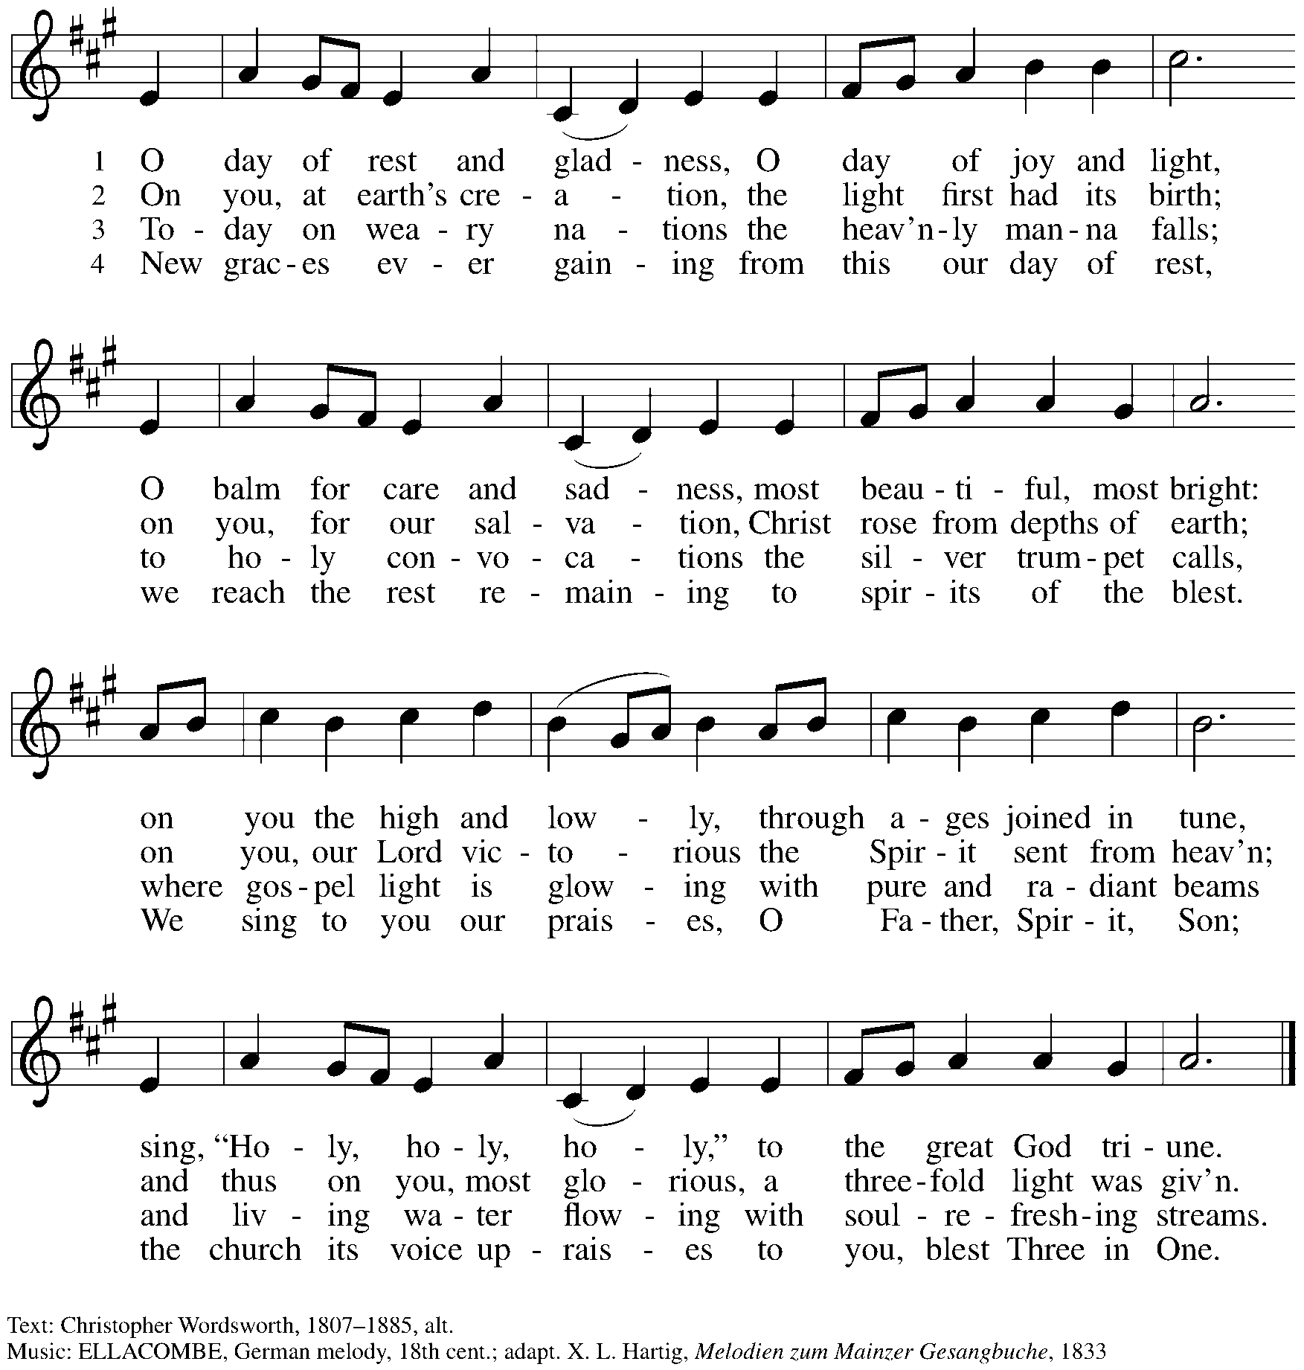

**Greeting**

P: The grace of our Lord Jesus Christ, the love of God,

and the communion of the Holy Spirit be with you all.

**C: And also with you.**

**Prayer of the Day**

P: Let us pray.

Almighty and ever-living God,

you are always more ready to hear than we are to pray,

and you gladly give more than we either desire or deserve.

Pour upon us your abundant mercy.

Forgive us those things that weigh on our conscience,

and give us those good things that come only through your Son,

Jesus Christ, our Savior and Lord.

**C: Amen.**

*Please be seated.*

*Children are invited to move to the Social Hall for Little Church; Big Faith.*

**Word**

*God speaks to us in Scripture reading, preaching, and song*

**First Reading** **– Genesis 18: 20-32**

20Then the Lord said, “How great is the outcry against Sodom and Gomorrah and how very grave their sin! 21I must go down and see whether they have done altogether according to the outcry that has come to me; and if not, I will know.”  
 22So the men turned from there, and went toward Sodom, while Abraham remained standing before the Lord. 23Then Abraham came near and said, “Will you indeed sweep away the righteous with the wicked? 24Suppose there are fifty righteous within the city; will you then sweep away the place and not forgive it for the fifty righteous who are in it? 25Far be it from you to do such a thing, to slay the righteous with the wicked, so that the righteous fare as the wicked! Far be that from you! Shall not the Judge of all the earth do what is just?” 26And the Lord said, “If I find at Sodom fifty righteous in the city, I will forgive the whole place for their sake.” 27Abraham answered, “Let me take it upon myself to speak to the Lord, I who am but dust and ashes. 28Suppose five of the fifty righteous are lacking? Will you destroy the whole city for lack of five?” And [the Lord] said, “I will not destroy it if I find forty-five there.” 29Again he spoke to [God], “Suppose forty are found there.” [The Lord] answered, “For the sake of forty I will not do it.” 30Then he said, “Oh do not let the Lord be angry if I speak. Suppose thirty are found there.” [The Lord] answered, “I will not do it, if I find thirty there.” 31He said, “Let me take it upon myself to speak to the Lord. Suppose twenty are found there.” [The Lord] answered, “For the sake of twenty I will not destroy it.” 32Then he said, “Oh do not let the Lord be angry if I speak just once more. Suppose ten are found there.” [The Lord] answered, “For the sake of ten I will not destroy it.”

L: Word of God, word of life.

**C: Thanks be to God.**

*Please rise as you are able.*

**Gospel Acclamation**

**C: Alleluia. Ask, and it will be given you; search and you will find;**

**knock, and the door will be opened to you. Alleluia.**

**Gospel – Luke 11: 1-13**

P: The holy Gospel according to St. Luke.

**C: Glory to you, O Lord.**

1[Jesus] was praying in a certain place, and after he had finished, one of his disciples said to him, “Lord, teach us to pray, as John taught his disciples.”2He said to them, “When you pray, say:  
 Father, hallowed be your name.  
  Your kingdom come.  
  3Give us each day our daily bread.  
  4And forgive us our sins,  
   for we ourselves forgive everyone indebted to us.  
  And do not bring us to the time of trial.”  
 5And he said to them, “Suppose one of you has a friend, and you go to him at midnight and say to him, ‘Friend, lend me three loaves of bread; 6for a friend of mine has arrived, and I have nothing to set before him.’ 7And he answers from within, ‘Do not bother me; the door has already been locked, and my children are with me in bed; I cannot get up and give you anything.’ 8I tell you, even though he will not get up and give him anything because he is his friend, at least because of his persistence he will get up and give him whatever he needs.  
 9“So I say to you, Ask, and it will be given you; search, and you will find; knock, and the door will be opened for you. 10For everyone who asks receives, and everyone who searches finds, and for everyone who knocks, the door will be opened. 11Is there anyone among you who, if your child asks for a fish, will give a snake instead of a fish? 12Or if the child asks for an egg, will give a scorpion? 13If you then, who are evil, know how to give good gifts to your children, how much more will the heavenly Father give the Holy Spirit to those who ask him!”

P: The Gospel of the Lord.

**C: Praise to you, O Christ.**

*Please be seated.*

**Sermon**

*A time of silence for prayer and reflection follows the sermon.*

*When the hymn of the day begins, please rise as you are able.*

**Hymn of the Day What a Friend We Have in Jesus *ELW* 742**

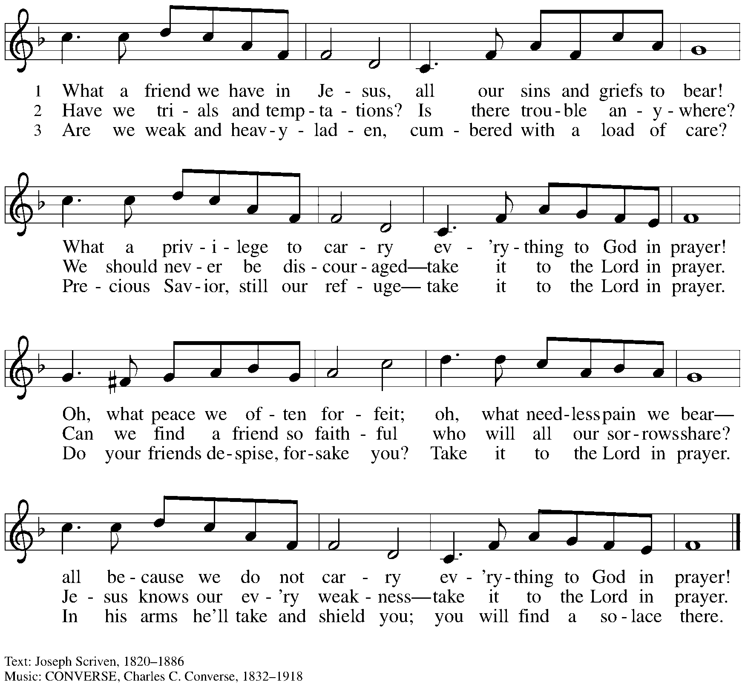

**Prayers of the People**

P: United in Christ and guided by the Spirit,

we pray for the church, the world, and all who are in need.

*After each petition*

P: God of grace,

**C: receive our prayer.**

P: God of every time and place, we offer these prayers and those of our hearts to you,

in Jesus’ name.

**C: Amen.**

*Please be seated.*

**Meal**

**Offering**

*We offer ourselves, our gifts, and our faithful service to God.*

*An usher will pass around an offering plate for anyone who would like to offer gifts before God.*

**Music during the Offering**

*Please rise as you are able.*

**Offertory Song Accept, O Lord, the Gifts We Bring *ELW* 691**

**v. 1-2**

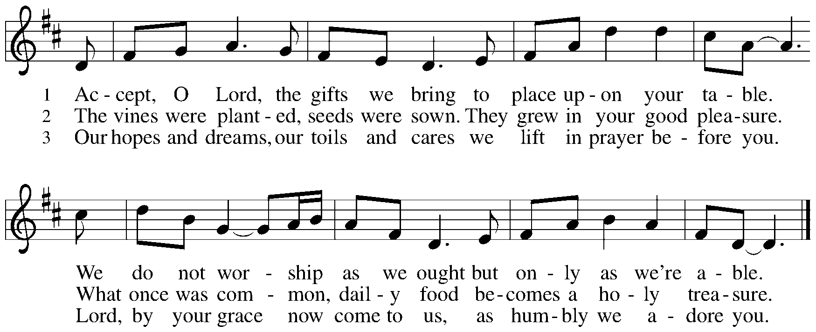

**Offertory Prayer**

P: Let us pray. Holy God, gracious and merciful,

**C: you bring forth food from the earth and nourish your whole creation.**

**Turn our hearts toward those who hunger in any way, that all may know your care;**

**and prepare us now to feast on the bread of life, Jesus Christ, our Savior and Lord.**

**Amen.**

**Dialogue**

P: The Lord be with you.

**C: And also with you.**

P: Lift up your hearts.

**C: We lift them to the Lord.**

P: Let us give thanks to the Lord our God.

**C: It is right to give our thanks and praise.**

**Preface**

P: It is indeed right, our duty and our joy,

that we should at all times and in all places

give thanks and praise to you, almighty and merciful God,

through our Savior Jesus Christ;

who on this day overcame death and the grave,

and by his glorious resurrection opened to us the way of everlasting life.

And so, with all the choirs of angels,

with the church on earth and the hosts of heaven,

we praise your name and join their unending hymn:

**Sanctus**

**Holy, holy, holy Lord,**

**God of power and might:**

**Heaven and earth are full of your glory.**

**Hosanna in the highest.**

**Blessed is the one who comes in the name of the Lord.**

**Hosanna in the highest.**

**Eucharistic Prayer**

P: Holy God, holy and mighty, holy and immortal …

… Do this for the remembrance of me.

Together as the body of Christ, we proclaim the Lord’s death until he comes.

**C: Christ has died.**

**Christ has risen.**

**Christ will come again.**

P: With this bread and cup we remember your Son …

… all our sins and sorrows will be no mor

**C: Amen. Come, Lord Jesus.**

P: Holy God, holy and merciful one, holy and compassionate …

… sharing your bounty with all the world.

**C: Amen. Come, Holy Spirit.**

P: Holy and benevolent God …

… with the Holy Spirit, in your holy church, now and forever.

**C: Amen.**

**Lord’s Prayer**

P: Gathered as one by the Holy Spirit, let us pray as Jesus taught us.

**C: Our Father in heaven,**

**hallowed be your name,**

**your kingdom come,**

**your will be done,**

**on earth as in heaven.**

**Give us today our daily bread.**

**Forgive us our sins**

**as we forgive those**

**who sin against us.**

**Save us from the time of trial**

**and deliver us from evil.**

**For the kingdom, the power,**

**and the glory are yours,**

**now and forever. Amen.**

**Fraction and Invitation**

***Agnus Dei /* Lamb of God**

**Lamb of God, you take away the sin of the world; have mercy on us.**

**Lamb of God, you take away the sin of the world;** **have mercy on us.**

**Lamb of God, you take away the sin of the world;** **grant us peace.**

*Please be seated.*

**Holy Communion**

* *Hand sanitizer is available if you would like to use it prior to receiving Communion.*
* *Worshipers from the pulpit side will proceed forward first, followed by the center section, and then the lectern side.*
* *The Communion wafers (regular and gluten-free) have been thoughtfully prepared using the gifts of the congregation by a member of St. Andrew’s altar care team, with a drop of wine or grape juice on each. The presiding minister will distribute one to each communicant.*
* *When you reach the presiding minister, please indicate if you would like grape juice or a gluten-free wafer.*
* *A blessing will be provided for anyone who does not yet receive the sacrament.*
* *Cushions have been placed at the altar rail for anyone who would like to kneel for prayer and reflection before returning to their pew.*
* *Everyone is asked to wait until you return to your place to consume the elements, and then promptly replace your mask.*

**Hymns during Holy Communion**

**Amazing Grace, How Sweet the Sound *ELW* 779**

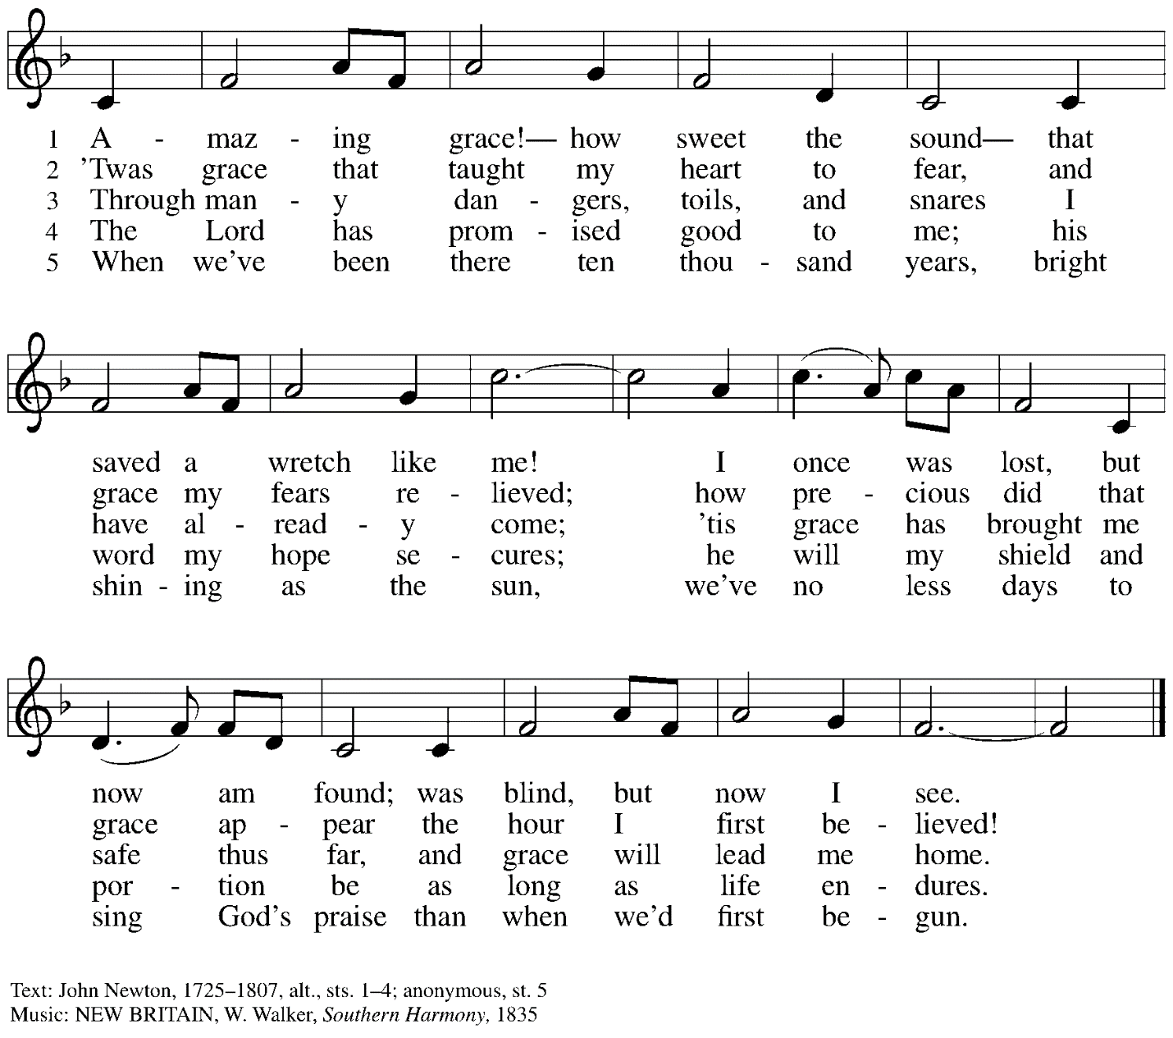

**Hymns during Holy Communion**

**O Lord, Hear My Prayer *ELW* 751**

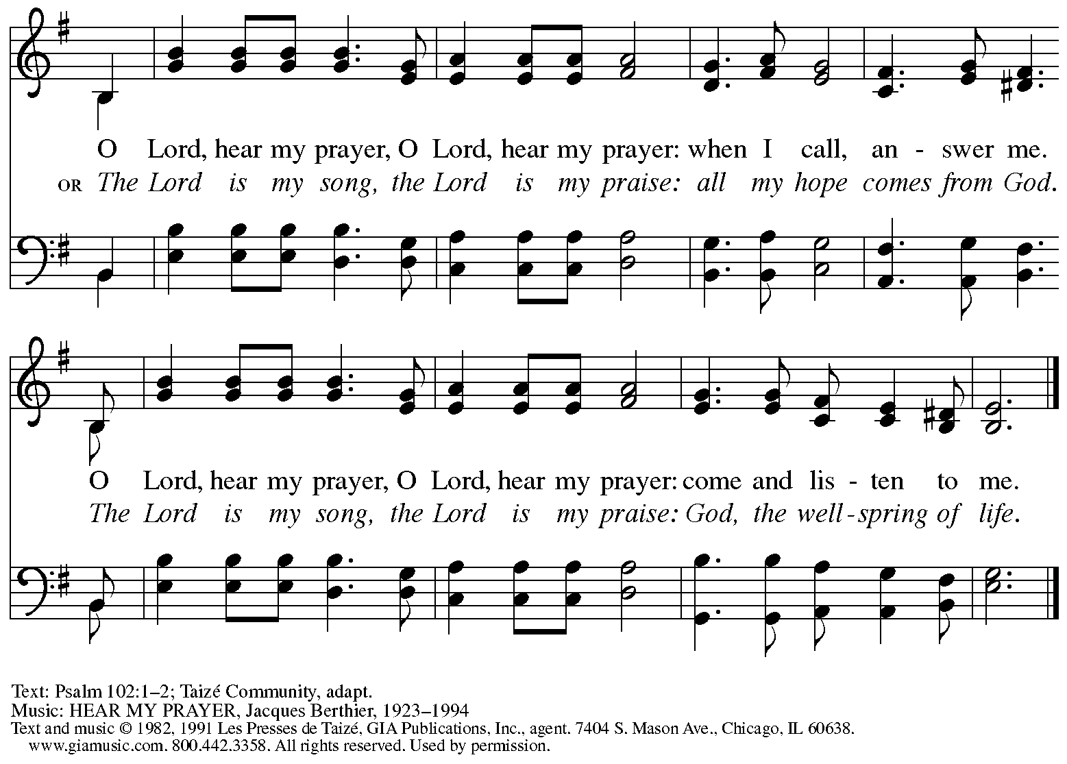

All rights reserved. Reprinted with permission under OneLicense.net # A-722139.

*When all have returned to their places, please rise as you are able.*

**Blessing**

P: The body and blood of our Lord Jesus Christ strengthen you and keep you in his grace.

**C: Amen.**

**Prayer**

P: Let us pray. Life-giving God,

through this meal you have bandaged our wounds

and fed us with your mercy.

Now send us forth to live for others, both friend and stranger,

that all may come to know your love.

This we pray in the name of Jesus.

**C: Amen.**

*Please be seated.*

**Sending**

**Announcements**

*Please rise as you are able.*

**Benediction**

P: The God ☩ of peace,

bless you, comfort you,

and show you the path of life

this day and always.

**C: Amen.**

**Sending Hymn Rise, O Church, Like Christ Arisen *ELW* 548**

**v. 1-2**

**1 Rise, O church, like Christ arisen,**

**from this meal of love and grace;**

**may we through such love envision**

**whose we are, and whose, our praise.**

**Alleluia, alleluia;**

**God, the wonder of our days.**

**2 Rise, transformed, and choose to follow**

**after Christ, though wounded, whole;**

**broken, shared, our lives are hallowed**

**to release and to console.**

**Alleluia, alleluia;**

**Christ, our present, past, and goal.**

Text: Susan Palo Cherwien, b. 1953. Music: SURGE ECCLESIA, Timothy J. Strand, b. 1958. Text © 1997 Susan Palo Cherwien, admin. Augsburg Fortress. Music © 1997 Augsburg Fortress. All rights reserved. Reprinted with permission under OneLicense.net # A-722139.

**Dismissal**

P: Go in peace. Serve the Lord.

**C: Thanks be to God!**

*Abbreviations*

P: Pastor/Presiding Minister

L: Lector

**C: Congregation**

***ELW*: *Evangelical Lutheran Worship* hymnal**

***ACS*: *All Creation Sings* hymnal**

*Those serving in worship today*

Piano Jeff Denlinger

Cantor Richard Krug

Lector Dixie Tymitz

Presiding Minister Rev. Ross Carmichael

*Liturgy and Hymnody Acknowledgements*

From SundaysandSeasons.com. Copyright © 2022 Augsburg Fortress. All rights reserved. Reprinted under OneLicense.net # A-722139.

Used by permission of Augsburg Fortress.

**Accept, O Lord, the Gifts We Bring** – Text: Beth Bergeron Folkemer, b. 1957. Music: BARBARA ALLEN, English folk tune. Text © 1990 Augsburg Fortress. All rights reserved. Reprinted with permission under OneLicense.net # A-722139.