+ Eighth Sunday after Pentecost
July 31, 2022
St. Andrew Lutheran Church
304 Morewood Ave.
Pittsburgh, PA 15213
St_andrewELCA@verizon.net
www.standrewpittsburgh.org

+ Eighth Sunday after Pentecost
Order for Worship

Today’s texts offer instruction and encouragement for all who are occasionally overwhelmed by the “unhappy business” of life. Jesus urges us to take care and be on guard against all kinds of greed. We who have died with Christ in Holy Baptism have also been raised with him and are encouraged to elevate our thinking, seeking the “things that are above.” To that end we seek the sustenance of the Lord’s supper and the encouragement of God’s word.

- While Allegheny County Covid-19 transmission rates are in the “low” or “green” category, masks are optional for all worship attendees.
- Adult and child-sized masks will continue to be available at the entrances.
- Hand sanitizer is available at the front of the sanctuary to use before Holy Communion, after you proceed past the baptismal font, as the alcohol has been affecting the finish on the font’s bowl.

Worship Services are live streamed to multiple online platforms.
By attending worship, you agree that your image and voice may be broadcast.

Welcome to St. Andrew!
- Worship “toolkits” to help children engage with the service are available in the black bookcase at the back of the worship space. There are “reader” and “pre-reader” resources available in each kit. Please feel free to use the kits for/with your children during worship.
- After the Prayer of the Day, children are invited to gather in the Social Hall for Little Church; Big Faith, a Bible lesson and activity. The group returns to the worship space for the Communion portion of the service.
- A restroom is available on the main level of the church, through the doors to the Social Hall and to the right in the main office.

Welcome

Prelude

Gathering
The Holy Spirit calls us together as the people of God.

Confession and Forgiveness

P: Blessed be the holy Trinity, ☩ one God,
whose steadfast love endures forever.
C: Amen.

P: Let us confess our sin in the presence of God and of one another.

Silence is kept for reflection.

P: Merciful God,
C: we confess that we have not followed your path
but have chosen our own way.
Instead of putting others before ourselves,
we long to take the best seats at the table.
When met by those in need,
we have too often passed by on the other side.
Set us again on the path of life.
Save us from ourselves
and free us to love our neighbors.
Amen.

P: Hear the good news!
God does not deal with us according to our sins
but delights in granting pardon and mercy.
In the name of ☩ Jesus Christ, your sins are forgiven.
You are free to love as God loves.
C: Amen.

Gathering Hymn Praise and Thanksgiving ELW 689
v. 1-2, 4

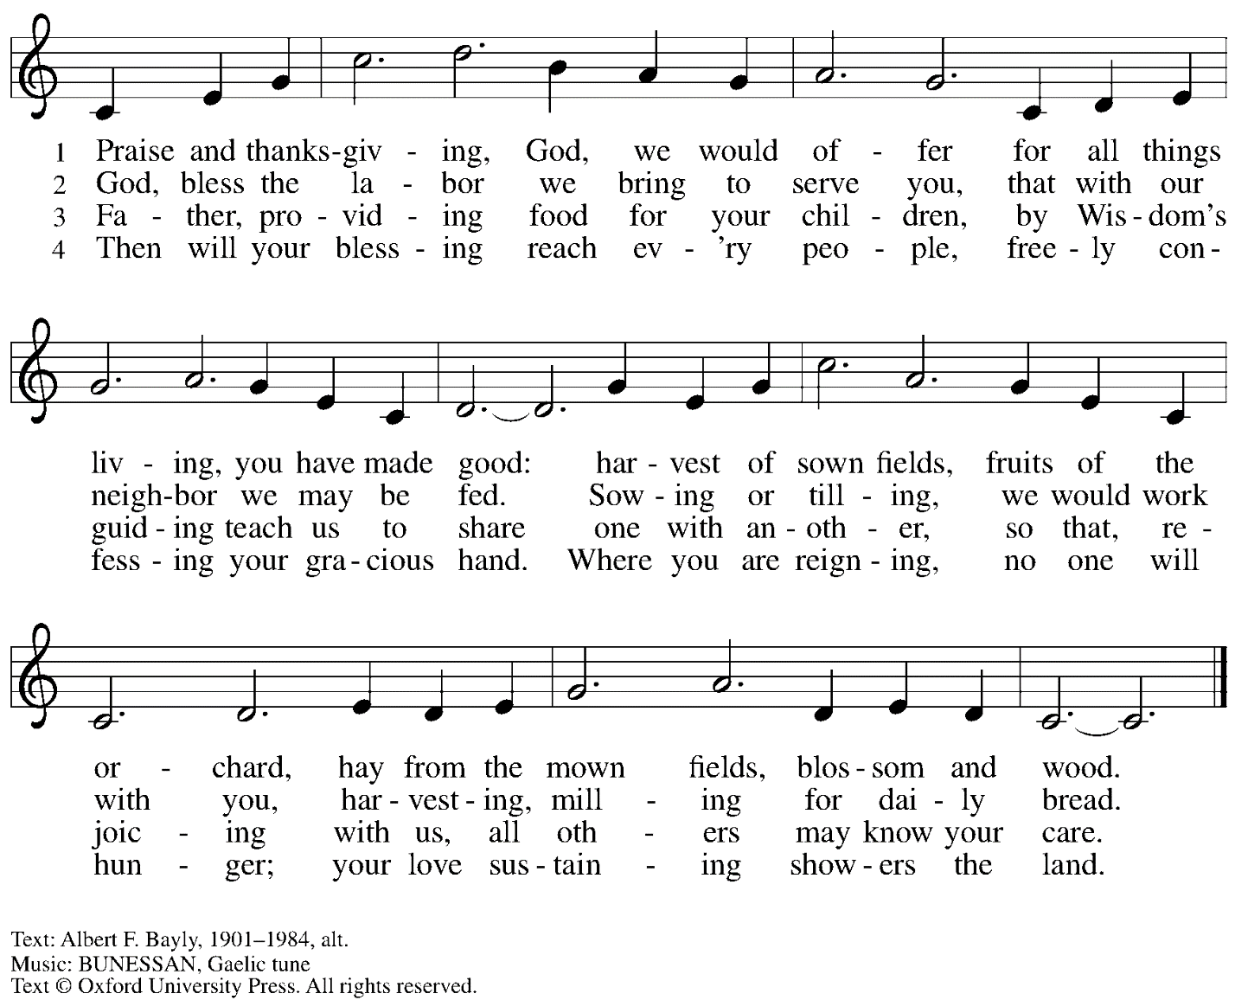
Reprinted with permission under OneLicense.net # A-722139.

Greeting

P: The grace of our Lord Jesus Christ, the love of God,
and the communion of the Holy Spirit be with you all.
C: And also with you.

Prayer of the Day

P: Let us pray. Benevolent God, you are the source, the guide, and the goal of our lives.
Teach us to love what is worth loving, to reject what is offensive to you,
and to treasure what is precious in your sight,
through Jesus Christ, our Savior and Lord.
C: Amen.

Please be seated.
Children are invited to join the adult leaders and move to the office for Little Church; Big Faith.

Word
God speaks to us in Scripture reading, preaching, and song

First Reading – Ecclesiastes 1: 2, 12-14, 2: 18-23

²Vanity of vanities, says the Teacher,
vanity of vanities! All is vanity.
¹²I, the Teacher, when king over Israel in Jerusalem, ¹³applied my mind to seek and to search out by wisdom all that is done under heaven; it is an unhappy business that God has given to human beings to be busy with. ¹⁴I saw all the deeds that are done under the sun; and see, all is vanity and a chasing after wind.
^{2:18}I hated all my toil in which I had toiled under the sun, seeing that I must leave it to those who come after me ¹⁹—and who knows whether they will be wise or foolish? Yet they will be master of all for which I toiled and used my wisdom under the sun. This also is vanity. ²⁰So I turned and gave my heart up to despair concerning all the toil of my labors under the sun, ²¹because sometimes one who has toiled with wisdom and knowledge and skill must leave all to be enjoyed by another who did not toil for it. This also is vanity and a great evil. ²²What do mortals get from all the toil and strain with which they toil under the sun? ²³For all their days are full of pain, and their work is a vexation; even at night their minds do not rest. This also is vanity.

L: Word of God, word of life.
C: Thanks be to God.

Please rise as you are able.

Gospel Acclamation

C: Alleluia. Blessed are the poor in spirit, for theirs is the kingdom of heaven. Alleluia.

Gospel – Luke 12: 13-21

P: The holy Gospel according to St. Luke.
C: Glory to you, O Lord.

¹³Someone in the crowd said to [Jesus,] “Teacher, tell my brother to divide the family inheritance with me.” ¹⁴But he said to him, “Friend, who set me to be a judge or arbitrator over you?” ¹⁵And he said to them, “Take care! Be on your guard against all kinds of greed; for one’s life does not consist in the abundance of possessions.” ¹⁶Then he told them a parable: “The land of a rich man produced abundantly. ¹⁷And he thought to himself, ‘What should I do, for I have no place to store my crops?’ ¹⁸Then he said, ‘I will do this: I will pull down my barns and build larger ones, and there I will store all my grain and my goods. ¹⁹And I will say to my soul, Soul, you have ample goods laid up for many years; relax, eat, drink, be merry.’ ²⁰But God said to him, ‘You fool! This very night your life is being demanded of you. And the things you have prepared, whose will they be?’ ²¹So it is with those who store up treasures for themselves but are not rich toward God.”

P: The Gospel of the Lord.
C: Praise to you, O Christ.

Please be seated.

Sermon

A time of silence for prayer and reflection follows the sermon.
When the hymn of the day begins, please rise as you are able.

Hymn of the Day Faith Begins by Letting Go ACS 1004
v. 1, 3

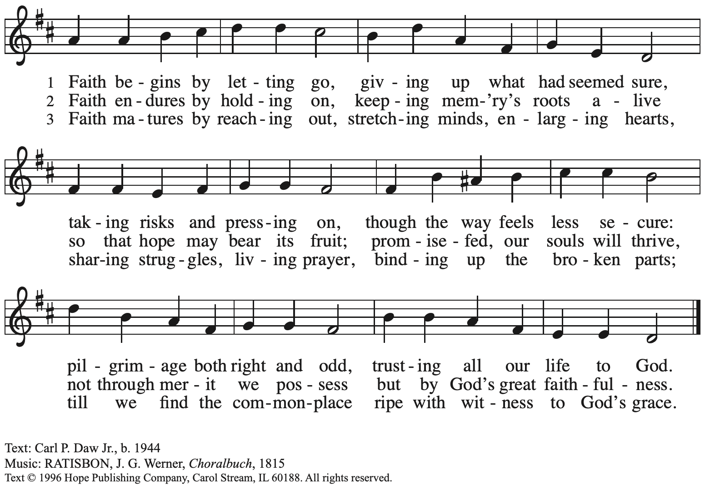
Reprinted with permission under OneLicense.net # A-722139.

Prayers of the People

P: United in Christ and guided by the Spirit,
we pray for the church, the world, and all who are in need.

After each petition
P: God of grace,
C: receive our prayer.

P: God of every time and place, we offer these prayers and those of our hearts to you,
in Jesus’ name.
C: Amen.

Please be seated.

Meal

Offering

We offer ourselves, our gifts, and our faithful service to God.
An usher will pass around an offering plate for anyone who would like to offer gifts before God.

Music during the Offering

Please rise as you are able.

Offertory Song Accept, O Lord, the Gifts We Bring ELW 691
v. 1-2

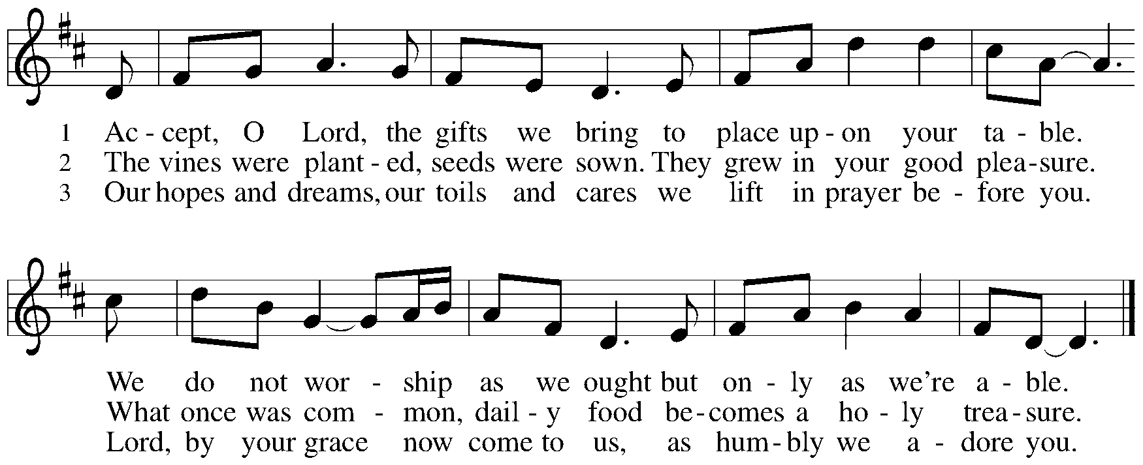

Offertory Prayer

P: Let us pray. Holy God, gracious and merciful,
C: you bring forth food from the earth and nourish your whole creation.
Turn our hearts toward those who hunger in any way, that all may know your care;
and prepare us now to feast on the bread of life, Jesus Christ, our Savior and Lord.
Amen.

Dialogue

P: The Lord be with you.
C: And also with you.

P: Lift up your hearts.
C: We lift them to the Lord.

P: Let us give thanks to the Lord our God.
C: It is right to give our thanks and praise.

Preface

P: It is indeed right, our duty and our joy,
that we should at all times and in all places
give thanks and praise to you, almighty and merciful God.
You reveal your glory
as the glory of the Father, the Son, and the Holy Spirit:
equal in majesty, undivided in splendor, one Lord, one God,
ever to be adored in your eternal glory.
And so, with all the choirs of angels,
with the church on earth and the hosts of heaven,
we praise your name and join their unending hymn:

Sanctus

Holy, holy, holy Lord,
God of power and might:
Heaven and earth are full of your glory.
Hosanna in the highest.
Blessed is the one who comes in the name of the Lord.
Hosanna in the highest.

Eucharistic Prayer

P: Holy God, holy and mighty, holy and immortal …
… Do this for the remembrance of me.

Together as the body of Christ, we proclaim the Lord’s death until he comes.
C: Christ has died.
Christ has risen.
Christ will come again.

P: With this bread and cup we remember your Son …
… all our sins and sorrows will be no mor
C: Amen. Come, Lord Jesus.

P: Holy God, holy and merciful one, holy and compassionate …
… sharing your bounty with all the world.
C: Amen. Come, Holy Spirit.

P: Holy and benevolent God …
… with the Holy Spirit, in your holy church, now and forever.
C: Amen.

Lord’s Prayer

P: Gathered as one by the Holy Spirit, let us pray as Jesus taught us.
C: Our Father in heaven,
hallowed be your name,
your kingdom come,
your will be done,
on earth as in heaven.
Give us today our daily bread.
Forgive us our sins
as we forgive those
who sin against us.
Save us from the time of trial
and deliver us from evil.
For the kingdom, the power,
and the glory are yours,
now and forever. Amen.

Fraction and Invitation

Agnus Dei / Lamb of God

Lamb of God, you take away the sin of the world; have mercy on us.
Lamb of God, you take away the sin of the world; have mercy on us.
Lamb of God, you take away the sin of the world; grant us peace.

Please be seated.

Holy Communion
- Hand sanitizer is available if you would like to use it prior to receiving Communion.
- Worshipers from the pulpit side will proceed forward first, followed by the center section, and then the lectern side.
- The Communion wafers (regular and gluten-free) have been thoughtfully prepared using the gifts of the congregation by a member of St. Andrew’s altar care team, with a drop of wine or grape juice on each. The presiding minister will distribute one to each communicant.
- When you reach the presiding minister, please indicate if you would like grape juice or a gluten-free wafer.
- A blessing will be provided for anyone who does not yet receive the sacrament.
- Cushions have been placed at the altar rail for anyone who would like to kneel for prayer and reflection before returning to their pew.

Hymns during Holy Communion
God, Whose Giving Knows No Ending Following Page

Hymns during Holy Communion
God, Whose Giving Knows No Ending ELW 678

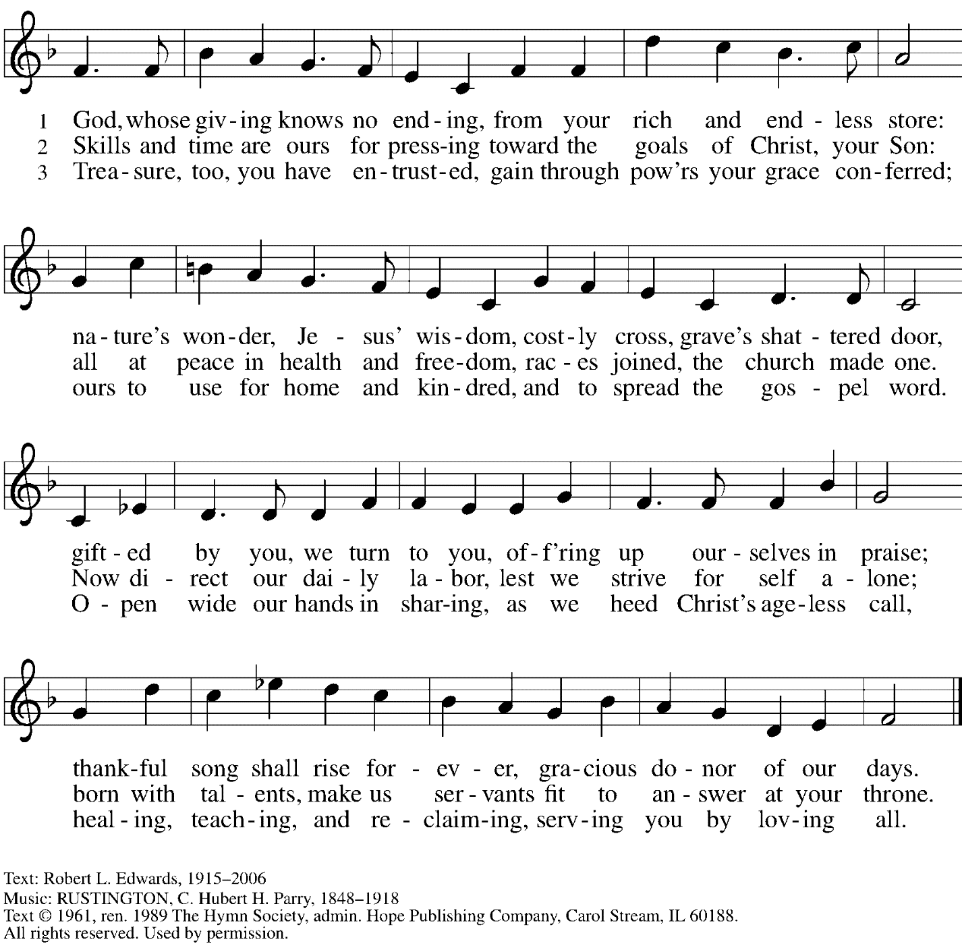
Reprinted with permission under OneLicense.net # A-722139.

Hymns during Holy Communion
Build a Longer Table ACS 1062

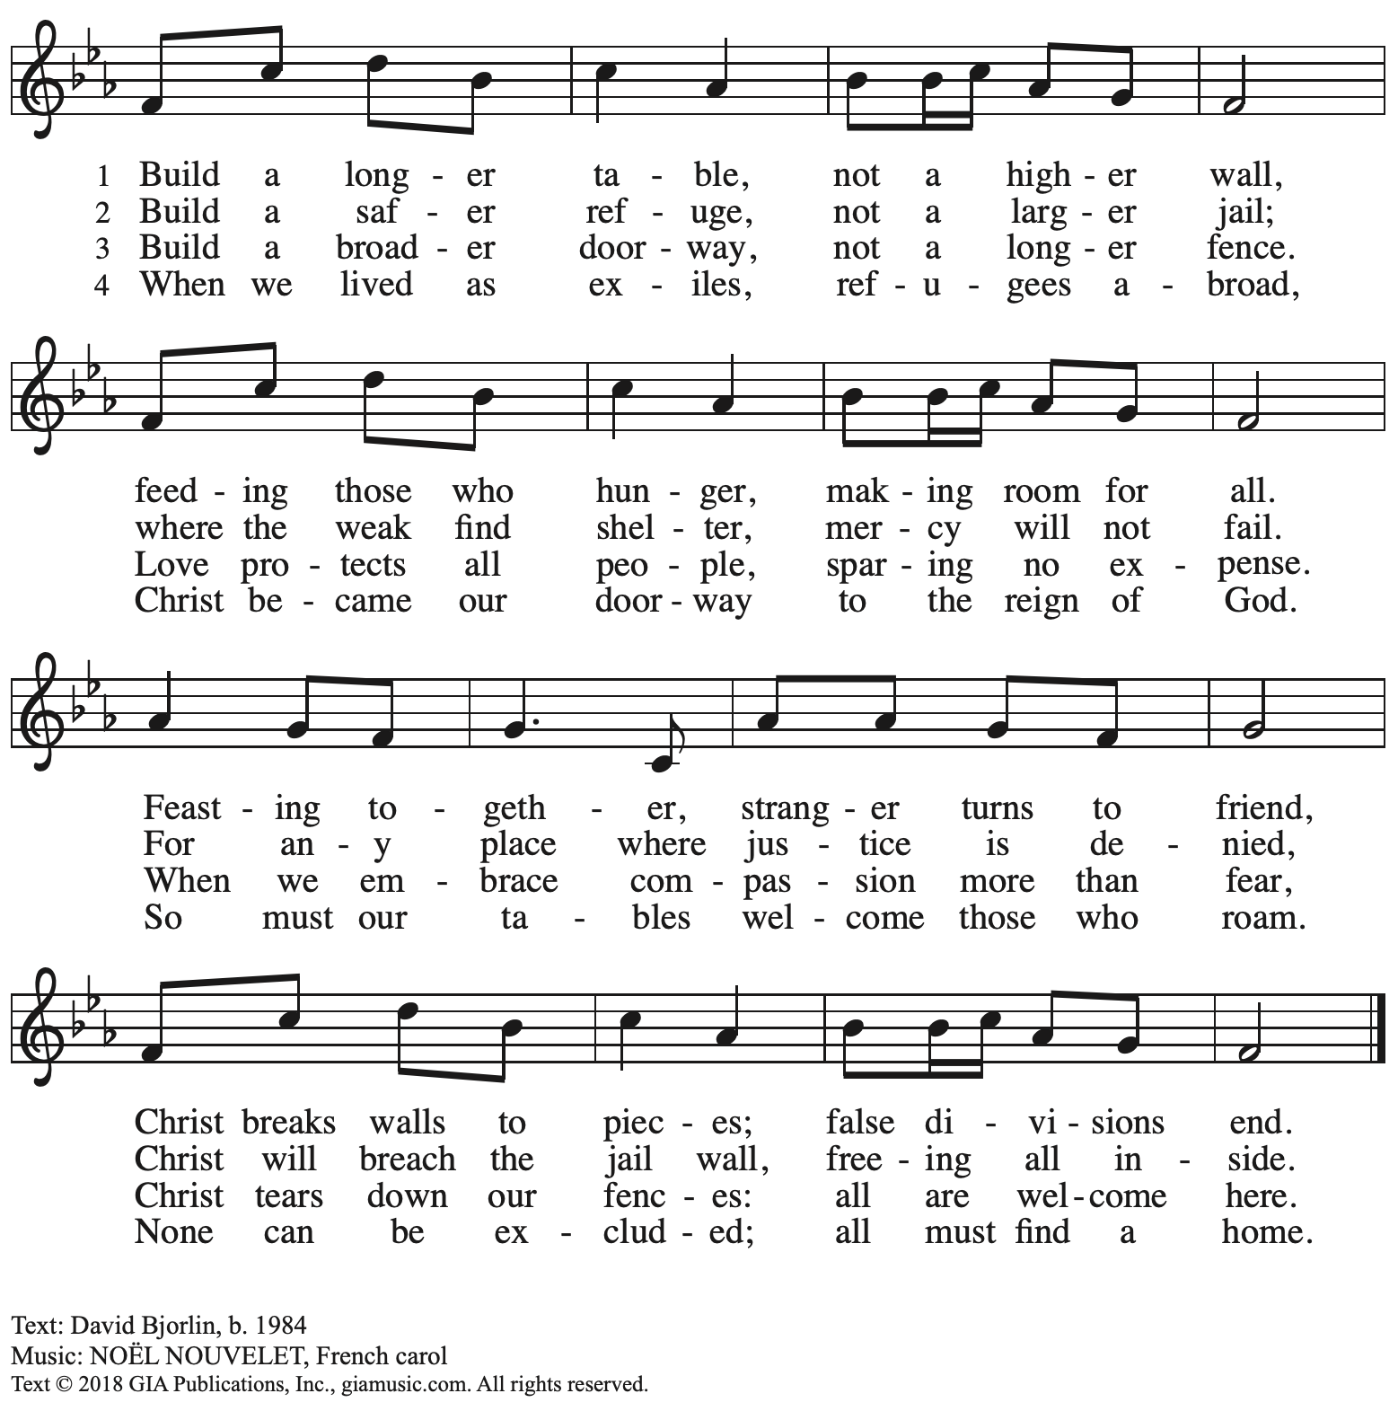
Reprinted with permission under OneLicense.net #A-722139.

When all have returned to their places, please rise as you are able.

Blessing

P: The body and blood of our Lord Jesus Christ strengthen you and keep you in his grace.
C: Amen.

Prayer

P: Let us pray.
Life-giving God,
through this meal you have bandaged our wounds
and fed us with your mercy.
Now send us forth to live for others,
both friend and stranger,
that all may come to know your love.
This we pray in the name of Jesus.
C: Amen.

Please be seated.

Sending

Announcements

Please rise as you are able.

Benediction

P: The God ☩ of peace,
bless you, comfort you,
and show you the path of life
this day and always.
C: Amen.

Sending Hymn For the Fruit of All Creation Following Page
v. 1-2

Sending Hymn For the Fruit of All Creation ELW 679
v. 1-2

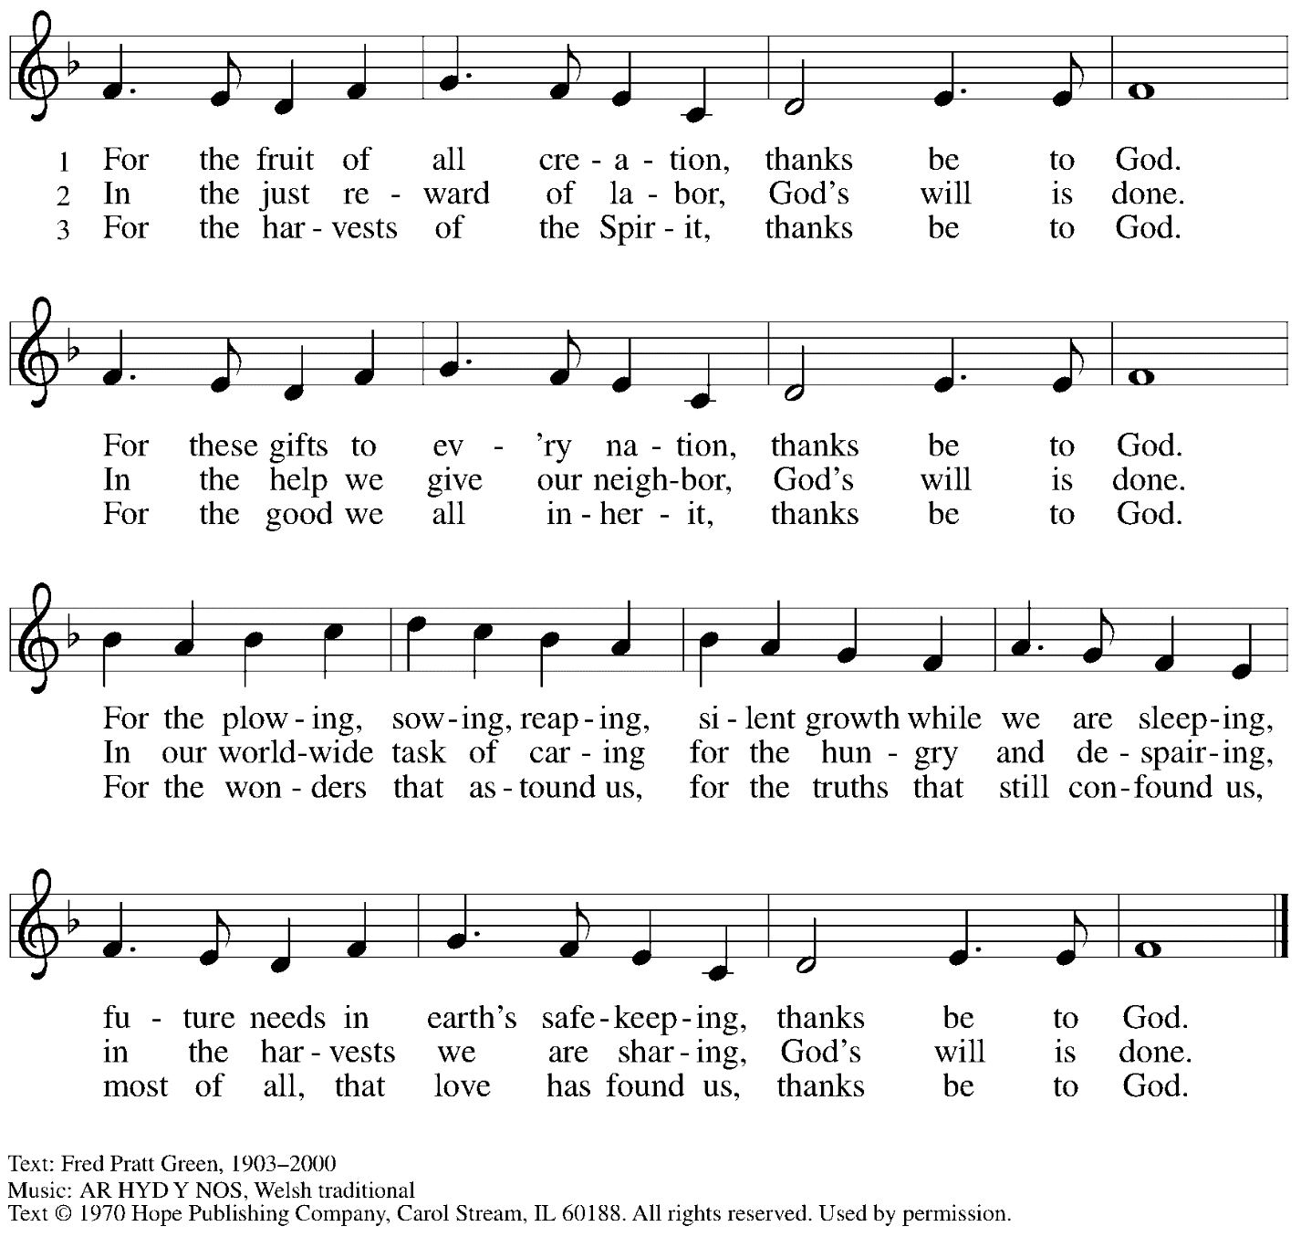
Reprinted with permission under OneLicense.net # A-722139.

Dismissal

P: Go in peace. Serve the Lord.
C: Thanks be to God!

Abbreviations

P: Pastor/Presiding Minister
L: Lector
C: Congregation

ELW: Evangelical Lutheran Worship hymnal
ACS: All Creation Sings hymnal

Those serving in worship today

Preaching and Presiding Minister The Rev. Deborah M. Byrum
Organ Jimmi Kocher-Hillmer
Cantor Ian Brown
Lector Sue Gaugler
Announcements Sharon Koch

Liturgy and Hymnody Acknowledgements

From SundaysandSeasons.com. Copyright © 2022 Augsburg Fortress. All rights reserved. Reprinted under OneLicense.net # A-722139.
Used by permission of Augsburg Fortress.

Accept, O Lord, the Gifts We Bring – Text: Beth Bergeron Folkemer, b. 1957. Music: BARBARA ALLEN, English folk tune. Text © 1990 Augsburg Fortress. All rights reserved. Reprinted with permission under OneLicense.net # A-722139.

