+ Tenth Sunday after Pentecost
August 14, 2022
St. Andrew Lutheran Church
304 Morewood Ave.
Pittsburgh, PA 15213
St_andrewELCA@verizon.net
www.standrewpittsburgh.org

+ Tenth Sunday after Pentecost
Order for Worship

The Word of God is a refining fire. Jesus is the great divide in human history.
He invites our undivided attention and devotion. Today in worship we are surrounded by a great “cloud of witnesses.” In the Word and in Holy Communion we are invited yet again to look to Jesus, “the pioneer and perfecter of our faith.”

The following safety precautions and protocols apply to everyone in the building,
regardless of vaccination status.

- Covid-19 transmission rates in Allegheny County have returned to the “high” category, so face masks that fully cover both your mouth and nose are required for all parishioners over the age of two (2).
- Physical distancing of at least six (6) feet will be observed at all times for people not from your household.
- Hand sanitizer is available at the front of the sanctuary to use before Holy Communion, after you proceed past the baptismal font, as the alcohol has been affecting the finish on the font’s bowl.

Worship Services are live streamed to multiple online platforms.
By attending worship, you agree that your image and voice may be broadcast.

Welcome to St. Andrew!
- Everyone is invited to make a nametag at the black bookcase in the back of the worship space if they would like.
- Worship “toolkits” to help children engage with the service are available in the black bookcase at the back of the worship space. There are “reader” and “pre-reader” resources available in each kit. Please feel free to use the kits for/with your children during worship.
- After the Prayer of the Day, children are invited to gather in the Social Hall for Little Church; Big Faith, a Bible lesson and activity. The group returns to the worship space for the Communion portion of the service.
- A restroom is available on the main level of the church, through the doors to the Social Hall and to the right in the main office.

Welcome

Prelude

Gathering
The Holy Spirit calls us together as the people of God.

Confession and Forgiveness

P: Blessed be the holy Trinity, ☩ one God,
whose steadfast love endures forever.
C: Amen.

P: Let us confess our sin in the presence of God and of one another.

Silence is kept for reflection.

P: Merciful God,
C: we confess that we have not followed your path
but have chosen our own way.
Instead of putting others before ourselves,
we long to take the best seats at the table.
When met by those in need,
we have too often passed by on the other side.
Set us again on the path of life.
Save us from ourselves
and free us to love our neighbors.
Amen.

P: Hear the good news!
God does not deal with us according to our sins
but delights in granting pardon and mercy.
In the name of ☩ Jesus Christ, your sins are forgiven.
You are free to love as God loves.
C: Amen.

Gathering Hymn Lord Jesus, Think on Me ELW 599
v. 1-3

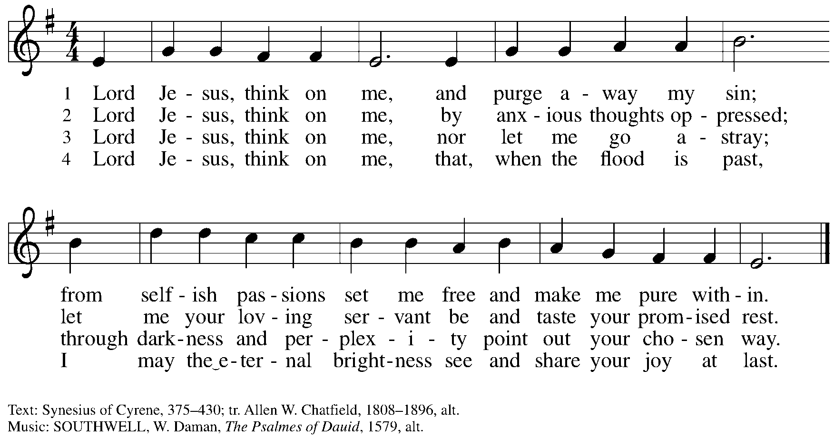
Reprinted with permission under OneLicense.net # A-722139.

Greeting

P: The grace of our Lord Jesus Christ, the love of God,
and the communion of the Holy Spirit be with you all.
C: And also with you.

Prayer of the Day

P: Let us pray.
O God, judge eternal,
you love justice and hate oppression, and you call us to share your zeal for truth.
Give us courage to support all victims of bloodshed and greed, and,
following your servants and prophets, to look to the pioneer and perfecter of our faith,
your Son, Jesus Christ, our Savior and Lord.
C: Amen.

Please be seated.
Children are invited to join the adult leaders and move to the office for Little Church; Big Faith.

Word
God speaks to us in Scripture reading, preaching, and song

First Reading – Jeremiah 23: 23-29

²³Am I a God near by, says the Lord, and not a God far off? ²⁴Who can hide in secret places so that I cannot see them? says the Lord. Do I not fill heaven and earth? says the Lord. ²⁵I have heard what the prophets have said who prophesy lies in my name, saying, “I have dreamed, I have dreamed!” ²⁶How long? Will the hearts of the prophets ever turn back—those who prophesy lies, and who prophesy the deceit of their own heart? ²⁷They plan to make my people forget my name by their dreams that they tell one another, just as their ancestors forgot my name for Baal. ²⁸Let the prophet who has a dream tell the dream, but let the one who has my word speak my word faithfully. What has straw in common with wheat? says the Lord. ²⁹Is not my word like fire, says the Lord, and like a hammer that breaks a rock in pieces?

L: Word of God, word of life.
C: Thanks be to God.

Please rise as you are able.

Gospel Acclamation

C: Alleluia. My sheep hear my voice. I know them and they follow me. Alleluia.

Gospel – Luke 12: 49-56

P: The holy Gospel according to St. Luke.
C: Glory to you, O Lord.

[Jesus said:] ⁴⁹“I came to bring fire to the earth, and how I wish it were already kindled! ⁵⁰I have a baptism with which to be baptized, and what stress I am under until it is completed! ⁵¹Do you think that I have come to bring peace to the earth? No, I tell you, but rather division! ⁵²From now on five in one household will be divided, three against two and two against three; ⁵³they will be divided:
father against son
and son against father,
mother against daughter
and daughter against mother,
mother-in-law against her daughter-in-law
and daughter-in-law against mother-in-law.”
⁵⁴He also said to the crowds, “When you see a cloud rising in the west, you immediately say, ‘It is going to rain’; and so it happens. ⁵⁵And when you see the south wind blowing, you say, ‘There will be scorching heat’; and it happens. ⁵⁶You hypocrites! You know how to interpret the appearance of earth and sky, but why do you not know how to interpret the present time?”

P: The Gospel of the Lord.
C: Praise to you, O Christ.

Please be seated.

Sermon

A time of silence for prayer and reflection follows the sermon.
When the hymn of the day begins, please rise as you are able.

Hymn of the Day The Church’s One Foundation ELW 654
v. 1, 3, 5

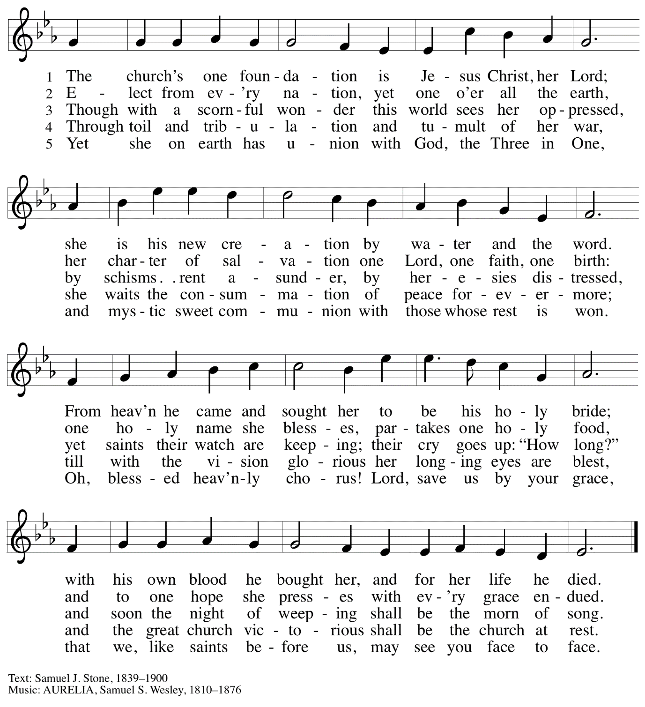

Prayers of the People

P: United in Christ and guided by the Spirit,
we pray for the church, the world, and all who are in need.

After each petition
P: God of grace,
C: receive our prayer.

P: God of every time and place, we offer these prayers and those of our hearts to you,
in Jesus’ name.
C: Amen.

Please be seated.

Meal

Offering

We offer ourselves, our gifts, and our faithful service to God.
An usher will pass around an offering plate for anyone who would like to offer gifts before God.

Music during the Offering

Please rise as you are able.

Offertory Song Accept, O Lord, the Gifts We Bring ELW 691
v. 1-2

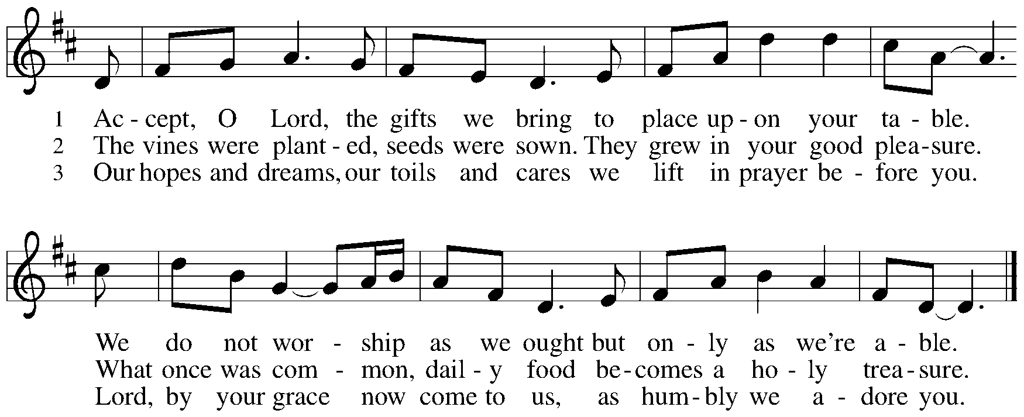

Offertory Prayer

P: Let us pray.
Holy God, gracious and merciful,
C: you bring forth food from the earth and nourish your whole creation.
Turn our hearts toward those who hunger in any way, that all may know your care;
and prepare us now to feast on the bread of life, Jesus Christ, our Savior and Lord.
Amen.

Dialogue

P: The Lord be with you.
C: And also with you.

P: Lift up your hearts.
C: We lift them to the Lord.

P: Let us give thanks to the Lord our God.
C: It is right to give our thanks and praise.

Preface

P: It is indeed right, our duty and our joy,
that we should at all times and in all places
give thanks and praise to you, almighty and merciful God,
through our Savior Jesus Christ;
who on this day overcame death and the grave,
and by his glorious resurrection opened to us the way of everlasting life.
And so, with all the choirs of angels,
with the church on earth and the hosts of heaven,
we praise your name and join their unending hymn:

Sanctus

Holy, holy, holy Lord,
God of power and might:
Heaven and earth are full of your glory.
Hosanna in the highest.
Blessed is the one who comes in the name of the Lord.
Hosanna in the highest.

Eucharistic Prayer

P: Holy God, holy and mighty, holy and immortal …
… Do this for the remembrance of me.

Together as the body of Christ, we proclaim the Lord’s death until he comes.
C: Christ has died.
Christ has risen.
Christ will come again.

P: With this bread and cup we remember your Son …
… all our sins and sorrows will be no mor
C: Amen. Come, Lord Jesus.

P: Holy God, holy and merciful one, holy and compassionate …
… sharing your bounty with all the world.
C: Amen. Come, Holy Spirit.

P: Holy and benevolent God …
… with the Holy Spirit, in your holy church, now and forever.
C: Amen.

Lord’s Prayer

P: Gathered as one by the Holy Spirit, let us pray as Jesus taught us.
C: Our Father in heaven,
hallowed be your name,
your kingdom come,
your will be done,
on earth as in heaven.
Give us today our daily bread.
Forgive us our sins
as we forgive those who sin against us.
Save us from the time of trial
and deliver us from evil.
For the kingdom, the power,
and the glory are yours,
now and forever. Amen.

Fraction and Invitation

Agnus Dei / Lamb of God

Lamb of God, you take away the sin of the world; have mercy on us.
Lamb of God, you take away the sin of the world; have mercy on us.
Lamb of God, you take away the sin of the world; grant us peace.

Please be seated.

Holy Communion
- Hand sanitizer is available if you would like to use it prior to receiving Communion.
- Worshipers from the pulpit side will proceed forward first, followed by the center section, and then the lectern side.
- The Communion wafers (regular and gluten-free) have been thoughtfully prepared using the gifts of the congregation by a member of St. Andrew’s altar care team, with a drop of wine or grape juice on each. The presiding minister will distribute one to each communicant.
- When you reach the presiding minister, please indicate if you would like grape juice or a gluten-free wafer.
- A blessing will be provided for anyone who does not yet receive the sacrament.
- Cushions have been placed at the altar rail for anyone who would like to kneel for prayer and reflection before returning to their pew.
- Everyone is asked to wait until you return to your place to consume the elements, and then promptly replace your mask.

Hymns during Holy Communion
Jesus Calls Us, O’er the Tumult ELW 696
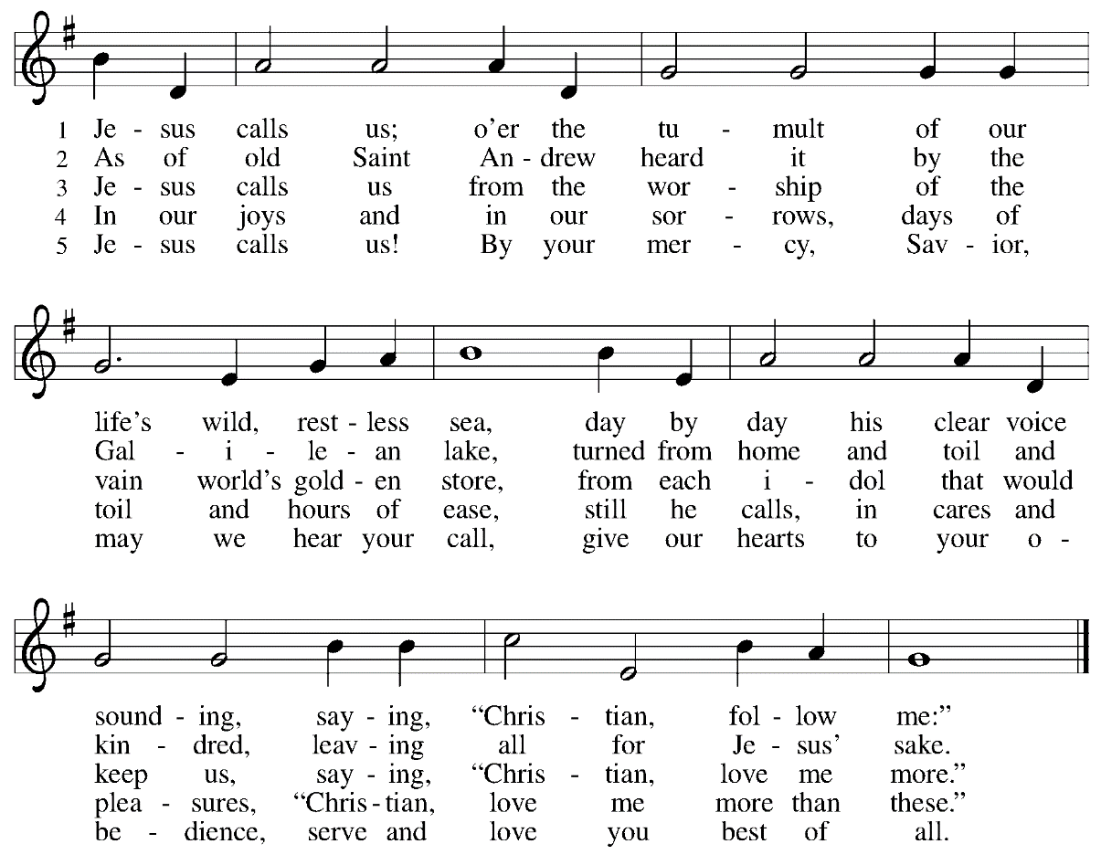

Hymns during Holy Communion
God of Grace and God of Glory ELW 705

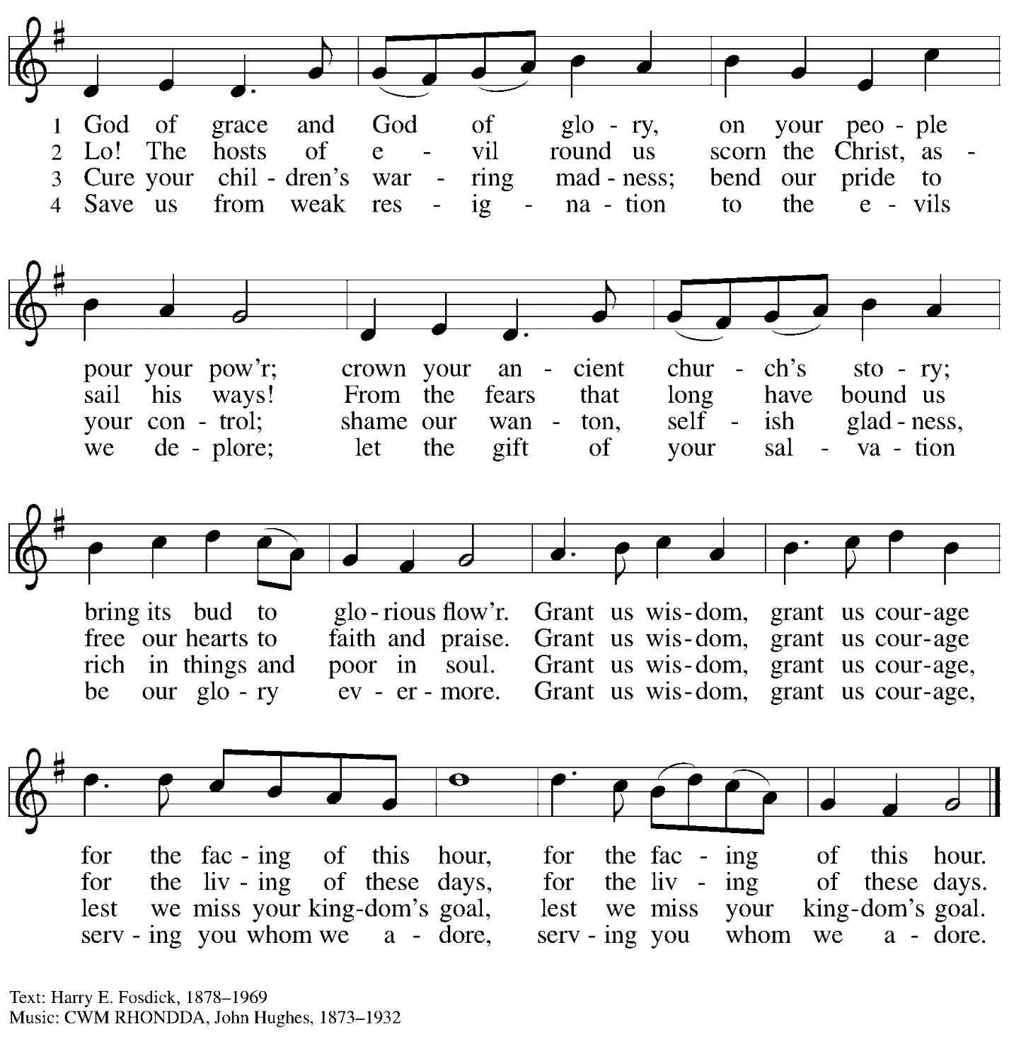

When all have returned to their places, please rise as you are able.

Blessing

P: The body and blood of our Lord Jesus Christ strengthen you and keep you in his grace.
C: Amen.

Prayer

P: Let us pray.
Life-giving God,
through this meal you have bandaged our wounds
and fed us with your mercy.
Now send us forth to live for others,
both friend and stranger,
that all may come to know your love.
This we pray in the name of Jesus.
C: Amen.

Please be seated.

Sending

Announcements

Please rise as you are able.

Benediction

P: The God ☩ of peace,
bless you, comfort you,
and show you the path of life
this day and always.
C: Amen.

Sending Hymn Rise Up, O Saints of God Following Page

Sending Hymn Rise Up, O Saints of God ELW 669
v. 1-3

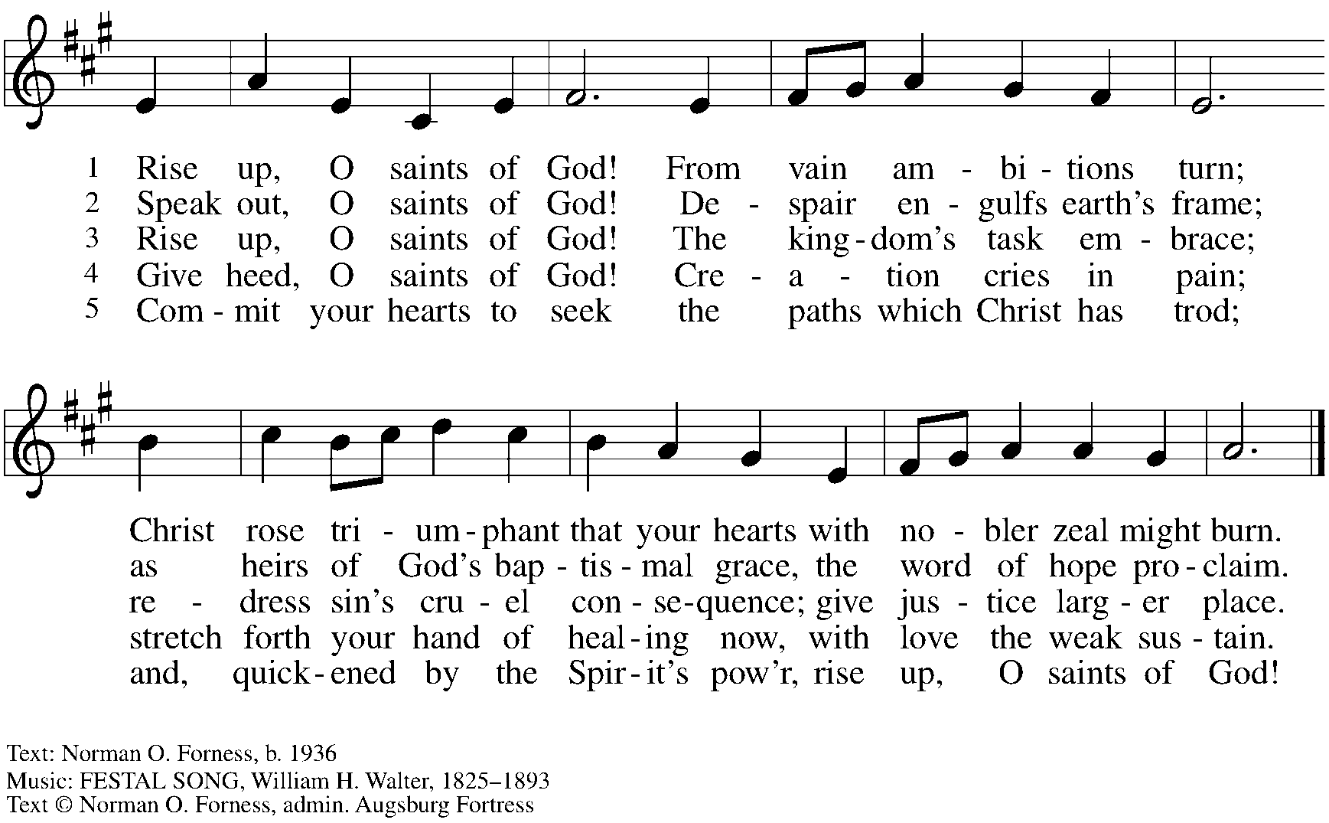
All rights reserved. Reprinted with permission under OneLicense.net # A-722139.

Dismissal

P: Go in peace. Serve the Lord.
C: Thanks be to God!

Abbreviations

P: Pastor/Presiding Minister
L: Lector
C: Congregation

ELW: Evangelical Lutheran Worship hymnal
ACS: All Creation Sings hymnal

Those serving in worship today

Organ Jimmi Kocher-Hillmer
Cantor Kristen Asplin
Lector Sue Gaugler
Presiding Minister Rev. Ross Carmichael

Liturgy and Hymnody Acknowledgements

From SundaysandSeasons.com. Copyright © 2022 Augsburg Fortress. All rights reserved. Reprinted under OneLicense.net # A-722139.
Used by permission of Augsburg Fortress.

Accept, O Lord, the Gifts We Bring – Text: Beth Bergeron Folkemer, b. 1957. Music: BARBARA ALLEN, English folk tune. Text © 1990 Augsburg Fortress. All rights reserved. Reprinted with permission under OneLicense.net # A-722139.

Jesus Calls Us; O’er the Tumult – Text: Cecil Frances Alexander, 1818-1895. Music: GALILEE, William H. Jude, 1851-1922.

St. Andrew Lutheran Church Announcements
August 14th, 2022

- Worship Today, August 14th, + Tenth Sunday after Pentecost – Since Allegheny County’s Covid-19 transmission rates have returned to the “high” category, masks that fully cover one’s nose and mouth are once again required during worship at St. Andrew. We thank you for your cooperation and consideration in order to better ensure the safety of everyone in the community. Attendees are invited to make their own name tags at the back of the worship space. Coffee hour will be held outside (behind the church building) after worship each Sunday as weather permits.
- Welcome, New Minister of Music Laura Reynolds! – After a search process and interviews with several gifted candidates over the past few months, St. Andrew is pleased to announce the hiring of Laura Reynolds as the congregation’s new Minister of Music! Laura has experience leading worship in a variety of churches, having played in Methodist, Baptist, Catholic, Non-Denominational, and Lutheran congregations since she was 16 years old. Laura holds a Bachelor of Music degree from Wayne State University in Detroit, an Artist’s Diploma from Conservatorio Scontrino in Trapani, Sicily, and a Master of Music in Piano Performance from the University of South Florida in Tampa. Laura will begin work this week and her first service will be next Sunday, August 21st. She is excited to work and worship with the many gifted instrumentalists and vocalists at St. Andrew!
- 2022 ELCA Churchwide Assembly - Every few years, the Evangelical Lutheran Church in America (ELCA), the denomination of which St. Andrew is a part, gathers in a Churchwide Assembly. The gathering includes rostered leaders and voting members from congregations across the ELCA, and is the highest legislative body of our church. The church met in assembly in Columbus this past week. For a summary of the actions and events of the Churchwide Assembly, please visit Churchwide Assembly - Evangelical Lutheran Church in America (elca.org).
- August Shelter Dinner with East End Cooperative Ministry Scheduled for Thursday, August 18th, 6:30 p.m. - Every month, on the third Thursday, St. Andrew prepares and serves dinner for guests of the shelter at East End Cooperative Ministry. People of the congregation are invited to choose one portion of the meal to cook/provide and/or to come serve the meal. Lately the arrival time has been 6:00 p.m. with dinner at 6:30 p.m. Please sign up at:
https://www.signupgenius.com/go/5080544AAAC22A1F58-shelter
- “Journey Together” Discontinued - The Journey Together session originally scheduled for August 20th has been canceled.
- Little Pantry and Little Library Assistance - St. Andrew is accepting donations of food items, as well as financial gifts, for the Little Pantry on an ongoing basis. We would especially appreciate help restocking. If you would like to help with the Pantry and/or Library, please sign up here: https://www.signupgenius.com/go/5080544AAAC22A1F58-free.
Contact Joyce Compton at joycecompton28@gmail.com if you have any questions.

