+ Eleventh Sunday after Pentecost
August 21, 2022
St. Andrew Lutheran Church
304 Morewood Ave.
Pittsburgh, PA 15213
St_andrewELCA@verizon.net
www.standrewpittsburgh.org

+ Eleventh Sunday after Pentecost
Order for Worship

Remember the sabbath day. Call the sabbath a delight.
This is the Lord’s day, and the Lord will do for us what the Lord does:
feed us, forgive us, help and heal us. Rejoice at all the wonderful things God is doing.

A few notes on precautions and protocols, which apply to everyone regardless of vaccination status, as St. Andrew returns to worship in the sanctuary:

- Face masks that fully cover both your mouth and nose are required for parishioners over the age of two (2) – the one exception being that worship leaders will remove masks during parts that are conducted at a distance from the pews.
- Physical distancing of at least six (6) feet will be observed at all times for people not from your household.
- Hand sanitizer is available at the front of the sanctuary to use before Holy Communion, after you proceed past the baptismal font.

Worship Services are live streamed to multiple online platforms.
By attending worship, you agree that your image and voice may be broadcast.

Welcome to St. Andrew!
- Everyone is invited to make a nametag at the black bookcase in the back of the worship space if they would like.
- Worship “toolkits” to help children engage with the service are available in the black bookcase at the back of the worship space. There are “reader” and “pre-reader” resources available in each kit. Please feel free to use the kits for/with your children during worship.
- After the Prayer of the Day, children are invited to gather in the Social Hall for Little Church; Big Faith, a Bible lesson and activity. The group returns to the worship space for the Communion portion of the service.
- A restroom is available on the main level of the church, through the doors to the Social Hall and to the right in the main office.

Welcome

Prelude

Gathering
The Holy Spirit calls us together as the people of God.

Confession and Forgiveness

P: Blessed be the holy Trinity, ☩ one God,
whose steadfast love endures forever.
C: Amen.

P: Let us confess our sin in the presence of God and of one another.

Silence is kept for reflection.

P: Merciful God,
C: we confess that we have not followed your path
but have chosen our own way.
Instead of putting others before ourselves,
we long to take the best seats at the table.
When met by those in need,
we have too often passed by on the other side.
Set us again on the path of life.
Save us from ourselves
and free us to love our neighbors.
Amen.

P: Hear the good news!
God does not deal with us according to our sins
but delights in granting pardon and mercy.
In the name of ☩ Jesus Christ, your sins are forgiven.
You are free to love as God loves.
C: Amen.

Gathering Hymn I Heard the Voice of Jesus Say ELW 611
v. 1-2

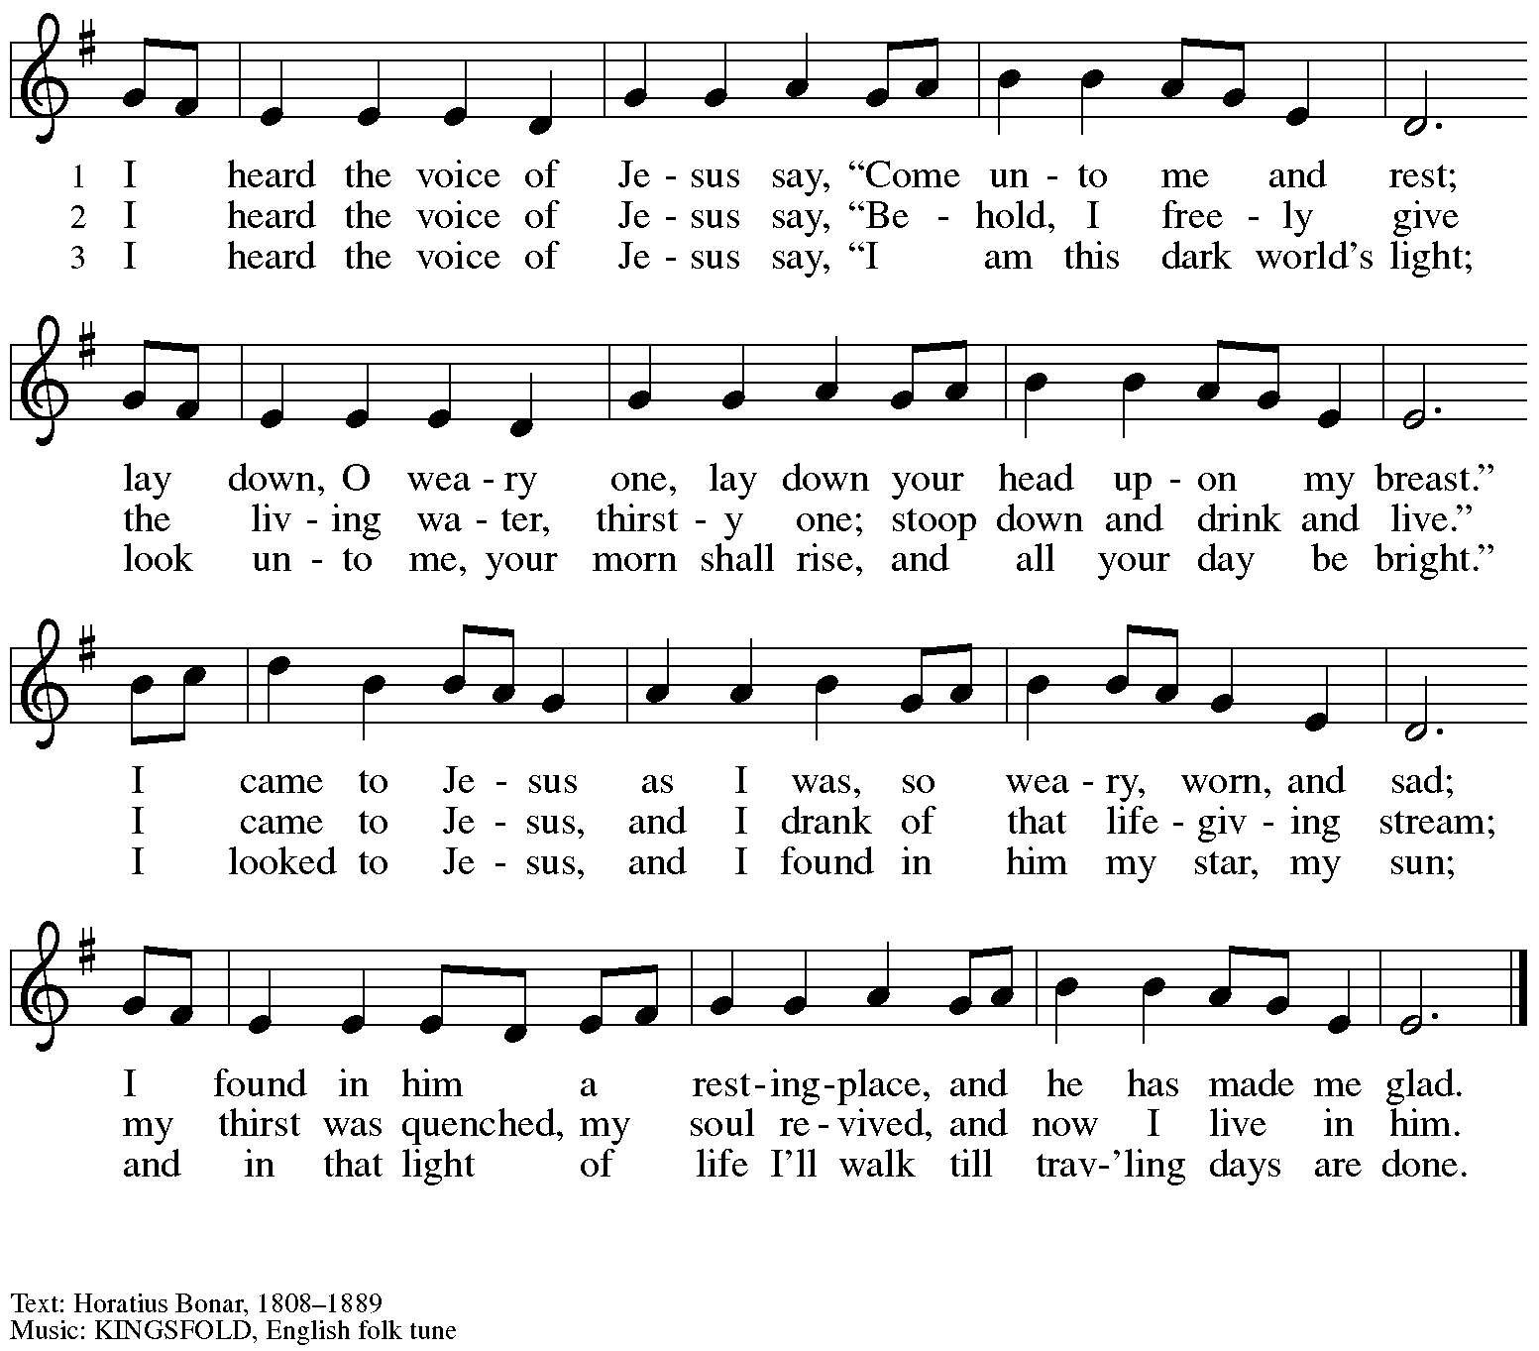

Greeting

P: The grace of our Lord Jesus Christ, the love of God,
and the communion of the Holy Spirit be with you all.
C: And also with you.

Prayer of the Day

P: Let us pray.
O God, mighty and immortal, you know that as fragile creatures surrounded by great dangers,
we cannot by ourselves remain strong. Give us strength of mind and body, so that even when we suffer because of human sin, we may rise victorious through your Son, Jesus Christ, our Savior and Lord.
C: Amen.

Please be seated.
Children are invited to join the adult leaders and move to the office for Little Church; Big Faith.

Word
God speaks to us in Scripture reading, preaching, and song

First Reading – Isaiah 58: 9b-14

^{9b}If you remove the yoke from among you,
the pointing of the finger, the speaking of evil,
¹⁰if you offer your food to the hungry
and satisfy the needs of the afflicted,
then your light shall rise in the darkness
and your gloom be like the noonday.
¹¹The Lord will guide you continually,
and satisfy your needs in parched places,
and make your bones strong;
and you shall be like a watered garden,
like a spring of water,
whose waters never fail.
¹²Your ancient ruins shall be rebuilt;
you shall raise up the foundations of many generations;
you shall be called the repairer of the breach,
the restorer of streets to live in.
¹³If you refrain from trampling the sabbath,
from pursuing your own interests on my holy day;
if you call the sabbath a delight
and the holy day of the Lord honorable;
if you honor it, not going your own ways,
serving your own interests, or pursuing your own affairs;
¹⁴then you shall take delight in the Lord,
and I will make you ride upon the heights of the earth;
I will feed you with the heritage of your ancestor Jacob,
for the mouth of the Lord has spoken.

L: Word of God, word of life.
C: Thanks be to God.

Please rise as you are able.

Gospel Acclamation Halle, Halle, Hallelujah ELW 172

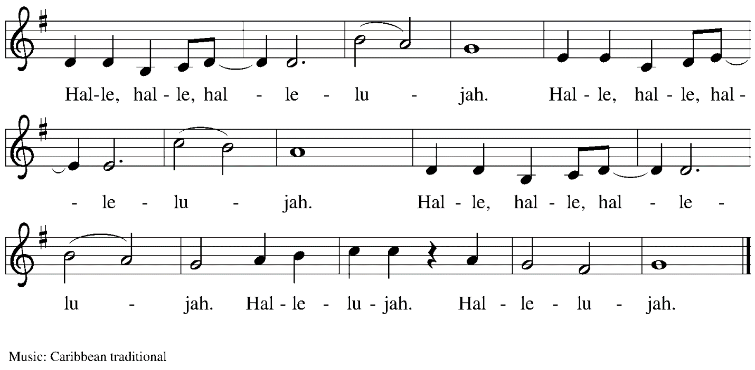

Gospel – Luke 13: 10-17

P: The holy Gospel according to St. Luke.
C: Glory to you, O Lord.

¹⁰Now [Jesus] was teaching in one of the synagogues on the sabbath. ¹¹And just then there appeared a woman with a spirit that had crippled her for eighteen years. She was bent over and was quite unable to stand up straight. ¹²When Jesus saw her, he called her over and said, “Woman, you are set free from your ailment.” ¹³When he laid his hands on her, immediately she stood up straight and began praising God. ¹⁴But the leader of the synagogue, indignant because Jesus had cured on the sabbath, kept saying to the crowd, “There are six days on which work ought to be done; come on those days and be cured, and not on the sabbath day.” ¹⁵But the Lord answered him and said, “You hypocrites! Does not each of you on the sabbath untie his ox or his donkey from the manger, and lead it away to give it water? ¹⁶And ought not this woman, a daughter of Abraham whom Satan bound for eighteen long years, be set free from this bondage on the sabbath day?” ¹⁷When he said this, all his opponents were put to shame; and the entire crowd was rejoicing at all the wonderful things that he was doing.

P: The Gospel of the Lord.
C: Praise to you, O Christ.

Please be seated.

Sermon

A time of silence for prayer and reflection follows the sermon.
When the hymn of the day begins, please rise as you are able.

Hymn of the Day When We Must Bear Persistent Pain ACS 1014

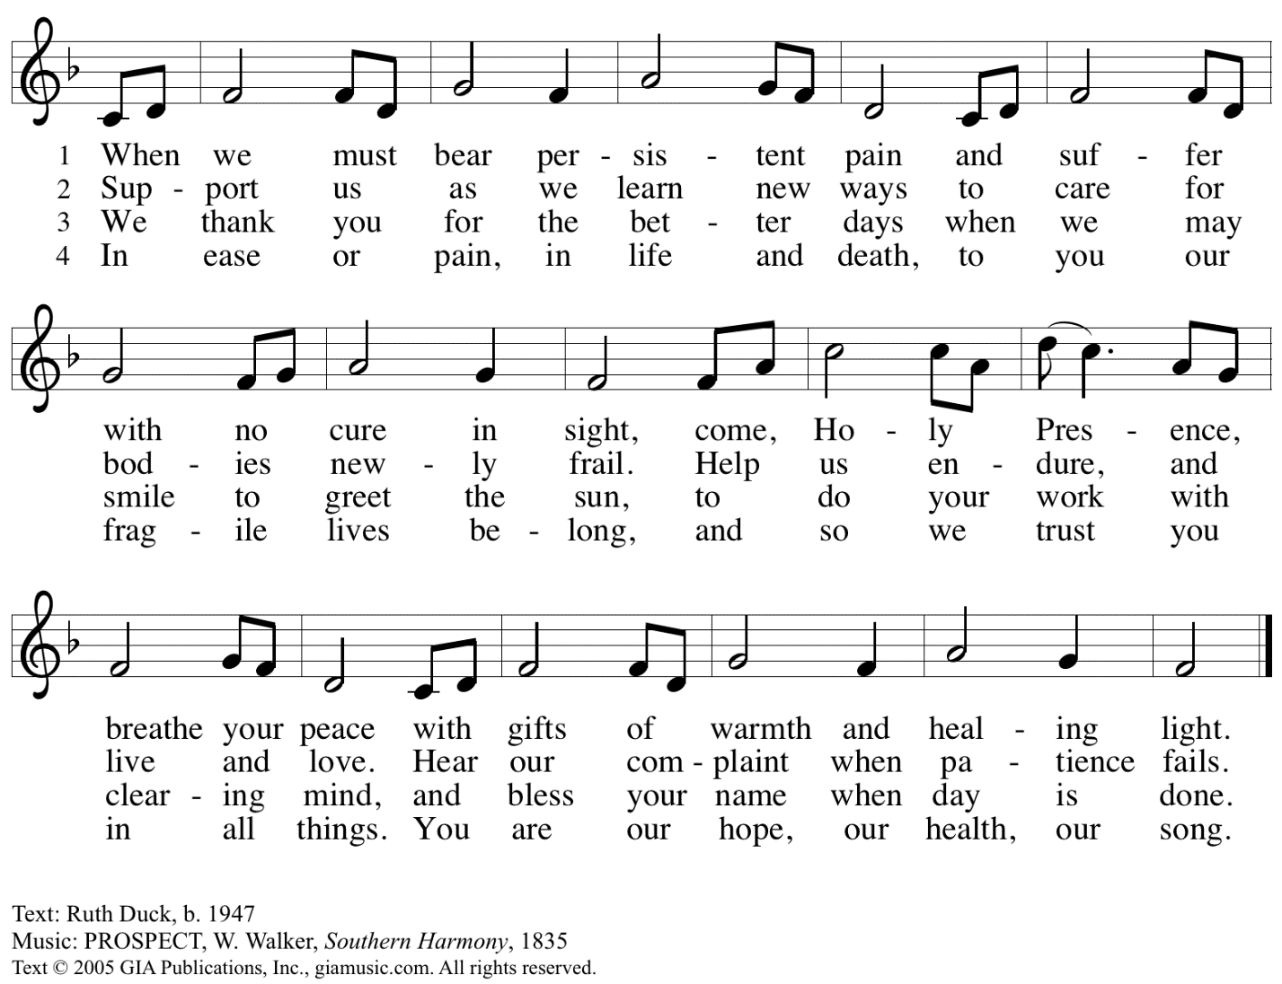
Arr. © 1968 Augsburg Publishing House, admin. Augsburg Fortress. All rights reserved. Reprinted with permission under OneLicense.net
# A-722139.

Following the Hymn of the Day, the presiding minister, minister of music,
and a representative of the congregation gather at the baptismal font.
The congregation is invited to join in a profession of faith, using the Apostles Creed.

Apostles Creed

C: I believe in God, the Father almighty,
creator of heaven and earth.

I believe in Jesus Christ, God’s only Son, our Lord,
who was conceived by the Holy Spirit,
born of the virgin Mary,
suffered under Pontius Pilate,
was crucified, died, and was buried;
he descended to the dead.*
On the third day he rose again;
he ascended into heaven,
he is seated at the right hand of the Father,
and he will come to judge the living and the dead.

I believe in the Holy Spirit,
the holy catholic church,
the communion of saints,
the forgiveness of sins,
the resurrection of the body,
and the life everlasting. Amen.

*Or, “he descended into hell,” another translation of this text in widespread use.

Installation of Minister of Music

The presiding minister, minister of music, and representative of the congregation gather
at the baptismal font.

Presentation

R: After prayerful deliberation, we of St. Andrew Lutheran Church
have appointed Laura Reynolds to serve in the position of Minister of Music.

The assembly is seated.

Address and Questions

The presiding minister addresses the one being installed.
P: Our Lord Jesus, who came among us as a servant,
calls us to faith and a life of loving service to our neighbor.
You come among us as one invited to render a particular service,
a gift from God to inspire us to love and good works.

Laura, in the presence of this assembly,
will you commit yourself to this new trust and responsibility,
in the confidence that it comes from God?
Response: I will, and I ask God to help me.

P: Will you carry out this ministry in accordance with the holy scriptures
and with the confessions of the Lutheran church
and in harmony with the constitutions
of the Evangelical Lutheran Church in America?
Response: I will, and I ask God to help me.

P: Will you be diligent in your study of the holy scriptures
and faithful in your use of the means of grace and in prayer?
Response: I will, and I ask God to help me.

P: Trusting in God's care,
will you seek to grow in love for those you serve,
strive for excellence in your skills,
and adorn the gospel of Jesus Christ with a godly life?
Response: I will, and I ask God to help me.

P: Almighty God, who has given you the will to do these things,
graciously give you the strength and compassion to perform them.
The assembly responds: Amen.

Please rise as you are able.

The presiding minister addresses the assembly.
P: People of God, will you receive Laura into this ministry
as one sent to serve in the church of Jesus Christ?
C: We will, and we ask God to help us.

P: Will you pray for her, help and honor her for her work's sake,
and in all things strive to live together in the peace and unity of Christ?
C: We will, and we ask God to help us.

The presiding minister addresses the lay professional.
P: Laura, I now declare you installed as Minister of Music of St. Andrew Lutheran Church.
Almighty God bless you, and direct your days and your deeds in peace,
that you may be a faithful servant of Christ.
C: Amen.

Prayer

P: Let us pray.
Gracious God, whom saints and angels delight to worship,
strengthen and bless your servant Laura, who through your gift of music
seeks to enliven our praises and proclaim your word of power.
Grant her joy and a spirit of bold trust, that her work may stir up in each of us
new awareness of your beauty and grace, and lead us in a life of fruitful service.
Join our voices with all the choirs of heaven;
through Jesus Christ, our Savior and Lord.
C: Amen.

The presiding minister may address the assembly with these or similar words.
P: People of God, I present to you Laura Reynolds, your Minister of Music.
Let us welcome her in the name of Christ.

The assembly may offer acclamation with applause.
The congregation is invited to sing the refrain of “Christ Goes Before,”
which is sung on special, celebratory occasions in the life of the St. Andrew congregation.

C: Christ goes before, and we are called to follow,
and all who follow find the Way, the Truth, the Life.

The service continues with the prayers of intercession.
Prayers are included for the newly installed lay professional,
for the congregation, and for the communities it serves.

Prayers of the People

P: Trusting in God’s extraordinary love, let us come before the Holy One in prayer.

After each petition
P: Merciful God,
C: receive our prayer.

P: Receive the prayers of your people, merciful God, and keep us forever in your steadfast love;
through Jesus Christ our Savior.
C: Amen.

Please be seated.

Meal

Offering

We offer ourselves, our gifts, and our faithful service to God.
An usher will pass around an offering plate for anyone who would like to offer gifts before God.
As the offering is collected, the table is prepared for Holy Communion.

Music during the Offering

Please rise as you are able.

Offertory Song All to Jesus I Surrender TFF 235
v. 1, 3

1 All to Jesus I surrender,
all to him I freely give;
I will ever love and trust him,
in his presence daily live.

Refrain
I surrender all, (I surrender all),
I surrender all, (I surrender all),
all to thee, my blessed Savior,
I surrender all.

3 All to Jesus I surrender,
Lord, I give myself to thee;
fill me with thy love and power,
let thy blessings fall on me. Refrain

Text: Judson W. Van De Venter, 1855-1939. Music: SURRENDER, Winfield S. Weeden, 1847-1908.

Offertory Prayer

P: Let us pray.
Holy God, gracious and merciful,
C: you bring forth food from the earth and nourish your whole creation.
Turn our hearts toward those who hunger in any way, that all may know your care;
and prepare us now to feast on the bread of life, Jesus Christ, our Savior and Lord.
Amen.

Dialogue

P: The Lord be with you.
C: And also with you.

P: Lift up your hearts.
C: We lift them to the Lord.

P: Let us give thanks to the Lord our God.
C: It is right to give our thanks and praise.

Preface

P: It is indeed right, our duty and our joy,
that we should at all times and in all places
give thanks and praise to you, almighty and merciful God,
through our Savior Jesus Christ;
who on this day overcame death and the grave,
and by his glorious resurrection opened to us the way of everlasting life.
And so, with all the choirs of angels,
with the church on earth and the hosts of heaven,
we praise your name and join their unending hymn:

Sanctus

Holy, holy, holy Lord,
God of power and might:
Heaven and earth are full of your glory.
Hosanna in the highest.
Blessed is the one who comes in the name of the Lord.
Hosanna in the highest.

Eucharistic Prayer

P: Holy God, holy and mighty, holy and immortal …
… Do this for the remembrance of me.

Together as the body of Christ, we proclaim the Lord’s death until he comes.
C: Christ has died.
Christ has risen.
Christ will come again.

P: With this bread and cup we remember your Son …
… all our sins and sorrows will be no mor
C: Amen. Come, Lord Jesus.

P: Holy God, holy and merciful one, holy and compassionate …
… sharing your bounty with all the world.
C: Amen. Come, Holy Spirit.

P: Holy and benevolent God …
… with the Holy Spirit, in your holy church, now and forever.
C: Amen.

Lord’s Prayer

P: Gathered as one by the Holy Spirit, let us pray as Jesus taught us.
C: Our Father in heaven,
hallowed be your name,
your kingdom come,
your will be done,
on earth as in heaven.
Give us today our daily bread.
Forgive us our sins
as we forgive those who sin against us.
Save us from the time of trial
and deliver us from evil.
For the kingdom, the power,
and the glory are yours,
now and forever. Amen.

Fraction and Invitation

Agnus Dei / Lamb of God

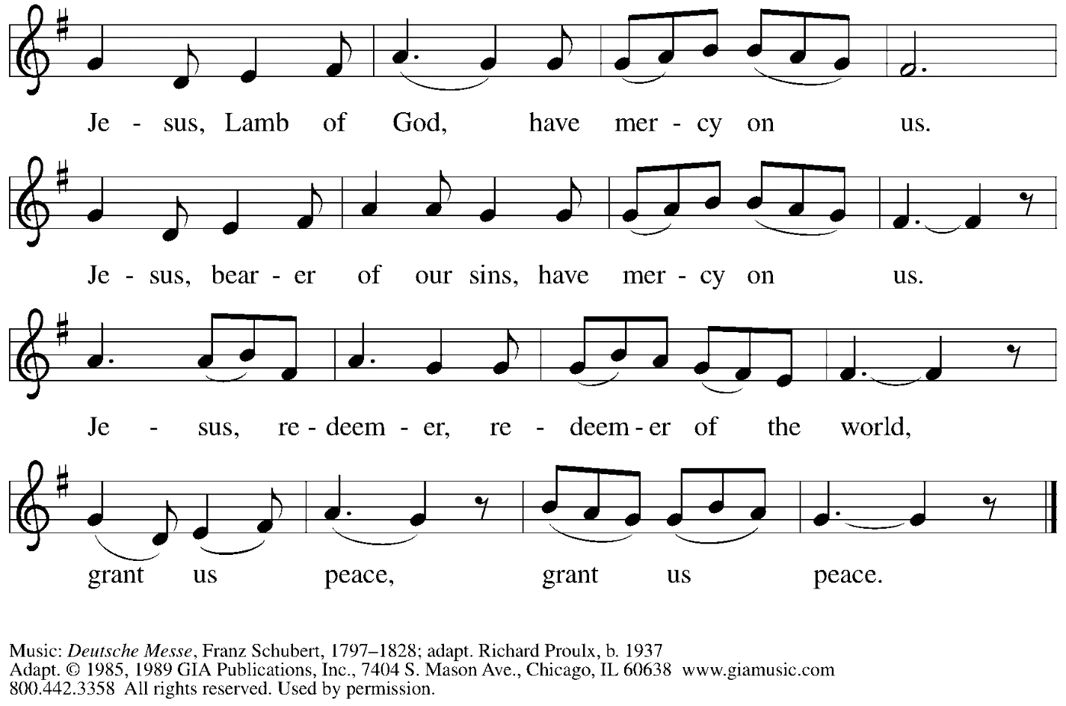
Reprinted with permission under OneLicense.net # A-722139.

Please be seated.

Holy Communion
- Hand sanitizer is available if you would like to use it prior to receiving Communion.
- Worshipers from the pulpit side will proceed forward first, followed by the center section, and then the lectern side.
- The Communion wafers (regular and gluten-free) have been thoughtfully prepared using the gifts of the congregation by a member of St. Andrew’s altar care team, with a drop of wine or grape juice on each. The presiding minister will distribute one to each communicant.
- When you reach the presiding minister, please indicate if you would like grape juice or a gluten-free wafer.
- A blessing will be provided for anyone who does not yet receive the sacrament.
- Cushions have been placed at the altar rail for anyone who would like to kneel for prayer and reflection before returning to their pew.
- Everyone is asked to wait until you return to your place to consume the elements, and then promptly replace your mask.

Hymns during Holy Communion
We Come to the Hungry Feast ELW 479

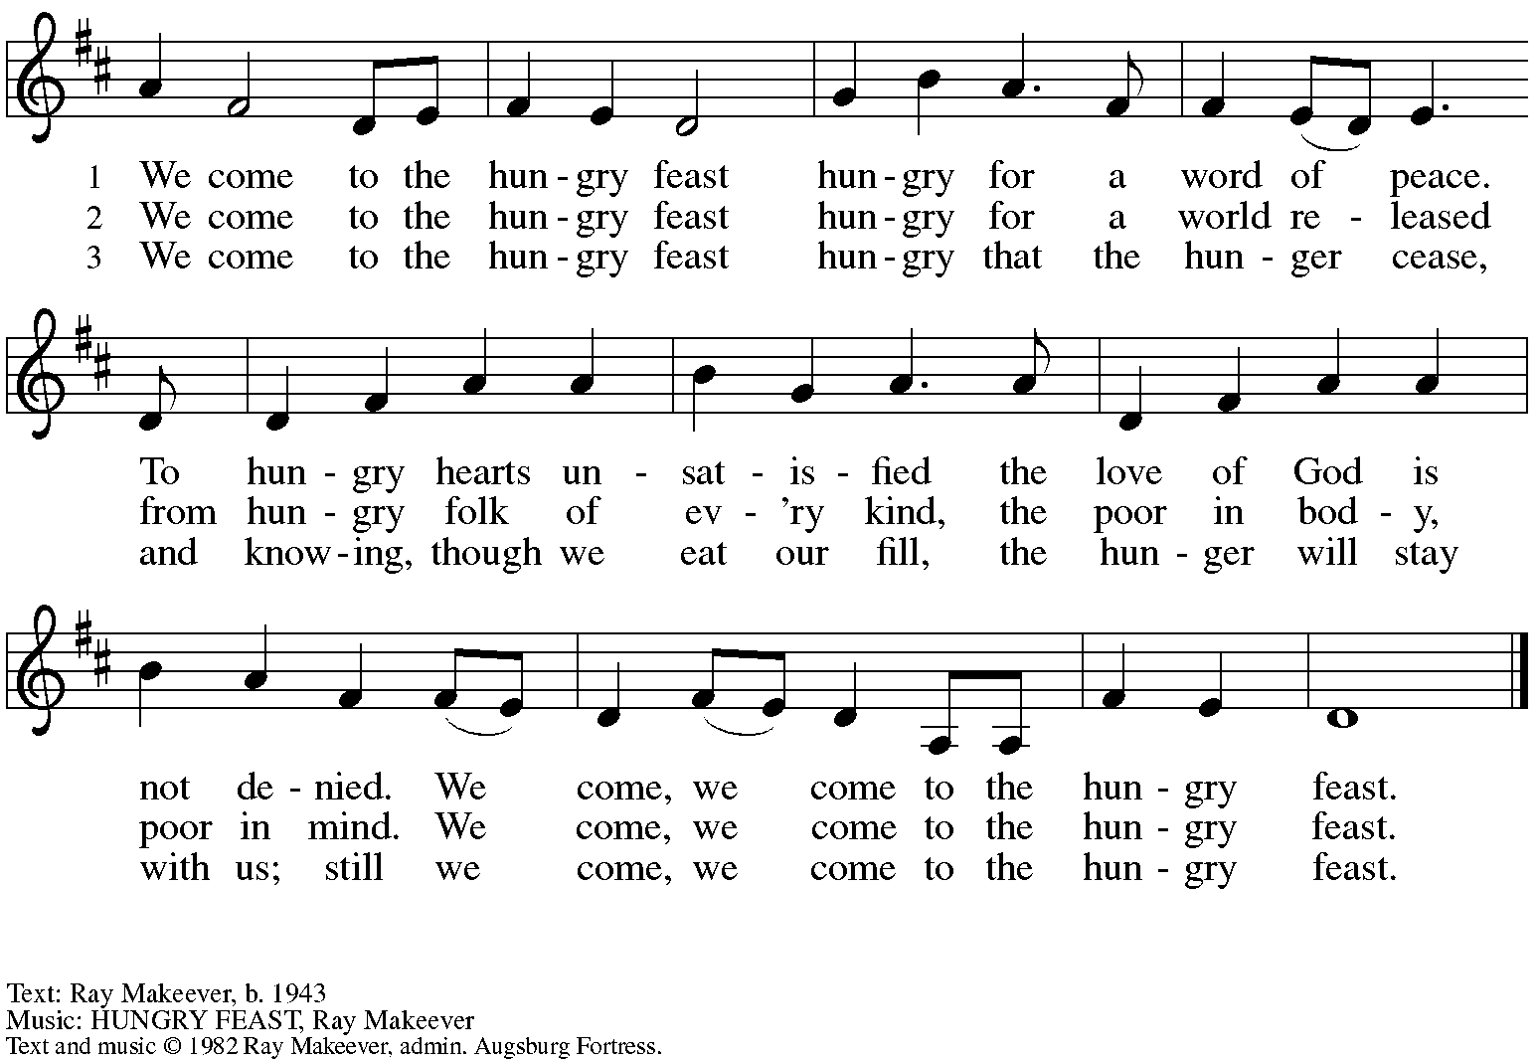
All rights reserved. Reprinted with permission under OneLicense.net # A-722139.
Hymns during Holy Communion
Rejoice, Ye Pure in Heart! ELW 873

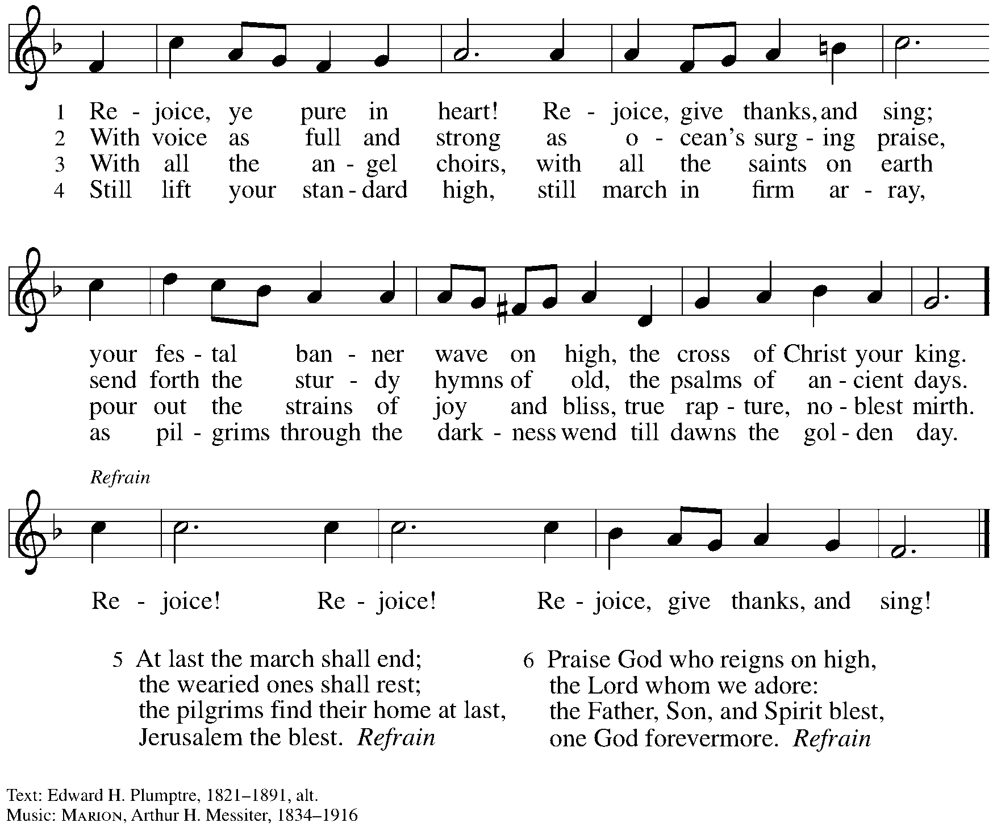

When all have returned to their places, please rise as you are able.

Blessing

P: The body and blood of our Lord Jesus Christ strengthen you and keep you in his grace.
C: Amen.

Prayer

P: Let us pray. Life-giving God, through this meal you have bandaged our wounds
and fed us with your mercy. Now send us forth to live for others, both friend and stranger,
that all may come to know your love. This we pray in the name of Jesus.
C: Amen.
Please be seated.

Sending

Announcements

Please rise as you are able.

Benediction

P: The God ☩ of peace, bless you, comfort you,
and show you the path of life, this day and always.
C: Amen.

Sending Hymn I’m So Glad Jesus Lifted Me ELW 860

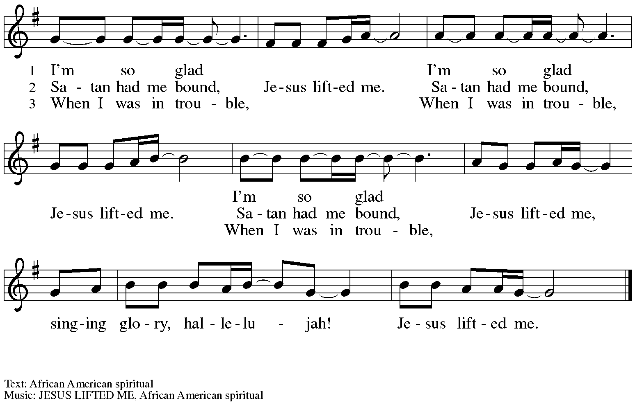

Dismissal

P: Go in peace. Serve the Lord.
C: Thanks be to God!

Abbreviations

P: Pastor/Presiding Minister
R: Congregational Representative
L: Lector
C: Congregation

ELW: Evangelical Lutheran Worship hymnal
ACS: All Creation Sings hymnal
TFF: This Far by Faith hymnal

Those serving in worship today

Minister of Music Laura Reynolds
Congregational Representative Sue Gaugler
Piano on “Christ Goes Before” Jimmi Kocher-Hillmer
Cantor Richard Krug
Lector Kelly Spanninger
Presiding Minister Rev. Ross Carmichael

Liturgy and Hymnody Acknowledgements

From SundaysandSeasons.com. Copyright © 2022 Augsburg Fortress. All rights reserved. Reprinted under OneLicense.net # A-722139.
Used by permission of Augsburg Fortress.

St. Andrew Lutheran Church Announcements
August 21, 2022

- Worship for Sunday, August 21st, + Eleventh Sunday after Pentecost - Allegheny County’s Covid-19 community level is now at "medium,” so St. Andrew once again requires masks for those over the age of two (2), except for worship leaders conducting parts of the service away from the congregation. Attendees are invited to make their own name tags at the back of the worship space. "Coffee" hour (BYOB) will be held outside (behind the church building) after worship each Sunday as weather permits.
- Welcome, New Minister of Music Laura Reynolds! - Please welcome Ms. Laura Reynolds, who will be installed as St. Andrew’s Minister of Music during worship today! Laura brings experience leading worship in Methodist, Baptist, Catholic, Non-Denominational, and Lutheran congregations. Laura holds a Bachelor of Music degree from Wayne State University in Detroit, an Artist’s Diploma from Conservatorio Scontrino in Trapani, Sicily, and a Master of Music in Piano Performance from the University of South Florida in Tampa. Laura is excited to work and worship with the many gifted instrumentalists and vocalists at St. Andrew!
- Summary of Churchwide Assembly - St. Andrew's denomination, the Evangelical Lutheran Church in America (ELCA), met in assembly last week. This gathering, the highest deliberative and legislative body of our church, was held in Columbus, Ohio, where the church was first incorporated 35 years ago as a merger of several Lutheran denominations. For more information about Churchwide Assembly or to watch the assembly sessions, please visit Churchwide Assembly - Evangelical Lutheran Church in America (elca.org). Our local Southwestern Pennsylvania Synod has provided a brief summary of the assembly at News from Churchwide Assembly — Southwestern Pennsylvania Synod (swpasynod.org).
- ELCA Fund for Leaders 25th Anniversary - Twenty-five years ago, leaders of our church established what we now know as the ELCA Fund for Leaders and challenged the church to make a robust commitment to theological education for its future leaders. In 2000, the Fund for Leaders awarded its first eight scholarships. Now, the Fund for Leaders supports over 300 candidates for ministry with over $3.2 million in scholarships, including $1 million more in scholarship support annually than it was five years ago. With synodical scholarship recipients, the Fund for Leaders network of alums has grown to over a thousand! The ELCA is celebrating the Fund for Leaders all year with new stories from alums and new resources and seeks to continue growing the Fund and to increase annual awards by another $1 million in the next five years. That will allow for 50 full-tuition scholarships to promising leaders every year. Together, we are working toward the Fund's ultimate goal: a future in which every ELCA seminary candidate can graduate without the burden of financial debt. For more information, or to donate (with matching gift opportunity), please visit 25th Anniversary - Evangelical Lutheran Church in America (elca.org).
- Little Pantry and Little Library Assistance - St. Andrew is accepting donations of food items, as well as financial gifts, for the Little Pantry on an ongoing basis. We would especially appreciate help restocking. If you would like to help with the Pantry and/or Library, please sign up here: https://www.signupgenius.com/go/5080544AAAC22A1F58-free.

