+ Twelfth Sunday after Pentecost
August 28, 2022
St. Andrew Lutheran Church
304 Morewood Ave.
Pittsburgh, PA 15213
St_andrewELCA@verizon.net
www.standrewpittsburgh.org

+ Twelfth Sunday after Pentecost
Order for Worship

Invited and inviting—that is the nature of the church.
By God’s grace in Holy Baptism we have a place at Christ’s banquet table.
When, by the power of that same Spirit, humility and mutual love continue among us,
the church can be more inviting still.

A few notes on precautions and protocols, which apply to everyone regardless of vaccination status, as St. Andrew returns to worship in the sanctuary:

- Allegheny County’s Covid-19 community level is in the “medium” category. Face masks that fully cover both your mouth and nose are required for parishioners over the age of two (2) – the one exception being that worship leaders will remove masks during parts that are conducted at a distance from the pews.
- Physical distancing of at least six (6) feet will be observed at all times for people not from your household.
- Hand sanitizer is available at the front of the sanctuary to use before Holy Communion, after you proceed past the baptismal font, as the alcohol has been affecting the finish on the font’s bowl.

Worship Services are live streamed to multiple online platforms.
By attending worship, you agree that your image and voice may be broadcast.

Welcome to St. Andrew!
- Everyone is invited to make a nametag at the black bookcase in the back of the worship space if they would like.
- Worship “toolkits” to help children engage with the service are available in the black bookcase at the back of the worship space. There are “reader” and “pre-reader” resources available in each kit. Please feel free to use the kits for/with your children during worship.
- After the Prayer of the Day, children are invited to gather in the Social Hall for Little Church; Big Faith, a Bible lesson and activity. The group returns to the worship space for the Communion portion of the service.
- A restroom is available on the main level of the church, through the doors to the Social Hall and to the right in the main office.

Welcome

Prelude

Gathering
The Holy Spirit calls us together as the people of God.

Confession and Forgiveness

P: Blessed be the holy Trinity, ☩ one God,
whose steadfast love endures forever.
C: Amen.

P: Let us confess our sin in the presence of God and of one another.

Silence is kept for reflection.

P: Merciful God,
C: we confess that we have not followed your path
but have chosen our own way.
Instead of putting others before ourselves,
we long to take the best seats at the table.
When met by those in need,
we have too often passed by on the other side.
Set us again on the path of life.
Save us from ourselves
and free us to love our neighbors.
Amen.

P: Hear the good news!
God does not deal with us according to our sins
but delights in granting pardon and mercy.
In the name of ☩ Jesus Christ, your sins are forgiven.
You are free to love as God loves.
C: Amen.

Gathering Hymn All Are Welcome ELW 641

1 Let us build a house where love can dwell
and all can safely live,
a place where saints and children tell
how hearts learn to forgive.
Built of hopes and dreams and visions,
rock of faith and vault of grace;
here the love of Christ shall end divisions:

Refrain
All are welcome, all are welcome,
all are welcome in this place.

3 Let us build a house where love is found
in water, wine and wheat:
a banquet hall on holy ground
where peace and justice meet.
Here the love of God, through Jesus,
is revealed in time and space;
as we share in Christ the feast that frees us: Refrain

5 Let us build a house where all are named,
their songs and visions heard
and loved and treasured, taught and claimed
as words within the Word.
Built of tears and cries and laughter,
prayers of faith and songs of grace,
let this house proclaim from floor to rafter: Refrain

Text: Marty Haugen, b. 1950. Music: TWO OAKS, Marty Haugen. Text and music © 1994 GIA Publications, Inc., 7404 S. Mason Ave., Chicago, IL 60638, www.giamusic.com. 800.442.3358. All rights reserved. Reprinted with permission under OneLicense.net # A-722139.

Greeting

P: The grace of our Lord Jesus Christ, the love of God,
and the communion of the Holy Spirit be with you all.
C: And also with you.

Prayer of the Day

P: Let us pray.
O God, you resist those who are proud and give grace to those who are humble.
Give us the humility of your Son, that we may embody the generosity of Jesus Christ,
our Savior and Lord.
C: Amen.

Please be seated.
Children are invited to join the adult leaders and move to the office for Little Church; Big Faith.

Word
God speaks to us in Scripture reading, preaching, and song

First Reading – Proverbs 25: 6-7

⁶Do not put yourself forward in the king’s presence
or stand in the place of the great;
⁷for it is better to be told, “Come up here,”
than to be put lower in the presence of a noble.

L: Word of God, word of life.
C: Thanks be to God.

Please rise as you are able.

Gospel Acclamation Halle, Halle, Hallelujah ELW 172

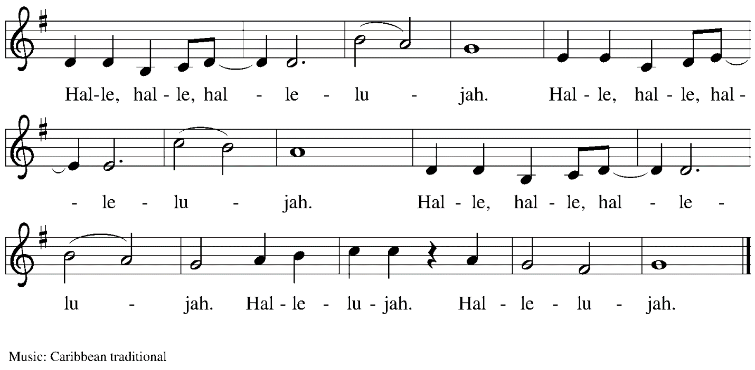

Gospel – Luke 14: 1, 7-14

P: The holy Gospel according to St. Luke.
C: Glory to you, O Lord.

¹On one occasion when Jesus was going to the house of a leader of the Pharisees to eat a meal on the sabbath, they were watching him closely.
⁷When he noticed how the guests chose the places of honor, he told them a parable. ⁸“When you are invited by someone to a wedding banquet, do not sit down at the place of honor, in case someone more distinguished than you has been invited by your host; ⁹and the host who invited both of you may come and say to you, ‘Give this person your place,’ and then in disgrace you would start to take the lowest place. ¹⁰But when you are invited, go and sit down at the lowest place, so that when your host comes, he may say to you, ‘Friend, move up higher’; then you will be honored in the presence of all who sit at the table with you. ¹¹For all who exalt themselves will be humbled, and those who humble themselves will be exalted.”
¹²He said also to the one who had invited him, “When you give a luncheon or a dinner, do not invite your friends or your brothers or your relatives or rich neighbors, in case they may invite you in return, and you would be repaid. ¹³But when you give a banquet, invite the poor, the crippled, the lame, and the blind. ¹⁴And you will be blessed, because they cannot repay you, for you will be repaid at the resurrection of the righteous.”

P: The Gospel of the Lord.
C: Praise to you, O Christ.

Please be seated.

Sermon

A time of silence for prayer and reflection follows the sermon.
When the hymn of the day begins, please rise as you are able.

Hymn of the Day v. 2-3
Vamos todos al banquete/Let Us Go Now to the Banquet ELW 523

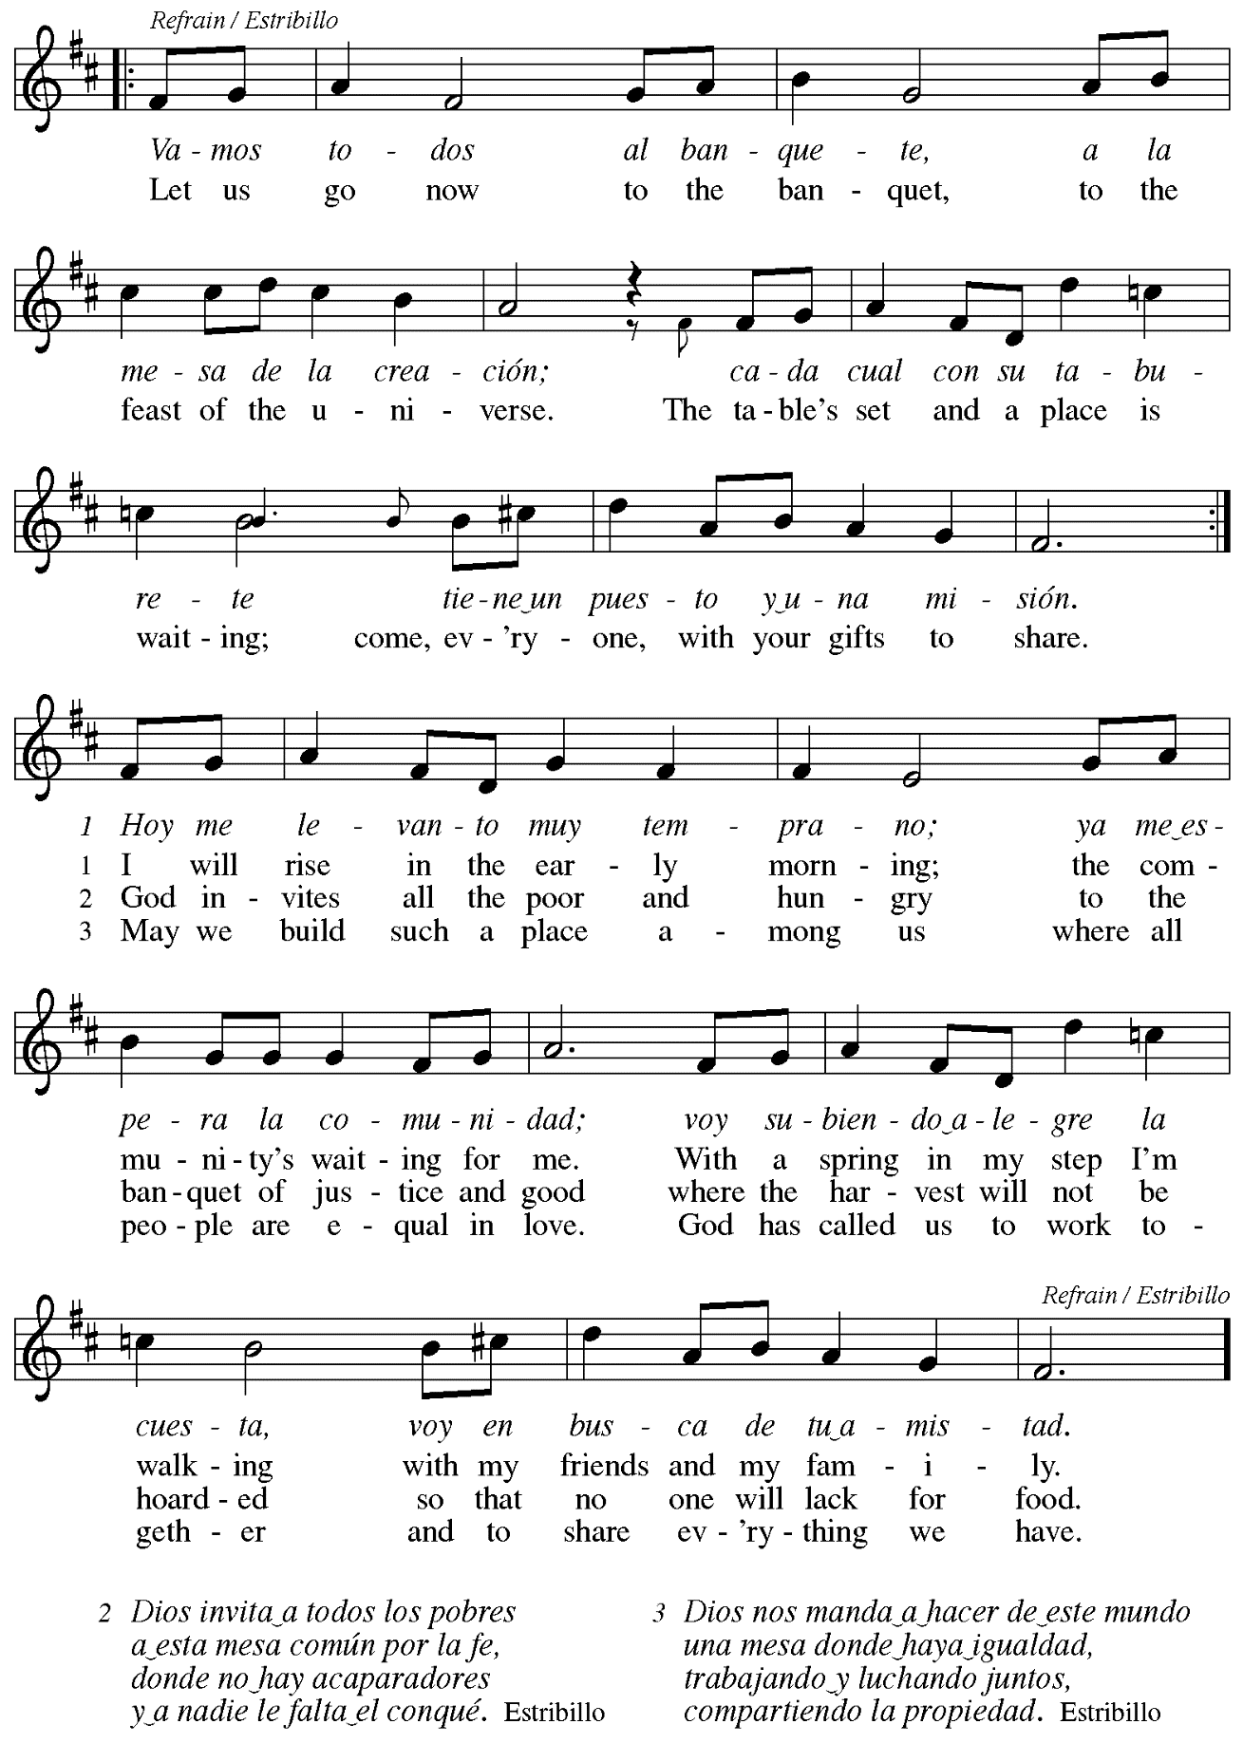
Prayers of the People

P: Trusting in God’s extraordinary love, let us come before the Holy One in prayer.

After each petition
P: Merciful God,
C: receive our prayer.

P: Receive the prayers of your people, merciful God, and keep us forever in your steadfast love;
through Jesus Christ our Savior.
C: Amen.

Please be seated.

Meal

Offering

We offer ourselves, our gifts, and our faithful service to God.
An usher will pass around an offering plate for anyone who would like to offer gifts before God.

Music during the Offering

Please rise as you are able.

Offertory Song All to Jesus I Surrender TFF 235
v. 1, 3

1 All to Jesus I surrender,
all to him I freely give;
I will ever love and trust him,
in his presence daily live.

Refrain
I surrender all, (I surrender all),
I surrender all, (I surrender all),
all to thee, my blessed Savior, I surrender all.

3 All to Jesus I surrender,
Lord, I give myself to thee;
fill me with thy love and power,
let thy blessings fall on me. Refrain

Text: Judson W. Van De Venter, 1855-1939. Music: SURRENDER, Winfield S. Weeden, 1847-1908.

Offertory Prayer

P: Let us pray.
Holy God, gracious and merciful,
C: you bring forth food from the earth and nourish your whole creation.
Turn our hearts toward those who hunger in any way, that all may know your care;
and prepare us now to feast on the bread of life, Jesus Christ, our Savior and Lord.
Amen.

Dialogue

P: The Lord be with you.
C: And also with you.

P: Lift up your hearts.
C: We lift them to the Lord.

P: Let us give thanks to the Lord our God.
C: It is right to give our thanks and praise.

Preface

P: It is indeed right, our duty and our joy,
that we should at all times and in all places
give thanks and praise to you, almighty and merciful God,
through our Savior Jesus Christ;
who on this day overcame death and the grave,
and by his glorious resurrection opened to us the way of everlasting life.
And so, with all the choirs of angels,
with the church on earth and the hosts of heaven,
we praise your name and join their unending hymn:

Sanctus

Holy, holy, holy Lord,
God of power and might:
Heaven and earth are full of your glory.
Hosanna in the highest.
Blessed is the one who comes in the name of the Lord.
Hosanna in the highest.

Eucharistic Prayer

P: Holy God, holy and mighty, holy and immortal …
… Do this for the remembrance of me.

Together as the body of Christ, we proclaim the Lord’s death until he comes.
C: Christ has died.
Christ has risen.
Christ will come again.

P: With this bread and cup we remember your Son …
… all our sins and sorrows will be no mor
C: Amen. Come, Lord Jesus.

P: Holy God, holy and merciful one, holy and compassionate …
… sharing your bounty with all the world.
C: Amen. Come, Holy Spirit.

P: Holy and benevolent God …
… with the Holy Spirit, in your holy church, now and forever.
C: Amen.

Lord’s Prayer

P: Gathered as one by the Holy Spirit, let us pray as Jesus taught us.
C: Our Father in heaven,
hallowed be your name,
your kingdom come,
your will be done,
on earth as in heaven.
Give us today our daily bread.
Forgive us our sins
as we forgive those who sin against us.
Save us from the time of trial
and deliver us from evil.
For the kingdom, the power,
and the glory are yours,
now and forever. Amen.

Fraction and Invitation

Agnus Dei Jesus, Lamb of God ELW 199

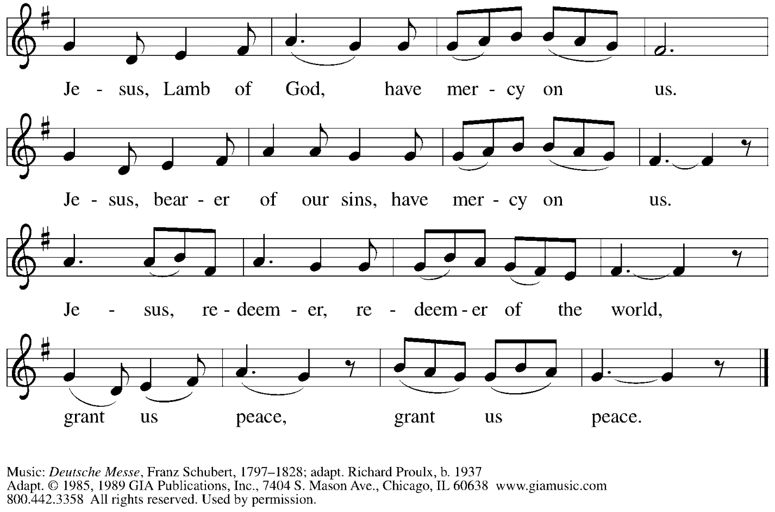
Reprinted with permission under OneLicense.net # A-722139.

Please be seated.

Holy Communion
- Hand sanitizer is available if you would like to use it prior to receiving Communion.
- Worshipers from the pulpit side will proceed forward first, followed by the center section, and then the lectern side.
- The Communion wafers (regular and gluten-free) have been thoughtfully prepared using the gifts of the congregation by a member of St. Andrew’s altar care team, with a drop of wine or grape juice on each. The presiding minister will distribute one to each communicant.
- When you reach the presiding minister, please indicate if you would like grape juice or a gluten-free wafer.
- A blessing will be provided for anyone who does not yet receive the sacrament.
- Cushions have been placed at the altar rail for anyone who would like to kneel for prayer and reflection before returning to their pew.
- Everyone is asked to wait until you return to your place to consume the elements, and then promptly replace your mask.

Hymns during Holy Communion
Now We Join in Celebration ELW 462

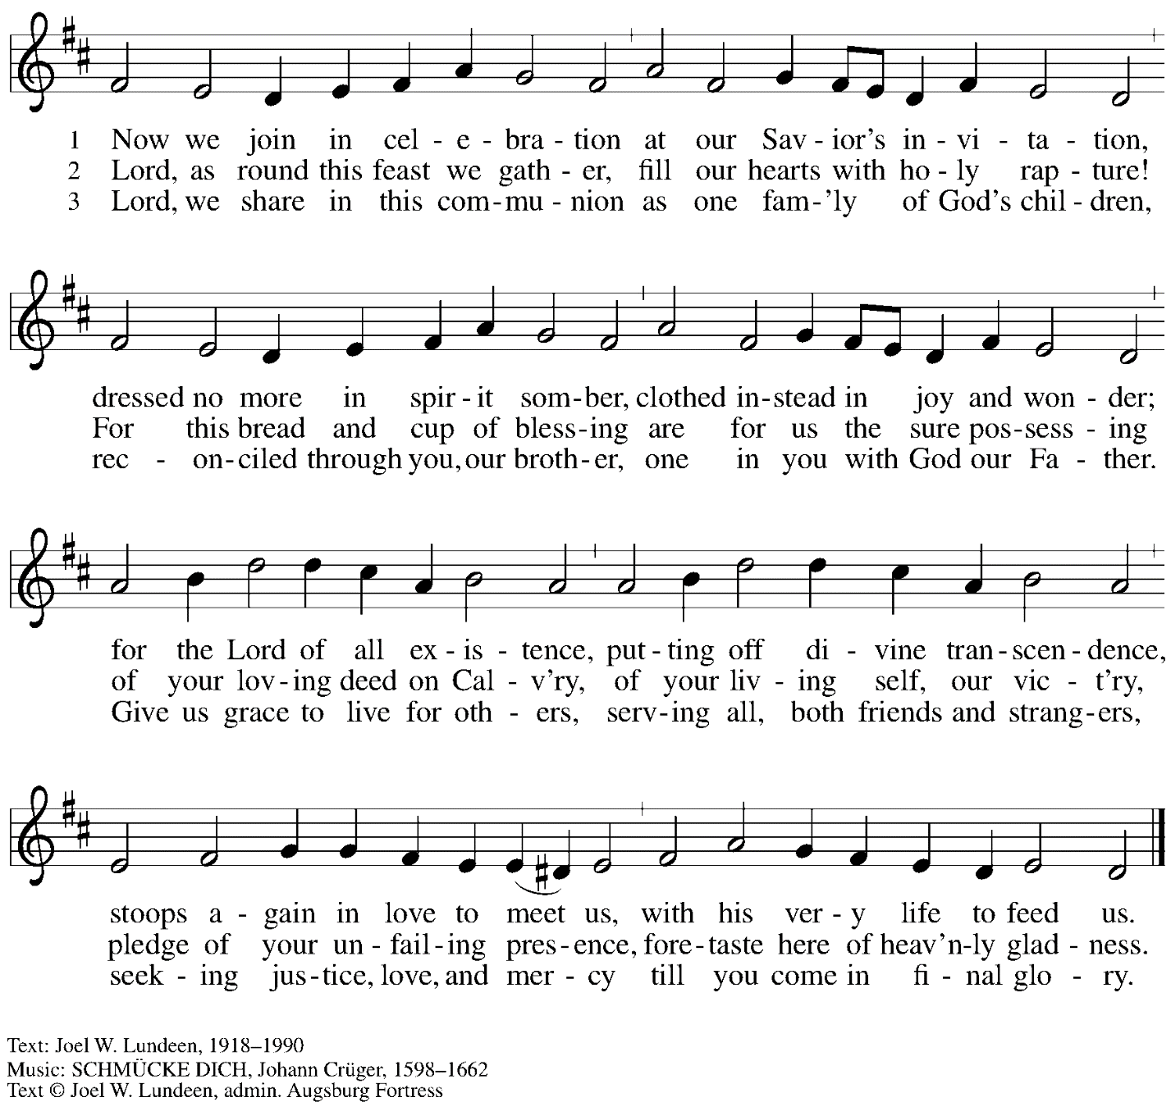
All rights reserved. Reprinted with permission under OneLicense.net # A-722139.

Hymns during Holy Communion
Bread of Life, Our Host and Meal ELW 464

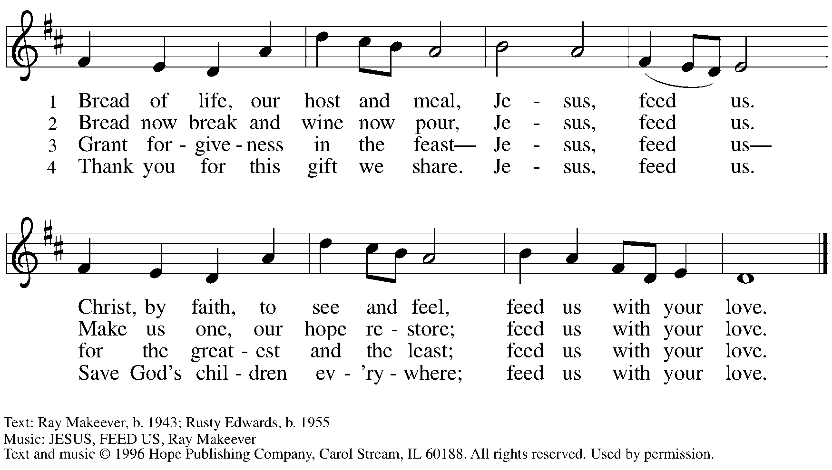
Reprinted with permission under OneLicense.net # A-722139.

When all have returned to their places, please rise as you are able.

Blessing

P: The body and blood of our Lord Jesus Christ strengthen you and keep you in his grace.
C: Amen.

Prayer

P: Let us pray. Life-giving God, through this meal you have bandaged our wounds
and fed us with your mercy. Now send us forth to live for others, both friend and stranger,
that all may come to know your love. This we pray in the name of Jesus.
C: Amen.

Please be seated.

Sending

Announcements

Please rise as you are able.

Benediction

P: The God ☩ of peace, bless you, comfort you,
and show you the path of life, this day and always.
C: Amen.

Sending Hymn
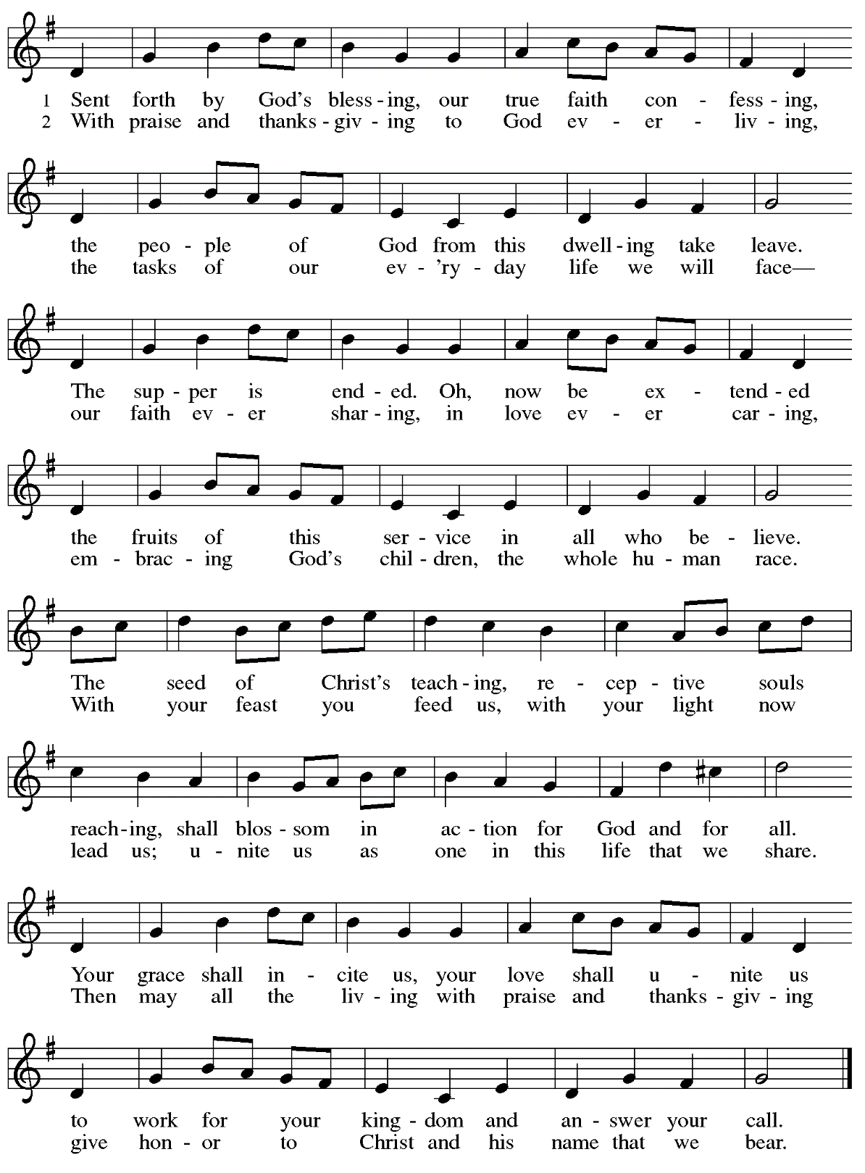

Dismissal

P: Go in peace. Serve the Lord.
C: Thanks be to God!

Abbreviations

P: Pastor/Presiding Minister
L: Lector
C: Congregation

ELW: Evangelical Lutheran Worship hymnal
ACS: All Creation Sings hymnal
TFF: This Far by Faith hymnal

Those serving in worship today

Preaching Minister Bishop Kurt F. Kusserow
Minister of Music Laura Reynolds
Cantor Noël Marsh
Lector Dixie Tymitz
Presiding Minister Rev. Ross Carmichael

Liturgy and Hymnody Acknowledgements

From SundaysandSeasons.com. Copyright © 2022 Augsburg Fortress. All rights reserved. Reprinted under OneLicense.net # A-722139.
Used by permission of Augsburg Fortress.

Vamos todos al banquete / Let Us Go Now to the Banquet – Text: Guillermo Cuéllar, b. 1955, Misa popular salvadoreña; tr. Bret Hesla, b. 1957, and William Dexheimer Pharris, b. 1956. Music: VAMOS TODOS AL BANQUETE, Guillermo Cuéllar,b. 1955. Text © 1988, Text and Music © 1994, 1996 GIA Publications, Inc., 7404 S. Mason Ave., Chicago, IL 60638. www.giamusic.com. 800.442.3358. All rights reserved.
Reprinted with permission under OneLicense.net # A-722139.

Sent Forth by God’s Blessing – Text: Omer Westendorf, 1916-1997, alt. Music: THE ASH GROVE, Welsh folk tune. Text © 1964 World Library Publications, 3708 River Rd., Franklin Park, IL 60131-2158. All rights reserved. Reprinted with permission under OneLicense.net
# A-722139.

St. Andrew Lutheran Church Announcements
August 28, 2022

- Worship in the Sanctuary and Online - Sunday, August 28th, + Twelfth Sunday after Pentecost - St. Andrew’s next service of Holy Communion will be this Sunday, August 28th, at 10:00 a.m. Allegheny County’s Covid-19 community level is once again in the “medium category, so masks are required in the building for everyone over the age of two (2), except for worship leaders conducting parts of the service at a distance from the congregation. Attendees are invited to make their own name tags at the back of the worship space. **Please do not attend an on-site event if you have felt sick in any way until you have 5 days without symptoms.** Worship will also be live-streamed to Facebook, YouTube, and Zoom. The login information for Zoom is listed in the Worship section below. Social hour will be held outside (behind the church building) after worship each Sunday as weather permits.
- Bishop Kusserow Today, August 28th! - Bishop Kurt Kusserow of our local Southwestern Pennsylvania Synod is attending worship with the congregation this Sunday and preaching - Please welcome him back to St. Andrew!
- Welcome, Minister of Music Laura Reynolds! - This past Sunday during worship, Laura Reynolds was installed as St. Andrew’s Minister of Music! Laura has experience leading worship in a variety of churches, having played in Methodist, Baptist, Catholic, Non-Denominational, and Lutheran congregations since she was 16 years old. Laura holds a Bachelor of Music degree from Wayne State University in Detroit, an Artist’s Diploma from Conservatorio Scontrino in Trapani, Sicily, and a Master of Music in Piano Performance from the University of South Florida in Tampa.
- September Produce Distribution - Tuesday, September 6th, 5:30-7:00 p.m. Shelter Dinner with East End Cooperative Ministry Scheduled for Thursday, August 18th, 6:30 p.m. - Each month, on the first Tuesday, St. Andrew hosts a fresh produce distribution in partnership with Greater Pittsburgh Community Food Bank. The next one will be Tuesday, September 6th. We invite people of the congregation to help serve with the distribution from 5:30-7:00 p.m. Additional help is needed during the day for setup and unloading of the produce. Arrival times have varied, so those who sign up will receive a call the day before with an approximate time. Please sign up at: https://www.signupgenius.com/go/5080544AAAC22A1F58-produce20.
- Little Pantry and Little Library Assistance - St. Andrew is accepting donations of food items, as well as financial gifts, for the Little Pantry on an ongoing basis. We would especially appreciate help restocking. If you would like to help with the Pantry and/or Library, please sign up here: https://www.signupgenius.com/go/5080544AAAC22A1F58-free.
- Summaries of ELCA Churchwide Assembly - St. Andrew's denomination, the Evangelical Lutheran Church in America (ELCA), met in assembly at the beginning of August. To read the ELCA’s Churchwide Assembly summary or to watch the assembly sessions, please visit Churchwide Assembly - Evangelical Lutheran Church in America (elca.org). Our local Southwestern Pennsylvania Synod has also provided a brief summary of the assembly at News from Churchwide Assembly — Southwestern Pennsylvania Synod (swpasynod.org).

