+ Ninth Sunday after Pentecost
August 7, 2022
St. Andrew Lutheran Church
304 Morewood Ave.
Pittsburgh, PA 15213
St_andrewELCA@verizon.net
www.standrewpittsburgh.org

+ Ninth Sunday after Pentecost
Order for Worship

Jesus says it is God’s “good pleasure to give you the kingdom.” It is God’s promise from the beginning—to Abraham, to the early church, and to the “little flock” of which we are a part in today’s assembly. Faith, God’s baptismal gift, trusts the promises of God. Have no fear.

A few notes on precautions and protocols, which apply to everyone regardless of vaccination status, as St. Andrew returns to worship in the sanctuary:

- Face masks that fully cover both your mouth and nose are required for parishioners over the age of two (2) – the one exception being that worship leaders will remove masks during parts that are conducted at a distance from the pews.
- Physical distancing of at least six (6) feet will be observed at all times for people not from your household.
- Hand sanitizer is available at the front of the sanctuary to use before Holy Communion, after you proceed past the baptismal font, as the alcohol has been affecting the finish on the font’s bowl.

Worship Services are live streamed to multiple online platforms.
By attending worship, you agree that your image and voice may be broadcast.

Welcome to St. Andrew!
- Everyone is invited to make a nametag at the black bookcase in the back of the worship space if they would like.
- Worship “toolkits” to help children engage with the service are available in the black bookcase at the back of the worship space. There are “reader” and “pre-reader” resources available in each kit. Please feel free to use the kits for/with your children during worship.
- After the Prayer of the Day, children are invited to gather in the Social Hall for Little Church; Big Faith, a Bible lesson and activity. The group returns to the worship space for the Communion portion of the service.
- A restroom is available on the main level of the church, through the doors to the Social Hall and to the right in the main office.

Welcome

Prelude

Gathering
The Holy Spirit calls us together as the people of God.

Confession and Forgiveness

P: Blessed be the holy Trinity, ☩ one God,
whose steadfast love endures forever.
C: Amen.

P: Let us confess our sin in the presence of God and of one another.

Silence is kept for reflection.

P: Merciful God,
C: we confess that we have not followed your path
but have chosen our own way.
Instead of putting others before ourselves,
we long to take the best seats at the table.
When met by those in need,
we have too often passed by on the other side.
Set us again on the path of life.
Save us from ourselves
and free us to love our neighbors.
Amen.

P: Hear the good news!
God does not deal with us according to our sins
but delights in granting pardon and mercy.
In the name of ☩ Jesus Christ, your sins are forgiven.
You are free to love as God loves.
C: Amen.

Gathering Hymn God Is Here! ELW 526
v. 1. 4

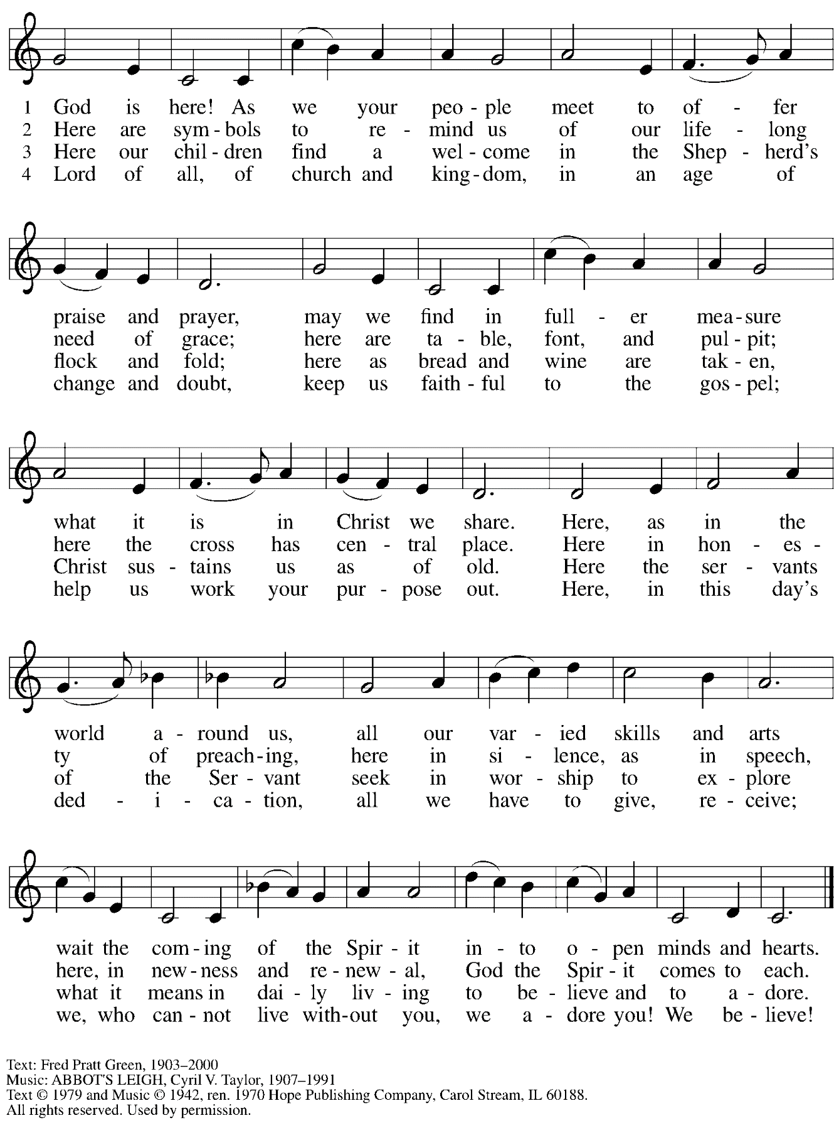
Reprinted with permission under OneLicense.net # A-722139.

Greeting

P: The grace of our Lord Jesus Christ, the love of God,
and the communion of the Holy Spirit be with you all.
C: And also with you.

Prayer of the Day

P: Let us pray.
Almighty God, you sent your Holy Spirit to be the life and light of your church.
Open our hearts to the riches of your grace,
that we may be ready to receive you whenever you appear,
through Jesus Christ, our Savior and Lord.
C: Amen.

Please be seated.
Children are invited to join the adult leaders and move to the office for Little Church; Big Faith.

Word
God speaks to us in Scripture reading, preaching, and song

First Reading – Genesis 15: 1-6
¹After these things the word of the Lord came to Abram in a vision, “Do not be afraid, Abram, I am your shield; your reward shall be very great.” ²But Abram said, “O Lord God, what will you give me, for I continue childless, and the heir of my house is Eliezer of Damascus?” ³And Abram said, “You have given me no offspring, and so a slave born in my house is to be my heir.” ⁴But the word of the Lord came to him, “This man shall not be your heir; no one but your very own issue shall be your heir.” ⁵God brought him outside and said, “Look toward heaven and count the stars, if you are able to count them.” Then God said to him, “So shall your descendants be.” ⁶And he believed the Lord; and the Lord reckoned it to him as righteousness.

L: Word of God, word of life.
C: Thanks be to God.

Please rise as you are able.

Gospel Acclamation

C: Alleluia. Keep awake and be ready,
for you do not know on what day your Lord is coming. Alleluia.

Gospel – Luke 12: 32-40

P: The holy Gospel according to St. Luke.
C: Glory to you, O Lord.

[Jesus said:] ³²“Do not be afraid, little flock, for it is your Father’s good pleasure to give you the kingdom. ³³Sell your possessions, and give alms. Make purses for yourselves that do not wear out, an unfailing treasure in heaven, where no thief comes near and no moth destroys. ³⁴For where your treasure is, there your heart will be also.
³⁵“Be dressed for action and have your lamps lit; ³⁶be like those who are waiting for their master to return from the wedding banquet, so that they may open the door for him as soon as he comes and knocks. ³⁷Blessed are those slaves whom the master finds alert when he comes; truly I tell you, he will fasten his belt and have them sit down to eat, and he will come and serve them.
³⁸If he comes during the middle of the night, or near dawn, and finds them so, blessed are those slaves.
³⁹“But know this: if the owner of the house had known at what hour the thief was coming, he would not have let his house be broken into. ⁴⁰You also must be ready, for the Son of Humanity is coming at an unexpected hour.”

P: The Gospel of the Lord.
C: Praise to you, O Christ.

Please be seated.

Sermon

A time of silence for prayer and reflection follows the sermon.
When the hymn of the day begins, please rise as you are able.

Hymn of the Day Be Thou My Vision Following Page

Hymn of the Day Be Thou My Vision ELW 793

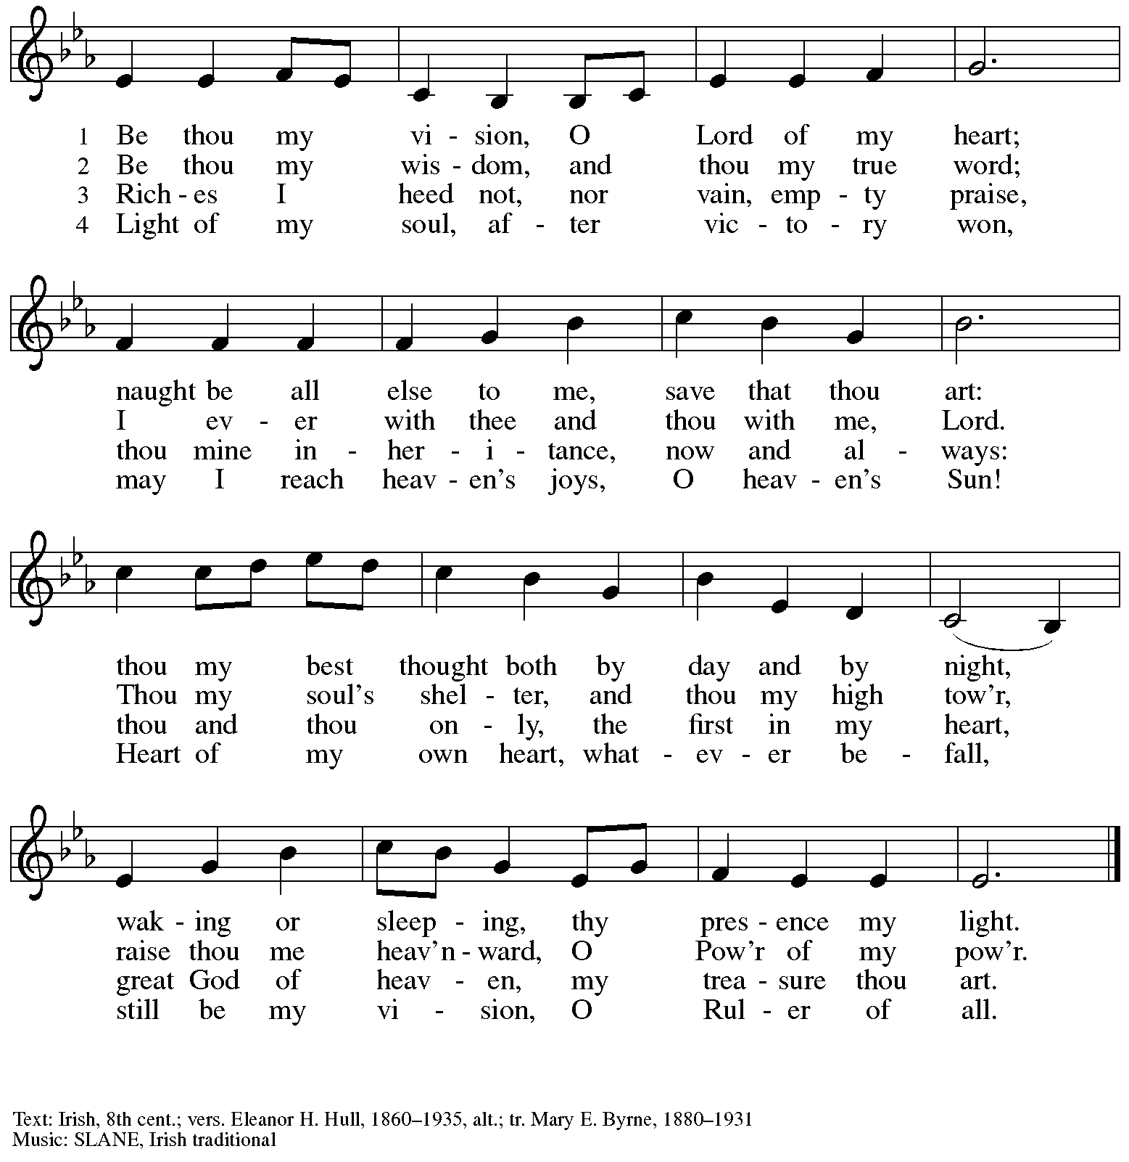

Prayers of the People

P: United in Christ and guided by the Spirit,
we pray for the church, the world, and all who are in need.

After each petition
P: God of grace,
C: receive our prayer.

P: God of every time and place, we offer these prayers and those of our hearts to you,
in Jesus’ name.
C: Amen.

Please be seated.

Meal

Offering

We offer ourselves, our gifts, and our faithful service to God.
An usher will pass around an offering plate for anyone who would like to offer gifts before God.

Music during the Offering

Please rise as you are able.

Offertory Song Accept, O Lord, the Gifts We Bring ELW 691
v. 1-2

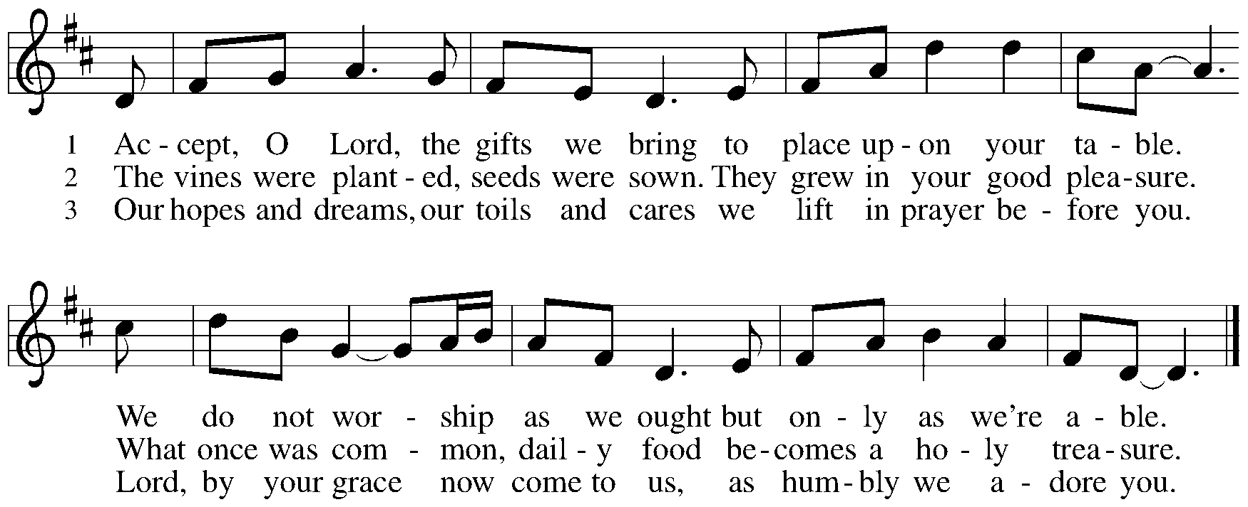

Offertory Prayer

P: Let us pray. Holy God, gracious and merciful,
C: you bring forth food from the earth and nourish your whole creation.
Turn our hearts toward those who hunger in any way, that all may know your care;
and prepare us now to feast on the bread of life, Jesus Christ, our Savior and Lord.
Amen.

Dialogue

P: The Lord be with you.
C: And also with you.

P: Lift up your hearts.
C: We lift them to the Lord.

P: Let us give thanks to the Lord our God.
C: It is right to give our thanks and praise.

Preface

P: It is indeed right, our duty and our joy,
that we should at all times and in all places
give thanks and praise to you, almighty and merciful God,
through our Savior Jesus Christ;
who on this day overcame death and the grave,
and by his glorious resurrection opened to us the way of everlasting life.
And so, with all the choirs of angels,
with the church on earth and the hosts of heaven,
we praise your name and join their unending hymn:

Sanctus

Holy, holy, holy Lord,
God of power and might:
Heaven and earth are full of your glory.
Hosanna in the highest.
Blessed is the one who comes in the name of the Lord.
Hosanna in the highest.

Eucharistic Prayer

P: Holy God, holy and mighty, holy and immortal …
… Do this for the remembrance of me.

Together as the body of Christ, we proclaim the Lord’s death until he comes.
C: Christ has died.
Christ has risen.
Christ will come again.

P: With this bread and cup we remember your Son …
… all our sins and sorrows will be no mor
C: Amen. Come, Lord Jesus.

P: Holy God, holy and merciful one, holy and compassionate …
… sharing your bounty with all the world.
C: Amen. Come, Holy Spirit.

P: Holy and benevolent God …
… with the Holy Spirit, in your holy church, now and forever.
C: Amen.

Lord’s Prayer

P: Gathered as one by the Holy Spirit, let us pray as Jesus taught us.
C: Our Father in heaven,
hallowed be your name,
your kingdom come,
your will be done,
on earth as in heaven.
Give us today our daily bread.
Forgive us our sins
as we forgive those
who sin against us.
Save us from the time of trial
and deliver us from evil.
For the kingdom, the power,
and the glory are yours,
now and forever. Amen.

Fraction and Invitation

Agnus Dei / Lamb of God

Lamb of God, you take away the sin of the world; have mercy on us.
Lamb of God, you take away the sin of the world; have mercy on us.
Lamb of God, you take away the sin of the world; grant us peace.

Please be seated.

Holy Communion
- Hand sanitizer is available if you would like to use it prior to receiving Communion.
- Worshipers from the pulpit side will proceed forward first, followed by the center section, and then the lectern side.
- The Communion wafers (regular and gluten-free) have been thoughtfully prepared using the gifts of the congregation by a member of St. Andrew’s altar care team, with a drop of wine or grape juice on each. The presiding minister will distribute one to each communicant.
- When you reach the presiding minister, please indicate if you would like grape juice or a gluten-free wafer.
- A blessing will be provided for anyone who does not yet receive the sacrament.
- Cushions have been placed at the altar rail for anyone who would like to kneel for prayer and reflection before returning to their pew.
- Everyone is asked to wait until you return to your place to consume the elements, and then promptly replace your mask.

Hymns during Holy Communion
Have No Fear, Little Flock ELW 764

1 Have no fear, little flock;
have no fear, little flock,
for the Father has chosen
to give you the kingdom;
have no fear, little flock!

2 Have good cheer, little flock;
have good cheer, little flock,
for the Father will keep you
in God’s love forever;
have good cheer, little flock!

3 Praise the Lord high above;
praise the Lord high above,
for God stoops down to heal you,
uplift and restore you;
praise the Lord high above!

4 Thankful hearts raise to God;
thankful hearts raise to God,
for God stays close beside you,
in all things works with you;
thankful hearts raise to God!

Text: Luke 12:32, st. 1; Marjorie Jilson, b. 1931, sts. 2-4. Music: LITTLE FLOCK, Heinz Werner Zimmermann, b. 1930. Text and Music © 1973 Concordia Publishing House. All rights reserved. Reprinted under OneLicense.net # A-722139.

Hymns during Holy Communion
Soul, Adorn Yourself with Gladness ELW 488

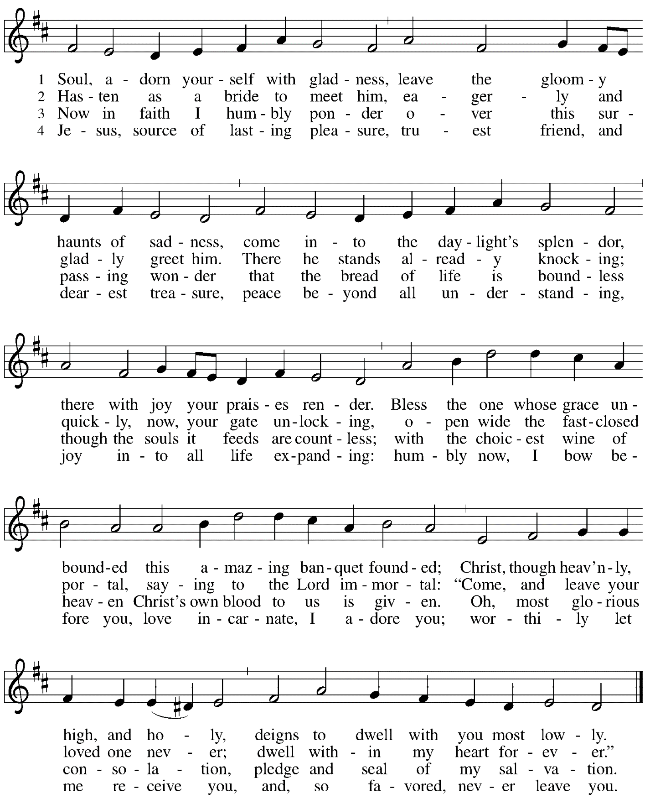

When all have returned to their places, please rise as you are able.

Blessing

P: The body and blood of our Lord Jesus Christ strengthen you and keep you in his grace.
C: Amen.

Prayer

P: Let us pray.
Life-giving God,
through this meal you have bandaged our wounds
and fed us with your mercy.
Now send us forth to live for others,
both friend and stranger,
that all may come to know your love.
This we pray in the name of Jesus.
C: Amen.

Please be seated.

Sending

Announcements

Please rise as you are able.

Benediction

P: The God ☩ of peace,
bless you, comfort you,
and show you the path of life
this day and always.
C: Amen.

Sending Hymn Praise the Lord, Rise Up Rejoicing Following Page

Sending Hymn Praise the Lord, Rise Up Rejoicing ELW 544

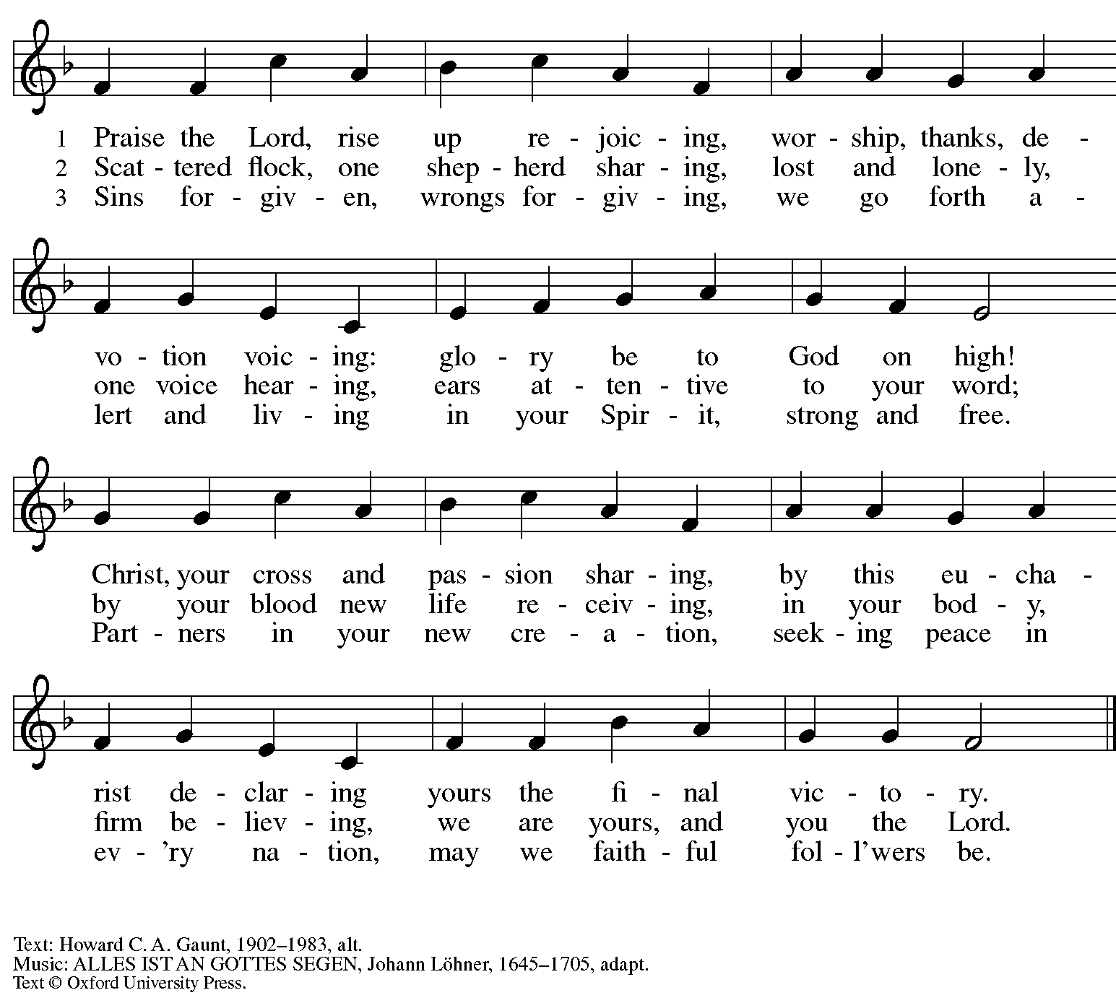
All rights reserved. Reprinted with permission under OneLicense.net # A-722139.

Dismissal

P: Go in peace. Serve the Lord.
C: Thanks be to God!

Abbreviations

P: Pastor/Presiding Minister
L: Lector
C: Congregation

ELW: Evangelical Lutheran Worship hymnal
ACS: All Creation Sings hymnal

Those serving in worship today

Piano Jeff Denlinger
Cantor Timothy Kocher-Hillmer
Presiding Minister Rev. Ross Carmichael

Liturgy and Hymnody Acknowledgements

From SundaysandSeasons.com. Copyright © 2022 Augsburg Fortress. All rights reserved. Reprinted under OneLicense.net # A-722139.
Used by permission of Augsburg Fortress.

Accept, O Lord, the Gifts We Bring – Text: Beth Bergeron Folkemer, b. 1957. Music: BARBARA ALLEN, English folk tune. Text © 1990 Augsburg Fortress. All rights reserved. Reprinted with permission under OneLicense.net # A-722139.

Soul, Adorn Yourself with Gladness – Text: Johann Franck, 1618-1677; tr. Lutheran Book of Worship. Music: SCHMÜCKE DICH, Johann Crüger, 1598-1662. Text © 1978 Lutheran Book of Worship, admin. Augsburg Fortress. All rights reserved. Reprinted with permission under OneLicense.net # A-722139.

