+ Thirteenth Sunday after Pentecost
September 4, 2022
St. Andrew Lutheran Church
304 Morewood Ave.
Pittsburgh, PA 15213
St_andrewELCA@verizon.net
www.standrewpittsburgh.org

+ Thirteenth Sunday after Pentecost
Order for Worship

Called to contemplate the cost of discipleship, we might be helped by translating the apostle Paul’s request to Philemon into our prayer of the day: Refresh my heart in Christ.
Strengthened by the presence and forgiveness of Christ in Holy Communion
and recalling God’s grace poured out in the waters of Baptism, we can recommit ourselves
to “choose life” – to choose life in God as our own.

The following safety precautions and protocols apply regardless of vaccination status.

- Covid-19 community level in Allegheny County remains in the “medium” category, so face masks that fully cover both your mouth and nose are required for all parishioners over the age of two (2), except for worship leaders conducting parts of the service away from the congregation.
- Physical distancing of at least six (6) feet will be observed at all times for people not from your household.
- Hand sanitizer is available at the front of the sanctuary to use before Holy Communion, after you proceed past the baptismal font, as the alcohol has been affecting the finish on the font’s bowl.

Worship Services are live streamed to multiple online platforms.
By attending worship, you agree that your image and voice may be broadcast.

Welcome to St. Andrew!
- Everyone is invited to make a nametag at the black bookcase in the back of the worship space if they would like.
- Worship “toolkits” to help children engage with the service are available in the black bookcase at the back of the worship space. There are “reader” and “pre-reader” resources available in each kit. Please feel free to use the kits for/with your children during worship.
- After the Prayer of the Day, children are invited to gather in the Social Hall for Little Church; Big Faith, a Bible lesson and activity. The group returns to the worship space for the Communion portion of the service.
- A restroom is available on the main level of the church, through the doors to the Social Hall and to the right in the main office.

Welcome

Prelude

Gathering
The Holy Spirit calls us together as the people of God.

Confession and Forgiveness

P: Blessed be the holy Trinity, ☩ one God,
whose steadfast love endures forever.
C: Amen.

P: Let us confess our sin in the presence of God and of one another.

Silence is kept for reflection.

P: Merciful God,
C: we confess that we have not followed your path
but have chosen our own way.
Instead of putting others before ourselves,
we long to take the best seats at the table.
When met by those in need,
we have too often passed by on the other side.
Set us again on the path of life.
Save us from ourselves
and free us to love our neighbors.
Amen.

P: Hear the good news!
God does not deal with us according to our sins
but delights in granting pardon and mercy.
In the name of ☩ Jesus Christ, your sins are forgiven.
You are free to love as God loves.
C: Amen.

Gathering Hymn Lead Me, Guide Me ELW 768
v. 1-2

Please use the red Evangelical Lutheran Worship hymnal found in the pew racks
for the text and music.

Greeting

P: The grace of our Lord Jesus Christ, the love of God,
and the communion of the Holy Spirit be with you all.
C: And also with you.

Prayer of the Day

P: Let us pray.
Direct us, O Lord God, in all our doings with your continual help,
that in all our works begun, continued, and ended in you,
we may glorify your holy name;
and finally, by your mercy, bring us to everlasting life,
through Jesus Christ, our Savior and Lord.
C: Amen.

Please be seated.
Children are invited to join the adult leaders and move to the office for Little Church; Big Faith.

Word
God speaks to us in Scripture reading, preaching, and song

First Reading – Deuteronomy 30: 15-20

¹⁵See, I have set before you today life and prosperity, death and adversity. ¹⁶If you obey the commandments of the Lord your God that I am commanding you today, by loving the Lord your God, walking in God’s ways, and observing God’s commandments, decrees, and ordinances, then you shall live and become numerous, and the Lord your God will bless you in the land that you are entering to possess. ¹⁷But if your heart turns away and you do not hear, but are led astray to bow down to other gods and serve them, ¹⁸I declare to you today that you shall perish; you shall not live long in the land that you are crossing the Jordan to enter and possess.
¹⁹I call heaven and earth to witness against you today that I have set before you life and death, blessings and curses. Choose life so that you and your descendants may live, ²⁰loving the Lord
your God, obeying God, and holding fast to God; for that means life to you and length of days, so that you may live in the land that the Lord swore to give to your ancestors, to Abraham, to Isaac, and to Jacob.

L: Word of God, word of life.
C: Thanks be to God.

Please rise as you are able.

Gospel Acclamation Halle, Halle, Hallelujah ELW 172

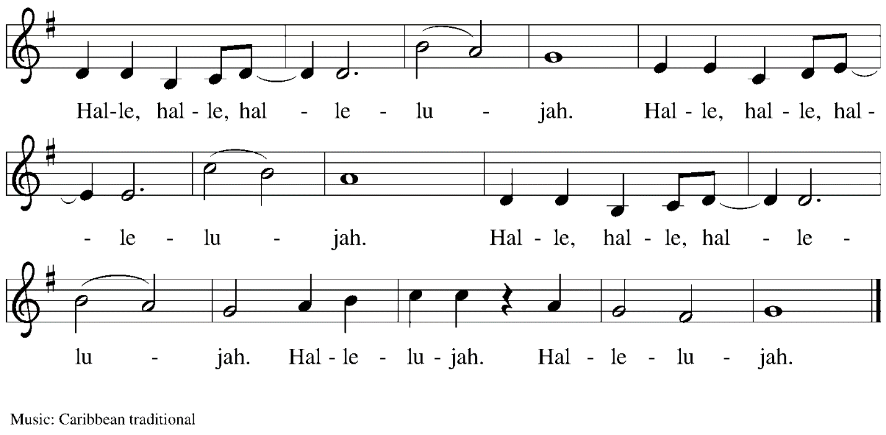

Gospel – Luke 14: 25-33

P: The holy Gospel according to St. Luke.
C: Glory to you, O Lord.

²⁵Now large crowds were gathering with [Jesus]; and he turned and said to them, ²⁶Whoever comes to me and does not hate father and mother, wife and children, brothers and sisters, yes, and even life itself, cannot be my disciple. ²⁷Whoever does not carry the cross and follow me cannot be my disciple. ²⁸For which of you, intending to build a tower, does not first sit down and estimate the cost, to see whether he has enough to complete it? ²⁹Otherwise, when he has laid a foundation and is not able to finish, all who see it will begin to ridicule him, ³⁰saying, ‘This fellow began to build and was not able to finish.’ ³¹Or what king, going out to wage war against another king, will not sit down first and consider whether he is able with ten thousand to oppose the one who comes against him with twenty thousand? ³²If he cannot, then, while the other is still far away, he sends a delegation and asks for the terms of peace. ³³So therefore, none of you can become my disciple if you do not give up all your possessions.”

P: The Gospel of the Lord.
C: Praise to you, O Christ.

Please be seated.

Sermon

A time of silence for prayer and reflection follows the sermon.
When the hymn of the day begins, please rise as you are able.
Hymn of the Day Take Up Your Cross, the Savior Said ELW 667

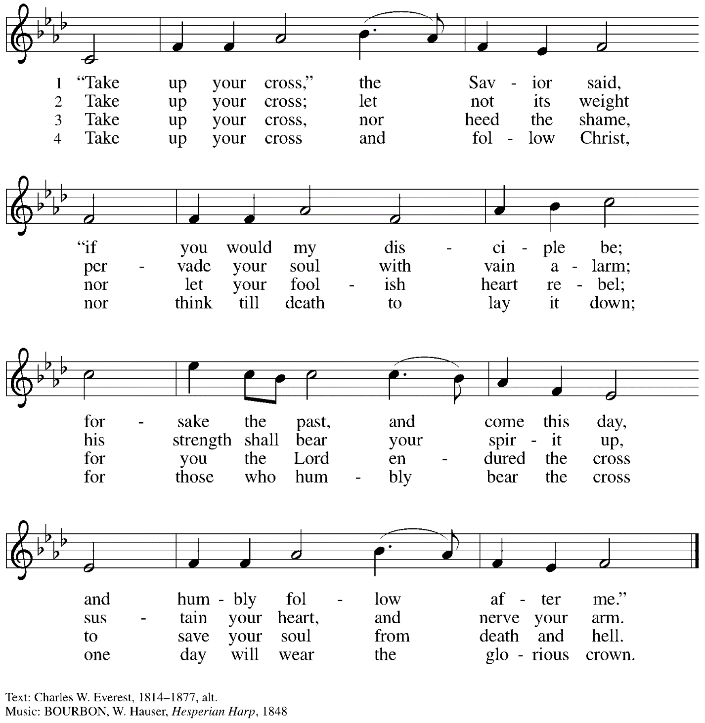
Arr. © 1968 Augsburg Publishing House, admin. Augsburg Fortress. All rights reserved. Reprinted under OneLicense.net # A-722139.

Prayers of the People

P: Trusting in God’s extraordinary love, let us come before the Holy One in prayer.

After each petition
P: Merciful God,
C: receive our prayer.

P: Receive the prayers of your people, merciful God, and keep us forever in your steadfast love;
through Jesus Christ our Savior.
C: Amen.

Please be seated.

Meal

Offering

We offer ourselves, our gifts, and our faithful service to God.
An usher will pass around an offering plate for anyone who would like to offer gifts before God.

Music during the Offering

Please rise as you are able.

Offertory Song All to Jesus I Surrender TFF 235
v. 1, 3

1 All to Jesus I surrender,
all to him I freely give;
I will ever love and trust him,
in his presence daily live.

Refrain
I surrender all, (I surrender all),
I surrender all, (I surrender all),
all to thee, my blessed Savior,
I surrender all.

3 All to Jesus I surrender,
Lord, I give myself to thee;
fill me with thy love and power,
let thy blessings fall on me. Refrain

Text: Judson W. Van De Venter, 1855-1939. Music: SURRENDER, Winfield S. Weeden, 1847-1908

Offertory Prayer

P: Let us pray.
Holy God, gracious and merciful,
C: you bring forth food from the earth and nourish your whole creation.
Turn our hearts toward those who hunger in any way, that all may know your care;
and prepare us now to feast on the bread of life, Jesus Christ, our Savior and Lord.
Amen.

Dialogue

P: The Lord be with you.
C: And also with you.

P: Lift up your hearts.
C: We lift them to the Lord.

P: Let us give thanks to the Lord our God.
C: It is right to give our thanks and praise.

Preface

P: It is indeed right, our duty and our joy,
that we should at all times and in all places
give thanks and praise to you, almighty and merciful God,
through our Savior Jesus Christ;
who on this day overcame death and the grave,
and by his glorious resurrection opened to us the way of everlasting life.
And so, with all the choirs of angels,
with the church on earth and the hosts of heaven,
we praise your name and join their unending hymn:

Sanctus

C: Holy, holy, holy Lord,
God of power and might:
Heaven and earth are full of your glory.
Hosanna in the highest.
Blessed is the one who comes in the name of the Lord.
Hosanna in the highest.

Eucharistic Prayer

P: Holy God, holy and mighty, holy and immortal …
… Do this for the remembrance of me.

Together as the body of Christ, we proclaim the Lord’s death until he comes.
C: Christ has died.
Christ has risen.
Christ will come again.

P: With this bread and cup we remember your Son …
… all our sins and sorrows will be no more.
C: Amen. Come, Lord Jesus.

P: Holy God, holy and merciful one, holy and compassionate …
… sharing your bounty with all the world.
C: Amen. Come, Holy Spirit.

P: Holy and benevolent God …
… with the Holy Spirit, in your holy church, now and forever.
C: Amen.

Lord’s Prayer

P: Gathered as one by the Holy Spirit, let us pray as Jesus taught us.
C: Our Father in heaven,
hallowed be your name,
your kingdom come,
your will be done,
on earth as in heaven.
Give us today our daily bread.
Forgive us our sins
as we forgive those who sin against us.
Save us from the time of trial
and deliver us from evil.
For the kingdom, the power,
and the glory are yours,
now and forever. Amen.

Fraction and Invitation

Agnus Dei Jesus, Lamb of God ELW 199

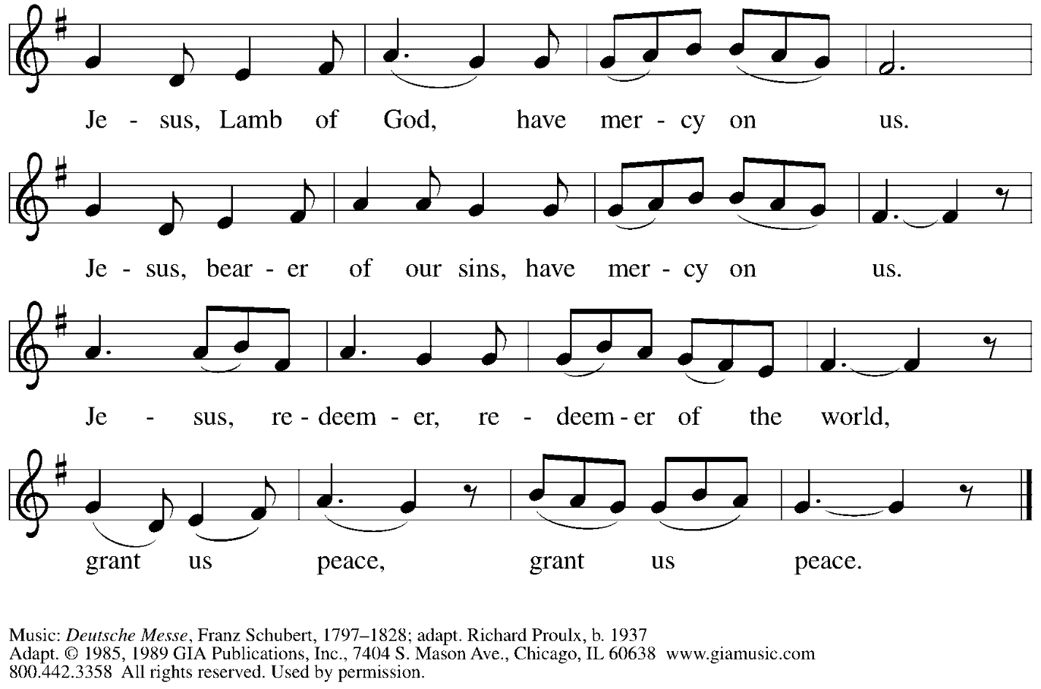
Reprinted under OneLicense.net # A-722139.

Please be seated.

Holy Communion
- Hand sanitizer is available if you would like to use it prior to receiving Communion.
- Worshipers from the pulpit side will proceed forward first, followed by the center section, and then the lectern side.
- The Communion wafers (regular and gluten-free) have been thoughtfully prepared using the gifts of the congregation by a member of St. Andrew’s altar care team, with a drop of wine or grape juice on each. The presiding minister will distribute one to each communicant.
- When you reach the presiding minister, please indicate if you would like grape juice or a gluten-free wafer.
- A blessing will be provided for anyone who does not yet receive the sacrament.
- Cushions have been placed at the altar rail for anyone who would like to kneel for prayer and reflection before returning to their pew.
- Everyone is asked to wait until you return to your place to consume the elements, and then promptly replace your mask.

Hymns during Holy Communion
Bread of Life from Heaven ELW 474

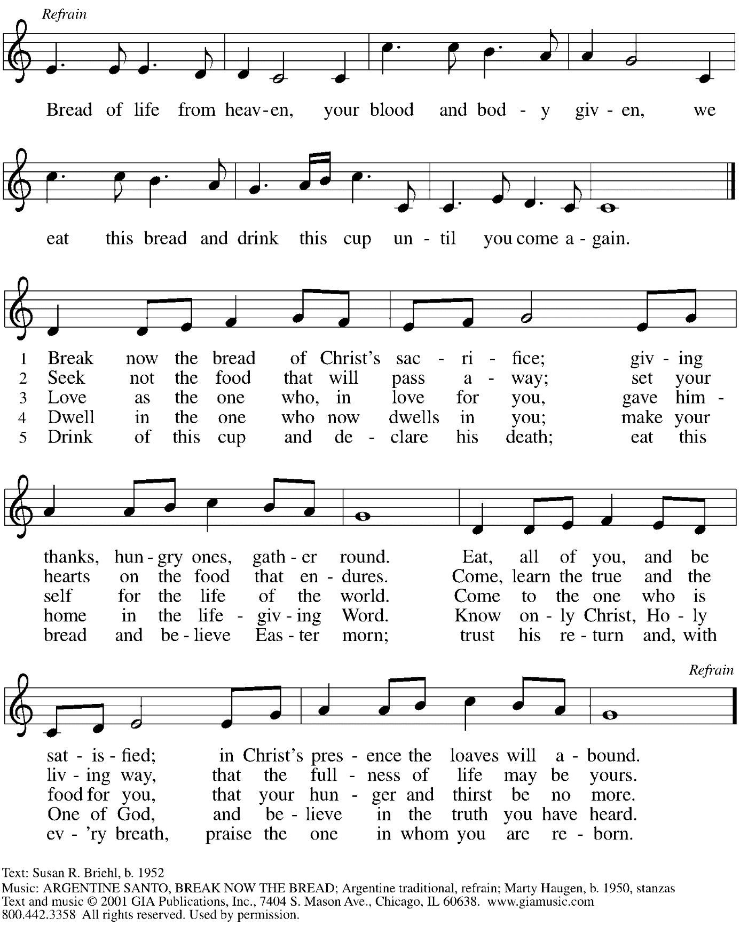
Reprinted under OneLicense.net # A-722139.

Hymns during Holy Communion
Take My Life, That I May Be / Toma, oh Dios, mi voluntad ELW 583

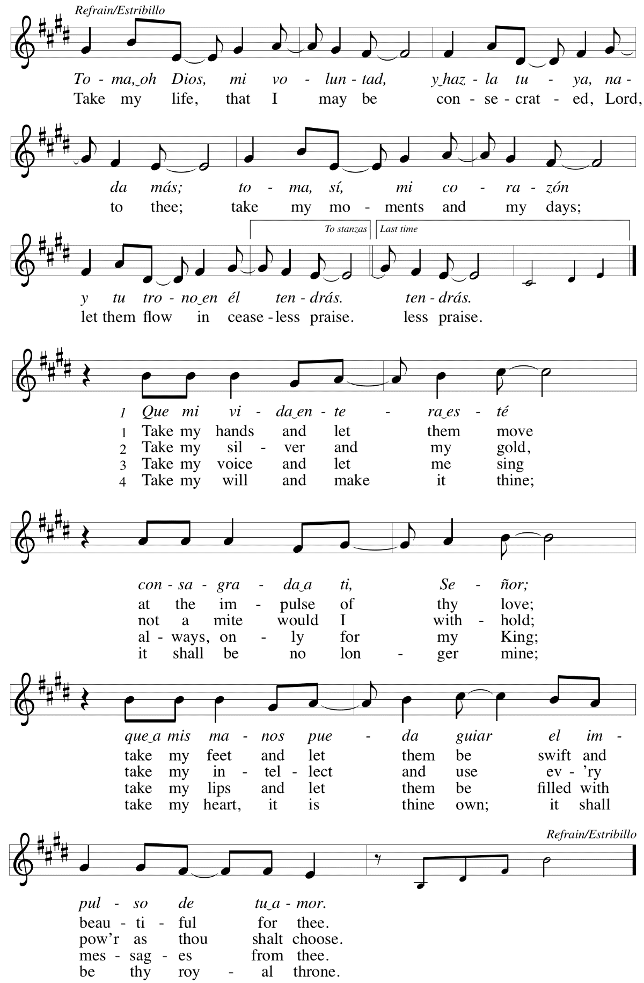
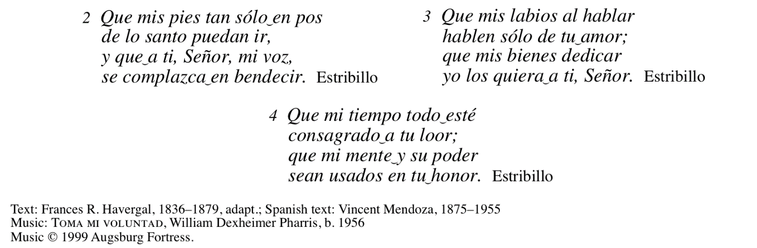
All rights reserved. Reprinted with permission under OneLicense.net # A-722139.

When all have returned to their places, please rise as you are able.

Blessing

P: The body and blood of our Lord Jesus Christ strengthen you and keep you in his grace.
C: Amen.

Prayer

P: Let us pray. Life-giving God, through this meal you have bandaged our wounds
and fed us with your mercy. Now send us forth to live for others, both friend and stranger,
that all may come to know your love. This we pray in the name of Jesus.
C: Amen.

Please be seated.

Sending

Announcements

Please rise as you are able.

Benediction

P: The God ☩ of peace,
bless you, comfort you,
and show you the path of life,
this day and always.
C: Amen.

Sending Hymn Lift High the Cross ELW 660
v. 2-3

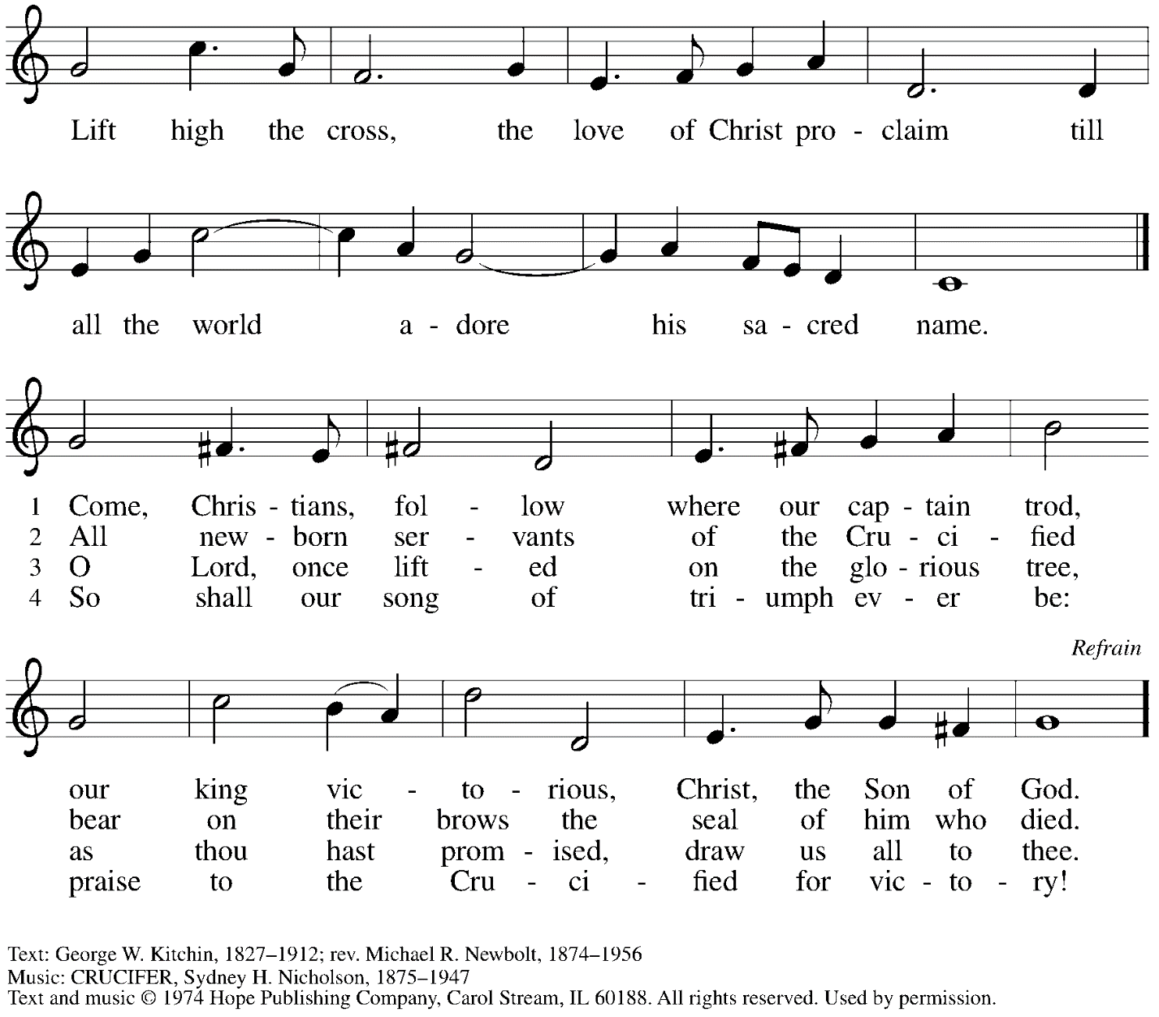

Dismissal

P: Go in peace. Serve the Lord.
C: Thanks be to God!

Abbreviations

P: Pastor/Presiding Minister
L: Lector
C: Congregation

ELW: Evangelical Lutheran Worship hymnal
ACS: All Creation Sings hymnal
TFF: This Far by Faith hymnal

Those serving in worship today

Minister of Music Laura Reynolds
Cantor Kristen Asplin
Lector Rev. Deb Byrum
Presiding Minister Rev. Ross Carmichael

Liturgy and Hymnody Acknowledgements

From SundaysandSeasons.com. Copyright © 2022 Augsburg Fortress. All rights reserved. Reprinted under OneLicense.net # A-722139.
Used by permission of Augsburg Fortress.

St. Andrew Lutheran Church Announcements
September 4th, 2022

Worship in the Sanctuary and Online - Sunday, September 4th, + Thirteenth Sunday after Pentecost - St. Andrew’s next service of Holy Communion will be this Sunday, September 4th, at 10:00 a.m. Allegheny County’s Covid-19 community level remains in the “medium” category, so masks are required in the building except when worship leaders are conducting parts of the service away from the congregation. Attendees are invited to make their own name tags at the back of the worship space. Worship will also be live-streamed to Facebook, YouTube, and Zoom. Social hour will be held outside (behind the church building) after worship each Sunday as weather permits.
- September Produce Distribution - Tuesday, September 6th, 5:30-7:00 p.m. - Each month, on the first Tuesday, St. Andrew hosts a fresh produce distribution in partnership with Greater Pittsburgh Community Food Bank. The next one will be Tuesday, September 6th. We invite people of the congregation to help serve with the distribution from 5:30-7:00 p.m. Additional help is needed during the day for setup and unloading of the produce. Arrival times have varied, so those who sign up will receive a call the day before with an approximate time. Please sign up at: https://www.signupgenius.com/go/5080544AAAC22A1F58-produce20.
- Shelter Dinner at East End Cooperative Ministry - Thursday, September 15th, 6:30 p.m. - Each month, people of St. Andrew provide a meal for guests of the shelter at East End Cooperative Ministry, with each contributor bringing one part of the meal or simply coming in the evening to help serve the meal. Please arrive by 6:00 p.m. If you would like to take part, please sign up here: https://www.signupgenius.com/go/5080544AAAC22A1F58-shelter1
- Help Supply Thanksgiving Dinner Bags - St. Andrew will be compiling bags of non-perishable Thanksgiving foods to deliver to our neighbors at the November 1st produce distribution, and we invite people of the congregation to contribute. There will be a box or bin located in the Social Hall near the Little Pantry supplies for anyone who would like to donate items. We are collecting the following:
  - Boxed stuffing
  - Instant potatoes
  - Canned green beans or corn
  - Cream of mushroom soup
  - French fried onions
  - Pudding mix and/or jello mix
  - Corn muffin mix
- Little Pantry and Little Library Assistance - St. Andrew is accepting donations of food items, as well as financial gifts, for the Little Pantry on an ongoing basis. We would especially appreciate help restocking. If you would like to help with the Pantry and/or Library, please sign up here:
https://www.signupgenius.com/go/5080544AAAC22A1F58-free.

