+ Fourteenth Sunday after Pentecost
September 11, 2022
St. Andrew Lutheran Church
304 Morewood Ave.
Pittsburgh, PA 15213
St_andrewELCA@verizon.net
www.standrewpittsburgh.org

+ Fourteenth Sunday after Pentecost
Order for Worship

The grumbling of the religious leaders in today’s gospel is actually our holy hope:
This Jesus welcomes sinners and eats with them.
That our God seeks and saves the lost is not only a holy hope, it is our only hope.
As the writer of 1 Timothy reminds us, “The saying is sure and worthy of full acceptance,
that Christ Jesus came into the world to save sinners.”
Thanks be to God.

- Allegheny County’s Covid-19 community level has gone to the “low” category, so face masks are optional in the building.
- Hand sanitizer is available at the front of the sanctuary to use before Holy Communion, after you proceed past the baptismal font, as the alcohol has been affecting the finish on the font’s bowl.

Worship Services are live streamed to multiple online platforms.
By attending worship, you agree that your image and voice may be broadcast.

Welcome to St. Andrew!

- Everyone is invited to make a nametag at the black bookcase in the back of the worship space if they would like.
- Worship “toolkits” to help children engage with the service are available in the black bookcase at the back of the worship space. There are “reader” and “pre-reader” resources available in each kit. Please feel free to use the kits for/with your children during worship.
- After the Prayer of the Day, children are invited to gather in the Social Hall for Little Church; Big Faith, a Bible lesson and activity. The group returns to the worship space for the Communion portion of the service.
- A restroom is available on the main level of the church, through the doors to the Social Hall and to the right in the main office.

Welcome

Prelude

Gathering
The Holy Spirit calls us together as the people of God.

Confession and Forgiveness

P: Blessed be the holy Trinity, ☩ one God,
whose steadfast love endures forever.
C: Amen.

P: Let us confess our sin in the presence of God and of one another.

Silence is kept for reflection.

P: Merciful God,
C: we confess that we have not followed your path
but have chosen our own way.
Instead of putting others before ourselves,
we long to take the best seats at the table.
When met by those in need,
we have too often passed by on the other side.
Set us again on the path of life.
Save us from ourselves
and free us to love our neighbors.
Amen.

P: Hear the good news!
God does not deal with us according to our sins
but delights in granting pardon and mercy.
In the name of ☩ Jesus Christ, your sins are forgiven.
You are free to love as God loves.
C: Amen.

Gathering Hymn There’s a Wideness in God’s Mercy ELW 588
v. 1-3

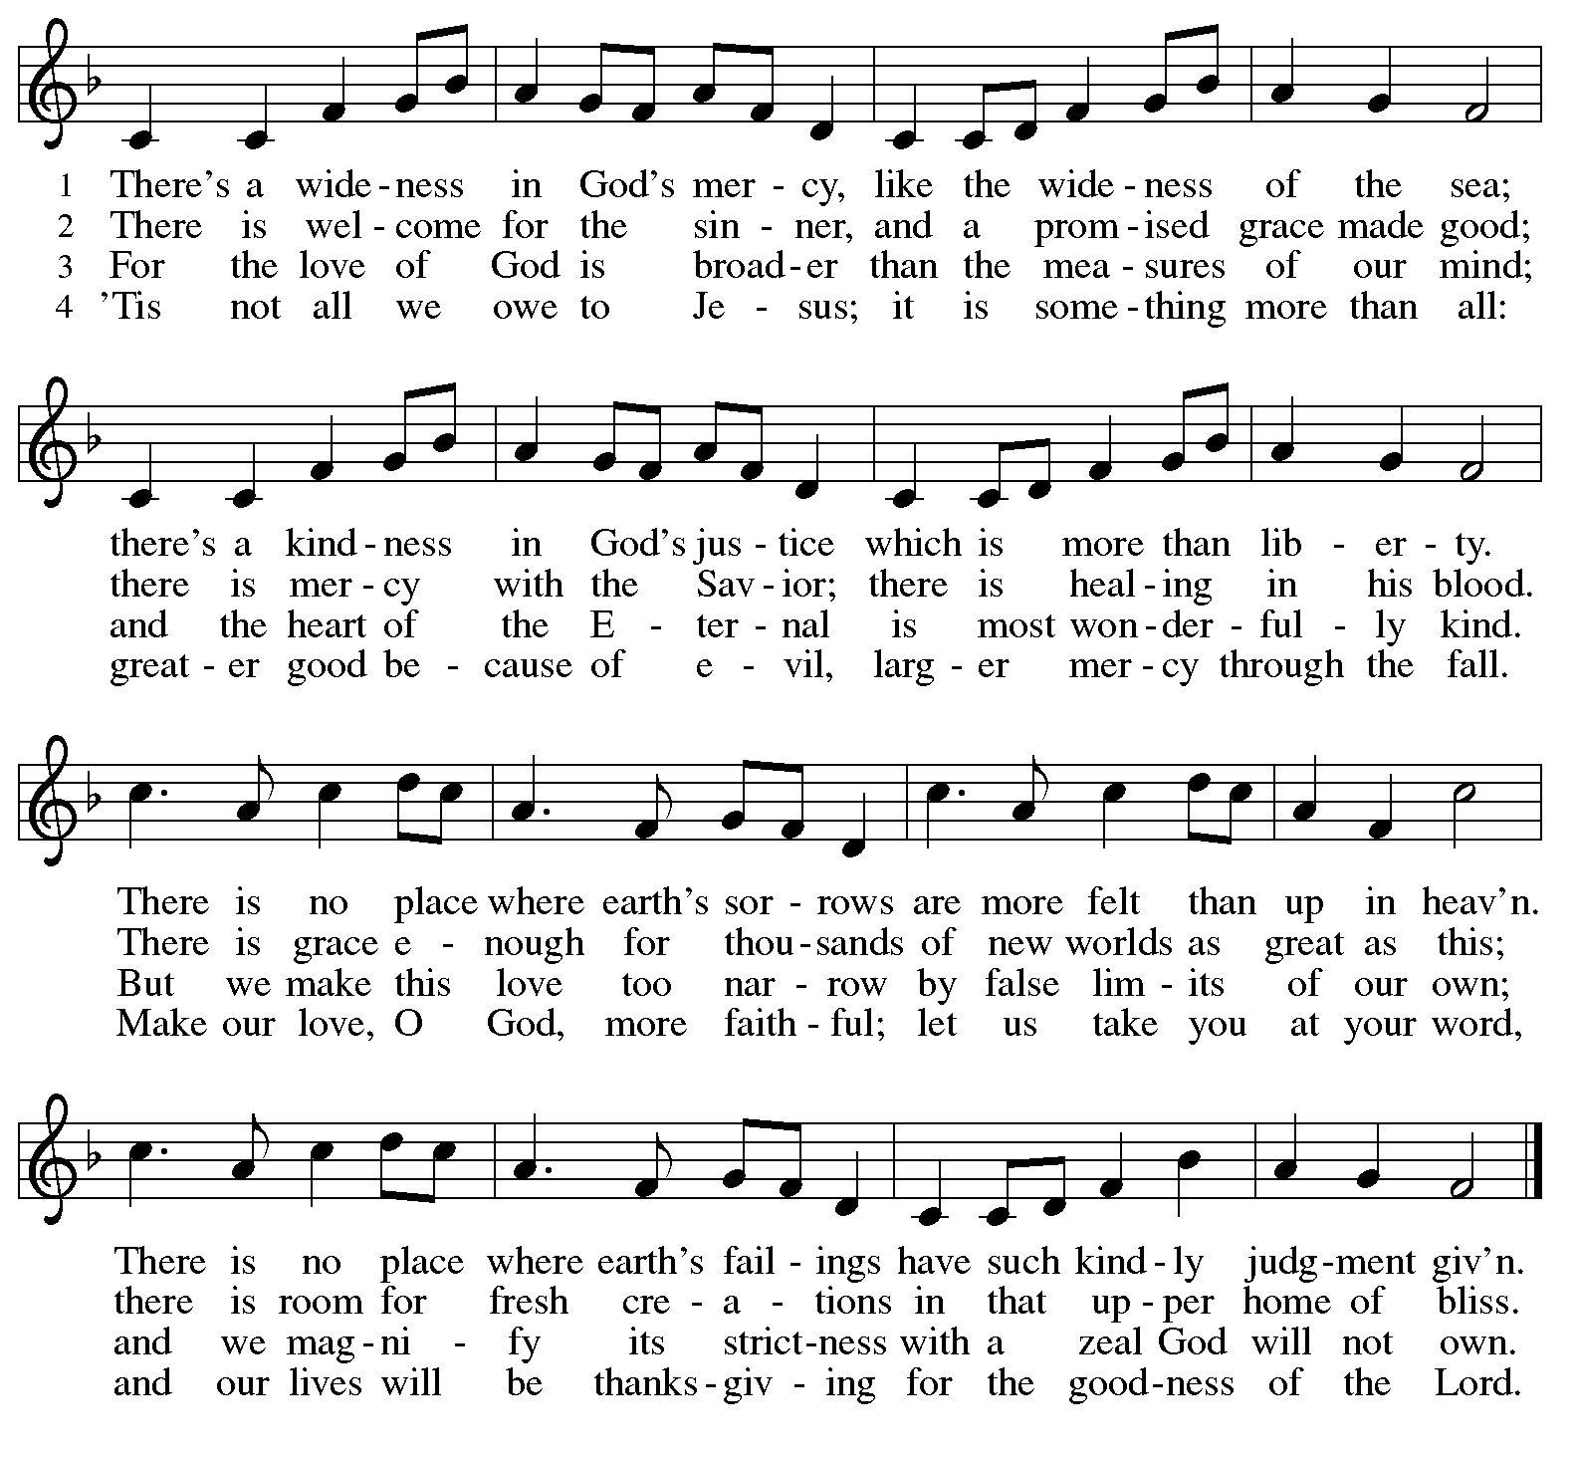
Text: Frederick W. Faber, 1814-1863, alt.
Music: LORD, REVIVE US, North American, 19th cent.

Greeting

P: The grace of our Lord Jesus Christ, the love of God,
and the communion of the Holy Spirit be with you all.
C: And also with you.

Prayer of the Day

P: Let us pray.
O God, overflowing with mercy and compassion,
you lead back to yourself all those who go astray.
Preserve your people in your loving care,
that we may reject whatever is contrary to you
and may follow all things that sustain our life in your Son,
Jesus Christ, our Savior and Lord.
C: Amen.

Please be seated.
Children are invited to join the adult leaders and move to the office for Little Church; Big Faith.

Word
God speaks to us in Scripture reading, preaching, and song

First Reading – Exodus 32: 7-14

⁷The Lord said to Moses, “Go down at once! Your people, whom you brought up out of the land of Egypt, have acted perversely; ⁸they have been quick to turn aside from the way that I commanded them; they have cast for themselves an image of a calf, and have worshiped it and sacrificed to it, and said, ‘These are your gods, O Israel, who brought you up out of the land of Egypt!’ ” ⁹The Lord said to Moses, “I have seen this people, how stiff-necked they are. ¹⁰Now let me alone, so that my wrath may burn hot against them and I may consume them; and of you I will make a great nation.”
¹¹But Moses implored the Lord his God, and said, “O Lord, why does your wrath burn hot against your people, whom you brought out of the land of Egypt with great power and with a mighty hand? ¹²Why should the Egyptians say, ‘It was with evil intent that he brought them out to kill them in the mountains, and to consume them from the face of the earth’? Turn from your fierce wrath; change your mind and do not bring disaster on your people. ¹³Remember Abraham, Isaac, and Israel, your servants, how you swore to them by your own self, saying to them, ‘I will multiply your descendants like the stars of heaven, and all this land that I have promised I will give to your descendants, and they shall inherit it forever.’” ¹⁴And the Lord changed the Lord’s mind about the disaster that the Lord planned to bring on God’s people.

L: Word of God, word of life.
C: Thanks be to God.

Please rise as you are able.

Gospel Acclamation Halle, Halle, Hallelujah ELW 172

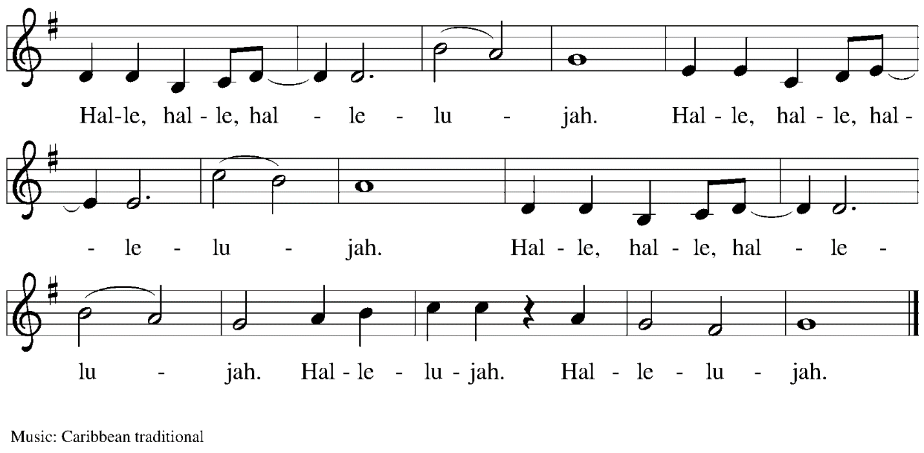

Gospel – Luke 15: 1-10

P: The holy Gospel according to St. Luke.
C: Glory to you, O Lord.

¹Now all the tax collectors and sinners were coming near to listen to [Jesus.] ²And the Pharisees and the scribes were grumbling and saying, “This fellow welcomes sinners and eats with them.”
³So he told them this parable: ⁴“Which one of you, having a hundred sheep and losing one of them, does not leave the ninety-nine in the wilderness and go after the one that is lost until he finds it? ⁵When he has found it, he lays it on his shoulders and rejoices. ⁶And when he comes home, he calls together his friends and neighbors, saying to them, ‘Rejoice with me, for I have found my sheep that was lost.’ ⁷Just so, I tell you, there will be more joy in heaven over one sinner who repents than over ninety-nine righteous persons who need no repentance.
⁸“Or what woman having ten silver coins, if she loses one of them, does not light a lamp, sweep the house, and search carefully until she finds it? ⁹When she has found it, she calls together her friends and neighbors, saying, ‘Rejoice with me, for I have found the coin that I had lost.’ ¹⁰Just so, I tell you, there is joy in the presence of the angels of God over one sinner who repents.”

P: The Gospel of the Lord.
C: Praise to you, O Christ.

Please be seated.

Sermon

A time of silence for prayer and reflection follows the sermon.
When the hymn of the day begins, please rise as you are able.

Hymn of the Day Look Who Gathers at Christ’s Table ACS 977

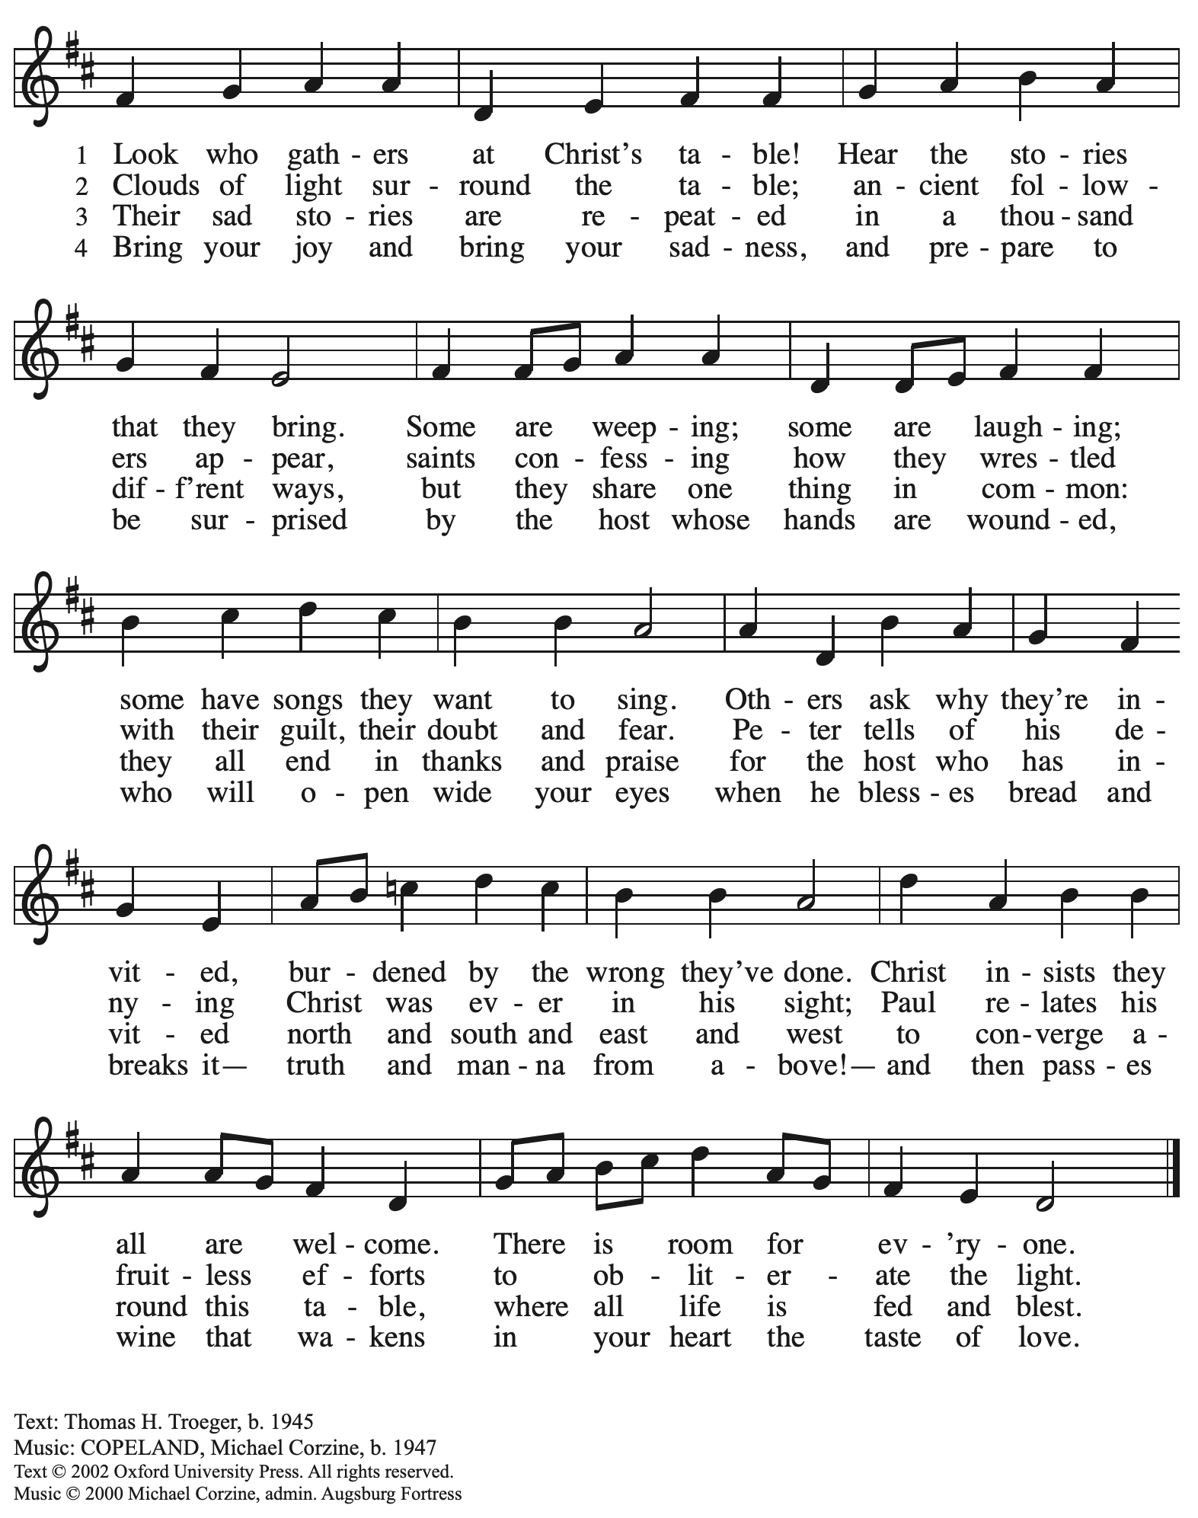
All rights reserved. Reprinted with permission under OneLicense.net # A-722139.

Prayers of the People

P: Trusting in God’s extraordinary love, let us come before the Holy One in prayer.

After each petition
P: Merciful God, C: receive our prayer.

P: Receive the prayers of your people, merciful God, and keep us forever in your steadfast love;
through Jesus Christ our Savior.
C: Amen.

Please be seated.

Meal

Offering

We offer ourselves, our gifts, and our faithful service to God.
An usher will pass around an offering plate for anyone who would like to offer gifts before God.

Music during the Offering

Please rise as you are able.

Offertory Song All to Jesus I Surrender TFF 235
v. 1, 3

1 All to Jesus I surrender,
all to him I freely give;
I will ever love and trust him,
in his presence daily live.

Refrain
I surrender all, (I surrender all),
I surrender all, (I surrender all),
all to thee, my blessed Savior,
I surrender all.

3 All to Jesus I surrender,
Lord, I give myself to thee;
fill me with thy love and power,
let thy blessings fall on me. Refrain

Text: Judson W. Van De Venter, 1855-1939. Music:

Offertory Prayer

P: Let us pray.
Holy God, gracious and merciful,
C: you bring forth food from the earth and nourish your whole creation.
Turn our hearts toward those who hunger in any way, that all may know your care;
and prepare us now to feast on the bread of life, Jesus Christ, our Savior and Lord.
Amen.

Dialogue

P: The Lord be with you.
C: And also with you.

P: Lift up your hearts.
C: We lift them to the Lord.

P: Let us give thanks to the Lord our God.
C: It is right to give our thanks and praise.

Preface

P: It is indeed right, our duty and our joy,
that we should at all times and in all places
give thanks and praise to you, almighty and merciful God,
through our Savior Jesus Christ;
who on this day overcame death and the grave,
and by his glorious resurrection opened to us the way of everlasting life.
And so, with all the choirs of angels,
with the church on earth and the hosts of heaven,
we praise your name and join their unending hymn:

Sanctus

Holy, holy, holy Lord,
God of power and might:
Heaven and earth are full of your glory.
Hosanna in the highest.
Blessed is the one who comes in the name of the Lord.
Hosanna in the highest.

Eucharistic Prayer

P: Holy God, holy and mighty, holy and immortal …
… Do this for the remembrance of me.

Together as the body of Christ, we proclaim the Lord’s death until he comes.
C: Christ has died.
Christ has risen.
Christ will come again.

P: With this bread and cup we remember your Son …
… all our sins and sorrows will be no more.
C: Amen. Come, Lord Jesus.

P: Holy God, holy and merciful one, holy and compassionate …
… sharing your bounty with all the world.
C: Amen. Come, Holy Spirit.

P: Holy and benevolent God …
… with the Holy Spirit, in your holy church, now and forever.
C: Amen.

Lord’s Prayer

P: Gathered as one by the Holy Spirit, let us pray as Jesus taught us.
C: Our Father in heaven,
hallowed be your name,
your kingdom come,
your will be done,
on earth as in heaven.
Give us today our daily bread.
Forgive us our sins
as we forgive those who sin against us.
Save us from the time of trial
and deliver us from evil.
For the kingdom, the power,
and the glory are yours,
now and forever. Amen.

Fraction and Invitation

Agnus Dei / Lamb of God

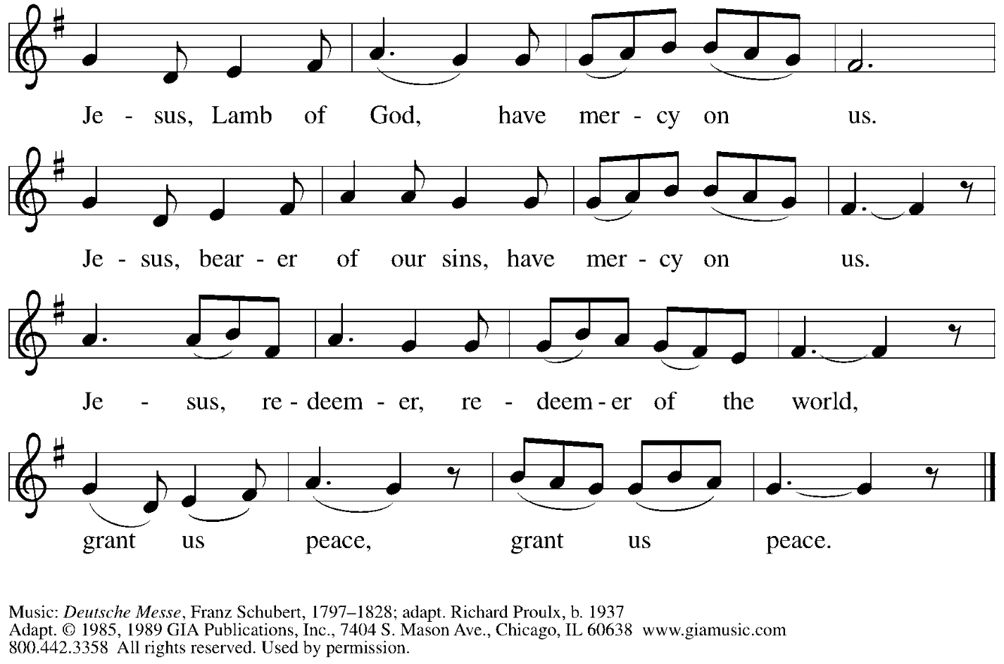
Reprinted with permission under OneLicense.net # A-722139.

Please be seated.

Holy Communion
- Hand sanitizer is available if you would like to use it prior to receiving Communion.
- Worshipers from the pulpit side will proceed forward first, followed by the center section, and then the lectern side.
- The Communion wafers (regular and gluten-free) have been thoughtfully prepared using the gifts of the congregation by a member of St. Andrew’s altar care team, with a drop of wine or grape juice on each. The presiding minister will distribute one to each communicant.
- When you reach the presiding minister, please indicate if you would like grape juice or a gluten-free wafer.
- A blessing will be provided for anyone who does not yet receive the sacrament.
- Cushions have been placed at the altar rail for anyone who would like to kneel for prayer and reflection before returning to their pew.
- Everyone is asked to wait until you return to your place to consume the elements, and then promptly replace your mask.

Hymns during Holy Communion
Though a Sinner I May Be ELW 609

2 Oh, the height of Jesus' love!
Higher than the heav'ns above,
deeper than the depths of sea,
lasting as eternity.
Love that found me—wondrous thought—
found me when I sought him not.

3 Only Jesus can impart
balm to heal the wounded heart,
peace that flows from sin forgiv'n,
joy that lifts the soul to heav'n,
faith and hope to walk with God
in the way that Enoch trod.

5 O my Savior, help afford
by your Spirit and your word!
When my wayward heart would stray,
keep me in the narrow way;
grace in time of need supply
while I live and when I die.

Text: William McComb, 1793-1870.
Music: GETHSEMANE, Richard Redhead, 1820-1901
All rights reserved. Reprinted under OneLicense.net # A-722139.

Hymns during Holy Communion
Softly and Tenderly Jesus Is Calling ELW 608

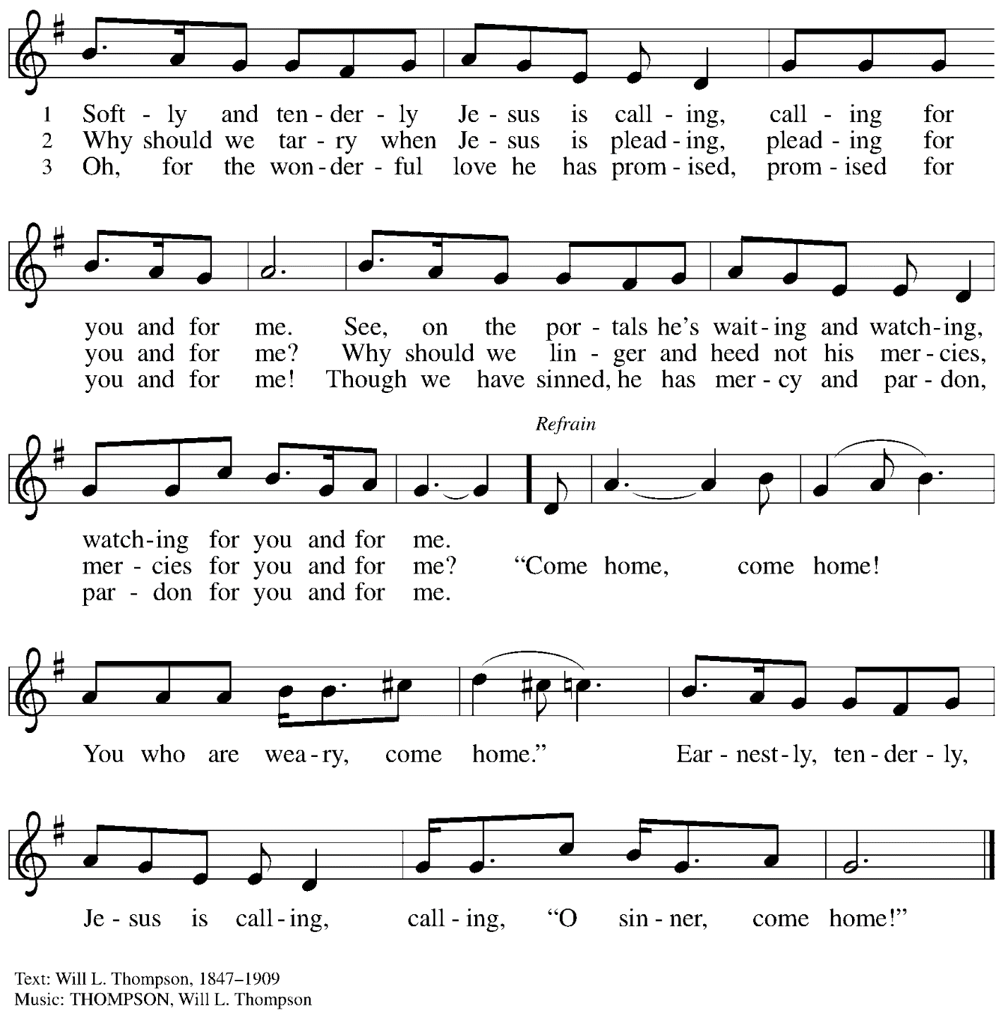

When all have returned to their places, please rise as you are able.

Blessing

P: The body and blood of our Lord Jesus Christ strengthen you and keep you in his grace.
C: Amen.

Prayer

P: Let us pray. Life-giving God, through this meal you have bandaged our wounds
and fed us with your mercy. Now send us forth to live for others, both friend and stranger,
that all may come to know your love. This we pray in the name of Jesus.
C: Amen.

Please be seated.

Sending

Announcements

Please rise as you are able.

Benediction

P: The God ☩ of peace, bless you, comfort you,
and show you the path of life, this day and always.
C: Amen.

Sending Hymn Come, Thou Fount of Every Blessing Following Page

Dismissal

P: Go in peace. Serve the Lord.
C: Thanks be to God!

Sending Hymn Come, Thou Fount of Every Blessing ELW 807

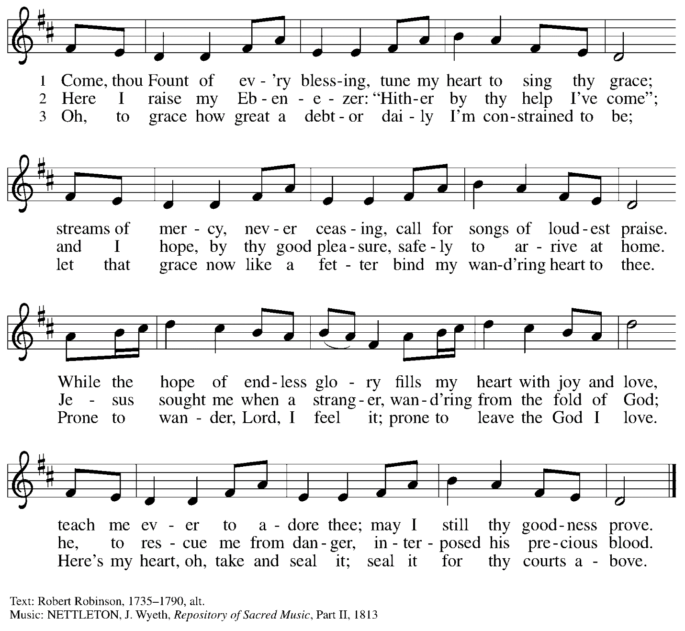

Abbreviations

P: Pastor/Presiding Minister
L: Lector
C: Congregation

ELW: Evangelical Lutheran Worship hymnal
ACS: All Creation Sings hymnal
TFF: This Far by Faith hymnal

Those serving in worship today

Minister of Music Laura Reynolds
Organ Jimmi Kocher-Hillmer
Cantor Timothy Kocher-Hillmer
Lector Michael Chapman
Presiding Minister Rev. Ross Carmichael

Liturgy and Hymnody Acknowledgements

From SundaysandSeasons.com. Copyright © 2022 Augsburg Fortress. All rights reserved. Reprinted under OneLicense.net # A-722139.
Used by permission of Augsburg Fortress.

St. Andrew Lutheran Church Announcements
September 11, 2022

- Worship in the Sanctuary and Online - Sunday, September 11th, + Fourteenth Sunday after Pentecost - St. Andrew’s next service of Holy Communion will be this Sunday, September 4th, at 10:00 a.m. Allegheny County’s Covid-19 community level is in the “low” category, so masks are optional in the building. Attendees are invited to make their own name tags at the back of the worship space. **Please do not attend an on-site event if you have felt sick in any way until you have 5 days without symptoms.** Worship will also be live-streamed to Facebook, YouTube, and Zoom. The login information for Zoom is listed in the Worship section below. Social hour will be held outside (behind the church building) after worship each Sunday as weather permits.
- Worship Committee Meeting – Sunday, September 11th, after Worship – The worship committee, which helps plan the congregation’s worship and music, will be meeting after worship this Sunday after worship, at approximately 11:30 a.m. Anyone interested is welcome to attend!
- Community Ministry Meeting – Monday, September 12th, 7:00 p.m. via Zoom – St. Andrew’s Community Ministry Team, which coordinates ministries with and for our local communities and beyond, will meet online on Monday, September 12th, at 7:00 p.m. via Zoom. If you are interested in participating and/or have new ideas for ministry, please speak with Pastor Ross Carmichael and he will send the link.
- Shelter Dinner at East End Cooperative Ministry - Thursday, September 15th, 6:30 p.m. - Each month, people of St. Andrew provide a meal for guests of the shelter at East End Cooperative Ministry, with each contributor bringing one part of the meal. Others simply come in the evening to help serve the meal, with a 6:00 p.m. arrival time for the 6:30 p.m. meal. If you would like to take part, please sign up here: https://www.signupgenius.com/go/5080544AAAC22A1F58-shelter1
- Help Supply “Thanksgiving Dinner” Bags - St. Andrew will be compiling bags of non-perishable “Thanksgiving” foods to deliver to our neighbors at the November 1st produce distribution, and we invite people of the congregation to contribute. There will be a box or bin located in the Social Hall near the Little Pantry supplies for anyone who would like to donate items. We are collecting the following:
  - Boxed stuffing
  - Instant potatoes
  - Canned green beans or corn
  - Cream of mushroom soup
  - French fried onions
  - Pudding mix and/or jello mix
  - Corn muffin mix
- Little Pantry and Little Library Assistance - St. Andrew is accepting donations of food items, as well as financial gifts, for the Little Pantry on an ongoing basis. We would especially appreciate help restocking. If you would like to help with the Pantry and/or Library, please sign up here: https://www.signupgenius.com/go/5080544AAAC22A1F58-free.
- Lutheran Campus Ministry Hosts Art Exhibit Exploring Race, Opening September 10th - Truth Be Told is an art exhibit created by fourteen women artists across the country as they reflected on racism. The group of seven Black women and seven white women began with conversations after the murder of Goerge Floyd. These discussions moved them each to consider one word and create an art piece around that word. Local Pittsburgh artist Debbie Jacknin, owner of Songbird Artistry, 4316 Penn Avenue, is one of these artists and has been an important part of bringing this exhibit to Pittsburgh.
The exhibit will be shown at the Lutheran University Center, 4515 Forbes Avenue, Pittsburgh 15213, starting on September 10th, with an opening reception beginning at 7:00 p.m. Open hours of viewing will be every Saturday and Sunday through October 9th, 1:00-6:00 p.m. Arrangements can be made to view the exhibit during the week by contacting the campus ministry at 412-682-6886 or email pastor@psalm.online. The Lutheran Campus Ministry in Greater Pittsburgh and its student group PSALM (Pittsburgh Students Active in Lutheran Ministry) received a grant from the Philip N. Knutson Endowment for Lutheran Campus Ministry to help foster conversation and reflection about vital issues facing the world. For more information, go to http://psalm.online.
- GameFest - October 15th, 2022 - Lutheran Campus Ministry in Greater Pittsburgh and PSALM are hosting a day of gaming fundraiser for campus ministry. It will be a whole day of tabletop gaming, with D&D, Catan, Call to Adventure, and much more, from the simple and quick to the labyrinthine. There will be some games scheduled and some open tables. They will have games on hand to try, or anyone can bring an old favorite and set it up in the space. There will be concessions and raffle baskets and people of all ages are welcome! The event is scheduled from 9:00 a.m. - 9:00 p.m. at the Lutheran University Center, 4515 Forbes Ave., Pittsburgh 15213. For tickets, please visit: PSALM GameFest Tickets, Sat, Oct 15, 2022 at 9:00 AM | Eventbrite.

