+ Fifteenth Sunday after Pentecost
September 18, 2022
St. Andrew Lutheran Church
304 Morewood Ave.
Pittsburgh, PA 15213
St_andrewELCA@verizon.net
www.standrewpittsburgh.org

+ Fifteenth Sunday after Pentecost
Order for Worship

This week’s readings invite us to consider what it means to be managers, rather than owners,
of all that we have. Apart from the generosity of God we have nothing, and by God’s gracious favor we have everything we need. As Christ Jesus gave himself for us and for all, we are called to be wise and generous with all that God has given us, that all may know and experience the abundance of God’s blessings.

The following safety precautions apply regardless of vaccination status.

- Covid-19 community level in Allegheny County remains is in the “low” category, so face masks are optional in the building.
- Hand sanitizer is available at the front of the sanctuary to use before Holy Communion, after you proceed past the baptismal font, as the alcohol has been affecting the finish on the font’s bowl.

Worship Services are live streamed to multiple online platforms.
By attending worship, you agree that your image and voice may be broadcast.

Welcome to St. Andrew!
- Everyone is invited to make a nametag at the black bookcase in the back of the worship space if they would like.
- Worship “toolkits” to help children engage with the service are available in the black bookcase at the back of the worship space. There are “reader” and “pre-reader” resources available in each kit. Please feel free to use the kits for/with your children during worship.
- After the Prayer of the Day, children are invited to gather in the Social Hall for Little Church; Big Faith, a Bible lesson and activity. The group returns to the worship space for the Communion portion of the service.
- A restroom is available on the main level of the church, through the doors to the Social Hall and to the right in the main office.

Welcome

Prelude

Gathering
The Holy Spirit calls us together as the people of God.

Confession and Forgiveness

P: Blessed be the holy Trinity, ☩ one God,
whose steadfast love endures forever.
C: Amen.

P: Let us confess our sin in the presence of God and of one another.

Silence is kept for reflection.

P: Merciful God,
C: we confess that we have not followed your path
but have chosen our own way.
Instead of putting others before ourselves,
we long to take the best seats at the table.
When met by those in need,
we have too often passed by on the other side.
Set us again on the path of life.
Save us from ourselves
and free us to love our neighbors.
Amen.

P: Hear the good news!
God does not deal with us according to our sins
but delights in granting pardon and mercy.
In the name of ☩ Jesus Christ, your sins are forgiven.
You are free to love as God loves.
C: Amen.

Gathering Hymn Be Thou My Vision ELW 793
v. 1-3

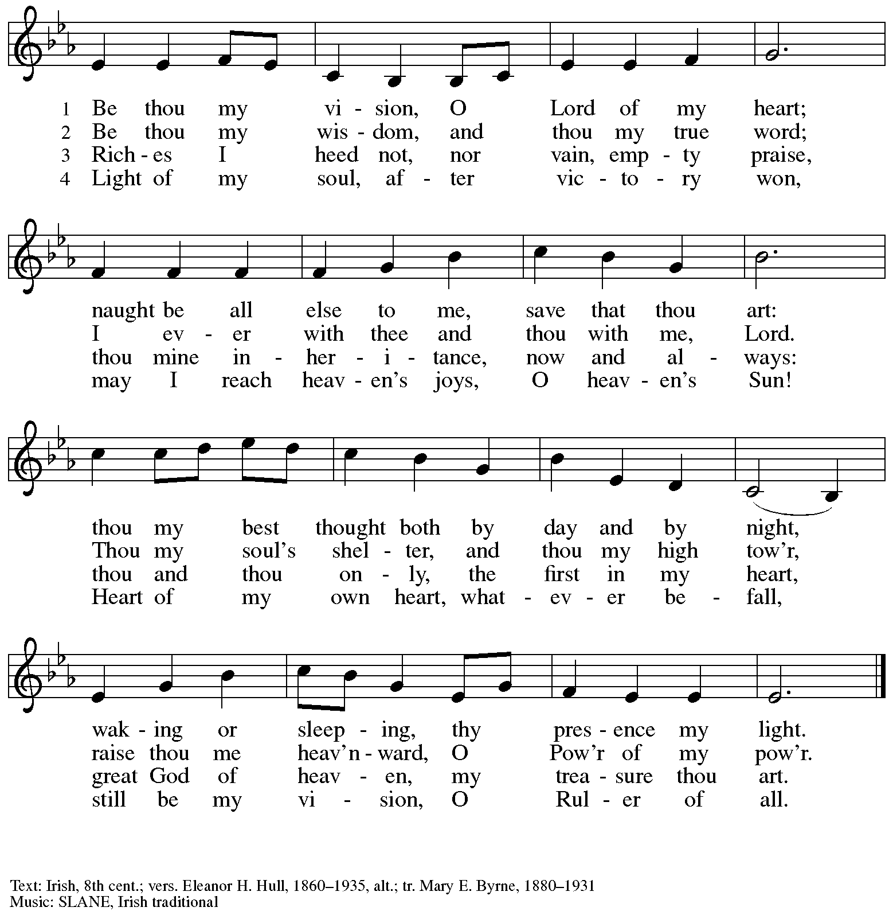

Greeting

P: The grace of our Lord Jesus Christ, the love of God,
and the communion of the Holy Spirit be with you all.
C: And also with you.

Prayer of the Day

P: Let us pray.
God among us, we gather in the name of your Son to learn love for one another.
Keep us away from evil paths. Turn our minds to your wisdom and our hearts to the grace revealed in your Son, Jesus Christ, our Savior and Lord.
C: Amen.

Please be seated.
Children are invited to join the adult leaders and move to the office for Little Church; Big Faith.

Word
God speaks to us in Scripture reading, preaching, and song

First Reading – Amos 8: 4-7

⁴Hear this, you that trample on the needy,
and bring to ruin the poor of the land,
⁵saying, “When will the new moon be over
so that we may sell grain;
and the sabbath,
so that we may offer wheat for sale?
We will make the ephah small and the shekel great,
and practice deceit with false balances,
⁶buying the poor for silver
and the needy for a pair of sandals,
and selling the sweepings of the wheat.”
⁷The Lord has sworn by the pride of Jacob:
Surely I will never forget any of their deeds.

L: Word of God, word of life.
C: Thanks be to God.

Please rise as you are able.

Gospel Acclamation Halle, Halle, Hallelujah ELW 172

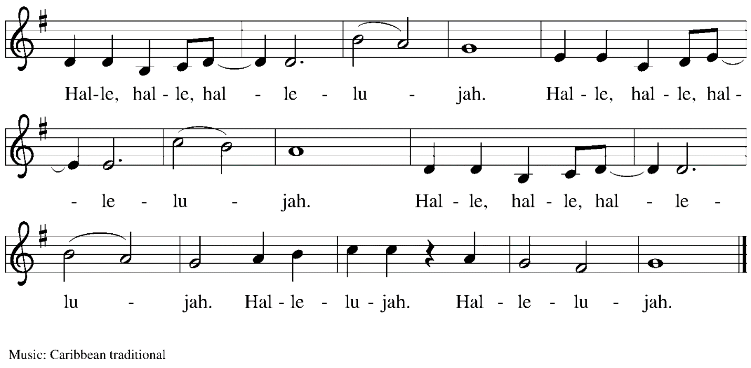

Gospel – Luke 16: 1-13

P: The holy Gospel according to St. Luke.
C: Glory to you, O Lord.

¹Then Jesus said to the disciples, “There was a rich man who had a manager, and charges were brought to him that this man was squandering his property. ²So he summoned him and said to him, ‘What is this that I hear about you? Give me an accounting of your management, because you cannot be my manager any longer.’ ³Then the manager said to himself, ‘What will I do, now that my master is taking the position away from me? I am not strong enough to dig, and I am ashamed to beg. ⁴I have decided what to do so that, when I am dismissed as manager, people may welcome me into their homes.’ ⁵So, summoning his master’s debtors one by one, he asked the first, ‘How much do you owe my master?’ ⁶He answered, ‘A hundred jugs of olive oil.’ He said to him, ‘Take your bill, sit down quickly, and make it fifty.’ ⁷Then he asked another, ‘And how much do you owe?’ He replied, ‘A hundred containers of wheat.’ He said to him, ‘Take your bill and make it eighty.’ ⁸And his master commended the dishonest manager because he had acted shrewdly; for the children of this age are more shrewd in dealing with their own generation than are the children of light. ⁹And I tell you, make friends for yourselves by means of dishonest wealth so that when it is gone, they may welcome you into the eternal homes.
¹⁰“Whoever is faithful in a very little is faithful also in much; and whoever is dishonest in a very little is dishonest also in much. ¹¹If then you have not been faithful with the dishonest wealth, who will entrust to you the true riches? ¹²And if you have not been faithful with what belongs to another, who will give you what is your own? ¹³No slave can serve two masters; for a slave will either hate the one and love the other, or be devoted to the one and despise the other. You cannot serve God and wealth.”

P: The Gospel of the Lord.
C: Praise to you, O Christ.

Please be seated.

Sermon

A time of silence for prayer and reflection follows the sermon.
When the hymn of the day begins, please rise as you are able.

Hymn of the Day Let Streams of Living Justice ELW 712

1. Let streams of living justice flow down upon the earth;
give freedom’s light to captives, let all the poor have worth.
The hungry’s hands are pleading, the workers claim their rights,
the mourners long for laughter, the blinded seek for sight.
Make liberty a beacon, strike down the iron power,
abolish ancient vengeance: proclaim your people’s hour.

3. You hallow our vocations, you call us to your way;
you shape us for your service—you the Potter, we the clay.
Share with us Creation’s moulding; form our minds to your delight;
Mighty Crafter of our vessels, fire our visions with your light—
consecrate your priest and people; warm the steps your saints have trod:
bless the bread of our endeavours, bless the wine of our resolve.

4. For healing of the nations, for peace that will not end,
for love that makes us lovers, God grant us grace to mend.
Weave our varied gifts together; knit our lives as they are spun;
on your loom of time enroll us till our thread of life is run.
O great Weaver of our fabric, bind Church and world in one;
dye our texture with your radiance, light our colours with your sun.

5. Your city’s built to music; we are the stones you seek;
your harmony is language: we are the words you speak.
Our faith we find in service, our hope in other’s dreams,
our love in hand of neighbour: our homeland brightly gleams.
Inscribe our hearts with justice; your way—the path untried;
your truth—the heart of stranger; your life—the Crucified.

Text: William Whitla, b. 1934.
Music: THAXTED, Gustav Holst, 1874-1934
Text © 1989 William Whitla. Reprinted with permission of the lyricist,
using an alternate version from that in Evangelical Lutheran Worship, with additional verses provided by the lyricist.

Prayers of the People

P: Trusting in God’s extraordinary love, let us come before the Holy One in prayer.

After each petition
P: Merciful God, C: receive our prayer.

P: Receive the prayers of your people, merciful God, and keep us forever in your steadfast love;
through Jesus Christ our Savior.
C: Amen.

Please be seated.

Meal

Offering

We offer ourselves, our gifts, and our faithful service to God.
An usher will pass around an offering plate for anyone who would like to offer gifts before God.

Music during the Offering

Please rise as you are able.

Offertory Song All to Jesus I Surrender TFF 235
v. 1, 3

1 All to Jesus I surrender,
all to him I freely give;
I will ever love and trust him,
in his presence daily live.

Refrain
I surrender all, (I surrender all),
I surrender all, (I surrender all),
all to thee, my blessed Savior,
I surrender all.

3 All to Jesus I surrender,
Lord, I give myself to thee;
fill me with thy love and power,
let thy blessings fall on me. Refrain

Text: Judson W. Van De Venter, 1855-1939. Music:

Offertory Prayer

P: Let us pray.
Holy God, gracious and merciful,
C: you bring forth food from the earth and nourish your whole creation.
Turn our hearts toward those who hunger in any way, that all may know your care;
and prepare us now to feast on the bread of life, Jesus Christ, our Savior and Lord.
Amen.

Dialogue

P: The Lord be with you.
C: And also with you.

P: Lift up your hearts.
C: We lift them to the Lord.

P: Let us give thanks to the Lord our God.
C: It is right to give our thanks and praise.

Preface

P: It is indeed right, our duty and our joy,
that we should at all times and in all places
give thanks and praise to you, almighty and merciful God,
through our Savior Jesus Christ;
who on this day overcame death and the grave,
and by his glorious resurrection opened to us the way of everlasting life.
And so, with all the choirs of angels,
with the church on earth and the hosts of heaven,
we praise your name and join their unending hymn:

Sanctus

Holy, holy, holy Lord,
God of power and might:
Heaven and earth are full of your glory.
Hosanna in the highest.
Blessed is the one who comes in the name of the Lord.
Hosanna in the highest.

Eucharistic Prayer

P: Holy God, holy and mighty, holy and immortal …
… Do this for the remembrance of me.

Together as the body of Christ, we proclaim the Lord’s death until he comes.
C: Christ has died.
Christ has risen.
Christ will come again.

P: With this bread and cup we remember your Son …
… all our sins and sorrows will be no more.
C: Amen. Come, Lord Jesus.

P: Holy God, holy and merciful one, holy and compassionate …
… sharing your bounty with all the world.
C: Amen. Come, Holy Spirit.

P: Holy and benevolent God …
… with the Holy Spirit, in your holy church, now and forever.
C: Amen.

Lord’s Prayer

P: Gathered as one by the Holy Spirit, let us pray as Jesus taught us.
C: Our Father in heaven,
hallowed be your name,
your kingdom come,
your will be done,
on earth as in heaven.
Give us today our daily bread.
Forgive us our sins
as we forgive those who sin against us.
Save us from the time of trial
and deliver us from evil.
For the kingdom, the power,
and the glory are yours,
now and forever. Amen.

Fraction and Invitation

Agnus Dei / Lamb of God

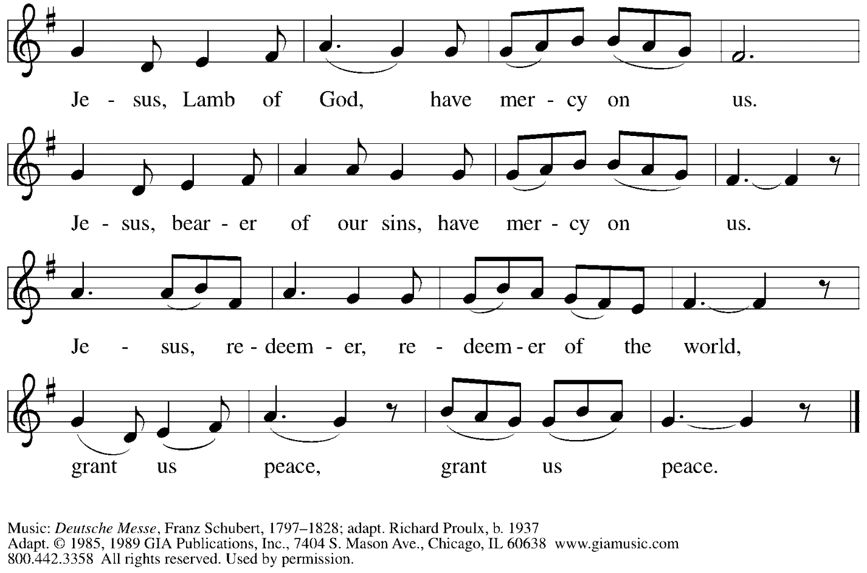
Reprinted with permission under OneLicense.net # A-722139.

Please be seated.

Holy Communion
- Hand sanitizer is available if you would like to use it prior to receiving Communion.
- Worshipers from the pulpit side will proceed forward first, followed by the center section, and then the lectern side.
- The Communion wafers (regular and gluten-free) have been thoughtfully prepared using the gifts of the congregation by a member of St. Andrew’s altar care team, with a drop of wine or grape juice on each. The presiding minister will distribute one to each communicant.
- When you reach the presiding minister, please indicate if you would like grape juice or a gluten-free wafer.
- A blessing will be provided for anyone who does not yet receive the sacrament.
- Cushions have been placed at the altar rail for anyone who would like to kneel for prayer and reflection before returning to their pew..

Hymns during Holy Communion
God, Whose Giving Knows No Ending ELW 678

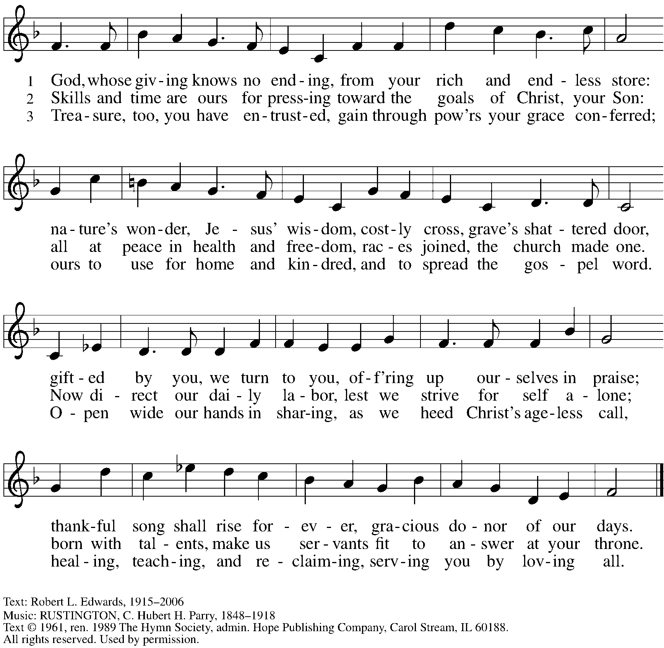
Reprinted with permission under OneLicense.net # A-722139.

Hymns during Holy Communion
We Are an Offering ELW 692

It was not possible to print this hymn. Please use the Evangelical Lutheran Worship hymnal found in the pews.

When all have returned to their places, please rise as you are able.

Blessing

P: The body and blood of our Lord Jesus Christ strengthen you and keep you in his grace.
C: Amen.

Prayer

P: Let us pray. Life-giving God, through this meal you have bandaged our wounds
and fed us with your mercy. Now send us forth to live for others, both friend and stranger,
that all may come to know your love. This we pray in the name of Jesus.
C: Amen.

Please be seated.

Sending

Announcements

Please rise as you are able.

Benediction

P: The God ☩ of peace, bless you, comfort you,
and show you the path of life, this day and always.
C: Amen.

Sending Hymn This Little Light of Mine ELW 677

1 This little light of mine, I'm gonna let it shine;
this little light of mine, I'm gonna let it shine;
this little light of mine, I'm gonna let it shine,
let it shine, let it shine, let it shine.

2 Everywhere I go, I'm gonna let it shine;
everywhere I go, I'm gonna let it shine;
everywhere I go, I'm gonna let it shine,
let it shine, let it shine, let it shine.

3 Jesus gave it to me, I'm gonna let it shine;
Jesus gave it to me, I'm gonna let it shine;
Jesus gave it to me, I'm gonna let it shine,
let it shine, let it shine, let it shine.

Text: African American spiritual. Music: THIS JOY, African American spiritual.

Dismissal

P: Go in peace. Serve the Lord.
C: Thanks be to God!

Abbreviations

P: Pastor/Presiding Minister
L: Lector
C: Congregation

ELW: Evangelical Lutheran Worship hymnal
ACS: All Creation Sings hymnal
TFF: This Far by Faith hymnal

Those serving in worship today

Minister of Music Laura Reynolds
Cantor Noël Marsh
Lector Colleen Cooke
Presiding Minister Rev. Ross Carmichael

Liturgy and Hymnody Acknowledgements

From SundaysandSeasons.com. Copyright © 2022 Augsburg Fortress. All rights reserved. Reprinted under OneLicense.net # A-722139.
Used by permission of Augsburg Fortress.

St. Andrew Lutheran Church Announcements
September 18th, 2022

- Worship in the Sanctuary and Online - Sunday, September 18th, + Fifteenth Sunday after Pentecost - St. Andrew’s next service of Holy Communion will be this Sunday, September 18th, at 10:00 a.m. Allegheny County’s Covid-19 community level is in the “low” category, so masks are optional in the building. **Please do not attend an on-site event if you have felt sick in any way until you have 5 days without symptoms.** Attendees are invited to make their own name tags at the back of the worship space. Worship will also be live-streamed to Facebook, YouTube, and Zoom. Social hour will be held after worship each Sunday.
- Fall Festival Outside at St. Andrew with Shine Bright Childcare and Learning Center – Friday, September 23rd, 6:00-7:30 p.m. – St. Andrew has been building a relationship with the people of Shine Bright Child Care and Learning Center just up the block on Morewood Avenue, and will join Shine Bright in hosting an outdoor fall festival on Friday, September 23rd, from 6:00-7:30 p.m. There will be games and face painting for children, along with food and music. People of all ages are welcome! St. Andrew will be providing food and drink for the event, so we are accepting donations in $10 increments to offset the cost of the food. If you would like to contribute to this or help with setup/takedown please sign up here: https://www.signupgenius.com/go/5080544AAAC22A1F58-fall.
Either way, please come! This will be a nice opportunity to get to know our neighbors!
- Bethel AME Reparations Petition Signing and Press Conference - Saturday, September 24th, 10:00 a.m. - 2:00 p.m. - Bethel AME Church, at 2700 Webster Ave. in the Hill District, will host a press conference and initial signing of a new petition in partnership with the Color of Change organization in their pursuit of reparations for their land and church that were taken in the 1950s. This will take place during a Hill District Community Resource Fair/Cookout on Saturday, September 24th, from 10:00 a.m. - 2:00 p.m. at Bethel. To sign or share the petition, please visit: https://bit.ly/Justice4Bethel.
- Seeking Repair with Native American Communities – Council of Three Rivers Announces Annual Pow Wow Event, September 24th-25th - At the Evangelical Lutheran Church in America’s churchwide assembly in 2016, our church adopted an official repudiation of the Doctrine of Discovery, a basis for colonization that has caused devastating harm to indigenous people and their communities throughout the world (Learn more here: elca.org/Repudiation). Local efforts to seek repair in our church’s relationship with Native American communities have slowly been progressing in the territory of the Southwestern Pennsylvania Synod under the leadership of the synod’s Authentic Diversity and Justice team. They have begun conversation with the people of Council of Three Rivers American Indian Center, an organization that provides educational and social-service programming to local indigenous people. The Synod has announced the Council of Three Rivers’ invitation to their 43rd Annual Pow Wow Saturday, September 24th, from 12:00 p.m. noon to 9:00 p.m. and Sunday, September 25th from 12:00 noon to 7:00 p.m. at Singing Winds (120 Charles St., Pittsburgh 15238). The event features music, dance, drumming demonstrations, indigenous arts and crafts, and food for sale. For more information, call 412-292-7683.
- Help Supply “Thanksgiving Dinner” Bags - St. Andrew will be compiling bags of non-perishable “Thanksgiving” foods to deliver to our neighbors at the November 1st produce distribution, and we invite people of the congregation to contribute. There will be a box or bin located in the Social Hall near the Little Pantry supplies for anyone who would like to donate items. We are collecting the following:
  - Boxed stuffing
  - Instant potatoes
  - Canned green beans or corn
  - Cream of mushroom soup
  - French fried onions
  - Pudding mix and/or jello mix
  - Corn muffin mix
- Little Pantry and Little Library Assistance - St. Andrew is accepting donations of food items, as well as financial gifts, for the Little Pantry on an ongoing basis. We would especially appreciate help restocking. If you would like to help with the Pantry and/or Library, please sign up here: https://www.signupgenius.com/go/5080544AAAC22A1F58-free.
- Lutheran Campus Ministry Hosts Art Exhibit Exploring Race, Open through October 9th - Truth Be Told is an art exhibit created by fourteen women artists across the country as they reflected on racism. The group of seven Black women and seven white women began with conversations after the murder of Goerge Floyd. These discussions moved them each to consider one word and create an art piece around that word. Local Pittsburgh artist Debbie Jacknin, owner of Songbird Artistry, 4316 Penn Avenue, is one of these artists and has been an important part of bringing this exhibit to Pittsburgh.
The exhibit will be shown at the Lutheran University Center, 4515 Forbes Avenue, Pittsburgh 15213. Open hours of viewing will be every Saturday and Sunday through October 9th, 1:00-6:00 p.m. Arrangements can be made to view the exhibit during the week by contacting the campus ministry at 412-682-6886 or email pastor@psalm.online. The Lutheran Campus Ministry in Greater Pittsburgh and its student group PSALM (Pittsburgh Students Active in Lutheran Ministry) received a grant from the Philip N. Knutson Endowment for Lutheran Campus Ministry to help foster conversation and reflection about vital issues facing the world. For more information, go to http://psalm.online.
- GameFest - October 15th, 2022 - Lutheran Campus Ministry in Greater Pittsburgh and PSALM are hosting a day of gaming fundraiser for campus ministry. It will be a whole day of tabletop gaming, with D&D, Catan, Call to Adventure, and much more, from the simple and quick to the labyrinthine. There will be some games scheduled and some open tables. They will have games on hand to try, or anyone can bring an old favorite and set it up in the space. There will be concessions and raffle baskets and people of all ages are welcome! The event is scheduled from 9:00 a.m. - 9:00 p.m. at the Lutheran University Center, 4515 Forbes Ave., Pittsburgh 15213. For tickets, please visit: PSALM GameFest Tickets, Sat, Oct 15, 2022 at 9:00 AM | Eventbrite.

