+ Sixteenth Sunday after Pentecost
September 25, 2022
St. Andrew Lutheran Church
304 Morewood Ave.
Pittsburgh, PA 15213
St_andrewELCA@verizon.net
www.standrewpittsburgh.org

+ Sixteenth Sunday after Pentecost
Order for Worship

Consideration of and care for those in need (especially those “at our gate,” visible to us, of whom we are aware) is an essential component of good stewardship. It is in the sharing of wealth that we avoid the snare of wealth. It is the one whom death could not hold—who comes to us risen from the dead—who can free us from the death grip of greed.

The following safety precautions apply regardless of vaccination status.

- Covid-19 community level in Allegheny County is in the “low” category, so face masks are optional in the building.
- Hand sanitizer is available at the front of the sanctuary to use before Holy Communion, after you proceed past the baptismal font, as the alcohol has been affecting the finish on the font’s bowl.

Worship Services are live streamed to multiple online platforms.
By attending worship, you agree that your image and voice may be broadcast.

Welcome to St. Andrew!
- Everyone is invited to make a nametag at the black bookcase in the back of the worship space if they would like.
- Worship “toolkits” to help children engage with the service are available in the black bookcase at the back of the worship space. There are “reader” and “pre-reader” resources available in each kit. Please feel free to use the kits for/with your children during worship.
- After the Prayer of the Day, children are invited to gather in the Social Hall for Little Church; Big Faith, a Bible lesson and activity. The group returns to the worship space for the Communion portion of the service.
- A restroom is available on the main level of the church, through the doors to the Social Hall and to the right in the main office.

Welcome

Prelude

Gathering
The Holy Spirit calls us together as the people of God.

Confession and Forgiveness

P: Blessed be the holy Trinity, ☩ one God,
whose steadfast love endures forever.
C: Amen.

P: Let us confess our sin in the presence of God and of one another.

Silence is kept for reflection.

P: Merciful God,
C: we confess that we have not followed your path
but have chosen our own way.
Instead of putting others before ourselves,
we long to take the best seats at the table.
When met by those in need,
we have too often passed by on the other side.
Set us again on the path of life.
Save us from ourselves
and free us to love our neighbors.
Amen.

P: Hear the good news!
God does not deal with us according to our sins
but delights in granting pardon and mercy.
In the name of ☩ Jesus Christ, your sins are forgiven.
You are free to love as God loves.
C: Amen.

Gathering Hymn Making Their Way ACS 979

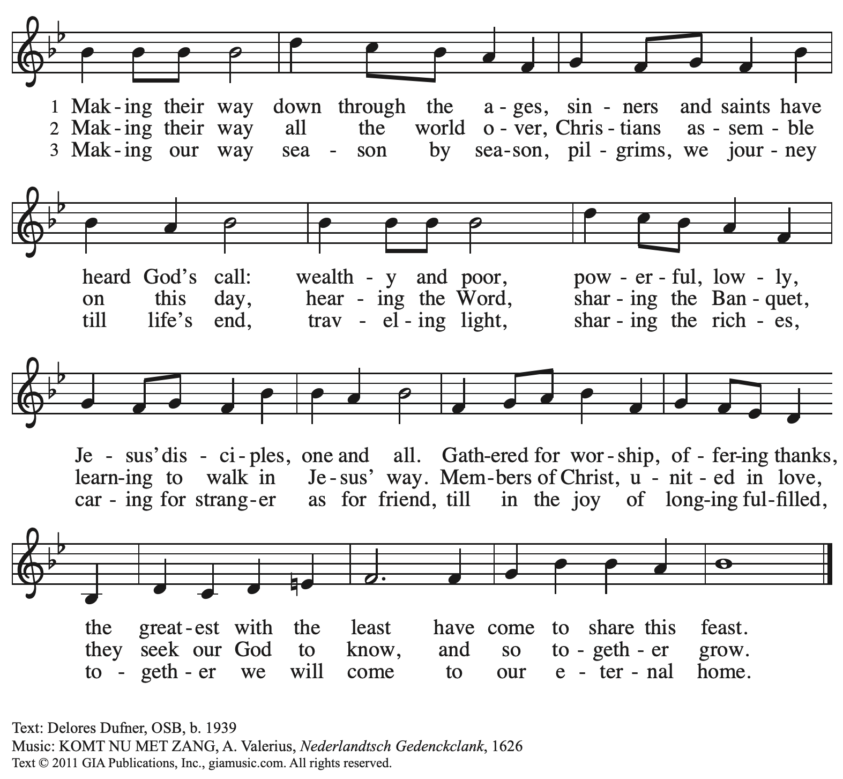
Reprinted with permission under OneLicense.net # A-722139.

Greeting

P: The grace of our Lord Jesus Christ, the love of God,
and the communion of the Holy Spirit be with you all.
C: And also with you.

Prayer of the Day

P: Let us pray.
O God, rich in mercy, you look with compassion on this troubled world.
Feed us with your grace, and grant us the treasure that comes only from you,
through Jesus Christ, our Savior and Lord.
C: Amen.

Please be seated.
Children are invited to join the adult leaders and move to the office for Little Church; Big Faith.

Word
God speaks to us in Scripture reading, preaching, and song

First Reading – Amos 6: 1a, 4-7

^{1a}Alas for those who are at ease in Zion,
and for those who feel secure on Mount Samaria …

⁴Alas for those who lie on beds of ivory,
and lounge on their couches,
and eat lambs from the flock,
and calves from the stall;
⁵who sing idle songs to the sound of the harp,
and like David improvise on instruments of music;
⁶who drink wine from bowls,
and anoint themselves with the finest oils,
but are not grieved over the ruin of Joseph!
⁷Therefore they shall now be the first to go into exile,
and the revelry of the loungers shall pass away.

L: Word of God, word of life.
C: Thanks be to God.

Please rise as you are able.

Gospel Acclamation Halle, Halle, Hallelujah ELW 172

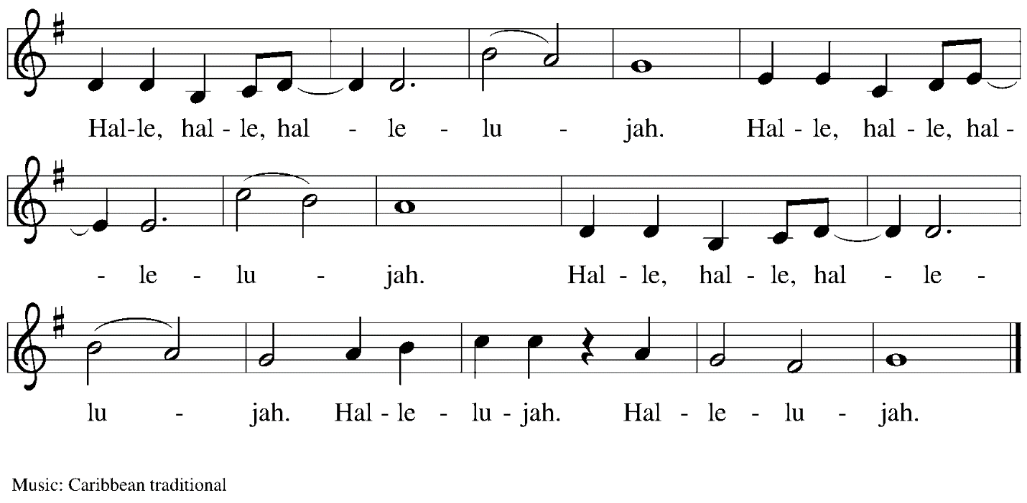

Gospel – Luke 16: 19-31

P: The holy Gospel according to St. Luke.
C: Glory to you, O Lord.
[Jesus said:] ¹⁹“There was a rich man who was dressed in purple and fine linen and who feasted sumptuously every day. ²⁰And at his gate lay a poor man named Lazarus, covered with sores, ²¹who longed to satisfy his hunger with what fell from the rich man’s table; even the dogs would come and lick his sores. ²²The poor man died and was carried away by the angels to be with Abraham. The rich man also died and was buried. ²³In Hades, where he was being tormented, he looked up and saw Abraham far away with Lazarus by his side. ²⁴He called out, ‘Father Abraham, have mercy on me, and send Lazarus to dip the tip of his finger in water and cool my tongue; for I am in agony in these flames.’ ²⁵But Abraham said, ‘Child, remember that during your lifetime you received your good things, and Lazarus in like manner evil things; but now he is comforted here, and you are in agony. ²⁶Besides all this, between you and us a great chasm has been fixed, so that those who might want to pass from here to you cannot do so, and no one can cross from there to us.’ ²⁷He said, ‘Then, father, I beg you to send him to my father’s house—²⁸for I have five brothers—that he may warn them, so that they will not also come into this place of torment.’ ²⁹Abraham replied, ‘They have Moses and the prophets; they should listen to them.’ ³⁰He said, ‘No, father Abraham; but if someone goes to them from the dead, they will repent.’ ³¹He said to him, ‘If they do not listen to Moses and the prophets, neither will they be convinced even if someone rises from the dead.’ ”

P: The Gospel of the Lord.
C: Praise to you, O Christ.

Please be seated.

Sermon

A time of silence for prayer and reflection follows the sermon.
When the hymn of the day begins, please rise as you are able.

Hymn of the Day Christ, Be Our Light ELW 715

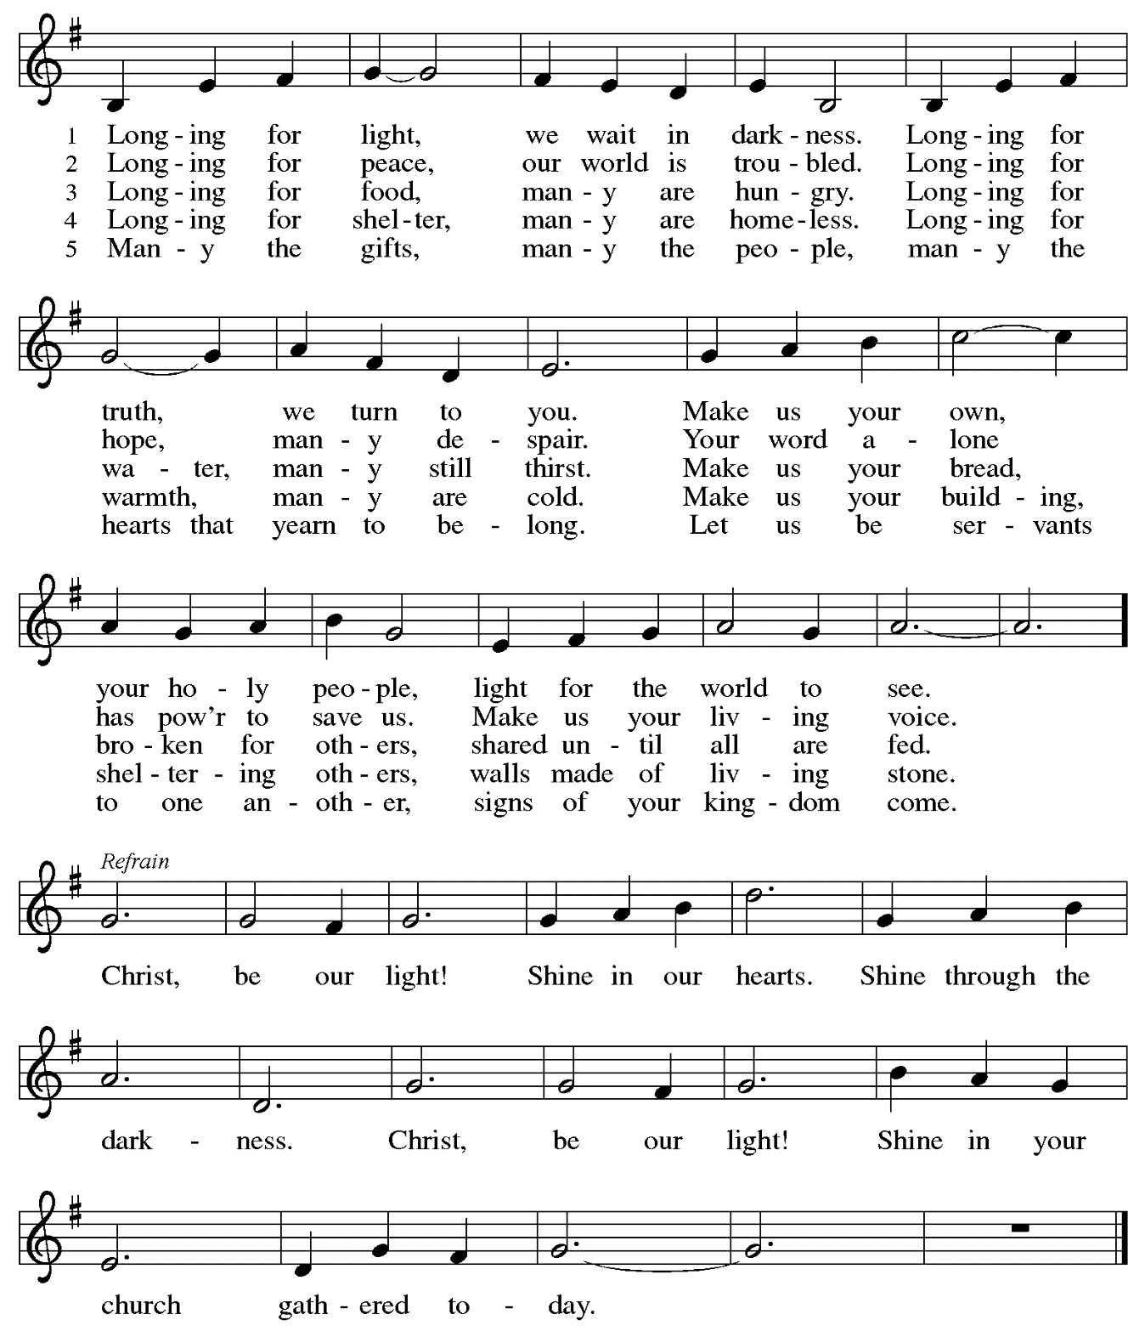

Prayers of the People

P: Trusting in God’s extraordinary love, let us come before the Holy One in prayer.

After each petition
P: Merciful God, C: receive our prayer.

P: Receive the prayers of your people, merciful God, and keep us forever in your steadfast love;
through Jesus Christ our Savior.
C: Amen.

Please be seated.

Meal

Offering

We offer ourselves, our gifts, and our faithful service to God.
An usher will pass around an offering plate for anyone who would like to offer gifts before God.

Music during the Offering

Please rise as you are able.

Offertory Song All to Jesus I Surrender TFF 235
v. 1, 3

1 All to Jesus I surrender,
all to him I freely give;
I will ever love and trust him,
in his presence daily live.

Refrain
I surrender all, (I surrender all),
I surrender all, (I surrender all),
all to thee, my blessed Savior,
I surrender all.

3 All to Jesus I surrender,
Lord, I give myself to thee;
fill me with thy love and power,
let thy blessings fall on me. Refrain

Text: Judson W. Van De Venter, 1855-1939. Music: SURRENDER, Winfield S. Weeden, 1847-1908

Offertory Prayer

P: Let us pray.
Holy God, gracious and merciful,
C: you bring forth food from the earth and nourish your whole creation.
Turn our hearts toward those who hunger in any way, that all may know your care;
and prepare us now to feast on the bread of life, Jesus Christ, our Savior and Lord.
Amen.

Dialogue

P: The Lord be with you.
C: And also with you.

P: Lift up your hearts.
C: We lift them to the Lord.

P: Let us give thanks to the Lord our God.
C: It is right to give our thanks and praise.

Preface

P: It is indeed right, our duty and our joy,
that we should at all times and in all places
give thanks and praise to you, almighty and merciful God,
through our Savior Jesus Christ;
who on this day overcame death and the grave,
and by his glorious resurrection opened to us the way of everlasting life.
And so, with all the choirs of angels,
with the church on earth and the hosts of heaven,
we praise your name and join their unending hymn:

Sanctus

Holy, holy, holy Lord,
God of power and might:
Heaven and earth are full of your glory.
Hosanna in the highest.
Blessed is the one who comes in the name of the Lord.
Hosanna in the highest.

Eucharistic Prayer

P: Holy God, holy and mighty, holy and immortal …
… Do this for the remembrance of me.

Together as the body of Christ, we proclaim the Lord’s death until he comes.
C: Christ has died.
Christ has risen.
Christ will come again.

P: With this bread and cup we remember your Son …
… all our sins and sorrows will be no more.
C: Amen. Come, Lord Jesus.

P: Holy God, holy and merciful one, holy and compassionate …
… sharing your bounty with all the world.
C: Amen. Come, Holy Spirit.

P: Holy and benevolent God …
… with the Holy Spirit, in your holy church, now and forever.
C: Amen.

Lord’s Prayer

P: Gathered as one by the Holy Spirit, let us pray as Jesus taught us.
C: Our Father in heaven,
hallowed be your name,
your kingdom come,
your will be done,
on earth as in heaven.
Give us today our daily bread.
Forgive us our sins
as we forgive those who sin against us.
Save us from the time of trial
and deliver us from evil.
For the kingdom, the power,
and the glory are yours,
now and forever. Amen.

Fraction and Invitation

Agnus Dei / Lamb of God

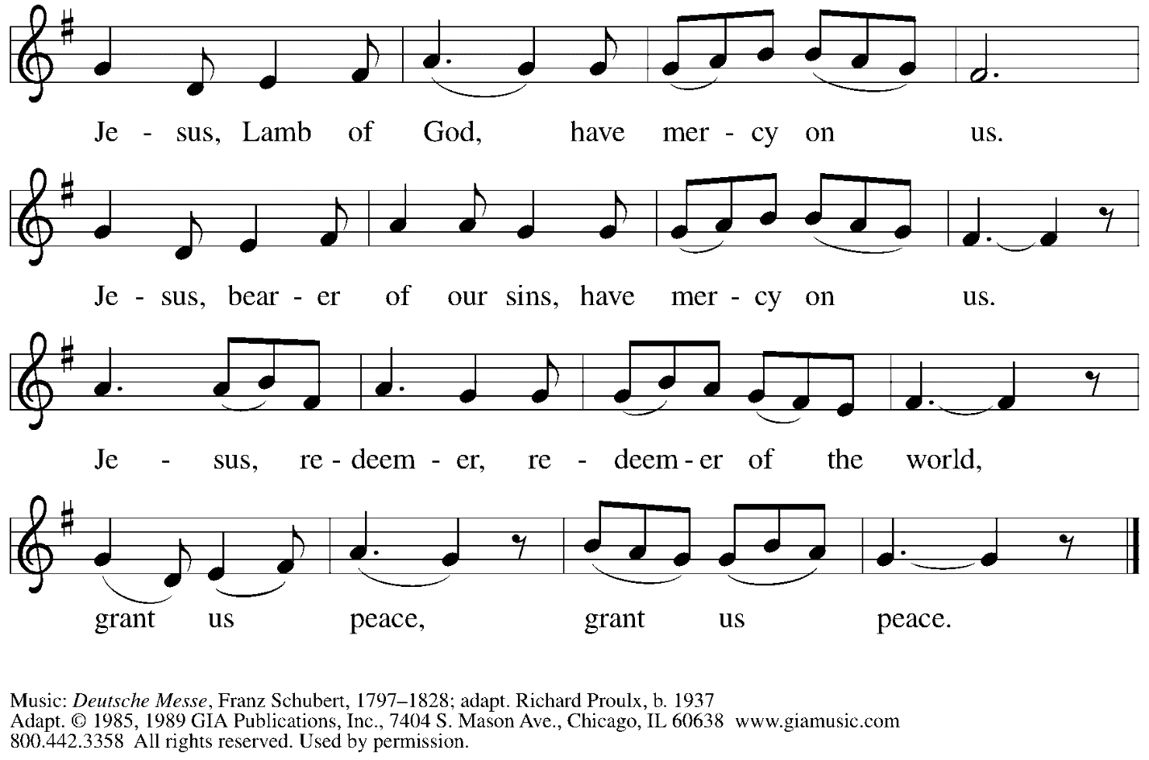
Reprinted with permission under OneLicense.net # A-722139.

Please be seated.

Holy Communion
- Hand sanitizer is available if you would like to use it prior to receiving Communion.
- Worshipers from the pulpit side will proceed forward first, followed by the center section, and then the lectern side.
- The Communion wafers (regular and gluten-free) have been thoughtfully prepared using the gifts of the congregation by a member of St. Andrew’s altar care team, with a drop of wine or grape juice on each. The presiding minister will distribute one to each communicant.
- When you reach the presiding minister, please indicate if you would like grape juice or a gluten-free wafer.
- A blessing will be provided for anyone who does not yet receive the sacrament.
- Cushions have been placed at the altar rail for anyone who would like to kneel for prayer and reflection before returning to their pew.
- Everyone is asked to wait until you return to your place to consume the elements, and then promptly replace your mask.

Hymns during Holy Communion
Lord, Listen to Your Children Praying ELW 752

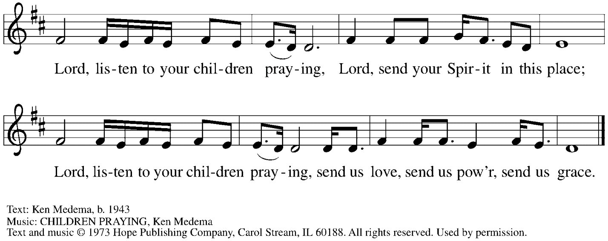

All rights reserved. Reprinted with permission under OneLicense.net # A-722139.

Hymns during Holy Communion
The Church of Christ, in Every Age ELW 729

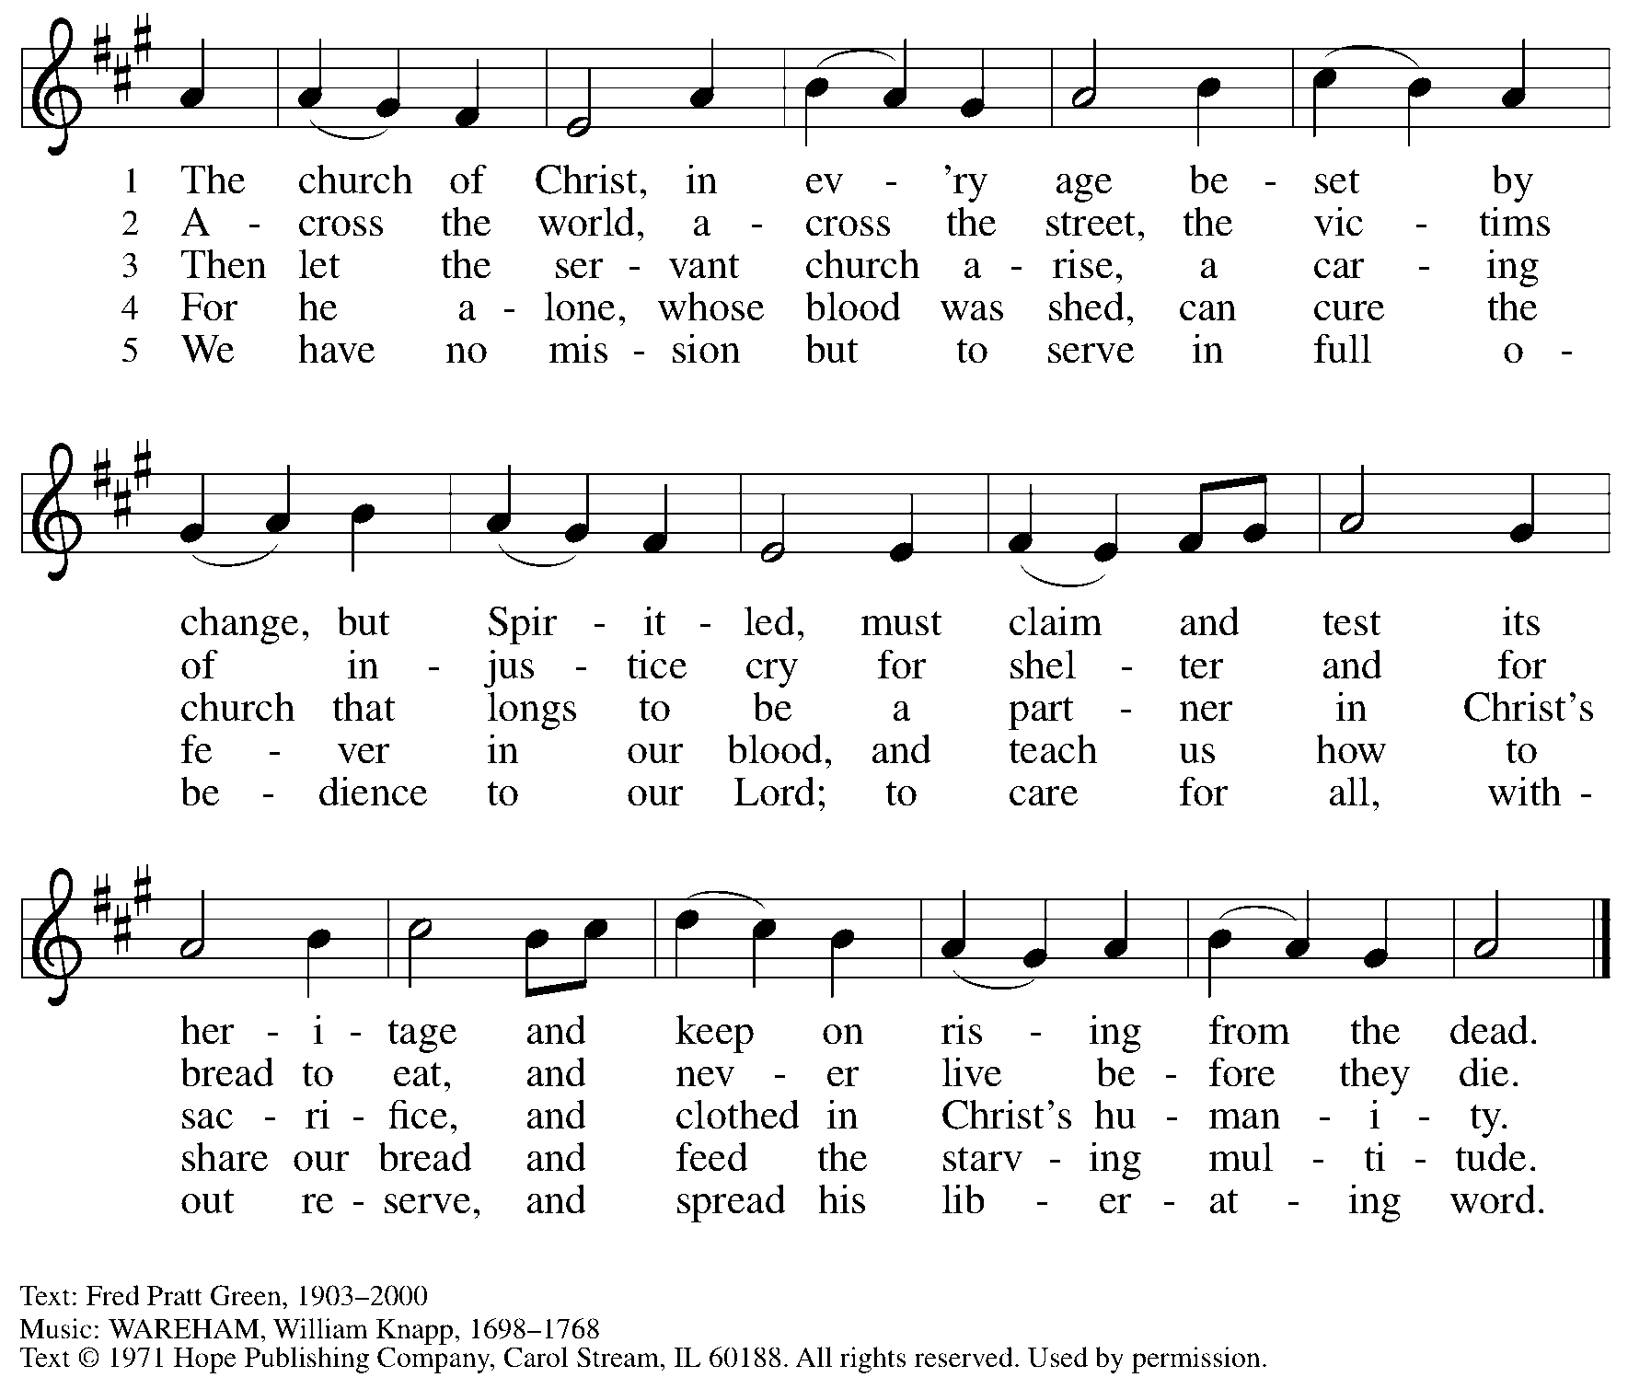
Reprinted under OneLicense.net #A-722139.

When all have returned to their places, please rise as you are able.

Blessing

P: The body and blood of our Lord Jesus Christ strengthen you and keep you in his grace.
C: Amen.

Prayer

P: Let us pray.
Life-giving God, through this meal you have bandaged our wounds
and fed us with your mercy.
Now send us forth to live for others, both friend and stranger,
that all may come to know your love. This we pray in the name of Jesus.
C: Amen.

Please be seated.

Sending

Announcements

Please rise as you are able.

Benediction

P: The God ☩ of peace, bless you, comfort you,
and show you the path of life, this day and always.
C: Amen.

Sending Hymn Canticle of the Turning Following Page

Dismissal

P: Go in peace. Serve the Lord.
C: Thanks be to God!

Sending Hymn Canticle of the Turning ELW 723

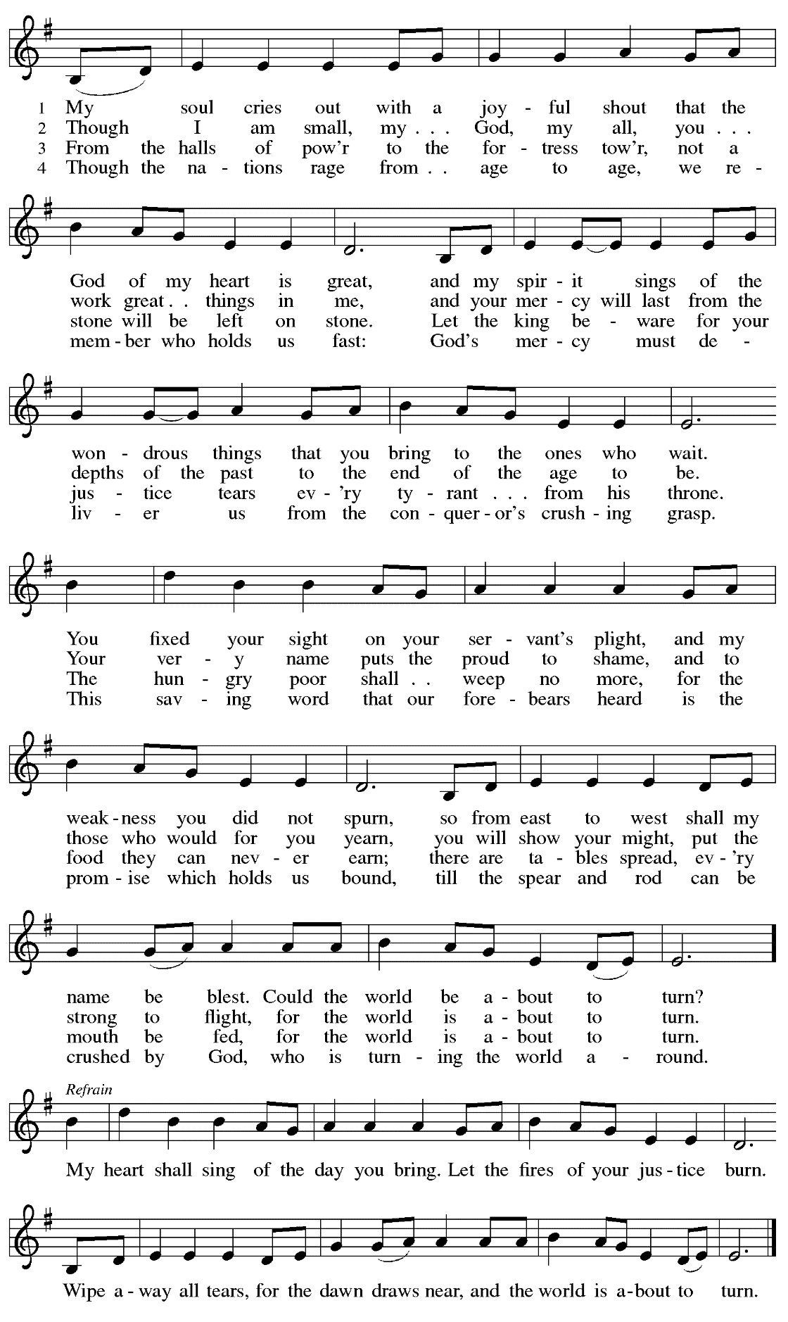
Abbreviations

P: Pastor/Presiding Minister
L: Lector
C: Congregation

ELW: Evangelical Lutheran Worship hymnal
ACS: All Creation Sings hymnal
TFF: This Far by Faith hymnal

Those serving in worship today

Minister of Music Laura Reynolds
Cantor Maria Mangano
Lector Pastor Paul Koch
Audio/Visual Ministers Linnea Asplin
Joseph Paetz
Presiding Minister Rev. Ross Carmichael

Liturgy and Hymnody Acknowledgements

From SundaysandSeasons.com. Copyright © 2022 Augsburg Fortress. All rights reserved. Reprinted under OneLicense.net # A-722139.
Used by permission of Augsburg Fortress.

Christ, Be Our Light – Text: Bernadette Farrell, b. 1957. Music: CHRIST, BE OUR LIGHT, Bernadette Farrell. Text and Music © 1993 Bernadette Farrell. Published by and admin. OCP Publications, 5536 NE Hassalo, Portland, OR 97213. All rights reserved. Reprinted with permission under OneLicense.net # A-722139.

Canticle of the Turning – Text: Rory Cooney, b. 1952, based on the Magnificat. Music: STAR OF COUNTY DOWN, Irish traditional.
Text © 1990 GIA Publications, Inc., 7404 S. Mason Ave., Chicago, IL 60638. www.giamusic.com. 800.442.3358. All rights reserved.
Reprinted with permission under OneLicense.net # A-722139.

St. Andrew Lutheran Church Announcements
September 25th, 2022

- Worship in the Sanctuary and Online - Sunday, September 25th, + Sixteenth Sunday after Pentecost – St. Andrew’s next service of Holy Communion will be this Sunday, September 25th, at 10:00 a.m. Allegheny County’s Covid-19 community level is in the “low” category, so masks are optional in the building. Worship will also be live-streamed to Facebook, YouTube, and Zoom. Attendees are invited to make their own name tags at the back of the worship space. Social hour will be held after worship each Sunday.
- Bethel AME Reparations Petition Available – Bethel AME Reparations Petition Signing and Press Conference – Saturday, September 24th, 10:00 a.m. - 2:00 p.m. - Bethel AME Church, at 2700 Webster Ave. in the Hill District, will host a press conference and initial signing of a new petition in partnership with the Color of Change organization in their pursuit of reparations for their land and church that were taken in the 1950s. This will take place during a Hill District Community Resource Fair/Cookout on Saturday, September 24th, from 10:00 a.m. - 2:00 p.m. at Bethel. To sign or share the petition, please visit: https://bit.ly/Justice4Bethel.
- Seeking Repair with Native American Communities – Council of Three Rivers Announces Annual Pow Wow Event, September 24th-25th – At the Evangelical Lutheran Church in America’s churchwide assembly in 2016, our church adopted an official repudiation of the Doctrine of Discovery, a basis for colonization that has caused devastating harm to indigenous people and their communities throughout the world (Learn more here: elca.org/Repudiation). Local efforts to seek repair in our church’s relationship with Native American communities have slowly been progressing in the territory of the Southwestern Pennsylvania Synod under the leadership of the synod’s Authentic Diversity and Justice team. They have begun conversation with the people of Council of Three Rivers American Indian Center, an organization that provides educational and social-service programming to local indigenous people. The Synod has announced the Council of Three Rivers’ invitation to their 43rd Annual Pow Wow Saturday, September 24th, from 12:00 p.m. noon to 9:00 p.m. and Sunday, September 25th from 12:00 noon to 7:00 p.m. at Singing Winds (120 Charles St., Pittsburgh 15238). The event features music, dance, drumming demonstrations, indigenous arts and crafts, and food for sale. For more information, call 412-292-7683.
- Dinner with St. Andrew – Wednesday, September 28th, 6:30 p.m., Totopo Cocina y Cantina, 660 Washington Rd., Mt Lebanon, 15228 – For more information, please visit Totopo (totopomex.com). If you plan to attend, please let Kelly Spanninger know at pkspanninger@verizon.net.
- Monthly Produce Distribution – Tuesday, October 4th, 5:30-7:00 p.m. – On the first Tuesday of each month, St. Andrew hosts a fresh produce distribution in partnership with Greater Pittsburgh Community Food Bank. The next one will be Tuesday, October 4th. We invite people of the congregation to help serve with the distribution from 5:30-7:00 p.m. Additional help is needed during the day for setup and unloading of the produce. Arrival times have varied, so those who sign up will receive a call the day before with an approximate time. Please sign up at: https://www.signupgenius.com/go/5080544AAAC22A1F58-produce21
- Lutheran Disaster Response Call for Support to Address Needs Following:
  - Hurricane Fiona in Puerto Rico and the Caribbean
  - Remnants of Typhoon Merbok in Alaska
  - Typhoon Nanmadol in Japan
  - A magnitude 7.7 earthquake in Papua New Guinea
  - Summer monsoon flooding in Pakistan
These are the disasters that made the biggest headlines, but there are countless others to which the Evangelical Lutheran Church in America responds, using your gifts to the Lutheran Disaster Response general fund.
- Help Supply “Thanksgiving Dinner” Bags – St. Andrew will be compiling bags of non-perishable “Thanksgiving” foods to deliver to our neighbors at the November 1st produce distribution, and we invite people of the congregation to contribute. There will be a box or bin located in the Social Hall near the Little Pantry supplies for anyone who would like to donate items. We are collecting the following:
  - Boxed stuffing
  - Instant potatoes
  - Canned green beans or corn
  - Cream of mushroom soup
  - French fried onions
  - Pudding mix and/or jello mix
  - Corn muffin mix
- Lutheran Campus Ministry Hosts Art Exhibit Exploring Race, Open through October 9th – Truth Be Told is an art exhibit created by fourteen women artists across the country in reflection on racism. The group of seven Black women and seven white women began conversations after the murder of Goerge Floyd, which moved them each to consider one word and create an art piece around that word. The exhibit is being shown at the Lutheran University Center, 4515 Forbes Avenue, Pittsburgh 15213. Open hours of viewing are every Saturday and Sunday through October 9th, 1:00-6:00 p.m. Arrangements can be made to view the exhibit during the week by contacting the campus ministry at 412-682-6886 or email pastor@psalm.online. The Lutheran Campus Ministry in Greater Pittsburgh and its student group PSALM (Pittsburgh Students Active in Lutheran Ministry) received a grant to help foster conversation and reflection about vital issues facing the world. For more information, go to http://psalm.online.
- GameFest – Saturday, October 15th, 2022 – Lutheran Campus Ministry in Greater Pittsburgh and PSALM are hosting a day of gaming fundraiser for campus ministry. It will be a whole day of tabletop gaming, with D&D, Catan, Call to Adventure, and much more, from the simple and quick to the labyrinthine. There will be some games scheduled and some open tables. They will have games on hand to try, or anyone can bring an old favorite and set it up in the space. There will be concessions and raffle baskets and people of all ages are welcome! The event is scheduled from 9:00 a.m. - 9:00 p.m. at the Lutheran University Center, 4515 Forbes Ave., Pittsburgh 15213. For tickets, please visit: PSALM GameFest Tickets, Sat, Oct 15, 2022 at 9:00 AM | Eventbrite.

