+ Seventeenth Sunday after Pentecost
October 2, 2022

St. Andrew Lutheran Church
304 Morewood Ave.
Pittsburgh, PA 15213
St_andrewELCA@verizon.net
www.standrewpittsburgh.org

+ Seventeenth Sunday after Pentecost
Order for Worship

In Luke’s Gospel, Jesus indicates that a little faith goes a long way. A mustard seed-worth of faith has miraculous potential. The patience, tenacity, and endurance required for a life of faith are the gifts received in Holy Baptism, Holy Communion, and the Word read and proclaimed in the assembly. Anticipate them. Receive them with thanksgiving.

The following safety precautions apply regardless of vaccination status.

- Covid-19 community level in Allegheny County remains is in the “low” category, so face masks are optional in the building.
- Hand sanitizer is available at the back of the sanctuary.

Worship Services are live streamed to multiple online platforms.
By attending worship, you agree that your image and voice may be broadcast.

Welcome to St. Andrew!
- Everyone is invited to make a nametag at the black bookcase in the back of the worship space if they would like.
- Worship “toolkits” to help children engage with the service are available in the black bookcase at the back of the worship space. There are “reader” and “pre-reader” resources available in each kit. Please feel free to use the kits for/with your children during worship.
- After the Prayer of the Day, children are invited to gather in the Social Hall for Little Church; Big Faith, a Bible lesson and activity. The group returns to the worship space for the Communion portion of the service.
- A restroom is available on the main level of the church, through the doors to the Social Hall and to the right in the main office.

Welcome

Prelude

Gathering
The Holy Spirit calls us together as the people of God.

Confession and Forgiveness

P: Blessed be the holy Trinity, ☩ one God,
who forgives all our sin,
whose mercy endures forever.
C: Amen.

P: God of all mercy and consolation,
come to the help of your people, turning us from our sin to live for you alone.
Give us the power of your Holy Spirit that we may confess our sin, receive your forgiveness,
and grow into the fullness of Jesus Christ, our Savior and Lord.
C: Amen.

P: Let us confess our sin in the presence of God and of one another.

Silence is kept for reflection.

P: Gracious God,
C: have mercy on us.
We confess that we have turned from you and given ourselves into the power of sin.
We are truly sorry and humbly repent.
In your compassion, forgives us our sins,
things we have done and things we have failed to do.
Turn us again to you, and uphold us by your Spirit,
so that we may live and serve you and our neighbors in newness of life,
through Jesus Christ, our Savior and Lord.
Amen.

P: God who is rich in mercy loved us even when we were dead in sin
and made us alive together with Christ.
By grace you have been saved.
In the name of ☩ Jesus Christ, your sins are forgiven.
Almighty God strengthen you with power through the Holy Spirit,
that Christ may live in your hearts through faith.
C: Amen.

Gathering Hymn What Is the World Like ACS 1047

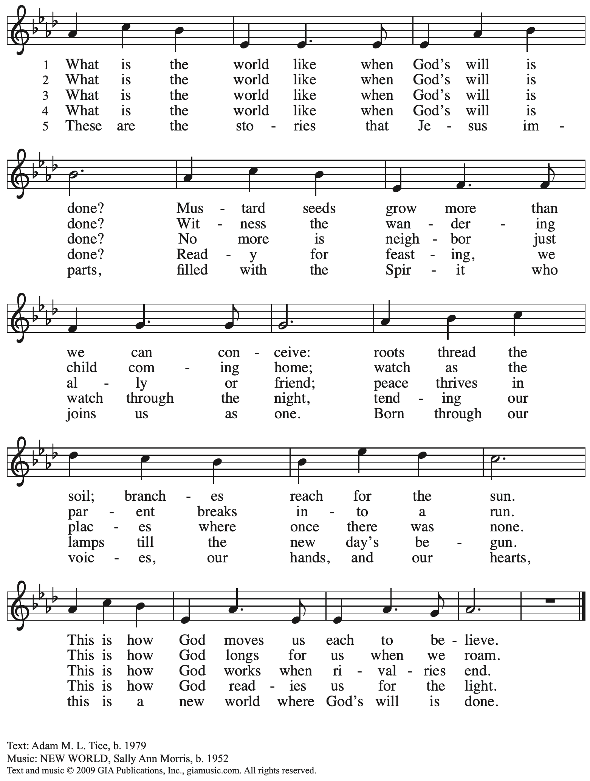
Reprinted with permission under OneLicense.net # A-722139.
Greeting

P: The grace of our Lord Jesus Christ, the love of God,
and the communion of the Holy Spirit be with you all.
C: And also with you.

Hymn of Praise Glory to God ELW p. 148

Prayer of the Day

P: Let us pray.
Benevolent, merciful God:
When we are empty, fill us. When we are weak in faith, strengthen us.
When we are cold in love, warm us, that with fervor we may love our neighbors
and serve them for the sake of your Son, Jesus Christ, our Savior and Lord.
C: Amen.

Please be seated.
Children are invited to join the adult leaders and move to the office for Little Church; Big Faith.

Word
God speaks to us in Scripture reading, preaching, and song

First Reading – Habakkuk 1: 1-4, 2: 1-4

¹The oracle that the prophet Habakkuk saw.
²O Lord, how long shall I cry for help,
and you will not listen?
Or cry to you “Violence!”
and you will not save?
³Why do you make me see wrongdoing
and look at trouble?
Destruction and violence are before me;
strife and contention arise.
⁴So the law becomes slack
and justice never prevails.
The wicked surround the righteous—
therefore judgment comes forth perverted.
^{2:1}I will stand at my watchpost,
and station myself on the rampart;
I will keep watch to see what the Lord will say to me,
and what the Lord will answer concerning my complaint.
²Then the Lord answered me and said:
Write the vision;
make it plain on tablets,
so that a runner may read it.
³For there is still a vision for the appointed time;
it speaks of the end, and does not lie.
If it seems to tarry, wait for it;
it will surely come, it will not delay.
⁴Look at the proud!
Their spirit is not right in them,
but the righteous live by their faith.

L: Word of God, word of life.
C: Thanks be to God.

Psalm 37: 1-9

The psalm will be led by the cantor, with the congregation invited to respond
with the alternate verses in bold print.

Psalm Tone

Psalm Refrain

¹Do not be provoked by | evildoers;
do not be jealous of those | who do wrong.
²For they shall soon wither | like the grass,
and like the green grass | fade away.
³Put your trust in the Lord| and do good;
dwell in the land and | find safe pasture.
⁴Take delight | in the Lord,
who shall give you your | heart’s desire. R
⁵Commit your way to the Lord; put your trust | in the Lord,
and see what | God will do.
⁶The Lord will make your vindication as clear | as the light
and the justice of your case like the | noonday sun.
⁷Be still before the Lord and wait | patiently.
Do not be provoked by the one who prospers, the one who succeeds in | evil schemes.

Psalm Refrain

⁸Refrain from anger, leave | rage alone;
do not be provoked; it leads on- | ly to evil.
⁹For evildoers shall | be cut off,
but those who hope in the Lord shall pos- | sess the land. R

Second Reading – 2 Timothy 1: 1-14

¹Paul, an apostle of Christ Jesus by the will of God, for the sake of the promise of life that is in Christ Jesus,
²To Timothy, my beloved child:
Grace, mercy, and peace from God the Father and Christ Jesus our Lord.
³I am grateful to God—whom I worship with a clear conscience, as my ancestors did—when I remember you constantly in my prayers night and day. ⁴Recalling your tears, I long to see you so that I may be filled with joy. ⁵I am reminded of your sincere faith, a faith that lived first in your grandmother Lois and your mother Eunice and now, I am sure, lives in you. ⁶For this reason I remind you to rekindle the gift of God that is within you through the laying on of my hands; ⁷for God did not give us a spirit of cowardice, but rather a spirit of power and of love and of self-discipline.
⁸Do not be ashamed, then, of the testimony about our Lord or of me his prisoner, but join with me in suffering for the gospel, relying on the power of God, ⁹who saved us and called us with a holy calling, not according to our works but according to God’s own purpose and grace. This grace was given to us in Christ Jesus before the ages began, ¹⁰but it has now been revealed through the appearing of our Savior Christ Jesus, who abolished death and brought life and immortality to light through the gospel. ¹¹For this gospel I was appointed a herald and an apostle and a teacher, ¹²and for this reason I suffer as I do. But I am not ashamed, for I know the one in whom I have put my trust, and I am sure that God is able to guard until that day what I have entrusted to God. ¹³Hold to the standard of sound teaching that you have heard from me, in the faith and love that are in Christ Jesus. ¹⁴Guard the good treasure entrusted to you, with the help of the Holy Spirit living in us.

L: Word of God, word of life.
C: Thanks be to God.

Please rise as you are able.

Gospel Acclamation Alleluia ELW p. 151

Gospel – Luke 17: 5-10

P: The holy Gospel according to St. Luke.
C: Glory to you, O Lord.
⁵The apostles said to the Lord, “Increase our faith!” ⁶The Lord replied, “If you had faith the size of a mustard seed, you could say to this mulberry tree, ‘Be uprooted and planted in the sea,’ and it would obey you.
⁷“Who among you would say to your slave who has just come in from plowing or tending sheep in the field, ‘Come here at once and take your place at the table’? ⁸Would you not rather say to him, ‘Prepare supper for me, put on your apron and serve me while I eat and drink; later you may eat and drink’? ⁹Do you thank the slave for doing what was commanded? ¹⁰So you also, when you have done all that you were ordered to do, say, ‘We are worthless slaves; we have done only what we ought to have done!’ ”

P: The Gospel of the Lord.
C: Praise to you, O Christ.

Please be seated.

Sermon

A time of silence for prayer and reflection follows the sermon.
When the hymn of the day begins, please rise as you are able.

Hymn of the Day O God, My Faithful God ELW 806

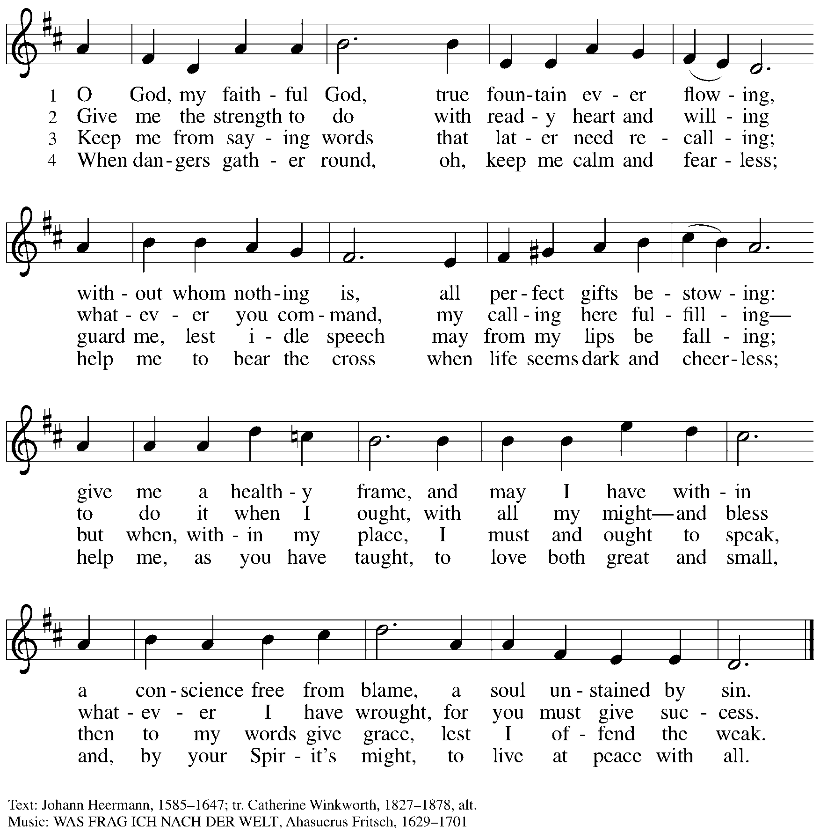

Prayers of the People

P: As scattered grains of wheat are gathered into one bread, so let us gather our prayers for the church, those in need, and all of God’s creation.

After each petition
P: God of grace,
C: receive our prayer.

P: Gathered in the communion of the Holy Spirit, we offer these and all our prayers to you, gracious God, through Jesus Christ, our Savior.
C: Amen.

Please be seated.

Meal

Offering

We offer ourselves, our gifts, and our faithful service to God.
An usher will pass around an offering plate for anyone who would like to offer gifts before God.

Music during the Offering

Please rise as you are able.

Offertory Song Let the Vineyards ELW 184

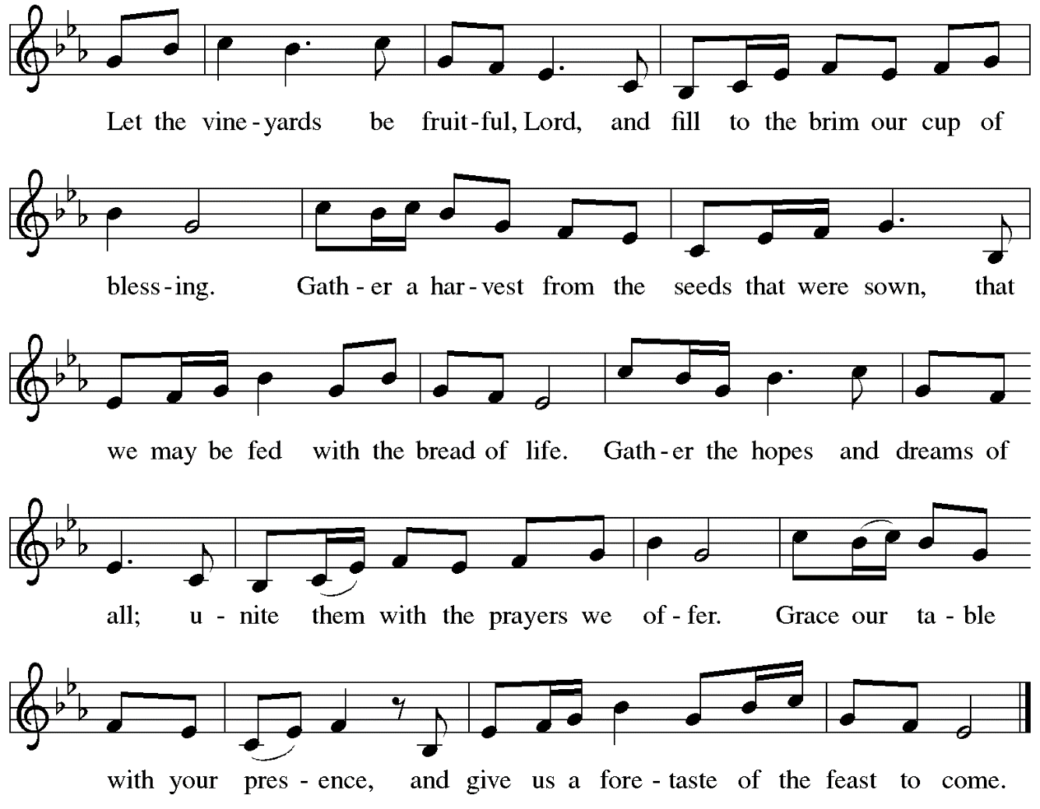

Offertory Prayer

P: Let us pray.
God, of all creation,
C: all you have made is good, and your love endures forever.
You bring forth bread from the earth and fruit from the vine.
Nourish us with these gifts, that we might be for the world
signs of your gracious presence in Jesus Christ, our Savior and Lord.
Amen.

Dialogue ELW p. 152

Preface (Sung by the presiding minister)

P: It is indeed right, our duty and our joy,
that we should at all times and in all places
give thanks and praise to you, almighty and merciful God,
through our Savior Jesus Christ;
who on this day overcame death and the grave,
and by his glorious resurrection opened to us the way of everlasting life.
And so, with all the choirs of angels,
with the church on earth and the hosts of heaven,
we praise your name and join their unending hymn:

Sanctus ELW p. 153

Eucharistic Prayer

P: Holy God …
… with every breath.
C: We praise you, O God.

P: Generations bless your faithfulness …
… into the future.
C: We bless you, O God.

P: We give you thanks for your dear Son …
… with us now.
C: We thank you, O God.

P: In the night in which he was betrayed …
… Do this for the remembrance of me.

Remembering his love for us on the way, at the table, and to the end,
we proclaim the mystery of faith.
C: Christ has died. Christ is risen. Christ will come again.

P: We pray for the gift of your Spirit …
… by your Spirit, in your church, without end.
C: Amen.

Lord’s Prayer

P: Gathered as one by the Holy Spirit, let us pray as Jesus taught us.
C: Our Father in heaven,
hallowed be your name,
your kingdom come,
your will be done,
on earth as in heaven.
Give us today our daily bread.
Forgive us our sins
as we forgive those who sin against us.
Save us from the time of trial
and deliver us from evil.
For the kingdom, the power,
and the glory are yours,
now and forever. Amen.

Fraction and Invitation

Agnus Dei / Lamb of God ELW p. 154

Please be seated.

Holy Communion
- Worshipers from the pulpit side will proceed forward first, followed by the center section, and then the lectern side.
- The Communion wafers (regular and gluten-free) have been thoughtfully prepared using the gifts of the congregation by a member of St. Andrew’s altar care team, with a drop of wine or grape juice on each. The presiding minister will distribute one to each communicant.
- When you reach the presiding minister, please indicate if you would like grape juice or a gluten-free wafer.
- A blessing will be provided for anyone who does not yet receive the sacrament.
- Cushions have been placed at the altar rail for anyone who would like to kneel for prayer and reflection before returning to their pew.

Hymns during Holy Communion
We Place upon Your Table, Lord ELW 467

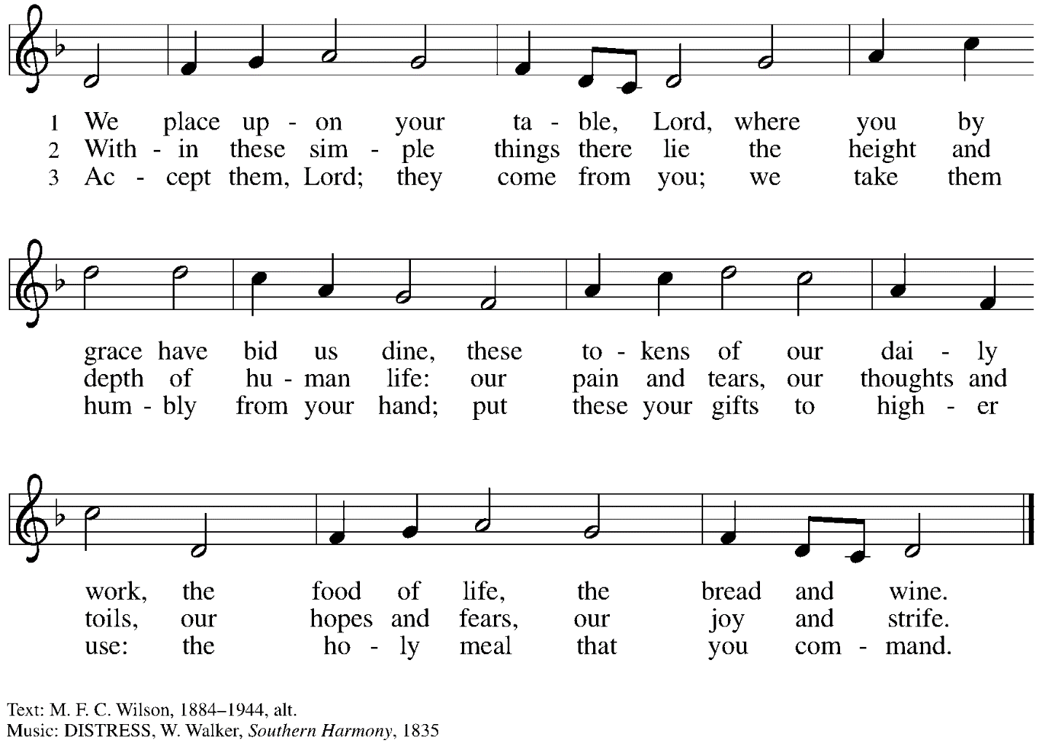

Hymns during Holy Communion
We Walk by Faith WOV 675

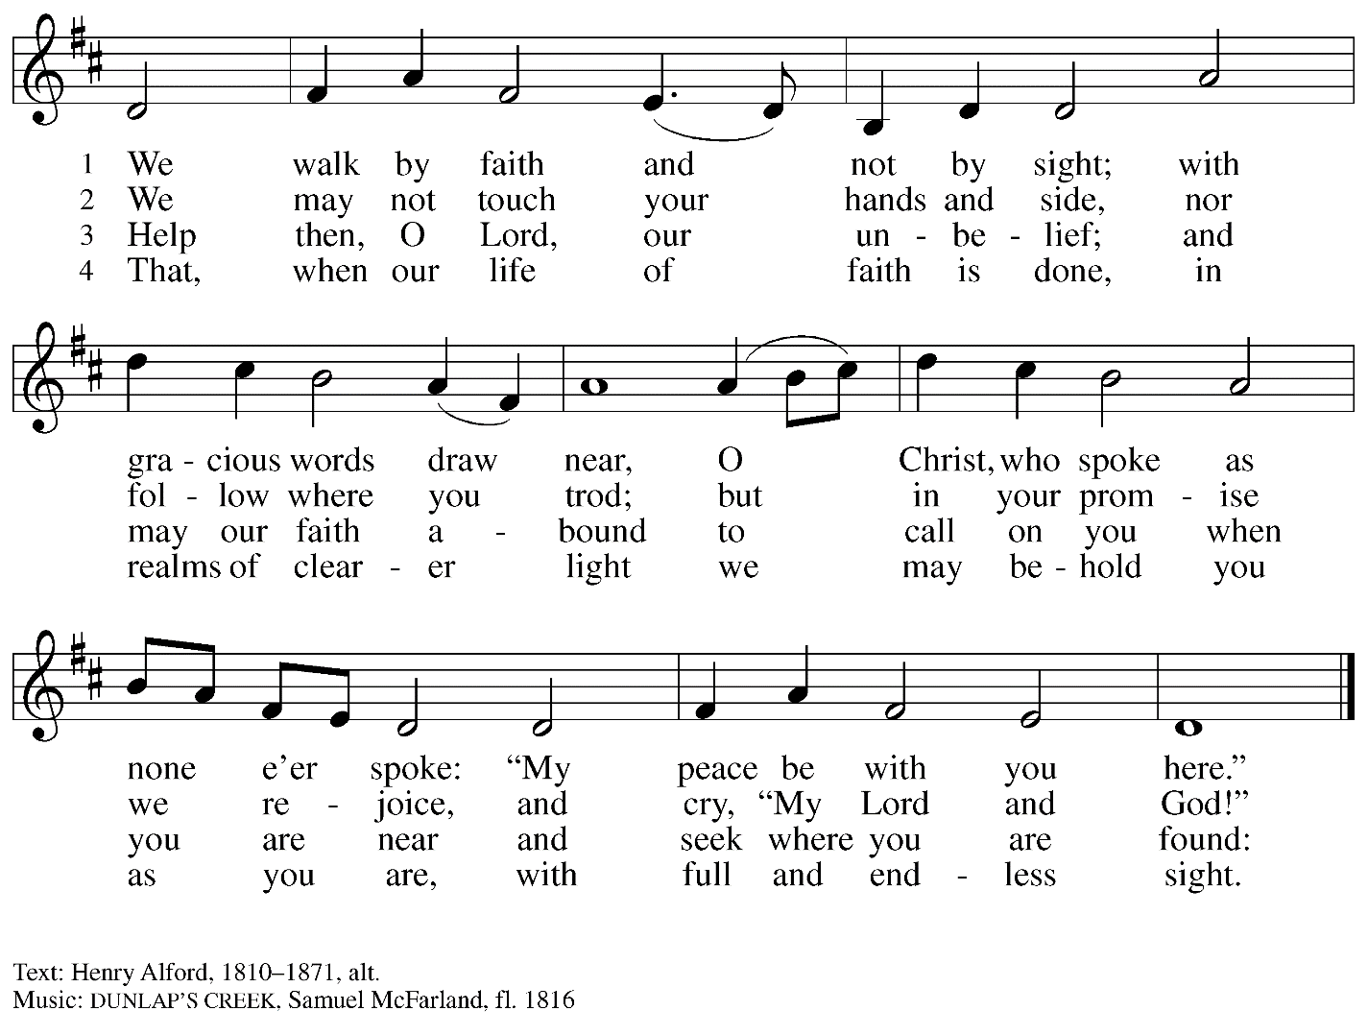

When all have returned to their places, please rise as you are able.

Blessing

P: The body and blood of our Lord Jesus Christ strengthen you and keep you in his grace.
C: Amen.

Prayer

P: Let us pray.
God of abundance, you have refreshed our hearts in this meal with bread for the journey.
Give us your grace on the way, that we may serve our neighbors with joy
and proclaim your goodness in all things, through Jesus Christ, our Savior and Lord.
C: Amen.

Please be seated.

Sending

Announcements

Please rise as you are able.

Benediction

P: God, who gives life to all things
and frees us from despair,
bless you with truth and peace.
The holy Trinity, ☩ one God,
guide you always in faith, hope, and love.
C: Amen.

Sending Hymn Haleluya! Pelo tsa rona ELW 535
Hallelujah! We Sing Your Praises

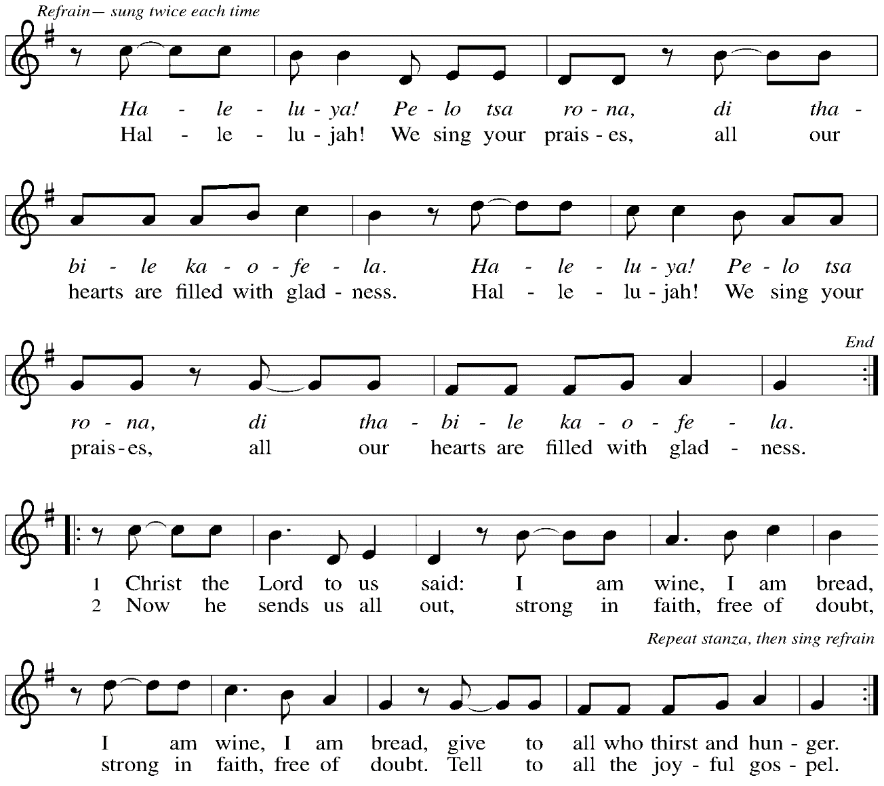

Dismissal

P: Go in peace. Serve the Lord.
C: Thanks be to God!

Abbreviations

P: Pastor/Presiding Minister
L: Lector
C: Congregation

ELW: Evangelical Lutheran Worship hymnal
ACS: All Creation Sings hymnal
WOV: With One Voice hymnal

Those serving in worship today

Minister of Music Laura Reynolds
Cantor David Rollinson
Lector Christy Ruhe
Audio Visual Minister Jason Galyardt
Presiding Minister Rev. Ross Carmichael

Liturgy and Hymnody Acknowledgements

From SundaysandSeasons.com. Copyright © 2022 Augsburg Fortress. All rights reserved. Reprinted under OneLicense.net # A-722139.
Used by permission of Augsburg Fortress.

Let the Vineyards – Text: John W. Arthur, 1922-1980. Music: Ronald A. Nelson, b. 1927. Text and music © 1978 Lutheran Book of Worship, admin. Augsburg Fortress. All rights reserved. Reprinted under OneLicense.net # A-722139.

Haleluya! Pelo tsa rona / Hallelujah! We Sing Your Praises – Text: South African; tr. Freedom Is Coming, 1984. Music: HALELUYA! PELO TSA RONA, South African. Tr. © 1984 Utryck, admn. Walton Music Corp. All rights reserved. Reprinted under OneLicesne.net # A-722139.

St. Andrew Lutheran Church Announcements
October 2nd, 2022

- Worship in the Sanctuary and Online – Sunday, October 2nd, + Seventeenth Sunday after Pentecost – St. Andrew’s next service of Holy Communion will be this Sunday, October 2nd, at 10:00 a.m. Allegheny County’s Covid-19 community level is in the “low” category, so face masks are optional in the building. Worship will also be live-streamed to Facebook, YouTube, and Zoom. Attendees are invited to make their own name tags at the back of the worship space. Social hour will be held after worship each Sunday.
- Bethel AME Reparations Petition Available – Bethel AME Church has released a new petition in partnership with the Color of Change organization in their pursuit of reparations for their land and church that were taken in the 1950s. To sign or share the petition, please visit: https://bit.ly/Justice4Bethel. A paper copy is available at the name tag cabinet in the back of St. Andrew's worship space for those who would like to sign using that medium.
- ReconcilingWorks Pittsburgh Next Meeting – Monday, October 3rd, 6:30 p.m., In Person at Prince of Peace Lutheran Church – The ReconcilingWorks organization advocates for the full welcome, inclusion, equity, and participation of LGBTQIA+ individuals and families in all aspects of life in the Church, congregations, and community. All are welcome. Prince of Peace is located at 400 Old Clairton Road in Pleasant Hills (Pittsburgh) 15236.
- Monthly Produce Distribution – Tuesday, October 4th, 5:30-7:00 p.m. – On the first Tuesday of each month, St. Andrew hosts a fresh produce distribution in partnership with Greater Pittsburgh Community Food Bank. The next one will be Tuesday, October 4th. We invite people of the congregation to help serve with the distribution from 5:30-7:00 p.m. Additional help is needed during the day for setup and unloading of the produce. Arrival times have varied, so those who sign up will receive a call the day before with an approximate time. Please sign up at: https://www.signupgenius.com/go/5080544AAAC22A1F58-produce21.
- Next Shelter Dinner at East End Cooperative Ministry – Thursday, October 20th, 6:30 p.m. – Every month, people of St. Andrew provide a meal for guests of the shelter at East End Cooperative Ministry (EECM). There are opportunities to cook, to helps serve the meal, or to donate financially to cover a portion of the meal. Look for the signup link soon. EECM is located at 6140 Station St., 15206.
- Lutheran Disaster Response Call for Support to Address Needs Following:
  - Hurricane Fiona in Puerto Rico and the Caribbean
  - Remnants of Typhoon Merbok in Alaska
  - Typhoon Nanmadol in Japan
  - A magnitude 7.7 earthquake in Papua New Guinea
  - Summer monsoon flooding in Pakistan
These are the disasters that made the biggest headlines, but there are countless others to which the Evangelical Lutheran Church in America responds, using your gifts to the Lutheran Disaster Response general fund.
- Help Supply “Thanksgiving Dinner” Bags - St. Andrew will be compiling bags of non-perishable “Thanksgiving” foods to deliver to our neighbors at the November 1st produce distribution, and we invite people of the congregation to contribute. There will be a box or bin located in the Social Hall near the Little Pantry supplies for anyone who would like to donate items. We are collecting the following:
  - Boxed stuffing
  - Instant potatoes
  - Canned green beans or corn
  - Cream of mushroom soup
  - French fried onions
  - Pudding mix and/or jello mix
  - Corn muffin mix

- Lutheran Campus Ministry Hosts Art Exhibit Exploring Race, Open through October 9th - Truth Be Told is an art exhibit created by fourteen women artists across the country in reflection on racism. The group of seven Black women and seven white women began conversations after the murder of Goerge Floyd, which moved them each to consider one word and create an art piece around that word. The exhibit is being shown at the Lutheran University Center, 4515 Forbes Avenue, Pittsburgh 15213. Open hours of viewing are every Saturday and Sunday through October 9th, 1:00-6:00 p.m. Arrangements can be made to view the exhibit during the week by contacting the campus ministry at 412-682-6886 or email pastor@psalm.online. The Lutheran Campus Ministry in Greater Pittsburgh and its student group PSALM (Pittsburgh Students Active in Lutheran Ministry) received a grant to help foster conversation and reflection about vital issues facing the world. For more information, go to http://psalm.online.
- GameFest – Saturday, October 15th, 2022 - Lutheran Campus Ministry in Greater Pittsburgh and PSALM are hosting a day of gaming fundraiser for campus ministry. It will be a whole day of tabletop gaming, with D&D, Catan, Call to Adventure, and much more, from the simple and quick to the labyrinthine. There will be some games scheduled and some open tables. They will have games on hand to try, or anyone can bring an old favorite and set it up in the space. There will be concessions and raffle baskets and people of all ages are welcome! The event is scheduled from 9:00 a.m. - 9:00 p.m. at the Lutheran University Center, 4515 Forbes Ave., Pittsburgh 15213. For tickets, please visit: PSALM GameFest Tickets, Sat, Oct 15, 2022 at 9:00 AM | Eventbrite.
- Camp Agapé Fall Festival - Saturday, October 15th, 2022 - Camp Agapé, an outdoor ministry of the Lutheran Church, is hosting a fall festival on Saturday, October 15th, from 1:00-4:00 p.m. The event is free, family-friendly, and will feature hayrides, pumpkins, treats, and games. The camp is located at 72 Agapé Road, Hickory, PA 15340 and their website is https://www.campagape.org/. Contact campagapeevents@gmail.com or 724-356-2308 for more information.

