+ Eighteenth Sunday after Pentecost
October 9, 2022

St. Andrew Lutheran Church
304 Morewood Ave.
Pittsburgh, PA 15213
St_andrewELCA@verizon.net
www.standrewpittsburgh.org

+ Eighteenth Sunday after Pentecost
Order for Worship

This week’s readings and life under God’s reign feature miracles:
The waters of Holy Baptism have healed us.
The body and blood of Jesus in Holy Communion have made us clean.
We have died with Christ and been raised with him.
For all this we have returned to offer thanks.
From this place we are sent on our way rejoicing to share the good news.

- Covid-19 community level in Allegheny County remains is in the “low” category, so face masks are optional in the building.
- Hand sanitizer is available at the back of the sanctuary.

Worship Services are live streamed to multiple online platforms.
By attending worship, you agree that your image and voice may be broadcast.

Welcome to St. Andrew!
- Everyone is invited to make a nametag at the black bookcase in the back of the worship space if they would like.
- Worship “toolkits” to help children engage with the service are available in the black bookcase at the back of the worship space. There are “reader” and “pre-reader” resources available in each kit. Please feel free to use the kits for/with your children during worship.
- After the Prayer of the Day, children are invited to gather in the Social Hall for Little Church; Big Faith, a Bible lesson and activity. The group returns to the worship space for the Communion portion of the service.
- A restroom is available on the main level of the church, through the doors to the Social Hall and to the right in the main office.

Welcome

Prelude

Gathering
The Holy Spirit calls us together as the people of God.

Confession and Forgiveness

P: Blessed be the holy Trinity, ☩ one God,
who forgives all our sin,
whose mercy endures forever.
C: Amen.

P: God of all mercy and consolation,
come to the help of your people, turning us from our sin to live for you alone.
Give us the power of your Holy Spirit that we may confess our sin, receive your forgiveness,
and grow into the fullness of Jesus Christ, our Savior and Lord.
C: Amen.

P: Let us confess our sin in the presence of God and of one another.

Silence is kept for reflection.

P: Gracious God,
C: have mercy on us.
We confess that we have turned from you and given ourselves into the power of sin.
We are truly sorry and humbly repent.
In your compassion, forgive us our sins,
things we have done and things we have failed to do.
Turn us again to you, and uphold us by your Spirit,
so that we may live and serve you and our neighbors in newness of life,
through Jesus Christ, our Savior and Lord.
Amen.

P: God who is rich in mercy loved us even when we were dead in sin
and made us alive together with Christ.
By grace you have been saved.
In the name of ☩ Jesus Christ, your sins are forgiven.
Almighty God strengthen you with power through the Holy Spirit,
that Christ may live in your hearts through faith.
C: Amen.

Gathering Hymn Baptized and Set Free ELW 453

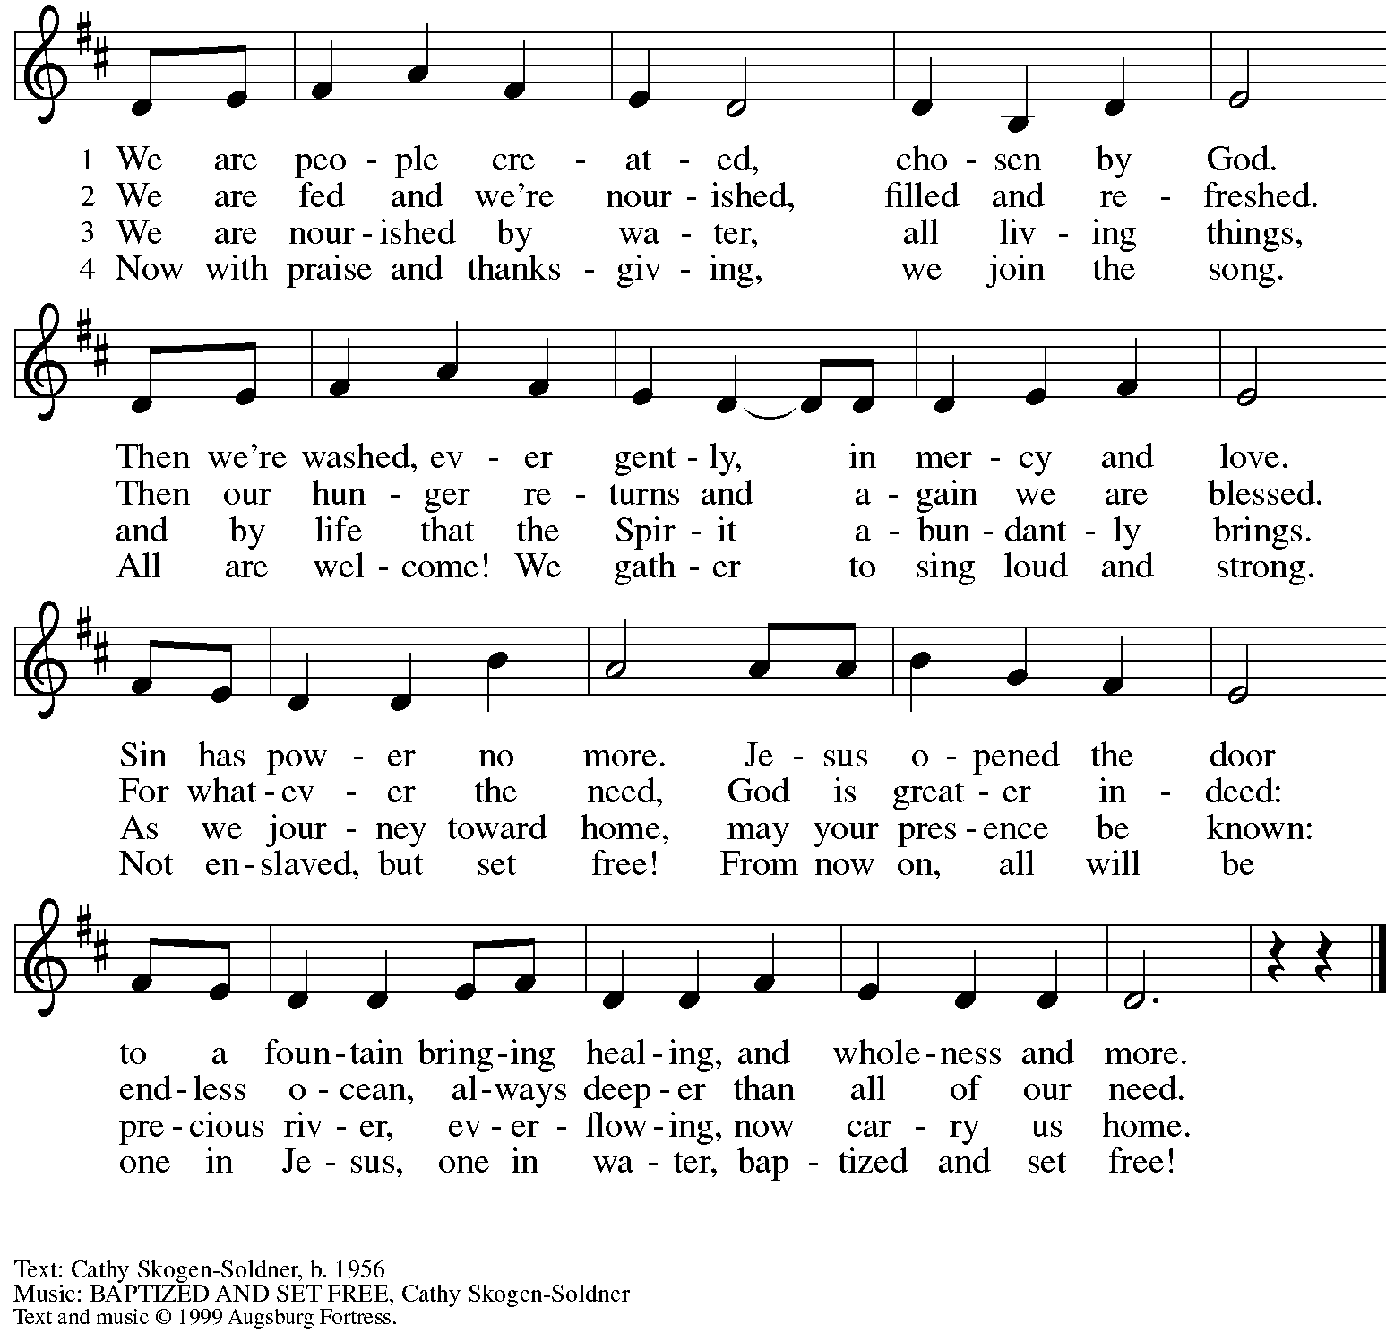
All rights reserved. Reprinted with permission under OneLicense.net # A-722139.

Greeting

P: The grace of our Lord Jesus Christ, the love of God,
and the communion of the Holy Spirit be with you all.
C: And also with you.

Hymn of Praise Glory to God ELW p. 148

Prayer of the Day

P: Let us pray.
Almighty and most merciful God, your bountiful goodness fills all creation.
Keep us safe from all that may hurt us, that, whole and well in body and spirit,
we may with grateful hearts accomplish all that you would have us do,
through Jesus Christ, our Savior and Lord.
C: Amen.

Please be seated.
Children are invited to join the adult leaders and move to the office for Little Church; Big Faith.
We ask that one additional adult from the congregation attend with the children.

Word
God speaks to us in Scripture reading, preaching, and song

First Reading – 2 Kings 5: 1-3, 7-15c

¹Naaman, commander of the army of the king of Aram, was a great man and in high favor with his master, because by him the Lord had given victory to Aram. The man, though a mighty warrior, suffered from leprosy. ²Now the Arameans on one of their raids had taken a young girl captive from the land of Israel, and she served Naaman’s wife. ³She said to her mistress, “If only my lord were with the prophet who is in Samaria! He would cure him of his leprosy.” ⁷When the king of Israel read the letter, he tore his clothes and said, “Am I God, to give death or life, that this man sends word to me to cure a man of his leprosy? Just look and see how he is trying to pick a quarrel with me.”
⁸But when Elisha the man of God heard that the king of Israel had torn his clothes, he sent a message to the king, “Why have you torn your clothes? Let him come to me, that he may learn that there is a prophet in Israel.” ⁹So Naaman came with his horses and chariots, and halted at the entrance of Elisha’s house. ¹⁰Elisha sent a messenger to him, saying, “Go, wash in the Jordan seven times, and your flesh shall be restored and you shall be clean.” ¹¹But Naaman became angry and went away, saying, “I thought that for me he would surely come out, and stand and call on the name of the Lord his God, and would wave his hand over the spot, and cure the leprosy! ¹²Are not Abana and Pharpar, the rivers of Damascus, better than all the waters of Israel? Could I not wash in them, and be clean?” He turned and went away in a rage. ¹³But his servants approached and said to him, “Father, if the prophet had commanded you to do something difficult, would you not have done it? How much more, when all he said to you was, ‘Wash, and be clean’?” ¹⁴So he went down and immersed himself seven times in the Jordan, according to the word of the man of God; his flesh was restored like the flesh of a young boy, and he was clean.
^{15a-c}Then he returned to the man of God, he and all his company; he came and stood before him and said, “Now I know that there is no God in all the earth except in Israel.”

L: Word of God, word of life.
C: Thanks be to God.

Psalm 111

The cantor will lead the singing of the psalm.
The congregation is invited to respond with the alternate verses in bold print.

Psalm Tone

Psalm Refrain

¹Hallelujah! I will give thanks to the Lord with | my whole heart,
in the assembly of the upright, in the | congregation.
²Great are your | works, O Lord,
pondered by all who de- | light in them. R
³Majesty and splendor | mark your deeds,
and your righteousness en- | dures forever.
⁴You cause your wonders to | be remembered;
you are gracious and full | of compassion.
⁵You give food to | those who fear you,
remembering forev- | er your covenant.
⁶You have shown your people the power | of your works
in giving them the lands | of the nations. R
⁷The works of your hands are faithful- | ness and justice;
all of your pre- | cepts are sure.
⁸They stand fast forev- | er and ever,
because they are done in | truth and equity.
⁹You sent redemption to your people and commanded your cove- | nant forever;
holy and awesome | is your name.
¹⁰The fear of the Lord is the begin- | ning of wisdom;
all who practice this have a good understanding. God’s praise en- | dures forever. R
Second Reading – 2 Timothy 2: 8-15

⁸Remember Jesus Christ, raised from the dead, a descendant of David—that is my gospel, ⁹for which I suffer hardship, even to the point of being chained like a criminal. But the word of God is not chained. ¹⁰Therefore I endure everything for the sake of the elect, so that they may also obtain the salvation that is in Christ Jesus, with eternal glory. ¹¹The saying is sure:
If we have died with him, we will also live with him;
¹²if we endure, we will also reign with him;
if we deny him, he will also deny us;
¹³if we are faithless, he remains faithful—
for he cannot deny himself.

¹⁴Remind them of this, and warn them before God that they are to avoid wrangling over words, which does no good but only ruins those who are listening. ¹⁵Do your best to present yourself to God as one approved by God, a worker who has no need to be ashamed, rightly explaining the word of truth.

L: Word of God, word of life.
C: Thanks be to God.

Please rise as you are able.

Gospel Acclamation Alleluia ELW p. 151

Gospel – Luke 17: 11-19

P: The holy Gospel according to St. Luke.
C: Glory to you, O Lord.
¹¹On the way to Jerusalem Jesus was going through the region between Samaria and Galilee.
¹²As he entered a village, ten lepers approached him. Keeping their distance, ¹³they called out, saying, “Jesus, Master, have mercy on us!” ¹⁴When he saw them, he said to them, “Go and show yourselves to the priests.” And as they went, they were made clean. ¹⁵Then one of them, when he saw that he was healed, turned back, praising God with a loud voice. ¹⁶He prostrated himself at Jesus’ feet and thanked him. And he was a Samaritan. ¹⁷Then Jesus asked, “Were not ten made clean? But the other nine, where are they? ¹⁸Was none of them found to return and give praise to God except this foreigner?” ¹⁹Then he said to him, “Get up and go on your way; your faith has made you well.”

P: The Gospel of the Lord.
C: Praise to you, O Christ.

Please be seated.

Sermon

A time of silence for prayer and reflection follows the sermon.
When the hymn of the day begins, please rise as you are able.

Hymn of the Day Oh, for a Thousand Tongues to Sing ELW 886

1 Oh, for a thousand tongues to sing
my great Redeemer's praise,
the glories of my God and King,
the triumphs of God’s grace!

2 My gracious Master and my God,
assist me to proclaim,
to spread through all the earth abroad
the honors of your name.

5 Look unto him, your Savior own,
O fallen human race!
Look and be saved through faith alone,
be justified by grace!

6 To God all glory, praise, and love
be now and ever giv'n
by saints below and saints above,
the church in earth and heav'n.

Text: Charles Wesley, 1707-1788, alt. Music: AZMON, Carl G. Glaser, 1784-1828, arr. Lowell Mason, 1792-1872.

Prayers of the People

P: As scattered grains of wheat are gathered into one bread, so let us gather our prayers for the church, those in need, and all of God’s creation.

After each petition
P: God of grace,
C: receive our prayer.

P: Gathered in the communion of the Holy Spirit, we offer these and all our prayers to you, gracious God, through Jesus Christ, our Savior.
C: Amen.

Please be seated.

Meal

Offering

We offer ourselves, our gifts, and our faithful service to God.
An usher will pass around an offering plate for anyone who would like to offer gifts before God.

Music during the Offering

Please rise as you are able.

Offertory Song Let the Vineyards ELW 184

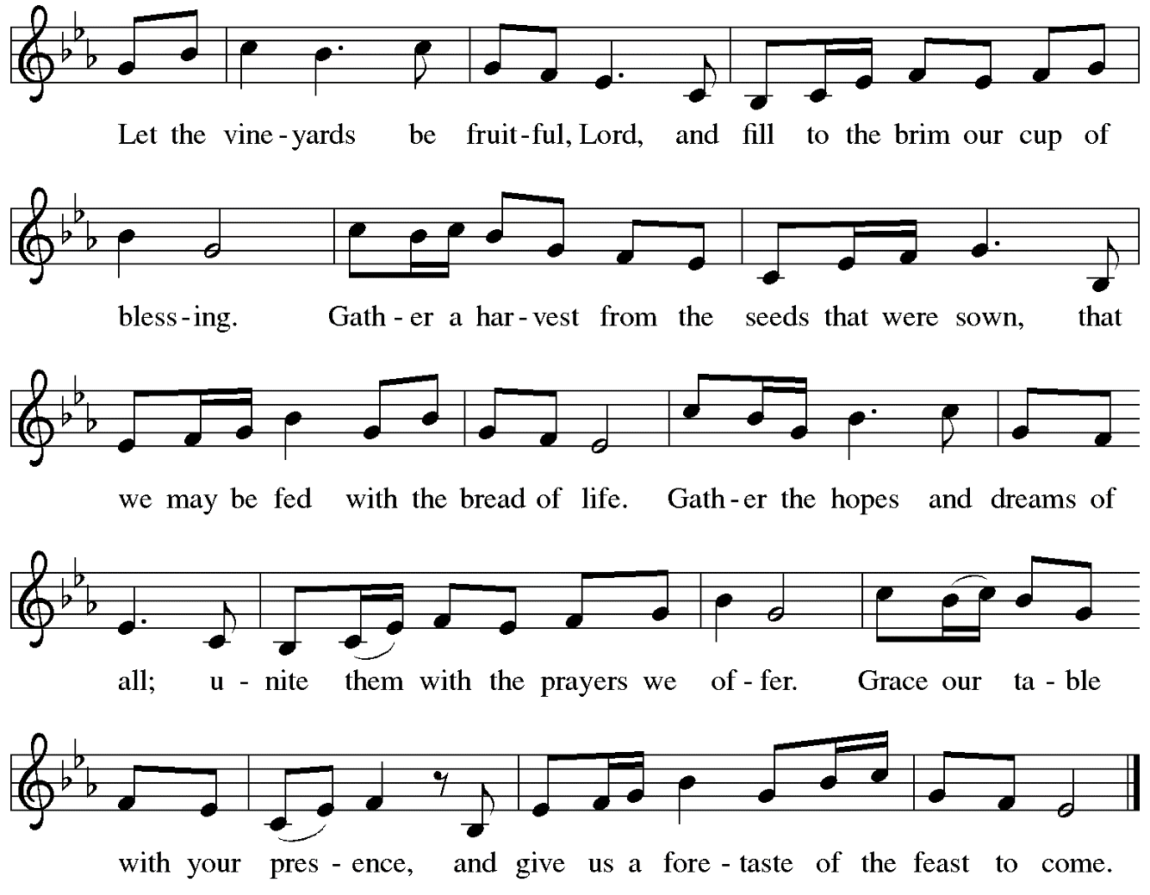

Offertory Prayer

P: Let us pray.
God, of all creation,
C: all you have made is good, and your love endures forever.
You bring forth bread from the earth and fruit from the vine.
Nourish us with these gifts,
that we might be for the world
signs of your gracious presence in Jesus Christ,
our Savior and Lord.
Amen.

Dialogue ELW p. 152

Preface (Sung by the presiding minister)

P: It is indeed right, our duty and our joy …
… we praise your name and join their unending hymn:

Sanctus ELW p. 153

Eucharistic Prayer

P: Holy God …
… with every breath.
C: We praise you, O God.

P: Generations bless your faithfulness …
… into the future.
C: We bless you, O God.

P: We give you thanks for your dear Son …
… with us now.
C: We thank you, O God.

P: In the night in which he was betrayed …
… Do this for the remembrance of me.

Remembering his love for us on the way, at the table, and to the end,
we proclaim the mystery of faith.
C: Christ has died. Christ is risen. Christ will come again.

P: We pray for the gift of your Spirit …
… by your Spirit, in your church, without end.
C: Amen.

Lord’s Prayer

P: Gathered as one by the Holy Spirit, let us pray as Jesus taught us.
C: Our Father in heaven,
hallowed be your name,
your kingdom come,
your will be done,
on earth as in heaven.
Give us today our daily bread.
Forgive us our sins
as we forgive those who sin against us.
Save us from the time of trial
and deliver us from evil.
For the kingdom, the power,
and the glory are yours,
now and forever. Amen.

Fraction and Invitation

Agnus Dei / Lamb of God ELW p. 154

Please be seated.

Holy Communion

- Worshipers from the pulpit side will proceed forward first, followed by the center section, and then the lectern side.
- The Communion wafers (regular and gluten-free) have been thoughtfully prepared using the gifts of the congregation by a member of St. Andrew’s altar care team, with a drop of wine or grape juice on each. The presiding minister will distribute one to each communicant.
- When you reach the presiding minister, please indicate if you would like grape juice or a gluten-free wafer.
- A blessing will be provided for anyone who does not yet receive the sacrament.
- Cushions have been placed at the altar rail for anyone who would like to kneel for prayer and reflection before returning to their pew.

Hymns during Holy Communion
The Numberless Gifts of God’s Mercy ELW 683

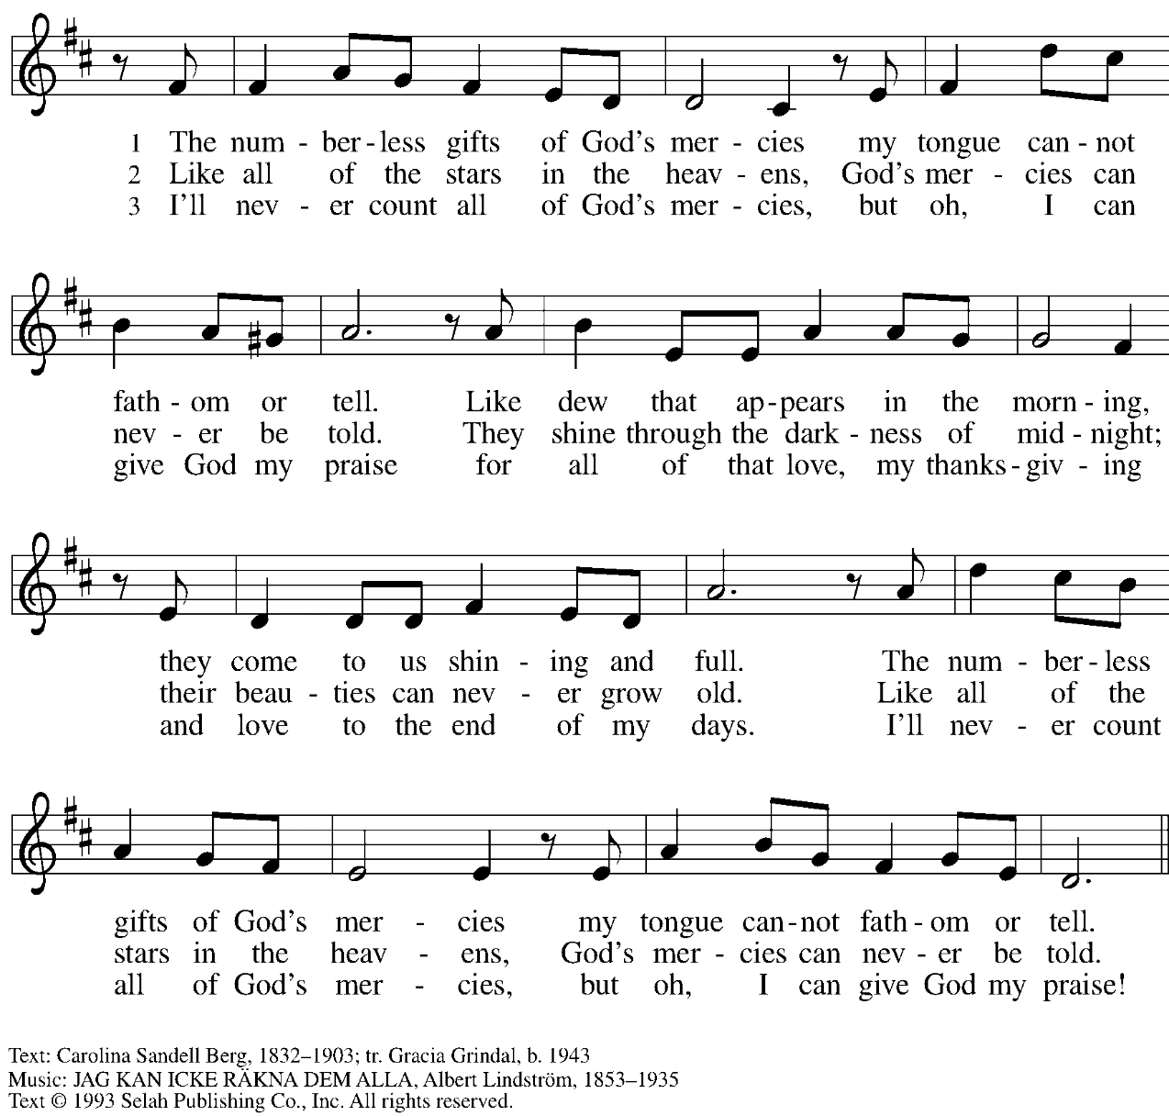
Reprinted under OneLicense.net # A-722139.

Hymns during Holy Communion
Now Thank We All Our God ELW 840

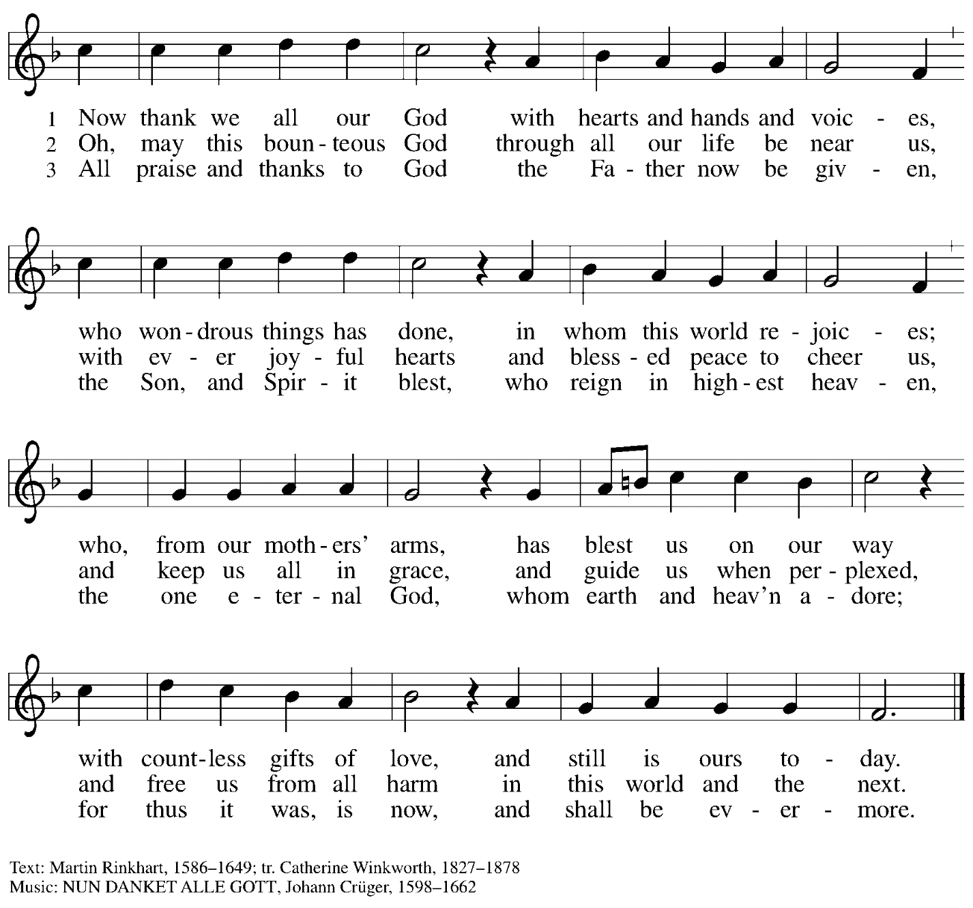

When all have returned to their places, please rise as you are able.

Blessing

P: The body and blood of our Lord Jesus Christ strengthen you and keep you in his grace.
C: Amen.

Prayer

P: Let us pray.
God of abundance, you have refreshed our hearts in this meal with bread for the journey.
Give us your grace on the way, that we may serve our neighbors with joy
and proclaim your goodness in all things, through Jesus Christ, our Savior and Lord.
C: Amen.

Please be seated.

Sending

Announcements

Please rise as you are able.

Benediction

P: God, who gives life to all things
and frees us from despair,
bless you with truth and peace.
The holy Trinity, ☩ one God,
guide you always in faith, hope, and love.
C: Amen.

Sending Hymn Cantad al Señor / Oh, Sing to the Lord Following Page

Dismissal

P: Go in peace. Serve the Lord.
C: Thanks be to God!

Sending Hymn Cantad al Señor / Oh, Sing to the Lord ELW 822

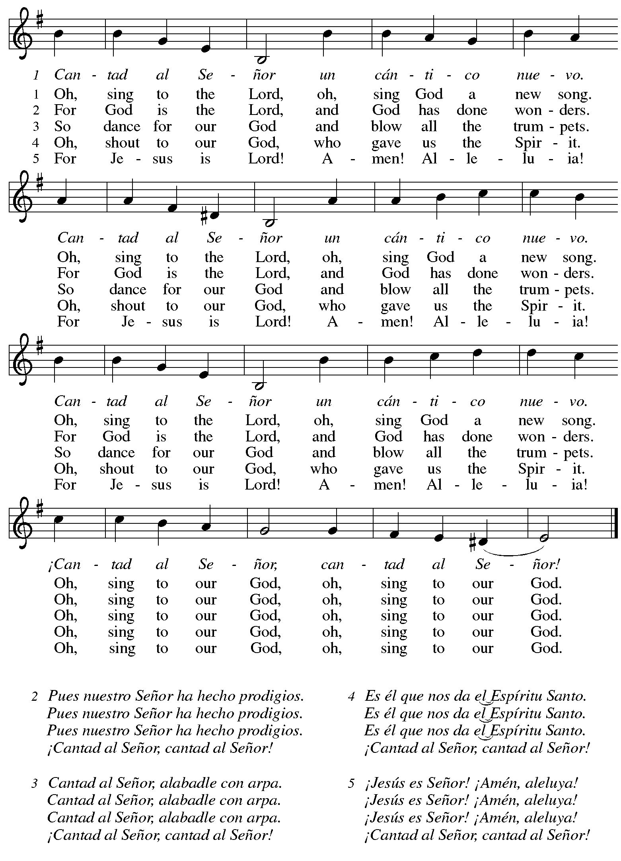
Abbreviations

P: Pastor/Presiding Minister
L: Lector
C: Congregation

ELW: Evangelical Lutheran Worship hymnal

Those serving in worship today

Minister of Music Laura Reynolds
Cantor Ian Brown
Lector Kelly Spanninger
Audio Visual Ministers Jason Galyardt
David Rollinson
Presiding Minister Rev. Ross Carmichael

Liturgy and Hymnody Acknowledgements

From SundaysandSeasons.com. Copyright © 2022 Augsburg Fortress. All rights reserved. Reprinted under OneLicense.net # A-722139.
Used by permission of Augsburg Fortress.

Let the Vineyards – Text: John W. Arthur, 1922-1980. Music: Ronald A. Nelson, b. 1927. Text and music © 1978 Lutheran Book of Worship, admin. Augsburg Fortress. All rights reserved. Reprinted under OneLicense.net # A-722139.

Cantad al Señor / Oh, Sing to the Lord – Text: Brazilian folk song; tr. Gerhard M. Cartford, b. 1923, Spanish and English. Music: CANTAD AL SEÑOR, Brazilian folk tune. Spanish and English text © Gerhard Cartford, admin. Augsburg Fortress. All rights reserved. Reprinted under OneLicense.net # A-722139.

St. Andrew Lutheran Church Announcements
October 9th, 2022

- Worship in the Sanctuary and Online – Sunday, October 9th, + Eighteenth Sunday after Pentecost – St. Andrew’s next service of Holy Communion will be this Sunday, October 9th, at 10:00 a.m. Allegheny County’s Covid-19 community level is in the “low” category, so face masks are optional in the building. Worship will also be live-streamed to Facebook, YouTube, and Zoom. Attendees are invited to make their own name tags at the back of the worship space. Social hour will be held after worship each Sunday.
- St. Andrew Celebrates 131st Anniversary on October 12th! – The St. Andrew congregation was officially organized on October 12th, 1891. We give thanks to God for blessing the congregation with these many years of grace and ministry. We will acknowledge the anniversary in worship on Sunday, October 16th and renew our commitment to living our faith together as a Reconciling in Christ congregation, devoted to full welcome and inclusion of LGBTQIA+ individuals and families and all God's people!
- Christ in our Home Devotional Booklets Now Available for October-December –
Christ in our Home is a booklet that offers a daily Bible reading with a short reflection and prayers, long with additional prayer concerns and readings for those who would like to expand their devotional practices. These are available at each entrance to the church, and we encourage people of the congregation to take one for yourself or others!
- Shelter Dinner at East End Cooperative Ministry – Thursday, October 20th, 6:30 p.m. – Every month, people of St. Andrew provide a meal for guests of the shelter at East End Cooperative Ministry (EECM). There are opportunities to cook, to helps serve the meal, or to donate financially to cover a portion of the meal. EECM is located at 6140 Station St., 15206. If you would like to contribute, please sign up
- Spiritual Care Volunteers Needed for AHN Palliative Care Patients – Palliative care is an approach that improves the quality of life for patients and their families facing problems associated with life-threatening illness, through the prevention and relief of suffering by means of early identification, assessment and treatment of pain and other problems, whether they be physical, psychosocial or spiritual.

- Spiritual Care Volunteers will visit with AHN Palliative Care patients and their families at one of our hospitals: Allegheny General, Allegheny Valley, Forbes, Jefferson, and West Penn.
- We also can use volunteers who work from their homes to call family members to provide emotional and spiritual support.
- Training is provided and required.
- Qualifications: Ability to stand and walk long hospital corridors, or use an assistive mobility device to do so. A willingness to attend volunteer orientation/training and meetings, to function as a member of one of our palliative care teams, and to complete simple charting under the direction of the spiritual care coordinator. Basic computer skills utilizing email and Zoom are very helpful.
- Clearances required (will be paid for by AHN).
- Volunteers who work in the hospitals must be up to date on all of their vaccinations, including the Covid vaccines and boosters. Current policies require everyone to wear surgical, KN95, or N95 face masks.
- We do not discriminate based on religious or spiritual beliefs. NO proselytizing is permitted.
- Free parking and meals.
For more information, contact the Spiritual Care Coordinator, Pr. Kim Rapczak, at: 412-738-4650 or Kimberly.Rapczak@ahn.org. To apply online, go to: https://www.ahn.org/volunteer-application (Make sure to select which hospital you want to work at, and under “other,” type: “palliative care.”).
- Bethel AME Reparations Petition Available – Bethel AME Church has released a new petition in partnership with the Color of Change organization in their pursuit of reparations for their land and church that were taken in the 1950s. To sign or share the petition, please visit: https://bit.ly/Justice4Bethel. A paper copy is available at the name tag cabinet in the back of St. Andrew's worship space for those who would like to sign using that medium.
- Lutheran Disaster Response Call for Support to Address Needs Following:
  - Hurricane Ian in the U.S.
  - Hurricane Fiona in Puerto Rico and the Caribbean
  - Remnants of Typhoon Merbok in Alaska
  - Typhoon Nanmadol in Japan
  - A magnitude 7.7 earthquake in Papua New Guinea
  - Summer monsoon flooding in Pakistan
These are the disasters that made the biggest headlines, but there are countless others to which the Evangelical Lutheran Church in America responds, using your gifts to the Lutheran Disaster Response general fund.
- Help Supply “Thanksgiving Dinner” Bags – St. Andrew will be compiling bags of non-perishable “Thanksgiving” foods to deliver to our neighbors at the November 1st
produce distribution, and we invite people of the congregation to contribute. There is a bin located in the Social Hall near the Little Pantry supplies for anyone who would like to donate items. We are collecting the following:
  - Boxed stuffing
  - Instant potatoes
  - Canned green beans or corn
  - Cream of mushroom soup
  - French fried onions
  - Pudding mix and/or jello mix
  - Corn muffin mix
- Lutheran Campus Ministry Art Exhibit Exploring Race, Truth Be Told, Extended until the End of the Semester – Truth be Told is an art exhibit created by fourteen women artists across the country in reflection on racism. The group of seven Black women and seven white women began conversations after the murder of Goerge Floyd, which moved them each to consider one word and create an art piece around that word. The exhibit is being shown at the Lutheran University Center, 4515 Forbes Avenue, Pittsburgh 15213. Open hours of viewing are every Saturday and Sunday from 1:00-6:00 p.m. Arrangements can be made to view the exhibit during the week by contacting the campus ministry at 412-682-6886 or by emailing pastor@psalm.online. For more information, go to http://psalm.online.
- GameFest – Saturday, October 15th, 2022 – Lutheran Campus Ministry in Greater Pittsburgh and PSALM are hosting a day of gaming fundraiser for campus ministry. It will be a whole day of tabletop gaming, with D&D, Catan, Call to Adventure, and much more, from the simple and quick to the labyrinthine. There will be some games scheduled and some open tables. They will have games on hand to try, or anyone can bring an old favorite and set it up in the space. There will be concessions and raffle baskets and people of all ages are welcome! The event is scheduled from 9:00 a.m. - 9:00 p.m. at the Lutheran University Center, 4515 Forbes Ave., Pittsburgh 15213. For tickets, please visit: PSALM GameFest Tickets, Sat, Oct 15, 2022 at 9:00 AM | Eventbrite.
- Camp Agapé Fall Festival - Saturday, October 15th, 2022 - Camp Agapé, an outdoor ministry of the Lutheran Church, is hosting a fall festival on Saturday, October 15th, from 1:00-4:00 p.m. The event is free, family-friendly, and will feature hayrides, pumpkins, treats, and games. The camp is located at 72 Agapé Road, Hickory, PA 15340 and their website is https://www.campagape.org/. Contact campagapeevents@gmail.com or 724-356-2308 for more information.

