[

+ Nineteenth Sunday after Pentecost
October 16, 2022

St. Andrew Lutheran Church
304 Morewood Ave.
Pittsburgh, PA 15213
St_andrewELCA@verizon.net
www.standrewpittsburgh.org

+ Nineteenth Sunday after Pentecost
Order for Worship

Pray always. Do not lose heart. This is Christ’s encouragement in the gospel today.
Wrestle with the word. Remember your baptism again and again. Come regularly to Christ’s table. Persistence in our every encounter with the divine will be blessed.

St. Andrew is celebrating its 131st anniversary as a congregation.
We give thanks for the many ways that God has blessed the people of this church and community with grace and love over the course of these years.
As we give thanks and reflect, we dedicate ourselves anew to our ministry of welcome as a Reconciling in Christ congregation, intentionally advocating for the full welcome, inclusion, and equity of LGBTQIA+ individuals and families in the life of the Church, congregation, and our communities. We also look forward in hope to all God will continue to do among us, and the future of mission and ministry God sets before us.

- Covid-19 community level in Allegheny County is now in the “medium” category. St. Andrew recently changed its policy to “masks optional” when community levels are both low and medium.
- Hand sanitizer is available at the back of the sanctuary.

Worship Services are live streamed to multiple online platforms.
By attending worship, you agree that your image and voice may be broadcast.

Welcome to St. Andrew!
- Everyone is invited to make a nametag at the black bookcase in the back of the worship space if they would like.
- Worship “toolkits” to help children engage with the service are available in the black bookcase at the back of the worship space. There are “reader” and “pre-reader” resources available in each kit. Please feel free to use the kits for/with your children during worship.
- After the Prayer of the Day, children are invited to gather in the Social Hall for Little Church; Big Faith, a Bible lesson and activity. The group returns to the worship space for the Communion portion of the service.
- A restroom is available on the main level of the church, through the doors to the Social Hall and to the right in the main office.

Welcome

Prelude

Gathering
The Holy Spirit calls us together as the people of God.

Thanksgiving for the Anniversary of the Congregation

Greeting

P: The grace of our Lord Jesus Christ, the love of God,
and the communion of the Holy Spirit be with you all.
C: And also with you.

Psalm 84

¹How dear to me is your dwelling,
O Lord of hosts!
²My soul has a desire and longing for the courts of the Lord;
my heart and my flesh rejoice in the living God.
³Even the sparrow has found a home, and the swallow a nest where she may lay her young,
by the side of your altars, O Lord of hosts, my king and my God.
⁴Happy are they who dwell in your house!
They will always be praising you.
⁵Happy are the people whose strength is in you,
whose hearts are set on the pilgrims’ way.
⁶Those who go through the balsam valley will find it a place of springs,
for the early rains have covered it with pools of water.
⁷They will climb from height to height,
and the God of gods will be seen in Zion.
⁸Lord God of hosts, hear my prayer;
give ear, O God of Jacob.
⁹Behold our defender, O God;
and look upon the face of your anointed.
¹⁰For one day in your courts is better than a thousand elsewhere.
I would rather stand at the threshold of the house of my God than dwell in the tents of the wicked.
¹¹For the Lord God is both sun and shield, bestowing grace and glory;
no good thing will the Lord withhold from those who walk with integrity.
¹²O Lord of hosts,
happy are they who put their trust in you!

Reading – 1 Peter 2: 1-6, 9

⁴Come to Christ, a living stone, though rejected by mortals yet chosen and precious in God's sight, and ⁵like living stones, let yourselves be built into a spiritual house, to be a holy priesthood, to offer spiritual sacrifices acceptable to God through Jesus Christ.
⁶For it stands in scripture:
"See, I am laying in Zion a stone,
a cornerstone chosen and precious;
and whoever believes in him will not be put to shame."
⁹But you are a chosen race, a royal priesthood, a holy nation, God's own people, in order that you may proclaim the mighty acts of the one who called you out of darkness into God’s marvelous light.

Dialogue

S: God of love, through our Savior Jesus Christ and by the power of your Holy Spirit,
you have shown your grace and faithfulness to the people of St. Andrew Lutheran Church throughout the generations. For all that we celebrate, and all that you have blessed us with,
we praise you, O God.
C: We praise you, O God.

S: God of inspiration, you have granted your people vision for a place of welcome and refuge in this city where your good news would be proclaimed in new and creative ways,
that all would be welcome and know your goodness. For this, we bless you, O God.
C: We bless you, O God.

S: God of comfort and help, you have enriched St. Andrew through the lives and gifts of your people throughout the years. We remember before you today the saints who have gone before us, friends, family, loved ones. Much has changed at St. Andrew over time, across various languages and cultures, through two global pandemics and world wars, with the church and our worship adapting to changing times, as conflicts and struggles caused division among your people, as life circumstances and changes in vocation led your people elsewhere and relationships were altered.
In our grief for all that has been lost, we turn to you, O God.
C: We turn to you, O God.

S: God of accompaniment, our portion and cup, you have given us who gather today a goodly heritage and have brought us this far along the way. We ask your ongoing presence with us in our worship, our ministries, and our daily roles, that you would strengthen us for the work you have set before us, sustain us in times of weariness, and help us to be faithful in following the way of your Son. We seek you, O God.
C: We seek you, O God.

S: God of hope, you have promised that the future of your people and this world you so love are secure in your care. In whatever is to come, amid trials and temptations, in our fears and doubts, we place our trust in you, O God.
C: We place our trust in you, O God.

S: O God, you have promised through your Son to be with your church forever. We give you thanks for those who founded this community of believers and for the signs of your presence in our congregation. Increase in us the spirit of faith and love, and make our community an example to all believers and to all nations. We pray through Jesus Christ, our Savior and Lord, who lives and reigns with you and the Holy Spirit, one God, now and forever.
C: Amen.
Gathering Hymn God, We Gather As Your People ACS 1038
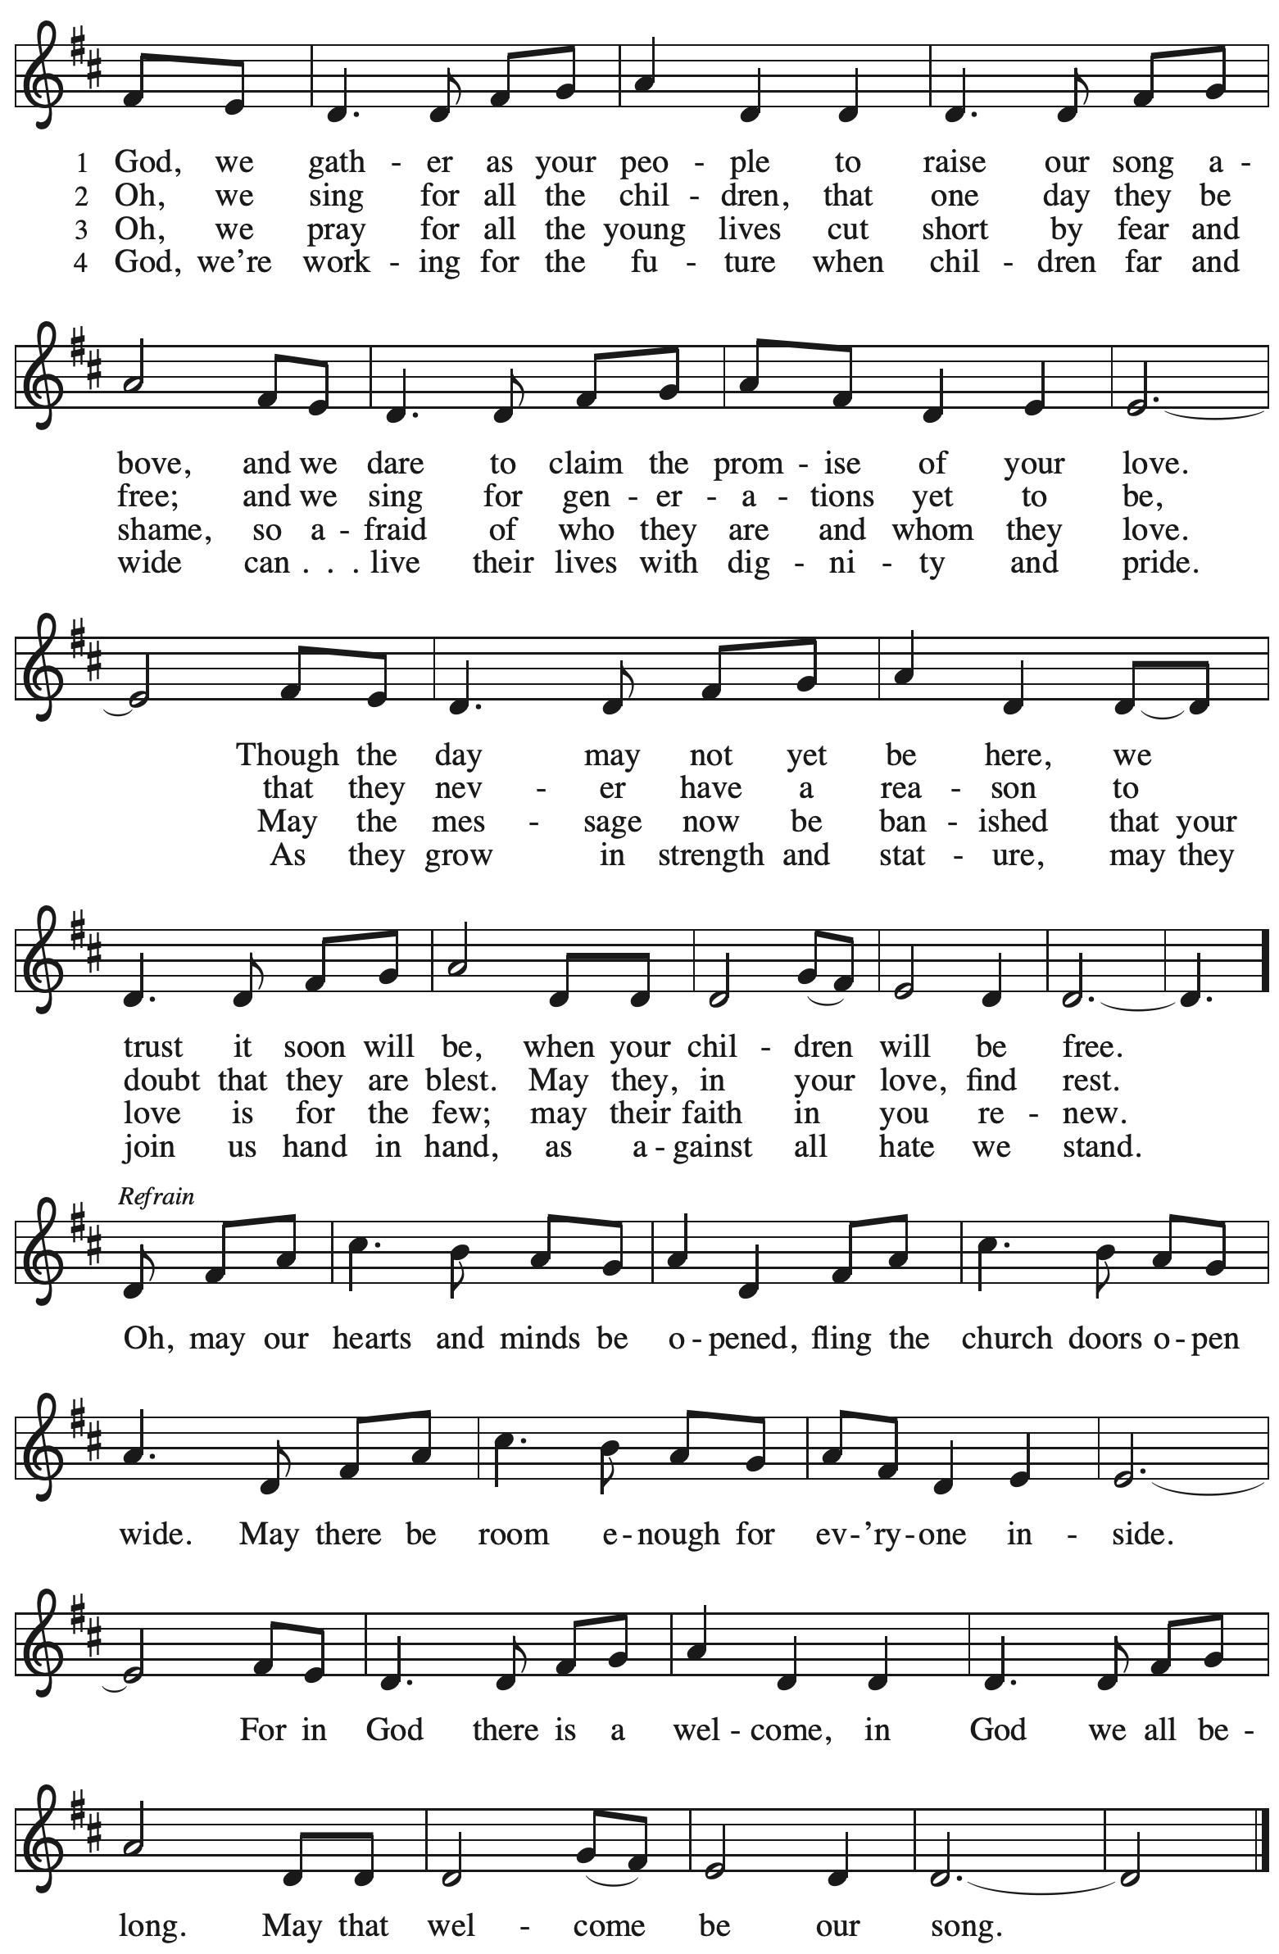

Greeting

P: The grace of our Lord Jesus Christ, the love of God,
and the communion of the Holy Spirit be with you all.
C: And also with you.

Hymn of Praise Glory to God ELW p. 148
Prayer of the Day

P: Let us pray.
O God, tireless guardian of your people, you are always ready to heed our cries.
Teach us to rely night and day on your care.
Inspire us to seek your enduring justice for all this suffering world,
through Jesus Christ, our Savior and Lord.
C: Amen.

Please be seated.
Children are invited to join the adult leaders and move to the office for Little Church; Big Faith.\
We ask that one additional adult from the congregation attend with the children.

Word
God speaks to us in Scripture reading, preaching, and song

First Reading – Genesis 32: 22-31

²²The same night [Jacob] got up and took his two wives, his two maids, and his eleven children, and crossed the ford of the Jabbok. ²³He took them and sent them across the stream, and likewise everything that he had. ²⁴Jacob was left alone; and a man wrestled with him until daybreak.
²⁵When the man saw that he did not prevail against Jacob, he struck him on the hip socket; and Jacob’s hip was put out of joint as he wrestled with him. ²⁶Then he said, “Let me go, for the day is breaking.” But Jacob said, “I will not let you go, unless you bless me.” ²⁷So he said to him, “What is your name?” And he said, “Jacob.” ²⁸Then the man said, “You shall no longer be called Jacob, but Israel, for you have striven with God and with humans, and have prevailed.” ²⁹Then Jacob asked him, “Please tell me your name.” But he said, “Why is it that you ask my name?” And there he blessed him. ³⁰So Jacob called the place Peniel, saying, “For I have seen God face to face, and yet my life is preserved.” ³¹The sun rose upon him as he passed Penuel, limping because of his hip.

L: Word of God, word of life.
C: Thanks be to God.

Psalm 121

The cantor will lead the singing of the psalm.
The congregation is invited to respond with the alternate verses in bold print.

Psalm Tone

Psalm Refrain

¹I lift up my eyes | to the hills;
from where is my | help to come?
²My help comes | from the Lord,
the maker of heav- | en and earth.
³The Lord will not let your | foot be moved
nor will the one who watches over you | fall asleep.
⁴Behold, the keep- | er of Israel
will neither slum- | ber nor sleep; R
⁵the Lord watches | over you;
the Lord is your shade at | your right hand;
⁶the sun will not strike | you by day,
nor the | moon by night.
⁷The Lord will preserve you | from all evil
and will | keep your life.
⁸The Lord will watch over your going out and your | coming in,
from this time forth for- | evermore. R

Second Reading – 2 Timothy 3: 14 – 4: 5

¹⁴But as for you, continue in what you have learned and firmly believed, knowing from whom you learned it, ¹⁵and how from childhood you have known the sacred writings that are able to instruct you for salvation through faith in Christ Jesus. ¹⁶All scripture is inspired by God and is useful for teaching, for reproof, for correction, and for training in righteousness, ¹⁷so that everyone who belongs to God may be proficient, equipped for every good work.

¹In the presence of God and of Christ Jesus, who is to judge the living and the dead, and in view of his appearing and his kingdom, I solemnly urge you: ²proclaim the message; be persistent whether the time is favorable or unfavorable; convince, rebuke, and encourage, with the utmost patience in teaching. ³For the time is coming when people will not put up with sound doctrine, but having itching ears, they will accumulate for themselves teachers to suit their own desires,
⁴and will turn away from listening to the truth and wander away to myths. ⁵As for you, always be sober, endure suffering, do the work of an evangelist, carry out your ministry fully.

L: Word of God, word of life.
C: Thanks be to God.

Please rise as you are able.

Gospel Acclamation (Sung by the cantor)

Alleluia. We have a build- | ing from God,
a house not made with hands, eternal | in the heavens.

Gospel – Luke 18: 1-8

P: The holy Gospel according to St. Luke.
C: Glory to you, O Lord.
¹Then Jesus told them a parable about their need to pray always and not to lose heart. ²He said, “In a certain city there was a judge who neither feared God nor had respect for people. ³In that city there was a widow who kept coming to him and saying, ‘Grant me justice against my opponent.’ ⁴For a while he refused; but later he said to himself, ‘Though I have no fear of God and no respect for anyone, ⁵yet because this widow keeps bothering me, I will grant her justice, so that she may not wear me out by continually coming.’ ” ⁶And the Lord said, “Listen to what the unjust judge says. ⁷And will not God grant justice to God’s chosen ones who cry to God day and night? Will God delay long in helping them? ⁸I tell you, God will quickly grant justice to them. And yet, when the Son of Humanity comes, will he find faith on earth?”

P: The Gospel of the Lord.
C: Praise to you, O Christ.

Please be seated.

Sermon

A time of silence for prayer and reflection follows the sermon.
When the hymn of the day begins, please rise as you are able.

Hymn of the Day The Church of Christ, in Every Age ELW 729

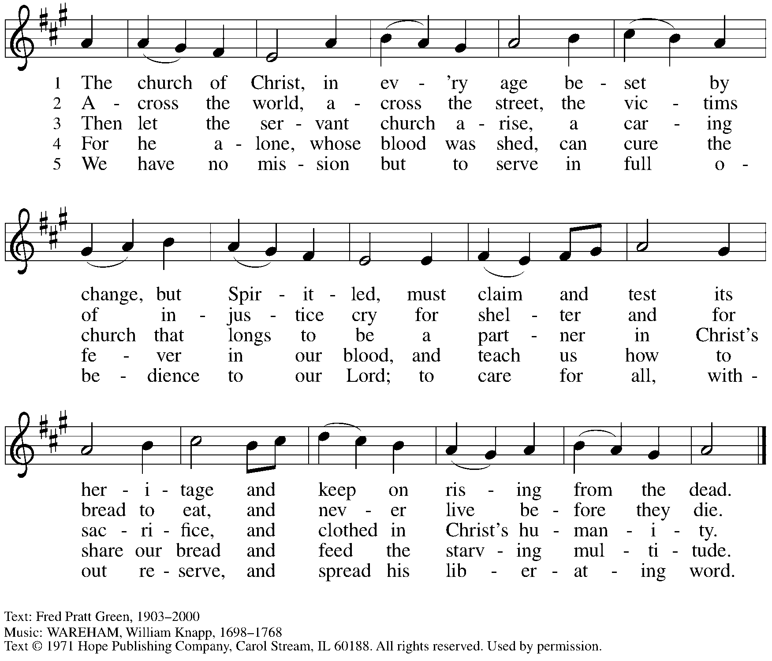
Reprinted with permission under OneLicense.net # A-722139.

Reconciling in Christ Commitment Renewal

Introduction

Dialogue

P: The time is now!
C: The day has come! The kin-dom of God has come near!

P: We celebrate that God in Christ has made St. Andrew one body with many members,
C: all sharing God’s grace and unconditional love.

P: As a Reconciling in Christ congregation, we dedicate ourselves:
C: to welcome all God’s people who are seeking healing and wholeness.

P: We dedicate ourselves:
C: to provide a nurturing, faith-forming spiritual home.

P: We dedicate ourselves:
C: to welcome people of all ages, races, abilities, cultures, sexual orientations,
gender identities and expressions, and family constellations.

P: Listen and pray in expectation,
C: proclaim in song: All Are Welcome!

P: Reconcile your people,
C: Open our doors! Gather us at your table!

P: May we learn to more fully live out these words even as we speak them.
C: Come, let us sing to the Lord; let us shout for joy to the rock of our salvation!

P: For the time is now!
C: The day has come! The kin-dom of God has come near!

People of the congregation are invited to join the cantor in singing the congregational refrain.

Congregational Refrain

C: Christ goes before, and we are called to follow,
and all who follow find the Way, the Truth, the Life.

Worship continues with the prayers of the people.

Prayers of the People

P: As scattered grains of wheat are gathered into one bread, so let us gather our prayers for the church, those in need, and all of God’s creation.

After each petition
P: God of grace,
C: receive our prayer.

P: Gathered in the communion of the Holy Spirit, we offer these and all our prayers to you, gracious God, through Jesus Christ, our Savior.
C: Amen.

Please be seated.

Meal

Offering

We offer ourselves, our gifts, and our faithful service to God.
An usher will pass around an offering plate for anyone who would like to offer gifts before God.

Today we invite the congregation to consider a donation to a second collection since we are using an African American spiritual during worship. Please see the note in the announcements at the back of the bulletin for more information.

Music during the Offering God Is Love ACS 1041

Please rise as you are able.

Offertory Song Let the Vineyards ELW 184

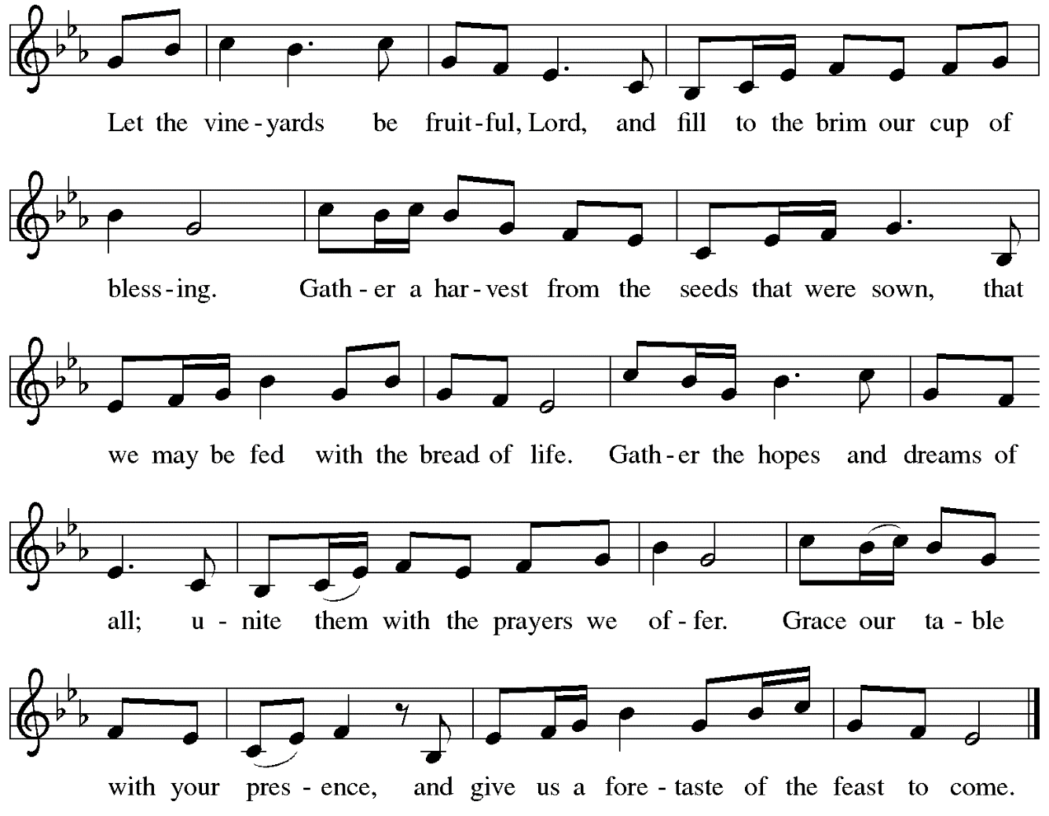
Offertory Prayer

P: Let us pray.
God, of all creation,
C: all you have made is good, and your love endures forever.
You bring forth bread from the earth and fruit from the vine.
Nourish us with these gifts, that we might be for the world
signs of your gracious presence in Jesus Christ, our Savior and Lord.
Amen.

Dialogue ELW p. 152

Preface (Sung by the presiding minister)

P: It is indeed right, our duty and our joy,
that we should at all times and in all places
give thanks and praise to you, almighty and merciful God,
through our Savior Jesus Christ;
who on this day overcame death and the grave,
and by his glorious resurrection opened to us the way of everlasting life.
And so, with all the choirs of angels,
with the church on earth and the hosts of heaven,
we praise your name and join their unending hymn:

Sanctus ELW p. 153

Eucharistic Prayer

P: Holy God …
… with every breath.
C: We praise you, O God.

P: Generations bless your faithfulness …
… into the future.
C: We bless you, O God.

P: We give you thanks for your dear Son …
… with us now.
C: We thank you, O God.

P: In the night in which he was betrayed …
… Do this for the remembrance of me.

Remembering his love for us on the way, at the table, and to the end,
we proclaim the mystery of faith.
C: Christ has died. Christ is risen. Christ will come again.

P: We pray for the gift of your Spirit …
… by your Spirit, in your church, without end.
C: Amen.

Lord’s Prayer

P: Gathered as one by the Holy Spirit, let us pray as Jesus taught us.
C: Our Father in heaven,
hallowed be your name,
your kingdom come,
your will be done,
on earth as in heaven.
Give us today our daily bread.
Forgive us our sins
as we forgive those who sin against us.
Save us from the time of trial
and deliver us from evil.
For the kingdom, the power,
and the glory are yours,
now and forever. Amen.

Fraction and Invitation

Agnus Dei / Lamb of God ELW p. 154

Please be seated.

Holy Communion
- Worshipers from the pulpit side will proceed forward first, followed by the center section, and then the lectern side.
- The Communion wafers (regular and gluten-free) have been thoughtfully prepared using the gifts of the congregation by a member of St. Andrew’s altar care team, with a drop of wine or grape juice on each. The presiding minister will distribute one to each communicant.
- When you reach the presiding minister, please indicate if you would like grape juice or a gluten-free wafer.
- A blessing will be provided for anyone who does not yet receive the sacrament.
- Cushions have been placed at the altar rail for anyone who would like to kneel for prayer and reflection before returning to their pew.

Hymn during Holy Communion
What God Ordains Is Good Indeed ELW 776

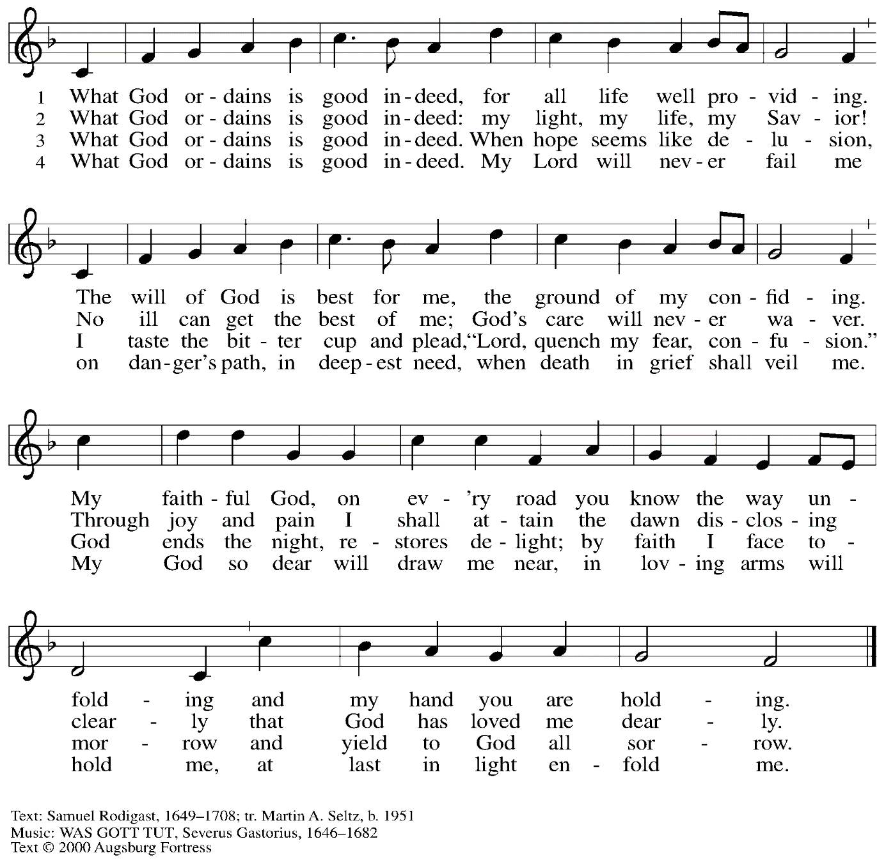
All rights reserved. Reprinted with permission under OneLicense.net # A-722139.

Hymn during Holy Communion
Welcome Table TFF 263

1 I’m gonna eat at the welcome table,
I’m gonna eat at the welcome table,
some of these days.
I’m gonna eat at the welcome table,
I’m gonna eat at the welcome table,
some of these days.

2 I’m gonna feast on milk and honey,
I’m gonna feast on milk and honey,
some of these days.
I’m gonna feast on milk and honey,
I’m gonna feast on milk and honey,
some of these days.

3 I’m gonna wade ’cross Jordan’s river,
I’m gonna wade ’cross Jordan’s river,
some of these days.
I’m gonna wade ’cross Jordan’s river,
I’m gonna wade ’cross Jordan’s river,
some of these days.

4 All God’s children gonna sit together,
All God’s children gonna sit together,
some of these days.
All God’s children gonna sit together,
All God’s children gonna sit together,
some of these days.

Text: African American spiritual. Music: WELCOME TABLE, African American spiritual.

When all have returned to their places, please rise as you are able.

Blessing

P: The body and blood of our Lord Jesus Christ strengthen you and keep you in his grace.
C: Amen.

Prayer

P: Let us pray.
P: Almighty God, we give you thanks that you have fed us with this heavenly food.
In your grace and by your Spirit, help us to be what we celebrate, the body of Christ in the world.
Send us out, renewed by this sacramental meal, to do the work you have given us to do:
to witness for Christ, to love you with singleness of heart,
and to serve you with clarity of purpose;
through Jesus Christ, our Savior and Lord
C: Amen.

Please be seated.

Sending

Announcements

Please rise as you are able.

Benediction

P: Go forth in peace and with the courage of faith.
Love God with all your heart, with all your soul, and with all your mind,
and love your neighbor as yourself.
C: Amen.

P: Whatever you do in word or deed,
do everything in the name of the Lord Jesus,
giving thanks to God through Christ.
C: Amen.

P: The God of hope fill you with joy and peace in believing,
so that you may abound in hope by the power of the Holy Spirit.
C: Amen.

P: Almighty and Triune God ☩ bless you now and forever.
C: Amen.

Sending Hymn All Are Welcome Following Page

Dismissal

P: Go in peace. Christ is with you.
C: Thanks be to God!

Sending Hymn All Are Welcome ELW 641

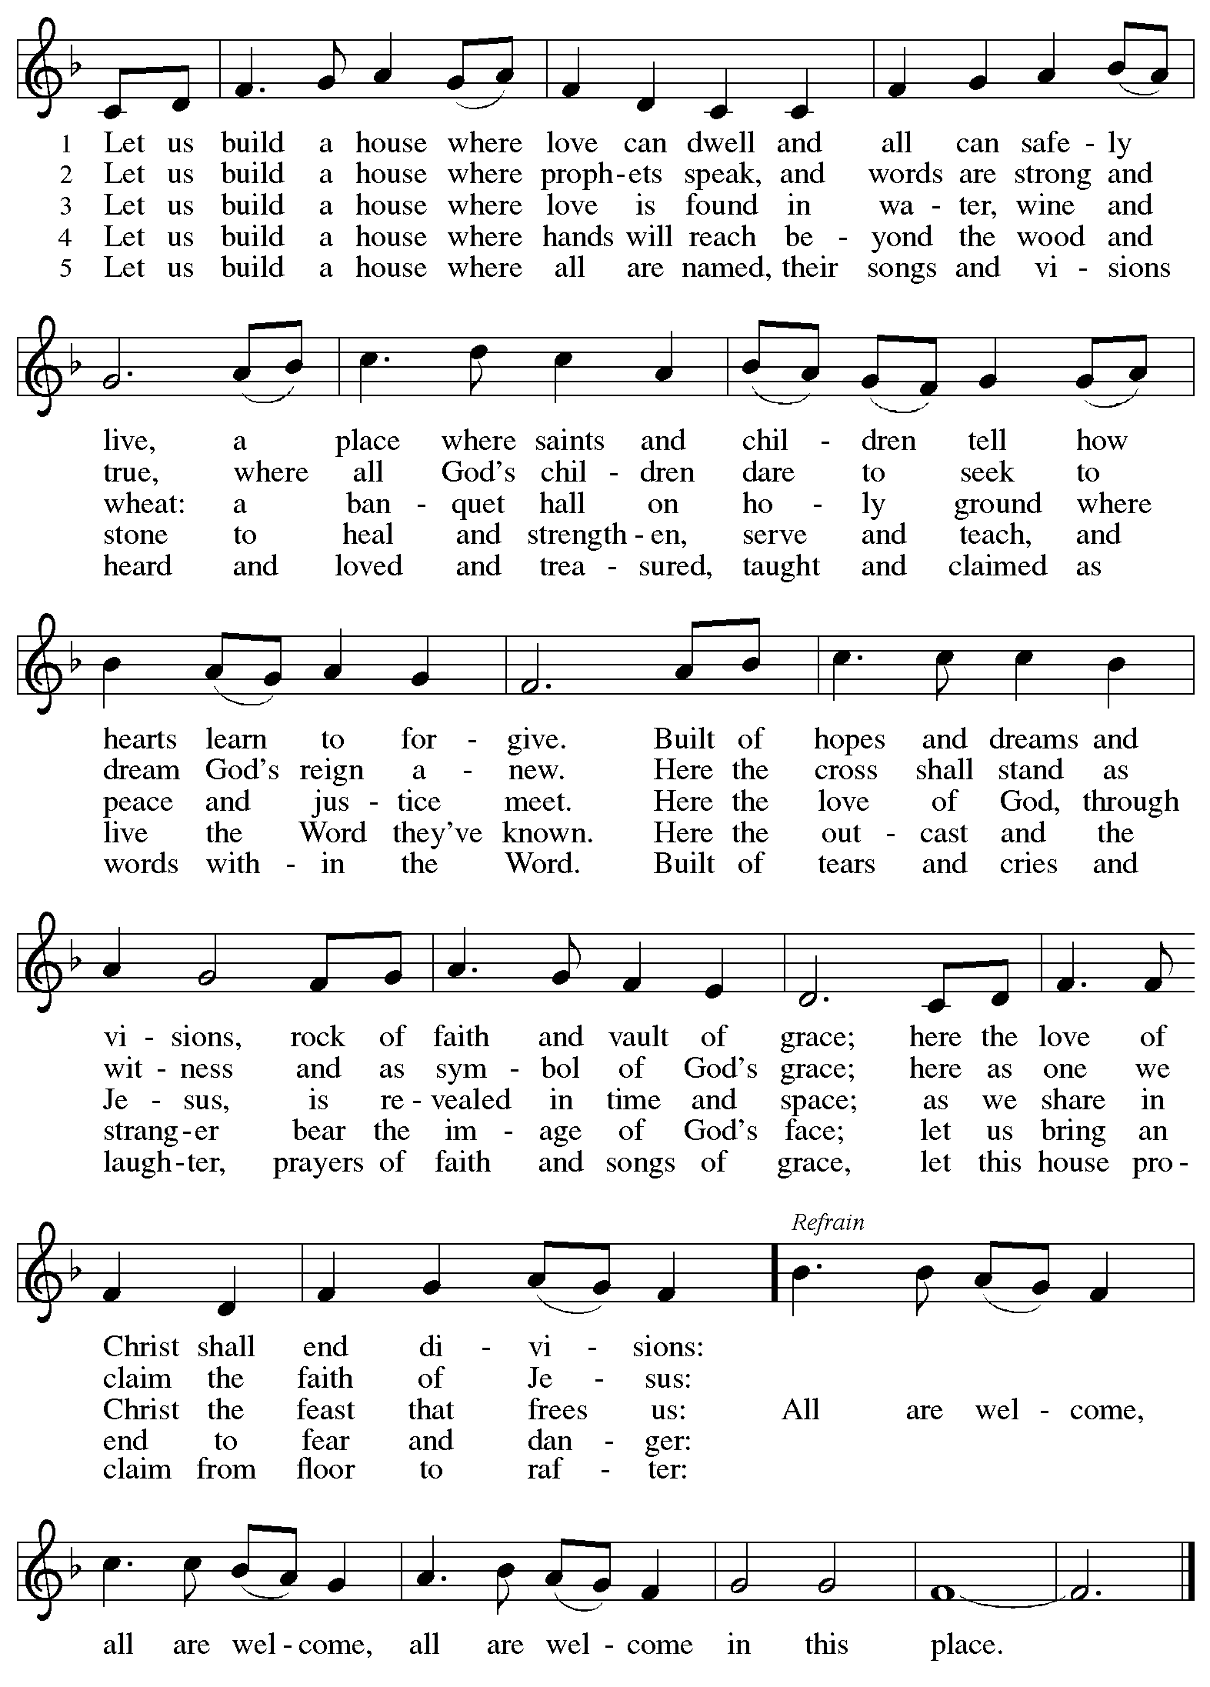
Abbreviations

P: Pastor/Presiding Minister
L: Lector
S: Speaker
C: Congregation

ELW: Evangelical Lutheran Worship hymnal
ACS: All Creation Sings hymnal
TFF: This Far by Faith hymnal

Those serving in worship today

Minister of Music Laura Reynolds
Cantor Joy Givens
Lector Maria Mangano
Audio Visual Ministers Linnea Asplin
Joseph Paetz
Presiding Minister Rev. Ross Carmichael

Liturgy and Hymnody Acknowledgements

From SundaysandSeasons.com. Copyright © 2022 Augsburg Fortress. All rights reserved. Reprinted under OneLicense.net # A-722139.
Used by permission of Augsburg Fortress.

Let the Vineyards – Text: John W. Arthur, 1922-1980. Music: Ronald A. Nelson, b. 1927. Text and music © 1978 Lutheran Book of Worship, admin. Augsburg Fortress. All rights reserved. Reprinted with permission under OneLicense.net # A-722139.

God, We Gather As Your People – Text: David Lohman, b. 1961. Music: WELCOME BE OUR SONG, David Lohman. Text and Music © 2007 Welcome Song Music, admin. Augsburg Fortress. All rights reserved. Reprinted with permission under OneLicense.net # A-722139.

All Are Welcome – Text: Marty Haugen, b. 1950. Music: TWO OAKS, Marty Haugen. Text and Music © 1994 GIA Publications, Inc., 7404 S. Mason Ave., Chicago, IL 60638. www.giamusic.com. 800.442.3358. All rights reserved. Reprinted with permission under OneLicense.net # A-722139.

St. Andrew Lutheran Church Announcements
October 16th, 2022

- Worship in the Sanctuary and Online – Sunday, October 16th, + Nineteenth Sunday after Pentecost – St. Andrew’s next service of Holy Communion will be this Sunday, October 16th, at 10:00 a.m. Allegheny County’s Covid-19 community level is in the “medium” category. St. Andrew recently changed its policy to “masks optional” when community levels are both low and medium. Worship will also be live-streamed to Facebook, YouTube, and Zoom. Attendees are invited to make their own name tags at the back of the worship space. Social hour will be held after worship each Sunday.
- St. Andrew’s 131st Anniversary – October 12th! – The St. Andrew congregation was officially organized on October 12th, 1891. Today in worship we give thanks to God for blessing the congregation with these many years of grace and ministry and renew our commitment to living our faith together as a Reconciling in Christ congregation, devoted to the full welcome and inclusion of LGBTQIA+ individuals and families and all God's people in the life of the Church, this congregation, and our communities!
- St. Andrew Begins Special Collection for Reparations When Using African American Spiritual Songs in Worship - Jesus' parable of the Good Samaritan from Luke's Gospel provides an example of how God's people are called to work for healing and repair for our neighbors independent of who or what caused harm. In light of this, the Worship Committee and Congregation Council of St. Andrew have discussed reparations in regard to African American spiritual songs used in our worship. The text and music of most hymns is attributed to specific authors, with copyrights in place, usage reported, and royalties paid to those whose works are featured in worship. With African American spirituals, this is not possible. In response to many years of such uncredited use, on Sundays when St. Andrew sings an African American spiritual in worship, we will invite people of the congregation to give to a second collection for reparations during the offering. Funds received in our initial collections will be donated to our siblings at Bethel AME Church, whose land and building were taken from them in the 1950s, to fund the development they are planning in the Hill District.
- Shelter Dinner at East End Cooperative Ministry – Thursday, October 20th, 6:30 p.m. – Every month, people of St. Andrew provide a meal for guests of the shelter at East End Cooperative Ministry (EECM). There are opportunities to cook, to helps serve the meal, or to donate financially to cover a portion of the meal. EECM is located at 6140 Station St., 15206. If you would like to contribute, please sign up at
https://www.signupgenius.com/go/5080544AAAC22A1F58-shelter2.
- Christ in our Home Devotional Booklets Now Available for October-December –
Christ in our Home is a booklet that offers a daily Bible reading with a short reflection and prayers, long with additional prayer concerns and readings for those who would like to expand their devotional practices. These are available at each entrance to the church, and we encourage people of the congregation to take one for yourself or others!
- Bethel AME Church-Pittsburgh Table Talk at Church of the Ascension, Sunday, October 16th, 1:30 p.m. – Bethel AME Church in the Hill district, their Pastor, Rev. Dr. Dale Snyder, and other community partners offer another opportunity to hear Bethel's story, discuss our Christian call to reparations for past harms, and work toward racial reconciliation in Pittsburgh. This event will begin at 1:30 p.m. and will be hosted by the Anglican Church of the Ascension, 4729 Ellsworth Avenue, 15213. For more information, please call 412-683-2160.
- Bethel AME Reparations Petition Available – Bethel AME Church has released a new petition in partnership with the Color of Change organization in their pursuit of reparations for their land and church that were taken in the 1950s. To sign or share the petition, please visit: https://bit.ly/Justice4Bethel. A paper copy is available at the name tag cabinet in the back of St. Andrew's worship space for those who would like to sign using that medium.
- Lutherlyn Family Halloween Fun - Sunday, October 23rd, 2:00-4:30 p.m. – Lutherlyn, a camp/outdoor ministry of the Lutheran Church, is hosting a Halloween Fun day with hayrides, carnival games, crafts, s'mores, jump pillow, nature activity, scavenger hunt, and discovery room from 2:00-4:00 p.m. At 4:00 p.m., participants will gather at the Dogwood Pavilion for an All Saints devotion and trick-or-treating (age 13 and younger). Admission is $8.00 per person. Please register by October 17th at https://www.lutherlyn.com/forms/retreateventreg/halloweenreg.html. Visit www.lutherlyn.com/2022 for a full list of events and retreats.
- Spiritual Care Volunteers Needed for AHN Palliative Care Patients – Palliative care is an approach that improves the quality of life for patients and their families facing problems associated with life-threatening illness, through the prevention and relief of suffering by means of early identification, assessment and treatment of pain and other problems, whether they be physical, psychosocial or spiritual.

- Spiritual Care Volunteers will visit with AHN Palliative Care patients and their families at one of our hospitals: Allegheny General, Allegheny Valley, Forbes, Jefferson, and West Penn.
- We also can use volunteers who work from their homes to call family members to provide emotional and spiritual support.
- Training is provided and required.
- Qualifications: Ability to stand and walk long hospital corridors, or use an assistive mobility device to do so. A willingness to attend volunteer orientation/training and meetings, to function as a member of one of our palliative care teams, and to complete simple charting under the direction of the spiritual care coordinator. Basic computer skills utilizing email and Zoom are very helpful.
- Clearances required (will be paid for by AHN).
- Volunteers who work in the hospitals must be up to date on all of their vaccinations, including the Covid vaccines and boosters. Current policies require everyone to wear surgical, KN95, or N95 face masks.
- We do not discriminate based on religious or spiritual beliefs. NO proselytizing is permitted.
- Free parking and meals.
For more information, contact the Spiritual Care Coordinator, Pr. Kim Rapczak, at: 412-738-4650 or Kimberly.Rapczak@ahn.org.
To apply online, go to: https://www.ahn.org/volunteer-application (Make sure to select which hospital you want to work at, and under “other,” type: “palliative care.”).

- Lutheran Disaster Response Calls for Support to Address Needs Following:
  - Hurricane Ian in the U.S.
  - Hurricane Fiona in Puerto Rico and the Caribbean
  - Remnants of Typhoon Merbok in Alaska
  - Typhoon Nanmadol in Japan
  - A magnitude 7.7 earthquake in Papua New Guinea
  - Summer monsoon flooding in Pakistan
These are the disasters that made the biggest headlines, but there are countless others to which the Evangelical Lutheran Church in America responds, using your gifts to the Lutheran Disaster Response general fund.
- Lutheran Campus Ministry Art Exhibit Exploring Race, Truth Be Told, Extended until the End of the Semester – Truth be Told is an art exhibit created by fourteen women artists across the country in reflection on racism. The group of seven Black women and seven white women began conversations after the murder of Goerge Floyd, which moved them each to consider one word and create an art piece around that word. The exhibit is being shown at the Lutheran University Center, 4515 Forbes Avenue, Pittsburgh 15213. Open hours of viewing are every Saturday and Sunday from 1:00-6:00 p.m. Arrangements can be made to view the exhibit during the week by contacting the campus ministry at 412-682-6886 or email pastor@psalm.online. For more information, go to http://psalm.online.

