

**+ Reformation Sunday**

**October 30, 2022**



**St. Andrew Lutheran Church**

**304 Morewood Ave.**

**Pittsburgh, PA 15213**

[**St_andrewELCA@verizon.net**](mailto:St_andrewELCA@verizon.net)

[**www.standrewpittsburgh.org**](http://www.standrewpittsburgh.org)

**+ Reformation Sunday**

**Order for Worship**

*Rooted in the past and growing into the future, the church must always be reformed*

*in order to live out the love of Christ in an ever-changing world.*

*We celebrate the good news of God’s grace,*

*that Jesus Christ sets us free every day to do this life-transforming work.*

*Trusting in the freedom given to us in Baptism, we pray for the church,*

*that Christians will unite more fully in worship, mission, and communion.*

* Covid-19 community level in Allegheny County is now in the “low” category. St. Andrew recently changed its policy to “masks optional” when community levels are both low and medium.
* Hand sanitizer is available at the back of the sanctuary.

***Worship Services are live streamed to multiple online platforms.***

***By attending worship, you agree that your image and voice may be broadcast.***

***Welcome to St. Andrew!***

* *Everyone is invited to make a nametag at the black bookcase in the back of the worship space if they would like.*
* *Worship “toolkits” to help children engage with the service are available in the black bookcase at the back of the worship space. There are “reader” and “pre-reader” resources available in each kit. Please feel free to use the kits for/with your children during worship.*
* *After the Prayer of the Day, children are invited to gather in the Social Hall for Little Church; Big Faith, a Bible lesson and activity. The group returns to the worship space for the Communion portion of the service.*
* *A restroom is available on the main level of the church, through the doors to the Social Hall and to the right in the main office.*

**Welcome**

**Prelude**

**Gathering**

*The Holy Spirit calls us together as the people of God.*

**Confession and Forgiveness**

P: Blessed be the holy Trinity, ☩ one God,

who forgives all our sin,

whose mercy endures forever.

**C: Amen.**

P: God of all mercy and consolation,

come to the help of your people, turning us from our sin to live for you alone.

Give us the power of your Holy Spirit that we may confess our sin, receive your forgiveness,

and grow into the fullness of Jesus Christ, our Savior and Lord.

**C: Amen.**

P: Let us confess our sin in the presence of God and of one another.

*Silence is kept for reflection.*

P: Gracious God,

**C: have mercy on us.**

**We confess that we have turned from you and given ourselves into the power of sin.**

**We are truly sorry and humbly repent.**

**In your compassion, forgives us our sins,**

**things we have done and things we have failed to do.**

**Turn us again to you, and uphold us by your Spirit,**

**so that we may live and serve you and our neighbors in newness of life,**

**through Jesus Christ, our Savior and Lord.**

**Amen.**

P: God who is rich in mercy loved us even when we were dead in sin

and made us alive together with Christ.

By grace you have been saved.

In the name of ☩ Jesus Christ, your sins are forgiven.

Almighty God strengthen you with power through the Holy Spirit,

that Christ may live in your hearts through faith.

**C: Amen.**

**Gathering Hymn A Mighty Fortress Is Our God *ELW* 505**

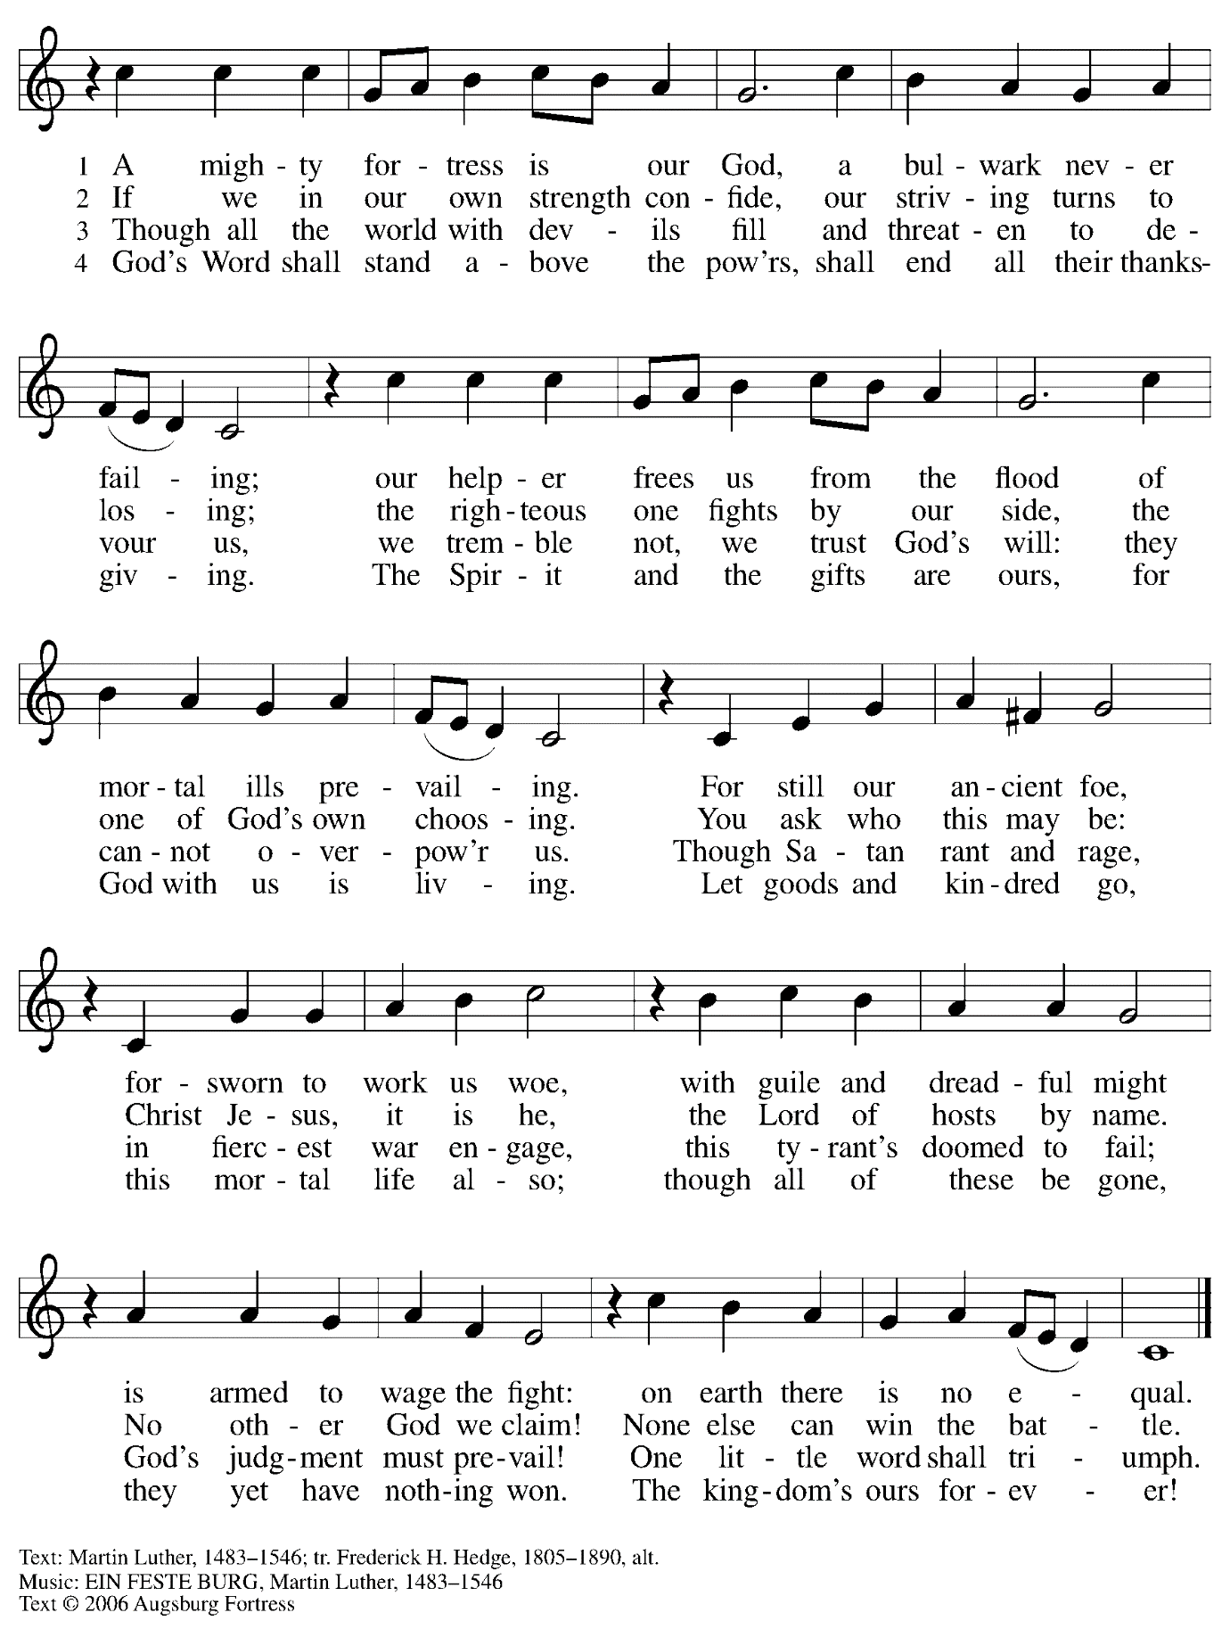

All rights reserved. Reprinted under OneLicense.net # A-722139.

**Greeting**

P: The grace of our Lord Jesus Christ, the love of God,

and the communion of the Holy Spirit be with you all.

**C: And also with you.**

**Hymn of Praise** *Glory to God ELW* p. 148



**Prayer of the Day**

P: The Lord be with you.

**C: And also with you.**

P: Let us pray.

Almighty God, gracious Lord,

we thank you that your Holy Spirit renews the church in every age.

Pour out your Holy Spirit on your faithful people.

Keep them steadfast in your word, protect and comfort them in times of trial,

defend them against all enemies of the gospel, and bestow on the church your saving peace, through Jesus Christ, our Savior and Lord, who lives and reigns with you and the Holy Spirit, one God, now and forever.

**C: Amen.**

*Please be seated.*

*Children are invited to join the adult leaders and move to the office for Little Church; Big Faith.*

*We ask that one additional adult from the congregation attend with the children.*

**Word**

*God speaks to us in Scripture reading, preaching, and song*

**First Reading – Jeremiah 31: 31-34**

31The days are surely coming, says the Lord, when I will make a new covenant with the house of Israel and the house of Judah. 32It will not be like the covenant that I made with their ancestors when I took them by the hand to bring them out of the land of Egypt—a covenant that they broke, though I was their husband, says the Lord. 33But this is the covenant that I will make with the house of Israel after those days, says the Lord: I will put my law within them, and I will write it on their hearts; and I will be their God, and they shall be my people. 34No longer shall they teach one another, or say to each other, “Know the Lord,” for they shall all know me, from the least of them to the greatest, says the Lord; for I will forgive their iniquity, and remember their sin no more.

L: Word of God, word of life.

**C: Thanks be to God.**

**Psalm 46**

*The cantor will lead the singing of the psalm.*

*The congregation is invited to respond with the alternate verses in bold print.*

*Psalm Tone*



*Psalm Refrain*



1God is our ref- **|** uge and strength,  
  a very present **|** help in trouble.  
 2**Therefore we will not fear, though the | earth be moved,**  
  **and though the mountains shake in the depths | of the sea;**  
 3though its waters **|** rage and foam,  
  and though the mountains tremble **|** with its tumult.  
 4**There is a river whose streams make glad the cit- | y of God,**  
  **the holy habitation of | the Most High.**  
 5God is in the midst of the city; it shall **|** not be shaken;  
  God shall help it at the **|** break of day.  
 6**The nations rage, and the | kingdoms shake;**  
  **God speaks, and the earth | melts away. R**  
 7The Lord of **|** hosts is with us;  
  the God of Jacob **|** is our stronghold.  
 8**Come now, regard the works | of the Lord,**  
  **what desolations God has brought up- | on the earth;**  
 9behold the one who makes war to cease in **|** all the world;  
  who breaks the bow, and shatters the spear, and burns the **|** shields with fire.  
 10**“Be still, then, and know that | I am God;**  
  **I will be exalted among the nations; I will be exalted | in the earth.”**  
 11The Lord of **|** hosts is with us;  
  the God of Jacob **|** is our stronghold.**R**

**Second Reading – Romans 3: 19-28**

19Now we know that whatever the law says, it speaks to those who are under the law, so that every mouth may be silenced, and the whole world may be held accountable to God. 20For “no human being will be justified in God’s sight” by deeds prescribed by the law, for through the law comes the knowledge of sin.  
  
 21But now, apart from law, the righteousness of God has been disclosed, and is attested by the law and the prophets, 22the righteousness of God through faith in Jesus Christ for all who believe. For there is no distinction, 23since all have sinned and fall short of the glory of God; 24they are now justified by God’s grace as a gift, through the redemption that is in Christ Jesus, 25whom God put forward as a sacrifice of atonement by his blood, effective through faith. God did this to show God’s righteousness, because in God’s divine forbearance God had passed over the sins previously committed; 26it was to prove at the present time that God’s own self is righteous and that God justifies the one who has faith in Jesus.  
 27Then what becomes of boasting? It is excluded. By what law? By that of works? No, but by the law of faith. 28For we hold that a person is justified by faith apart from works prescribed by the law.

L: Word of God, word of life.

**C: Thanks be to God.**

*Please rise as you are able.*

**Gospel Acclamation**  *Alleluia**ELW* p. 151



**Gospel – John 8: 31-36**

P: The holy Gospel according to St. John.

**C: Glory to you, O Lord.**

31Jesus said to the Jews who had believed in him, “If you continue in my word, you are truly my disciples; 32and you will know the truth, and the truth will make you free.” 33They answered him, “We are descendants of Abraham and have never been slaves to anyone. What do you mean by saying, ‘You will be made free’?”  
 34Jesus answered them, “Very truly, I tell you, everyone who commits sin is a slave to sin. 35The slave does not have a permanent place in the household; the son has a place there forever. 36So if the Son makes you free, you will be free indeed.”

P: The Gospel of the Lord.

**C: Praise to you, O Christ.**

*Please be seated.*

**Sermon**

*A time of silence for prayer and reflection follows the sermon.*

*When the hymn of the day begins, please rise as you are able.*

**Hymn of the Day Lord, Keep Us Steadfast in Your Word *ELW* 517**

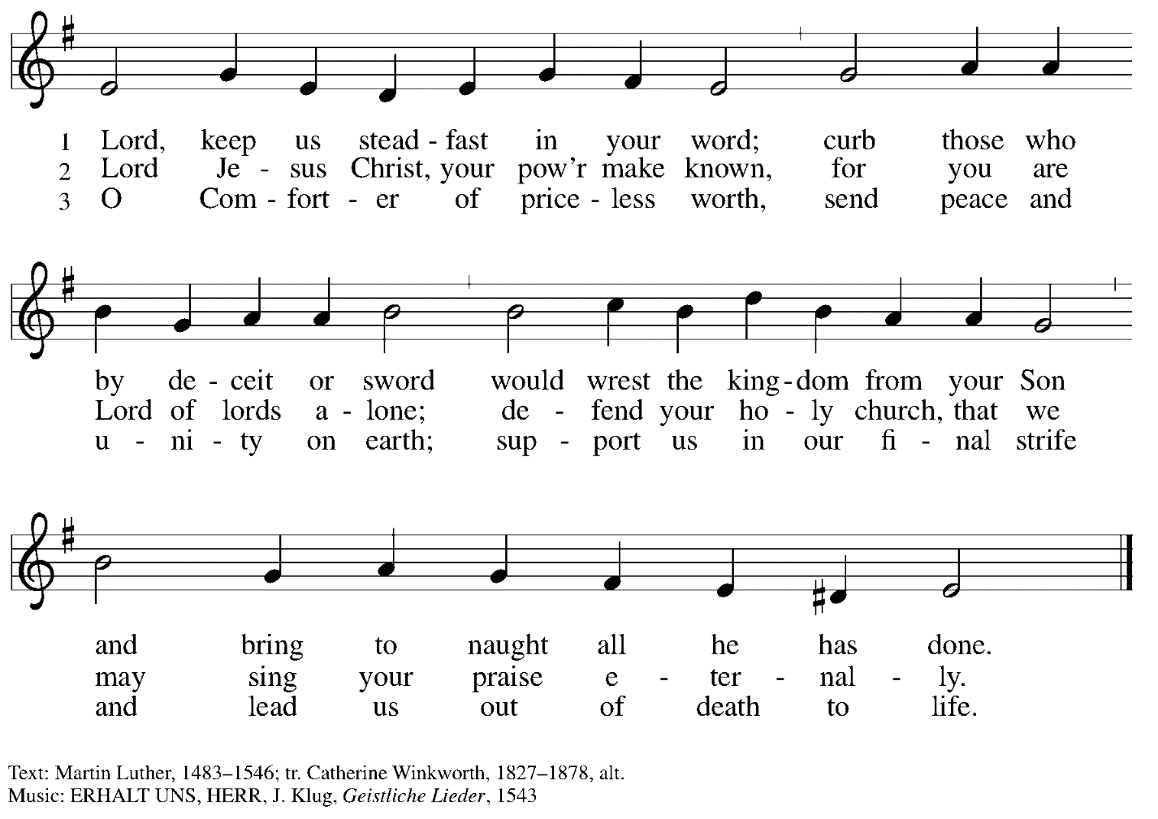

**Prayers of the People**

P: As scattered grains of wheat are gathered into one bread,

so let us gather our prayers for the church, those in need, and all of God’s creation.

*After each petition*

P: God of grace,

**C: receive our prayer.**

P: Gathered in the communion of the Holy Spirit, we offer these and all our prayers to you, gracious God, through Jesus Christ, our Savior.

**C: Amen.**

*Please be seated.*

**Meal**

**Offering**

*We offer ourselves, our gifts, and our faithful service to God.*

*An usher will pass around an offering plate for anyone who would like to offer gifts before God.*

**Music during the Offering**

*Please rise as you are able.*

**Offertory Song Let the Vineyards *ELW* 184**

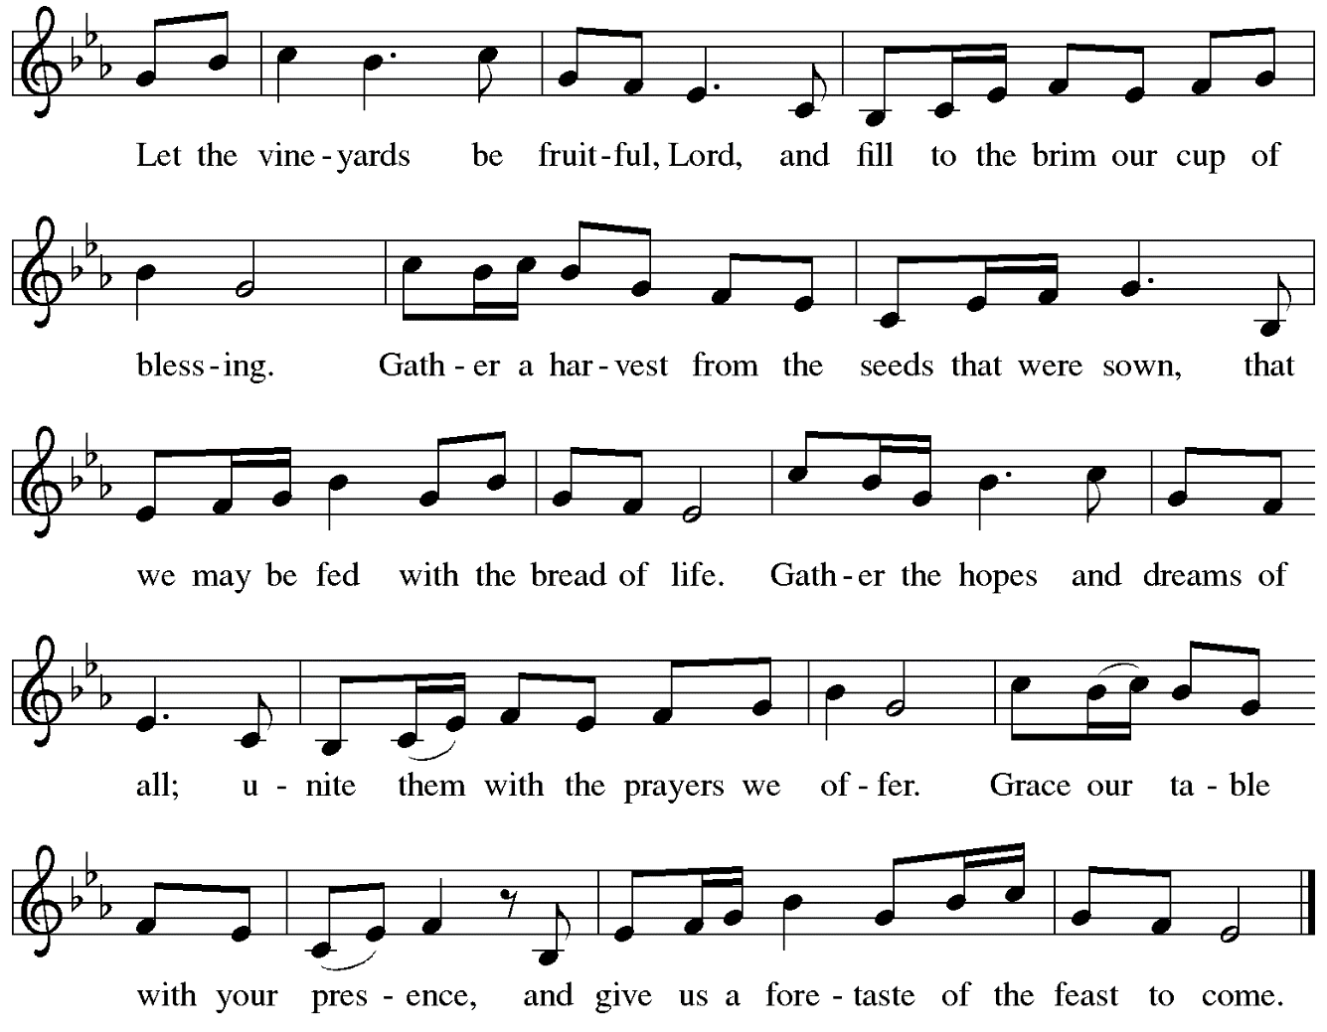

**Offertory Prayer**

P: Let us pray. God, of all creation,

**C: all you have made is good, and your love endures forever.**

**You bring forth bread from the earth and fruit from the vine.**

**Nourish us with these gifts, that we might be for the world**

**signs of your gracious presence in Jesus Christ, our Savior and Lord.**

**Amen.**

**Dialogue** *ELW* p. 152



**Preface** *(Sung by the presiding minister)*

P: It is indeed right, our duty and our joy,

that we should at all times and in all places

give thanks and praise to you, almighty and merciful God,

through our Savior Jesus Christ;

who on this day overcame death and the grave,

and by his glorious resurrection opened to us the way of everlasting life.

And so, with all the choirs of angels,

with the church on earth and the hosts of heaven,

we praise your name and join their unending hymn:

**Sanctus** *ELW* p. 153



**Eucharistic Prayer**

P: Holy God …

… with every breath.

**C: We praise you, O God.**

P: Generations bless your faithfulness …

… into the future.

**C: We bless you, O God.**

P: We give you thanks for your dear Son …

… with us now.

**C: We thank you, O God.**

P: In the night in which he was betrayed …

… Do this for the remembrance of me.

Remembering his love for us on the way, at the table, and to the end,

we proclaim the mystery of faith.

**C: Christ has died. Christ is risen. Christ will come again.**

P: We pray for the gift of your Spirit …

… by your Spirit, in your church, without end.

**C: Amen.**

**Lord’s Prayer**

P: Gathered as one by the Holy Spirit, let us pray as Jesus taught us.

**C: Our Father in heaven,**

**hallowed be your name,**

**your kingdom come,**

**your will be done,**

**on earth as in heaven.**

**Give us today our daily bread.**

**Forgive us our sins**

**as we forgive those** **who sin against us.**

**Save us from the time of trial**

**and deliver us from evil.**

**For the kingdom, the power,**

**and the glory are yours,**

**now and forever. Amen.**

**Fraction and Invitation**

***Agnus Dei /* Lamb of God** *ELW* p. 154



*Please be seated.*

**Holy Communion**

* *Worshipers from the pulpit side will proceed forward first, followed by the center section, and then the lectern side.*
* *The Communion wafers (regular and gluten-free) have been thoughtfully prepared using the gifts of the congregation by a member of St. Andrew’s altar care team, with a drop of wine or grape juice on each. The presiding minister will distribute one to each communicant.*
* *When you reach the presiding minister, please indicate if you would like grape juice or a gluten-free wafer.*
* *A blessing will be provided for anyone who does not yet receive the sacrament.*
* *Cushions have been placed at the altar rail for anyone who would like to kneel for prayer and reflection before returning to their pew.*

**Hymn during Holy Communion**

**By Grace We Have Been Saved *ACS* 1006**

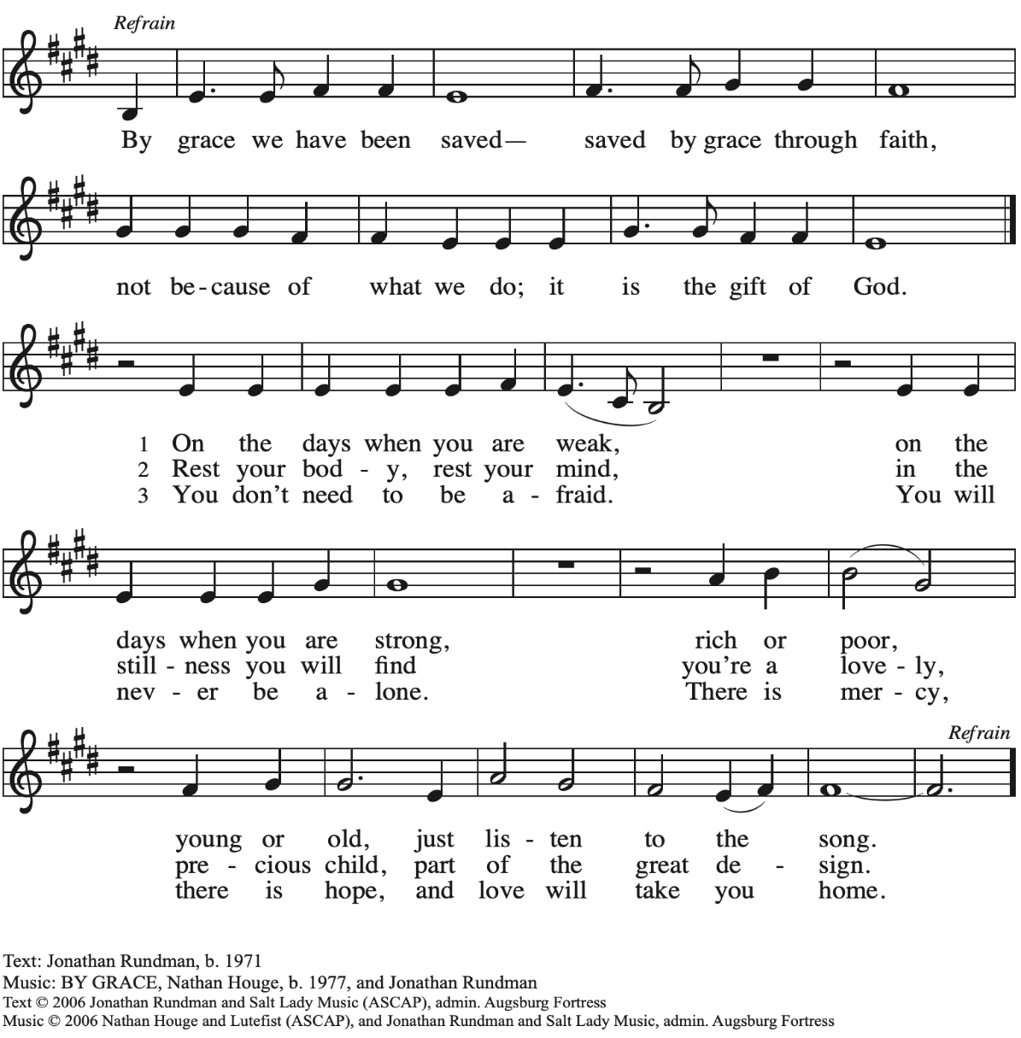

All rights reserved. Reprinted with permission under OneLicense.net # A-722139.

**Hymn during Holy Communion**

**Founded on Faith *ACS* 1048**

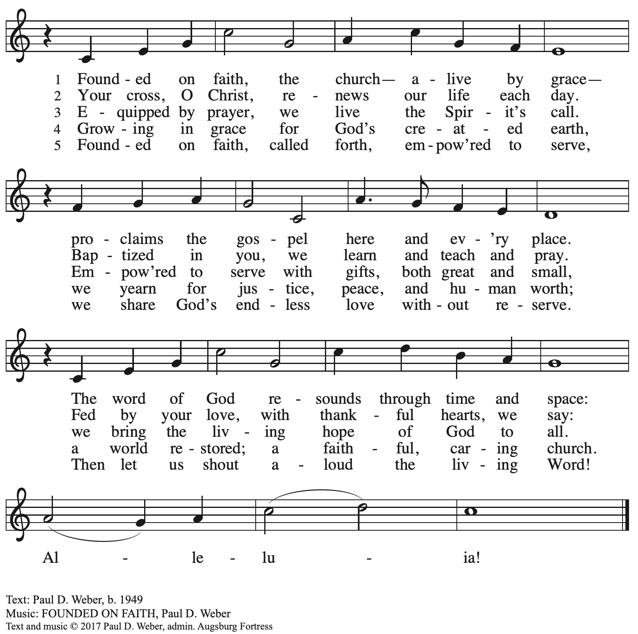

All rights reserved. Reprinted with permission under OneLicense.net #A-722139.

**Hymn during Holy Communion**

**That Priceless Grace *ELW* 591**

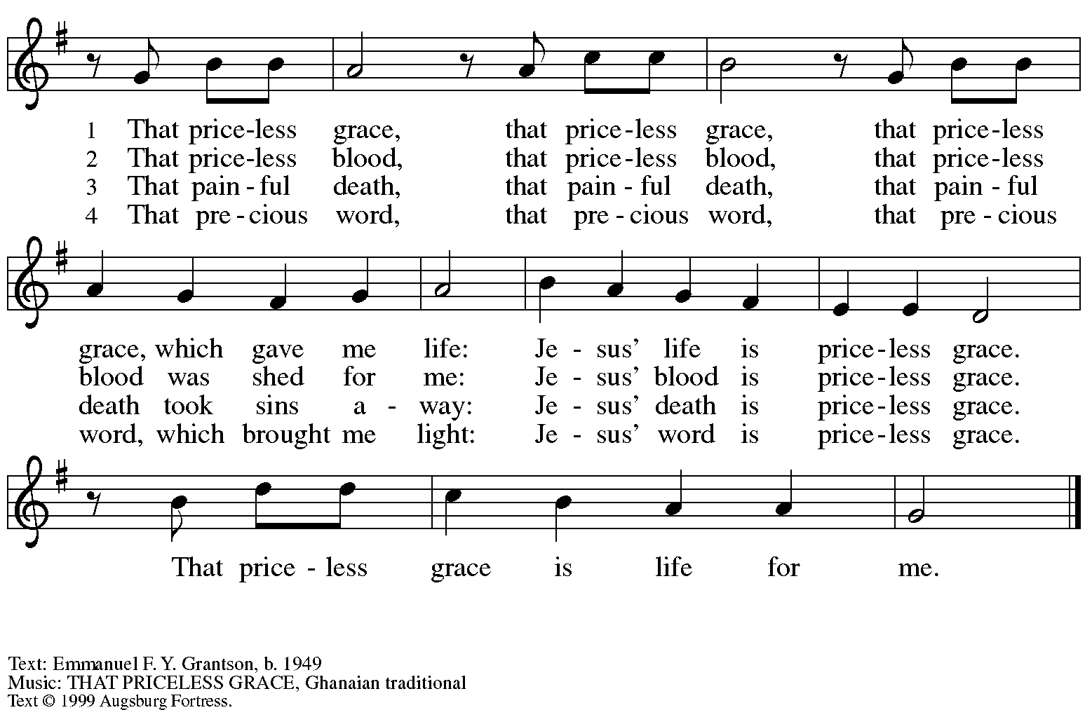

All rights reserved. Reprinted with permission under OneLicense.net # A-722139.

*When all have returned to their places, please rise as you are able.*

**Blessing**

P: The body and blood of our Lord Jesus Christ strengthen you and keep you in his grace.

**C: Amen.**

**Prayer**

P: Let us pray.

P: God of abundance, you have refreshed our hearts in this meal with bread for the journey.

Give us your grace on the way, that we may serve our neighbors with joy

and proclaim your goodness in all things, through Jesus Christ, our Savior and Lord.

**C: Amen.**

*Please be seated.*

**Sending**

**Announcements**

*Please rise as you are able.*

**Benediction**

P: God who gives life to all things

and frees us from despair,

bless you with truth and peace.

The holy Trinity, ☩ one God,

guide you always in faith, hope, and love.

**C: Amen.**

**Sending Hymn Listen, God Is Calling *ELW* 513**

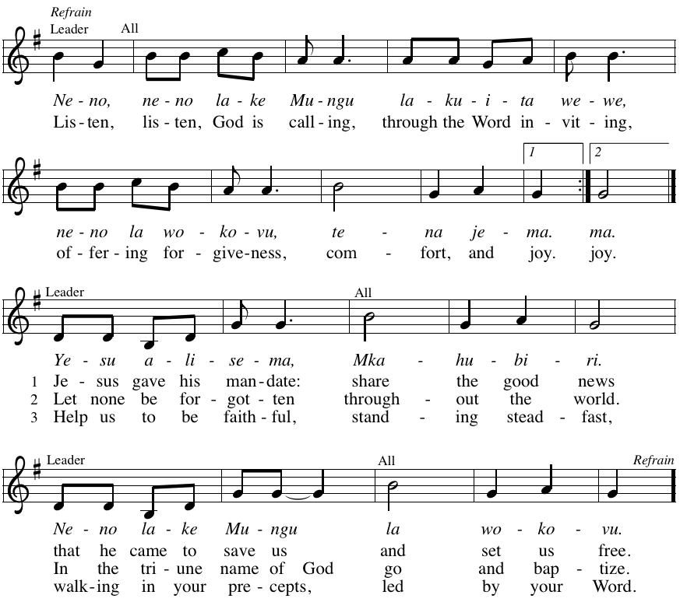

**Dismissal**

P: Go in peace. Christ is with you.

**C: Thanks be to God!**

*Abbreviations*

P: Pastor/Presiding Minister

L: Lector

R: Congregational Representative

**C: Congregation**

***ELW*: *Evangelical Lutheran Worship* hymnal**

***ACS*: *All Creation Sings* hymnal**

*Those serving in worship today*

Minister of Music Laura Reynolds

Organ and Drum Jimmi Kocher-Hillmer

Cantor and Recorder Timothy Kocher-Hillmer

Lector Noël Marsh

Audio Visual Ministers Jason Galyardt

David Rollinson

Presiding Minister Rev. Ross Carmichael

*Liturgy and Hymnody Acknowledgements*

From SundaysandSeasons.com. Copyright © 2022 Augsburg Fortress. All rights reserved. Reprinted under OneLicense.net # A-722139.

Used by permission of Augsburg Fortress.

***Let the Vineyards*** – Text: John W. Arthur, 1922-1980. Music: Ronald A. Nelson, b. 1927. Text and music © 1978 *Lutheran Book of Worship*, admin. Augsburg Fortress. All rights reserved. Reprinted with permission under OneLicense.net # A-722139.

***Listen, God Is Calling*** – Text: Tanzanian traditional, tr. Howard S. Olson, b. 1922. Music: NENO LAKE MUNGU, Tanzanian tune. Text © 1968 Lutheran Theological College, Makumira, Tanzania, admin Augsburg Fortress. All rights reserved. Reprinted under OneLicense.net # A-722139.

**St. Andrew Lutheran Church Announcements**

**October 30th, 2022**

* **Worship in the Sanctuary and Online – Sunday, October 30th, + Reformation Sunday** – St. Andrew’s next service of Holy Communion will be this Sunday, October 30th, at 10:00 a.m. Allegheny County’s Covid-19 community level is in the “low” category. St. Andrew recently changed its policy to “masks optional” when community levels are both low and medium. Worship will also be live-streamed to Facebook, YouTube, and Zoom. Worship attendees are invited to make their own name tags at the back of the worship space. Coffee hour will be held in the Social Hall next to the sanctuary after worship.
* **St. Andrew Lunch Gathering - Sunday, October 30th, 12:30 p.m. at Hofbrauhaus - South Side Works** – These monthly gatherings for lunch or dinner are simply an opportunity to spend time and share conversation with others in the congregation over a meal. October's lunch will be at 12:30 p.m. on Sunday, October 30th at Hofbrauhaus-South Side Works, 2705 S. Water St., Pittsburgh 15203.
* **November Fresh Produce Distribution - Tuesday, November 1st, 5:30-7:00 p.m.**– On the first Tuesday of every month, St. Andrew serves as a distribution site for fresh produce supplied by the Greater Pittsburgh Community Food Bank. The next one will be Tuesday, November 1st. St. Andrew invites you to consider coming earlier in the day to help with setup and unloading, usually between 11:00 a.m. and 1:00 p.m. Coordinators will call those who have signed up once we have a better idea of the truck's arrival time. We also appreciate assistance with the distribution itself in the evening. If you would like to help, please sign up at: <https://www.signupgenius.com/go/5080544AAAC22A1F58-produce22>
* **Work Day Fall Cleanup - Saturday, November 5th, 10:00 a.m.** – Join in efforts to prepare St. Andrew's building, and especially outdoor grounds, for winter. We will be cleaning window wells, weeding, and spreading mulch, among other tasks on Saturday, November 5th, beginning at 10:00 a.m. The autumn leaves are falling so there will be plenty of work opportunities for everyone!
* **Fall Focus on Commitment and Giving** – Each year around this time, St. Andrew offers the congregation the opportunity to make a commitment to financial giving in the upcoming year as our grateful response to all God's gifts. Next week, you will receive a letter introducing this year's focus, including a reflection on giving and a commitment card for your prayerful consideration over the next few weeks. In worship on Sunday, November 13th, we will consider themes of stewardship, how we manage, care for, and use God's gifts, and then we invite everyone to return your commitment card on + Reign of Christ Sunday, November 20th, to dedicate our gifts in worship. Please watch for more information next week! Thank you for the many ways you carry out and support the ministries of St. Andrew!
* **Spiritual Care Volunteers Needed for AHN Palliative Care Patients** – Palliative care is an approach that improves the quality of life for patients and their families facing problems associated with life-threatening illness, through the prevention and relief of suffering by means of early identification, assessment and treatment of pain and other problems, whether they be physical, psychosocial or spiritual.
* Spiritual Care Volunteers will visit with AHN Palliative Care patients and their families at one of our hospitals: Allegheny General, Allegheny Valley, Forbes, Jefferson, and West Penn.
* We also can use volunteers who work from their homes to call family members to provide emotional and spiritual support.
* Training is provided and required.
* Qualifications: Ability to stand and walk long hospital corridors, or use an assistive mobility device to do so. A willingness to attend volunteer orientation/training and meetings, to function as a member of one of our palliative care teams, and to complete simple charting under the direction of the spiritual care coordinator. Basic computer skills utilizing email and Zoom are very helpful.
* Clearances required (will be paid for by AHN).
* Volunteers who work in the hospitals must be up to date on all of their vaccinations, including the Covid vaccines and boosters. Current policies require everyone to wear surgical, KN95, or N95 face masks.
* We do not discriminate based on religious or spiritual beliefs. NO proselytizing is permitted.
* Free parking and meals.

For more information, contact the Spiritual Care Coordinator, Pr. Kim Rapczak, at: 412-738-4650 or [Kimberly.Rapczak@ahn.org](mailto:Kimberly.Rapczak@ahn.org).

To apply online, go to: <https://www.ahn.org/volunteer-application> (Make sure to select which hospital you want to work at, and under “other,” type: “palliative care.”).

* **Lutheran Immigration and Refugee Service LIRS) "Hope for the Holidays" Program**– Each year, with the help of hundreds of supporters, Lutheran Immigrations and Refugee Service collects cards and donations for gifts for distribution at immigration detention centers across the country, sharing holiday hope and joy with individuals and families seeking safety in the U.S. Last year, volunteers provided over 16,000 cards and 1,700 gifts to asylum-seekers across the country. To learn more or get involved, visit the Hope for the Holidays hub at [Hope For The Holidays | LIRS (wpengine.com)](https://lirsprod.wpengine.com/take-action/hope-for-the-holidays/?mc_cid=e12aa1f9ad&mc_eid=47529dfd1c). The site has a video about the program, a toolkit with resources available for download, and opportunities for advocacy and donations.
* **Climate Care Social Message from the Evangelical Lutheran Church in America - Read and Comment!**– The earth is the Lord's, and all that is in it, the world, and those who live in it! (Psalm 24: 1) What is a faithful Lutheran response to the Earth's changing climate and worsening natural disasters? How do we think about this crisis as people of faith, and what are we called to do?

After hearing requests from across the church for guidance, the ELCA Church Council in November 2021 authorized development of a social message on climate care. Social messages are ELCA social teaching documents on specific social topics; these documents shape ELCA policy and help members discern how to respond to an issue.  
  
A draft of the social message "Earth's Climate Crisis" is now posted for public comment! Feedback of this kind helps the drafters know how the document could be more clear, helpful and faithfully Lutheran. Please [read the social message draft](https://community.elca.org/page.redir?target=https%3a%2f%2fdownload.elca.org%2fELCA+Resource+Repository%2fDRAFT-Social_Message_on_Climate_Care.pdf&srcid=322630&srctid=1&erid=1a86171a-1786-446b-9e2a-98e835da9e26&trid=1a86171a-1786-446b-9e2a-98e835da9e26) and [use this survey](https://community.elca.org/page.redir?target=https%3a%2f%2fwww.surveymonkey.com%2fr%2fR8R98QX&srcid=322630&srctid=1&erid=1a86171a-1786-446b-9e2a-98e835da9e26&trid=1a86171a-1786-446b-9e2a-98e835da9e26) to share your input by **Friday, Dec. 2**.

Questions or longer responses can be emailed to [draftsocialmessage@elca.org](mailto:draftsocialmessage@elca.org).  
  
Read and respond here: <https://elca.org/climatecare>  
  
The drafters and review team will study the public feedback to prepare a proposed social message. That proposed message will be reviewed by the Conference of Bishops and presented to the Church Council for consideration this coming spring.

This public comment period is your chance to contribute directly as our church considers how to address this crucial topic affecting God's good creation. Please help improve this social message so it can be as effective as possible. And share the news with others, so they can participate too!  
  
God's peace,  
  
Rev. Roger A. Willer, Ph.D.  
Director for Theological Ethics  
Office of the Presiding Bishop, ELCA

* **Bethel AME Reparations Petition Available**– Bethel AME Church has released a new petition in partnership with the Color of Change organization in their pursuit of reparations for their land and church that were taken in the 1950s. To sign or share the petition, please visit: <https://bit.ly/Justice4Bethel>. A paper copy is available at the name tag cabinet in the back of St. Andrew's worship space for those who would like to sign using that medium.
* **Lutheran Campus Ministry Art Exhibit Exploring Race, *Truth Be Told*, Extended until the End of the Semester** – *Truth be Told*is an art exhibit created by fourteen women artists across the country in reflection on racism. The group of seven Black women and seven white women began conversations after the murder of Goerge Floyd, which moved them each to consider one word and create an art piece around that word. The exhibit is being shown at the Lutheran University Center, 4515 Forbes Avenue, Pittsburgh 15213. Open hours of viewing are every Saturday and Sunday from 1:00-6:00 p.m. Arrangements can be made to view the exhibit during the week by contacting the campus ministry at 412-682-6886 or email [pastor@psalm.online](http://pastor@psalm.online). For more information, go to <http://psalm.online>.