+ First Sunday of Advent
November 27, 2022

St. Andrew Lutheran Church
304 Morewood Ave.
Pittsburgh, PA 15213
St_andrewELCA@verizon.net
www.standrewpittsburgh.org

+ First Sunday of Advent
Order for Worship

The new church year begins with a wake-up call: Christ is coming soon!
In today’s readings both Paul and Jesus challenge us to wake from sleep,
for we know neither the day nor hour of the Lord’s coming.
Isaiah proclaims the day when God will gather all people on the holy mountain
and there will be no more war or suffering.
Though we vigilantly watch for the promised day of salvation, we wait for what we already have: Christ comes among us as the word and meal that strengthen our faith in the promises of God.

- Masks are optional at St. Andrew when Covid-19 community level in Allegheny County is in the low and medium categories.
- Hand sanitizer is available at the back of the sanctuary.

Worship Services are live streamed to multiple online platforms.
By attending worship, you agree that your image and voice may be broadcast.

Welcome to St. Andrew!
- Everyone is invited to make a nametag at the black bookcase in the back of the worship space if they would like.
- Worship “toolkits” to help children engage with the service are available in the black bookcase at the back of the worship space. There are “reader” and “pre-reader” resources available in each kit. Please feel free to use the kits for/with your children during worship.
- A restroom is available on the main level of the church, through the doors to the Social Hall and to the right in the main office.

A few notes specific to today’s service:
- Little Church; Big Faith, the Bible lesson and activity for children that usually takes place after the Prayer of the Day, will not be held today.
- Today St. Andrew returns to serving the sacrament of Holy Communion with both (separate) elements, bread and wine/grape juice. The presiding minister will first distribute the bread (host). Please consume this and then pick up an empty glass from the tray next to the presiding minister. The Communion Assistant will pour wine from the chalice or grape juice from the cruet into your glass. Please step to the side to consume the wine or grape juice. As you return to your pew, glasses may be returned to the empty trays on either side of the center aisle.

Welcome

Prelude

Gathering
The Holy Spirit calls us together as the people of God.

Confession and Forgiveness

P: Blessed be the Lord, the God of Israel,
who alone does wondrous things.
C: Blessed be God’s name forever.
Amen.

P: Beloved, now is the time to wake from sleep.
Let us confront our sins,
and confess them to the one who is merciful and just.

Silence is kept for reflection.

P: God of new beginnings,
C: we confess that we have not welcomed your holy reign.
We have strayed from your paths.
We prepare for war instead of peace.
We dishonor one another and your creation.
Purify us with your refining fire
and set us again on your way of love,
that we may bear fruit worthy of repentance,
and welcome your coming among us.
Amen.

P: People of God,
a new thing is growing in our midst,
a tender branch, a living sign.
By water and the Spirit you are joined to this wonder.
You have put on ☩ Christ,
and your sins have been washed away.
Rejoice in the way of the Lord.
C: Amen.

Gathering Hymn Come, Thou Long-Expected Jesus ELW 254

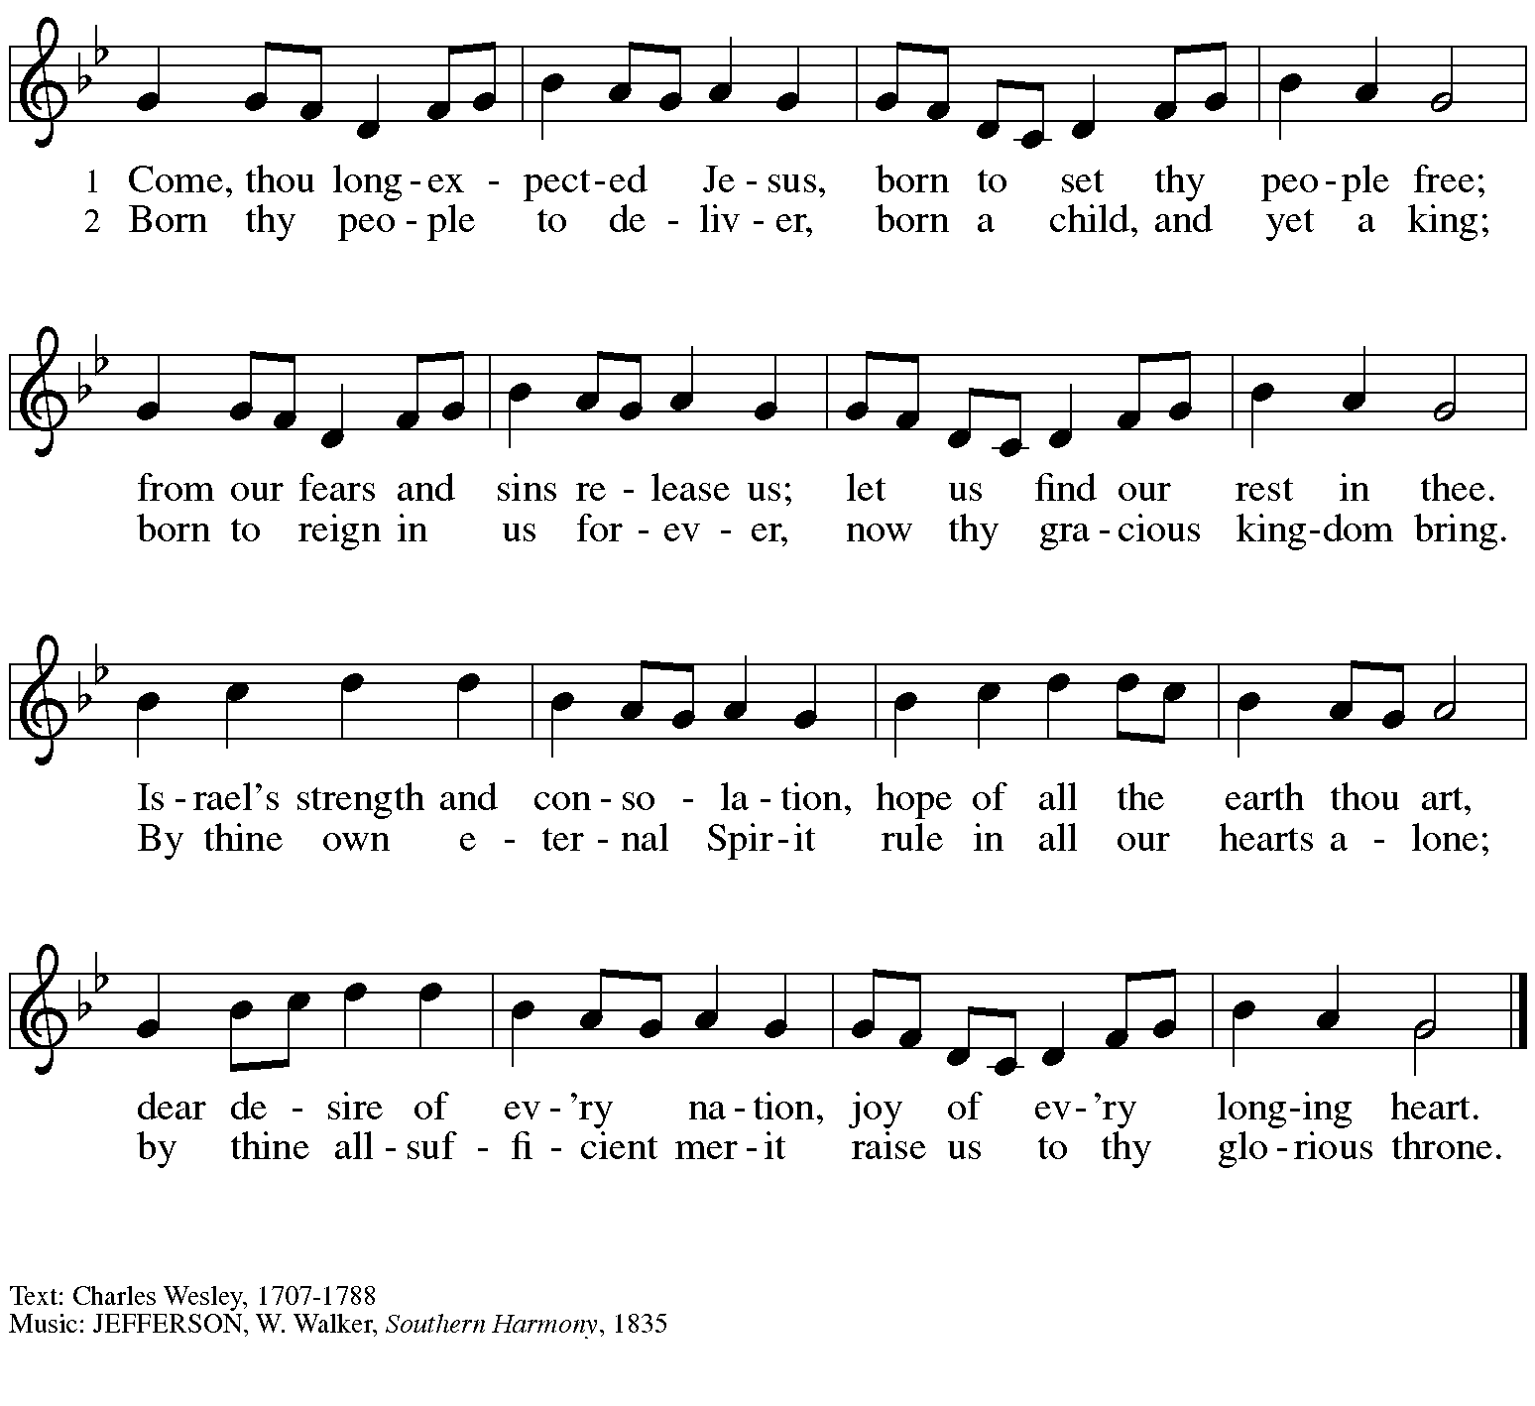

Greeting

P: The grace of our Lord Jesus Christ, the love of God,
and the communion of the Holy Spirit be with you all.
C: And also with you.

Kyrie HS p. 3

A: In peace, in peace,
Refrain
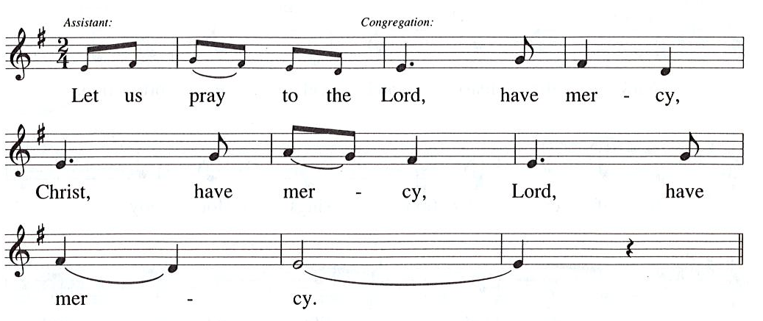

Prayer of the Day

A: For the Reign of God, and for peace throughout the world,
for the unity of all … (Refrain)

A: For your people here, who have come to give you praise,
for the strength to live your word … (Refrain)

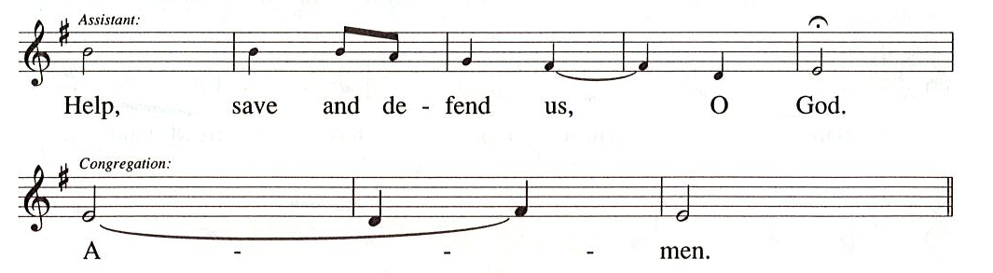

Prayer of the Day
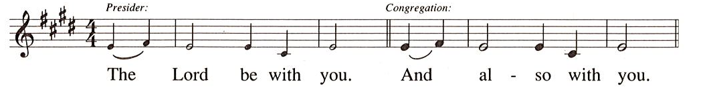

P: Let us pray.
Stir up your power, Lord Christ, and come.
By your merciful protection save us from the threatening dangers of our sins,
and enlighten our path in the way of your salvation,
for you live and reign with the Father and the Holy Spirit,
one God, now and forever.
C: Amen.

Please be seated.
Children are invited to come forward and gather around the Advent Wreath
for the lighting of the candle.

Hymn during Candle Lighting
Light One Candle to Watch for Messiah ELW 240
v. 1

1 Light one candle to watch for Messiah:
Lead our way through the darkness.
He shall bring salvation to Israel,
God fulfills the promise.

Little Church; Big Faith, our Bible lesson and activity for children, will not meet this Sunday.
When the candle is lit and the hymn has concluded, all return to their pews.

Word
God speaks to us in Scripture reading, preaching, and song

First Reading – Isaiah 2: 1-5

²In days to come
the mountain of the Lord’s house
shall be established as the highest of the mountains,
and shall be raised above the hills;
all the nations shall stream to it.
³Many peoples shall come and say,
“Come, let us go up to the mountain of the Lord,
to the house of the God of Jacob;
that the Lord may teach us God’s ways
and that we may walk in God’s paths.”
For out of Zion shall go forth instruction,
and the word of the Lord from Jerusalem.
⁴The Lord shall judge between the nations,
and shall arbitrate for many peoples;
they shall beat their swords into plowshares,
and their spears into pruning hooks;
nation shall not lift up sword against nation,
neither shall they learn war any more.

⁵O house of Jacob,
come, let us walk
in the light of the Lord!

L: Word of God, word of life.
C: Thanks be to God.

Psalm 122

The cantor will lead the singing of the psalm.
The congregation is invited to respond with the alternate verses in bold print,
and to join in singing the refrain.

Psalm Tone

Psalm Refrain

¹I was glad when they | said to me,
“Let us go to the house | of the Lord.”
²Now our | feet are standing
within your gates, | O Jerusalem.
³Jerusalem is built | as a city
that is at unity | with itself;
⁴to which the tribes go up, the tribes | of the Lord,
the assembly of Israel, to praise the name | of the Lord. R
⁵For there are the | thrones of judgment,
the thrones of the | house of David.
⁶Pray for the peace | of Jerusalem:
“May they pros- | per who love you.
⁷Peace be with- | in your walls
and quietness with- | in your towers.
⁸For the sake of my kindred | and companions,
I pray for | your prosperity.
⁹Because of the house of the | Lord our God,
I will seek to | do you good.” R

Second Reading – Romans 13: 11-14

¹¹Besides this, you know what time it is, how it is now the moment for you to wake from sleep. For salvation is nearer to us now than when we became believers; ¹²the night is far gone, the day is near. Let us then lay aside the works of darkness and put on the armor of light; ¹³let us live honorably as in the day, not in reveling and drunkenness, not in debauchery and licentiousness, not in quarreling and jealousy. ¹⁴Instead, put on the Lord Jesus Christ, and make no provision for the flesh, to gratify its desires.

L: Word of God, word of life.
C: Thanks be to God.

Please rise as you are able.

Gospel Acclamation Alleluia HS p. 8

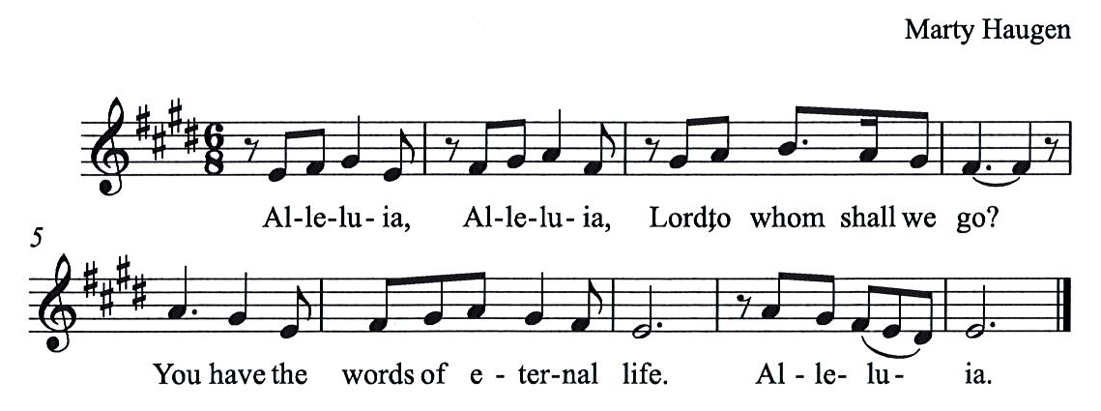

Gospel – Matthew 24: 36-44

P: The holy Gospel according to St. Matthew.
C: Glory to you, O Lord.
[Jesus said to the disciples,] ³⁶“About that day and hour no one knows, neither the angels of heaven, nor the Son, but only the Father. ³⁷For as the days of Noah were, so will be the coming of the Son of Humanity. ³⁸For as in those days before the flood they were eating and drinking, marrying and giving in marriage, until the day Noah entered the ark, ³⁹and they knew nothing until the flood came and swept them all away, so too will be the coming of the Son of Humanity.
⁴⁰Then two will be in the field; one will be taken and one will be left. ⁴¹Two women will be grinding meal together; one will be taken and one will be left. ⁴²Keep awake therefore, for you do not know on what day your Lord is coming. ⁴³But understand this: if the owner of the house had known in what part of the night the thief was coming, he would have stayed awake and would not have let his house be broken into. ⁴⁴Therefore you also must be ready, for the Son of Humanity is coming at an unexpected hour.

P: The Gospel of the Lord.
C: Praise to you, O Christ.

Please be seated.

Sermon

A time of silence for prayer and reflection follows the sermon.
When the hymn of the day begins, please rise as you are able.

Hymn of the Day O Lord, How Shall I Meet You ELW 241

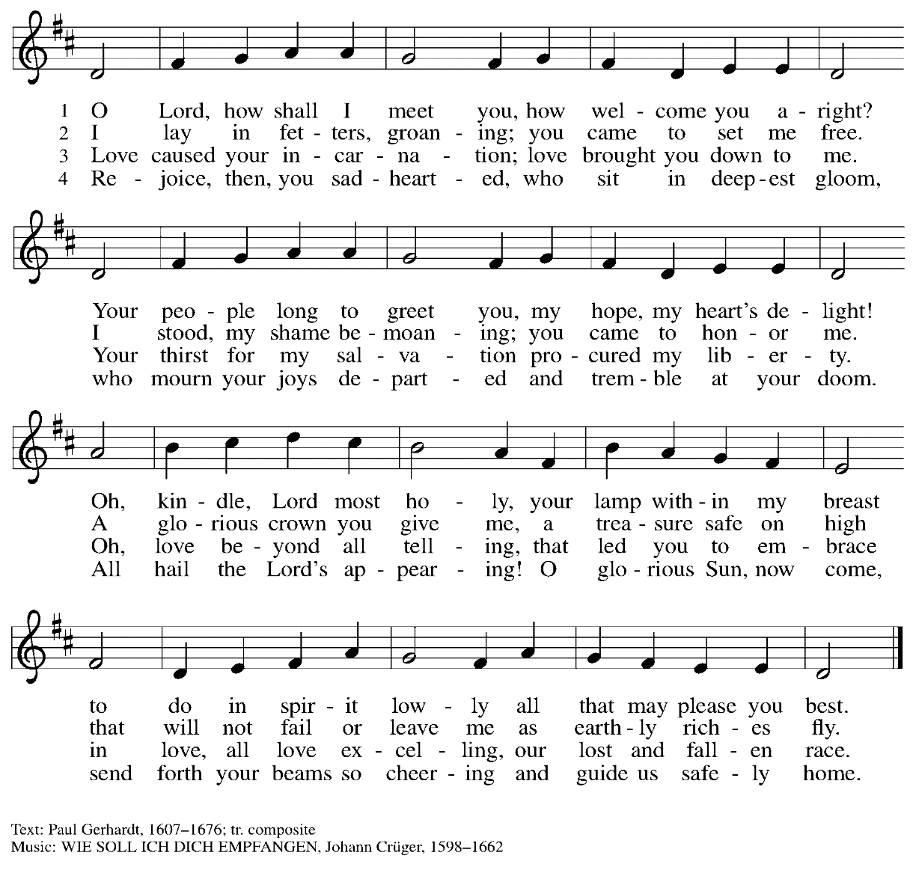

Prayers of the People

P: As we prepare for the fullness of Christ’s presence,
let us pray for the world as it yearns for new hope.

After each petition
P: God, in your mercy,
C: receive our prayer.

P: God of our longing, you know our deepest needs.
By your Spirit, gather our prayers and join them with those of all your people,
through Jesus Christ, our Savior.
C: Amen.

Please be seated.

Meal

Offering

We offer ourselves, our gifts, and our faithful service to God.
An usher will pass around an offering plate for anyone who would like to offer gifts before God.

Music during the Offering

Please rise as you are able.

Offertory Song As the Grains of Wheat ELW 465

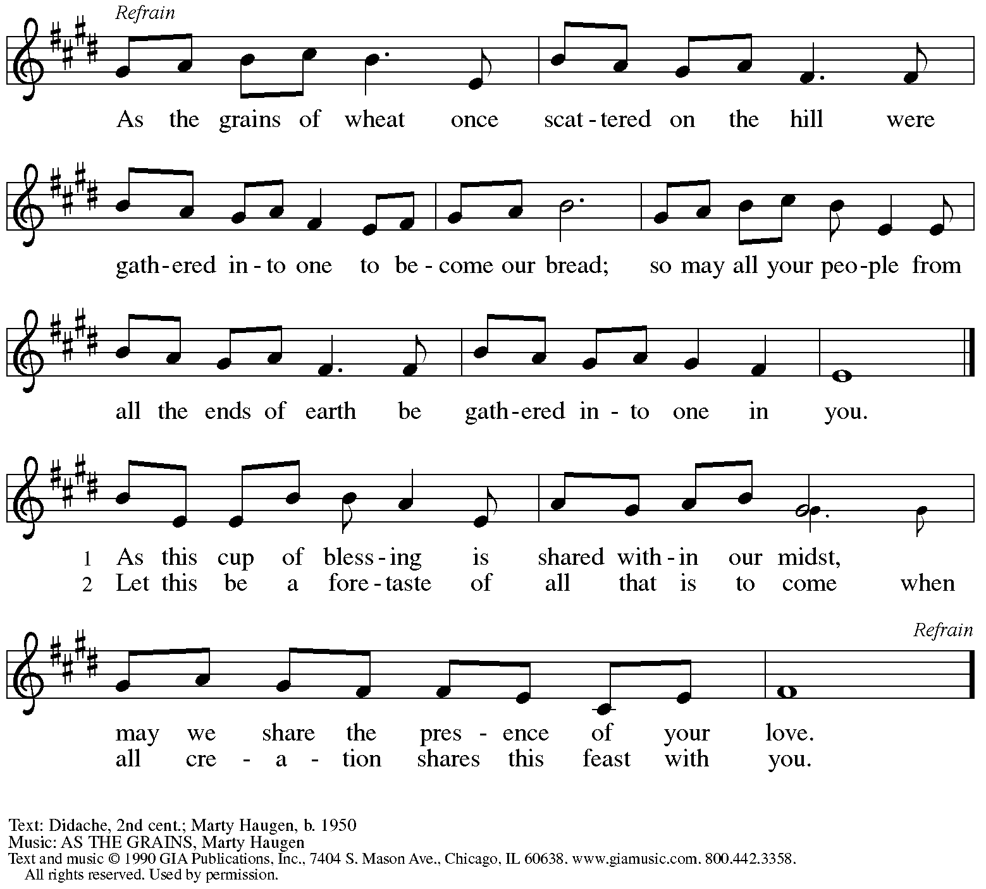
Reprinted with permission under OneLicense.net #A-722139.

Offertory Prayer

P: Let us pray. Eternal God,
C: you make the desert bloom and send springs of water to thirsty ground.
Receive these simple gifts we offer,
and make us messengers of your mercy and love
for all in need of your justice and healing.
We ask this through Christ our Savior.
Amen.

Dialogue HS p. 14

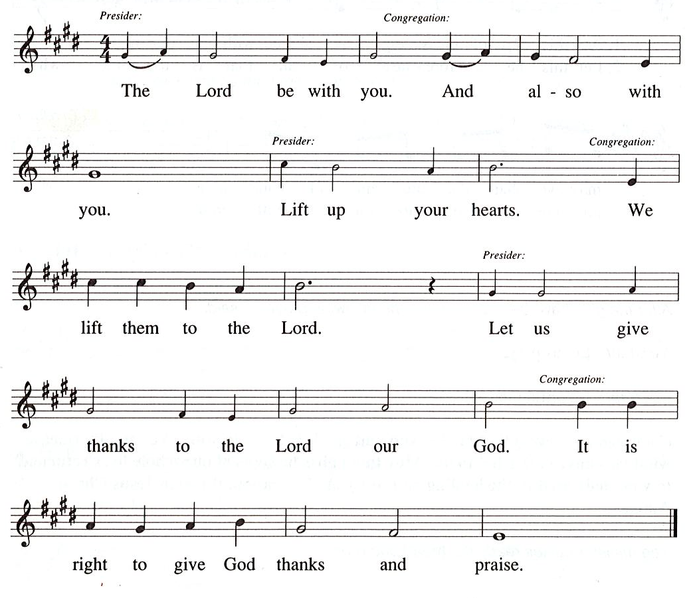

Preface (Sung by the presiding minister)

P: It is our duty and delight
that we should everywhere and always
offer thanks and praise to you, O God,
through Jesus Christ,
whose coming the prophets and John the Baptist
announced with great joy.
And so with the church on earth,
all creation and the hosts of heaven,
we praise your name and join their unending hymn:

Sanctus HS p. 15

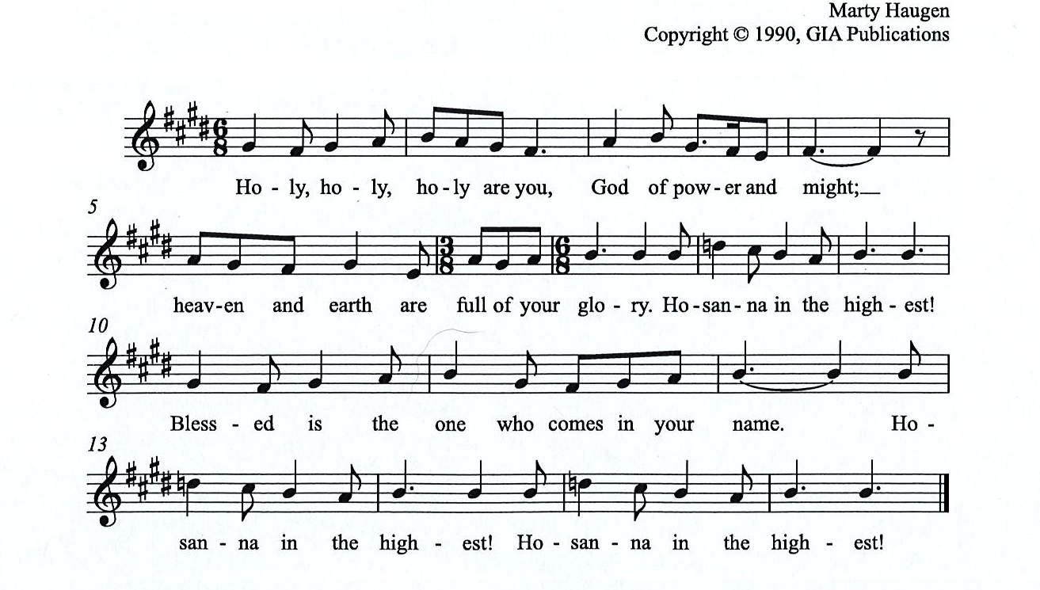

All rights reserved. Reprinted under OneLicensne.net # A-722319.

Eucharistic Prayer

P: Holy One, the beginning and the end, the giver of life …
… Do this for the remembrance of me.

Let us proclaim the mystery of faith:

Christ has died. Christ is risen. Christ will come, come again.
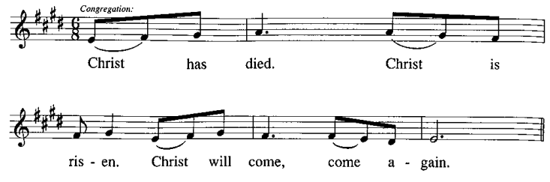
C:

P: With this bread and cup we remember …
… We look with hope for his coming.

Amen. Come, Lord Jesus. Amen. Come, Lord Jesus.
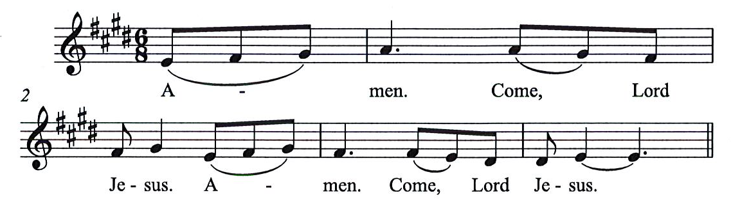
C:

P: Holy God, we long for your Spirit. …
… Bring the gift of peace on earth.

Amen. Come Holy Spirit. Amen. Come, Holy Spirit.
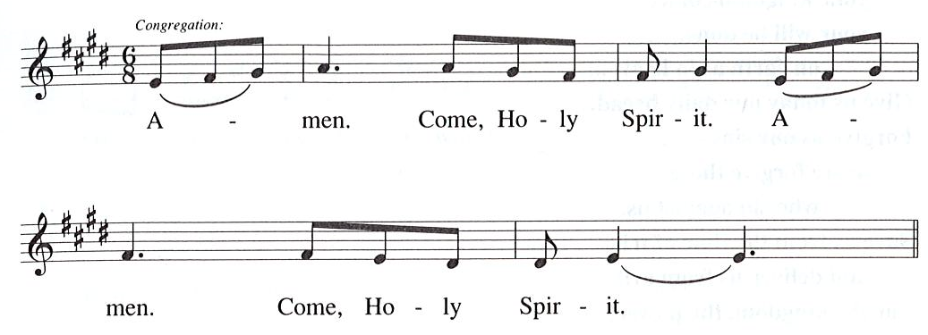
C:

P: All praise and glory are yours, …
… one God, now and forever.
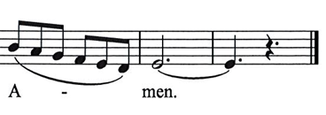
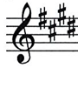
C:

Lord’s Prayer

P: Gathered as one by the Holy Spirit, let us pray as Jesus taught us.
C: Our Father in heaven,
hallowed be your name,
your kingdom come,
your will be done,
on earth as in heaven.
Give us today our daily bread.
Forgive us our sins
as we forgive those who sin against us.
Save us from the time of trial
and deliver us from evil.
For the kingdom, the power,
and the glory are yours,
now and forever. Amen.

Fraction and Invitation

Agnus Dei / Lamb of God HS p. 18

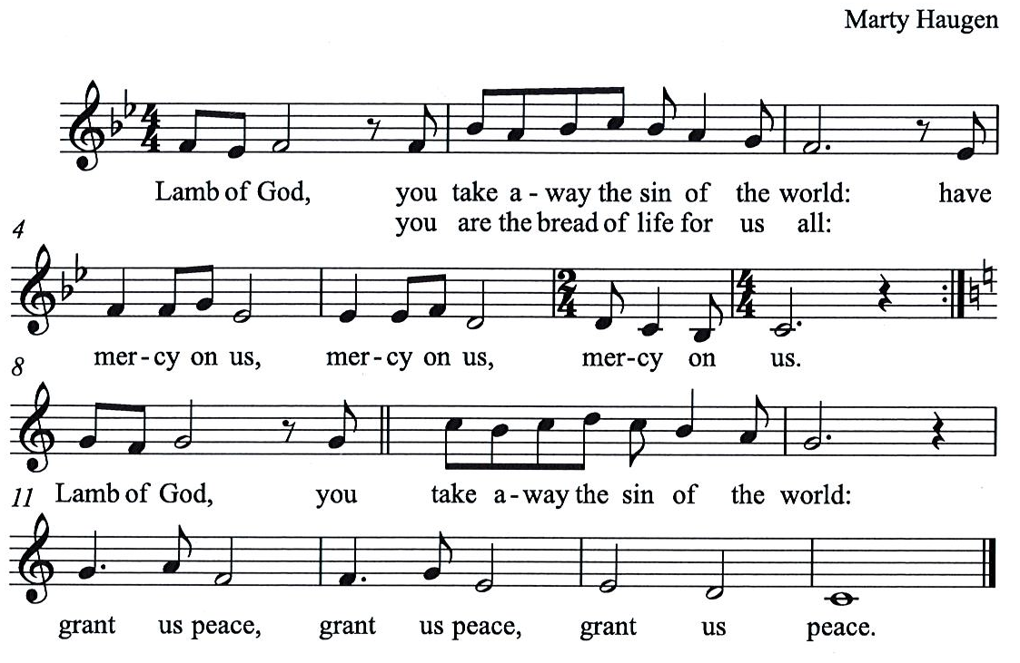

Please be seated.

Holy Communion
- Worshipers from the pulpit side will proceed forward first, followed by the center section, and then the lectern side.
- Holy Communion will be served with bread and wine/grape juice.
- The presiding minister will first distribute the bread (host) to each communicant. Please indicate if you require a gluten-free host.
- Once you have consumed the bread, please pick up an empty glass from the tray next to the presiding minister. The Communion Assistant will pour wine from the chalice or grape juice from the cruet into your glass.
- Please step to the side to consume the wine or grape juice.
- As you return to your pew, glasses may be returned to the empty trays on either side of the center aisle.
- A blessing will be provided for anyone who does not yet receive the sacrament.
- All are invited to join in singing the hymns during Holy Communion.

Hymn during Holy Communion
Keep Your Lamps Trimmed and Burning ACS 949

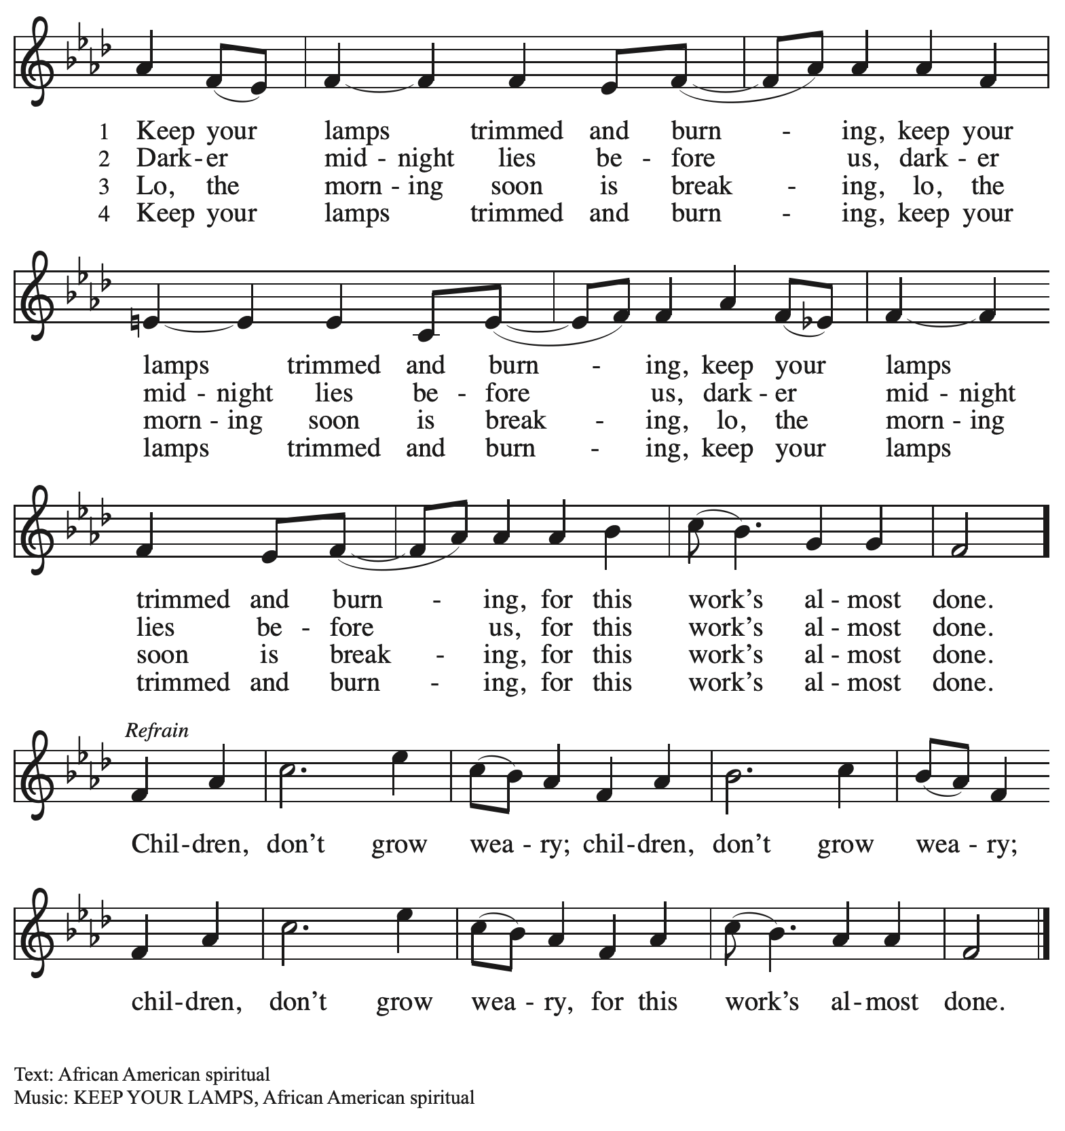

Hymn during Holy Communion
Joyous Light of Heavenly Glory ELW 561

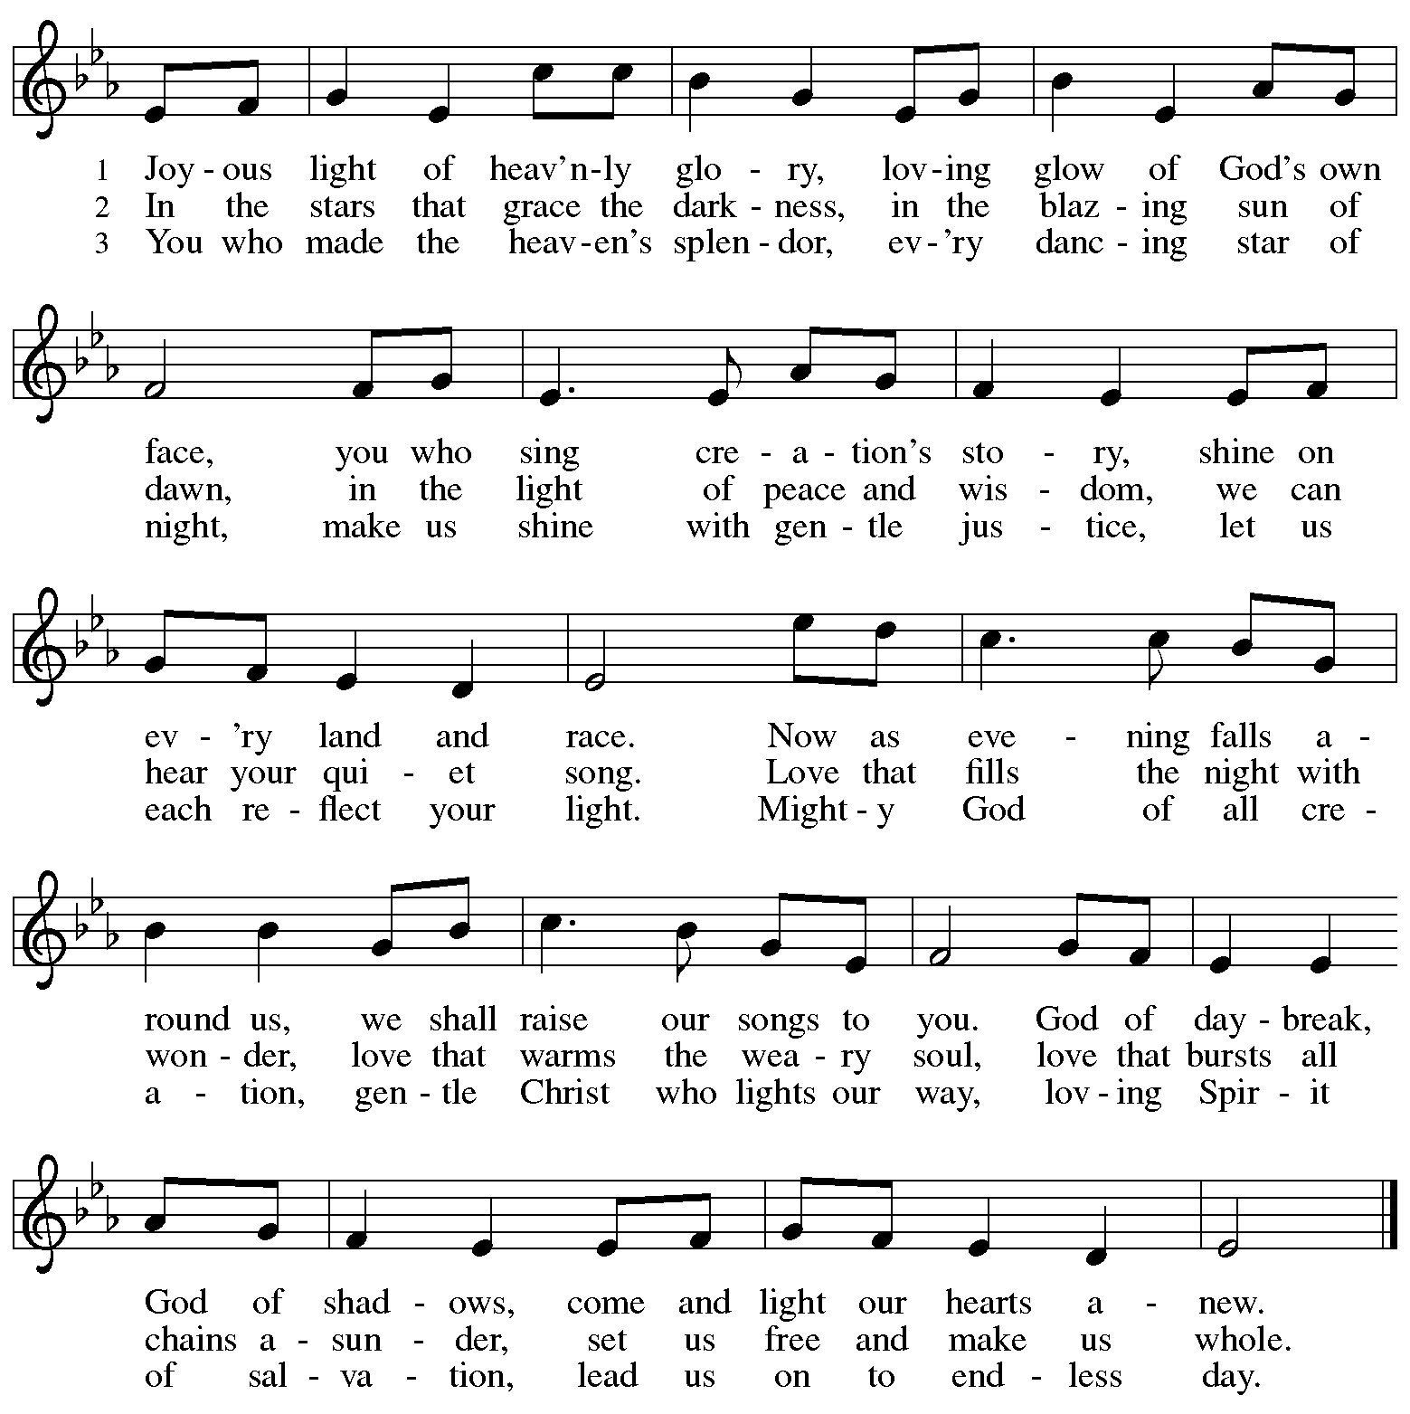

When all have returned to their places, please rise as you are able.

Blessing

P: The grace of our Lord Jesus Christ and the gifts of his body and blood strengthen, keep,
and unite us, now and forever.
C: Amen.

Hymn of Thanksgiving HS p. 20

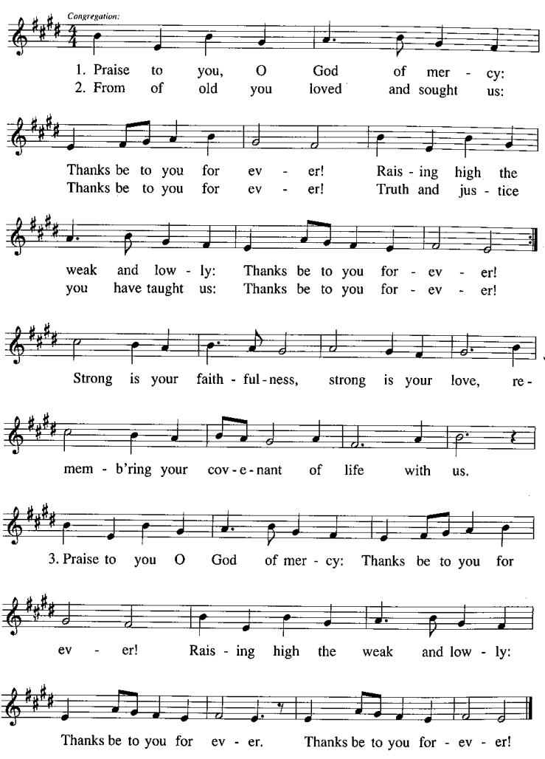
Prayer

P: Let us pray.
Faithful God, in this meal you have remembered your mercy,
bringing heaven to earth in the body and blood of Christ.
As we await the day when all your promises will be fulfilled,
sustain and strengthen us by this holy mystery.
Guide us toward your promised future coming to birth
in Jesus Christ, our Savior and Lord.
C: Amen.

Please be seated.

Sending

Announcements

Please rise as you are able.

Benediction

P: God the eternal Word,
who dwells with us in Jesus,
and who holds us in the grace of the Holy Spirit,
☩ bless you now and forever.
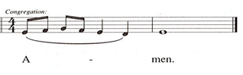
C:

Sending Hymn Awake! Awake, and Greet the New Morn Following page

Dismissal

P: Go in peace. Christ is near.
C: Thanks be to God!

Sending Hymn Awake! Awake, and Greet the New Morn ELW 242

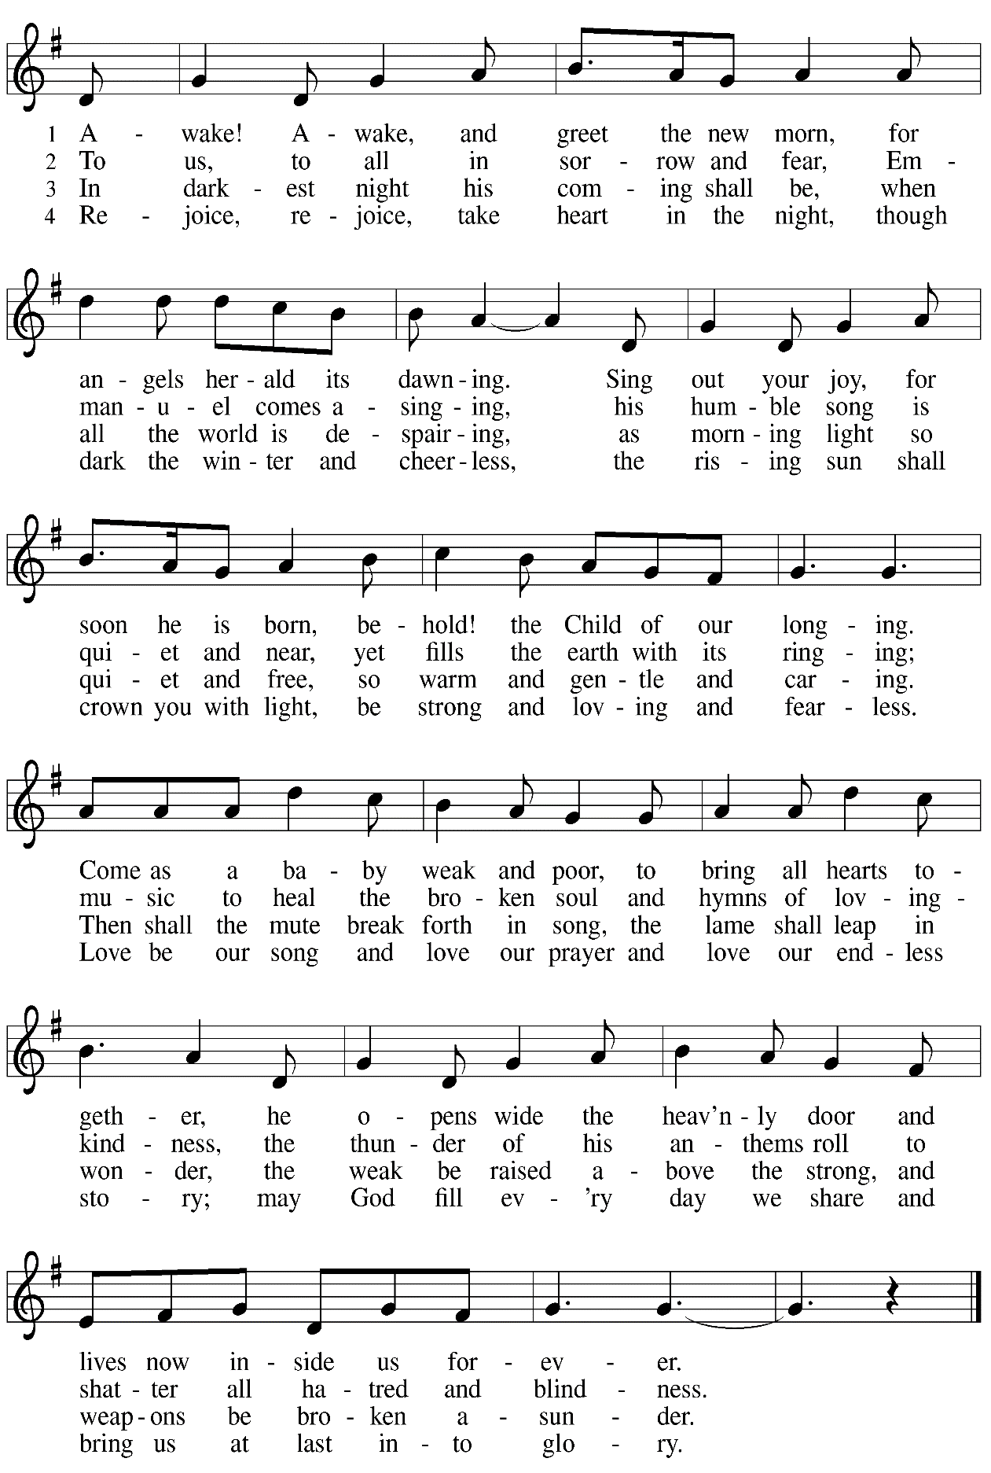
Abbreviations

P: Pastor/Presiding Minister
A: Assistant (Cantor)
L: Lector
C: Congregation

HS: Hymnal Supplement
ELW: Evangelical Lutheran Worship hymnal
ACS: All Creation Sings hymnal

Those serving in worship today

Minister of Music Laura Reynolds
Cantor Richard Krug
Lector and Communion Assistant Jodie Minor
Presiding Minister Rev. Ross Carmichael

Liturgy and Hymnody Acknowledgements

From SundaysandSeasons.com. Copyright © 2022 Augsburg Fortress. All rights reserved. Reprinted under OneLicense.net # A-722139.
Used by permission of Augsburg Fortress.

Light One Candle to Watch for Messiah – Text: Wayne L. Wold, b. 1954. Music: TIF IN VELDELE, Yiddish folk tune. Text © 1984 Fortress Press, admin. Augsburg Fortress. All rights reserved. Reprinted with permission under OneLicense.net # A-722139.

Joyous Light of Heavenly Glory – Text: Greek hymn, 3rd cent., para. Marty Haugen, b. 1950. Music: JOYOUS LIGHT, Marty Haugen. Text and music © 1987 GIA Publications, Inc., 7404 S. Mason Ave., Chicago, IL 60638. www.giamusic.com. 800.442.3358. All rights reserved. Reprinted under OneLicense.net # A-722139.

Awake! Awake, and Greet the New Morn – Text: Marty Haugen, b. 1950. Music: REJOICE, REJOICE, Marty Haugen. Text and music © 1983 GIA Publications, Inc., 7404 S. Mason Ave., Chicago, IL 60638. www.giamusic.com 800.442.3358. All rights reserved. Reprinted with permission under OneLicense.net # A-722139.

St. Andrew Lutheran Church Announcements
November 27th, 2022

- Worship in the Sanctuary and Online – Sunday, November 27th, + First Sunday of Advent – A new church year begins with the season of Advent and worship with Holy Communion this Sunday, November 27th, at 10:00 a.m. Masks are optional at St. Andrew when Allegheny County’s Covid-19 community level is in the low and medium categories. Worship will also be live-streamed to Facebook, YouTube, and Zoom. Little Church; Big Faith, our Bible lesson and activity for children, will not meet this Sunday. Worship attendees are invited to make their own name tags at the back of the worship space. Coffee hour will be held in the Social Hall next to the sanctuary after worship.
- Fall Focus on Commitment and Giving – Thank You! – We would like to thank everyone who turned in a commitment card this past week on our dedication Sunday. If you were not able to submit one this past Sunday and would like to do so, we will still be accepting them in the upcoming weeks. They can be placed in the Sunday offering plates or turned in to the church office. We are so grateful for the gifts all of you share with the St. Andrew community!
- Seeking Donations for Coffee Hour – As more people return to coffee hour or attend for the first time, it would be helpful to have additional donations to support this ministry. Any of the following would be much appreciated: Ground coffee, creamers, canned drinks, children’s drinks, individually wrapped food items of any kind. Donations may be left on the coffee table in the Social Hall. Thank you for your consideration.
- Annual Meeting of the Congregation - Sunday, December 4th, after Worship – St. Andrew's congregational constitution specifies that we hold the annual meeting of the congregation in the fourth quarter of the year, usually in November or December. This year's annual meeting will be on Sunday, December 4th, after worship. The purpose of this meeting is to elect members to serve on the Congregation Council, which serves as our board of directors, and to adopt a budget for ministry in the year ahead. Any Confirmed member of the congregation is eligible to vote at the meeting, though we welcome the presence and perspective of all from the community. No absentee or proxy votes can be accepted but we will offer a Zoom link option for those who cannot attend in person.
- Monthly Produce Distribution – Tuesday, December 6th, 5:30-7:00 p.m. – St. Andrew's monthly produce distribution in cooperation with Greater Pittsburgh Community Food Bank is coming up on its usual First Tuesday of the month, December 6th. We invite people of the congregation to help serve with the distribution itself from 5:30-7:00 p.m., or to come earlier in the day to help with setup and unloading. The delivery is usually sometime between 11:00 a.m. and 1:00 p.m., but we will call the people who sign up to let them know once we have confirmation from the food bank. If you would like to help, please sign up at https://www.signupgenius.com/go/5080544AAAC22A1F58-produce23.
- Sing with a Choir on Sunday, December 18th during Worship – If you love to sing, we are putting together a choir for the fourth Sunday of Advent, December 18. The choir will sing during the worship service. There will be two rehearsals, December 11 after service and December 18 before service. Laura will record the music and you can learn it at your own pace. Please see Laura if you are interested or contact her at ministerofmusic@standrewpittsburgh.org.
- Bethel AME Pittsburgh Updates – Our friends at Bethel AME are collecting clean, gently worn/used Winter clothing of all sizes. Items can be left on the table next to the pantry shelves in St. Andrew’s Social Hall.
- Blanket the Capitol Lawn and Cover Our Neighbors with Care – An Invitation from our Church’s Witness in Society Office – The ELCA Witness in Society office is partnering with several synods, advocates, and foundation partners to organize a Homeless Remembrance Blanket awareness event in Washington D.C. on December 21st, the longest night of the year. The event, which includes invited bishops, members of Congress, Administration officials, dignitaries, and nonprofit advocacy organizations, will be gathering hundreds of blankets from across the country in a symbolic art installation on the U.S. Capitol lawn near the Christmas tree.
The event will bring greater attention to those struggling with homelessness on the coldest nights of the year. Interested advocates are welcome to participate in-person at the U.S. Capitol, or join the full-day event virtually.

Blankets will be arriving from each state in the country, with letters and invitations to lawmakers to visit an agency or ministry with those experiencing homelessness in their district. Please consider donating a blanket or joining us in the nation's capital on Dec. 21st for the event, or on Jan. 4th, to deliver blankets and letters to members of Congress.

If you would like to connect with other Lutherans in attendance, or to help – by making a blanket, writing a letter, stitching donated squares, setting up and tearing down the art installation or delivering blankets to members of Congress in January for delivery in their districts – please email Lutheran Advocacy Ministry of Pennsylvania (LAMPa), at LAMPa@LutheranAdvocacyPA.org with “Blanket” in the subject line.
- Spiritual Care Volunteers Needed for AHN Palliative Care Patients – Palliative care is an approach that improves the quality of life for patients and their families facing problems associated with life-threatening illness, through the prevention and relief of suffering by means of early identification, assessment and treatment of pain and other problems, whether they be physical, psychosocial or spiritual.

- Spiritual Care Volunteers will visit with AHN Palliative Care patients and their families at one of our hospitals: Allegheny General, Allegheny Valley, Forbes, Jefferson, and West Penn.
- We also can use volunteers who work from their homes to call family members to provide emotional and spiritual support.
- Training is provided and required.
- Qualifications: Ability to stand and walk long hospital corridors, or use an assistive mobility device to do so. A willingness to attend volunteer orientation/training and meetings, to function as a member of one of our palliative care teams, and to complete simple charting under the direction of the spiritual care coordinator. Basic computer skills utilizing email and Zoom are very helpful.
- Clearances required (will be paid for by AHN).
- Volunteers who work in the hospitals must be up to date on all of their vaccinations, including the Covid vaccines and boosters. Current policies require everyone to wear surgical, KN95, or N95 face masks.
- We do not discriminate based on religious or spiritual beliefs. NO proselytizing is permitted.
- Free parking and meals.
For more information, contact the Spiritual Care Coordinator, Pr. Kim Rapczak, at: 412-738-4650 or Kimberly.Rapczak@ahn.org.
To apply online, go to: https://www.ahn.org/volunteer-application (Make sure to select which hospital you want to work at, and under “other,” type: “palliative care.”).
- Lutheran Campus Ministry Art Exhibit Exploring Race, Truth Be Told, Extended until the End of the Semester – Truth be Told is an art exhibit created by fourteen women artists across the country in reflection on racism. The group of seven Black women and seven white women began conversations after the murder of Goerge Floyd, which moved them each to consider one word and create an art piece around that word. The exhibit is being shown at the Lutheran University Center, 4515 Forbes Avenue, Pittsburgh 15213. Open hours of viewing are every Saturday and Sunday from 1:00-6:00 p.m. Arrangements can be made to view the exhibit during the week by contacting the campus ministry at 412-682-6886 or email pastor@psalm.online. For more information, go to http://psalm.online.

