+ Twenty-third Sunday
November 13, 2022

St. Andrew Lutheran Church
304 Morewood Ave.
Pittsburgh, PA 15213
St_andrewELCA@verizon.net
www.standrewpittsburgh.org

+ Twenty-third Sunday after Pentecost
Order for Worship

The warnings are urgent in this week’s readings: Be prepared for the coming of the Lord.
But the baptized are given and taught what they need to live in the meantime.
The baptized are strengthened for the living of these days in Word and Sacrament.
The baptized gather around the invitation of the apostle:
“Do not be weary in doing what is right.”

- Masks are optional at St. Andrew when Covid-19 community level in Allegheny County is in the low and medium categories.
- Hand sanitizer is available at the back of the sanctuary.

Worship Services are live streamed to multiple online platforms.
By attending worship, you agree that your image and voice may be broadcast.

Welcome to St. Andrew!
- Everyone is invited to make a nametag at the black bookcase in the back of the worship space if they would like.
- Worship “toolkits” to help children engage with the service are available in the black bookcase at the back of the worship space. There are “reader” and “pre-reader” resources available in each kit. Please feel free to use the kits for/with your children during worship.
- After the Prayer of the Day, children are invited to gather in the Social Hall for Little Church; Big Faith, a Bible lesson and activity. The group returns to the worship space for the Communion portion of the service.
- A restroom is available on the main level of the church, through the doors to the Social Hall and to the right in the main office.

Welcome

Prelude

Gathering
The Holy Spirit calls us together as the people of God.

Confession and Forgiveness

P: Blessed be the holy Trinity, ☩ one God,
who forgives all our sin,
whose mercy endures forever.
C: Amen.

P: God of all mercy and consolation,
come to the help of your people, turning us from our sin to live for you alone.
Give us the power of your Holy Spirit that we may confess our sin, receive your forgiveness,
and grow into the fullness of Jesus Christ, our Savior and Lord.
C: Amen.

P: Let us confess our sin in the presence of God and of one another.

Silence is kept for reflection.

P: Gracious God,
C: have mercy on us.
We confess that we have turned from you and given ourselves into the power of sin.
We are truly sorry and humbly repent.
In your compassion, forgives us our sins,
things we have done and things we have failed to do.
Turn us again to you, and uphold us by your Spirit,
so that we may live and serve you and our neighbors in newness of life,
through Jesus Christ, our Savior and Lord.
Amen.

P: God who is rich in mercy loved us even when we were dead in sin
and made us alive together with Christ.
By grace you have been saved.
In the name of ☩ Jesus Christ, your sins are forgiven.
Almighty God strengthen you with power through the Holy Spirit,
that Christ may live in your hearts through faith.
C: Amen.

Gathering Hymn Through the Night of Doubt and Sorrow ELW 327

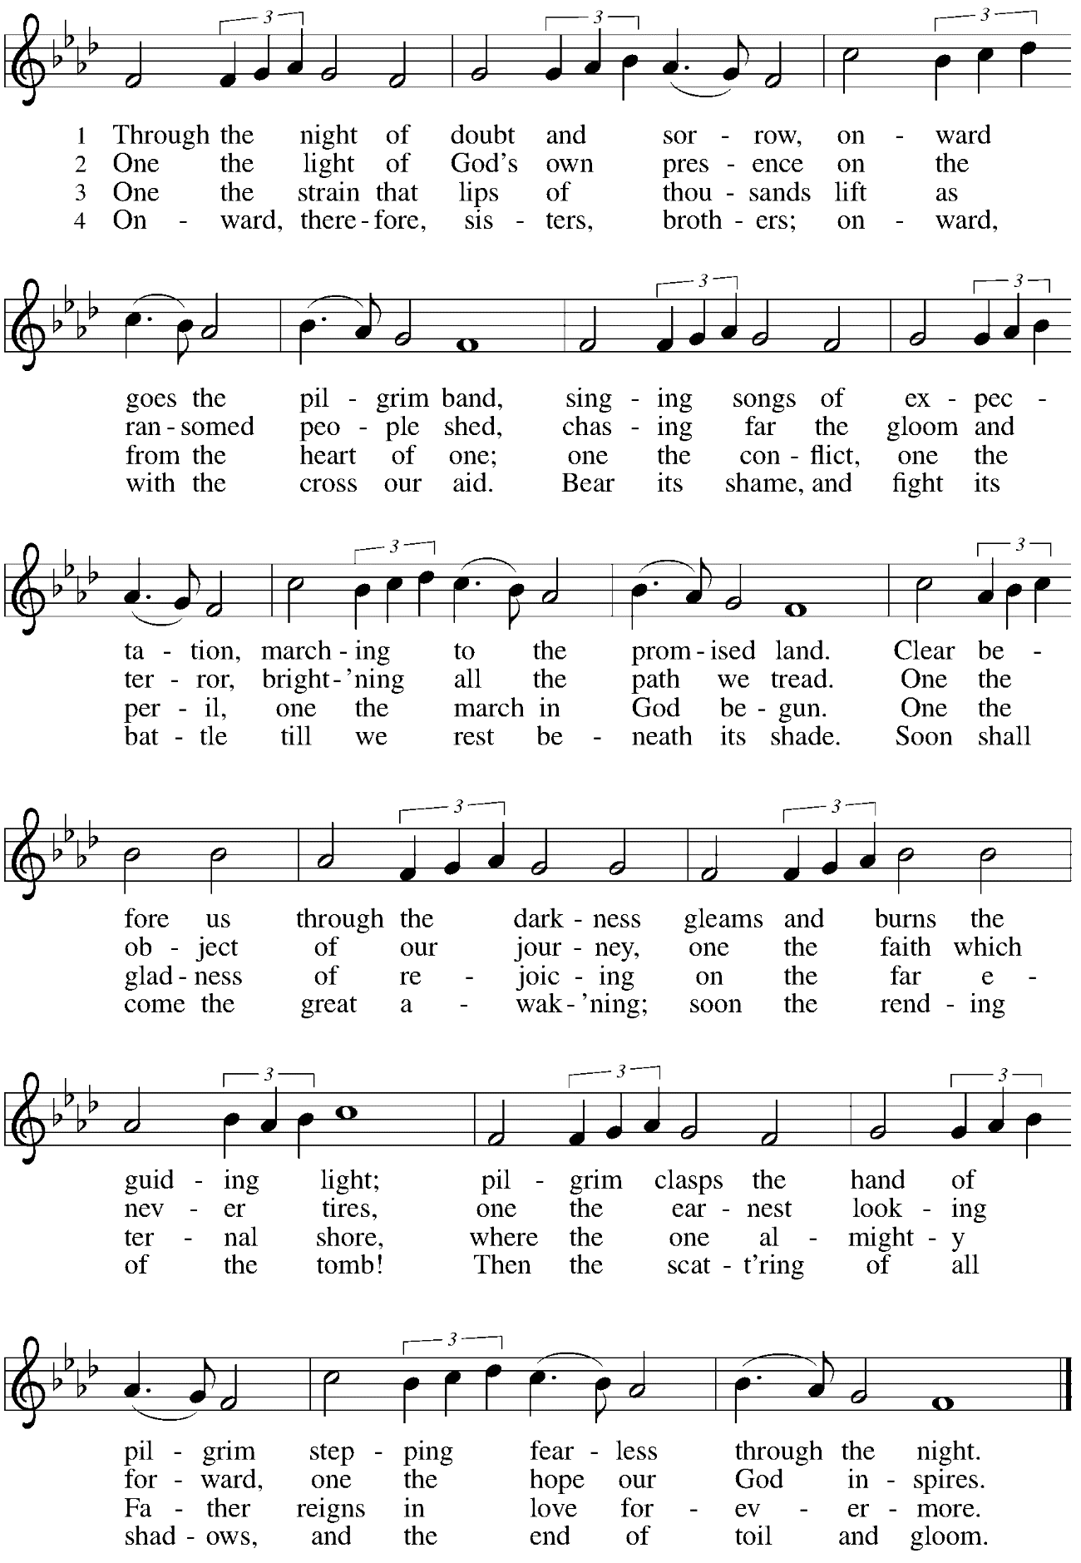
Greeting

P: The grace of our Lord Jesus Christ, the love of God,
and the communion of the Holy Spirit be with you all.
C: And also with you.

Hymn of Praise Glory to God ELW p. 148

Prayer of the Day

P: The Lord be with you.
C: And also with you.

P: Let us pray.
O God, the protector of all who trust in you, without you nothing is strong, nothing is holy. Embrace us with your mercy, that with you as our ruler and guide,
we may live through what is temporary without losing what is eternal,
through Jesus Christ, our Savior and Lord.
C: Amen.

Please be seated.
Children are invited to join the adult leaders and move to the office for Little Church; Big Faith.
We ask that one additional adult from the congregation attend with the children.

Word
God speaks to us in Scripture reading, preaching, and song

First Reading – Malachi 4: 1-2a

¹See, the day is coming, burning like an oven, when all the arrogant and all evildoers will be stubble; the day that comes shall burn them up, says the Lord of hosts, so that it will leave them neither root nor branch. ^{2a}But for you who revere my name the sun of righteousness shall rise, with healing in its wings.

L: Word of God, word of life.
C: Thanks be to God.

Psalm 98

The cantor will lead the singing of the psalm.
The congregation is invited to respond with the alternate verses in bold print.

Psalm Tone

Psalm Refrain

¹Sing a new song to the Lord, who has done | marvelous things,
whose right hand and holy arm have | won the victory.
²O Lord, you have made | known your victory,
you have revealed your righteousness in the sight | of the nations.
³You remember your steadfast love and faithfulness to the | house of Israel;
all the ends of the earth have seen the victory | of our God.
⁴Shout with joy to the Lord, | all you lands;
lift up your voice, re- | joice, and sing. R
⁵Sing to the Lord| with the harp,
with the harp and the | voice of song.
⁶With trumpets and the sound | of the horn
shout with joy before the | king, the Lord.
⁷Let the sea roar, and | all that fills it,
the world and those who | dwell therein.
⁸Let the rivers | clap their hands,
and let the hills ring out with joy before the Lord, who comes to | judge the earth.
⁹The Lord will judge the | world with righteousness
and the peo- | ples with equity. R

Second Reading – 2 Thessalonians 3: 6-13

⁶Now we command you, beloved, in the name of our Lord Jesus Christ, to keep away from believers who are living in idleness and not according to the tradition that they received from us. ⁷For you yourselves know how you ought to imitate us; we were not idle when we were with you, ⁸and we did not eat anyone’s bread without paying for it; but with toil and labor we worked night and day, so that we might not burden any of you. ⁹This was not because we do not have that right, but in order to give you an example to imitate. ¹⁰For even when we were with you, we gave you this command: Anyone unwilling to work should not eat. ¹¹For we hear that some of you are living in idleness, mere busybodies, not doing any work. ¹²Now such persons we command and exhort in the Lord Jesus Christ to do their work quietly and to earn their own living. ¹³Kindred, do not be weary in doing what is right.

L: Word of God, word of life.
C: Thanks be to God.

Please rise as you are able.

Gospel Acclamation Alleluia ELW p. 151

Gospel – Luke 21: 5-19

P: The holy Gospel according to St. Luke.
C: Glory to you, O Lord.
⁵When some were speaking about the temple, how it was adorned with beautiful stones and gifts dedicated to God, [Jesus] said, ⁶“As for these things that you see, the days will come when not one stone will be left upon another; all will be thrown down.”
⁷They asked him, “Teacher, when will this be, and what will be the sign that this is about to take place?” ⁸And he said, “Beware that you are not led astray; for many will come in my name and say, ‘I am the one!’ and, ‘The time is near!’ Do not go after them.
⁹“When you hear of wars and insurrections, do not be terrified; for these things must take place first, but the end will not follow immediately.” ¹⁰Then he said to them, “Nation will rise against nation, and kingdom against kingdom; ¹¹there will be great earthquakes, and in various places famines and plagues; and there will be dreadful portents and great signs from heaven.
¹²“But before all this occurs, they will arrest you and persecute you; they will hand you over to synagogues and prisons, and you will be brought before kings and governors because of my name. ¹³This will give you an opportunity to testify. ¹⁴So make up your minds not to prepare your defense in advance; ¹⁵for I will give you words and a wisdom that none of your opponents will be able to withstand or contradict. ¹⁶You will be betrayed even by parents and brothers, by relatives and friends; and they will put some of you to death. ¹⁷You will be hated by all because of my name. ¹⁸But not a hair of your head will perish. ¹⁹By your endurance you will gain your souls.”

P: The Gospel of the Lord.
C: Praise to you, O Christ.

Please be seated.

Sermon

A time of silence for prayer and reflection follows the sermon.
When the hymn of the day begins, please rise as you are able.

Hymn of the Day God Alone Be Praised ACS 1023

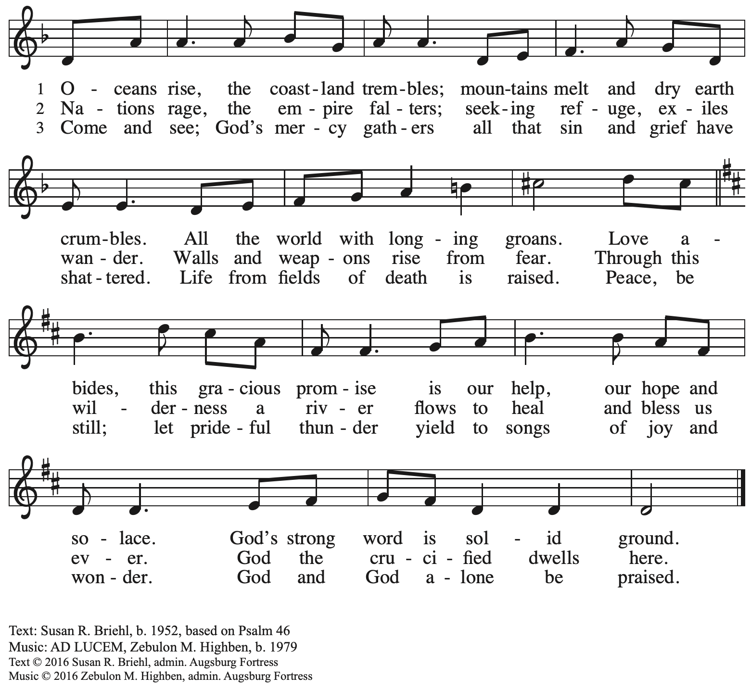

Prayers of the People

P: As scattered grains of wheat are gathered into one bread,
so let us gather our prayers for the church, those in need, and all of God’s creation.

After each petition
P: God of grace,
C: receive our prayer.

P: Gathered in the communion of the Holy Spirit, we offer these and all our prayers to you, gracious God, through Jesus Christ, our Savior.
C: Amen.

Please be seated.

Meal

Reflection on Giving and Commitment

Offering

We offer ourselves, our gifts, and our faithful service to God.
An usher will pass around an offering plate for anyone who would like to offer gifts before God.

Music during the Offering

Please rise as you are able.

Offertory Song Let the Vineyards ELW 184

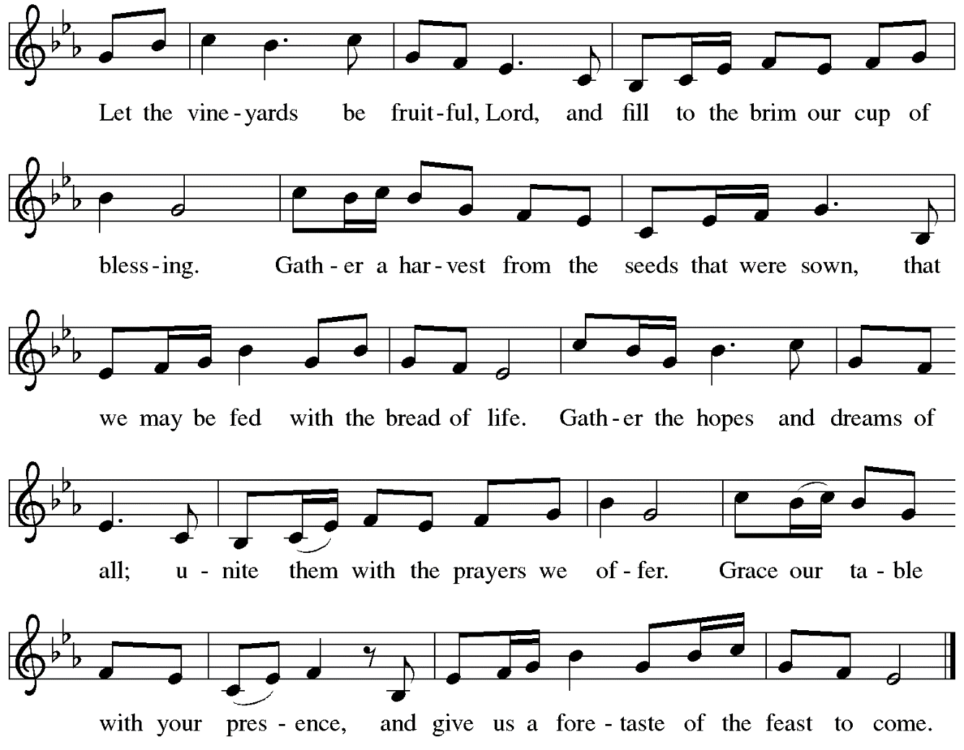

Offertory Prayer

P: Let us pray. God, of all creation,
C: all you have made is good, and your love endures forever.
You bring forth bread from the earth and fruit from the vine.
Nourish us with these gifts, that we might be for the world
signs of your gracious presence in Jesus Christ, our Savior and Lord.
Amen.

Dialogue ELW p. 152

Preface (Sung by the presiding minister)

P: It is indeed right, our duty and our joy,
that we should at all times and in all places
give thanks and praise to you, almighty and merciful God,
through our Savior Jesus Christ;
who on this day overcame death and the grave,
and by his glorious resurrection opened to us the way of everlasting life.
And so, with all the choirs of angels,
with the church on earth and the hosts of heaven,
we praise your name and join their unending hymn:

Sanctus ELW p. 153

Eucharistic Prayer

P: Holy God …
… with every breath.
C: We praise you, O God.

P: Generations bless your faithfulness …
… into the future.
C: We bless you, O God.

P: We give you thanks for your dear Son …
… with us now.
C: We thank you, O God.

P: In the night in which he was betrayed …
… Do this for the remembrance of me.

Remembering his love for us on the way, at the table, and to the end,
we proclaim the mystery of faith.
C: Christ has died. Christ is risen. Christ will come again.

P: We pray for the gift of your Spirit …
… by your Spirit, in your church, without end.
C: Amen.

Lord’s Prayer

P: Gathered as one by the Holy Spirit, let us pray as Jesus taught us.
C: Our Father in heaven,
hallowed be your name,
your kingdom come,
your will be done,
on earth as in heaven.
Give us today our daily bread.
Forgive us our sins
as we forgive those who sin against us.
Save us from the time of trial
and deliver us from evil.
For the kingdom, the power,
and the glory are yours,
now and forever. Amen.

Fraction and Invitation

Agnus Dei / Lamb of God ELW p. 154

Please be seated.

Holy Communion
- Worshipers from the pulpit side will proceed forward first, followed by the center section, and then the lectern side.
- The Communion wafers (regular and gluten-free) have been prepared by St. Andrew’s altar care team, with a drop of wine or grape juice on each.
- When you reach the presiding minister, please indicate if you would like grape juice or a gluten-free wafer.
- A blessing will be provided for anyone who does not yet receive the sacrament.
- If for accessibility or other concerns you need Communion brought to you, please let an usher know and the presiding minister will come to you.
- Cushions have been placed at the altar rail for anyone who would like to kneel for prayer and reflection before returning to their pew.

Hymn during Holy Communion
Nada te turbe / Nothing Can Trouble ACS 1033

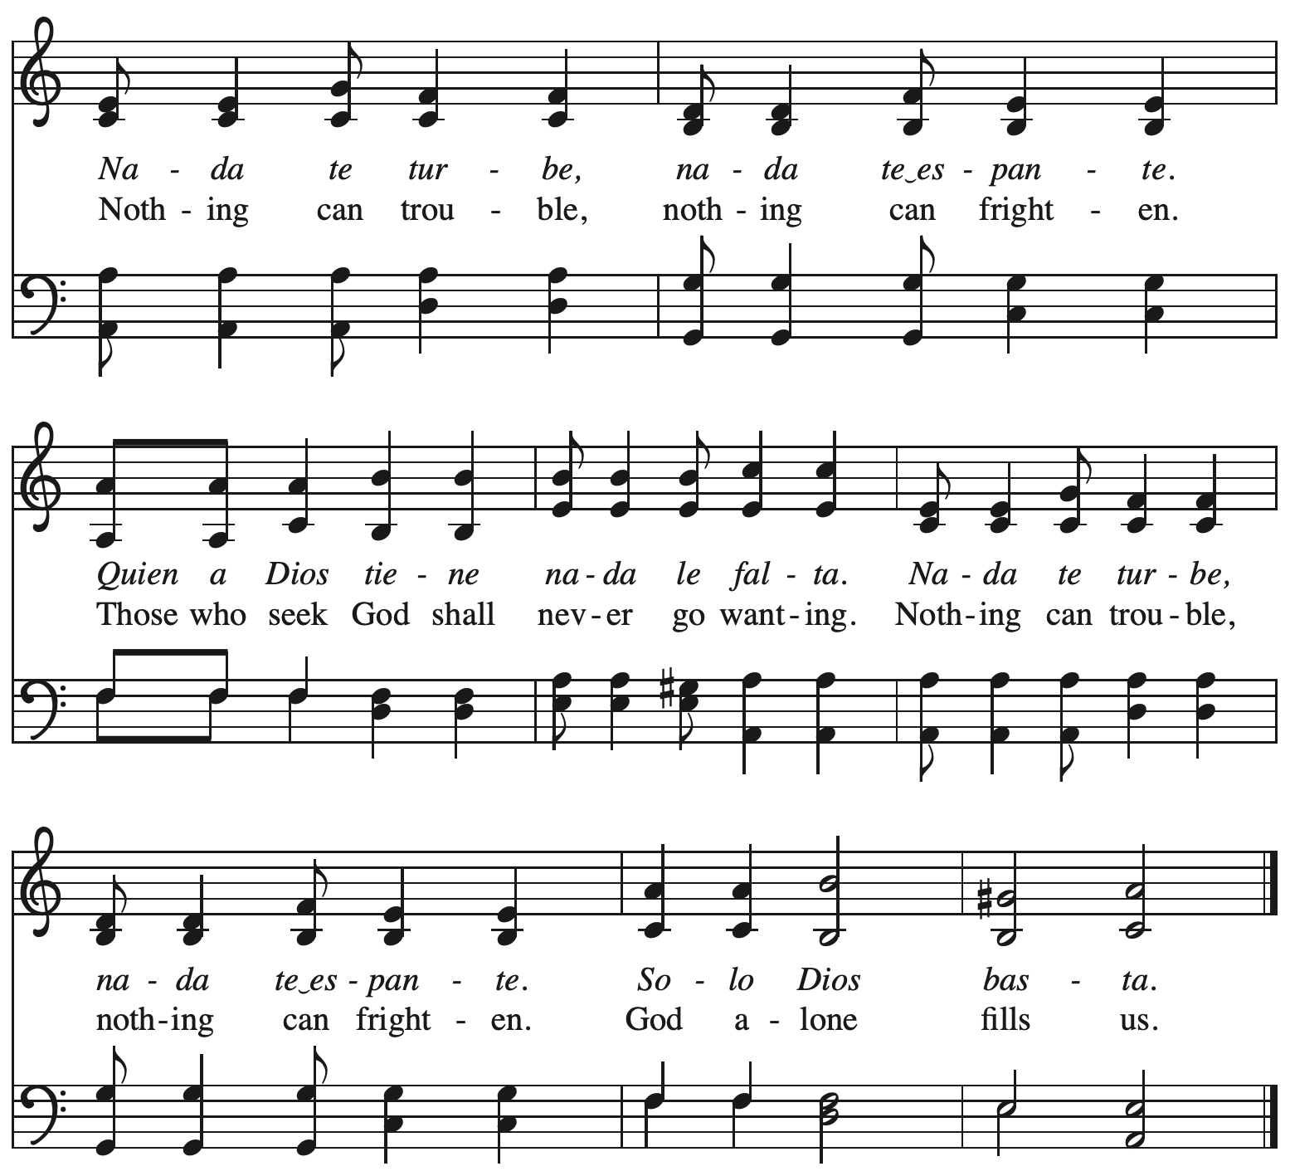
Hymn during Holy Communion
In the Midst of Earthly Life ACS 1026
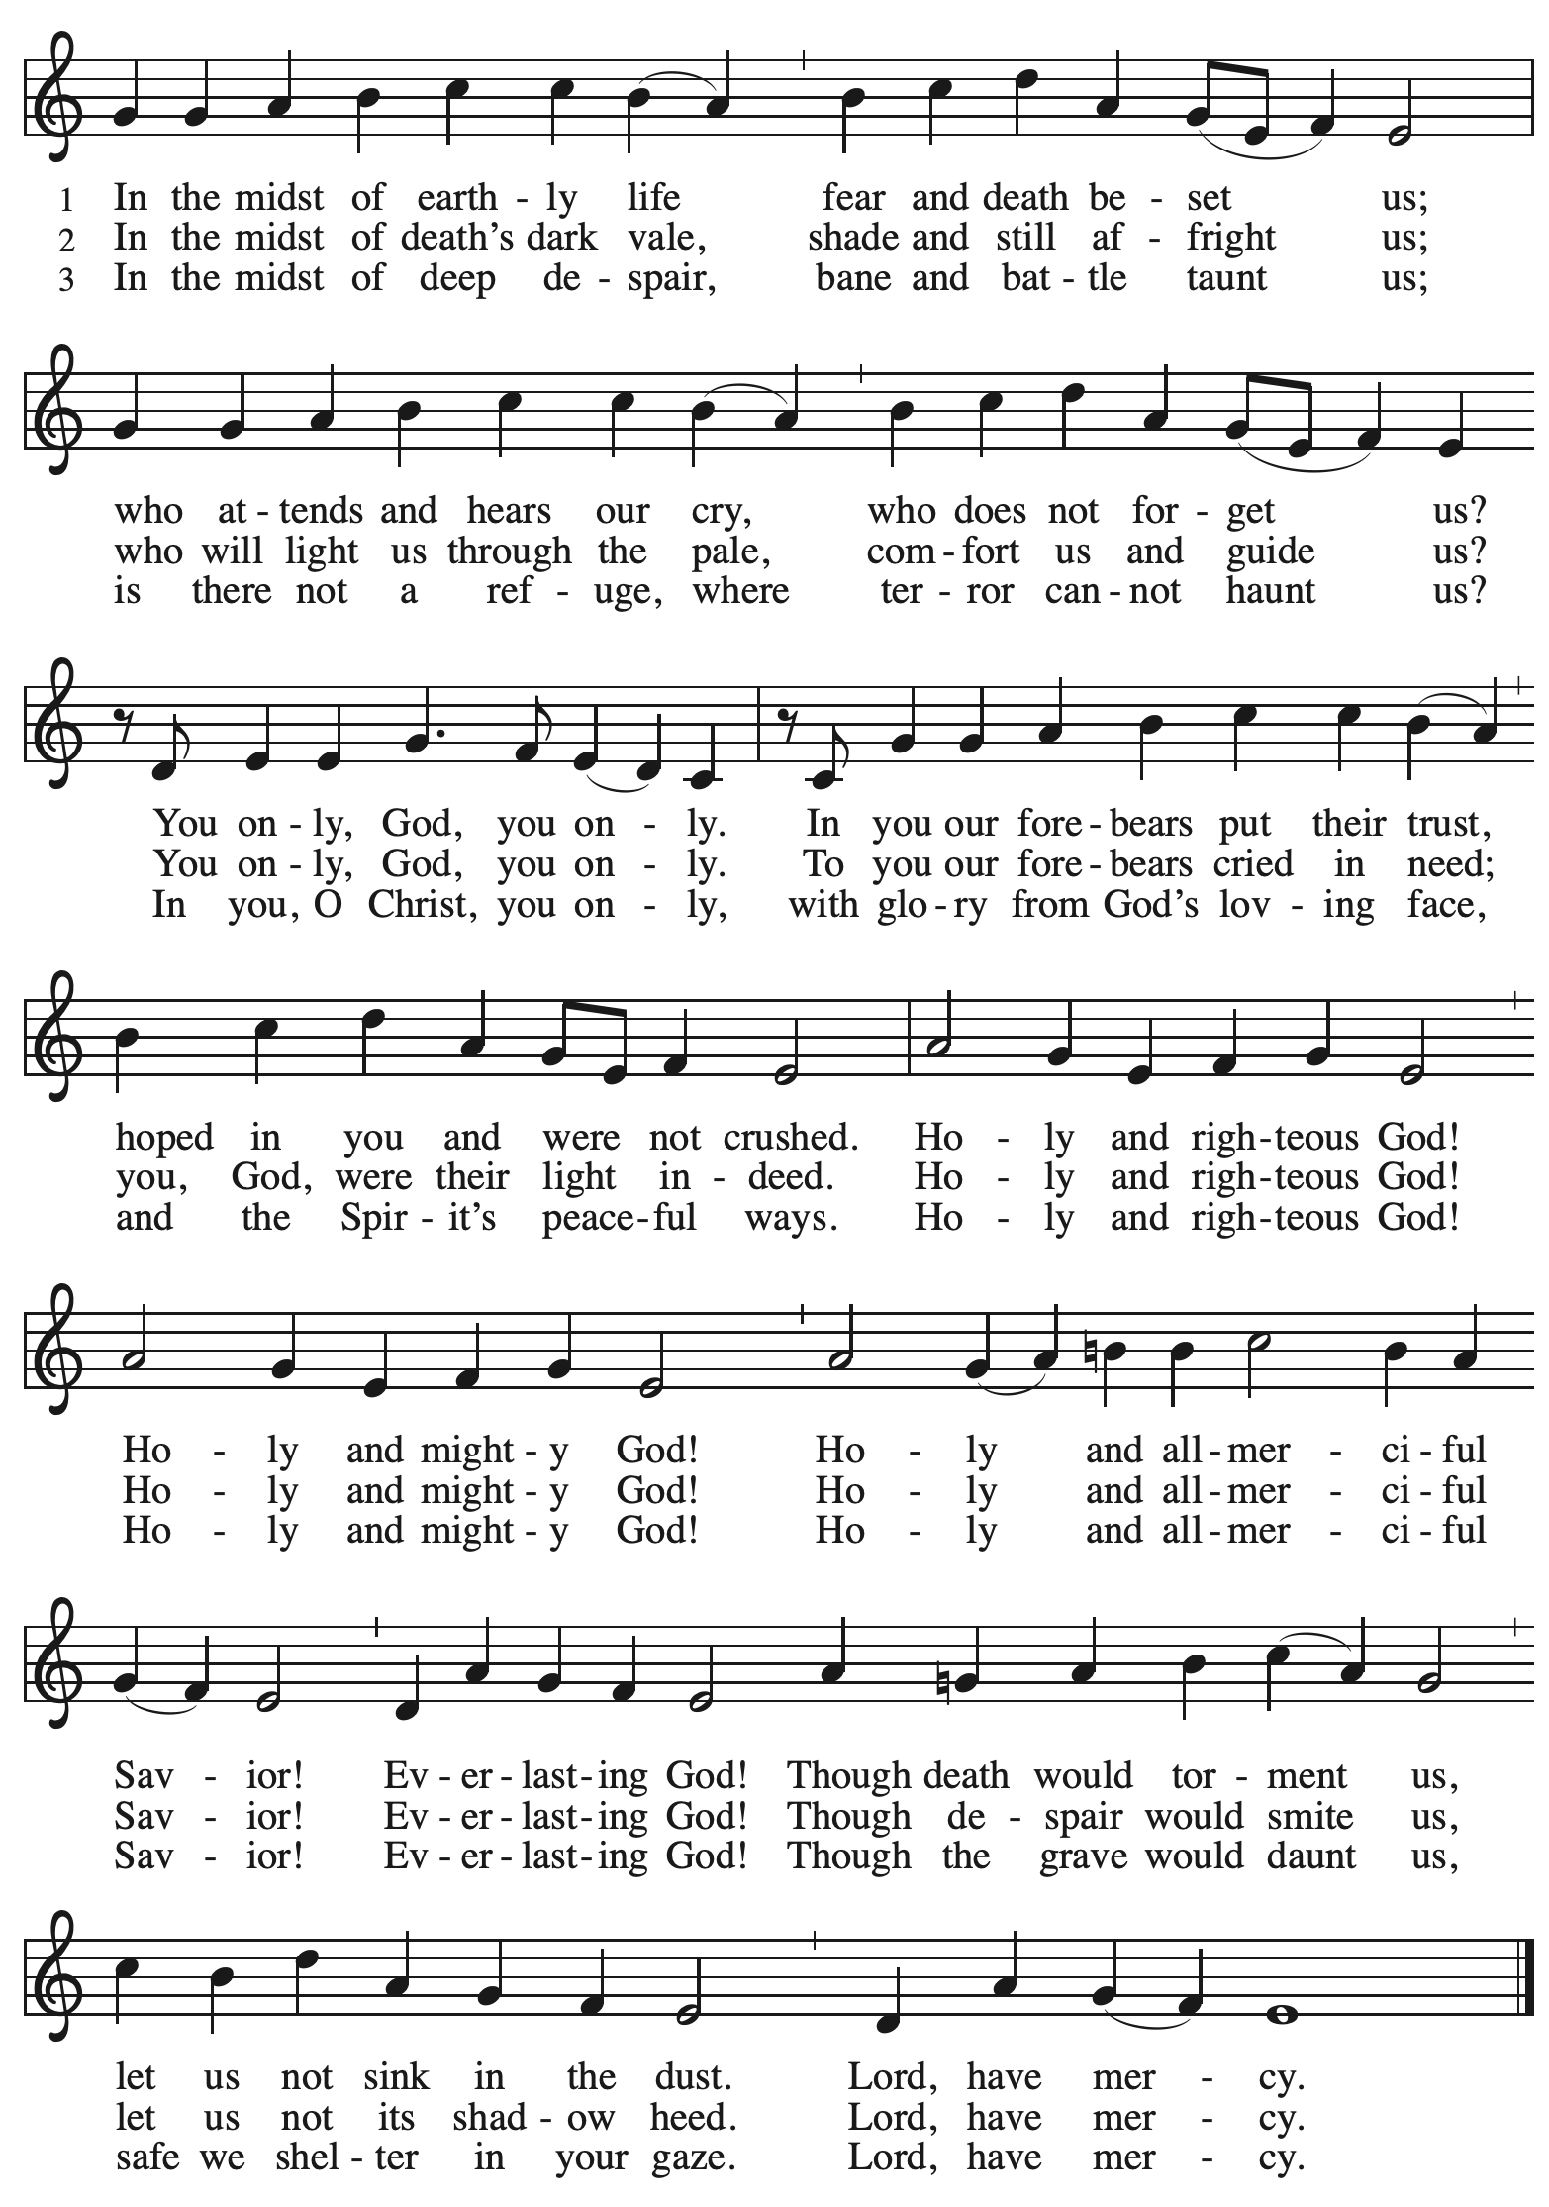
Hymn during Holy Communion
When Peace, like a River ELW 785

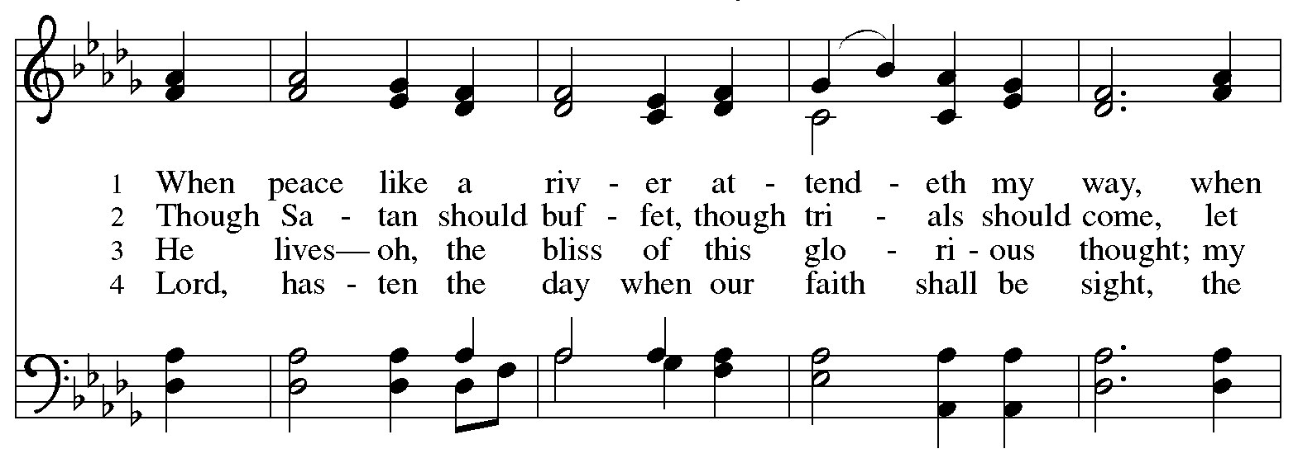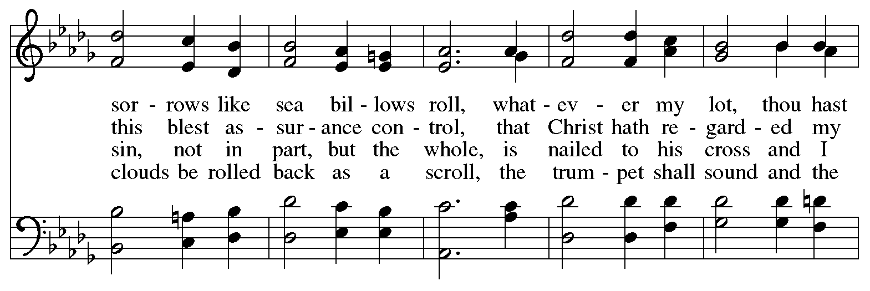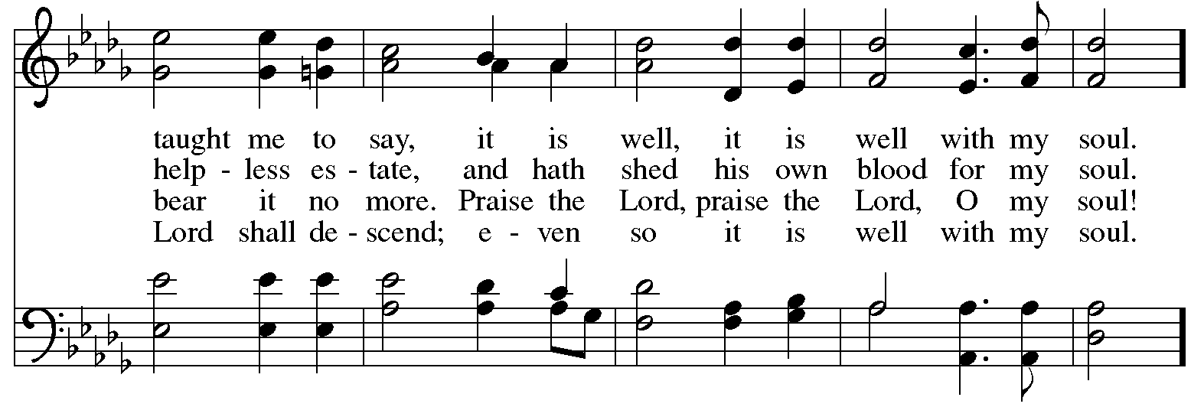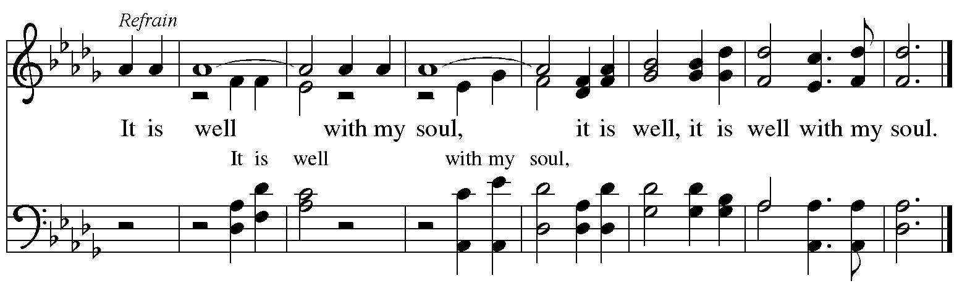

When all have returned to their places, please rise as you are able.

Blessing

P: The body and blood of our Lord Jesus Christ strengthen you and keep you in his grace.
C: Amen.

Prayer

P: Let us pray.
P: God of abundance, you have refreshed our hearts in this meal with bread for the journey.
Give us your grace on the way, that we may serve our neighbors with joy
and proclaim your goodness in all things, through Jesus Christ, our Savior and Lord.
C: Amen.

Please be seated.

Sending

Announcements

Please rise as you are able.

Benediction

P: God who gives life to all things
and frees us from despair,
bless you with truth and peace.
The holy Trinity, ☩ one God,
guide you always in faith, hope, and love.
C: Amen.

Sending Hymn Rise, O Sun of Righteousness Following page
v. 1-2, 4-5

Dismissal

P: Go in peace. Christ is with you.
C: Thanks be to God!

Sending Hymn Rise, O Sun of Righteousness ELW 657
v. 1-2, 4-5

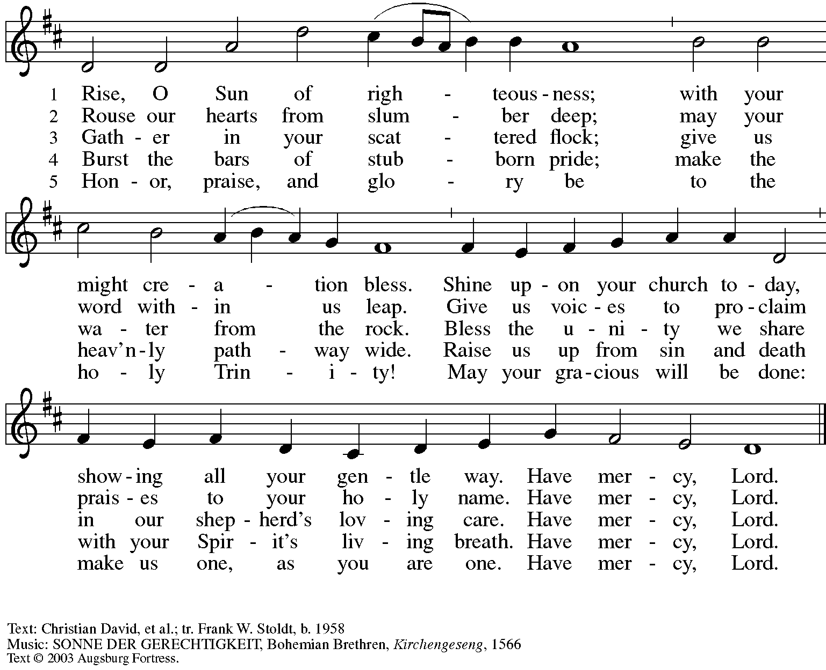
All rights reserved. Reprinted with permission under OneLicense.net #A-722139.

Abbreviations

P: Pastor/Presiding Minister
L: Lector
C: Congregation

ELW: Evangelical Lutheran Worship hymnal
ACS: All Creation Sings hymnal

Those serving in worship today

Minister of Music Laura Reynolds
Lector Lester Prince
Presiding Minister Rev. Ross Carmichael

Liturgy and Hymnody Acknowledgements

From SundaysandSeasons.com. Copyright © 2022 Augsburg Fortress. All rights reserved. Reprinted under OneLicense.net # A-722139.
Used by permission of Augsburg Fortress.

Let the Vineyards – Text: John W. Arthur, 1922-1980. Music: Ronald A. Nelson, b. 1927. Text and music © 1978 Lutheran Book of Worship, admin. Augsburg Fortress. All rights reserved. Reprinted with permission under OneLicense.net # A-722139.

Through the Night of Doubt and Sorrow – Text: Bernhardt S. Ingemann, 1789-1862; tr. Sabine Baring-Gould, 1834-1924, alt.
Music: EBENEZER, Thomas J. Williams, 1869-1944. All rights reserved. Reprinted with permission under OneLicense.net # A-722139.

In the Midst of Earthly Life – Text: Martin Luther, 1483-1546; tr. Susan Palo Cherwien, b. 1953.
Music: MITTEN WIR IM LEBEN SIND, Gradual, 13th cent., adapt. Johann Walter, 1496-1570.
Text © 2005 Susan Palo Cherwien, admin. Augsburg Fortress.
All rights reserved. Reprinted with permission under OneLicense.net #A-722139.

Nada te turbe / Nothing Can Trouble – Text: Teresa of Avila, 1515-1582; adapt. Taizé Community.
Music: NADA TE TURBE, Jacques Berthier, 1923-1994.
Text and Music © 1986, 1991, Ateliers et Presses de Taizé, admin GIA Publications, Inc. giamusic.com.
All rights reserved. Reprinted under OneLicense.net # A-722139.

When Peace, like a River / It Is Well with My Soul – Text: Horatio G. Spafford, 1828-1888.
Music: VILLE DU HAVRE, Philip P. Bliss, 1838-1876.

St. Andrew Lutheran Church Announcements
November 13th, 2022

- Worship in the Sanctuary and Online – Sunday, November 13th, + Twenty-third Sunday after Pentecost – St. Andrew’s next service of Holy Communion will be this Sunday, November 13th, at 10:00 a.m. Masks are optional at St. Andrew when Allegheny County’s Covid-19 community level is in the “low” and “medium” categories. Worship will also be live-streamed to Facebook, YouTube, and Zoom. Worship attendees are invited to make their own name tags at the back of the worship space. Coffee hour will be held in the Social Hall next to the sanctuary after worship.
- Fall Focus on Commitment and Giving – Each year around this time, St. Andrew offers the congregation the opportunity to make a commitment to financial giving in the upcoming year as our grateful response to all God's gifts. The congregation recently sent a mailing with a commitment card for your prayerful consideration over the next week. In conjunction with this focus, we will hear a reflection on giving during worship today. We then invite you to bring your completed commitment card with you to worship next Sunday, November 20th, when we will dedicate our gifts in the service. Thank you for the many ways you support the ministries of St. Andrew!
- Help for Kelly and Joyce - Transportation Needed! – St. Andrew's treasurer, Kelly Spanninger, suffered a fall this week, requiring surgery and hospitalization. She will likely be moving to rehabilitation at another facility soon. Kelly wife Joyce does not drive, so we are seeking to arrange transportation for Joyce to visit Kelly on Mondays, Tuesdays, and Fridays around 6:00 p.m. and on the weekends (speak with Joyce to discuss details. Anyone able to help is encouraged to sign up at: https://www.signupgenius.com/go/4090f45afaf2ba75-rides.
- Shelter Dinner at East End Cooperative Ministry – Thursday, November 17th, 6:30 p.m. – On the third Thursday of every month, people from St. Andrew prepare or provide and serve a meal with guests of East End Cooperative Ministry. EECM is located at 6140 Station St., Pittsburgh 15206. If you would like to help, please sign up here: https://www.signupgenius.com/go/5080544AAAC22A1F58-shelter35.
- St. Andrew Christmas and Holiday Giving Focus – Foster Love Project – St. Andrew offers one or two local organizations each year for the congregation to focus our Christmas and holiday giving. This year, we invite your support for the Foster Love Project (Foster Love Project - Foster Love Project), whose mission is “to provide love in action for kids in foster care, as well as support to the families who are providing care for them.” The bulletin board in the social hall has a set of tags containing items for which children and youth in foster care have asked – these tags indicate price and have a QR code to link directly to a site for online purchase. You can also see the list of items here:
https://www.target.com/gift-registry/gift/flp-holiday-standrew. If you choose one, please let Vanessa Brown (community@standrewpittsburgh.org) know and then take the tag the next time you are at the church building. Purchases should be made by December 1st. Thank you for your generosity!
- Bethel AME Church Pittsburgh Updates
  - Prayer Group Meets Saturday, November 12th, 12:00 p.m. at Bethel, 2720 Webster Avenue, 15219. This group plans to meet twice monthly in prayer and may occasionally meet at Bethel’s historic site. All are encouraged to attend.
  - Press Conference Date Moved to Friday, November 18th, 11:00 a.m. at Bethel.
  - Reparations Petition Still Available – Bethel invites signatures on a petition in partnership with the Color of Change organization in their pursuit of reparations for their land and church that were taken in the 1950s. To sign or share the petition, please visit: https://bit.ly/Justice4Bethel. A paper copy is available at the name tag cabinet in the back of St. Andrew's worship space for those who would like to sign using that medium.
- Spiritual Care Volunteers Needed for AHN Palliative Care Patients – Palliative care is an approach that improves the quality of life for patients and their families facing problems associated with life-threatening illness, through the prevention and relief of suffering by means of early identification, assessment and treatment of pain and other problems, whether they be physical, psychosocial or spiritual.

- Spiritual Care Volunteers will visit with AHN Palliative Care patients and their families at one of our hospitals: Allegheny General, Allegheny Valley, Forbes, Jefferson, and West Penn.
- We also can use volunteers who work from their homes to call family members to provide emotional and spiritual support.
- Training is provided and required.
- Qualifications: Ability to stand and walk long hospital corridors, or use an assistive mobility device to do so. A willingness to attend volunteer orientation/training and meetings, to function as a member of one of our palliative care teams, and to complete simple charting under the direction of the spiritual care coordinator. Basic computer skills utilizing email and Zoom are very helpful.
- Clearances required (will be paid for by AHN).
- Volunteers who work in the hospitals must be up to date on all of their vaccinations, including the Covid vaccines and boosters. Current policies require everyone to wear surgical, KN95, or N95 face masks.
- We do not discriminate based on religious or spiritual beliefs. NO proselytizing is permitted.
- Free parking and meals.
For more information, contact the Spiritual Care Coordinator, Pr. Kim Rapczak, at: 412-738-4650 or Kimberly.Rapczak@ahn.org.
To apply online, go to: https://www.ahn.org/volunteer-application (Make sure to select which hospital you want to work at, and under “other,” type: “palliative care.”).
- Climate Care Social Message from the Evangelical Lutheran Church in America - Read and Comment!

The earth is the Lord's, and all that is in it, the world, and those who live in it!
(Psalm 24: 1)

What is a faithful Lutheran response to the Earth's changing climate and worsening natural disasters? How do we think about this crisis as people of faith, and what are we called to do?
After hearing requests from across the church for guidance, the ELCA Church Council in November 2021 authorized development of a social message on climate care. Social messages are ELCA social teaching documents on specific social topics; these documents shape ELCA policy and help members discern how to respond to an issue.
A draft of the social message "Earth's Climate Crisis" is now posted for public comment! Feedback of this kind helps the drafters know how the document could be more clear, helpful and faithfully Lutheran. Please read the social message draft and use this survey to share your input by Friday, Dec. 2nd.
Questions or longer responses can be emailed to draftsocialmessage@elca.org.
Read and respond here: https://elca.org/climatecare
The drafters and review team will study the public feedback to prepare a proposed social message. That proposed message will be reviewed by the Conference of Bishops and presented to the Church Council for consideration this coming spring.
This public comment period is your chance to contribute directly as our church considers how to address this crucial topic affecting God's good creation. Please help improve this social message so it can be as effective as possible. And share the news with others, so they can participate too!
God's peace,
Rev. Roger A. Willer, Ph.D.
Director for Theological Ethics
Office of the Presiding Bishop, ELCA
- Lutheran Campus Ministry Art Exhibit Exploring Race, Truth Be Told, Extended until the End of the Semester – Truth be Told is an art exhibit created by fourteen women artists across the country in reflection on racism. The group of seven Black women and seven white women began conversations after the murder of Goerge Floyd, which moved them each to consider one word and create an art piece around that word. The exhibit is being shown at the Lutheran University Center, 4515 Forbes Avenue, Pittsburgh 15213. Open hours of viewing are every Saturday and Sunday from 1:00-6:00 p.m. Arrangements can be made to view the exhibit during the week by contacting the campus ministry at 412-682-6886 or email pastor@psalm.online. For more information, go to http://psalm.online.

