+ Reign of Christ Sunday
November 20, 2022

St. Andrew Lutheran Church
304 Morewood Ave.
Pittsburgh, PA 15213
St_andrewELCA@verizon.net
www.standrewpittsburgh.org

+ Reign of Christ Sunday
Order for Worship

Jeremiah’s promise of the execution of “justice and righteousness in the land”
finds ironic fulfillment in the execution of Jesus of Nazareth, the King of the Jews.
It appears utterly contradictory that a king should be crucified with a criminal.
This victory appears for all the world as humiliating defeat.
Yet through the gate of death Jesus opens the door to paradise.

- Masks are optional at St. Andrew when Covid-19 community level in Allegheny County is in the low and medium categories.
- Hand sanitizer is available at the back of the sanctuary.

Worship Services are live streamed to multiple online platforms.
By attending worship, you agree that your image and voice may be broadcast.

Welcome to St. Andrew!
- Everyone is invited to make a nametag at the black bookcase in the back of the worship space if they would like.
- Worship “toolkits” to help children engage with the service are available in the black bookcase at the back of the worship space. There are “reader” and “pre-reader” resources available in each kit. Please feel free to use the kits for/with your children during worship.
- After the Prayer of the Day, children are invited to gather in the Social Hall for Little Church; Big Faith, a Bible lesson and activity. The group returns to the worship space for the Communion portion of the service.
- A restroom is available on the main level of the church, through the doors to the Social Hall and to the right in the main office.

Welcome

Prelude

Gathering
The Holy Spirit calls us together as the people of God.

Confession and Forgiveness

P: Blessed be the holy Trinity, ☩ one God,
who forgives all our sin,
whose mercy endures forever.
C: Amen.

P: God of all mercy and consolation,
come to the help of your people, turning us from our sin to live for you alone.
Give us the power of your Holy Spirit that we may confess our sin, receive your forgiveness,
and grow into the fullness of Jesus Christ, our Savior and Lord.
C: Amen.

P: Let us confess our sin in the presence of God and of one another.

Silence is kept for reflection.

P: Gracious God,
C: have mercy on us.
We confess that we have turned from you and given ourselves into the power of sin.
We are truly sorry and humbly repent.
In your compassion, forgives us our sins,
things we have done and things we have failed to do.
Turn us again to you, and uphold us by your Spirit,
so that we may live and serve you and our neighbors in newness of life,
through Jesus Christ, our Savior and Lord.
Amen.

P: God who is rich in mercy loved us even when we were dead in sin
and made us alive together with Christ.
By grace you have been saved.
In the name of ☩ Jesus Christ, your sins are forgiven.
Almighty God strengthen you with power through the Holy Spirit,
that Christ may live in your hearts through faith.
C: Amen.

Gathering Hymn Beautiful Savior ELW 838

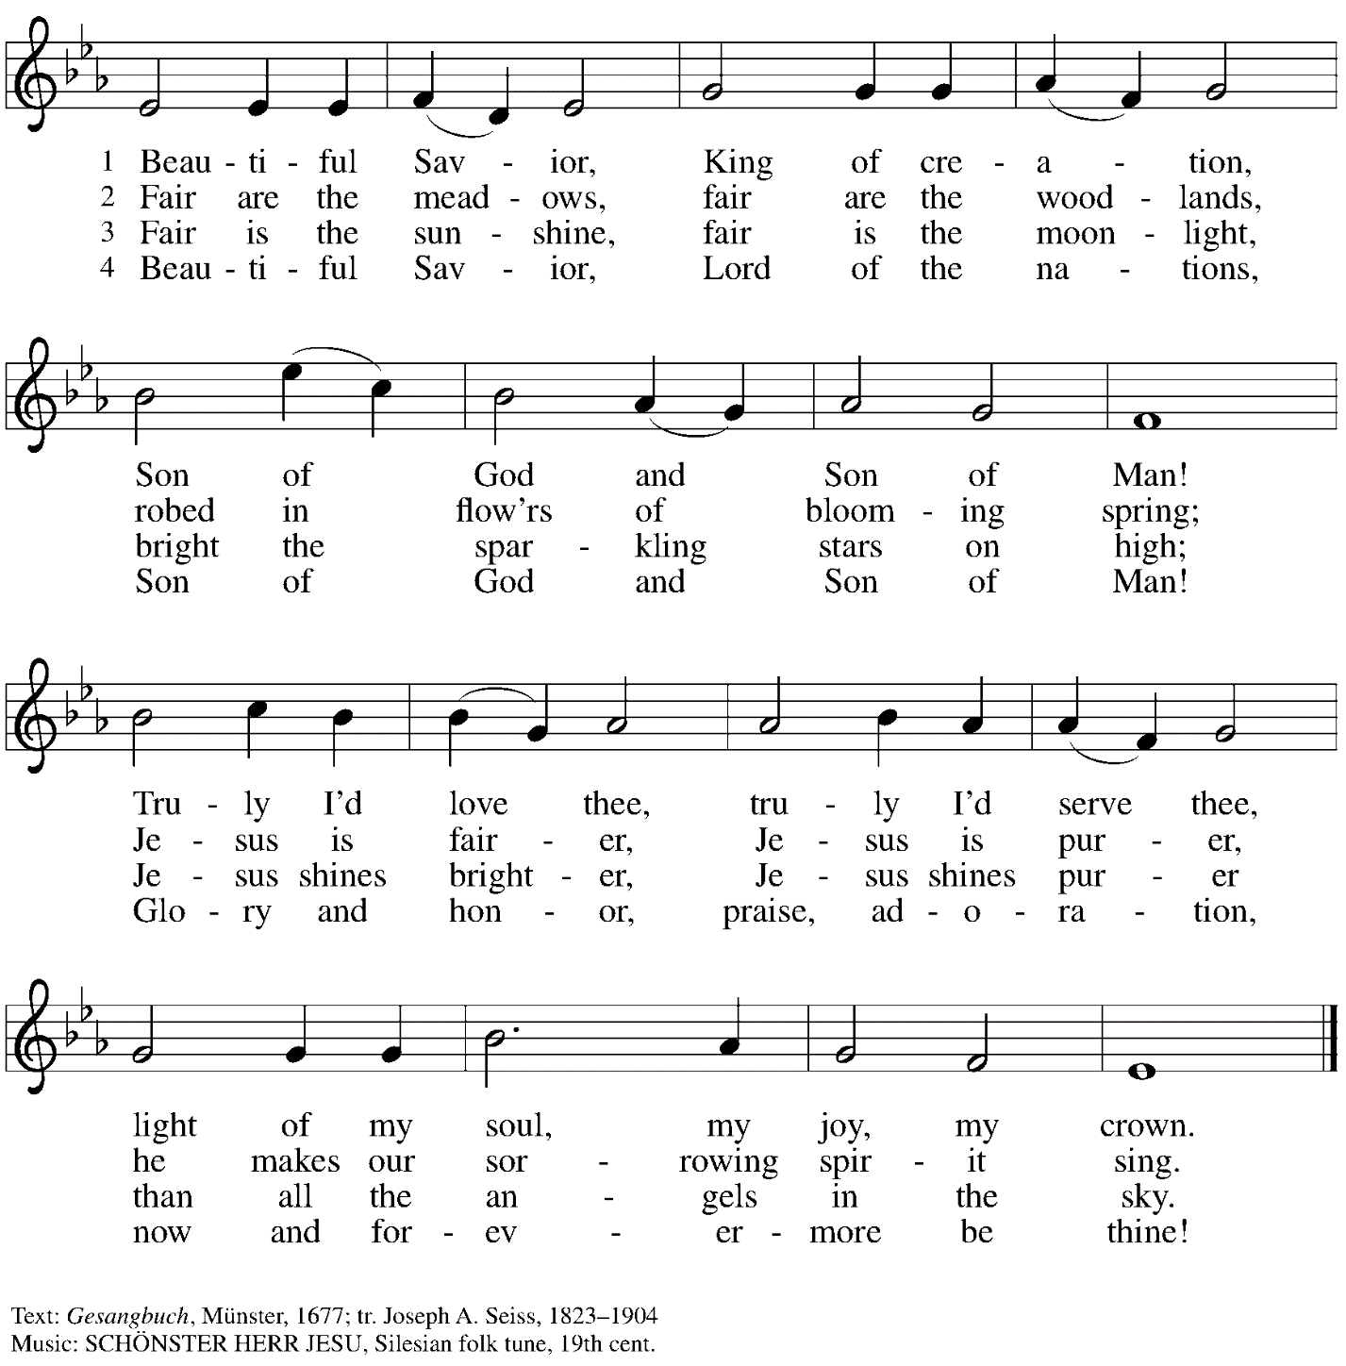

Greeting

P: The grace of our Lord Jesus Christ, the love of God,
and the communion of the Holy Spirit be with you all.
C: And also with you.

Hymn of Praise Glory to God ELW p. 148

Prayer of the Day

P: The Lord be with you.
C: And also with you.

P: Let us pray.
O God, our true life, to serve you is freedom, and to know you is unending joy.
We worship you, we glorify you, we give thanks to you for your great glory.
Abide with us, reign in us, and make this world into a fit habitation for your divine majesty, through Jesus Christ, our Savior and Lord, who lives and reigns with you and the Holy Spirit,
one God, now and forever.
C: Amen.

Please be seated.
Children are invited to join the adult leaders and move to the office for Little Church; Big Faith.
We ask that one additional adult from the congregation attend with the children.

Word
God speaks to us in Scripture reading, preaching, and song

First Reading – Jeremiah 23: 1-6

¹Woe to the shepherds who destroy and scatter the sheep of my pasture! says the Lord.
²Therefore thus says the Lord, the God of Israel, concerning the shepherds who shepherd my people: It is you who have scattered my flock, and have driven them away, and you have not attended to them. So I will attend to you for your evil doings, says the Lord. ³Then I myself will gather the remnant of my flock out of all the lands where I have driven them, and I will bring them back to their fold, and they shall be fruitful and multiply. ⁴I will raise up shepherds over them who will shepherd them, and they shall not fear any longer, or be dismayed, nor shall any be missing, says the Lord.

⁵The days are surely coming, says the Lord, when I will raise up for David a righteous Branch, and he shall reign as king and deal wisely, and shall execute justice and righteousness in the land. ⁶In his days Judah will be saved and Israel will live in safety. And this is the name by which he will be called: “The Lord is our righteousness.”

L: Word of God, word of life.
C: Thanks be to God.

Psalm 46

The cantor will lead the singing of the psalm.
The congregation is invited to respond with the alternate verses in bold print.

Psalm Tone

Psalm Refrain

¹God is our ref- | uge and strength,
a very present | help in trouble.
²Therefore we will not fear, though the | earth be moved,
and though the mountains shake in the depths | of the sea;
³though its waters | rage and foam,
and though the mountains tremble | with its tumult.
⁴There is a river whose streams make glad the cit- | y of God,
the holy habitation of | the Most High.
⁵God is in the midst of the city; it shall | not be shaken;
God shall help it at the | break of day.
⁶The nations rage, and the | kingdoms shake;
God speaks, and the earth | melts away. R
⁷The Lord of | hosts is with us;
the God of Jacob | is our stronghold.
⁸Come now, regard the works | of the Lord,
what desolations God has brought up- | on the earth;
⁹behold the one who makes war to cease in | all the world;
who breaks the bow, and shatters the spear, and burns the | shields with fire.
¹⁰“Be still, then, and know that | I am God;
I will be exalted among the nations; I will be exalted | in the earth.”
¹¹The Lord of | hosts is with us;
the God of Jacob | is our stronghold. R

Second Reading – Colossians 1: 11-20

¹¹May you be made strong with all the strength that comes from God’s glorious power,
and may you be prepared to endure everything with patience, while joyfully ¹²giving thanks to the Father, who has enabled you to share in the inheritance of the saints in the light. ¹³God has rescued us from the power of darkness and transferred us into the kingdom of God’s beloved Son, ¹⁴in whom we have redemption, the forgiveness of sins.
¹⁵Christ is the image of the invisible God, the firstborn of all creation; ¹⁶for in him all things in heaven and on earth were created, things visible and invisible, whether thrones or dominions or rulers or powers—all things have been created through Christ and for Christ. ¹⁷Christ himself is before all things, and in him all things hold together. ¹⁸Christ is the head of the body, the church;
Christ is the beginning, the firstborn from the dead, so that he might come to have first place in everything. ¹⁹For in Christ all the fullness of God was pleased to dwell, ²⁰and through Christ, God was pleased to reconcile to Godself all things, whether on earth or in heaven, by making peace through the blood of Christ’s cross.

L: Word of God, word of life.
C: Thanks be to God.

Please rise as you are able.

Gospel Acclamation Alleluia ELW p. 151

Gospel – Luke 23: 33-43

P: The holy Gospel according to St. Luke.
C: Glory to you, O Lord.
³³When they came to the place that is called The Skull, they crucified Jesus there with the criminals, one on his right and one on his left. ³⁴⟦Then Jesus said, “Father, forgive them; for they do not know what they are doing.”⟧ And they cast lots to divide his clothing. ³⁵And the people stood by, watching; but the leaders scoffed at him, saying, “He saved others; let him save himself if he is the Messiah of God, the chosen one!” ³⁶The soldiers also mocked him, coming up and offering him sour wine, ³⁷and saying, “If you are the King of the Jews, save yourself!” ³⁸There was also an inscription over him, “This is the King of the Jews.”
³⁹One of the criminals who were hanged there kept deriding him and saying, “Are you not the Messiah? Save yourself and us!” ⁴⁰But the other rebuked him, saying, “Do you not fear God, since you are under the same sentence of condemnation? ⁴¹And we indeed have been condemned justly, for we are getting what we deserve for our deeds, but this man has done nothing wrong.” ⁴²Then he said, “Jesus, remember me when you come into your kingdom.” ⁴³He replied, “Truly I tell you, today you will be with me in Paradise.”

P: The Gospel of the Lord.
C: Praise to you, O Christ.

Please be seated.

Sermon

A time of silence for prayer and reflection follows the sermon.
When the hymn of the day begins, please rise as you are able.

Hymn of the Day O Christ, What Can It Mean for Us Following page

Hymn of the Day O Christ, What Can It Mean for Us ELW 431

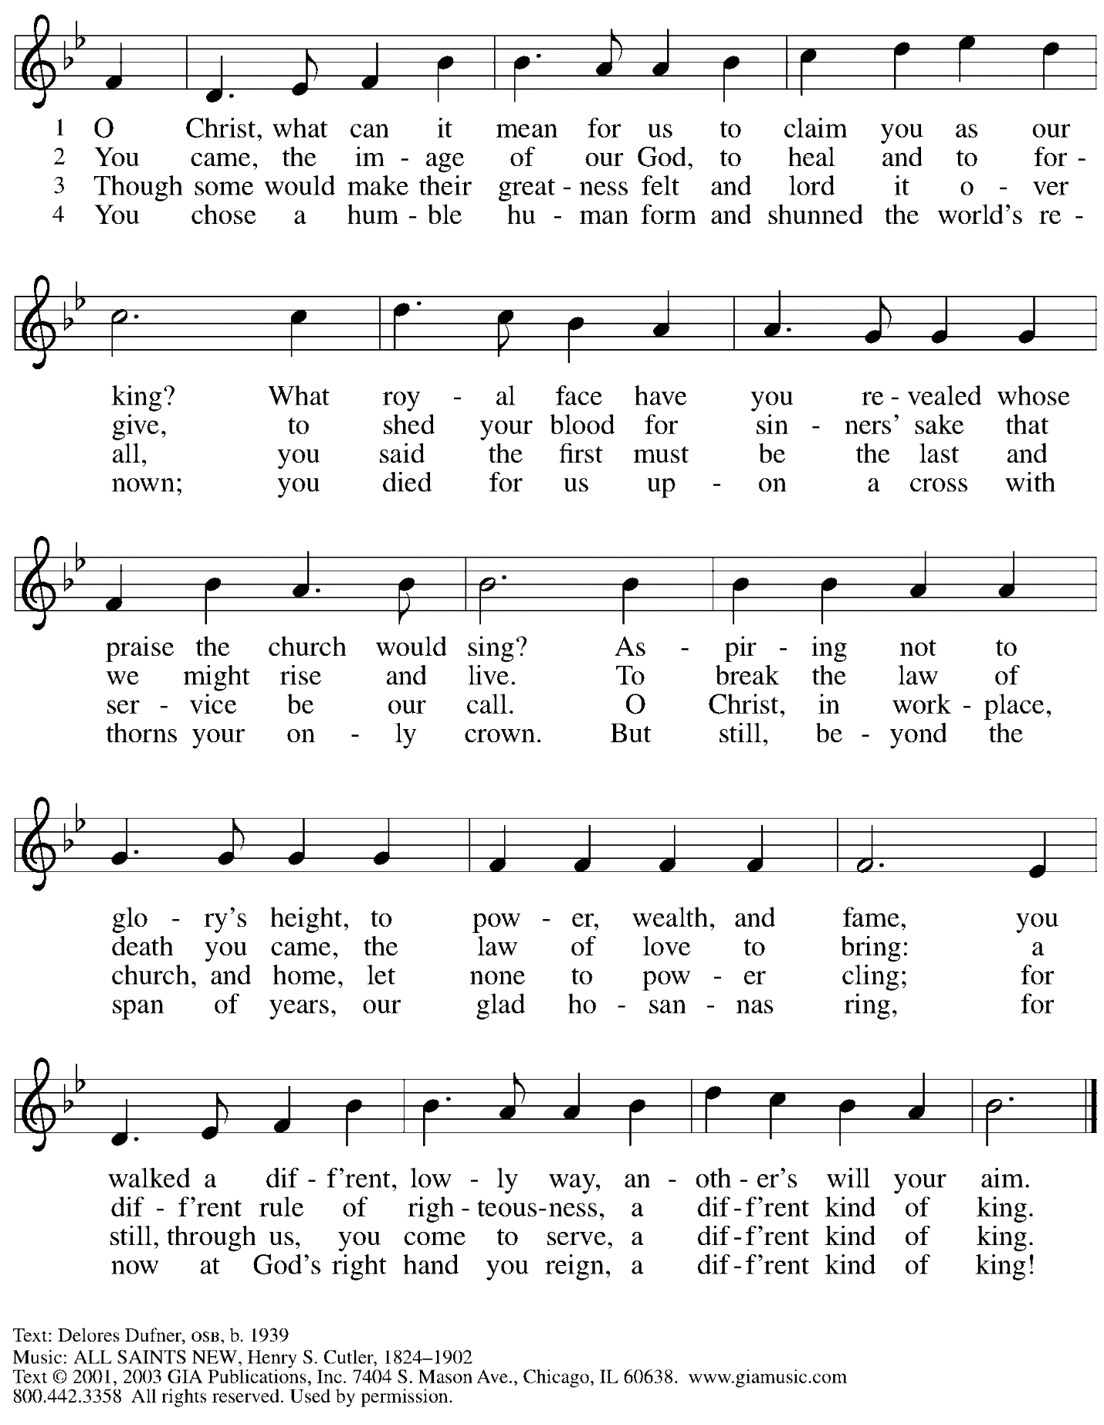
Reprinted with permission under OneLicense.net # A-722139.

Prayers of the People

P: As scattered grains of wheat are gathered into one bread,
so let us gather our prayers for the church, those in need, and all of God’s creation.

After each petition
P: God of grace,
C: receive our prayer.

P: Gathered in the communion of the Holy Spirit,
we offer these and all our prayers to you, gracious God,
through Jesus Christ, our Savior.
C: Amen.

Please be seated.

Dedication of Gifts and Commitments

Introduction

Call to Giving

P: God has shown us the meaning of generosity –
C: in the rich diversity of creation,
in the boundless love and grace of Jesus Christ,
in the never-failing gift of the Holy Spirit!

P: God has abundantly blessed us and called us –
C: to be a community that honors one another,
to be joyful servants of our neighbors,
and to share our time, gifts, and material possessions.

All: Let us rejoice in all that God has given,
and in what we are freed to give!

People of the congregation are invited to bring their commitment cards forward to dedicate to God. All are invited to sing the hymn of dedication, “For the Fruit of All Creation,” until everyone who chooses to bring forward a commitment card has had the opportunity to do so.

Hymn of Dedication For the Fruit of All Creation ELW 679

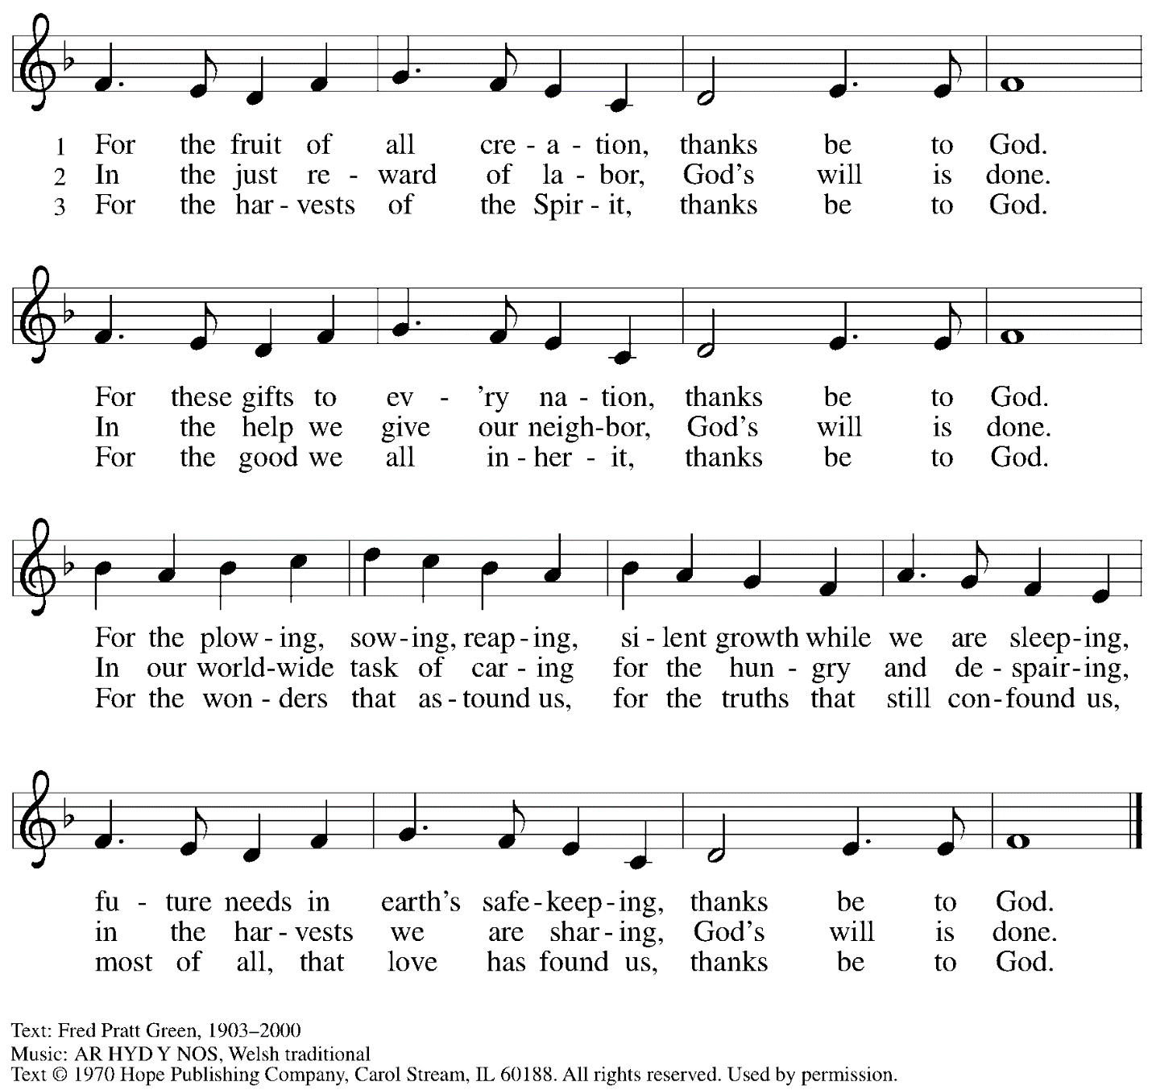
Reprinted with permission under OneLicense.net #A-722139.

Concluding Dialogue

P: In humble gratitude,
we dedicate these gifts to you, O God –
C: by your grace, may they serve your people
and proclaim your goodness to all the world!

Meal

Offering

We offer ourselves, our gifts, and our faithful service to God.
An usher will pass around an offering plate for anyone who would like to offer gifts before God.

Music during the Offering

Please rise as you are able.

Offertory Song Let the Vineyards ELW 184

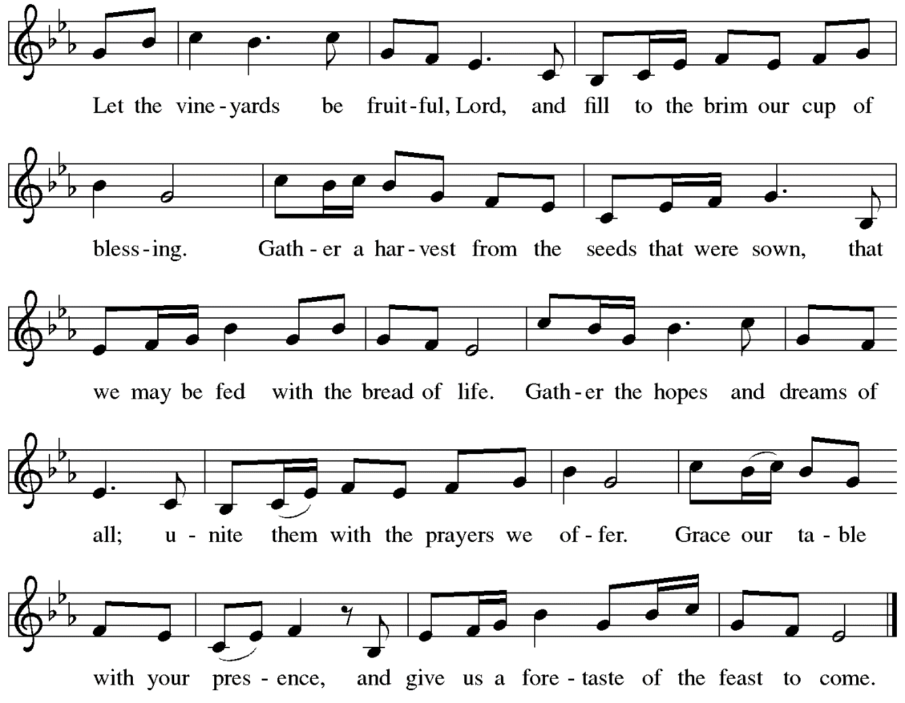

Offertory Prayer

P: Let us pray. Almighty and eternal God,
C: So draw our hearts to you, so inspire our minds, so fill our imaginations,
so guide our wills, that we may be wholly yours, utterly dedicated to you;
and then use us, we pray, and these your gifts, as you will, but always to your glory
and the welfare of your people, through our Lord and Savior Jesus Christ. Amen.
(William Laud, 17th century)
Dialogue ELW p. 152

Preface (Sung by the presiding minister)

P: It is indeed right, our duty and our joy …
… we praise your name and join their unending hymn:

Sanctus ELW p. 153

Eucharistic Prayer

P: Holy God …
… with every breath.
C: We praise you, O God.

P: Generations bless your faithfulness …
… into the future.
C: We bless you, O God.

P: We give you thanks for your dear Son …
… with us now.
C: We thank you, O God.

P: In the night in which he was betrayed …
… Do this for the remembrance of me.

Remembering his love for us on the way, at the table, and to the end,
we proclaim the mystery of faith.
C: Christ has died. Christ is risen. Christ will come again.

P: We pray for the gift of your Spirit …
… by your Spirit, in your church, without end.
C: Amen.

Lord’s Prayer

P: Gathered as one by the Holy Spirit, let us pray as Jesus taught us.
C: Our Father in heaven,
hallowed be your name,
your kingdom come,
your will be done,
on earth as in heaven.
Give us today our daily bread.
Forgive us our sins
as we forgive those who sin against us.
Save us from the time of trial
and deliver us from evil.
For the kingdom, the power,
and the glory are yours,
now and forever. Amen.

Fraction and Invitation

Agnus Dei / Lamb of God ELW p. 154

Please be seated.

Holy Communion
- Worshipers from the pulpit side will proceed forward first, followed by the center section, and then the lectern side.
- The Communion wafers (regular and gluten-free) have been thoughtfully prepared using the gifts of the congregation by a member of St. Andrew’s altar care team, with a drop of wine or grape juice on each. The presiding minister will distribute one to each communicant.
- When you reach the presiding minister, please indicate if you would like grape juice or a gluten-free wafer.
- A blessing will be provided for anyone who does not yet receive the sacrament.
- Cushions have been placed at the altar rail for anyone who would like to kneel for prayer and reflection before returning to their pew.

Hymn during Holy Communion
Jesus, Remember Me ELW 616

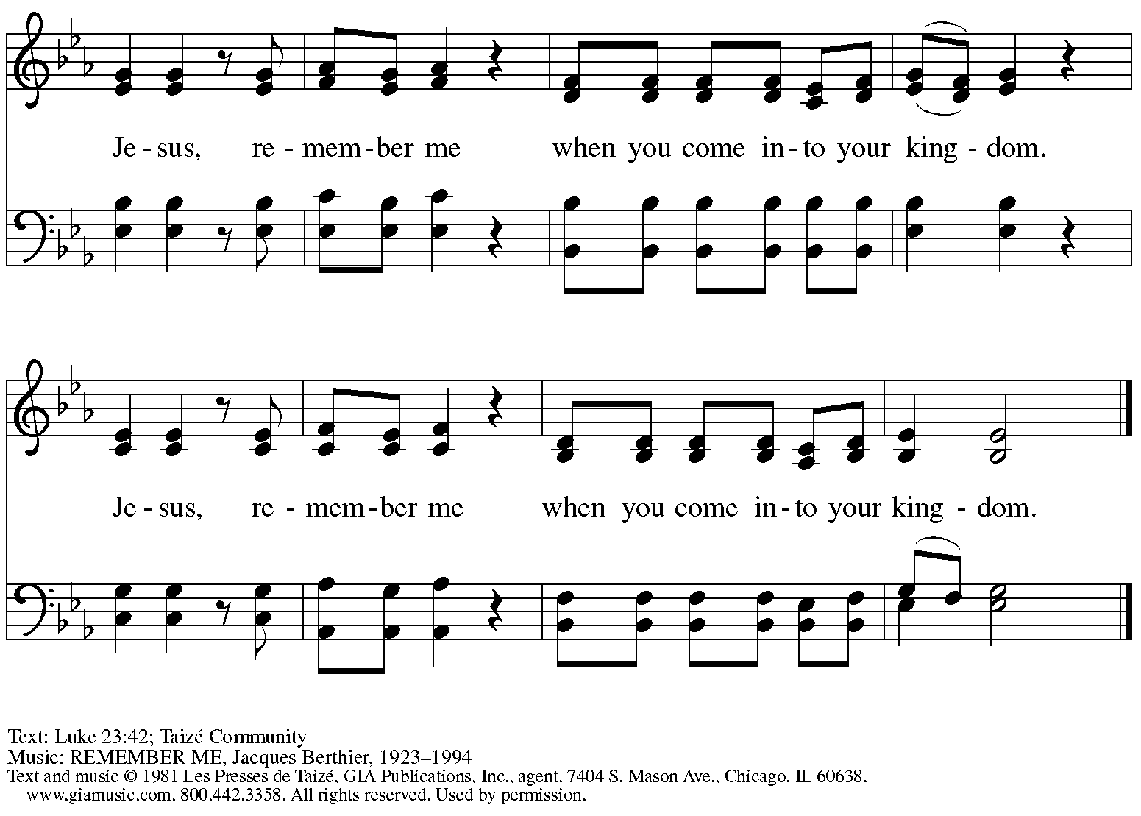
Reprinted with permission under OneLicense.net # A-722139.

Hymn during Holy Communion
The Head That Once Was Crowned ELW 432
v. 1-2, 4, 6

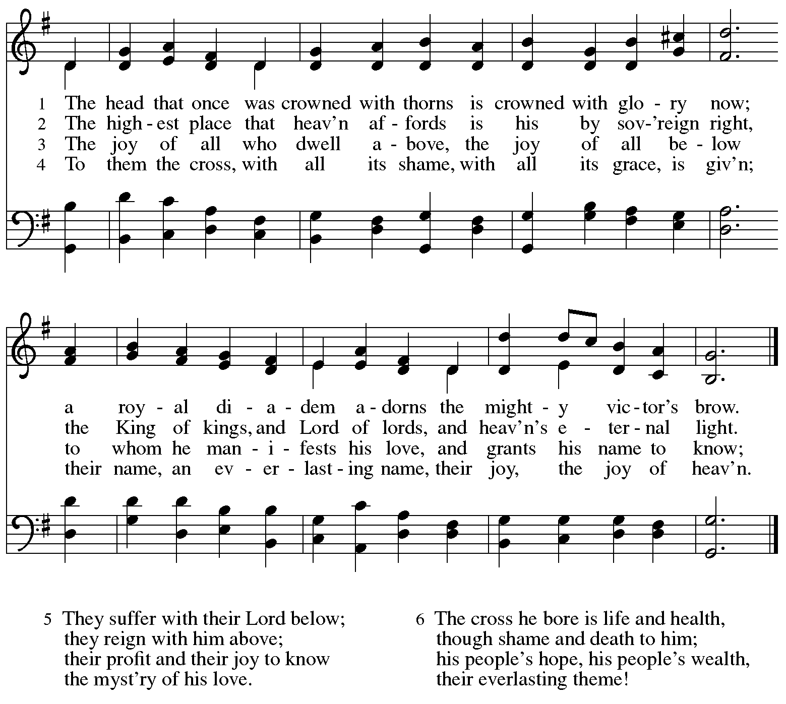

Text: Thomas Kelly, 1769-1855. Music: ST. MAGNUS, Jeremiah Clarke, 1669-1707.

Hymn during Holy Communion
Before the Ancient One, Christ Stands ACS 953

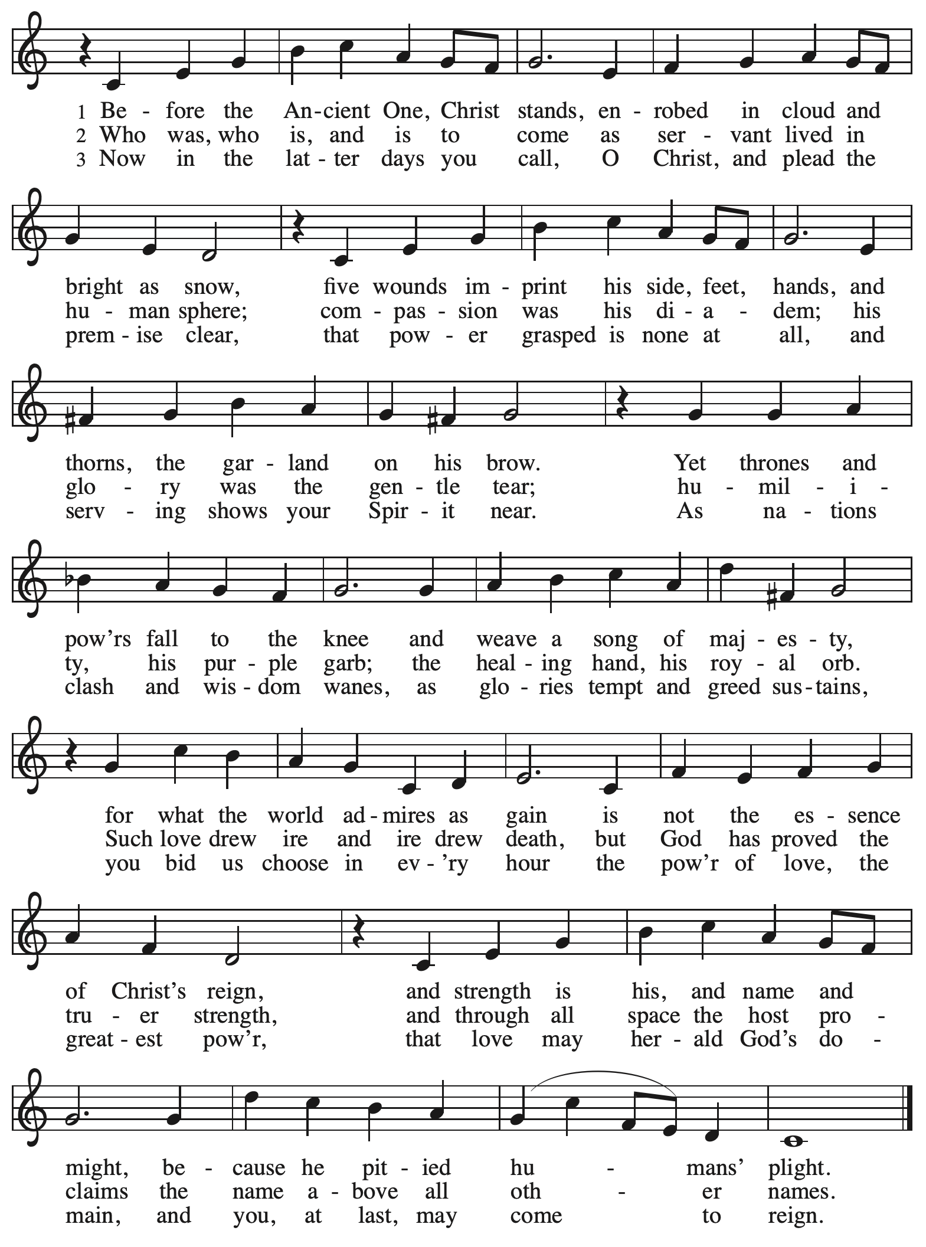

When all have returned to their places, please rise as you are able.

Blessing

P: The body and blood of our Lord Jesus Christ strengthen you and keep you in his grace.
C: Amen.

Prayer

P: Let us pray.
P: God of abundance, you have refreshed our hearts in this meal with bread for the journey.
Give us your grace on the way, that we may serve our neighbors with joy
and proclaim your goodness in all things, through Jesus Christ, our Savior and Lord.
C: Amen.

Please be seated.

Sending

Announcements

Please rise as you are able.

Benediction

P: God who gives life to all things
and frees us from despair,
bless you with truth and peace.
The holy Trinity, ☩ one God,
guide you always in faith, hope, and love.
C: Amen.

Sending Hymn Crown him with Many Crowns Following page

Dismissal

P: Go in peace. Christ is with you.
C: Thanks be to God!

Sending Hymn Crown him with Many Crowns ELW 858

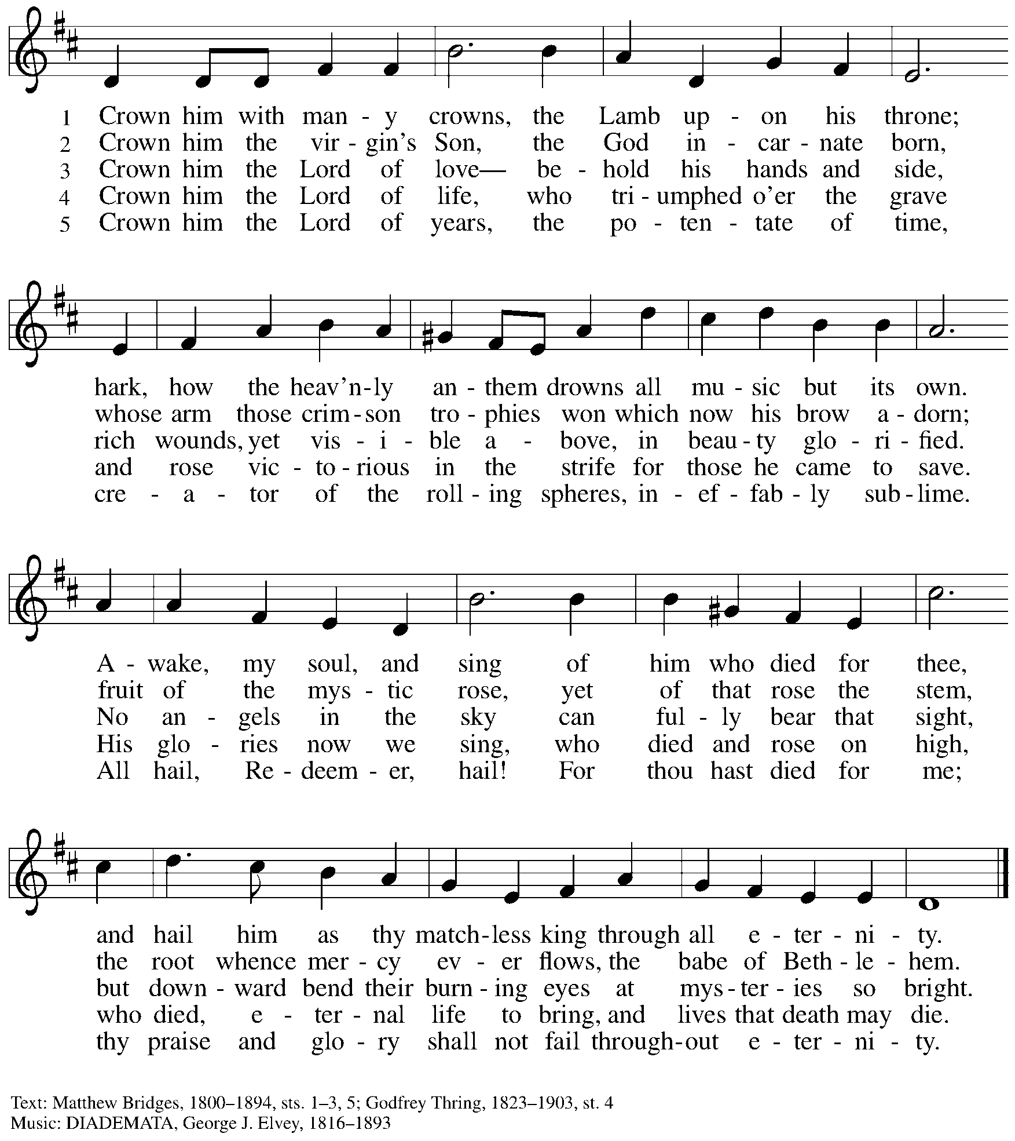

Abbreviations

P: Pastor/Presiding Minister
L: Lector
C: Congregation

ELW: Evangelical Lutheran Worship hymnal
ACS: All Creation Sings hymnal

Those serving in worship today

Minister of Music Laura Reynolds
Cantor Kristen Asplin
Lector Pastor Deb Byrum
Presiding Minister Rev. Ross Carmichael

Liturgy and Hymnody Acknowledgements

From SundaysandSeasons.com. Copyright © 2022 Augsburg Fortress. All rights reserved. Reprinted under OneLicense.net # A-722139.
Used by permission of Augsburg Fortress.

Let the Vineyards – Text: John W. Arthur, 1922-1980. Music: Ronald A. Nelson, b. 1927. Text and music © 1978 Lutheran Book of Worship, admin. Augsburg Fortress. All rights reserved. Reprinted with permission under OneLicense.net # A-722139.

Before the Ancient One, Christ Stands – Susan Palo Cherwien, b. 1953.
Music: CHRIST CHURCH, MINNEAPOLIS, Robert Buckley Farlee, b. 1950.
Text © 1997 Susan Palo Cherwien, admin. Augsburg Fortress.
Music © 2008, Robert Buckley Farlee, admin. Augsburg Fortress.
All rights reserved. Reprinted with permission under OneLicense.net # A-722139.

St. Andrew Lutheran Church Announcements
November 20th, 2022

- Worship in the Sanctuary and Online – Sunday, November 20th, + Reign of Christ Sunday – St. Andrew’s next service of Holy Communion will be this Sunday, November 20th, at 10:00 a.m. Masks are optional in worship when Allegheny County’s Covid-19 community level is in the low and medium categories. Worship will also be live-streamed to Facebook, YouTube, and Zoom. This week in worship, we give thanks for the saints who have gone before us and inspired us by their faithfulness for our baptismal living. Worship attendees are invited to make their own name tags at the back of the worship space. Coffee hour will be held in the Social Hall next to the sanctuary after worship.
- Fall Focus on Commitment and Giving – This Sunday, November 20th, Commitment Sunday – Each year around this time, St. Andrew offers the congregation the opportunity to make a commitment to financial giving in the upcoming year as our grateful response to all God's gifts. The congregation recently sent a mailing with a commitment card for your prayerful consideration. In conjunction with this focus. We invite you to bring your completed commitment card with you to worship this Sunday, November 20th, when we will dedicate our gifts in the service.
- Annual Meeting of the Congregation – Sunday, December 4th, after Worship – St. Andrew's congregational constitution specifies that we hold the annual meeting of the congregation in the fourth quarter of the year, usually in November or December. This year's annual meeting will be on Sunday, December 4th, after worship. The purpose of this meeting is to elect members to serve on the Congregation Council, which serves as our board of directors, and to adopt a budget for ministry in the year ahead. Any Confirmed member of the congregation is eligible to vote at the meeting, though we welcome the presence and perspective of all from the community. No absentee or proxy votes can be accepted but we will offer a Zoom link option for those who cannot attend in person.
- Sing with a Choir at St. Andrew on Sunday, December 18th during Worship – If you love to sing, we are putting together a choir for the fourth Sunday of Advent, December 18th. The choir will sing during the worship service. There will be two rehearsals, December 11th after service and December 18th before service. Laura will record the music and you can learn it at your own pace. Please see Laura if you are interested or contact her at ministerofmusic@standrewpittsburgh.org.
- Interfaith Thanksgiving Service – Tuesday, November 22nd, 7:30 p.m. at Third Presbyterian Church – Join members of Beth Shalom, Temple Sinai, First Unitarian Church, Third Presbyterian Church, and members of many spiritual traditions as we come together in one of Pittsburgh's most beautiful places of worship to give thanks and praise as a diverse and powerful collection of spiritual communities. Reverend Karie Charlton of Third Presbyterian and Reverend Liddy Barlow of Christian Associates of SWPA will offer prayers. Cantor David Reinwald of Temple Sinai will lead us in songs in Hebrew and English. Mr. Lenny Young, Ms. Raquel Winica and Mr. Michael Hammer of Third Church will offer service music. Reverend Kate Walker, pastor of First Unitarian, will speak about her church's work on anti-racism initiatives. Light refreshments will be served. Third Presbyterian is located at 5701 Fifth Ave., Pittsburgh 15232. No RSVP is required. For more information, contact Rabbi Mark Asher Goodman at mgoodman@bethshalompgh.org.
- Renaissance City Choir 2022 Holiday Concert – Saturday, December 3rd, 7:30 p.m. –Pittsburgh's LGBTQIA+ chorus, Renaissance City Choir, invites you to "Holiday Greetings and Gay Happy Meetings," its first in-person concert since 2019! This year's holiday concert will be Saturday, December 3rd, at 7:30 p.m. at East Liberty Presbyterian Church, 116 S. Highland Ave., 15206. RCC will be joined by Vocal Confluence, a barbershop chorus. A livestream ticketing option is also available. To purchase tickets, please visit Holiday Greetings & Gay Happy Meetings: Renaissance City Choir 2022 Holiday Concert Tickets in Pittsburgh, PA, United States (ticketleap.com).
- Blanket the Capitol Lawn and Cover Our Neighbors with Care – An Invitation from our Church’s Witness in Society Office – The ELCA Witness in Society office is partnering with several synods, advocates, and foundation partners to organize a Homeless Remembrance Blanket awareness event in Washington D.C. on December 21st, the longest night of the year. The event, which includes invited bishops, members of Congress, Administration officials, dignitaries, and nonprofit advocacy organizations, will be gathering hundreds of blankets from across the country in a symbolic art installation on the U.S. Capitol lawn near the Christmas tree. The event will bring greater attention to those struggling with homelessness on the coldest nights of the year. Interested advocates are welcome to participate in-person at the U.S. Capitol, or join the full-day event virtually.

Blankets will be arriving from each state in the country, with letters and invitations to lawmakers to visit an agency or ministry with those experiencing homelessness in their district. Please consider donating a blanket or joining us in the nation's capital on Dec. 21st for the event, or on Jan. 4th, to deliver blankets and letters to members of Congress.

If you would like to connect with other Lutherans in attendance, or to help – by making a blanket, writing a letter, stitching donated squares, setting up and tearing down the art installation or delivering blankets to members of Congress in January for delivery in their districts – please email Lutheran Advocacy Ministry of Pennsylvania (LAMPa), at LAMPa@LutheranAdvocacyPA.org with “Blanket” in the subject line.
- Spiritual Care Volunteers Needed for AHN Palliative Care Patients – Palliative care is an approach that improves the quality of life for patients and their families facing problems associated with life-threatening illness, through the prevention and relief of suffering by means of early identification, assessment and treatment of pain and other problems, whether they be physical, psychosocial or spiritual.

- Spiritual Care Volunteers will visit with AHN Palliative Care patients and their families at one of our hospitals: Allegheny General, Allegheny Valley, Forbes, Jefferson, and West Penn.
- We also can use volunteers who work from their homes to call family members to provide emotional and spiritual support.
- Training is provided and required.
- Qualifications: Ability to stand and walk long hospital corridors, or use an assistive mobility device to do so. A willingness to attend volunteer orientation/training and meetings, to function as a member of one of our palliative care teams, and to complete simple charting under the direction of the spiritual care coordinator. Basic computer skills utilizing email and Zoom are very helpful.
- Clearances required (will be paid for by AHN).
- Volunteers who work in the hospitals must be up to date on all of their vaccinations, including the Covid vaccines and boosters. Current policies require everyone to wear surgical, KN95, or N95 face masks.
- We do not discriminate based on religious or spiritual beliefs. NO proselytizing is permitted.
- Free parking and meals.
For more information, contact the Spiritual Care Coordinator, Pr. Kim Rapczak, at: 412-738-4650 or Kimberly.Rapczak@ahn.org. To apply online, go to: https://www.ahn.org/volunteer-application (Make sure to select which hospital you want to work at, and under “other,” type: “palliative care.”).
- Lutheran Campus Ministry Art Exhibit Exploring Race, Truth Be Told, Extended until the End of the Semester – Truth be Told is an art exhibit created by fourteen women artists across the country in reflection on racism. The group of seven Black women and seven white women began conversations after the murder of Goerge Floyd, which moved them each to consider one word and create an art piece around that word. The exhibit is being shown at the Lutheran University Center, 4515 Forbes Avenue, Pittsburgh 15213. Open hours of viewing are every Saturday and Sunday from 1:00-6:00 p.m. Arrangements can be made to view the exhibit during the week by contacting the campus ministry at 412-682-6886 or email pastor@psalm.online. For more information, go to http://psalm.online.

