+ Second Sunday of Advent
December 4, 2022

St. Andrew Lutheran Church
304 Morewood Ave.
Pittsburgh, PA 15213
St_andrewELCA@verizon.net
www.standrewpittsburgh.org

+ Second Sunday of Advent
Order for Worship

At the heart of our Advent preparation stands John the Baptist, who calls us to repent and make a new beginning. As the nights grow longer in the northern hemisphere we turn toward the approaching light of Christ. For Christians he is the root of Jesse, the righteous judge who welcomes all, especially the poor and meek of the earth. We wait with hope for that day when the wolf will dwell with the lamb, and there will be no more hurt or destruction. From the Lord’s table we are sent in the spirit of John the Baptist to proclaim that in Christ the kingdom of God has come near.

- Masks are optional at St. Andrew when Covid-19 community level in Allegheny County is in the low and medium categories.
- Hand sanitizer is available at the back of the sanctuary.

Worship Services are live streamed to multiple online platforms.
By attending worship, you agree that your image and voice may be broadcast.

Welcome to St. Andrew!
- Everyone is invited to make a nametag at the black bookcase in the back of the worship space if they would like.
- Children are invited to participate in Little Church; Big Faith, a Bible lesson and activity for children, following the Prayer of the Day.
- Worship “toolkits” to help children engage with the service are available in the black bookcase at the back of the worship space. There are “reader” and “pre-reader” resources available in each kit. Please feel free to use the kits for/with your children during worship.
- St. Andrew has recently returned to serving the sacrament of Holy Communion with both (separate) elements, bread and wine/grape juice. The presiding minister will first distribute the bread (host). Please consume this and then pick up an empty glass from the tray next to the presiding minister. The Communion Assistant will pour wine from the chalice or grape juice from the cruet into your glass. Please step to the side to consume the wine or grape juice. As you return to your pew, glasses may be returned to the empty trays on either side of the center aisle.
- A restroom is available on the main level of the church, through the doors to the Social Hall and to the right in the main office.

Welcome

Prelude

Gathering
The Holy Spirit calls us together as the people of God.

Confession and Forgiveness

P: Blessed be the Lord, the God of Israel,
who alone does wondrous things.
C: Blessed be God’s name forever.
Amen.

P: Beloved, now is the time to wake from sleep.
Let us confront our sins,
and confess them to the one who is merciful and just.

Silence is kept for reflection.

P: God of new beginnings,
C: we confess that we have not welcomed your holy reign.
We have strayed from your paths.
We prepare for war instead of peace.
We dishonor one another and your creation.
Purify us with your refining fire
and set us again on your way of love,
that we may bear fruit worthy of repentance,
and welcome your coming among us.
Amen.

P: People of God,
a new thing is growing in our midst,
a tender branch, a living sign.
By water and the Spirit you are joined to this wonder.
You have put on ☩ Christ,
and your sins have been washed away.
Rejoice in the way of the Lord.
C: Amen.

Gathering Hymn Comfort, Comfort Now My People ELW 256

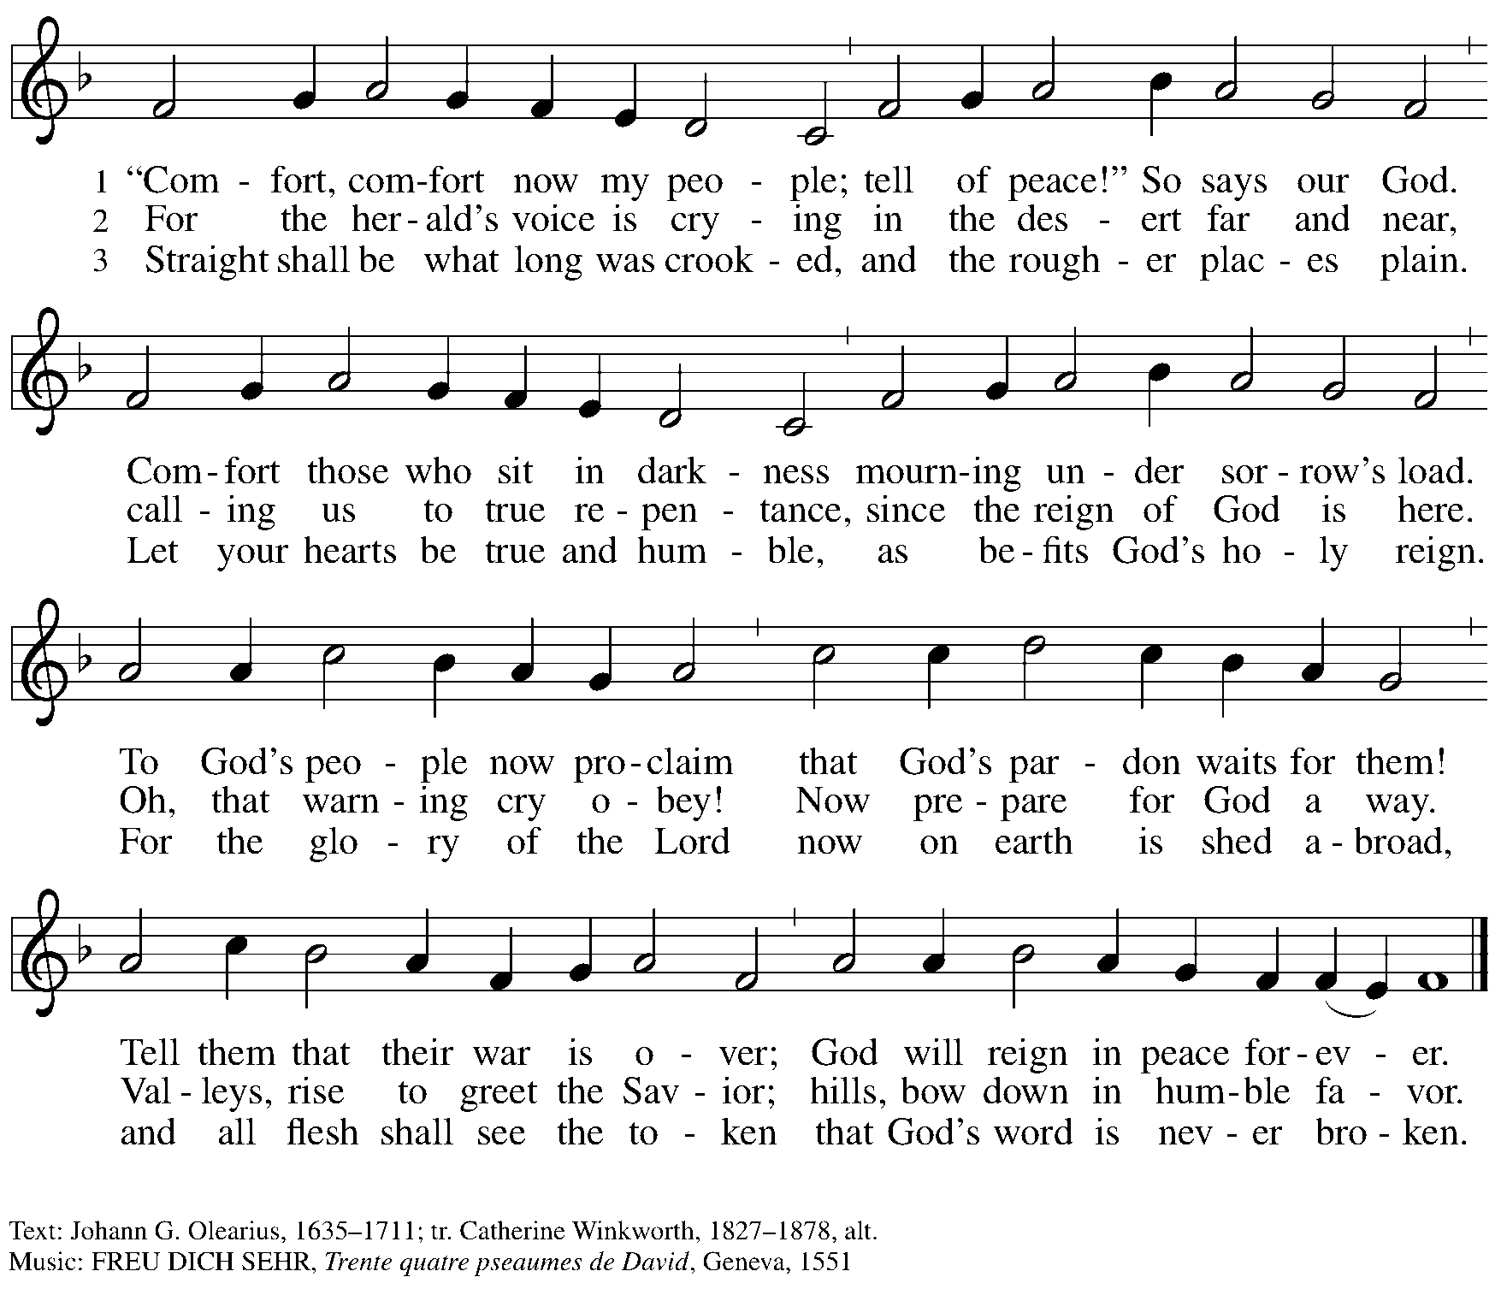

Greeting

P: The grace of our Lord Jesus Christ, the love of God,
and the communion of the Holy Spirit be with you all.
C: And also with you.

Kyrie HS p. 3

A: In peace, in peace,
Refrain
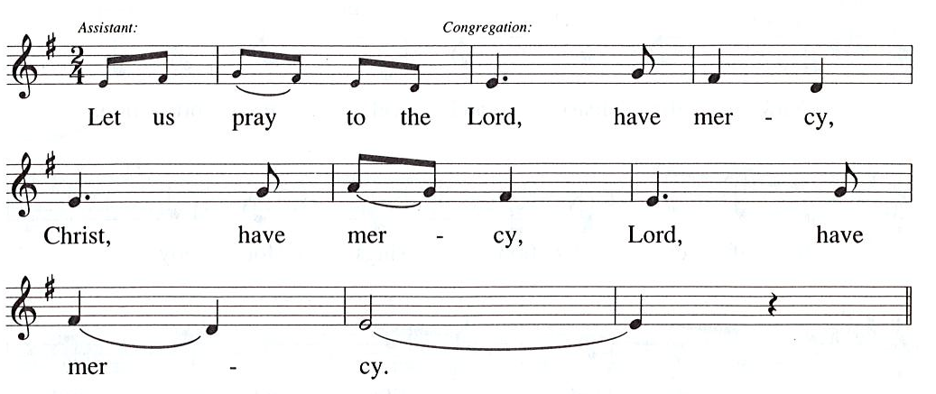

Prayer of the Day

A: For the Reign of God, and for peace throughout the world,
for the unity of all … (Refrain)

A: For your people here, who have come to give you praise,
for the strength to live your word … (Refrain)

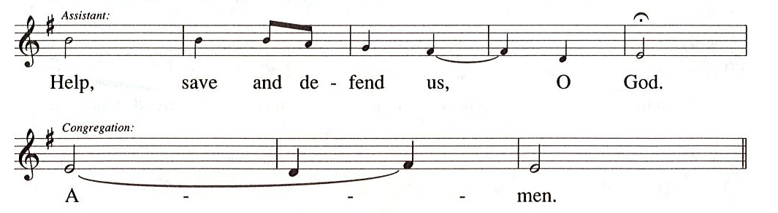

Prayer of the Day
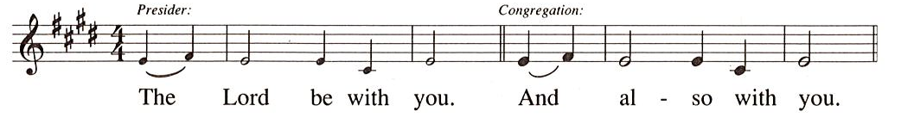

P: Let us pray.
Stir up our hearts, Lord God, to prepare the way of your only Son.
By his coming, nurture our growth as people of repentance and peace;
through Jesus Christ, our Savior and Lord,
who lives and reigns with you and the Holy Spirit,
one God, now and forever.
C: Amen.

Please be seated.
Children are invited to come forward and gather around the Advent Wreath
for the lighting of the candles.

Hymn during Candle Lighting
Light One Candle to Watch for Messiah ELW 240
v. 1-2

1 Light one candle to watch for Messiah:
Lead our way through the darkness.
He shall bring salvation to Israel,
God fulfills the promise.

2. Light two candles to watch for Messiah;
Lead our way through the darkness.
He shall feed the flock like a shepherd,
gently lead them homeward.

After the lighting of the Advent candles and hymn, children are invited to join the adult leaders at the door and move to the office for Little Church; Big Faith.
We ask that one additional adult from the congregation attend with the children.

Word
God speaks to us in Scripture reading, preaching, and song

First Reading – Isaiah 11: 1-10

¹A shoot shall come out from the stump of Jesse,
and a branch shall grow out of his roots.
²The spirit of the Lord shall rest on him,
the spirit of wisdom and understanding,
the spirit of counsel and might,
the spirit of knowledge and the fear of the Lord.
³His delight shall be in the fear of the Lord.

He shall not judge by what his eyes see,
or decide by what his ears hear;
⁴but with righteousness he shall judge the poor,
and decide with equity for the meek of the earth;
he shall strike the earth with the rod of his mouth,
and with the breath of his lips he shall kill the wicked.
⁵Righteousness shall be the belt around his waist,
and faithfulness the belt around his loins.

⁶The wolf shall live with the lamb,
the leopard shall lie down with the kid,
the calf and the lion and the fatling together,
and a little child shall lead them.
⁷The cow and the bear shall graze,
their young shall lie down together;
and the lion shall eat straw like the ox.
⁸The nursing child shall play over the hole of the asp,
and the weaned child shall put its hand on the adder’s den.
⁹They will not hurt or destroy
on all my holy mountain;
for the earth will be full of the knowledge of the Lord
as the waters cover the sea.
¹⁰On that day the root of Jesse shall stand as a signal to the peoples; the nations shall inquire of him, and his dwelling shall be glorious.

L: Word of God, word of life.
C: Thanks be to God.

Psalm 72: 1-7, 18-19

The cantor will lead the singing of the psalm.
The congregation is invited to respond with the alternate verses in bold print,
and to join in singing the refrain

Psalm Tone

Psalm Refrain

¹Give the king your jus- | tice, O God,
and your righteousness to | the king’s son;
²that he may rule your | people righteously
and the | poor with justice;
³that the mountains may bring prosperity | to the people,
and the | hills, in righteousness.
⁴Let him defend the needy a- | mong the people,
rescue the poor, and crush | the oppressor. R
⁵May he live as long as the sun and | moon endure,
from one generation | to another.
⁶Let him come down like rain upon | the mown field,
like showers that wa- | ter the earth.
⁷In his time may the | righteous flourish;
and let there be an abundance of peace till the moon shall | be no more.
¹⁸Blessed are you, Lord God, the | God of Israel;
you alone do | wondrous deeds!
¹⁹And blessed be your glorious | name forever,
and may all the earth be filled with your glory. A- | men. Amen. R

Second Reading – Romans 15: 4-13

⁴Whatever was written in former days was written for our instruction, so that by steadfastness and by the encouragement of the scriptures we might have hope. ⁵May the God of steadfastness and encouragement grant you to live in harmony with one another, in accordance with Christ Jesus, ⁶so that together you may with one voice glorify the God and Father of our Lord Jesus Christ.
⁷Welcome one another, therefore, just as Christ has welcomed you, for the glory of God. ⁸For I tell you that Christ has become a servant of the circumcised on behalf of the truth of God in order that he might confirm the promises given to the patriarchs, ⁹and in order that the Gentiles might glorify God for God’s mercy.
As it is written,
“Therefore I will confess you among the Gentiles,
and sing praises to your name”;
¹⁰and again he says,
“Rejoice, O Gentiles, with God’s people”;
¹¹and again,
“Praise the Lord, all you Gentiles,
and let all the peoples praise the Lord”;
¹²and again Isaiah says,
“The root of Jesse shall come,
the one who rises to rule the Gentiles;
in him the Gentiles shall hope.”
¹³May the God of hope fill you with all joy and peace in believing, so that you may abound in hope by the power of the Holy Spirit.

L: Word of God, word of life.
C: Thanks be to God.

Please rise as you are able.

Gospel Acclamation Alleluia HS p. 8

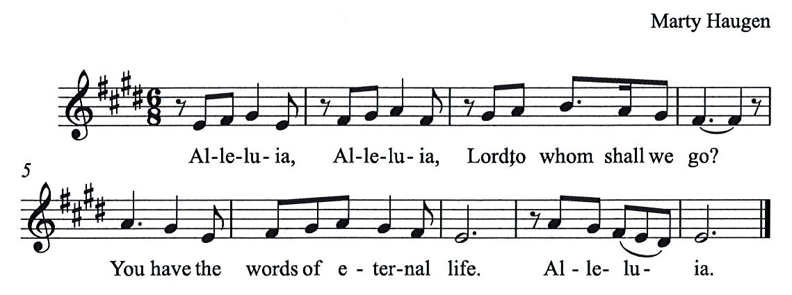

Gospel – Matthew 3: 1-12

P: The holy Gospel according to St. Matthew.
C: Glory to you, O Lord.
¹In those days John the Baptist appeared in the wilderness of Judea, proclaiming, ²“Repent, for the kingdom of heaven has come near.” ³This is the one of whom the prophet Isaiah spoke when he said,
“The voice of one crying out in the wilderness:
‘Prepare the way of the Lord,
make his paths straight.’ ”
⁴Now John wore clothing of camel’s hair with a leather belt around his waist, and his food was locusts and wild honey. ⁵Then the people of Jerusalem and all Judea were going out to him, and all the region along the Jordan, ⁶and they were baptized by him in the river Jordan, confessing their sins.
⁷But when he saw many Pharisees and Sadducees coming for baptism, he said to them, “You brood of vipers! Who warned you to flee from the wrath to come? ⁸Bear fruit worthy of repentance. ⁹Do not presume to say to yourselves, ‘We have Abraham as our ancestor’; for I tell you, God is able from these stones to raise up children to Abraham. ¹⁰Even now the ax is lying at the root of the trees; every tree therefore that does not bear good fruit is cut down and thrown into the fire.
¹¹“I baptize you with water for repentance, but one who is more powerful than I is coming after me; I am not worthy to carry his sandals. He will baptize you with the Holy Spirit and fire. ¹²His winnowing fork is in his hand, and he will clear his threshing floor and will gather his wheat into the granary; but the chaff he will burn with unquenchable fire.”

P: The Gospel of the Lord.
C: Praise to you, O Christ.

Please be seated.

Sermon

A time of silence for prayer and reflection follows the sermon.
When the hymn of the day begins, please rise as you are able.

Hymn of the Day On Jordan’s Banks the Baptist’s Cry ELW 249

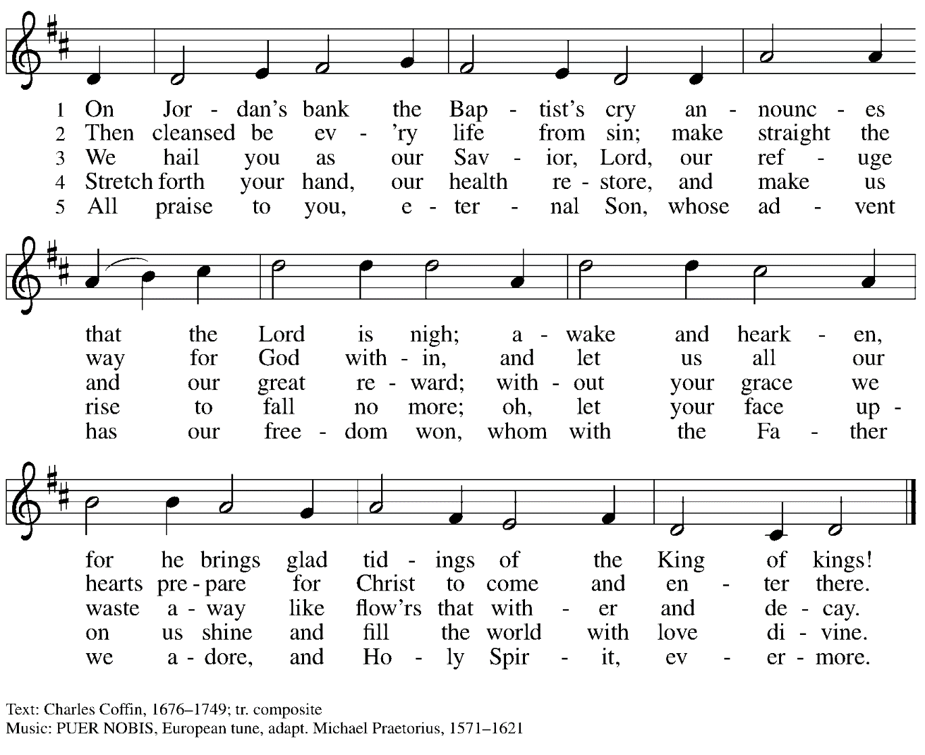

Prayers of the People

P: As we prepare for the fullness of Christ’s presence,
let us pray for the world as it yearns for new hope.

After each petition
P: God, in your mercy,
C: receive our prayer.

P: God of our longing, you know our deepest needs.
By your Spirit, gather our prayers and join them with those of all your people,
through Jesus Christ, our Savior.
C: Amen.

Please be seated.

Meal

Offering

We offer ourselves, our gifts, and our faithful service to God.
An usher will pass around an offering plate for anyone who would like to offer gifts before God.

Music during the Offering

Please rise as you are able.

Offertory Song As the Grains of Wheat ELW 465

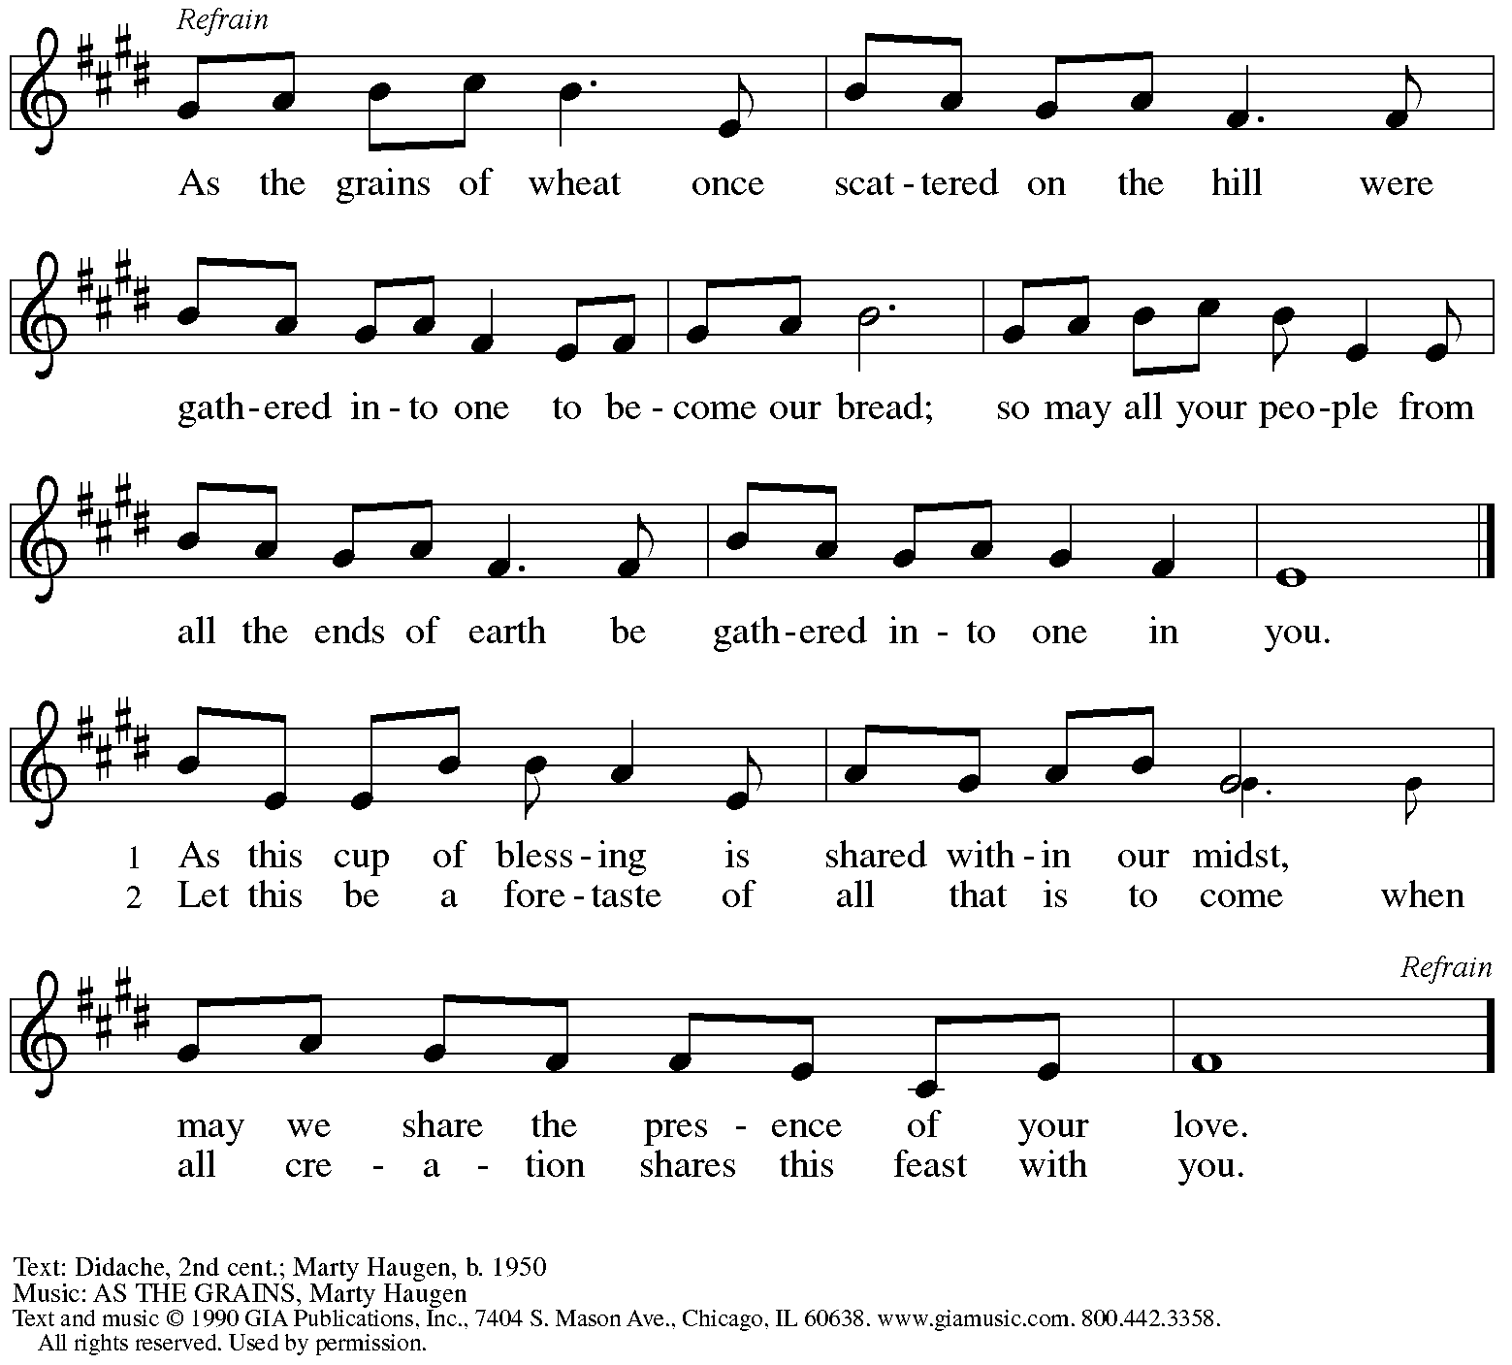
Reprinted with permission under OneLicense.net #A-722139.

Offertory Prayer

P: Let us pray. Eternal God,
C: you make the desert bloom
and send springs of water to thirsty ground.
Receive these simple gifts we offer,
and make us messengers of your mercy and love
for all in need of your justice and healing.
We ask this through Christ our Savior.
Amen.

Dialogue HS p. 14

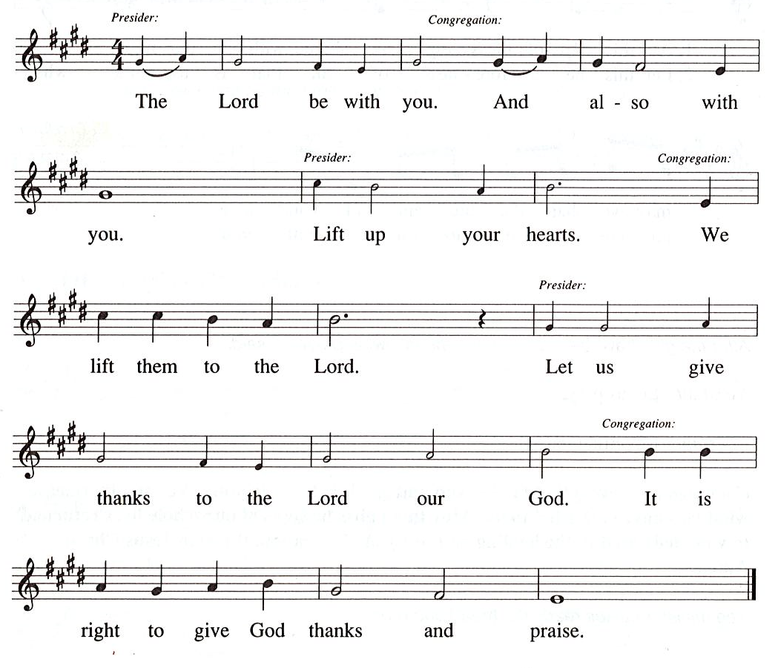

Preface (Sung by the presiding minister)

P: It is our duty and delight …
… we praise your name and join their unending hymn:

Sanctus HS p. 15

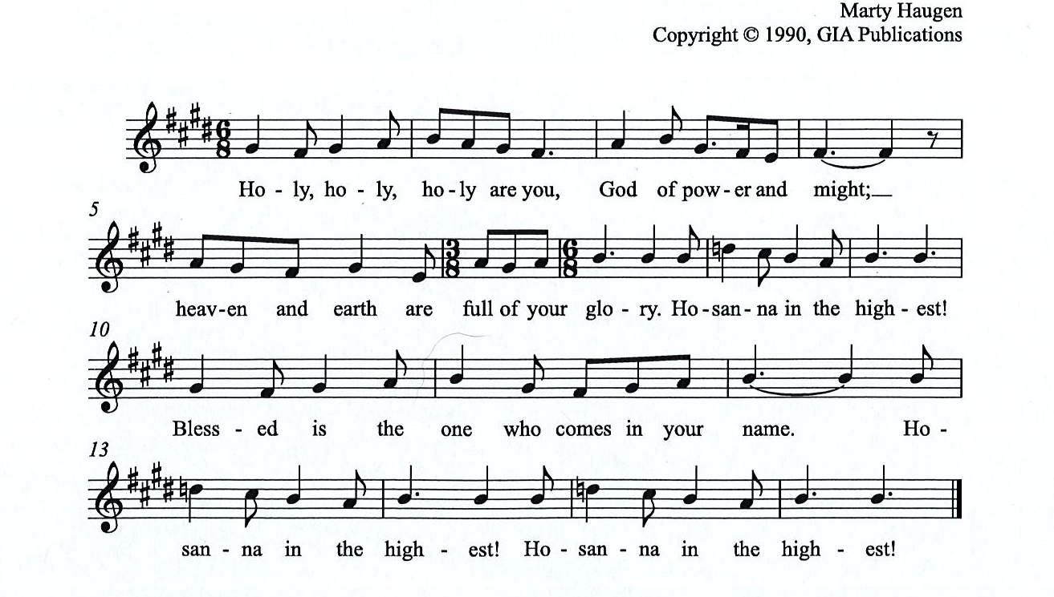

All rights reserved. Reprinted under OneLicensne.net # A-722319.

Eucharistic Prayer

P: Holy One, the beginning and the end, the giver of life …
… Do this for the remembrance of me.

Let us proclaim the mystery of faith:
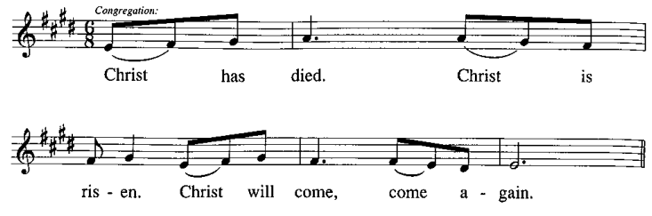
C:

P: With this bread and cup we remember …
… We look with hope for his coming.
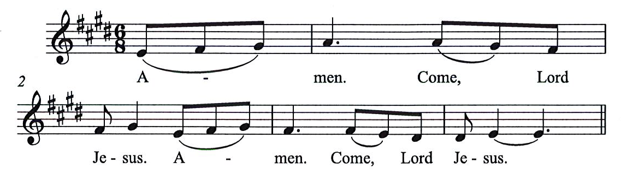
C:

P: Holy God, we long for your Spirit. …
… Bring the gift of peace on earth.
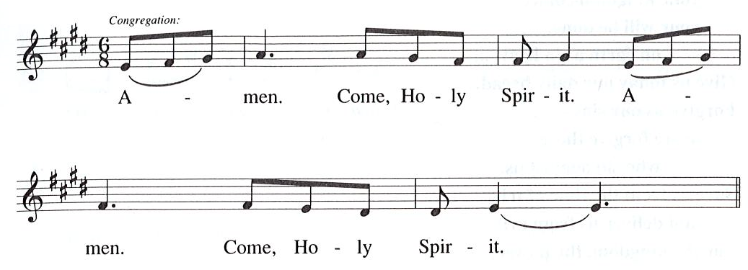
C:

P: All praise and glory are yours, …
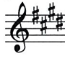
… one God, now and forever.
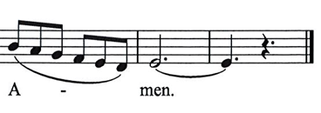
C:

Lord’s Prayer

P: Gathered as one by the Holy Spirit, let us pray as Jesus taught us.
C: Our Father in heaven,
hallowed be your name,
your kingdom come,
your will be done,
on earth as in heaven.
Give us today our daily bread.
Forgive us our sins
as we forgive those who sin against us.
Save us from the time of trial
and deliver us from evil.
For the kingdom, the power,
and the glory are yours,
now and forever. Amen.

Fraction and Invitation

Agnus Dei / Lamb of God HS p. 18

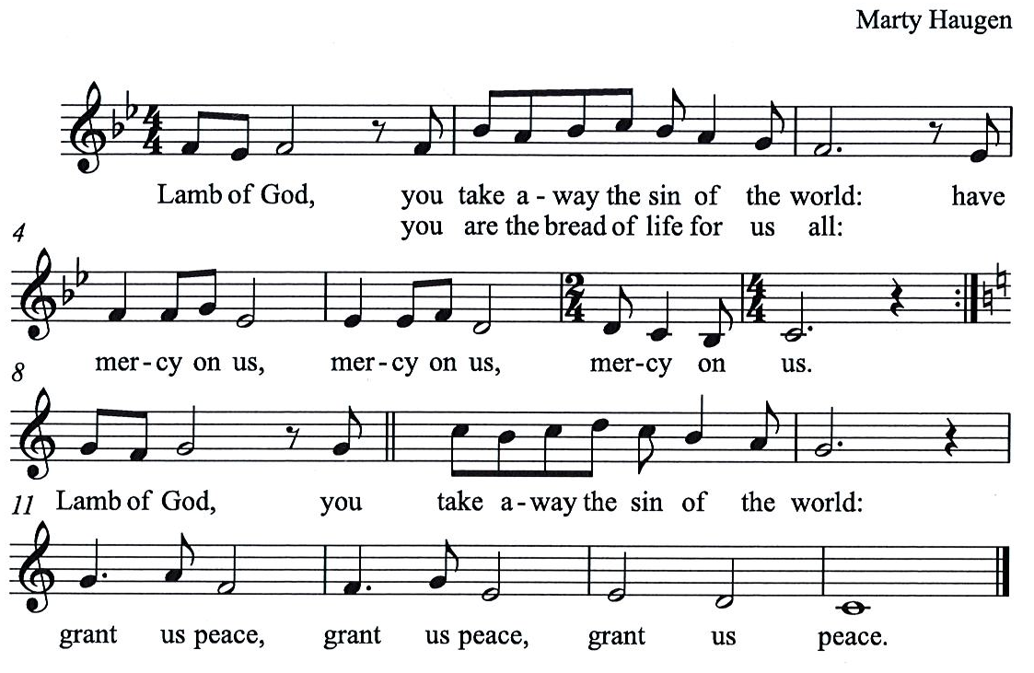

Please be seated.

Holy Communion
- Worshipers from the pulpit side will proceed forward first, followed by the center section, and then the lectern side.
- Holy Communion will be served with bread and wine/grape juice.
- The presiding minister will first distribute the bread (host) to each communicant. Please indicate if you require a gluten-free host.
- Once you have consumed the bread, please pick up an empty glass from the tray next to the presiding minister. The Communion Assistant will pour wine from the chalice or grape juice from the cruet into your glass.
- Please step to the side to consume the wine or grape juice.
- As you return to your pew, glasses may be returned to the empty trays on either side of the center aisle.
- A blessing will be provided for anyone who does not yet receive the sacrament.
- All are invited to join in singing the hymns during Holy Communion.

Hymn during Holy Communion
Now the Heavens Start to Whisper ACS 901

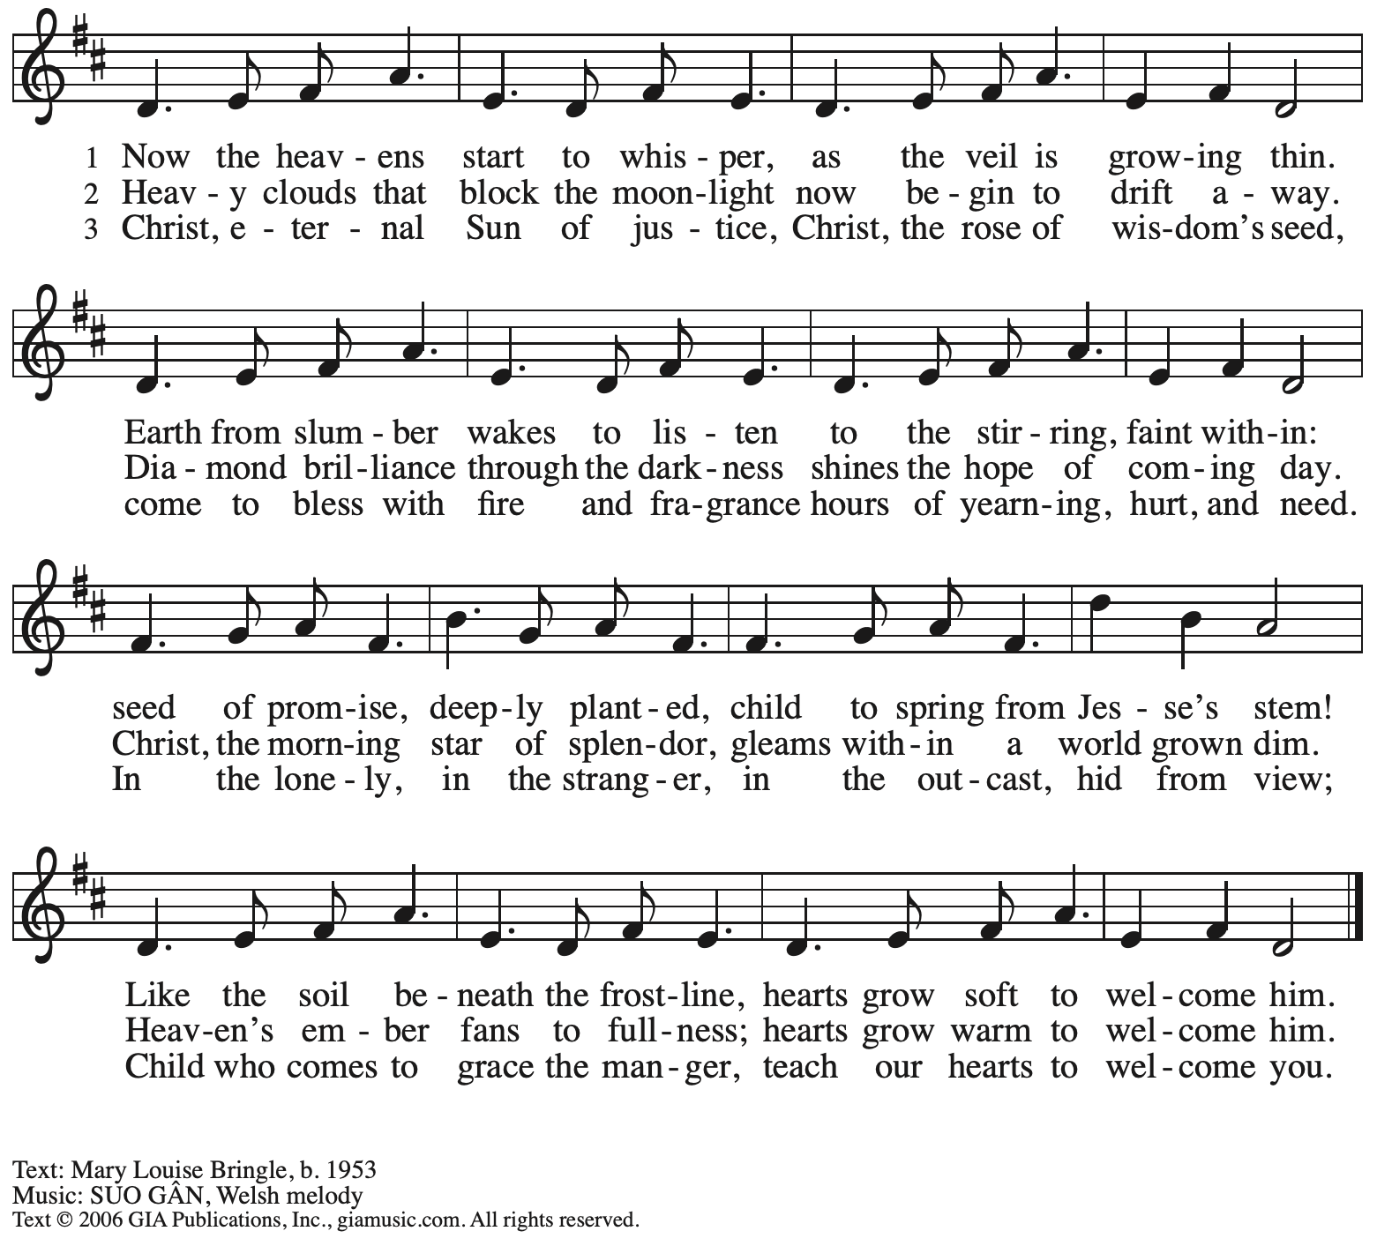

Hymn during Holy Communion
Hail to the Lord’s Anointed ELW 311

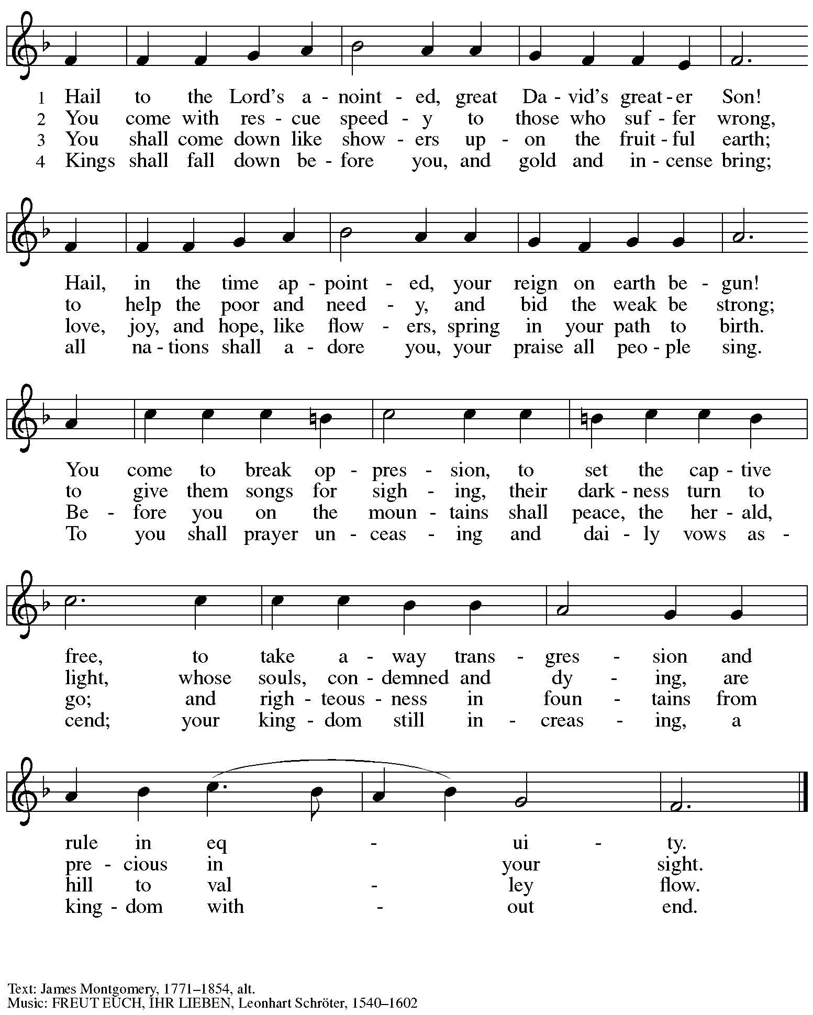

Hymn during Holy Communion
Wait for the Lord HS 726

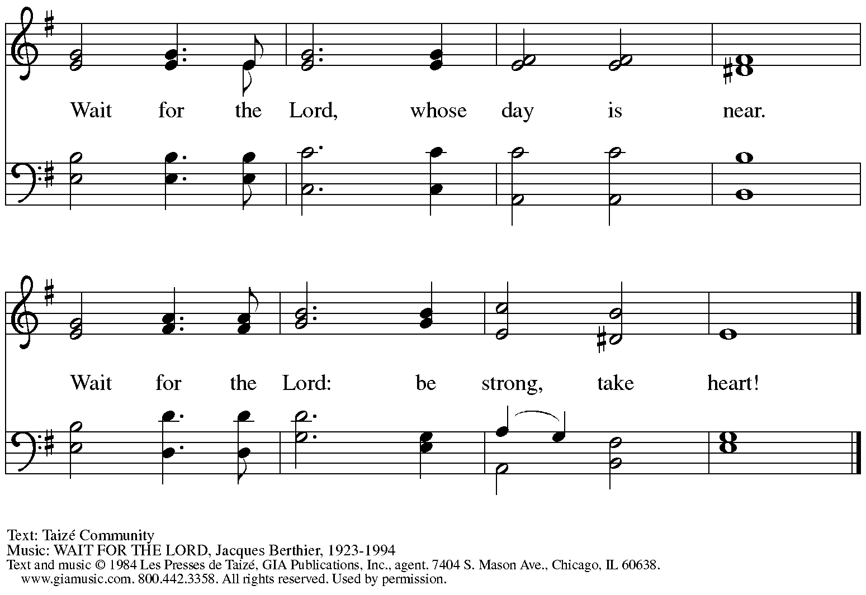
Verses from Psalm 39, 69, 118, 122, Isaiah 40, Matthew 6-7, Philippians 4. Reprinted under OneLicense.net # A-722139.

1. Prepare the way for the Lord. Make a straight path for him,

2. The glory of the Lord shall be revealed.

3. All the earth will see the Lord.

4. Rejoice in the Lord always. He is at hand.

7. I waited for the Lord, who heard my cry.

8. Our eyes are fixed on the Lord our God.

9. O Lord, show us your way. Guide us in your truth.

10. Prepare the way of the Lord.

When all have returned to their places, please rise as you are able.

Blessing

P: The grace of our Lord Jesus Christ and the gifts of his body and blood strengthen, keep,
and unite us, now and forever.
C: Amen.

Hymn of Thanksgiving HS p. 20

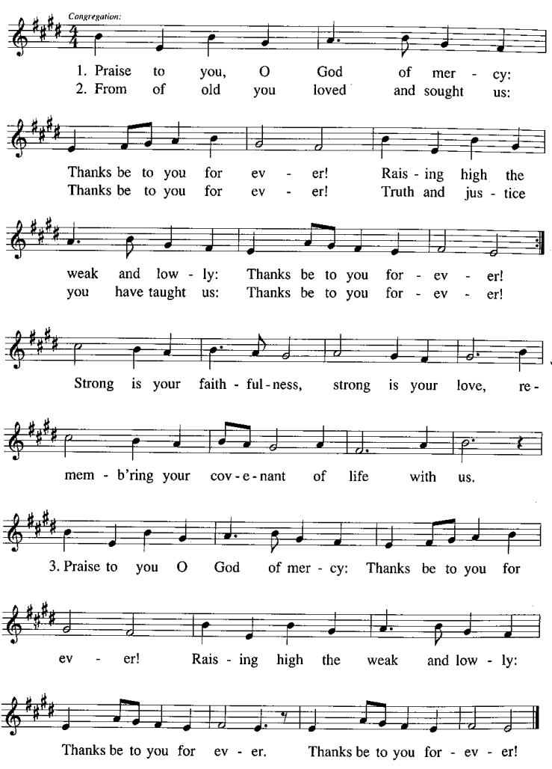

Prayer

P: Let us pray.
Faithful God, in this meal you have remembered your mercy,
bringing heaven to earth in the body and blood of Christ.
As we await the day when all your promises will be fulfilled,
sustain and strengthen us by this holy mystery.
Guide us toward your promised future coming to birth
in Jesus Christ, our Savior and Lord.
C: Amen.

Please be seated.

Sending

Announcements

Please rise as you are able.

Benediction

P: God the eternal Word,
who dwells with us in Jesus,
and who holds us in the grace of the Holy Spirit,
☩ bless you now and forever.
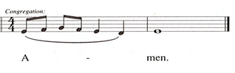
C:

Sending Hymn Prepare the Royal Highway Following page

Dismissal

P: Go in peace. Christ is near.
C: Thanks be to God!

Sending Hymn Prepare the Royal Highway ELW 264

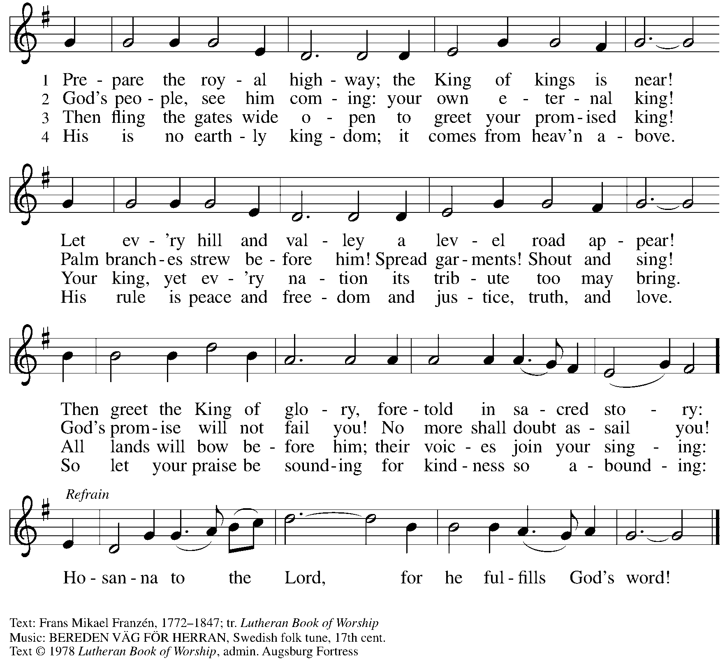
All rights reserved. Reprinted under OneLicense.net # A-722139.

Abbreviations

P: Pastor/Presiding Minister
A: Assistant (Cantor)
L: Lector
C: Congregation

HS: Hymnal Supplement
ELW: Evangelical Lutheran Worship hymnal
ACS: All Creation Sings hymnal

Those serving in worship today

Minister of Music Laura Reynolds
Cantor and Clarinet Maria Mangano
Presiding Minister Rev. Ross Carmichael

Liturgy and Hymnody Acknowledgements

From SundaysandSeasons.com. Copyright © 2022 Augsburg Fortress. All rights reserved. Reprinted under OneLicense.net # A-722139.
Used by permission of Augsburg Fortress.

Light One Candle to Watch for Messiah – Text: Wayne L. Wold, b. 1954. Music: TIF IN VELDELE, Yiddish folk tune. Text © 1984 Fortress Press, admin. Augsburg Fortress. All rights reserved. Reprinted with permission under OneLicense.net # A-722139.

St. Andrew Lutheran Church Announcements
December 4th, 2022

- Worship in the Sanctuary and Online – Sunday, December 4th, + Second Sunday of Advent – St. Andrew’s next worship with Holy Communion will be this Sunday, December 4th, at 10:00 a.m. Masks are optional at St. Andrew when Allegheny County’s Covid-19 community level is in the low and medium categories. Worship will also be live-streamed to Facebook, YouTube, and Zoom. Worship attendees are invited to make their own name tags at the back of the worship space. Coffee hour will be held in the Social Hall next to the sanctuary after worship.
- Annual Meeting of the Congregation Today after Worship – St. Andrew's congregational constitution specifies that we hold the annual meeting of the congregation in the fourth quarter of the year, usually in November or December. This year's annual meeting will be on Sunday, December 4th, after worship. The purpose of this meeting is to elect members to serve on the Congregation Council, which serves as our board of directors, and to adopt a budget for ministry in the year ahead. Any Confirmed member of the congregation is eligible to vote at the meeting, though we welcome the presence and perspective of all from the community. No absentee or proxy votes can be accepted but we will offer a Zoom link option for those who cannot attend in person.
- Seeking Individuals to Serve in Various Worship Roles – As worship attendance increases and we return to distribution of wine at Holy Communion, we ask people of St. Andrew to consider offering your gifts in worship. On the upcoming Sundays, we will pass around a signup sheet describing different roles needed, including altar care and setup, Communion Assistant, Audio/Visual Minister, Adult Leader or Helper for Little Church; Big Faith, Usher, Cantor, Lector, and Counter. Please consider how best to share your gifts to enrich the worship experience of St. Andrew!
- Monthly Produce Distribution – Tuesday, December 6th, 5:30-7:00 p.m. – St. Andrew's monthly produce distribution in cooperation with Greater Pittsburgh Community Food Bank is coming up on its usual First Tuesday of the month, December 6th. We invite people of the congregation to help serve with the distribution itself from 5:30-7:00 p.m., or to come earlier in the day to help with setup and unloading. The delivery is usually sometime between 11:00 a.m. and 1:00 p.m., but we will call the people who sign up to let them know once we have confirmation from the food bank. If you would like to help, please sign up at https://www.signupgenius.com/go/5080544AAAC22A1F58-produce23.
- Shelter Dinner at East End Cooperative Ministry – Thursday, December 15th, 6:30 p.m. – Every month, on the third Thursday, people of St. Andrew provide a meal for guests of the shelter at East End Cooperative Ministry (EECM). A menu is chosen ahead of time and individuals/families are invited to cook, bake, or otherwise provide one portion of the meal. Those who are unable to attend may also help provide for the meal financially. We also appreciate anyone who would like to come and help serve the meal at 6:30 p.m. EECM is located at 6140 Station St. in East Liberty, 15206. Please sign up here: https://www.signupgenius.com/go/5080544AAAC22A1F58-shelter36.
- Sing with a Choir on Sunday, December 18th during Worship – If you love to sing, we are putting together a choir for the fourth Sunday of Advent, December 18. The choir will sing during the worship service. There will be two rehearsals, December 11 after service and December 18 before service. Laura will record the music and you can learn it at your own pace. Please see Laura if you are interested or contact her at ministerofmusic@standrewpittsburgh.org.
- Donations for Coffee Hour – As more people return to coffee hour or attend for the first time, it would be helpful to have additional donations to support this ministry. Any of the following would be much appreciated: Ground coffee, creamers, canned drinks, children’s drinks, individually wrapped food items of any kind. Donations may be left on the coffee table in the Social Hall. Thank you for your consideration.
- Christ in our Home Current Devotional Booklets for the Next Quarter (January - March 2023) Available at Church Entrances – Christ in our Home is a booklet that offers a daily Bible reading with a short reflection and prayers, long with additional prayer concerns and readings for those who would like to expand their devotional practices. These are available at each entrance to the church, and we encourage people of the congregation to take one for yourself and others!
- Two Vigils to Remember Recent Victims of Gun Violence – Wednesday, December 7th and Thursday, December 15th – First United Methodist Church, at the corner of Centre and Aiken, joins the Pittsburgh Equality Center for a 6:00 p.m. vigil on Wednesday, December 7th, outside the church, to remember those killed at Club Q in Colorado Springs. Bidwell Presbyterian Church (1025 Liverpool Street, 15233) will host a vigil co-sponsored by CeaseFire PA, Squirrel Hill Stands against Gun Violence, PIIN, and other organizations on Thursday, December 15th, the tenth anniversary of the mass shooting at Sandy Hook Elementary School.
- Bethel AME Pittsburgh Updates – Our friends at Bethel AME are collecting clean, gently worn/used Winter clothing of all sizes. Items can be left on the table next to the pantry shelves in St. Andrew’s Social Hall.

