+ Third Sunday of Advent
December 11, 2022



St. Andrew Lutheran Church
304 Morewood Ave.
Pittsburgh, PA 15213
St_andrewELCA@verizon.net
www.standrewpittsburgh.org

+ Third Sunday of Advent
Order for Worship

A note of joyful expectation marks today’s worship.
Isaiah announces that the desert shall rejoice and blossom,
and Jesus points to the unexpected and transforming signs of God’s reign. We wait with patience for the coming of the Lord, even as we rejoice at his presence among us this day:
in word and holy supper, in church and in our homes,
in silent reflection and in works of justice and love.
We pray that God would open our eyes and ears to the wonders of Christ’s advent among us.

- Masks are optional at St. Andrew when Covid-19 community level in Allegheny County is in the low and medium categories.
- Hand sanitizer is available at the back of the sanctuary.

Worship Services are live streamed to multiple online platforms.
By attending worship, you agree that your image and voice may be broadcast.

Welcome to St. Andrew!
- Everyone is invited to make a nametag at the black bookcase in the back of the worship space if they would like.
- Children are invited to participate in Little Church; Big Faith, a Bible lesson and activity, following the Prayer of the Day.
- Worship “toolkits” to help children engage with the service are available in the black bookcase at the back of the worship space. There are “reader” and “pre-reader” resources available in each kit. Please feel free to use the kits for/with your children during worship.
- St. Andrew has recently returned to serving the sacrament of Holy Communion with both (separate) elements, bread and wine/grape juice. The presiding minister will first distribute the bread (host). Please consume this and then pick up an empty glass from the tray next to the presiding minister. The Communion Assistant will pour wine from the chalice or grape juice from the cruet into your glass. Please step to the side to consume the wine or grape juice. As you return to your pew, glasses may be returned to the empty trays on either side of the center aisle.
- A restroom is available on the main level of the church, through the doors to the Social Hall and to the right in the main office.

Welcome

Prelude

Gathering
The Holy Spirit calls us together as the people of God.

Confession and Forgiveness

P: Blessed be the Lord, the God of Israel,
who alone does wondrous things.
C: Blessed be God’s name forever.
Amen.

P: Beloved, now is the time to wake from sleep.
Let us confront our sins,
and confess them to the one who is merciful and just.

Silence is kept for reflection.

P: God of new beginnings,
C: we confess that we have not welcomed your holy reign.
We have strayed from your paths.
We prepare for war instead of peace.
We dishonor one another and your creation.
Purify us with your refining fire
and set us again on your way of love,
that we may bear fruit worthy of repentance,
and welcome your coming among us.
Amen.

P: People of God,
a new thing is growing in our midst,
a tender branch, a living sign.
By water and the Spirit you are joined to this wonder.
You have put on ☩ Christ,
and your sins have been washed away.
Rejoice in the way of the Lord.
C: Amen.

Gathering Hymn Light Dawns on a Weary World ELW 726

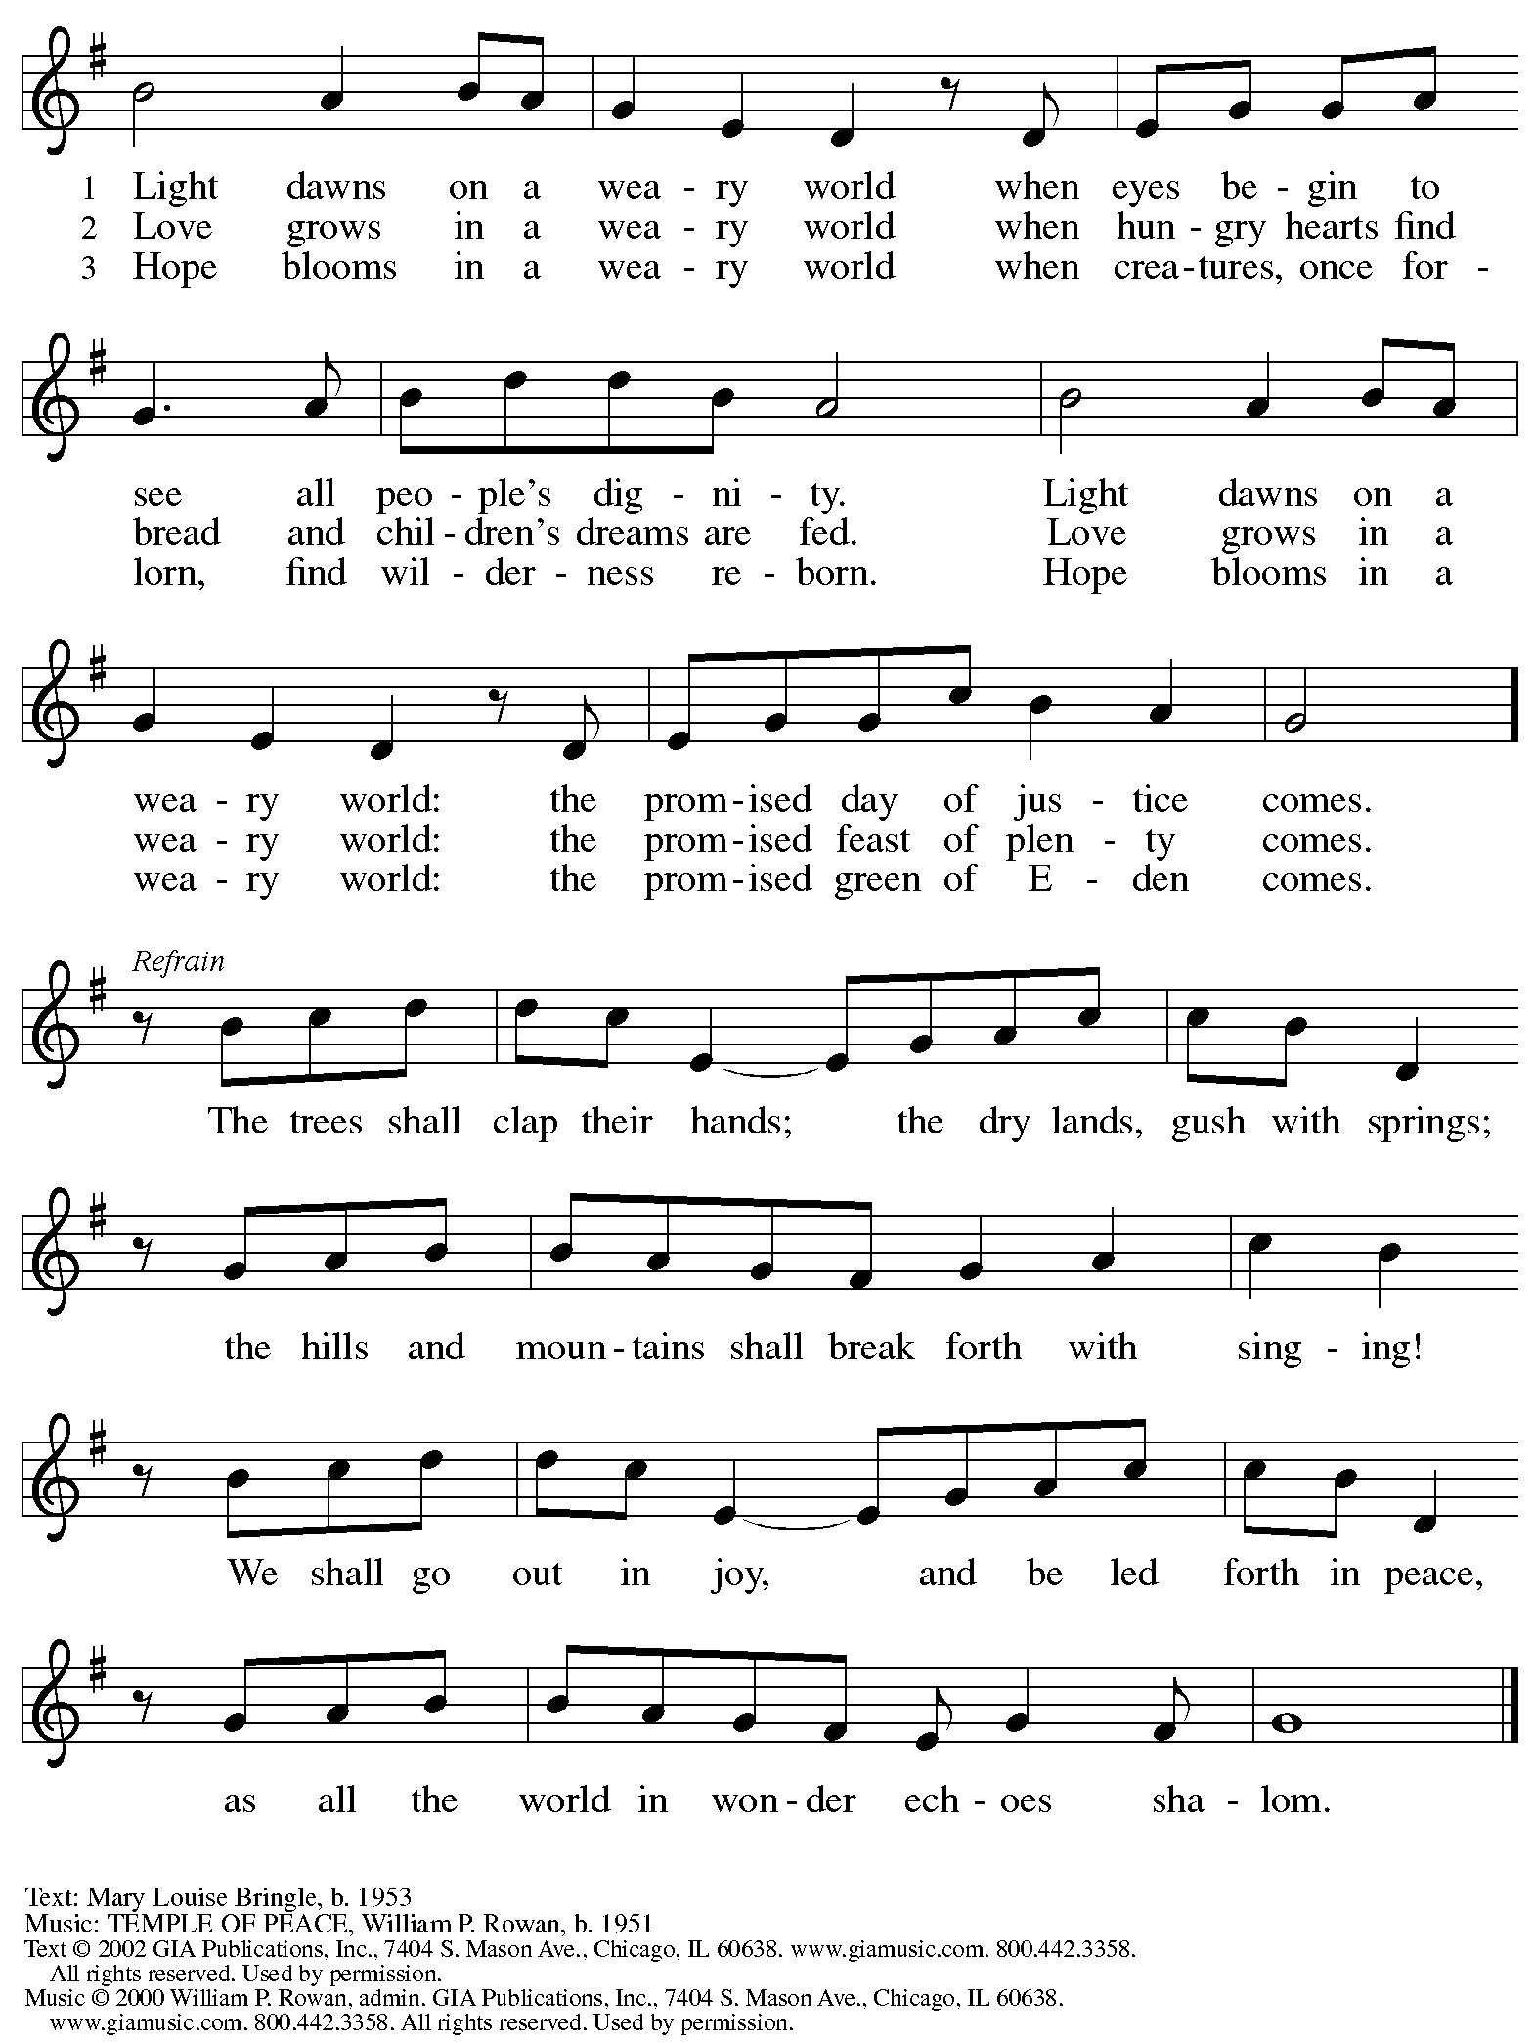
Reprinted under OneLicense.net # A-722139.

Greeting

P: The grace of our Lord Jesus Christ, the love of God,
and the communion of the Holy Spirit be with you all.
C: And also with you.

Kyrie HS p. 3

A: In peace, in peace,
Refrain
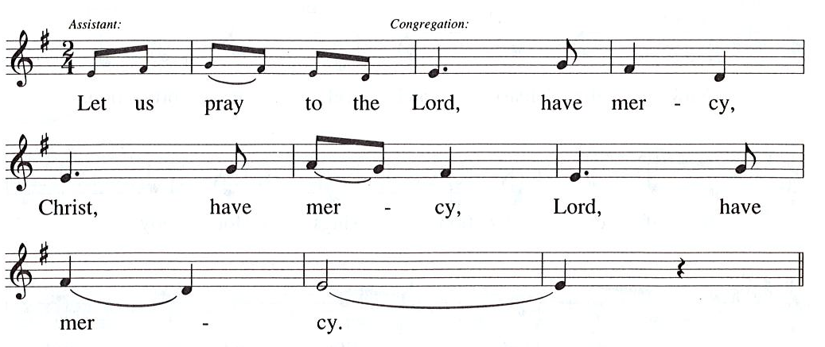

Prayer of the Day

A: For the Reign of God, and for peace throughout the world,
for the unity of all … (Refrain)

A: For your people here, who have come to give you praise,
for the strength to live your word … (Refrain)

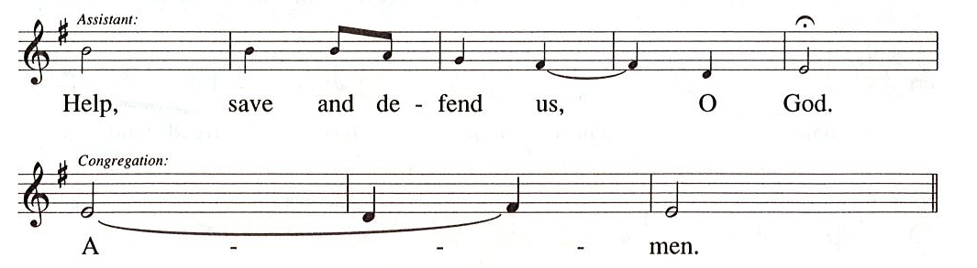

Prayer of the Day
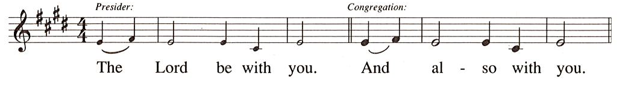

P: Let us pray.
Stir up the wills of all who look to you, Lord God,
and strengthen our faith in your coming,
that, transformed by grace, we may walk in your way;
through Jesus Christ, our Savior and Lord,
who lives and reigns with you and the Holy Spirit,
one God, now and forever.
C: Amen.

Please be seated.
Children are invited to come forward and gather around the Advent Wreath
for the lighting of the candles.

Hymn during Candle Lighting
Light One Candle to Watch for Messiah ELW 240
v. 1-3

1 Light one candle to watch for Messiah:
Lead our way through the darkness.
He shall bring salvation to Israel,
God fulfills the promise.

2. Light two candles to watch for Messiah;
Lead our way through the darkness.
He shall feed the flock like a shepherd,
gently lead them homeward.

3 Light three candles to watch for Messiah:
Lead our way through the darkness.
Raise your heads and lift high the gateway
for the king of glory.

After the lighting of the Advent candles and hymn, children are invited to join the adult leaders at the door and move to the office for Little Church; Big Faith.
We ask that one additional adult from the congregation attend with the children.

Word
God speaks to us in Scripture reading, preaching, and song

First Reading – Isaiah 35: 1-10

¹The wilderness and the dry land shall be glad,
the desert shall rejoice and blossom;
like the crocus ²it shall blossom abundantly,
and rejoice with joy and singing.
The glory of Lebanon shall be given to it,
the majesty of Carmel and Sharon.
They shall see the glory of the Lord,
the majesty of our God.
³Strengthen the weak hands,
and make firm the feeble knees.
⁴Say to those who are of a fearful heart,
“Be strong, do not fear!
Here is your God,
who will come with vengeance,
with terrible recompense.
God will come and save you.”
⁵Then the eyes of the blind shall be opened,
and the ears of the deaf unstopped;
⁶then the lame shall leap like a deer,
and the tongue of the speechless sing for joy.
For waters shall break forth in the wilderness,
and streams in the desert;
⁷the burning sand shall become a pool,
and the thirsty ground springs of water;
the haunt of jackals shall become a swamp,
the grass shall become reeds and rushes.
⁸A highway shall be there,
and it shall be called the Holy Way;
the unclean shall not travel on it,
but it shall be for God’s people;
no traveler, not even fools, shall go astray.
⁹No lion shall be there,
nor shall any ravenous beast come up on it;
they shall not be found there,
but the redeemed shall walk there.
¹⁰And the ransomed of the Lord shall return,
and come to Zion with singing;
everlasting joy shall be upon their heads;
they shall obtain joy and gladness,
and sorrow and sighing shall flee away.

L: Word of God, word of life.
C: Thanks be to God.

Magnificat – Luke 1: 46b-55 Holy Is his Name
John Michael Talbot

A version of the Magnificat, the text from Luke’s Gospel appointed in the place of the psalm
this Sunday, is sung as a duet.

Second Reading – James 5: 7-10

⁷Be patient, therefore, beloved, until the coming of the Lord. The farmer waits for the precious crop from the earth, being patient with it until it receives the early and the late rains. ⁸You also must be patient. Strengthen your hearts, for the coming of the Lord is near. ⁹Beloved, do not grumble against one another, so that you may not be judged. See, the Judge is standing at the doors! ¹⁰As an example of suffering and patience, beloved, take the prophets who spoke in the name of the Lord.

L: Word of God, word of life.
C: Thanks be to God.

Please rise as you are able.

Gospel Acclamation Alleluia HS p. 8

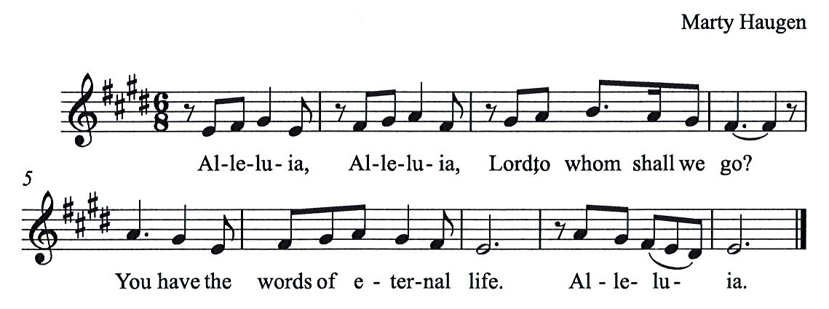

Gospel – Matthew 11: 2-11

P: The holy Gospel according to St. Matthew.
C: Glory to you, O Lord.
²When John heard in prison what the Messiah was doing, he sent word by his disciples ³and said to him, “Are you the one who is to come, or are we to wait for another?” ⁴Jesus answered them, “Go and tell John what you hear and see: ⁵the blind receive their sight, the lame walk, the lepers are cleansed, the deaf hear, the dead are raised, and the poor have good news brought to them. ⁶And blessed is anyone who takes no offense at me.”
⁷As they went away, Jesus began to speak to the crowds about John: “What did you go out into the wilderness to look at? A reed shaken by the wind? ⁸What then did you go out to see? Someone dressed in soft robes? Look, those who wear soft robes are in royal palaces. ⁹What then did you go out to see? A prophet? Yes, I tell you, and more than a prophet. ¹⁰This is the one about whom it is written,
‘See, I am sending my messenger ahead of you,
who will prepare your way before you.’
¹¹Truly I tell you, among those born of women no one has arisen greater than John the Baptist; yet the least in the kingdom of heaven is greater than he.”

P: The Gospel of the Lord.
C: Praise to you, O Christ.

Please be seated.

Sermon

A time of silence for prayer and reflection follows the sermon.
When the hymn of the day begins, please rise as you are able.

Hymn of the Day Hark! A Thrilling Voice Is Sounding Following Page

Hymn of the Day Hark! A Thrilling Voice Is Sounding ELW 246

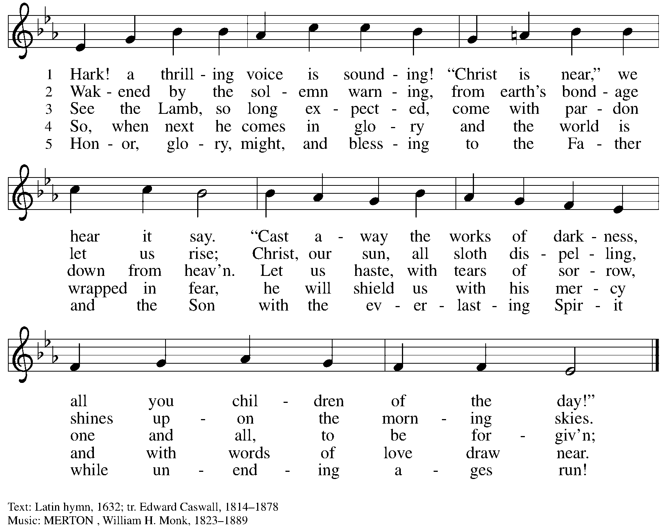

Prayers of the People

P: As we prepare for the fullness of Christ’s presence,
let us pray for the world as it yearns for new hope.

After each petition
P: God, in your mercy,
C: receive our prayer.

P: God of our longing, you know our deepest needs.
By your Spirit, gather our prayers and join them with those of all your people,
through Jesus Christ, our Savior.
C: Amen.

Please be seated.
Meal

Offering

We offer ourselves, our gifts, and our faithful service to God.
An usher will pass around an offering plate for anyone who would like to offer gifts before God.

Music during the Offering

Please rise as you are able.

Offertory Song As the Grains of Wheat ELW 465

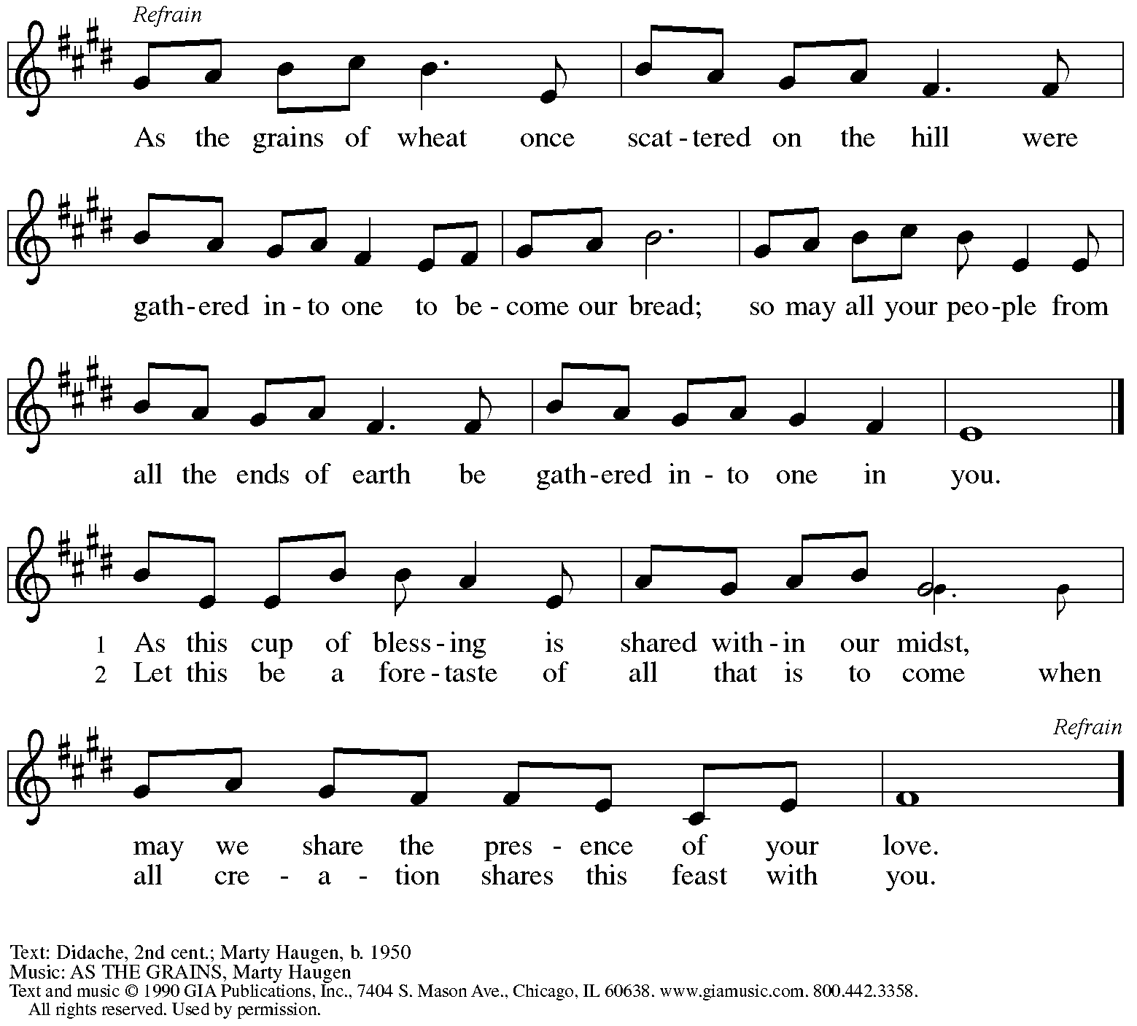
Reprinted with permission under OneLicense.net #A-722139.

Offertory Prayer

P: Let us pray. Eternal God,
C: you make the desert bloom
and send springs of water to thirsty ground.
Receive these simple gifts we offer,
and make us messengers of your mercy and love
for all in need of your justice and healing.
We ask this through Christ our Savior.
Amen.

Dialogue HS p. 14

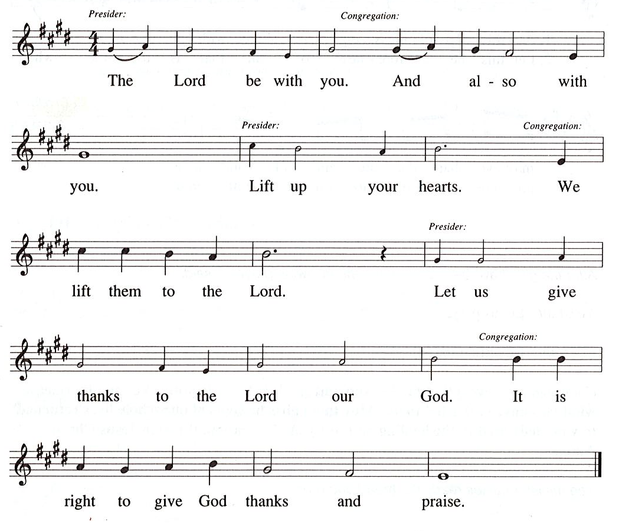

Preface (Sung by the presiding minister)

P: It is our duty and delight …
… we praise your name and join their unending hymn:

Sanctus HS p. 15

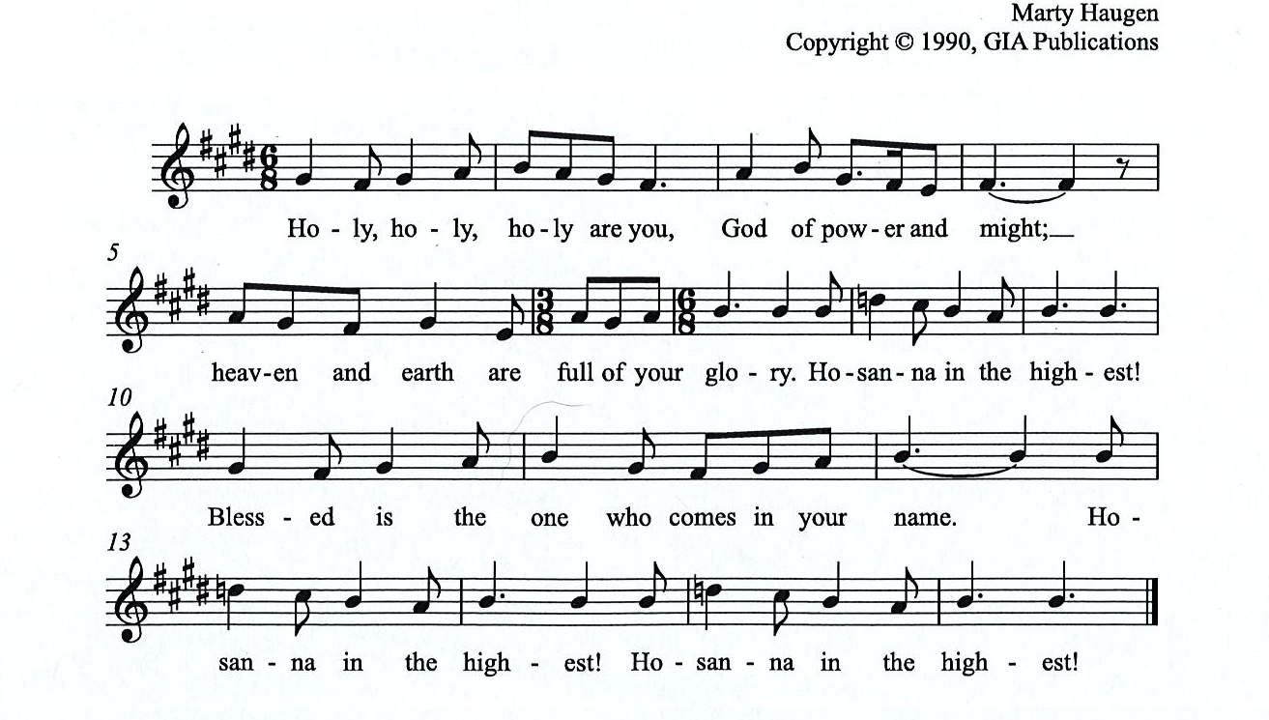

All rights reserved. Reprinted under OneLicensne.net # A-722319.

Eucharistic Prayer

P: Holy One, the beginning and the end, the giver of life …
… Do this for the remembrance of me.

Let us proclaim the mystery of faith:
The presiding minister sings, then the congregation responds
P: Christ has died. Christ is risen. Christ will come, come again.
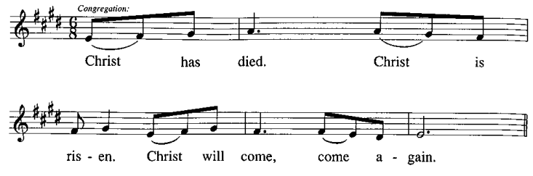
C:

P: With this bread and cup we remember …
… We look with hope for his coming.

P: Amen. Come, Lord Jesus. Amen. Come, Lord Jesus.
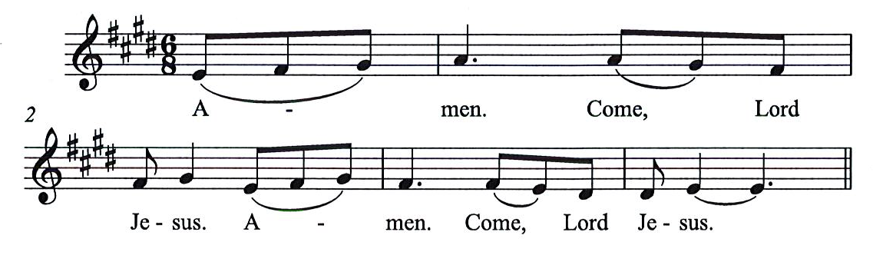
C:

P: Holy God, we long for your Spirit. …
… Bring the gift of peace on earth.

P: Amen. Come, Holy Spirit. Amen, Come, Holy Spirit.
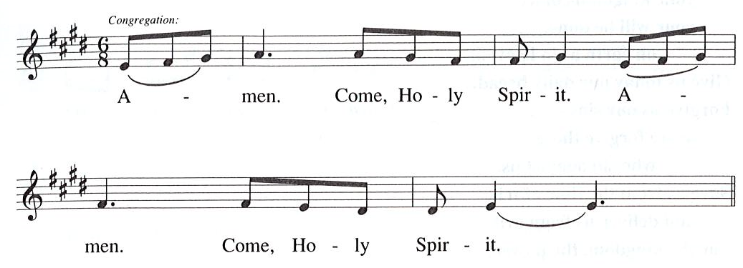
C:

P: All praise and glory are yours, …
… one God, now and forever.
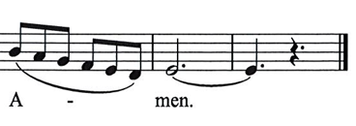
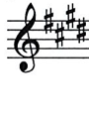
C:

Lord’s Prayer

P: Gathered as one by the Holy Spirit, let us pray as Jesus taught us.
C: Our Father in heaven,
hallowed be your name,
your kingdom come,
your will be done,
on earth as in heaven.
Give us today our daily bread.
Forgive us our sins
as we forgive those who sin against us.
Save us from the time of trial
and deliver us from evil.
For the kingdom, the power,
and the glory are yours,
now and forever. Amen.

Fraction and Invitation

Agnus Dei / Lamb of God HS p. 18

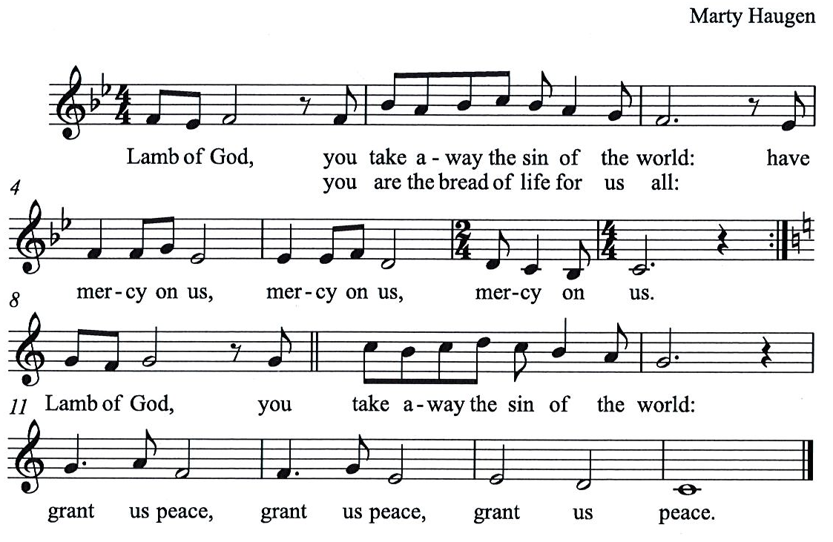

Please be seated.

Holy Communion
- Worshipers from the pulpit side will proceed forward first, followed by the center section, and then the lectern side.
- Holy Communion will be served with bread and wine/grape juice.
- The presiding minister will first distribute the bread (host) to each communicant. Please indicate if you require a gluten-free host.
- Once you have consumed the bread, please pick up an empty glass from the tray next to the presiding minister. The Communion Assistant will pour wine from the chalice or grape juice from the cruet into your glass.
- Please step to the side to consume the wine or grape juice.
- As you return to your pew, glasses may be returned to the empty trays on either side of the center aisle.
- A blessing will be provided for anyone who does not yet receive the sacrament.
- All are invited to join in singing the hymns during Holy Communion.

Hymn during Holy Communion
My Soul in Stillness Waits HS 724

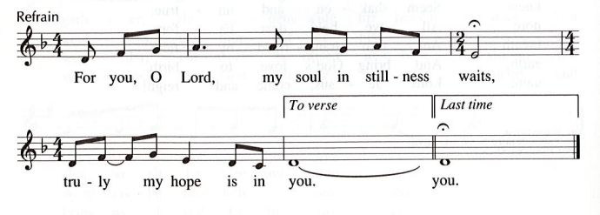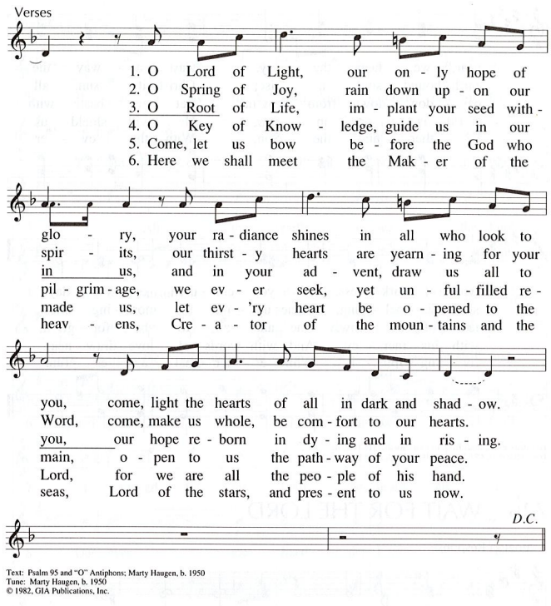
All rights reserved. Reprinted under OneLicense.net # A-722139.
Hymn during Holy Communion
Hark, the Glad Sound! ELW 239

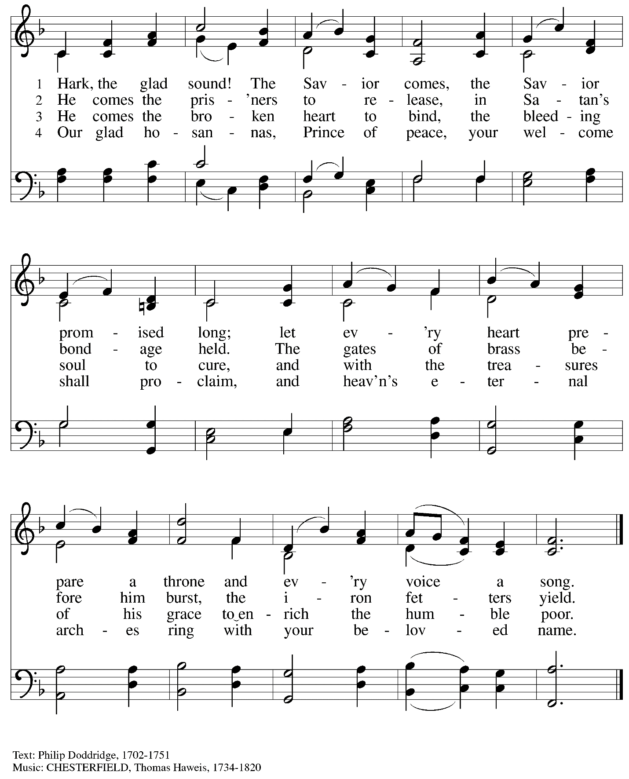

When all have returned to their places, please rise as you are able.

Blessing

P: The grace of our Lord Jesus Christ and the gifts of his body and blood strengthen, keep,
and unite us, now and forever.
C: Amen.

Hymn of Thanksgiving HS p. 20

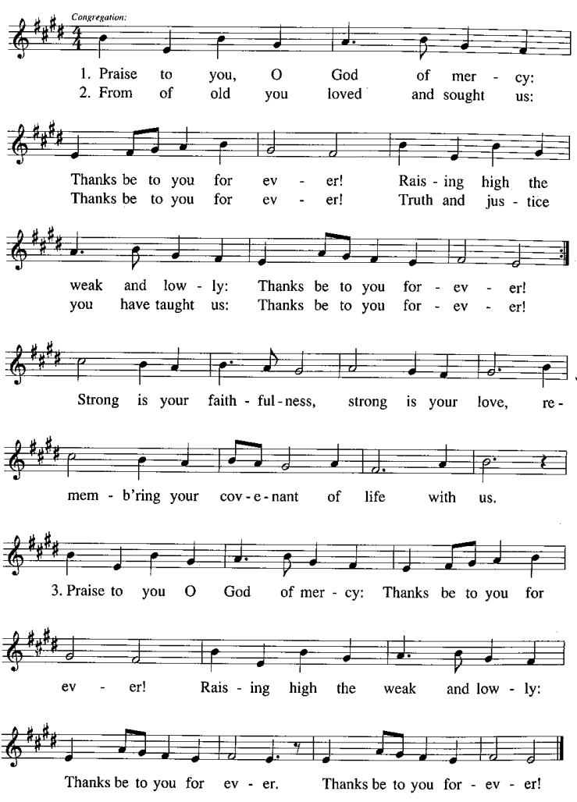

Prayer

P: Let us pray.
Faithful God, in this meal you have remembered your mercy,
bringing heaven to earth in the body and blood of Christ.
As we await the day when all your promises will be fulfilled,
sustain and strengthen us by this holy mystery.
Guide us toward your promised future coming to birth
in Jesus Christ, our Savior and Lord.
C: Amen.

Please be seated.

Sending

Announcements

Please rise as you are able.

Benediction

P: God the eternal Word,
who dwells with us in Jesus,
and who holds us in the grace of the Holy Spirit,
☩ bless you now and forever.
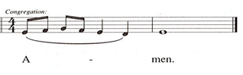
C:

Sending Hymn All Earth Is Hopeful Following page

Dismissal

P: Go in peace. Christ is near.
C: Thanks be to God!

Sending Hymn All Earth Is Hopeful ELW 266

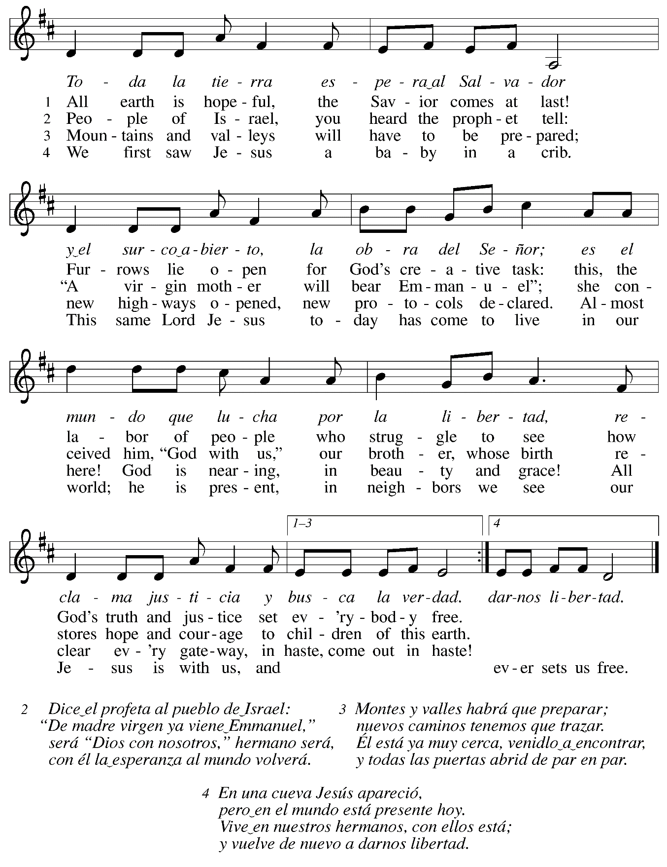

Abbreviations

P: Pastor/Presiding Minister
A: Assistant (Cantor)
L: Lector
C: Congregation

HS: Hymnal Supplement
ELW: Evangelical Lutheran Worship hymnal
ACS: All Creation Sings hymnal

Those serving in worship today

Minister of Music Laura Reynolds
Cantor Joy Givens
Clarinet Maria Mangano
Lector and Communion Assistant Colleen Cooke
Magnificat Singers Kristen Asplin
Linnea Asplin
Presiding Minister Rev. Ross Carmichael

Liturgy and Hymnody Acknowledgements

From SundaysandSeasons.com. Copyright © 2022 Augsburg Fortress. All rights reserved. Reprinted under OneLicense.net # A-722139.
Used by permission of Augsburg Fortress.

Light One Candle to Watch for Messiah – Text: Wayne L. Wold, b. 1954. Music: TIF IN VELDELE, Yiddish folk tune. Text © 1984 Fortress Press, admin. Augsburg Fortress. All rights reserved. Reprinted with permission under OneLicense.net # A-722139.

Toda la tierra / All Earth Is Hopeful – Text: Alberto Taulé, b. 1932, tr. Madeleine Forell Marshall, b. 1946. Music: TODA LA TIERRA, Alberto Taulé. Spanish text and tune © 1993 and English text © 1995 Centro de Pastoral Litúrgica, admin. OCP Publications, 5536 NE Hassalo, Portland, OR 97213.

St. Andrew Lutheran Church Announcements
December 11th, 2022

- Worship in the Sanctuary and Online – Sunday, December 11th, + Third Sunday of Advent – St. Andrew’s next worship with Holy Communion will be this Sunday, December 11th, at 10:00 a.m. Masks are optional at St. Andrew when Allegheny County’s Covid-19 community level is in the low and medium categories. Worship will also be live-streamed to Facebook, YouTube, and Zoom. Worship attendees are invited to make their own name tags at the back of the worship space. Coffee hour will be held in the Social Hall next to the sanctuary after worship.
- Seeking Individuals to Serve in Various Worship Roles – As worship attendance increases and we return to distribution of wine at Holy Communion, we ask people of St. Andrew to consider offering your gifts in worship. On the upcoming Sundays, we will pass around a signup sheet describing different roles needed, including altar care and setup, Communion Assistant, Audio/Visual Minister, Adult Leader or Helper for Little Church; Big Faith, Usher, Cantor, Lector, and Counter. Please consider how best to share your gifts to enrich the worship experience of St. Andrew!
- Shelter Dinner at East End Cooperative Ministry - Thursday, December 15th, 6:30 p.m. – Every month, on the third Thursday, people of St. Andrew provide a meal for guests of the shelter at East End Cooperative Ministry (EECM). A menu is chosen ahead of time and individuals/families are invited to cook, bake, or otherwise provide one portion of the meal. Those who are unable to attend may also help provide for the meal financially. We also appreciate anyone who would like to come and help serve the meal at 6:30 p.m. EECM is located at 6140 Station St. in East Liberty, 15206. Please sign up at: https://www.signupgenius.com/go/5080544AAAC22A1F58-shelter36.
- Help Decorate the Church for Christmas – Sunday, December 18th, after Worship! –
We invite everyone from the congregation to stay after worship next Sunday, December 18th as we decorate the sanctuary for the Christmas season!
- Christmas Worship Schedule:
Saturday, December 24th, 7:00 p.m. – Worship with Candlelight and Holy Communion
Sunday, December 25th, 10:00 a.m. – Worship with Holy Communion
- Donations for Coffee Hour – As more people return to coffee hour or attend for the first time, it would be helpful to have additional donations to support this ministry. Any of the following would be much appreciated: Ground coffee, creamers, canned drinks, children’s drinks, individually wrapped food items of any kind. Donations may be left on the coffee table in the Social Hall. Thank you for your consideration.
- Christ in our Home Current Devotional Booklets for the Next Quarter (January - March 2023) Available at Church Entrances – Christ in our Home is a booklet that offers a daily Bible reading with a short reflection and prayers, long with additional prayer concerns and readings for those who would like to expand their devotional practices. These are available at each entrance to the church, and we encourage people of the congregation to take one for yourself and others!
- Bethel AME Pittsburgh Updates – Our friends at Bethel AME are collecting clean, gently worn/used Winter clothing of all sizes. Items can be left on the table next to the pantry shelves in St. Andrew’s Social Hall.
- Blanket the Capitol Lawn and Cover Our Neighbors with Care – An Invitation from our Church’s Witness in Society Office – The ELCA Witness in Society office is partnering with several synods, advocates, and foundation partners to organize a Homeless Remembrance Blanket awareness event in Washington D.C. on December 21st, the longest night of the year. The event, which includes invited bishops, members of Congress, Administration officials, dignitaries, and nonprofit advocacy organizations, will be gathering hundreds of blankets from across the country in a symbolic art installation on the U.S. Capitol lawn near the Christmas tree.
The event will bring greater attention to those struggling with homelessness on the coldest nights of the year. Interested advocates are welcome to participate in-person at the U.S. Capitol, or join the full-day event virtually.

Blankets will be arriving from each state in the country, with letters and invitations to lawmakers to visit an agency or ministry with those experiencing homelessness in their district. Please consider donating a blanket or joining us in the nation's capital on Dec. 21st for the event, or on Jan. 4th, to deliver blankets and letters to members of Congress.

If you would like to connect with other Lutherans in attendance, or to help – by making a blanket, writing a letter, stitching donated squares, setting up and tearing down the art installation or delivering blankets to members of Congress in January for delivery in their districts – please email Lutheran Advocacy Ministry of Pennsylvania (LAMPa), at LAMPa@LutheranAdvocacyPA.org with “Blanket” in the subject line.

