+ Fourth Sunday of Advent
December 18, 2022

St. Andrew Lutheran Church
304 Morewood Ave.
Pittsburgh, PA 15213
St_andrewELCA@verizon.net
www.standrewpittsburgh.org

+ Fourth Sunday of Advent
Order for Worship

Isaiah prophesies that a young woman will bear a son and will name him Emmanuel.
The Gospel this week is Matthew’s account of the annunciation and birth of the one named Emmanuel, God-with-us. During these final days of Advent we pray, “O Come, O Come, Emmanuel,” a beloved hymn based on the “O Antiphons,” ancient prayers appointed for the seven days preceding Christmas. On this last Sunday of Advent, we prepare to celebrate the birth of the one born to save us from the power of sin and death.

- Masks are optional at St. Andrew when Covid-19 community level in Allegheny County is in the low and medium categories.
- Hand sanitizer is available at the back of the sanctuary.

Worship Services are live streamed to multiple online platforms.
By attending worship, you agree that your image and voice may be broadcast.

Welcome to St. Andrew!
- Everyone is invited to make a nametag at the black bookcase in the back of the worship space if they would like.
- Children are invited to participate in Little Church; Big Faith, a Bible lesson and activity, following the Prayer of the Day.
- Worship “toolkits” to help children engage with the service are available in the black bookcase at the back of the worship space. There are “reader” and “pre-reader” resources available in each kit. Please feel free to use the kits for/with your children during worship.
- St. Andrew has recently returned to serving the sacrament of Holy Communion with both (separate) elements, bread and wine/grape juice. The presiding minister will first distribute the bread (host). Please consume this and then pick up an empty glass from the tray next to the presiding minister. The Communion Assistant will pour wine from the chalice or grape juice from the cruet into your glass. Please step to the side to consume the wine or grape juice. As you return to your pew, glasses may be returned to the empty trays on either side of the center aisle.
- A restroom is available on the main level of the church, through the doors to the Social Hall and to the right in the main office.

Welcome

Prelude

Gathering
The Holy Spirit calls us together as the people of God.

Confession and Forgiveness

P: Blessed be the Lord, the God of Israel,
who alone does wondrous things.
C: Blessed be God’s name forever.
Amen.

P: Beloved, now is the time to wake from sleep.
Let us confront our sins,
and confess them to the one who is merciful and just.

Silence is kept for reflection.

P: God of new beginnings,
C: we confess that we have not welcomed your holy reign.
We have strayed from your paths.
We prepare for war instead of peace.
We dishonor one another and your creation.
Purify us with your refining fire
and set us again on your way of love,
that we may bear fruit worthy of repentance,
and welcome your coming among us.
Amen.

P: People of God,
a new thing is growing in our midst,
a tender branch, a living sign.
By water and the Spirit you are joined to this wonder.
You have put on ☩ Christ,
and your sins have been washed away.
Rejoice in the way of the Lord.
C: Amen.

Gathering Hymn O Come, O Come, Emmanuel ELW 257

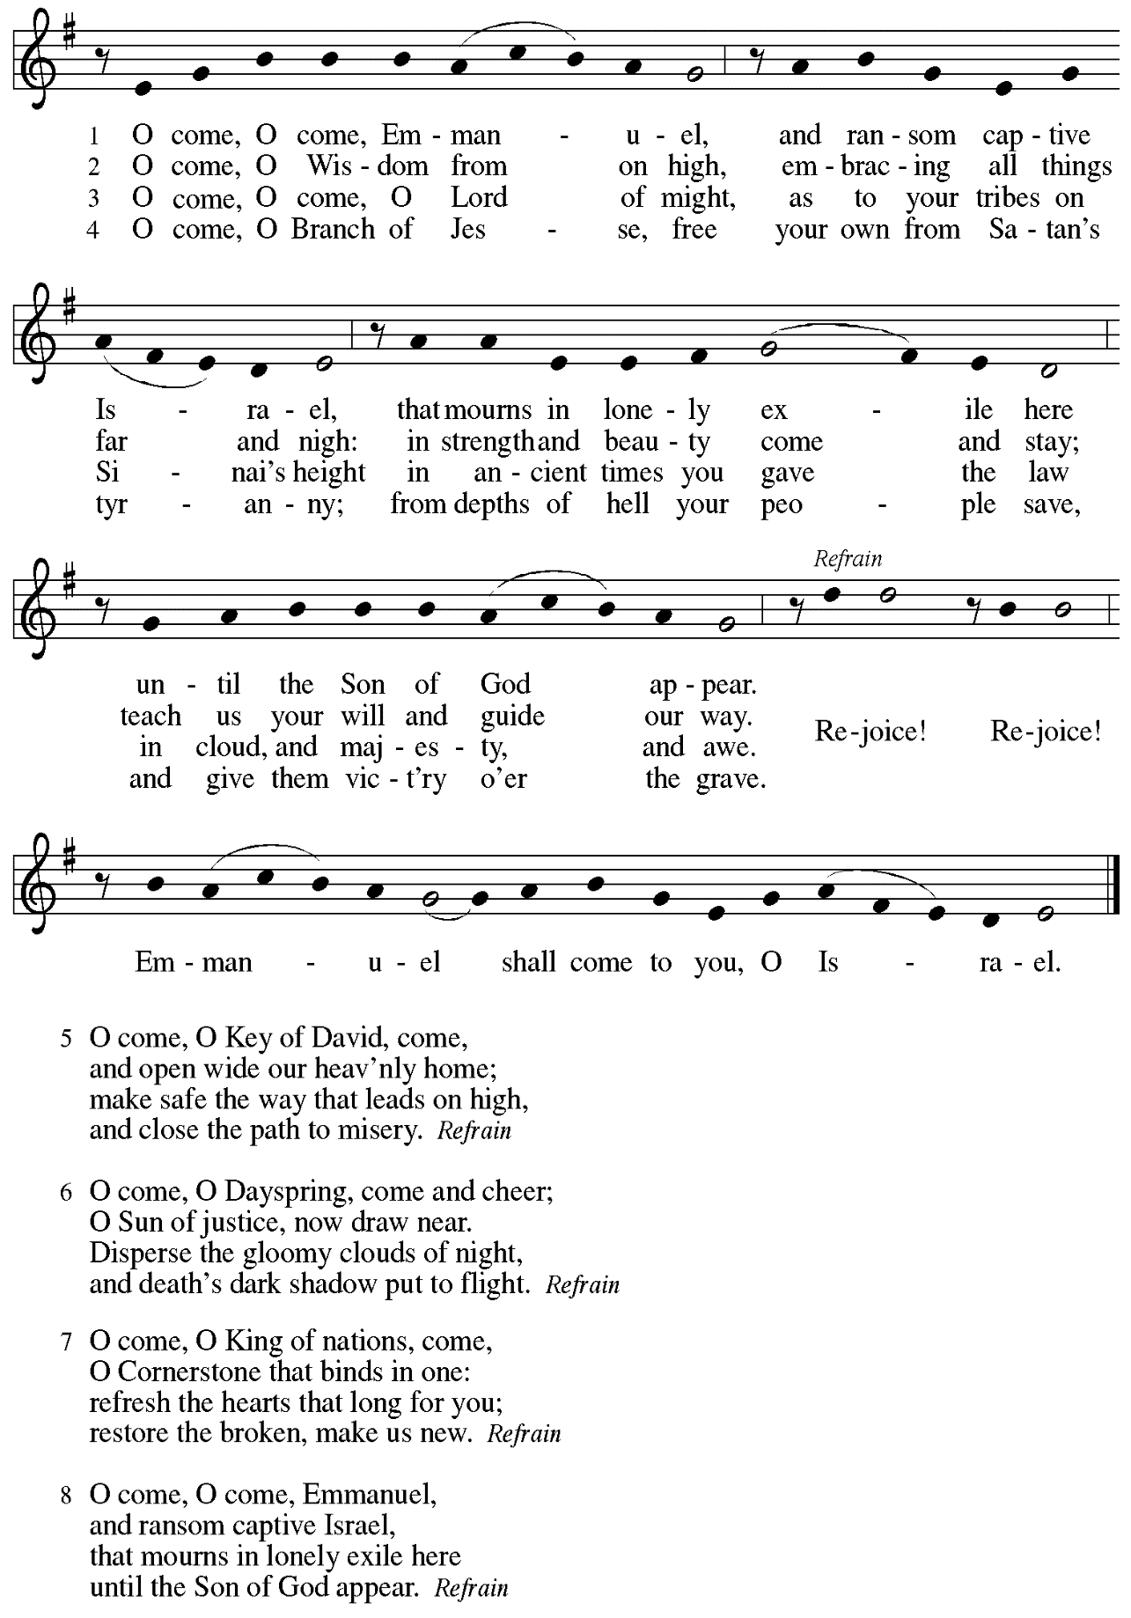

Greeting

P: The grace of our Lord Jesus Christ, the love of God,
and the communion of the Holy Spirit be with you all.
C: And also with you.

Kyrie HS p. 3

A: In peace, in peace,
Refrain
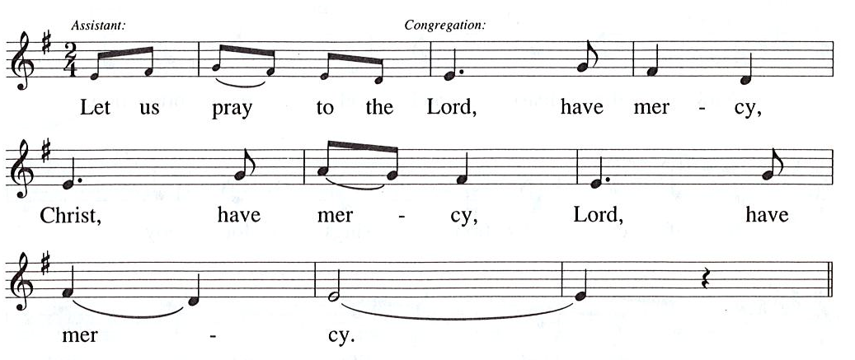

Prayer of the Day

A: For the Reign of God, and for peace throughout the world,
for the unity of all … (Refrain)

A: For your people here, who have come to give you praise,
for the strength to live your word … (Refrain)

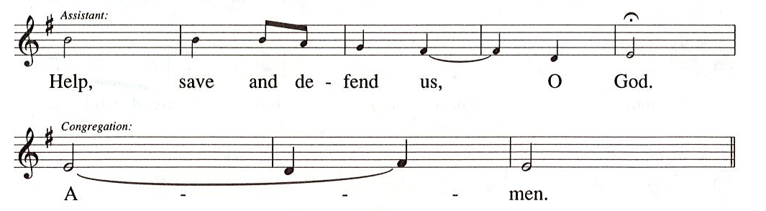

Prayer of the Day
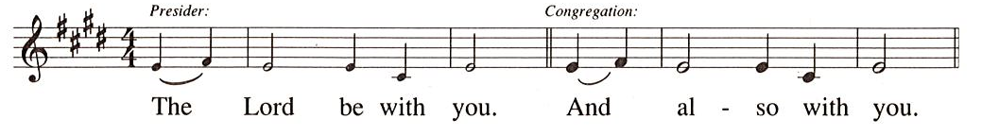

P: Let us pray.
Stir up your power, Lord Christ, and come.
With your abundant grace and might, free us from the sin that hinders our faith,
that eagerly we may receive your promises, for you live and reign
with the Father and the Holy Spirit, one God, now and forever.
C: Amen.

Please be seated. Children are invited to come forward and gather around the Advent Wreath
for the lighting of the candles.

Hymn during Candle Lighting
Light One Candle to Watch for Messiah ELW 240
v. 1-4

1 Light one candle to watch for Messiah:
Lead our way through the darkness.
He shall bring salvation to Israel,
God fulfills the promise.

2. Light two candles to watch for Messiah;
Lead our way through the darkness.
He shall feed the flock like a shepherd,
gently lead them homeward.

3 Light three candles to watch for Messiah:
Lead our way through the darkness.
Raise your heads and lift high the gateway
for the king of glory.

4 Light four candles to watch for Messiah:
Lead our way through the darkness.
Christ is coming, tell the glad tidings.
Let your lights be shining!

After the lighting of the Advent candles and hymn, children are invited to join the adult leaders at the door and move to the office for Little Church; Big Faith.
We ask that one additional adult from the congregation attend with the children.

Word
God speaks to us in Scripture reading, preaching, and song

First Reading – Isaiah 7: 10-16

¹⁰The Lord spoke to Ahaz, saying, ¹¹Ask a sign of the Lord your God; let it be deep as Sheol or high as heaven. ¹²But Ahaz said, I will not ask, and I will not put the Lord to the test. ¹³Then Isaiah said: “Hear then, O house of David! Is it too little for you to weary mortals, that you weary my God also? ¹⁴Therefore the Lord himself will give you a sign. Look, the young woman is with child and shall bear a son, and shall name him Immanuel. ¹⁵He shall eat curds and honey by the time he knows how to refuse the evil and choose the good. ¹⁶For before the child knows how to refuse the evil and choose the good, the land before whose two kings you are in dread will be deserted.”

L: Word of God, word of life.
C: Thanks be to God.

Psalm 80: 1-7, 17-19

The cantor will lead the singing of the psalm.
The congregation is invited to respond with the alternate verses in bold print,
and to join in singing the refrain.

Psalm tone

Psalm refrain

¹Hear, O Shepherd of Israel, leading Joseph | like a flock;
shine forth, you that are enthroned up- | on the cherubim.
²In the presence of Ephraim, Benjamin, | and Manasseh,
stir up your strength and | come to help us.
³Restore | us, O God;
let your face shine upon us, and we | shall be saved.
⁴O Lord| God of hosts,
how long will your anger fume when your | people pray? R
⁵You have fed them with the | bread of tears;
you have given them bowls of | tears to drink.
⁶You have made us the derision | of our neighbors,
and our enemies laugh | us to scorn.
⁷Restore us, O | God of hosts;
let your face shine upon us, and we | shall be saved.
¹⁷Let your hand be upon the one at | your right hand,
the one you have made so strong | for yourself.
¹⁸And so will we never turn a- | way from you;
give us life, that we may call up- | on your name.
¹⁹Restore us, O Lord| God of hosts;
let your face shine upon us, and we | shall be saved. R

Second Reading – Romans 1: 1-7

¹Paul, a servant of Jesus Christ, called to be an apostle, set apart for the gospel of God, ²which God promised beforehand through the prophets in the holy scriptures, ³the gospel concerning God’s Son, who was descended from David according to the flesh ⁴and was declared to be Son of God with power according to the spirit of holiness by resurrection from the dead, Jesus Christ our Lord, ⁵through whom we have received grace and apostleship to bring about the obedience of faith among all the Gentiles for the sake of his name, ⁶including yourselves who are called to belong to Jesus Christ,
⁷To all God’s beloved in Rome, who are called to be saints:
Grace to you and peace from God our Father and the Lord Jesus Christ.

L: Word of God, word of life.
C: Thanks be to God.

Please rise as you are able.

Gospel Acclamation Alleluia HS p. 8
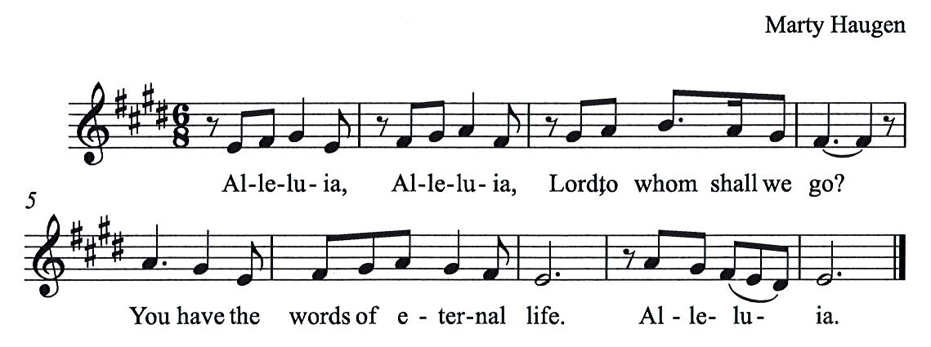

Gospel – Matthew 1: 18-25

Gospel – Matthew 1: 18-25

P: The holy Gospel according to St. Matthew.
C: Glory to you, O Lord.
¹⁸Now the birth of Jesus the Messiah took place in this way. When his mother Mary had been engaged to Joseph, but before they lived together, she was found to be with child from the Holy Spirit. ¹⁹Her husband Joseph, being a righteous man and unwilling to expose her to public disgrace, planned to dismiss her quietly. ²⁰But just when he had resolved to do this, an angel of the Lord appeared to him in a dream and said, “Joseph, son of David, do not be afraid to take Mary as your wife, for the child conceived in her is from the Holy Spirit. ²¹She will bear a son, and you are to name him Jesus, for he will save his people from their sins.” ²²All this took place to fulfill what had been spoken by the Lord through the prophet:
²³“Look, the virgin shall conceive and bear a son,
and they shall name him Emmanuel,”
which means, “God is with us.”²⁴When Joseph awoke from sleep, he did as the angel of the Lord commanded him; he took her as his wife, ²⁵but had no marital relations with her until she had borne a son; and he named him Jesus.

P: The Gospel of the Lord.
C: Praise to you, O Christ.

Please be seated.

Sermon

A time of silence for prayer and reflection follows the sermon.
When the hymn of the day begins, please rise as you are able.

Hymn of the Day Savior of the Nations, Come Following Page

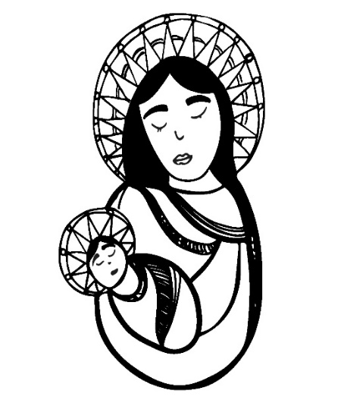

Hymn of the Day Savior of the Nations, Come ELW 263

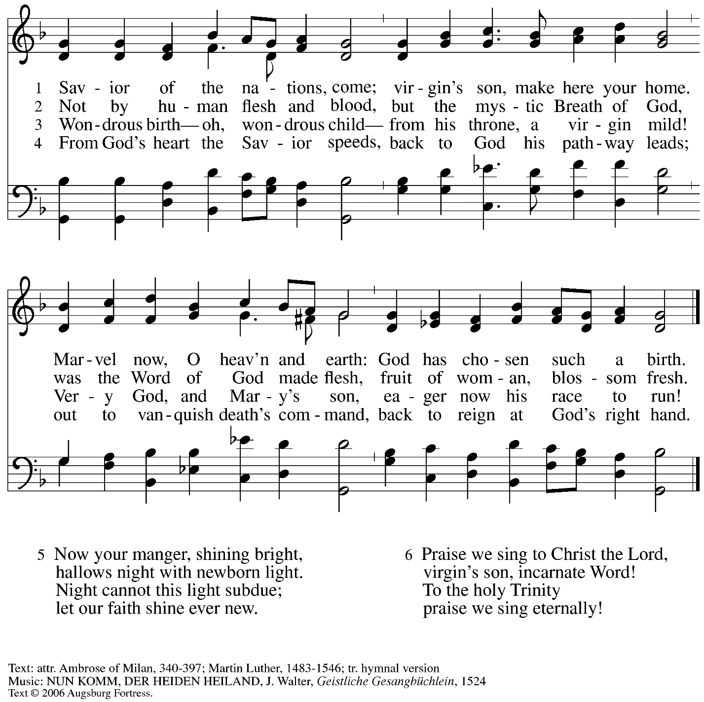
All rights reserved. Reprinted with permission under OneLicense.net # A-722139.

Prayers of the People

P: As we prepare for the fullness of Christ’s presence,
let us pray for the world as it yearns for new hope.

After each petition
P: God, in your mercy,
C: receive our prayer.

P: God of our longing, you know our deepest needs. By your Spirit, gather our prayers
and join them with those of all your people, through Jesus Christ, our Savior.
C: Amen.

Please be seated.

Meal

Offering

We offer ourselves, our gifts, and our faithful service to God.
An usher will pass around an offering plate for anyone who would like to offer gifts before God.

Music during the Offering

Please rise as you are able.

Offertory Song As the Grains of Wheat ELW 465

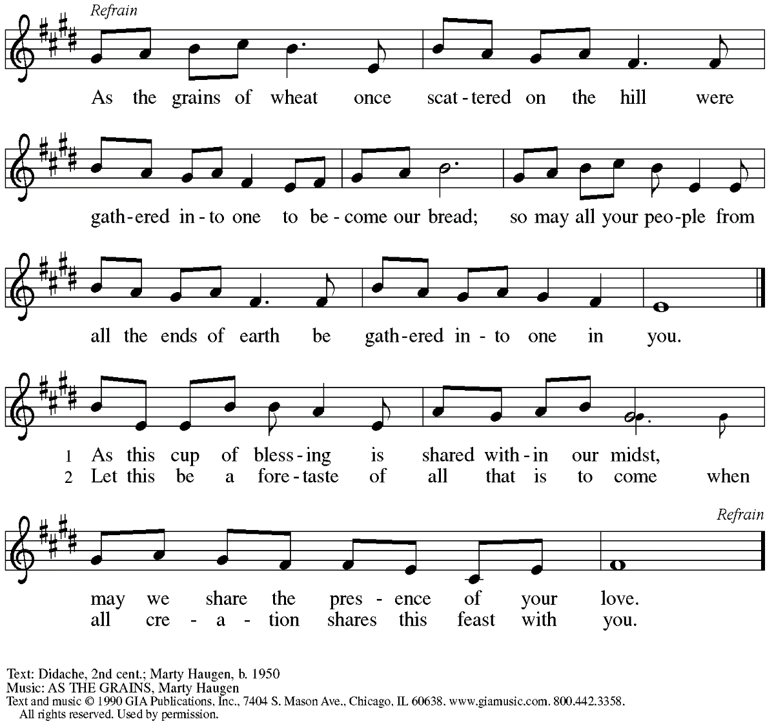
Reprinted with permission under OneLicense.net #A-722139.

Offertory Prayer

P: Let us pray. Eternal God,
C: you make the desert bloom
and send springs of water to thirsty ground.
Receive these simple gifts we offer,
and make us messengers of your mercy and love
for all in need of your justice and healing.
We ask this through Christ our Savior.
Amen.

Dialogue HS p. 14

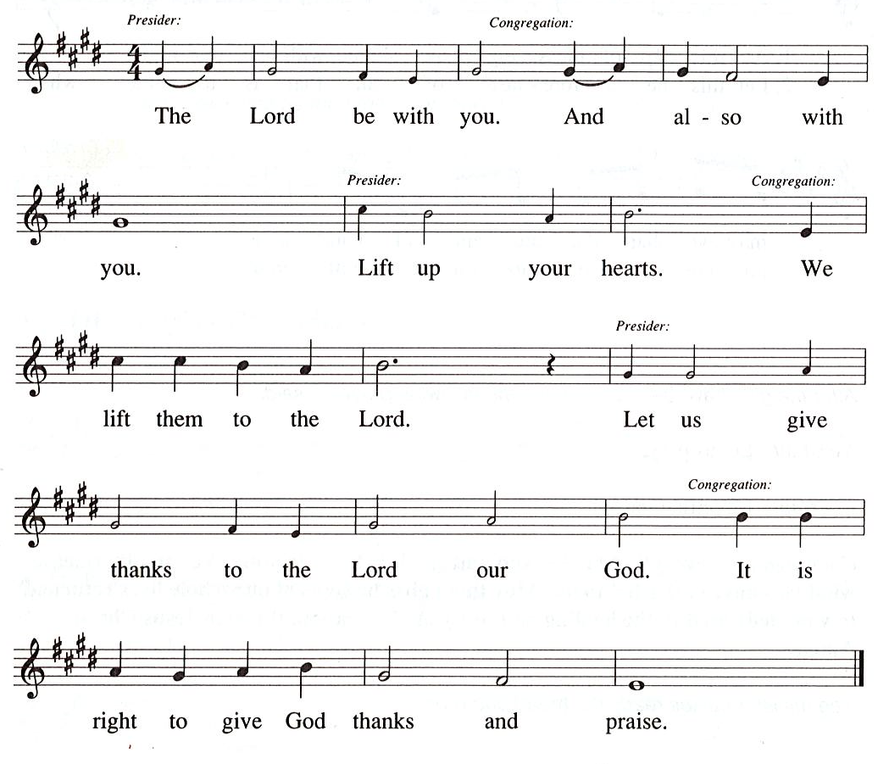

Preface (Sung by the presiding minister)

P: It is our duty and delight …
… we praise your name and join their unending hymn:

Sanctus HS p. 15

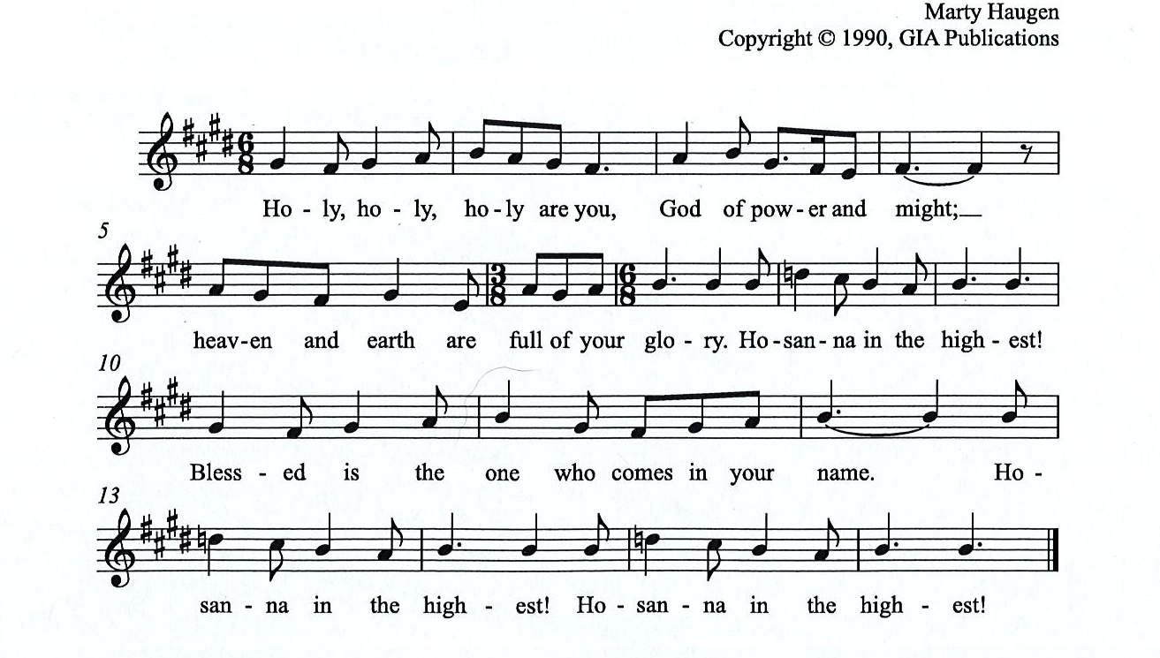

All rights reserved. Reprinted under OneLicensne.net # A-722319.

Eucharistic Prayer

P: Holy One, the beginning and the end, the giver of life …
… Do this for the remembrance of me.

Let us proclaim the mystery of faith:

Christ has died. Christ is risen. Christ will come, come again.
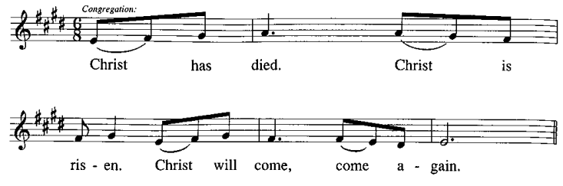
C:

P: With this bread and cup we remember …
… We look with hope for his coming.

Amen. Come, Lord Jesus. Amen. Come, Lord Jesus.
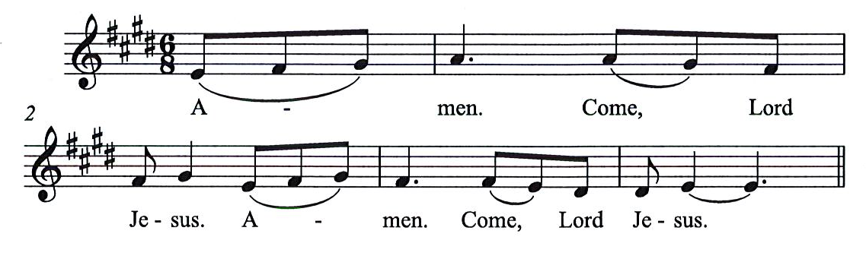
C:

P: Holy God, we long for your Spirit. …
… Bring the gift of peace on earth.

Amen. Come, Holy Spirit. Amen, Come Holy Spirit.
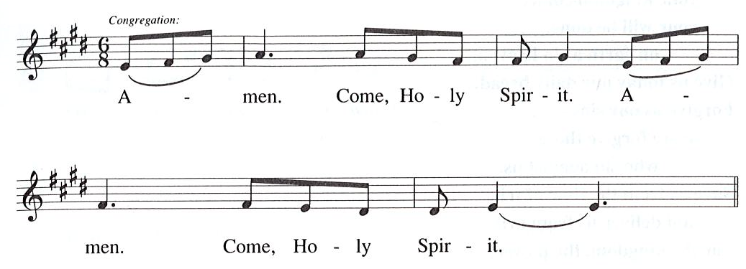
C:

P: All praise and glory are yours, …
… one God, now and forever.
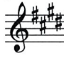
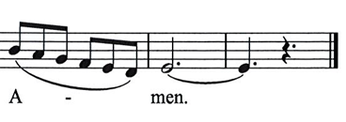
C:

Lord’s Prayer

P: Gathered as one by the Holy Spirit, let us pray as Jesus taught us.
C: Our Father in heaven,
hallowed be your name,
your kingdom come,
your will be done,
on earth as in heaven.
Give us today our daily bread.
Forgive us our sins
as we forgive those who sin against us.
Save us from the time of trial
and deliver us from evil.
For the kingdom, the power,
and the glory are yours,
now and forever. Amen.

Fraction and Invitation

Agnus Dei / Lamb of God HS p. 18

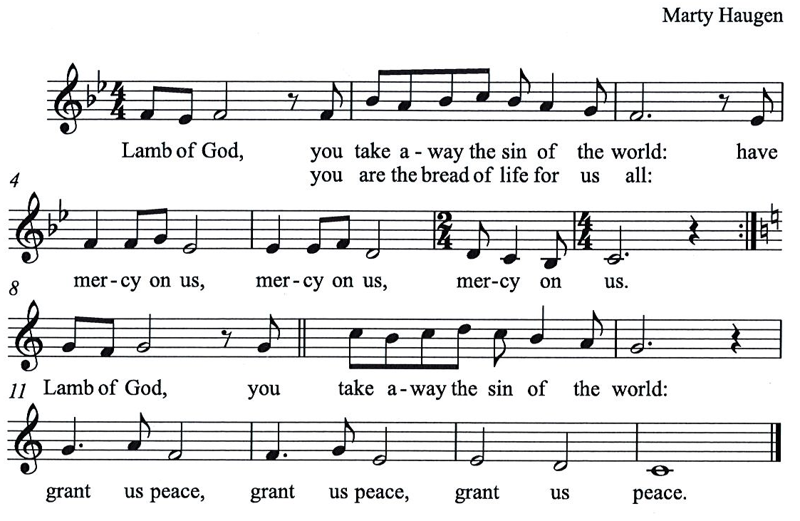

Please be seated.

Holy Communion
- Worshipers from the pulpit side will proceed forward first, followed by the center section, and then the lectern side.
- Holy Communion will be served with bread and wine/grape juice.
- The presiding minister will first distribute the bread (host) to each communicant. Please indicate if you require a gluten-free host.
- Once you have consumed the bread, please pick up an empty glass from the tray next to the presiding minister. The Communion Assistant will pour wine from the chalice or grape juice from the cruet into your glass.
- Please step to the side to consume the wine or grape juice.
- As you return to your pew, glasses may be returned to the empty trays on either side of the center aisle.
- A blessing will be provided for anyone who does not yet receive the sacrament.
- All are invited to join in singing the hymns during Holy Communion.

Hymn during Holy Communion
Unexpected and Mysterious ELW 258
v. 1, 3

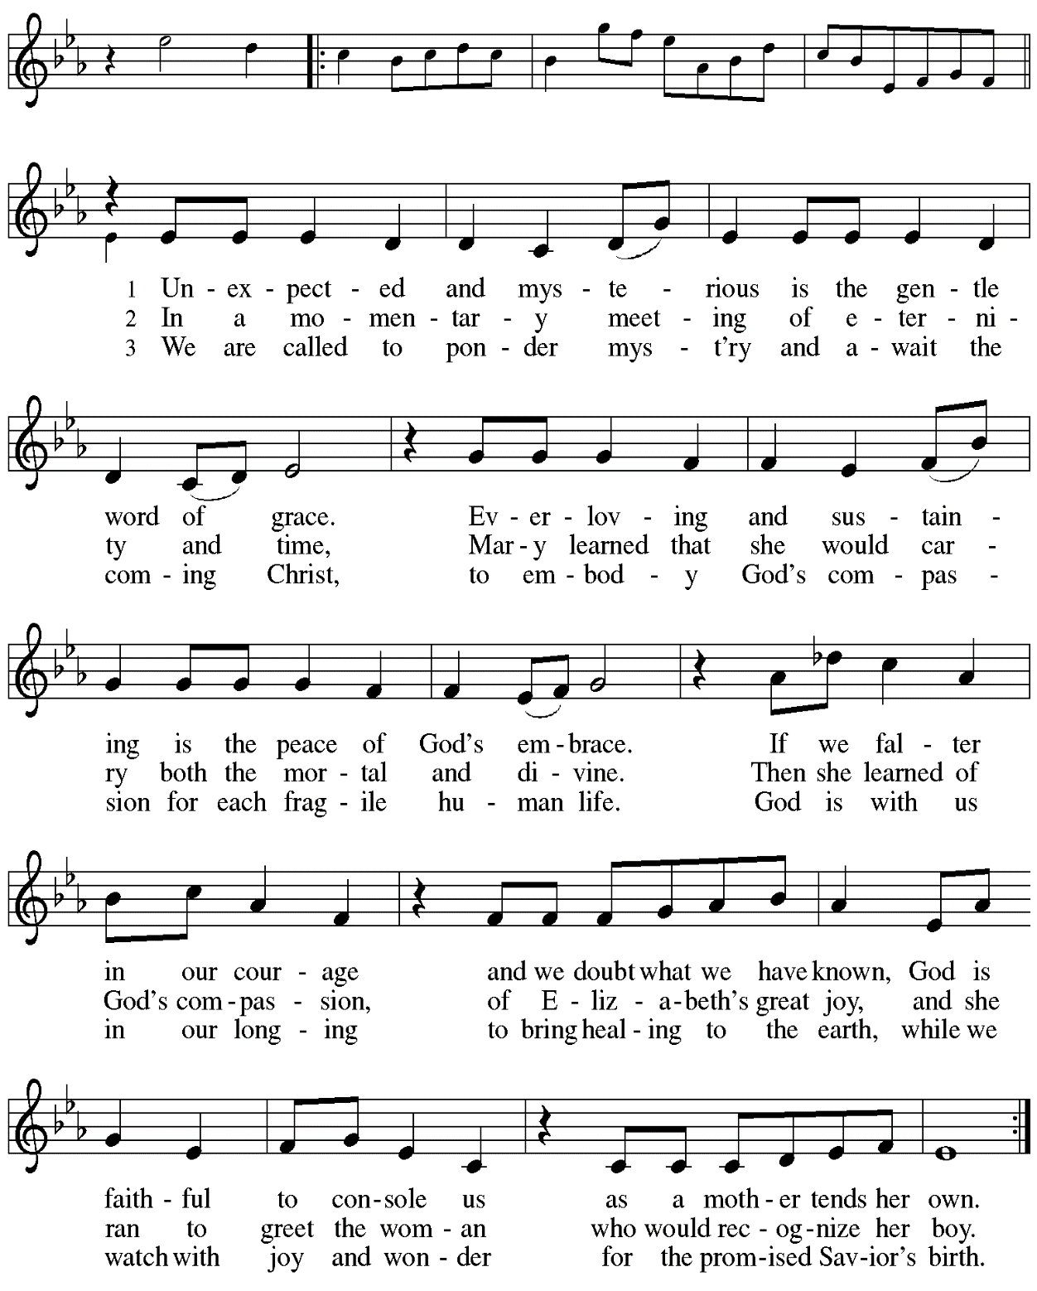
Hymn during Holy Communion
We Are Waiting for Jesus ACS 905

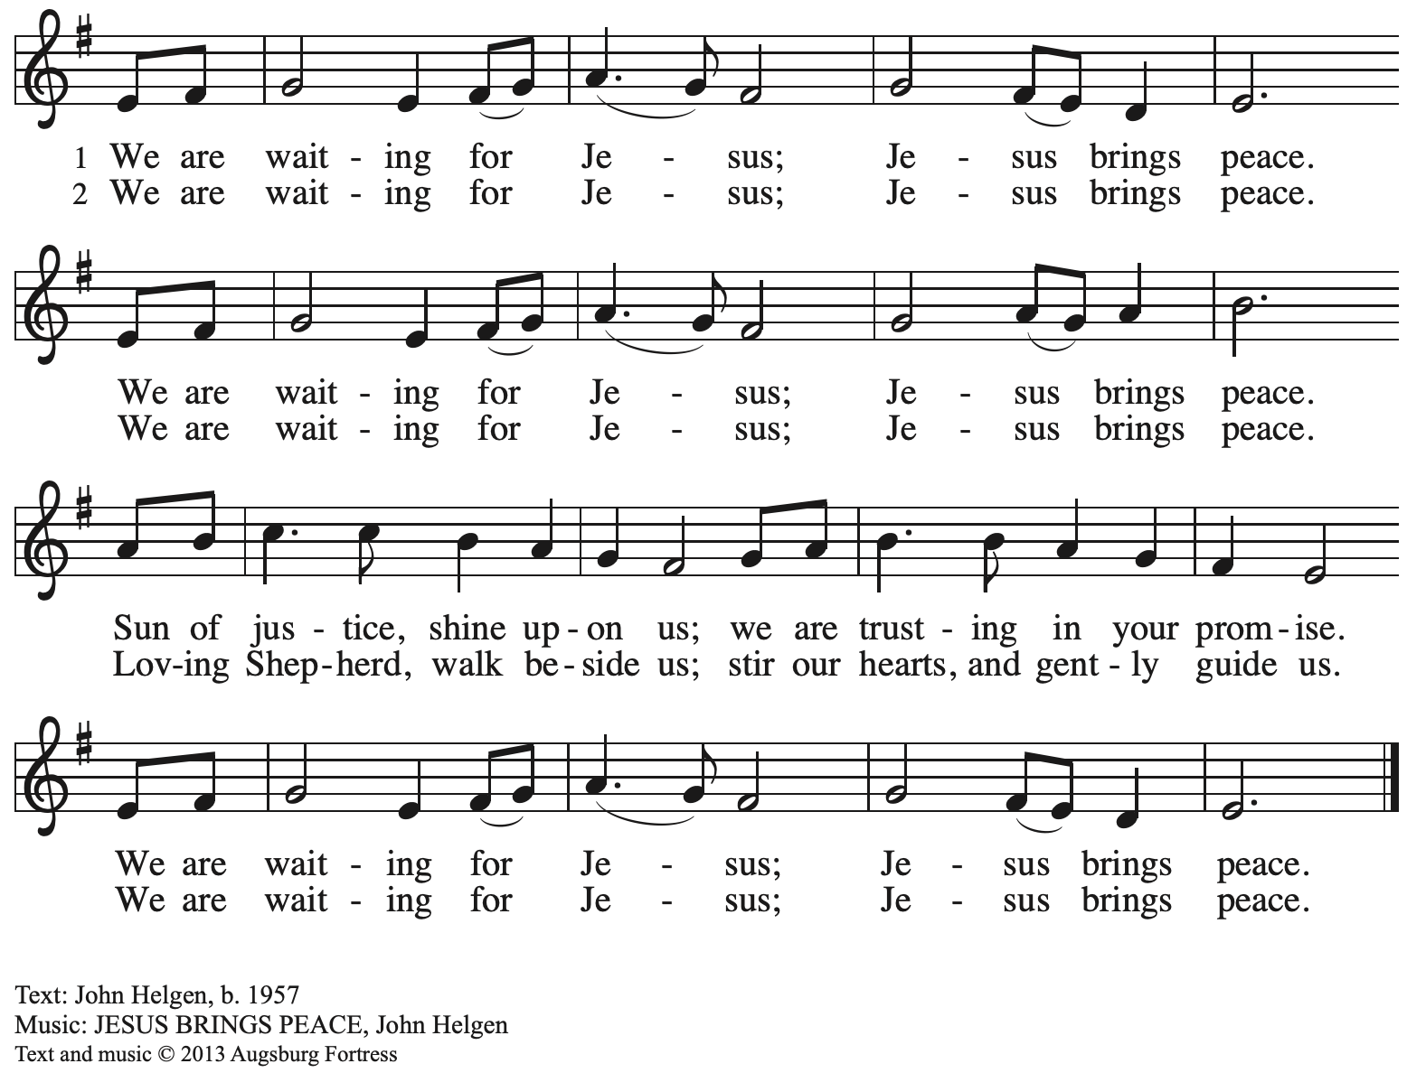
All rights reserved. Reprinted with permission under OneLicense.net # A-722139.

Hymn during Holy Communion
Love Divine, All Loves Excelling ELW 631

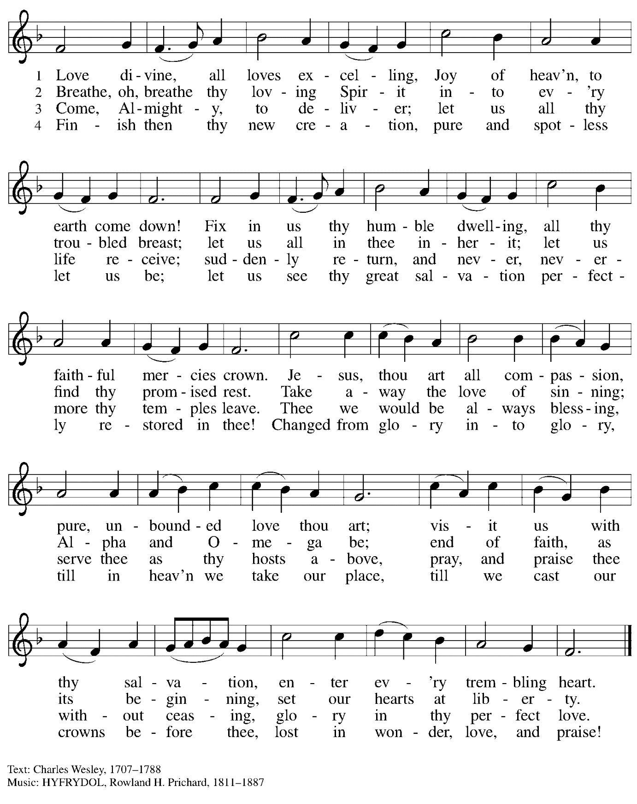

When all have returned to their places, please rise as you are able.

Blessing

P: The grace of our Lord Jesus Christ and the gifts of his body and blood strengthen, keep,
and unite us, now and forever.
C: Amen.

Hymn of Thanksgiving HS p. 20

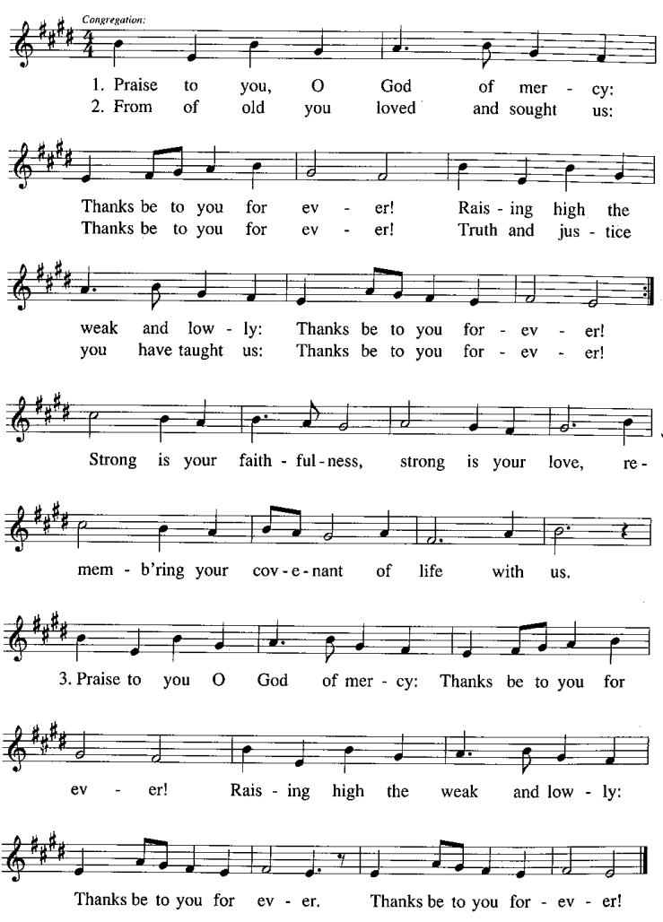

Prayer

P: Let us pray.
Faithful God, in this meal you have remembered your mercy,
bringing heaven to earth in the body and blood of Christ.
As we await the day when all your promises will be fulfilled,
sustain and strengthen us by this holy mystery.
Guide us toward your promised future coming to birth
in Jesus Christ, our Savior and Lord.
C: Amen.

Please be seated.

Sending

Announcements

Please rise as you are able.

Benediction

P: God the eternal Word,
who dwells with us in Jesus,
and who holds us in the grace of the Holy Spirit,
☩ bless you now and forever.
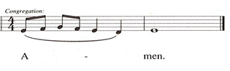
C:

Sending Hymn Soon and Very Soon Following page

Dismissal

P: Go in peace. Christ is near.
C: Thanks be to God!

Sending Hymn Soon and Very Soon ELW 439

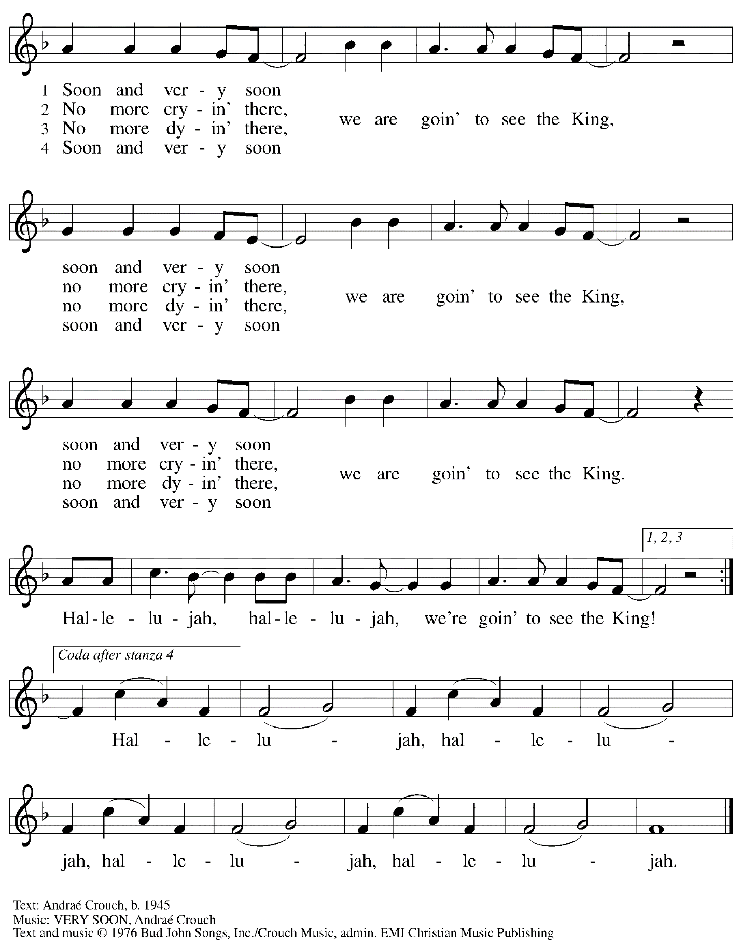
All rights reserved. Reprinted under OneLicense.net # A-722139.
Abbreviations

P: Pastor/Presiding Minister
A: Assistant (Cantor)
L: Lector
C: Congregation

HS: Hymnal Supplement
ELW: Evangelical Lutheran Worship hymnal
ACS: All Creation Sings hymnal

Those serving in worship today

Minister of Music Laura Reynolds
Clarinet Maria Mangano
Cantor Ian Brown
Lector and Communion Assistant Michael Chapman
Presiding Minister Rev. Ross Carmichael

Liturgy and Hymnody Acknowledgements

From SundaysandSeasons.com. Copyright © 2022 Augsburg Fortress. All rights reserved. Reprinted under OneLicense.net # A-722139.
Used by permission of Augsburg Fortress.

O Come, O Come, Emmanuel – Text: Psalteriolum Cantionum Catholicarum, Köln, 1710; tr. Composite.Music: VENI, EMMANUEL, French processional, 15th cent. Text sts. 2, 6, 7 © 1997 Augsburg Fortress. All rights reserved. Reprinted with permission under OneLicense.net # A-722139.

Light One Candle to Watch for Messiah – Text: Wayne L. Wold, b. 1954. Music: TIF IN VELDELE, Yiddish folk tune. Text © 1984 Fortress Press, admin. Augsburg Fortress. All rights reserved. Reprinted with permission under OneLicense.net # A-722139.

Unexpected and Mysterious – Text: Jeannette M. Lindholm, b. 1961. Music: ST. HELENA, Calvin Hampton, 1938-1984. Text © 2002 Jeannette M. Lindholm, admin. Augsburg Fortress. Music © 1977 GIA Publications, Inc, 7404 S. Mason Ave., Chicago, IL 60638. www.giamusic.com. 800.442.3358. All rights reserved. Reprinted with permission under OneLicense.net # A-722139.

St. Andrew Lutheran Church Announcements
December 18th, 2022

- Worship in the Sanctuary and Online – Sunday, December 18th, + Fourth Sunday of Advent – St. Andrew’s next worship with Holy Communion will be this Sunday, December 18th, at 10:00 a.m. Masks are optional at St. Andrew when Allegheny County’s Covid-19 community level is in the low and medium categories. Worship will also be live-streamed to Facebook, YouTube, and Zoom. Worship attendees are invited to make their own name tags at the back of the worship space. Coffee hour will be held in the Social Hall next to the sanctuary after worship.
- Seeking Individuals to Serve in Various Worship Roles – As worship attendance increases and we return to distribution of wine at Holy Communion, we ask people of St. Andrew to consider offering your gifts in worship. On the upcoming Sundays, we will pass around a signup sheet describing different roles needed, including altar care and setup, Communion Assistant, Audio/Visual Minister, Adult Leader or Helper for Little Church; Big Faith, Usher, Cantor, Lector, and Counter. Please consider how best to share your gifts to enrich the worship experience of St. Andrew!
- Help Decorate the Church for Christmas Sunday, December 18th, after Worship! – We invite everyone to stay after worship this Sunday as we decorate the sanctuary for the Christmas season!
- Christmas Worship Schedule:
Saturday, December 24th, 7:00 p.m. – Worship with Candlelight and Holy Communion
Sunday, December 25th, 10:00 a.m. – Worship with Holy Communion
- Little Church; Big Faith Will Not Meet during Worship on Saturday, December 24th, Christmas Eve; Sunday, December 25th, Christmas Day; or Sunday, January 1st, First Sunday of Christmas. We will resume the Bible lesson and activities during worship on Sunday, January 8th.
- We will not have Coffee Hour on Christmas Eve, December 24th, Christmas Day, December 25th, or January 1st
- Humor and the Bible – Come and Discuss in the New Year! – Is there humor in the Bible? Isn't it a pious look at life that inspires us and places us in awe of God? Doesn't the Bible contain instructions for life's do's and don'ts? Doesn't the Bible give us warnings and signs of hope? Perhaps all these things are true, but if we can suspend our piety, our past notions or suspicions about the Bible, we just might hear and experience a humorous side of the Bible we hadn't appreciated before. We might even laugh! In our upcoming Zoom discussion, January 10th, 17th, 24th, and 31st, Pastor Paul Koch will lead us in looking more closely at various passages throughout the Bible that might surprise you, make you smile, or even bring a laugh or two. Imagine finding humor in the Creation stories, the end of Daniel, or hearing some of Jesus' sayings in a humorous (or at least a little sarcastic) way! Zoom login information is now available in your “This Week at St. Andrew” email - log on, and enjoy!
- Christ in our Home Current Devotional Booklets for the Next Quarter (January - March 2023) Available at Church Entrances – Christ in our Home is a booklet that offers a daily Bible reading with a short reflection and prayers, long with additional prayer concerns and readings for those who would like to expand their devotional practices. These are available at each entrance to the church, and we encourage people of the congregation to take one for yourself and others!
- Bethel AME Pittsburgh Updates – Our friends at Bethel AME are collecting clean, gently worn/used Winter clothing of all sizes. Items can be left on the table next to the pantry shelves in St. Andrew’s Social Hall.

