+ The Nativity of our Lord
Christmas Day
December 25, 2022

St. Andrew Lutheran Church
304 Morewood Ave.
Pittsburgh, PA 15213
St_andrewELCA@verizon.net
www.standrewpittsburgh.org

+ The Nativity of our Lord
Christmas Day
Order for Worship

As on the first day of creation, on this Christmas Day the Word illumines the world, shining forth to bring all things into being. Today we celebrate the incarnate Word, God becoming flesh to live among us in the person of Jesus Christ then and now. Emboldened by the good news of Christ’s birth, along with the shepherds, Mary and Joseph, and all witnesses to the light of Christ, we declare to the world that we have indeed seen and been transformed by the arrival of “the salvation of our God.” O come, let us adore!

- Masks are optional at St. Andrew when Covid-19 community level in Allegheny County is in the low and medium categories.
- Hand sanitizer is available at the back of the sanctuary.

Worship Services are live streamed to multiple online platforms.
By attending worship, you agree that your image and voice may be broadcast.

Welcome to St. Andrew!
- Everyone is invited to make a nametag at the black bookcase in the back of the worship space if they would like.
- Worship “toolkits” to help children engage with the service are available in the black bookcase at the back of the worship space. There are “reader” and “pre-reader” resources available in each kit. Please feel free to use the kits for/with your children during worship.
- St. Andrew has recently returned to serving the sacrament of Holy Communion with both (separate) elements, bread and wine/grape juice. The presiding minister will first distribute the bread (host). Please consume this and then pick up an empty glass from the tray next to the presiding minister. The Communion Assistant will pour wine from the chalice or grape juice from the cruet into your glass. Please step to the side to consume the wine or grape juice. As you return to your pew, glasses may be returned to the empty trays on either side of the center aisle.
- A restroom is available on the main level of the church, through the doors to the Social Hall and to the right in the main office.

Welcome

Prelude

Gathering
The Holy Spirit calls us together as the people of God.

Confession and Forgiveness

P: Blessed be the holy Trinity, ☩ one God,
the Word made flesh,
our life and our salvation.
C: Amen.

P: Trusting the goodness and lovingkindness of God our Savior,
let us confess our sin.

Silence is kept for reflection.

P: God of life,
C: you promise good news of great joy for all people,
and call us to be messengers of your peace.
We confess that too often we hoard our joy,
our resources, and our security.
We nurture conflict and build barriers.
We neglect the needs of our neighbors
and ignore the groaning of creation.
Have mercy on us.
Where we are self-centered, open our hearts.
Where we are reluctant, give us courage.
Where we are cynical, restore our trust.
Renew us with your grace
and give us again the hope of eternal life in you.
Amen.

P: Hear the good news:
We are children of God and heirs of God’s promises
through the outpouring of the Holy Spirit.
In ☩ Jesus we are forgiven and redeemed.
Sing with joy, for all the ends of the earth
shall know the salvation of God.
C: Amen.

Gathering Hymn Angels from the Realms of Glory ELW 275

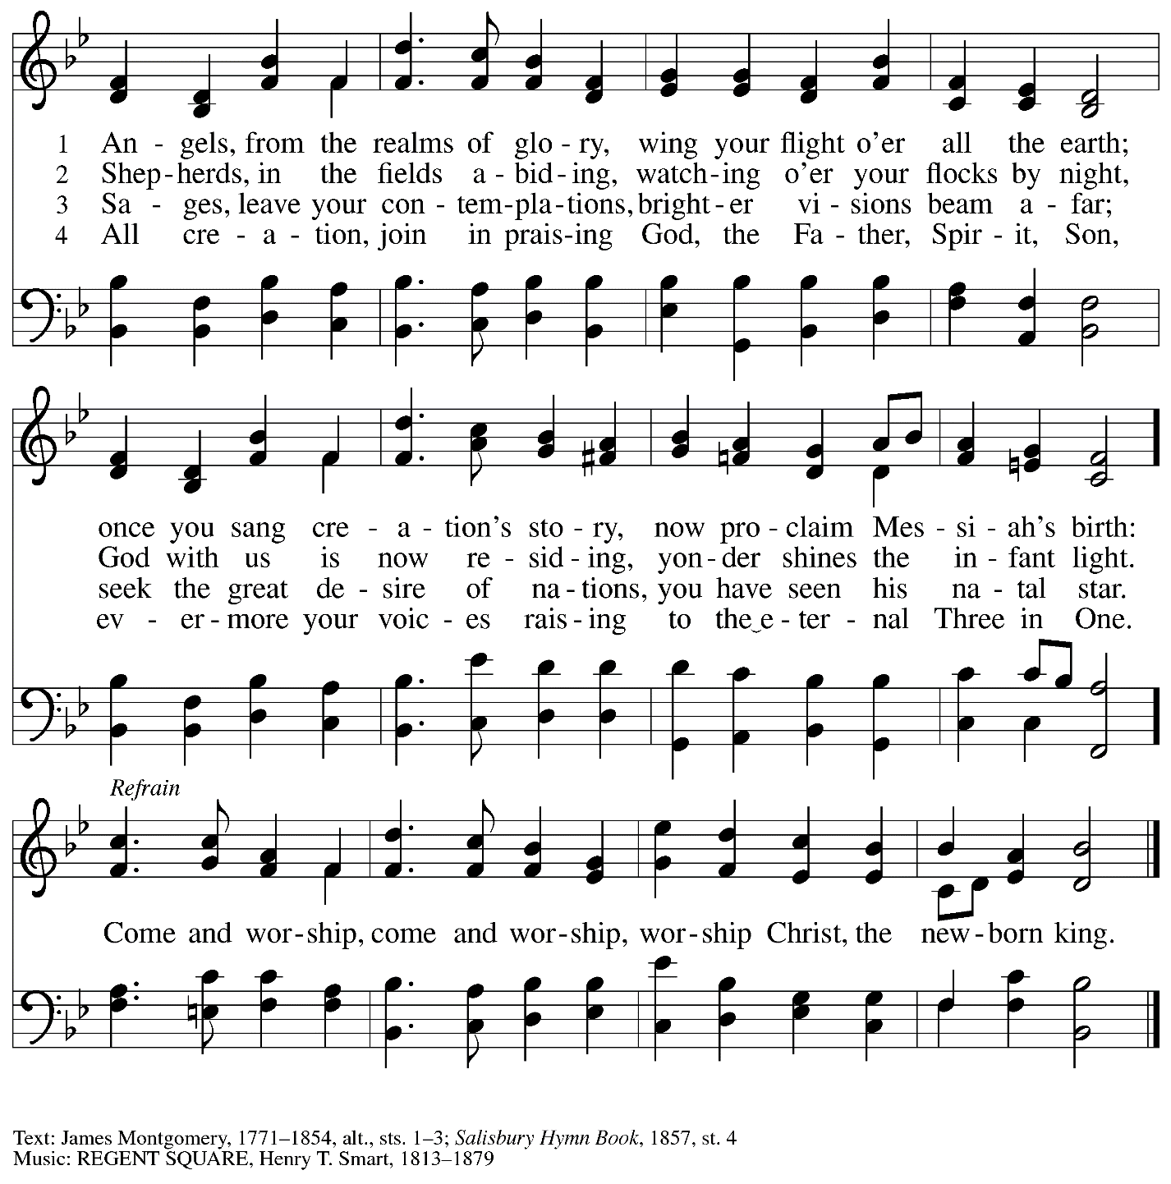

Greeting

P: The grace of our Lord Jesus Christ, the love of God,
and the communion of the Holy Spirit be with you all.
C: And also with you.

Hymn of Praise Angels We Have Heard on High ELW 289

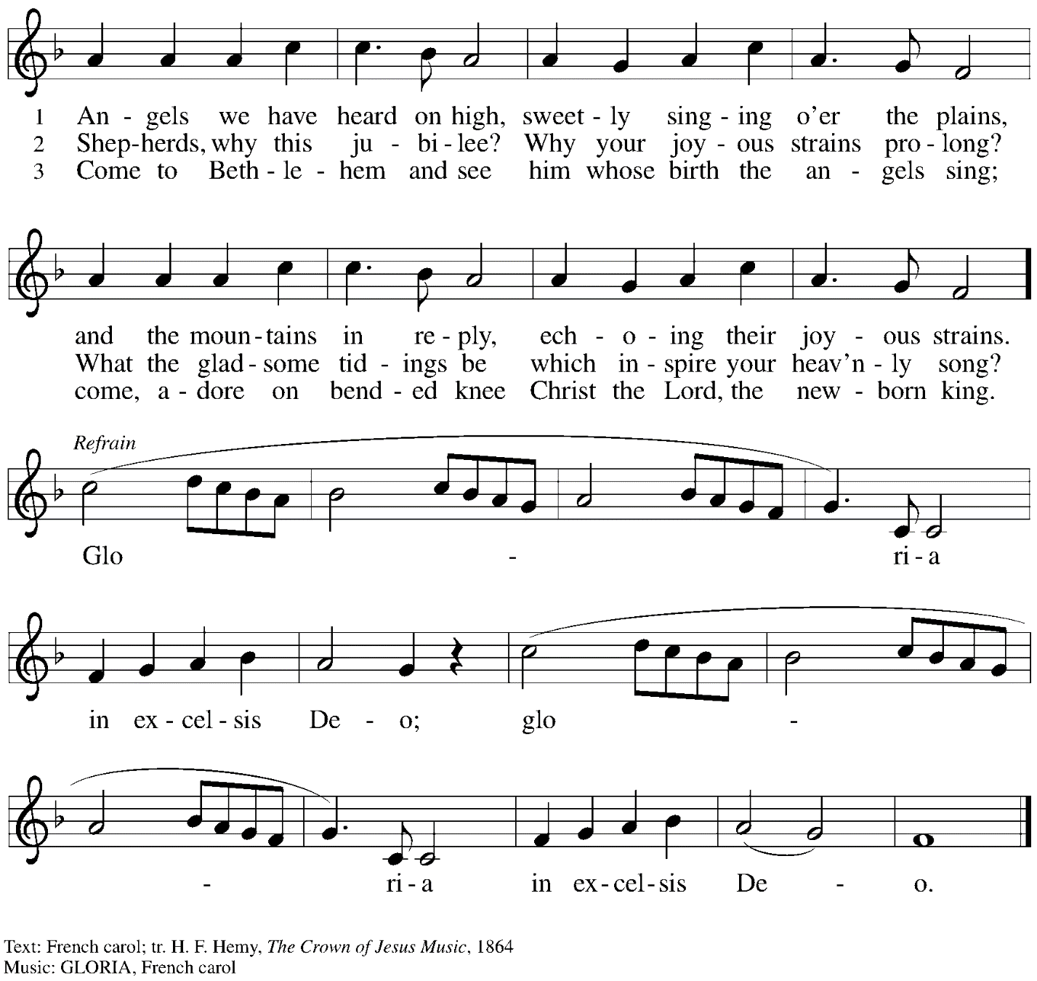

Prayer of the Day

P: Let us pray.
Almighty God,
you gave us your only Son to take on our human nature and to illumine the world with your light. By your grace adopt us as your children and enlighten us with your Spirit, through Jesus Christ,
our Redeemer and Lord, who lives and reigns with you and the Holy Spirit,
one God, now and forever.
C: Amen.

Please be seated.

Word
God speaks to us in Scripture reading, preaching, and song

First Reading – Isaiah 52: 7-10

⁷How beautiful upon the mountains
are the feet of the messenger who announces peace,
who brings good news,
who announces salvation,
who says to Zion, “Your God reigns.”
⁸Listen! Your sentinels lift up their voices,
together they sing for joy;
for in plain sight they see
the return of the Lord to Zion.
⁹Break forth together into singing,
you ruins of Jerusalem;
for the Lord has comforted God’s people,
the Lord has redeemed Jerusalem.
¹⁰The Lord has bared God’s holy arm
before the eyes of all the nations;
and all the ends of the earth shall see
the salvation of our God.

L: Word of God, word of life.
C: Thanks be to God.

Psalm 98

The cantor will lead the singing of the psalm.
The congregation is invited to respond with the alternate verses in bold print,
and to join in singing the refrain.

Psalm tone

Psalm refrain

¹Sing a new song to the Lord, who has done | marvelous things,
whose right hand and holy arm have | won the victory.
²O Lord, you have made | known your victory,
you have revealed your righteousness in the sight | of the nations.
³You remember your steadfast love and faithfulness to the | house of Israel;
all the ends of the earth have seen the victory | of our God.
⁴Shout with joy to the Lord, | all you lands;
lift up your voice, re- | joice, and sing. R
⁵Sing to the Lord| with the harp,
with the harp and the | voice of song.
⁶With trumpets and the sound | of the horn
shout with joy before the | king, the Lord. R
⁷Let the sea roar, and | all that fills it,
the world and those who | dwell therein.
⁸Let the rivers | clap their hands,
and let the hills ring out with joy before the Lord, who comes to | judge the earth.
⁹The Lord will judge the | world with righteousness
and the peo- | ples with equity. R

Second Reading – Hebrews 1: 1-4

¹Long ago God spoke to our ancestors in many and various ways by the prophets, ²but in these last days God has spoken to us by a Son, whom God appointed heir of all things, through whom God also created the worlds. ³He is the reflection of God’s glory and the exact imprint of God’s very being, and he sustains all things by his powerful word. When he had made purification for sins, he sat down at the right hand of the Majesty on high, ⁴having become as much superior to angels as the name he has inherited is more excellent than theirs.

L: Word of God, word of life.
C: Thanks be to God.

Please rise as you are able.

Gospel Acclamation ELW p. 142

Gospel – John 1: 1-14

P: The holy Gospel according to St. John.
C: Glory to you, O Lord.
¹In the beginning was the Word, and the Word was with God, and the Word was God. ²The Word was in the beginning with God. ³All things came into being through the Word, and without the Word not one thing came into being. What has come into being ⁴in the Word was life, and the life was the light of all people. ⁵The light shines in the darkness, and the darkness did not overcome it.
⁶There was a man sent from God, whose name was John. ⁷He came as a witness to testify to the light, so that all might believe through him. ⁸He himself was not the light, but he came to testify to the light. ⁹The true light, which enlightens everyone, was coming into the world.
¹⁰He was in the world, and the world came into being through him; yet the world did not know him. ¹¹He came to what was his own, and his own people did not accept him. ¹²But to all who received him, who believed in his name, he gave power to become children of God, ¹³who were born, not of blood or of the will of the flesh or of the will of humanity, but of God.
¹⁴And the Word became flesh and lived among us, and we have seen his glory, the glory as of a father’s only son, full of grace and truth.

P: The Gospel of the Lord.
C: Praise to you, O Christ.

Please be seated.

Sermon

A time of silence for prayer and reflection follows the sermon.
When the Hymn of the Day begins, please rise as you are able.

Hymn of the Day God Loved the World ELW 323
v. 1-2, 4-5

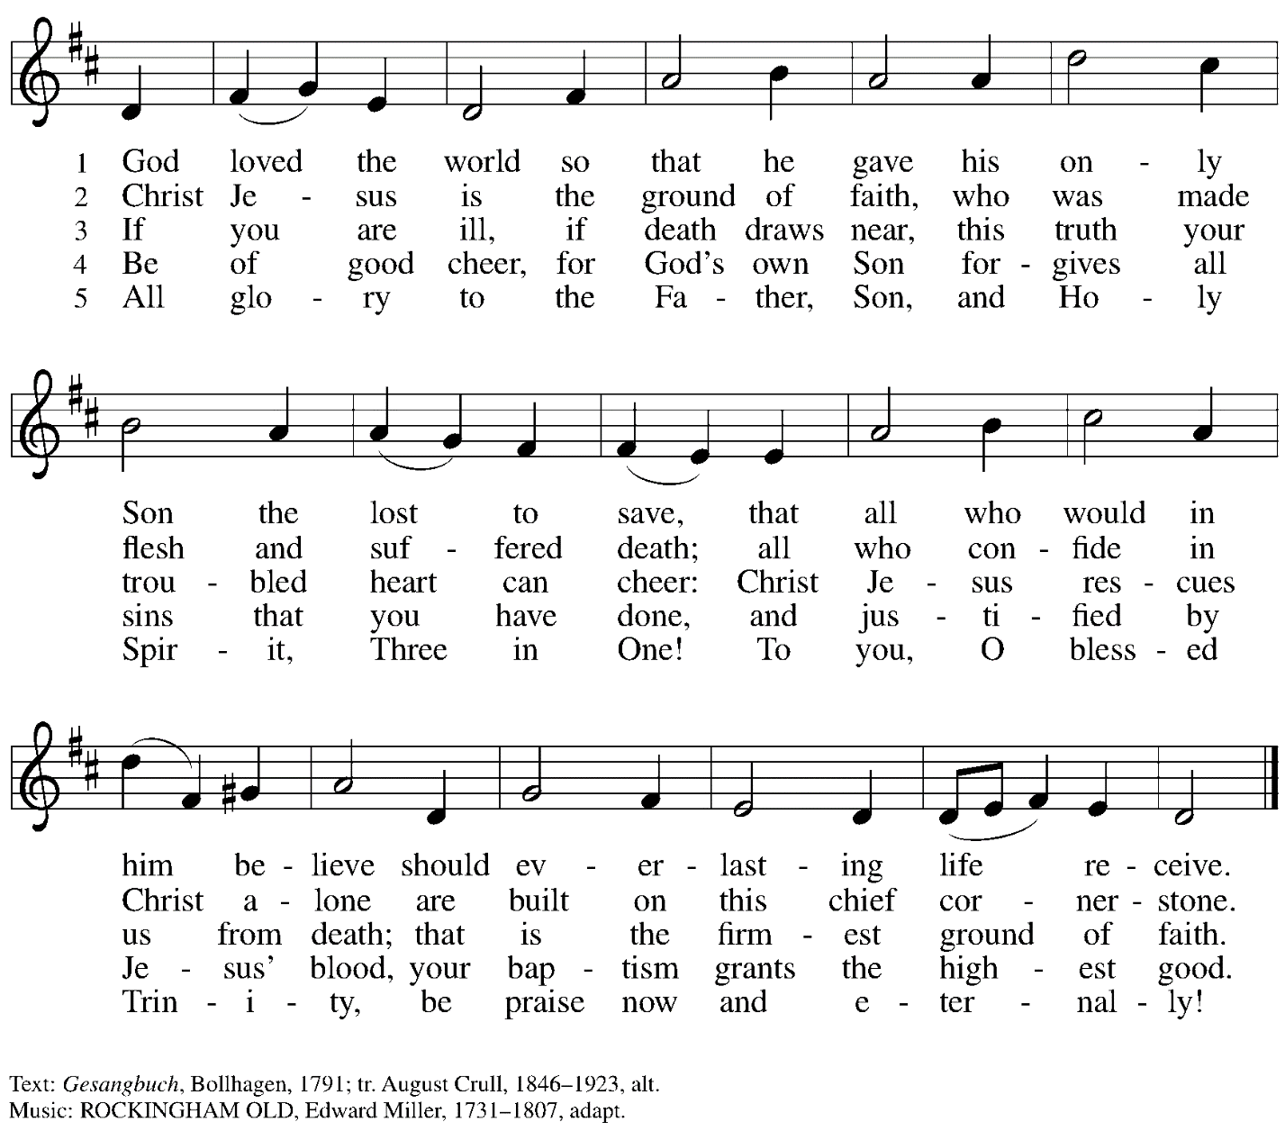

Nicene Creed

P: Rejoicing in the good news of Christ’s birth, we confess our faith:
C: We believe in one God,
the Father, the Almighty,
maker of heaven and earth,
of all that is, seen and unseen.

We believe in one Lord, Jesus Christ,
the only Son of God,
eternally begotten of the Father,
God from God, Light from Light,
true God from true God,
begotten, not made,
of one Being with the Father;
through him all things were made.
For us and for our salvation
he came down from heaven,
was incarnate of the Holy Spirit and the virgin Mary
and became truly human.
For our sake he was crucified under Pontius Pilate;
he suffered death and was buried.
On the third day he rose again
in accordance with the scriptures;
he ascended into heaven
and is seated at the right hand of the Father.
He will come again in glory to judge the living and the dead,
and his kingdom will have no end.

We believe in the Holy Spirit, the Lord, the giver of life,
who proceeds from the Father and the Son,*
who with the Father and the Son is worshiped and glorified,
who has spoken through the prophets.
We believe in one holy catholic and apostolic church.
We acknowledge one baptism for the forgiveness of sins.
We look for the resurrection of the dead,
and the life of the world to come. Amen.
*Or, “who proceeds from the Father.” The phrase “and the Son” is a later addition to the creed.

Prayers of the People

P: With wonder and joy at Christ’s coming into the world,
we pray for the church, the world, and all who are in need.

After each petition
P: God of grace,
C: receive our prayer.

P: In the light of the mystery of eternal love made flesh,
we commend to you all for whom we pray, gracious God,
through Jesus Christ our Savior.
C: Amen.

Please be seated.

Meal

Offering

We offer ourselves, our gifts, and our faithful service to God.
As the offering is gathered for the mission of the church, including the care of those in need,
the table is set for Holy Communion.

Music during the Offering

As the gifts are brought forward for presentation, please rise as you are able
and join in singing the Offertory Song.

Offertory Song In the Bleak Midwinter ELW 294

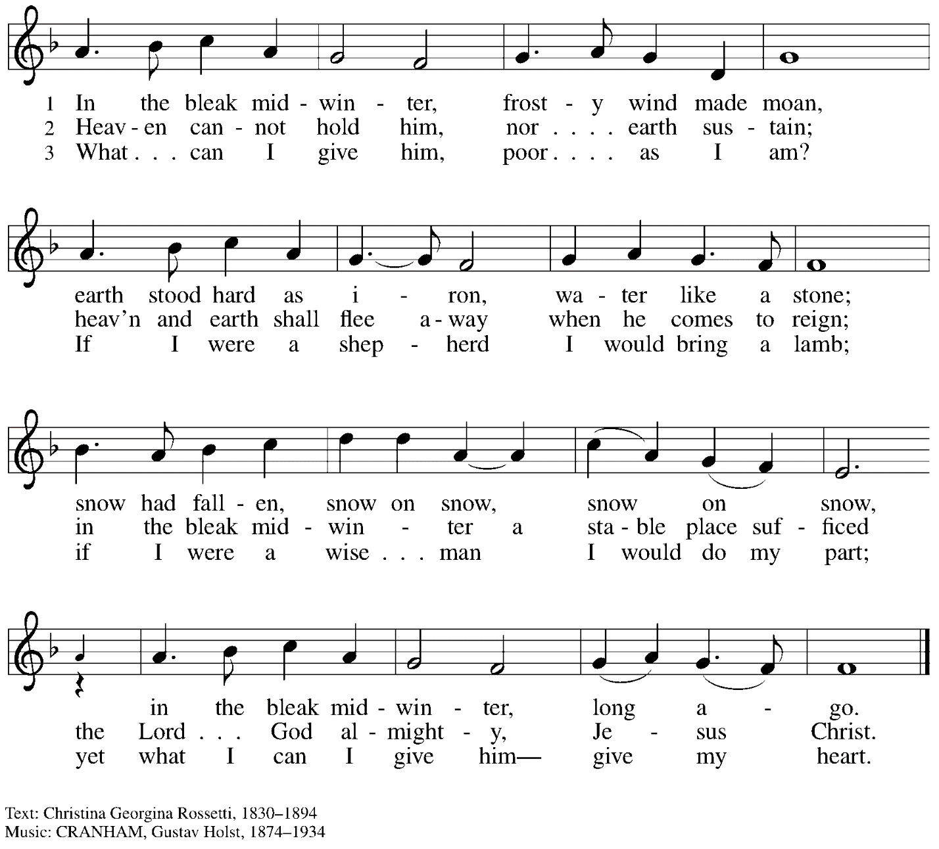

Offertory Prayer

P: Let us pray. Good and loving God,
C: we rejoice in the birth of Jesus,
who came among the poor to bring the riches of his grace.
As you have blessed us with your gifts, let them be a blessing for others.
With the trees of the field, with all earth and heaven,
we shout for joy at the coming of your Son, Jesus Christ our Lord.
Amen.

Dialogue ELW p. 144

Preface (Sung by the presiding minister)

P: It is indeed right, our duty and our joy …
… we praise your name and join their unending hymn:

Sanctus ELW p. 144

Eucharistic Prayer

P: Holy One, the beginning and the end, the giver of life …
… Do this for the remembrance of me.

P: Let us proclaim the mystery of faith:
C: Christ has died.
Christ is risen.
Christ will come again.

P: With this bread and cup we remember …
… We look with hope for his coming.
C: Amen. Come, Lord Jesus.

P: Holy God, we long for your Spirit. …
… Bring the gift of peace on earth.
C: Amen. Come, Holy Spirit.

P: All praise and glory are yours, …
… one God, now and forever.
C: Amen.

Lord’s Prayer

P: Gathered as one by the Holy Spirit, let us pray as Jesus taught us.
C: Our Father in heaven,
hallowed be your name,
your kingdom come,
your will be done,
on earth as in heaven.
Give us today our daily bread.
Forgive us our sins
as we forgive those who sin against us.
Save us from the time of trial
and deliver us from evil.
For the kingdom, the power,
and the glory are yours,
now and forever. Amen.

Fraction and Invitation

P: Glory to God in the highest!
Come to the table of peace.

Agnus Dei / Lamb of God ELW p. 146

Please be seated.

Holy Communion
- All who seek God and a deeper and stronger life in Christ are welcome to receive Holy Communion.
- Please inform and usher if you would like the ministers to bring Communion to you.
- Worshipers from the pulpit side will proceed forward first, followed by the center section, and then the lectern side.
- Holy Communion will be served with bread and wine/grape juice.
- The presiding minister will first distribute the bread (host) to each communicant. Please indicate if you require a gluten-free host.
- Once you have consumed the bread, please pick up an empty glass from the tray next to the presiding minister. The Communion Assistant will pour wine from the chalice or grape juice from the cruet into your glass.
- Please step to the side to consume the wine or grape juice.
- As you return to your pew, glasses may be returned to the empty trays on either side of the center aisle.
- A blessing will be provided for anyone who does not yet receive the sacrament.
Please place your hands on your heart and bow your head if you would like a blessing.
- All are invited to join in singing the hymns during Holy Communion.

Hymn during Holy Communion
Away in a Manger ELW 278

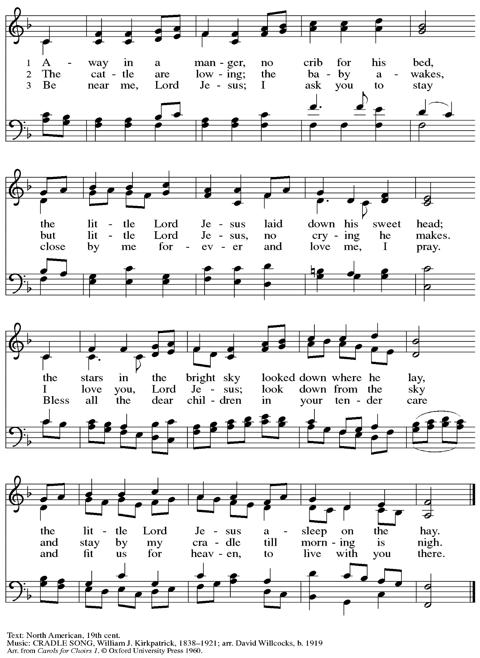
All rights reserved. Reprinted under OneLicense.net # A-722139.
Hymn during Holy Communion
Good Christian Friends, Rejoice ELW 288

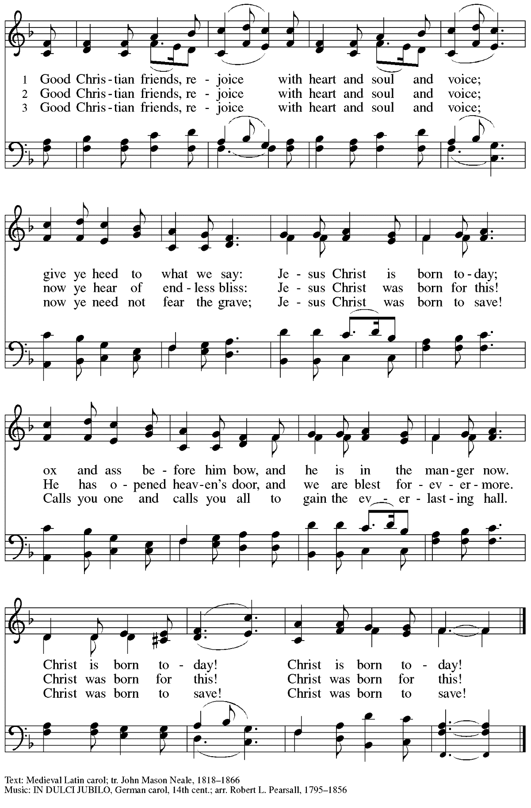

When all have returned to their places, please rise as you are able.

Blessing

P: The grace of our Lord Jesus Christ and the gifts of his body and blood strengthen, keep,
and unite us, now and forever.
C: Amen.

Prayer

P: Let us pray.
Radiant God, you have brought us your salvation,
and in this meal we have feasted on your grace.
May your Word take flesh in us, that we may be your holy people,
Revealing your glory made known to us in Jesus Christ, our Savior and Lord.
C: Amen.

Sending

Benediction

P: God bless you and keep you,
☩ Jesus grant you grace and truth,
and the Spirit send peace upon your hearts,
now and forever.
C: Amen.

Sending Hymn Go Tell It on the Mountain Following page

Dismissal

P: Go in peace. Share the good news!
C: Thanks be to God!

Sending Hymn Go Tell It on the Mountain ELW 290

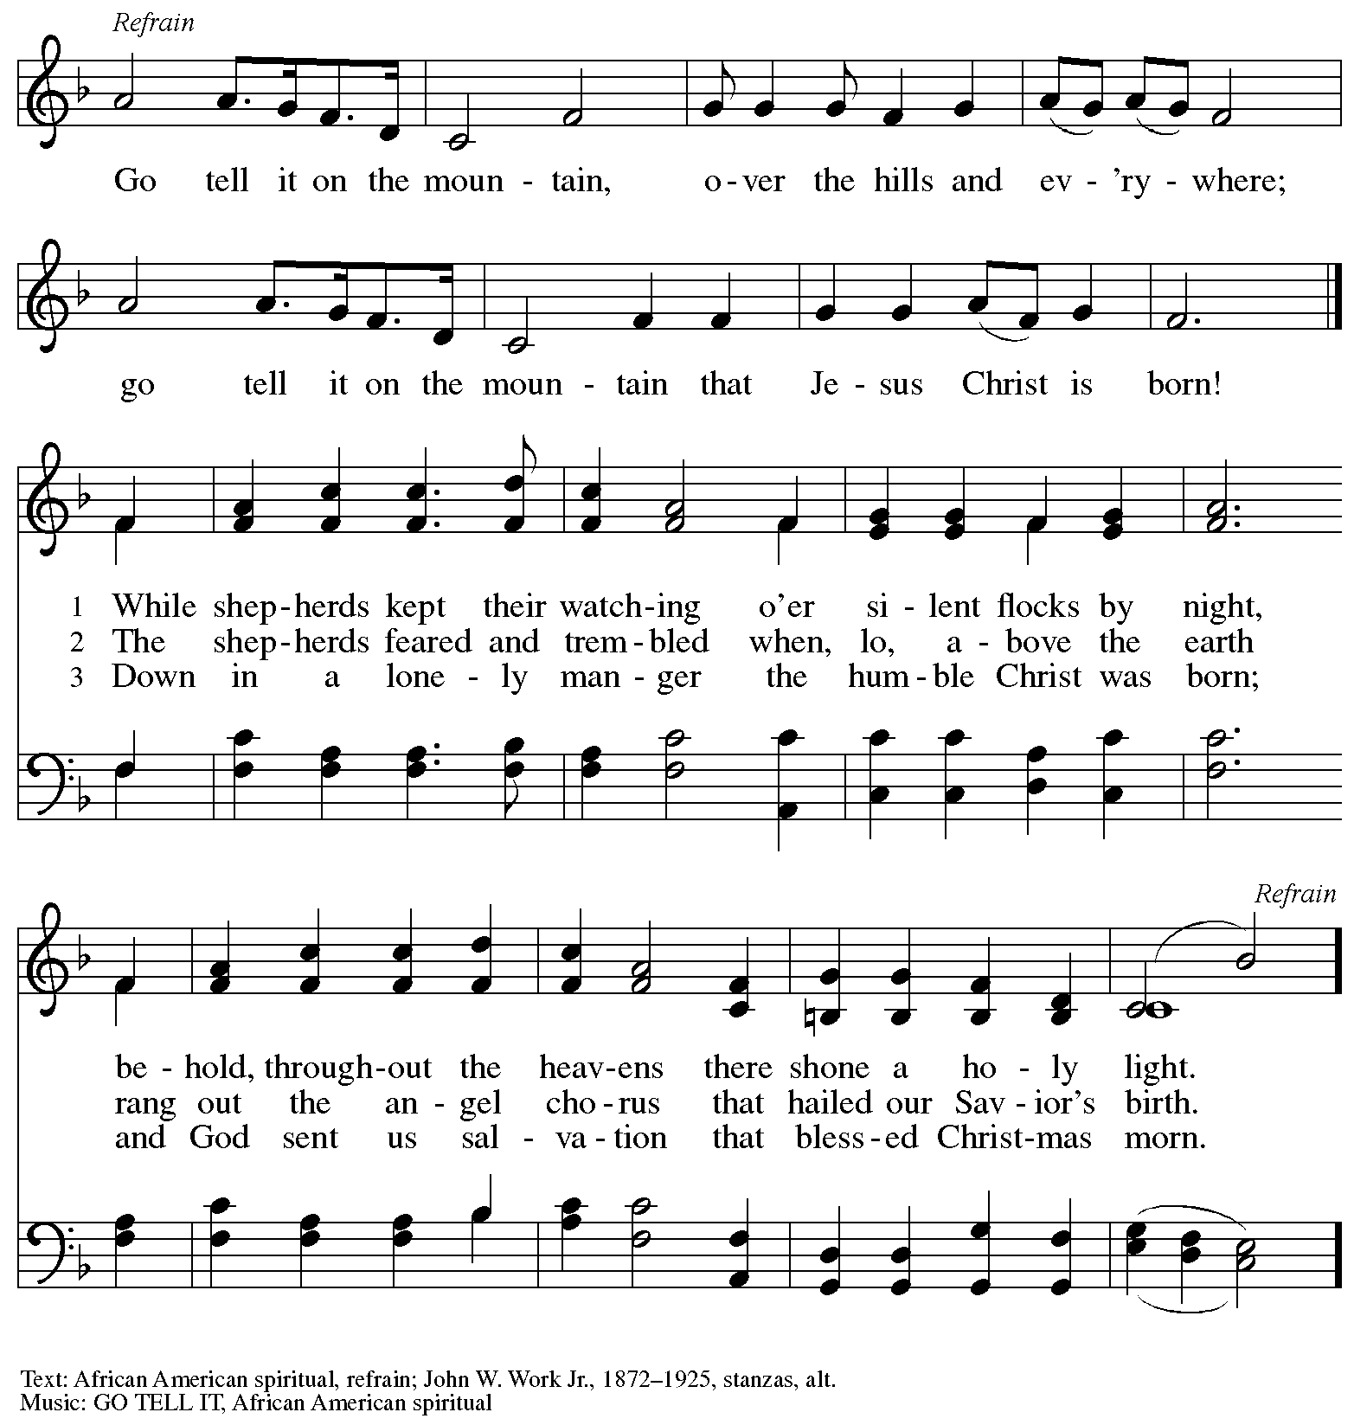

Abbreviations

P: Pastor/Presiding Minister
L: Lector
C: Congregation

ELW: Evangelical Lutheran Worship hymnal

Those serving in worship today

Minister of Music Laura Reynolds
Organ Jimmi Kocher-Hillmer
Cantor Timothy Kocher-Hillmer
Lector Dixie Tymitz
Presiding Minister Rev. Ross Carmichael

Liturgy and Hymnody Acknowledgements

From SundaysandSeasons.com. Copyright © 2022 Augsburg Fortress. All rights reserved. Reprinted under OneLicense.net # A-722139.
Used by permission of Augsburg Fortress.

St. Andrew Lutheran Church Announcements
December 25th, 2022

- Welcome to Worship at St. Andrew for the Nativity of our Lord – Christmas Day, December 25th! – Merry and blessed Christmas to all! We are so glad you have gathered here today for the celebration of Christ’s birth! Masks are optional at St. Andrew when Allegheny County’s Covid-19 community level is in the low and medium categories. Worship attendees are invited to make name tags at the back of the worship space if you would like.
- Little Church; Big Faith Will Not Meet during Worship Today, Christmas Day, nor on Sunday, January 1st. We will resume the Bible lesson and activities for children during worship on Sunday, January 8th.
- St. Andrew Will Not Have Coffee Hour Today, Christmas Day, December 25th, or January 1st. Coffee hour will also resume on Sunday, January 8th.
- Pastor Carmichael Taking Vacation Time - Monday, December 26th - Saturday, December 31st – Pastor Ross will be out of the office the week after Christmas. If you are in need of a pastor during this time, please contact Pastor Larry Kemp at 412.302.6988.
- January 2023 Produce Distribution – Tuesday, January 3rd, 5:30-7:00 p.m. – St. Andrew’s Monthly produce distribution will be coming up soon after the holidays, so if you would like to help on that day with unloading and setup (usually some time between 11:00 a.m. and 1:00 p.m.) or in the evening with the distribution from 5:30-7:00 p.m. please plan ahead! Sign up at: https://www.signupgenius.com/go/5080544AAAC22A1F58-produce24.
- Christ in our Home Current Devotional Booklets for the Next Quarter (January - March 2023) Available at Church Entrances – Christ in our Home is a booklet that offers a daily Bible reading with a short reflection and prayers, long with additional prayer concerns and readings for those who would like to expand their devotional practices. These are available at each entrance to the church, and we encourage people of the congregation to take one for yourself and others!
- Humor and the Bible – Come and Discuss in the New Year! – Is there humor in the Bible? Isn't it a pious look at life that inspires us and places us in awe of God? Doesn't the Bible contain instructions for life's do's and don'ts? Doesn't the Bible give us warnings and signs of hope? Perhaps all these things are true, but if we can suspend our piety, our past notions or suspicions about the Bible, we just might hear and experience a humorous side of the Bible we hadn't appreciated before. We might even laugh! In our upcoming Zoom discussion, on Tuesdays, January 10th, 17th, 24th, and 31st at 7:00 p.m., Pastor Paul Koch will lead us in looking more closely at various passages throughout the Bible that might surprise you, make you smile, or even bring a laugh or two. Imagine finding humor in the Creation stories, the end of Daniel, or hearing some of Jesus' sayings in a humorous (or at least a little sarcastic) way! Zoom login information is now available in your “This Week at St. Andrew” email - log on, and enjoy!

