+ The Nativity of our Lord
Christmas Eve
December 24, 2022

St. Andrew Lutheran Church
304 Morewood Ave.
Pittsburgh, PA 15213
St_andrewELCA@verizon.net
www.standrewpittsburgh.org

+ The Nativity of our Lord
Christmas Eve
Order for Worship

In the northern hemisphere’s deepest winter night, we welcome the light of the Christ child. Isaiah declares that the light of the long-promised king will illumine the world and bring endless peace and justice. Paul reminds us that the grace of God through Jesus Christ brings salvation to all people. The angels declare that Jesus’ birth is good and joyful news for everyone, including lowly shepherds. Filled with the light that shines in our lives, we go forth to share the light of Christ with the whole world.

- Masks are optional at St. Andrew when Covid-19 community level in Allegheny County is in the low and medium categories.
- Hand sanitizer is available at the back of the sanctuary.

Worship Services are live streamed to multiple online platforms.
By attending worship, you agree that your image and voice may be broadcast.

Welcome to St. Andrew!
- Everyone is invited to make a nametag at the black bookcase in the back of the worship space if they would like.
- Worship “toolkits” to help children engage with the service are available in the black bookcase at the back of the worship space. There are “reader” and “pre-reader” resources available in each kit. Please feel free to use the kits for/with your children during worship.
- Tonight’s service will include the sacrament of Holy Communion with bread (gluten-free available) and wine or grape juice. The presiding minister will first distribute the bread (host). Please consume this and then pick up an empty glass from the tray next to the presiding minister. The Communion Assistant will pour wine from the chalice or grape juice from the cruet into your glass. Please step to the side to consume the wine or grape juice. As you return to your pew, glasses may be returned to the empty trays on either side of the center aisle.
- A restroom is available on the main level of the church, through the doors to the Social Hall and to the right in the main office.

Prelude

Gathering
The Holy Spirit calls us together as the people of God.

Please rise as you are able.

Christmas Proclamation

Gathering Hymn O Come, All Ye Faithful ELW 283

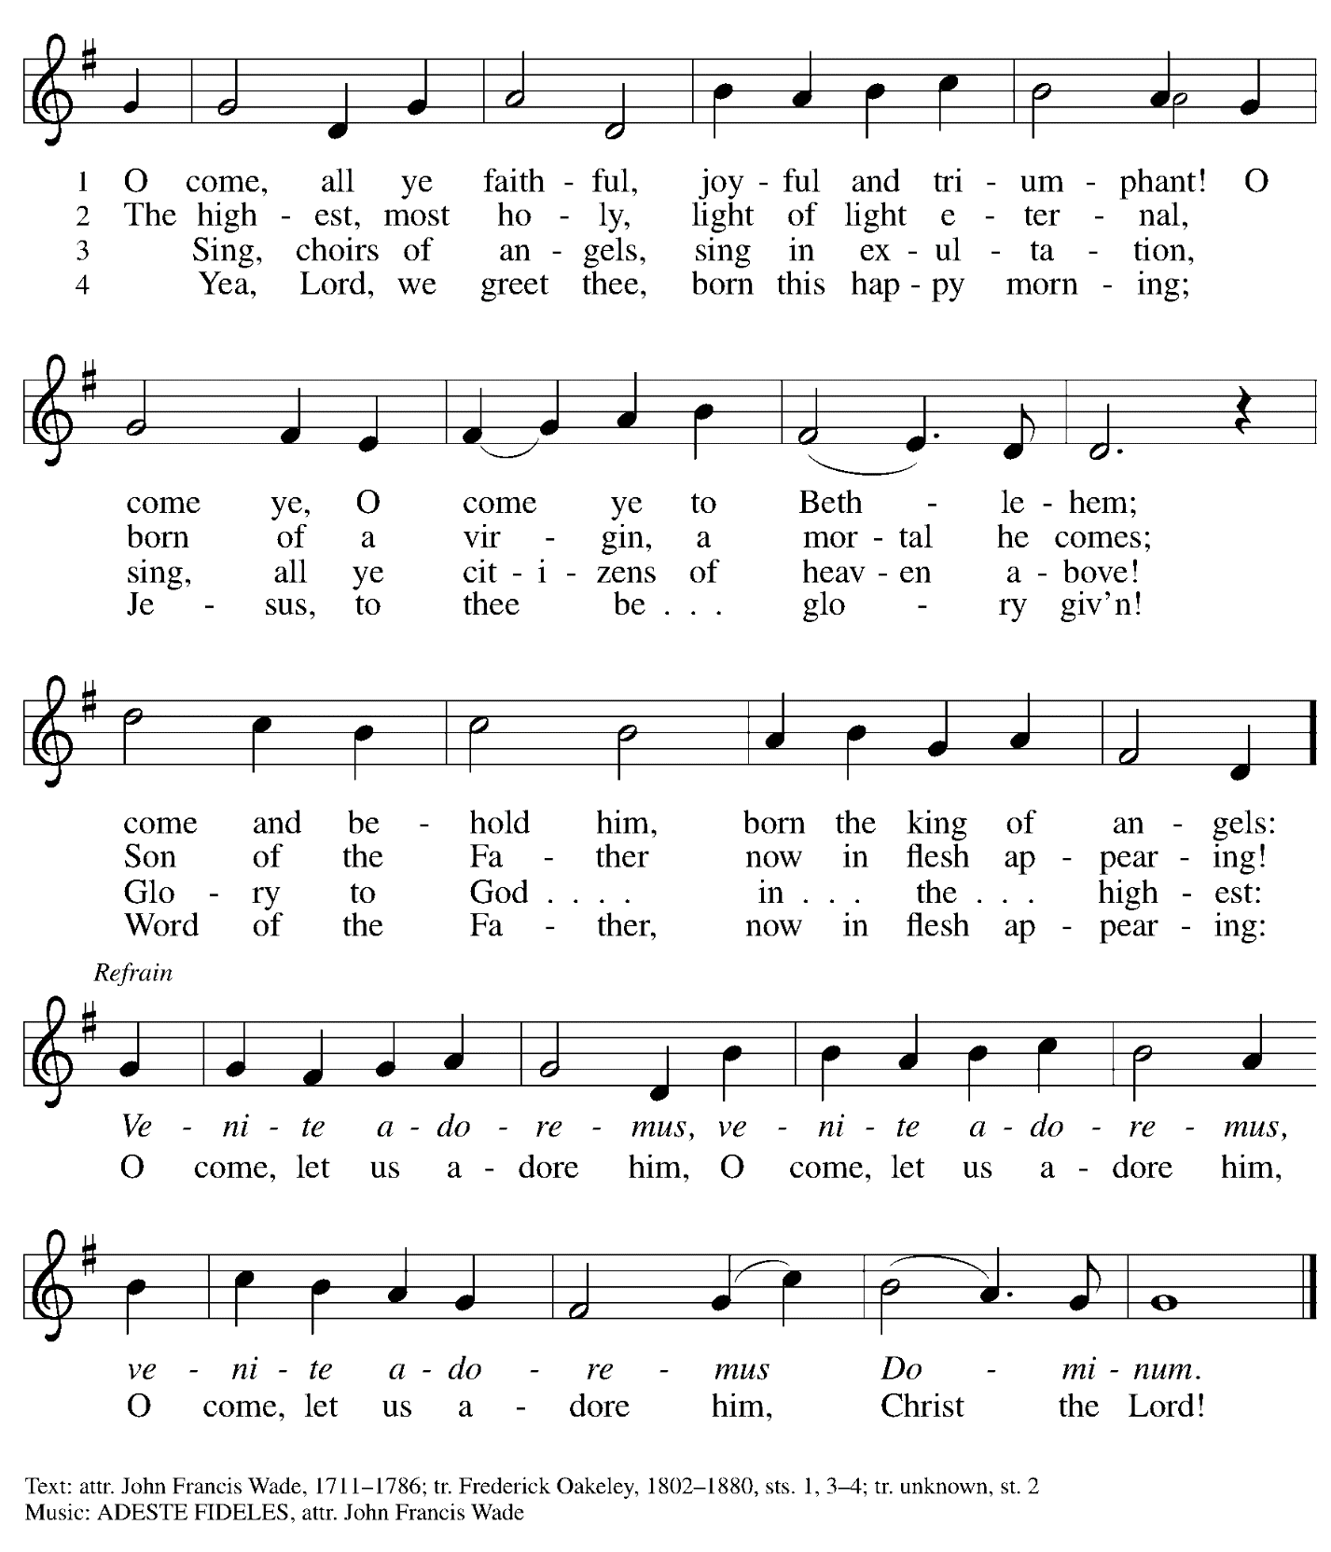

Greeting

P: The grace of our Lord Jesus Christ, the love of God,
and the communion of the Holy Spirit be with you all.
C: And also with you.

Hymn of Praise Angels We Have Heard on High ELW 289

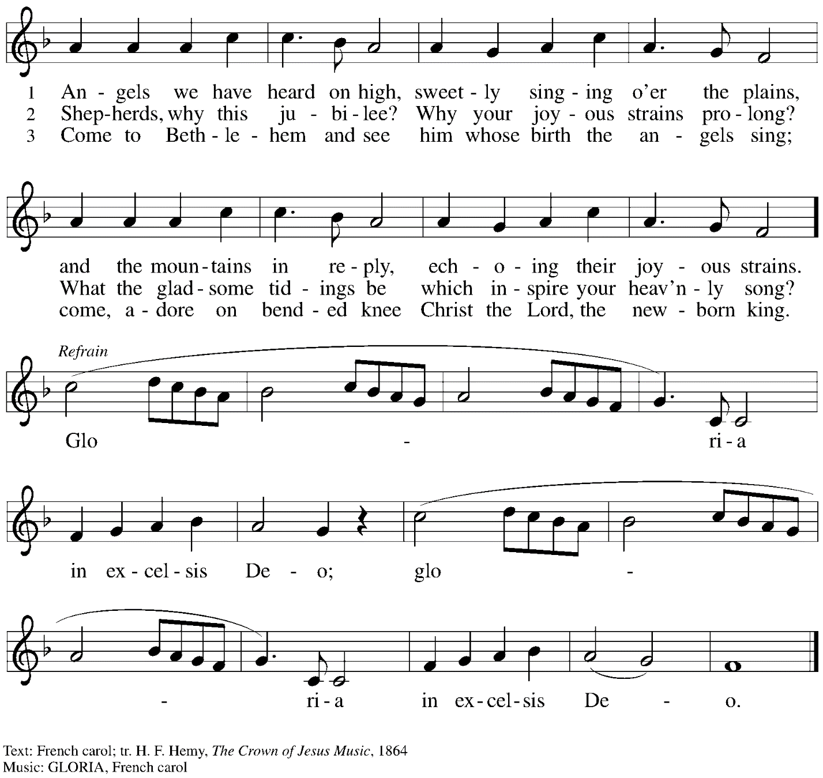

Prayer of the Day

P: Let us pray.
Almighty God, you made this holy night shine with the brightness of the true Light.
Grant that here on earth we may walk in the light of Jesus’ presence
and in the last day wake to the brightness of his glory;
through your Son, Jesus Christ our Lord,
who lives and reigns with you and the Holy Spirit,
one God, now and forever.
C: Amen.

Please be seated.

Word
God speaks to us in Scripture reading, preaching, and song

First Reading – Isaiah 9: 2-7

²The people who walked in darkness
have seen a great light;
those who lived in a land of deep darkness—
on them light has shined.
³You have multiplied the nation,
you have increased its joy;
they rejoice before you
as with joy at the harvest,
as people exult when dividing plunder.
⁴For the yoke of their burden,
and the bar across their shoulders,
the rod of their oppressor,
you have broken as on the day of Midian.
⁵For all the boots of the tramping warriors
and all the garments rolled in blood
shall be burned as fuel for the fire.
⁶For a child has been born for us,
a son given to us;
authority rests upon his shoulders;
and he is named
Wonderful Counselor, Mighty God,
Everlasting Father, Prince of Peace.
⁷His authority shall grow continually,
and there shall be endless peace
for the throne of David and his kingdom.
He will establish and uphold it
with justice and with righteousness
from this time onward and forevermore.
The zeal of the Lord of hosts will do this.

L: Word of God, word of life.
C: Thanks be to God.

Psalm 96

The cantor will lead the singing of the psalm.
The congregation is invited to respond with the alternate verses in bold print,
and to join in singing the refrain.

Psalm tone

Psalm refrain

¹Sing to the Lord| a new song;
sing to the Lord, | all the earth.
²Sing to the Lord, bless the name | of the Lord;
proclaim God’s salvation from | day to day.
³Declare God’s glory a- | mong the nations
and God’s wonders a- | mong all peoples.
⁴For great is the Lord and greatly | to be praised,
more to be feared | than all gods. R
⁵As for all the gods of the nations, they | are but idols;
but you, O Lord, have | made the heavens.
⁶Majesty and magnificence are | in your presence;
power and splendor are in your | sanctuary.
⁷Ascribe to the Lord, you families | of the peoples,
ascribe to the Lord hon- | or and power.
⁸Ascribe to the Lord the honor due the | holy name;
bring offerings and enter the courts | of the Lord. R
⁹Worship the Lord in the beau- | ty of holiness;
tremble before the Lord, | all the earth.
¹⁰Tell it out among the nations: “The | Lord is king!
The one who made the world so firm that it cannot be moved will judge the peo- | ples with equity.”
¹¹Let the heavens rejoice, and let the | earth be glad;
let the sea thunder and all that is in it; let the field be joyful and all that | is therein.
¹²Then shall all the trees of the wood shout for joy at your com- | ing, O Lord,
for you come to | judge the earth.
¹³You will judge the | world with righteousness
and the peoples | with your truth. R

Second Reading – Titus 2: 11-14

¹¹The grace of God has appeared, bringing salvation to all, ¹²training us to renounce impiety and worldly passions, and in the present age to live lives that are self-controlled, upright, and godly,
¹³while we wait for the blessed hope and the manifestation of the glory of our great God and Savior, Jesus Christ. ¹⁴He it is who gave himself for us that he might redeem us from all iniquity and purify for himself a people of his own who are zealous for good deeds.

L: Word of God, word of life.
C: Thanks be to God.

Children’s Word

Children are invited to come forward to hear the story of Christmas and Jesus’ birth.

When the story has concluded and everyone has returned to their places,
please rise as you are able.

As we begin to sing our Gospel Acclamation, Silent Night, Holy Night!, candles are lighted.
As the light is passed throughout the congregation, please tilt your unlit candle toward the light.
Once your candle is lit, please hold it upright to assist others with lighting theirs.
Battery-powered candles are available so that young children can participate safely.

Gospel Acclamation Silent Night, Holy Night! ELW 281
v. 1-2

1 Silent night, holy night!
All is calm, all is bright
round yon virgin mother and child.
Holy Infant, so tender and mild,
sleep in heavenly peace,
sleep in heavenly peace.

2 Silent night, holy night!
Shepherds quake at the sight;
glories stream from heaven afar,
heav'nly hosts sing, alleluia!
Christ, the Savior, is born!
Christ, the Savior, is born!

Gospel – Luke 2: 1-14 [15-20]

P: The holy Gospel according to St. Luke.
C: Glory to you, O Lord.
¹In those days a decree went out from Emperor Augustus that all the world should be registered. ²This was the first registration and was taken while Quirinius was governor of Syria. ³All went to their own towns to be registered. ⁴Joseph also went from the town of Nazareth in Galilee to Judea, to the city of David called Bethlehem, because he was descended from the house and family of David. ⁵He went to be registered with Mary, to whom he was engaged and who was expecting a child. ⁶While they were there, the time came for her to deliver her child. ⁷And she gave birth to her firstborn son and wrapped him in bands of cloth, and laid him in a manger, because there was no place for them in the inn.
⁸In that region there were shepherds living in the fields, keeping watch over their flock by night. ⁹Then an angel of the Lord stood before them, and the glory of the Lord shone around them, and they were terrified. ¹⁰But the angel said to them, “Do not be afraid; for see—I am bringing you good news of great joy for all the people: ¹¹to you is born this day in the city of David a Savior, who is the Messiah, the Lord. ¹²This will be a sign for you: you will find a child wrapped in bands of cloth and lying in a manger.” ¹³And suddenly there was with the angel a multitude of the heavenly host, praising God and saying,
¹⁴“Glory to God in the highest heaven,
and on earth peace among those whom God favors!”

[ ¹⁵When the angels had left them and gone into heaven, the shepherds said to one another, “Let us go now to Bethlehem and see this thing that has taken place, which the Lord has made known to us.” ¹⁶So they went with haste and found Mary and Joseph, and the child lying in the manger. ¹⁷When they saw this, they made known what had been told them about this child; ¹⁸and all who heard it were amazed at what the shepherds told them. ¹⁹But Mary treasured all these words and pondered them in her heart. ²⁰The shepherds returned, glorifying and praising God for all they had heard and seen, as it had been told them.]

P: The Gospel of the Lord.
C: Praise to you, O Christ.

All are invited to sing the concluding verse of Silent Night, Holy Night!
When the hymn concludes, please feel free to extinguish your candles.

Gospel Acclamation Silent Night, Holy Night! ELW 281
v. 3

3 Silent night, holy night!
Son of God, love's pure light
radiant beams from your holy face,
with the dawn of redeeming grace,
Jesus, Lord, at your birth,
Jesus, Lord, at your birth.

Text: Joseph Mohr, 1792-1849; tr. Johan F. Young, 1820-1885. Music: STILLE NACHT, Franz Gruber, 1787-1863.

Please be seated.

Sermon

A time of silence for prayer and reflection follows the sermon.
When the Hymn of the Day begins, please rise as you are able.

Hymn of the Day Hark! The Herald Angels Sing Following page

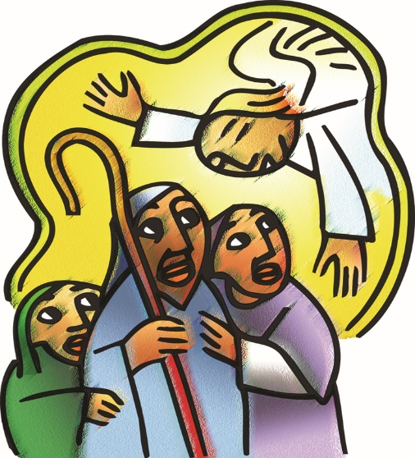

Hymn of the Day Hark! The Herald Angels Sing ELW 270

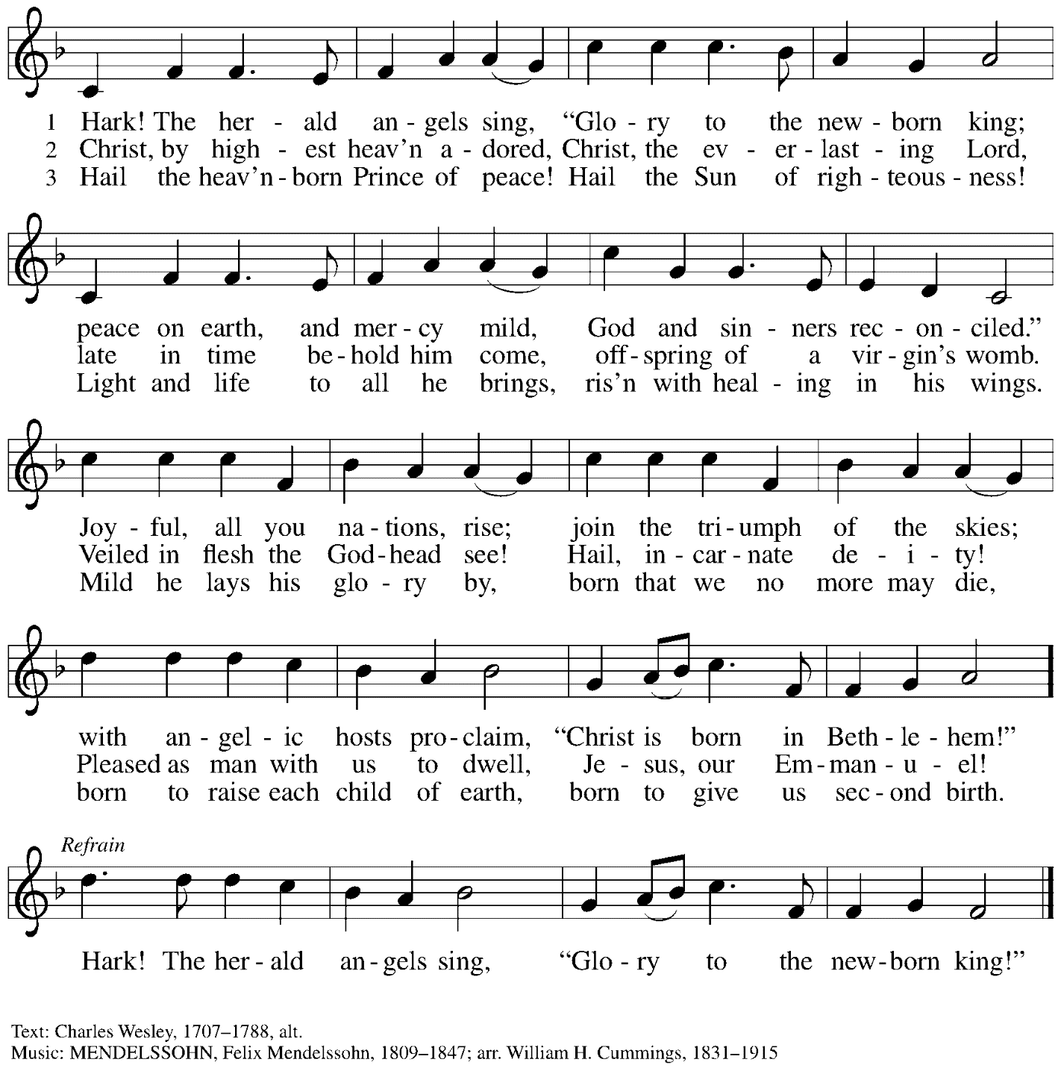

Nicene Creed

P: Rejoicing in the good news of Christ’s birth, we confess our faith:
C: We believe in one God,
the Father, the Almighty,
maker of heaven and earth,
of all that is, seen and unseen.

C: We believe in one Lord, Jesus Christ,
the only Son of God,
eternally begotten of the Father,
God from God, Light from Light,
true God from true God,
begotten, not made,
of one Being with the Father;
through him all things were made.
For us and for our salvation
he came down from heaven,
was incarnate of the Holy Spirit and the virgin Mary
and became truly human.
For our sake he was crucified under Pontius Pilate;
he suffered death and was buried.
On the third day he rose again
in accordance with the scriptures;
he ascended into heaven
and is seated at the right hand of the Father.
He will come again in glory to judge the living and the dead,
and his kingdom will have no end.

We believe in the Holy Spirit, the Lord, the giver of life,
who proceeds from the Father and the Son,*
who with the Father and the Son is worshiped and glorified,
who has spoken through the prophets.
We believe in one holy catholic and apostolic church.
We acknowledge one baptism for the forgiveness of sins.
We look for the resurrection of the dead,
and the life of the world to come. Amen.
*Or, “who proceeds from the Father.” The phrase “and the Son” is a later addition to the creed.

Prayers of the People

P: With wonder and joy at Christ’s coming into the world,
we pray for the church, the world, and all who are in need.

After each petition
P: God of grace,
C: receive our prayer.

P: In the light of the mystery of eternal love made flesh,
we commend to you all for whom we pray, gracious God,
through Jesus Christ our Savior.
C: Amen.

Please be seated.

Meal

Offering

We offer ourselves, our gifts, and our faithful service to God.
As the offering is gathered for the mission of the church, including the care of those in need,
the table is set for Holy Communion.

Music during the Offering

As the gifts are brought forward for presentation, please rise as you are able
and join in singing the Offertory Song.

Offertory Song In the Bleak Midwinter Following page

Offertory Song In the Bleak Midwinter ELW 294

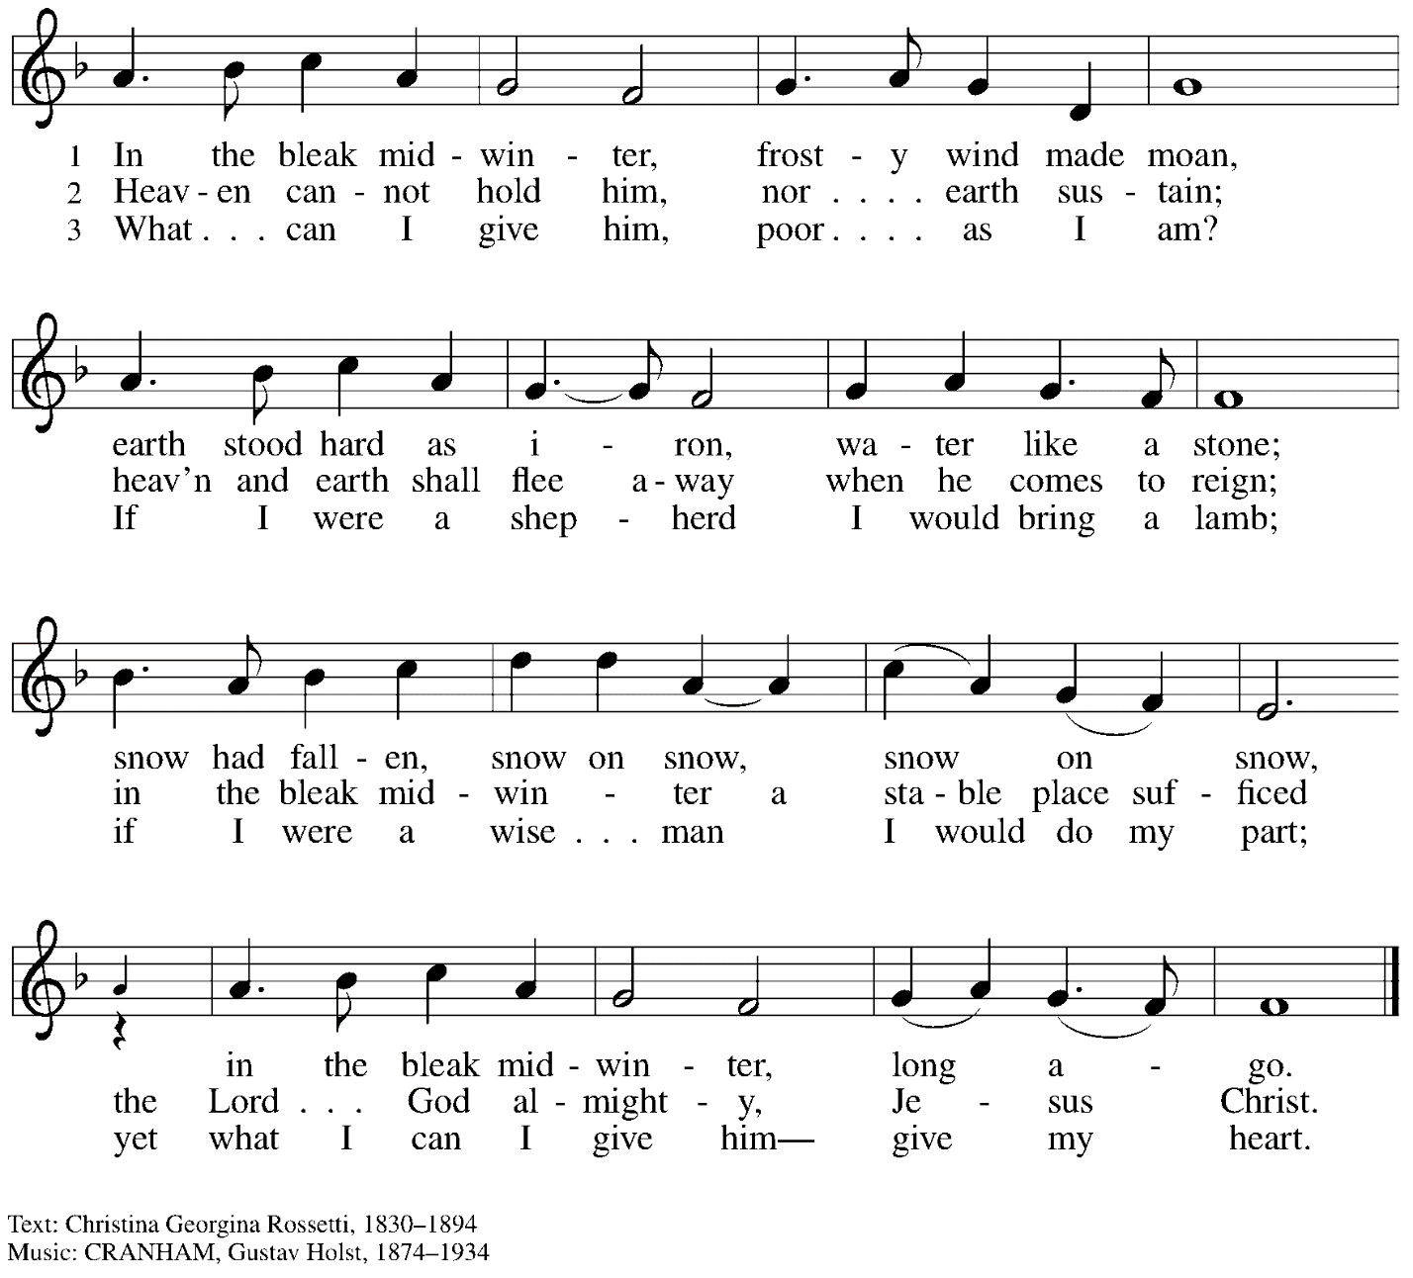

Offertory Prayer

P: Let us pray. Good and loving God,
C: we rejoice in the birth of Jesus,
who came among the poor to bring the riches of his grace.
As you have blessed us with your gifts, let them be a blessing for others.
With the trees of the field, with all earth and heaven,
we shout for joy at the coming of your Son, Jesus Christ our Lord.
Amen.

Dialogue ELW p. 144

Preface (Sung by the presiding minister)

P: It is indeed right, our duty and our joy …
… we praise your name and join their unending hymn:

Sanctus ELW p. 144

Eucharistic Prayer

P: Holy One, the beginning and the end, the giver of life …
… Do this for the remembrance of me.

P: Let us proclaim the mystery of faith:
C: Christ has died.
Christ is risen.
Christ will come again.

P: With this bread and cup we remember …
… We look with hope for his coming.
C: Amen. Come, Lord Jesus.

P: Holy God, we long for your Spirit. …
… Bring the gift of peace on earth.
C: Amen. Come, Holy Spirit.

P: All praise and glory are yours, …
… one God, now and forever.
C: Amen.

Lord’s Prayer

P: Gathered as one by the Holy Spirit, let us pray as Jesus taught us.
C: Our Father in heaven,
hallowed be your name,
your kingdom come,
your will be done,
on earth as in heaven.
Give us today our daily bread.
Forgive us our sins
as we forgive those who sin against us.
Save us from the time of trial
and deliver us from evil.
For the kingdom, the power,
and the glory are yours,
now and forever. Amen.

Fraction and Invitation

P: Glory to God in the highest!
Come to the table of peace.

Agnus Dei / Lamb of God ELW p. 146

Please be seated.

Holy Communion
- All who seek God and a deeper and stronger life in Christ are welcome to receive Holy Communion.
- Please inform an usher if you would like the ministers to bring Communion to you.
- Worshipers from the pulpit side will proceed forward first, followed by the center section, and then the lectern side.
- Holy Communion will be served with bread and wine/grape juice.
- The presiding minister will first distribute the bread (host) to each communicant. Please indicate if you would like a gluten-free host.
- Once you have consumed the bread, please pick up an empty glass from the tray next to the presiding minister. The Communion Assistant will pour wine from the chalice or grape juice from the cruet into your glass.
- Please step to the side to consume the wine or grape juice.
- As you return to your pew, glasses may be returned to the empty trays on either side of the center aisle.
- A blessing will be provided for anyone who does not yet receive the sacrament. Please place your hands on your heart and bow your head if you would like a blessing.
- All are invited to join in singing the hymns during Holy Communion.

Hymn during Holy Communion
Away in a Manger ELW 277

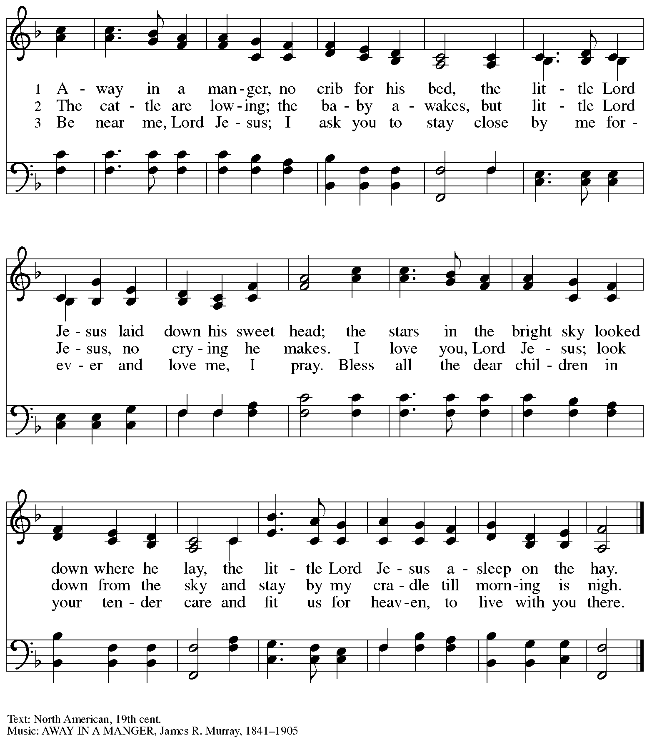

Hymn during Holy Communion
The First Noel ELW 300

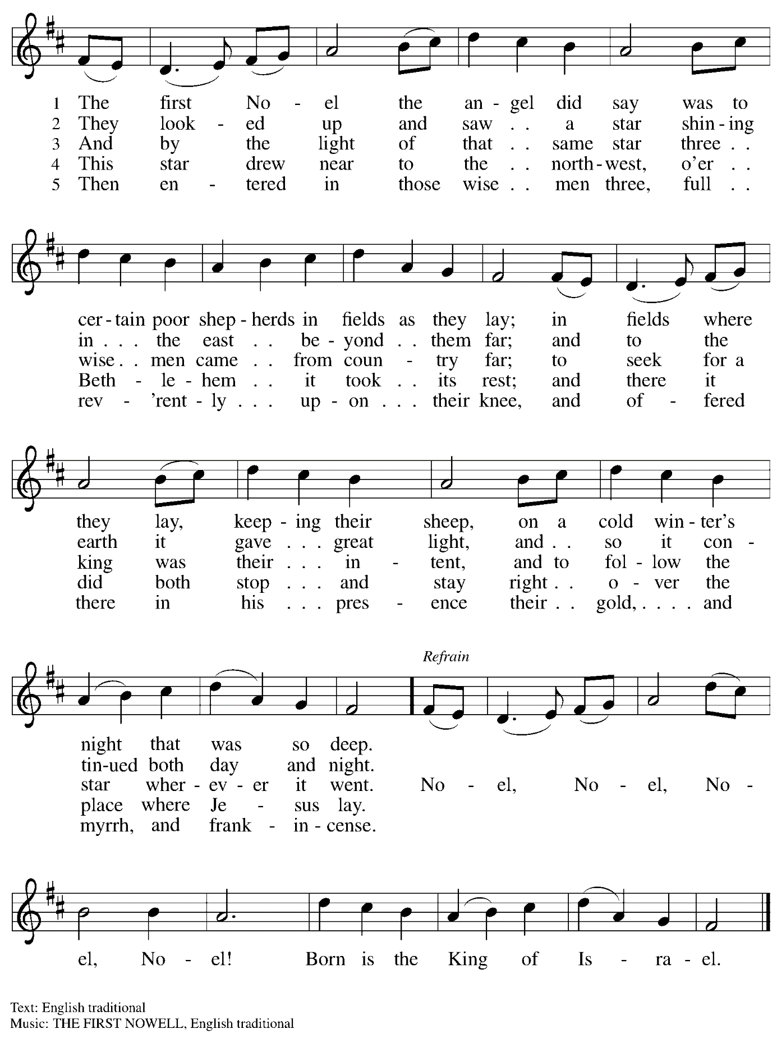

Hymn during Holy Communion
It Came upon the Midnight Clear ELW 282

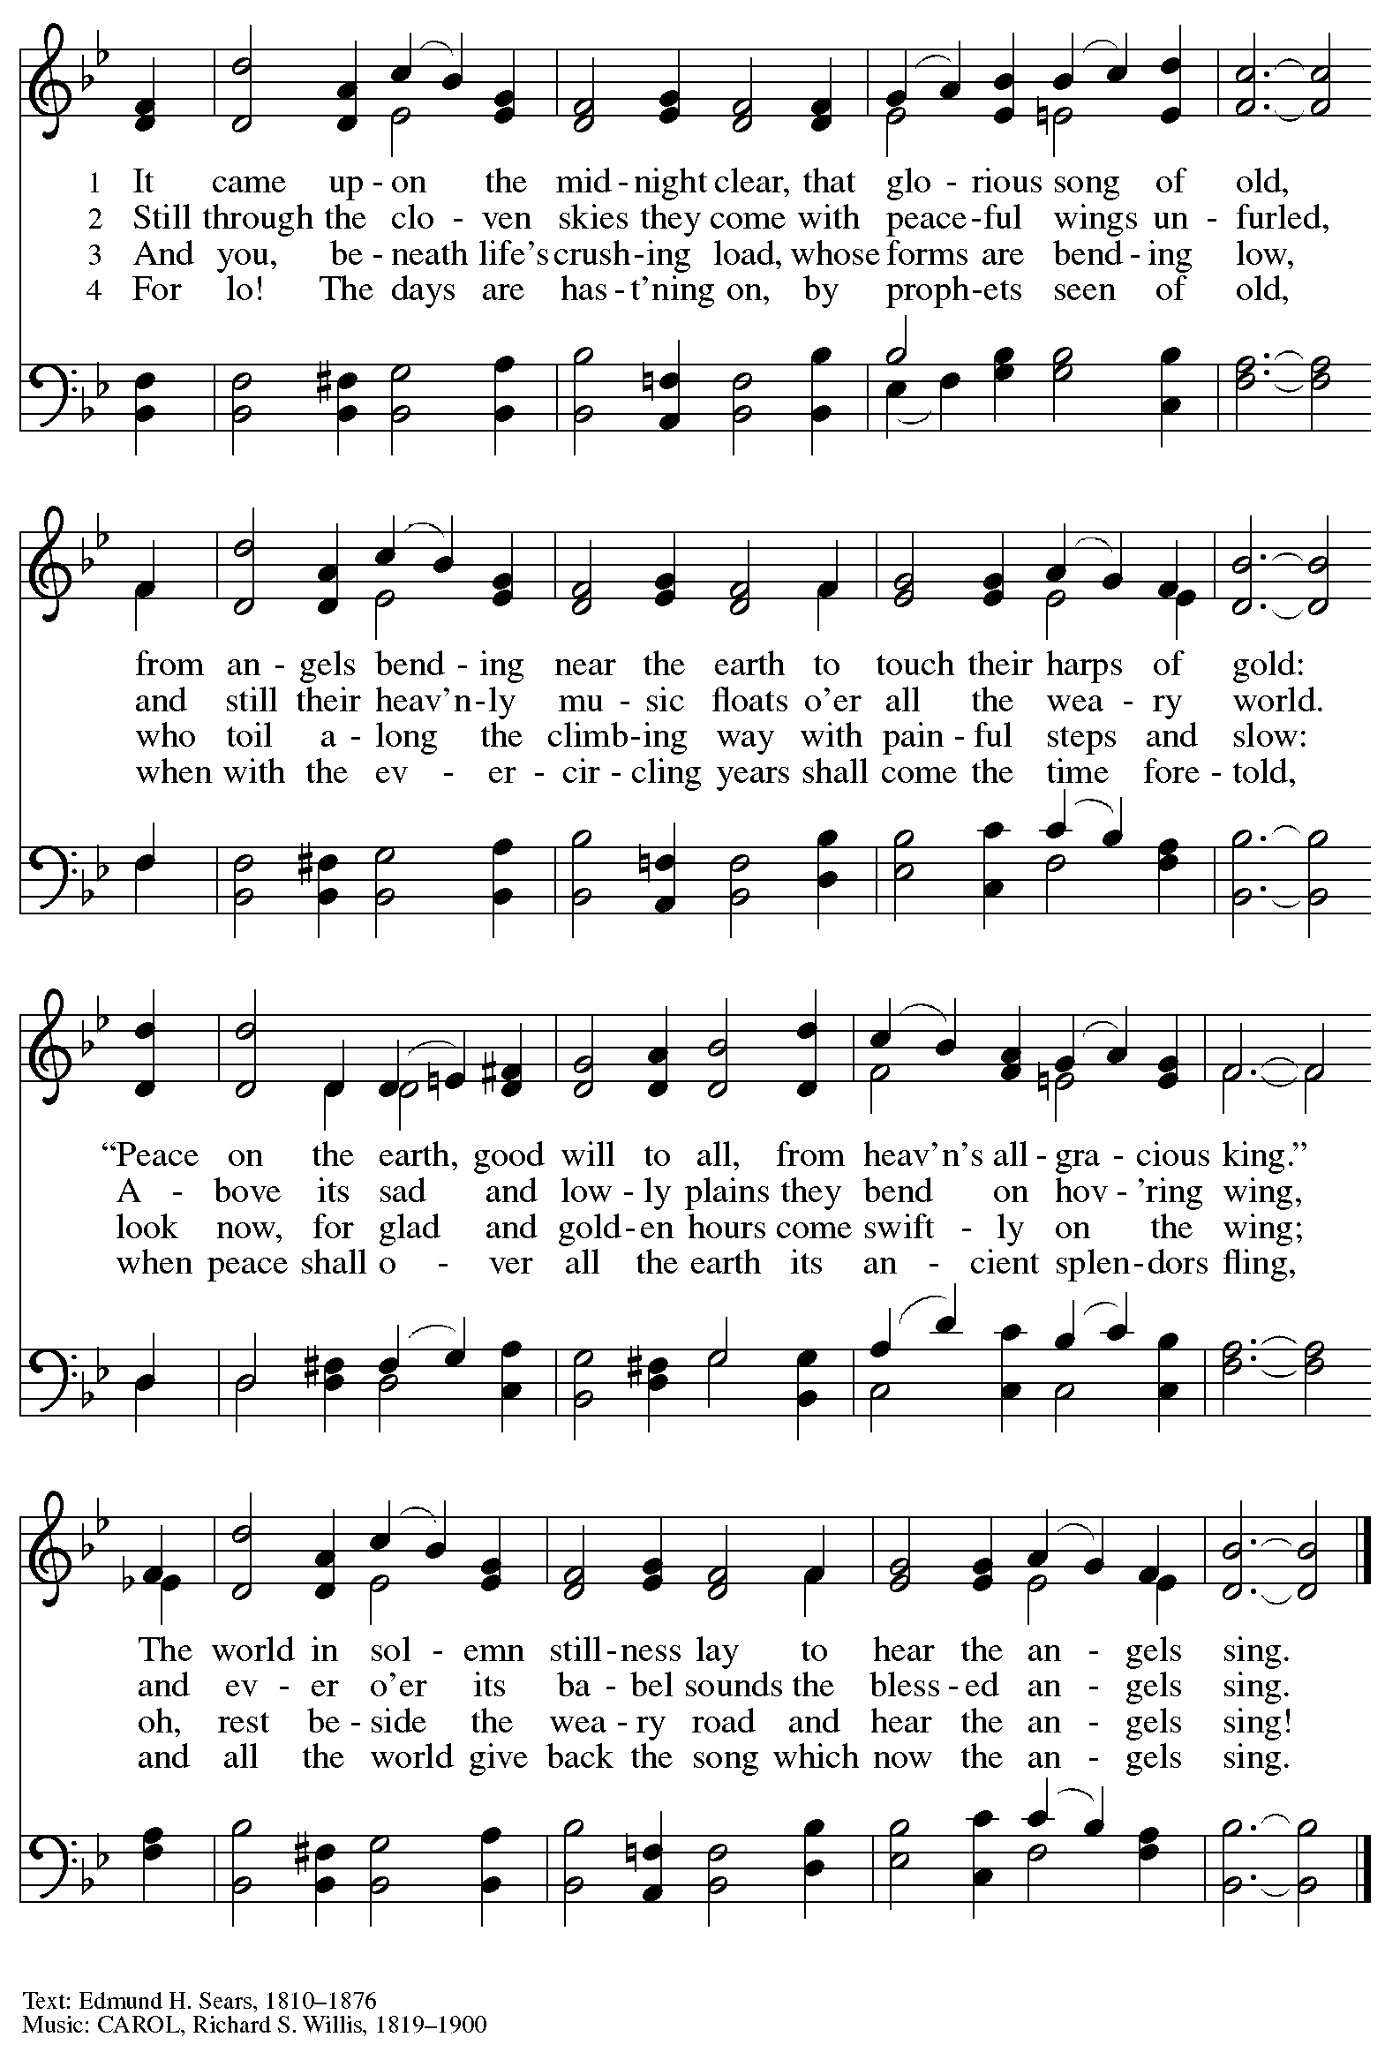

Hymn during Holy Communion
Love Has Come ELW 292

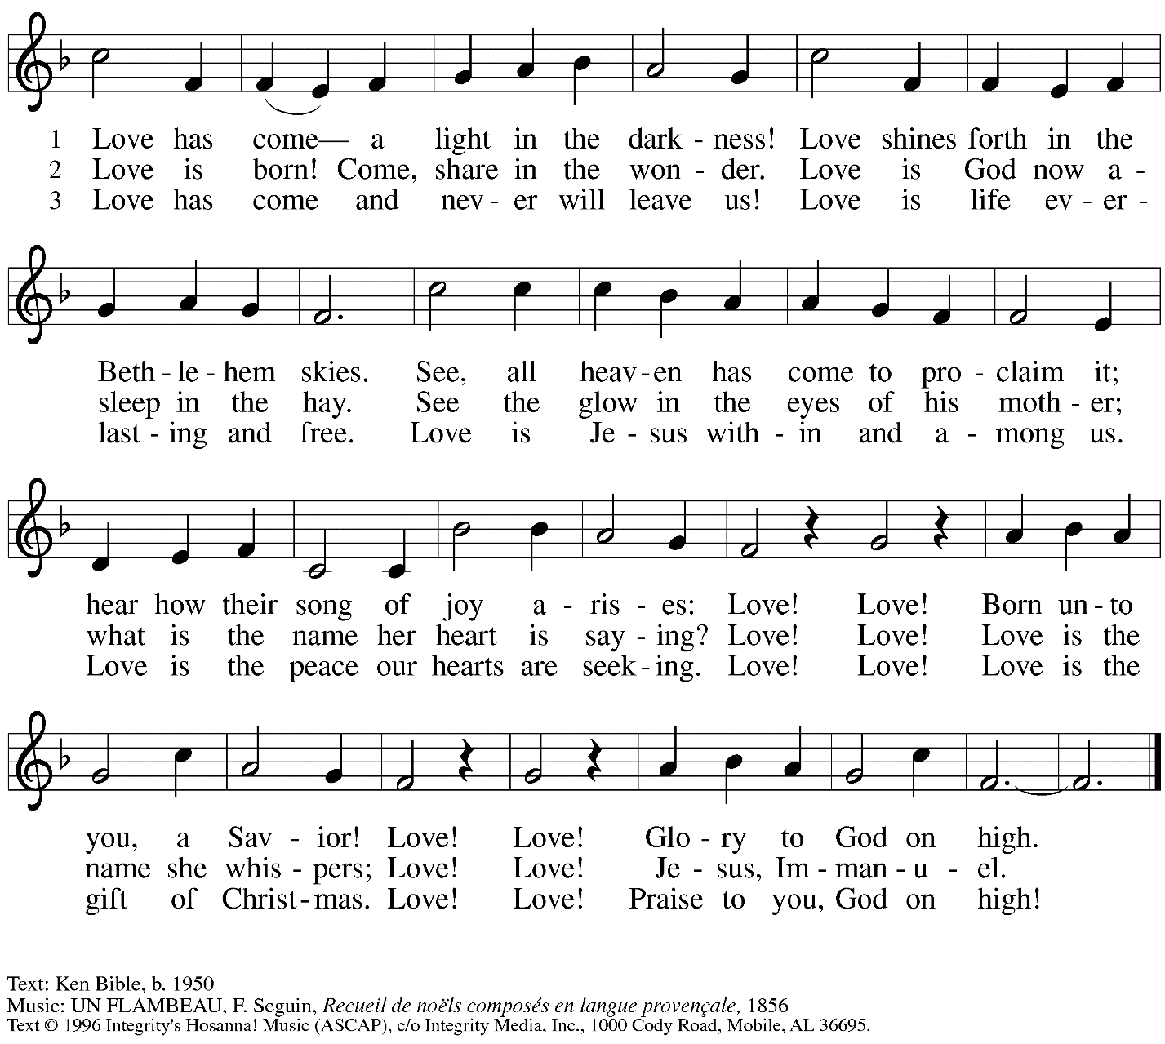
All rights reserved. Reprinted under OneLicense.net # A-722139.

Hymn during Holy Communion
What Child Is This ELW 296

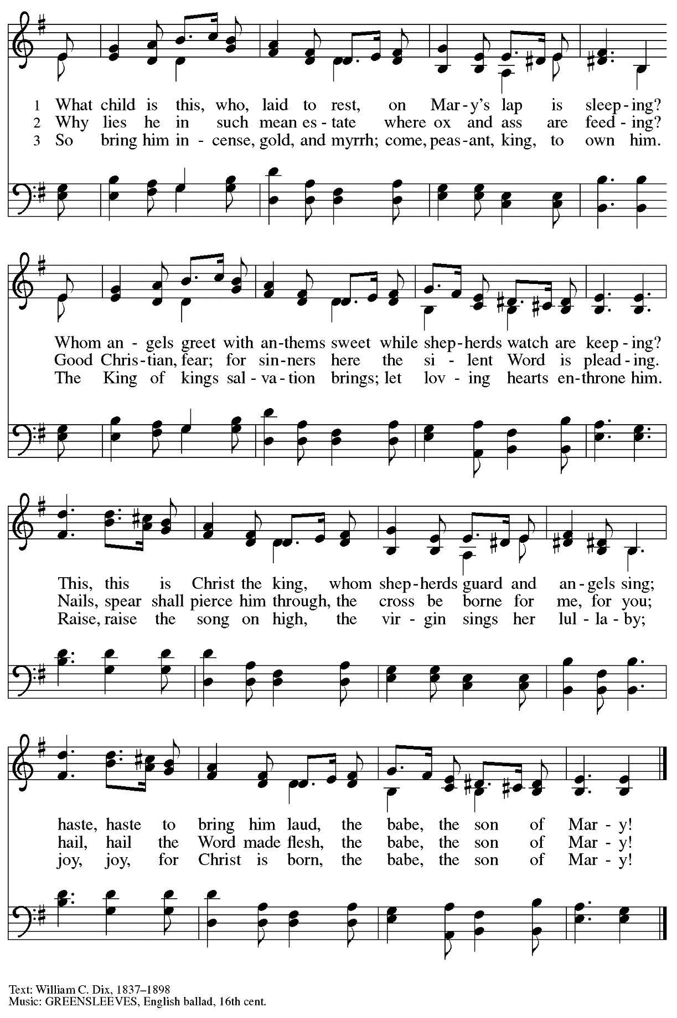

When all have returned to their places, please rise as you are able.

Blessing

P: The body and blood of our Lord Jesus Christ strengthen you and keep you in his grace.
C: Amen.

Prayer

P: Let us pray.
Radiant God, you have brought us your salvation,
and in this meal we have feasted on your grace.
May your Word take flesh in us, that we may be your holy people,
Revealing your glory made known to us in Jesus Christ, our Savior and Lord.
C: Amen.

Sending

Benediction

P: God bless you and keep you,
☩ Jesus grant you grace and truth,
and the Spirit send peace upon your hearts,
now and forever.
C: Amen.

Sending Hymn Joy to the World Following page

Dismissal

P: Go in peace. Share the good news!
C: Thanks be to God!

Sending Hymn Joy to the World ELW 267

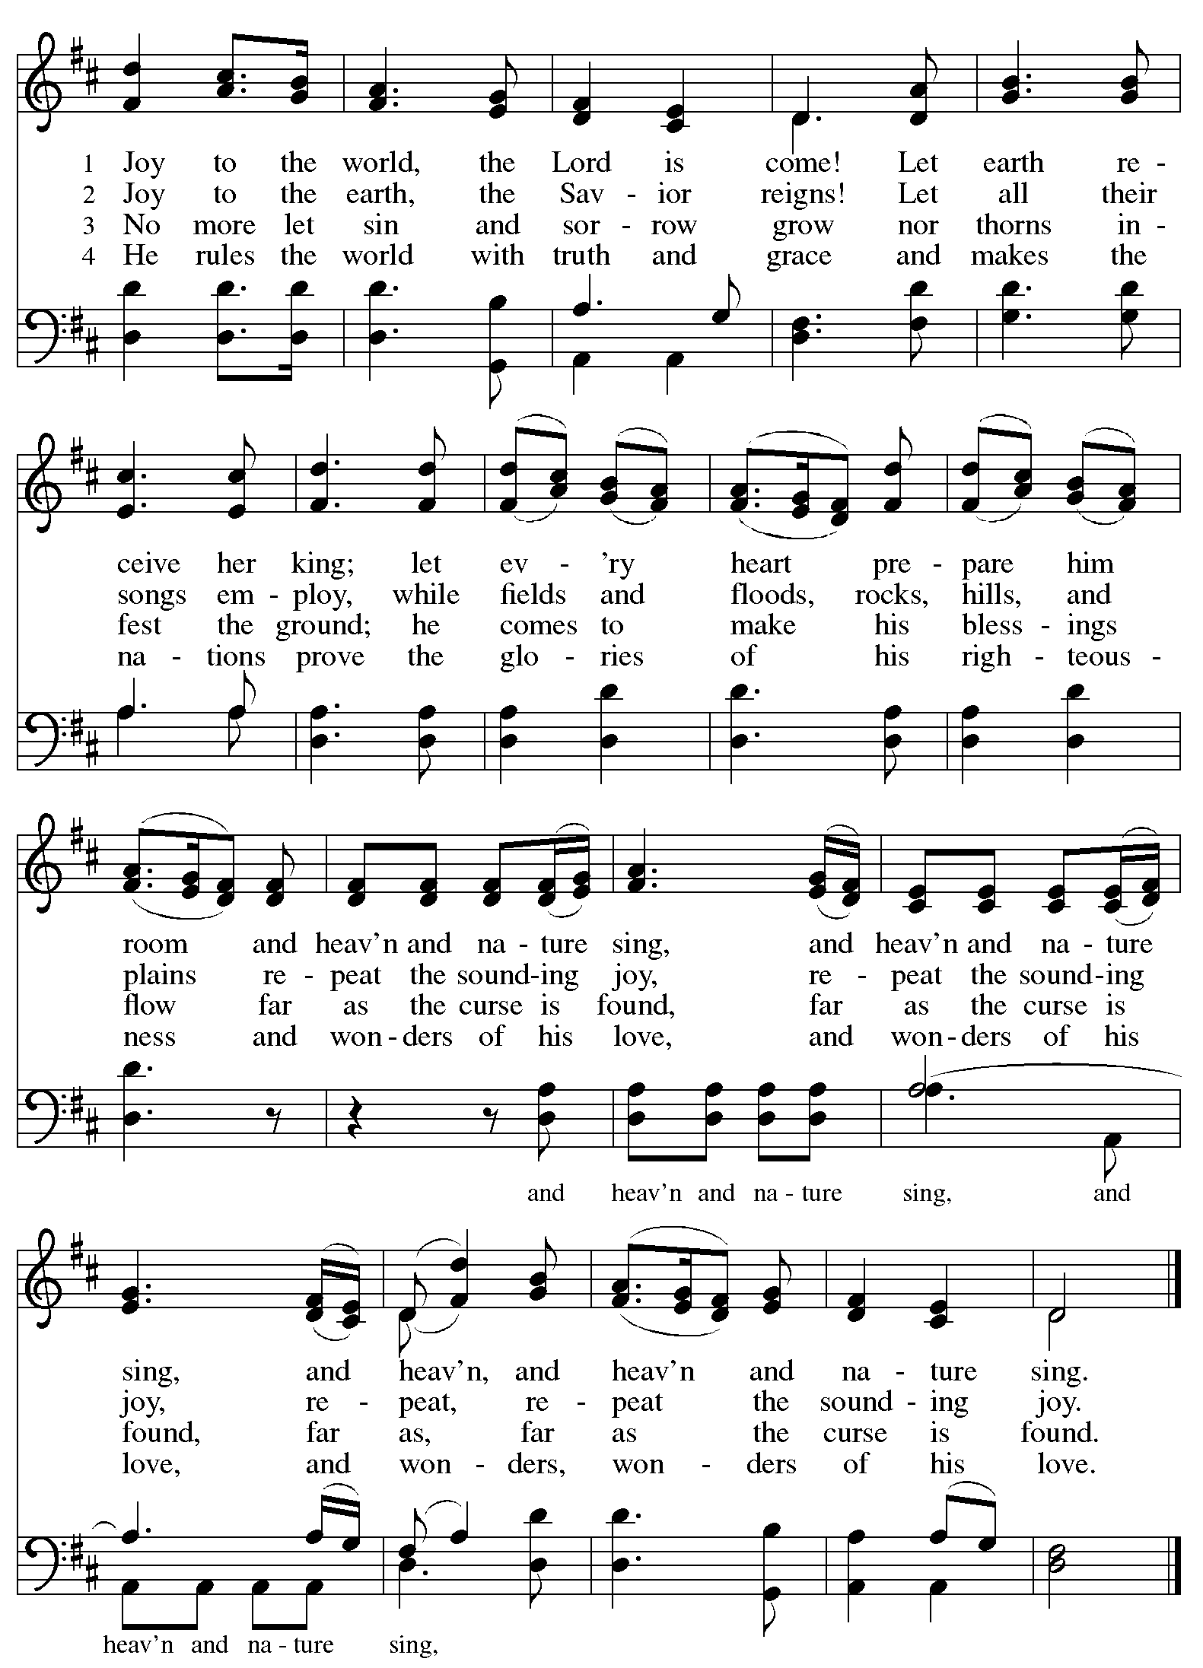
Abbreviations

P: Pastor/Presiding Minister
L: Lector
C: Congregation

ELW: Evangelical Lutheran Worship hymnal

Those serving in worship today

Minister of Music Laura Reynolds
Organ Jimmi Kocher-Hillmer
Cantor Richard Krug
Kristen Asplin
Lector Pastor Paul Koch
Communion Assistant Timothy Kocher-Hillmer
Presiding Minister Rev. Ross Carmichael

Liturgy and Hymnody Acknowledgements

From SundaysandSeasons.com. Copyright © 2022 Augsburg Fortress. All rights reserved. Reprinted under OneLicense.net # A-722139.
Used by permission of Augsburg Fortress.

Joy to the World – Text: Isaac Watts, 1674- 1748. Music: VENI, EMMANUEL, ANTIOCH, English melody, 18th cent.; arr. Lowell Mason, 1792-1872.

St. Andrew Lutheran Church Announcements
December 24th, 2022

- Worship in the Sanctuary and Online – Saturday, December 24th, + The Nativity of our Lord – Christmas Eve – St. Andrew’s next worship with Holy Communion will be this Saturday, December 24th, at 7:00 p.m. Masks are optional at St. Andrew when Allegheny County’s Covid-19 community level is in the low and medium categories. Worship will also be live-streamed to Facebook, YouTube, and Zoom. Worship attendees are invited to make name tags at the back of the worship space if you would like.
- Christmas Day Worship – Sunday, December 25th, 10:00 a.m. – Worship with Holy Communion
- Little Church; Big Faith Will Not Meet during Worship tonight, December 24th, Christmas Eve; Sunday, December 25th, Christmas Day; or Sunday, January 1st, First Sunday of Christmas. We will resume the Bible lesson and activities during worship on Sunday, January 8th.
- Christ in our Home Current Devotional Booklets for the Next Quarter (January - March 2023) Available at Church Entrances – Christ in our Home is a booklet that offers a daily Bible reading with a short reflection and prayers, long with additional prayer concerns and readings for those who would like to expand their devotional practices. These are available at each entrance to the church, and we encourage people
of the congregation to take one for yourself and others!

