+ Fourth Sunday in Lent
March 10th, 2024
10:00 a.m.

St. Andrew Lutheran Church
304 Morewood Ave.
Pittsburgh, PA 15213
412.682.3342
St_andrewELCA@verizon.net
www.standrewpittsburgh.org

+ Fourth Sunday in Lent
Order for Worship

The fourth of the Old Testament promises providing a baptismal lens this Lenten season is the promise God makes to Moses: those who look on the bronze serpent will live. In today’s gospel, Jesus says he will be lifted up on the cross like the serpent, so that those who look to him in faith will live. When we receive the sign of the cross in Baptism, that cross becomes the sign we can look to in faith for healing, for restored relationship to God, for hope when we are dying.

Welcome to St. Andrew!
- St. Andrew Lutheran congregation welcomes all who are seeking a place of healing and wholeness – a nurturing, faith-forming spiritual home. Our community embraces people of all ages, ethnicities, cultures, abilities, sexual orientations, gender identities and expressions, and family constellations. Come and See!
- Worship Services are live streamed to multiple online platforms. By attending worship, you agree that your image and voice may be broadcast.
- Everyone is invited to make a nametag at the black bookcase in the back of the worship space if they would like. There are stickers indicating pronouns on the bookcase if you would like to include them on your name tag.
- Children are invited to attend Little Church – Big Faith, a Bible lesson and activity, during worship (after the Prayer of the Day). The group returns to the worship space for the liturgy of Holy Communion.
- Worship “toolkits” to help children engage with the service, along with “busy bags” for younger children, are available in the bookcase at the back of the sanctuary. Please feel free to take one to use with/for your children.
- Holy Communion is served with bread (gluten-free available) and wine or grape juice. The presiding minister will distribute the bread (host). Please consume this and then pick up an empty glass from the tray. The Communion Assistant will pour wine or grape juice into your glass. Please step to the side to consume the wine or grape juice. Feel free to kneel at the altar for prayer and reflection. As you return to your pew, glasses may be returned to the empty trays on either side of the center section.
- A restroom is available on the main level of the church, through the doors to the Social Hall and to the right in the main office.

Abbreviations

P: Pastor/Presiding Minister ELW: Evangelical Lutheran Worship hymnal
A: Assisting Minister ACS: All Creation Sings hymnal
L: Lector
C: Congregation

Prelude Op. 28 No. 6 F. Chopin

Welcome

Gathering
The Holy Spirit calls us together as the people of God

Centering Music Return to God ACS 921

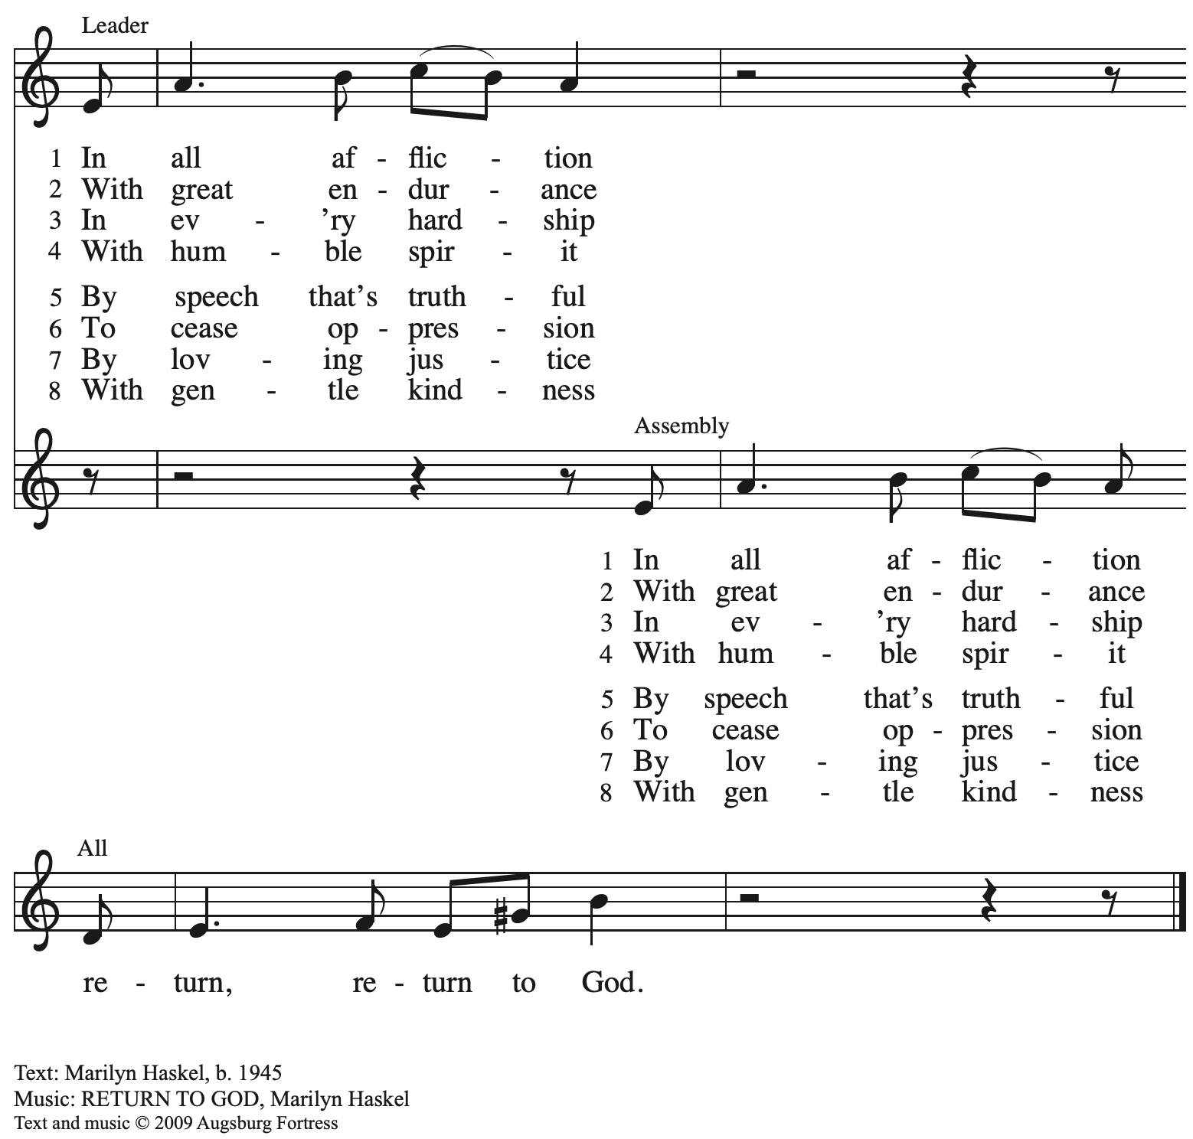
All rights reserved. Reprinted with permission under OneLicense.net # A-722139.

Confession and Forgiveness

Please rise as you are able. All may make the sign of the cross,
the sign that is marked at Baptism, as the presiding minister begins.

P: Blessed be the holy Trinity, ☩ one God,
who looks upon us in compassion,
forgives our sin,
and heals our wounds.
C: Amen.

P: Let us confess our sin in the presence of God and of one another.

Silence is kept for reflection.

P: Have mercy, O God,
C: for we have sinned
against you and our neighbors,
by what we have done
and by what we have failed to do.
In your compassion,
cleanse us from our sin
and take away our guilt.
Create in us a new heart
and give us a steadfast spirit.
Do not cast us away,
but fill us with your Holy Spirit
and restore your joy within us.
Amen.

P: As far as the highest mountain is to the lowest ocean floor,
so deep is God’s compassion for you.
As high as heaven is above earth,
so vast is God’s love for you.
As far as east is from west,
so far God removes your sin from you,
renewing your life through Jesus Christ.
Blessed be God who crowns us with mercy and love.
C: Blessed be God forever. Amen.

Gathering Hymn O Christ, Our Hope ELW 604

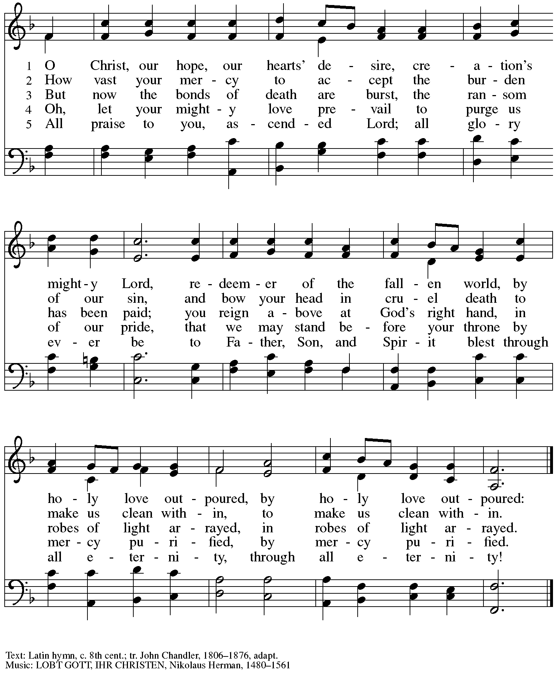

Greeting

P: The grace of our Lord Jesus Christ, the love of God,
and the communion of the Holy Spirit be with you all.
C: And also with you.

Kyrie ACS p. 31

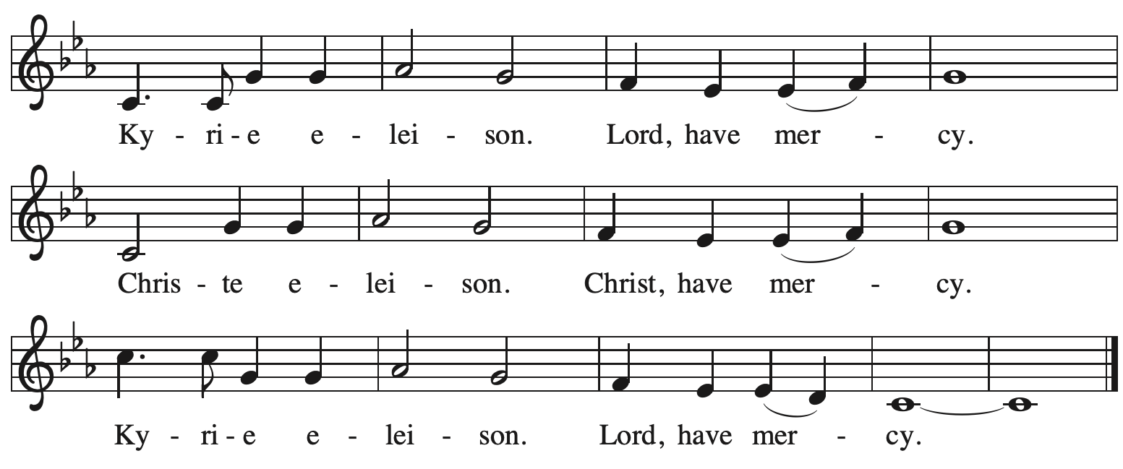

Prayer of the Day

P: Let us pray.
O God, rich in mercy, by the humiliation of your Son you lifted up this fallen world
and rescued us from the hopelessness of death. Lead us into your light,
that all our deeds may reflect your love, through Jesus Christ, our Savior and Lord,
who lives and reigns with you and the Holy Spirit, one God, now and forever.
C: Amen.

Please be seated.
Children are invited to join the adult leaders at the door and move to the office for Little Church – Big Faith. We ask that one additional adult from the congregation attend with the children.

Word
God speaks to us in Scripture reading, preaching, and song

First Reading – Numbers 21: 4-9

⁴From Mount Hor [the Israelites] set out by the way to the Red Sea, to go around the land of Edom; but the people became impatient on the way. ⁵The people spoke against God and against Moses, “Why have you brought us up out of Egypt to die in the wilderness? For there is no food and no water, and we detest this miserable food.” ⁶Then the Lord sent poisonous serpents among the people, and they bit the people, so that many Israelites died. ⁷The people came to Moses and said, “We have sinned by speaking against the Lord and against you; pray to the Lord to take away the serpents from us.” So Moses prayed for the people. ⁸And the Lord said to Moses, “Make a poisonous serpent, and set it on a pole; and everyone who is bitten shall look at it and live.” ⁹So Moses made a serpent of bronze, and put it upon a pole; and whenever a serpent bit someone, that person would look at the serpent of bronze and live.

L: Word of God, word of life.
C: Thanks be to God.

Psalm 107: 1-3, 17-22

Psalm tone

Psalm refrain

¹Give thanks to the Lord, for the | Lord is good,
for God’s mercy en- | dures forever.
²Let the redeemed of the | Lord proclaim
that God redeemed them from the hand | of the foe,
³gathering them in | from the lands;
from the east and from the west, from the north and | from the south.
¹⁷Some were fools and took re- | bellious paths;
through their sins they | were afflicted.
¹⁸They loathed all man- | ner of food
and drew near | to death’s door.
¹⁹Then in their trouble they cried | to the Lord
and you delivered them from | their distress. R
²⁰You sent forth your | word and healed them
and rescued them | from the grave.
²¹Let them give thanks to you, Lord, for your | steadfast love
and your wonderful works | for all people.
²²Let them offer sacrifices | of thanksgiving
and tell of your deeds with | shouts of joy. R

Second Reading – Ephesians 2: 1-10

¹You were dead through the trespasses and sins ²in which you once lived, following the course of this world, following the ruler of the power of the air, the spirit that is now at work among those who are disobedient. ³All of us once lived among them in the passions of our flesh, following the desires of flesh and senses, and we were by nature children of wrath, like everyone else. ⁴But God, who is rich in mercy, out of the great love with which God loved us ⁵even when we were dead through our trespasses, made us alive together with Christ—by grace you have been saved—⁶and raised us up with him and seated us with him in the heavenly places in Christ Jesus, ⁷so that in the ages to come God might show the immeasurable riches of God’s grace in kindness toward us in Christ Jesus. ⁸For by grace you have been saved through faith, and this is not your own doing; it is the gift of God—⁹not the result of works, so that no one may boast.
¹⁰For we are what God has made us, created in Christ Jesus for good works, which God prepared beforehand to be our way of life.

L: Word of God, word of life.
C: Thanks be to God.

Please rise as you are able.

Gospel Acclamation ACS p. 34

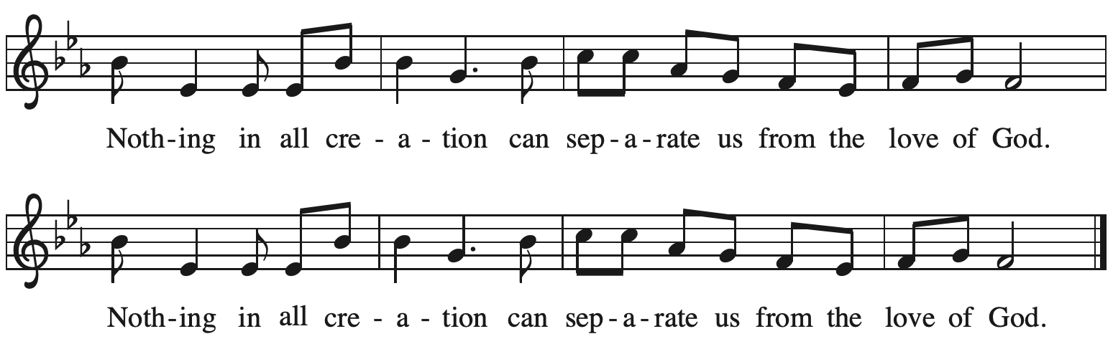

Gospel – John 3: 14-21

P: The holy Gospel according to St. John.
C: Glory to you, O Lord.

[Jesus said:] ¹⁴“Just as Moses lifted up the serpent in the wilderness, so must the Son of Humanity be lifted up, ¹⁵that whoever believes in him may have eternal life.
¹⁶“For God so loved the world that God gave God’s only Son, so that everyone who believes in him may not perish but may have eternal life.
¹⁷“Indeed, God did not send the Son into the world to condemn the world, but in order that the world might be saved through him. ¹⁸Those who believe in him are not condemned; but those who do not believe are condemned already, because they have not believed in the name of the only Son of God. ¹⁹And this is the judgment, that the light has come into the world, and people loved darkness rather than light because their deeds were evil. ²⁰For all who do evil hate the light and do not come to the light, so that their deeds may not be exposed. ²¹But those who do what is true come to the light, so that it may be clearly seen that their deeds have been done in God.”

P: The Gospel of the Lord.
C: Praise to you, O Christ.

Please be seated.

Sermon

A time of silence for prayer and reflection follows the sermon.
As the hymn of the day begins, please rise as you are able.

Hymn of the Day God Loved the World ELW 323

1 God loved the world so that God gave
God’s only Son the lost to save,
that all who would in him believe
should everlasting life receive.

2 Christ Jesus is the ground of faith,
who was made flesh and suffered death;
all who confide in Christ alone
are built on this chief cornerstone.

3 If you are ill, if death draws near,
this truth your troubled heart can cheer:
Christ Jesus rescues us from death;
that is the firmest ground of faith.

4 Be of good cheer, for God's own Son
forgives all sins that you have done,
and justified by Jesus' blood,
your baptism grants the highest good.

5 All glory to the Father, Son,
and Holy Spirit, Three in One!
To you, O blessed Trinity,
be praise now and eternally!

Text: Gesangbuch, Bollhagen, 1791; tr. August Crull, 1846-1923, alt. Music: ROCKINGHAM OLD, Edward Miller, 1731-1807, adapt.

Apostles’ Creed

P: Trusting in God’s mercy, we confess our faith.
C: I believe in God, the Father almighty,
creator of heaven and earth.

C: I believe in Jesus Christ, God’s only Son, our Lord,
who was conceived by the Holy Spirit,
born of the virgin Mary,
suffered under Pontius Pilate,
was crucified, died, and was buried;
he descended to the dead.*
On the third day he rose again;
he ascended into heaven,
he is seated at the right hand of the Father,
and he will come to judge the living and the dead.

I believe in the Holy Spirit,
the holy catholic church,
the communion of saints,
the forgiveness of sins,
the resurrection of the body,
and the life everlasting. Amen.

*Or, “he descended into hell,” another translation of this text in widespread use.

Prayers of the People

A: Trusting in God’s promise to reconcile all things, let us pray for the church,
the well-being of creation, and all who are in need.

After each petition
A: Merciful God,
C: receive our prayer.

The presiding minister concludes the prayers
P: Accompany us on our journey through this season, O God of grace,
and receive the prayers of our hearts, through Jesus Christ, our Savior.
C: Amen.

Peace

The presiding minister and the assembly greet one another in the peace of the risen Christ.
P: The peace of Christ be with you always.
C: And also with you.

The people may greet those around them with a sign of Christ’s peace and may say
Peace be with you or similar words. Please be mindful that not everyone will be comfortable with sharing the peace, so please seek consent before shaking hands or hugging. Other possible ways to share the peace include a simple bow with the verbal greeting of peace, or simply a verbal expression of peace.

When the greetings of peace have concluded, please be seated.

Meal
God feeds us with the presence of Jesus Christ

Offering

We offer ourselves, our gifts, and our faithful service to God.
As the offering is gathered for the mission of the church, including the care of those in need,
the table is set for Holy Communion.

Music during the Offering
Beneath the Cross of Jesus arr. Bober

As the gifts are brought forward for presentation, please rise as you are able.

Offertory Song Create in Me a Clean Heart ELW 188

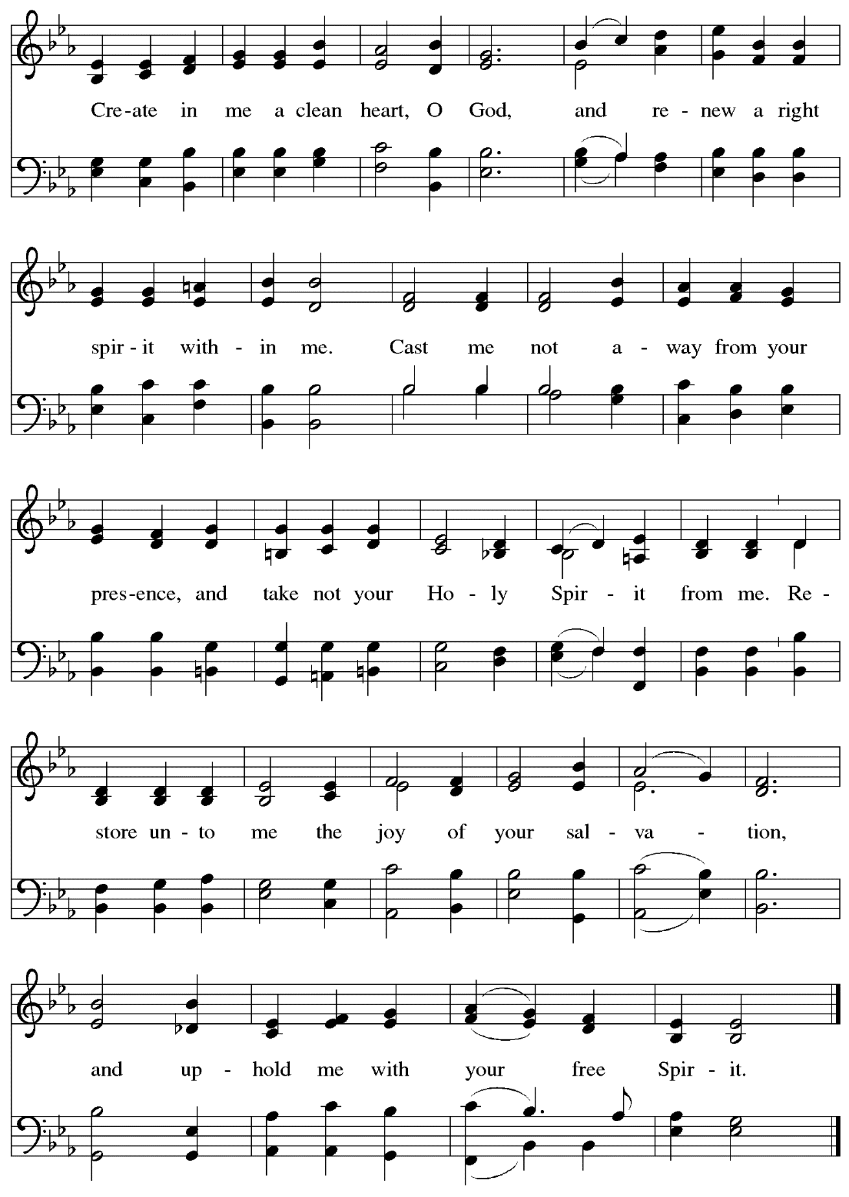
Music: J.A. Freylinghausen, 1670-1739.

Offertory Prayer

A: Let us pray.
God our provider,
C: you have not fed us with bread alone,
but with words of grace and life.
Bless us and these your gifts,
which we receive from your bounty,
through Jesus Christ our Lord.
Amen.

Dialogue

P: The Lord be with you.
C: And also with you.

P: Lift up your hearts.
C: We lift them to the Lord.

P: Let us give thanks to the Lord our God.
C: It is right to give our thanks and praise.

Preface

P: It is indeed right, our duty and our joy,
that we should at all times and in all places
give thanks and praise to you, almighty and merciful God,
through our Savior Jesus Christ.
You call your people to cleanse their hearts
and prepare with joy for the paschal feast,
that, renewed in the gift of baptism,
we may come to the fullness of your grace.
And so, with all the choirs of angels,
with the church on earth and the hosts of heaven,
we praise your name and join their unending hymn:

Sanctus ACS p. 36

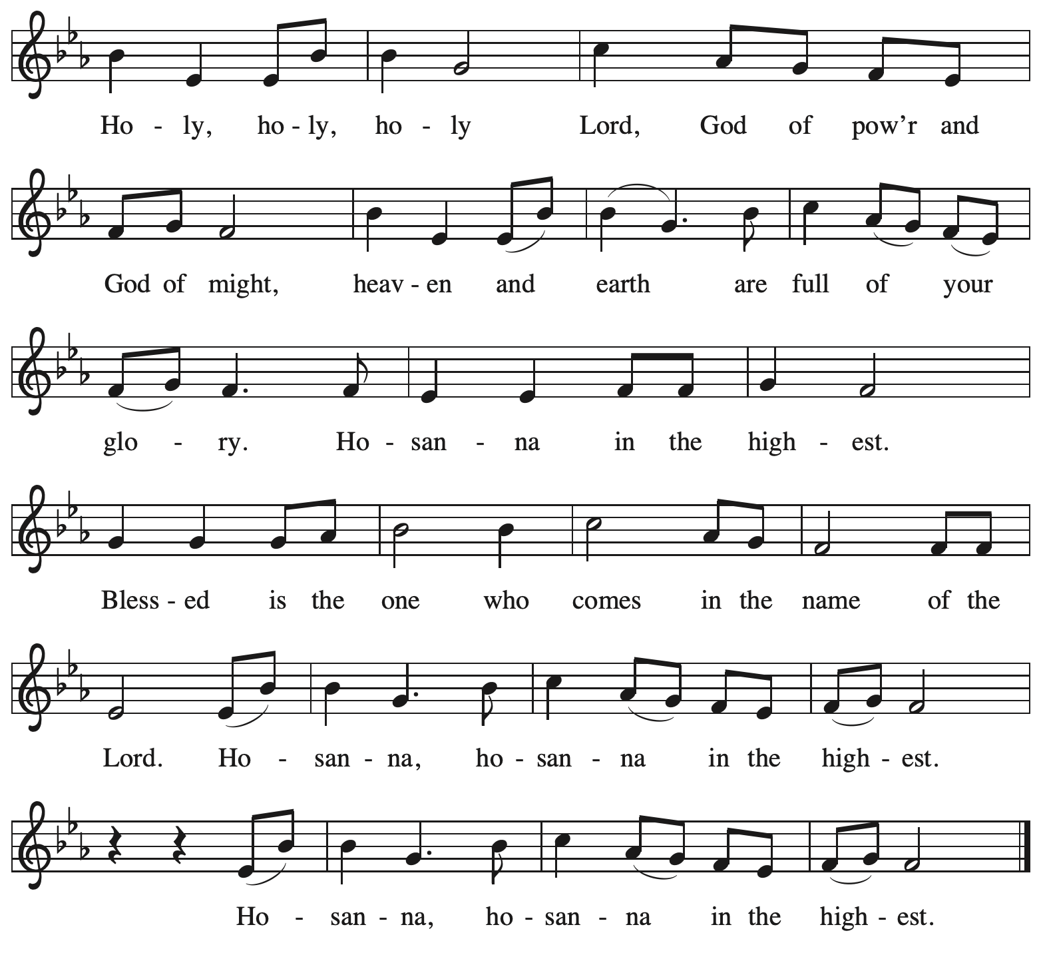

Eucharistic Prayer

P: Blessed are you, O God of the universe
Your mercy is everlasting
and your faithfulness endures from age to age.

Praise to you for creating the heavens and the earth.
Praise to you for saving the earth from the waters of the flood.
Praise to you for bringing the Israelites safely through the sea.
Praise to you for leading your people through the wilderness
to the land of milk and honey.

P: Praise to you for the words and deeds of Jesus, your anointed one.
Praise to you for the death and resurrection of Christ.
Praise to you for your Spirit poured out on all nations.

In the night in which he was betrayed,
our Lord Jesus took bread, and gave thanks;
broke it, and gave it to his disciples, saying:
Take and eat; this is my body, given for you.
Do this for the remembrance of me.

Again, after supper, he took the cup, gave thanks,
and gave it for all to drink, saying:
This cup is the new covenant in my blood,
shed for you and for all people for the forgiveness of sin
Do this for the remembrance of me.

With this bread and cup
we remember our Lord’s passover from death to life
as we proclaim the mystery of faith:
C: Christ has died.
Christ is risen.
Christ will come again.

P: O God of resurrection and new life:
Pour out your Holy Spirit on us
and on these gifts of bread and wine.
Bless this feast.
Grace our table with your presence.
C: Come, Holy Spirit.

P: Reveal yourself to us in the breaking of the bread.
Raise us up as the body of Christ for the world.
Breathe new life into us.
Send us forth,
burning with justice, peace, and love.
C: Come, Holy Spirit.

P: With your holy ones of all times and places,
with the earth and all its creatures,
with sun and moon and stars,
we praise you, O God,
blessed and holy Trinity,
now and forever.
C: Amen.

Lord’s Prayer (Sung)

P: Gathered as one by the Holy Spirit, let us pray as Jesus taught us.
C:
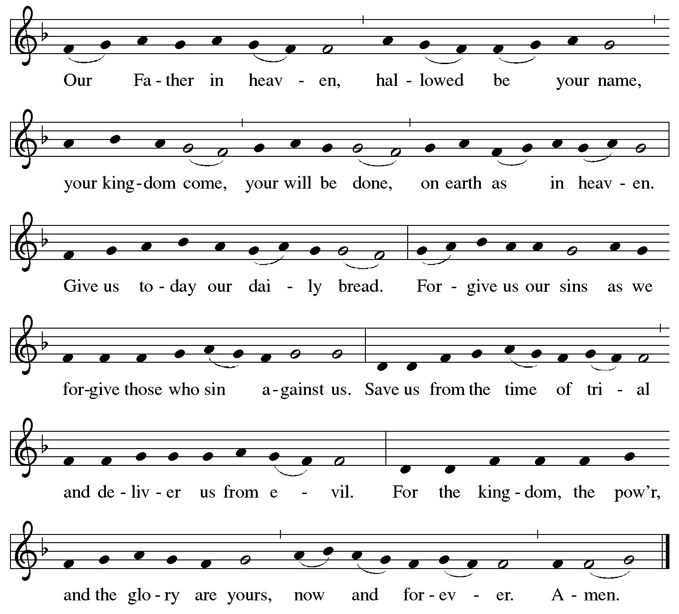

Fraction and Invitation

P: Come to the table of mercy.
Receive God’s gifts of grace.

Agnus Dei / Lamb of God ACS p. 40

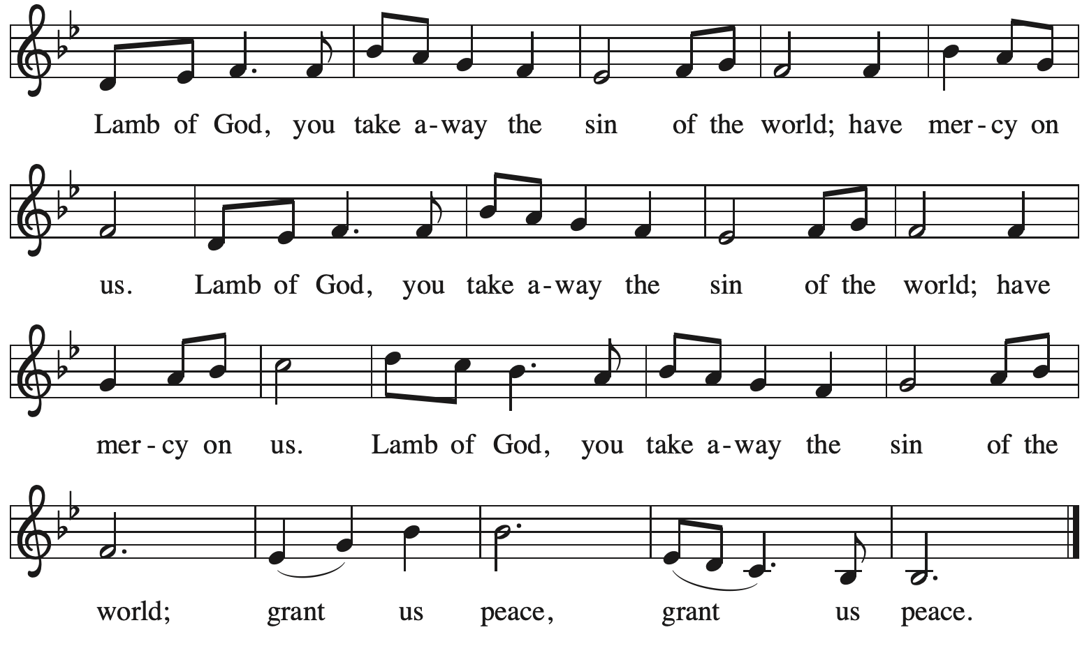

Please be seated.

Holy Communion
- All who seek God and desire a deeper and stronger life in Christ are welcome to receive Holy Communion.
- Worshipers from the pulpit side will proceed forward first, followed by the center section, and then the lectern side.
- Please inform an usher if you would like the ministers to bring Communion to you.
- Holy Communion will be served with bread and wine/grape juice.
- The presiding minister will first distribute the bread (host) to each communicant. Please indicate if you require a gluten-free host.
- Once you have consumed the bread, please pick up an empty glass from the tray next to the presiding minister. The Communion Assistant will pour wine from the chalice or grape juice from the cruet into your glass.
- Please step to the side to consume the wine or grape juice.
- Feel free to kneel at the altar rail for prayer after receiving the sacrament.
- As you return to your pew, glasses may be returned to the empty trays on either side of the center section.
- A blessing will be provided for anyone who does not yet receive the sacrament.
- All are invited to join in singing the hymns during Holy Communion.

Hymns during Holy Communion
My Song Is Love Unknown ELW 343

1 My song is love unknown,
my Savior's love to me,
love to the loveless shown
that they might lovely be.
Oh, who am I that for my sake
my Lord should take frail flesh and die?

2 He came from his blest throne
salvation to bestow;
the world that was his own
would not its Savior know.
But, oh, my friend, my friend indeed,
who at my need his life did spend!

3 Sometimes we strew his way
and his sweet praises sing;
resounding all the day
hosannas to our king.
Then "Crucify!" is all our breath,
and for his death we thirst and cry.

4 We cry out; we will have
our dear Lord made away,
a murderer to save,
the prince of life to slay.
Yet cheerful he to suff'ring goes
that he his foes from thence might free.

5 In life no house, no home
my Lord on earth might have;
in death no friendly tomb
but what a stranger gave.
What may I say? Heav'n was his home
but mine the tomb wherein he lay.

6 Here might I stay and sing—
no story so divine!
Never was love, dear King,
never was grief like thine.
This is my friend, in whose sweet praise
I all my days could gladly spend!

Text: Samuel Crossman, 1624-1683, alt. Music: LOVE UNKNOWN, John Ireland, 1879-1962. Music © John Ireland Trust. All rights reserved. Reprinted with permission under OneLicense.net # A-722139.

Hymns during Holy Communion
By Grace We Have Been Saved ACS 1006

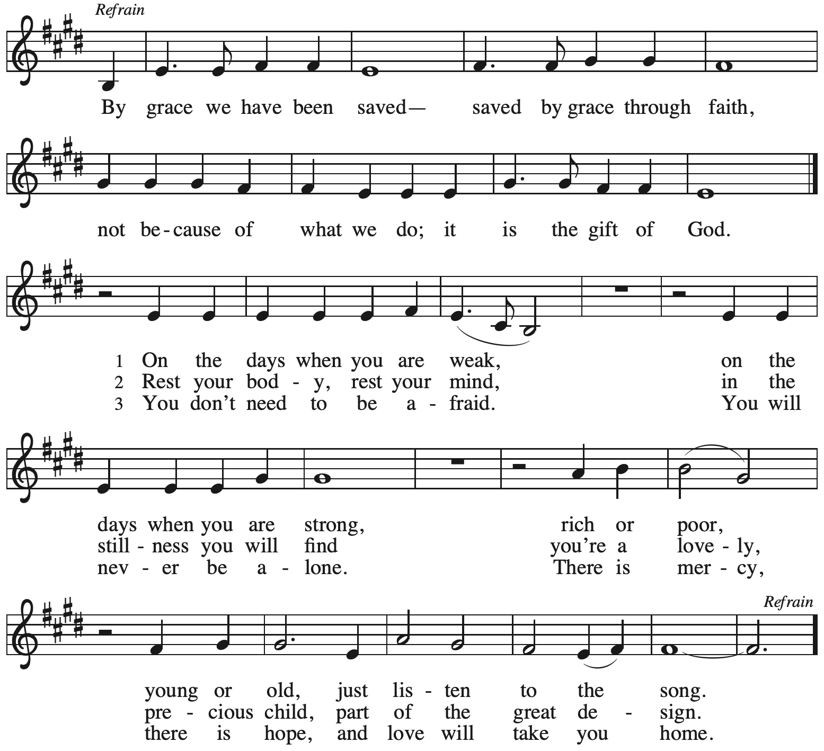

Hymns during Holy Communion
Jesus, Keep Me Near the Cross ELW 335

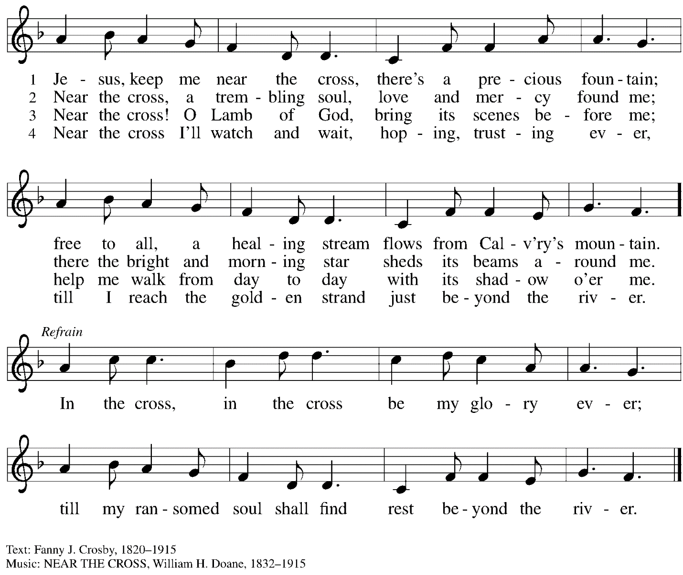

When all have returned to their places, please rise as you are able.

Blessing

P: The body and blood of our Lord Jesus Christ strengthen you and keep you in his grace.
C: Amen.

Prayer

A: Let us pray.
Compassionate God, you have fed us with the bread of heaven.
Sustain us in our Lenten pilgrimage:
may our fasting be hunger for justice;
our alms, a making of peace;
and our prayer, the song of grateful hearts,
through Jesus Christ, our Savior and Lord.
C: Amen.

Please be seated.

Sending
God blesses us and sends us in mission to the world

Announcements

Please rise as you are able.

Benediction

P: The peace of God,
which surpasses all understanding,
keep your hearts and your minds
in ☩ Christ Jesus.
C: Amen.

Sending Hymn Lift High the Cross Following page

Dismissal

A: Go in peace. Christ is with you.
C: Thanks be to God!

Postlude Maestoso C. Franck

Sending Hymn Lift High the Cross ELW 660

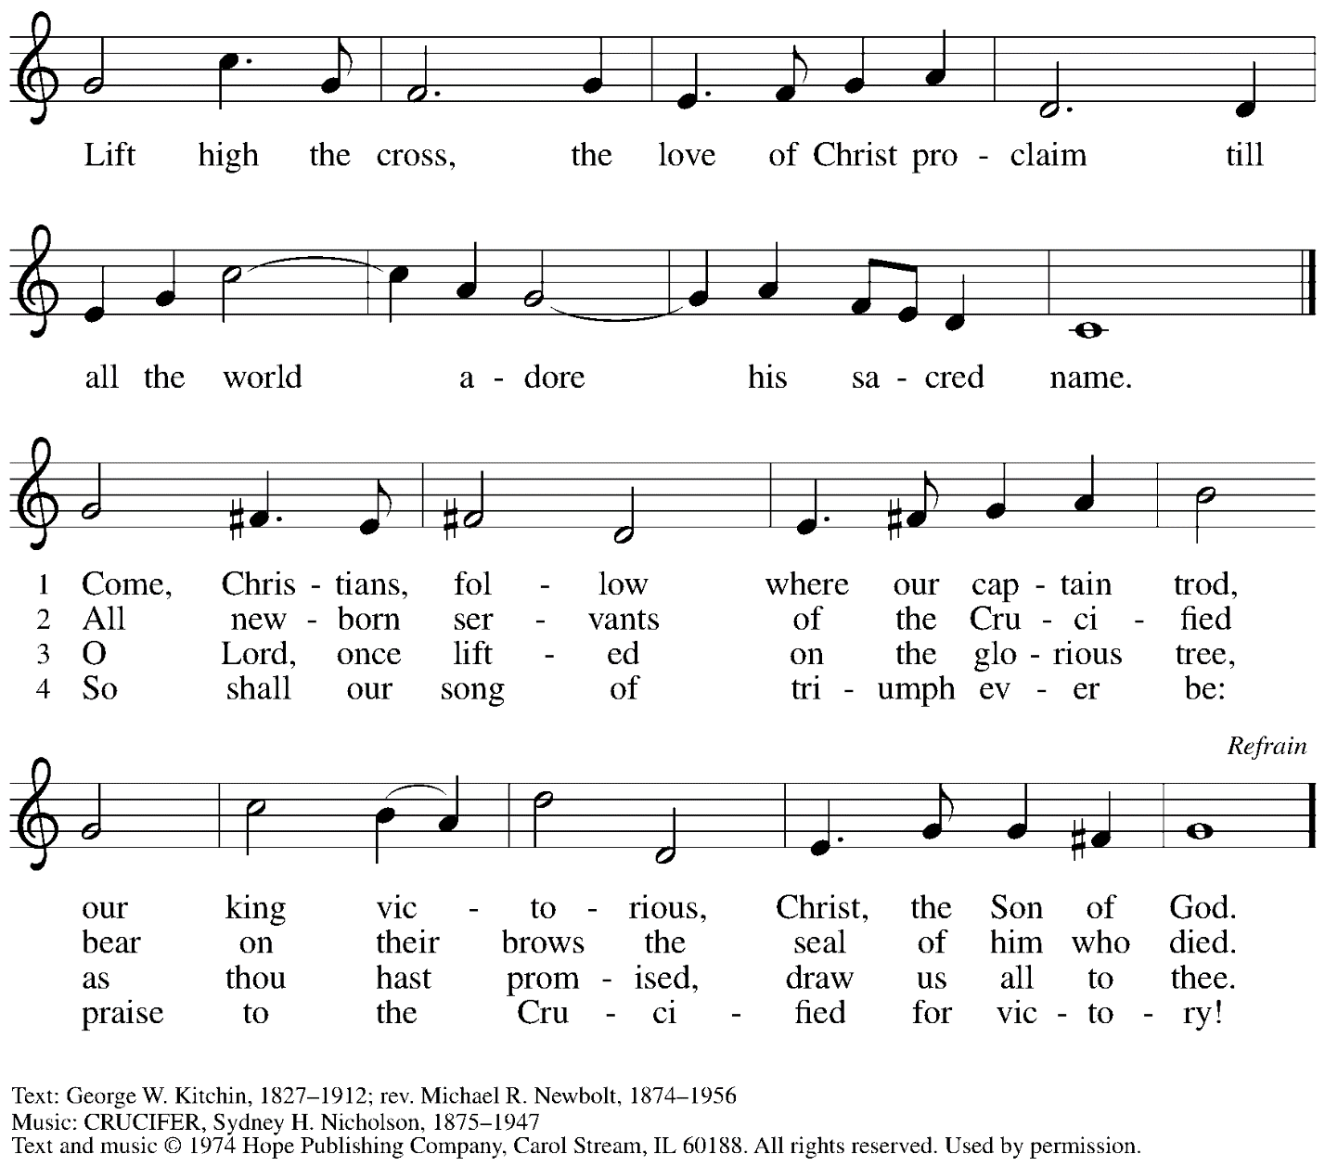
Reprinted with permission under OneLicense.net # A-722139.

Those serving in worship

Altar Care Christy Ruhe
Assisting Minister Timothy Kocher-Hillmer
Audio-Visual Ministers Kristen Asplin
Cantor Ian Brown
Coffee Hour Maria Mangano and David Rollinson
Lector Joyce Compton
Little Church – Big Faith Teacher Sue Gaugler
Minister of Music Laura Reynolds
Piano Sarita
Presiding and Preaching Minister The Rev. Ross I. Carmichael

Liturgy and Hymnody Acknowledgements

From SundaysandSeasons.com. Copyright © 2024 Augsburg Fortress. All rights reserved. Reprinted under OneLicense.net # A-722139.
Used by permission of Augsburg Fortress.

By Grace You Have Been Saved – Text: Jonathan Rundman, b. 1971. Music: BY GRACE, Nathan Houge, b. 1977, and Jonathan Rundman. Text © 2006 Jonathan Rundman and Salt Lady Music (ASCAP), admin. Augsburg Fortress. Music © 2006 Nathan Houge and Lutefist (ASCAP), and Jonathan Rundman and Salt Lady Music, admin. Augsburg Fortress. All rights reserved. Reprinted with permission under OneLicense.net # A-722139.

Please use the QR code below to link to St. Andrew’s Announcements online!

St. Andrew Lutheran Church Announcements
March 10th, 2024

- Welcome to Worship at St. Andrew on the Fourth Sunday in Lent, March 10th, 2024 – We are so glad you are here, and we offer a special welcome to all visitors and guests who are gathered at the church or online! Children are invited to participate in Little Church – Big Faith, a Bible lesson and activity, after the prayer of the day. There are worship “toolkits” to help children engage with worship and “busy bags” for younger children available in the bookcase at the back of the sanctuary. Please feel free to take one to use with/for your children. We invite everyone to gather in the social hall (through the door on the left side of the worship space) for coffee and conversation after worship!
- Meeting of the Congregation Today after Worship – Each year in the winter/spring, St. Andrew gathers for a congregational meeting to review financial figures for the previous year, report of our various ministries, and update the congregation on upcoming developments and initiatives. Please plan to stay after worship!
- Expanded Coffee Hour with Annual Congregational Meeting – Recently Rijasoa Andriamanana and Kikao Josoa have been worshiping at St. Andrew while Rija does research at Duquesne University. They have been members of another Reconciling in Christ ELCA congregation in Albuquerque, NM and are originally from Madagascar and the Malagasy Lutheran Church. Rija and Kikao have graciously offered to prepare food from Madagascar to share with the congregation with coffee hour before the annual meeting, and we thank them for their generosity! Please visit an expanded coffee hour on Sunday and enjoy some cuisine of Madagascar as we set up for the congregational meeting!
- Growing in Faith Together – Gather for the Congregational Meeting Today after Worship – This week, we encourage the group to participate in the annual meeting. The small group gatherings will continue on March 17th and March 24th. If you are interested in participating or have any questions, please speak with Pastor Ross or contact Jeff at jdenlinger26@icloud.com.
- Shelter Dinner at East End Cooperative Ministry – Thursday, March 21st, Arrival 6:00 p.m., Dinner 6:30 p.m. – Each month, on the third Thursday, people of St. Andrew provide and serve a meal for the guests of the shelter at East End Cooperative Ministry (EECM), 6140 Station St., 15206. Anyone can sign up to prepare or purchase a portion of the meal to bring to EECM at 6:00 p.m. that day, or just come to help serve the meal at 6:30 p.m. If you would like to contribute, please sign up at:
https://www.signupgenius.com/go/5080544AAAC22A1F58-48072861-march.
- Worship Schedule for Holy Week – With the service of Palm Sunday / Sunday of the Passion, the church enters into the contemplation of the passion, death, and resurrection of our Savior Jesus Christ. Our primary means for this reflection is through the service of the Triduum – the Great Three Days of Holy Week – one service that unfolds in three parts: Maundy Thursday, Good Friday, and the Vigil of Easter. The service schedule for the upcoming week is:
  - Palm Sunday / Sunday of the Passion – Sunday, March 24th, 10:00 a.m. – On Palm Sunday, the church joins the crowds of Mark's Gospel in celebrating Jesus' arrival in Jerusalem with waving branches and shouts of "Hosanna!" The festivity of this day is tempered by the recounting of the passion story as we remember and reflect on the events of the last week of Jesus' life and the gift of salvation he brings.
  - Triduum – Maundy Thursday, March 28th, 7:00 p.m. – The Church concludes the season of Lent with Confession and Forgiveness, receives Jesus’ command to love one another, remembers Christ’s example of such love in the washing of feet, and takes part in the sacrament of Holy Communion.
  - Triduum – Good Friday, March 29th, 7:00 p.m. – Service of Shadows and Stones – In relative darkness, we hear Gospel accounts of the crucifixion, sing prayerful, meditative hymns, and leave stones at the foot of the cross as we honor our crucified Savior.
  - Triduum – The Vigil of Easter, March 30th, 5:00 p.m. – The church tells God’s story of salvation through worship, word, sacrament, and song as we gather around a fire, hear stories of God’s faithfulness throughout the ages, give thanks for the gift of Baptism, and move into the celebration of the resurrection with Holy Communion.
  - The Resurrection of our Lord – Easter Sunday, March 31st, 10:00 a.m. – Worship with Holy Communion – We join the church throughout the world in proclaiming the good news of Christ’s resurrection!
- Empty Bowls Dinner Benefitting Greater Pittsburgh Community Food Bank – Sunday, April 7th, at Rodef Shalom Congregation – This annual event will be hosted by our neighbors at Rodef Shalom congregation at 4905 Fifth Ave. Oakland 15213. There will be three seatings: from 1:00-3:00 p.m., 3:30-5:30 p.m., and 6:00-8:00 p.m. A Soup and Bowl takeout option is also available. Cost is $25 for presale and $30 at the door. Tickets and information can be found at pittsburghfoodbank.org/emptybowls.
- Inviting Coffee Hour Signups for Upcoming Sundays – One way that we at St. Andrew build community is by sharing conversation over food and drinks at coffee hour after worship on Sundays. We invite people of the congregation to serve by getting the coffee brewing, setting out cups, napkins, food items, and cold drinks, and cleaning up afterward. Everything needed is at St. Andrew and instructions are available. If you would be willing to set up coffee hour on any of the upcoming Sundays, please sign up here:
https://www.signupgenius.com/go/5080B4AAFAF2CABF85-47069030-coffee.
Thank you for your consideration!
- Call for Parishioners to Serve in Worship Roles – St. Andrew's worship is made possible by many people who serve in various roles – Some people prepare the altar and setup Communion, some run the sound/streaming system, while others teacher Little Church – Big Faith for the children, serve as ushers, wash communion cups, count the offering, and more. It is not just roles like Cantor and Lector that involve being up in front of the congregation! If you are interested in getting more involved in worship, talk to Pastor Ross or Joseph Paetz. Most positions serve once a month or less!
- Compline Prayer Service, a Ministry of Lutheran Campus Ministry in Greater Pittsburgh, Sundays at 8:00 p.m. at Heinz Chapel – Compline was traditionally a monastic prayer service, and the Pittsburgh Compline Choir sings a choral version of compline rooted in this thousand-year-old tradition of scripture, song, and silence. This service also streams on Facebook (Pittsburgh Compline Choir) and YouTube (The Pittsburgh Compline Choir). Heinz Chapel is located off of S. Bellefield Ave. in Oakland.
- Christ in Our Home Devotional Booklets for January - March Available at Church Entrances – This resource offers a daily Bible reading with a short reflection and prayer, along with additional readings and prayer topics for those who would like to expand their devotional practices. We encourage people of the congregation to take one for yourself, your family unit, or others!

Flowers for Easter

St. Andrew will be ordering Lilies (6 inch, five bloom)
Tulips (8 inch)
Daffodils (6 inch)
to decorate the worship space for Easter Sunday, March 31st,
and the Easter season.
If you would like to sponsor and dedicate flowers, please order using this form.
Suggested Donation: $8.00 each Order by: Sunday, March 24th

Orders may be submitted at the desk in the main office
or through the Sunday offering plates.
Please submit payment with order - Checks may be made payable to:
St. Andrew Lutheran Church

Name __________________________________________
In Honor of __________________________________________
In Memory of __________________________________________
In Appreciation/Love for __________________________________________

Number of Lilies ________
Number of Tulips ________
Number of Daffodils ________

