+ Palm Sunday / Sunday of the Passion
March 24, 2024

St. Andrew Lutheran Church
304 Morewood Ave.
Pittsburgh, PA 15213
St_andrewELCA@verizon.net
www.standrewpittsburgh.org

+ Palm Sunday / Sunday of the Passion
Order for Worship

This week, the center of the church’s year, is one of striking contrasts:
Jesus rides into Jerusalem surrounded by shouts of glory,
only to be left alone to die on the cross, abandoned by even his closest friends. Mark’s gospel presents Jesus in his complete human vulnerability: agitated, grieved, scared, forsaken.
Though we lament Christ’s suffering and all human suffering, we also expect God’s salvation:
in the wine and bread, Jesus promises that his death will mark a new covenant with all people. We enter this holy week thirsty for the completion of God’s astonishing work.

Welcome to St. Andrew!
- St. Andrew Lutheran congregation welcomes all who are seeking a place of healing and wholeness – a nurturing, faith-forming spiritual home. Our community embraces people of all ages, ethnicities, cultures, abilities, sexual orientations, gender identities and expressions, and family constellations. Come and See!
- Worship Services are live streamed to multiple online platforms. By attending worship, you agree that your image and voice may be broadcast.
- Everyone is invited to make a nametag at the black bookcase in the back of the worship space if they would like. There are stickers indicating pronouns on the bookcase if you would like to include them on your name tag.
- Children are invited to attend Little Church – Big Faith, a Bible lesson and activity, during worship (after the Prayer of the Day). The group returns to the worship space for the liturgy of Holy Communion.
- Worship “toolkits” to help children engage with the service, along with “busy bags” for younger children, are available in the bookcase at the back of the sanctuary. Please feel free to take one to use with/for your children.
- Holy Communion is served with bread (gluten-free available) and wine or grape juice. The presiding minister will distribute the bread (host). Please consume this and then pick up an empty glass from the tray. The Communion Assistant will pour wine or grape juice into your glass. Please step to the side to consume the wine or grape juice. Feel free to kneel at the altar for prayer and reflection. As you return to your pew, glasses may be returned to the empty trays on either side of the center section.
- A restroom is available on the main level of the church, through the doors to the Social Hall and to the right in the main office.

Abbreviations

P: Pastor/Presiding Minister ELW: Evangelical Lutheran Worship hymnal
A: Assisting Minister ACS: All Creation Sings hymnal
L: Lector
C: Congregation
Gathering
The Holy Spirit calls us together as the people of God.

The congregation gathers in the social hall so that all who are able may enter in procession. Palm branches are distributed before the service begins.

The presiding minister begins
P: Blessed is the one who comes in the name of the Lord!
C: Hosanna in the highest!

P: Blessed is the one who comes in the name of the Lord!
C: Hosanna in the highest!

P: Blessed is the one who comes in the name of the Lord!
C: Hosanna in the highest!

Processional Gospel Mark 1: 1-11

P: The holy Gospel according to Mark.
C: Glory to you, O Lord.

¹When they were approaching Jerusalem, at Bethphage and Bethany, near the Mount of Olives,
Jesus] sent two of his disciples ²and said to them, “Go into the village ahead of you, and immediately as you enter it, you will find tied there a colt that has never been ridden; untie it and bring it. ³If anyone says to you, ‘Why are you doing this?’ just say this, ‘The Lord needs it and will send it back here immediately.’” ⁴They went away and found a colt tied near a door, outside in the street. As they were untying it, ⁵some of the bystanders said to them, “What are you doing, untying the colt?” ⁶They told them what Jesus had said; and they allowed them to take it. ⁷Then they brought the colt to Jesus and threw their cloaks on it; and he sat on it. ⁸Many people spread their cloaks on the road, and others spread leafy branches that they had cut in the fields. ⁹Then those who went ahead and those who followed were shouting,
“Hosanna!
Blessed is the one who comes in the name of the Lord!
¹⁰Blessed is the coming kingdom of our ancestor David!
Hosanna in the highest heaven!”
¹¹Then he entered Jerusalem and went into the temple; and when he had looked around at everything, as it was already late, he went out to Bethany with the twelve.

P: The Gospel of the Lord.
C: Praise to you, O Christ.

Blessing of the Palms

The presiding minister and the congregation greet each other.
P: The Lord be with you.
C: And also with you.

P: Let us pray.

A brief silence is kept.

P: We praise you, O God,
for redeeming the world through our savior Jesus Christ.
Today he entered the holy city in triumph
and was proclaimed Messiah and king
by those who spread garments and branches along his way.
Bless these branches and those who carry them.
Grant us grace to follow our Lord in the way of the cross,
so that, joined to his death and resurrection,
we enter into life with you;
through the same Jesus Christ,
who lives and reigns with you and the Holy Spirit,
one God, now and forever.
C: Amen.

Procession

The assisting minister addresses the assembly.
A: Let us go forth in peace.
C: In the name of Christ. Amen.

The congregation follows the cross and ministers into the church.
“Pave the Way with Branches,” ACS 928, is sung as the people process into the church.

Processional Hymn Pave the Way with Branches ACS 928

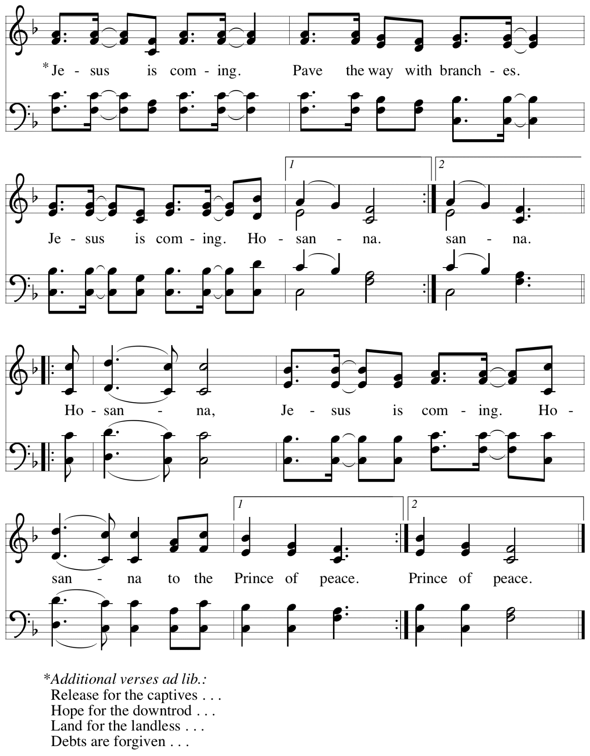
When all have reached their places and the hymn has been sung, the presiding minister and congregation join in the concluding dialogue.

P: Blessed is the one who comes in the name of the Lord.
C: Hosanna in the highest!

Children’s Choir Cloaks and Branches R. Cootes

Prayer of the Day

P: As we now enter into the contemplation of the passion of our Lord Jesus Christ
and meditate on the salvation of the world through his sufferings, death, burial, and resurrection,
let us pray.

Silence is kept.

P: Everlasting God,
in your endless love for the human race, you sent our Lord Jesus
to take on our nature and to suffer death on the cross.
In your mercy, enable us to share in his obedience to your will
and in the glorious victory of his resurrection;
through the one who lives and reigns with you and the Holy Spirit,
one God, now and forever.
C: Amen.

Please be seated.
Children are invited to join the adult leaders at the door and move to the office for Little Church – Big Faith. We ask that one additional adult from the congregation attend with the children.

Word
God speaks to us in Scripture reading, preaching, and song

First Reading – Isaiah 50: 9-4a

⁴The Lord God has given me
the tongue of a teacher,
that I may know how to sustain
the weary with a word.
Morning by morning the Lord wakens—
wakens my ear
to listen as those who are taught.
⁵The Lord God has opened my ear,
and I was not rebellious,
I did not turn backward.
⁶I gave my back to those who struck me,
and my cheeks to those who pulled out the beard;
I did not hide my face
from insult and spitting.
⁷The Lord God helps me;
therefore I have not been disgraced;
therefore I have set my face like flint,
and I know that I shall not be put to shame;
⁸the one who vindicates me is near.
Who will contend with me?
Let us stand up together.
Who are my adversaries?
Let them confront me.
^{9a}It is the Lord God who helps me;
who will declare me guilty?

L: Word of God, word of life.
C: Thanks be to God.

Psalm 31: 9-16

The cantor will lead the singing of the psalm.
The congregation is invited to respond with the alternate verses in bold print,
and to join in singing the refrain.

Psalm tone

Psalm refrain

⁹Have mercy on me, O Lord, for I | am in trouble;
my eye is consumed with sorrow, and also my throat | and my belly.
¹⁰For my life is wasted with grief, and my | years with sighing;
my strength fails me because of affliction, and my bones | are consumed.
¹¹I am the scorn of all my enemies, a disgrace to my neighbors, a dismay to | my
acquaintances;
when they see me in the street | they avoid me.
¹²Like the dead I am forgotten, | out of mind;
I am as useless as a | broken pot. R
¹³For I have heard the whispering of the crowd; fear is | all around;
they put their heads together against me; they plot to | take my life.
¹⁴But as for me, I have trusted in | you, O Lord.
I have said, “You | are my God.
¹⁵My times are | in your hand;
rescue me from the hand of my enemies, and from those who | persecute me.
¹⁶Let your face shine up- | on your servant;
save me in your | steadfast love.” R

Second Reading – Philippians 2: 5-11

⁵Let the same mind be in you that was in Christ Jesus,
⁶who, though he was in the form of God,
did not regard equality with God
as something to be exploited,
⁷but emptied himself,
taking the form of a slave,
being born in human likeness.
And being found in human form,
⁸he humbled himself
and became obedient to the point of death—
even death on a cross.
⁹Therefore God also highly exalted him
and gave him the name
that is above every name,
¹⁰so that at the name of Jesus
every knee should bend,
in heaven and on earth and under the earth,
¹¹and every tongue should confess
that Jesus Christ is Lord,
to the glory of God the Father.

L: Word of God, word of life.
C: Thanks be to God.

Please rise as you are able.

Gospel Acclamation All Glory, Laud, and Honor ELW 344

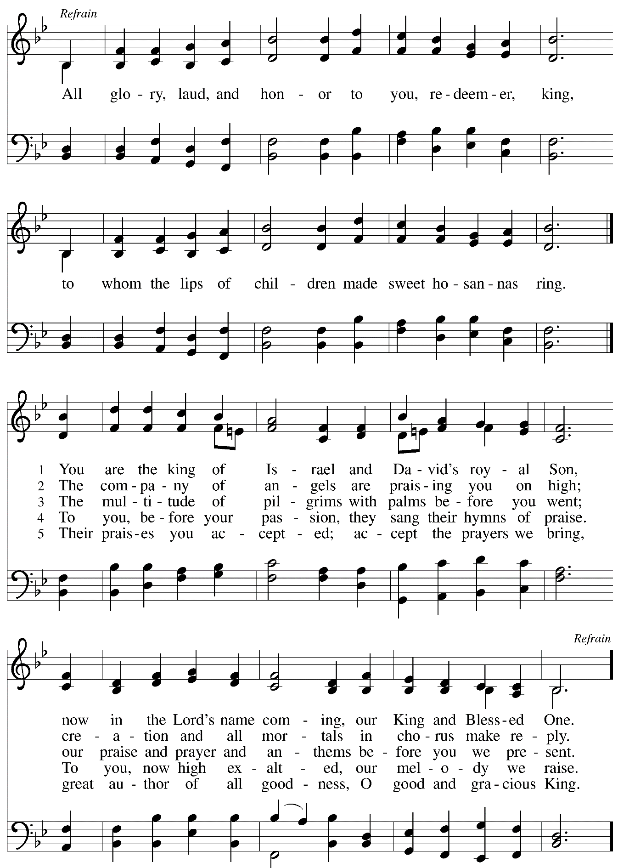

Gospel – Mark 14: 1 – 15: 47

L: The passion of our Lord Jesus Christ according to St. Mark.

The passion narrative is read in parts by several members of the congregation.

At various places in the reading, a verse of the hymn “Ah, Holy Jesus” ELW 349,
will be sung by the congregation.

Please be seated for the reading.

Narrator: It was two days before the Passover and the festival of Unleavened Bread …

Narrator: So he began to look for an opportunity to betray Jesus.

Ah, Holy Jesus – v. 1 ELW 349

C: Ah, holy Jesus, how hast thou offended
that we to judge thee have in hate pretended?
By foes derided, by thine own rejected,
O most afflicted.

Narrator: On the first day of Unleavened Bread …

Jesus: It would have been better for that one not to have been born.

Ah, Holy Jesus – v. 2 ELW 349

C: Who was the guilty? Who brought this upon thee?
Alas, my treason, Jesus, hath undone thee.
'Twas I, Lord Jesus, I it was denied thee;
I crucified thee.

Narrator: While they were eating …

Narrator: And all of them said the same.

Ah, Holy Jesus – v. 3 ELW 349

C: Lo, the Good Shepherd for the sheep is offered;
the slave hath sinned, and the Son hath suffered;
for our atonement, while we nothing heeded,
God interceded.

Narrator: They went to a place called Gethsemane …

Narrator: Those who were crucified with him also taunted him.

Ah, Holy Jesus – v. 4 ELW 349

C: For me, kind Jesus, was thine incarnation,
thy mortal sorrow, and thy life's oblation;
thy death of anguish and thy bitter passion,
for my salvation.

Narrator: When it was noon …

Centurion: Truly this man one God’s Son!

Ah, Holy Jesus – v. 5 ELW 349

C: Therefore, kind Jesus, since I cannot pay thee,
I do adore thee, and will ever pray thee;
think on thy pity and thy love unswerving,
not my deserving.

Narrator: There were also women looking on from a distance …

Narrator: Mary Magdalene and Mary the mother of Joses saw where the body was laid.

A period of silence for prayer and reflection follows the Passion reading.
The service continues with the prayers of the people. Please rise as you are able.

Prayers of the People

A: Trusting in God’s promise to reconcile all things, let us pray for the church,
the well-being of creation, and all who are in need.

After each petition
A: Merciful God,
C: receive our prayer.

The presiding minister concludes the prayers:
P: Accompany us on our journey through this season, O God of grace,
and receive the prayers of our hearts, through Jesus Christ, our Savior.
C: Amen.

Peace

The presiding minister and the assembly greet one another in the peace of the risen Christ.
P: The peace of Christ be with you always.
C: And also with you.

The people may greet those around them with a sign of Christ’s peace and may say
Peace be with you or similar words. Please be mindful that not everyone will be comfortable with sharing the peace, so please seek consent before shaking hands or hugging. Other possible ways to share the peace include a simple bow with the verbal greeting of peace, or simply a verbal expression of peace.

When the greetings of peace have concluded, please be seated.

Meal
God feeds us with the presence of Jesus Christ

Offering

We offer ourselves, our gifts, and our faithful service to God.
As the offering is gathered for the mission of the church, including the care of those in need,
the table is set for Holy Communion.

Music during the Offering
O Sacred Head, Now Wounded arr. Oines

As the gifts are brought forward for presentation, please rise as you are able.

Offertory Song Create in Me a Clean Heart ELW 188

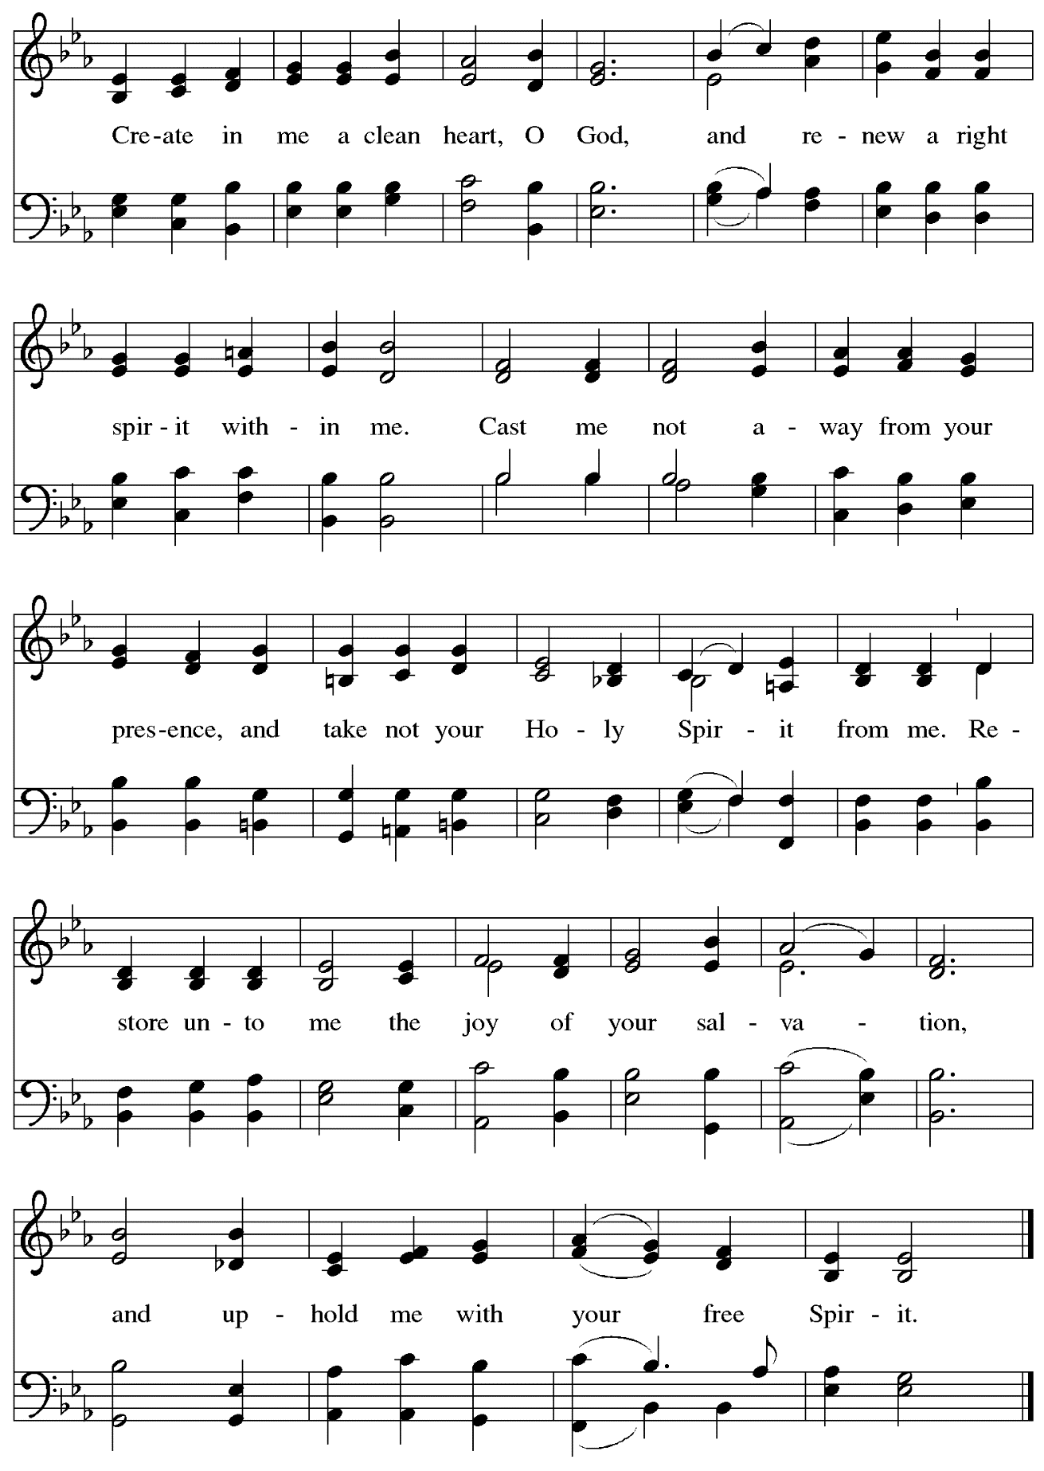
Music: J.A. Freylinghausen, 1670-1739.

Offertory Prayer

A: Let us pray.
God our provider,
C: you have not fed us with bread alone
but with words of grace and life.
Bless us, and these your gifts,
which we receive from your bounty,
through Jesus Christ our Lord.
Amen.

Dialogue

P: The Lord be with you.
C: And also with you.

P: Lift up your hearts.
C: We lift them to the Lord.

P: Let us give thanks to the Lord our God.
C: It is right to give our thanks and praise.

Preface

P: It is indeed right, our duty and our joy,
that we should at all times and in all places
give thanks and praise to you, almighty and merciful God,
through our Savior Jesus Christ;
whose suffering and death gave salvation to all.
You gather your people around the tree of the cross,
transforming death into life.
And so, with all the choirs of angels,
with the church on earth and the hosts of heaven,
we praise your name and join their unending hymn:

Sanctus ACS p. 36

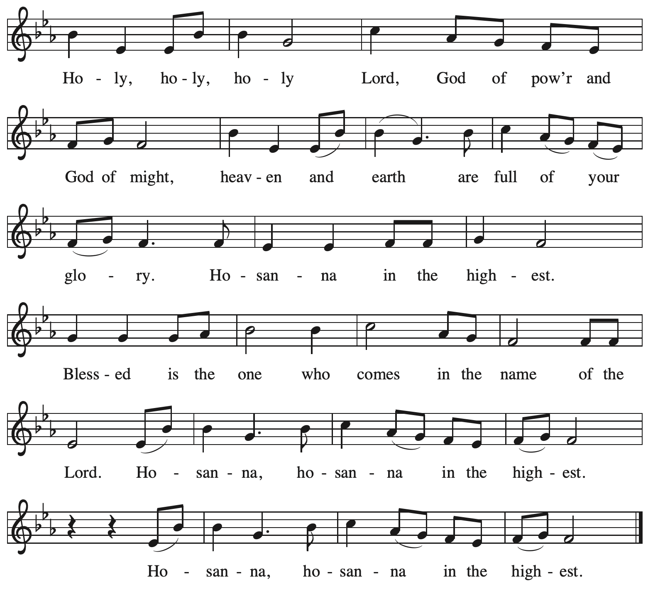

Eucharistic Prayer

P: Blessed are you, O God of the universe,
Your mercy is everlasting
and your faithfulness endures from age to age.

Praise to you for creating the heavens and the earth.
Praise to you for saving the earth from the waters of the flood.
Praise to you for bringing the Israelites safely through the sea.
Praise to you for leading your people through the wilderness
to the land of milk and honey.
P: Praise to you for the words and deeds of Jesus, your anointed one.
Praise to you for the death and resurrection of Christ.
Praise to you for your Spirit poured out on all nations.

In the night in which he was betrayed,
our Lord Jesus took bread, and gave thanks;
broke it, and gave it to his disciples, saying:
Take and eat; this is my body, given for you.
Do this for the remembrance of me.

Again, after supper, he took the cup, gave thanks,
and gave it for all to drink, saying:
This cup is the new covenant in my blood,
shed for you and for all people for the forgiveness of sin.
Do this for the remembrance of me.

With this bread and cup
we remember our Lord’s passover from death to life
as we proclaim the mystery of faith:
C: Christ has died. Christ is risen. Christ will come again.

P: O God of resurrection and new life:
Pour out your Holy Spirit on us
and on these gifts of bread and wine.
Bless this feast.
Grace our table with your presence.
C: Come, Holy Spirit.

P: Reveal yourself to us in the breaking of the bread.
Raise us up as the body of Christ for the world.
Breathe new life into us.
Send us forth,
burning with justice, peace, and love.
C: Come, Holy Spirit.

P: With your holy ones of all times and places,
with the earth and all its creatures,
with sun and moon and stars,
we praise you, O God,
blessed and holy Trinity,
now and forever.
C: Amen.

Lord’s Prayer

P: Gathered as one by the Holy Spirit, let us pray as Jesus taught us.
C:
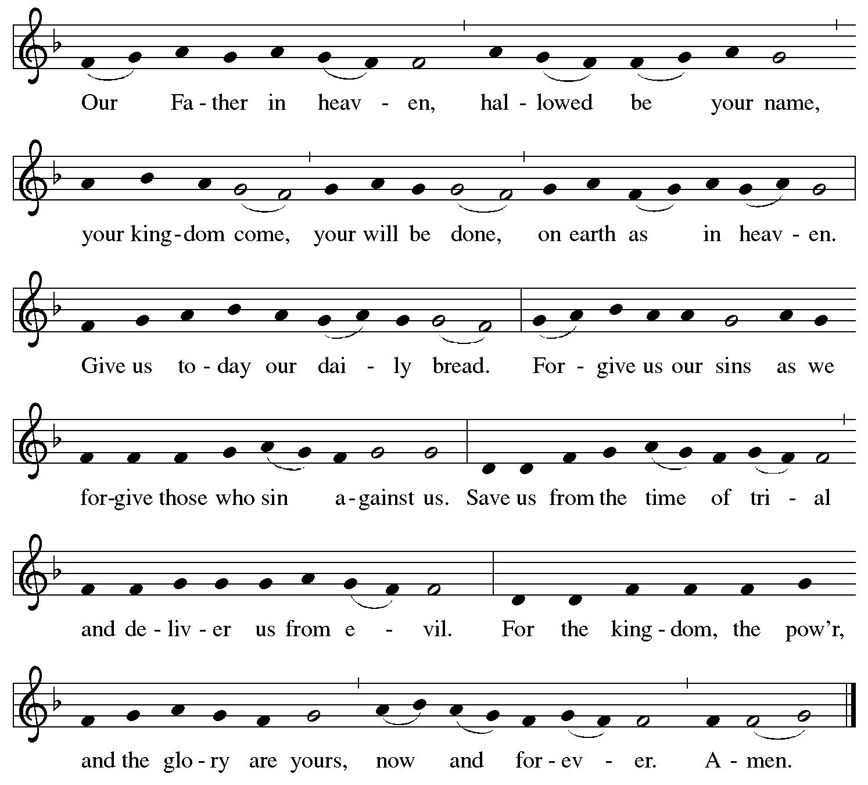

Fraction and Invitation

P: Come to the table of mercy;
receive God’s gifts of grace.

Agnus Dei/Lamb of God ACS p. 40

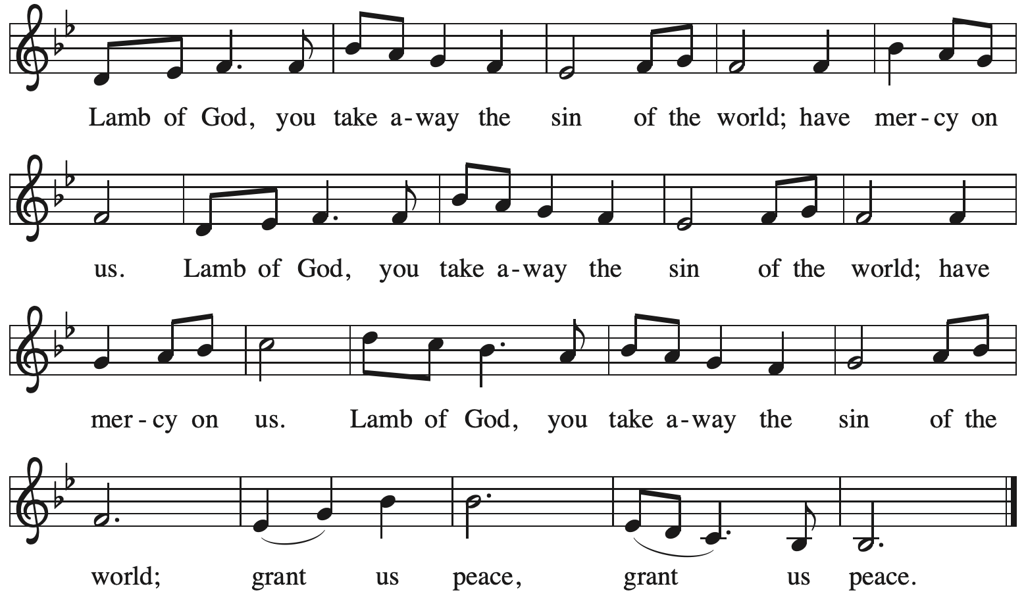

Please be seated.

Holy Communion
- All who seek God and desire a deeper and stronger life in Christ are welcome to receive Holy Communion.
- Worshipers from the pulpit side will proceed forward first, followed by the center section, and then the lectern side.
- Please inform an usher if you would like the ministers to bring Communion to you.
- Holy Communion will be served with bread and wine/grape juice.
- The presiding minister will first distribute the bread (host) to each communicant. Please indicate if you require a gluten-free host.
- Once you have consumed the bread, please pick up an empty glass from the tray next to the presiding minister. The Communion Assistant will pour wine from the chalice or grape juice from the cruet into your glass.
- Please step to the side to consume the wine or grape juice.
- Feel free to kneel at the altar rail for prayer after receiving the sacrament.
- As you return to your pew, glasses may be returned to the empty trays on either side of the center section.
- A blessing will be provided for anyone who does not yet receive the sacrament.
- All are invited to join in singing the hymns during Holy Communion.

Hymn during Holy Communion
Let Us Break Bread Together ELW 471

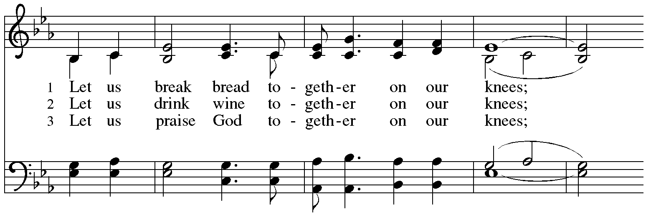
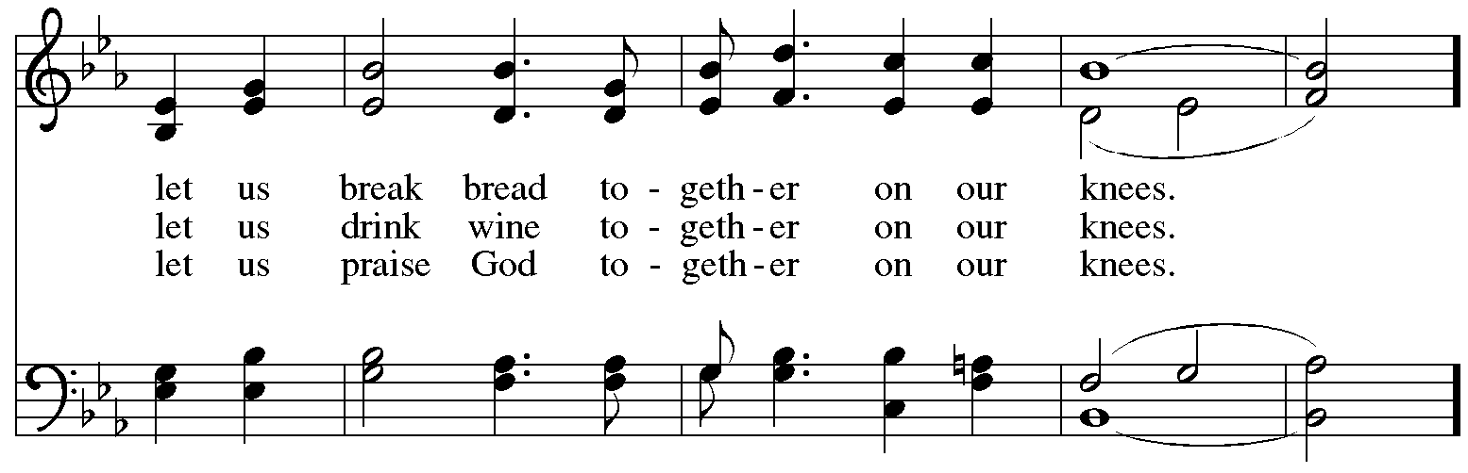
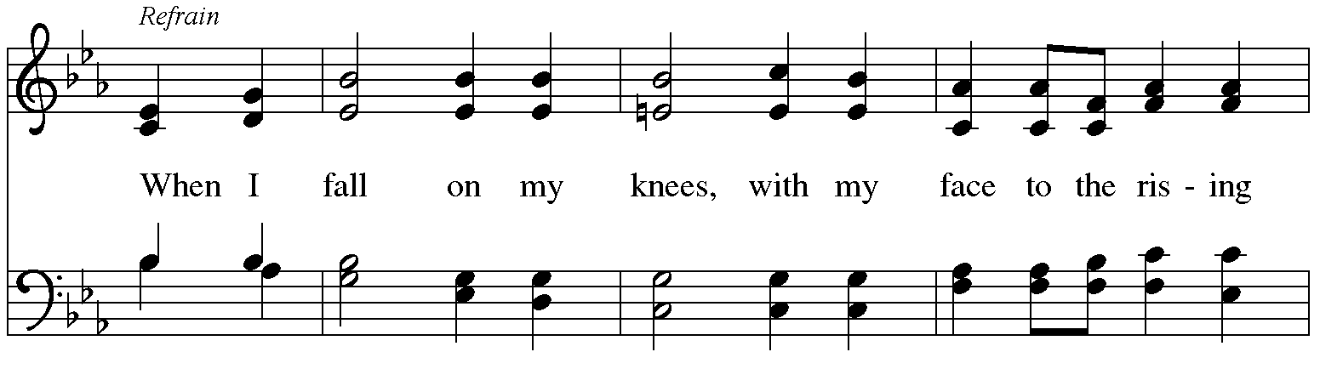
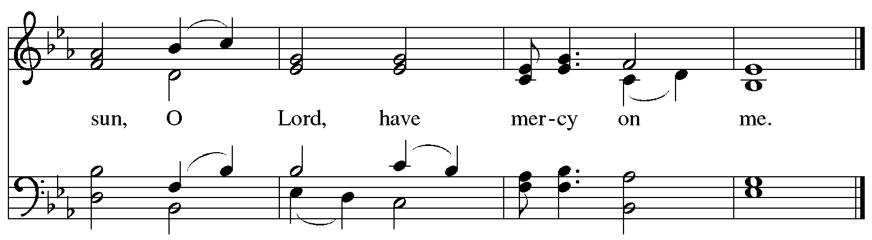
Hymn during Holy Communion
Jesus, I Will Ponder Now ELW 345

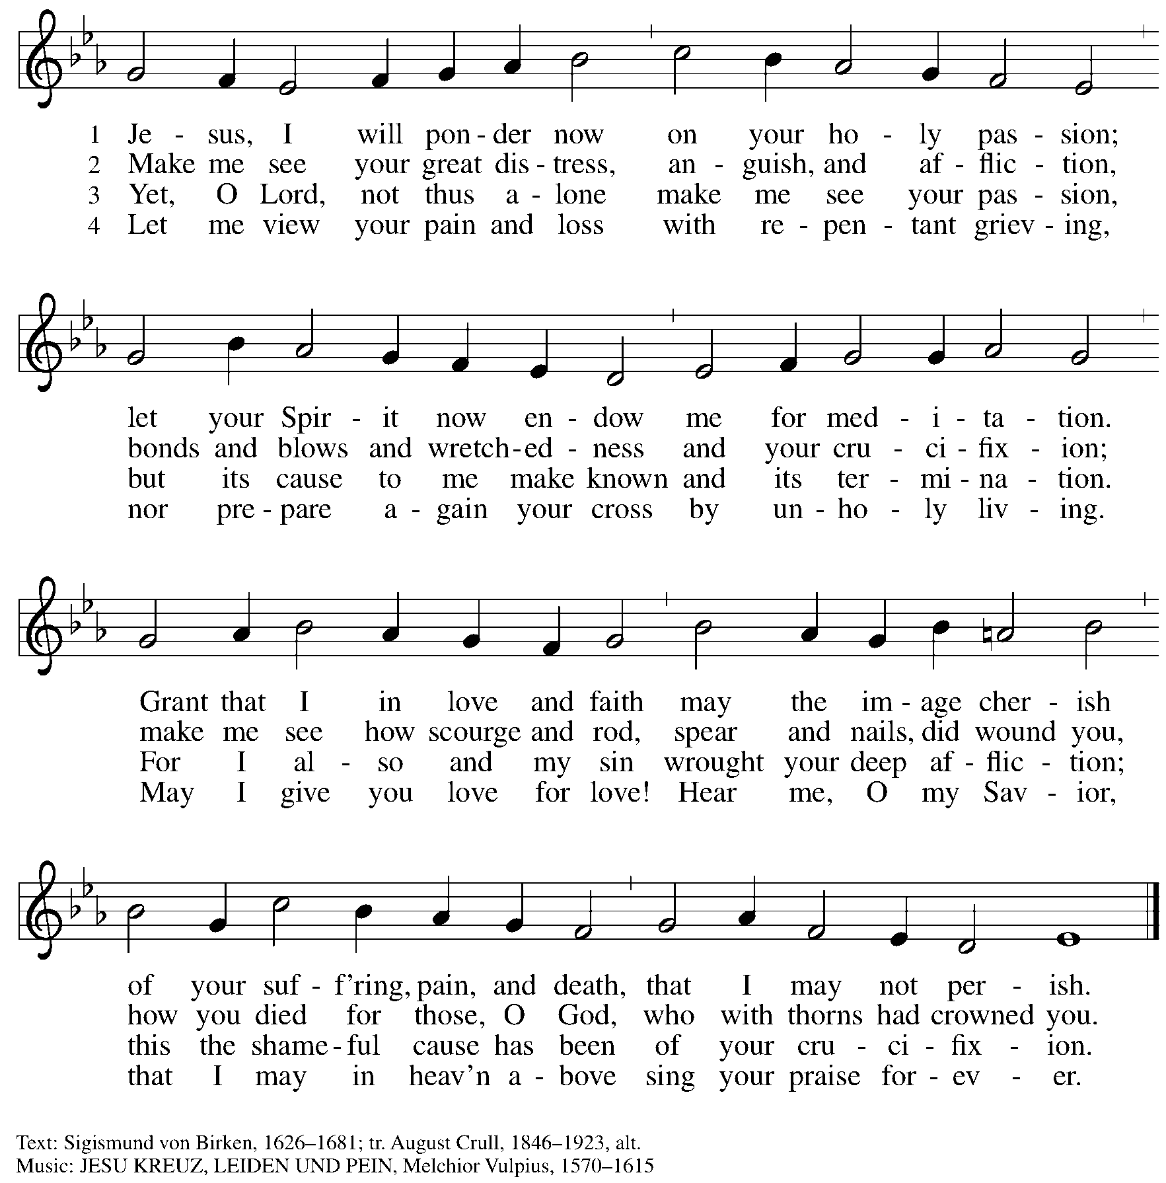

Hymn during Holy Communion
Alas! And Did My Savior Bleed ELW 337

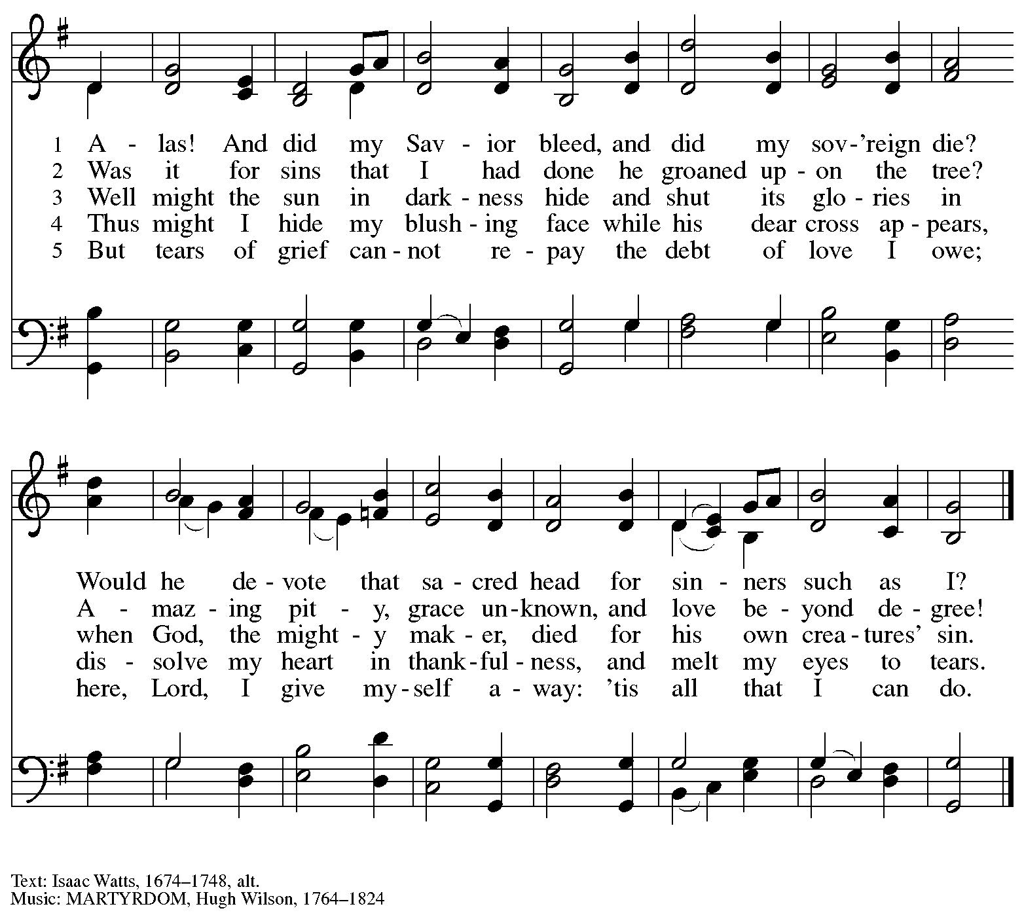

Hymn during Holy Communion
There in God’s Garden ELW 342

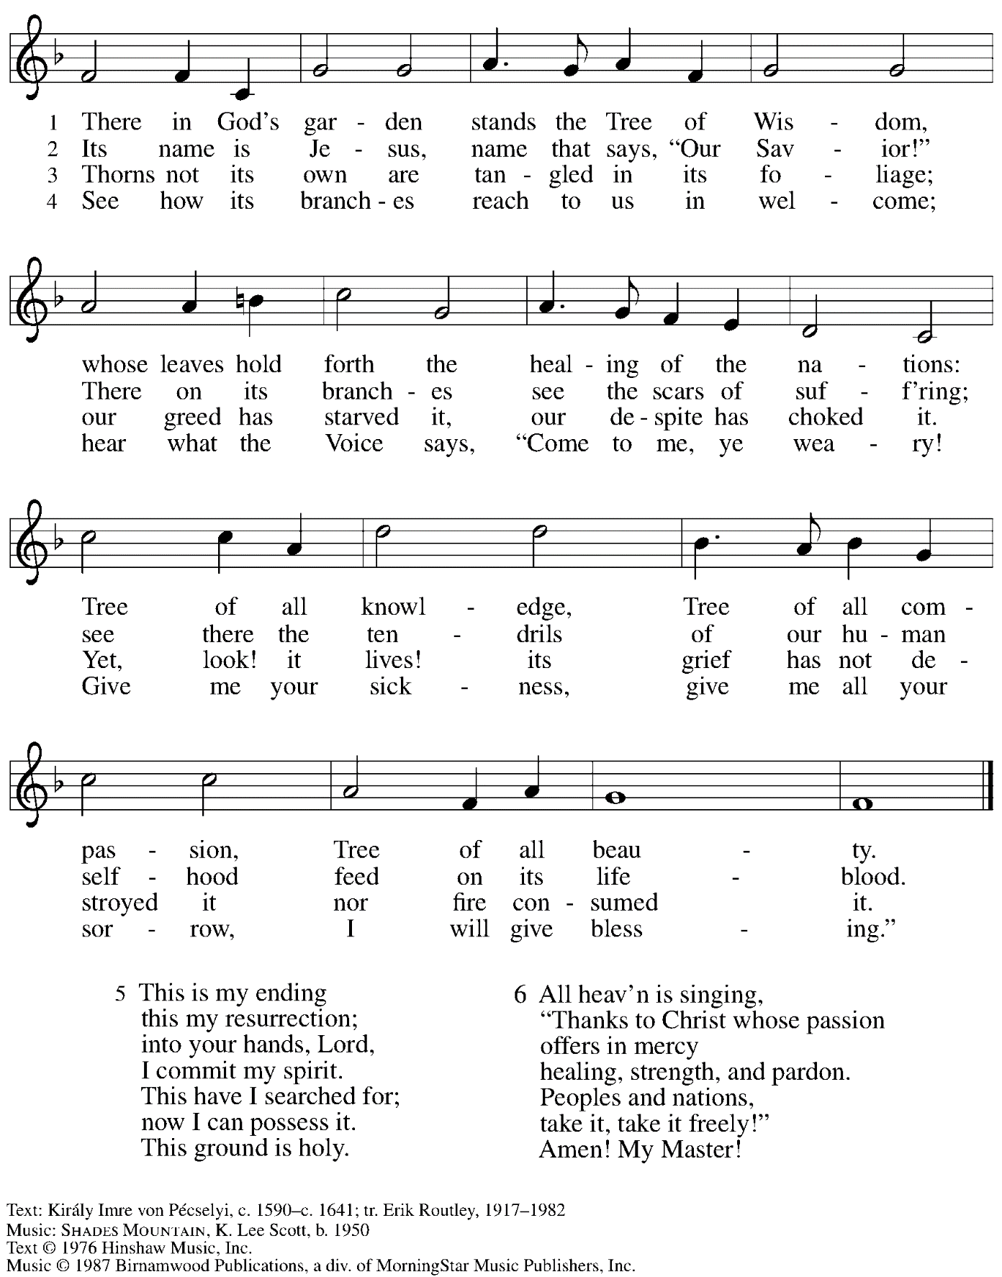
All rights reserved. Reprinted with permission under OneLicense.net # A-722139.

When all have returned to their places, please rise as you are able.

Blessing

P: The body and blood of our Lord Jesus Christ strengthen you and keep you in his grace.
C: Amen.

Prayer

A: Let us pray.
Compassionate God,
you have fed us with the bread of heaven.
Sustain us in our Lenten pilgrimage: may our fasting be hunger for justice;
our alms, a making of peace; and our prayer, the song of grateful hearts,
through Jesus Christ, our Savior and Lord.
C: Amen.

Please be seated.

Sending
God blesses us and sends us in mission to the world.

Announcements

Please rise as you are able.

Benediction

P: The peace of God,
which surpasses all understanding,
keep your hearts and your minds
in ☩ Christ Jesus.
C: Amen.

Sending Hymn Go to Dark Gethsemane Following page

Dismissal

A: Go in peace. Christ is with you.
C: Thanks be to God.

Postlude Adagio Op. 68 No. 35 R. Schumann

Sending Hymn Go to Dark Gethsemane ELW 347

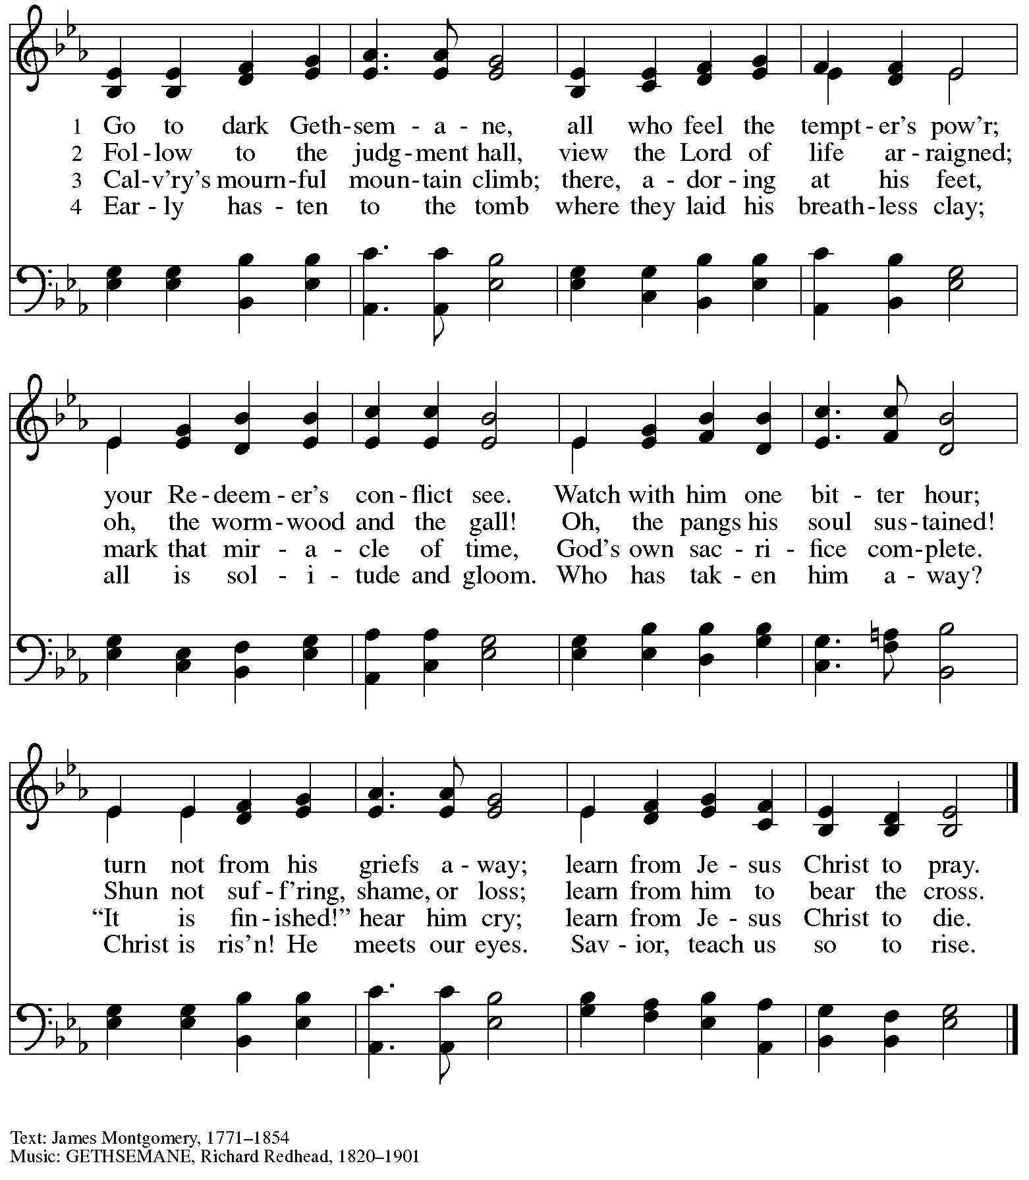

Those serving in worship today

Assisting Minister and Crucifer Jimmi Kocher-Hillmer
Audio-Visual Ministers Sarita
Joseph Paetz
Cantor Timothy Kocher-Hillmer
Lector Pastor Paul Koch
Passion Narrative Readers Lindsay Baxter
Jeff Denlinger
Jason Galyardt
Kai
Alda Maria Gonzaga
Kathy Hays
Monica Snyder
Minister of Music Laura Reynolds
Presiding Minister Pastor Ross I. Carmichael

Liturgy and Hymnody Acknowledgements

From SundaysandSeasons.com. Copyright © 2024 Augsburg Fortress. All rights reserved. Reprinted under OneLicense.net # A-722139.
Used by permission of Augsburg Fortress.

Pave the Way with Branches – Text: Bret Hesla, b. 1957. Music: PAVE THE WAY, Bret Hesla. Text and music © 1999 Bret Hesla, admin. Augsburg Fortress. All rights reserved. Reprinted with permission under OneLicense.net # A-722139.

All Glory, Laud, and Honor – Text: Theodulph of Orleans, c. 760-821; tr. John Mason Neale, 1818-1866, alt. Music: VALET WILL ICH DIR GEBEN, Melchior Teschner, 1584-1635.

Ah, Holy Jesus – Text: Johann Heerman, 1585-1647; tr. Robert Bridges, 1844-1930, alt. Music: HERZLIEBSTER JESU, Johann Crüger, 1598-1662.

Please use the QR code below to link to St. Andrew’s Announcements online!

St. Andrew Lutheran Church Announcements
March 24th, 2024

- Welcome to Worship at St. Andrew on + Palm Sunday / Sunday of the Passion – March 24th, 2024 – We are so glad you are here, and we offer a special welcome to all visitors and guests who are gathered at the church or online! Children are invited to participate in Little Church – Big Faith, a Bible lesson and activity, after the prayer of the day. There are worship “toolkits” to help children engage with worship and “busy bags” for younger children available in the bookcase at the back of the sanctuary. Please feel free to take one to use with/for your children. We invite everyone to gather in the social hall (through the door on the left side of the worship space) for coffee and conversation after worship!
- LAMPa's Period Poverty Campaign – Information at Coffee Hour Today – Period poverty – the inability to afford menstrual hygiene products – has gained more and more attention in recent years, though the issue is nothing new. For generations, those who experience menstruation have too often had to miss school or work due to lack of period supplies, or because of period stigma. Addressing period poverty and taking steps to provide menstrual hygiene products in public spaces is a crucial step in addressing educational, gender, and economic equity. This is why Lutheran Advocacy Ministry in Pennsylvania (LAMPa) is launching a Period Poverty Postcard Campaign. Pastor Erin Jones, St. Andrew member and LAMPa staff, will have postcards available at coffee hour on Sunday, March 24th! Fill one out and chat with her about other ways to engage in advocacy to end period poverty in Pennsylvania!
- Growing in Faith Together – Last Gathering Today after Worship – St. Andrew’s last spring small group gathering for people new to the congregation will be held after worship today, March 24th. Thank you to all who have participated!
- Worship Schedule for Holy Week – With today’s service, the church enters into the contemplation of the passion, death, and resurrection of our Savior Jesus Christ. Our primary means for this reflection is through the service of the Triduum – the Great Three Days of Holy Week – one service that unfolds in three parts: Maundy Thursday, Good Friday, and the Vigil of Easter. The service schedule for the upcoming week is:
  - Triduum – Maundy Thursday, March 28th, 7:00 p.m. – The Church concludes the season of Lent with Confession and Forgiveness, receives Jesus’ command to love one another, remembers Christ’s example of such love in the washing of feet, and takes part in the sacrament of Holy Communion.
  - Triduum – Good Friday, March 29th, 7:00 p.m. – Service of Shadows and Stones – In relative darkness, we hear Gospel accounts of the crucifixion, sing prayerful, meditative hymns, and leave stones at the foot of the cross as we honor our crucified Savior.
  - Triduum – The Vigil of Easter, March 30th, 5:00 p.m. – The church tells God’s story of salvation through worship, word, sacrament, and song as we gather around a fire, hear stories of God’s faithfulness throughout the ages, give thanks for the gift of Baptism, and move into the celebration of the resurrection with Holy Communion.
  - The Resurrection of our Lord – Easter Sunday, March 31st, 10:00 a.m. – Worship with Holy Communion – We join the church throughout the world in proclaiming the good news of Christ’s resurrection!
- Children (and Others!) Are Invited to Bring Stuffed Animals to Easter Vigil (Saturday, March 30th, 5:00 p.m.) to Tell the Creation Story! – St. Andrew strives to hold an Easter Vigil service in which people of all ages can participate. The day’s readings begin with the first creation story from Genesis, and this year we are inviting children of all ages to bring their favorite stuffed animals to worship to bring forward as we tell the story of God’s creation together!
- New Christ in Our Home Devotional Booklets for April - June Available at Church Entrances – This resource offers a daily Bible reading with a short reflection and prayer, along with additional readings and prayer topics for those who would like to expand their devotional practices. We encourage people of the congregation to take one for yourself, your family unit, or others!
- Monthly Produce Distribution – Tuesday, April 2nd, 5:30-7:00 p.m. – St. Andrew’s monthly distribution of fresh produce (in partnership with Greater Pittsburgh Community Food Bank) will be Tuesday, April 2nd, from 5:30-7:00 p.m. We would also appreciate help with unloading and setup earlier in the day, usually sometime between 10:30 a.m. and 1:00 p.m.
- Empty Bowls Dinner Benefitting Greater Pittsburgh Community Food Bank – Sunday, April 7th, at Rodef Shalom Congregation – This annual event will be hosted by our neighbors at Rodef Shalom congregation at 4905 Fifth Ave. Oakland 15213. There will be three seatings: from 1:00-3:00 p.m., 3:30-5:30 p.m., and 6:00-8:00 p.m. A Soup and Bowl takeout option is also available. Cost is $25 for presale and $30 at the door. Tickets and information can be found at pittsburghfoodbank.org/emptybowls.
- New Signup Form for Worship Roles – St. Andrew's worship is made possible by many people who serve in various roles – Some people prepare the altar and setup Communion, some run the sound/streaming system, while others teacher Little Church – Big Faith for the children, serve as ushers, wash communion cups, count the offering, and more. It is not just roles like Cantor and Lector that involve being up in front of the congregation! If you are interested in getting more involved in worship, talk to Pastor Ross or Joseph Paetz. Most positions serve once a month or less. We have created a new form for those wishing to express interest in service for any of the roles – please access it here https://forms.gle/qfeJvbFR6V8DtTsz7 and someone will be in touch soon!

Flowers for Easter

St. Andrew will be ordering Lilies (6 inch, five bloom)
Tulips (6 inch)
Daffodils (6 inch)
to decorate the worship space for Easter Sunday, March 31st,
and the Easter season.
If you would like to sponsor and dedicate flowers, please order using this form.
Suggested Donation: $8.00 each Order by: Sunday, March 24th

Orders may be submitted at the desk in the main office, through the Sunday offering plates, or at this link:
https://www.signupgenius.com/go/5080B4AAFAF2CABF85-48433750-easter
Please submit payment with order - Checks may be made payable to:
St. Andrew Lutheran Church

Name __________________________________________
In Honor of __________________________________________
In Memory of __________________________________________
In Appreciation/Love for __________________________________________

Number of Lilies ________
Number of Tulips ________
Number of Daffodils ________

