+ Name of Jesus
January 1, 2023

St. Andrew Lutheran Church
304 Morewood Ave.
Pittsburgh, PA 15213
St_andrewELCA@verizon.net
www.standrewpittsburgh.org

+ Name of Jesus
Order for Worship

Through Baptism, we are called Christian. We are “Christ-ened” at the font.
Bearing Christ’s name, we share the same Father
and are invited to address this parent intimately: Abba!
Jesus bears our sins in humble obedience to the will of God.
Today we pray that the mind of Christ, whose name we bear, would be our own.
It is a good way to begin, again, a new year.

- Masks are optional at St. Andrew when Covid-19 community level in Allegheny County is in the low and medium categories.
- Hand sanitizer is available at the back of the sanctuary.

Worship Services are live streamed to multiple online platforms.
By attending worship, you agree that your image and voice may be broadcast.

Welcome to St. Andrew!
- Everyone is invited to make a nametag at the black bookcase in the back of the worship space if they would like.
- Worship “toolkits” to help children engage with the service are available in the black bookcase at the back of the worship space. There are “reader” and “pre-reader” resources available in each kit. Please feel free to use the kits for/with your children during worship.
- St. Andrew has recently returned to serving the sacrament of Holy Communion with both (separate) elements, bread and wine/grape juice. The presiding minister will first distribute the bread (host). Please consume this and then pick up an empty glass from the tray next to the presiding minister. The Communion Assistant will pour wine from the chalice or grape juice from the cruet into your glass. Please step to the side to consume the wine or grape juice. As you return to your pew, glasses may be returned to the empty trays on either side of the center aisle.
- A restroom is available on the main level of the church, through the doors to the Social Hall and to the right in the main office.

Welcome

Prelude

Gathering
The Holy Spirit calls us together as the people of God.

Confession and Forgiveness

P: Blessed be the holy Trinity, ☩ one God,
the Word made flesh,
our life and our salvation.
C: Amen.

P: Trusting the goodness and lovingkindness of God our Savior,
let us confess our sin.

Silence is kept for reflection.

P: God of life,
C: you promise good news of great joy for all people,
and call us to be messengers of your peace.
We confess that too often we hoard our joy,
our resources, and our security.
We nurture conflict and build barriers.
We neglect the needs of our neighbors
and ignore the groaning of creation.
Have mercy on us.
Where we are self-centered, open our hearts.
Where we are reluctant, give us courage.
Where we are cynical, restore our trust.
Renew us with your grace
and give us again the hope of eternal life in you.
Amen.

P: Hear the good news:
We are children of God and heirs of God’s promises
through the outpouring of the Holy Spirit.
In ☩ Jesus we are forgiven and redeemed.
Sing with joy, for all the ends of the earth
shall know the salvation of God.
C: Amen.

Gathering Hymn Once in Royal David’s City ELW 269

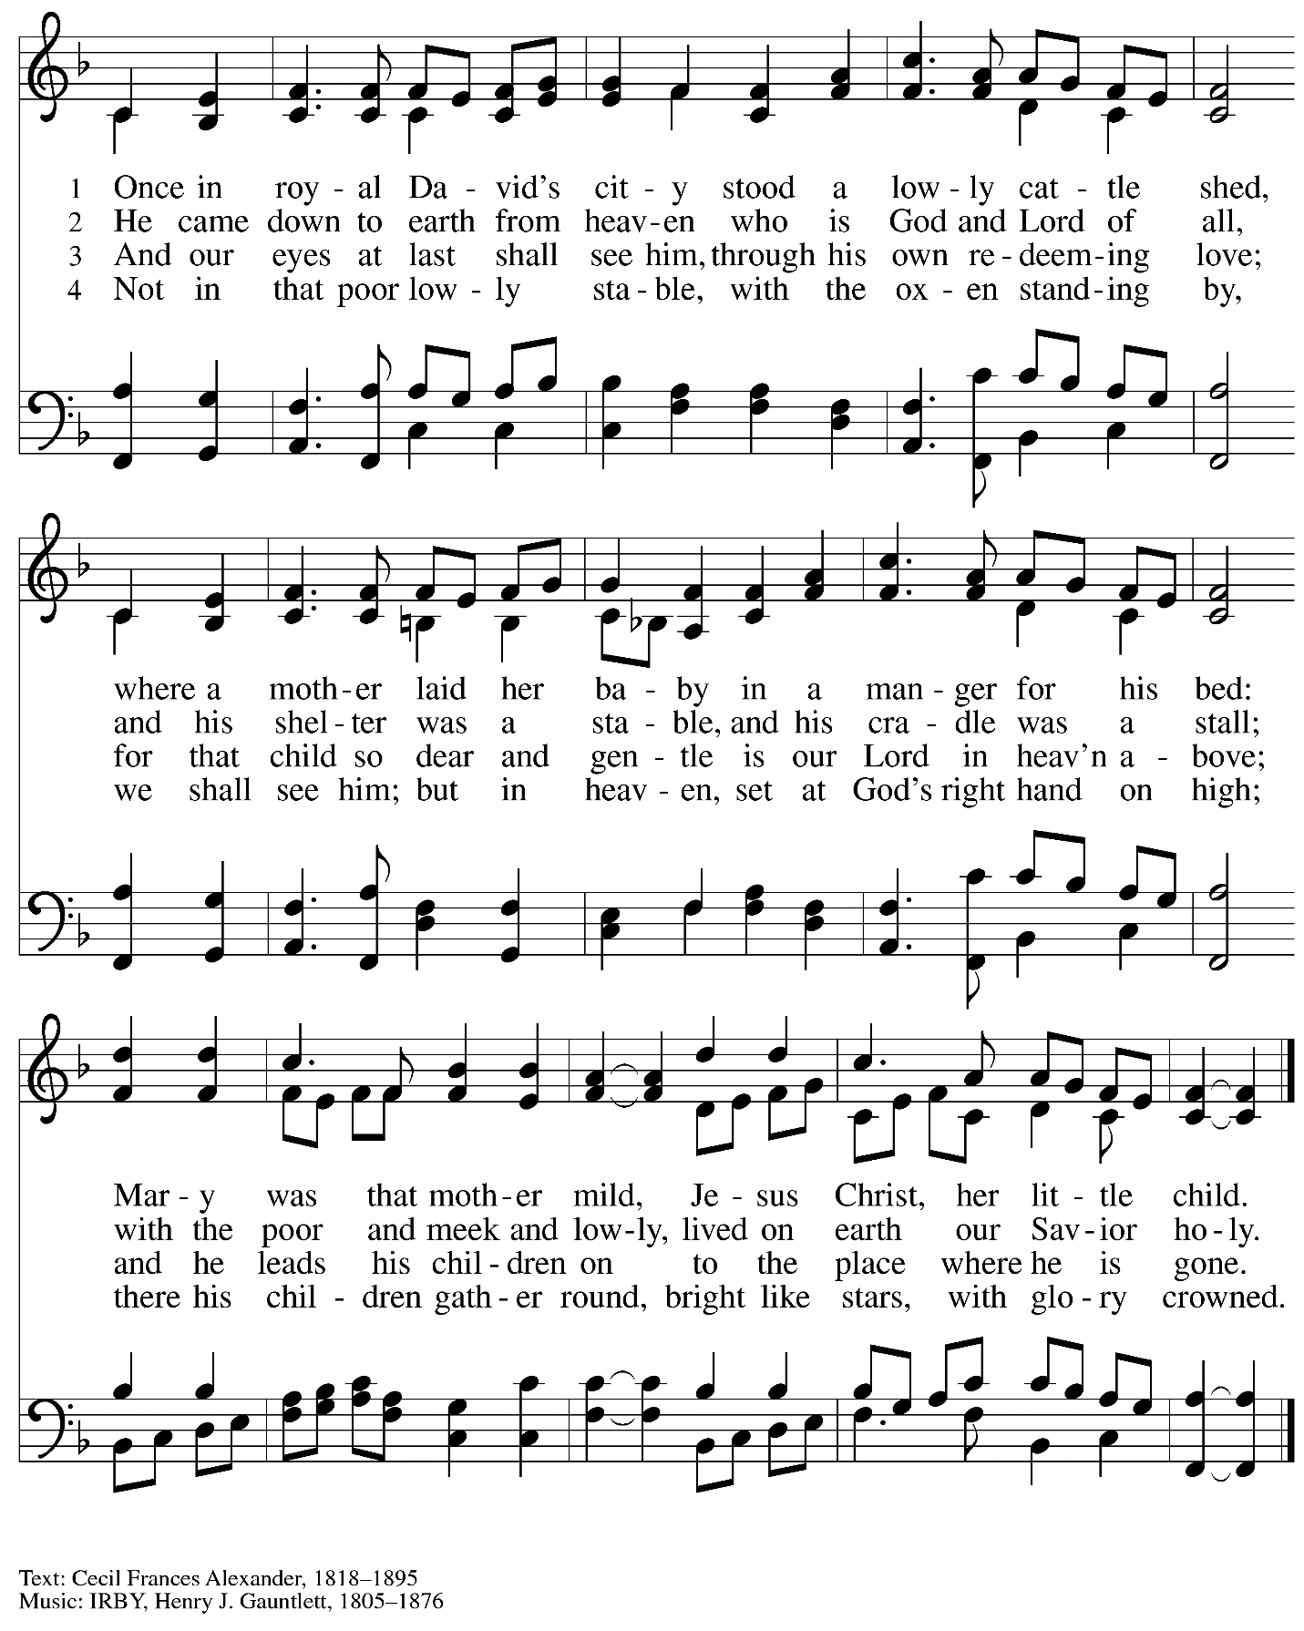

Greeting

P: The grace of our Lord Jesus Christ, the love of God,
and the communion of the Holy Spirit be with you all.
C: And also with you.

Hymn of Praise Angels We Have Heard on High ELW 289

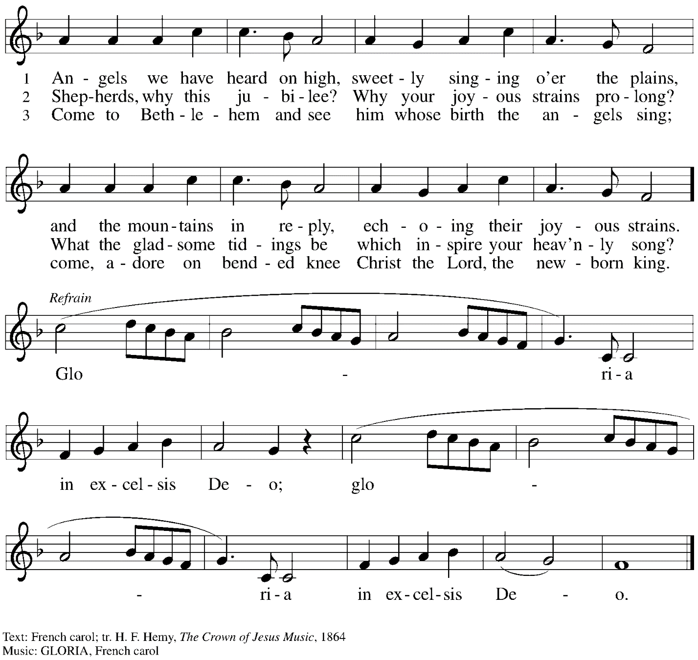

Prayer of the Day

P: Let us pray.
Eternal Father, you gave your incarnate Son the holy name of Jesus to be a sign of our salvation. Plant in every heart the love of the Savior of the world, Jesus Christ our Lord,
who lives and reigns with you and the Holy Spirit, one God, now and forever.
C: Amen.

Please be seated.

Word
God speaks to us in Scripture reading, preaching, and song

First Reading – Numbers 6: 22-27

²²The Lord spoke to Moses, saying: ²³Speak to Aaron and his sons, saying, Thus you shall bless the Israelites: You shall say to them,
²⁴The Lord bless you and keep you;
²⁵the Lord make his face to shine upon you, and be gracious to you;
²⁶the Lord lift up his countenance upon you, and give you peace.
²⁷So they shall put my name on the Israelites, and I will bless them.

L: Word of God, word of life.
C: Thanks be to God.

Psalm 8

The cantor will lead the singing of the psalm.
The congregation is invited to respond with the alternate verses in bold print,
and to join in singing the refrain.

Psalm tone

Psalm refrain

¹O | Lord our Lord,
how majestic is your name in | all the earth!—
²you whose glory is chanted above the heavens out of the mouths of in- | fants and children;
you have set up a fortress against your enemies, to silence the foe | and avenger.
³When I consider your heavens, the work | of your fingers,
the moon and the stars you have set | in their courses,
⁴what are mere mortals that you should be mind- | ful of them,
human beings that you should | care for them? R
⁵Yet you have made them little less | than divine;
with glory and hon- | or you crown them.
⁶You have made them rule over the works | of your hands;
you have put all things un- | der their feet:
⁷all | flocks and cattle,
even the wild beasts | of the field,
⁸the birds of the air, the fish | of the sea,
and whatever passes along the paths | of the sea.
⁹O | Lord our Lord,
how majestic is your name in | all the earth! R

Second Reading – Galatians 4: 4-7

⁴When the fullness of time had come, God sent God’s Son, born of a woman, born under the law, ⁵in order to redeem those who were under the law, so that we might receive adoption as children. ⁶And because you are children, God has sent the Spirit of God’s Son into our hearts, crying, “Abba! Father!” ⁷So you are no longer a slave but a child, and if a child then also an heir, through God.

L: Word of God, word of life.
C: Thanks be to God.

Please rise as you are able.

Gospel Acclamation ELW p. 142

Gospel – Luke 2: 15-21

P: The holy Gospel according to St. Luke.
C: Glory to you, O Lord.
¹⁵When the angels had left them and gone into heaven, the shepherds said to one another, “Let us go now to Bethlehem and see this thing that has taken place, which the Lord has made known to us.” ¹⁶So they went with haste and found Mary and Joseph, and the child lying in the manger.
¹⁷When they saw this, they made known what had been told them about this child; ¹⁸and all who heard it were amazed at what the shepherds told them. ¹⁹But Mary treasured all these words and pondered them in her heart. ²⁰The shepherds returned, glorifying and praising God for all they had heard and seen, as it had been told them.
²¹After eight days had passed, it was time to circumcise the child; and he was called Jesus, the name given by the angel before he was conceived in the womb.

P: The Gospel of the Lord.
C: Praise to you, O Christ.

Please be seated.

Sermon

A time of silence for prayer and reflection follows the sermon.
When the Hymn of the Day begins, please rise as you are able.

Hymn of the Day That Boy-Child of Mary ELW 293

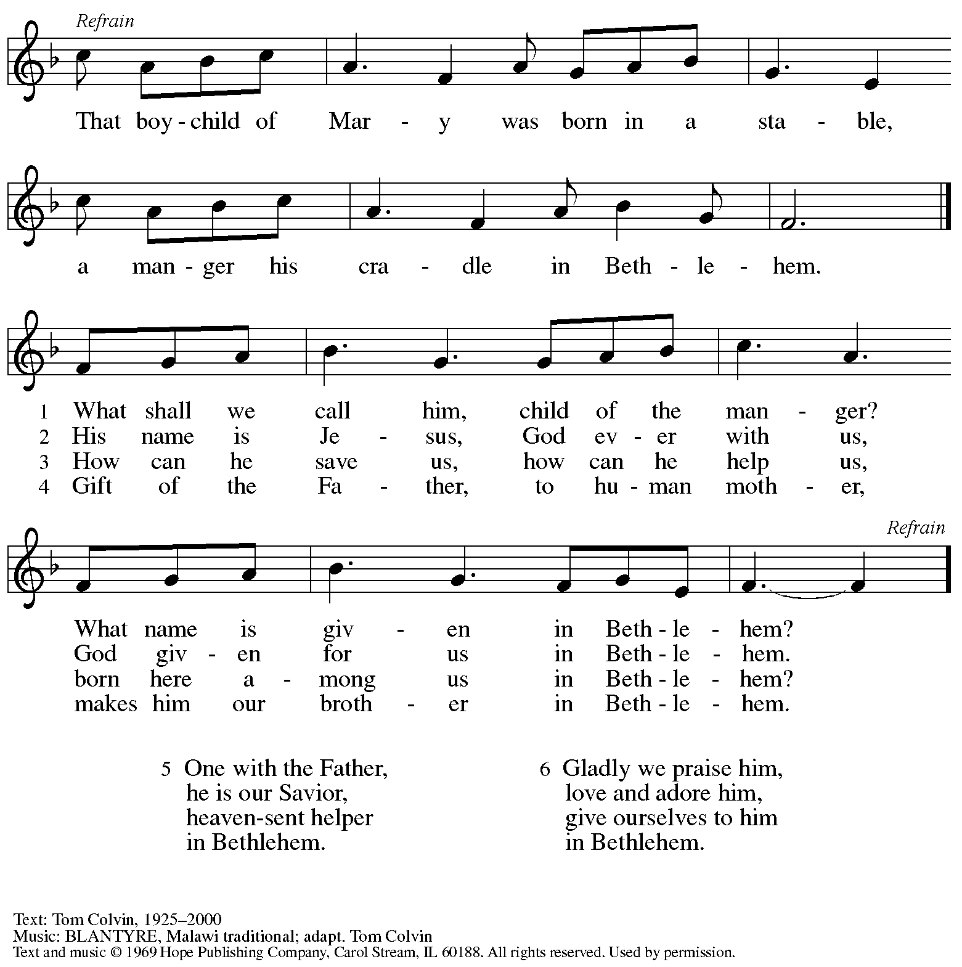
Reprinted with permission under OneLicense.net # A-722139.

Nicene Creed

P: Rejoicing in the good news of Christ’s birth, we confess our faith:
C: We believe in one God,
the Father, the Almighty,
maker of heaven and earth,
of all that is, seen and unseen.

We believe in one Lord, Jesus Christ,
the only Son of God,
eternally begotten of the Father,
God from God, Light from Light,
true God from true God,
begotten, not made,
of one Being with the Father;
through him all things were made.
For us and for our salvation
he came down from heaven,
was incarnate of the Holy Spirit and the virgin Mary
and became truly human.
For our sake he was crucified under Pontius Pilate;
he suffered death and was buried.
On the third day he rose again
in accordance with the scriptures;
he ascended into heaven
and is seated at the right hand of the Father.
He will come again in glory to judge the living and the dead,
and his kingdom will have no end.

We believe in the Holy Spirit, the Lord, the giver of life,
who proceeds from the Father and the Son,*
who with the Father and the Son is worshiped and glorified,
who has spoken through the prophets.
We believe in one holy catholic and apostolic church.
We acknowledge one baptism for the forgiveness of sins.
We look for the resurrection of the dead,
and the life of the world to come. Amen.
*Or, “who proceeds from the Father.” The phrase “and the Son” is a later addition to the creed.

Prayers of the People

A: With wonder and joy at Christ’s coming into the world,
we pray for the church, the world, and all who are in need.

After each petition
A: God of grace,
C: receive our prayer.

The presiding minister concludes the prayers:
P: In the light of the mystery of eternal love made flesh,
we commend to you all for whom we pray, gracious God,
through Jesus Christ our Savior.
C: Amen.

Please be seated.

Meal

Offering

We offer ourselves, our gifts, and our faithful service to God.
As the offering is gathered for the mission of the church, including the care of those in need,
the table is set for Holy Communion.

Music during the Offering

As the gifts are brought forward for presentation, please rise as you are able
and join in singing the Offertory Song.

Offertory Song In the Bleak Midwinter ELW 294

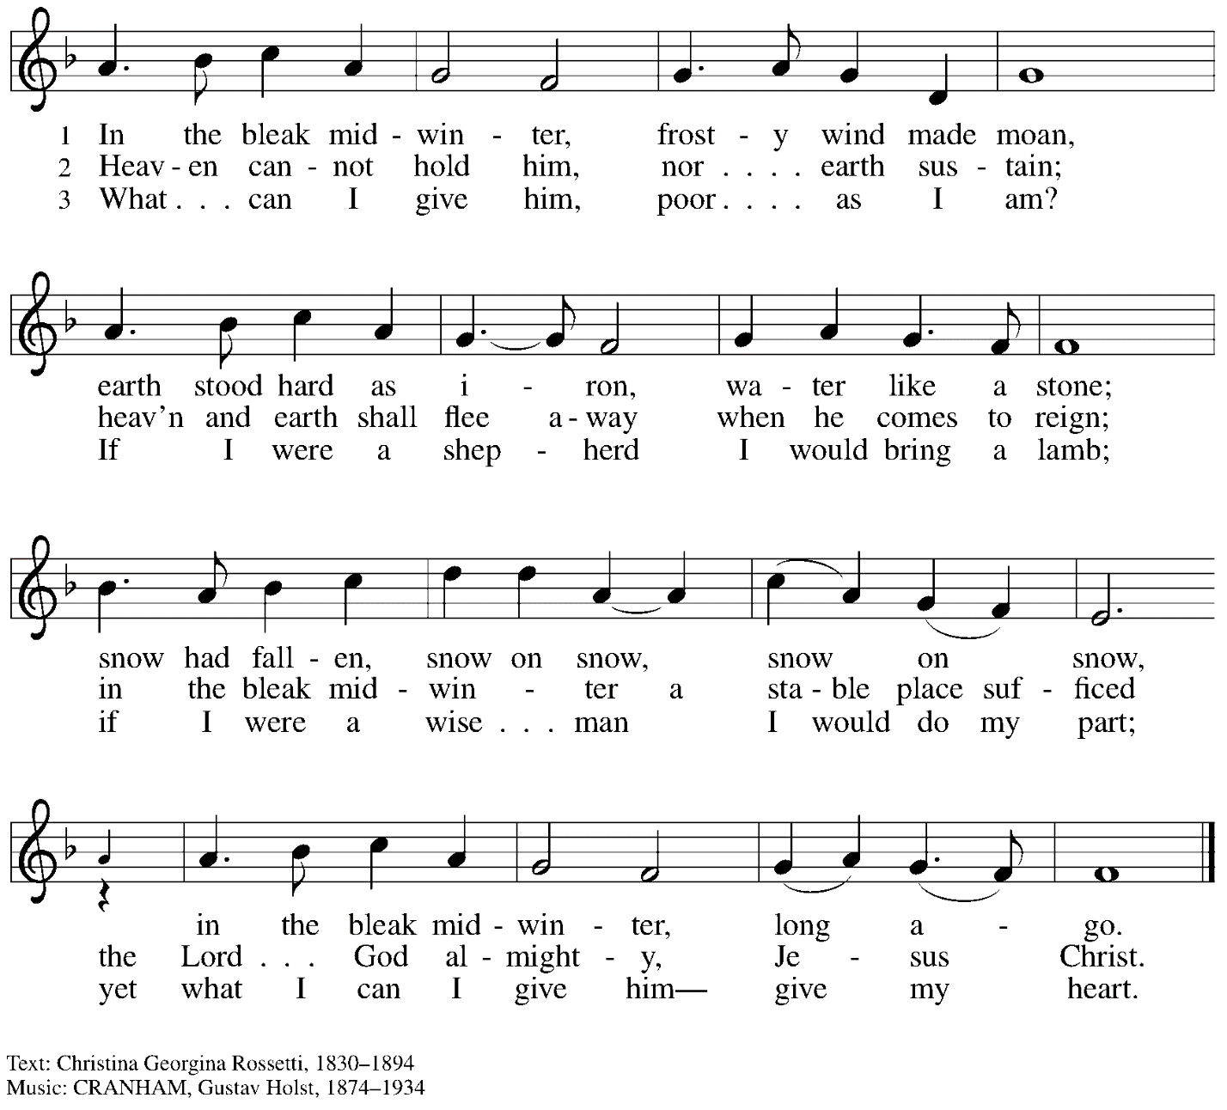

Offertory Prayer

A: Let us pray.
Good and loving God,
C: we rejoice in the birth of Jesus,
who came among the poor to bring the riches of his grace.
As you have blessed us with your gifts, let them be a blessing for others.
With the trees of the field, with all earth and heaven,
we shout for joy at the coming of your Son, Jesus Christ our Lord.
Amen.

Dialogue ELW p. 144

Preface (Sung by the presiding minister)

P: It is indeed right, our duty and our joy …
… we praise your name and join their unending hymn:

Sanctus ELW p. 144

Eucharistic Prayer

P: Holy One, the beginning and the end, the giver of life …
… Do this for the remembrance of me.

P: Let us proclaim the mystery of faith:
C: Christ has died.
Christ is risen.
Christ will come again.

P: With this bread and cup we remember …
… We look with hope for his coming.
C: Amen. Come, Lord Jesus.

P: Holy God, we long for your Spirit. …
… Bring the gift of peace on earth.
C: Amen. Come, Holy Spirit.

P: All praise and glory are yours, …
… one God, now and forever.
C: Amen.

Lord’s Prayer

P: Gathered as one by the Holy Spirit, let us pray as Jesus taught us.
C: Our Father in heaven,
hallowed be your name,
your kingdom come,
your will be done,
on earth as in heaven.
Give us today our daily bread.
Forgive us our sins
as we forgive those who sin against us.
Save us from the time of trial
and deliver us from evil.
For the kingdom, the power,
and the glory are yours,
now and forever. Amen.

Fraction and Invitation

P: Glory to God in the highest!
Come to the table of peace.

Agnus Dei / Lamb of God ELW p. 146

Please be seated.

Holy Communion
- All who seek God and desire a deeper and stronger life in Christ are welcome to receive Holy Communion
- Worshipers from the pulpit side will proceed forward first, followed by the center section, and then the lectern side.
- Please inform an usher if you would like the ministers to bring Communion to you.
- Holy Communion will be served with bread and wine/grape juice.
- The presiding minister will first distribute the bread (host) to each communicant. Please indicate if you require a gluten-free host.
- Once you have consumed the bread, please pick up an empty glass from the tray next to the presiding minister. The Communion Assistant will pour wine from the chalice or grape juice from the cruet into your glass.
- Please step to the side to consume the wine or grape juice.
- As you return to your pew, glasses may be returned to the empty trays on either side of the center aisle.
- A blessing will be provided for anyone who does not yet receive the sacrament.
- All are invited to join in singing the hymns during Holy Communion.

Hymn during Holy Communion
Infant Holy, Infant Lowly ELW 276

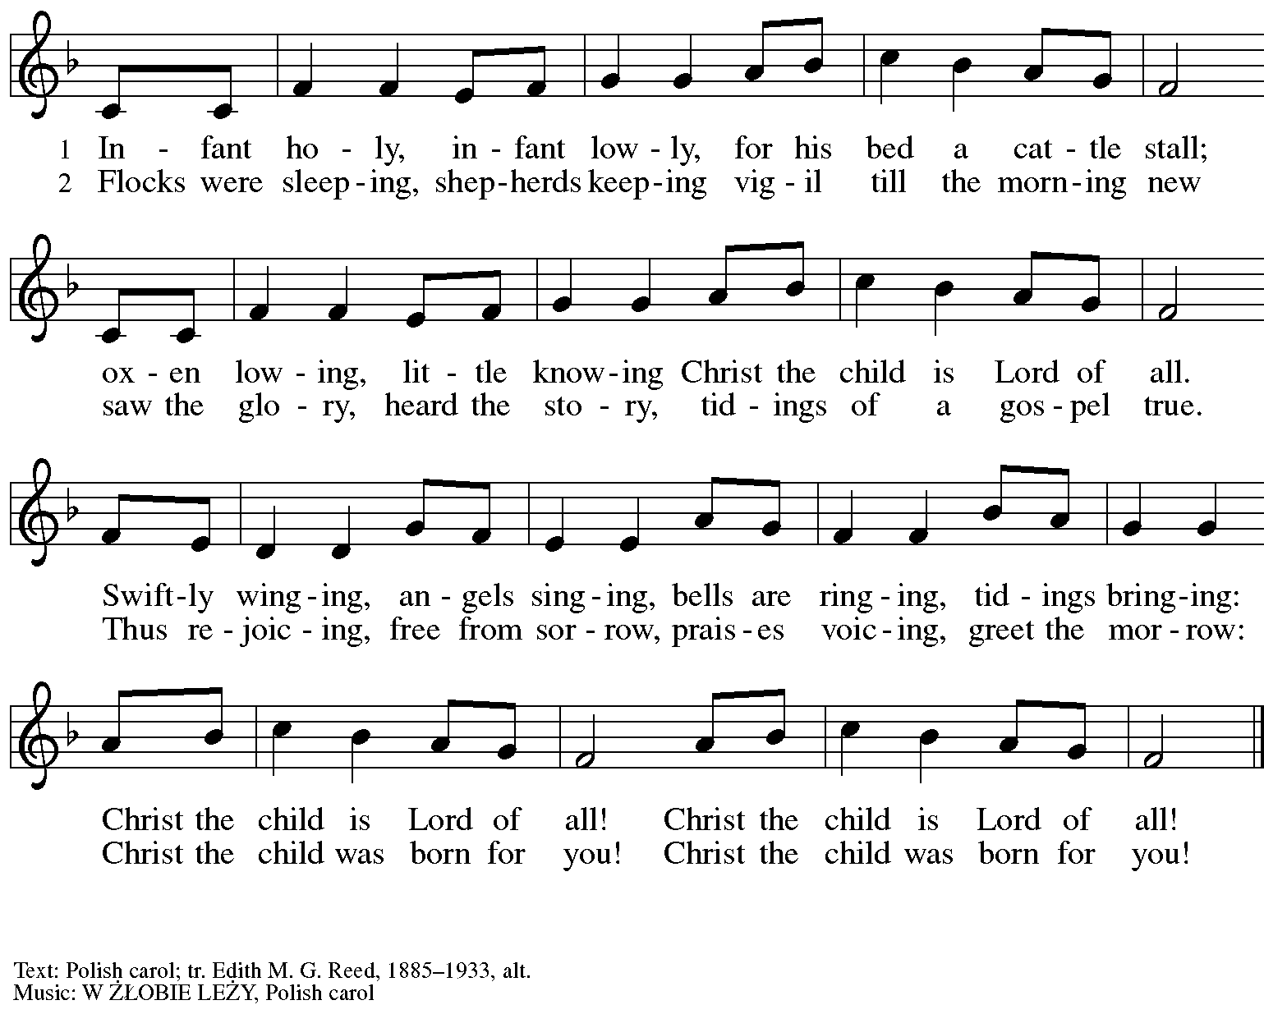

Hymn during Holy Communion
Mary Had a Baby TFF 55

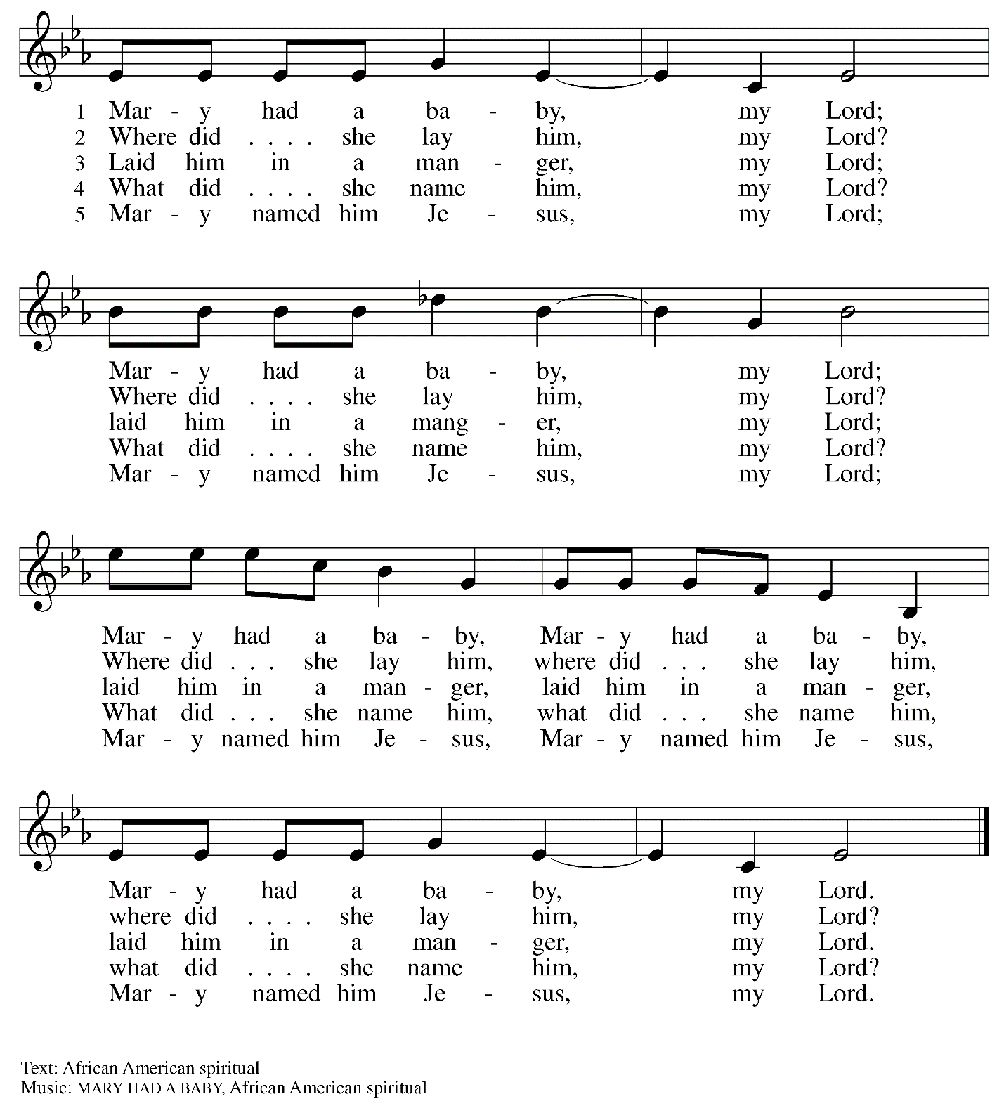

When all have returned to their places, please rise as you are able.

Blessing

P: The grace of our Lord Jesus Christ and the gifts of his body and blood strengthen, keep,
and unite us, now and forever.
C: Amen.

Prayer

A: Let us pray.
Radiant God, you have brought us your salvation,
and in this meal we have feasted on your grace.
May your Word take flesh in us, that we may be your holy people,
Revealing your glory made known to us in Jesus Christ, our Savior and Lord.
C: Amen.

Sending

Benediction

P: God bless you and keep you,
☩ Jesus grant you grace and truth,
and the Spirit send peace upon your hearts,
now and forever.
C: Amen.

Sending Hymn Jesus, What a Wonderful Child Following page

Dismissal

A: Go in peace. Share the good news!
C: Thanks be to God!

Sending Hymn Jesus, What a Wonderful Child ELW 297

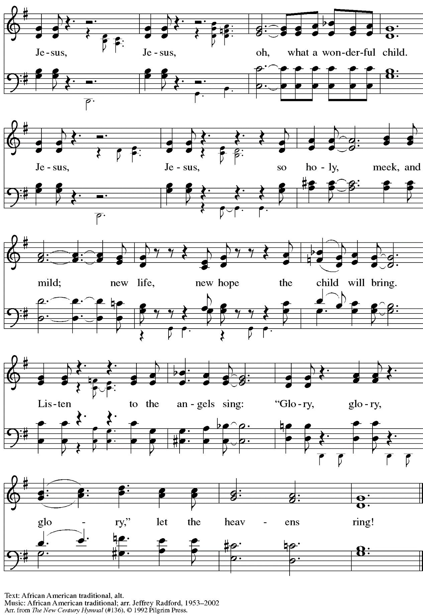
All rights reserved. Reprinted under OneLicense.net # A-722139.
Abbreviations

P: Pastor/Presiding Minister
A: Assisting Minister
L: Lector
C: Congregation

ELW: Evangelical Lutheran Worship hymnal
TFF: This Far by Faith hymnal

Those serving in worship today

Minister of Music Laura Reynolds
Assisting Minister Colleen Cooke
Cantor Colten Rohleder
Lector Sue Gaugler
Presiding Minister Rev. Ross Carmichael

Liturgy and Hymnody Acknowledgements

From SundaysandSeasons.com. Copyright © 2022 Augsburg Fortress. All rights reserved. Reprinted under OneLicense.net # A-722139.
Used by permission of Augsburg Fortress.

St. Andrew Lutheran Church Announcements
January 1st, 2023

- Welcome to Worship at St. Andrew on January 1st, 2023, + Name of Jesus Sunday – Merry and blessed Christmas to all! We are so glad you have gathered here today as we continue the celebration of Christ’s birth! Masks are optional at St. Andrew when Allegheny County’s Covid-19 community level is in the low and medium categories. Worship attendees are invited to make a name tag at the back of the worship space if you would like.
- Little Church; Big Faith Will Not Meet during Worship Today – We will resume the Bible lesson and activities for children during worship on Sunday, January 8th.
- No Coffee Hour Today – Coffee hour will resume after worship next Sunday, January 8th.
- January 2023 Produce Distribution – Tuesday, January 3rd, 5:30-7:00 p.m. – St. Andrew’s Monthly produce distribution will be coming up soon after the holidays, so if you would like to help on that day with unloading and setup (usually some time between 11:00 a.m. and 1:00 p.m.) or in the evening with the distribution from 5:30-7:00 p.m. please plan ahead! Sign up at: https://www.signupgenius.com/go/5080544AAAC22A1F58-produce24.
- Community Ministry Meeting – Monday, January 9th, Online – Please contact Vanessa Brown (vanessa.brown7@gmail.com) or Conrad Kalcich (conrad.kalcich@gmail.com) for the Zoom link.
- Humor and the Bible? - Come and Discuss Tuesdays, January 10th, 17th, 24th, and 31st, 7:00 p.m., 7:00 p.m. Online – Is there humor in the Bible? Isn't it a pious look at life that inspires us and places us in awe of God? Doesn't the Bible contain instructions for life's do's and don'ts? Doesn't the Bible give us warnings and signs of hope? Perhaps all these things are true, but if we can suspend our piety, our past notions or suspicions about the Bible, we just might hear and experience a humorous side of the Bible we hadn't appreciated before. We might even laugh! In our upcoming Zoom discussion, Tuesdays, January 10th, 17th, 24th, and 31st, at 7:00 p.m., Pastor Paul Koch will lead us in looking more closely at various passages throughout the Bible that might surprise you, make you smile, or even bring a laugh or two. Imagine finding humor in the Creation stories, the end of Daniel, or hearing some of Jesus' sayings in a humorous (or at least a little sarcastic) way! Zoom login information can be found in your weekly This Week at St. Andrew email – tune in and enjoy!

