+ Second Sunday after Epiphany
January 15, 2023

St. Andrew Lutheran Church
304 Morewood Ave.
Pittsburgh, PA 15213
St_andrewELCA@verizon.net
www.standrewpittsburgh.org

+ Second Sunday after Epiphany
Order for Worship

This week’s Gospel opens with further reflection on Jesus’ baptism.
Jesus is the Lamb of God who takes away the sin of the world and the one anointed by the Spirit.
In the liturgy we come and see Christ revealed among us in word and meal.
We go forth to invite others to come and worship the Holy One
and to receive the gifts of grace and peace made known among us.

The festival of Epiphany and the season that follows emphasize God’s ongoing revelation of Jesus Christ to people of all nations. In this spirit, St. Andrew’s worship music throughout the season will feature hymns and songs that reflect the rich variety of contributions that people of various lands, cultures, and languages have made to the hymnody of the global Christian church. “In sharing one another’s music, we share more than music. Music of various cultures brings us a glimpse of one another’s experience of God. As any culture connects its experience of the holy to its music, a unique context for God’s presence is created – we experience together the way God weaves a varied, diverse tapestry of revelation among us. The church’s song is a great place to experience that sharing.”
Evangelical Lutheran Worship: Musician’s Guide, Augsburg Fortress, 2007. p. 63

- Masks are optional at St. Andrew when Covid-19 community level in Allegheny County is in the low and medium categories.
- Hand sanitizer is available at the back of the sanctuary.

Worship Services are live streamed to multiple online platforms.
By attending worship, you agree that your image and voice may be broadcast.

Welcome to St. Andrew!
- Everyone is invited to make a nametag at the black bookcase in the back of the worship space if they would like.
- Worship “toolkits” to help children engage with the service are available in the black bookcase at the back of the worship space. There are “reader” and “pre-reader” resources available in each kit. Please feel free to use the kits for/with your children during worship.
- St. Andrew has recently returned to serving the sacrament of Holy Communion with both (separate) elements, bread and wine/grape juice. The presiding minister will first distribute the bread (host). Please consume this and then pick up an empty glass from the tray next to the presiding minister. The Communion Assistant will pour wine from the chalice or grape juice from the cruet into your glass. Please step to the side to consume the wine or grape juice. As you return to your pew, glasses may be returned to the empty trays on either side of the center aisle.
- A restroom is available on the main level of the church, through the doors to the Social Hall and to the right in the main office.

Welcome

Prelude

Gathering
The Holy Spirit calls us together as the people of God.

Thanksgiving for Baptism

P: Blessed be the holy Trinity, ☩ one God,
the fountain of living water,
the rock who gave us birth,
our light and our salvation.
C: Amen.

The presiding minister addresses the assembly
P: Joined to Christ in the waters of Baptism,
we are clothed with God's mercy and forgiveness.
Let us give thanks for the gift of Baptism.

Water may be poured into the font as the presiding minister gives thanks.

P: We give you thanks, O God,
for in the beginning your Spirit moved over the waters
and by your Word you created the world,
calling forth life in which you took delight.

Through the waters of the flood you delivered Noah and his family.
Through the sea you led your people Israel from slavery into freedom.
At the river your Son was baptized by John and anointed with the Holy Spirit.
By water and your Word you claim us as your children,
making us heirs of your promise and servants of all.

We praise you for the gift of water that sustains life,
and above all we praise you for the gift of new life in Jesus Christ.
Shower us with your Spirit,
and renew our lives with your forgiveness, grace, and love.

To you be given honor and praise
through Jesus Christ our Lord
in the unity of the Holy Spirit, now and forever.
C: Amen.

Gathering Hymn Light Shines in Darkness ELW 307

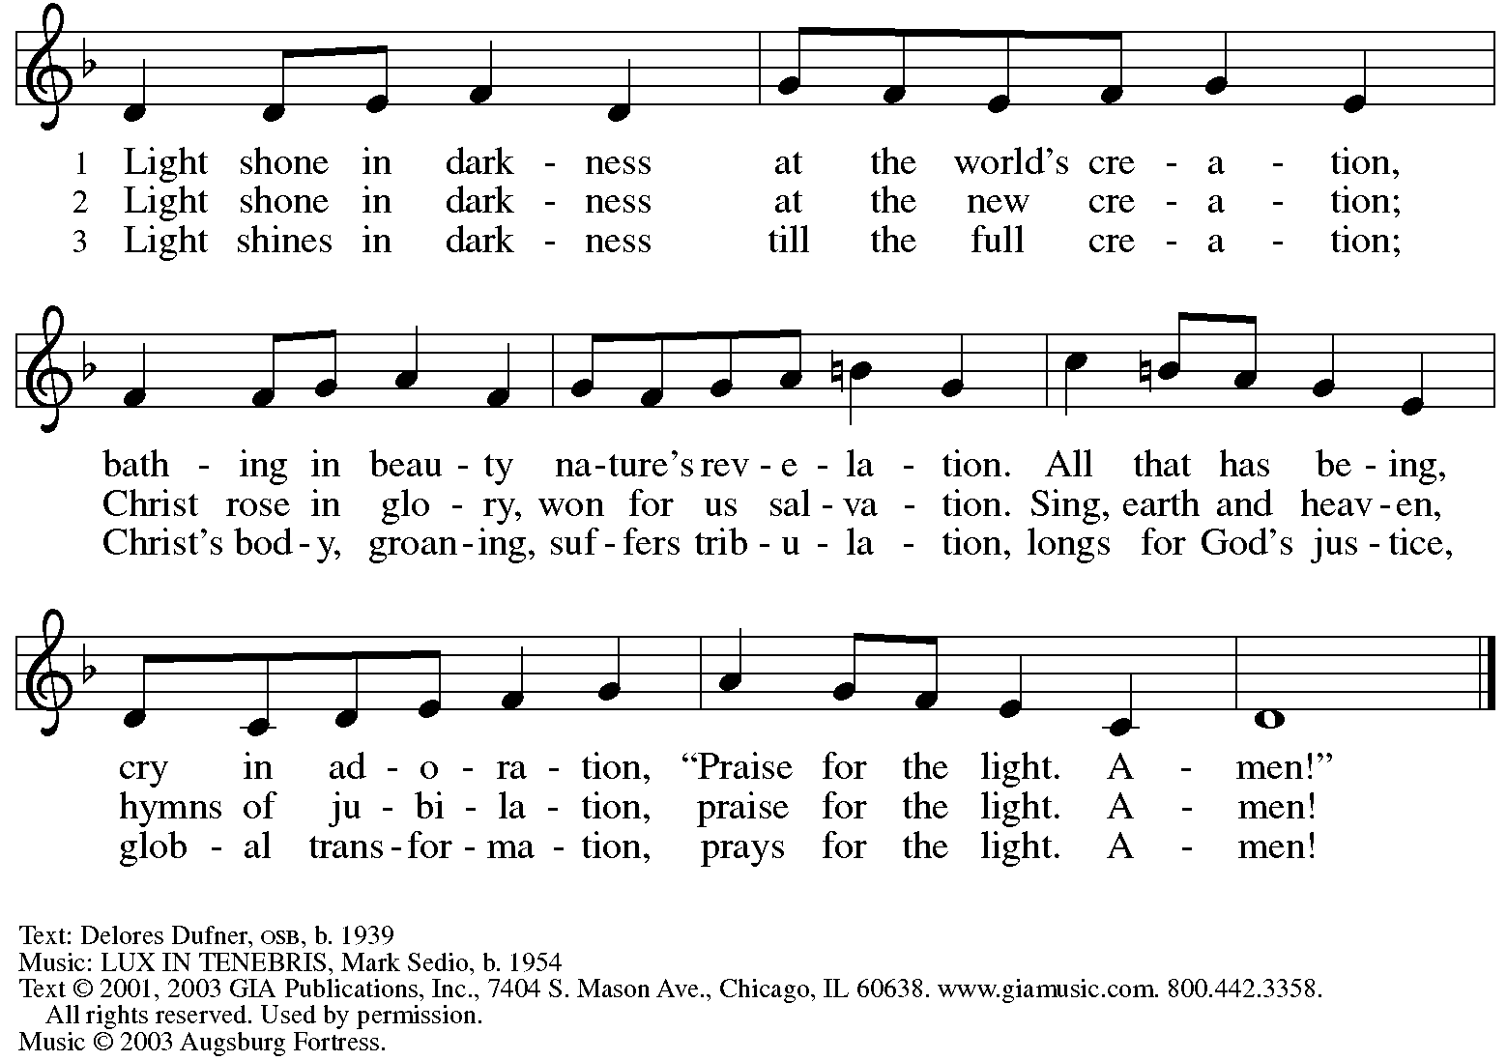
Reprinted under OneLicense.net # A-722139.

Greeting

P: The grace of our Lord Jesus Christ, the love of God,
and the communion of the Holy Spirit be with you all.
C: And also with you.

Hymn of Praise Glory to God, Glory in the Highest ELW 164

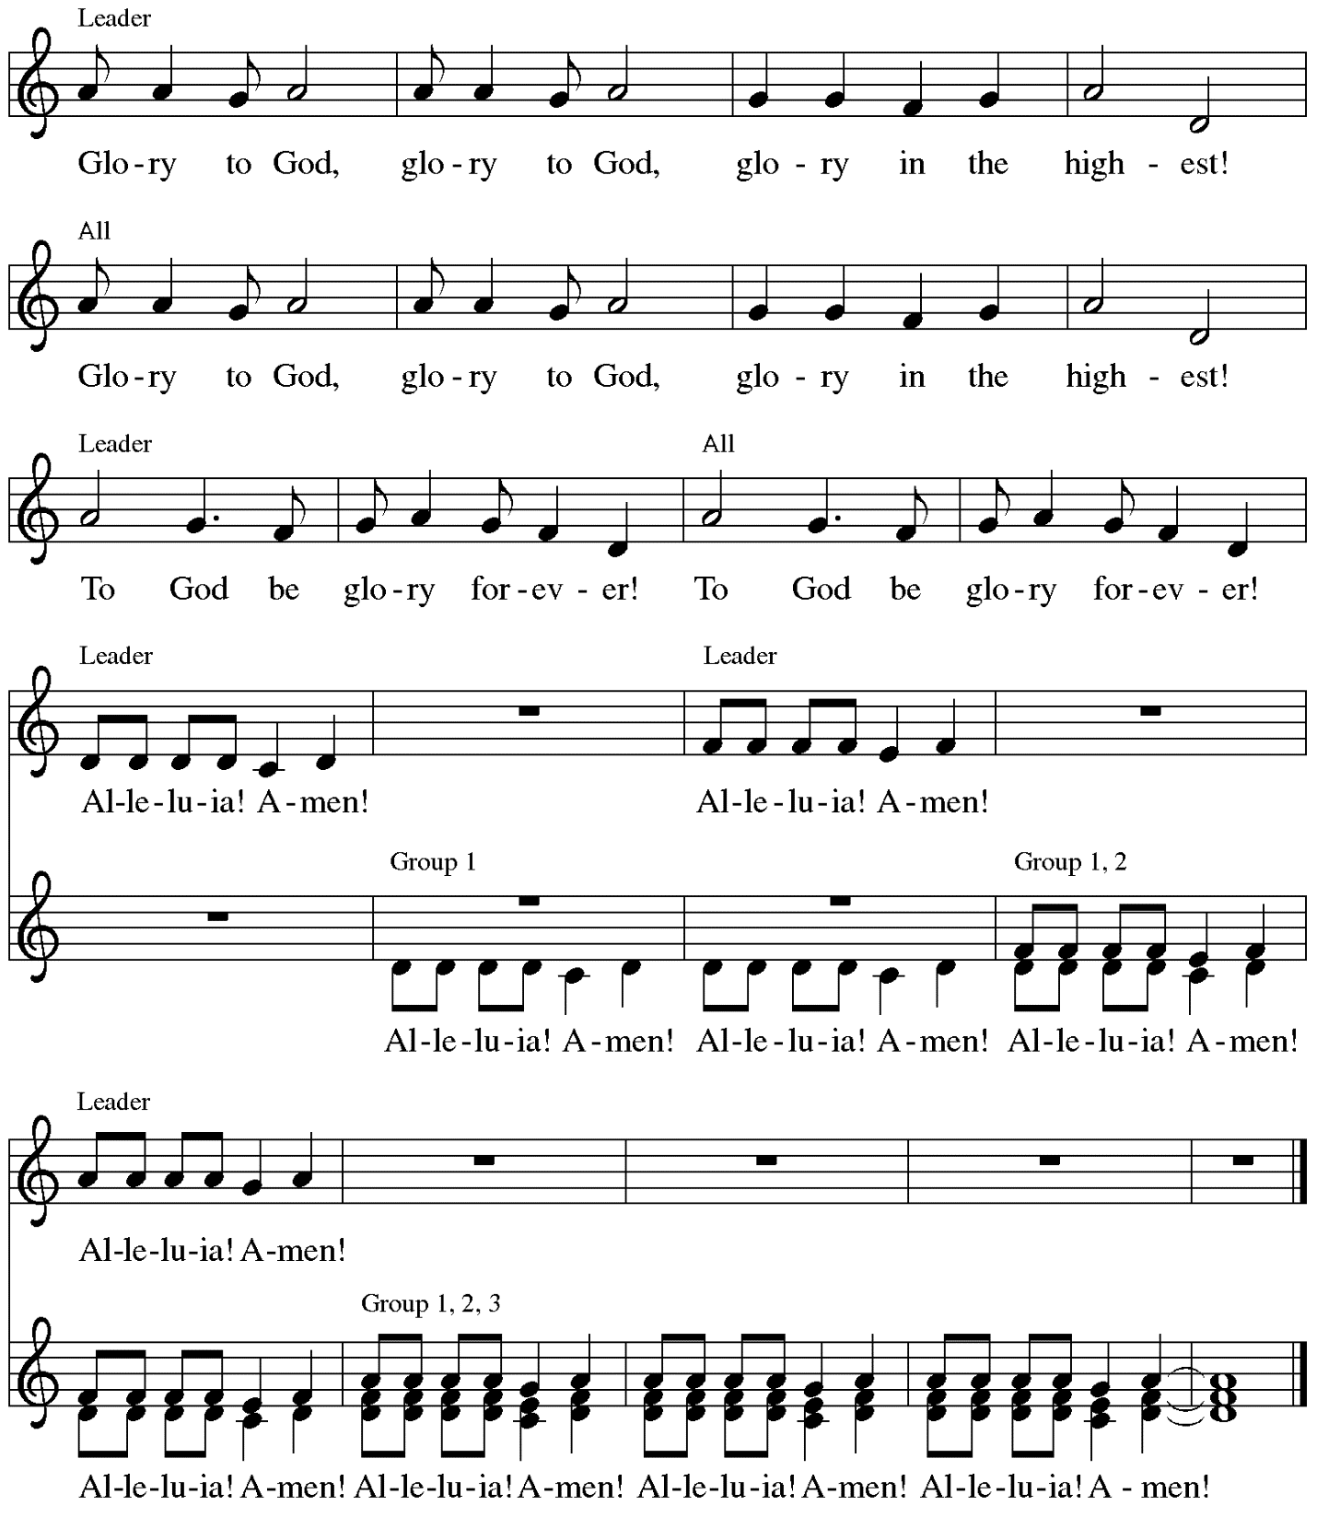

Music: Peruvian traditional

Prayer of the Day

P: The Lord be with you.
C: And also with you.

P: Let us pray.
Holy God, our strength and our redeemer, by your Spirit hold us forever,
that through your grace we may worship you and faithfully serve you,
follow you and joyfully find you, through Jesus Christ, our Savior and Lord.
C: Amen.

Please be seated.
Children are invited to join the adult leaders at the door and move to the office for Little Church; Big Faith. We ask that one additional adult from the congregation attend with the children.

Word
God speaks to us in Scripture reading, preaching, and song

First Reading – Isaiah 49: 1-7

¹Listen to me, O coastlands,
pay attention, you peoples from far away!
The Lord called me before I was born,
while I was in my mother’s womb God named me.
²The Lord made my mouth like a sharp sword,
in the shadow of God’s hand the Lord hid me;
the Lord made me a polished arrow,
in God’s quiver the Lord hid me away.
³And the Lord said to me, “You are my servant,
Israel, in whom I will be glorified.”
⁴But I said, “I have labored in vain,
I have spent my strength for nothing and vanity;
yet surely my cause is with the Lord,
and my reward with my God.”
⁵And now the Lord says,
who formed me in the womb to be God’s servant,
to bring Jacob back to God,
and that Israel might be gathered to God,
for I am honored in the sight of the Lord,
and my God has become my strength—
⁶God says,
“It is too light a thing that you should be my servant
to raise up the tribes of Jacob
and to restore the survivors of Israel;
I will give you as a light to the nations,
that my salvation may reach to the end of the earth.”
⁷Thus says the Lord,
the Redeemer of Israel and his Holy One,
to one deeply despised, abhorred by the nations,
the slave of rulers,
“Kings shall see and stand up,
princes, and they shall prostrate themselves,
because of the Lord, who is faithful,
the Holy One of Israel, who has chosen you.”

L: Word of God, word of life.
C: Thanks be to God.

Psalm 40: 1-11

The cantor will lead the singing of the psalm.
The congregation is invited to respond with the alternate verses in bold print,
and to join in singing the refrain.

Psalm tone

Psalm refrain

¹I waited patiently up- | on the Lord,
who stooped to me and | heard my cry.
²The Lord lifted me out of the desolate pit, out of the | miry clay,
and set my feet upon a high cliff, making my | footing sure.
³The Lord put a new song in my mouth, a song of praise | to our God;
many shall see, and stand in awe, and put their trust | in the Lord.
⁴Happy are they who trust | in the Lord!
They do not turn to enemies or to those who | follow lies. R
⁵Great are the wonders you have done, O Lord my God! In your plans for us, none can be com- | pared with you!
Oh, that I could make them known and tell them! But they are more than | I can count.
⁶Sacrifice and offering you do | not desire;
you have opened my ears: burnt-offering and sin-offering you have | not required. R
⁷And so I said, “Here I | am; I come.
In the scroll of the book it is writ- | ten of me:
⁸‘I love to do your will, | O my God;
your law is | deep within me.’ ”
⁹I proclaimed righteousness in the | great assembly;
I have not restrained my lips, O | Lord, you know.
¹⁰I have not hidden your righteousness in my heart; I have spoken of your faithfulness and | your deliverance;
I have not concealed your steadfast love and truth from the | great assembly.
¹¹You are the Lord; do not withhold your compas- | sion from me;
may your steadfast love and your truth continually | keep me safe. R
Second Reading – 1 Corinthians 1: 1-9

¹Paul, called to be an apostle of Christ Jesus by the will of God, and our brother Sosthenes,
²To the church of God that is in Corinth, to those who are sanctified in Christ Jesus, called to be saints, together with all those who in every place call on the name of our Lord Jesus Christ, both their Lord and ours:
³Grace to you and peace from God our Father and the Lord Jesus Christ.
⁴I give thanks to my God always for you because of the grace of God that has been given you in Christ Jesus, ⁵for in every way you have been enriched in him, in speech and knowledge of every kind—⁶just as the testimony of Christ has been strengthened among you—⁷so that you are not lacking in any spiritual gift as you wait for the revealing of our Lord Jesus Christ. ⁸God will also strengthen you to the end, so that you may be blameless on the day of our Lord Jesus Christ. ⁹God is faithful; by God you were called into the fellowship of God’s Son, Jesus Christ our Lord.

L: Word of God, word of life.
C: Thanks be to God.

Please rise as you are able.

Gospel Acclamation Heleluyan / Hallelujah ELW 171

Heleluyan, heleluyan; hele, heleluyan.
Heleluyan, heleluyan; hele, heleluyan.

Hallelujah, hallelujah; halle, hallelujah.
Hallelujah, hallelujah; halle, hallelujah.

Music: Muscogee (Creek); transc. Charles H. Webb, b. 1933.
Transcription © 1989 The United Methodist Publishing House, admin. The Copyright Company.
Reprinted with permission under OneLicense.net # A-722139.

Gospel – John 1: 29-42

P: The holy Gospel according to St. John.
C: Glory to you, O Lord.
²⁹[John the Baptist] saw Jesus coming toward him and declared, “Here is the Lamb of God who takes away the sin of the world!³⁰This is the one of whom I said, ‘After me comes a man who ranks ahead of me because he was before me.’ ³¹I myself did not know him; but I came baptizing with water for this reason, that he might be revealed to Israel.” ³²And John testified, “I saw the Spirit descending from heaven like a dove, and it remained on him. ³³I myself did not know him, but the one who sent me to baptize with water said to me, ‘The one on whom you see the Spirit descend and remain is the one who baptizes with the Holy Spirit.’ ³⁴And I myself have seen and have testified that this is the Son of God.”
³⁵The next day John again was standing with two of his disciples, ³⁶and as he watched Jesus walk by, he exclaimed, “Look, here is the Lamb of God!” ³⁷The two disciples heard him say this, and they followed Jesus. ³⁸When Jesus turned and saw them following, he said to them, “What are you looking for?” They said to him, “Rabbi” (which translated means Teacher), “where are you staying?” ³⁹He said to them, “Come and see.” They came and saw where he was staying, and they remained with him that day. It was about four o’clock in the afternoon. ⁴⁰One of the two who heard John speak and followed him was Andrew, Simon Peter’s brother. ⁴¹He first found his brother Simon and said to him, “We have found the Messiah” (which is translated Anointed).
⁴²He brought Simon to Jesus, who looked at him and said, “You are Simon son of John. You are to be called Cephas” (which is translated Peter).

P: The Gospel of the Lord.
C: Praise to you, O Christ.

Please be seated.

Sermon

A time of silence for prayer and reflection follows the sermon.
When the Hymn of the Day begins, please rise as you are able.

Hymn of the Day Now Behold the Lamb ELW 341

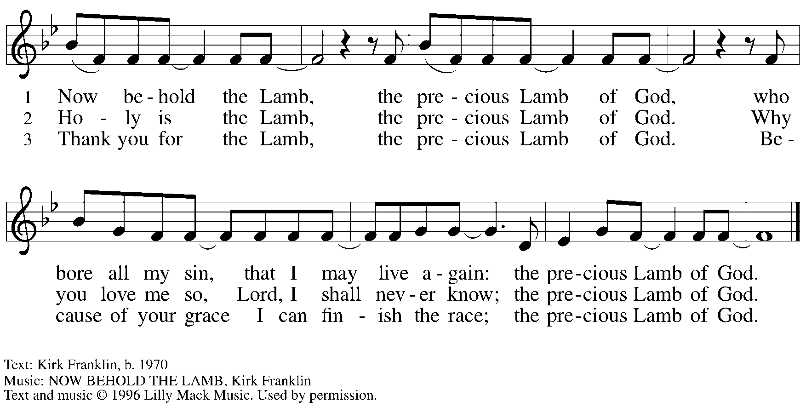
All rights reserved. Reprinted with permission under CCLI # 11561207.

Apostles Creed

C: I believe in God, the Father almighty,
creator of heaven and earth.

I believe in Jesus Christ, God’s only Son, our Lord,
who was conceived by the Holy Spirit,
born of the virgin Mary,
suffered under Pontius Pilate,
was crucified, died, and was buried;
he descended to the dead.*
On the third day he rose again;
he ascended into heaven,
he is seated at the right hand of the Father,
and he will come to judge the living and the dead.

I believe in the Holy Spirit,
the holy catholic church,
the communion of saints,
the forgiveness of sins,
the resurrection of the body,
and the life everlasting. Amen.

*Or, “he descended into hell,” another translation of this text in widespread use.

Prayers of the People

A: Called together to follow Jesus, we pray for the church,
the world, and all who are in need.

After each petition
A: Merciful God,
C: receive our prayer.

The presiding minister concludes the prayers:
P: We bring these needs and hope to you, O God,
trusting in your wisdom, grace, and power
revealed in Jesus Christ, our Savior.
C: Amen.

Please be seated.

Meal

Offering

We offer ourselves, our gifts, and our faithful service to God.
As the offering is gathered for the mission of the church, including the care of those in need,
the table is set for Holy Communion.

Music during the Offering

As the gifts are brought forward for presentation, please rise as you are able
and join in singing the Offertory Song.

Offertory Song ELW 523
Vamos todos al banquete / Let Us Go Now to the Banquet
v. 2-3

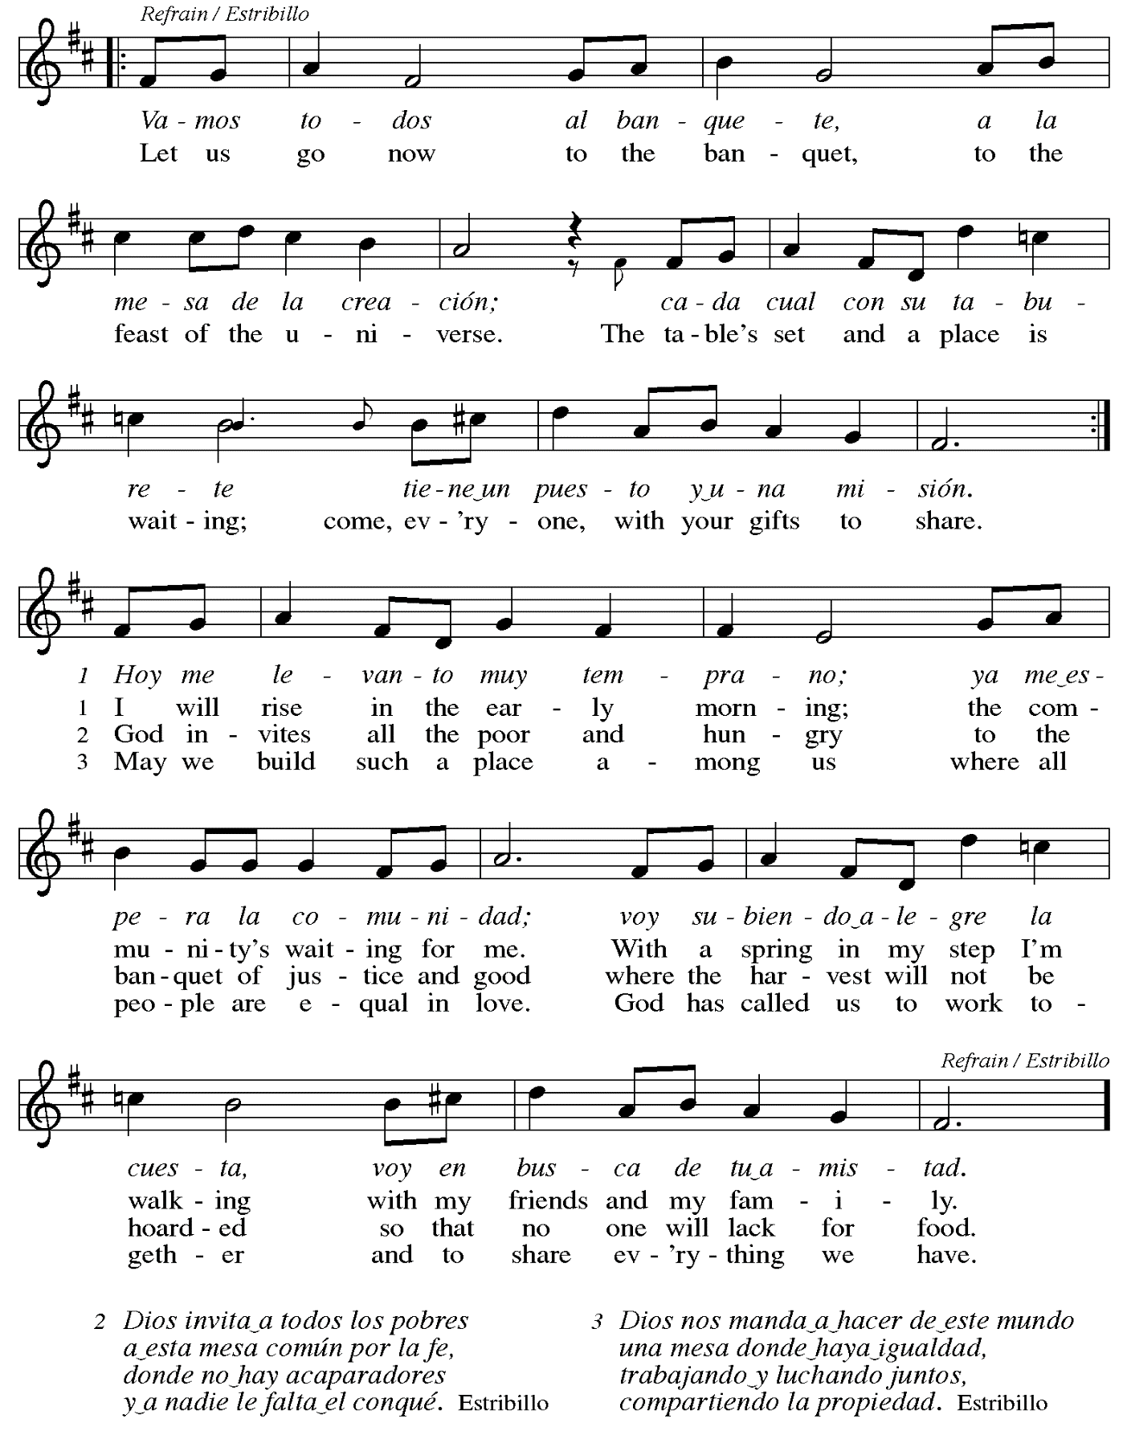

Offertory Prayer

A: Let us pray.
Liberating God,
C: you break the bonds of injustice
and set free those who are oppressed.
Receive these offerings in thanksgiving
for all your deeds of merciful power,
that they may serve in your work of justice and freedom.
You we magnify and adore, through Jesus our Savior.
Amen.

Dialogue

P: The Lord be with you.
C: And also with you.

P: Lift up your hearts.
C: We lift them to the Lord.

P: Let us give thanks to the Lord our God.
C: It is right to give our thanks and praise.

Preface (Spoken by the presiding minister)

P: It is indeed right, our duty and our joy,
that we should at all times and in all places
give thanks and praise to you, almighty and merciful God,
through our Savior Jesus Christ;
who on this day overcame death and the grave,
and by his glorious resurrection opened to us the way of everlasting life.
And so, with all the choirs of angels,
with the church on earth and the hosts of heaven,
we praise your name and join their unending hymn:

Sanctus Santo, Santo, Santo ELW 762
Refrain Only

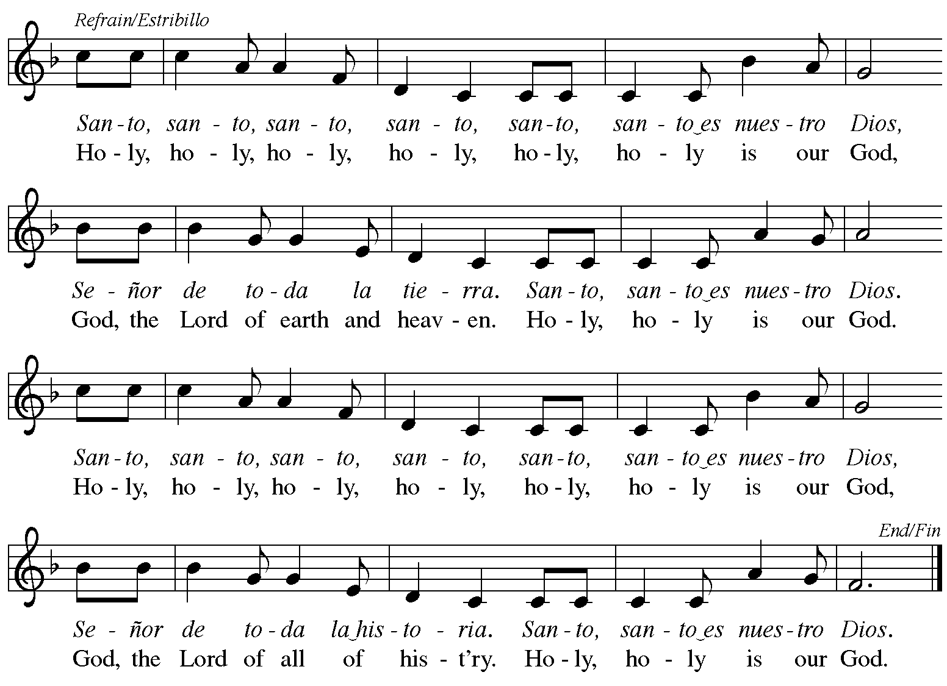
Reprinted with permission under OneLicense.net # A-722139.

Eucharistic Prayer

P: Blessed are you, O God,
creator of heaven and earth.
You rescued your covenant people,
led them on all their journeys,
and taught them by the prophets.
You so loved the world
that you gave your only Son,
so that everyone who believes in him
may not perish but may have eternal life.

In the night in which he was betrayed,
our Lord Jesus took bread,
and gave thanks; broke it,
and gave it to his disciples,
saying: Take and eat;
this is my body, given for you.
Do this for the remembrance of me.

Again, after supper,
he took the cup, gave thanks,
and gave it for all to drink,
saying: This cup
is the new covenant in my blood,
shed for you and for all people
for the forgiveness of sin.
Do this for the remembrance of me.

P: As often as we eat this bread
and drink this cup,
we proclaim the Lord’s death
until he comes.
C: Christ has died.
Christ is risen.
Christ will come again.

P: Pour out your Holy Spirit
in this meal and make us one,
in this community of faith
and with your people throughout the world.

Glory and praise to you, O God,
Author of Life,
Word made flesh,
Power of the Most High,
now and forever.
C: Amen.

Lord’s Prayer

P: Gathered as one by the Holy Spirit, let us pray as Jesus taught us.
C: Our Father in heaven,
hallowed be your name,
your kingdom come,
your will be done,
on earth as in heaven.
Give us today our daily bread.
Forgive us our sins
as we forgive those who sin against us.
Save us from the time of trial
and deliver us from evil.
For the kingdom, the power,
and the glory are yours,
now and forever. Amen.

Fraction and Invitation

P: These are the gifts of God for the people of God.
Come, share the feast.

Agnus Dei / Lamb of God TFF 35

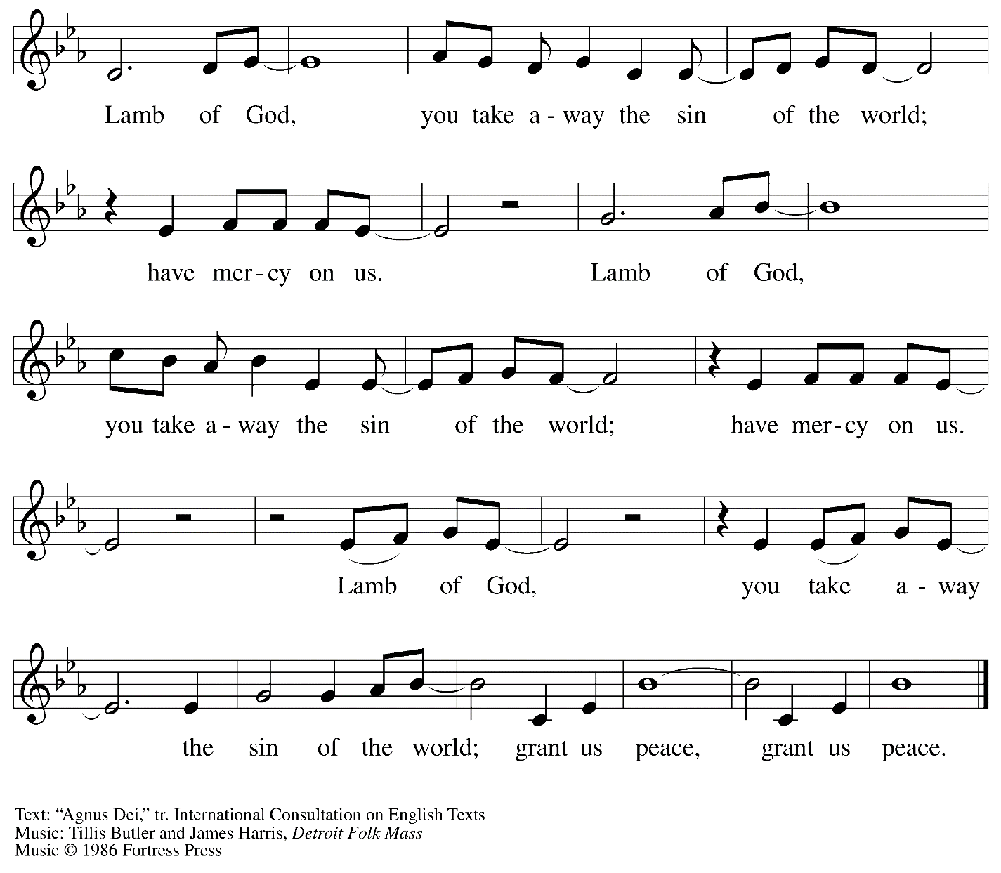
All rights reserved. Reprinted under OneLicense.net # A-722139.

Please be seated.
Holy Communion
- All who seek God and desire a deeper and stronger life in Christ are welcome to receive Holy Communion
- Worshipers from the pulpit side will proceed forward first, followed by the center section, and then the lectern side.
- Please inform an usher if you would like the ministers to bring Communion to you.
- Holy Communion will be served with bread and wine/grape juice.
- The presiding minister will first distribute the bread (host) to each communicant. Please indicate if you require a gluten-free host.
- Once you have consumed the bread, please pick up an empty glass from the tray next to the presiding minister. The Communion Assistant will pour wine from the chalice or grape juice from the cruet into your glass.
- Please step to the side to consume the wine or grape juice.
- As you return to your pew, glasses may be returned to the empty trays on either side of the center aisle.
- A blessing will be provided for anyone who does not yet receive the sacrament.
- All are invited to join in singing the hymns during Holy Communion.

Hymn during Holy Communion
Nuestro Padre nos invita / God Extends an Invitation ELW 486

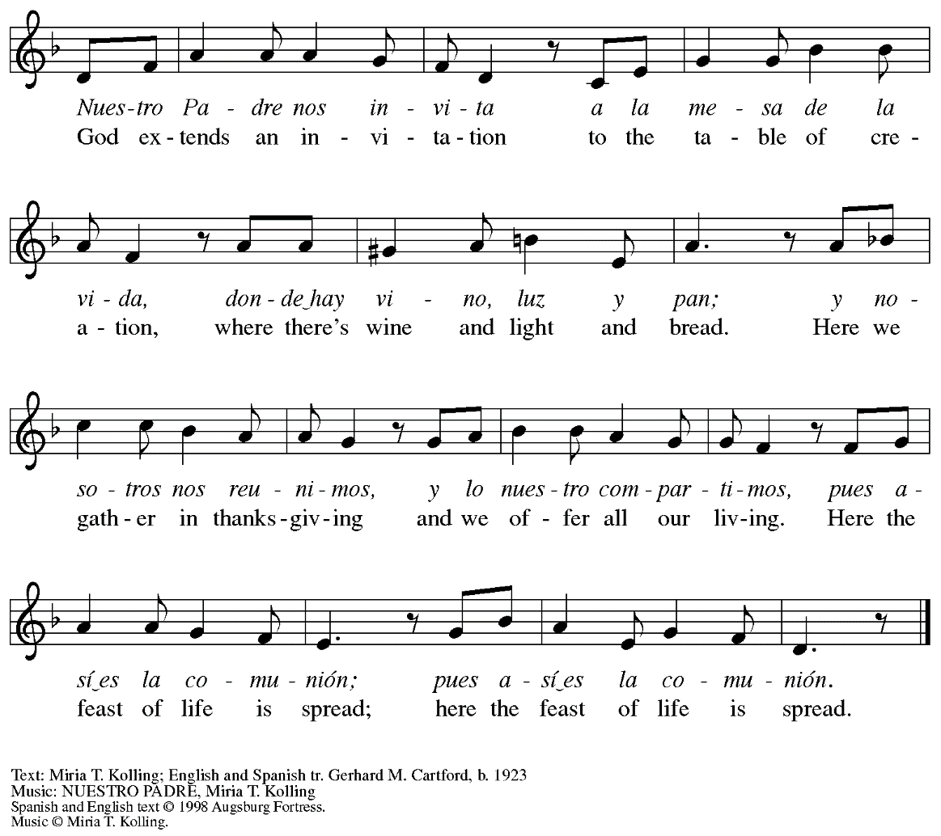

Hymn during Holy Communion
Christ Comes to Us as One Unknown ELW 737

1 Christ comes to us as one unknown,
a breath unseen, unheard;
as though within a heart of stone,
or shriveled seed in darkness sown,
a pulse of being stirred,
a pulse of being stirred.

2 Christ comes when souls in silence lie
and thoughts of day depart;
half-seen upon the inward eye,
a falling star across the sky
of night within the heart,
of night within the heart.

3 Christ comes to us in sound of seas,
the ocean's fume and foam;
yet small and still upon the breeze,
a wind that stirs the tops of trees,
a voice to call us home,
a voice to call us home.

4 Christ comes in love as once he came
by flesh and blood and birth;
to bear within our mortal frame
a life, a death, a saving name,
for ev'ry child of earth,
for ev'ry child of earth.

5 Christ comes in truth when faith is grown;
believed, obeyed, adored;
the Christ in all the scriptures shown,
as yet unseen, but not unknown,
our Savior and our Lord,
our Savior and our Lord.

Text: Timothy Dudley-Smith, b. 1926.
Music: REPTON, C. Hubert H. Parry, 1848-1918.
Text © 1984 Hope Publishing Company, Carol Stream, IL 60188.
All rights reserved. Used by permission. Reprinted under OneLicense.net # A-722139.

Hymn during Holy Communion
Come to the Table ELW 481

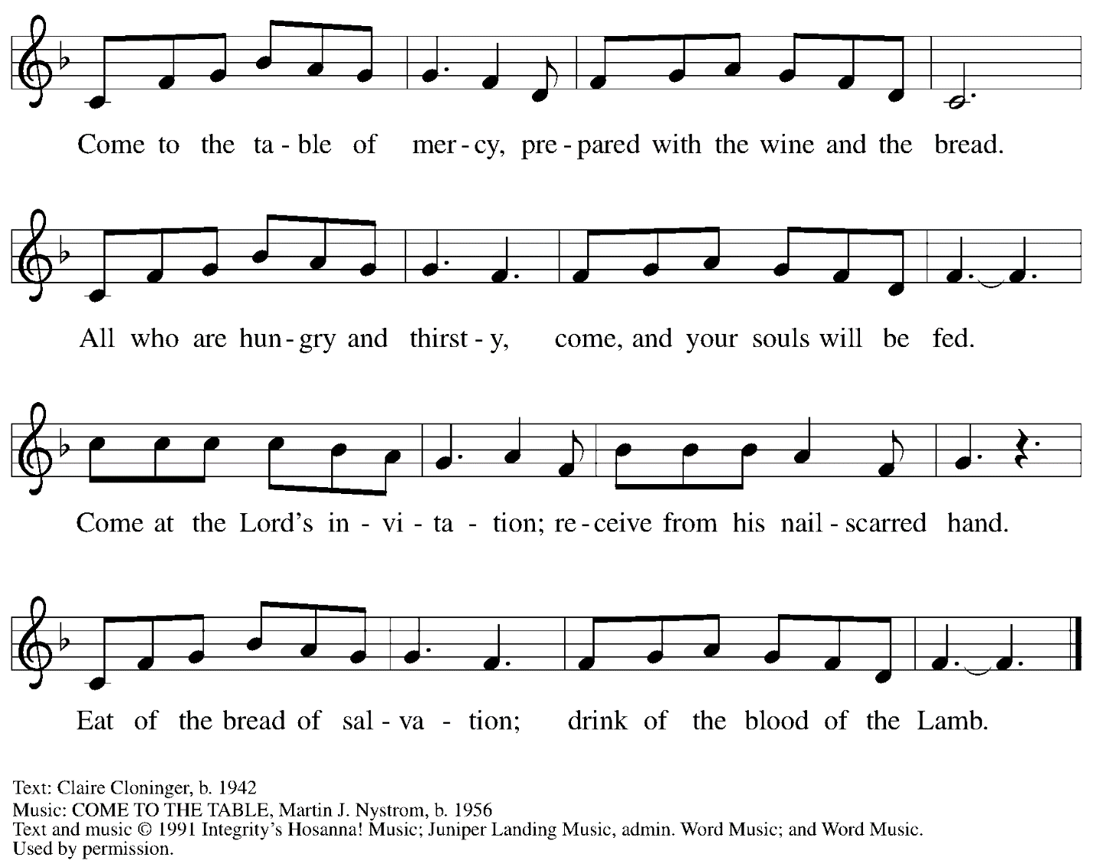
All rights reserved. Reprinted under OneLicense.net # A-722139 and CCLI # 11561207.

When all have returned to their places, please rise as you are able.

Blessing

P: The body and blood of our Lord Jesus Christ strengthen you and keep you in his grace.
C: Amen.

Prayer

A: Let us pray.
Holy One,
we thank you for the healing
that springs forth abundantly from this table.
Renew our commitment to do justice, love kindness,
and journey humbly with you,
through Jesus Christ, our Savior and Lord.
C: Amen.

Sending

Benediction

P: The Lord bless you and keep you.
The Lord’s face shine on you
with grace and mercy.
The Lord look upon you with favor
and ☩ give you peace.
C: Amen.

Sending Hymn Rise, Shine, You People! Following page

Dismissal

A: Go in peace. Serve the Lord.
C: Thanks be to God!

Sending Hymn Rise, Shine, You People! ELW 665
v. 1, 4

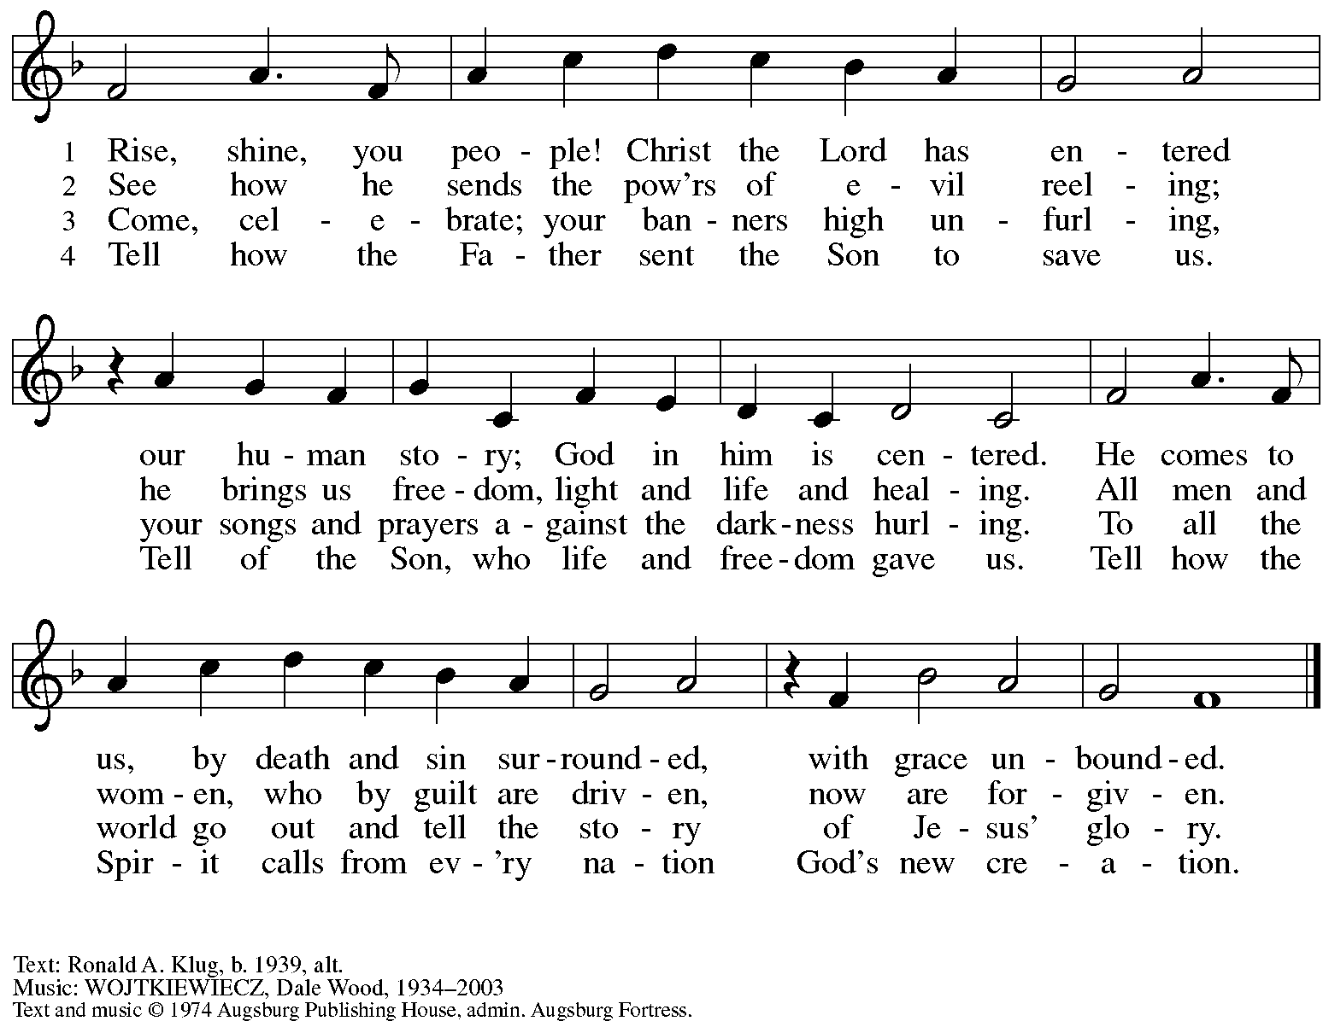
All rights reserved. Reprinted under OneLicense.net # A-722139.

Abbreviations

P: Pastor/Presiding Minister
A: Assisting Minister
L: Lector
C: Congregation

ELW: Evangelical Lutheran Worship hymnal
TFF: This Far by Faith hymnal

Those serving in worship today

Minister of Music Laura Reynolds
Assisting Minister Jimmi Kocher-Hillmer
Cantor Timothy Kocher-Hillmer
Lector Lester Prince
Preaching and Presiding Minister The Rev. Dr. Martin J. Rafanan

Liturgy and Hymnody Acknowledgements

From SundaysandSeasons.com. Copyright © 2023 Augsburg Fortress. All rights reserved. Reprinted under OneLicense.net # A-722139.
Used by permission of Augsburg Fortress.

Vamos todos al banquete / Let Us Go Now to the Banquet – Text: Guillermo Cuéllar, b. 1955, Misa popular salvadoreña; tr. Bret Hesla, b. 1957, and William Dexheimer Pharris, b. 1956. Music: VAMOS TODOS AL BANQUETE, Guillermo Cuéllar, b. 1955. Text and music © 1994, 1996 GIA Publications, Inc., 7404 S. Mason Ave., Chicago, IL 60638. www.giamusic.com. 800.442.3358. All rights reserved. Reprinted under OneLicense.net #A-722139.

St. Andrew Lutheran Church Announcements
January 15th, 2023

- Welcome to Worship at St. Andrew on January 15th, 2023, the + Second Sunday after Epiphany – Today we welcome The Rev. Dr. Martin J. Rafanan, who will be preaching and presiding while Pastor Ross Carmichael shares the Word with our neighbors at Bethel AME Church. Masks are optional at St. Andrew when Allegheny County’s Covid-19 community level is in the low and medium categories. Worship attendees are invited to make a name tag at the back of the worship space if you would like. All are welcome to a time of coffee and conversation in the Social Hall after worship.
- Humor and the Bible Discussion Continues – Tuesdays, January 17th, 24th, and 31st, 7:00 p.m. Online – Is there humor in the Bible? Isn't it a pious look at life that inspires us and places us in awe of God? Doesn't the Bible contain instructions for life's do's and don'ts? Doesn't the Bible give us warnings and signs of hope? Perhaps all these things are true, but if we can suspend our piety, our past notions or suspicions about the Bible, we just might hear and experience a humorous side of the Bible we hadn't appreciated before. We might even laugh! In our Zoom discussions on Tuesdays, January 17th, 24th, and 31st, at 7:00 p.m., Pastor Paul Koch will lead us in looking more closely at various passages throughout the Bible that might surprise you, make you smile, or even bring a laugh or two. Imagine finding humor in the Creation stories, the end of Daniel, or hearing some of Jesus' sayings in a humorous (or at least a little sarcastic) way! Zoom login information can be found below – tune in and enjoy!
- Shelter Dinner at East End Cooperative Ministry – Thursday, January 19th, 6:30 p.m. – Every month, people from St. Andrew provide a meal for guests of the shelter at East End Cooperative Ministry (6140 Station St., Pittsburgh 15206). Each person or household signs up to provide one portion of the meal, or anyone can just come at 6:00 p.m. to help with preparation and serving the meal at 6:30 p.m. Please sign up at:
https://www.signupgenius.com/go/5080544AAAC22A1F58-shelter37.
- “Pulpit Exchange” with Bethel AME Church Continues Next Sunday, January 22nd – Continuing to build on the relationships that have developed between people of St. Andrew and Bethel AME Church in the Hill through the past year, on Sunday, January 22nd, we will welcome The Rev. Dr. Dale Snyder, Pastor of Bethel, who will be preaching and sharing worship with St. Andrew that day. We pray for God’s blessings as we seek greater unity in the Body of Christ!
- Donations for Coffee Hour – As more people return to coffee hour or attend for the first time, it would be helpful to have additional donations to support this ministry. Any of the following would be much appreciated: Ground coffee, creamers, canned drinks, children’s drinks, individually wrapped food items of any kind. Donations may be left on the coffee table in the Social Hall. Thank you for your consideration.

