+ Third Sunday after Epiphany
January 22, 2023

St. Andrew Lutheran Church
304 Morewood Ave.
Pittsburgh, PA 15213
St_andrewELCA@verizon.net
www.standrewpittsburgh.org

+ Third Sunday after Epiphany
Order for Worship

Jesus begins his public ministry calling fishers to leave their nets and follow him.
In Jesus, the reign of God has come near.
The people who went about in darkness have seen a great light.
We see this light most profoundly in the cross –
as Jesus suffers with us and all who are oppressed by sickness, sin, or evil.
Light dawns for us as we gather around the Word, the font, and the holy table.
We are then sent to share the good news,
that others may be “caught” by the net of God’s grace and mercy.

- Masks are optional at St. Andrew when Covid-19 community level in Allegheny County is in the low and medium categories.
- Worship Services are live streamed to multiple online platforms. By attending worship, you agree that your image and voice may be broadcast.

The festival of Epiphany and the season that follows emphasize God’s ongoing revelation of Jesus Christ to people of all nations. In this spirit, St. Andrew’s worship music throughout the season will feature hymns and songs that reflect the rich variety of contributions that people of various lands, cultures, and languages have made to the hymnody of the global Christian church. “In sharing one another’s music, we share more than music. Music of various cultures brings us a glimpse of one another’s experience of God. As any culture connects its experience of the holy to its music, a unique context for God’s presence is created – we experience together the way God weaves a varied, diverse tapestry of revelation among us. The church’s song is a great place to experience that sharing.”
Evangelical Lutheran Worship: Musician’s Guide, Augsburg Fortress, 2007. p. 63

Welcome to St. Andrew!
- Everyone is invited to make a nametag at the black bookcase in the back of the worship space if they would like.
- Worship “toolkits” to help children engage with the service are available in the black bookcase at the back of the worship space. There are “reader” and “pre-reader” resources available in each kit. Please feel free to use the kits for/with your children during worship.
- St. Andrew has recently returned to serving the sacrament of Holy Communion with both (separate) elements, bread and wine/grape juice. The presiding minister will first distribute the bread (host). Please consume this and then pick up an empty glass from the tray next to the presiding minister. The Communion Assistant will pour wine from the chalice or grape juice from the cruet into your glass. Please step to the side to consume the wine or grape juice. As you return to your pew, glasses may be returned to the empty trays on either side of the center aisle.
- A restroom is available on the main level of the church, through the doors to the Social Hall and to the right in the main office.

Welcome

Prelude

Gathering
The Holy Spirit calls us together as the people of God.

P: Blessed be the holy Trinity, ☩ one God,
the fountain of living water,
the rock who gave us birth,
our light and our salvation.
C: Amen.

The presiding minister addresses the assembly
P: Joined to Christ in the waters of Baptism,
we are clothed with God's mercy and forgiveness.
Let us give thanks for the gift of Baptism.

Water may be poured into the font as the presiding minister gives thanks.

P: We give you thanks, O God,
for in the beginning your Spirit moved over the waters
and by your Word you created the world,
calling forth life, in which you took delight.

Through the waters of the flood you delivered Noah and his family.
Through the sea you led your people Israel from slavery into freedom.
At the river your Son was baptized by John and anointed with the Holy Spirit.
By water and your Word you claim us as your children,
making us heirs of your promise and servants of all.

We praise you for the gift of water that sustains life,
and above all we praise you for the gift of new life in Jesus Christ.
Shower us with your Spirit,
and renew our lives with your forgiveness, grace, and love.

To you be given honor and praise
through Jesus Christ our Lord
in the unity of the Holy Spirit, now and forever.
C: Amen.

Gathering Hymn Arise, Your Light Has Come! ELW 314

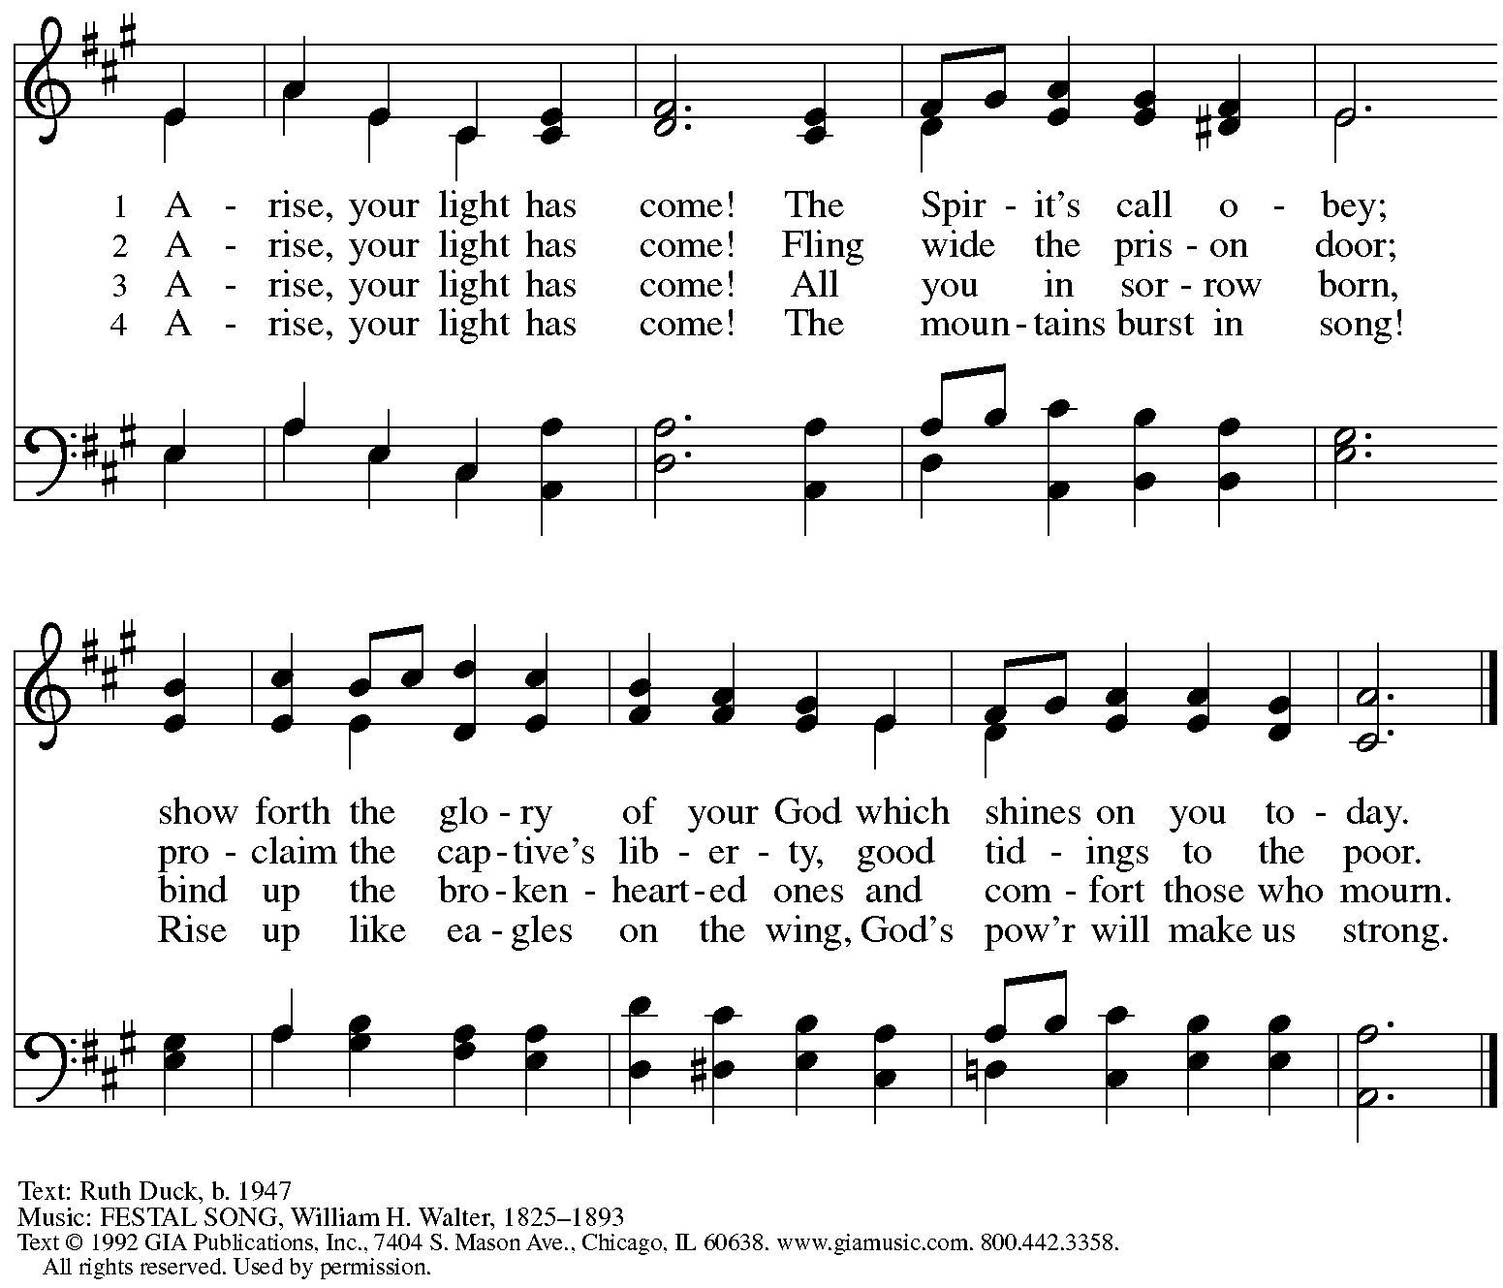
Reprinted under OneLicense.net # A-722139.

Greeting

P: The grace of our Lord Jesus Christ, the love of God,
and the communion of the Holy Spirit be with you all.
C: And also with you.

Hymn of Praise Glory to God, Glory in the Highest ELW 164

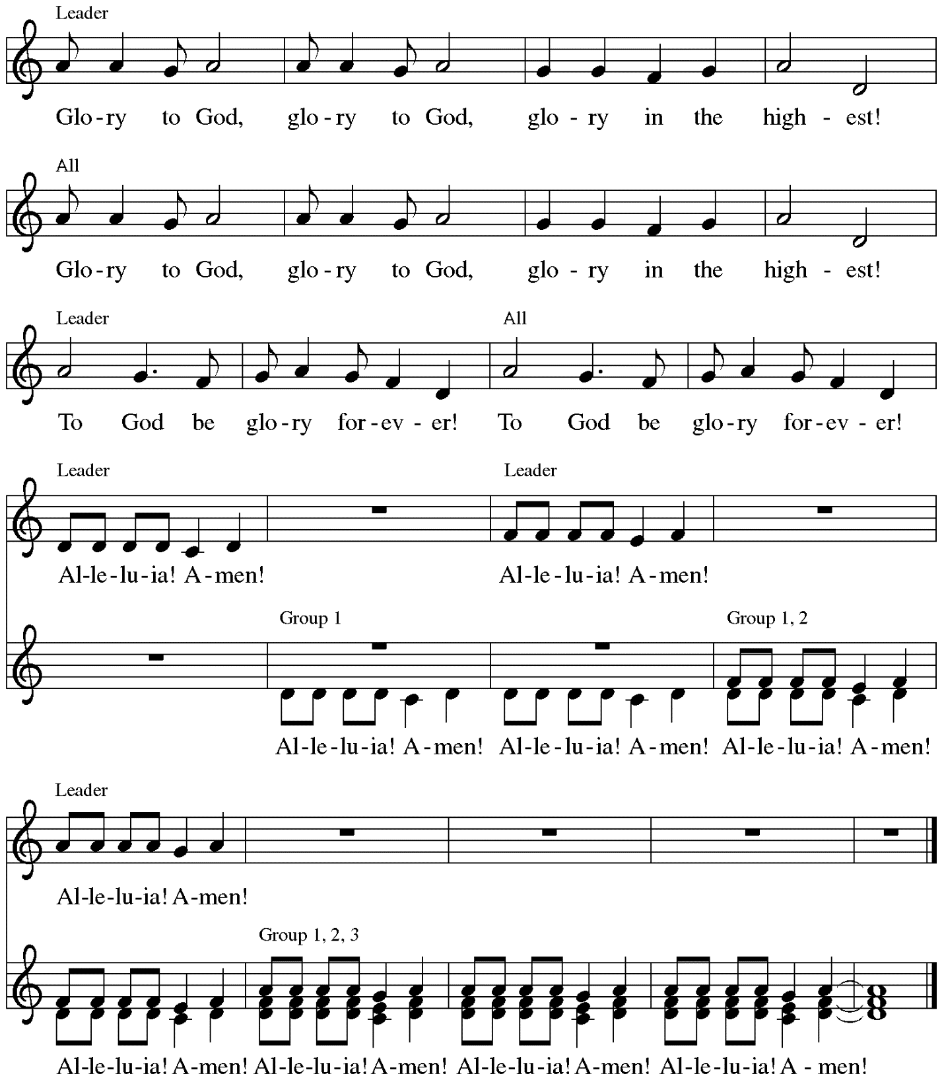

Music: Peruvian traditional

Prayer of the Day

P: The Lord be with you.
C: And also with you.

P: Let us pray.
Lord God, your lovingkindness always goes before us and follows after us.
Summon us into your light, and direct our paths in the ways of goodness
that come through the cross of your Son, Jesus Christ, our Savior and Lord.
C: Amen.

Please be seated.
Children are invited to join the adult leaders at the door and move to the office for Little Church; Big Faith. We ask that one additional adult from the congregation attend with the children.

Word
God speaks to us in Scripture reading, preaching, and song

First Reading – Isaiah 9: 1-4

¹There will be no gloom for those who were in anguish. In the former time [the Lord] brought into contempt the land of Zebulun and the land of Naphtali, but in the latter time the Lord will make glorious the way of the sea, the land beyond the Jordan, Galilee of the nations.
²The people who walked in darkness
have seen a great light;
those who lived in a land of deep darkness—
on them light has shined.
³You have multiplied the nation,
you have increased its joy;
they rejoice before you
as with joy at the harvest,
as people exult when dividing plunder.
⁴For the yoke of their burden,
and the bar across their shoulders,
the rod of their oppressor,
you have broken as on the day of Midian.

L: Word of God, word of life.
C: Thanks be to God.

Psalm 27: 1, 4-9

The cantor will lead the singing of the psalm.
The congregation is invited to respond with the alternate verses in bold print,
and to join in singing the refrain.

Psalm tone

Psalm refrain
¹The Lord is my light and my salvation; whom then | shall I fear?
The Lord is the stronghold of my life; of whom shall I | be afraid?
⁴One thing I ask of the Lord; one | thing I seek;
that I may dwell in the house of the Lord all the days of my life;
to gaze upon the beauty of the Lord and to seek God | in the temple.
⁵For in the day of trouble God will | give me shelter,
hide me in the hidden places of the sanctuary, and raise me high up- | on a rock.
⁶Even now my head is lifted up above my enemies | who surround me.
Therefore I will offer sacrifice in the sanctuary, sacrifices of rejoicing;
I will sing and make music | to the Lord. R
⁷Hear my voice, O Lord, | when I call;
have mercy on me and | answer me.
⁸My heart speaks your message— | “Seek my face.”
Your face, O Lord, | I will seek.
⁹Hide not your face from me, turn not away from your ser- | vant in anger.
Cast me not away—you have been my helper; forsake me not, O God of | my salvation. R

Second Reading – 1 Corinthians 1: 10-18

¹⁰Now I appeal to you, kindred, by the name of our Lord Jesus Christ, that all of you be in agreement and that there be no divisions among you, but that you be united in the same mind and the same purpose. ¹¹For it has been reported to me by Chloe’s people that there are quarrels among you, my siblings. ¹²What I mean is that each of you says, “I belong to Paul,” or “I belong to Apollos,” or “I belong to Cephas,” or “I belong to Christ.” ¹³Has Christ been divided? Was Paul crucified for you? Or were you baptized in the name of Paul? ¹⁴I thank God that I baptized none of you except Crispus and Gaius, ¹⁵so that no one can say that you were baptized in my name. ¹⁶(I did baptize also the household of Stephanas; beyond that, I do not know whether I baptized anyone else.) ¹⁷For Christ did not send me to baptize but to proclaim the gospel, and not with eloquent wisdom, so that the cross of Christ might not be emptied of its power.
¹⁸For the message about the cross is foolishness to those who are perishing, but to us who are being saved it is the power of God.

L: Word of God, word of life.
C: Thanks be to God.

Please rise as you are able.

Gospel Acclamation Heleluyan / Hallelujah ELW 171

Heleluyan, heleluyan; hele, heleluyan.
Heleluyan, heleluyan; hele, heleluyan.

Hallelujah, hallelujah; halle, hallelujah.
Hallelujah, hallelujah; halle, hallelujah.

Music: Muscogee (Creek); transc. Charles H. Webb, b. 1933. Transcription © 1989 The United Methodist Publishing House, admin.
The Copyright Company. Reprinted with permission under OneLicense.net # A-722139.

Gospel – Matthew 4: 12-23

P: The holy Gospel according to St. Matthew.
C: Glory to you, O Lord.
¹²Now when Jesus heard that John had been arrested, he withdrew to Galilee. ¹³He left Nazareth and made his home in Capernaum by the sea, in the territory of Zebulun and Naphtali, ¹⁴so that what had been spoken through the prophet Isaiah might be fulfilled:
¹⁵“Land of Zebulun, land of Naphtali,
on the road by the sea, across the Jordan, Galilee of the Gentiles—
¹⁶the people who sat in darkness
have seen a great light,
and for those who sat in the region and shadow of death
light has dawned.”
¹⁷From that time Jesus began to proclaim, “Repent, for the kingdom of heaven has come near.”
¹⁸As he walked by the Sea of Galilee, he saw two brothers, Simon, who is called Peter, and Andrew his brother, casting a net into the sea—for they were fishermen. ¹⁹And he said to them, “Follow me, and I will make you fish for people.” ²⁰Immediately they left their nets and followed him. ²¹As he went from there, he saw two other brothers, James son of Zebedee and his brother John, in the boat with their father Zebedee, mending their nets, and he called them.
²²Immediately they left the boat and their father, and followed him.
²³Jesus went throughout Galilee, teaching in their synagogues and proclaiming the good news of the kingdom and curing every disease and every sickness among the people.

P: The Gospel of the Lord.
C: Praise to you, O Christ.

Please be seated.

Sermon

A time of silence for prayer and reflection follows the sermon.
When the Hymn of the Day begins, please rise as you are able.

Hymn of the Day Here I Am, Lord ELW 574
v. 2-3

2 "I, the Lord of snow and rain,
I have borne my people's pain.
I have wept for love of them.
They turn away.
I will break their hearts of stone,
give them hearts for love alone.
I will speak my word to them.
Whom shall I send?" Refrain

Refrain
Here I am, Lord. Is it I, Lord?
I have heard you calling in the night.
I will go, Lord, if you lead me.
I will hold your people in my heart.

3 "I, the Lord of wind and flame,
I will tend the poor and lame.
I will set a feast for them.
My hand will save.
Finest bread I will provide
till their hearts be satisfied.
I will give my life to them.
Whom shall I send?" Refrain

Apostles Creed

C: I believe in God, the Father almighty,
creator of heaven and earth.

I believe in Jesus Christ, God’s only Son, our Lord,
who was conceived by the Holy Spirit,
born of the virgin Mary,
suffered under Pontius Pilate,
was crucified, died, and was buried;
he descended to the dead.*
On the third day he rose again;
he ascended into heaven,
he is seated at the right hand of the Father,
and he will come to judge the living and the dead.

I believe in the Holy Spirit,
the holy catholic church,
the communion of saints,
the forgiveness of sins,
the resurrection of the body,
and the life everlasting. Amen.

*Or, “he descended into hell,” another translation of this text in widespread use.

Prayers of the People

A: Called together to follow Jesus, we pray for the church,
the world, and all who are in need.

After each petition
A: Merciful God,
C: receive our prayer.

The presiding minister concludes the prayers:
P: We bring these needs and hope to you, O God,
trusting in your wisdom, grace, and power
revealed in Jesus Christ, our Savior.
C: Amen.

Please be seated.

Meal

Offering

We offer ourselves, our gifts, and our faithful service to God.
As the offering is gathered for the mission of the church, including the care of those in need,
the table is set for Holy Communion.

Music during the Offering

As the gifts are brought forward for presentation, please rise as you are able
and join in singing the Offertory Song.

Offertory Song ELW 523
Vamos todos al banquete / Let Us Go Now to the Banquet
v. 2-3

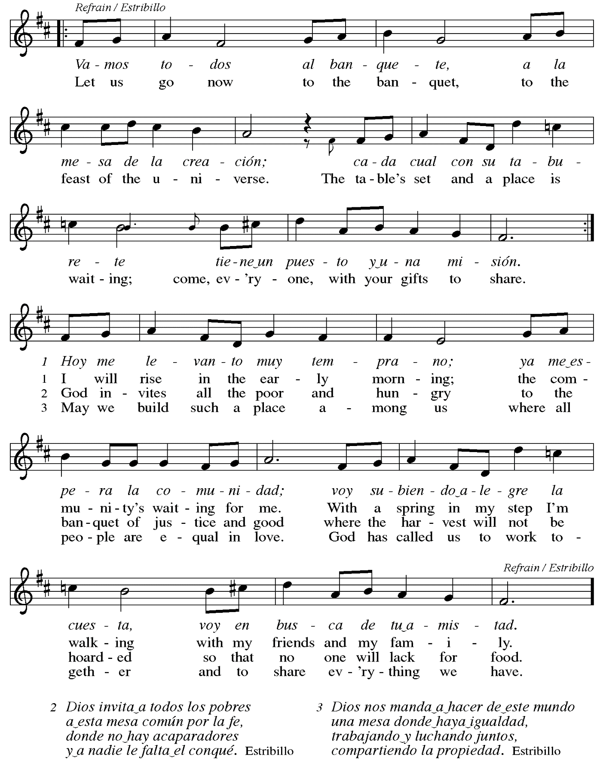

Offertory Prayer

A: Let us pray.
Liberating God,
C: you break the bonds of injustice
and set free those who are oppressed.
Receive these offerings in thanksgiving
for all your deeds of merciful power,
that they may serve in your work of justice and freedom.
You we magnify and adore, through Jesus our Savior.
Amen.

Dialogue

P: The Lord be with you.
C: And also with you.

P: Lift up your hearts.
C: We lift them to the Lord.

P: Let us give thanks to the Lord our God.
C: It is right to give our thanks and praise.

Preface (Spoken by the presiding minister)

P: It is indeed right, our duty and our joy,
that we should at all times and in all places
give thanks and praise to you, almighty and merciful God,
through our Savior Jesus Christ;
who on this day overcame death and the grave,
and by his glorious resurrection opened to us the way of everlasting life.
And so, with all the choirs of angels,
with the church on earth and the hosts of heaven,
we praise your name and join their unending hymn:

Sanctus Santo, Santo, Santo, Santo ELW 762
Refrain Only

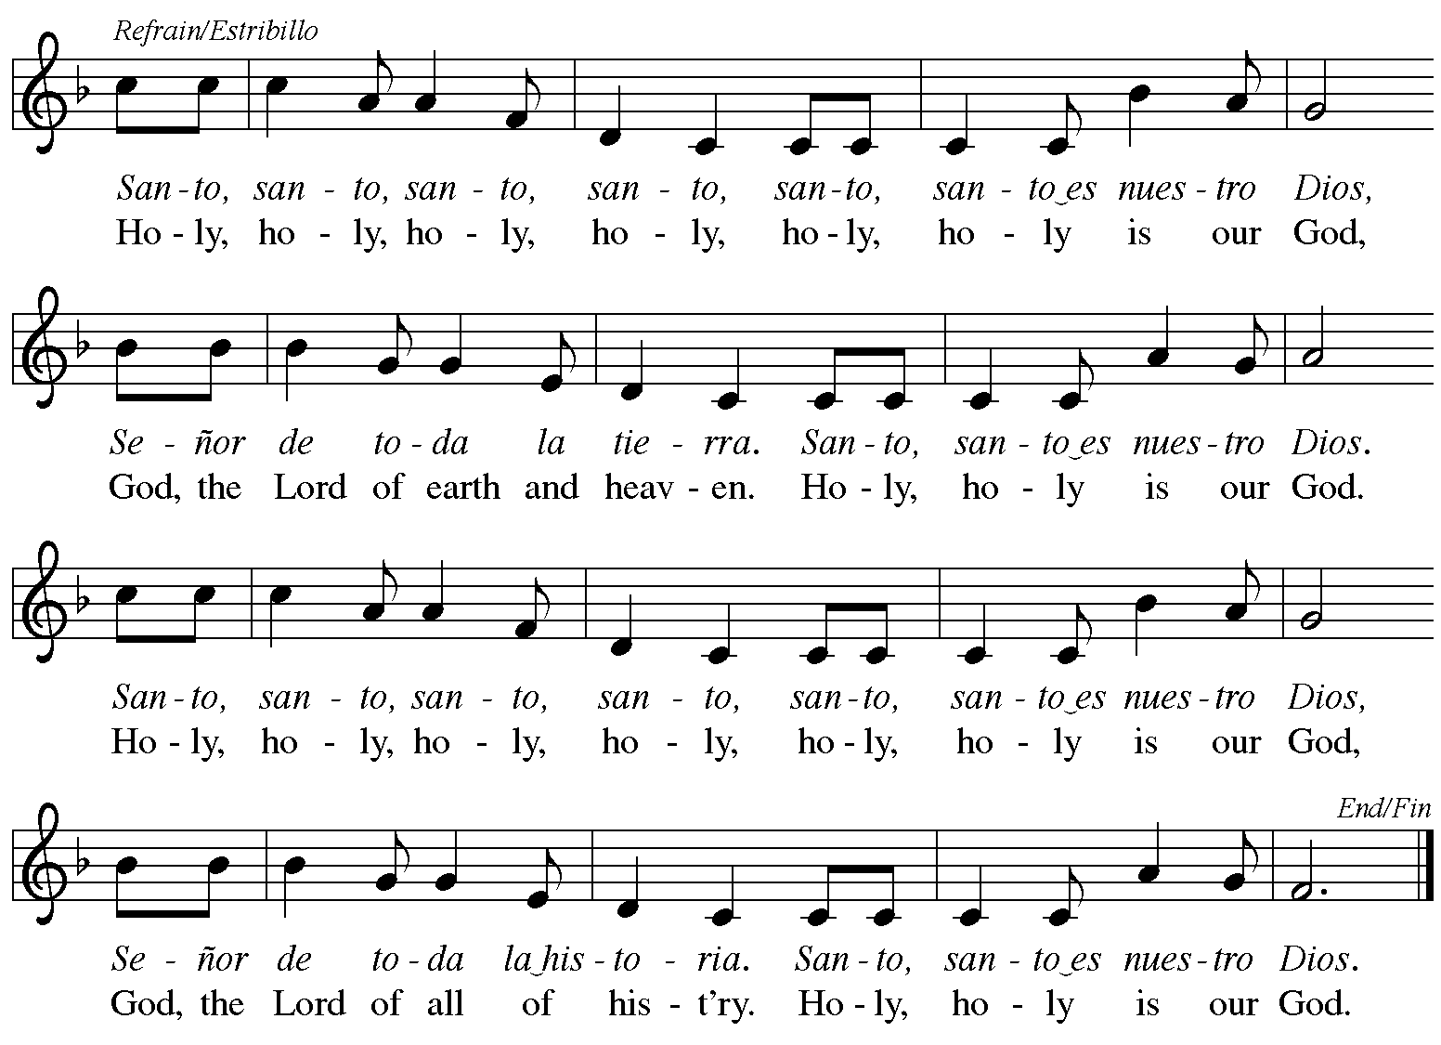
Reprinted with permission under OneLicense.net # A-722139.

Eucharistic Prayer

P: Blessed are you, O God,
creator of heaven and earth.
You rescued your covenant people,
led them on all their journeys,
and taught them by the prophets.
You so loved the world
that you gave your only Son,
so that everyone who believes in him
may not perish but may have eternal life.

In the night in which he was betrayed,
our Lord Jesus took bread,
and gave thanks; broke it,
and gave it to his disciples,
saying: Take and eat;
this is my body, given for you.
Do this for the remembrance of me.

Again, after supper,
he took the cup, gave thanks,
and gave it for all to drink,
saying: This cup
is the new covenant in my blood,
shed for you and for all people
for the forgiveness of sin.
Do this for the remembrance of me.

P: As often as we eat this bread
and drink this cup,
we proclaim the Lord’s death
until he comes.
C: Christ has died.
Christ is risen.
Christ will come again.

P: Pour out your Holy Spirit
in this meal and make us one,
in this community of faith
and with your people throughout the world.

Glory and praise to you, O God,
Author of Life,
Word made flesh,
Power of the Most High,
now and forever.
C: Amen.

Lord’s Prayer

P: Gathered as one by the Holy Spirit, let us pray as Jesus taught us.
C: Our Father in heaven,
hallowed be your name,
your kingdom come,
your will be done,
on earth as in heaven.
Give us today our daily bread.
Forgive us our sins
as we forgive those who sin against us.
Save us from the time of trial
and deliver us from evil.
For the kingdom, the power,
and the glory are yours,
now and forever. Amen.

Fraction and Invitation

P: These are the gifts of God for the people of God.
Come, share the feast.

Agnus Dei Lamb of God TFF 35

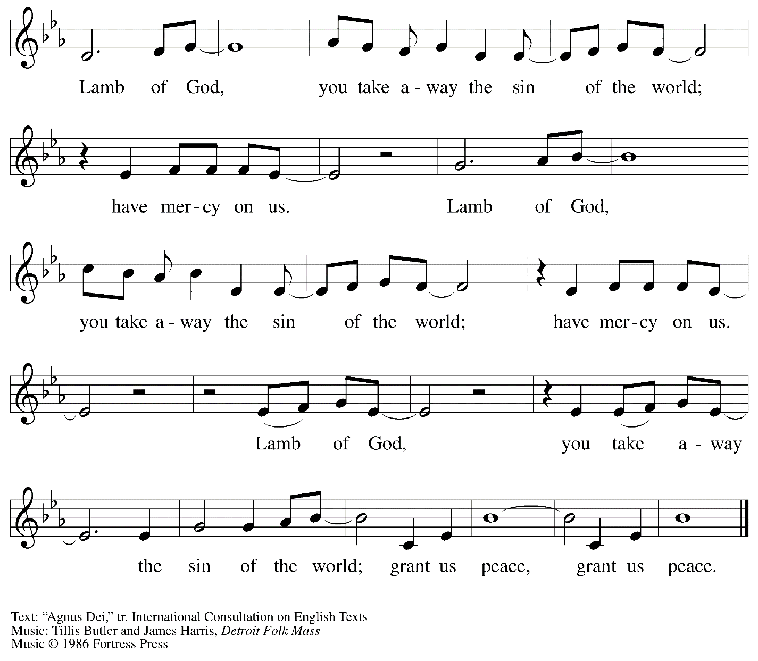
All rights reserved. Reprinted under OneLicense.net # A-722139.

Please be seated.
Holy Communion
- All who seek God and desire a deeper and stronger life in Christ are welcome to receive Holy Communion.
- Worshipers from the pulpit side will proceed forward first, followed by the center section, and then the lectern side.
- Please inform an usher if you would like the ministers to bring Communion to you.
- Holy Communion will be served with bread and wine/grape juice.
- The presiding minister will first distribute the bread (host) to each communicant. Please indicate if you require a gluten-free host.
- Once you have consumed the bread, please pick up an empty glass from the tray next to the presiding minister. The Communion Assistant will pour wine from the chalice or grape juice from the cruet into your glass.
- Please step to the side to consume the wine or grape juice.
- As you return to your pew, glasses may be returned to the empty trays on either side of the center aisle.
- A blessing will be provided for anyone who does not yet receive the sacrament.
- All are invited to join in singing the hymns during Holy Communion.

Hymn during Holy Communion
Jesus Calls Us; o’er the Tumult ELW 696
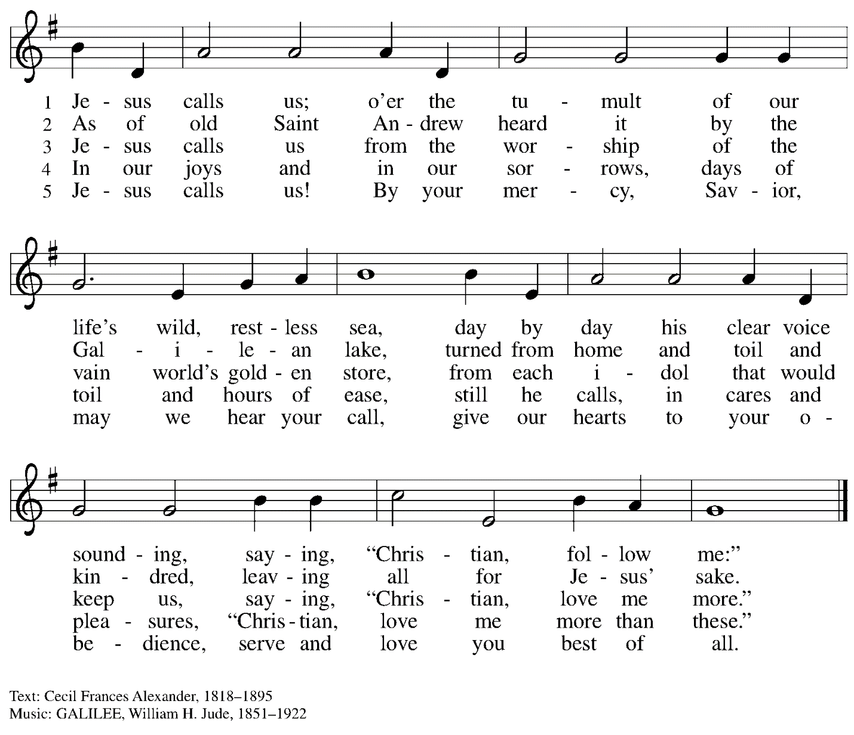

Hymn during Holy Communion
Will You Come and Follow Me ELW 798

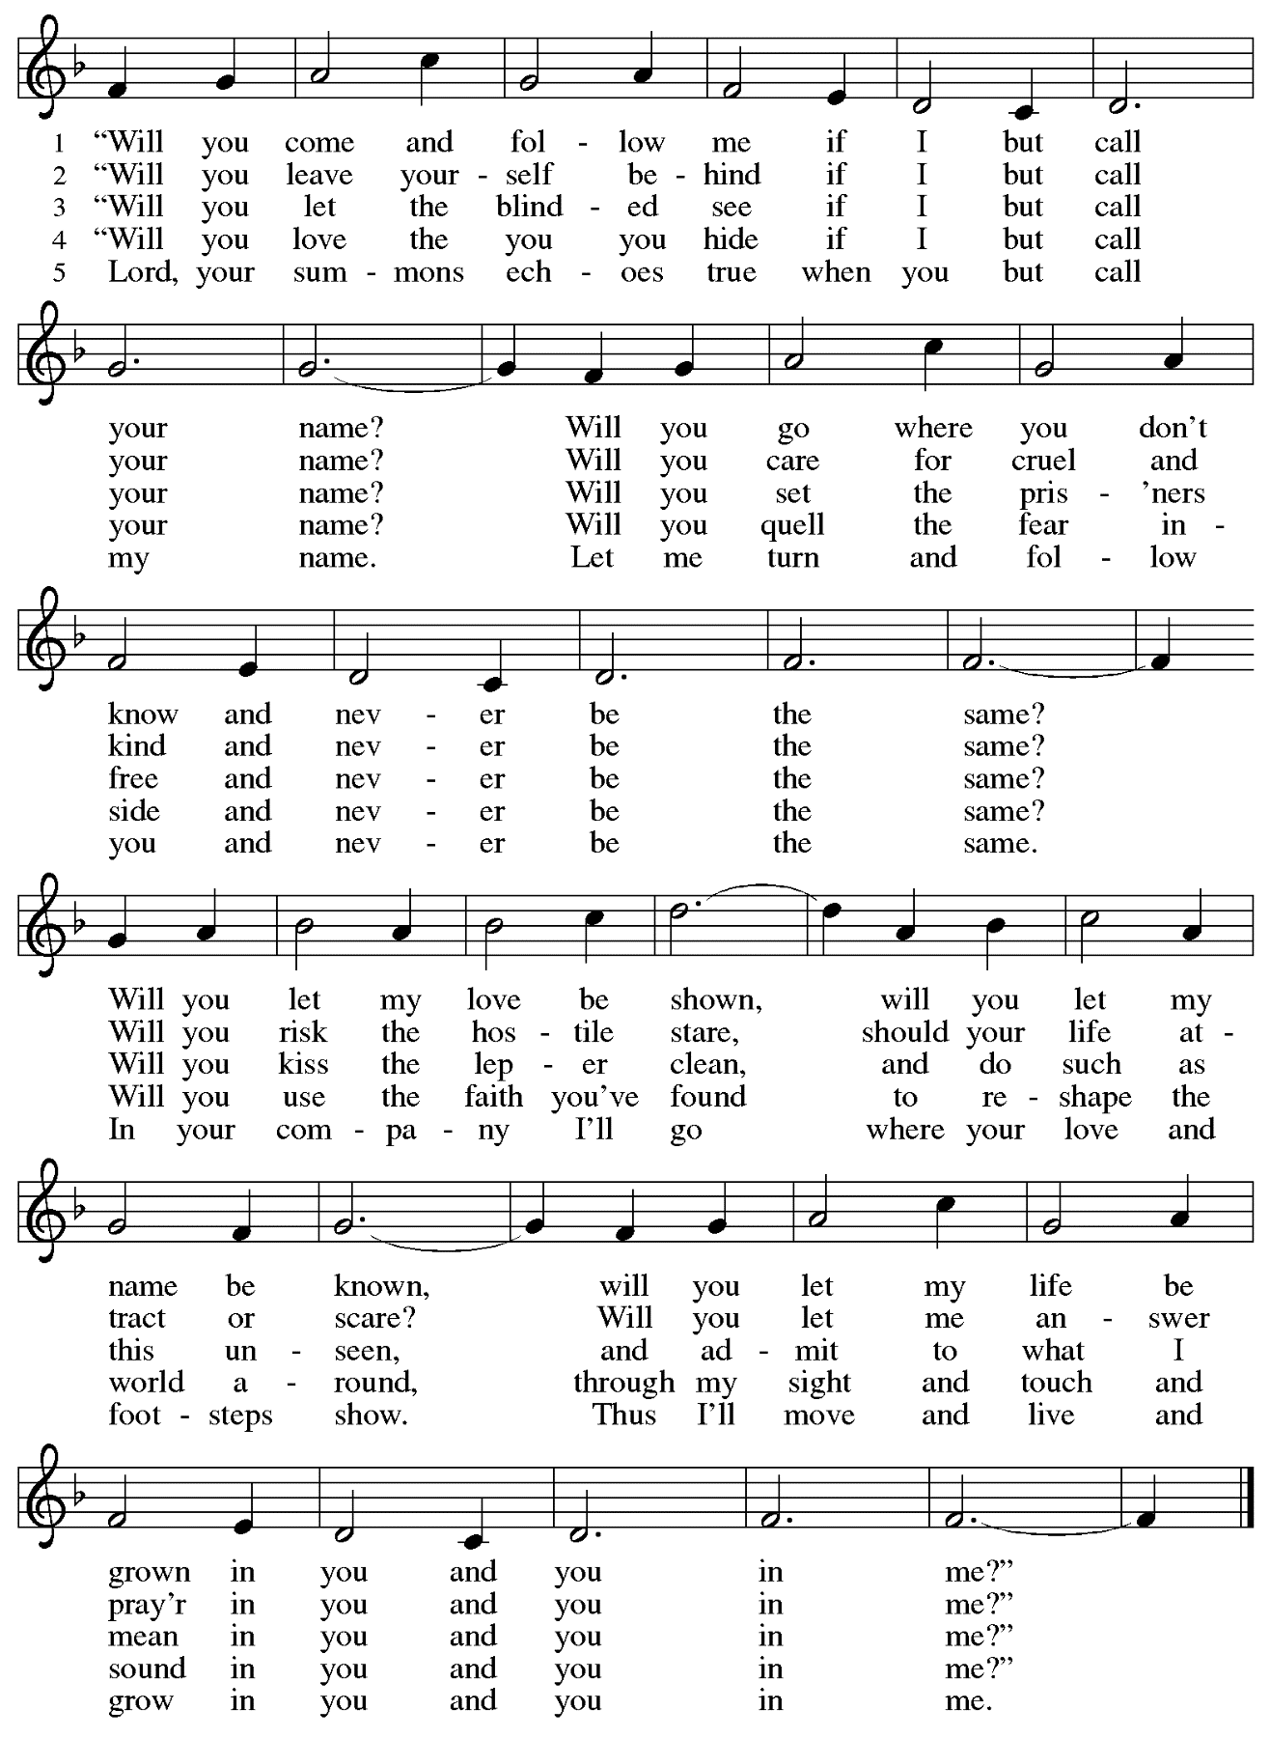
Hymn during Holy Communion
Christ, Be Our Light ELW 715

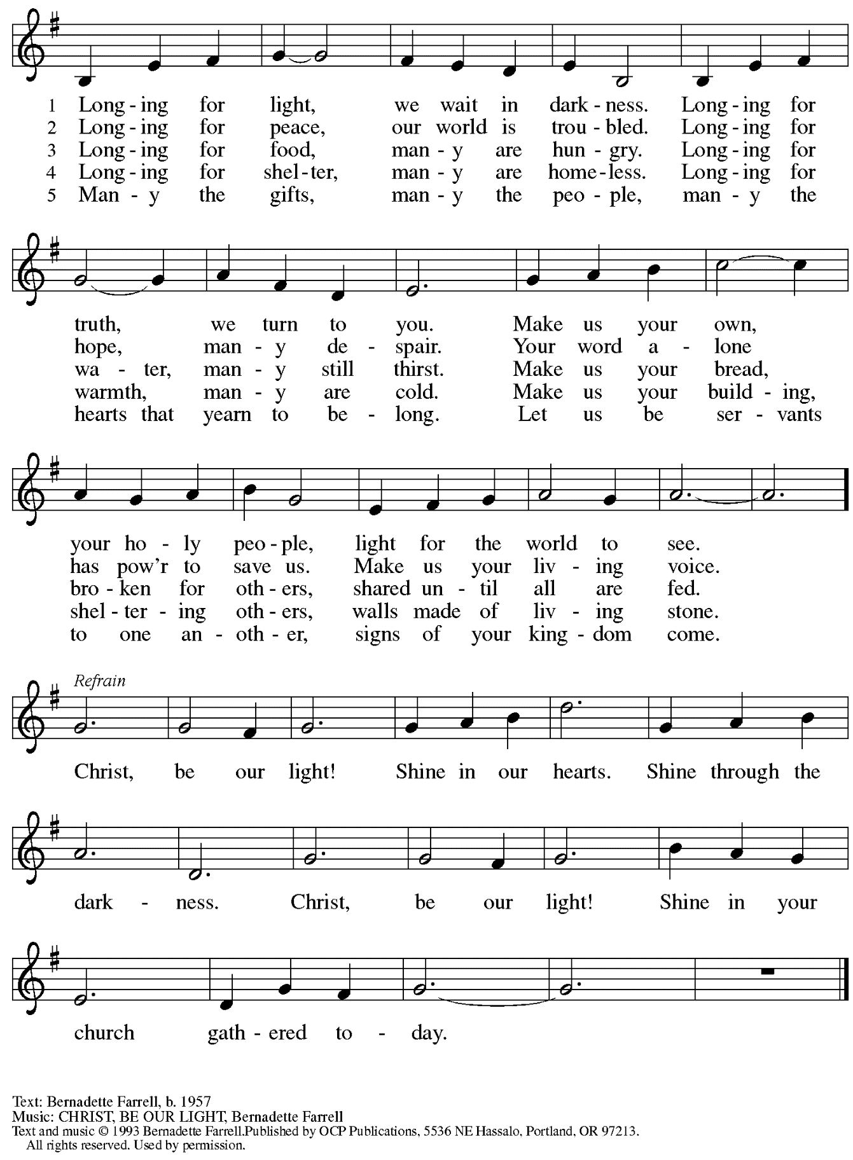
Reprinted with permission under OneLicense.net # A-722139.

When all have returned to their places, please rise as you are able.

Blessing

P: The body and blood of our Lord Jesus Christ strengthen you and keep you in his grace.
C: Amen.

Prayer

A: Let us pray.
Holy One,
we thank you for the healing
that springs forth abundantly from this table.
Renew our commitment to do justice, love kindness,
and journey humbly with you,
through Jesus Christ, our Savior and Lord.
C: Amen.

Sending

Announcements

Benediction

P: The Lord bless you and keep you.
The Lord’s face shine on you
with grace and mercy.
The Lord look upon you with favor
and ☩ give you peace.
C: Amen.

Sending Hymn God’s Work, Our Hands Following page

Dismissal

A: Go in peace. Serve the Lord.
C: Thanks be to God!

Sending Hymn God’s Work, Our Hands ACS 1000

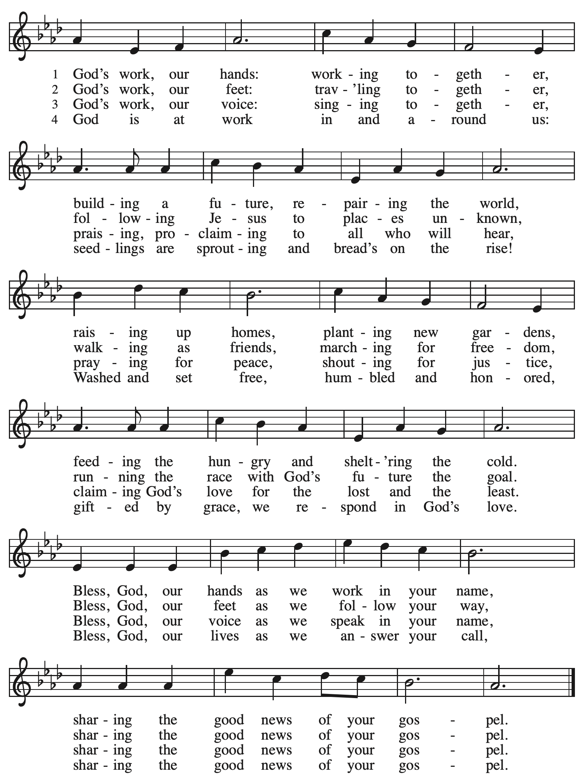
Abbreviations

P: Pastor/Presiding Minister
A: Assisting Minister
L: Lector
C: Congregation

ELW: Evangelical Lutheran Worship hymnal
TFF: This Far by Faith hymnal
ACS: All Creation Sings hymnal

Those serving in worship today

Preaching Minister The Rev. Dr. Dale B. Snyder
Guest Minister The Rev. Prudence Harris
Minister of Music Laura Reynolds
Assisting Minister Jeff Denlinger
Audio Visual Ministers Jason Galyardt
Dave Rollinson
Cantor Noël Marsh
Lector Colleen Cooke
Presiding Minister The Rev. Ross I. Carmichael

Liturgy and Hymnody Acknowledgements

From SundaysandSeasons.com. Copyright © 2023 Augsburg Fortress. All rights reserved. Reprinted under OneLicense.net # A-722139.
Used by permission of Augsburg Fortress.

Here I Am, Lord – Text: Daniel L. Schutte, b. 1946. Music: HERE I AM, LORD, Daniel L. Schutte. Text and music © 1981 OCP Publications, Inc. All rights reserved. Reprinted with permission under OneLicense.net # A-722139.

Vamos todos al banquete / Let Us Go Now to the Banquet – Text: Guillermo Cuéllar, b. 1955, Misa popular salvadoreña; tr. Bret Hesla, b. 1957, and William Dexheimer Pharris, b. 1956. Music: VAMOS TODOS AL BANQUETE, Guillermo Cuéllar, b. 1955. Text and music © 1994, 1996 GIA Publications, Inc., 7404 S. Mason Ave., Chicago, IL 60638. www.giamusic.com. 800.442.3358. All rights reserved. Reprinted under OneLicense.net #A-722139.

Will You Come and Follow Me – The Summons – Text: John L. Bell, b. 1949. Music: KELVINGROVE, Scottish traditional. Text © 1987 Iona Community, GIA Publications, Inc., agent. 7404 S. Mason Ave., Chicago, IL 60638. www.giamusic.com. 800.442.3358. All rights reserved. Reprinted with permission under OneLicense.net # A-722139.

God’s Work, Our Hands – Text: Wayne L. Wold, b. 1954. Music: EARTH AND ALL STARS, David N. Johnson, 1922-1987. Text © 2019 Evangelical Lutheran Church in America, admin. Augsburg Fortress. Music © 1968 Augsburg Publishing House, admin. Augsburg Fortress.
All rights reserved. Reprinted with permission under OneLicense.net # A-722139.

St. Andrew Lutheran Church Announcements
January 22nd, 2023

- Welcome to Worship at St. Andrew on January 22nd, 2023, the + Third Sunday after Epiphany – Today we welcome pastors of Bethel AME Church in the Hill district, The Rev. Dr. Dale B. Snyder, Sr. and The Rev. Prudence Harris! We thank them both for their presence, and thank Pastor Snyder, who will share God’s Word as our preaching minister this week. Masks are optional at St. Andrew when Allegheny County’s Covid-19 community level is in the low and medium categories. Worship attendees are invited to make a name tag at the back of the worship space if you would like. All are welcome to share in an “expanded coffee hour” in the social hall after worship to welcome our friends from Bethel.
- Life of Faith Survey – Please complete by Sunday, February 12th! – St. Andrew has been participating in a project that explores the gap between faith (at church) and life (in the world). The foundational Lutheran understanding of vocation serves as the bridge for this consistent gap. (Vocation is often understood as “calling,” and the survey uses the terms interchangeably.) People of St. Andrew are invited to take the following survey, which asks questions about your beliefs about your own vocation or calling, as well as your experiences within your congregation. Please be assured that all answers are anonymous and your responses will be kept strictly confidential. Please find the survey here: https://www.surveymonkey.com/r/VB8F3FC.
Paper copies can be made available for those who prefer that medium. Thank you for your time and participation!
- Humor and the Bible Discussion Continues – Tuesdays, January 24th and 31st, 7:00 p.m. Online – Is there humor in the Bible? Isn't it a pious look at life that inspires us and places us in awe of God? Doesn't the Bible contain instructions for life's do's and don'ts? Doesn't the Bible give us warnings and signs of hope? Perhaps all these things are true, but if we can suspend our piety, our past notions or suspicions about the Bible, we just might hear and experience a humorous side of the Bible we hadn't appreciated before. We might even laugh! In our Zoom discussions on Tuesdays, January 24th and 31st, at 7:00 p.m., Pastor Paul Koch will lead us in looking more closely at various passages throughout the Bible that might surprise you, make you smile, or even bring a laugh or two. Imagine finding humor in the Creation stories, the end of Daniel, or hearing some of Jesus' sayings in a humorous (or at least a little sarcastic) way! Zoom login information can be found in your This Week at St. Andrew email – tune in and enjoy!

Welcome, Preaching Minister The Rev. Dr. Dale B. Snyder!

Dale B. Snyder, Sr. is a second-generation AME Pastor in the Third Episcopal District of the African Methodist Episcopal Church. Over the last 28 years, he has served as Pastor of the following churches: Bethel Massillon AME Church in Massillon, Ohio; St. John AME Church in Youngstown, Ohio; Mt. Moriah AME Church in Maple Hts., Ohio; Quinn Chapel AME Church in Cleveland, Ohio; Bethel AME Church in Columbus, Ohio; St. James AME Church in Erie, Pennsylvania; and currently serving at Bethel AME Church in Pittsburgh. Pastor Snyder is a veteran of the US Army. He graduated from David Myers University with a BS in Corporate Management and a BS in Business Administration. He also graduated from Ashland Theological Seminary Degree in Black Church Studies and received a Master of Divinity from Payne Theological Seminary and a Doctor of Ministry degree from Payne Theological Seminary. He has a vast amount of business experience, owning various businesses for over 40 years and managing government agencies for 15 years before committing to ministry fulltime.

In 2012, Pastor Snyder was the recipient of the Dr. Martin Luther King, Jr. Humanitarian Award, which was presented by the Columbus Education Association for his work to defeat issue 5, the collective bargaining bill in the state of Ohio.

Pastor Snyder has served in the following positions within the community: Former Social Action Director for the Third Episcopal District of the African Methodist Episcopal Church, Inc., 2010-2020; Past-President of the Interdenominational Ministerial Alliance of Columbus, Ohio and Vicinity, 2013-2016; Board member of Ohio Unity Coalition; and, Board Member of Minority Brand, which manages Bounce TV Columbus. Pastor Snyder is the current President of the Hill District Ministerial Alliance. Pastor Snyder is married to Carmelita Snyder and they have a blended family of 7 adult children.

